Planning and Building Approvals Process Review

Discussion Paper

Disclaimer
The views expressed herein are those of Better Regulation Victoria and do not purport to represent the position of the Victorian Government. The content of this report is provided for information purposes only. Neither Better Regulation Victoria nor the Victorian Government accepts any liability to any person for the information (or the use of such information) which is provided in this report or incorporated into it by reference. The information in this report is provided on the basis that all persons having access to this report undertake responsibility for assessing the relevance and accuracy of its content.

Better Regulation Victoria
GPO Box 4379
Melbourne Victoria 3001 Australia
Telephone: (03) 9092 5800
Email: contact@betterreg.vic.gov.au
Webpage: www.betterregulation.vic.gov.au

© State of Victoria 2019

You are free to re-use this work under a Creative Commons Attribution 4.0 licence, provided you credit the State of Victoria (Department of Treasury and Finance) as author, indicate if changes were made and comply with the other licence terms. The licence does not apply to any branding, including Government logos.

Copyright queries may be directed to IPpolicy@dtf.vic.gov.au

ISBN 000-0-000000-00-0
Published month 2019

If you would like to receive this publication in an accessible format please email contact@betterreg.vic.gov.au

This document is also available in Word and PDF format at www.betterregulation.vic.gov.au

Foreword
This review has focused on how to eliminate unnecessary delays while improving the necessary scrutiny that planning and building applications need to ensure quality outcomes.
A planning system where approvals take far too long leaves all participants in the system frustrated about the outcomes and is clearly not working as well as it should. Building approvals that have not prevented a series of systemic problems are clearly in need of review.
This review has looked at the root causes for why planning and building approvals have become so complex and time consuming and, in many cases, less effective than they should be. This discussion paper has identified 27 points in the approvals chain where specific short and medium-term improvements can be made.
Many of these issues have been identified in the past and individual councils have already made significant efforts to address these. What is needed is adoption of best practices, reforming the rules and simplifying processes, along the entire approvals chain.
There are many decisions-makers involved along the pipeline and reforming the planning and building approvals system will require coordination across all of these. There is scope to improve the interactions between all decision-makers and potentially deliver a significant efficiency dividend as a result of these reforms.
A range of estimates has been provided by various parties of the economic cost of avoidable delays in the $33 billion construction sector. These appear to lie somewhere in the order of $400 to $600 million a year – or up to 2 per cent of the value of the sector. This would impact housing affordability and reduce delays and costs.
This discussion paper sets out what we have heard from stakeholders, the conclusions we have drawn from looking at the data and the analysis of council approvals processes being undertaken by PwC.
I would like to thank the advisory board of Bill Kusznirczuk, Kate Roffey and Radley de Silva as well as the review team for all their hard work on this discussion paper. Thanks are also due to the many councils, industry groups, associations of professionals and others with an interest in planning and building approvals for the time and guidance they gave us as we developed this paper. We look forward to their feedback.
Comments are being sought by Friday 15 November 2019 and can be submitted online at: www.engage.vic.gov.au/planning-and-building-approvals-process-review. A final report including specific recommendations on implementation will be submitted in December 2019.
Anna Cronin
Commissioner for Better Regulation
Red Tape Commissioner

This Discussion Paper
This discussion paper reports on the findings of the review of the planning and building approvals processes which was undertaken during 2019 by the Red Tape Commissioner, Anna Cronin, at the direction of the Treasurer, the Hon Tim Pallas MP, and the Minister for Planning, the Hon Richard Wynne MP.
The Terms of Reference for the review are in Appendix 1.
This discussion paper’s findings and suggestions are based on consultation with a broad range of stakeholders and on the work of the review team which supported the Commissioner during the review.
Feedback is sought on the suggestions for proposed improvements set out in this discussion paper to inform the final report, due in December 2019.This will include recommendations for short-term ‘quick wins’ as well as longer term reforms.
We welcome feedback by Friday 15 November 2019 on the proposed improvements set out in this discussion paper, in particular stakeholders’ responses to the following questions for each proposal:
- Are there benefits from this approach?
- Are there other approaches which warrant consideration? What are they?
- Are there specific examples where these or similar approaches have already been adopted and, if so, what were the benefits of doing so?
- Are there other factors that should be considered?
Comments can be submitted online at www.engage.vic.gov.au/planning-and-building-approvals-process-review.
As indicated in this report, there are several important parallel processes underway to reform particular parts of Victoria’s planning and building system – most notably the foreshadowed review of the Building Act 1993 and also the next stages of Smart Planning, VicSmart and the PSP 2.0 program.
It is envisaged that the final report will recommend an ongoing process to monitor progress in implementing its recommendations. As with previous reviews by the Commissioner for Better Regulation, this could be in the form of an annual ‘check-up’ on the progress being made. This will provide independent advice to Government and maintain momentum to implement measurable improvement in performance over time.

Background to the Review
In March 2019, the Treasurer, the Hon Tim Pallas MP, and the Minister for Planning, the Hon Richard Wynne MP, directed the Red Tape Commissioner, Anna Cronin, to undertake a review of the planning and building approvals process and early works infrastructure approvals in Victoria. The Terms of Reference ask for the identification of ‘opportunities to streamline these processes to reduce delays and costs without compromising the public interest’.
This review has been supported by an Advisory Board of planning and building experts comprising:
- Bill Kusznirczuk, Managing Director of Clement-Stone Town Planners, Deputy Chairman of the Victorian Planning Authority (VPA), Advisory Board Member of the Office of Projects Victoria and former Chairman and Chief Commissioner of the Victorian Building Authority (VBA);
- Kate Roffey, Director at the City of Wyndham and former Chief Executive Officer of the Committee for Melbourne; and
- Radley de Silva, former Chief Executive Officer of the Master Builders Association of Victoria (MBAV).
The Advisory Board has met monthly since March 2019 and, in addition to providing valuable guidance and insight into the planning and building processes, has supported the development and preparation of this discussion paper. The Advisory Board will continue to support this review to deliver the final report to the Treasurer and the Minister for Planning.
The process for conducting this review has included:
- extensive stakeholder consultation;
- mapping of council planning and building approval processes;
- a series of policy workshops; and
- the release of this discussion paper.

Stakeholder consultation
A broad cross-section of stakeholders is interested in this review. Stakeholders that have been consulted and have contributed their views and experiences include:
- industry associations;
- councils;
- referral authorities;
- developers, building practitioners and consultants;
- government departments, agencies and regulators; and
- professional practitioners and other experts.
Consultation has been undertaken through one-on-one and group meetings, site visits, presentations to relevant groups and at other forums.
Regular meetings have been held with representatives from the peak industry associations, including the Urban Development Institute of Australia (UDIA), the Property Council of Australia (PCA), the Housing Industry Association (HIA) and MBAV and with the Planning Institute of Australia (Victorian Division) (PIA). Written submissions, case studies and other materials have been received from these stakeholders and many others.
Wider consultation was facilitated through an invitation to provide feedback by completing an online survey or providing written submissions.

Mapping council processes
PricewaterhouseCoopers (PwC) was engaged to map council planning and building approval processes. This task, which was undertaken between June and August 2019, involved face-to-face consultations with relevant teams within councils as well as a number of follow-up meetings.
Thirteen councils participated in the mapping activity. These councils were a representative sample from a mix of geographical areas including metropolitan, growth areas and regional cities.

Policy workshops
In August and September 2019, four workshops were held with key stakeholders to canvas views on key issues. Two workshops were held with councils, one with referral authorities and one with planning experts. Further briefings of key stakeholders will be held before the final report is submitted in December.

Contents
Foreword 1
This Discussion Paper 2
Background to the Review 3
Glossary 7
Overview 9
The importance of planning: balancing private and public interests 9
The impact of delays on the economy and housing affordability 11
The causes of delays 20
System-wide improvements to address persistent problems 21
Opportunities for improvement in specific approvals stages 26
Part A – The Strategic Approvals Process 29
Introduction 29
A1. Simplify planning schemes 38
A2. Streamline planning scheme amendments 42
A3. Streamline the PSP process 45
A4. Escalate planning for sites of strategic importance 49
Part B – The Permit Approval Process 53
Introduction 53
B1. More help with applications 57
B2. Ensure lodged applications are complete 59
B3. Move to online planning permit processing and tracking 61
B4. Improve planning resources for councils 63
B5. Modernise public advertising of proposals 66
B6. Stream applications according to risk 68
B7. Reduce requests for further information 71
B8. Reduce response times for referrals 73
B9. Make decisions within a reasonable time 77
B10. Promote best practice delegation of decisions 80
Part C – The Post-permit Approval Process 83
Introduction 83
C1. Checking compliance with permit conditions 86
C2. Streamline variations to the terms of a permit 90
C3. Reduce timelines for electricity connections 92
C4. Simplify payment of infrastructure contributions 95
C5. Approvals by other authorities 102
C6. Coordinate planning and building permit assessments 106
Part D – The Building Approvals Phase 109
Introduction 109
D1. Expand the workforce of building surveyors, inspectors and fire safety engineers 116
D2. Improve access to building records 123
D3. Streamline building permit requirements for low-risk work 125
D4. Standardise construction management plans 128
D5. Improve consistency of council asset protection requirements 130
D6. Distinguish building ‘consultants’ from building surveyors 131
D7. Clarify processes for enforcement 133
Appendix 1 – Terms of Reference 139

Glossary
AER | Australian Energy Regulator
AIBS | Australian Institute of Building Surveyors
ATS | Amendment Tracking System
BAB | Building Appeals Board
BAMS | Building Activity Management System
CAV | Consumer Affairs Victoria
CEO | Chief Executive Officer
DBDRV | Domestic Building Dispute Resolution Victoria
DCP | Development Contribution Plan
DELWP | Department of Environment, Land, Water and Planning
DJPR | Department of Jobs, Precincts and Regions
DTF | Department of Treasury and Finance
EES | Environment Effects Statement
EPBC Act | Environment Protection Biodiversity Conservation Act 1999
ESC | Essential Services Commission
GAIC | Growth Area Infrastructure Contribution
HIA | Housing Industry Association
ICP | Infrastructure Contribution Plan
IT | Information Technology
KPI | Key Performance Indicator
LGV | Local Government Victoria
LPP | Local Planning Panel
LUV | Land Use Victoria
MAV | Municipal Association of Victoria
MBAV | Master Builders Association of Victoria
MSA | Melbourne Strategic Assessment
NCC | National Construction Code
PCA | Property Council of Australia
PEXA | Property Exchange Australia
PIA | Planning Institute of Australia
PI insurance | Professional indemenity insurance
PPARS | Planning Permit Activity Reporting System
PPV | Planning Panels Victoria
PSA | Planning Scheme Amendment
PSP | Precinct Structure Plan
PwC | PricewaterhouseCoopers
RBA | Reserve Bank of Australia
RCTP | Rural Councils Transformation Program
RFI | Request for Information
RPS | Regional Planning Services (DELWP)
SARA | State Assessment and Referral Agency (Queensland)
SDO | Service Delivery Obligation
SIC | Service Improvement Commitment
SPA | Staged Payment Agreement
SPEAR | Surveying and Planning through Electronic Applications and Referrals
SRO | State Revenue Office
TAFE | Technical and Further Education
UDIA | Urban Development Institute of Australia
UGZ | Urban Growth Zone
VBA | Victorian Building Authority
VCAT | Victorian Civil and Administrative Tribunal
VLGA | Victorian Local Government Association
VMBSG | Victorian Municipal Building Surveyors Group
VPA | Victorian Planning Authority
VPELA | Victorian Planning & Environmental Law Association
VPP | Victoria Planning Provision
WIK | Work in Kind

Overview
This overview provides the context for this discussion paper.
The paper sets out a four-stage framework for understanding the nature of planning and building approvals processes and then explains how unnecessary delays and costs impose substantial constraints on the construction sector – and the impact of these delays and costs on the supply of land and on housing affordability in Victoria.
Proposed improvements to the approvals system to reduce delays and costs are outlined in this discussion paper with a focus on 27 specific aspects of the approvals framework.

The importance of planning: balancing private and public interests
The choices Victorians make about how to use their land and what to build on it are regulated through the planning and building system, created by the Planning and Environment Act 1987 (Planning and Environment Act), the Building Act 1993 (Building Act) and the Subdivision Act 1988.
The objectives of the Planning and Environment Act and the Building Act are supported by planning and building systems designed to deliver a range of economic, environmental and social benefits.
Owners of land must go through formal processes to obtain approval to:
- change the rules about how they can use and develop their land, such as rezoning their land from agricultural to residential or commercial (strategic approvals);
- change the use for their land under the existing rules, such as obtaining a permit to build a second dwelling on a residential lot (permit approvals);
- meet conditions required by a permit or variations to the terms of a permit, such as making a minor variation to the design of a building or approvals from other authorities, such as electricity distributors (post-permit approvals); and
- commence, progress and complete building works (building approvals).
These four stages are illustrated in Figure 1. Each stage involves balancing the interests of the private individual and the public interest. Not all users necessarily move through each stage. Nonetheless, as illustrated in Figure 1, at each stage:
- the user seeks approval from a decision maker;
- the decision maker will seek input or sometimes further approvals from other authorities or the public; and
- in the event of a dispute, there is an arbiter that can provide a second opinion or, in some cases, a binding resolution.
It is worth noting that the Minister for Planning must approve any planning scheme amendment adopted by a council and can “call in” permits in some sitations.
Decision makers approving proposals are required to consider the public interest so that the intended uses of land and buildings:
- are consistent with the planning and building rules and objectives;
- achieve their intended economic, environmental and social benefits; and
- deliver efficient supply of land for residential, commercial and industrial development to meet the housing and employment needs of Victorians now and into the future.




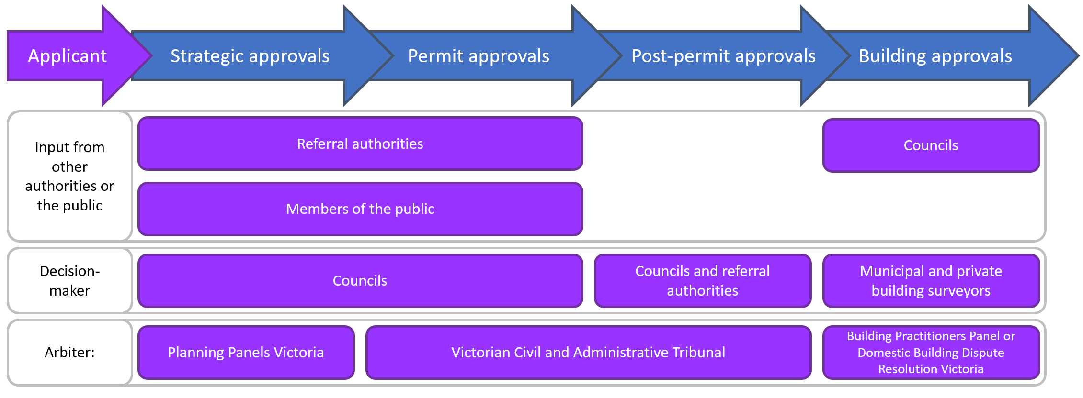
This is a stylised representation of the most common configuration of these roles. For example, technically the decision maker at the strategic approvals stage will be whichever ‘planning authority’ has been delegated that role by the Minister for Planning, and the decision maker at the permit or ‘statutory’ approvals stage will be whichever ‘responsible authority’ has been delegated that role.

Figure 1: A map of roles in the four stages of planning and building approvals

The impact of delays on the economy and housing affordability
Approvals processes necessarily involve decision makers taking time to assess whether applications meet the requirements of the planning and building system. In some cases, additional time may be necessary to make a decision because the quality of information provided is not adequate.
The Victorian current planning approvals processes have accumulated over many years. The planning legislation, Victoria Planning Provisions and local planning provisions have been added to over time with the approvals system now containing many layers of State and local government policies, standards and requirements. There are many decision-making authorities in the mix and users can incur significant costs and delays as they navigate the system. These costs and delays are at risk of growing larger over time given prevailing pressures of the system.
This discussion paper identifies opportunities to improve planning and building approval processes, without undermining the intent of the regulations or rules which underpin them. In other words, this discussion paper proposes initiatives which will reduce administrative burden (‘red tape’) while ensuring that the objectives of State and local governments are maintained and respected.
Unnecessary delays in these processes have significant impacts, such as:
- keeping families in the private rental market for longer periods than necessary – while they incur significant costs (waiting for work to start on new homes or to move into housing that has been constructed);
- putting upward pressure on house prices and rents;
- increasing the costs of getting the necessary permits approved for all types of construction, including commercial and industrial; and
- developers incurring significant additional holding and opportunity costs (these costs have been the focus of many of the submissions we have received).
Reducing delays in these approval processes can therefore generate jobs and underpin further growth in Victoria’s $33 billion construction sector as well as deliver improvements in housing affordability. Process improvements are needed not just to make the system more efficient, but also to make it more flexible – Victoria’s planning and building system will continue to face pressure from significant growth in housing activity, driven by population growth, and the changing nature of housing demand.

The scale of the construction sector and the benefits of reducing delays
Planning approvals are the key gateway that can limit, delay or facilitate the development of land, buildings and infrastructure. The most immediate benefit of improving planning and building processes is a reduction in the delay costs incurred by the construction sector (and those involved in residential, commercial and industrial development), and the corresponding economic growth and employment that the sector creates (see Box 1).
Box 1: Victoria’s construction sector in three charts (Source: Australian Bureau of Statistics (ABS) data)
Over the last ten years, the construction sector’s contribution to Victoria’s gross value added has increased steadily from around $24 billion (see Figure 2) to around $33 billion, with a relatively stable mix of engineering, residential and non-residential construction (see Figure 3). The sector’s contribution to Victorian jobs reflects the industry’s cyclical nature, rising and falling between 8 and 10 per cent of total employment over the last decade (see Figure 4).

Figure 2: Gross value added by the construction sector, $ millions, 2009-2018
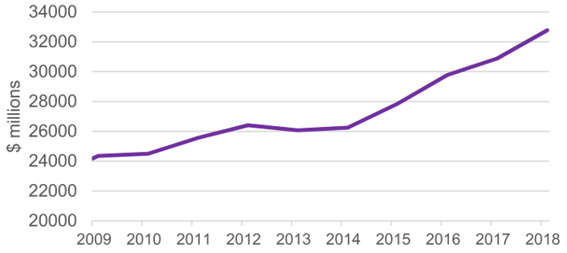

Figure 3: Construction work done, Victoria (share of total value), 2009-2019
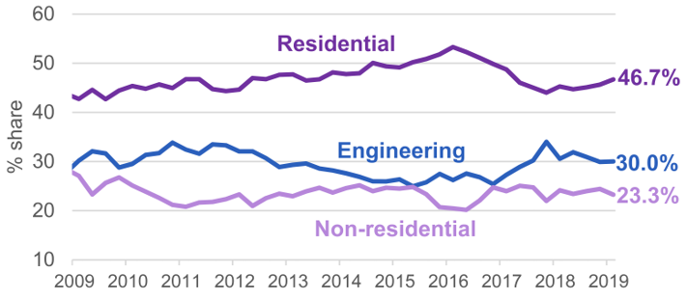

Figure 4: Construction sector’s share of total Victorian employment (four-quarter moving average), 2009-2019
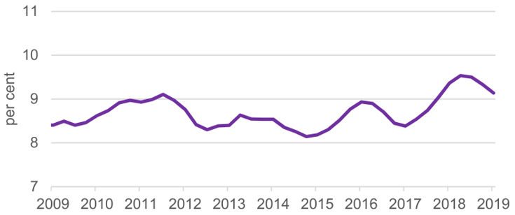

The sheer size of the construction sector and its significance to the Victorian economy mean that while the total costs attributable to planning and building approvals processes can be difficult to quantify, they are likely to be large. The PCA, in a submission to this review, estimated that improving referrals and providing better resources to councils could reduce delays in all dwelling approvals by around one week, unlocking around half a billion dollars in value added to the Victorian economy each year. Similarly, SGS estimates that the potential benefits from improvements in planning and building processes could be from $400 million to $600 million per year, based on their analysis of delay costs faced by developers.
This estimate is based on the foregone rental yield that residential and commercial developments could otherwise be expected to generate. For commercial developments, for example, SGS estimates that the cost of a day’s delay could be as high as $50,000 per day for a single high-rise commercial development. Reducing the time taken to approve developments of this type by a month could save $1.5 million for just one development.
The delay costs in the context of residential development are comparable. SGS estimates that the cost of a day’s delay to an applicant can range from around $70 per dwelling per day for low-rise dwellings to around $180 per dwelling per day for high-rise, high quality development.
ABS data show that there were around 75,000 dwelling units approved in Victoria in 2017-18, of which around 46,500 were for new dwellings, including 19,500 high-rise dwellings. Using the SGS figures as estimates of the average delay costs for low- and high-rise residential dwellings suggests that for each additional day taken to approve residential permit applications for new dwellings as a category, applicants incur total delay costs of $7.6 million.
Planning Permit Activity Reporting System (PPARS) data suggests that of all residential permits for new dwellings in Victoria in 2017-18, almost two-thirds took more than two months to assess, a quarter took more than six months to assess, and nearly one in ten took more than ten months to assess (see Figure 5). If process improvements reduced the time taken to approve permits in this category by an average of one month, this would equate to around $200 million in avoided delay costs.

Figure 5: Proportion of permit applications for new residential dwellings processed, by gross days taken to assess permits
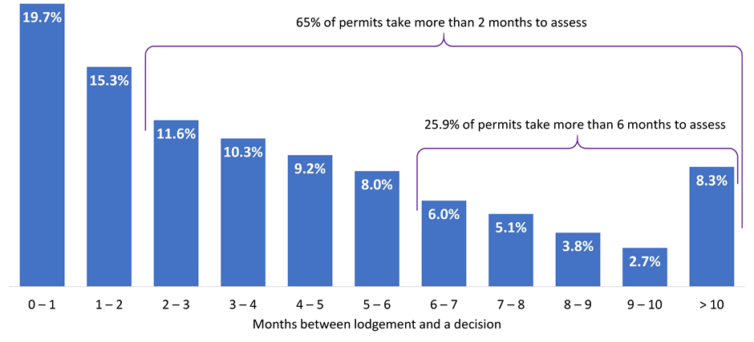
With large delay costs, long timeframes and so many permits in the system, small process improvements can quickly build up into large benefits.
In the permit approvals stage, for example, PwC’s mapping of council processes for this review identified a number of ‘best practices’ where councils could focus their improvement. Preliminary analysis by PwC estimates that applying just five of these best practices to a subset of permit applications could generate benefits of up to $100 million per year in avoided administrative and delay costs by:
- engaging earlier with referral authorities through pre-application processes;
- sending referrals and requests for information concurrently;
- better coordinating and managing internal referrals and assessment;
- adopting best practice delegations; and
- processing applications online with a system that applicants can view.
PwC’s estimated benefits are conservative because they only apply to a subset of applications and do not account for:
- the broader benefits of improved economic growth and employment in the construction sector; and
- any additional utility for applicants from faster processing of their applications (for example, making it easier for developers to make investment decisions with confidence in the likely timeframe for an outcome, helping families move into their new homes sooner).
Other benefits and reductions in delays will also be generated by improvements proposed in the other three stages of this discussion paper, contributing to the total potential savings of up to $600 million.
The potential benefits of process improvements in the planning and building system highlight the importance of continuing to invest in programs that support productivity improvements. These can yield substantial benefits for those using and administering the planning system, the construction sector, and for the Victorian economy as a whole. See below for a discussion of existing government initiatives.

The impact of approvals processes on housing affordability
The delay costs discussed above put significant upward pressure on house prices. The SGS submission to the Council on Federal Financial Relations (Affordable Housing Working Group Issues Paper) in March 2016 identified efficient development assessment processes and standards as one of four major building blocks for improving housing affordability.
Delays in planning processes can also impact on housing affordability by slowing the release of land for development – previous work by the Reserve Bank of Australia and the Productivity Commission has identified the complexity of planning and its approval processes as a key constraint on land supply. These impacts vary in different parts of the housing market (see see below).
The Australian Housing and Urban Research Institute, in its report on housing supply responsiveness in Australia (May 2017), found that often the most important aspect of the planning system for developers was the certainty and consistency of advice provided by planning officers.

Supply of housing

Inner-city apartments
The boom in inner-city apartment developments over the last five years has been dramatic: Southbank, Docklands and the Central Business District have seen rapid growth driven by a high level of investor and overseas interest. These factors have ebbed in recent times and the focus has recently shifted to medium-rise apartment developments close to middle suburban activity centres.
The emergence of problems with use of non-compliant flammable cladding, construction defects and other issues has dampened buyer enthusiasm and placed pressure on industry to maintain higher standards.

Land supply in the middle suburbs
DELWP produces the Urban Development Program each year, providing a detailed analysis of the location and scale of approved developments across the metropolitan area. A partner report looks at the industrial land supply and a third looks at the greenfields development outlook.
DELWP has also produced a retrospective analysis of where developments have occurred over the last decade. This has indicated that policies to encourage higher densities around major activity centres has been largely successful. These developments have boosted price competition resulting in more affordable housing and increased amenity with population growth leading to revitalisation and improved liveability.
There is currently no government target for ‘build ready’ land across all the established urban areas of Melbourne and major regional towns. To promote more competition and provide stability to the development process it has been suggested that there should be a target to reach two years of build ready land in the urban market.

Land supply in regional towns
Most regional cities have significant land zoned for development, compared to current levels of demand. The growth of regional centres is less constrained by housing supply than by availability of jobs and the frequency of transport links to larger centres.

Greenfields land supply
Over the last three years the Victorian Planning Authority provided funding through the Streamlining for Growth program and has assisted 26 regional councils to design their development plans. Historically Melbourne has enjoyed lot prices below the national average, and below those of lots in Sydney. This has been supported by the Victorian Government’s forward planning to provide large areas for development and maintain a competitive greenfields lot market, which depends upon maintaining:
- an adequate long-term supply of land that is zoned for development; and,
- sufficient short-term supply of subdivided lots available for purchase.
However, the period from 2014 to 18 shows that land supply needs to be able to respond quickly to rising demand in order to meet the Government’s objectives. Any unnecessary delays in approval processes stymie a swift response.
The Government has a long-term planning target of providing 15 years’ supply of zoned land with a Precinct Structure Plan (PSP) in place, and a short-term target of having four months’ supply of lots available for sale at any given point in time (see Part A for discussion of delays in the PSP process). Since 2018, the supply of zoned land has been around the 15-year long-term target (see Figure 6).

Figure 6: Victoria’s supply of PSP-approved land in growth corridors
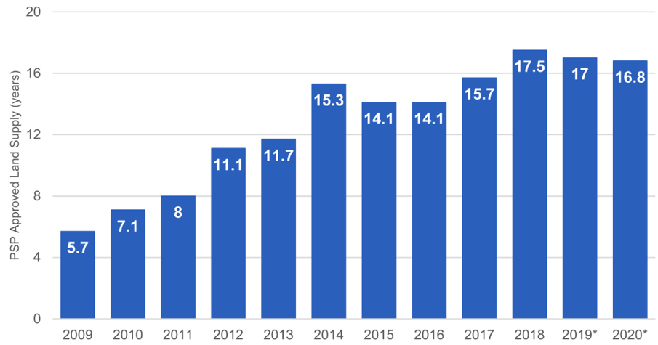*Estimated. Assumes average consumption of 15,500 lots p.a. Source: Research 4, Nation Market Report
However, from 2014 to 2018, the supply of subdivided lots available on the market fell far short of the four-month short-term target (see Figure 7).

Figure 7: Melbourne’s supply of greenfield lots, 2013-2019
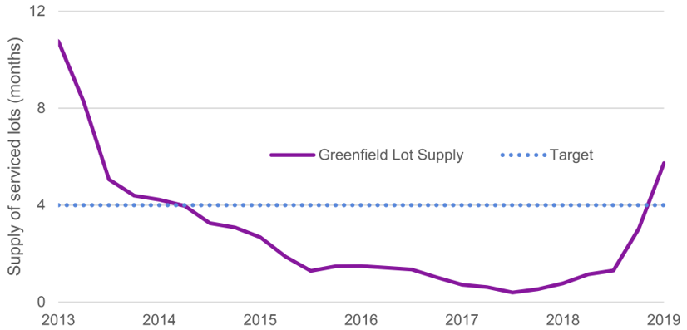
Source: Research 4, Nation Market Report
At one point, there was less than two weeks’ supply on the market – subdivided lots were effectively selling as soon as they were available. Although the supply of lots for sale has now returned to the Government’s target of four months, the sustained period of high demand had a significant effect on lot prices. By mid-2018, the median lot price in Melbourne had increased 55 per cent in two years and had exceeded the national average (see Figure 8).

Figure 8: Median lot prices, Melbourne and other selected capital cities, 2013-2019
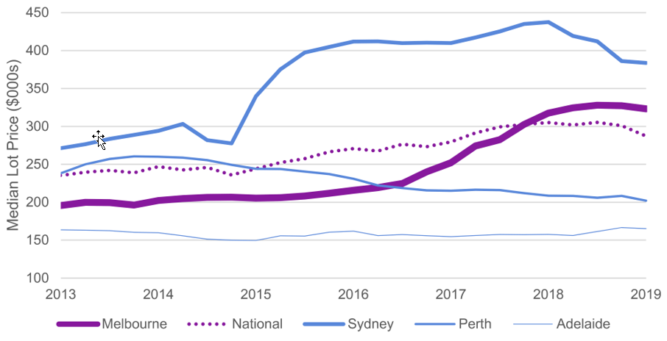
Source: Research 4, Nation Market Report
Had planning approvals processes for approving subdivisions been faster, supply would have been able to respond more quickly and the impact on Melbourne lot prices could have been mitigated. This example highlights the need to reduce any unnecessary delays in Victoria’s planning and building approvals, and to improve its ability to adapt to changing trends in housing demand.

Housing demand: rising in line with population and changing to reflect shifting preferences
The record demand for housing over the last five years has placed a great deal of pressure on the planning and building approvals system, with record demand for the approval of new lots in greenfield growth corridors and high-rise apartments in central Melbourne as well as growth in medium-rise apartments near suburban activity centres.
ABS data shows that Victoria’s population growth has outpaced other states, with Melbourne growing faster than all other capital cities at 2.5 per cent in the last calendar year. In 2017, Plan Melbourne 2017-2050 projected a statewide population increasing from six million in 2016 to 10.1 million in 2051: eight million of whom would live in Melbourne. These estimates are based on average population growth of 100,000 a year, which has been eclipsed in recent years with population growth averaging around 140,000 in each of the last three years.
The Victoria in Future July 2019 report projects a population of 11.2 million by 2056. Victoria’s population has been growing faster than any other state or territory and this trend is predicted to continue. A third of this increase will come from natural growth and two-thirds from interstate and international net migration.
To deliver the housing supply required to meet Victoria in Future population growth forecasts, the Urban Development Institute of Australia (UDIA) estimates that up to 68,000 new dwellings would need to be built each year.
Population growth has driven strong growth in housing demand, as seen in Victoria’s dwelling approvals over time (see Figure 9). Up until the late 1990s, annual dwelling approvals in Victoria were trending at around 30,000 per year. Since the late 1990s, there has been a steady increase in that trend from 30,000 per year to around 70,000 per year, peaking in 2018 with around 75,000 dwelling approvals.

Figure 9: Long-term trends in dwelling approvals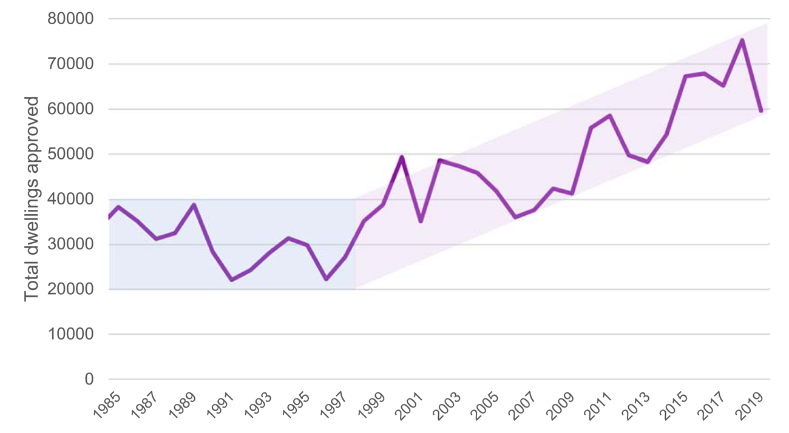
Source: ABS data
As depicted in Figure 9, dwelling approvals grew rapidly from 2014 to 2018, which put great stress on the planning system as developers in each market rushed to get their projects approved.
Over the last 12 months there has been a correction back to around 60,000 dwelling approvals, which has been attributed to several factors:
- tighter loan conditions being applied by the Australian Prudential Regulation Authority;
- changes in policies on approved borrowers arising from the Hayne Royal Commission; and
- a slow down in overseas investment in Victorian housing following controls on transfer of funds.
This recent dip in dwelling approvals presents a timely opportunity to streamline the approvals system. Streamlining the approvals will strengthen the system’s capacity to deal with the longer-term growth trend driven by ongoing strong population growth and the expectation that, in the long term, demand for new building approvals will remain high.

The changing nature of housing demand
Changing demographics have also driven a change in the type and location of housing in demand. There has been a strong shift away from traditional family homes on large blocks to a more diverse range of housing styles – including apartments, townhouses and homes suited to smaller family units. Despite record demand in the growth corridors, the proportion of sales there has declined due to a significant expansion in the number of high-rise apartments in central Melbourne and medium-rise apartments near suburban activity centres.
Changes in the type of housing in demand is reflected in the trend towards increasing density of housing, seen in the rapid rise in approvals for houses (including semi-detached, row or terrace houses and townhouses) with two or more storeys and flats, units or apartments with four or more storeys (see Figure 10).

Figure 10: A tale of two decades – the shift in housing demand towards higher density
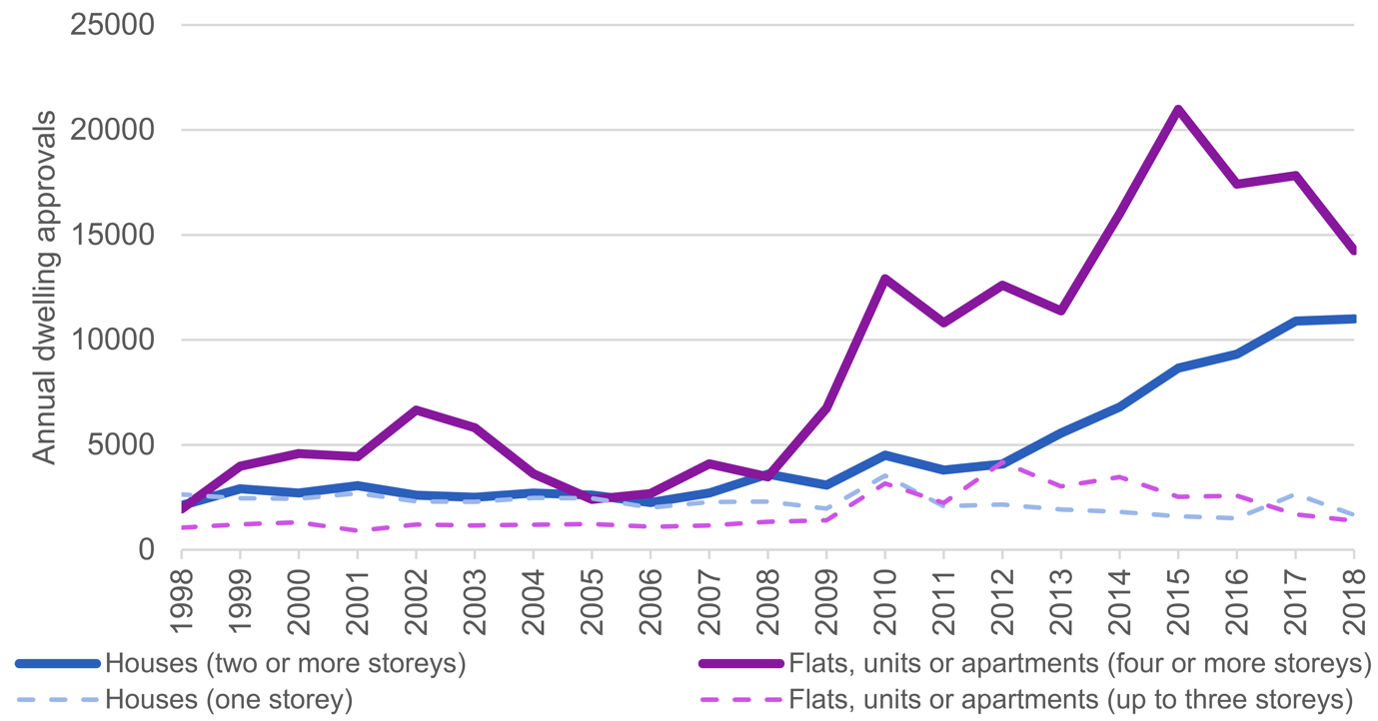
Source: ABS data.
As noted above home buyer preferences have changed towards more affordable options including houses on smaller lots, town houses, and medium- and higher-density developments close to town centres, employment and transport hubs.

The causes of delays
In seeking opportunities to improve the planning and building permit approvals processes, this review has:
- heard from a wide range of users and administrators of the system about what causes delays in the planning and building approvals process;
- considered more than 30 past reports into the planning and building approvals process in Victoria and elsewhere; and
- explored best practice approaches in other Australian states and territories and overseas, including those in Queensland, South Australia and Scotland.
In doing so, we have developed an understanding of specific causes of delays in each of the four stages of the system, and these are explained in each of parts A, B, C and D. However, our consultations and literature review also revealed the systemic nature of the causes of delays, many of which have been raised consistently since the 1990s and persist today, including that approvals processes simply take longer than they should (see Box 3).
These include:
- disproportionate and inconsistent requirements for users to meet at each stage of the process;
- more decision points or decision makers than are necessary to support the intent of the regulations;
- unnecessary process steps or steps that could be better coordinated (see Box 4);
- complicated, overlapping and sometimes contradictory policy settings;
- unclear information for users about what they need to do to meet those requirements;
- insufficient resources and skills for those administering the system;
- a lack of user-focused culture in organisations administering the system;
- limited adoption of best-practice processes and technology to manage internal processes or provide users with access to information; and
- too little transparent monitoring and accountability for performance.
The fact that these problems persist over time demonstrates the importance of regularly pursuing new opportunities for improvement, or different ways of trying to make the most of opportunities that have already been identified.
Box 3: Avoidable delays – why do some decisions take so long?
A common systemic complaint is that council and government agency processes simply take a lot longer than they should. Typical examples of unnecessary delays referenced by stakeholders include:
- key decision makers going on leave, without any process to resolve current cases until their return;
- the need for decisions to be signed off by a succession of people, involving delays at each stage;
- files being mislaid or allocated to the wrong staff;
- contradictory advice, sometimes from the same agency or from two agencies which are then unable to resolve their differences, leaving no process or ability for the affected applicant to intervene; and
- receiving email advice that approval had been signed but not receiving the formal document granting approval.
The PCA cited one example which included several of the above problems in succession, causing great frustration and significant delays for the applicant.

Box 4: Opportunities to build concurrent and better integrated approvals processes
Many of the planning, building and referral processes in the system are sequential: that is, process steps only start once the previous step is complete.
For example, the assessment of a planning permit application may need coordination of internal referrals to a council’s engineers, traffic management and environment staff and consultation with building staff and external referral agencies, such as a water authority or VicRoads. Often this input is considered sequentially rather than concurrently, with obvious impacts on the time taken, and in some cases resulting in planning permits needing to be amended or resubmitted.
An example of problems created by not coordinating internal referrals was provided to the review. It referred to a municipal building surveyor who was not consulted at the beginning of an application process. This meant that the building requirements for building on flood-prone land were not identified until late in the process which resulted in the project being completely changed and requiring a new planning permit.
The mapping which was undertaken for the review confirmed the value of pre-application meetings with proponents, early engagement with relevant council staff (including those involved in any likely internal referrals) and external referral authorities as a way to improve the quality of decision making and reduce delays. Consolidating council planning and building staff into a ‘development branch’ located in one council office was an example of ‘best practice’. Co-location can deliver faster, well-coordinated and consistent processes for internal and external referrals (see parts B and C).

System-wide improvements to address persistent problems
Each of the improvements proposed in this discussion paper targets at least one of the causes outlined above. This review has also identified some bigger-picture opportunities for improvement that provide support at a whole-of-system level. These include:
- extending existing programs to support councils and simplifying system requirements;
- providing additional resources and training programs to address shortages, and focus on upskilling of planning and building practitioners;
- creating an end-to-end performance reporting system; and
- undertaking a review of planning legislation.

Extending programs to support councils and simplify system requirements
The review notes that the Victorian Government is already implementing a number of initiatives to address some of these issues, including:
- the Small Business Better Approvals program (which focuses on introducing a user-focused culture and creating concierge and concurrent approval processes within councils for small business – see Box 5);
- the Rural Council Transformation Fund (which has funded programs where councils receive incentives to collaborate with other councils to improve internal systems);
- the Streamlining for Growth program (which has been used in some cases to provide training to upskill councils in their administration of strategic planning matters and implement new process management techniques – see Box 6); and
- DELWP’s Smart Planning program (which has succeeded in identifying and implementing opportunities make the system’s requirements simpler, more consistent, more proportionate and more accessible).
These initiatives have helped improve council operations and planning approval processes. This review supports extending and integrating programs like these to improve the effectiveness of Victoria’s ongoing investment in the planning and building system’s needs. Meeting those needs is a matter of continuous improvement, rather than a set-and-forget approach.
Box 5: Better Approvals
Small Business Victoria’s ‘Better Approvals’ program has seen substantial progress made in the way councils provide approvals to small business start-ups and operations.
This approach is based on a ‘concierge model’ where an applicant is given a single point of contact at the council who helps them navigate the council’s approvals process. The objective is to end the ‘nightmare’ of an applicant, in this case a small business, being repeatedly referred from one officer to another, each time having to repeat their request and often submit similar paperwork. The Better Approvals approach also provides opportunities for approvals to be assessed concurrently.
There are key components of the Better Approvals process that could readily be adapted by councils and referral authorities to planning processes, including pre-application meetings, concierge approaches and concurrent assessment (see Part B). Post-permit approvals were noted by many stakeholders as being particularly difficult to deal with – a lack of feedback and responsiveness and accountability from decision makers was more evident in these stages (see Part C).
The potential benefits from applying a Better Approvals approach to planning processes are highlighted by the review’s findings that, in general, faster approval times are delivered when pre-application stages (including meetings) are embedded in council processes and when there is a focus on coordinating processes concurrently.

Box 6: Streamlining for Growth
The Streamlining for Growth program is administered by the Victorian Planning Authority (VPA). It was established in early 2016 as a post-PSP approvals program providing targeted funding and resourcing assistance to growth area councils. The program is designed to coordinate the efforts of all parts of the Victorian Government, local government and the private sector to deliver better outcomes for the fastest growing areas of the Victorian community.
Streamlining for Growth has received a total of $24 million in funding since 2016 to support 169 projects across Victoria. Assistance provided includes grant funding (54 per cent of projects), provision of consultants (35 per cent) and VPA staff time (11 per cent). 47 per cent of funding has been for projects in metropolitan growth areas, 34 per cent to projects in other metropolitan areas and 19 per cent has been for projects in regional councils.
A recent evaluation of the program by consultants ACIL Allen found that it delivered savings of $8 for every $1 spent. The total estimated saving was $170 million to $210 million in land holding cost savings, including $69 million in red tape reduction. Programs like this should continue to be prioritised for investment in improving the planning approvals system.

Providing additional resources and training programs to address shortages of planning and building practitioners
Capacity issues in councils were the focus of a number of submissions to the review. As mentioned above, various current government initiatives are focused on building capacity and capability in councils, and this review proposes to build on those initiatives.
The review found that decision makers for planning and building approvals (particularly council planners) feel that they lack the time and resources to thoroughly consider and balance all relevant matters in a timely fashion. Many delays in planning approvals are attributed to a shortage of planners – particularly in regional and outer metropolitan Victoria. Another example given was that too often a planner is given half a day to prepare a report when, in the interest of fully informed decisions, several days should be allowed.
Shortages of planners – and building surveyors and inspectors – was a frequently cited reason for delays and inefficiencies in the planning and building approvals systems. As noted above the VPA has provided strategic planning support for councils through its core work program and the Streamlining for Growth program. In some cases, the VPA undertakes strategic planning on behalf of the council.
Councils often have difficulty retaining planners with examples given to the review of the stresses of working on the front counter and dealing with the complexity of the system.
Several suggestions have been made about how to address these problems, including the use of contract planners, better training and upskilling for planning and building staff, and creating new professional development opportunities and career advancement pathways.
This review proposes additional planning resources to assist regional councils with planning application complexity and workload, and to support council officer training (see B2).
To increase the supply and capability of building surveyors and inspectors, the review suggests a number of initiatives including:
- bridging courses for builders, engineers, architects and project managers who may wish to transition into building surveying and inspection work; and
- strengthening the quality of prescribed courses, including offering a mandatory unit of study on the National Construction Code requirements (as recommended by the Shergold and Weir Report, Building Confidence – Improving the effectiveness of compliance and enforcement systems for the building and construction industry across Australia (see D1)).
Given the ever-changing nature of the planning and building system, measures such as these should be complemented by efforts to promote continuous improvement in the skills of those administering the system – for example, through continuous professional development for planning and building practitioners in relation to their role in this system. The proposal in the Local Government Bill 2019 to require candidates and councillors to undertake training could be used to improve councillors’ understanding of their role in the planning system.
Concerns were also expressed about the level of experience available to consider referrals in authorities such as VicRoads (and its successor bodies). It was suggested that staff often lacked the detailed experience necessary to give authoritative answers and that many of the referrals could be dealt with by councils through the use of codes to improve timeliness of responses and give referral authority staff more time to focus on the more significant proposals, where, for example, safety issues require attention (see B8).

Creating a comprehensive planning performance reporting system
A consistent feature of almost every previous report on the planning and building system is the need for greater transparency and accountability for performance, and it remains a priority issue for many of the stakeholders consulted in this review.
DELWP already maintains a database of council-reported performance in approving permit applications – PPARS – which is used to produce public quarterly reports, and Local Government Victoria (LGV) maintains the Know Your Council website based on PPARS data. DELWP has also recently introduced, as part of a Smart Planning initiative, the Amendment Tracking System (ATS) to assess the performance of authorising, assessing and approving planning scheme amendments. The Surveying and Planning through Electronic Applications and Referrals (SPEAR) system used for subdivision approvals also has tracking and monitoring capabilities.
While the data provided by these systems is not comprehensive across all decision-making points in the planning approvals system, it provides a strong foundation for a more comprehensive monitoring and reporting system. At present there is no systematic monitoring and public reporting of the real time taken in approval processes for post-permit approvals. The Victorian Building Authority (VBA) gathers a range of data relating to building permit approvals. However, it is somewhat limited as the data is not currently integrated with monitoring or reporting at other stages of the process and does not necessarily focus on timelines and delays (see Figure 11).

Figure 11: We cannot improve what we cannot see – the current state of performance monitoring and reporting in Victoria’s planning and building system
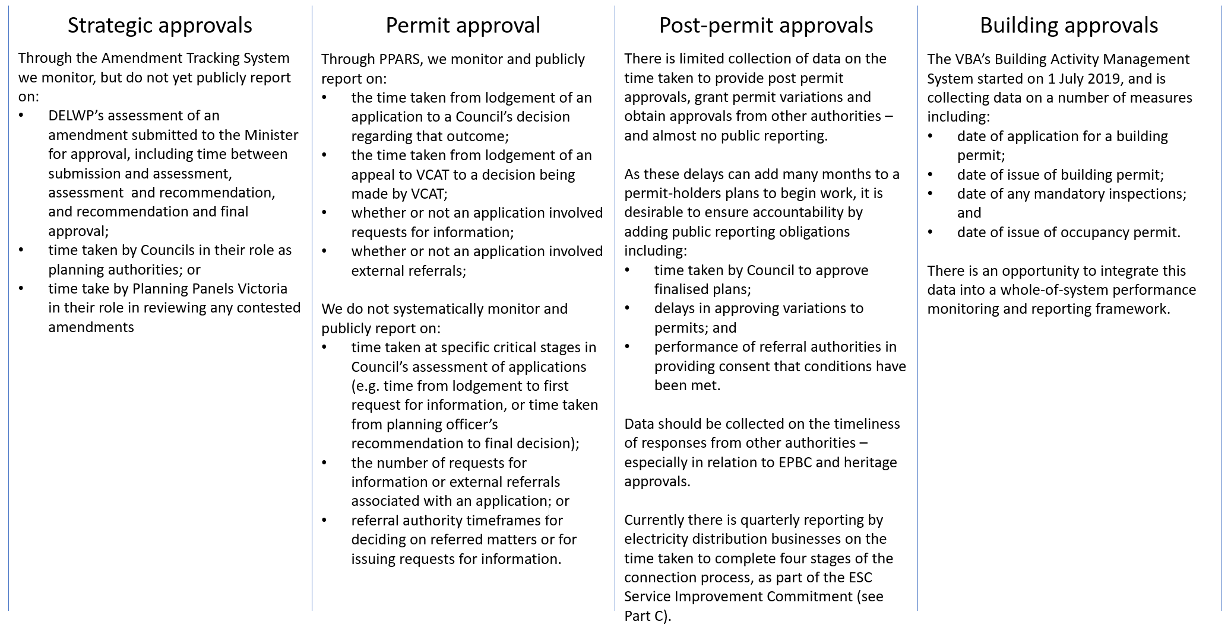
There is, therefore, an opportunity to create a whole-of-system monitoring and reporting framework by improving PPARS and the ATS to provide a deeper understanding of what drives delays and costs in approvals processes to, for example:
- identify the time taken at individual stages of the approvals process (such as from lodgement to first request for information, or from last referral to application outcome), rather than simply the date an application was lodged and the date an outcome was decided;
- provide the capability to routinely report on total timeframes for an application including any amendments, rather than treating any amendments as a separate application;
- report on the number of requests for further information and how long it took for those requests to be addressed; and
- report on referral authority timelines and progress towards reducing the number of referrals required (as recommended in DELWP’s Referral and notice provisions Planning Practice Note).
In addition, monitoring could be improved by measures to:
- extend PPARS monitoring of councils and referral authorities from the permit approvals stage into the post-permit approvals stage (in the case of electricity distributors, this should involve integrating the data already being reported as part of the Service Improvement Commitment); and
- introduce public reporting requirements for building and occupancy permits including, for example, the date a permit was requested and the date it was issued, along with timeframes for any requests to and responses from reporting authorities, the date and number of inspections, any notices and orders, and the date the occupancy permit was issued.
This review acknowledges that investing in datasets and reporting processes is not costless and that any new requirements for DELWP, councils, referral authorities or building practitioners to report data need to be proportionate to the benefit of being able to better understand the bottlenecks in the system and how best to improve them. This review considers those potential benefits to be substantial given the current availability and quality of data relating to approval processes.
The mapping and anlaysis of council processes being undertaken by PwC has found that there is wide variation in the workflow tracking or management systems used by councils. Some have relatively detailed and sophisticated systems, while others do not have the facilities to easily report the type of data noted above. Assisting councils to upgrade their IT systems and management techniques, as proposed in Part B, would therefore expedite approvals processes and facilitate an improved monitoring and reporting system.

Undertaking a review of legislation
This review is limited in scope to the approvals processes, rather than the system’s overarching legislative framework. However, many of the issues raised highlight that the Planning and Environment Act is now 30 years old and in need of review.
Both users of the system and those that administer it raised issues that occur from overlapping or outdated provisions, too much specification of detail in legislation or poor integration between the Act and other legislation. Similarly, some of the improvements proposed in this paper would require legislative change.
The Victorian Government has recently committed to a review of the Building Act, and a number of the issues raised in this discussion paper should also be considered in the course of that review.

Opportunities for improvement in specific approvals stages
In addition to the system-wide opportunities for improvement mentioned above, this review has identified 27 specific opportunities to reduce delays and costs across the four stages of planning and building approvals, including changes that can be made quickly as well as those involving reform pathways to best practice in those approvals (see Figure 12).
Parts A, B, C and D of this report explain these opportunities and suggest 102 proposed improvements. Comment is now sought on these opportunities for removing duplication, improving responsiveness and timeliness, modernising and better coordinating the internal (council) and external referral authority processes, increasing workforce capability, and introducing additional targeted benchmarking and reporting of approval and post-approval processes.
As noted above, a number of State and local government initiatives are already underway to improve the planning and building systems. This review has taken into consideration these initiatives, noting their impact and proposing to build on their effectiveness.

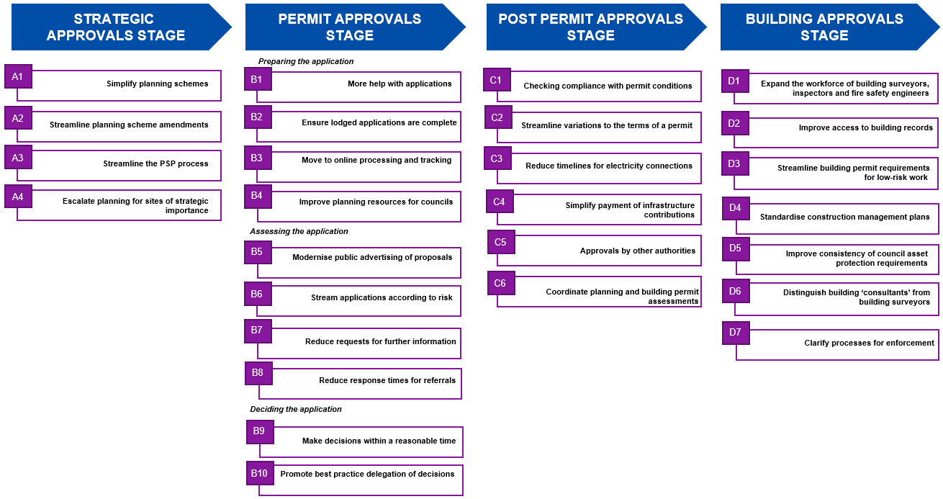

Figure 12 – 27 opportunities for improvement across the four approvals stages of the planning and building system

Part A – The Strategic Approvals Process

Introduction
Strategic planning is the process of determining the framework of policies and strategies about how land can be used, developed and protected and creating plans and rules to implement those policies and strategies.
State, regional and municipal strategic statements, such as Plan Melbourne and the eight regional growth plans, are the primary components of Victoria’s strategic planning framework. They provide a region-wide context and set the key parameters needed to deliver housing, jobs and liveability as the population grows. Strategic planning statements are key resources drawn on by planners and the Victorian Civil and Administrative Tribunal (VCAT) in deciding whether proposals are consistent with long-term policy goals and should or should not be approved.
Strategic statements are typically approved by the Minister and are often ‘incorporated documents’ in the planning scheme.
In addition, there are many issue-specific or site-specific plans, such as structure plans, which set out specific requirements, particularly where intensive development is expected.

Planning schemes
These policies, strategies and rules are set out in planning schemes. A planning scheme is a form of subordinate legislation that sets out the planning objectives, polices and provisions that regulate the use, development, protection and conservation of land in a municipality. Matters that a planning scheme may provide for are described in section 6 of the Planning and Environment Act.
Under the Act, only the Minister for Planning (the Minister) or a ‘planning authority’ authorised by the Minister may prepare a planning scheme.
The local council, designated by the Minister, is usually the planning authority responsible for amending planning schemes. The Minister can also approve another minister or authority as the planning authority to amend a scheme.
The Act requires that a planning scheme must:
- seek to further the objectives of planning in Victoria;
- contain a Municipal Strategic Statement (MSS) or Municipal Planning Statement (MPS); and
- make provisions which relate to the use, development, protection or conservation of land.
Section 7 of the Act prescribes the structure of planning schemes in Victoria, which must have a consistent format and include a range of ‘standard provisions’ – statewide planning provisions that are common across Victoria. The prescribed format and statewide provisions are set out in the reference document, Victoria Planning Provisions (VPP).
In preparing and maintaining planning schemes, councils draw from the VPP in two ways. First, councils must include any statewide provision schemes that the VPP prescribes as mandatory for all planning schemes. Second, councils may also include other statewide provisions in the VPP that are relevant to or give effect to its MSS, MPS or local planning policies. The council may then also include its own local provisions, provided these do not conflict with statewide provisions.
Planning schemes also include maps that show where different land use zones and overlays apply. Zones and overlays regulate how land can be used and developed and can also apply to such matters as tree protection, heritage protection or identifying land potentially contaminated by its past use. Many of these zones and overlays are set out as standard statewide overlays, but also allow local provisions to be included as variations or additions in the form of schedules.
If a statewide provision is changed in the VPP, then all planning schemes with that provision are also changed. If a statewide provision is changed in the VPP and creates an inconsistency between the new statewide provision and the local provision, then the statewide provision prevails.

Structure planning
Planning schemes may reflect the vision of a council (or other planning authority, if relevant) for an ‘activity centre’ – defined as a community hub ‘where people shop, work, meet, relax and often live’. These can include shopping centres, commercial areas and places undergoing major changes (such as the redevelopment of a disused industrial area for housing or greenfield development).

Structure plans
Planning scheme amendments (PSAs) for these activity centres are often supported by detailed structure plans that set the physical layout of an activity centre, define its boundaries and outline the key objectives and parameters for managing the future growth of that area, including any infrastructure works.
Boundaries for these areas can be set at the council’s discretion, and the proposal to amend a scheme to include a structure plan is coordinated by the council. Departmental guidelines provide advice to councils on the recommended process for preparing structure plans, including best practice for setting boundaries and preparing structure plans, including appropriate forms of community and inter-governmental consultation. Once created, a structure plan is usually exhibited along with the PSA that is proposed to implement it.

Priority precincts and National Employment and Innovation Clusters
The Department of Jobs, Precincts and Regions (DJPR) is responsible for ‘priority precincts’ – areas capable of supporting jobs and housing growth with good access to other parts of Melbourne and Victoria. These include areas such as Parkville, Arden, Fishermans Bend and Richmond to Docklands and Sunshine.
DJPR’s priority precincts portfolio is also responsible for coordination of Victoria's National Employment and Innovation Clusters (NEICs), which include Dandenong, Fishermans Bend, Latrobe, Monash, Parkville, Sunshine and Werribee. The VPA workplan for 2019-20 includes a new role supporting the delivery of priority precincts including areas around the Suburban Rail Loop project.
The delivery of these precincts and NEICs will, in most cases, require amendments to planning schemes usually supported by structure plans.

Precinct Structure Plans
In 2005, Melbourne’s growth corridors were created and the area within the Urban Growth Boundary was rezoned as the Urban Growth Zone (UGZ). PSAs to enable urban development of this land are underpinned by the preparation of ‘Precinct Structure Plans’ (PSPs). PSPs are structure plans tailored to support the development of new suburbs in the areas. Most PSPs are prepared by the VPA in collaboration with the local council. See Box A1 for more on the VPA’s role in the planning system.
Through the PSP process the VPA, councils, developers and government agencies have successfully planned around 350,000 new dwellings and 39 new town centres. In a 2017 report from AHURI, one developer noted that ‘…you whinge and moan about [our PSP system], but in comparison to like New South Wales it’s amazing’.
However, there are opportunities to improve the PSP process and to extend best practice approaches of the process to structure planning for other areas, including priority precincts (see A3 and A4).
Figure A1: Map of PSP boundaries in the Western Growth Corridor
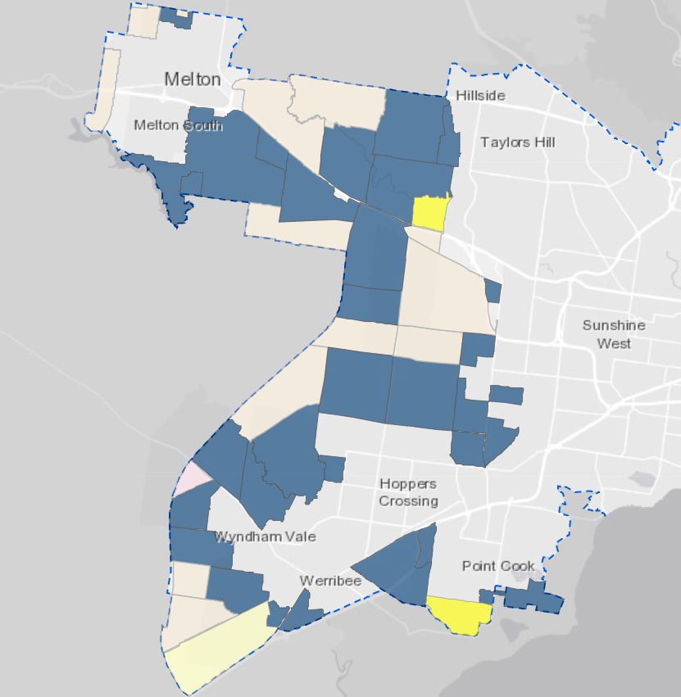
Box A1: The Victorian Planning Authority
The VPA is a Victorian Government statutory authority established under the Victorian Planning Authority Act 2017. Under the Act, a Board of directors is responsible for determining the general policies and strategic direction of the VPA, with clear purpose to provide advice and assistance as directed by the Minister for Planning and Minister for Priority Precincts in accordance with the objectives of planning in Victoria.
The VPA’s purpose in designated areas is to:
- deliver spatial planning for urban growth, undertaking place-based planning that gives effect to Government policy; and
- support the coordination of infrastructure and land use in growth areas
The VPA operates in designated areas in Melbourne’s greenfields, established Melbourne and regional cities and peri-urban towns.
The VPA also developed and implemented the Government’s Streamlining for Growth program to provide targeted support for councils across Victoria to accelerate the delivery of land for jobs and homes. This program has funded the reform and improvement of structure planning processes and post-structure plan approvals in designated growth areas.
The VPA is not empowered to undertake development or provide infrastructure, and the VPA does not operate or administer the planning system (this is a role undertaken by DELWP’s planning group).

The planning scheme amendment process
Rules about how land can be used or developed in a council area are changed by amending that area’s planning scheme. A PSA can only be prepared and ‘adopted’ by a planning authority (usually councils). All amendments must then be approved by the Minister and laid before Parliament for a specified time before coming into effect. Parliament can revoke an amendment.
For example, to implement a policy to protect residential amenity, a planning scheme’s zoning map might identify separate zones for residential and industrial uses with appropriate buffer zones. This is to ensure new factories are not permitted in that residential area so that conflicts over such issues as noise and traffic are avoided. Similarly, new housing might be prohibited in industrial zones that could restrict industry or manufacturing. Where factories and homes are already beside each other, ‘zone controls’ can put restrictions on the allowable industrial operations.
The purpose and scale of PSAs vary widely. For example, an amendment might be required where:
- the Minister needs to:
    - transform former industrial land into a new residential neighbourhood; or
    - support a higher concentration of jobs as part of a NEIC by allowing a mixture of housing and offices in an existing residential area;
- a council wants to:
    - apply the Residential Growth Zone to facilitate higher density housing around an activity centre;
    - apply the Neighbourhood Residential Zone to areas where building height limits and garden requirements apply; or
    - specify the information an applicant needs to provide when lodging a permit application;
- a developer and/or landowner wants to ask the council or the Minister to consider an amendment to:
    - allow redevelopment of rural land zoned for future development as a new residential community; or
    - allow redevelopment of existing industrial land for commercial use.
Once approved by the Minister, the PSA process may provide for public consultation about the proposed amendment, giving those potentially affected by the amendment an opportunity to comment.
PSAs are sometimes sought by proponents to enable them to change the use of their land. However, councils have no obligation to prepare, advertise or approve any request for an amendment. The only option the proponent has, if there is an impasse, is to raise the issue with the Minister.
In some cases, referral authority views are sought and if they are slow to respond, this can also delay the process.
The process for a PSA prepared by the council as the planning authority is outlined below.

Figure A2: Key steps in the Planning Scheme Amendment process
Note: The panel review is only required if the council does not make changes suggested in any submissions.

Preparation of an amendment (if one is needed)
This first step in the amendment process is a decision by a planning authority that an amendment is needed. To make the decision, the planning authority reviews the existing planning scheme provisions, and the relevant strategies and policies, and drafts provisions, maps and documents to justify the amendment. An amendment will typically be needed to implement strategic planning work undertaken by a council, such as an open space strategy or to facilitate a development proposal by rezoning land.
Authorisation
The Minister must authorise a planning authority to prepare a PSA. The planning authority provides its justification and documentation to the Minister. The Minister’s decision is usually delegated to planning staff at DELWP, who have ten days to review the proposal. The Minister may authorise, refuse or decide that the application requires further review. Authorisation enables the Minister to ensure that a proposed amendment is consistent with Victorian Government policy. If the Minister decides that further review is needed before the council, as planning authority, can exhibit the proposed amendment, there is currently no specified time within which the review needs to be finalised.
Exhibition
Once authorised (and ten days before exhibiting the proposed amendment), the council is required to provide amendment documentation to the Minister as required by section 17(3) of Planning and Environment Act so that DELWP can check the content against the drafting rules and that the authorisation conditions, if any, have been met, that notice is being undertaken correctly and that the property database is informed of the proposed changes so property certificates are up-to-date when exhibition commences. The Minister also exhibits the amendment on DELWP’s website. Where the Minister is the planning authority, the amendment is exhibited and notified unless it is a section 20(4) amendment where no exhibition or notice is required.
Submissions
The council may receive submissions from affected landowners and the community. A submission may support or oppose a proposed amendment. If a submission asks for changes to the proposed amendment, the council can decide to:
- adopt the amendment with the suggested changes and proceed to seek Ministerial approval;
- abandon the amendment; or
- proceed with the amendment without incorporating the suggested changes.
If the council decides on the third option, it must first refer the relevant submissions, and may refer all submissions, to Planning Panels Victoria (PPV) for an independent review.

Panel review
When a council refers submissions to PPV, the Chief Panel Member (under delegation from the Minister) selects the panel to consider submissions from an independent pool of experts appointed by the Minister (see Box A2 for more detail on PPV’s role and improvements they are making). The panel’s task is to provide the council with a report on the referred submissions. Submitters can provide a further submission to the panel and can present their submission to the panel at a public hearing. Once the panel’s review is complete, its report is provided to the council, which must make this report public after 28 days but can release the report earlier if it wishes.

Planning authority adoption
Having considered community input and any panel report, the council can decide to adopt a final version of the proposed amendment and submit it to the Minister for approval. The council may also decide not to proceed with the amendment.

Ministerial approval
If the council decides to proceed with the amendment it is submitted to the Minister for approval. The Minister then decides to accept or reject the amendment adopted by the council. The Minister can approve it with changes, particularly if there are inconsistencies with statewide policies.
Councils’ discretion to progress the amendment process
It is important to note that councils are not obliged to take an amendment through any stage of the amendment process. A council may decline to commence a proposed amendment and may also decline to progress an amendment to exhibition once authorised. Once an amendment process has commenced, a council can also stop the process at any time, and there can be long pauses where the fate of the amendment is unclear. If a council stops the process and does not resume it within two years of the exhibition of a proposed amendment, the amendment ‘lapses’. If the proposal is to be reactivated, a new amendment will need to be authorised and exhibited.
The accumulation of multiple layers in the planning system has, not surprisingly, resulted in some inconsistencies, duplication and redundant elements. It now takes some considerable technical knowledge to navigate the system and find the information that is required. The unnecessary complications in this system create delays and costs which impact on economic efficiency, particularly in the construction industry and on housing affordability and employment.

Box A2: PPV
Planning panels are established under the Planning and Environment Act as a means of obtaining independent advice and facilitating public participation in planning and environment decision making. Panels consider submissions, conduct hearings and prepare reports.
Planning panels are advisory and make recommendations; with the final decision made by the planning authority and ultimately the Minister for Planning. In addition to hearings on PSAs, PPV also provides panel members for advisory committees and Environment Effects Statement (EES) inquiries.
Under Chief Panel Member, Kathy Mitchell, there are six full-time panel members and 60 sessional members who are appointed by the Minister. They are subject to careful conflict of interest arrangements in which matters they are selected to hear. There is a small support staff with core funding but most of PPV’s work is funded by the applicants.
In 2018-19 PPV panels were appointed to hear 59 PSAs, seven combined amendments and permits, two combined EES hearings, seven advisory committees and two Ministerial call ins. A total of 4,625 public submissions were received and considered.
PPV has procedures that respond to different types of hearings processes, broadly based around a directions hearing, initial submissions, ‘taken as read’ expert evidence which is then tested at hearing and further submissions focusing on the key issues. The proposed planning controls, permit conditions and environmental performance requirements are often canvassed with relevant parties on a ‘without prejudice’ basis as part of the hearing process.
The Chief Panel Member advised there are a number of current ‘hot issues’ in planning policy, some of which may result in process delays due to a lack of clarity or a means for the panel to make a recommendation in the absence of set policy.
A conundrum exists when changes are made to a proposal after the public exhibition stage. On the one hand this can be a good thing, where it reflects an improvement of the design to address concerns. However, it can also mean that other parties who were comfortable with the exhibited proposal may now be unable to comment on the changes proposed, thus being denied procedural fairness. A similar problem arises with permit applications which are amended between the time they are considered by council and the hearing by VCAT.
PPV is currently considering ways to address these issues without leaving proposals in a cycle of re-exhibition. Other improvements currently being implemented include greater use of electronic correspondence and tabling of documents, pre-setting dates for hearings and recording larger hearings. The Spring Street hearing rooms have been upgraded, including the introduction of a wi-fi ‘click and share’ capability.

Recent reform efforts and outcomes
The Smart Planning program, which is designed to make the planning policy framework clear and accessible (see Box A3), has improved the system by simplifying existing provisions, making information and processing accessible online, adopting plain English provisions and expanding the VicSmart program (see Box B6.1 in Section B6).

Other reform processes underway include the streamlining of the PSP process being undertaken by the Victorian Planning Authority and its Streamlining for Growth grants which are assisting councils to improve their technology, coordination and customer service.
This review has noted the work in progress and listened to stakeholders about the work that still needs to be done.
Four opportunities to improve strategic planning processes and reduce delays and costs have been identified:
- Simplify planning schemes to make it easier for users to understand and consistently interpret the requirements and thereby reduce costs and delays.
- Streamline the amendment process by reducing delays in assessment by DELWP or a council and improving transparency about council decisions to discontinue amendments.
- Reduce the time taken to prepare a PSP by implementing the PSP 2.0 process, applying it to other precincts and removing any overlap between PSP provisions and permit requirements in the permit approvals process.
- Reduce delays in approving PSAs for strategic sites by appointing the VPA to prepare PSAs for specific sites in collaboration with the relevant councils and other stakeholders.
These are discussed in detail below for comment.

Box A3: Smart Planning program
Smart Planning was established in 2016 with $26 million in funding for two years and then in 2018-19 was allocated another $15.5 million in funding over three years.
Significant improvements delivered as a result of Smart Planning include:
- planning schemes across Victoria have been trimmed by 8,000 pages (removing redundant and duplicated material);
- new digital planning IT systems and tools provide access to 70,000 pages of planning rules online. The statewide Planning Portal now has 3 million hits a year;
- the new VicPlan interactive map has replaced 15,000 separate PDF maps, and is being accessed by 7,000 people a month;
- the expansion of permit types that are eligible for a ten-day approval through the VicSmart program; and
- permits are no longer required for straightforward proposals, such as installing domestic water tanks and electric car charging stations.
There is no doubt Smart Planning is making a difference and stakeholders have applauded its improvements.
DELWP is currently consulting with stakeholders about possible options for further reforms as part of Smart Planning, including:
- options to develop ‘a code’ that facilitates secondary dwellings on the same lot as an existing dwelling in a residential zone; and
- introducing a new assessment pathway – the proposed VicSmart Plus – with a 30-day turnaround and targeted notification.
The recommendations from this review complement these and a number of the initiatives already in the Smart Planning pipeline. An extension of Smart Planning – Smart Planning Stage 3 – is underway, aiming to improve planning schemes further through measures which include:
- consolidation of State, regional and local planning policy into the new Planning Policy Framework that is anticipated to trim planning schemes across Victoria by another 15,000 pages;
- mapping 250 incorporated documents into the new Specific Controls Overlay to improve transparency and create greater certainty on where those rules apply;
- streamlining policy and rules, cleaning out the clutter of unnecessary regulations, and reorganising the structure of planning schemes so that they are easier to administer and understand;
- new digital initiatives to bring more processes online and provide data on the performance of the planning system;
- updating land use terms to ensure that new uses such as battery storage for renewable energy are being catered for in the planning system;
- fixing errors and inconsistencies across 5,500 local schedules; and
- development of proposals for new assessment pathways and related codes for planning permit applications.

Simplify planning schemes
There are opportunities to simplify planning schemes, in order to improve their usability, for property owners, the community and planning professionals. Making the planning schemes easier to understand and use enables better decisions to be made and reduces delays and costs.

Opportunities for improvement
Planning schemes are intended to reflect a community’s preferred planning policies by setting specific requirements to apply those policies to each piece of land. The range of issues and policy objectives means that planning schemes can be complex.
Examples of the types of users who need to navigate planning schemes include:
- landowners who want to develop or modify the use of their land, and want to determine what they can or cannot do on that land (for example, by doing a planning report search);
- prospective land developers who want to know what information they need to include in planning permit applications;
- council planners, who need to be able to identify and apply local planning provisions to deliver the timely processing of planning applications;
- members of the public seeking to understand the implications of proposed PSAs; and
- numerous other everyday users, such as Victorian Government authorities, architects, planners, and professionals in the development industry.
Stakeholders have noted that planning schemes are often difficult to navigate, because they are set out more as legal documents, and reading and understanding them requires a level of assumed knowledge. For example, planning schemes have no introductory plain language explanation of what the document is or the purpose it serves – although this can be found in supporting documentation on DELWP and council websites, including A Practitioner’s Guide to Victorian Planning Schemes, using Victoria’s planning system and practice notes.
Each planning scheme starts with a detailed list and explanation of the scheme’s objectives and strategies which, while fundamental to the system itself and often providing the rationale for specific requirements or standards, are not always relevant to a typical user who wants to know whether they might need a permit and, if so, what information they might need to provide.
The structure and layout of planning schemes often makes the documents unnecessarily long, due to content that is repeated across multiple sections. Schemes often contain multiple overlays that repeat the same permit requirements, and which could be consolidated in cases where they relate to common themes.
For example, the Environmental Significance Overlay, Vegetation Protection Overlay and Significant Landscape Overlay provisions all state that a permit is required to remove, destroy or lop any vegetation in areas covered by these overlays (see Figure A1.1). These could be consolidated, while still recognising the different reasons that vegetation controls are required.
Figure A1.1: Example of duplicative permit requirements from different overlays
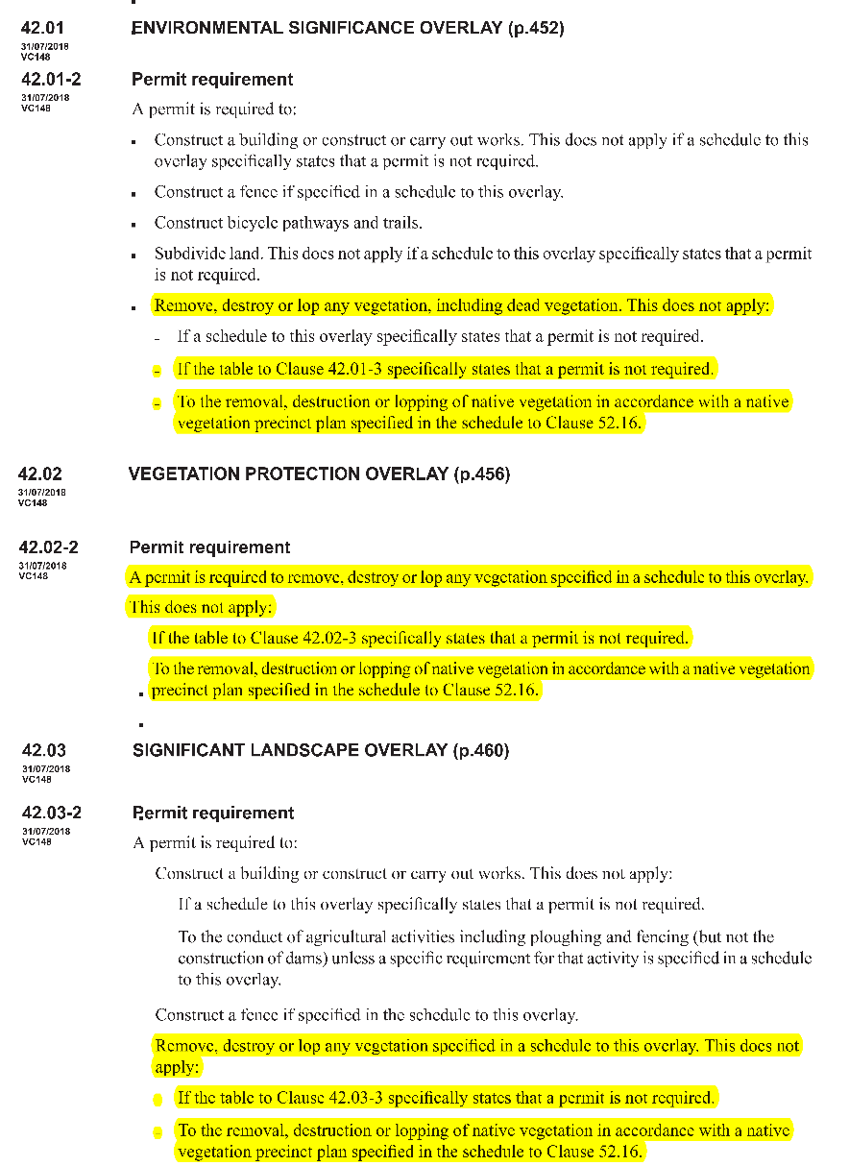
Source: Victoria Planning Provisions
The opportunity to simplify planning schemes was recognised by the introduction of the Smart Planning program in 2016. Smart Planning has had considerable success in making planning schemes more accessible and readable by improving and standardising their online presentation. Smart Planning has also introduced the ATS, which provides a central system where amendments can be proposed and then tracked through the various stages of the planning scheme amendment process. As with many IT systems, this has not been universally embraced, but it is a step change that should be refined and persisted with.
In addition to planning schemes being too complex, this review also heard from many stakeholders who were frustrated by the variation between planning schemes in different council areas. This variation reflects different communities’ attitudes to land use and development. Some stakeholders raised concerns about differences between local requirements which were minimal in practical terms, but which caused delays and costs by needing to meet slightly different standards when operating across different municipalities (for example, in relation to design requirements or measures to protect agricultural land). It was suggested that the preparation of guidelines for councils, and the provision of support for councils to develop consistent regional requirements where council objectives are the same, would reduce delays and costs.
These concerns suggest that there are further opportunities to standardise planning rules and to apply system-wide decision rules more consistently to both State and local planning policies. The Smart Planning program has identified potential opportunities to standardise overlays and provide modular commonly referenced provisions, for example, in the way that a significant tree is defined and removal is assessed.

Proposed improvements
Making planning schemes more user-friendly in their language and structure would improve assessment times and the quality of planning outcomes by:
- enabling users to find information more easily;
- reducing time spent by authorities in processing approvals;
- promoting better understanding of the information that applicants should provide;
- being clearer about how authorities will consider applications;
- reducing complexity in the permit process; and
- increasing the scope for integrated decision making.
Opportunities for improvements include:
- Extending the Smart Planning program to further improve planning schemes with a focus on:
- applying plain language drafting principles, including a contents page to enable users to find the sections relevant to their concerns;
- revising the order of material in a planning scheme from ‘most used’ to ‘least used’ provisions to make it easier for users to navigate schemes and exit at the earliest point;
- considering the way digital delivery may change how planning schemes are set out and how they can be searched;
- providing clear information up front about who will decide the application’s outcome; and
- continuing the translation of planning schemes into the integrated planning policy framework.
This review notes that simplifying planning schemes can involve substantial cost and effort, and the benefits of doing so would need to warrant wholesale change. It invites stakeholders to provide feedback on whether, in their view, changes such as those outlined above would yield substantial improvements in the planning process.
- Consolidating planning scheme requirements, principles or rules that serve similar purposes (while allowing for local variation).
- Faster policy resolution for emerging planning issues to ensure a consistent statewide approach with clear and appropriate frameworks for local council variation.
- Councils working within their regions and across Victoria to harmonise their planning policies, where possible. Recent efforts through the Planning in the Economic Growth Zone (PEGZ) program in the Latrobe Valley have shown the benefits of this collaborative approach at a regional level (see Box A1.1). The proposal in Section B4 to create regional planning hubs to support non-metropolitan councils’ strategic and statutory planning functions would complement this collaborative approach.

Box A1.1: Case study of PEGZ
The PEGZ initiative aimed to improve the planning system in the Latrobe Valley to make it easier and quicker for people to develop land and to establish and grow businesses. The goal was to simplify the three planning schemes for Latrobe City Council, Baw Baw Shire Council and Wellington Shire Council, and make them easier to understand and more consistent, so that the planning schemes would better facilitate development across the region rather than hinder it.
Key elements of the PEGZ initiative included:
- building relationships and sharing information;
- simplifying processes;
- facilitating economic development through a priority project approach to fast track proposals; and
- providing resources to councils.
PEGZ has drawn on the expertise of DELWP’s regional planners and council planners, and strategically used funding to streamline the planning system to boost economic growth and create jobs. It has set the groundwork for a range of new projects and initiatives to further improve planning systems.
DELWP has worked with the three PEGZ councils to translate their local planning policy framework into the new integrated planning policy framework as part of Smart Planning.
Significant insights and innovations were shared between the three council areas by looking at their work from a regional perspective.
Tangible benefits of the PEGZ project to date include:
- reducing 589 standard permit conditions to 57;
- reducing 39 planning ‘themes’ to 13;
- removing 20 per cent of permit triggers (assessed as low value) from planning schemes;
- reducing 17 fees to four standardised fees across three councils;
- reducing backlogs with 101 permit applications processed;
- introducing fast track assessment and coordination of significant projects;
- implementing online planning permit and electronic assessment systems; and
- creating 100 jobs as a result of rezoning approval being completed in 35 days.
PEGZ has demonstrated how planning can play a proactive role responding to economic shock in a region. It has also shown that collaboration across councils and government organisations can magnify efforts and deliver an ‘open for business’ culture.

Streamline planning scheme amendments

Opportunities for improvement
Amending a planning scheme involves many steps and decisions, some of which duplicate others or add unnecessary administrative burden for councils. The time taken to complete PSAs has been noted by multiple stakeholders as a source of frustration and significant cost.
Opportunities to improve different stages or aspects of the process for approving amendments are outlined below.

Authorisation
In some cases, DELWP decides that it needs to review a proposal further before a council can exhibit the proposed amendment. Currently there is no specific timeframe for this additional review which creates uncertainty for councils.

Quality of notification
DELWP’s templates for amendment notices are drafted in technical language making it hard for non-planners to understand what is being proposed. This can result in objections based on misunderstandings or concerns being raised at later stages in the process, including in cases where the benefits of revitalising declining centres with higher density activity centres (and the corresponding attraction of more services and increased land values) are not well communicated.
It is important that there is appropriate engagement with the public when major PSAs are being adopted. The implications need to be well understood to avoid a negative reaction if the changes are misunderstood or misrepresented.
Failing to resolve and communicate key parameters at the PSA stage – such as height limits, infrastructure requirements and setbacks – can result in protracted disputes later on when individual permits are being considered.
As an example of good practice, when preparing PSAs to implement a PSP the VPA produces illustrated colour brochures and conducts public information sessions to explain each amendment. The brochures contain all the required statutory information but are more descriptive of the vision for the area and what development outcomes can be expected.

Decisions on submissions
The time taken to assess and report on submissions made about amendments can add long periods to the assessment process. Councils need to ensure officer reports are tabled at council meetings within a reasonable period after the objection period has closed. If a council receives submissions requesting changes to a proposed amendment and does not wish to incorporate those changes into the amendment, it must refer the matter to PPV and should do so without delay.

Panel review
After receiving a panel report, a council is not required to release it until 28 days after receipt. Councils do not always require this length of time to consider the report and it could be shared with interested parties sooner in some cases.

Multiple amendments
A common theme in contributions to the review was the opportunity to deal more expeditiously with simple or ‘machinery’ amendments, such as correcting errors or updating minor details.
For example, machinery amendments are often lodged separately by councils as individual proposals rather than bundled into groups for processing at the same time. Data from the ATS suggests that 20 machinery amendments have been submitted by councils to DELWP since December 2018. These were submitted at irregular intervals, and six were submitted by councils making multiple submissions. There may also be other simple amendments which could be grouped together.

Impasses in cases where councils abandon a proposed amendment
As noted above, councils are not obliged to take an amendment through any stage of the amendment process. The Planning and Environment Act requires that, if a council decides to ‘abandon’ an amendment, it must notify the Minister. However, the matter can be left in abeyance for many months before a decision is taken to abandon the amendment. As noted above, the Act and its regulations make no mention of proponents, so there is no statutory requirement to notify the proponent of an amendment and no avenue for the proponent to appeal or to reactivate the amendment.
While there are legitimate reasons for councils not to consider a proposed amendment or to stop pursuing a proposed amendment (for example, because it conflicts with State or local planning policies), stakeholders have raised concerns about the lack of feedback and the lack of a mechanism to break the impasse. In practice, proponents can seek the Minister’s intervention to have an abandoned amendment completed by DELWP and/or referred to a panel for a report.

Proposed improvements

Authorisation
- Councils could be provided with a final response within 30 days of DELWP initiating a further review of an authorisation request.

Notification
- DELWP’s notice templates should be rewritten in plain English (supplemented by technical language where required under legislation) and include images to show examples of what sort of changes a community can expect to see under the amended scheme, modelled on the VPA’s approach.

Decisions on submissions
- In cases where where it is clear that there will be unresolvable issues, the recommendation to proceed to a panel hearing should occur at the earliest opportunity (noting that Ministerial Direction No.15 requires councils to request a panel if necessary within 40 business days of the close of submissions).

Panel review
- Panel reports should only be embargoed by councils for seven days (rather than 28).

Multiple amendments
- The number of administrative and simple amendments could be reduced by having councils and DELWP group non-urgent matters into periodic omnibus amendments.

Reasons for decisions
- Councils should be required to make a formal decision with reasons when deciding to abandon or not exhibit a proponent’s amendment. This would ensure that both the proponent and the Minister for Planning are better informed if a proponent seeks the Minister’s intervention on an abandoned amendment.

Streamline the PSP process
Box A3.1: What is a PSP?
In 2005, Melbourne’s growth corridors were created and the area within the Urban Growth Boundary was rezoned as the UGZ. PSAs within those zones are required to go through a PSP process. The map of PSPs was created by the GAA in 2006, dividing the growth corridors into 119 precincts.
The PSP process was intended to better coordinate the various organisations and decisions involved in master planning for large area developments.
PSPs provide the foundations for master planning development of the growth corridors around Melbourne and regional cities. They set out master plans within the policy framework outlined in Plan Melbourne and the eight Regional Growth plans. They are the core planning tool to shape new communities to achieve the Victorian Government’s objective of ‘20-minute walkable communities’.
PSPs are high level strategic documents, which plan the locations for future town centres, schools, community facilities, open spaces, and how roads and public transport will connect them to nearby major activity centres in the UGZ.
Each PSP contains an Infrastructure Plan identifying who will pay for what and when. It also contains a series of maps setting out the planning controls and environmental constraints as well as controls to protect heritage and natural features.
Some PSPs are for commercial and industrial development to support jobs growth. In PSPs which plan residential precincts, the objective is to achieve densities of 20 dwellings per hectare on average, and to provide land to support one local job for every dwelling to reduce the need for long-distance commuting.
The priorities for PSPs are set by the Minister annually, based on a range of considerations, including land supply and the likely timing of major Victorian infrastructure projects such as schools and rail lines. This is done through the VPA Statement of Expectations and Annual Business Plan, published around August each year.
Over the two years to December 2018, 14 PSPs were developed and approved with capacity for 100,000 additional residential lots. Over the next two years, a further 13 PSPs have been prioritised to deliver 50,000 residential lots and employment land for 50,000 jobs.
So far, 70 metropolitan PSPs have been completed and approved. Another 17 are in preparation and 32 remain to be planned during the 2020s. Together, these areas will provide for Melbourne’s growth corridor demand out to 2051 – absorbing 30 per cent of Melbourne’s total population growth on its way to passing the eight million residents mark.
PSPs have also been developed for both greenfield and strategic sites in most regional cities to provide a future land supply. More are being planned, particularly around Geelong, Ballarat and Bendigo. These PSPs have mostly been developed as partnerships between the VPA and the respective councils, as many regional councils lack resources for longer term strategic planning (see B2 for proposed improvements to address this issue).
From PSP to subdivision permits
After the PSP has been gazetted and the planning scheme amendment (and associated Infrastructure Contributions Plan) has been adopted, the next step is for the developer to submit its plans for the first stage of subdivision for approval. Often this does not happen for some time as the PSPs are setting aside a 15-year land supply, and major services such as drainage and sewerage need to be planned for sequential roll out over time.
Stakeholders report that often, even after a only couple of years, referral authorities change their plans or standards advised during the PSP process, meaning that the proposed subdivisions often need substantial redesign. Developers also often change their plans to align with changes in market demand. Hence, disputes arise about whether the revised plans are sufficiently ‘generally in accordance with’ the PSP or whether cheaper alternatives are being proposed. The VPA is currently consulting on a specific guidance as to how the issue of variation between the PSP and the subdivision application should be handled.
For situations where development is ready to proceed, there is provision in section 96A of Planning and Environment Act for permits to be approved in the same process used to adopt the PSP. This can remove the need for a second process to approve the first stage of a new development.
In the past, the use of this section 96A has been problematic, resulting in patchy development with isolated groups of houses without access to infrastructure. Homebuyers in these scattered developments often feel disappointed as they expect all the promised schools and facilities to be there when they move in.
There is, however, a role for section 96A approvals where the first stage is well planned, integrated with adjacent developed areas and capable of providing a viable community during the initial development phase.
Developer funding for subdivision assessment
Wyndham City Council has implemented a successful funding Memorandum of Understanding (MOU) with ten major developers, facilitated by the VPA. These developers made a contribution to support an increase in the Council’s planning resources. This has enabled the Council to provide significant improvement in timeliness and reduced rework of proposals for subdivision permits without redirecting resources from other applications. A variation on this scheme has been adopted by Casey City Council.
Broadly these are appropriate measures as the Council retains control of the additional resources and the funding does not impact on the actual outcome of the assessment; it simply gives the Council more resources to complete the detailed work, which benefits everyone.

Opportunities for improvement
In most cases, the VPA takes the role of ‘lead agency’ for the preparation of the PSP and the associated infrastructure contribution plans. It advises councils on the preparation of other PSPs in Melbourne and regional areas, prepares the growth corridor plans, produces guidance on drafting PSPs, and coordinates input into these processes from State and local government authorities, including councils. In a minority of cases, the local council acts as the lead agency.
Over time, the requirements and guidelines for PSP preparation have become more detailed and prescriptive. The time to prepare a PSP currently averages three-and-a-half years. There have been unpredictable and lengthy delays in finalising some PSPs which have created significant uncertainty for landowners and developers, delaying long-term land supply for housing.

Stakeholders (including the VPA) have identified a number of factors that drive these delays, including:
- slow responses from referral authorities including Victorian authorities and utilities;
- PSP project management practices;
- complex infrastructure contribution arrangements;
- lengthy hearings at PPV for complex PSP issues;
- duplication between the adopted PSP plan and the assessment of subsequent planning permit applications for the subdivision to deliver the outcome envisaged in the PSP;
- conflicts between commitments made during the PSP process by councils or referral authorities, and the later refusal of subsequent planning permit approvals (because the authority has formed a new view);
- slow approvals from the Commonwealth on endangered species offsets under the Melbourne Strategic Assessment; and
- out-of-date planning guidelines for PSPs (these are currently being reviewed by the VPA for greenfield developments).
To address these issues the VPA has undertaken a review of the PSP process, with a focus on greenfield development (where the majority of PSPs take place, given the location of the UGZ). Based on this review, the VPA has recently released a new ‘PSP 2.0 Framework’ for public comment. This is a set of improved project management techniques designed specifically for PSP preparation and approval. PSP 2.0 is expected to yield improvements that will reduce the time taken to complete a PSP to around two years in duration. The key findings and outputs of PSP 2.0 are described in Box A3.2.

Proposed improvements
- The PSP 2.0 approach should be implemented by the VPA and, as soon as possible, applied to the PSPs in the current program to speed up the rezoning of land and maintain the government target of a 15-year land supply.
- The PSP 2.0 approach should be adapted to speed up the planning for the preparation of plans and precinct plans for regional cities’ strategic sites prioritised by the Victorian Government (including those led by DJPR).
- Differing views have been expressed by stakeholders regarding the most appropriate size for a PSP. The VPA should balance the need for strategic planning over larger areas with the desirability of approving manageable-sized precincts in a planned sequence that aligns with the delivery timeframes for new public transport and school infrastructure.
- Once PSP 2.0 has been used in the development of a few PSPs, the approach should be evaluated to ensure that the process improvements are delivering reductions in delays and costs while maintaining quality outcomes.
- Guidelines should be developed to encourage the proper sequencing of development across a PSP, including the issue of permits for the first stage of development using section 96A and combining the assessment with the process for approval of the PSP.
- Wyndham City Council’s MOU experience should be more widely utilised in growth corridor areas where the delays in bringing lots to market are a real constraint on competition and housing affordability.

Box A3.2: What is a site of strategic importance?
In 2019 the VPA reviewed the PSP planning process with the objective of reducing delays and costs. The result is an updated ‘PSP 2.0’ process for PSPs that the VPA intends to use when preparing and coordinating PSPs. This aims for a two-year preparation-to-approval timeframe for PSPs. The VPA has set out the intended process improvements in the chart below, with councils and referral authorities involved in the first step in both cases.
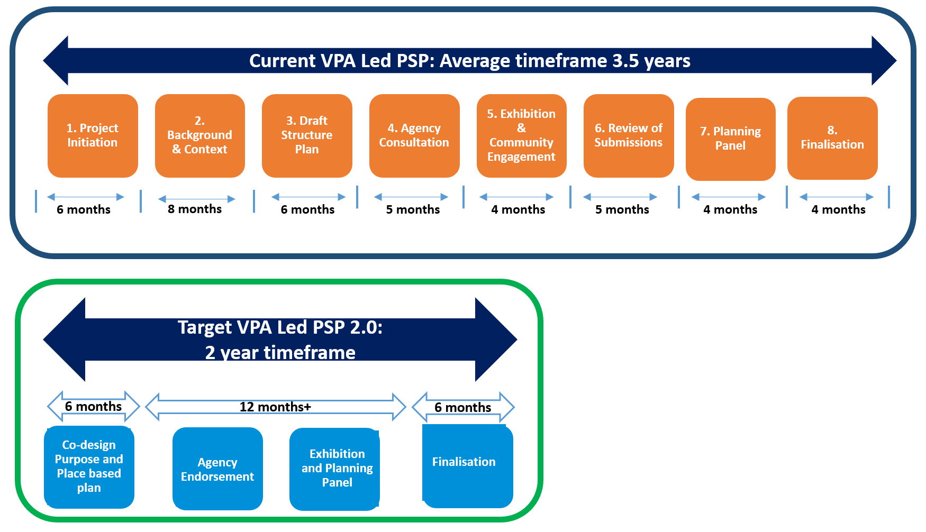
The main opportunities to improve the PSP processes identified in the VPA’s review are to:
- identify up front all public authorities, landowners and developers whose agreement is necessary for successful delivery of a precinct;
- directly involve all relevant authorities, landowners and developers in designing the precinct from the start of the PSP process;
- agree clear and fast dispute resolution methods between government authorities with competing interests;
- improve the speed and transparency of document production and distribution by using collaborative online portals; and
- apply plain language provisions consistently across all PSPs (for example the strategic objectives of all PSPs, or a standard requirement that applies to drainage designs across areas that require a PSP).
The VPA is testing this new approach in its preparation of the Craigieburn West PSP.

Escalate planning for sites of strategic importance
Box A4.1: What is a site of strategic importance?
Overall, Melbourne remains a very low-density city with many areas of former manufacturing land and poor-quality buildings ripe for redevelopment. These range from major inner-city redevelopment precincts like Fishermans Bend and Arden to smaller suburban sites, such as Altona North, East Bentleigh Village and Lilydale Quarry, all of which are being currently planned.
At the same time, there is community concern about protecting existing residential character. Thus, the potential for greater density largely rests with finding sites that meet community expectations as good opportunities for redevelopment.
Significantly increasing residential density creates a need to plan for roads, public transport, major drainage, schools, power and utilities. This requires engagement and negotiation with numerous Victorian Government authorities and utility companies. Lack of infrastructure, in most cases, is the underlying reason why a site remains undeveloped.
The scale and complexity of some strategic sites means that planning processes require more resources and a wider range of skills than councils may have.
The Victorian Government may wish to identify these sites as being of strategic importance and to ensure that their development is well planned and coordinated across government.

Opportunities for improvement
Some PSAs aim to transform large sites in ways that align with the Victorian Government’s strategic priorities – for example, to improve housing affordability, increase population density close to recent or planned upgrades to public transport, increase employment through the creation of an NEIC, or facilitate urban renewal projects. This makes them sites of strategic importance to the Victoria.
These amendments tend to be more complex, involving significant pieces of land and new infrastructure works, and this means that planning processes for these sites are often slow. This creates uncertainty for the landowner, undermines investment confidence in similar opportunities for strategic development and, in cases where the sites are disused former industrial sites, blights the aesthetics of the local neighbourhood. These delays also lock up land that could otherwise be contributing to housing affordability and economic growth, and which offer major opportunities to revitalise local communities.
Determining the appropriate developer contributions for new State and local infrastructure is a particularly complex problem for such ‘brownfield’ sites. As noted above, councils often lack the information, skills and resources to prepare the detailed costings needed to underpin the setting of an appropriate rate for the true cost of developing the land and providing the infrastructure needed to support a residential development.
The VPA has developed these skills through its involvement with strategic planning for sites across Victoria. The Minister for Planning can allocate a number of strategic site planning roles to the VPA, ranging from acting as the planning authority to supporting a council in its work (see Table A4.1).

Table A4.1: Four levels of engagement between VPA and councils
VPA ROLE | DESCRIPTION
AUTHORITY | Where the Victorian Planning Authority is the appointed planning authority with the mandate to lead the project and deliver outcomes (including recommending a Planning Scheme amendment to the Minister) in partnership with the relevant council(s) and government agencies.
PROVIDER | Where the local council or Minister is the planning authority and the Victorian Planning Authority has the lead role to prepare a plan or other report, working in partnership with the relevant council(s) and government agencies, which the Victorian Planning Authority then submits to the planning authority for them to progress through the statutory process.
ADVISOR | Provide advice, finance and technical advice and support in relation to a plan being prepared by a council or government agency. The Victorian Planning Authority advises and influences but does not determine the content.
FACILITATOR | Victorian Planning Authority assists a council or government agency with their work, providing a grant or general advice about how planning policies need to be considered. May involve participation in a steering committee or project group.
Source: Victorian Planning Authority – Minister’s Statement of Expectations 2019-22
These roles vary in terms of how much control the VPA has over planning, but they all involve the VPA working in partnership with councils and relevant authorities so that the objectives of Plan Melbourne (or the respective Regional Growth plans) are incorporated into the planning process, and that the future infrastructure needs and funding arrangements are identified from the outset.
The VPA Business Plan sets out how the VPA will deliver on the Statement of Expectations and Ministerial Direction issued by the Hon Richard Wynne MP, Minister for Planning, and how they provide advice on priority precincts to the Hon Gavin Jennings MP, Minister for Priority Precincts. The Business Plan sets out the VPA’s approach and substantial list of priority projects for the year and provides details on these projects, including its role, project timing and targets, and funding information.
The benefits of partnerships between the VPA and councils are demonstrated in the case of Precinct 15 (see Box A4.2), in which one such partnership was the most effective way to coordinate planning for this strategic site. Wider application to other sites of strategic importance is the best way to reduce delays and improve community benefits.

Proposed improvements
Planning for sites of strategic importance needs to be timely and well-coordinated with delivery of the major infrastructure required to underpin development, while ensuring sound planning principles are applied. There are several steps that could be taken to prioritise sites for planning escalation.
- The VPA and DJPR could advise the Minister for Planning and the Minister for Priority Precincts of the pipeline of sites of strategic importance in Melbourne and regional cities after consulting with councils and other stakeholders. The selection criteria could include whether:
- development is strategic and desirable to implement a direction in Plan Melbourne or helps leverage key government infrastructure such as the Suburban Rail Loop;
- the site matches areas identified by government for future housing and/or job growth;
- the precinct spans multiple local government boundaries;
- the landowner has requested the amendment be given priority; and/or
- the council concerned has failed to decide in a reasonable time or is not able to prepare a plan for its development.
- The VPA, in consultation with DJPR, the Suburban Rail Loop Authority and relevant councils and stakeholders, should advise the Minister for Planning and the Minister for Priority Precincts about which of the sites could be prioritised and the best form of engagement with the council for planning to be undertaken jointly in each case.

Box A4.2: Case Study – Precinct 15 in Hobson’s Bay
In 2008, Hobson’s Bay City Council identified the 67-hectare location of a former Don Smallgoods site in Altona North (see Figure A4.1) as a strategic development opportunity, and the Minister for Planning approved its inclusion in the Council’s planning scheme.
For five years, the process of planning the site was characterised by delays due to challenges in reaching agreement between the Council and landowners, resource issues at the Council and difficulty in coordinating multiple infrastructure authorities. By 2015 planning had ground to a halt.
In 2016, the Minister for Planning provided the VPA with the resources to work with the Council to actively plan the site, and the process was completed within two years with the agreement of all stakeholders on key issues.
Development is now underway to provide 3,000 new homes (including 150 dedicated affordable homes), a local shopping centre and parks, all just 8 kilometres from Melbourne’s CBD. The development will also include provision of $58 million of local community infrastructure.
Had this tailored approach to planning for the site been used at the outset, the total time from identification of site to development could have been reduced by at least five years.
Figure A4.1: Map of Precinct 15 in Hobson’s Bay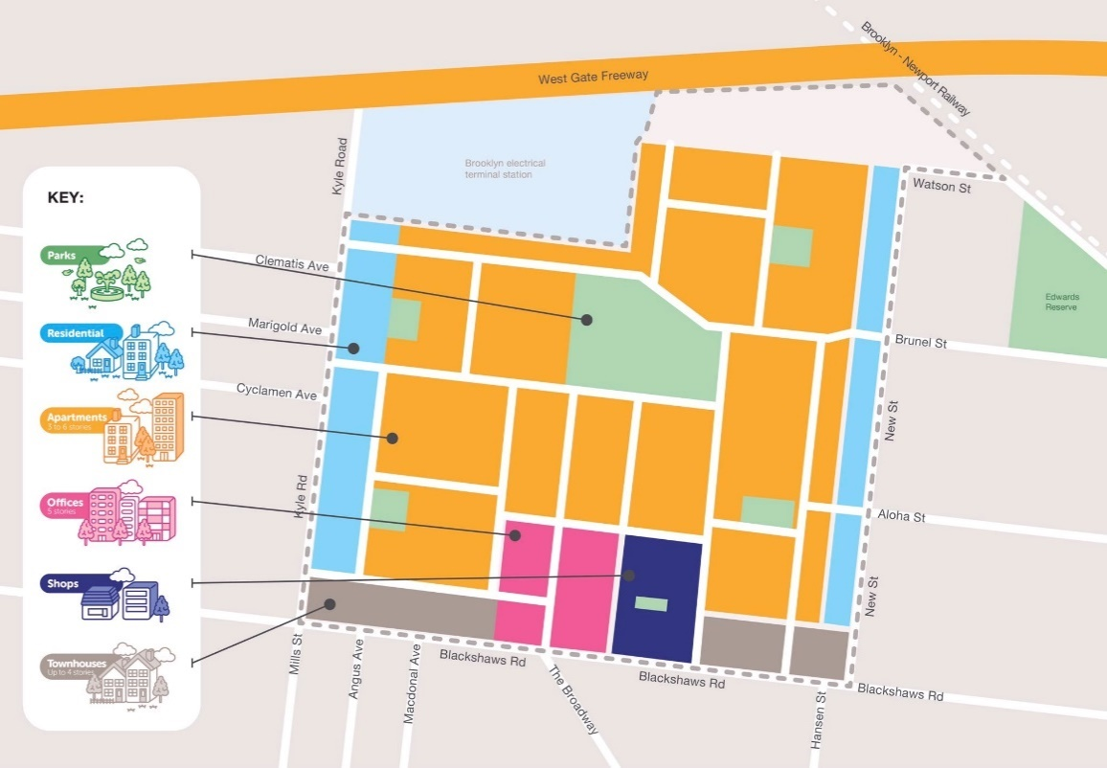

Part B – The Permit Approval Process

Introduction
The planning permit approval process is at the core of the planning system’s determination of what a landowner may do on their land. The power to issue permits is held by the ‘responsible authority’ (usually the local council) and must be exercised consistently with the planning scheme.
This approval process is the main mechanism for a council and the community to exercise judgement about whether a proposed use and development of land meet the State and local planning objectives for that land.

Figure B1: Seven key steps in the permit approval process
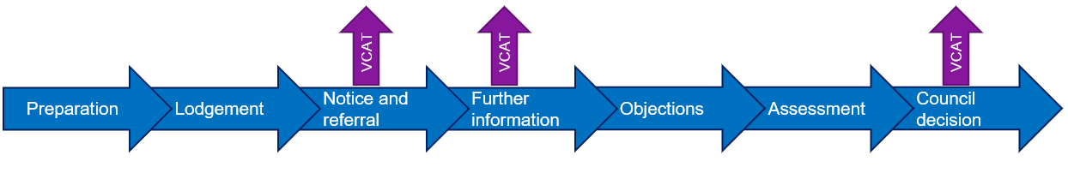

Preparation
Before starting any construction or changing the use of land, the owner needs to first establish whether a planning permit will be required, given the zoning and overlays that apply to the property.
In preparing the planning permit application, the applicant must describe their proposal in plans and other documents and provide any information required by the planning scheme. The more effort that goes into preparation, the more unlikely it is that the application will encounter delays. Some councils offer pre-application services to help an applicant prepare their application.

Lodgement
The formal assessment process commences once the applicant lodges an application with the responsible authority, with the accompanying fee and prescribed information. The council planning staff then record the application in the planning permit register and start the formal approval process, which may involve giving notice, referral to a specified agency or requesting further information from the applicant.
Increasingly, applicants can lodge their application online and then track its progress.
Once an application is received, the council is expected to make its decision within 60 statutory days. However, the ‘statutory clock’ is not continuous and can pause and reset at various stages through the assessment process, which can extend the total timeframe.

Notice and referral
As soon as possible after receiving the application, the council must identify any relevant referral authority that must be notified. A referral authority is an authority responsible for such things as flood or bushfire management, utility provision, access to adjacent roads and a range of other issues. A referral authority is expected to provide its response within 28 days.
The council must give notice of the application if the council determines that the proposal may cause material detriment to another person or if the planning scheme specifies that notice must given. Depending on the size and intensity of the proposed use or development, notice may be given by:
- mailing information to property owners or occupiers who may be affected by the proposal;
- displaying a notice on the land;
- putting a notice in the local newspaper; and/or
- any other method considered necessary.
A council must not make a decision on the application until at least 14 days after the last notice has been given.

Further information
A council may ask the applicant to provide additional information if it thinks that is necessary to inform its understanding of the proposal or the conditions of approval. This resets its statutory ‘decision clock’ and may extend the time it has to make a decision.
A referral authority may also request further information, which also resets the clock for its response.

Objections
In response to the public notice of the planning application, a member of the public may make a submission to the council objecting to the proposal and outlining the reasons for their objection.
Objections are encouraged to be submitted within 14 days of receiving the notice, but the council must consider any objection received before it makes its decision.

Assessment
Having obtained all necessary information from the applicant, input from any referral authority and considered all objections raised by members of the public, the council planning officers assess the application and prepare a recommendation about whether it should be approved and, if so, any conditions which should be included in the approval.

Council decision
The decision on a planning application is legally made by the council as the responsible authority. In practice most applications are decided by senior planning staff under delegation. Different councils have different approaches to delegations.
The decision to grant a planning permit will usually include a range of conditions. A condition of the permit may be that amended plans addressing various matters must be submitted and approved by the council before the development can commence (these are called post-permit conditions and secondary consents).

VCAT appeal
An applicant can apply to VCAT for a review of:
- a requirement to give notice;
- a requirement for more information to be provided;
- the failure of a council to determine a permit within 60 days; or
- a council’s decision to refuse a permit.
Applications to VCAT can take several months to be heard. The process can include a compulsory conference and then a formal hearing before an expert Tribunal member. Community members who objected to the application also have VCAT review rights. A dispute over a matter of law can be taken to the Supreme Court.
There are few appeals on the first two grounds due to the length of time involved in being listed for a hearing. Stakeholders suggested that there was a need for increased use of the ‘Short Cases List’ to tackle these simpler issues quickly.

Recent reform efforts and outcomes
The Smart Planning program has simplified the permit arrangements by making them more uniform across Victoria, raising the triggers to exempt minor building works to existing buildings from requiring a permit and providing a fast track for new categories of work to enable a permit to be issued within ten days.
In regional Victoria and in Melbourne’s growth areas, the issue of permits for new subdivisions is a critical step in bringing new lots to market and enabling the development of new communities.
Victoria’s strong economy and record population growth resulted in the submission of a high volume of planning permit applications between 2016 and 2018. Many councils were struggling to find the resources to manage the demand. This sparked several reform efforts to boost council capacity to achieve greater consistency in the outcomes.
Considerable effort has gone into speeding up the process and boosting capacity in the growth area councils through the VPA’s Streamlining for Growth program.
Ten opportunities for improvement have been identified in the permit approvals process where further improvements appear possible.
These include opportunities across the three broad stages of the permit application process:

Preparing the application
- Provide more help with applications, including better information on websites about information requirements and greater use of preapplication meetings.
- Ensure lodged applications are complete by going straight back to the applicant about missing information before starting the assessment process.
- Set a target for all councils to adopt an online system for accepting and processing permits, which enables applicants and objectors to track progress.
- Ensure council planning staff are properly resourced and have the right skills in the workforce to manage demand.

Assessing the application
- Modernise public notification of proposals by using online alerts and contemporary advertising to explain the proposal more effectively.
- Stream applications according to risk to handle simple issues faster and give sufficient time for complex matters to be assessed.
- Reduce the use of requests for further information (RFIs) and set expectations for prompt responses.
- Reduce response times from referral authorities and seek exeprt input from the council (internal referrals) at an earlier stage.

Deciding the application
- Ensure decisions are made within a reasonable time and address the problem of too many matters being appealed to VCAT for ‘failure to determine’.
- Promote best practice delegation of decisions by having consistent practices about which permits are determined by staff and which need a full council decision.

More help with applications

Opportunities for improvement
Both individuals and professionals acting for developers need to be able to obtain detailed and accurate information to help them to complete their applications. This highlights the importance of access to information on council websites and the availability of staff to explain over the counter or on the phone what is required in each case.
Stakeholders advised that when councils and referral authorities hold pre-application meetings, the process is significantly improved as the applicant can explain their proposal and the council or referral authority can provide detailed information about the requirements for lodging a complete application. Councils and referral authorities are not required to offer pre-application meetings; however, when councils do provide a pre-application meeting the process is more productive and efficient. Robust applications that include all the information needed to make a timely decision limit the need for the council or referral authority to make multiple RFIs, which are resource-intensive for all concerned and delay consideration of the applicant’s proposal. The quality of the advice councils and referral authorities can provide at this stage in the process also depends on the accuracy and level of detail provided by the applicant.
There is considerable variation among councils in the use of pre-application meetings and the way they are conducted. For example, some councils charge a fee to fund the service. Others provide the service for applications of a certain complexity. Some councils provide written advice following a pre-application meeting, while others provide less formal advice that is not recorded.
Our consultation suggests that few councils involve referral authorities or their internal specialists in pre-application meetings.
If applicants wish to, they can approach referral authorities directly to resolve issues early on and even get prior approvals. However, this option is rarely taken up, even by large professional developers.
There is frustration among applicants that pre-application meetings are not always encouraged or available. Their value in reducing later delays also depends on councils being consistent in their response to the application throughout the assessment process. This issue was addressed for small business applications, as part of the Better Approvals Program, by introducing a ‘Concierge’, or case management, approach which provides consistent advice to the applicant throughout the process.

Proposed improvements
There is significant value in councils providing clear and user-friendly information to planning applicants about what is required of them and in ensuring that application forms are designed to elicit all the information that is required for different types of developments. It may be useful for DELWP, in consultation with the MAV and VLGA, to produce model application forms for different types of developments which specify the Victorian planning requirements to which councils could add their local planning scheme requirements.
For a permit application of any degree of complexity, a pre-application meeting with the council and referral authorities offers the potential for all parties to understand the nature of the proposal, to clarify the specific requirements and to outline the steps in the approval process.
- It would be useful for DELWP to provide a Planning Practice Note (PPN) and model application forms to councils about how pre-application processes can be used to identify the key issues and the information requirements, including:
  - which elements of a proposal trigger the need for a permit and what planning policies apply;
  - the supporting information that will be required to be submitted with the application;
  - which referral authorities and which council officers will need to consider the application;
  - whether early engagement by the user with referral authorities would be useful;
  - any additional information that will be required for those referrals; and
  - any potential major issues with the proposal and ways to address them.
Ideally, councils should provide written advice after these meetings within a reasonable timeframe, addressing the matters discussed and noting any unresolved issues.
Councils should outline the process for pre-application meetings on their websites and provide checklists of material that users should bring to the meetings or provide in advance.
- To ensure that pre-application meetings are effective, senior planners should be involved to bring their knowledge of recent decisions made by the council and by VCAT (to promote consistency of advice). For larger proposals, these meetings could also involve other staff and decision makers, such as referral authorities and internal referrals such as drainage engineers or heritage advisers.
- Councils could be required to offer pre-application meetings and be able to charge a reasonable fee for more complex matters. These fees could be reimbursed when a complete application is lodged, and no further information is required. The best practice guidelines should establish some benchmarks for these fees.
The goal of these pre-application meetings is to provide applicants with a level of certainty before they lodge applications and reduce the risk of applications facing lengthy delays once in the system. While pre-application stages involve additional resources and effort, those councils which have introduced these meetings have noted improvements in the quality of applications that are subsequently lodged, reducing the need for RFIs and reducing administrative burden and delays later on.
Referral authorities could also consider formalising and offering pre-application meetings.
- Difficulties later in the process would be avoided by adopting a Better Approvals approach focused on council planning and building approvals processes. This would facilitate concurrent decision making, streamline referrals and embed the concierge model as a form of case management. This would give each applicant a consistent contact with whom to discuss their issues. Ideally this contact would be maintained throughout all other stages of approval in which councils were involved, including the post-permit approvals and building approvals processes. Councils could be assisted to adopt best practices and implement relevant changes being recommended by this review.

Ensure lodged applications are complete
Box B2.1: Quality of applications submitted
To be considered ‘complete’ under the Planning and Environment Act, an application must also include all information required by a council’s planning scheme.
When a proposal in an application does not contain required information, or the information provided does not clearly or properly describe the proposal, a council may request further information.
According to PPARS data, 50 per cent of planning permit applications submitted to councils result in a later RFI. This proportion has been growing steadily over recent years.
Ensuring applications are complete would complement the reforms proposed to improve pre-application engagement (see B1) and to move the processing of permits online (see B3).
A recent Innovation by the Titles Office (now part of Land Use Victoria) shows the potential benefits of having correct information at the beginning of the process. The average time taken to process large subdivisions (over 100 lots) was five weeks due to errors in the applications. The error rate fell when a new fast track system of three days was introduced for applications that were accurate, resulting in significant time savings for applicants and Titles Office staff.

Opportunities for improvement
Ensuring an application is complete is the first step towards reducing the unacceptably high rate of later RFIs which are a primary cause of avoidable delay.
Both council staff and applicants have reported that incomplete applications are a significant cause of delay and confusion during the assessment process. Sometimes councils accept an incomplete application, intending to address the information deficiency later on. This diverts a council’s resources from its core task of deciding applications.
PPARS data suggests that in the past three years incomplete applications took on average 85 days longer to decide than applications that were decision-ready at lodgement.
There are good examples of councils that have adopted practices to tackle this problem:
- Latrobe City Council only accepts complete applications and uses a concierge approach to manage prospective applicants’ understanding of information requirements. The Council has noted that its adoption of this approach over the last few years has seen a significantly more efficient use of its resources; and
- the City of Banyule augments its pre-application meetings by using a traffic light system to communicate with applicants about the status of particular issues relevant to a planning permit application. Progress and agreement on various matters are documented throughout the planning permit process.
Given the large number of applications for which further information is sought and the time taken by councils and applicants to provide additional information, there is potential for significant time savings by ensuring applications are complete when lodged.

Proposed improvements
- Councils should only accept applications once they are complete. Guidelines, standard forms and checklists should be developed to help applicants prepare complete applications.
- To support this, the VPP should be amended to increase clarity of application requirements by:
- reviewing all VPP application requirement lists for clarity, consistency and relevance;
- developing standard application requirement lists and forms for common application types, including land use, building and works, subdivision, signs, and vegetation removal; and
- testing the development of application requirements lists for certain applications types.
- DELWP, through its Smart Planning program should work with councils to review the information requirements in local schedules to check whether they duplicate requirements under the VPPs and, if not, whether the additional requirements are actually necessary to enable consideration of local issues.

Move to online planning permit processing and tracking
Box B3.1: The current state of online processing
Digital technology can underpin substantial efficiencies in planning assessment processes, increase transparency to users and improve public access to information. There is currently no statewide e-planning platform in Victoria and wide variation exists in councils’ use of digital platforms.
The Smart Planning program has recently reached a milestone with all councils having their planning schemes online and able to be accessed from a common portal. There are, however, further steps required to make this a truly integrated online planning scheme which is fully searchable.
Currently, many councils do not provide for electronic lodgement of applications: they still process their applications manually. For some councils, the cost of developing new digital systems is a major barrier to their adoption.
The most recent overview of capability was two years ago when the MAV surveyed all councils to gain a snapshot of their digital planning processing capabilities. The feedback revealed that fewer than 10 councils had digital planning platforms that provided public access, such as electronic lodgement of planning applications or objections. The councils that did have digital functionality were found to use a wide range of software tools and products from different developers.
Around half of the councils surveyed were in the process of converting to digital planning or had committed to future transitions, so the current situation may be more advanced. While other councils have digital platforms that could be used in their planning processes, these differ in capability and compatibility. Consultation suggests that councils use different digital platforms for a range of functions, including customer service, approvals, data storage and payments.

Opportunities for improvements
While larger, well-resourced councils are able to prioritise their operations to invest in digital technology, some regional and rural councils struggle to do so. The Rural Councils Transformation Program (RCTP) has an important role to play in overcoming this barrier.
Regional groups of councils have been funded under the RCTP to develop common systems, technologies and processes to maximise the use of digital solutions in service delivery, resulting in economies of scale and improved collaboration, including planning. For example, the City of Ballarat and four of its neighbouring councils have received funding to deliver a shared IT platform to support finance, payroll, records, safety, fleet management, building, environmental health, planning, waste and community services.
Digital planning portals offer the possibility for real-time monitoring of the progress of planning permit applications. They can also provide visible dashboards for all parties involved in the process, including for referral authorities and the community to input their responses or objections and for councils to publish decisions and reports. Fully digitised planning portals would also enable improved monitoring and performance reporting. The digital management of planning permits should also link to the SPEAR system (see Box B3.2) used for subdivisions and the digital handling of permits, thereby providing a complete, trackable, end-to-end record of a development cycle, including enforcement matters.
Some stakeholders have argued for a single statewide planning portal, but it is unrealistic at this time. Each council has its own IT system that is tied to larger platforms used to manage all council business.

Proposed improvements
- An achievable timeframe should be set for all councils to have their planning permit applications fully trackable online and further efforts should be made to ensure greater compatibility between the different systems. An achievable statewide goal would be for the DELWP website to offer a direct entry point to each of the 79 councils’ planning web pages.
- Desirable features for council-based permit management systems should include:
- development and introduction of common data standards which will help to drive greater standardisation of planning permit application requirements and allow for easier sharing of data across council systems; and
- an end-to-end system for managing and tracking all aspects of council processes, with the capacity to coordinate engagement between parties, read and compare different versions of plans, pay planning fees, and so on.
Implementing these systems should be considered in the context of other related initiatives, including:
- the significant modernisation achieved by DELWP’s Smart Planning reforms in digitising planning schemes, Ministerial planning permits and the PSA process; and
- the existing use of SPEAR (see Box B3.2) for managing subdivisions and the investment that authorities and private users have made in adapting their systems to SPEAR.
- The RCTP should be extended to support initiatives that deliver online tracking and processing of planning applications for rural councils.

BOX B3.2: The benefits of the SPEAR system for subdivision applications
In Victoria, the subdivision process has been handled electronically for some time with SPEAR – a Government-subsidised online portal for land subdivision approvals. SPEAR has proven to be a useful and popular tool for developers, practitioners and authorities alike.
Councils, referral authorities, and applicants and their agents use it to process permit applications (including partial processing of VCAT reviews) and approvals of official subdivision plans. The system also integrates with Victoria’s land title registration system. It can also be used by anyone to view basic information about applications across Victoria.

Improve planning resources for councils

Opportunities for improvement
Councils and industry stakeholders have identified a shortage of planners in some councils as a significant constraint for the efficient delivery of planning and other services. While shortages are experienced across Victoria, they appear to be particularly acute in regional Victoria and outer metropolitan Melbourne.
The MAV released the Local Government Workforce and Future Skills Report for Victoria in March 2018. It estimated that 74 per cent of Victorian councils are experiencing skills shortages with the key gaps including:
- engineers;
- planners;
- building surveyors;
- project managers; and
- IT specialists.
The report found that a shortage of planners is experienced by 42 per cent of Victorian councils.. Together with engineers and building surveyors, these were by far the highest reported skill shortages.
The report also found that:
- almost 60 per cent of Victorian councils identified experience gaps between the skill level of the employee and the specific skills required to effectively perform the role;
- this skill shortage is mainly experienced at the senior level, in management and supervisory roles;
- there was a critical skill gap for project management in major strategic and development projects; and
- the skill gap was attributed to a high demand for experienced planners coupled with some councils’ inability to meet market wages because of budgetary restraints.
There may be opportunities to address these issues by better aligning council planning fee revenue and expenditure on those planning services (see Box B4.1).
The MAV report found that councils have responded to the shortage by offering cadetships, visa sponsorship and a broadening of the geographic area in which they advertise. Despite this, difficulties persist in attracting and retaining mid-level planning and other related staff.
Councils often face sudden increases in the need for resources during times of peak workflow. While councils can sometimes supplement their own planning staff with consultant planners to assist in completing assessment tasks, this is often costly and does not help councils to build an in-house skill base.
Box B4.1: Planning fee revenue and council planning services
Planning application fees were last changed in 2016, under the Planning and Environment Fee Regulations 2016. The fee changes were intended to reflect the councils’ costs for providing planning services, based on a sample of 15 councils. In many cases there were significant increases in the fees.
Several contributions to this review have suggested that there needs to be a greater transparency in how planning fee revenue is used, as there was a perception that some councils had not reinvested the increased revenue in their planning activities. The PIA suggested this was squeezing council planning departments and contributing to work overloads and delays.
Given the impact of these fees, they will be revisited in 2021 or earlier through the mid-cycle fee evaluation regulatory review process. This will provide an opportunity to assess their relationship to the costs of providing planning activities.
Some councils use contract planners to help with backlogs and fill capacity gaps. For example, Latrobe City Council uses contract planners to prepare planning reports and do other planning work, but the approval of permits rests with Council or its delegated officers. This is a potential way for councils to deal with pressing shortages and reduce backlogs. In this context, it may be useful for councils to have access to a list of accredited planners from which they can draw relevant contractors to undertake this work on their behalf, subject to their delegations.
The HIA suggested in a submission to this review that an ‘…accredited approvals process [for contract planners] could operate on a user pays basis and could be an option for applicants to elect to adopt’. This review is interested in the views of councils, industry and other stakeholders on this suggestion and its practical application.
Councils reported that their capacity to access and deliver training to existing staff is limited by time constraints to attend training, difficulty in sourcing local trainers and a lack of suitable courses, as well as their high costs.
The VPA also provided planning support to councils across Victoria by undertaking strategic planning on behalf of the council or through the Streamlining for Growth program.

Proposed improvements
- Provide additional resources for DELWP’s Regional Planning Services network to act as regional planning hubs, providing resources and facilitating training to support councils’ planning functions (see Box B4.2). This support is mainly needed in non-metropolitan areas, where councils often lack the resources to deal with complex or strategic planning issues and manage staff gaps. While the most critical role of these additional resources would be in permit approvals, these hubs could also provide additional resources and facilitate training to support councils’ strategic planning functions.
- DELWP and PIA could develop online training packages for planners across Victoria. Peak industry bodies could also be funded to work in partnership with DELWP to deliver training packages based on the successful development and delivery of the DELWP/UDIA training module Property Economics: A short introduction for Urban Planners dealing with Affordable Housing.
- DELWP could encourage harmonisation between councils’ local planning requirements and processes by holding regular regional meetings between councils, referral authorities, the VPA and other relevant bodies, to facilitate communication and resolution of issues. The MAV annual regional conference is a good forum for sharing statewide experiences and regular regional meetings could be built on this.
Box B4.2: Regional Planning Hubs
DELWP’s Regional Planning Services (RPS) division is an existing network of regional offices, with the core role of delivering the Minister for Planning’s statutory planning obligations (such as processing Ministerial permits and amendments, and the authorisation and approval of council amendments).
There are five regional offices (based in the Gippsland, Grampians, Hume, Loddon Mallee and Barwon South regions) that are staffed with teams of qualified and experienced planning practitioners who have local knowledge and existing relationships with each of the councils in their region.
Given the RPS division’s locations and skill base, these offices would be well placed to be the base for additional resources as ‘regional planning hubs’, with additional staff on hand to provide resources and facilitate training for councils in need of support for both their strategic and statutory planning responsibilities. This would offer a greater breadth of assistance to regional councils and help them manage their workforce challenges.
Councils could then seek support from these hubs if they require additional assistance, including:
- providing backup planners when councils are experiencing temporary shortages (for example, when staff are on leave, or positions are vacant pending recruitment) to avoid applications sitting unprocessed;
- helping councils manage peak workloads by providing immediate assistance with planning permit and planning scheme amendment assessments;
- helping councils resource strategic work such as a planning scheme review or a heritage study;
- supporting regional planning training initiatives for planning and other staff;
- facilitating regional forums and working groups (including involvement from regional referral authorities) to resolve complex strategic proposals and share innovative ideas to improve the quality and performance of planning schemes; and
- coordinating the assistance from a panel of technical specialist consultants to provide expert advice on complex permit and amendment assessments.

Modernise public advertising of proposals
Box B5.1: How notification of planning permits currently works
When a council receives a planning permit application, it must notify all the parties that may be affected by the proposal (or require the applicant to notify those parties) unless:
- the council is satisfied that the proposal would not cause any detriment; or
- the category of application is exempted from notice by the planning scheme.
As a minimum, notices must describe why the proposal needs a permit, identify the permit applicant and the land address, where to view plans and how to object.
In general, a council may give notice by putting a sign on the land concerned, publishing a notice in local newspapers, giving notice personally to affected landowners, sending notices by post or any other way it deems appropriate. Specific provisions apply to notifying the removal or change to a restrictive covenant on the use of land.
Those receiving formal notice are invited to inspect plans and can make a submission to the council regarding the permit by the specified date.

Opportunities for improvement
Current procedures for notifying parties of a planning permit application often rely on newspaper advertisements and the notices erected on properties where a development is proposed. These are often difficult for an interested non-planner to understand.
The prescribed form of the statutory notice is complicated and dense. There is little opportunity to include images and the mechanism for broad notice relies on newspapers, which are increasingly less effective. The use of web-based notices is voluntary and varies with councils.
These deficiencies reduce the effectiveness of the notification process and make it difficult for members of the public to engage in the early stages of the planning permit approval process. Providing clear and understandable information about a development and being clear about what aspects are open to objection is fundamental to the fair operation of the planning permit system.
Poor communication at the notification stage can increase the likelihood of objections being raised at later stages, including last-minute concerns about planning permit applications (for example, about there being insufficient time for the community to consider proposals) or even appeals to VCAT to raise issues that should have been addressed early on.
The content and readability of notices could be greatly improved. Glen Eira City Council has developed a new format (see Figure 5.1) which is far more informative than other notification styles, is easier to understand by non-planners, includes additional information and contains all the prescribed information from the regulations.

Figure 5.1: Glen Eira City Council application notice
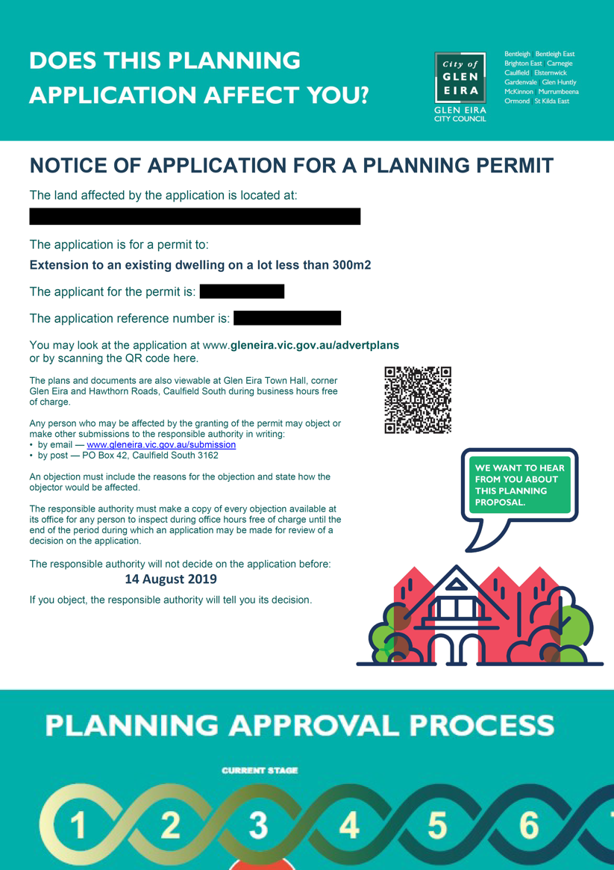

Proposed improvements
- Experience in Queensland has suggested a significant improvement in public understanding of proposals as a result of a requirement under the Sustainable Planning Act 2009, which states that the notice of a permit application should include a picture of the proposal where a significant building is proposed. A similar requirement could be adopted in Victoria for applications involving a new building or larger developments. Pictures could be displayed on signs similar to real estate display boards. The cost to the applicant would be modest but there would be significant benefits, including a reduction in objections based on misunderstandings of the proposal.
- Formal notice should be provided on council websites, via email alerts and on social media. Formal notification by mail for affected landowners should remain a requirement. Councils could use their regular local newspaper columns and advertisements to give notice about major developments currently on display.
- DELWP could prepare an updated PPN on ‘Best Practice’ modern notification processes for different types of applications, in consultation with MAV and VLGA.

Stream applications according to risk

Opportunities for improvement
Currently all permit applications go through a standard assessment process unless they fit the criteria for VicSmart (see Box B6.1). There is a strong case for more risk-based streamlining of applications by providing alternative pathways for the assessment of permit applciations.
Some stakeholders argue that a number of the permits they currently apply for are for low-risk work that could go into VicSmart or be exempted altogether. A need has also been identified for a new code assessment pathway for permit applications that are too complex for VicSmart, but are straightforward enough to not require the full 60-day assessment process. The Smart Planning program is working on providing this pathway – VicSmart Plus – which would see appropriate permit applications assessed within 30 days.
In some instances, the level of effort that goes into considering some issues of detail in a permit application is disproportionate to the potential impact of the activity being considered. Sometimes the original reason for a planning control has evaporated over time; for example, a temporary sales office no longer requires a permit on a new housing development site as it creates little if any detrimental impact and can bring the benefit of surveillance over an otherwise vacant site before construction starts. Other matters previously subject to planning permits can be better managed by other means. For example, councils use their local road and food safety powers to manage food trucks.
There are further opportunities to use exemptions or reductions in the thresholds in planning schemes and referral authority requirements that could streamline approvals. Some of these issues are being analysed as part of the Smart Planning program with a view to striking a better balance about how low-risk issues are managed.
Issues include:
- non-retail land uses (such as gyms, dance studios, wellness centres and light industry), which add vitality and patronage to shopping strips and centres but currently cannot be located in these areas. Instead they have to locate in less attractive local industrial areas with substandard pedestrian access and low visibility;
- provide greater flexibility in the definitions of zones to enable important community facilities to be located in residential areas – for example removing current restrictions on child care centres, aged care homes and social housing and in appropriate situations allow greater heights and other concessions;
- a home owner wanting to construct an additional dwelling in a backyard to rent out or accommodate relatives is currently treated in the same way as a developer wanting to construct a multi-unit development for resale. A less onerous requirement would be preferable;
- dependent persons units are permit free but subject to restrictive conditions;
- other secondary dwellings could be assessed under the VicSmart Plus approach subject to meeting garden requirements and any other appropriate conditions. It should be noted that building permit requirements for setbacks and design matters address the same requirements as those in the planning scheme. Smart Planning has proposed to standardise requirements for building a second dwelling on one title and remove limits on its use; and
- for lots of less than the minimum size (either 300 or 500 square metres), Rescode does not provide the VicSmart ten-day turnaround for permit applications. Stakeholders have argued that siting and design issues for smaller blocks can be adequately dealt with through the siting standards in the building code and the building permit or at least brought within VicSmart.

Box B6.1: VicSmart
VicSmart provides a 10-day assessment and approval pathway for simple applications, including:
- building a front fence for a dwelling;
- building a house extension;
- removing a tree; or
- displaying a sign in a commercial or industrial zone.
All planning schemes make the Chief Executive Officer of a council or their delegate the responsible authority for VicSmart applications in their municipalities. VicSmart applications are assessed against a limited list of criteria. Given the low impacts of these types of activities, public notice is not required and there are no third-party appeal rights.
In 2017, Smart Planning expanded the application categories eligible for VicSmart to double the number of applications that can be processed using this pathways. The new classes of permit included buildings and works of up to $100,000 in value in residential zones and of up to $500,000 in value in commercial zones, and extensions to dwellings on small lots, provided they comply with specified amenity requirements set out in the planning scheme including, for example, setbacks, the length of boundary walls, and buildings that would overlook secluded private space.
The extensions to the VicSmart process mean the proportion of permits fast-tracked in ten days has increased from 7 per cent to 16 per cent of all planning applications.
As part of the VicSmart program, 25,000 permits a year for new or renovated dwellings are being issued more quickly. The responsible authority, typically the council, no longer has to inform the applicant in writing that the neighbourhood and site description plans are satisfactory prior to notice being given or the application determined. Previously, when the council had to formally respond in writing that the plans were acceptable, this could add weeks or months to the process. Now councils include consideration of these plans as part of their application assessment process.
DELWP is currently consulting on the possibility of introducing a new assessment pathway – VicSmart Plus – which would feature a 30-day turnaround with targeted notice provisions. DELWP is consulting on whether this pathway would be suited to approvals for secondary dwellings, extensions of home businesses, extensions to dwellings, and the construction of a dwelling on lots smaller than 500 square metres.
There may also be other opportunities to use VicSmart to promote other faster assessment pathways that are currently possible but not systematised. For example, one stakeholder has noted that under the current planning provisions developments within specific overlays (for example, the Special Building Overlay and Land Subject to Inundation Overlay) can be processed via VicSmart as long as there are no other triggers, and pre-development consent has been obtained from relevant referral authorities. They have used this approach to obtain ten-day turnarounds from councils in applications of this kind.

Proposed improvements
- The Smart Planning program should review the identified issues with current prohibited and restricted uses, to allow:
- non-retail land uses that add vitality and patronage to shopping strips and centres; and
- planning concessions for child care centres, aged care facilities and social housing located in residential areas.
- The proposed VicSmart Plus should enable 30-day streamlined issuing of permits for:
- secondary dwellings on an existing lot; and
- dwelling applications on a small lot in an established area.
- Following the review of the small lot code for growth areas, consider the case for amending Rescode and then dealing with siting and other issues through building permits.

Reduce requests for further information
Box B7.1: What is an RFI?
Under the provisions of section 54(1) of Planning and Environment Act, the responsible authority (a council) can require the applicant to provide more information about a proposal, either for itself or on behalf of a referral authority. The RFI must be in writing and set out the information to be provided. If the RFI is made within the prescribed time, the request must also specify a date by which the information must be received.
The prescribed time for a VicSmart application RFI is five business days after the responsible authority received the application. For all other applications, the prescribed time is 28 days after the responsible authority received the application. In Queensland it is ten days after receipt of the application.
An RFI within the prescribed time means that the ‘clock’ is stopped and reset. The clock counts the number of days until the applicant may apply for a review of the failure of the responsible authority to determine the application. The clock starts again from zero when a satisfactory response to the responsible authority’s request is received.
An applicant can ask the responsible authority to extend the date specified to provide further information. The request to extend the date must be made before the end date.
For performance reporting purposes, councils currently report to DELWP on the gross days elapsed between the start of the most recently reset clock and the date the decision is made.

Opportunities for improvement
RFIs are a major cause of delay in the planning approvals system. While such requests are an important mechanism to ensure that decision makers are fully informed, stakeholders suggest that these requests are sometimes used to ‘manage’ workloads or to meet performance reporting targets.
Analysis of PPARS data shows that almost half of all applications received at least one RFI (compared to around one-third ten years ago) and that one RFI adds an average of 85 days to the time taken for processing a planning permit application. These figures imply that RFIs added over 2.2 million days of time to the planning process in 2017-18.
Consultation suggests that RFIs:
- are often made by councils to obtain information that should have been included when the application was lodged (based on the requirements of the planning scheme) (see B2);
- can include requests for changes to the application itself, rather than for information about the application (which can prompt amending applications that restart the assessment process in cases where the change could be implemented through a permit condition); and
- can ask for information that the applicant considers:
  - unnecessary to inform the decision;
  - more detailed than is necessary to inform the decision; and/or
  - is information already available or that has been provided.
Feedback from some councils suggests that better use of pre-application meetings (see B1) and refusing to accept incomplete applications (see B2) are more effective ways for them to ensure that applications contain the information required by a planning scheme and would help to reduce the use of RFIs and the associated delays.
A council and an applicant may interpret what constitutes ‘required’ information differently. While an applicant is entitled to appeal to VCAT against an RFI, in the 2018-19 financial year, VCAT only received three applications for review of a council’s RFI. Stakeholder feedback suggests that the applicants are reluctant to appeal at that stage of the application because the costs and delays associated with such an appeal are often prohibitive.

Proposed improvements
- Where RFIs are necessary, responsiveness could be improved by having councils ‘pause the clock’ on statutory timelines for decisions, rather than reset it. This recognises that, in many cases, assessment of other aspects of an application can continue even if all relevant information is not yet present. This would also have the effect of reducing the use of RFIs as a tool to manage workload or performance reporting. The applicant would still be responsible for any time they take to respond to the RFI.
- Set a deadline to encourage prompt assessment of the need for further information and curb multiple requests – possibly based on the Queensland cut-off time of ten days.
- VCAT could improve and promote the prominence, availability and turnaround times of its Short Cases List to enable an applicant to seek a prompt review of an RFI, which could, in many cases, be done on the day of the hearing.
- DELWP could support councils to help them more accurately and efficiently assess the need for RFIs by issuing a PPN and facilitating training opportunities for councils that illustrate:
- how to distinguish between further information requirements and requests for amendments to an application;
- the type and level of information necessary to inform common decisions (see B2);
- the types of changes to applications that are better dealt with through permit conditions rather than asking for the change in an RFI; and
- best-practice for addressing requests for amendments to applications, including:
- using pre-application meetings to offer applicants a choice between having councils request and finalise changes to an application before issuing the permit or do so by using permit conditions;
- when requesting an amendment, being clear that the request is for a change to the application rather than information;
- advising the applicant as to whether a requested amendment is a minor matter or one which is likely to affect the applicant’s chances of having the permit approved; and
- ensuring the applicant understands that where an amendment has been requested, the applicant has choices about how to respond (for example, the applicant may choose not to make changes and proceed with the application, and this will not necessarily jeopardise the chances of having the permit approved).

Reduce response times for referrals
Box B8.1: What is a ‘referral authority’?
Councils must refer permit applications to a ‘referral authority’ where required by the planning scheme. These authorities are either ‘determining authorities’ who make a concurrent decision on the application or ‘recommending authorities’ whose advice is considered by council. This process is generally referred to as ‘a referral’.
The intention is to ensure the requirements of all authorities are known and reflected in the one decision. Having referrals coordinated by councils avoids the applicant needing to seek separate approvals from each of these authorities for each aspect of the proposal.
There are approximately 68 referral authorities in the Victorian planning system, with a wide range of workloads. These include planning bodies, water authorities, electricity and gas utilities as well as Ministers and their departments, managing approvals for environment, roads, public transport, health service providers and health and safety and resource regulators.
These authorities are also routinely involved in the strategic planning phase. For example, this enables their strategic requirements to be provided when PSPs are first drawn up (how roads will be linked to the overall road network and how electricity or water will be delivered to the precinct). They are also engaged in the post-permit phase as infrastructure is built by the developer and ownership transfers to the long-term operator (usually the referral authority).
Being designated as a referral authority in a planning scheme carries a responsibility to act efficiently and effectively in protecting the community benefit outcome that warranted its designation as a referral authority. This responsibility is no doubt generally understood by referral authorities, but is not currently clearly articulated in the planning scheme or Planning and Environment Act.

Opportunities for improvement
According to DELWP’s PPARS data, 13,248 planning permit applications (25 per cent of total applications) were referred to at least one authority in 2017-18. If a referral authority has not provided a final response within 28 days, the council may proceed to decide an application without referral authority input. However, in practice, it is rare for a council to decide an application without some input where a referral is required by the planning scheme.
Stakeholders also reported that significant delays are experienced when matters are referred to referral authorities, with the clock being stopped while further information is sought. They also reported lack of customer focus and responsiveness in the approach of some referral authorities to managing their responsibilities as referral authorities, rather than according them priority and communicating with applicants. This may be in part because referral authorities receive no fees for undertaking these duties, and there is very limited information reported on performance.
Box 8.2: SARA in Queensland
Queensland’s SARA (State Assessment and Referral Agency) is a Victorian Government body assessing a small number of pre-identified major impact applications, and more commonly is the single point of contact for some referral responses on State matters to a council considering a permit application. All other application types follow the model currently operating in Victoria, with applications sent to the local council and referred out to relevant authorities for a concurrent decision or feedback.
Prior to the establishment of SARA, permit applicants needed an approval from individual authorities (for example, a roads approval, a drainage approval, a planning approval – a system with inherent inefficiencies and poor coordination).
SARA, and the many other Queensland referral authorities, charge fees for their assessment services – mostly between $3,000-$12,000 per referral, with SARA development assessments starting at $20,000. Required referral response times range between two weeks for local government building work referrals to four weeks for utility service referrals. By contrast, Victorian referral authorities charge no assessment fees and all applications must be decided in four weeks.
The SARA model for referral and assessment of larger State-interest applications has been well received by the development industry.
While Victoria’s referral system already channels referrals through a single point of contact (councils), there are aspects of the SARA model incorporated in the proposed escalation of planning for sites of strategic importance. In those cases, the VPA could function in a similar way to SARA in coordinating all referrals and enforcing timeliness.
There is a need for greater proportionality in applying what are often routine referrals to referral authorities. A more efficient model would be to focus their assessment effort on more complex matters (or at the most relevant point for the given authority).

Involve authorities at the most relevant point
For instance, power and water/sewer supply companies are referral authorities. In growth areas they generally need to see detailed plans after a permit has been issued (‘certification plans’) and agree with the developer on how to best connect their service to the subdivision. Normally they do not provide input to the design of a new subdivision before the permit is issued. They may require easements and small infrastructure lots on the certification plans. Yet every subdivision application for three or more lots is referred to these authorities before the planning permit is issued.
Moving to a standard subdivision permit condition for referral of certification plans and connection agreements could have removed up to 40,000 unnecessary administrative actions for the 7,000 new land subdivisions in 2018-19. As these authorities are already integrated into the SPEAR portal, they can anticipate upcoming referrals by checking on current permit applications in the system.

Focus effort on nonconforming or more complex matters
The Department of Transport (DoT) (formerly Public Transport Victoria and VicRoads) receives around 5,000 referrals each year. About 40 per cent of these referrals are for residential driveway access to a main road for five or less homes. At the other end of the scale are major reconfigurations of highways resulting from adjacent development involving millions of dollars of public infrastructure. Currently both types of application go through the same assessment processes. A clear design code could enable councils to undertake assessment of ‘driveway’ applications on behalf of DoT, which they already do for local roads. This would enable more assessment effort to be applied to the complex and higher impact road reconfiguration applications.
Similarly, the CFA receives high volumes of referrals for largely standardised fire hydrant installations in new subdivisions as well as highly complex fire safety installations for commercial and industrial buildings. Again, both categories of application go through the same procedure, despite the former being highly suited to a standard condition approach and the latter a more rigorous individualised assessment befitting the differing risk profiles of each type of installation.
An appropriate council officer (such as a traffic engineer or municipal fire prevention officer) could be trained and accredited to make straightforward decisions (such as for vehicle crossings or subdivision hydrant installations) on behalf of the referral authority so that only more significant matters are triaged to the referral authority for full review. This would also promote closer liaison between the referral authority and the council about the types of matters that are being referred and which could be dealt with more efficiently.

Proposed improvements
This review has found that while there are examples of efficient systems in place for some approvals at some authorities, the more common experience of stakeholders (including councils) is one of difficulty in communicating with them, slow decision making, and being surprised by policy positions that change between the strategic and statutory planning phases. Improvements that could address these issues include:
- Improving performance by having the relevant Ministers for referral authorities emphasise the importance of abiding by the expected 28-day turnaround and pausing – not resetting – the clock for RFIs, and:
- giving appropriate focus and resources to the role;
- better managing referrals through such actions as standardising and removing simple referrals and focusing resources on more complex referrals;
- consulting on and providing up-front guidance on referral decision criteria and authority requirements; and
- considering delegation of simple approvals.
- Improving performance reporting, with the Planning Minister requiring referral authorities to regularly report under section 14A of the Planning and Environment Act:
- their published guidance for applicants and councils regarding application information requirements, their decision-making criteria and policies and how they apply to their referral decisions including evidence of the consultative processes undertaken to inform this material;
- their decisions including timeframes, outputs and post-permit timeframes;
- the resourcing of the role and anticipated resourcing needs; and
- targets for a reduction in referrals required by developing standards for less complex, matters.
- Supporting improvements in referral authority performance, eligibility for funding through the Streamlining for Growth program which could be extended to all councils and referral authorities seeking to improve their responsiveness and decision quality and reducing unnecessary referrals.
- Resourcing the VPA to enable it to provide continuous improvement assistance to referral authorities including:
- hosting information sharing and inter-authority, authority-council and authority-industry relationship building at the regional level (many councils reported improved referral authority performance when inter-agency relationships and communication channels were maintained);
- designing standard form publications about application guidance and decision-making guidance for referral authority use; and
- strategically reviewing workloads for opportunities to rationalise the type of referrals that require individual review, those that may be addressed through standard conditions, or may only require notification or other methods.
This support could be focused on identifying opportunities to improve proportionality in the work done by referral authorities and collaborating with councils and referral authorities to coordinate referrals in complex cases.
- Referral authorities should be engaged early in the design process to ensure that their issues are properly addressed and do not arise late in the process. Subsequent referrals should check compliance with the agreed scheme in accordance with section 55(1) of Planning and Environment Act.
- The triggers for referral should be reviewed to enable simpler matters to be dealt with directly by a council, based on design codes issued by the referral authority.

Make decisions within a reasonable time
Box B9.1: Current provisions on decision timeframes
If the council does not make a decision within 60 statutory days of receipt of a planning permit application, the applicant can choose to seek a review at VCAT. There is a general expectation, therefore, that a council should endeavour to make a decision on an application within 60 days.
Permit applications have become increasingly complex in content and scale over time, and particularly complex cases can be difficult for a council to consider and decide on in 60 days. However, there are detailed provisions for ‘stopping or resetting the clock’ which means the actual gross time taken is, on average, nearly double this set period.
The time taken is compounded by the issues of constrained resources (see B4), repeated RFIs (see B7) and delayed responses from referral authorities (see B8).
If a council does not make a decision within the 60-day timeframe, it is considered to have ‘failed to determine’ the application. At this point, an applicant can either wait until the council makes a decision after the timeframe has elapsed or they can exercise their right to appeal to VCAT against a failure to determine.
PPARS data suggests that from 2015-16 to 2018-19, of the 220,000 permit applications lodged, over 115,000 took longer than 60 gross days to determine. Of these, over 61,000 were judged by responsible authorities to take more than the statutory timeframe. Less than 1,250 were the subject of appeals to VCAT on the grounds of failure to determine. Applicants still incur substantial costs from delays due to failures to determine, but typically do not appeal to VCAT because they regard the costs and delays associated with the appeals process to be prohibitive.
VCAT has advised this review of several initiatives underway to reduce costs and delays in the appeals process (see Box B9.2).

Opportunities for improvement
The Smart Planning program has recognised a proportionate approach to planning permit processes in cases for simpler matters by:
- increasing the number of minor works which are now exempt from requiring a planning permit;
- expanding the VicSmart process for dealing with certain types of permit applications with a target of a delegated decision within ten days (see Box B6); and
- developing a potential further assessment pathway for permits which could be brought within the VicSmart process with a target of 30 days.
In all other cases, it is expected that the council will make a decision within 60 days.
Some applications are complex, and it is legitimate for councils to require additional assessment time. Indeed, some stakeholders have suggested that allowing longer timeframes for more complex applications could provide councils with the additional time they need to make a fully informed decision without resorting to ‘stop the clock’ provisions as well as providing the applicant with greater clarity about when they would be likely to get an outcome. The example of Scotland was raised by the PIA where councils and applicants agree on an alternative approval deadline for complex matters as part of the pre-application process.
Some stakeholders have suggested that extending the statutory timeframe for more complex applications might provide a more reasonable time for decisions that often require negotiations, extensive notice and are followed by a formal hearing at a council meeting. Suggested timeframes are in the order of 90 to 120 days.
Others have highlighted the importance of a narrow definition of ‘complex applications’ to avoid this becoming the new default timeframe, regardless of actual complexity. This move should be seen as part of bringing the actual ‘end-to-end’ time for assessment more in line with the trigger for ‘failure to determine’ applications to VCAT. At the end of the day for a developer, the important thing is to have some certainty about what to expect. A longer timeframe is acceptable, provided it is realistic and is adhered to. The current situation, where the gross time bears little relationship to the statutory goal, is unacceptable.
Support for council planning capacity and capability through regional support hubs (see B4) could improve councils’ ability to manage complex caseloads, reducing the number of cases that result in failures to make a decision (and the associated delays and costs associated with a VCAT review in cases where applicants pursue an appeal (see Box B9.2)).

Proposed improvement
- Consider a longer statutory timeframe for complex applications. Guidance on the definition of the threshold for what is ‘complex’ should be set based on the complexity of the assessment rather than just the size of the project.
Alternatively, a negotiated approach could be considered, enabling councils to enter an agreement with an applicant on the expected timeframe.
This review notes that the effectiveness of these changes to timeframes would depend on the definition of ‘complex’, and that creating this definition would have other statutory implications. This review invites stakeholder feedback on whether creating a longer timeframe for more complex applications would improve the planning process on balance and, if so, what criteria would be best to use to define complex.
Improvements proposed in other sections of this report are likely to reduce the number of applications that are not determined within timeframes and/or the likelihood that an applicant appeals to VCAT when a timeframe is not met. For example:
- better resourcing and training for councils (see B4) should make it easier for them to meet these timeframes;
- pre-application meetings (see B1);
- accepting only complete applications (see B2); and
- improving the quality of council RFIs (see B7) should help provide councils with the information they need to make decisions more quickly once an application is lodged.
Other measures that could improve the proportion of decisions made within reasonable timeframes include:
- Councils should report on the time taken for applications at different stages of the assessment and decision process, so that key performance indicators can be determined for the median time and the proportion of cases exceeding a maximum limit.
- As part of the proposal for user-focused concierge services that begin at the pre-application stage (see B1), councils should also provide users with updates throughout the assessment process, so that they are aware of any potential delays and have confidence about the expected timeframe for a decision even if that timeframe exceeds the statutory minimum.

Box B9.2: VCAT Appeals
VCAT is part of Victoria’s judiciary, separate to the Executive, and hence outside the Terms of Reference for this review. However, a number of interface issues were raised by contributors to the review that relate to the overall time taken to resolve planning and building permit issues, including VCAT processes. VCAT informed this review of initiatives underway to improve the timeliness and outcomes of the processes of the Tribunal.
The VCAT Court Services division is currently working on a package of process improvements. Many of these apply across all VCAT divisions, not just the Planning Division. These include:
- changes to the registry arrangements to improve the handling of applications;
- appointment of well qualified planners in the registry to facilitate the accurate triaging of planning cases and better estimate the time needed to resolve them;
- seeking funding to replace current paper-based processes with full online lodgement (currently applications can be prepared online but are then printed out for processing);
- exploring the increased use of electronic notification of hearings and lodgement of legal papers to speed up the advancement of cases; and
- seeking additional funding to support more members to deal with current caseloads.
A number of contributors to this review have raised the desirability of having a separate ‘Short Hearings List’ to more expeditiously deal with matters where only one or two issues are at stake and can be resolved on the day by the VCAT member after hearing from both parties.
In fact, such a list already exists – the Short Cases List – and applicants can seek to use it by ticking a box on the lodgement form. However, it is not currently widely used and there is low awareness of this option. The Tribunal advised that it plans to increase awareness of the list.
The Tribunal has also advised that it has adopted policies to more accurately estimate the time required to hear cases and to keep parties appearing before the court on track and adhering to the points in dispute to reduce unnecessary extension to the length of hearings.
Major Cases List
Of particular interest to many planning applicants is the Major Cases List, which allows matters to be dealt with by priority on account of their economic importance. This list is self-funded and is not intended to delay consideration of other matters.
Developers expressed concern that the list is not delivering a significantly faster outcome than the standard list and therefore queried the basis for charging higher fees. Currently these matters are taking 20 to 22 weeks – not dissimilar to the average for other matters.
VCAT advised that consideration of options to improve timelines for the Major Cases List is underway.

Promote best practice delegation of decisions
Box B10.1: How are decisions delegated?
The decision on a planning application is legally made by the responsible authority, in most cases councils and, in practice, most are decided by planning staff under delegation. The form of these delegations is determined by the council and varies considerably across different councils. If a decision is not delegated, it will be referred to a council or committee meeting and interested parties may be invited to address the council.
Only the more substantial matters are then taken to council. Typically, a delegated decision will be made where the application is considered to be consistent with the planning policies set by the council.

Opportunities for improvement
There is considerable variation in the way that councils delegate their planning decisions to their officers and when applications are referred to councillors.
Over the two years, 2016-17 and 2017-18, there were an average of 54,207 planning permit applications per year. Of these 43,577 (80 per cent) led to a decision and the remaining applications either did not require a permit, or were withdrawn, lapsed or failed to be determined.
However, PPARs data indicates that 97 per cent of decisions were determined by a delegate with 3 per cent directly decided by council. The council determined:
- 13.3 per cent of complex applications;
- 2.8 per cent of average applications; and
- 1.2 per cent of simple applications (but these still represent 11 per cent of the matters going to council).
On average, 72 per cent of applications that were determined by council received less than six objections.
Some simple permit decisions are handled through the fast track VicSmart process that aims to make a decision within ten days. All Victorian planning schemes specify that a VicSmart application must be decided by the council’s CEO or a delegate.
Some councils embed the role of councillors in setting strategic planning policy, while delegating most planning permit decisions to senior staff. Others define the circumstances in which councillors make the decisions.
Most new councillors have training in their obligations to make decisions based on the planning policies and not to inappropriately intervene or fail to disclose any conflicts of interest. The MAV runs councillor training and produces a guidebook for councillors that contains guidance on planning rules.
Proposed amendments to the Local Government Act 1989 would strengthen these provisions and provide more guidance on the balance of responsibilities between councillors and council staff. It will also introduce mandatory induction training for councillors to help them better understand the position requirements.
The role of councillors came in for some comment by stakeholders during this review. Some stakeholders suggested that decisions should be made by independent or semi-independent panels as is the case in South Australia. Deferral of decisions by councils was another area of concern. Stakeholders advised this often occurred because of reservations of one councillor.
Elected councillors have an important role to reflect local opinion and to manage local issues. The community expects them to exercise their powers carefully and to determine each issue before them in the best interests of the whole community. Stakeholders suggested that when sitting as a ‘Planning Committee’, councillors are more clearly acting in this determinative role based on their municipality’s planning scheme.

Proposed improvements
- The current status of delegation arrangements across councils could be reviewed to streamline council officer delegations and develop a model ‘deed of delegation’ which reflects best practice, helps councils to triage matters and reduces delays.
- A model deed of delegation could be developed and supported by a general guideline that defines common criteria for which matters are suitable for determination by the council’s CEO, the director of planning, other senior staff, council or council committees for determination.
- The frequency of councils’ planning subcommittee meetings came in for some criticism. ‘Missing a meeting’ can add a month to the final approval. Shorter, more frequent meetings (say fortnightly) may mean that the volume of approvals can be transacted without such long pauses.
- There is also scope for the government to review the current training given to councillors about their roles and responsibilities when making decisions within the planning framework. The proposal in the Local Government Bill 2019 to require candidates and councillors to undertake training could support this improvement.

Part C – The Post-permit Approval Process

Introduction
This part of the review focuses on approvals required after the planning permit has been issued. In this phase, the proponent moves up from being the ‘applicant’ to being a ‘permit holder’.
Stakeholder feedback suggests that some permit holders spend six to 12 months getting post-permit approvals for permit conditions before obtaining final ‘sign off’. This post-permit phase is sometimes the most challenging of the development process as it may involve obtaining approvals from authorities outside the planning process and sometimes from the Commonwealth.
If details remain to be finalised at the time the permit is approved, conditions may be added requiring final plans to be approved. Further approvals are often required for subdivision, the construction of a building or the carrying out of early infrastructure works (for example, building electricity assets in greenfield developments).
For a number of reasons, the permit holder may decide to change their plans or the timing of the project, often in a relatively small way, and this can trigger the need for a variation to the permit.
Examples of requirements that are part of the post-approval phase include the following:
- a permit holder’s designs may need to be amended to meet conditions set by the council and any requirements imposed by a referral authority. Disputes over how to interpret the conditions and get sign off for compliance can result in matters being referred to VCAT;
- the submission of plans showing the specific dimensions of lots and council reserves on a subdivision, the quantity of earth to be moved on a site and any changes to site levels, construction and site management requirements and landscaping;
- for new housing estates, developers need to have plans approved by separate authorities and companies for roads and local drainage, water and sewer supply, major drainage, electricity, gas and telecommunications connections. These need to meet strict safety standards before authorities will accept ownership of the final constructed asset;
- while many of these plans comprise standard components, they can be complex if the site or surrounds have sensitive environmental features or there is a significant amount of development being planned. Landscape design and vegetation retention plans are also generally required before construction commences;
- when subdividing land in Melbourne’s growth areas, developers must also pay the Growth Areas Infrastructure Contribution (GAIC) which contributes to upgrades and establishment of public transport, schools, health and emergency services, and recreation and community facilities. GAICs must be paid before the titles can be issued for subdivided lots;
- when developing land in other areas, developer contributions may be required by the planning scheme. These contributions are usually required to be paid prior to the commencement of development;
- GAIC needs to be paid and Infrastructure Contributions Plans (ICPs), Staged Payment Agreements (SPAs) and Works in Kind (WIK) contributions negotiated where they apply to the site;
- councils sometimes enter into section 173 agreements with permit holders, and the terms of these agreements are reflected in the permit itself. These agreements can create conditions that must be completed, often before works commence. These conditions can often require the permit holder to make additional payments or to deliver WIK;
- approvals may also be required from other authorities, including permits or exemptions from Heritage Victoria, Worksafe, EPA Victoria, airspace and airport authorities and the Commonwealth Government for nationally endangered flora and fauna;
- internal approvals across council may be required from engineering, waste management, landscaping, heritage, design or environmental areas; and
- finally, before premises can be occupied, the assets built by the developer for utility services such as electricity and water supply need to be certified for safety so that they can be transferred to the utility which becomes the new owner of the supply assets.

Recent reform efforts and outcomes
Recent reforms to the post-permit stage include:
- the VPA’s Streamlining for Growth program, which has focused on council capacity, technology and skills. It has included funding for a number of improvements to post-permit processes, particularly for new housing developments, by local government and the VPA. A recent review of the program found the reforms carried out have generated significant benefits and been well received across government and private stakeholder;
- the Essential Services Commission’s establishment of a Service Improvement Commitment (SIC) with electricity distribution businesses and industry to address electricity connection delays in new housing estates. This has led to Victoria’s five distributors improving their performance, including better online approval systems and the implementation of more efficient infrastructure audit practices. While some early gains have been acknowledged by developer customers, the performance of the electricity distributors on these measures continues to be monitored, and this review has identified opportunities to strengthen the commitment;
- the State Revenue Office has reached agreement with Land Use Victoria (the former Titles Office) to move from paper to electronic lodgement of GAIC documentation. The process of lodging title-related documents electronically is anticipated to improve further with the widespread take-up of the Property Exchange Australia’s (PEXA) electronic lodgement technology;
- Land Use Victoria has successfully implemented a three-day approval for new subdivisions of more than 10 lots if the application is free of errors. The immediate effect of this reform has been a significant reduction in the error rate of submitted documentation; and
- in 2018 the Victorian Government introduced changes to the infrastructure contribution system via the Planning and Environment Amendment (Public Land Contributions) Act 2018, in response to concerns raised by the development industry and councils. The Act addresses these concerns by allowing landowners to transfer land directly as part of their infrastructure contribution. As there were a number of implementation issues raised by stakeholders, DELWP and VPA are working with industry and councils to identify ways to further improve the system.
This review has identified six opportunities for improvement in the post-permit approvals process where further streamlining appears possible:
- Checking compliance with permit conditions – for example, the process for the approval of changes to plans and work required to be completed to the satisfaction of the council or a referral authority before the start of construction.
- Streamlining variations to the terms of a permit – for example, variations in the conditions or timeframe of a permit requested by the permit holder.
- Faster timelines for electricity connections – including completion of audits of constructed infrastructure before the handover to the ultimate operator, such as electricity supply poles and wires.
- Simplifying payment of infrastructure contributions – for example, payments under development contributions, GAIC, ICP and section 173 agreements or ‘works in kind’.
- Finalising approvals by other authorities – for example, Commonwealth Government endangered species approvals, heritage permits, Aboriginal Cultural Heritage Management Plans and other potential approvals needed in parallel with the planning system.
- Coordinating planning and building permit assessments.
With respect to early building works approvals and utilities, the Terms of Reference asked that the review identify utilities other than electricity that are experiencing connection issues. Consultation undertaken by this review to date has not identified any systematic or significant connection issues relating to water or gas. The issue of delays in telecommunications connections affects new residents rather than developers seeking post-permit approvals. This review invites stakeholders to provide feedback on whether, in their view, there are significant connection issues relating to other utilities that should be considered.

Checking compliance with permit conditions

Opportunities for improvement
When granting a permit, councils are entitled to attach to that permit conditions that must be met at a stage of the process including, for example:
- before construction can commence;
- before construction can be completed; or
- before a building can occupied.
Most permits have conditions attached, and they are not necessarily significant hurdles. However, stakeholder feedback suggests that:
- there are too many conditions being attached to permits;
- the wording of conditions is often ambiguous;
- the approach to what is managed through a condition (as opposed to amending the application itself) and how conditions are expressed varies substantially between and within councils;
- some conditions are not planning matters and should be assessed under other legislation; and
- section 62(4) of Planning and Environment Act is not as clear as it could be on conditions that are appropriate and those that are not.
The use of inconsistent and unclear conditions creates uncertainty about how and when the matters raised in those conditions can be met or whether in fact they should be met.
Conditions should focus on describing the impacts of the proposed development and ensure that:
- they achieve a planning outcome;
- they meet planning scheme requirements;
- they provide sufficient infrastructure improvements to offset new demand arising from the life of the use or development;
- they do not use the land in ways that unduly affects amenity (for example, the opening hours and number of patrons for a nightclub); and
- they enable the council to enforce compliance with these conditions and the planning scheme requirements in general.
A UK Government circular (updated in July 2019) provides clear advice that conditions can only be imposed within the powers available and must be reasonable, explaining each of those powers in detail. There is also advice on what approach should be taken to using conditions.
Planning conditions are to be kept to a minimum and only used if they satisfy the following the test of being:
- necessary;
- relevant to planning;
- relevant to the development to be permitted;
- enforceable;
- precise; and
- reasonable in all other respects.
Model acceptable conditions and examples of unacceptable conditions are attached to the circular.
There are model conditions and guidance about writing planning permits and some example conditions for specific land uses on the DELWP website; however, they are not as clear as they could be and do not appear to have been updated since 2007. There are also model conditions provided by the VPA for growth area permit conditions, and VCAT decisions inform the way conditions are written.
Points of delay when satisfying permit conditions
From the perspective of councils, an increasing proportion of their workload is spent handling permit conditions. Permits were once likely to have only a few conditions that stipulated relatively simple and clear compliance requirements (for example, requiring that the use and development of the land be carried out in accordance with the plans that had been endorsed by council). Today, however, a typical permit has many more conditions, and these conditions can be more complex.
For example, a typical multi-dwelling development permit can contain 15 to 30 conditions and, rather than specifying simple compliance requirements, may include a number of conditions that can generate substantial work and may create the need to make substantial changes to the intended design later in the process (for example, requiring the permit holder to undertake a full traffic assessment and intersection design before construction can commence). Sometimes these conditions duplicate those in the building permit or matters which are more reasonably handled at that stage.
Feedback from councils suggests that:
- permit holders frequently submit final plans that do not address all the specified conditions, with councils then needing to issue multiple RFIs;
- where conditions stipulate expert reports or substantial changes to plans, these require significant council resources to assess; and
- works done to meet conditions will sometimes raise new issues that require the permit holder to lodge an application to the council to amend the application permit, which means going back to the start of the statutory planning phase.
Permit holders have also outlined a range of systemic delay points including that:
- they do not have the same protection against delays and disputes that are offered in the permit phase because council timeframes for action are not monitored or reported;
- councils sometimes do not provide clear information regarding their post-permit processes, the council’s requirements or the permit holder’s VCAT review rights;
- conditions that are applied to planning permits by councils are sometimes unnecessary, unreasonable, have no legal standing or may duplicate requirements in other legislation;
- councils could obtain information earlier in the process through the pre-application and permit consideration stage;
- sometimes conditions added by other council departments (for example, engineering and drainage requirements) conflict with planning conditions (as the internal referrals were not considered concurrently earlier in the process);
- different council departments can be unresponsive to permit holders’ queries and can be difficult to negotiate with; and
- section 173 agreements can be costly to negotiate and prepare, and delay the process. Permit holders are routinely required to pay all legal costs associated with transacting these arrangements, so the more difficult they are to negotiate the greater the cost to the proponent.
Disputes over conditions
Despite the delays in obtaining post-permit approvals, applicants advised that in some cases it is not considered cost effective to appeal to VCAT as it is more cost and time effective to wait for council’s response (or accept unfavourable requirements) because of the perception that it could take six months or more for a VCAT hearing.
VCAT’s Short Cases List is already able to hear disputes about secondary consents. It is not clear that this list is used as effectively as it could be. VCAT could further promote its availability and turnaround times to prompt permit holders to use this avenue to resolve post-permit matters.

Proposed improvements
- DELWP, in consultation with the VPA, VCAT and the MAV, should formalise post-permit processes and set appropriate timeframes for granting approvals by providing a PPN and updating the Writing Planning Permits guide to consolidate and enshrine best practice principles.
- These best practice principles should take into consideration the UK example, include model conditions, provide examples of unacceptable conditions and provide clear advice to planning staff so that they:
- only apply planning conditions that arise directly from the specific issues related to the permit;
- only use conditions that are necessary and reasonable where existing provisions under planning and other legislation cannot more effectively or appropriately manage compliance; and
- clearly communicate draft conditions to applicants before a permit is granted, to ensure that there is a common understanding.
- DELWP together with PIA and VPELA could develop an education and guidance program aimed at promoting:
- more effective and targeted use of conditions; and
- collaboration between councils to develop consistent conditions.
- Encourage the development of a statewide manual of standardised engineering infrastructure requirements and conditions. The manual should aim to facilitate greater consistency across councils and reduce the time taken to negotiate infrastructure contributions. An example is the Local Government Infrastructure Design Association's Infrastructure Design Manual or the VPA’s Engineering Design and Construction Manual for Melbourne’s Growth Areas.
- In adopting the Better Approvals approach for planning and building approvals processes (see B1), councils should consult with applicants about draft conditions before the permit is finalised – to ensure that there is a common understanding of the problem and what the condition seeks to achieve. This would be a continuation of the case amangement approach that this review proposes should commence in pre-application meetings.
- As part of the more comprehensive data collection and monitoring framework being proposed in this review (see Introduction), councils would collect performance data for the post-permit process (for example, the time taken by councils to review amended plans submitted to meet a permit condition).

Streamline variations to the terms of a permit

Opportunities for improvement
Making changes to an existing permit that requires secondary consents
After a permit is granted, a permit holder may wish to change some aspect of it. Any change to the permit must be approved by the council or relevant referral authority.
For substantial changes, a permit holder will need to lodge an amending application (essentially going back through the permit approvals stage). However, in cases where the changes are relatively minor or within the parameters set out in the permit, the applicant can instead seek a ‘secondary consent’ from the council or relevant referral authority, avoiding the need to go back through the permit approvals stage.
Despite the intention that secondary consents should be about minor changes, councils have said that assessing applications for secondary consents often requires considerable effort. Sometimes lengthy assessment reports are required as applications often include multiple changes and must be assessed against a complex set of established VCAT principles.
Permit holders have noted that there are no specific fees prescribed in the Planning and Environment Act (Fees) Regulations 2016 for the assessment of secondary consents (or for other ‘checks’ undertaken in the post-permit phase).
Instead, councils have adopted their own fee structures for applications for secondary consent. These vary widely (from around $150 to $1,000) and it is often not clear which factors in an application for a secondary consent determine the total fees charged. While the fees might legitimately represent cost recovery for the council, there is a lack of clarity and consistency.
Permit holders have also complained that council processes for assessing secondary consents are not transparent and that, as a result, it is difficult to anticipate how long the assessment of requested changes may add to their timelines.
Requests for extensions of time
Planning permits often prescribe a date by which development must commence and a date by which it must be completed. Permit holders may request an extension of either of these times from council. While most councils have online information and forms for permit holders to complete to request an extension, the information and forms vary widely. In some cases, the forms do not provide applicants with all the relevant information about reasonable grounds for a request, or how the council will assess a request. The criteria for when such a request can be refused are unclear and subject to VCAT precedents.
Requests for time extensions are common, which indicates that timeframes prescribed in permits may be unrealistic. The assessment processes draw heavily on council resources and, in the case of disputes, those of VCAT as well.
As the Planning and Environment (Fees) Regulations 2016 do not include fees for extensions of time requests, councils set their own fees for ‘extension of time’ requests.

Proposed improvements
Secondary consents
- VCAT’s Short Cases List could be used more often to hear secondary consent disputes quickly.
- DELWP could develop a PPN to guide councils and permit holders about the process and assessment criteria for secondary consents. This should be based on the VCAT principles about what constitutes a reasonable secondary consent amendment. The aim would be to make the principles more accessible for less frequent users and reduce the time council staff take to examine individual cases. A PPN could be clear about which matters are appropriate for secondary consents and establish expected approval times, depending on the complexity of the changes. For example, it could specify a quick turnaround for changes to plans that relate to buildings and works that are otherwise exempt from the requirement for a permit. A PPN could also provide advice on when a secondary consent is not appropriate and when a planning permit amendment is required.
- Fees should be prescribed for secondary consents (as well as other post-permit fees), thereby replacing the various local fees charged by councils and providing consistency across Victoria. Fees could be scaled in a number of ways, for example, according to the number of changes requested or the overall cost of development. This may require amending legislation and/or regulations.
- As part of the broadening of performance monitoring for planning activities, councils should be required to report the number of conditions added to permits and the time taken for post-permit decisions.
Requests for extensions of time
- A PPN should be developed to provide guidance for councils about how to set specific timeframes that reflect the nature and complexity of a proposal, and for councils and permit applicants about the process and assessment criteria for extensions of time requests

Reduce timelines for electricity connections

Opportunities for improvement
Electricity distributors are required by the Electricity Distribution Code to meet prescribed timeframes for standard and basic connections (for example, existing buildings or small urban redevelopments), but there are no prescribed timeframes for non-standard connections (which generally capture newly-created lots in estates in greenfield developments). The level of performance has been a long-standing problem.
The Terms of Reference sought a review of the issue given long-standing and ongoing complaints from industry that Victoria’s electricity distributors take too long to complete non-standard connections and seem unaccountable and unresponsive in their dealings with developers. These delays impact on the home buyer’s ability to take ownership of land and start building, and on the developer’s ability to redirect their resources to developing further stages of the project.
The safety and functionality of the electricity network is of paramount importance, and reliability is fundamental to both developers and consumers.
The delivery model for electricity infrastructure is that electricity assets are built by developers and then transferred to the responsible distribution company. Distributors have a keen interest to ensure that in taking ownership of the infrastructure, network supply and reliability can be maintained. Therefore, they closely audit the work done on site by the developer (and their contractors and subcontractors). The distributor will only proceed to make connections if the work is considered to be of sufficient quality and is safe.
These audits routinely pick up cases of poor on-site work that would potentially jeopardise reliable network supply over time. The work of the civil contractor is often failed by the audit process due to non-conformance to the distributor’s safety standards. The audit failure rates remain very high and in some distribution areas in 2018, more than half of all projects failed their first audit. Developers have suggested that distributors’ auditors often refuse to sign off an audit because of non-safety-related issues with examples cited being a scratched power pole and a ground cable cover not laid precisely in line with the finished soil height of a nature strip.
A particular source of aggravation for developers had been ‘auditor walk-offs’, where the distribution business auditor leaves a site partially audited after identifying a sample of defects. Since March 2019, all distributions businesses have adopted procedures to ensure that audits are completed in full. Developers have noted this improvement.

The SIC
To improve performance a SIC was introduced in September 2018 by the Essential Services Commission (ESC). This is a voluntary agreement that sets out objectives for electricity distribution businesses to meet in the connection process. The Electricity Connections Governance Committee (the ‘SIC committee’), which first met in December 2018, is now meeting every second month. The SIC is scheduled to run for a 24-month period (finishing in October 2020). There is no clarity at present about what ongoing process is envisaged or whether there will be any enforcement mechanism where commitments for improved performance are not met.
Reporting on the first six months of the SIC’s operation indicates that that there have been some improvements to the timeliness of construction audits and the provision of temporary connections but timelines for certain steps in the connection process have not improved.
More broadly, development industry feedback has been that improvements have occurred in the timeliness of audits since the SIC was introduced. Developers have also reported that distribution businesses were introducing improved systems and had changed certain policies to enable a more pragmatic approach (for example, accepting photographs as evidence that certain construction work has been completed). In addition, each distribution businesses represented on the SIC reported that they are actively working on implementing more customer-focused approaches (such as online portals) which will improve their responsiveness to customer requests.

Electricity Distribution Code review
In parallel to the SIC process the ESC is also undertaking a review of the Electricity Distribution Code (‘the Code’). In order to undertake the business of distributing electricity in Victoria, electricity distribution businesses are required to obtain a licence from the ESC. Licensed distribution businesses are required to comply with the rules that are set out by the ESC within the Code, which the ESC reviews and makes changes to on a periodic basis. The ESC states that this review of the Code will be a staged process over several years but its principal focus in 2019 is on technical and customer service standards.
Under the existing regulatory structure, distributors are given significant discretion to determine their own standards and requirements for electricity connections. This is evidenced by the significant differences in processes for approvals by different distributors. The Code enables the distributors to self-regulate by requiring customers to satisfy the reasonable technical requirements of that distributor as detailed in the Service and Installation Rules (a set of rules developed by each of the five distribution businesses, with no explicit regulatory oversight).
There is uncertainty about the respective roles of the Australian Energy Regulator (AER) and the ESC regarding responsibilities for monitoring the effectiveness of greenfield electricity connections. Both entities have agreed to draft a regulatory roadmap by mid-2020 outlining responsibilities. Notwithstanding this, the ESC has implemented the SIC, with the support of the AER.
Incorporating clearer and standardised timelines for non-standard connections and consequences for non-compliance into the Code could act as an effective mechanism to ‘lock in’ some of the recently observed improvements. The SIC committee met for the sixth time in September 2019 and received updates from the distribution businesses on progress. Notably, there was discussion at this meeting of the scope to codify SIC provisions, but no specific agreement or outcome was reached. It is noted that the ESC has the power to unilaterally amend the Code if it determines that the amendment would better achieve its objectives.

Proposed improvements
- The ESC should amend the Code to include an appropriate performance framework for distributors in respect of the non-standard connection. The framework would encourage continuous improvement, maintain safety standards and include consequences for non-compliance. Specific targets could be set for each stage of the non-standard connection process which are not contestable for each distributor.
For example, targets could be that 90 per cent of applications are completed within:
- 20 business days for master planning design approval;
- 15 business days for practical completion;
- 5 business days for initial audit; and
- 20 business days for tie-in of new developments.
- The Civil Contractors’ Federation and Energy Safe Victoria could lead work with all five distribution businesses to develop training and support for contractors and subcontractors with the aim of decreasing construction audit failure rates. This could involve:
- enhancing shared understanding and engagement between civil contractors and distribution businesses;
- the promotion of the role of a site coordinator;
- setting of minimum standards for professional accreditation and qualifications for design, engineering, civil construction and project management; and
- establishing clear and accessible technical and construction standards.

Simplify payment of infrastructure contributions
Box C4.1: When are infrastructure contributions levied?
Development projects for new housing or increased densification create and add demand for community infrastructure. Such development activity is therefore often tied to a requirement to make contributions towards improving those facilities and building new infrastructure as a condition of the permit.
These financial arrangements broadly come in three types:
- ICPs and, for smaller developments, Development Contribution Plans (DCPs). ICPs pay for council infrastructure such as local roads, parks, children’s centres, libraries and other community facilities. Outside the growth corridors, ICPs can provide for State Infrastructure, whereas DCPs apply only to local facilities. ICPs are struck at a rate to share the cost of all infrastructure between a group of landowners in the designated precinct;
- GAIC is charged at a flat rate per hectare for land in the growth corridors to pay for State infrastructure – half for public transport and half for community facilities such as schools, emergency services and regional parks; and
- Section 173 Agreements are individual agreements struck between a council and developer to provide for infrastructure related to a development on a single site. These normally cover basic council infrastructure and are increasingly being used to strike arrangements over the provision of affordable housing as part of large multi-unit developments.
In most cases, developers can offer to provide land or undertake works of equivalent value in lieu of paying cash. The nature, scope and standard of these agreements is subject to negotiation and open to the council to accept or reject.
For example, a developer may offer to construct a community park and playground instead of paying a contribution. Frequently, after the permit is issued, the developer and the council have trouble agreeing on the specific design of that park and playground. Developers argue for basic standards, councils argue that community expectations have increased.
The obligation to pay GAIC is registered on the title and has to be paid at one of a number of trigger points – although it can usually be deferred and paid in stages when growth corridor land is finally subdivided. This means that a proof of payment of GAIC becomes an obstacle in registering new titles, the last step before selling the land to new owners. Since its introduction in 2010, a series of amendments has made GAIC quite complicated – to the point where the requirements occupy 100 pages of the Planning and Environment Act.

Table C4.1 – GAIC
Funding state-level infrastructure in Melbourne’s fringe growth areas.
The GAIC is a one-off charge payable by land owners in Melbourne’s growth areas that contributes to the cost of providing state-level infrastructure in new suburbs. The GAIC only applies to events involving land over 0.41 hectares (slightly less than half a soccer field). The GAIC is jointly administered by the Victorian Planning Authority, the State Revenue Office and DELWP, and was established in 2010.
Where is it applicable? | Only on certain types of land in seven growth area councils (Cardinia, Casey, Hume, Melton, Mitchell, Whittlesea, Wyndham).
What is it for? | Intended to contribute to the cost of providing State infrastructure – principally schools, transport projects (bus and rail), and all emergency services.
How much? | An indexed amount per hectare – for 2019-20 from $97,360 to $115,640.
Who collects it? | The State Revenue Office (SRO).
When is it paid? | There are certain trigger events that include buying, subdividing, or applying for a building permit on large blocks of land.

Table C4.2 – ICP
Funding community infrastructure in new suburbs – applies in greenfields but can extend to regional and strategic sites.
An ICP is a plan that is prepared by the council and the developer, and in the case of PSPs by the VPA. It outlines what community infrastructure is to be established in a specified PSP area and what contributions are required to be made by developers. Once complete, the ICP is incorporated into the local planning scheme. Legislation was established in 2016 to introduce the new ICP process which superseded the previous system known as DCPs.
Where is it applicable? | Currently only applicable to metropolitan greenfield growth areas. This may be added to in time by the Minister for Planning.
What is it for? | It is intended to contribute to the cost of funding basic transport and community infrastructure needs of new communities. Examples of infrastructure categories that can be included in an ICP are community and recreation infrastructure, transport infrastructure, drainage infrastructure, public land for community and recreation, transport and drainage infrastructure.
How much? | The cost of infrastructure is divided between all landowners in the precinct. There are complex arrangements for equalising the contribution of land and an ability to provide some WIK.
Who collects it? | Typically, ICP payments are collected by the relevant local council.
When is it paid? | At the time of development (specified as a condition within the planning permit).

Opportunities for improvement
There are opportunities for improvement in:
- arrangments for ICPs;
- the administrative arrangements for the GAIC; including with
    - Staged Payment Arrangements;
    - SRO notices;
    - approval of subdivisions;
    - the GAIC Hardship Board; and
- the use of section 173 agreements.

ICP arrangements
The reform of the previous DCP arrangements for greenfield sites began in 2014 with the intention of simplifying how infrastructure needs were identified and costed. In 2016, legislation established a new system of ICPs based on flat charges per hectare set to cover three categories – transport, community infrastructure and land.
The ICP arrangements were designed to fund State infrastructure in locations where GAIC did not apply and were intended to be progressively applied to regional developments and strategic sites.
This first round of reforms was complicated by the variation in land values between different growth corridors and a higher rate was set for the land component in the south-east compared to the northern and western growth corridors.
Industry sought further changes to equalise the impact between landowners with different amounts of developable land and to enable the contribution of land in lieu of cash. These amendments were passed in 2018 but have proved complicated to implement and the transitional arrangements imposed considerable delays for some of the recently approved PSPs – where subdivisions could not be approved until interim ICP arrangements had been agreed.
Fundamental differences between developers and councils about what standard of community services should be funded through the ICP and how they are to be costed has further complicated the finalisation of plans. It now appears that the same degree of complexity applies to ICPs as for the former DCPs.
Attempts to negotiate a flat rate for regional developments failed as there were too many variable factors between different towns, particularly in relation to drainage – which in Melbourne is handled by a separate funding levy. Practically, the funding of infrastructure in the regions has reverted to a case-by-case basis and there has been no reduction in the time required to finalise DCPs.
Similarly, there has been no resolution of a standard method for calculating the ICP rates for developments on strategic sites in established areas. There has been a lengthy process to try to resolve a rate for Fishermans Bend. Further work is being done drawing on the lessons from this process.
In the meantime, some councils in established areas have seen a pattern of strong development but scattered over their municipality. These councils have sought to adopt municipal-wide DCP arrangements – that is, requiring contributions from a number of separate medium-sized developments to fund community infrastructure needed to cope with a rapidly expanding local population.
The PCA submission went into considerable detail about the technical issues its members have with the ICP arrangements, the impact on different landowners, the process for valuations, rights of appeal, the method of offering land, including alternative land outside the precinct, credits given for WIK and a range of other matters.
The detailed design of the ICP system is outside the scope of this review. However, the ICP problem is a significant issue, as it is a major factor in any development. The VPA is in discussions with industry stakeholders and is working towards resolution of these issues.
GAIC administrative arrangements
The GAIC is administered by the SRO, the VPA and DELWP. Allocation of the contributions to infrastructure projects is administered by LGV, within DELWP and by the VPA. The amount of GAIC contributions has steadily increased from around $10 million in the year it came into effect (2010-11) to around $150 million in 2018-19. There are a number of steps involved in this process and the completion of each step takes longer than necessary.
The UDIA and PCA, whose members most frequently make GAIC payments, have identified bottlenecks in the administration of GAIC.
VPA – Staged Payment Agreements
When the liability for GAIC is triggered (for example, by the subdivision of land) the developer normally elects to pay 30 per cent of the total liability and enters into a SPA.
The SPA sets out the amounts to be paid and when they fall due. However, the rate is indexed each year and interest accrues until the actual payment is made which introduces the need for individual calculations.
The VPA is responsible for approving SPAs. It determines priority for considering each application.
Currently VPA’s average processing time is eight to 12 weeks – although the VPA has an internal objective of approving SPAs within four weeks. There is a backlog of 25 to 40 applications which are prioritised based on how soon the first payment will become due. The backlog is primarily due to a shortage of resources at the VPA, as it is not funded for the costs of collecting the GAIC, unlike the SRO which is funded. Another factor contributing to delays in VPA approval of some SPAs is the poor quality of applications.
Incomplete applications, or the need to go back and secure additional information, delays the approval process. In some cases, the zone boundary between land liable for GAIC runs and land that is not liable for GAIC runs through an individual title, or there are surveying anomalies that need to be checked.
The Minister has delegated approval of SPAs of less than $10 million to the CEO of the VPA. Some stakeholders sought a higher delegation to remove the further time required for Ministerial sign off.
To improve GAIC processes the VPA has recently:
- reallocated internal resources to assist with increased payment staging requests;
- revised the SPA application form and guidelines;
- updated the assessment framework for approvals by the CEO or Minister;
- removed the need for developers to request minor changes to payment dates as the timing of their development changes by providing greater flexibility; and
- increased digital information sharing with SRO on payment staging requests to enable greater cross-agency visibility of the contribution status of land across the growth areas.
From discussions with the UDIA there remain several additional areas where the current arrangements are inflexible and further reforms could be considered such as:
- streamlining the minor amendment of SPAs;
- automatically reissuing a SPA if the GAIC liability is not triggered within the anticipated year – adjusting the payment date and the indexed GAIC rate without a fresh application from the developer; and
- amending legislation to allow the proposed ‘super lot’ method of deferring the payment of GAIC on the balance of a title not actually subdivided.
State Revenue Office
Currently a person wishing to pay their GAIC liability needs to email the SRO to get a calculation of the additional interest due for a planned payment date. This involves adjusting for the current indexed rate of GAIC and applying interest at the ten-year bond rate. This calculation process takes some time and, on occasion, the SRO response is provided too late and the payment date may be missed and a new calculation required.
The SRO has considered the issues raised in this review and has agreed to develop a ‘GAIC Staged Payment Calculator’ to be available on the SRO website.
Approval of subdivisions
The SRO is responsible for the formal issuing of various notices required under the GAIC legislation which are a prerequisite for the approval of a subdivision and creation of new lots for sale. Historically this process has been, at times, quite protracted.
The issuing of new land titles has been going through a series of reforms. In 2017 the Titles Office (now Land Use Victoria (LUV)) successfully introduced a fast-track system which committed to a three-day turnaround for complete and accurate applications. The error rate plummeted as a result and all parties agree the new system is far more efficient.
Since the establishment of LUV, the outsourcing of the titles function and the establishment of PEXA as the national title processing body have meant the subdivision process has increasingly gone online and delays have been reduced.
The online tracking system SPEAR is also well regarded as being an efficient and helpful tool to identify issues that might hold up an approval.
GAIC Hardship Board
The GAIC hardship provisions were originally included to address potential situations where small landowners were in hardship due to having to pay significant GAIC without having sufficient equity in their land. In practice these transitionary provisions proved unnecessary and very few applications were made. In the last five years there was only one application and the reasons for the existence of a Hardship Relief Board have disappeared. All the land within the UGZ has substantially increased in value since being rezoned and there is no foreseeable GAIC hardship in the future. The Hardship Relief Board still exists with members paid sitting fees, if required.
Section 173 agreements
These agreements have traditionally been used to raise funding by councils for required infrastructure where development is on a single site. Councils need to be able to demonstrate the ‘nexus’ between the development and the additional infrastructure requirement.
They are also used in order to avoid delay in the issue of a permit where the long-term ICP/DCP arrangement for the precinct has yet to be determined. In Fishermans Bend, for example, in 2014 a section 173 condition was included on every permit issued, requiring the developer to contribute $15,000 per dwelling (indexed) towards the precinct infrastructure. This obligation will be replaced by another amount to be determined once the precinct plans and an ICP scheme is in place.
Stakeholders have expressed concern that some councils are using these agreements to extract unreasonable contributions from developers. It has been asserted that in some cases councils withhold approval for planning permits unless they get contributions to infrastructure through S173 agreements.
More recently, by amending the Planning and Environment Act, section 173 agreements have now been legislated as the preferred method for entering affordable housing voluntary agreements. Under these arrangements the developer undertakes to gift (or sell at a discount), a small proportion of units in a residential development for use as affordable housing, usually in partnership with a Community Housing Association (CHA). There have been some issues that have arisen in negotiating section 173 affordable housing agreements that have delayed the agreement process. For example, the basis for transferring ownership to a community housing association and the number of units of affordable housing involved has been negotiated in a case-by-case basis.
The Minister for Planning has recently established a Ministerial Advisory Committee chaired by Jude Munro AO to recommend a longer-term strategy for delivery of affordable housing as part of new developments and to clarify the intention of the legislation.

Proposed improvements
Simplify calculation of ICPs
- The VPA, developer organisations and councils should continue working towards an agreement on how to move to a simpler arrangement that can deliver an ICP for developments in a parallel timeframe to approval of a PSP.
Simplify GAIC administrative arrangements
- Efforts to streamline the staged payment system should continue with the goal of achieving the four-week target timeframes for processing staged payment requests and a simple method to roll over SPAs when the GAIC liability has not been triggered within the financial year.
- The VPA should be funded adequately to enable it to process in a timely way the collection of GAIC – possibly by enabling it to be reimbursed in the same way as the SRO is for its costs.
- SRO’s current work with LUV to fully integrate GAIC notices will facilitate land transfers within the electronic PEXA system and the SPEAR system used to manage subdivision plans, and the availability of an online calculator for staged payments will further improve response times.
- A regular meeting (at least annually) should be held with VPA, LUV and SRO senior staff and representatives of the land development industry to monitor the implementation of reforms and deal with other issues as they arise.
- The GAIC Hardship Board should be abolished by repealing the relevant sections of the Planning and Environment Act.
Section 173 agreements
- DELWP, councils and MAV should develop model section 173 agreements and explore the opportunity to create benchmark prices for standard infrastructure that can be applied across Victoria.

Approvals by other authorities

Opportunities for improvement
Apart from the planning approvals that a project requires, there are several other categories of approvals that development projects often require that lie outside the planning system. Ideally these approvals should be sought early in the process and resolved prior to the planning matters being finalised.
However, sometimes these issues remain unresolved and become the determinant of whether the project will proceed (for example, construction of a missing section of Edgars Road, a major arterial in Epping, was largely resolved and funded until a lengthy delay occurred due to the need for Commonwealth approval of an endangered grassland offset).
Endangered species
Geographically, Melbourne is surrounded by grasslands and bush areas which contain key remnant areas of native vegetation – including important habitat for more than a dozen endangered species of animals, plants and reptiles. Some of these areas are contained within regional parks and others are protected from future urban development by their location in the dozen ‘green wedges’ which lie outside the Urban Growth Boundary.
There are some 36 other areas inside the Urban Growth Boundary (but yet to be developed) which have been identified under the Victorian Biodiversity Conservation Strategy to be set aside as future conservation parklands as the PSPs in these areas are developed. A significant number of these lie along local creeks and protect the habitat of the endangered Growling Grass Frog. These can be areas that are subject to flooding and are often proposed to create new parks along creeks as an attractive urban design.
There are patches of grasslands or other habitat that remain in areas which are zoned for future urban development. In these cases, developers can apply to remove the vegetation if they fund ‘offsets’ elsewhere – that is, the acquisition of land and propagation of the particular species involved.
This Biodiversity Management Framework is controlled by the Federal Government under the Environment Protection Biodiversity Conservation Act 1999 (EPBC). Victoria entered into an agreement with the Commonwealth Government in 2008 called the Melbourne Strategic Assessment (MSA) which established clear frameworks for the operation of the offset system. This included the establishment of two grassland reserves west of Melbourne and a grassy woodland reserve in the north, funded through payments from developers requiring offsets.
This system has broadly been successful and enabled development to occur in a number of places where it might otherwise have been blocked. However, the rollout of PSPs requires minor changes to be made to the MSA. The process of making these changes has become bogged down in delays as every variation has to be assessed by DELWP and then approved by the Federal Department of the Environment.
One of the impediments in dealing with this biodiversity framework is that approvals ultimately lie with the Commonwealth and timelines are, therefore, subject to its prioritisation.

Heritage
The role of the Victorian Government, through the work of Heritage Victoria and the Heritage Council of Victoria, is to protect and preserve places and objects of Victorian heritage significance such as Flinders Street Station and the Brighton Bathing Boxes. The Victorian Heritage Register established under the Heritage Act 2017 includes 2,358 places and objects of State-level significance.
Permits for changes to Victorian heritage-listed places are determined by the Executive Director of Heritage Victoria. The Heritage Council, an independent statutory authority, acts as the review body for permit decisions made by Heritage Victoria.
The protection of places of local heritage significance is the responsibility of Victoria’s 79 councils. Councils are responsible under the Planning and Environment Act for ensuring their planning schemes protect places with local heritage significance by applying a Heritage Overlay. To introduce a Heritage Overlay for a local place or precinct, a planning scheme amendment is prepared by the council with final approval by the Minister for Planning. There are more than 180,000 properties included in Heritage Overlays, and councils are responsible for issuing planning permits for the use and development of local heritage places.
Many stakeholders reported a mismatch between heritage and planning approvals which can create uncertainty and deter investment. Ideally, heritage issues should be dealt with in parallel with planning and early in the process
Aboriginal Cultural Heritage Management Plans (CHMPs)
The protection of Aboriginal heritage is a legislative requirement. As with other heritage issues, the lessons from recent developments is that it is critical to identify Aboriginal heritage issues at an early stage, prior to an application being made, and to be proactive about them to avoid the approval of the CHMP ending up as the last matter to be resolved.
CHMPs have detailed requirements that require close consultation with the relevant Aboriginal communities, Traditional Owners and Aboriginal Victoria, the Government agency responsible for oversight.
A CHMP is a report prepared by a heritage adviser. As well as the costs of the adviser, fees are paid to the organisation which approves the CHMP (the Registered Aboriginal Party (RAP) for the area or Aboriginal Victoria if there is no RAP). It contains an assessment of the potential impact of a proposed activity on Aboriginal cultural heritage. It outlines measures to be taken before, during and after an activity in order to manage and protect Aboriginal cultural heritage in the activity area.
A CHMP is required when high impact activities are planned in an area of cultural heritage sensitivity, as defined by the Aboriginal Heritage Regulations 2018. In such an area, planning permits, licences and work authorities cannot be issued unless a CHMP has been approved for the activity.
Heritage protection and demolition permits
Recently there have been several prominent cases where a developer has secured a demolition permit, under the Building Act, consented to by the council, for a building which is not protected by a Heritage Overlay. Subsequently the council decided that the building has local heritage significance and then asked the Minister for Planning to amend the planning scheme without public exhibition to apply the Heritage Overlay for a 12-month interim period, during which time an amendment to apply the Heritage Overlay on a permanent basis is prepared and exhibited
Given the existence of a planning permit and demolition permit for a property, both consented to by the council, a decision to reverse directions raises concerns of fairness, property rights and due process. It also causes significant delays and costs for proponents who may have signed contracts with builders and will have unforeseen holding and other costs.
The Building Act requires that before a private building surveyor approves a demolition permit it should be referred to the council to avoid this situation arising. This is sometimes referred to as the Building Act safety net and has been in place since the year 2000.
If councils consider that a building proposed for demolition has heritage value but it has not yet been assessed then the council can ask the Minister to approve an interim Heritage Overlay. Until the Minister makes a decision, the demolition permit application is suspended. If the Minister agrees to an interim Heritage Overlay then the council generally has 12 months to complete the heritage study and, if appropriate, apply an ongoing Heritage Overlay. If, at the end of this period, a property where the owner was seeking a demolition permit is included in the Heritage Overlay a planning permit will be required for any work on that property.
Ideally, all councils should redouble their efforts to update their Heritage Overlays to minimise risk and meet community expectations. Also, they should not consent to demolition permits if they consider that a property is of local heritage significance. The Heritage Council of Victoria has commenced a review that will provide an opportunity to explore these issues (see Box C5.2).
Box C5.2: The State of Heritage Review: Local Heritage
At the Minister’s direction, the Heritage Council of Victoria has commenced a review into local cultural heritage recognition, protection and management. The main aims of the review are to:
- establish a clear picture of local cultural heritage protection and management arrangements across Victoria to identify what support is required to improve local cultural heritage management;
- identify examples of best-practice local cultural heritage management and how this may be shared and celebrated;
- provide tangible and practical opportunities for enhancing the way State and local governments work together to recognise, protect and manage local heritage; and
- promote and encourage community understanding of the benefits of State and local cultural heritage protection and make heritage protection arrangements across Victoria easier to understand.

Proposed improvements
- Proponents need to be aware of the full range of approvals that they need, including those from other authorities. Improved pre-application processes (see B1) should enable these approvals to be identified by council planners at an early stage.
- The Minister for Planning and the Minister for Environment and Climate Change could seek direct talks with the Commonwealth to reduce the time taken for approvals under the EPBC Act by ensuring that assessments under the existing bilateral agreements are used as extensively as possible and that the potential for bilateral approvals by the Victorian Government have been pursued. This would give greater flexibility to negotiate offsets while securing viable reserves of endangered habitat.
- Councils should ensure their heritage studies and Heritage Overlays in planning schemes are up to date and in line with current community expectations to protect buildings of local heritage significance.
- DELWP, in consultation with relevant parties, should provide clearer advice and information for councils and proponents about State and local heritage responsibilities and processes, including the safety protections of the Building Act.

Coordinate planning and building permit assessments

Opportunities for improvement
Concerns have been raised about unexpected or overlapping requirements and conditions that result from the separate assessment of planning and building permits and which cause unnecessary delays to obtain a building permit. For example, there have been conditions where:
- the subsequent assessment of a building permit raises matters not stipulated or anticipated at the planning permit stage that necessitate an amendment to the planning permit before the building permit can be issued; and
- an occupancy permit cannot be issued, or a building occupied until conditions on a planning permit have been met.
It can take substantial time and effort to address these requirements and considerable frustration for permit holders and builders. Examples of issues that arise are detailed below.

Flooding requirements in flood-prone areas that set minimum floor levels for plans
This issue arises because details in planning schemes about flood-prone areas are not always up-do-date. Some areas in a municipality may be flood-prone even though they are not shown as such in the planning scheme. As a result, a planning permit may be issued without stipulating that the area is flood-prone, and without prescribing any minimum floor level requirements. When the applicant subsequently applies for a building permit, they are required to obtain a ‘building information statement’ and include it in their application. This statement provides up-to-date information about flood-prone areas, triggering the imposition of minimum floor level requirements.

Planning permits tying conditions to occupancy permits
Another issue which has been brought to our attention is that some planners are linking their planning conditions to the issuing of the occupancy permit by the building surveyor for the occupation of a building. However, the building surveyor does not have any planning powers and is not obliged under the Building Act to consider planning matters before issuing an occupancy permit. Examples of these conditions include:
- completing specific work for the realignment of an existing drainage easement;
- providing a certified survey on floor levels as constructed to Melbourne Water;
- providing a written report on the measures specified in a Sustainable Management Plan; and
- ensuring that common walls limit noise transmission.
As noted in the post-approval phase of this discussion paper, planning conditions should not rely on other legislation for their enforcement.
In addition to delaying the building permit process, these conditions delay the finalisation of the building contract. This in turn delays the payment of the builder, which is a particular concern where the builder is not the developer.
These types of issues arise more frequently where there is lack of communication about permit applications between council planning and building departments. Some councils, such as the City of Melbourne, have addressed this by creating a single ‘Development Branch’, which co-locates planning and building staff, and fosters a culture to strengthen consultation and collaboration on the assessment of permit applications. In addition, they have also dedicated significant time and effort into designing a ‘best practice’ process flow which involves close interaction between all relevant council approvals teams required for any given development project.

Proposed improvements
As outlined in previous sections, the proposed improvements include the implementation of a more coordinated internal referral ‘whole of project’ approach to approvals within councils and an enhanced training initiative to promote best practice when drafting planning permits – a Planning Better Approvals process.
Specific improvements include:
- Councils should use the concierge approach proposed in this review (see B1) to anticipate and address specific issues early in the approvals process and to underpin effective coordination of planning, building, engineering, heritage and other specialist staff at councils. This ‘whole of project’ customer focus would provide oversight and coordination of internal approvals, monitor timeframes to ensure responses are provided in a timely manner and assist to broker compromises or alternative solutions when necessary.
- With respect to flooding, the relevant authorities (for example, drainage authorities and catchment management authorities) should collaborate to develop a single, consolidated set of flood mapping information, with this data then made available to all parties who use and administer the system. Smart Planning could then consider integrating this information into the online portal.
- An additional measure that could be implemented in the short term is to require the ‘building information statement’ to be provided at the time information is provided about the planning permit application requirements. It could then be considered as part of the planning approval process and provide access to any flooding information held by a council under the building regulations. This would enable building designers to incorporate this information in their planning permit application, avoiding unnecessary rework causing increased costs and delays if the information is discovered later.

Part D – The Building Approvals Phase

Introduction
This section reports on the building approvals process, which stakeholder feedback indicates is generally not experiencing the same degree of delays, but nevertheless there are some opportunities for improvement.
The building approvals process is an important regulatory control in Victoria providing verification that building design and construction complies with the regulated standards both before work commences and at the mandatory and other stages during construction. Together the Building Act 1993 (the Building Act) and the Building Regulations 2018 (the Building Regulations) set out the regulated standards.
The Building Act provides the legal framework for controlling building work, building standards, building and occupancy approvals – commonly referred to as ‘permits’– and the maintenance of specific building safety features. The central objective of the Building Act is to protect the safety and health of people who use buildings and places of public entertainment.
The Building Regulations prescribe the specific requirements and standards necessary to implement the policy objectives of the Building Act. These include the requirements for building permits, building inspections, occupancy permits, regulatory enforcement and maintenance of buildings. The Building Regulations also adopt the National Construction Code (NCC) as a technical reference for the design and construction of buildings and other structures in Victoria.
Over the last few years, there has been concern about the effectiveness and integrity of the building regulatory framework. Numerous reviews, inquiries and audits have been undertaken into the Victorian building regulatory framework since 2000 that have identified deficiencies in this framework. In response, the Victorian Government has undertaken an extensive reform program and further initiatives are underway to continue to address the deficiencies and concerns.
The reform program includes implementing recommendations made by the Victorian Cladding Taskforce in both its 2017 ‘Interim Report’ and its ‘Report from the Co-Chairs’ released in July 2019 to address the use of non-compliant combustible cladding on buildings in Victoria.
In July 2019, the Victorian Government also foreshadowed a review of the Building Act to identify the legislative changes needed to strengthen the regulatory framework.
The goal of this review is to identify ways in which some processes can be improved, including strengthening the effectiveness of regulations and the professionalism of building practitioners.

Building permit process
Figure D1 shows the five stages that a project must progress through in the building permit process.

Figure D1: The stages in the building permit process

Specific activities occur at each stage in the building permit process with the responsibilities shared between several individuals and authorities. Key among these is the building surveyor who is involved in all of the five stages.
Building surveyors perform the core regulatory function of authorising all classes and types of building work and are responsible for carrying out mandatory inspections that are intended to ensure that the construction of buildings complies with the Building Act, Building Regulations and the building permit. A building surveyor may be either a municipal building surveyor, who is employed by a local council, or a private building surveyor.
Building surveyors must be registered with the VBA before they can commence work. To be eligible for registration, building surveyors must, along with probity requirements, complete training and experience requirements and hold professional indemnity insurance.
Each of the five stages in the building permit process are described below, along with the roles of the building surveyor and the relevant authorities.

Appointment of a building surveyor
All new construction, alteration and demolition work, unless specifically exempt under the Building Regulations, requires a building permit.
To obtain a permit, the owner of the property (or their agent, for example a project manager they engage to act on their behalf) must either appoint a private building surveyor or apply to a municipal building surveyor to assess their application. The appointment of a building surveyor is intended to ensure that the application is independently reviewed as adequate to support the proposed construction and meets all the legal requirements that apply to the builder and the project
An application for a building permit must contain enough information to enable it to be processed and to show that the proposed building work complies with the Building Act and the Building Regulations. Therefore, among other matters, an application must detail the nature and cost of the building work, and include drawings, specifications, plans and title documents. Many of the certificates and records required for a building permit application are held by councils.
On receiving an application, the building surveyor calculates the building levies and applies to the VBA for a permit number. The owner or their agent then pays the levy direct to the VBA. The VBA cannot issue a permit number until the levy has been paid.

Assessment of the building permit application
In assessing a building permit application, a building surveyor must:
- determine if the permit application complies with the Building Act and the Building Regulations;
- ensure that the builder who will carry out the work meets the requirements under the Building Act and the Building Regulations; and
- be satisfied that any reports and consents from the reporting authorities have been obtained.
Like referral requirements for planning permits, a building permit application must be referred to a reporting authority by the building surveyor, if the applicant has not already done so.
The authorities that must report on or consent to a building permit include the council responsible for the land where the proposed building work will occur, any other affected council, and any relevant service authorities such as for drainage, sewerage, electricity, gas or water supply. The purpose of the referral is to ensure that the proposed building work does not adversely affect the assets and infrastructure of the reporting authorities, the operational requirements of emergency services or the amenity of the community.
Examples of situations where a permit application will be referred to a reporting authority are to obtain the consent of a water supply authority if building over an easement, the consent of a sewerage authority when installing or altering a septic tank system or the consent of a drainage authority for building in a flood-prone area.
If the reporting authority does not provide a report within the prescribed time, the building surveyor may decide on the building permit. An applicant may appeal a referral authority report, or lack of a report, to the Building Appeals Board (BAB).
Depending on the requirements of the relevant planning scheme, proposed building work may require a planning permit. If a planning permit is required, the building surveyor cannot issue a building permit unless they are satisfied that the planning permit has been obtained and any relevant conditions on the planning permit have been met. For example, there may be a condition for the builder to prepare a construction management plan before the building permit can be issued (see D4 for a discussion of construction management plans).

Decision to issue a building permit
After receiving the reports and consents from the reporting authorities, a building surveyor may issue (with or without conditions) or refuse a building permit. If a permit is refused, the building owner may appeal the decision through the BAB.
A permit may be for the whole or a stage of the proposed project.
The building surveyor must lodge a copy of the building permit and associated documentation with the council. This enables the council to maintain a public register of all building work in its municipality (see D2 for a discussion of building records).

Construction including inspecting building work
Once the permit is issued, the building work can start and be carried out according to the building permit conditions. A building surveyor, a building inspector or an engineer must inspect the building work at the end of each of the mandatory stages or at any other times specified in the building permit.
Box D1 – Building surveyors, inspectors and engineers
A building surveyor is responsible for inspecting work as a building is constructed. They may do this personally or engage a building inspector to complete the inspection on their behalf, or a suitably qualified engineer to inspect an aspect of the work. For example, a civil engineer may be appointed to inspect the structural, sewerage, water or drainage works while a mechanical engineer may be appointed to inspect the hydraulic services.
Where the work is complex, multiple people may be involved in the inspection, such as a fire safety engineer to inspect the fire and smoke-resisting elements and a building inspector to inspect other aspects of the building work. Whoever carries out the inspection must do it in person; they cannot rely on photographs, videos, declarations or reports.
Like building surveyors, building inspectors and civil, mechanical, electrical and fire safety engineers involved in the building industry must be registered with the VBA.
The mandatory inspection stages are different for new construction and demolition work. For construction of a new building or alterations to an existing building, the five mandatory inspection stages are:
- before the footings are placed;
- before pouring the reinforced concrete slab;
- when the frame is up;
- the fire and smoke-resisting elements in multi-unit residential buildings such as a boarding house, hostel, student and backpacker accommodation, the residential part of a hotel, motel, school or detention centre, a health building and an aged-care building; and
- when work is completed.
The purpose of the inspections is to carry out an independent assessment of the building work to check that at the time of the inspection it complies with the Building Act, the Building Regulations and the building permit.

Decision to issue an occupancy permit
An occupancy permit means that the building is fit for occupation; it does not confirm that the building work complies with the Building Act and the Building Regulations. It is the builder who is responsible for ensuring that the building work complies with the legislative requirements. An occupancy permit is only required if specified in the building permit. If an occupancy permit is not required, a certificate of final inspection will be issued instead.
The five stages in the building permit process can be undertaken by either a municipal building surveyor or a private building surveyor. Municipal and private building surveyors perform some functions in common and municipal building surveyors have some additional functions. Figure D2 compares the roles of municipal and private building surveyors.
Figure D2: Roles of municipal and private building surveyors*
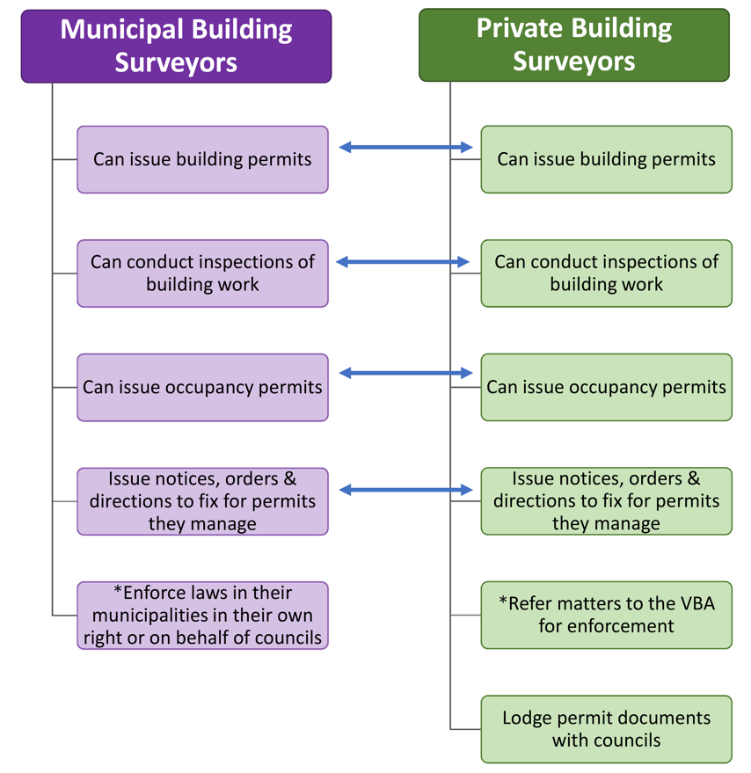
*Note: Details of the enforcement responsibilities of municipal and private building surveyors are described in Section D7 and illustrated in Figure D7.1.

Recent reform efforts and outcomes
Previous reports, including the 2011 and 2015 reports by the Auditor-General, identified issues with the building permit process and made recommendations for improvement. Many of the issues have been addressed by the Victorian Government through its ongoing program of reform to the building regulatory framework.
Some of the important reforms to the building permit process that have been implemented by the Victorian Government since 2015 include:
- addressing potential conflicts of interest by requiring owners to appoint private building surveyors;
- giving the VBA and private building surveyors stronger powers to direct builders to fix defective work to ensure early intervention and the rectification of defective and non-compliant work by builders;
- providing tools for building surveyors, such as checklists, to assist them to carry out their functions and to ensure all required documents are lodged with councils;
- introducing corporate registration for building practitioners, including building surveyors, to enable the probity of these businesses to be checked and the VBA to take disciplinary action against their directors;
- strengthening the regulation of building inspections to provide greater assurance that the person who carries out an inspection of building work is qualified to do so;
- clarifying that the administrative and enforcement functions of councils apply where private building surveyors have been appointed;
- introducing an online system at the VBA to issue building permit numbers;
- confirming that the builder named on the building permit is responsible for ensuring that the work complies with the Building Act, Regulations and permit; and
- broadening the power of the VBA and councils to obtain court orders for rectification of non-compliant building work.
In July 2019, the Victorian Government announced a package of initiatives to address high-risk cladding in buildings. The initiatives include a review of the Building Act ‘to identify what legislative change is needed to strengthen the system and better protect consumers’. The Victorian Government is currently considering the scope of that review and how it will be delivered. Depending on the scope of this discussion paper, it could consider some of the possible opportunities for improvement identified below.

What this review found about the building approvals process
Stakeholder feedback and analysis undertaken for this review has identified five blockages which are delaying building and increasing costs for owners and developers.
These include delays in the:
- preparation, assessment and lodgement of building permit applications;
- issuing of building permits and the commencement of building work;
- inspections of building work and the completion of buildings;
- discharge of any conditions on planning permits that must be met before building and occupancy permits can be issued; and
- issue of occupancy permits and the occupation of buildings.
In most instances delays are the result of a mix of factors with some causing delays at multiple stages in the building permit process.
The causes of delays include:
- shortage of building surveyors, inspectors and fire safety engineers (see Section D1);
- difficulty accessing certificates and documents held by councils and needed for the preparation and assessment of building permit applications (see Section D2) and for enforcement (see Section D7);
- certain types of small low-risk building work unnecessarily requiring a building permit (see Section D3);
- the cost and timing of preparing construction management plans (see Section D4);
- inconsistent requirements for the protection of council assets and infrastructure (see Section D5);
- poor quality reports from building consultants escalating/creating disputes between owners and builders and stopping building work (see Section D6);
- the rectification of poor-quality work that should have been detected earlier (see Section D7);
- directions and orders awaiting enforcement (see Section D7); and
- conditions on planning permits that must be completed during the building permit process (see Section C6).
Eight opportunities for improvement have been identified to address these delays:
- Expand the workforce of building surveyors, building inspectors and fire safety engineers.
- Improve access to building records.
- Streamline building permit requirements for low-risk work.
- Standardise construction management plans.
- Improve consistency of council asset protection requirements.
- Distinguish building ‘consultants’ from building surveyors.
- Clarify processes for enforcement.
Each opportunity is discussed below.

Expand the workforce of building surveyors, inspectors and fire safety engineers

Opportunities for improvement
The Australian Institute of Building Surveyors (AIBS), MBAV, HIA and Victorian Municipal Building Surveyors Group (VMBSG) have reported shortages of building surveyors, building inspectors and fire engineers for the private sector and local government, particularly in regional areas and for smaller building projects.
These shortages are consistent with the finding of Infrastructure Australia’s 2019 ‘Australian Infrastructure Audit’ – that the increasing size and complexity of infrastructure projects, particularly in Victoria and New South Wales, are exceeding industry capacity and that ‘[a]t all levels and for all types of infrastructure, access to appropriate skills is a problem’. Infrastructure Australia advises that ‘[i]f we are going to continue to be productive and accommodate change, we need to grow industry skills and capacity’.
The shortages of building surveyors, inspectors and fire engineers are resulting in heavy workloads and causing delays in the approval and construction of buildings. Stakeholders have advised that for some projects it is difficult to find a building surveyor; to organise timely inspections with a building surveyor or inspector; to find a fire safety engineer to design and approve performance solutions; and to schedule a time for a building surveyor to undertake the final inspection and issue an occupancy permit.
AIBS has been reporting a national shortage of building surveyors since at least 2015. Data provided by the VBA suggests that while the number of registered building surveyors in Victoria has increased since 2013-14, their workloads have remained high, and the complexity of their work and the value of building work has increased significantly. Practicing building surveyors registered with the VBA are estimated to have issued on average around 205 building permits in 2017-18 compared to 202 in 2013-14, and 163 occupancy permits and certificates of final inspection in 2017-18 compared to 165 in 2013-14.
A recent report by the Municipal Association of Victoria (MAV) ranked building surveyors third highest in the list of the top ten occupations with skill shortage in local councils.
In addition, building surveyors, along with inspectors, carry out inspections of building work at the mandatory and other stages of constructing or renovating a building to ensure that the work at those stages complies with the Building Act, the Building Regulations and the building permit. During 2017-18, each registered surveyor and inspector is estimated to have carried out on average around 424 inspections compared to 421 in 2013-14.
Where a mandatory stage involves the inspection of fire and smoke-resisting building elements, this is required to be carried out by a fire safety engineer, or a building surveyor or inspector with fire safety qualifications. As the mandatory fire safety inspection was only introduced in July 2018, there is some concern that this may be putting additional pressure on the 208 registered fire safety engineers, given the engineering skill shortage predicted by Engineers Australia.
The mix of factors contributing to these shortages are the:
- broad scopes of work for each of the two classes of building surveyors;
- coverage and increasing cost of professional indemnity (PI) insurance;
- lack of interest from school leavers in the profession; and
- ageing nature of the profession.
These factors are each outlined below.

Scope of work of registered building surveyors
The two classes of registration for building surveyors (unlimited and limited) have broad scopes of work that authorises them to perform the full range of functions for all classes of buildings and are only distinguished by the size and height of buildings. Such broad scopes of work result in high entry requirements and increase the liability of building surveyors and their risk profile for PI insurance, both of which can discourage people from entering and remaining in the profession. It also means that for the approval of low-rise domestic buildings such as single dwellings, owners are still required to use building surveyors, either limited or unlimited.

PI insurance
In July 2019, the PI insurance issue came to a head with the only remaining insurer responding to a potential increase in claims arising from defective building work, in particular, combustible cladding, by withdrawing exclusion free policies and increasing premiums for some building surveyors by a reported 300 per cent. Insufficient information on the incidence of defective work and the cost of rectification have made it difficult for the insurer to determine its likely exposure and appropriately price PI insurance policies.
To address this information gap, the VBA wrote to building surveyors in June 2019 advising them of their cladding exposure as identified in the statewide Cladding Audit and that they should disclose this information to their insurer to enable any future claim to be covered by their existing policies.
The Victorian Government responded to the PI insurance policy changes by amending the Building Practitioners’ Insurance Ministerial Order to allow PI insurance policies with certain exclusions for external wall cladding products. Cladding Safety Victoria was established in July 2019 to provide support and guidance to building owners and occupants of buildings with combustible cladding about how to reduce fire risks, help them find qualified project managers and other professionals and, in higher risk situations, provide funding for approved rectification works.
At the July 2019 meeting of the Building Ministers’ Forum, states and territories agreed to work towards a coordinated approach to PI insurance. An options paper is being developed in collaboration between New South Wales and Queensland that will set out a pathway for professional standards schemes and alternative PI insurance options. The options paper will be released for targeted consultation with insurers and the building industry.

Interest in the profession
Enrolment and graduation rates are low in the university and TAFE courses students are required to complete to be eligible for registration with the VBA as building surveyors and inspectors. This is due to a lack of interest among school leavers in studying the relevant courses.
A study commissioned by the MBAV in 2017 reported that 45 students commenced the Bachelor of Building Surveying at Victoria University in 2015 but only nine students completed the course that year. Low numbers of graduates in university building surveying courses has been experienced across Australia since 2002.
While enrolments in the Advanced Diploma of Building Surveying were significantly higher and increased from 145 students in 2015 to 215 students in 2018, the numbers completing the course were much lower with 45 students graduating in 2015 and 55 graduating in 2018. While the numbers of graduating students in the Advanced Diploma are encouraging, stakeholders have advised that many students seek employment in related occupations instead of building surveying and inspection. There is also a gender imbalance as there are very few female building surveyors or inspectors.
This lack of interest is attributed to building surveying and inspection being seen as a ‘risky profession’. The roles are not well publicised and recent reports on building issues emphasise the liabilities and risks placed on surveyors and inspectors and discourage new entrants.
There is also a perception that there are no clear career pathways in the profession for graduates, and no targeted entry paths or ‘bridging’ arrangements that recognise the knowledge and skills of practitioners from related occupations such as builders, architects, engineers and project managers, who may wish to move across to building surveying and inspection work. For example, there is a pool of experienced builders facing physical challenges as they age in their current roles who could be expected to be interested in becoming building surveyors or inspectors.
In response to these issues, the VBA is implementing a long-term strategy to promote interest in the profession and encourage the participation of women.
The strategy includes:
- participating in careers expos and speaking at schools to promote the professions;
- supporting graduate surveyors to gain registration through placements with councils and the VBA;
- designing a formal graduate program for building surveyors; and
- investigating professional development programs and online training to keep industry knowledge up to date.
Other barriers to entering the profession identified by stakeholders include:
- the quality and level of courses;
- the availability of courses (which are mostly delivered face-to-face and concentrated in Melbourne);
- the availability of qualified trainers with practical knowledge and experience; and
- the cost of courses (full fees are estimated to be between $30,000 to $50,000 per course depending on whether it is a TAFE or university course).
The Commonwealth Government has a subsidy program to assist with course tuition fees for university courses, including the Bachelor of Building Surveying. The Victorian Government introduced the ‘Free TAFE Program’ in early 2019, which, among other courses, includes the TAFE Advanced Diploma in Building Surveying that is prescribed for the registration of the limited class of building surveyors and inspectors.
In terms of course quality, stakeholders have raised concerns about the content of some courses, noting that there are gaps in key areas such as the practical application of the technical requirements and standards for the construction of buildings under the Building Act and the NCC. Consistent with this observation, Peter Shergold and Bronwyn Weir, in their 2018 report to the Building Ministers’ Forum, noted that ‘there are gaps in the accountability of practitioners with key responsibilities for compliance with the NCC across Australia’. Accordingly, they recommended a compulsory unit on this topic in the National Construction, Plumbing and Services Training Package:
‘An essential element of training packages must be training on the NCC and the manner in which it needs to be applied. This is not presently a compulsory unit of study for all qualifications which are required for registration. It should be. Effective implementation of the NCC depends upon it.’
The building permit is the means by which the requirements of the NCC are incorporated into the build. The NCC specifies the minimum building standards but there can be a variation from the standards when a building surveyor approves a performance solution which certifies that an alternative approach, usually at a lower cost, is the equivalent of the standards.
The concern for the engineering professions is future capacity. The low number of local engineering graduates each year means that, for at least the last 15 years, Australia has been relying heavily on skilled migration to meet local demand. A recent report by Engineering Australia, ‘Engineers Make Things Happen’, noted that there are risks with this approach, in particular, in terms of building local engineering capability to meet future demand as Australia diversifies from a resource-based economy.

Ageing profession
While the number of new entrants to the industry is low with an average of 29 new building surveyors and 45 new inspectors registered with the VBA each year between 2013-14 and 2018-19, to date this has been enough to offset the number leaving through retirement or moving to other professions. However, with 30 per cent of building surveyors and inspectors over the age of 55, it is anticipated that an estimated 330 building surveyors and inspectors will retire in the next 10 to 15 years. In these circumstances it is essential to increase the number of people entering the profession each year to reduce workloads and improve the quality and timeliness of services provided by building surveyors and inspectors.

Proposed improvements
The following improvements are proposed.
- Establish a new class of building surveyor for low-risk building work.
Depending on the scope of the Victorian Government's recently foreshadowed review of the Building Act, it is proposed that a new class of building surveyor be created that has a narrower scope of work. This scope of work would be limited to low-rise domestic building works (Class 1 and 10 buildings) not exceeding 500 square metres floor area.
Box D1.2: Building Classes
Class 1 buildings
A residential dwelling including:
- a single detached dwelling, or one of a group of two or more attached dwellings, each being a building, separated by a fire-resisting wall, including a row house, terrace house, town house or villa unit; and
- a boarding house, guest house, hostel or similar, with a total area of all floors not exceeding 300 square metres, and where not more than 12 people reside, and is not located above or below another dwelling or another Class.
Class 10 Buildings
Non-habitable building or structure including a:
- private garage, carport, shed or the like;
- structure being a fence, mast, antenna, retaining or free-standing wall, swimming pool or the like; and;
- private bushfire shelter.
A narrower scope of work would reduce the risks arising for building surveyors from carrying out that work compared to the existing limited and unlimited classes of building surveyors. The reduction in liability for potentially defective building work resulting from this lower risk profile for low-rise domestic building work would be expected to ease the cost of PI insurance for the new class of building surveyor.
Increasing the supply of building surveyors to perform functions for low-rise domestic building work would free up more qualified surveyors to do more complex work, thereby reducing delays associated with appointing building surveyors for that work and improving quality assurance.
The proposal is consistent with evidence that around 83 per cent of building permits issued over the last 10 years were for Class 1 and 10 buildings of less than two storeys. It would also support national harmonisation by aligning Victoria with equivalent classes of registration in New South Wales, Queensland and South Australia and facilitate the movement of surveyors into Victoria through mutual recognition.
Box D1.3: Registration categories for building surveyors (certifiers) in Queensland
Building Certifier Level 1 – all classes of buildings and structures.
Building Certifier Level 2 – buildings and structures up to three storeys and with a total floor area of up to 2,000 square metres, or, under the supervision of a Building Certifier Level 1, helps assess and inspect all classes of buildings and structures.
Building Certifier Level 3 – Class 1 buildings and Class 10 buildings and structures.
- Increasing interest in the building and engineering professions.
- To interest school leavers in the building surveying and inspection professions, the following improvements could be considered:
  - the VBA, supported by the Victorian Government, the peak industry associations and training providers, continues to deliver its long-term strategy to market the profession as a desirable career option for school leavers and people wanting to change occupations, with a particular focus on encouraging women to consider careers as building surveyors and inspectors;
  - the VBA, together with the peak industry associations and training providers, should:
    - identify opportunities to increase the availability of training, particularly in regional Victoria, and provide flexible modes of study to support students to access and complete courses;
    - identify and recommend, as appropriate, any additional courses that could be prescribed for the registration of building surveyors and inspectors; and
    - strengthen the coverage in the prescribed courses of the technical requirements and standards under the Building Act and the NCC by recommending the preparation of a separate unit of study on this topic and developing local content and materials for use by training providers.
  - the Victorian Government should:
    - in partnership with the VBA and peak industry associations, consider promoting and providing scholarships for approved university and TAFE courses;
    - consider subsidising HECS fees and providing other funding support for university students studying the Bachelor of Building Surveying to complement the extension of the Free TAFE Program announced in August 2019;
    - consider funding training providers to support the development of trainers with industry experience, robust training materials and assessment tools to enhance training standards; and
    - consider providing support for cadetships.
- To address the predicted engineering skills shortage and the impact this may have on the availability of appropriately skilled fire safety engineers, Engineering Australia’s ‘pipeline strategy’ is supported, which calls on the Commonwealth Government to try to reverse the decline in secondary school students, in particular women, taking up science, technology, engineering and maths subjects.
- Set-up new bridging pathways for practitioners from related professions.
A new entry pathway for building surveyors and inspectors should be introduced for practitioners from related professions such as builders, architects, engineers and project managers. This would comprise a series of targeted bridging courses that recognise the knowledge and experience of these practitioners while providing top-up competencies in building surveying, law and practice.
The bridging course pathway could be developed by the VBA in consultation with relevant peak industry bodies and training providers. The VBA could then recognise the bridging pathway using the power under section 171 of the Building Act, which gives it the authority to consider alternative non-prescribed qualification pathways for applicants for registration as building surveyors and inspectors. However, to support the VBA in promoting this pathway, it could be set out in a Ministerial Direction to the VBA. The VBA could also prepare and publish guidelines on its approach to administering the bridging pathway to ensure that the process is consistent and transparent. Consideration could also be given to whether the bridging courses should be accredited by the Victorian Registration and Qualification Authority or other relevant accrediting body.
Introducing a clear pathway for practitioners from related professions to transition into building surveying and inspection work would both expand the career paths for these practitioners and assist in alleviating the shortages of building surveyors and inspectors.

Improve access to building records

Opportunities for improvement
Councils are currently the central repository for records relating to building and occupancy permits, notices and orders and certificates of final inspection. They receive these documents from building surveyors at various stages during the building permit process. These documents become public records and are frequently needed for the preparation of subsequent building permits, for example, in the case of alterations and for enforcement.
Stakeholders have reported that delays can arise if these records are not available, they are incomplete, or are kept in hard copy and assessing them is time consuming and difficult. Despite changes to the Building Regulations to clarify that building records can be lodged, stored and retrieved electronically, some records are still lodged in hard copy by building surveyors and stored by councils. Additionally, many historic records are still stored as hard copy. Therefore, as time passes and properties are sold it can become increasingly difficult to access past building records.
‘It is frequently difficult to access all the relevant documents about the construction of a building, especially when the building has been sold. Important assumptions and requirements that underpin the design and performance solutions for the building are not always available to subsequent owners. This has become a bigger issue as the complexity of buildings and their fire safety systems have increased, especially where performance solutions have been used.’
Where accurate building records are not available, there are potential safety risks and owners can incur unnecessary additional costs and delays in preparing a building permit. Without access to the relevant building records about the materials or methods used in constructing the building, owners need to engage an independent professional, for example, an architect, engineer or building inspector to compile the information they need. Depending on the condition of the building, these reports can cost up to $30,000 and in many cases are based, at least in part, on the expert opinion and assumptions made by the professional, rather than a verified written record.
As Shergold and Weir noted, the inaccessibility of building records can have broader implications.
‘Unfortunately, despite requirements for record creation and keeping, key information is not readily accessible or auditable. The recent cladding audits have demonstrated that the ability to identify buildings for audit and to examine building approvals documentation in a comprehensive manner has been challenging for some jurisdictions.’
Previous inquiries and reports have recommended that building records be centralised and digitised to increase the speed, accuracy, and availability of records, and to reduce the lodgement and storage costs.

Proposed improvement
- A central database for Victoria that is managed by the VBA is the intention of the Victorian Government. In the longer term, the Building Activity Management System (BAMS) platform, recently introduced by the VBA to manage building permit numbers, is intended to provide a central building records database.
Once the needed software and infrastructure are in place through BAMS, councils could be assisted to migrate existing digitised records to BAMS and digitise and lodge remaining hard copy building information.
The intention of the BAMS system is that building surveyors would lodge records electronically direct to BAMS and would have unlimited access to records held in BAMS to support them to perform their building permit and enforcement functions. Councils would use the access they have through BAMS to records in their jurisdictions to respond to public requests for access to records.

Streamline building permit requirements for low-risk work

Opportunities for improvement
There are many categories of building work that are exempt from the requirement to obtain a building permit and an occupancy permit. These are listed in schedule 3 of the Building Regulations and include 18 categories of buildings and works, such as for the repair, renewal or maintenance of an existing part of a building or the demolition of a garage.
The rationale for the exemptions is that the work is of such a minor nature that the protections and advantages that a permit provides are not necessary. However, to ensure public protection, each category of exempt work is subject to certain conditions being met. For example, to be exempt, a pergola must meet certain siting requirements and be no larger than 20 square metres and no higher than 3.6 metres.
Stakeholders have identified additional areas where the requirement for building and occupancy permits could be removed without compromising safety or standards. Where the risk of building work is low, removing the requirement to obtain a building permit and an occupancy permit would mean the earlier commencement of that building work and would reduce the cost of completing the work.
While the list of exemptions has been progressively expanded with each sunset review of the Building Regulations, there remain some categories of low-risk, high-volume work where a building and occupancy permits are unnecessary, impractical or burdensome in terms of the cost compared to the potential benefits. Such permit requirements may lead to delays and costs, put additional pressure on the heavy workloads of building surveyors, and can lead to works being done illegally to circumvent the permit process.
Stakeholders have highlighted small decks, mobility access ramps and small sheds as examples where the requirement to obtain permits is disproportionate to the risks posed by those structures.
Decks
While certain pergolas are exempt from a building permit, the construction of any type of deck associated with a building, regardless of whether it is attached to a building, requires a permit in Victoria. In other states, such as New South Wales, Queensland, and South Australia, certain decks do not require a permit provided they meet specified requirements about size and siting. For example, among other requirements, a deck is exempt from building approval if its maximum height is one metre in New South Wales and 500 millimetres in South Australia.

Mobility access ramps
There is no specific exemption for mobility access ramps in the Building Regulations. Whether the construction of a particular ramp is exempt from obtaining a building permit, depends on it meeting the conditions set out in clause 4 of Schedule 3 of the Building Regulations.
As councils consider exemptions on a case-by-case basis and are reported as being generally conservative in their approach to the conditions specified in clause 4, in particular whether the structural soundness of the building or the safety of the public will be adversely affected, it means that permits may usually be required for mobility access ramps. It also means that decisions on the need for permits vary both within councils and across councils and, therefore, it may not be easy to predict when a permit will be required.
In addition, the cost of building permits for such low-risk building works can be more than the cost of building a mobility access ramp.
Regardless of whether a building permit is required for particular case, the construction of a mobility ramp must comply with the accessibility standards in the NCC.
Sheds
In Victoria, as in other states, sheds (Class 10a non-habitable buildings) are exempt from a building permit in certain circumstances, although these vary across states. For example, the size of an exempt shed is 10 square metres or less in Victoria, Queensland and Western Australia, 15 square metres in South Australia and generally 20 square metres in New South Wales, except in certain rural areas where the limit is 50 square metres. Only Tasmania has a smaller limit of nine square metres.

Proposed improvements
To address the costs and delays that arise where low-risk, low impact work requires a building and an occupancy permit, the range of exemptions could be expanded, on the condition that the work meets certain requirements.
- Decks
The construction of a low-rise deck could be exempted from the requirement to obtain a building permit provided its maximum height does not exceed 800 millimetres. This height aligns with the overlooking requirements. To ensure its structural integrity, the construction of a deck would continue to be captured by Part 2 of the Building Regulations so that it is subject to the requirements of the NCC.

- Mobility access ramps
To ensure that all mobility access ramps are exempt from the requirement to obtain a building permit, including those that provide higher level access, exemptions could be introduced for:
- mobility access ramps that do not exceed 800 millimetres in height provided they comply with the NCC; and
- mobility ramps that exceed 800 millimetres in height provided they comply with the NCC and are certified on completion by a building surveyor or inspector.
Under both these sets of conditions, mobility access ramps would be exempted from the front, side and rear setback requirements.
- Sheds
The existing exemption for sheds could be expanded by increasing the current 10-square-metre floor area trigger to 16 square metres. Stakeholders have advised that increasing the size to 16 square metres would ensure that enough space is available in exempt sheds to store tools and equipment for land and bushfire management.
The proposed exemptions would require amendments to the Victorian Planning Provisions and the Building Regulations to specify the details and conditions, provide an exemption from the setback requirements and require ‘as built documents’ to be lodged with councils. The Building Act would also need to be amended to set out the responsibility of building surveyors and inspectors to certify certain mobility access ramps when construction is completed.

Standardise construction management plans

Opportunities for improvement
Construction management plans are required for large or difficult to build developments and address matters such as public safety, amenity and site security, operating hours, noise and vibration controls, air and dust management, stormwater and sediment control, waste and materials re-use and traffic management. The purpose of a construction management plan is to ensure that building work and demolitions do not adversely affect the community or the environment in the surrounding area.
The requirement for a builder to prepare a construction management plan is made through a condition on a planning permit which must be met before a building permit can be issued.
Major builders have identified that the approval processes for construction management plans can be costly and time consuming. One stakeholder identified three projects in Melbourne where it took 12 months for the construction management plans to be approved, and two projects in the suburbs where the construction management plans took six months to be approved.
One cause of delay is that the building surveyor is prohibited from issuing a building permit until the council is satisfied that the building permit complies with the planning permit. This only occurs when the council confirms, and communicates, that it is satisfied with the construction management plan which is a condition on the planning permit.
One major builder also identified an apparent skills gap in certain councils that did not have the ability to assess and approve construction management plans, citing multiple questions that demonstrated a lack of experience in the relevant field. This inexperience was seen to cause a delay in the review and approval of a construction management plan that took six months to be approved.
Stakeholders have also advised that the details required in construction management plans can be unclear, that the standards of documentation vary between councils and that procedures for administering plans are inconsistent across councils.
Rather than being imposed as a condition on a permit, stakeholders have suggested that construction management plans be agreed at the same time as planning permits so that work can commence immediately.

Proposed improvements
In October 2018, the Victorian Government committed to introducing mandatory construction management plans to put an end to residents being disturbed by noise from construction workers or rubbish removalists outside reasonable hours.
In line with this commitment, DELWP recently consulted on the next stage of the ‘Building Better Apartments’ initiative and included the following proposal in its 2019 Better Apartments in Neighbourhoods Discussion Paper:
‘Before the development commences, including demolition, bulk excavation and site preparation works, a Construction Management Plan must be submitted to and approved by council. The Construction Management Plan must consider the following, as appropriate:
- Public safety and site security
- Operating hours, noise and vibration controls
- Air quality (airborne dust and pollutants)
- Traffic management
- Erosion and sediment
- Stormwater
- Litter, concrete and other construction wastes
- Chemical contamination’.
DELWP’s proposal to standardise the requirements for the preparation of construction management plans, if applied across Victoria, should provide benefits in terms of consistency.
- As many of the elements included in a construction management plan draw on local laws, DELWP could also prepare a model local law in consultation with councils and MAV to further facilitate standardisation across Victoria. The model local law would encourage a standard form and application of standard requirements, which could be varied by councils in certain circumstances to suit local conditions. Councils would need to replace their existing local laws with the model laws in line with the procedure for doing so set out in the Local Government Act
- To accompany the model local law, a model construction management plan and guidelines for the model plan could be developed. These would support the consistent preparation and assessment of construction management plans within Victoria. The guidelines and model plan prepared by the City of Melbourne are examples of current best practice that could guide this work.
- Consideration could also be given to including construction management plans in the concierge model of case management in councils (see B1). The City of Greater Dandenong has been cited by stakeholders as an example of using this practice efficiently.

Improve consistency of council asset protection requirements

Opportunities for improvement
The HIA has expressed concern about inconsistent requirements for the protection of council assets and other matters prior to the commencement of building work.
Before work can commence, a developer or their builder must obtain an Asset Protection Permit from the relevant council and pay a security bond. Council assets include, for example, footpaths, driveways, roads, kerbs and channels, trees, drains and pit lids and nature strips. Councils may also require developers and their builders to obtain permits for utility or development-related work, such as working in a road reserve, temporary road closures, constructing or altering a vehicle crossing, service authority works, drainage works in easements, building over easements and applying to connect storm water to a legal point of discharge.
The purpose of these permits is to ensure that public assets and infrastructure are kept safe during demolition and building work and fully restored afterwards. They also avoid developers and builders having to pay for pre-existing damage to council assets and infrastructure.
Despite previous attempts to improve greater consistency, the HIA submission notes that the requirements for these permits vary between councils in both form and substance. As a result, builders experience additional administrative burden to identify and respond to the different requirements of each council. Many of these matters are implemented by councils through local laws or administrative requirements. They may also be required to be addressed as part of a construction management plan condition for a planning permit.
The inconsistency of these requirements across councils creates unnecessary administrative overheads for developers and builders operating in more than one municipality to comply with each requirement.

Proposed improvements
- Stakeholders have recommended that a standard practice guide should be set for building-related work that could be adopted by all councils to create uniformity across Victoria.
- To support such a practice guide and standardise the requirements for council permits and asset protection, a model local law could be developed in consultation with councils and MAV. As proposed for construction management plans, the model local law could adopt a standard form and consistent requirements, which could be varied by councils to suit local conditions. Councils could also publish enforcement policies relating to these local laws. The model local law could be adopted by councils through an amendment to their local laws using the power given to them by the Local Government Act.
- Consideration could also be given to including asset protection requirements in the concierge model within councils (see B1).

Distinguish building ‘consultants’ from building surveyors

Opportunities for improvement
Building consultants are generally engaged by owners undertaking small building projects, such as building, renovating or extending a single or dual occupancy dwelling. They are engaged by owners to seek advice about the quality of the building work that is independent of the builder and the building surveyor and inspector.
However, stakeholder feedback suggests that building consultants are, in some instances, raising minor matters that are causing disputes between owners and builders and unnecessarily delaying building work. In a submission to this review, the HIA advised that its members have indicated that building consultants are causing disputes, raising unnecessary complaints about the quality of work, trying to direct builders and trade contractors and giving inappropriate advice to clients. Where a dispute arises, this may result in the builder not being paid and work stopping while the dispute is resolved.
While agreeing that owners should not be restricted from engaging building consultants, the HIA is concerned that they are not registered and that there are no mandatory qualification and experience requirements for building consultants, and no process for builders and owners to complain when consultant reports are inadequate or incorrect.
Much of the concern arises because building consultants’ inspections duplicate the functions of private/municipal building surveyors and inspectors but without the legislative authority of these statutory roles. The roles of building surveyor/inspector and building consultant are further confused where the building consultant carries out inspections at the mandatory inspection stages or after the occupancy permit has been issued. Stakeholders have observed that in many cases the reports provided by building consultants tend to highlight minor technical matters, for example, reporting work as defective where it is within agreed tolerances.
DBDRV, which was established in 2017 to provide binding dispute resolution services for owners and builders before a matter goes to VCAT, has confirmed that owners are lodging disputes based on the reports from building consultants. DBDRV identified three categories of building consultants, including those who:
- are skilled and qualified, and provide good quality and accurate reports;
- are unskilled and provide reports that are technically inaccurate and misquote regulatory requirements and building standards (stakeholders have also raised concerns that some building consultants may not be qualified to prepare reports and may be unfamiliar with domestic building contracts and the NCC); and
- aggressively market their services and provide reports that, while technically correct, tend to mislead owners about the consequences of the ‘defect’.
An example of a ‘defect’ listed in a report by the last category of building consultant that resulted in the owner applying to DBDRV was the width of the perpend (vertical) mortar layer used in the construction of a wall. Because the perpend was one millimetre over (which was technically correct) the owner was led to believe that the ‘defect’ jeopardised the structural integrity of the wall and, therefore, that the wall needed to be rebuilt. An independent expert report by DBDRV found no structural concerns.

Proposed improvements
- It is proposed that in the short term, Consumer Affairs Victoria (CAV) runs a communications campaign to raise consumer awareness of the the role of building consultants compared to building surveyors, the importance of engaging a qualified person, what to look for when engaging a building consultant, the risks, the relevant laws, where to get help and how to make a complaint.
- In the longer term, DELWP and CAV could undertake a joint review into the:
- issues raised by stakeholders, such as the HIA, and the risks for building owners and consumers more generally arising from the operation of building consultants; and
- measures, both regulatory and non-regulatory, to address the issues including, but not limited to, the costs and benefits of a consumer awareness campaign and a registration scheme for building consultants. A registration scheme could consider standards of practice including permitted and prohibited conduct, which may be in the form of a mandatory code of conduct.

Clarify processes for enforcement

Opportunities for improvement
The building permit process in Victoria relies heavily on the approvals of private building surveyors who have statutory responsibility for the complete process from issuing the permit that approves the start of building work through to verifying work at mandatory stages during construction and, finally, certifying that a completed building is suitable for occupation. This means that private building surveyors have a critical role in ensuring the integrity of the permit process and the quality and standard of building work at the mandatory inspection stages.
Private certification was introduced in Victoria in July 1993 to encourage competition by providing the option to use a private or a municipal building surveyor to certify building work. By 2018-19, private building surveyors issued over 96 per cent of building permits.
However, since then problems have emerged with the operation of private certification. There is:
- an inherent conflict of interest between private building surveyors and builders; and
- fragmentation of the respective accountabilities and processes of private building surveyors, municipal building surveyors, councils and the VBA for ensuring the quality of building work and enforcing compliance with the Building Act and the Building Regulations.
Conflict of interest
Several recent reports have found an inherent conflict of interest with the way in which private certification in the building permit process works. This conflict, which is not unique to Victoria, arises because of the control that private building surveyors have over all aspects of the permit process combined with the commercial relationships they have with builders who they depend on for ongoing work. This makes them vulnerable to competing interests and demands which may compromise the public interest.
The conflict of interest and its consequences was highlighted in the 2011 and 2015 reports on the building regulatory framework by successive Victorian Auditors-General.
‘The current regulatory framework also entrenches a long-recognised conflict of interest for private building surveyors who are assessing the compliance of other building practitioners while often also relying on them for work. This undermines the building surveyors' statutory role.’
In 2017, the Victorian Government amended the Building Act to address this conflict by prohibiting builders from engaging private building surveyors on behalf of owners. Despite this prohibition, Shergold and Weir advise that even if the building surveyor is appointed by the owner, the conflict will remain as this appointment will be influenced by the private building surveyors’ relationships with builders and/or designers.

Shergold and Weir also noted that:
‘It is consistently reported that many private building surveyors are not inclined to take enforcement action against their ‘clients’.’
Underpinning the conflict is the broad range of statutory functions that private building surveyors perform in Victoria. As previously noted, they have control over all of the stages in the building permit process. This means that verification of the standard and quality of building work, for all but a few projects, depends solely on the views and expertise of a single private building surveyor. This increases the potential risk to public health and safety.
For example, if a private building surveyor, either intentionally or unintentionally, approves flawed designs and specifications or unsuitable alternative fire safety measures, they are less likely to identify and require rectification of these problems during construction. Similar issues arise where the same private building surveyor conducts the mandatory inspections and also issues the occupancy permit.
Like Victoria, full private certification models are in place in other states, such as New South Wales and Queensland. Shergold and Weir noted that some jurisdictions with full private certification are ‘… considering limiting the involvement of private building surveyors…’. Other states and territories, such as Western Australia, have partial private certification models that limit the roles of private building surveyors. In Western Australia, building surveyors are responsible for certifying that proposed building work complies with the NCC, but councils are responsible for issuing both building and occupancy permits.
Fragmentation of enforcement processes and accountabilities
Shergold and Weir concluded that it is not just the inherent conflict of interest that contributes to problems in the building permit process but, among other factors, the gaps and weaknesses in the processes and accountabilities for the building permit process.
Figure D7.1 shows the statutory processes and accountability for issuing permits and undertaking enforcement in Victoria. It also shows the new role of the State Building Surveyor.
The position of the State Building Surveyor was recommended by the Victorian Cladding Taskforce in its 2017 Interim Report ‘… to provide authoritative compliance advice, provide technical guidance and provide interpretations of relevant standards’. The inaugural State Building Surveyor was appointed in June 2019 and as head of the profession ‘… will support the industry change required to ensure buildings are consistently well-built, safe and fit for purpose’.
As shown in Figure D7.1, the enforcement accountabilities for the building permit process are split between four groups – private building surveyors, municipal building surveyors, local councils and the VBA – which leads to fragmentation and confusion.
Stakeholder feedback to this review and previous inquiries have reported that this fragmentation means, in practice, that it is often not clear who is responsible for enforcement of building permit matters. As a result, matters may be referred to the wrong person or authority, referred on from one person or authority to another on multiple occasions, or not fully considered.
For example, where a private building surveyor finds non-compliant work during an inspection, they are required to direct the builder to fix the work. If the builder does not fix the non-compliant work, the private building surveyor is required to refer the matter to the VBA for enforcement, which in turn, may refer it to the municipal building surveyor at the relevant council.

Figure D7.1 Statutory processes and accountabilities for issuing permits and enforcement – building permit process
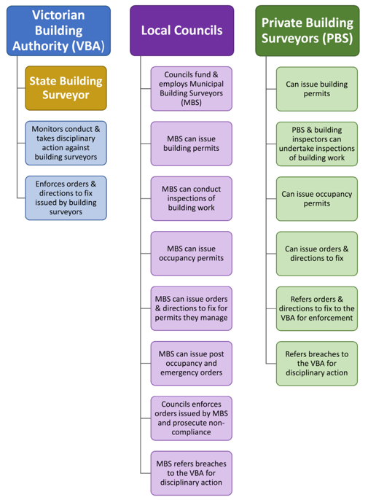

Box D7.1: Enforcement accountabilities
Private and municipal building surveyor accountabilities
For work they have been appointed to manage, both private and municipal building surveyors may require the rectification of non-compliant building work or work that presents a risk to the life, safety or health of any person by:
- issuing a direction to a builder to fix work that fails to comply with the Building Act, the Building Regulations and the permit; and
- serving a notice and order on a building owner to stop work or to require certain work to be carried out.
While the powers of private building surveyors are limited to these matters, municipal building surveyors have the power to issue orders after building work has been completed, including issuing emergency orders.
Any non-compliance with orders and directions issued by private building surveyors is referred to the VBA for enforcement while orders issued by municipal building surveyors are enforced by councils.
Council accountabilities
Though councils are responsible for dealing with unlawful building work and have the power to prosecute offences for non-compliance, these functions are generally delegated to their municipal building surveyor. Municipal building surveyors also perform an array of other building functions on behalf of councils, such as issuing reports and consents, dealing with changes of building use and enforcing essential safety measures.
However, the extent to which municipal building surveyors and councils can proactively undertake enforcement activities is limited by a lack of sufficient funding. The building function must complete with other council activities for funding from rates, with only limited opportunity for cost recovery,
VBA accountabilities
The VBA shares responsibility for enforcing the building permit process. It has responsibility for enforcing directions, notices and orders issued by private building surveyors that have not been complied with by the builder or the owner and, like councils, can prosecute offences.
The VBA’s compliance-monitoring and enforcement responsibilities extend beyond the building permit process. It also monitors the conduct of building practitioners, including building surveyors, inspectors and engineers, and is responsible for enforcement of their compliance with the Building Act and the Building Regulations. It has powers to undertake inspections, investigations and audits of work carried out by building practitioners and can take disciplinary action where necessary.
Shergold and Weir have described state and territory enforcement arrangements, such as those in Victoria, as fragmented and patchy:
‘This results in a fragmented system of regulatory oversight which is prone to duplication, confusion, unclear lines of responsibility and a lack of information sharing. This can be exacerbated in cases if some authorities believe that they have received inadequate funding. To the public, especially when things go wrong, this often looks like a game of buck-passing.’
The problems outlined above – conflict of interest and fragmentation of enforcement processes and accountabilities – contribute to delays and additional costs in the building permit process.
To streamline the process, both the VMBSG and AIBS have proposed that the processes and functions be reconsidered.
The key features of the proposal put to this review by the VMBSG are:
- a single regulator which has clear responsibility for ensuring that building work is complaint at all stages of the building permit process;
- the single regulator be funded from the building permit levy;
- private building surveyors be limited to only issuing building permits, or alternatively be limited to dealing with specific classes of building work or only inspecting and certifying work for which they did not issue the building permit and have no relationship with the private building surveyor that issued that permit;
- certain classes of building permits issued by private building surveyors be approved by municipal building surveyors;
- municipal building surveyors be responsible for inspecting building work and issuing occupancy permits, although they could engage private building surveyors and building inspectors to undertake inspections on their behalf; and
- municipal building surveyors integrated into the structure of the single regulator.
The VMBSG supports the State Building Surveyor as the single regulator with responsibility for administering and enforcing the building regulations in Victoria and employing all municipal building surveyors. As a transitional option, the VMBSG suggests that councils be responsible for administering and enforcing the building regulations in their municipalities and continue to employ municipal building surveyors who would be accountable to the State Building Surveyor.
Stakeholder feedback is sought on the need to streamline the process and clarify enforcement accountabilities, and the approach and particular features needed to do this.

Proposed improvements

Accountability and enforcement
- Depending on the scope of the Victorian Government's recently foreshadowed review of the Building Act, that alternative models for the administration and enforcement of the building permit process be considered, including those proposed by stakeholders.
Addressing the fragmentation of the enforcement processes would assist in building consumer confidence in the operation and integrity of the building permit process and the regulatory system.
- That Recommendation 6 of the 2019 Victorian Cladding Taskforce be implemented – ‘that consideration be given to the development and implementation of a protocol between the VBA and councils, which sets out accountabilities, mechanisms for cooperation and communication, strategic interventions and agreed procedures for referring enforcement actions.’ .Similarly, the 2015 report by the Auditor-General noted the opportunity for the VBA and councils to establish communication and reporting protocols. Protocols were raised as an administrative approach to addressing ongoing uncertainty about responsibilities for enforcement that ‘would have significantly enhanced system-wide monitoring.’ The development of local council building plans could also be considered to complement the protocol.

Performance reporting
- The State Building Surveyor should include monitoring and regular reporting on the operation and performance of the building permit process, including making recommendations to improve the process, where needed.
The 2005 inquiry into housing regulation by the Victorian Competition and Efficiency Commission and, more recently, the 2015 report by the Victorian Auditor-General, noted the need for a performance monitoring framework for the building regulatory system.

Conflict of interest
- To remove the inherent conflict, the review of the Building Act could also consider the respective roles of municipal and private building surveyors.
- That a practice guide for building surveyors and inspectors be developed, which benchmarks the processes and the matters they must consider when inspecting each class of building. By clarifying processes and accountabilities for building inspections, a practice guide would assist with quality of work issues arising from conflicts of interest. A similar guide is in place in Queensland and proposed in New South Wales. The practice guide would be supported by templates for building surveyors and inspectors to record the details and outcomes of inspections.
The 2011 report on the building permit process by the Victorian Auditor-General recommended standard templates and procedures to assist building surveyors to ‘… to adequately document their assessment approach and basis of their decisions …[and] … to demonstrate, using these templates and procedures, their consideration and acquittal of mandatory safety and technical requirements’.
Implementation of the guide and templates would require an amendment to the Building Act to provide a head of power for the VBA to approve and enforce a practice guide for building surveyors and inspectors.
- The code of conduct being developed by the VBA would support the proposed practice guide and strengthen the conflict of interest obligations of private building surveyors and inspectors.
While the Building Act imposes obligations on surveyors and inspectors to avoid conflicts of interest, and since 2017 has prohibited builders from engaging building surveyors, the VBA’s code of conduct will strengthen the professional conduct of building surveyors and inspectors and further promote their independence. As noted by Shergold and Weir:
‘Codes of conduct can be an effective means of documenting the clear standards of behaviour expected of professionals who have statutory responsibilities. They also provide a reference against which auditing can be carried out and disciplinary action taken where the code is not met.’.

Appendix 1 – Terms of Reference

Each of Victoria’s municipalities has its own planning schemes, which contains statewide provisions drawn from the reference document Victoria Planning Provisions as well as municipal-level provisions. See Part A for an overview of these and other components of planning schemes, as well as the process for planning scheme amendments to keep these up to date.
PwC generated these estimates using PPARS data and the method used for SPEAR to estimate delay costs, by applying this to subdivision applications, as well as the other application types where delay costs were most likely to be relevant (for example, single dwelling, multi-dwelling and one or more new building applications).
Homes for Victorians, February 2017.
See, for example, Better Decisions Faster (DSE 2003), Housing Regulation in Victoria Building Better Outcomes (VCEC 2005), Cutting Red Tape in Planning (DSE 2006), the ‘Underwood Review’ – Victorian Planning System Ministerial Advisory Committee Initial Report (2011), Compliance with Building Permits (VAGO 2011), Victoria’s Consumer Protection Framework for Building Construction (VAGO 2015), Managing Land Use and Development (VAGO 2017), and Building Confidence – Improving the effectiveness of compliance and enforcement systems for the building and construction industry across Australia (Peter Shergold and Bronwyn Weir, 2018).
https://www.localgovernment.vic.gov.au/our-programs/local-government-act-review
See Section 7(4)(b)(i) of Planning and Environment Act.
As declared by the Minister for Planning under the Planning and Environment Act.
Other complex structure plans that are not in the UGZ, such as those that may be required for some of DJPR’s priority precincts, are not required to go through the VPA’s PSP process, and instead are prepared following DELWP’s structure plan guidance.
See https://vpa-web.s3.amazonaws.com/wp-content/uploads/2017/11/VPA-Local-Town-Centres-PB-261017.pdf
Section 26 of the Planning and Environment Act allows councils to make a report public at any stage and requires them to do so after 28 days.
https://www.planning.vic.gov.au/schemes-and-amendments/planning-report-search
For example, https://www.planning.vic.gov.au/schemes-and-amendments/planning-scheme-structure
Machinery amendments such as these are known as section 20A amendments.
The duties of the ‘responsible authority’ role are described at section 14 of the Planning and Environment Act. By default, the local council carries out the responsible authority role in its municipality; see section 13(2)(a) of the Act. A planning scheme can specify a different responsible authority – for example, every Victorian planning scheme specifies the Minister for Planning as the responsible authority for wind turbine permit applications.
Depending on the planning controls for each parcel of land, there are uses that are exempt from needing a planning permit, but for most substantial changes of use a permit is required.
Every responsible authority must maintain an up-to-date register of the applications that it receives. The information that must be included in the register is set out in regulation 15 of the Planning and Environment Regulations 2015.
A planning scheme can require that specified persons or bodies be given notice of specified classes of application in accordance with section 52(1)(c) of the Planning and Environment Act.
This is a requirement of the Planning and Environment Act.
See section 47 of the Planning and Environment Act.
Planning schemes list ‘application requirements’ and ‘information requirements’ for most application types – these list aspects of a proposal that must be described when lodging an application. Theoretically at least, if all of the information requirements are met and the description is accurate, the council can make a decision.
PwC analysis of PPARS data.
Amendments would be made under Part 1A of the Planning and Environment Act.
https://www.spear.land.vic.gov.au/spear/index.shtml
https://www.spear.land.vic.gov.au/spear/pages/eplan/about/victorian-eplan-implementation.shtml
Local Government Workforce and Future Skills Report, Victoria, Section 3 (Municipal Association of Victoria, December 2018).
This describes the general or default notification requirements in the planning system. In some cases, for example, planning schemes may exempt specific types of applications from these notification requirements.
The Planning and Environment Act prescribes what notice must be given for applications effecting a registered restrictive covenant on a title.
Submissions are not limited to those who receive formal notice: anyone may make submission, and anyone may inspect the planning application at the council office, and request copies from the council. Formal notice simply ensures that specific parties have been notified.
See clause 54.04 of the Victoria Planning Provisions.
In resetting the notional decision time, an RFI provides a council more time to assess and decide an application and divert resources to other pressing applications. See, for example, Stephen Rowley, ‘The Victorian Planning System: Practice, Problems & Prospects’ (The Federation Press, 2017), pp 65-73.
These were appeals under section 78 of the Planning and Environment Act.
See section 55 of the Planning and Environment Act and clause 66 of each planning scheme.
DELWP’s PPARS data currently includes a binary measure for each application that indicates whether a referral was required or not. This can be correlated with gross days for each application to move from lodgement to approval to indicate the average effect of referrals on time taken to approve a permit, but does not reflect how many referrals were made or which referral authorities were involved.
Sustainable Planning Regulation 2009 (QLD).
Property Council of Australia, Cutting the costs: Streamlining state agency approvals (November 2017).
Unless the application is a VicSmart application or has been referred to VCAT or ‘called-in’ by the Minister for Planning.
See section 188 of the Planning and Environment Act and section 14 of the Local Government Act.
PPARS contains an ‘estimated effort’ data field – provided by council officers as a number of processing hours. These have been simplified into three categories of complex/average/simple.
https://www.localgovernment.vic.gov.au/funding-programs/growth-areas-infrastructure-contribution-fund/growth-areas-infrastructure-contribution-projects
This review has also heard from stakeholders with examples of section 173 agreements being used to introduce additional requirements that go beyond the standard requirements for permits, or which impose clauses or conditions that apply to the later use of the property after construction, serving as a type of covenant. Stakeholders in the community housing sector in particular noted that section 173 agreements were routinely used in ways that compromised the viability of projects intended to provide affordable housing, community housing and/or social housing.
See https://vpa.vic.gov.au/streamlining-for-growth-program/ for program details and a copy of the independent review.
PEXA was the first privately-owned Electronic Lodgement Network Operator to meet the Model Operating Requirements as assessed by the Australian Registrars National Conveyancing Council and has subsequently gained approval to operate an Electronic Lodgement Network in each Australian state. See: https://www.arnecc.gov.au/resources/links/electronic_lodgment_network_operators
See Writing Planning Permits (Department of Sustainability and Environment (Vic), 2007) and Growth Area Model Planning Permit Conditions – A Manual for Implementation (Growth Areas Authority (Vic), 2011) for typical conditions that require post-permit approvals.
See https://www.gov.uk/guidance/use-of-planning-conditions.
For the VPA’s model conditions, see https://vpa.vic.gov.au/greenfield/model-planning-permit-conditions/. The VPA’s model conditions are currently being reviewed and updated.
There are no prescribed legislative or regulatory criteria for extension of time requests. Councils (and, in the case of disputes, VCAT) instead assess these requests against a set of principles established by case law.
Essential Services Commission, Version 9A (20 August 2018)
The Committee membership comprises representatives from: AusNet Services; CitiPower/Powercor/United Energy; Jemena; the Property Council of Australia; the Urban Development Institute of Australia (Victorian Branch); the Victorian Planning Authority; and the Essential Services Commission.
201TH to 201TM of the Planning and Environment Act.
See terms of reference at: https://www.planning.vic.gov.au/__data/assets/pdf_file/0021/435054/TOR-MAC-Planning-Mechanisms-Affordable-Housing-10.09.2019.pdf
Adding them to the provision in section 201VA (c) of the Planning and Environment Act, which currently reimburses the SRO for its costs.
https://w.www.vic.gov.au/aboriginalvictoria/heritage/planning-and-heritage-management-processes/cultural-heritage-management-plans.html
The objectives of the Building Act are set out in section 4 of the Act and include to protect the safety and health of people who use buildings and places of public entertainment, enhance the amenity of buildings, promote plumbing practices which protect the safety and health of people and the integrity of water supply and wastewater systems, facilitate the adoption and efficient application of national building and plumbing standards, facilitate the cost-effective construction and maintenance of buildings and plumbing systems, facilitate the construction of environmentally and energy efficient buildings, and aid the achievement of an efficient and competitive building and plumbing industry.
Once appointed, a building surveyor usually remains for the duration of a building project although they can transfer the project to another building surveyor provided, they notify the VBA and the relevant council. This may occur, for example, if a building surveyor temporarily or permanently shuts down their business.
Under regulation 34 of the Building Regulations, reporting authorities have between ten and 15 days, depending on the class of building, to advise on an application for a building permit.
The Building Appeals Board (BAB) is an independent statutory body established under the Building Act to hear and determine appeals, disputes and requests for modifications to the regulations for a particular building project.
This example is drawn from the VBA Practice Note 69-2018; Mandatory notification stages and inspection of building work; p 3.
A certificate of final inspection is usually issued for extensions or alterations to existing homes.
Media Release from the Premier of Victoria ‘Tackling High-Risk Cladding to Keep Victorians Safe’; 16 July 2019.
Infrastructure Australia; An Assessment of Australia’s Future Infrastructure Needs – The Australian Infrastructure Audit 2019; June 2019; p 237.
Media Release ‘Record Infrastructure spend the new normal, 2919 Infrastructure Australian Audit warns’,13 August 2019.
Sydney Morning Herald; ‘Government: Building surveying is a growth industry – Business is booming for building surveyors, with many practitioners now approaching retirement’; March 2015.
Building survey average workloads have been calculated based on an estimate of 83 per cent of building surveyors registered with the VBA being active, i.e. issuing building and occupancy permits.
Municipal Association of Victoria; Local Government Workforce and Future Skills Report Victoria; December 2018; p 46.
There was a marginal increase in the number of fire safety engineers registered with the VBAuthority at 30 June 2019 up from 195 registered on 30 June 2018.
Building ministers’ Forum; Communiqué; July 2019
The courses prescribed for registration include the Bachelor of Building Surveying at Holmesglen and Victoria University for building surveyors and inspectors (unlimited and limited), and the Advanced Diploma of Building Surveying for building surveyors and inspectors (limited). The Advanced Diploma in Building Surveying is offered at Holmesglen, Victoria University, Melbourne Polytechnic and is expected to commence delivery in 2020 at the Ballarat campus of Federation University.
Deloitte Access Economics for the Master Builders Association of Victoria; Construction workforce in Victoria; November 2017; p 23.
Conference Paper; ‘Building Surveyors in Australia: an emerging profession?’; July 2006. (Based on the findings of the AIBS Skills Shortage Reports 2005.)
As the Advanced Diploma of Building Surveying is a two-year full-time course, average student enrolments for each of the course were 73 students in 2015 and 108 in 2018.
Course data extracted from the National Centre for Vocational Education Research website accessed on 12 September 2019.
Kim Maund, Willy Sher and Rosemary Naughton; Understanding the Building Certification System: A Need for Accreditation Reform; Australasian Journal of Construction Economics and Building; Vol. 2, No. 2 (2014); p 67-68.
VBA website; ‘Inspiring the next generation of building surveyors’; Thursday 27 June 2019; accessed 16 August 2019. https://www.vba.vic.gov.au/news/news/2019/inspiring-the-next-generation-of-building-surveyors
Peter Shergold and Bronwyn Weir; Building Ministers’ Forum Expert Opinion, Building Confidence: Improving the effectiveness of compliance and enforcement systems for the building and construction industry across Australia; February 2018; p 15.
Peter Shergold and Bronwyn Weir; p 17.
Andre Kaspura on behalf of Engineering Australia; ‘Engineers Make Things Happen: The need for an engineering pipeline strategy’; 2017; p 6.
Peter Shergold and Bronwyn Weir; p. 27.
Peter Shergold and Bronwyn Weir; p. 27.
For example, Stephen Kip (Warrington Fire Research [Aust.] Pty Ltd) & Matthew Curtain (Pitt and Sherry); ‘Improving the Efficiency and Effectiveness of the Building and Occupancy Permit Process under the Building Act 1993 – Research and Survey outcomes Report’; prepared for the Building Commission; June 2004; p. 4.
Clause 4 applies to alterations to a building and exempts building work if it will not: - adversely affect the structural soundness of the building and does not include - a change in the floor area or height of the building; - underpinning or replacement of footings - removal or alteration of a support element of a building. - project beyond the street alignment; - adversely affect the safety of the public or occupiers of the building; - involve work on a building included in the Heritage Register; and - adversely affect an essential safety measure relating to the building.
Setback is specified in the Victorian Planning Provisions, the Planning Schemes and the Building Regulations and is the minimum distance from the front, side and rear boundaries of a property within which a building must not be located.
Department of Environment, Land, Water and Planning; Better Apartments in Neighbourhoods Discussion Paper 2019; p 37.
In April 2013, the Department of Planning and Community Development, now DELWP, published the ‘Good Practice Guide for Asset Protection Permits in Local Government’. Among other matters, these guidelines were aimed at promoting greater consistency in the permit conditions and the application of local laws across councils in Victoria.
Building consultants, also known as independent building inspectors, private inspectors and third-party inspectors, carry out property inspections and provide reports in a range of circumstances, such as for the purchase or renovation of a property, off-the-plan sales, pests, asbestos, insurance and new construction management.
While they are not required to be licensed or registered, the quality of their work is subject to the Australian Consumer Law, which among other matters, prohibits false and misleading statements and conduct, and applies guarantees to ensure that services for consumers, including those provided by building consultants, are fit for purpose and delivered with due care and skill and within a reasonable time.
Victorian Auditor-General; Victoria's Consumer Protection Framework for Building Construction, May 2015; p xi.
Peter Shergold and Bronwyn Weir; p 11.
Peter Shergold and Bronwyn Weir; p 26.
Peter Shergold and Bronwyn Weir; p 12.
Peter Shergold and Bronwyn Weir; p 19.
Victorian Cladding Taskforce; Interim Report; November 2017; p 5.
Victorian Building Authority, Media Release; VBA Appoints new State Building Authority; 14 June 2019.
Peter Shergold and Bronwyn Weir; p 15.
Administration and enforcement functions are, in part, funded by the building levy under section 206G(1) of the Building Act.
Department of Environment, Land, Water and Planning; Victorian Cladding Taskforce; Report from the Co-Chairs; July 2019; p 42.
Victorian Auditor-General; May 2015; p 34.
Victorian Auditor-General; ‘Compliance with Building Permits’; December 2011; p xv.
Peter Shergold and Bronwyn Weir; p 25.

