Job Management

Post a job
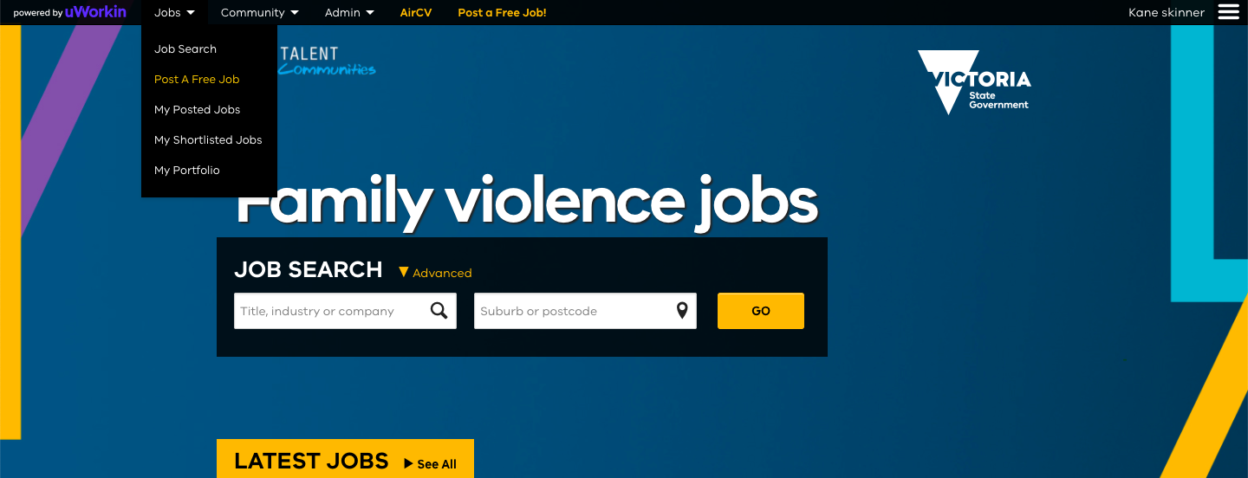
Signed-in users can post a free job advertisement by selecting “Jobs” in the top navigation bar and then by selecting “Post A Job”.
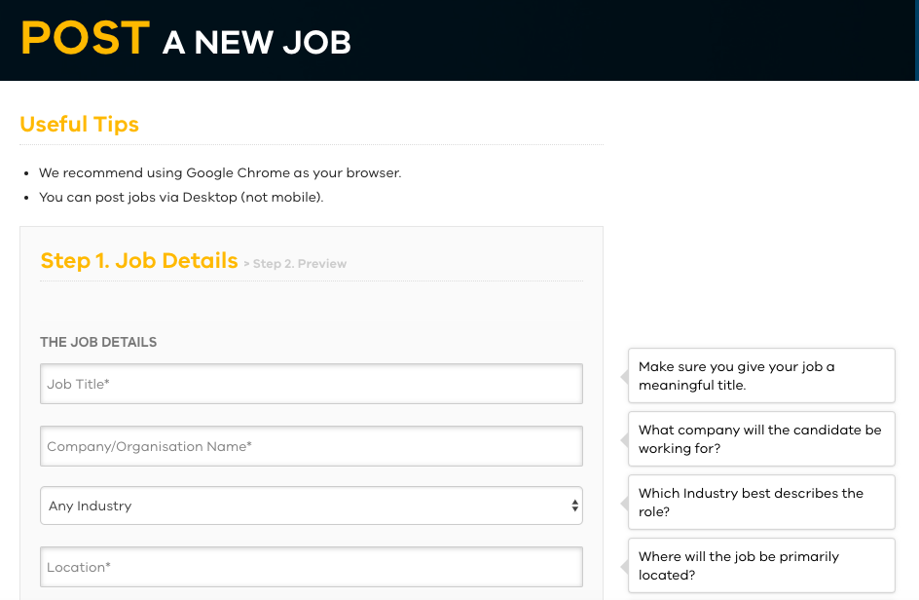
Useful tips are located on the right-hand side of the “Post a new job” page. If you have your job listed on an external website and you would like to use the application function of that website, then you can do so by adding a URL for the job as listed on the external website. This will enable you to utilise the candidate tracking functions of that website. Alternatively, you can use the job application process built into the Talent Community.
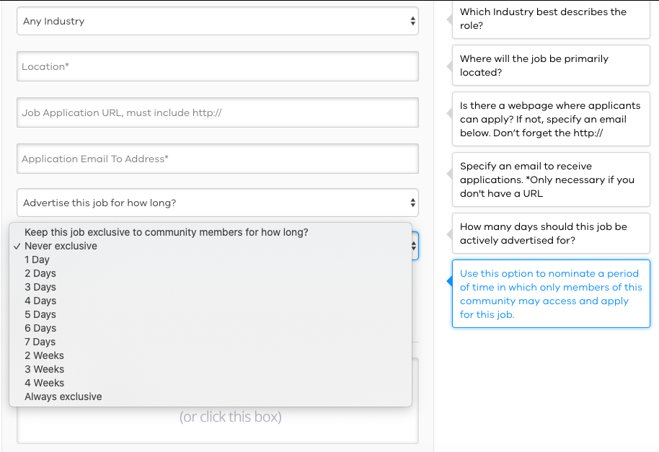
When posting the vacancy you can determine the length of time you would like the job to be advertised and the period of time that the job will be exclusive to the Talent Community members.
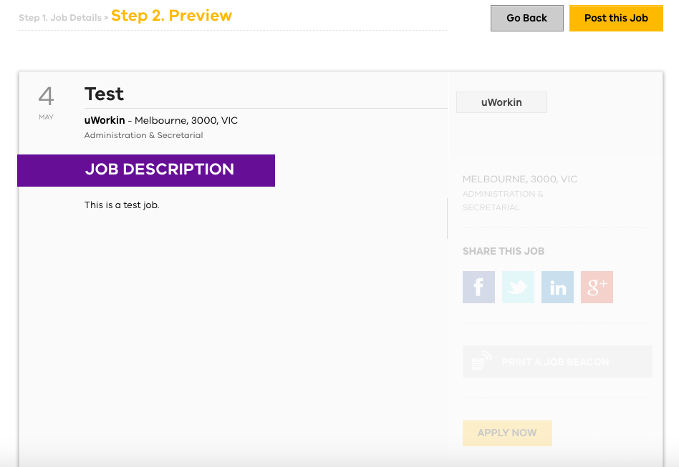
You can preview the job before posting the job for approval.
Only Talent Community members can search exclusive jobs. Upon expiry of the “exclusive period”, your job will be made public for all non-members as well as Talent Community users. It will be distributed at no cost across the uWorkin job network of websites as well as iPhone and Android Apps.
The Talent Community administrators will receive an email when your job is submitted.

My Jobs
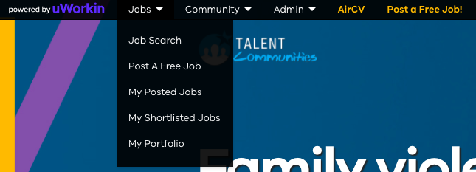
Signed-in users can view the status of their jobs at any time by clicking the “Jobs” tab in the top navigation bar and then by clicking “My Posted Jobs”.

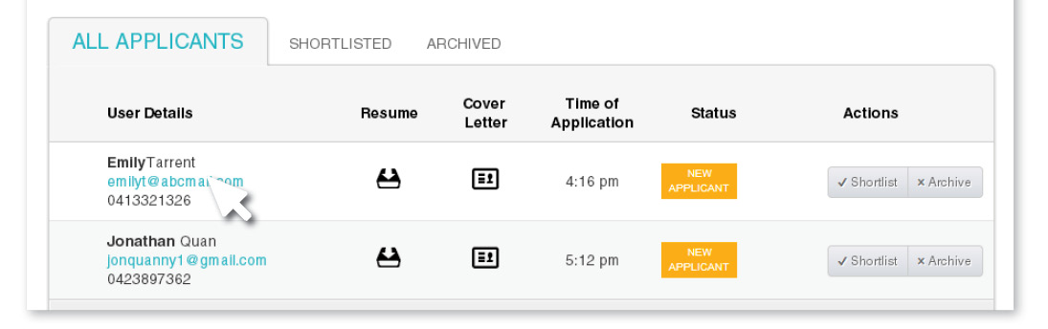
Signed-in employers can view the applications received for their jobs at any time by clicking the “Jobs” tab in the top navigation bar and then clicking “My Posted Jobs”. From this screen you can:
- Download an applicants resume
- View an applicants cover letter (if included in their application)
- Export the list of applicants to a CSV file
- Shortlist and Archive jobs
You will not receive any notifications if you have added an external URL to your job because the external application process will take over responsibility for this.
You can view approved jobs and jobs pending for approval at any time. You can also ‘post a job’ and ‘expire a job’ from within the “My Jobs” tab.
The Talent Community administrators must approve your job before it goes live.
You will receive a notification email that your job has been approved by Talent Community administrators and is now live. You cannot edit a live job. You can though expire the job from within the “My Posted jobs” tab and post a new job.
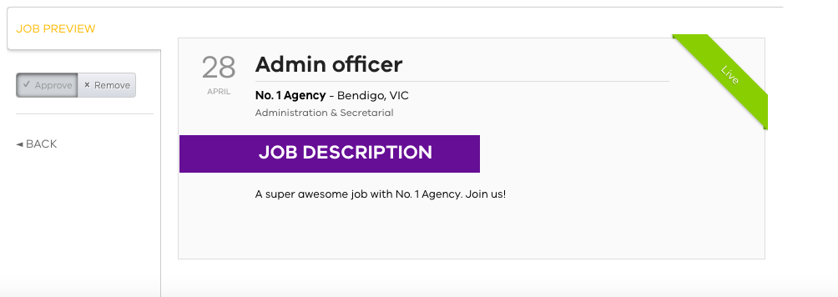
You cannot edit a live job. You can though expire the job from within “My Jobs” tab and post a new job.

Share your Job

Once your job is live, you can share your job across all social channels to ensure jobseekers get the best chance to see it.



