
Common Templates
Automated Briefing and Correspondence

Standard
Departments must use the Automated Briefing and Correspondence common templates for in-scope briefs and correspondence at the portfolio, branch/unit, division and departmental level.

Document Control
Applies to | All departments and Victoria Police | Authority | Digital Strategy and Transformation,  Department of Premier and Cabinet
Period | To be determined | Advised by | N/A
Issue Date | To be determined | Document ID | ABC-STD-02
Review Date | To be determined | Version | 1.0


Except for any logos, emblems, trademarks and contents attributed to other parties, the statements of direction, policies and standards of the Victorian Government’s Victorian Secretaries Board or CIO Leadership Group are licensed under the Creative Commons Attribution 4.0 International licence. To view a copy of this licence, visit https://creativecommons.org/licenses/by/4.0/.

Requirements

In-scope
For the purposes of this standard, the scope of ‘briefs’ includes all forms of briefs with the exception of cabinet submissions, parliamentary questions and Public Accounts and Estimates Committee (PAEC) briefs.
For the purposes of this standard, the scope of ‘correspondence’ includes all correspondence to a Minister, Secretary, Deputy Secretary, Executive Director or Director that requires a response, no matter the channel it comes via.

 | It is recommended that the Automated Briefs and Correspondence (ABC) Governance Model (governance model) and ABC Guideline (guideline) be read prior to reading this document.

Briefs
Departments must at a minimum:
- Create briefs using the common brief template:
    - Common brief
      - briefs initiated by the department to the Premier or Minister/s that provides information, advice or seeks support on policy issues, key projects or decisions, or approval of an attached correspondence etc.
      - briefs requested by the Premier or Minister that seeks information or advice on policy issues, key projects or decisions etc.
      - briefs internal to the department that provide information or advice or seek support on departmental business, recruitment, expenditure or procurement etc.
    - Event briefs
      - briefs to the Premier, Minister or Secretary that provides background and logistical information and speaking points in preparation for a meeting, event or function.
- Create, edit and manage all briefs digitally with the electronic record as the public record (official record) as defined in the Public Records Act 1973.
- Ensure all briefs are kept to a maximum of two pages (excluding attachments) where possible.
- Ensure all briefs are electronically approved in line with the Electronic Approval Standard.

Correspondence
Departments must at a minimum:
- Respond to correspondence in the format it was received, unless requested otherwise by the sender or the signatory.
- Create hardcopy correspondence using the common template when:
    - responding to hardcopy correspondence received by the Premier, Minister/s, Secretary or Department.
    - sending out hardcopy correspondence on behalf of the Premier, Minister/s, Secretary or Department.
- Create electronic correspondence using the common template when responding to correspondence received electronically (e.g. emails) addressed to the Premier, Minister/s or Secretary.
Correspondence received by email should be responded to by email using the electronic correspondence template attached to a return email, unless specifically requested otherwise by the correspondence signor.

- Create a covering brief for correspondence when approval (signing) of the correspondence is required by the Premier, Minister/s or Secretary.
- Create, edit and manage correspondence digitally with the digital version as the public record as defined in the Public Records Act 1973, including:
    - All inbound hardcopy correspondence received is scanned and managed internally as a digital record (responding externally via hardcopy as appropriate).
    - Ensure all outbound correspondence is managed entirely as a digital record internally to the department (regardless of its final form once it leaves the department).

General
Departments must at a minimum:
- Print digital briefs and correspondence only as a ‘working document’ when there is a need to:
- print a draft for reading and mobility purposes
- physically sign the document
- send physical correspondence out to a citizen or
- provide evidence in a physical format.
Working documents, no longer required, should be disposed of according to the department’s digitisation plan (see Digitisation for Public Records Office Victoria’s digitisation requirements) and protected according to its Victorian Protective Data Security Framework (VPDSF) classification.
All other hardcopy records should continue to be managed and disposed of according to PROV policy and requirements and protected according to its VPDSF classification.
Copies of security classified records should be kept to a minimum and securely managed and tracked.
- Signed working documents of a digital brief or correspondence must be scanned back into the briefing and correspondence system (which should be a Public Record Office Victoria approved electronic document management business system), disposed of according to the department’s digitisation plan and protected according to its VPDSF classification.
The governance model, common process, roles, definitions, business rules and common templates are subject to formal change control via the Whole of Victorian Government (WOVG) ABC Group.

Overview
The purpose of the ABC Templates Standard (the standard) is to define the expectation around the use of the government’s standard templates for briefing and correspondence.
The use of common templates is an important precursor step towards improving productivity and effectiveness in the end-to-end process for briefs and correspondence.

Rationale
Government departments are becoming more aware of the problems and restrictions they operate under in the current, disparate briefing and correspondence processes and templates.
The implementation of common briefing and correspondence templates will help the government to move towards commonality of practice in briefing and correspondence, reducing the impact of machinery of government (MOG) and created portability of knowledge.
The emphasis is on creating a consistent WOVG practice: irrespective of department, system or level of technical or digital maturity. Thus, the use of common templates, in conjunction with the common process, will improve productivity via ensuring that people trained in briefing and correspondence are immediately productive after changes in machinery of government or when transferring to other parts of the government. Further, legislative compliance will improve as a result of increased accountability; costs will reduce as digital systems eliminate paper, which will further improve productivity as manual processes (including ‘walking the brief around’) are reduced or eliminated.
Guideline

Overview
The following provides guidance on how to use the common brief and correspondence templates. For more detailed guidance on the ABC standards and common process see ABC Guideline.

Template types

Templates types | Description
Brief – Ministerial and Department (use brief template) | Briefing to the Minister that requires the Minister to make a decision or for noting.  Briefing to the Secretary, Deputy Secretary, Executive Director or Director that requires the them to make a decision (may also be used for other internal departmental briefings).  How to use:  The brief template is described by providing a sample picture of each section of the template supported by a business rules matrix that outlines each of the elements of the common brief template.
Event brief (use brief template with modifications) | An event brief is tailored to specifically highlight the details of an event.  How to use:  The base of the event brief template is the brief template (see above). Any differences in look and feel or business rules between the common brief and event brief templates is detailed at the end of the common brief template.
Correspondence – hard copy or electronic | Reply to correspondence received, addressed either to a Minister, Secretary, Deputy Secretary, Executive Director or Director.  How to use:  The correspondence template is described by providing a sample picture of each section of the template supported by a business rules matrix that outlines each of the elements of the correspondence template.

The following brief types are not in-scope for this guideline including regulatory brief, cabinet brief, adjournment debate brief, cabinet submission brief, possible parliamentary question, question on notice, question without notice and constituency questions.

Business rules
The business rules for each section of a common template are captured using the following matrix:

Intent:
This descriptor captures a high-level overview of the section and the purpose of the section within the brief, including whether the section is mandatory, optional or customisable.
Position:
This descriptor captures the approximate location of the section, relative to other sections including whether the position is mandatory, optional or customisable.
Composition:
This descriptor captures the structure of the section, including the applicability of a section title and content of the section, as well as describing aspects within the section that may be mandatory, optional or customisable.
A section composition can be made up of the following:
Section Title – A section title is a title that is captured in the Brief Section Title.
Title – A title is the lead title within the section.
Subtitles – Subtitles are secondary titles within the section.
Content – The description of content is to assist with outlining what and how the information written in the section should be conveyed.
Instructional text:
This descriptor outlines how to compose the section.
Comments:
This descriptor provides further information in relation to the section.
Example:
Where applicable, an example of the application of the business rules/section.
Event brief:
This descriptor demonstrates how the template should be adjusted for an event brief.

Font and Styling
The business rules for font type and size, headings styles, spacing and margins are:
Component | Business rule
Section Title | Left aligned, bold, black, Arial size 14, border top and bottom
Title | Left aligned, bold, black, Arial size 12
Subtitles | Left aligned, bold, black, Arial size 12
Content | Left aligned, black, Arial size 12  Sentences spaced by 3pt and left aligned
Tables | Table Heading: left aligned, bold, black Arial size 11  Table Text: normal, black, Arial Size 11
Header/ Footer | Bold, black, Arial size 8

**Numbering of the section titles and subsection titles is optional.
Whilst the template numbers heading numbering is optional.

All text is left aligned, unless stated otherwise.

Definitions – mandatory, optional and customisable
Mandatory or mandatory | Any reference to a mandatory section, component or wording must follow the business rules outlined.
Optional or optional | Any reference to an optional section, component or wording can follow the business rules outlined, though it is not required.
Customisable, or customisable | Any reference to a customisable section, component or wording allows for local departmental preferences to be applied.

Common/Event brief template – page one
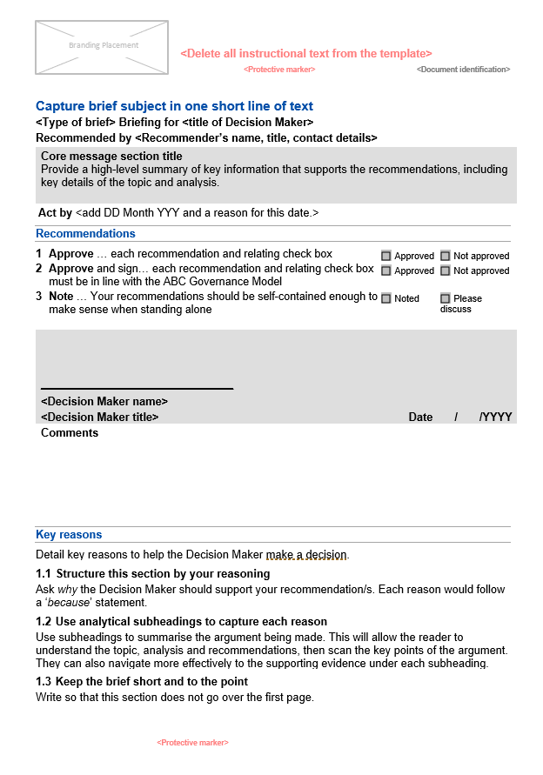
Protective marking (Mandatory)
Key reasons section (Mandatory)
Decision Maker section (Mandatory)
Recommendations section (Mandatory)
Act by section (Optional)
Header section (Mandatory)
Branding section (Mandatory)
Document identification section (Mandatory)
Core message section (Mandatory)

Common/Event brief template – page two
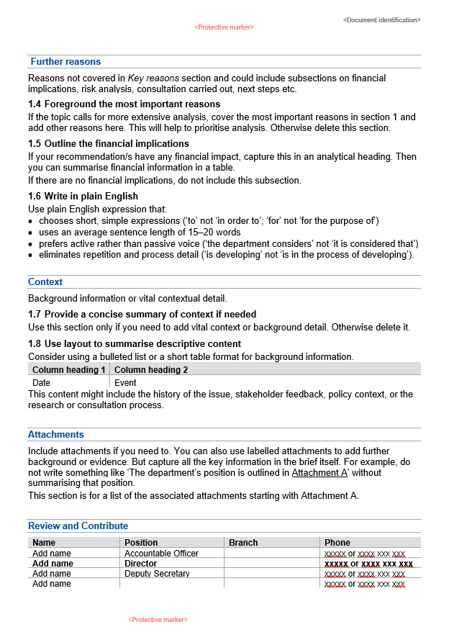
Protective marking (Mandatory)
Document identification section (Mandatory)
Protective marking section (Mandatory)
Review and Contribute section (Mandatory)
Attachments section (Optional)
Further reasons section (Optional)
Context section (Optional)

Introduction – brief
A brief is the preparation of advice for decision by at least the next level up (in the department, Minister or Cabinet). The Decision Maker can be the Cabinet, Minister, Secretary, Deputy Secretary, Executive Director or Director.
This guideline covers the following types of briefs:
- Common brief – a document prepared for the Decision Maker to inform them on key activities, tasks or events relevant to their portfolio.
- Event brief – a brief to inform someone (higher next level authority) about an event that is expected to occur in the future.
- Correspondence response briefs – a brief in response to correspondence received by a department. A common brief should be used.

Branding section

Intent:
It is mandatory to have a departmental branding section on the first page of the brief. This section should display, through a logo and name, the department that the brief originates from.
Position:
Mandatory, top left-hand corner of the first page of the brief.
Composition:
Section Title: None
Title: None
Subtitles: None
Content: Customisable department logo and name.
Instructional text:
The departmental branding must be consistent with Brand Victorian guidelines and logos.
Example:



Event brief:
An Event brief uses the same rules.

Header section

Intent:
It is mandatory to have a Header section on the first page. The Header section captures the intent/subject of the brief, the type of brief, the title of the Decision Maker for whom the brief is for and details of the executive recommending the brief up for decision.
Position:
Mandatory, on the first page, below the Branding section, starting as the first row of text on the first page.
Composition:
Section Title: None
Title: Mandatory, (Line 1) a short one line that captures the title or intent or subject of the brief.
Subtitles: None
Content: After the title (Line 1), there are two lines of text,
Line 2 has three components:
- Optional <Type of brief> text outlining the brief type, followed by
- Mandatory “Briefing for the”, followed by
- Mandatory and customisable <title of the Decision Maker>

Line 3 has two components:
- Mandatory “Recommended by”, followed by
- Mandatory and customisable <Recommender’s name, title, contact details>

Instructional text:
Where there are multiple recommenders use one recommender only, being the main contact.
Example:
Seeking approval of the new brief process
Common Brief for the Executive Director of Briefs
Recommended by John Smith, Director of Processes, 0421 234 567

Event brief:
The Header section should be adjusted to reflect the needs of an Event brief, for example:
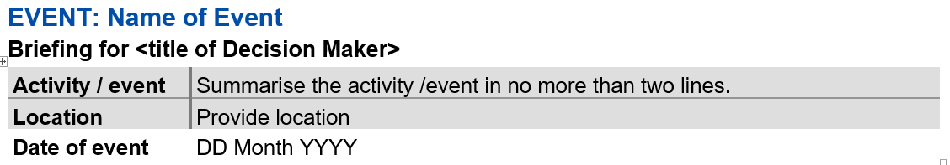

Core message section
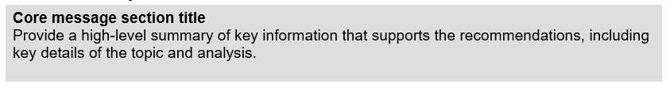

Intent:
It is mandatory to have a Core message section on the first page. This section provides a high-level summary of the key reasons, issues and context of the brief that helps the Decision Maker to know why they are being briefed and what they are being asked to do.
Position:
Mandatory, on the first page, below the Header section.
Composition:
Section Title: None
Title: Optional and customisable.
Subtitles: None
Content: Mandatory and customisable, a core message that does not exceed four lines of text, i.e. two to three sort sentences.
Instructional text:
- The title can be customised to suit the needs of the department, examples include Core message, Key issues, Purpose or Topic and Analysis.
- The content of the Core message section should be succinct and to the point and must not be longer than four lines of text.
Example:

Event brief:
An Event brief does not have a Core message section.

Act by section
Intent:
The Act by section is optional. It provides a date by which the recommendation(s) put to the Decision Maker need to be acted upon and, if required, a supporting reason for the date.
Position:
Mandatory, if used, the Act by section must be on the first page below the Core message. section.
Composition:
Section Title: None
Title: Act by
Subtitles: None
Content: If used there are three components of this section, all on one line of text:
- Mandatory ‘Act by’, followed by:
- Mandatory and customisable – the date (day, month and year), followed by
- Optional and customisable – the supporting reason.

Example:
Act by 9 January 2020 to ensure agreement by departments by 14 January 2020

Event brief:
An Event brief does not have an Act by section.

Recommendations section
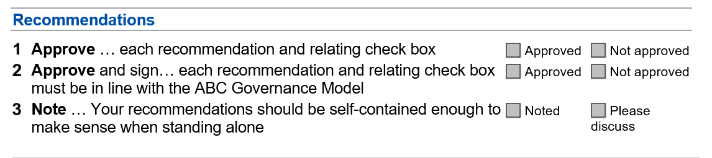

Intent:
The Recommendations section is mandatory. It provides the recommendation(s) for the Decision Maker to either approve, not approve or note.
Position:
Mandatory, on the first page, below the Act by section, if the Act by section has been used, otherwise below the Core message section and above the Decision Maker section.
Composition:
Section Title: Mandatory – Recommendations
Title: None
Subtitles: None
Content: Mandatory and customisable, starting underneath the title a listing of one or more recommendations for the Decision Maker. Supported by check boxes for each recommendation stated.
Instructional text:
- One or more recommendations are required.
- Only number recommendations when there are two or more.
- The required recommendations for the brief are bolded and followed by the recommendation reason, e.g. Approve and sign the attached contract.
- Check boxes are aligned right of page for each recommendation stated.
- The Decision Maker must check one check box for each recommendation.
Comments:
The recommendation types and check boxes are documented in the ABC Governance Model.
Example:
Event brief:
An Event brief uses the same rules.

Decision Maker section
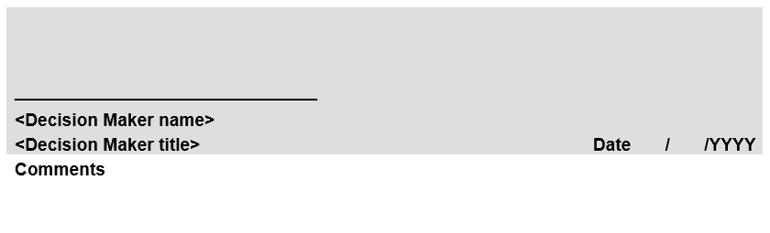

Intent:
It is mandatory to have a Decision Maker section on the first page. It provides a space for the Decision Maker’s acknowledgement e.g. signature; name and title of the Decision Maker; date the brief was acknowledged by the Decision Maker; and space for the Decision Maker to provide comment(s) to the Recommender.
Position:
Mandatory, on the first page, below the Recommendations section and above the Key reasons section.
Composition:
Section Title: None
Title: None
Subtitles: None
Content: The Decision Maker section is made up of five components:
- Acknowledgement – Mandatory – the Decision Maker’s acknowledgement (e.g. signature) of the recommendation(s).
- Decision Maker Name – Mandatory and customisable – the Decision Maker’s name.
- Decision Maker Title – Mandatory and customisable – the Decision Maker’s title.
- Date – Mandatory – the date the Decision Maker acknowledged the recommendation(s).
- Comments – Mandatory – for the Decision Maker to optionally write comment(s) in relation to the brief.

Instructional text:
- The “date” component must be on the same line as the “Decision Maker Title” component and, right aligned on the page.
- The Comments component should be titled ‘Comments’ and bolded, with space for the Recommender to optionally populate.
- Departments should limit acknowledgement to one Decision Maker.
- Where acknowledgement by multiple Decision Makers is required, the Decision Maker section should be repeated.
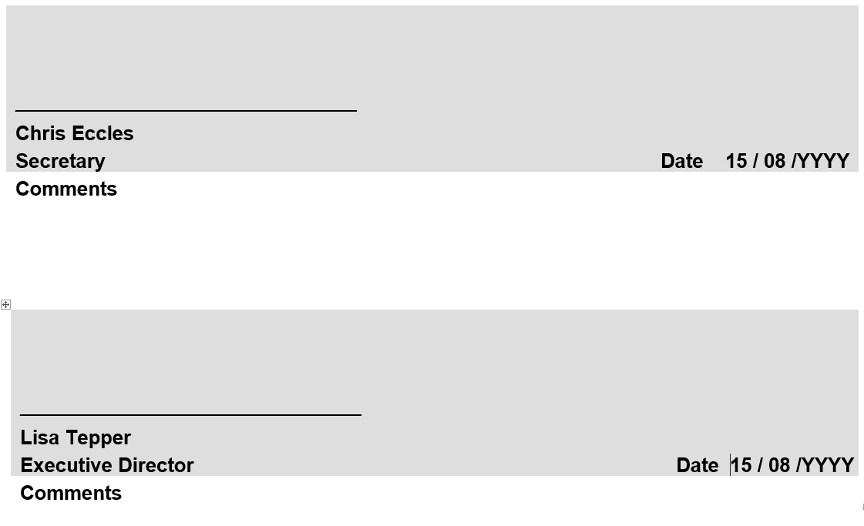
Example:

Event brief:
An Event brief uses the same rules.

Key reasons section
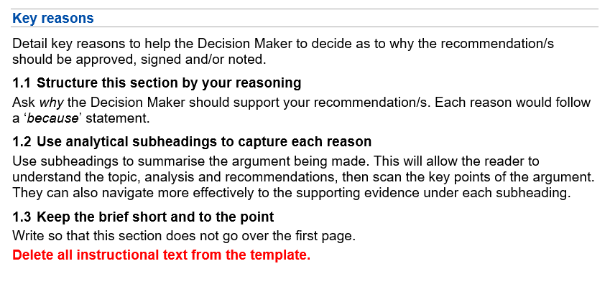

Intent:
It is mandatory to have a Key reasons section on the first page. It provides the key reason(s) to help the Decision Maker make the decision/s recommended.
Position:
Mandatory, on the first page, below the Decision Maker section. The Key reasons section must not flow over to the second page of the brief.
Composition:
Section Title: Mandatory and customisable.
Title: None
Subtitles: Optional and customisable.
Content: Customisable, the Key reasons section should be three to five key points of text or a paragraph of text.
Instructional text:
- The Key reasons section title is customisable, examples include, ‘Key reasons’, ‘Key information’ or ‘Key issues’.
- Content for the key reason section should not flow over to page two of the brief.
- The content is customisable, e.g. can be dot point text or one paragraph of text.
- The Key reasons section can be the first numbered section of the brief.
Comments:
Further support on “how to write content” for the Key reasons section could be provided by departments.
Event brief:
An Event brief uses the same rules.

Protective marking section

Intent:
It is mandatory to have a protective marking section on all pages of the brief and its attachments. The protective marking indicates the use, handling and dissemination requirements of the brief and helps to prevent unauthorised use its information.
Position:
Mandatory, centred, on the top and bottom of each page of the brief and its attachments.
Composition:
Section Title: None
Title: None
Subtitles: None
Content: Mandatory and customisable text indicating the protective marking.
Instructional text:
A department needs to be aware of its obligations when assessing official information to determine what protective marking to apply.
The protective marking being applied must be in line with the protective markings outlined by the Victorian Protective Data Security Framework.
Ideally use capitals, bold text, large font and a distinctive colour (red preferred), for example OFFICIAL
Event brief:
An Event brief uses the same rules.

Document identification section

Intent:
To be able to uniquely identify the brief, it is mandatory to have a Document identification section on the first page.
Position:
Mandatory for it to be on the first page, and customisable as to whether it is in the footer or header. It should not interfere with other sections of the page.
Composition:
Section Title: None
Title: None
Subtitles: None
Content: Mandatory, customisable, alphanumeric text to uniquely identify the brief.
Instructional text:
The unique identification text could be derived from a departments records document management system, where the brief may be stored and uniquely identifiable.
Event brief:
An Event brief uses the same rules.

Further reasons section
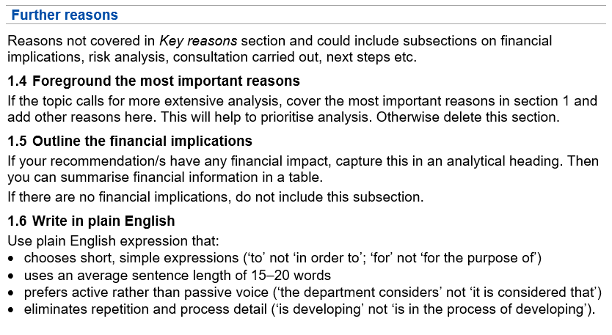
Intent:
It is optional to have a Further reasons section. If used, it provides supplementary reason(s) and information to the Decision Maker to help them understand why the Recommendation(s) should be approved/noted.
Position:
Mandatory, if used, it must be the first section on the second page of the brief.
Composition:
Section Title: Mandatory and customisable.
Title: None
Subtitles: Optional and customisable.
Content: Mandatory and customisable subsections detailing further analysis and reasons including reasons not covered in the Key reasons section or the financial implications.
Instructional text:
- If the Further reasons section is used, the Further reasons section title is mandatory.
- The Further reasons section can be numbered, with the title starting with ‘2’, followed by the title, all in bold text.
- The Further reasons section title is customisable, examples include, ‘Further reasons’, ‘Additional information’ etc.
- The content is customisable, allowing for subsection titles that are customisable and could be in bold text, with further content supported by tables of information.
Comments: Further support on “how to write content” for this section could be provided by departments.
Event brief:
An Event brief uses the same rule.

Context section
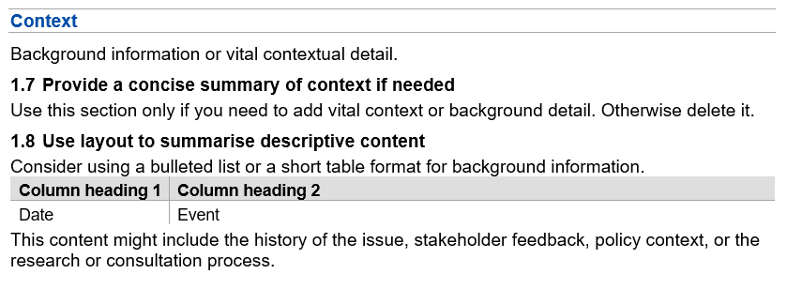

Intent:
It is optional to have a Context section. The Context section provides background or vital contextual information, that are not the key reasons, and will help the Decision Maker to decide.
Position:
Mandatory, the Context section should be below the Further reasons section or be the first section on the second page of the brief.
Composition:
Section Title: Mandatory and customisable.
Title: None
Subtitles: Optional and customisable.
Content: Mandatory and customisable subsections of content detailing additional context and background information.
Instructional text:
- The Context section title is customisable, examples include, ‘Context’, ‘Background information’, ‘Further information’ etc.
- The subtitles are customisable and should provide a concise summary of the content.
- Tables, bullet points or number lists can be used to display content if desired.
Comments:
Further support on “how to write content” for this section should be provided by departments.
Event brief:
An Event brief uses the same rules.

Attachments section
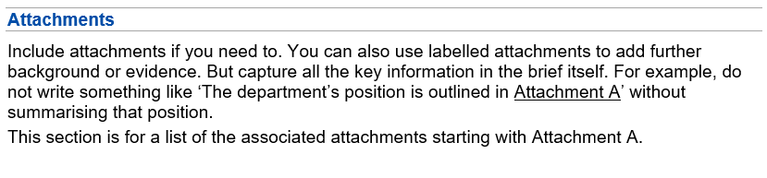

Intent:
The Attachments section provides a list of attachments that accompany the brief. This section is optional.
Position:
Mandatory, if used, it should be the first, second or third section on the second page, dependant on the use of the Further Reasons section and/or Context.
Composition:
Section Title: Mandatory
Title: None
Subtitles: None
Content: Customisable, starting underneath the title, the Attachments section lists the numbered attachments that accompany the brief.
Instructional text:
- If used the Attachments section title is mandatory text ‘Attachments’ in bold text.
- The Attachments section title can be numbered, with the title starting with ‘2’ or ‘3’ or ;4’, dependant on the use of the previous sections, followed by the title, all in bold text.
- The content is customisable, listing the attachments that accompany the brief.
- The list of attachments can be as a bulleted list or in a table.
Comments:
Some departments may choose to list their attachments as a part of the Recommendations section.
Event brief:
An Event brief uses the same rules and may be accompanied with a number of separate attachments, such as speaking notes, biographies of special guests, event logistic information.

Review and Contribute section
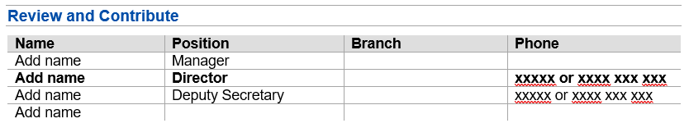
Intent:
It is mandatory to have a Review and Contribute section at the end of the brief. It provides a list of people involved in developing the brief in line with the Automated Briefs and Correspondence (ABC) Governance Model and standards.
Position:
Mandatory, at the end of the brief.
Composition:
Section Title: Mandatory
Title: None

Subtitles: None

Content: Customisable – the Review and Contribute section is a table that, in line with ABC Governance Model and standards, lists the names, positions, branch (department) organisation unit and phone number of key stakeholders who reviewed and/or contributed to the brief.
The order of stakeholders listed is – The Accountable Officer, Lead Author, Recommender, and up to five other contributors as required.
Instructional text:
- In line with the ABC Governance Model and standards, a table with four columns headings: Name; Position; Branch; Phone, and up to five rows that provide for the corresponding details for the Authorised Officer, Lead Author, Recommender, and up to five other contributors as required.
- Where someone is in multiple roles, as identified by the ABC Governance Model and standards, only state their details once in the table.
Comments:
Not all people who participate as reviewers and contributors need to be noted in the Review and Contribute Section or the brief in general.
Event brief:
An Event brief uses the same rules.

Correspondence template
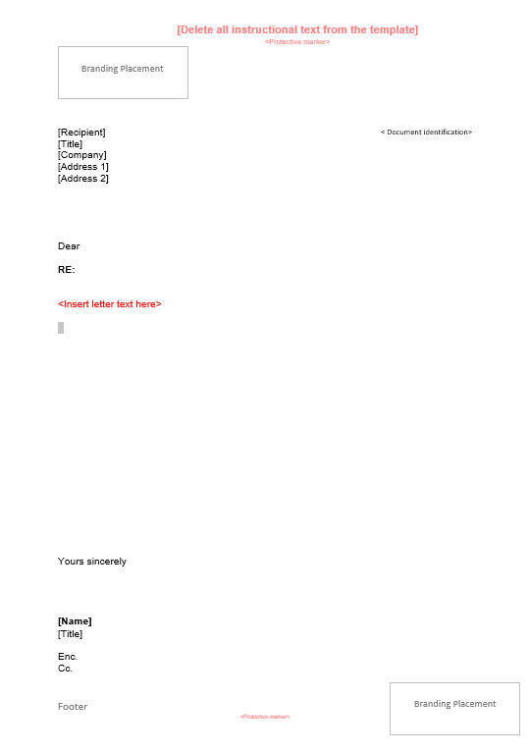
Protective marking section (Mandatory)
Protective marking section (Mandatory)
Footer section (Optional)
Branding section (Mandatory)
Recipient address section (Mandatory)
Attachments section (Optional)
Carbon copy section (Optional)
Signature section (Mandatory)
Closing section (Mandatory)
Letter body section (Mandatory)
Salutation section (Mandatory)
Document identification section (Mandatory)
Letter subject section (Optional)

Introduction – correspondence
Correspondence is from entities external to the receiving department that requires a response. It could be addressed to the Minister, Premier or department from someone outside the department and requires a response.
Correspondence can be received in both electronic and hardcopy format and can be:
- Inbound – any form of correspondence which is sent to a department or Minister.
- Outbound – a communication sent from a department to another department or someone outside the Victorian Government.
Outbound correspondence may be accompanied by a brief to assist the Decision Maker in regards to the correspondence.

Letterhead (branding) section

Intent:
It is mandatory to have a letterhead (branding) section. This section displays who/where the correspondence is from, the department’s address block and branding.
Position:
Mandatory, top of the first page of the brief.
Composition:
Section Title: None
Title: None
Subtitles: None
Content: Logo, address and name is customisable.
Instructional text:
The branding must be consistent with Brand Victorian guidelines and logos.

Recipient address section

Intent:
It is mandatory to have a Recipient address section on the first page. This section captures the address for the recipient of the correspondence.
Position:
Mandatory, below the letter head section, starting as the first row of text on the first page.
Composition:
Section Title: None
Title: None
Subtitles: None
Content: Potentially five lines of text, made up of the following,
Line 1 customisable, the recipient’s name
Line 2 customisable, the recipient’s title (if available)
Line 3 optional, customisable, the recipient’s company
Line 4 and Line 5 customisable, the recipient’s complete address – note this could be an email address or a physical address.
Comments:
Further support on “how to write content” for this section could be provided by departments, where most departments use all capitals for suburb and state and insert three spaces in between suburb, state and postcode (no commas).

Protective marking section

Intent:
It is mandatory to have a protective marking section on all pages of correspondence and its attachments. The protective marking indicates the use, handling and dissemination requirements of the correspondence and helps to prevent unauthorised use of its information.
Position:
Mandatory, centred, on the top and bottom of each page of the correspondence and its attachments.
Composition:
Section Title: None
Title: None
Subtitles: None
Content: Mandatory and customisable text indicating the protective marking.
Instructional text:
A department needs to be aware of its obligations when assessing official information to determine what protective marking to apply.
The protective marking being applied must be in line with the protective markings outlined by the Victorian Protective Data Security Framework.
Ideally use capitals, bold text, large font and a distinctive colour (red preferred), for example OFFICIAL

Document identification section

Intent:
It is mandatory to have a Document identification section on the first page. To be able to uniquely identify the letter, a unique document identifier is applied to the document.
Position:
The position is customisable, and it is mandatory for it to be on the first page and not interfere with other sections, with preference being bottom right of the first page.
Composition:
Section Title: None
Title: None
Subtitles: None
Content: alphanumeric text to uniquely identify the brief.
Instructional text:
The unique identification text could be derived from a departments records document management system, where the brief may be stored and uniquely identified within that system.
Comments:
Ensure the department’s document and records management system reference is correct and located in top right under address block.

Salutation section



Intent:
It is mandatory to have a Salutation section on the first page. The opening line of the letter, addressing the letter to the letter recipient.
Position:
Mandatory four-line spaces after the Address section.
Composition:
Section Title: None
Title: None
Subtitles: None
Content: One line of text that opens the correspondence and addresses the correspondence to the addressee.
Comments:
Further support on “how to write content” for this section could be provided by departments, noting when using honorifics, include in both the address block and salutation.

Letter subject section

RE: Response to your request for information regarding the implementation of the new process

Intent:
It is optional to have a Letter section on the first page. Provide a one line “title” about the correspondence, i.e. What the correspondence is about.
Position:
If used, mandatory one-line space after the Salutation section.
Composition:
Section Title: None
Title: None
Subtitles: None
Content: maximum one line of text detailing the subject of the letter.
Instructional text:
Bold text can be used.
Comments:
Further support on “how to write content” for this section could be provided by departments by referring to department’s style guideline.

Letter body section

Intent:
It is mandatory to have a Letter content section starting on the first page. The body of the letter.
Position:
Mandatory one-line space after the Salutation section or if used, one-line space after the Letter subject section.
Composition:
Section Title: None
Title: None
Subtitles: None
Content: Letter text
Instructional text:
Try to keep the letter to one page.
Comments:
Consider centring letter text on the page when it appears top/bottom heavy. Consider the aesthetics of the page and ensure it appears balanced to the eye. Maintain noted spacing requirements when balancing page.
Further support on “how to write content” for this section could be provided by departments by referring to department’s style guideline.

Closing section



Intent:
It is mandatory to have a Closing section.
Position:
Mandatory one-line space after the Letter content section.
Composition:
Section Title: None
Title: None
Subtitles: None
Content: A few words that close off the letter, e.g. Yours sincerely
Instructional text:
Ensure that this section and any subsequent sections used are not the only sections on the second page.

Signature section



Intent:
It is mandatory to have a Signature section. Provide space for the sender’s “wet ink” or electronic signature.
Position:
Mandatory after the Closing section.
Composition:
Section Title: None
Title: None
Subtitles: None
Content: Four lines of blank space for a signature, followed by:
  - Name of sender, followed by
  - Tittle of sender
  - Date letter was signed (optional)
Instructional text:
Ensure that this section and any subsequent sections used are not the only sections on the second page.

Attachments section

Enc.

Intent:
It is optional to have an Attachments section. Inform the correspondence receipt of any attachments to the letter.
Position:
If used, mandatory one blank line space after the Closing section.
Composition:
Section Title: None
Title: None
Subtitles: None
Content: One line, starting with “Enc.” followed by the title of the attachment(s).
Instructional text:
Ensure that this section and any subsequent sections used are not the only sections on the second page.

Carbon copy section

Cc.

Intent:
It is optional to have a Carbon copy section. Inform the correspondence recipient who else has also been sent a copy of the letter.
Position:
If used, mandatory one blank line space after the Attachments section.
Composition:
Section Title: None
Title: None
Subtitles: None
Content: One line, starting with “Cc.” followed by the name of the individuals who have also been sent a copy of the correspondence.
Instructional text:
Ensure that this section and any subsequent sections used are not the only sections on the second page.

Footer section
Fig 1:

Fig 2:



Intent:
It is optional to have a Footer section.
Position:
If used, mandatory in the footer of the letter, on each page, when more than one page is used.
Composition:
Section Title: None
Title: None
Subtitles: None
Content: The footer could contain text, as outlined in figure 1 above, such as
“Your details will be dealt with in accordance with the Public Records Act 1973 and the Privacy and Data Protection Act 2014. Should you have any queries or wish to gain access to your personal information held by this department please contact our Privacy Officer at the above address.”
along with appropriate government branding;
or
Details and branding as outlined in the above figure 2.
Instructional text:
Do not have this section as the only section on the second page.
Comments:
The branding must be consistent with Brand Victorian guidelines and logos.

Derivation, scope and glossary

Derivation
This standard is derived from the Automated Briefs and Correspondence Policy, and is guided by the Automated Briefs and Correspondence Statement of Direction (ABC SOD) and the Information Technology Strategy for the Victorian Government, 2016–2020 (IT strategy).

Scope
All departments and Victoria Police, referred to collectively as ‘departments’, are formally in-scope. While not required, the standard may be adopted by agencies and partner organisations, if desired.

Glossary
The glossary of terms and abbreviations used in this document are defined in the Automated Briefs and Correspondence Glossary.

Related documents, tools and references
- Automated Briefs and Correspondence - Governance Model
- Automated Briefs and Correspondence Guideline
- Automated Briefs and Correspondence Policy
- Automated Briefs and Correspondence Standard – ABC Governance
- Automated Briefs and Correspondence Standard – ABC Monitoring and Reporting
- Automated Briefs and Correspondence Standard – Common Process
- Automated Briefs and Correspondence Statement of Direction
- Information Technology Strategy for the Victorian Government, 2016–2020 (IT strategy)

Further information
For further information regarding this standard, please contact Digital Strategy and Transformation, Department of Premier and Cabinet, at: digital.transformation@dpc.vic.gov.au.

Document Control

Approval
This document is yet to be formally approved and is published as guidance only. It is expected that when delivery of the common platform commences, under the requirements of VSB approved ABC SOD, the ABC Governance Model and associated standards and templates will be formally reviewed and approved.

Version history
Version | Date | Comments
0.1 | 07/05/2018 | First formal draft for review
0.2 | 15/05/2018 | Minor changes identified during review period.
0.3 | 30/05/2018 | Second formal draft for review
0.4 | 01/08/2018 | Input from review round
0.5 | 14/06/2019 | Final draft
1.0 | 03/09/2019 | Final version

