Audit of timber harvesting operations in Victoria's State forests
Report of the 2018-19 Forest Audit Program
IS284400-RP-002 | RevC
February 21, 2020
Department of Environment, Land, Water and Planning

Contract 341868
Report of the 2018-19 Forest Audit Program
Department of Environment, Land, Water and Planning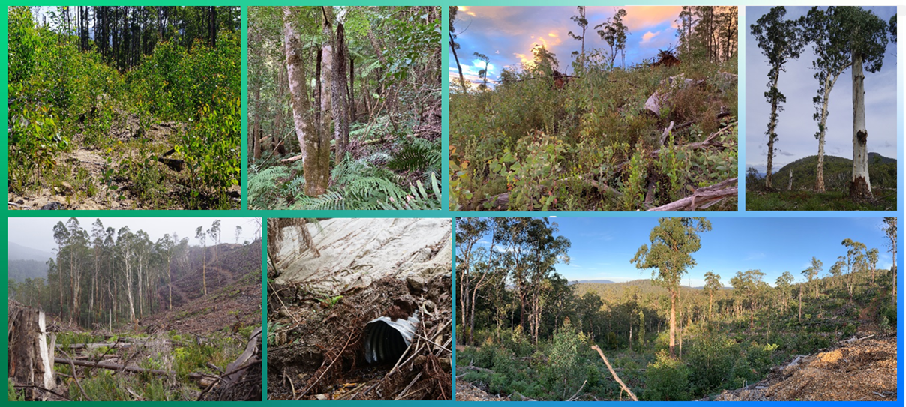

Audit of timber harvesting operations in Victoria's State forests
Project No: | IS284400
Document Title: | Report of the 2018-19 Forest Audit Program
Document No.: | IS284400-RP-002
Revision: | RevC
Date: | February 21, 2020
Client Name: | Department of Environment, Land, Water and Planning
Client No: | Contract 341868
Project Manager: | Craig Clifton
Author: | Craig Clifton and Drew King
File Name: | is284400-RP-002 fap2018-19 audit report-revC
Jacobs Group (Australia) Pty Limited
ABN 37 001 024 095
50 Mitchell St
PO Box 952
Bendigo VIC 3552 Australia
T +61 3 5444 1861
F +61 3 5444 1862
www.jacobs.com
© Copyright 2019 Jacobs Group (Australia) Pty Limited. The concepts and information contained in this document are the property of Jacobs. Use or copying of this document in whole or in part without the written permission of Jacobs constitutes an infringement of copyright.
Limitation: This document has been prepared on behalf of, and for the exclusive use of Jacobs’ client, and is subject to, and issued in accordance with, the provisions of the contract between Jacobs and the client. Jacobs accepts no liability or responsibility whatsoever for, or in respect of, any use of, or reliance upon, this document by any third party.
Document history and status
Revision | Date | Description | Author | Checked | Reviewed | Approved
Rev A | 7/09/2019 | Draft for DELWP and VicForests review and comment | CC, DK | DE | DE | Rev A
Rev B | 29/01/2020 | Final, following review and comment by DELWP and VicForests | CC, DK | DE | DE | Rev B
Rev C | 21/02/2020 | Final, noting VicForests substantive comments on RevA and the auditors’ responses | CC, DK | DE | DE | Rev C
Contents
Executive Summary i
Glossary 1
1. Introduction 3
1.1 Sustainable Forest Management in Victoria 3
1.2 Forest Audit Program 3
2. Audit scope 5
2.1 Audit objectives 5
2.2 Audit scope 5
2.3 Audit timing 6
2.4 Audit team 6
3. Audit approach 8
3.1 Coupe selection 8
3.2 Audit criteria and workbook 9
3.3 Field assessments 12
3.4 Environmental impact assessment 15
4. Audit results 16
4.1 Overall compliance findings 16
4.1.1 Harvest coupes 16
4.1.2 Regeneration coupes 17
4.2 Harvest coupes: environmental compliance theme 18
4.2.1 Compliance elements related to the protection of forest soils 18
4.2.2 Compliance elements related to the protection of water flows, water quality and river health 20
4.2.3 Compliance elements related to the protection of biodiversity values 23
4.3 Harvest coupes: roading compliance theme 25
4.3.1 Compliance elements related to in-coupe road and waterway crossing design 25
4.3.2 Compliance elements related to in-coupe road and waterway crossing construction 26
4.3.3 Compliance elements related to in-coupe road and waterway crossing maintenance and closure 27
4.4 Harvest coupes: infrastructure compliance theme 28
4.5 Harvest coupes: coupe planning and management 31
4.6 Coupe regeneration and rehabilitation 33
5. Discussion 35
5.1 Overall audit findings 35
5.1.1 Harvest coupes 35
5.1.2 Regeneration coupes 38
5.2 Comparison with previous audits 39
5.3 Potential improvements to coupe planning, timber harvesting and coupe regeneration practices 40
5.3.1 Coupe planning 40
5.3.2 Design, construction and maintenance of in-coupe roads and waterway crossings 41
5.3.3 Coupe infrastructure 42
5.3.4 Biosecurity 44
5.3.5 Coupe infrastructure rehabilitation 45
5.3.6 Monitoring and recording of coupe activities 46
5.4 Potential improvements to the regulatory framework for timber harvesting 47
5.5 Auditee comments 48
6. Conclusions and recommendations 49
6.1 Conclusions 49
6.1.1 Overall compliance findings for harvest coupes 49
6.1.2 Overall compliance findings for regeneration coupes 51
6.1.3 Comparison with previous audits 51
6.2 Recommendations 51
7. References 54

Appendix A. Audit compliance elements
Appendix B. Environmental impact assessment tool
B.1 Extent and location of impact
B.2 Extent and duration of recovery
B.3 Asset
B.4 Overall environmental risk
Appendix C. Incidents leading to assessments of non-conformance with audit criteria and the regulatory framework for timber harvesting
C.1 Harvesting coupes
C.2 Regeneration coupes
Appendix D. VicForests’ comments on draft audit report

Executive Summary

Audit scope and objectives
This report documents the methods, results and key findings of an environmental audit of timber harvesting operations in Victoria’s State forests. Jacobs Group (Australia) Pty Ltd (Jacobs) was commissioned by the Department of Environment, Land, Water and Planning (DELWP) to deliver the 2018-19 audit, as part of its Forest Audit Program (FAP). The audit addresses mandatory compliance elements, based on the Code of Practice for Timber Production (the Code) and the Management Standards and Procedures for Timber Harvesting Operations in Victoria’s State forests 2014 (the MSPs).
The FAP has been in operation since 2002 and has been managed by DELWP since 2010. It assesses compliance with the regulatory framework for timber harvesting operations in State forests in Victoria and identifies and assesses any risk of harm they pose to the environment.
The specific regulatory compliance criteria that were considered in this years’ audit were selected by DELWP’s Timber Harvesting Compliance Unit (THCU) and related to several themes:
- Protection of soil, water and biodiversity values
- Execution of in-coupe road design and construction
- Rehabilitation of coupe infrastructure
- Implementation of forest coupe planning
- Coupe regeneration.
Conformance with the regulatory framework was assessed for timber harvesting and related roading operations conducted in 30 coupes listed in VicForests’ Timber Release Plan (TRP), as well as for regeneration activities in a further 10 coupes. The coupes were located in State forests within the Benalla-Mansfield, Central, Central Gippsland, Dandenong, East Gippsland, North-East and Tambo Forest Management Areas (FMAs; Figure ES.1). Three of the harvesting coupes included in the audit were located in Melbourne Water catchment areas.
Source: Department of Environment, Land Water and Planning.
Figure ES.1 Victorian Forest Management Areas

Audit approach
Prospective coupes for the audit were selected from a list of coupes included in VicForests’ current TRP. Selection was randomised, but (for harvest coupes) weighted towards coupes with higher risk features, including: waterway crossings, long lengths of in-coupe road, steep slopes, more erosive soils, presence of threatened flora and/or fauna and of Special Protection or Special Management Zones (SPZ and SMZ respectively).
As coupe selection was risk-based, rather than fully randomised, the findings of this audit cannot be taken as being statistically representative of VicForests’ operations overall.
Compliance criteria considered in the audit drew on mandatory requirements of Code, mostly as expressed in applicable clauses from the MSPs and associated Planning Standards (PS). Compliance criteria were grouped into five compliance themes, with several sub-themes, as follows:
- Environment: compliance criteria drew on Section 2.2 of the Code (Environmental values in State forests) and related compliance elements from the MSPs and PS. There were three environmental sub-themes: soil, water (incorporating flows, water quality and river health) and biodiversity. Some audit criteria related to more than one of these sub-themes.
- Roading: compliance criteria drew on Section 2.4 of the Code (Roading for timber harvesting operations) and related compliance elements from the MSPs. There were three roading sub-themes: design, construction and maintenance-closure. Some of these compliance elements are also relevant to the water and biodiversity sub-themes.
- Coupe infrastructure: compliance criteria drew on Section 2.5.2 of the Code (Coupe infrastructure) and related compliance elements from the MSPs relating to the rehabilitation of coupe infrastructure, including landings, snig tracks and boundary tracks.
- Coupe planning: compliance criteria drew on parts of Section 2.5 of the Code (Timber Harvesting) relating to conformance of timber harvesting operations with coupe plans (developed as per Section 2.3 of the Code).
- Forest regeneration: compliance criteria drew on Section 2.6 of the Code (Forest regeneration) and related compliance elements from the MSPs.
Audits on individual harvest coupes considered up to 151 compliance criteria0F. Those conducted in regeneration coupes considered up to 29 criteria. An audit workbook was completed for each coupe, based on observations by the audit team and their review of VicForests’ Forest Coupe Plan (FCP). Where instances of non-conformance with the regulatory framework were detected, their potential environmental impact was assessed using the FAP’s environmental impact assessment (EIA) tool. Field assessments for the audit were undertaken between April and June 2019.
VicForests personnel accompanied the audit team on all coupe assessments. This enabled useful discussions about planning and management practices, applicable elements of the regulatory framework and of any non-conformances that were observed.

Audit findings

Compliance with environmental and roading criteria for harvesting coupes
On average, the audited coupes fully conformed with 84% of applicable criteria, with the level of full conformance for individual coupes ranging between 61% and 98%. The average level of full conformance1F varied across audit themes, as follows:
Environmental compliance elements: | Roading compliance elements:
- Protection of forest soils: 74% (46-100%);  - Protection of water flows, water quality and river health: 81% (36-100%);  - Protection of biodiversity values: 84% (55-96%). | - Road design: 67% (20-100%);  - Road construction: 81% (50-100%);  - Road maintenance and closure: 83% (33-100%).
Infrastructure compliance elements  - 84% (56-100%) | Coupe planning compliance elements  - 92% (80-100%)
Forest regeneration compliance elements:
- 90% (73-100%)
Some non-conformance incidents (e.g. inappropriately constructed waterway crossings, escaped regeneration burns) may be assessed against several criteria and result in multiple non-compliances. A total of 74 such incidents were observed in this audit, 69 in the audit of harvest coupes and 5 in the audit of regeneration coupes. These were detected in 30 of the 40 coupes included in both components of the audit. As many as seven incidents and as few as zero were observed in a single coupe.
The FAP’s EIA tool was used to assess the potential environmental impact associated with each non-conformance. EIA ratings ranged between negligible and major, with 33 non-conformances in seven coupes (including one regeneration coupe) assessed to have major potential environmental impact. These resulted from several types of incident:
- Regeneration burns breaching planned boundaries and entering adjoining SPZs or other intended exclusion areas
- In-coupe roads and waterway crossings being constructed with non-conforming drainage structures and spacings
- Machinery entry to and track construction in SPZs adjoining audit coupes.
The EIA ratings given reflected the sensitivity of locations at which they occurred and are considered by the auditors to appropriately reflect the level of environmental risk.
Other kinds of non-compliance issues with potential environmental impact were:
- Drain spacings along snig and boundary tracks and in-coupe roads exceeding the specified value based on slope and soil erosion hazard
- In-coupe road and landing embankments not having engineered design, contributing to mass soil movement
- Rehabilitation of coupe infrastructure contributing to soil erosion and mass soil movement
- Landings not being fully or successfully rehabilitated
- Snig tracks entering or crossing drainage line filters, where reasonably practicable alternatives existed
- Harvesting (of a single tree) outside the TRP coupe boundary
- Soil from in-coupe road, waterway or landing embankments covering the base of retained, live trees
- Machinery disturbing and pushing soil into a riparian filter area.
Most of these issues have been observed in recent FAP audits, although the frequency of regeneration burns affecting areas that were not intended to be directly disturbed by harvesting or regeneration activities, was significantly greater in this than in previous FAP audits.

Recommendations
Findings of this audit have led to a series of recommendations from the auditor to VicForests and DELWP (Table ES.1). Recommendations to VicForests address potential improvements in the management of timber harvesting and related roading activities and those to DELWP address potential improvements to the regulatory framework, including the FAP.
The priority given to recommendations reflects either the potential environmental impact associated with the aspect of harvesting practice or the importance of the recommendation to the effectiveness of the regulatory framework.
Table ES.1 Recommendations of the 2018-19 Forest Audit Program
Recommendations for VicForests | Recommendations for DELWP
High priority:
V-03: That VicForests work with its contractors to minimise disturbances of riparian buffers and filters by snig tracks. Where it is reasonably practicable to do so, snig track crossings of drainage lines and temporary streams should be avoided. Where crossings are necessary, appropriate drainage should be constructed and crossings should be appropriately rehabilitated once the snig track is no longer required.  V-04: That VicForests amend its couple planning and monitoring recording processes to ensure those planning and supervising harvesting operations appropriately assess and manage biosecurity risks associated with machinery movement, the import of gravel for in-coupe roads, Myrtle Wilt and the entry and spread of new weeds. | D-01: That DELWP engage with VicForests to monitor and evaluate implementation of new in-coupe road planning, design and construction procedures to ensure they lead to improved regulatory compliance and environmental performance.  D-02: DELWP should revise Code and MSP prescriptions in relation to pests, weeds and diseases to provide improved rigour and transparency in biosecurity risk management practices. Consideration should be given to mandatory washdown of harvesting and road construction machinery being moved onto a coupe, assessment of quarry disease and weed status and reporting of these in FCPs.  D-03: In its next revision of the MSPs, DELWP should develop and include a table that specifies appropriate maximum drainage structure spacings for snig and boundary tracks.
Moderate priority:
V-01: That VicForests adopt a consistent practice of marking maps of in-coupe waterways with the waterway classification as well as whether a buffer, filter or buffer and filter have been applied.
V-02: That VicForests continue to work with its contractors to ensure that appropriately-spaced drainage structures are constructed on all snig tracks. This means not exceeding the spacings specified in the UPs and not having structures that are unnecessarily close and/or disproportionately large.
V05: That VicForests review, and as necessary, revise its UPs to ensure that it instructs contractors to rehabilitate any snig track, landing or other area where machinery has compacted the soil as required by MSP 7.2.2.6 and not just snig tracks and landings.
V-06: That VicForests develop procedures to track the status of drainage along boundary (or other) tracks that have been constructed or made trafficable for regeneration burning to ensure that drainage is constructed or reinstated once the coupe is burnt or otherwise regenerated, in conformance with MSP 7.2.3.4.
V-07: That VicForests develop specific forms (or sections of forms) for its coupe monitoring records that require explicit assessment of in-coupe road and waterway crossing conformance with applicable Code and MSP prescriptions.

Glossary
Audit criteria | Criteria used to assess whether timber harvesting and related activities are consistent with mandatory requirements of the Code and MSP.
Code | The Code of Practice for Timber Production 2014, which lists mandatory actions for timber harvesting activities in native forests and plantations in Victoria.
Conformance | Conformance with audit criteria. Activities were assessed to conform (or fully conform comply), not conform or partly conform with audit criteria. Part conformance was determined where the actions did not fully conform with the compliance element, but no environmental impact assessment was required or applicable. Environmental Impact Assessment (EIA) ratings were applicable to instances of non-conformance.
Coupe | An individual management unit within forests and plantations where timber harvesting or thinning activities are planned and conducted. Under the Sustainable Forests (Timber) Act 2004, a coupe is a specific area of State forest identified for the purposes of timber harvesting and regeneration in a Timber Release Plan.
DELWP | Department of Environment, Land, Water and Planning: DELWP has responsibility for environmental regulation of timber production activities in State forests. DELWP were formerly known as the Department of Environment and Primary Industries (DEPI) and the Department of Sustainability and Environment (DSE).
EI | Environmental impact, as assessed using the EIA rating tool (Appendix B).
EIA rating tool | A tool developed for the FAP (see Appendix B) to provide a consistent basis for assessing the potential environmental implications of non-compliance with audit criteria.
FAP | Forest Audit Program – an annual program of environmental audits coordinated by DELWP to ensure that timber production operations in State forests provide for sustainable forest management.
Filter strip | A protective boundary around a drainage line, temporary stream or buffer strip. Trees may be harvested from within the filter strip, although they may not generally be entered by harvesting machines.
Forest coupe plan (FCP) | A plan that is prepared for each coupe that describes the biophysical character of the coupe and the nature of planned harvesting operations. The minimum FCP content requirements are specified in the Code. The FCP is contained within a coupe file that includes other information, including coupe monitoring records, traffic management provisions and silvicultural operations. The coupe file may also refer to information about the coupe and its operations that is held within a VicForests or DSE information management system.
Forest Management Area (FMA) | The basic regional unit for forest planning used for public land in Victoria. These forest planning units are not administrative units.
Incident | An event, action or lack of action on a coupe that gives rise to an assessment of non or partial compliance with an audit criterion. The nature of the audit criteria and various prescriptions mean that a single incident may result in multiple non-compliances.
In-coupe road | A temporary road constructed to provide access to landings and/or allow haulage of timber from the coupe.
Landing | An area within the coupe that is specifically developed to sort, process and/or load trees or parts of trees for transport from the forest. Top soil is removed before landings are developed. Landings must be rehabilitated at coupe closure (including by re-spreading top soil) unless they are to be used for an adjacent coupe.
MSP | Management standards and procedures for timber harvesting operations in Victoria’s State forests 2014. They are designed to help interpret the Code for timber harvesting and related activities in State forests. They are a secondary source of mandatory prescriptions for forest management.
PS | Planning standards for timber harvesting operations in Victoria’s State forests 2014. Appendix 5 to the MSPs.
Rainforest stand | Patch of rainforest vegetation that meets the minimum species composition, size and projected foliage cover requirements of MSP 4.4.7 and 4.4.8 for recognition as a rainforest stand.
Rainforest vegetation | A patch of vegetation comprised of recognised rainforest canopy species, as per MSP 4.4.7.
Rough heaping | A method of preparing coupes for regeneration, generally following failure of initial attempts. Remaining woody material is pushed into heaps and burnt. Soils, understorey and coupe infrastructure are disturbed by machinery to create a receptive seed bed.
Snig track | A track through a harvested coupe along which harvested logs are towed or winched, normally towards a landing.
Soil erosion hazard | Soil erosion hazard (or SEH) is a composite index of the potential for soil erosion to occur within a forest coupe. SEH is based on field assessments of soil texture, aggregate stability, structure, colour, organic content, mottling and stoniness. It also takes account of the erosivity of rainfall at the location, average slope, slope length, tree size and revegetation capacity. The method of calculation is described in the MSP (DEPI, 2014b). SEH is assessed for each coupe during harvest planning.
State forest | Publicly-owned and managed forest estate. Victoria has 3.4 million ha of State forest. State forest is managed for multiple beneficial uses, including conserving flora and fauna, protecting water catchments and water supply, providing timber for sustainable forestry, protecting landscape, archaeological and historic values, and providing recreational and educational opportunities.
Timber Release Plan (TRP) | Timber resources in State forests in eastern Victoria are allocated to VicForests for the purposes of harvesting and/or selling through the Allocation to VicForests Order 2004 (as amended). The Allocation Order specifies the extent and location of the forest stands to which VicForests has access under this Order. VicForests must prepare a Timber Release Plan for allocated areas.  Timber Release Plans (TRPs) are publicly available documents that must include: a schedule of coupes selected for timber harvesting and associated access road requirements; details of the location and approximate timing of timber harvesting in the proposed coupes; and details of the location of any associated access roads. They are prepared by VicForests in accordance with Part 5 of the Sustainable Forests (Timber) Act 2004 and may be reviewed and changed in accordance with Section 43.
UP | VicForests’ Utilisation Procedures. Operational procedures used by VicForests and its contractors in their management of harvesting and in-coupe roading operations. The UPs typically apply Code and MSP requirements.

Introduction

Sustainable Forest Management in Victoria
The legislative framework for the harvesting and management of timber resources in Victoria’s State forests is provided by the Forests Act 1958, the Conservation, Forests and Lands Act 1987 (the CFL Act) and the Sustainable Forests (Timber) Act 2004 (the SFT Act). The latter establishes the current regulatory framework for the sustainable management of Victoria’s State forests.
Under the SFT Act, harvesting of timber from public land by VicForests is to be conducted in a manner which has regard to the principles of ecologically sustainable development. The Act provides for the development of a Sustainability Charter, which sets out the State’s objectives for sustainable forest management. These objectives (DSE, 2006) are to:
- Maintain and conserve biodiversity in State forests;
- Maintain and improve the capacity of forest ecosystems to produce wood and non-wood products;
- Promote healthy forests by actively managing disturbance;
- Maintain and conserve the soil and water resources of State forests;
- Maintain and better understand the role of Victoria’s State forests in global carbon cycles;
- Maintain and enhance the socio-economic benefits of State forests to Victorian communities;
- Ensure Victoria’s legal, institutional and economic frameworks effectively support the sustainable management of State forests.
The SFT Act requires VicForests and its contractors to comply with relevant Codes of Practice. Under the CFL Act, the Minister may make such Codes of Practice, including for sustainable forest management, to specify management standards and procedures.
The regulatory framework for sustainable forest management requires organisations and individuals undertaking commercial timber harvesting on public land to comply with two Codes of Practice, the Code of Practice for Timber Production 2014 (the Code; DEPI, 2014a) and the Code of Practice for Bushfire Management on Public Land 2012, as well as various management prescriptions and guidelines. These Codes of Practice are administered by the Department of Environment, Land, Water and Planning (DELWP) on behalf of the Minister.
The SFT Act provides for the Minister to seek an audit of VicForests’ compliance with relevant Codes of Practice. If such an audit includes any adverse findings against VicForests, the Minister must make those adverse findings available to VicForests and VicForests must prepare a written response to those findings, including details of measures VicForests intends to undertake or has undertaken to improve compliance with the relevant Code of Practice. Any adverse findings of an audit and VicForests response(s) to these are to be made available to the public.
In reviewing VicForests’ Allocation Order, the SFT Act requires that the Minister will also have regard to VicForests’ compliance with such Codes of Practice.

Forest Audit Program
Since 2002, environmental auditors appointed under the Environment Protection Act 1970 have been engaged to undertake audits of timber harvesting operations in Victoria’s State forests. These audits have assessed compliance with the Code and related standards and management procedures. This program of audits has been delivered by DELWP2F, under its Forest Audit Program (FAP) since 2010.

Audit scope

Audit objectives
The FAP enables DELWP to commission an environmental auditor to provide an objective and independent assessment of:
- Compliance by VicForests and their contractors with prescriptions for timber harvesting and related forestry operations outlined in the regulatory framework; and
- Environmental performance of timber harvesting operations in Victoria’s State forests, and any associated risks of harm to the environment.
The FAP is a key contributor to continual improvement to systems of sustainable management for Victoria’s State forests.

Audit scope
The audit addresses mandatory compliance elements drawn from both the Code and Management Standards and Procedures for Timber Harvesting Operations in Victoria’s State forests 2014 (MSPs3F; DEPI, 2014b). Code compliance elements for this audit were selected by DELWP prior to commissioning of the audit and address:
- Protection of soil, water and biodiversity values
- Execution of in-coupe road design and construction
- Rehabilitation of coupe infrastructure
- Implementation of forest coupe planning
- Coupe regeneration.
Compliance elements for the audit (see Appendix A) also included mandatory requirements of the MSPs and their Planning Standards (PS; Planning Standards for timber harvesting operations in Victoria’s State forests 2014; DEPI, 2014c). These were selected by the auditors and agreed with DELWP’s Timber Harvesting Compliance Unit (THCU) prior to commencement of the audit.
Collectively, the suite of compliance elements seeks to ensure that harvesting, associated forest roading activities and coupe regeneration are conducted so that the range, quantity and quality of environmental goods and services provided by State forests are maintained.
The audit included 40 coupes that were listed in VicForests’ current Timber Release Plan (TRP). Compliance elements relating to coupe planning, forest harvesting and in-coupe roading were assessed for 30 coupes located in State forests in the Central Highlands, East Gippsland, Gippsland and North East FMA regions (Figure 2.1). Compliance elements related to forest regeneration were assessed for 10 coupes distributed across this area.
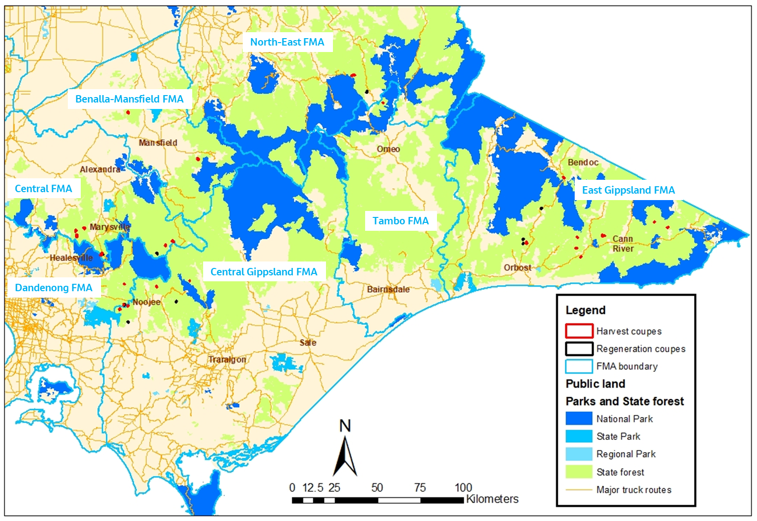
Figure 2.1 Locations of harvest (red) and regeneration (black) coupes included in 2018-19 Forest Audit Program

Audit timing
Field assessments of the coupes included in this audit were undertaken between April and June 2019. Audit reporting was carried out in two stages, with an initial summary report on the results of the audit submitted to DELWP in June 2019. The summary report (Jacobs, 2019) provided preliminary information on compliance assessments and the potential environmental impact of any non-conformances but did not draw out any overall findings or conclusions.

Audit team
The audit team were all employed by Jacobs Group (Australia) Pty Ltd (Jacobs). The team included:
- Craig Clifton (Project Manager and lead auditor): Craig is an EPA-appointed natural resources environmental auditor. He developed the audit methodology, led the field assessments and their analysis and is lead author of this audit report. Craig is an experienced environmental auditor and has led audit teams undertaking six previous audit projects as part of the FAP.
- David Endersby (Project Director): David is a principal consultant with extensive experience in ecological survey. He has participated in several previous FAP audits as a field team member, project director and technical reviewer. David is the internal technical reviewer for this report and Jacobs’ project director. He was also lead ecologist in some of the field audits.
- Dr Drew King (Audit team member): Drew is a senior ecologist with extensive ecological survey experience and has been involved in previous timber harvesting compliance investigations and FAP audits for DELWP. Drew was lead ecologist for field audits in coupes located in East Gippsland, Gippsland and North East FMA regions.
- Rebecca Sutherland (Audit team member): Rebecca is an experienced ecologist and was lead ecological on field audits in coupes located in Benalla-Mansfield FMA and the Central Highlands FMA region.
- Briony Mitchell (Audit team member): Briony is a senior consultant with extensive ecological survey and assessment experience. She was lead ecologist for field audits in the Gippsland FMA region.
- Kait Goudge (Audit team member): Kait is a graduate ecological consultant with experience in ecological surveys. She assisted with field audits in East Gippsland FMA.
- Laura Parker: Goudge (Audit team member): Laura is a graduate ecological consultant with experience in ecological surveys. She also assisted with field audits in East Gippsland FMA.

Audit approach

Coupe selection
Target coupes for the audit were selected from the set of VicForests’ TRP coupes which were operational or under regeneration during the 2017-18 financial year. As per DELWP’s terms of reference for this audit, 30 harvest coupes and 10 regeneration coupes were selected, distributed between Forest Management Areas (FMAs) as listed in Table 3.1. Reserve coupes were also selected in each FMA region in case the initial target coupes were inaccessible at the time of the field audit.
A risk-based selection process was used to identify the target and reserve harvest coupes. The process was based on the characterisation of the coupes in information provided to DELWP by VicForests. The factors influencing selection included:
- Waterway crossing was planned and/or constructed to access the coupe. While these crossings were generally for in-coupe roads, in some cases the target coupes were accessed via snig track crossings
- Rainforest vegetation4F was identified as being present within the gross coupe boundary
- Length of in-coupe road required to access the landing(s) or constructed through the coupe to access other coupes
- Higher soil erosion hazard in the A, B or C horizon
- Higher average coupe slope
- Presence of State forest zoned as Special Protection and/or Special Management Zone (SPZ/SMZ, respectively) within or adjacent to the coupe
- Presence of Victorian Biodiversity Atlas (VBA) records of threatened native flora and/or fauna species within the coupe.
Table 3.1 Summary of audit targets by Forest Management Area
FMA region | # Harvest coupes | # Regeneration coupes
Gippsland FMAs – Central Gippsland, Tambo | 5 | 2
East Gippsland | 10 | 3
Central Highlands FMAs – Central, Dandenong | 10 | 3
North-East FMAs – Benalla-Mansfield, North-East | 5 | 2
Coupes were preferentially selected where multiple risk factors were present. None of the harvest coupes had previously been included in FAP audits. Harvesting operations were still in progress at several coupes, however, at the time of audit, harvesting and regeneration had generally been completed. Three of the selected harvest coupes (461-510-0005 Fairway, 464-501-0031 Phasinator and 469-501-0005 Lady Lavery) were located in Melbourne Water catchment areas. The list of harvest coupes included in the audit is given in Table 3.2, with the location of each coupe shown in Figure 2.1.
Selection of regeneration coupes was influenced by logistical factors (mainly proximity to selected harvest coupes) and the presence of longer lengths of in-coupe road and waterway crossings. Some regeneration coupes had been included in previous FAP audits (although not for regeneration). Selection of the coupes did not consider whether they were had been assessed by VicForests as being fully rehabilitated and regenerated. The list of harvest coupes included in the audit is given in Table 3.3, with the location of each coupe shown in Figure 2.1.
The gross coupe area for the target coupes ranged between 7.3 ha and 71.45F ha, with the average being 39.4 ha. The average harvest area in 2017-18 was 11.6 ha, although some coupes were harvested over several years.
Twenty-five of the coupes were planned to have in-coupe roads, with the average planned length approximately 340 m. However, as operations were conducted, the actual length of new in-coupe road constructed, or existing tracks upgraded, was less than planned for eight coupes. The length of in-coupe road constructed or upgraded exceeded the planned length in a further five coupes.
Waterway crossings were planned for 10 of the coupes included in the audit but were only actually constructed to access eight of the coupes. One of these crossings was not recorded in the operations planning for the coupe. Seventeen of the coupes were located in designated water supply catchments.
Soils in the harvest audit coupes were generally relatively stable, with only six of the 30 coupes recording soil erosion hazard (SEH) values of high or greater. Coupes were not generally located in steep terrain. The average slope was estimated to be 15° or more in eight of the 30 coupes.
The average gross size of regeneration coupes included in the audit was 42.3 ha. All had in-coupe roads and four of the ten had waterway crossings.

Audit criteria and workbook
Audit criteria were based on mandatory requirements of the Code selected by DELWP’s THCU. Most commonly, these referenced compliance elements from the MSPs and its PS, as these provide more detailed interpretations of Code requirements. Compliance criteria were grouped into several themes, as follows:
- Environment: compliance criteria developed for the audit drew on Section 2.2 of the Code (Environmental values in State forests) and related compliance elements from the MSPs and PS. There were three environmental sub-themes: soil, water (incorporating flows, water quality and river health) and biodiversity. Some audit criteria related to more than one of these sub-themes.
- Roading: compliance criteria developed for the audit drew on Section 2.4 of the Code (Roading for timber harvesting operations) and related compliance elements from the MSPs. There were three roading sub-themes: design, construction and maintenance-closure. Some of these compliance elements are also relevant to the water and biodiversity sub-themes.

Table 3.2 Location and characteristics of harvest coupes included in 2018-19 FAP
Audit # | Coupe address | Coupe Name | FMA | Rainforest vegetation | Waterway crossing¹ | In-coupe road length² | Average slope | Max soil erosion hazard | SMZ or SPZ | Listed flora | Listed fauna
1 | 299-511-0002 | Corkscrew | Central | No | Yes | 1-400 m | >15 | Low | SPZ | No | No
2 | 300-501-0003 | Floater | Central | Yes | No | 0 | <15 | Low | SMZ only | No | Yes
3 | 300-517-0003 | Funnel Web | Central | Yes | Yes | 1-400 m | <15 | High | SMZ only | No | No
4 | 300-517-0004 | Black Widow | Central | Yes | Yes | 1-400 m | <15 | High | SMZ only | No | Yes
5 | 309-512-0002 | Creepy | Central | Yes | Yes | 1-400 m | <15 | Mod | SPZ | No | Yes
6 | 309-512-0008 | Eminem | Central | Yes | No | 1-400 m | >15 | Low | SMZ only | No | No
7 | 318-512-0010 | The Wolfman | Central | No | No | 1-400 m | >15 | High | SMZ only | No | No
8 | 320-503-0020 | Fedora | Central | Yes | No | 1-400 m | <15 | Mod | SPZ | No | No
9 | 348-501-0004 | Shorty | Dandenong | Yes | No | 1-400 m | <15 | Low | Nil | No | Yes
10 | 349-514-0004 | Shaq is Back | Dandenong | No | Yes | 1-400 m | >15 | Mod | Nil | No | No
11 | 384-504-0004 | No Doubt | Benalla-Mansfield | No | No | 0 | >15 | Mod | SMZ only | No | No
12 | 388-505-0004 | Princess Di | Benalla-Mansfield | No | No | 0 | 0 | Mod | SPZ | No | No
13 | 411-501-0002 | Barjarg Flat | Benalla-Mansfield | No | No | 0 | <15 | Mod | SMZ only | No | Yes
14 | 461-510-0005 | Fairway | Central Gippsland | Yes | No | 1-400 m | <15 | Mod | SMZ only | No | Yes
15 | 464-501-0031 | Phasinator | Central Gippsland | Yes | No | 1-400 m | <15 | Mod | SMZ only | No | No
16 | 469-501-0005 | Lady Lavery | Central Gippsland | No | No | >400 m | <15 | Low | SPZ | No | Yes
17 | 480-505-0005 | Orca | Central Gippsland | Yes | No | 1-400 m | <15 | Low | SMZ only | No | Yes
18 | 687-512-0012 | Mulloway | North East | No | No | >400 m | >15 | Mod | Nil | No | No
19 | 687-514-0004 | Whiting | North East | No | No | 1-400 m | >15 | High | SMZ only | No | No
20 | 749-501-0015 | Knockabout | Tambo | No | No | >400 m | <15 | Mod | Nil | No | No
21 | 827-503-0005 | Freeline | East Gippsland | Yes | No | >400 m | <15 | Mod | SMZ only | No | No
22 | 827-505-0005 | Fungus | East Gippsland | Yes | No | >400 m | <15 | Mod | SMZ only | No | No
23 | 833-505-0005 | Pilcrow | East Gippsland | Yes | Yes | 1-400 m | <15 | Mod | SMZ only | No | No
24 | 833-513-0005 | Oracle | East Gippsland | No | No | 1-400 m | <15 | Mod | Nil | No | Yes
25 | 834-503-0007 | Patrol Gravel Pit | East Gippsland | Yes | No | 1-400 m | <15 | Mod | SMZ only | No | No
26 | 868-507-0003 | Group Therapy | East Gippsland | Yes | Yes | 0 | >15 | Mod | SPZ | No | Yes
27 | 868-507-0015 | Sleepy Hollow | East Gippsland | Yes | No | 1-400 m | <15 | Low | SMZ only | No | No
28 | 875-511-0012 | Vox | East Gippsland | No | Yes | 1-400 m | <15 | High | SMZ only | No | No
29 | 876-516-0004 | Wingan River | East Gippsland | Yes | No | >400 m | <15 | Mod | SMZ only | No | No
30 | 891-516-0024 | Another Bit | East Gippsland | No | No | >400 m | <15 | High | SPZ | Yes | Yes
Note:
- Waterway crossing colour code: yellow – feature flagged as ‘yes’, but not present in coupe; green – waterway crossing accurately flagged as present or absent; orange – waterway crossing present, although not flagged as such during coupe planning.
- In-coupe road length colour code: yellow – in coupe road length less than estimate; green – road length accurately estimated; orange – actual in-coupe road length greater than estimated.
Table 3.3 Location and characteristics of regeneration coupes included in 2018-19 FAP
Audit # | Coupe address | Coupe Name | FMA | In-coupe road length | Waterway crossing | Silvicultural system
R1 | 309-512-0001 | Lil John | Central | 1-400 m | Yes | Regrowth retention
R2 | 317-508-0006 | Sandman | Central | 1-400 m | No | Even-aged clearfell
R3 | 349-514-0006 | You Just Know | Dandenong | >400 m | Yes | Seed tree regeneration
R4 | 464-505-0013 | Behind the Gate | Central Gippsland | >400 m | No | Even-aged clearfell
R5 | 484-501-0028 | Below | Central Gippsland | 1-400 m | Yes | Seed tree regeneration
R6 | 686-511-0001 | Bottom End | North East | 1-400 m | No | Even-aged clearfell
R7 | 686-511-0004 | Tym Tym | North East | 1-400 m | No | Even-aged clearfell
R8 | 827-501-0022 | Fire Exit | East Gippsland | >400 m | No | Seed tree regeneration
R9 | 827-501-0026 | Tick | East Gippsland | >400 m | No | Seed tree regeneration
R10 | 836-524-0021 | Buckskin | East Gippsland | 1-400 m | Yes | Seed tree regeneration

- Coupe infrastructure: compliance criteria developed for the audit drew on Section 2.5.2 of the Code (Coupe infrastructure) and related compliance elements from the MSPs relating to the rehabilitation of coupe infrastructure, including landings, snig tracks and boundary tracks.
- Coupe planning: compliance criteria for the audit drew on parts of Section 2.5 of the Code (Timber Harvesting) relating to conformance of timber harvesting operations with coupe plans (developed as per Section 2.3 of the Code).
- Forest regeneration: compliance criteria developed for the audit drew on Section 2.6 of the Code (Forest regeneration) and related compliance elements from the MSPs.
Audits considered up to 151 compliance criteria6F for harvest coupes and up to 29 criteria for regeneration coupes (see Appendix A). These were assessed, as applicable, for the target coupes in each category.
A digital audit workbook was developed to capture assessments against all applicable criteria for each individual coupe. Assessments recorded in the workbook were based on observations by the audit team and their review of VicForests’ Forest Coupe Plan (FCP). They considered the applicability of each criterion, as well as the operations’ conformance with the audit criteria. The latter was assessed using the descriptors in Table 3.4.
Table 3.4 Descriptors used to assess conformance with audit criteria
Level of compliance | Fully conforms | Non-conforming with no environmental impact  (part conformance) | Non-conforming with environmental impact  (full non-conformance)
Description | All requirements of the compliance element are fully satisfied. | All requirements of the compliance element are not fully satisfied. However, the non-conformance is procedural and will pose no direct risk of harm to the environment. | All requirements of the compliance element are not fully satisfied. The non-conformance has potential to pose a risk of harm to the environment.
The workbook was also used to capture the basis for any non-conformance assessment. Photographs of coupe features were taken, particularly where/if non-conformances were observed.

Field assessments
Field assessments of relevant coupe characteristics (Table 3.5) were carried out in each of the 30 harvesting coupes. Global positioning systems (GPS) were used in most coupes to track the field team’s movements7F.
Table 3.5 Field assessment methods for harvesting coupes
Attribute being assessed | Criteria | Method
- Waterway classification and correct provision of riparian filters and/or buffers. | 1, 3, 5 | Assessment of waterway as drainage line, temporary stream or permanent stream, based on Code definitions. Streams and widths of filters/buffers will be assessed along up to 600 m of waterway per coupe, if present. Adequacy of filter and buffer widths will be assessed with a range finder, supported by ground traverses to locate the centreline of the stream (as required).
- Soil erosion hazard | 2 | Comparison of VicForests assessment of soil erosion hazard with observations of erosion within the coupe. Soil erosion hazard will be assessed using MSP methods where evidence of soil conditions and soil erosion suggests to the auditor that the initial assessment may have been incorrect or only applicable for one of multiple soil types present within the coupe.
- Extent to which harvesting was conducted on slopes >30° (or >25° in coupes with granite soils in East Gippsland FMA). | 4 | Visual observation, using a clinometer, if required. Supported by subsequent GIS analysis using VF lidar data, if available.
- Adequacy of protection provided to soils, waterways and river health. | 6, 7, 8 | Assessed and interpreted by the auditors, based on the presence of excessive disturbance and/or activities which are not compliant with elements of the regulatory framework. Considers in-coupe roads (ICR) and coupe infrastructure (snig tracks [ST] and landings).
- Presence of in-coupe roads or snig tracks in riparian habitats. | 7 | Visual observations and auditors’ interpretations of the reasonable practicability of alternative placements which avoided riparian areas.
- Waterway crossings and culverts. | 7 | Assessment of culverts, embankments and road drainage against MSP requirements. Observations and auditors’ interpretation of crossings in which the culvert had been removed. Observations of sediment entry into the waterway.
- Habitat trees. | 9, 10, 11, 12, 13 | Assessment of the density and distribution of habitat trees, their location in relation to other habitat and their potential to develop hollows.
- Linear reserve SPZ (EG only) | 11, 18 | Appropriateness of ICR construction through SPZ linear reserve (if present), maintenance of canopy closure over road.
- If listed threatened fauna or flora are recorded as being present, whether prescribed management actions been followed. | 14 | Comparison of observed coupe conditions with management actions specified in the MSP Planning Standards and forest coupe plan (FCP). In EG FMA have any disturbances in SMZ follows the agreed approach?
- Harvesting in Box Ironbark forests in Gippsland and EG FMAs | 15 | Exclusion of selective harvesting, regeneration approach.
- Harvesting and/or road construction in or near heathland or montane riparian thicket (MRT) if present within or near the coupe. | 16 | Confirmation of the presence of the vegetation community and observation of its proximity to ICRs. Auditors’ assessment as to the reasonable practicability of alternative road location if the road entered the protected vegetation community. Presence of harvesting in or in proximity to heathlands or MRT.
- Old growth forest (OGF) | 17 | Provision of buffers around verified OGF within Leadbeater’s Possum (LBP) range.
- Rainforest buffers. | 18 | Identification of rainforest stands, as per MSP definitions. Assessment of provision of any required buffers as per MSP compliance requirements. Assessed for up to 600 m length of rainforest boundary in each coupe.
- Protection of exclusion areas | 19, 31 | Identification and assessment of any effect of harvesting operation (including roading, regeneration burning and machinery movement) on exclusion areas, including SPZ.
- Myrtle Wilt risk. | 21 | Observation of harvesting related damage to or wounding of Myrtle Beech trees, in applicable coupes.
- In-coupe road clearing width. | 23 | For in-coupe roads through retained vegetation, assess whether clearing width was consistent with MSP requirements.
- In-coupe road construction | 24, 26 | Assessment of whether road construction follows any documented plan or design. Identification of any evidence that road construction was inconsistent with need to minimise risk of erosion and water quality impact. Identification of any evidence that table drains were constructed by subsequent excavation. Assessment of the appropriateness of the intensity of earthworks for ICRs. Observation and auditors’ interpretation of the adequacy of road maintenance and any road closure works.
- Fill batters | 25 | Evidence of soil movement and instability. Observation of instances where fill batters cover parts or all of base of live trees to be retained post-harvest.
- Road drainage | 26 | Compliance with MSP drain spacing requirements, based on soil erosion hazard and gradient, for full length of in-coupe road. Assessment of effectiveness of drainage and appropriateness of drainage disposal, considering Code and MSP requirements.  Conformance of culvert construction and management with MSP requirements.
- Disturbance to stream beds | 27 | Appropriateness and avoidability of disturbance to stream beds during and following waterway crossing (WWX) construction and removal.
- ICR and (WWX) closure | 28 | Have any WWXs that are no longer required been removed and rehabilitated as per MSP requirements. Has an ICR that is no longer required been closed permanently?
- Coupe management | 30 | Observation of the consistency between the FCP and the timber harvesting operation.
- Coupe infrastructure | 32 | Assess if ST have been progressively rehabilitated and rehabilitated in a way that prevents soil movement into streams and consistent with MSP requirements. Assess adequacy of ST and boundary track (BT) drainage and its conformance to MSP requirements. Assess up to 400 m length (each) of ST and BT. Assess adequacy of landing rehabilitation, including removal of cording, bark and slash.
Field assessments were also carried out in the 10 target regeneration coupes, based on the procedures outlined in Table 3.6. GPS were again used, in most cases, to track the field team’s movements through the coupe.
Table 3.6 Field assessment methods for regeneration coupes
Attribute being assessed | Criteria | Method
- Coupe stocking | 33 | Success of coupe regeneration compared with MSP requirements. Stocking assessed at a minimum of 50 random locations in each coupe, using 2.27 m radius sampling plots.
- Protection of harvest exclusion areas | 34, 31 | Identify any evidence that regeneration activities (including rough heaping) have protected harvesting exclusion areas and riparian buffers and filters.
- Rehabilitation of coupe infrastructure | 32 | Assess adequacy of ST, BT and landing rehabilitation.
- Rehabilitation of WWX | 28 | Assess whether structures preventing closed roads draining into the site of former WWXs are operating effectively. Assess if former WWX sites have been effectively stabilised and rehabilitated, to avoid soil movement into the waterway.
Each audit criterion for both the harvesting and regeneration audit components was assessed as to its applicability to the coupe in question. That assessment was based on documentary evidence in VicForests’ coupe files or related records and observations by the field audit team. Coupes were assessed to either fully, partly or not conform with the criterion, as per Table 3.4. The workbook was used to capture the basis for the assessment. Photographs of coupe features were taken, particularly where/if non-conformances were observed.

Environmental impact assessment
The EIA tool provided by DELWP (Appendix B) was used to assess the potential environmental impacts of any instances of non-conformance with audit criteria and the regulatory framework for timber harvesting. The tool assesses potential environmental impact based on:
- Extent and location of impact: an auditor’s assessment based on one or more of several factors:
- Proportion of the harvestable coupe area affected by the non-conformance
- Length of in-coupe road without conforming drainage
- The number and/or extent of incidences of inappropriate disturbances (i.e. disturbances to planned timber harvesting exclusions areas which are not permitted by the Code or MSPs) to waterways, riparian buffers or filters or other areas within or adjacent to the gross coupe area.
- Duration of impact/recovery time: an assessment by the auditor of the likely time required for the coupe to recover from any impact or disturbance associated with the non-conformance incident.
- Values affected: an assessment based on the value or environmental aspect experiencing or potentially experiencing an impact stemming from the non-conformance. General forest areas are valued less than riparian or rainforest buffers and SPZ, for example.
The overall five-point EIA rating is based on the total score for each component. Ratings may range between negligible and severe.
If a non-conformance did not directly pose a risk of harm to the environment, it was assessed as non-conforming with no environmental impact, as per Table 3.4.

Audit results
The following discussion summarises the results of the assessments of conformance with compliance criteria based on mandatory elements of the regulatory framework for timber harvesting in State forests, as listed in Appendix A. Overall results are presented first, with those for each compliance theme and sub-theme following. As the coupe selection method was risk-based, rather than random, these results are not statistically representative of VicForests’ operations overall.
Due to space constraints in the figures, coupes are represented by the number assigned in Table 3.2 or Table 3.3 for harvesting and regeneration coupes, respectively. In the narrative accompanying these figures, coupes are referred to by that number (rather than the TRP coupe number) and the coupe name.

Overall compliance findings

Harvest coupes
A total of 151 criteria were identified from the various compliance elements applicable to timber harvesting coupes (Appendix A). Of these, 28 criteria did not actually apply to any of the selected coupes. The overall level of full conformance with applicable audit criteria ranged between 61% (28 Vox) and 98% (11 No Doubt), with the average being 84% (Figure 4.1). Harvesting operations in none of the 30 coupes fully complied with all applicable audit criteria. Some of the non-conformances identified in 26 of the 30 coupes had potential for environmental impact (EI).
Figure 4.1 also shows the actual number of incidents resulting in non-conformance with one or more audit criteria8F. These ranged between zero (4 coupes, as above) and seven (23 Pilcrow), with an average of 2.3 incidents per coupe. A list of the incidents leading to assessments of non-conformance with audit criteria and the regulatory framework for timber harvesting is given in Appendix C.
The EIA tool (Appendix B) was used to assess the potential EI associated with each non-conformance incident9F. This ranged between negligible and major (Figure 4.1). Non-conformances which were assessed to have major environmental impact (EI) were detected in six of the 30 harvest coupes included in the audit. These related to waterway crossings, regeneration burns escaping into what were intended to be unharvested buffers and construction of tracks into SPZs.
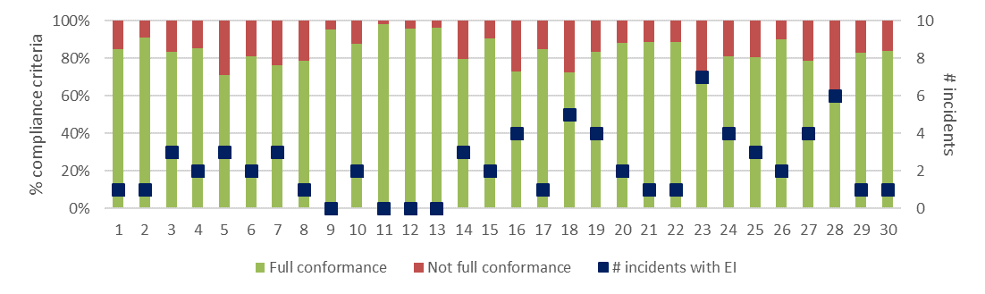
a) Level of conformance with audit criteria and number of non-conformance incidents with assessable environmental impact. Conformance as per Table 3.4, with not full compliance including all criteria with which the coupe did not fully comply, regardless of the potential for environmental impact.
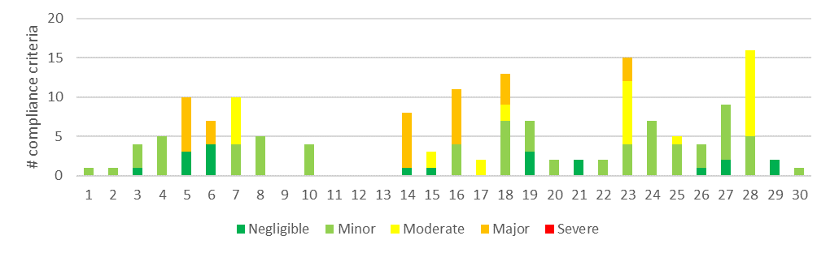
b) Number of compliance criteria with assessable environmental impacts and the assessed level of impact for each instance of non-conformance.
Figure 4.1 Overall compliance findings and assessed environmental impact for instances of non-conformance for harvest coupes. The x-axis refers to the coupe numbers, as per Table 3.2.

Regeneration coupes
A total of 29 criteria were identified from the various compliance elements applicable to regeneration coupes (Appendix A10F), five of which were not applicable to any of the coupes included in this component of the audit. The overall level of full conformance with applicable audit criteria ranged between 73% (R1 Lil John) and 100% (R4 Behind the Gate), with the average being 90% (Figure 4.2). Operations on only one of the 10 regeneration coupes (R4 Behind the Gate) were found to fully conform with all applicable audit criteria. The number of non-conformance incidents per coupe ranged between zero and two, with an average of 0.5 per coupe (Figure 4.2).
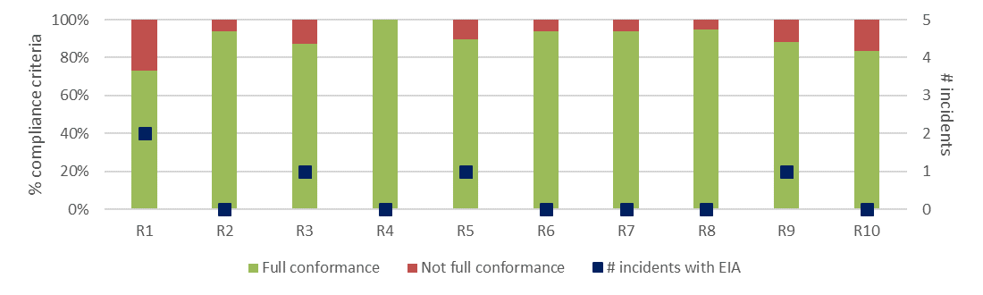
a) Level of conformance with audit criteria and number of non-conformance incidents with assessable environmental impact. Conformance as per Table 3.4, with not full compliance including all criteria with which the coupe did not fully comply, regardless of the potential for environmental impact.
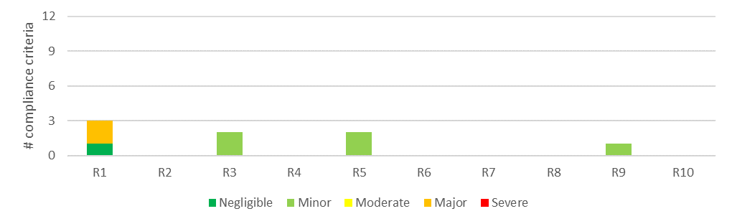
b) Number of compliance criteria with assessable environmental impacts and the assessed level of impact for each instance of non-conformance.
Figure 4.2 Overall compliance findings and assessed environmental impact for instances of non-conformance for regeneration coupes. The x-axis refers to the coupe numbers, as per Table 3.3.
The EIA tool (Appendix B) was used to assess the potential EI associated with each non-conformance incident. This ranged between negligible and major (Figure 4.2). Non-conformances with major potential EI were only assessed for R1 Lil John. This related to a regeneration burn that breached containment and affected an adjacent SPZ.
Seven of the 10 regeneration coupes were assessed to be adequately stocked. R6 Bottom End and R7 Tym Tym were both poorly stocked throughout, despite generally having what appeared to be receptive seed beds. R1 Lil John was also assessed to not be adequately stocked overall, however significant areas within the coupe were adequately stocked.

Harvest coupes: environmental compliance theme
The environmental compliance theme included three main groups of compliance element and audit criteria, those relating to soil, water and biodiversity values. Several roading compliance elements and criteria were also applicable to this theme.

Compliance elements related to the protection of forest soils
Compliance elements related to the protection of forest soils (Appendix A) primarily relate to the avoidance of erosion or mass soil movement, as well as to mitigating the risk of entry of sediments into waterways, should they be mobilised. The entry of mobilised sediments into waterways is primarily dealt with under the water sub-theme (Section 4.2.2). The avoidance of erosion and mass movement of soils is achieved by:
- Assessing and understanding soil erosion hazard within the coupe and adjusting operations accordingly
- Not harvesting in excessively steep areas11F
- Application of seasonal closures to coupes in water supply catchments to reduce the risk of mobilising sediment when harvesting or snigging machinery would disturb wet soils
- Appropriate location, construction, maintenance, closure and/or removal of in-coupe roads, road drainage and road or snig track waterway crossings.
A total of 25 audit criteria were relevant to the protection of forest soils, two of which were not applicable to any of the target coupes. The average level of full conformance with applicable criteria was found to be 74%, with the level of conformance ranging between 46% (5 Creepy) and 100% (5 coupes; Figure 4.3). The assessed environmental impact (EI) associated with non-conformances ranged between negligible and major.
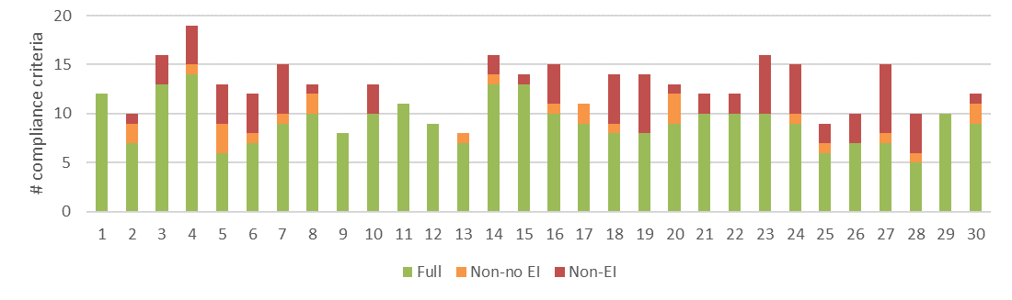
a) Level of conformance with audit criteria. Conformance definitions (Full, Non-no EI, Non-EI) as per Table 3.4..
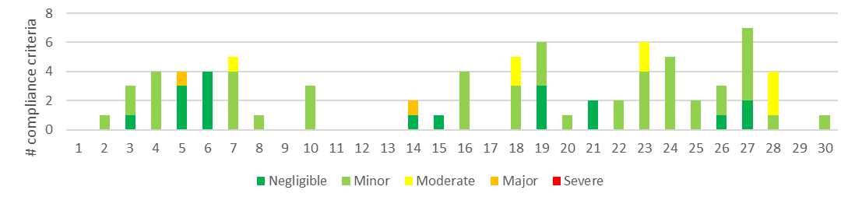
b) Number of compliance criteria with assessable environmental impacts and the assessed level of impact for each instance of non-conformance.
Figure 4.3 Compliance findings and assessed environmental impact for instances of non-conformance for criteria applicable to the protection of forest soils. The x-axis refers to the coupe numbers, as per Table 3.2.
Non-conformance incidents resulting in actual or potential environmental impacts on forest soils were identified in 23 coupes. The types of incidents resulting in assessed EI of moderate or major included:
- Major potential EI:
A culvert (5 Creepy) was constructed so that its outlet projected above the downstream bed of a permanent stream, leading to erosion and sediment mobilisation (Figure 4.4)
A regeneration burn (14 Fairway) affected a significant area of a planned riparian buffer, removed understorey vegetation and exposed soils in this sensitive area to the risk of erosion (Figure 4.4).
In both cases, the level of assessed EI results from the sensitivity of the locations in which the non-conformance incidents occurred and the risk posed to soils and water quality. At the time of the audit, the actual environmental effect of the non-conformance incidents on forest soils was minimal.
- Moderate potential EI:
Long lengths of in-coupe road (23 Pilcrow, 28 Vox) without effective drainage (in excess of MSP prescriptions), resulting in erosion of the road surface12F and significant quantities of road sediment being deposited into waterways (Figure 4.4). Assessed EI is considered by the auditors to reflect the actual level of environmental impact of the non-conformance incident.
Several snig track crossings (7 The Wolfman) ran through drainage line filter strips in circumstances where there were reasonably practicable alternatives to this. The assessed EI was considered by the auditor to be more consistent with the sensitivity of the environment than the level of impact on forest soils.
Many sections of snig track (18 Mulloway) without effective drainage (as per VicForests Utilisation Procedures), resulting in potential for and actual erosion and sediment movement.
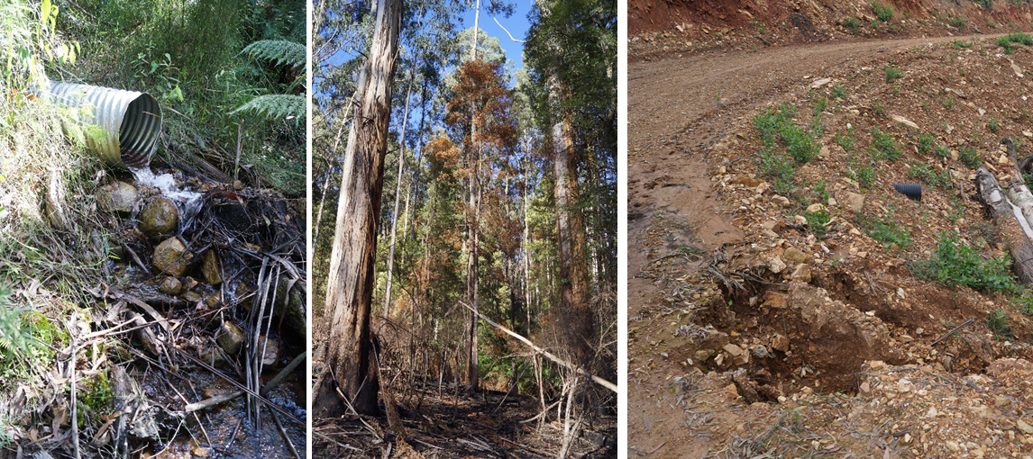
The outlet of this culvert on 5 Creepy projects almost 1 m above the downstream bed of the permanent stream and has resulted in some (minor) erosion. The assessed major EI relates to the sensitivity of this location rather than the actual level of impact | The regeneration burn in 14 Fairway burnt significant areas of the planned riparian buffer. This destroyed groundcover and poses a risk of soil erosion and sediment transport into the buffered waterway. Again, the assessed major EI relates to the sensitivity of the location in which the non-conformance occurred. | Lack of effective drainage of this in-coupe road in 23 Pilcrow resulted in drainage from several hundred metres of road informally running across the embankment of a waterway crossing, leading to erosion of the road surface and embankment and deposition of significant quantities of sediment into a temporary stream. Assessed EI was moderate.
Figure 4.4: Examples of non-conformance incidents with potential or actual environmental impacts on forest soils.

Compliance elements related to the protection of water flows, water quality and river health
Compliance elements relevant to this theme (Appendix A) seek to protect water flows, water quality and river health by:
- Classifying waterways present in the coupe and applying at least the minimum width of filters and/or buffers required
- Application of seasonal closures to reduce the risk of sediment mobilisation during wet weather in water supply catchments
- Appropriate design, construction and maintenance of in-coupe roads, road drainage and waterway crossings.
Many of the compliance requirements (and criteria) are also applicable to the protection of forest soils and to the management of impacts from in-coupe road construction. A total of 45 audit criteria were relevant to this theme, two of which were not applicable to any of the target coupes.
The average level of full conformance with applicable criteria was found to be 81%, with the level of conformance ranging between 36% (28 Vox) and 100% (four coupes). The assessed EI associated with non-conformances ranged between negligible and major (Figure 4.5). Non-conformances which were assessed to have major EI were identified on six coupes (5 Creepy, 6 Eminem, 14 Fairway, 16 Lady Lavery, 18 Mulloway and 23 Pilcrow). Water-related non-conformances with EI were observed in 25 of the 30 harvest coupes included in this component of the audit.
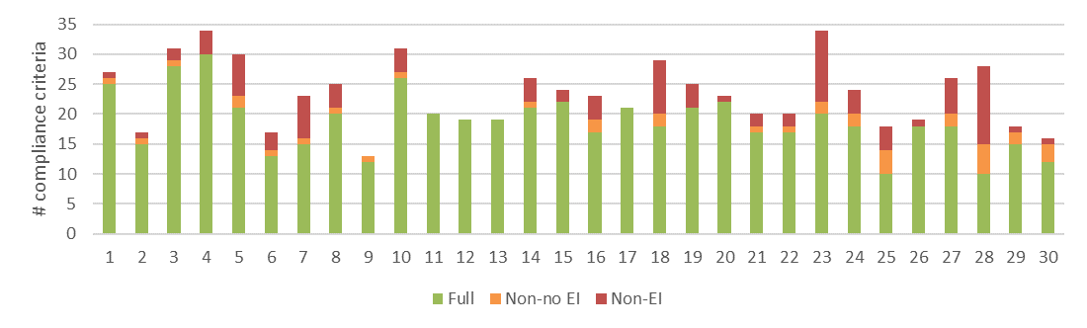
a) Level of conformance with audit criteria. Conformance definitions (Full, Non-no EI, Non-EI) as per Table 3.4.
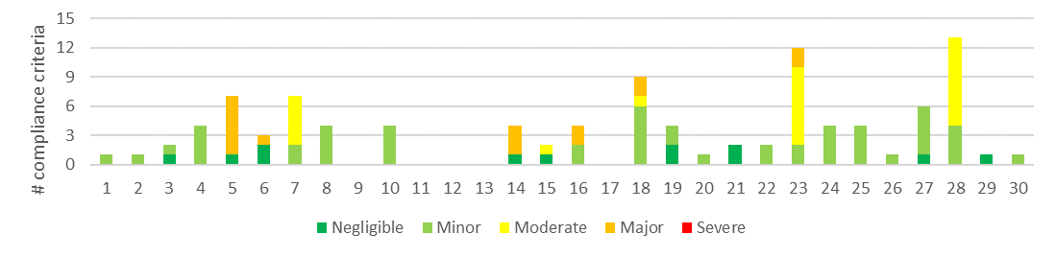
b) Number of compliance criteria with assessable environmental impacts and the assessed level of impact for each instance of non-conformance.
Figure 4.5 Compliance findings and assessed environmental impact for instances of non-conformance for criteria applicable to the protection of water quality, flows and river health. The x-axis refers to the coupe numbers, as per Table 3.2.
Several of the incidents with moderate or major potential EI relating to water quality, flows and river health were also non-conforming with forest soils compliance criteria. The types of incident with moderate or major potential EI included:
- Major potential EI:
A culvert (5 Creepy; Figure 4.4) was constructed so that its outlet projected above the downstream bed of a waterway, leading to erosion and sediment mobilisation into the permanent stream
Regeneration burns in 6 Eminem, 14 Fairway, 16 Lady Lavery, 18 Mulloway, 23 Pilcrow affected planned riparian buffers, which directly affects these environments and poses a risk to river health and water quality (Figure 4.4)
The in-coupe road leading into 5 Creepy had no drains to intercept run-off prior to the waterway crossing, with the result that over 100 m of road drained directly into the permanent stream, rather than the approximately 20 m prescribed by the MSPs.
The major EI rating for these incidents is consistent with the sensitivity of the environments in which they occurred and is considered by the auditor to be an appropriate indication of the risk to river health and water quality.
- Moderate potential EI:
Long lengths of in-coupe road (23 Pilcrow, 28 Vox) without effective drainage (in excess of MSP prescriptions), resulting in significant quantities of road sediment being deposited into waterways (Figure 4.4). In both cases there was also no effective structures to intercept and divert road drainage prior to it reaching a waterway crossing (of a temporary stream) on the in-coupe roads.
The culvert inlet on the waterway crossing in 28 Vox was elevated above the upstream bed of the temporary stream and the culvert outlet was blocked and not visible (Figure 4.6).
Several snig track crossings (7 The Wolfman) ran through and partly disturbed drainage line filter strips in circumstances where there were reasonably practicable alternatives to this.
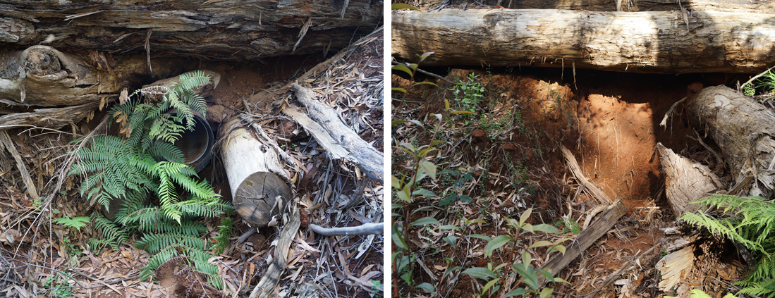
Culvert inlet is elevated above the bed of the temporary stream. Assessed EI is moderate, reflecting the sensitivity of the location in which the non-conformance was observed. | Presumed location of culvert outlet, which could not be identified due to blockage by sediment. Treated as part of the same non-conformance incident as the inlet. EI assessed to be moderate.
Figure 4.6 Examples of inappropriate construction and maintenance of a waterway crossing culvert on 28 Vox, leading to potential effects on water flows, water quality and/or river health.
Non-conforming waterway crossings have been a recurring feature of the FAP (e.g. Jacobs, 2016; 2018a; 2018b). Key issues have historically included:
- No, ineffective and/or poorly maintained structures to intercept road drainage approximately 20 m before it reaches the waterway (as required by the MSPs)
- Culvert outlets elevated above the downstream bed of the waterway and/or draining onto the waterway crossing embankment
- Excessive soil disturbance during the removal of in-coupe road and snig track crossings and/or insufficient site rehabilitation
- Waterway crossings with large culverts (750+ mm) not including fish ladders.
The sensitivity of waterway crossing sites, and in some cases, the level of actual EI, has frequently contributed to moderate or major EI ratings. Of the eight coupes with waterway crossings included in this audit, in only one (1 Corkscrew) was the crossing and associated in-coupe road drainage fully compliant with regulatory requirements. In four of the remaining seven coupes, non-conformances were assessed to have minor potential EI. The assessed EI of non-conformances in 23 Pilcrow and 28 Vox was moderate, due to the crossings being located on temporary streams. The non-conforming crossing in 5 Creepy was on a permanent stream and the EI was therefore assessed to be major. The main issues with non-conforming crossings identified in this audit were: no or poor drainage to intercept road runoff and culvert outlets elevated above the downstream bed of the waterway.

Compliance elements related to the protection of biodiversity values
Compliance elements relevant to this theme (Appendix A) seek to protect biodiversity values by:
- Retaining trees and other habitat within the gross coupe and/or harvested area, including old growth elements and trees with or with potential to form hollows
- Preventing harvesting activities, roading and regeneration burning from taking place within and/or adjacent to sensitive vegetation communities (e.g. heathlands, montane riparian thickets, rainforest stands) and other retained vegetation within the coupe
- Identifying listed, threatened species of native flora and fauna which have been recorded within or adjacent to the coupe and applying the management measures prescribed by the MSPs and PS
- Not harvesting in (or otherwise disturbing) Special Protection Zones (SPZ) established to protect important native fauna habitats (e.g. for Leadbeater’s Possum, Long-footed Potoroo, Owls)
- Maintaining passage for fish or other aquatic fauna along permanent streams
- Managing the risk of entry or spread of weeds and soil-borne or other plant diseases.
A total of 63 audit criteria are relevant to the protection of biodiversity values, of which 22 were not applicable to any of the selected coupes.
The average level of full conformance with applicable criteria was found to be 84%, with the level of full conformance ranging between 55% (16 Lady Lavery) and 96% (10 Shaq is Back; Figure 4.7).
Biodiversity-related non-conformances with EI were observed on eight of the 30 coupes. The assessed EI ranged between negligible and major (Figure 4.7), with the latter being the most common level of potential EI. Non-conformances with major and moderate potential EI were associated with two main types of incident:
- Regeneration burns: in seven of the 30 coupes included in this audit, regenerations burns breached containment or otherwise burnt into areas that were to remain unharvested and hence unaffected by regeneration activities. Most of these areas were riparian buffers. Damage from the regeneration burns has at least temporarily affected biodiversity values associated with understorey habitat (particularly) and had, in some cases, killed mature eucalypt or Myrtle Beech trees (Figure 4.8). The assessed EI of non-conformances was major in five coupes (6 Eminem, 14 Fairway, 16 Lady Lavery, 18 Mulloway, 23 Pilcrow) and moderate in two coupes (15 Phasinator, 17 Orca). With the exception of 17 Orca, the regeneration burn crossed from the harvest/regeneration area into unharvested vegetation. In 17 Orca, heat from the regeneration burn scorched the canopy of and appears to have killed several Myrtle Beech trees.
- Track construction in SPZ: in both 14 Fairway and 16 Lady Lavery, tracks were created within SPZ areas that were to remain unharvested. The track in 14 Fairway (Figure 4.8) was constructed to contain the regeneration burn and for part of its length entered a Leadbeaters Possum SPZ. As noted in the coupe diary for 16 Lady Lavery, the harvesting contractor cleared vegetation from an existing track located in an SPZ adjacent to the coupe.
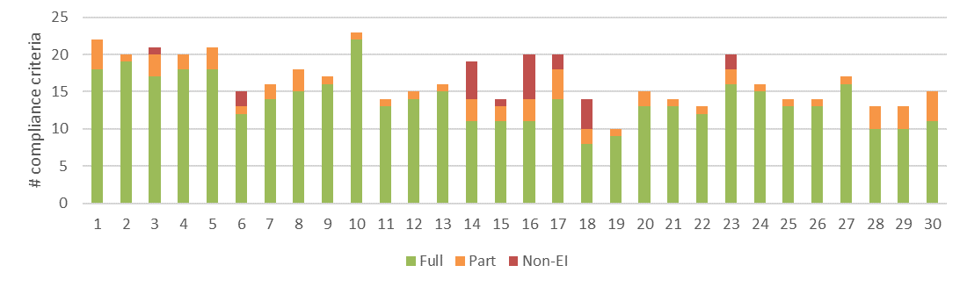
a) Level of conformance with audit criteria. Conformance definitions (Full, Non-no EI, Non-EI) as per Table 3.4.
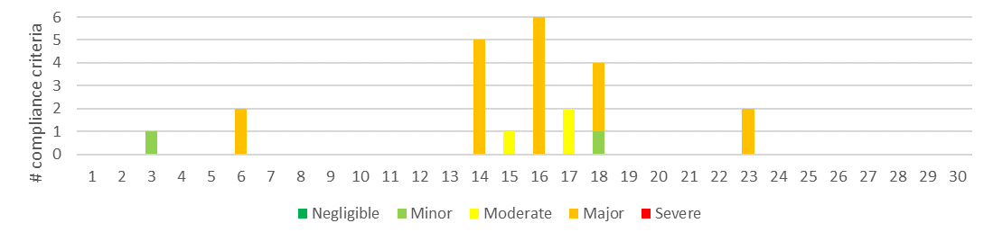
b) Number of compliance criteria with assessable environmental impacts and the assessed level of impact for each instance of non-conformance.
Figure 4.7 Compliance findings and assessed environmental impact for instances of non-conformance for criteria applicable to the protection of biodiversity values. The x-axis refers to the coupe numbers, as per Table 3.2.
Retained trees in the riparian buffer on the edge of 10 Shaq is Back coupe sustained extensive damage from windthrow following harvesting of this and the adjoining coupe. While the damage is inconsistent with the Code requirement (2.2.2.4) to identify and manage risks to biodiversity values, the Code specifies that these risks are to be addressed through management actions that are consistent with the MSPs. As none of the management actions on the coupe (related to the windthrow event) were inconsistent with the MSPs, no non-conformance was recorded.
Non-conformances with no EI were relatively common for this set of compliance elements and accounted for 13% of applicable audit criteria. The main common sources of non-conformance related to stand hygiene or biosecurity procedures, particularly having clear evidence (including in the FCP) of the status and management of root and foliar diseases (Phytophthora, Armillaria, Myrtle Wilt) within the stand and any road surfacing materials imported into the coupe.
There is no suggestion of weed or disease issues being associated with or exacerbated by roading or harvesting in any of the coupes. However, the auditors consider that there was often insufficient explicit evidence in the coupe documentation of the proactive management of biosecurity risks.

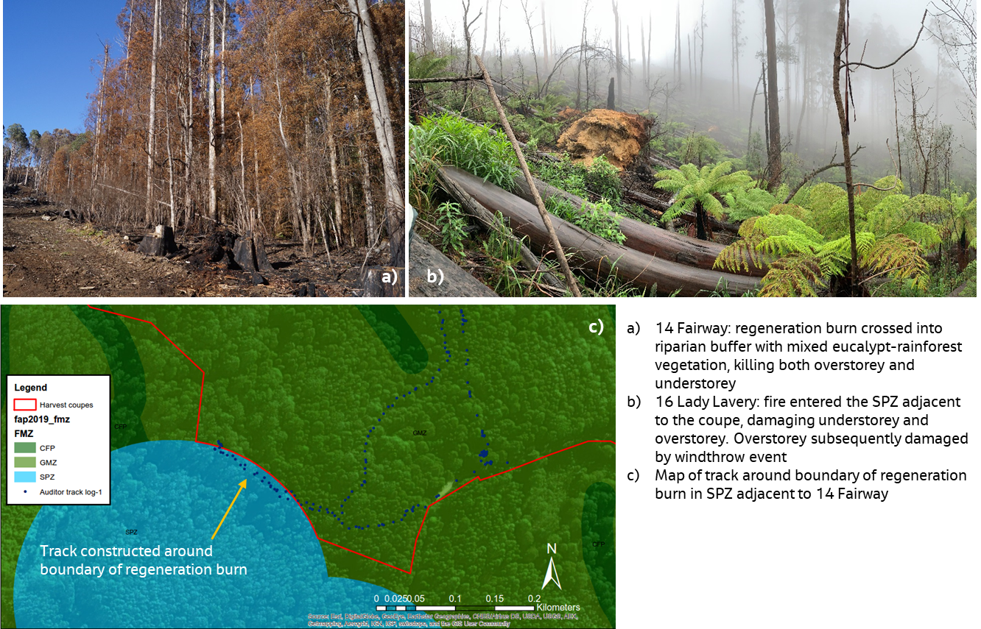
Figure 4.8 Examples of non-conformance incidents with potential/actual environmental impact on biodiversity values.

Harvest coupes: roading compliance theme
The roading theme included three main groups of compliance element and audit criteria, those relating to: in-coupe road and waterway crossing design; construction; and maintenance and closure. Many of the roading compliance elements and criteria were also applicable to the environmental sub-themes.

Compliance elements related to in-coupe road and waterway crossing design
The eight compliance elements relevant to this theme (Appendix A) seek to ensure that appropriate design protects soil and water values from risks associated with the construction of road embankments, waterway crossings and road drainage structures. Design is intended to ensure the stability of roads and road embankments, safe passage of high flow events through crossings and culverts and to prevent erosion of roads and crossings and associated sediment generation. Six of the eight criteria were applicable to the audited coupes.
The average level of full conformance with applicable criteria was found to be 67%, with the level of conformance ranging between 20% (4 Black Widow, 24 Oracle) and 100% (nine coupes; Figure 4.9). The main design-related non-conformance issue was the FCP having no recorded engineering basis for design of the in-coupe road, larger embankment and/or waterway crossing (e.g. as required by Code 2.4.2.4, 2.4.3.1, 2.4.3.2; MSP 6.2.2.3, 6.2.5.4). Mostly, these non-conformances did not directly result in assessments of potential EI.
In 11 of the audited coupes, road design non-conformances were assessed to have potential EI (Figure 4.9). The three incidents with major or moderate potential EI (5 Creepy; 23 Pilcrow and 28 Vox, respectively) were associated with the absence of explicit design of structures to intercept road drainage prior to entry into waterways at crossings. This resulted in extended distances of in-coupe road (»100 m, rather than ~20 m) draining directly into a waterway.
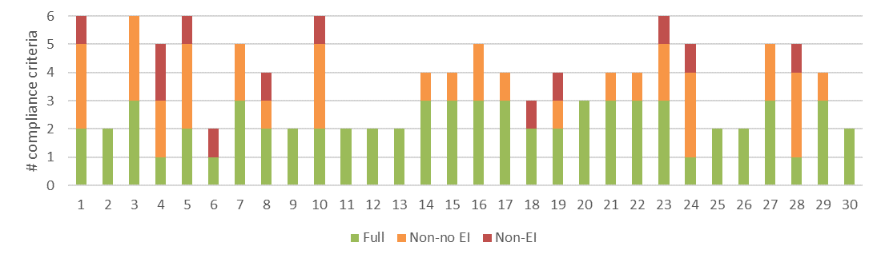
a) Level of conformance with audit criteria. Conformance definitions (Full, Non-no EI, Non-EI) as per Table 3.4.
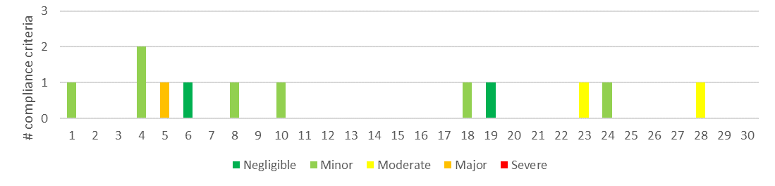
b) Number of compliance criteria with assessable environmental impacts and the assessed level of impact for each instance of non-conformance.
Figure 4.9 Compliance findings and assessed environmental impact for instances of non-conformance for criteria applicable to the road design. The x-axis refers to the coupe numbers, as per Table 3.2.

Compliance elements related to in-coupe road and waterway crossing construction
The 38 compliance elements relevant to this theme13F (Appendix A), like those for road design, largely seek to protect soil and water values from risks associated with road drainage and the construction of road embankments and waterway crossings. The average level of full conformance with applicable criteria was found to be 81%, with the level of conformance ranging between 50% (28 Vox) and 100% (eight coupes; Figure 4.10).
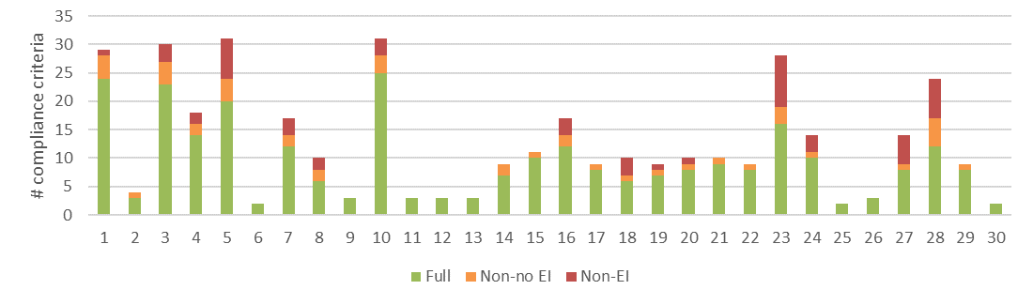
a) Level of conformance with audit criteria. Conformance definitions (Full, Non-no EI, Non-EI) as per Table 3.4.
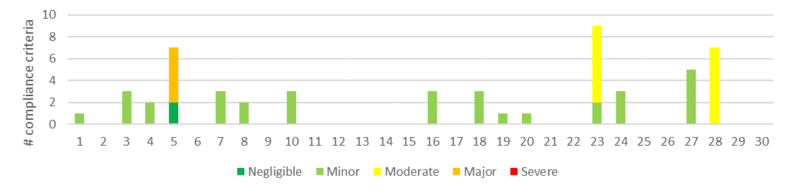
b) Number of compliance criteria with assessable environmental impacts and the assessed level of impact for each instance of non-conformance.
Figure 4.10 Compliance findings and assessed environmental impact for instances of non-conformance for criteria applicable to road construction. The x-axis refers to the coupe numbers, as per Table 3.2.
Non-conformances with potential EI were identified in 15 of the audited coupes. Incidents with major or moderate potential EI related to in-coupe roads being constructed without drainage structures to divert road runoff from directly entering permanent or temporary waterways. Non-conformances with moderate EI in 23 Pilcrow and 28 Vox were also associated with excessive spacings between in-coupe drainage structures.
As has been observed in previous audits that have considered the construction of in-coupe roads (e.g. Jacobs 2016; Jacobs 2018a; Jacobs 2018b), the distance between drainage spacings on many coupes (nine) exceeds the maximum permitted by the MSPs for given slope and soil erosion hazard combinations.
Non-conformances with no potential EI were mainly associated with biosecurity (the FCP having a record indicating road-making materials were imported from a Phytophthora or Armillaria-free quarry) and the absence of a documented plan for construction of the in-coupe road.

Compliance elements related to in-coupe road and waterway crossing maintenance and closure
Only nine compliance criteria relevant to road maintenance or closure were considered in this audit (Appendix A), eight of which were applicable to at least some coupes. Like compliance elements for road design and construction, they are largely concerned with protecting soil and water values from risks associated with the use of in-coupe roads, their closure following the completion of harvesting operations and the removal of any waterway crossings. The average level of full conformance with applicable criteria was found to be 83%, with the level of conformance ranging between 33% (5 Creepy, 18 Mulloway, 23 Pilcrow, 28 Vox) and 100% (21 coupes; Figure 4.11).
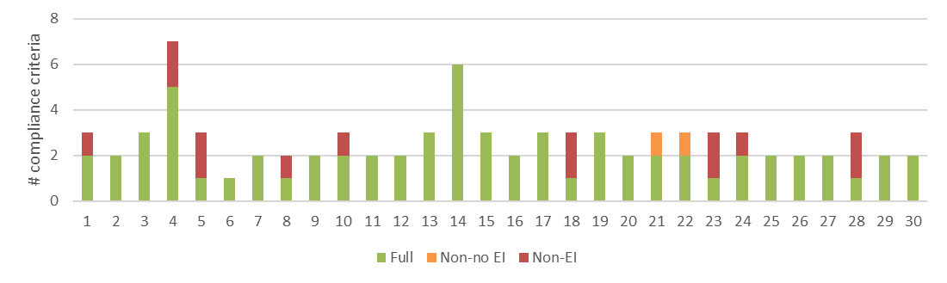
a) Level of conformance with audit criteria. Conformance definitions (Full, Non-no EI, Non-EI) as per Table 3.4.
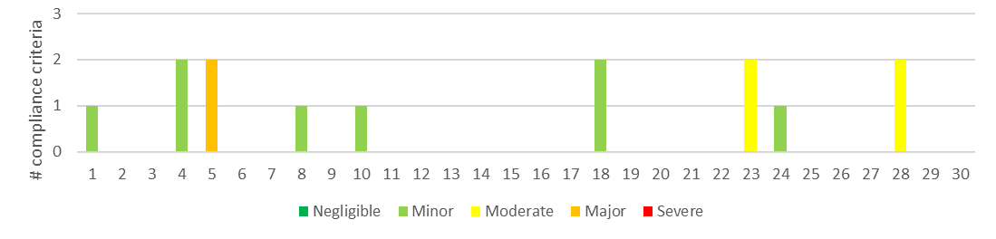
b) Number of compliance criteria with assessable environmental impacts and the assessed level of impact for each instance of non-conformance.
Figure 4.11 Compliance findings and assessed environmental impact for instances of non-conformance for criteria applicable to road maintenance and closure. The x-axis refers to the coupe numbers, as per Table 3.2.
The level of assessed EI associated with non-conformances ranged between minor and major. Non-conformance incidents on the three coupes with major or moderate potential EI (5 Creepy, 23 Pilcrow, 28 Vox) have been discussed previously and relate to inadequate in-coupe road drainage and the lack of diversion of road drainage before entry to a waterway. The incidents are applicable to maintenance because an appropriate monitoring and maintenance regime should have detected that drainage was non-conforming with MSP requirements and led to rectification.
Maintenance works were carried out on 23 Pilcrow and documented in a VicForests ‘Road Works Plan’. The monitoring report for that plan recorded that the in-coupe road was effectively drained (as of May 2018), although this was not the case at the time of the audit.

Harvest coupes: infrastructure compliance theme
Compliance elements considered under the infrastructure theme have a similar function to those for in-coupe roading, in that they seek to protect soil and water values from risks associated with the construction, use and rehabilitation of snig tracks, boundary tracks and landings. Nineteen audit criteria were identified (Appendix A), with all of these applying to at least one of the audited coupes.
The average level of full conformance with applicable criteria was found to be 84%, with the level of full conformance ranging between 56% (18, Mulloway, 28 Vox) and 100% (11 No Doubt, 12 Princess Di, 13 Barjarg Flat, 17 Orca; Figure 4.12). The highest level of assessed EI resulting from non-conformances was moderate, in 7 The Wolfman, 18 Mulloway. These issues arose from:
- Snig tracks being constructed through drainage line filters where there were reasonably practicable alternatives to doing so (7 The Wolfman)
- Lengthy sections of snig and/or boundary track without effective cross drainage (23 Pilcrow).
Boundary tracks in several coupes were found to have been constructed and left largely without effective cross-drainage. This was most commonly detected in coupes in East Gippsland that did not require regeneration burning. It is assumed that drainage construction was planned to occur following burning, but when the coupe regenerated naturally, the tracks were left as constructed. These incidents were typically assessed to have minor or negligible potential EI.
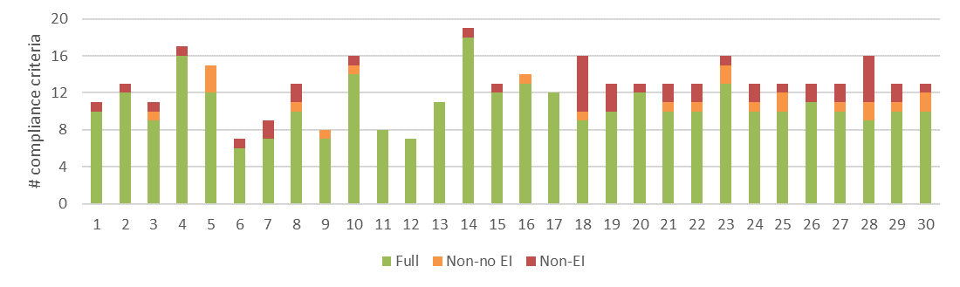
a) Level of conformance with audit criteria. Conformance definitions (Full, Non-no EI, Non-EI) as per Table 3.4.
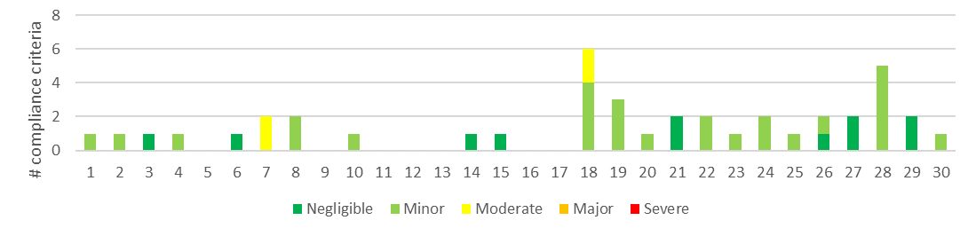
b) Number of compliance criteria with assessable environmental impacts and the assessed level of impact for each instance of non-conformance.
Figure 4.12 Compliance findings and assessed environmental impact for instances of non-conformance for criteria applicable to coupe infrastructure. The x-axis refers to the coupe numbers, as per Table 3.2.
The layout and rehabilitation of snig tracks and rehabilitation of the landing on 24 Oracle contributed (following a major rainfall event) to erosion and mass movement of a section of closed in-coupe road (Figure 4.13). During the rainfall event, water flows from the landing and several snig tracks (some that were not effectively drained) converged on the in-coupe road. The accumulation of water resulted in water infiltrating into the road, causing the formation of a tunnel (d) and contributing to mass movement of the in-coupe road embankment (c, d).
The landing had been ripped across the slope and soil spread across it. However, the direction of ripping did not follow the contours on the approach to the drainage depression. As a result, the rip lines helped to direct run-off from the landing towards the low point on the in-coupe road. These issues were exacerbated by the erodibility of the soil14F.
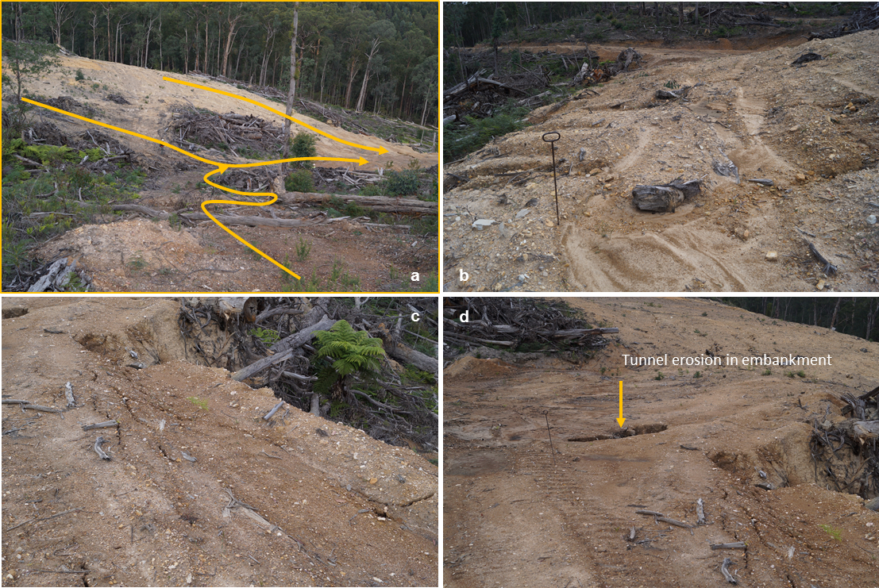
a) Arrows highlight the convergence of water flows along snig tracks and across the rehabilitated landing towards a low point on the in-coupe road. b) Erosion rills on rehabilitated landing. c) Early evidence of mass movement on in-coupe road embankment. d) Water accumulating on this section of in-coupe road has contributed to tunnel erosion below the embankment (arrow), erosion of its edge and slumping.
Figure 4.13: Issues associated with layout and rehabilitation of coupe infrastructure in an area with erodible soils, 24 Oracle.
Several non-conformances were connected with this incident, all of which were assessed to have minor EI. The assessed impact would have been greater had the incident occurred at a location where there was a chance of the sediment that was mobilised finding its way to the waterway that formed part of the coupe boundary.
The incident highlights the importance of snig track drainage and rehabilitation and of planning snig track layout, so that drainage along multiple tracks does not converge on a potentially sensitive location, such as an in-coupe road embankment.
The landing on 3 Funnel Web (which also serviced 4 Black Widow) highlights challenges and risks in rehabilitating landings with large cuttings and in areas of dispersive soils (Figure 4.14). Terrain limitations meant that the landing needed to be cut into the hill slope, which exposed quite dispersive sub-soils. When rehabilitating the landing by reducing the slope of the cutting, the soil that was generated was spread across the landing area. Some of this soil was mobilised during rain events before the area could be regenerated and carried towards a nearby waterway.
Landing rehabilitation on this coupe was assessed as non-conforming because it had not been effective in preventing sediment from being mobilised during the rain event (potential EI assessed as negligible). Given the erodibility of the soil, consideration could have been given to the use of sediment traps or similar structures to help prevent sediment movement towards the waterway.
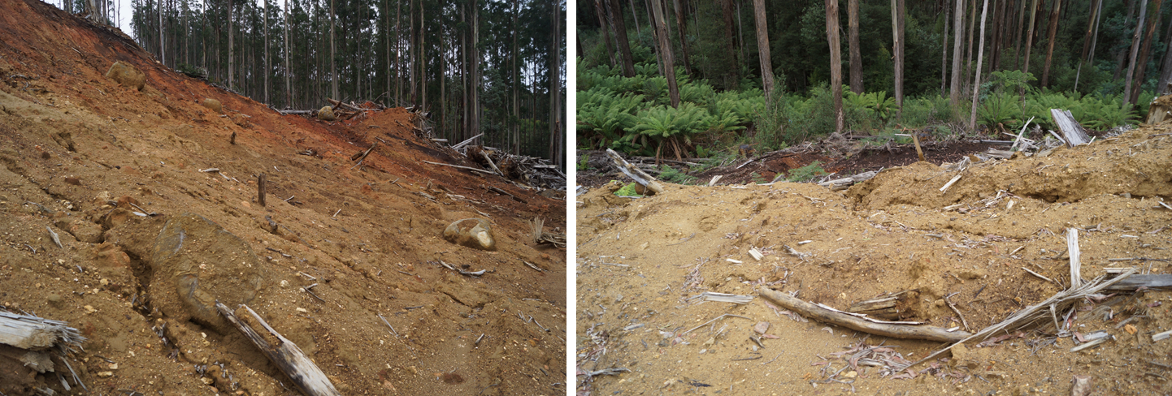
Figure 4.14: Rehabilitation of deeply incised landing, with dispersive sub-soil, 3 Funnel Web.

Harvest coupes: coupe planning and management
Compliance elements considered under this theme are concerned with the development of the FCP and the consistency of coupe operations with that plan. The compliance elements seek to protect soil, water and biodiversity values from risks associated with harvesting, roading and regeneration operations. Twenty-five audit criteria were identified (Appendix A), with two of these not applying to any of the audited coupes.
The average level of full conformance with applicable criteria was found to be 92%, with the level of full conformance ranging between 80% (5 Creepy) and 100% (nine coupes; Figure 4.15). Potential EI resulting from non-conformances was assessed to be major for six coupes and moderate for four coupes (Figure 4.15). The incidents giving rise to the non-conformances have been discussed previously and include:
- Drainage of long lengths of in-coupe road into waterway crossings (5 Creepy, 23 Pilcrow, 28 Vox)
- Regeneration burns crossing into planned exclusion areas (mostly riparian buffers; 6 Eminem, 16 Lady Lavery, 23 Pilcrow), adjacent SPZs (14 Fairway, 16 Lady Lavery) and an adjacent coupe (18 Mulloway)
- Construction of tracks in an adjacent SPZ (14 Fairway, 16 Lady Lavery)
- Snig tracks being constructed through drainage line filters where there were reasonably practicable alternatives to doing so (7 The Wolfman).
The incidents relate to timber harvesting operations not having been conducted in accordance with the FCP (Code 2.5.1.2) and/or harvesting activities (i.e. regeneration burns, machinery access) being carried out within SPZs (Code 2.5.1.5, MSP 7.1.2.1).
The audit identified three areas of coupe planning that are inconsistent with audit criteria, namely:
- Inclusion of a map in the FCP showing waterway classification (Audit criterion 1.02, Appendix A; 12 coupes), as evidenced by an explicit reference to the class of waterway or to whether a filter or buffer applied15F
- Inclusion of a map in the FCP showing areas of the coupe with slopes over 30° (Audit criterion 4.01, Appendix A; five coupes), as evidenced by a map showing areas within and near to the coupe with slope in 20-30° and 30°+ categories (if such slopes are likely)
- Inclusion of a map in the FCP showing areas of the coupe with granite-derived soils and slopes over 25° (East Gippsland FMA only; Audit criterion 4.04, Appendix A – two coupes), as evidenced by a map showing areas within and near to the coupe with slope in at least 20-30° category (if such slopes are likely) and a map or text flagging that the coupe is in an area of granite-derived soil.
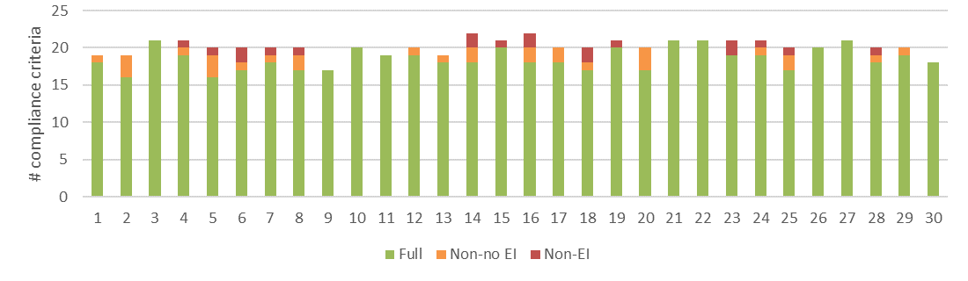
a) Level of conformance with audit criteria. Conformance definitions (Full, Non-no EI, Non-EI) as per Table 3.4.
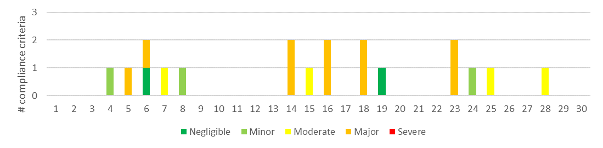
b) Number of compliance criteria with assessable environmental impacts and the assessed level of impact for each instance of non-conformance.
Figure 4.15 Compliance findings and assessed environmental impact for instances of non-conformance for criteria applicable to coupe planning and management. The x-axis refers to the coupe numbers, as per Table 3.2.
While these are not explicitly required by the Code or MSPs, such maps are implicit in MSP 2.3.1.2, which requires that FCPs include a map which clearly and accurately identifies …areas … to which special prescriptions apply (including biodiversity protection or habitat enhancement, water quality and aquatic habitat protection…).
Definition of a boundary as a filter or buffer and, more particularly, as a filter or buffer for a drainage line, temporary stream or permanent stream clearly communicates the sensitivity of the location to the contractor and provides an unambiguous point of reference for assessing potential EI in case of a breach. Mapping of high slope areas within a coupe highlights areas where special care is required in harvesting. It also enables harvesting to be planned so that no more than 10% of the net harvest area exceeds the slope threshold (as per MSP 3.4.1.1-3.4.1.3).

Coupe regeneration and rehabilitation
A total of 29 criteria were identified from the various compliance elements applicable to regeneration coupes (Appendix A16F), with four of these not being applicable to any of the 10 coupes included in this component of the audit. As noted in Section 4.1.2, the overall level of full conformance with applicable audit criteria ranged between 73% (R1 Lil John) and 100% (R4 Behind the Gate), with the average being 90% (Figure 4.2).
Non-conformances with potential EI were observed in four of the 10 coupes (R1 Lil John, R3 You just know, R5 Below, R9 Tick), with the assessed level of environmental impact ranging to up to major. Incidents associated with these non-conformances included:
- Regeneration burning breaching the coupe boundary: the regeneration burn in R1 Lil John extended into a neighbouring SPZ. The fire damaged the understorey but did not kill the eucalypt overstorey. Due to the sensitivity of this location, the potential EI was assessed to be major.
- Non-reinstatement of cross-drainage on a snig track: drainage on a section of snig track in R3 You Just Know that was used for access during regeneration burning had not been reinstated. As a result, drainage spacing exceed MSP specifications. The assessed potential EI was minor.
- Failure of large embankment: the embankment on one of the landings on R5 Below and the in-coupe road used to access it was found to have experienced mass movement and be actively eroding (Figure 4.16). The assessed potential EI was minor, reflecting that the incident was well-removed from waterways.
- Inappropriate or incomplete landing rehabilitation: parts of the landing on R1 Lil John appeared to have been burnt at very high temperature, suggesting that insufficient bark had been removed (contrary to MSP 7.2.2.5). This was assessed to have negligible EI. One of the two landings on R9 Tick appeared to have been only partly ripped and rehabilitated. Regeneration was progressing in this area, but only slowly. The assessed EI was minor.
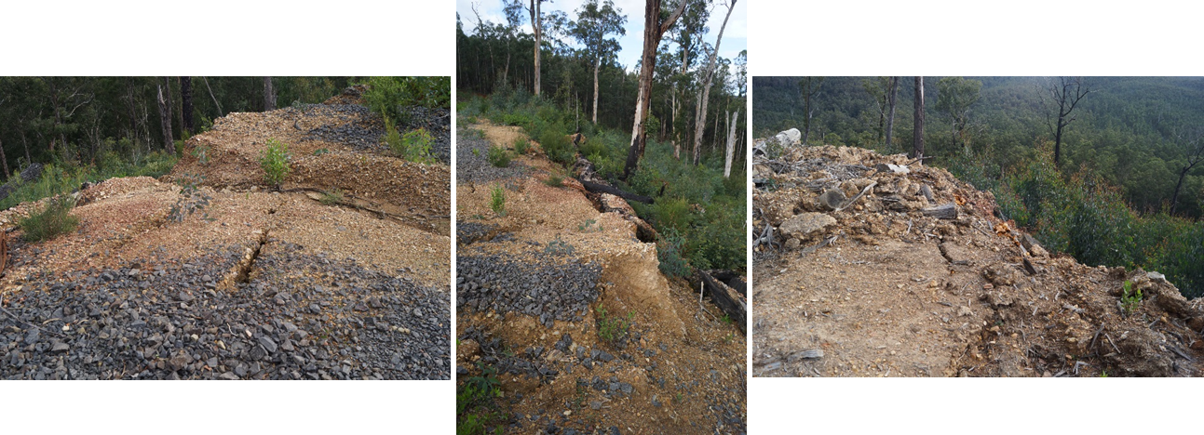
Figure 4.16: Mass movement and erosion of the in-coupe road and landing embankments, R5 Below.
Seven of the 10 coupes were found to be adequately regenerated. R6 Bottom End and R7 Tym Tym (located adjacent to each other) were both poorly stocked at the time of audit. Despite the seedbed appearing to be receptive, it seemed unlikely that the coupes would regenerate adequately without further intervention. R1 Lil John was unevenly regenerated, with some areas having good stocking and other areas (often with an apparently receptive seedbed) having little regeneration.
Since coupe regeneration is a compliance requirement of the Code, insufficient regeneration at the time of the field assessment was considered to be a non-conformance17F. No potential EI was assessed, as the coupes remained under VicForests’ management for regeneration and hence it is expected that further work to successfully regenerate the coupe would be undertaken and that the coupe would eventually comply with relevant Code and MSP requirements.
In-coupe roads into three coupes that had been successfully regenerated had not been permanently closed to traffic, as required by the Code and MSPs. There was no evidence that this was associated with any adverse environmental impact and so potential EI was not assessed.
Observations made during this component of the audit suggests some variability in the rate at which coupe infrastructure regenerates. Snig tracks typically regenerate quickly, with eucalypts and understorey species establishing at a similar rate to the rest of the coupe. Boundary tracks appear to be slower to regenerate, potentially reflecting competition for water with adjacent mature trees. Landings appear to regenerate variably, depending on the success of rehabilitation works, effects of regeneration burning and impacts of browsing animals. Unripped areas in the vicinity of landings that have been compacted by log trucks or snigging traffic appear to regenerate slowly.

Discussion

Overall audit findings
The audit is intended to assess VicForests’ conformance with selected elements of the regulatory framework for timber harvesting activities in State forests, as well as any environmental risks posed by non-conformances. This section provides a summary of the audit’s overall findings in relation to these objectives.

Harvest coupes
The harvesting and roading component of this audit considered 30 coupes that were located in State forests distributed through eastern Victoria. Since coupe selection was weighted towards those with higher risk natural and constructed features (e.g. rainforest vegetation, waterway crossings, in-coupe roads, steeper slopes, more erodible soils), the findings of the audit are not necessarily statistically representative of VicForests’ operations overall.
The audit found that full conformance was achieved with 84% of applicable audit criteria, overall (Figure 5.1). The level of full conformance varied between compliance themes, ranging between 67% (road design) and 92% (coupe planning). Non-conformances with direct or potential EI were associated with 69 unique incidents within or directly adjacent to 26 of the 30 coupes included in this component of the audit.
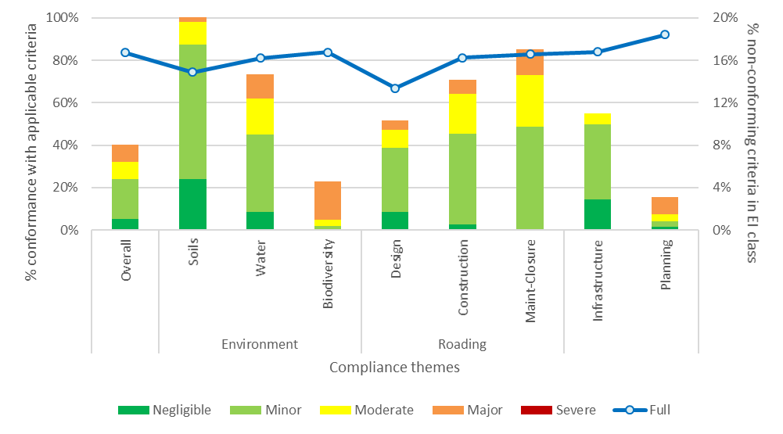
% full conformance with applicable audit criteria overall and in each harvest coupe audit theme (left Y axis). % non-conformances with EI overall and for audit themes and sub-themes (right Y axis)
Figure 5.1 Summary of overall audit findings for conformance with the regulatory framework for timber harvesting and related activities in State forests in Victoria: harvest coupes.
Instances of non-conformance with audit criteria were identified across all audit themes and sub-themes. The assessed EI associated with non-conformances is summarised by audit theme and sub-theme in Figure 5.1. Non-conformances with potential EI were most common (proportionally) in the soils and road maintenance and closure sub-themes (noting that there were only eight applicable criteria for the latter). In both cases, non-conformances with potential EI were recorded for at least 16% of applicable (non-conforming) criteria.
Assessed EI for non-conformances ranged between negligible and major. The most common level of assessed EI was minor. Major and moderate EI-rated non-conformances were associated with 16% and 18% of audit criteria for which non-conformances were recorded, respectively.
A variety of incident types were found to result in non-conformances with potential EI. These are summarised in Table 5.1. Four types of incident were assessed to have EI ratings of up to major:
- Long-lengths of in-coupe roads being constructed without effective drainage structures
- Waterway crossings on permanent streams being designed and constructed without appropriate placement of culverts or construction of drainage to intercept in-coupe road runoff before it enters the waterway
- Regeneration burns breaching containment and burning into adjacent SPZ or other exclusion areas
- Construction of tracks within SPZs.
Major EI ratings for these incidents reflected the sensitivity of the locations at which the incidents occurred, and in some cases, the level of EI. The first three of these types of incident with major potential EI have been identified in previous FAP audits.
The four most common incidents with potential EI included: excessive drainage structure spacing on in-coupe roads; inappropriately designed and constructed waterway crossings; excessive drainage structure spacing on snig and boundary tracks; and mass movement of in-coupe road and landing embankments.
Three of the main non-conformance incidents with potential EI were observed more frequently in the current audit than in the 2017-18 FAP and two of the incidents were observed less frequently (Table 5.1). Several types of incident were identified in this audit that were not observed in the previous audit. This reflects the inclusion of new audit criteria (e.g. relating to the rehabilitation of coupe infrastructure), as well as the detection of some incidents that had not previously been observed (e.g. machine entry into SPZs) and the detection of other incidents that were not observed in the 2017-18 audit (e.g. mass movement of in-coupe road or landing embankments) but had been observed in earlier FAP audits.
Almost all incidents posed a risk to soil and water values. Several threatened (to varying extents) the productive capacity of the regenerating forest and some posed a risk to biodiversity values (Table 5.1).
Table 5.1 Types of incident resulting in non-conformances with the regulatory framework that have potential or actual environmental impact, including comparison with 2017-18 FAP
Type of incident | # incidents |  | Maximum EI rating | Code (C), MSP (M) or PS (P) reference
Type of incident | 2018-19 | 2017-18¹ | Maximum EI rating | Code (C), MSP (M) or PS (P) reference
- Drain spacing along snig tracks or boundary tracks exceeded permitted value based on soil erosion hazard and slope  Potential consequences: soil erosion, sediment deposition into waterways, impairment of aquatic habitat, reduced water quality. | 14 | Not in scope | Minor | C2.5.2.5
- In-coupe road drainage structure spacing exceeded permitted value based on soil erosion hazard and slope  Potential consequences: soil erosion, sediment deposition into waterways, impairment of aquatic habitat, reduced water quality. | 10 | 8 | Major | C2.4.2.5, M6.2.4.1
- Engineer not engaged in design of road or landing embankment. Embankment subject to mass movement of soil  Potential consequences: soil mass movement and erosion, damage to regenerating forest. | 9 | Not observed | Minor | C2.2.1.2/14/15, 2.4.3.3, M6.2.2.3
- Waterway crossing design and/or construction that does not conform with the regulatory framework (including culvert installation, management of road drainage in the vicinity of the crossing)  Potential consequences: soil erosion, sediment deposition into waterways, impairment of aquatic habitat, reduced water quality. | 8 | 5 | Major | C2.2.1.2/6/8, M6.2.5.5
- Rehabilitation of infrastructure (landing, snig track, in-coupe road) has contributed to soil mass movement and/or erosion  Potential consequences: soil erosion, sediment deposition into waterways, impairment of aquatic habitat, reduced water quality, loss of production from regenerating forest. | 5 | Not in scope | Minor | C2.2.1.2/12/14, 2.5.1.2, M6.4.1.2 , 7.2.2.2
- Regeneration burn entering exclusion areas within or adjacent to coupe or vegetation in exclusion area damaged by regeneration burn that remains within the planned burn boundary  Potential consequences: soil erosion, sediment deposition into waterways, impairment of aquatic and terrestrial habitat, reduced water quality, loss of fire-sensitive biodiversity values. | 5 | 4 | Major | C2.2.1.2, 2.2.2.4/5, 2.5.1.2, M4.1.4.5
- Landing not fully rehabilitated  Potential consequences: reduced productive capacity of regenerating forest. | 5 | Not in scope | Minor | M7.2.2.2
- Snig track crosses into drainage line filter, without apparent sanction and/or when reasonably practicable alternatives existed  Potential consequences: soil erosion, sediment deposition into waterways, impairment of aquatic habitat, reduced water quality. | 3 | Not in scope | Moderate | C2.2.1.2, 2.2.1.5, 2.5.1.2, M3.3.1.1, 3.5.1.1/3, 7.1.4.1
- Machinery entry into SPZ or other exclusion areas within or adjacent to coupe  Potential consequences: soil compaction/disturbance, reduction in habitat values. | 3 | Not observed | Major | C2.2.1.2/5, 2.5.1.2, M3.5.1.1, 4.2.1.1, 7.1.2.1, P4.3.1.1
- Damage to adjacent coupe due to regeneration burn crossing a coupe boundary  Potential consequences: soil erosion, loss of productive capacity of regenerating forest. | 1 | Not observed | Moderate | C2.2.2.5, 2.5.1.2
- Harvesting of tree outside coupe boundary  Minimal potential consequence. | 1 | Not observed | Moderate | C2.5.1.2
- Inadequate maintenance of road drainage structure (silt trap) leading to impairment of effectiveness  Potential consequences: soil erosion, sediment deposition into waterways, impairment of aquatic habitat, reduced water quality. | 1 | 4 | Minor | M2.2.1.8/12
- Part of the base of a tree retained in a coupe covered by in-coupe road or landing embankment materials  Potential consequences: (minimal) reduction in productive capacity of regenerating forest. | 1 | 3 | Minor | M6.2.2.1
- Entry of harvesting machinery into riparian filter strip  Potential consequences: soil erosion, sediment deposition into waterways, impairment of aquatic habitat, reduced water quality. | 1 | 1 | Minor | C2.2.1.2/12, 2.5.1.2
Note:
- Not observed: non-conformance not observed in 2017-18 FAP audit; Not in scope: non-conformance relates to compliance requirement that was not with the scope of the 2017-18 FAP audit.

Regeneration coupes
The regeneration component of the audit considered 10 coupes distributed across State forests in eastern Victoria. As coupe selection considered risk and logistics, the results of the audit of regeneration coupes are not statistically representative of VicForests’ operations overall.
The overall level of full conformance with applicable audit criteria ranged between 73% and 100%, with the average being 90% (Figure 4.2). Seven of the 10 coupes were assessed to be adequately regenerated at the time of the audit18F. Landings on two of the coupes were not fully rehabilitated at the time of the audit.
Non-conformances with potential EI were identified on four of the 10 coupes (Figure 4.2). Incidents resulting in these non-conformances resulted from regeneration activities, as well as earlier harvesting and roading activities. They included:
- Regeneration burns entering into an adjacent SPZ
- Insufficient removal of bark from the landing19F
- Non-reinstatement of appropriately spaced drainage on a snig track used in regeneration burning
- Failure of embankments on an in-coupe road and the landing it connected to
- Landing embankment materials covered the base of unharvested trees
- Partial rehabilitation of the landing.
The only incident with greater than minor potential EI, was the unplanned entry of the regeneration burn in R1 Lil John into the adjacent SPZ.

Comparison with previous audits
As has been noted previously, coupe selection for the audit is risk-based, rather than fully randomised. This means that audit results may not be statistically representative of VicForests’ operations overall and audit results therefore not be directly comparable between years. However, since there has been a broadly consistent approach to coupe selection and compliance criteria for at least the environment and roading themes over the past three audits (from 2016-17 onwards), there is some basis for comparison of audit results for harvest coupes over time.
The comparison of audit results (Table 5.2) suggests reductions in conformance with audit criteria overall and in the environmental sub-themes, relative to both the 2016-17 and 2017-18 audits. Larger reductions in full conformance with audit criteria were recorded for the soils, biodiversity , road design and road construction sub-themes. Some of these differences reflect the more stringent approach taken in this year’s audit to assessing conformance with biosecurity requirements under the Code and MSPs (particularly confirmation of the soil-borne disease free status of gravel used on in-coupe roads), the greater incidence of detection of regeneration burns entering planned protection areas and the capacity in this audit to record such incidents as non-conformances in all FMAs20F.
Table 5.2 Comparison of audit results for recent FAP audits of harvesting coupes
 | % Full conformance with applicable audit criteria |  |  | # Non-conformances with major potential environmental impact¹
FAP compliance theme and sub-theme | 2016-17² | 2017-18³ | 2018-19 | 2016-17² | 2017-18³ | 2018-19
Overall⁴ | 86% | 91% | 79% | 37 | 4 | 31
Environment
- Soils | 83% | 87% | 74% | 13 | 2 | 2
- Water | 85% | 90% | 81% | 29 | 4 | 16
- Biodiversity | 90% | 92% | 84% | 13 | 0 | 18
Roading
- Design | 57% | 81% | 67% | 7 | 0 | 1
- Construction | 79% | 92% | 81% | 30 | 0 | 5
- Maintenance and closure | 73% | 71% | 83% | 5 | 0 | 2
Notes:
- Note that individual incidents may give rise to non-conformances against more than one audit criterion.
- Jacobs 2018a
- Jacobs 2018b
- The overall assessment result for the 2018-19 audit has been adjusted from that reported in Figure 5.1 to restrict it to the sub-themes included in previous audits. However, this adjustment does not account for the inclusion, in this year’s audit, of additional regulatory requirements in the sub-themes considered by previous audits. Accounting for these additional criteria potentially adds 1-2% to the overall % full conformance and that for water and biodiversity sub-themes
The number of non-conformances with major potential EI recorded in the current audit was greater overall than in the 2017-18 audit, but less overall than was recorded in the 2016-17 audit. Some of the reductions in the number of non-conformances with major potential EI recorded (between 2016-17 and 2018-19) reflects the reduced duplication of compliance criteria between sub-themes in the current audit and more stringent analysis of the relevance of the actual non-conformance incident to the audit criterion.
The types of incident giving rise to potential EI (Table 5.1) have generally remained consistent between recent audits21F, although the frequency of incidents has changed over time. Incidents relating to waterway crossings (particularly those with major or moderate potential EI) were particularly numerous in 2016-17, but were significantly less frequently observed in the two most recent audits. Issues with regeneration burns entering adjoining exclusion areas have been observed in previous audits, but not at the frequency observed in this audit. The audit team also observed two instances of tracks being constructed or cleared into SPZ areas adjoining the coupe, a non-conformance that had not previously been recorded.

Potential improvements to coupe planning, timber harvesting and coupe regeneration practices
Observations from the current audit and reflections on non-conformance incidents from previous audits suggests several potential areas for improvement in coupe planning, timber harvesting and coupe regeneration practices, as discussed in the following sections.

Coupe planning
Coupe planning and its documentation by VicForests typically conforms well with Code and MSP requirements. Several incremental improvements in practice are suggested by observations made in this audit, some of which have been made in previous audits, as follows:
- Explicit mapping of waterway classifications: there is significant variation in practice between operators in the mapping of waterways in coupe operations maps. The MSPs require that waterways are accurately mapped (2.3.1.2 b) and that the three waterway classes (permanent streams, temporary streams and drainage lines; 3.1.1.1) are used to determine buffer and filter widths. The practice of some operators is to explicitly label waterways according to the class (as above). Other operators, in mapping the planned harvest boundary, colour filters, buffers and non-waterway boundaries differently.
While both practices are assessed to conform to MSP requirements, the auditor’s preference is to explicitly mark the waterway classification and indicate whether the boundary is a buffer, filter or combination of the two (as per MSP Tables 9 and 10). This provides unambiguous evidence of how the coupe planner has classified the waterway and may be used to demonstrate waterway protection beyond minimum compliance (e.g. where buffers are used along temporary drainage lines).
- Mapping of coupe slope: many FCPs were found to include maps showing slope classes as a guide to where harvesting would or would not be appropriate. These are typically only included (or necessary) where slopes exceed about 20° and help to demonstrate conformance with MSPs 2.3.1.2 b, 3.4.1 and Table 11 (for Water Supply Protection Areas; WSPAs). Where they are used, they typically show slopes in the range 20-30° and >30°. No examples have been sighted (in relevant coupes) showing slopes >25°, which is the limit for harvesting on granite soils in East Gippsland FMA and in some WSPAs.
While it is recognised that slope mapping has limited accuracy, the inclusion of such information helps to provide evidence supporting the coupe planner’s decisions about marking harvest boundaries. The auditor’s preference is for such maps to be included in FCPs in all applicable coupes.
- Geology: geology is only specifically relevant to coupe planning in East Gippsland FMA, where the slope limit for harvesting is reduced to 25° on sites with granite-derived soils (MSP 3.4.1.3). In the auditors’ experience, land systems or geological mapping is typically used to determine if soils are granite-derived. Since this mapping is rather coarse in scale (1:250,000), it should not be used as the sole arbiter of the presence of granite-derived soils. It is suggested that for coupes located within (say) 2 km of granite geology, the soil assessments specifically determine and note the actual parent material. If it is granite, then this information should inform the selection of the slope limit for harvesting.
Several East Gippsland coupes located near to (but not within) areas mapped as having granite geology were suspected of having granite-derived soils, but this was not noted in the FCP. However, these coupes did not have steep slopes and there was no danger of the 25° slope limit for harvesting on such soils having been breached.
VicForests’ coupe planning template (for the coupes included in this audit) did not specifically enable recording of the combination of granite soils and slopes >25°, which could result in this special slope limit being overlooked.
In comments on the draft audit report, VicForests reported that they have addressed the two latter points. A spatial data layer has been produced (copy provided to the auditors) that combines slope class and the presence of granite-based soils and is based on the best available (LiDAR) slope and lithological data. The data is used to flag coupes with these combined risks and is field checked. Outputs are recorded in the coupe file. Generation of this data set post-dates planning for the East Gippsland coupes included in the audit. VicForests also report having adopted a more general practice of using LiDAR data to classify and map coupe slopes. Recommendations regarding the latter two issues discussed above that were in the draft Audit Report are no longer applicable and have not been included here.
Recommendation V-01 Medium priority
That VicForests adopt a consistent practice of marking maps of in-coupe waterways with the waterway classification as well as whether a buffer, filter or buffer and filter have been applied.

Design, construction and maintenance of in-coupe roads and waterway crossings
Recent FAP audits by this audit team (Jacobs, 2016; 2018a; 2018b) have consistently identified deficiencies in the design, construction and maintenance of in-coupe roads and waterway crossings. Most of these deficiencies were also observed in this audit, including the following:
- Design: Section 2.4.2 of the Code notes that good design is vital to minimise construction and maintenance costs, reduce environmental risk … and ensure public safety is maintained. It specifically addresses design requirements for in-coupe roads, waterway crossings and embankments. In common with previous audits, this audit identified little evidence of formal design of any of these features. This contributed to non-conformance incidents that were observed to be associated with:
Erosion of the road surface
Deposition of in-coupe road sediments into temporary and permanent waterways
Mass movement of in-coupe road, waterway crossing and landing embankments
Blockage of any potential for the passage of fish or other aquatic fauna across a waterway crossing culvert.
Lack of formal designs for in-coupe roads, waterway crossings and embankments has been addressed in recommendations in previous FAP audits (Jacobs 2018a; 2018b), which are supported, but not reiterated here. Potential EIs associated with the lack of formal design are moderate or lower, except for waterway crossings. Since these involve environmentally sensitive locations, the lack of design (combined with poor construction practices) can lead to potential EI assessments of major for non-conformances.
VicForests report having recently developed new procedures and guidance for the planning, design and construction of in-coupe roads, (at least) partly in response to related recommendations from previous audits. It is hoped that this will significantly improve roading practice, reduce the incidence of regulatory non-conformances and reduce the risks posed to soil and water values (particularly) associated with the construction and operation of in-coupe roads.
- Waterway crossing construction: shortcomings in waterway crossing construction that were observed in this audit were discussed in Sections 4.2.1 and 4.2.2. These were generally similar to the kinds of issues observed in previous audits (e.g. Jacobs 2018a; 2018b), and included:
Lack of drainage to divert water flowing along the in-coupe road into unharvested vegetation rather than the waterway
Culvert outlets being elevated above the downstream (and upstream in one case) bed of the waterway, with potential for erosion, sediment mobilisation and water quality impacts and preventing any opportunity for upstream movement of aquatic fauna.
Recommendations addressing non-conforming waterway crossing construction practices have been made in previous audits (Jacobs 2018a; 2018b). These are supported, but not reiterated here. As above, it is hoped that VicForests’ new procedures and guidance for in-coupe road planning, design and construction will address observed deficiencies and non-conformances in waterway crossing construction.
- Drainage on in-coupe roads: repeated instances (incidents in nine coupes) were observed in this audit of in-coupe roads with (effective) drainage at the spacings that exceeded the specifications in Table 21 of the MSPs. Potential EIs associated with most of these non-conformances were assessed to be minor or negligible and reflected relatively small excess distances between drainage structures in areas of lower environmental sensitivity. However, several non-conformances were assessed to have moderate or major potential EI. In two coupes (23 Pilcrow, 28 Vox), this reflected that there were several hundred metres of recently constructed in-coupe road without any formally constructed drainage. In these coupes and 5 Creepy, the long lengths of in-coupe drained directly into temporary or permanent waterways (respectively).
Repeated instances of non-conforming drainage spacings have been commented on in previous audits (e.g. Jacobs 2018a; 2018b). As with other recurring issues relating to design and construction of in-coupe roads and waterway crossings, it hoped that VicForests’ new procedures and guidance will lead to improved regulatory compliance and environmental performance.
Recommendation D-01 High priority
That DELWP engage with VicForests to monitor and evaluate implementation of new in-coupe road planning, design and construction procedures to ensure they lead to improved regulatory compliance and environmental performance.

Coupe infrastructure
The location and construction of coupe infrastructure has not been within the scope of recent audits conducted by this audit team (i.e. Jacobs 2018a; 2018b). Several non-conformance issues were repeatedly observed in this audit that should be addressed by VicForests, namely:
- Drainage spacing: numerous instances were observed in this audit of snig and boundary tracks being closed without effective drainage features (typically outsloping or ‘bar and breach’ cross drains) being constructed at intervals consistent with VicForests Utilisation Procedures22F (UPs). Only instances where drainage features were more widely-spaced than specified in the UPs were assessed as non-conformances (14 coupes; Table 5.1). Potential EI associated with these non-conformances was generally low (minor or less), with the snig tracks typically being located away from sensitive environments and the excess distance between drainage structures being relatively small.
The spacing between drainage structures along some snig tracks was considered by the auditors to be unnecessarily small and the level of disturbance to the coupe from drainage structure construction excessive.
- Construction of snig tracks through waterways: the MSPs specify that machinery is to be excluded from waterway buffers and filters (7.1.3.2 and 7.1.4.1, respectively), except during the construction of a sanctioned stream crossing or use of an established crossing. This applies to in-coupe roads, as well as to snig and boundary tracks (MSP 7.2.1.1, 7.2.3.1). Several instances were observed in this audit of snig tracks being constructed across temporary stream and drainage line filters or buffers. In some cases (generally for temporary streams), there was no reasonably practicable alternative to construction and use of these crossings and these were marked on the coupe plan. In other instances (3 coupes, Table 5.1), snig tracks were either constructed along (#7 The Wolfman) or across (e.g. 18 Mulloway) drainage line filters without apparent consideration of drainage construction or the use of alternative snig track routes (Figure 5.2).
Non-conformances of these types were assessed to have greater potential EI than those relating to drainage structure spacing, due to the greater sensitivity of locations in which they were observed. Although they were identified along drainage lines which only carry water infrequently, there is potential for sediment to be mobilised to at least a temporary stream during an extreme rainfall event.
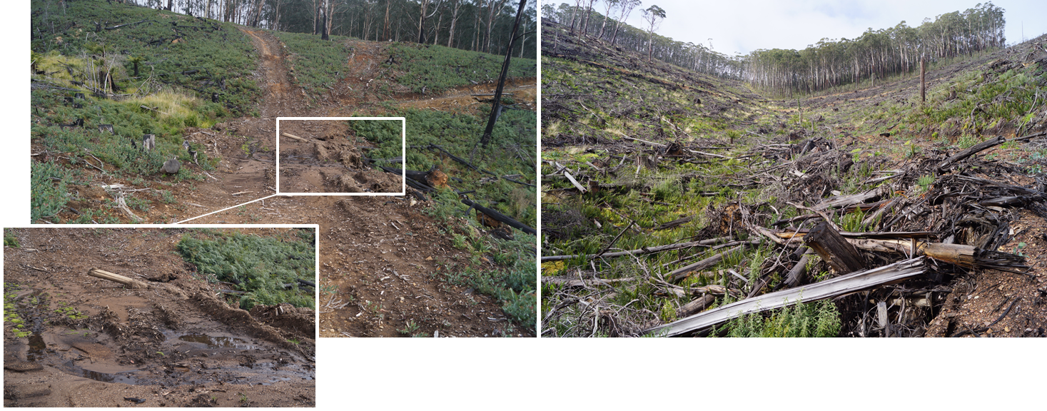
a) 18 Mulloway: snig track constructed across drainage line filter without effective drainage `line filter | b) 7 The Wolfman: snig track constructed across drainage line filter without effective drainage
Figure 5.2: Examples of snig tracks constructed along or across drainage line filters, without apparent authorisation and not in conformance with the Code and MSPs
- Construction of tracks in SPZ: three instances were observed in this audit of tracks being constructed into SPZ or other buffer areas that were not intended to be harvested or disturbed by harvest-related activity. In one case (14 Fairway, Figure 5.3), the track appears to have been constructed to help contain the regeneration burn23F. The environmental sensitivity of the areas into which the tracks were constructed contributed to the high potential EI values that were assessed (up to major).
While each of the non-conformances seemed to be random and unrelated events, they reflect a concerning lapse in attention by the parties involved (VicForests or its contractors).
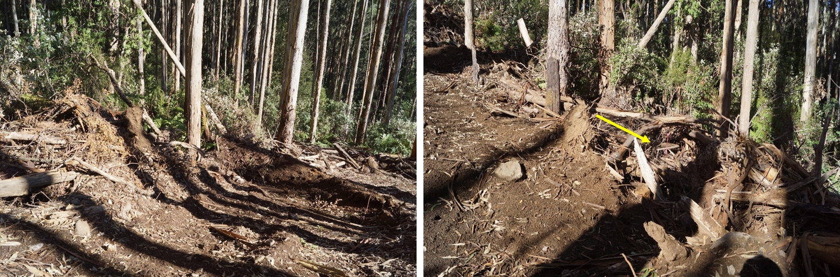
Figure 5.3: Track constructed into SPZ adjacent to 14 Fairway. Both images show that trees have been pushed into the SPZ during track construction. The yellow arrow points to tape marking the coupe boundary.
Recommendation V-02 Medium priority
That VicForests continue to work with its contractors to ensure that appropriately-spaced drainage structures are constructed on all snig tracks. This means not exceeding the spacings specified in the UPs and not having structures that are unnecessarily close and/or disproportionately large.
Recommendation V-03 High priority
That VicForests work with its contractors to minimise disturbances of riparian buffers and filters by snig tracks. Where it is reasonably practicable to do so, snig track crossings of drainage lines and temporary streams should be avoided. Where crossings are necessary, appropriate drainage should be constructed and crossings should be appropriately rehabilitated once the snig track is no longer required.

Biosecurity
The 2016-17 FAP audit report (Jacobs 2018a) included discussion of Code mandatory actions in relation to biosecurity issues, particularly pests, weeds and diseases. That discussion referenced earlier audit findings (URS 2015) of systematic non-conformance in relation to the prevention of Phytophthora cinnamomi introduction via infected quarry materials. Jacobs (2018a) suggested three improvements to Code or MSP provisions for the management of biosecurity risks:
- Wash down: of harvesting and road construction machinery prior to relocation to a new coupe, or at least forest area
- Monitoring of disease status: quarries from which materials are sourced for forest road construction should be checked annually by a competent, independent party to confirm disease and weed-free status
- Treatment: gravel obtained from quarries which are not confirmed as weed and disease free should be treated to mitigate any weed or disease threat prior to use within a harvest coupe.
Wash down of harvesting machinery is routine practice for VicForests (as per its UPs; VicForests, 2017) but is not necessarily routinely recorded in the coupe file. Furthermore, there is no routine recording in the coupe file of the disease (free) status of quarries used to supply road materials. In both matters, the coupe files do not necessarily provide evidence of conformance with applicable Code and MSP requirements and that biosecurity risks associated with machinery and importation of gravel have been appropriately addressed. In this audit, the lack of evidence that these risks were appropriately managed resulted in assessments of non-conformance without potential EI24F (as per the definitions in Table 3.4).
A similar lack of evidence was observed that the MSP requirement (4.5.1.2) to minimise the risk of Myrtle Wilt infestations in areas with Myrtle Beech had been conformed with. This again resulted in this audit in assessments of non-conformance without potential EI.
The MSPs also require pre and post-harvest assessments of weed infestations (4.5.1.3). Some coupe files included the results of weed assessments, but many did not. When asked, VicForests were able to provide records from coupe reconnaissance to indicate that the assessments were undertaken and hence no non-conformances were assessed. Post-harvest weed assessments are normally undertaken during regeneration surveys. VicForests were able to provide records of weed assessment results, where these were not held in the coupe file.
VicForests treatment of biosecurity risks during coupe planning and operations is not nearly as transparent or auditable as its treatment of risks to soil, catchment or biodiversity values. Section 5 of the FCPs (and some other records in paper coupe files) hold specific records of how the latter are addressed, but there is no corresponding section to demonstrate that biosecurity risks are actually being managed in conformance with the regulatory framework.
Recommendation V-04 High priority
That VicForests amend its couple planning and monitoring recording processes to ensure those planning and supervising harvesting operations appropriately assess, manage and report on biosecurity risks associated with machinery movement, the import of gravel for in-coupe roads, Myrtle Wilt and the entry and spread of new weeds.

Coupe infrastructure rehabilitation
Several instances were observed in this audit, where coupe infrastructure had not been properly rehabilitated at the completion of harvest or regeneration as required by MSP 7.2.2 and 7.2.3.4. Two main issues were identified:
- Non or partial rehabilitation of landings: landings on four harvest coupes and one regeneration coupe had not been fully rehabilitated at the time of the audit, despite the coupe having regenerated and/or other infrastructure having been rehabilitated. Non-conformance incidents identified include whole landings not having been rehabilitated (28 Vox) and landings and other nearby areas that had been compacted by landing traffic not appearing to have been fully ripped or otherwise rehabilitated, as required by MSP 7.2.2.6 (e.g. 9R Tick, 19 Whiting). Potential EI associated with these incidents was no greater than minor, reflecting the relatively small proportion of the coupe affected and the location of landings away from more sensitive environments.
Discussions with VicForests’ staff about not rehabilitating the whole area around the landing that had been compacted by machinery in one coupe suggested that VicForests’ UPs focus rehabilitation on the landing and snig tracks in the vicinity, but not explicitly address other areas that may have been compacted by machinery traffic, as per MSP 7.2.2.6.
- Failure to construct or reinstate drainage on boundary tracks: several coupes were identified where drainage on boundary tracks was either not constructed or had not been not-reinstated following regeneration. Some of these incidents were observed in East Gippsland coupes that had regenerated without burning. Boundary tracks were constructed or made trafficable in anticipation of the regeneration burn, however as regeneration proceeded without intervention, there was no specific trigger for machinery to be brought to the coupe to construct or reinstate drainage. Potential EI assessed for these incidents was no greater than minor, reflecting the length of boundary track involved. However, some boundary tracks are steep and drain towards waterways and hence it is possible for the failure to drain the tracks to lead to sediment being mobilised towards waterways.
Recommendation V-05 Medium priority
That VicForests review, and as necessary, revise its UPs to ensure that it instructs contractors to rehabilitate any snig track, landing or other area where machinery has compacted the soil as required by MSP 7.2.2.6 and not just snig tracks and landings.
Recommendation V-06 Medium priority
That VicForests develop procedures to track the status of drainage along boundary (or other) tracks that have been constructed or made trafficable for regeneration burning to ensure that drainage is constructed or reinstated once the coupe is burnt or otherwise regenerated, in conformance with MSP 7.2.3.4.

Monitoring and recording of coupe activities
Several instances were noted in this audit where coupe monitoring records were inconsistent with what could be clearly observed within the coupe. Examples include:
- 23 Pilcrow: where a road works plan had been prepared for the construction and development of an in-coupe road (which was to service an adjacent coupe). The in-coupe road included two waterway crossings. The coupe monitoring record indicated that the road was effectively drained and that drainage control devices were operating effectively. However, both waterway crossings were found, at the time of audit, to be non-conforming and long lengths of the road had no effective drainage.
- 28 Vox: where the coupe monitoring record suggested that the landing was rehabilitated, when the soil stockpile remained in place and the landing had not been ripped and rehabilitated.
The reasons for the inaccurate reporting are not clear. However, they suggest that at least in these cases, the monitoring records were completed from memory and/or without close inspection of coupe conditions.
That non-conforming in-coupe road drainage and waterway crossings were found in other coupes in this and previous audits, suggests that monitoring records for in-coupe roads and waterway crossings are not necessarily based on close assessments of the conformance of these features with VicForests’, Code or MSP requirements. Rectifying this may help to improve the level of regulatory compliance in in-coupe and waterway crossing design, construction, maintenance and closure.
Recommendation V-07 Medium priority
That VicForests develop specific forms (or sections of forms) for its coupe monitoring records that require explicit assessment of in-coupe road and waterway crossing conformance with applicable Code and MSP prescriptions.

Potential improvements to the regulatory framework for timber harvesting
Comments on potential improvements in the regulatory framework for timber harvesting and in management of the audit program have been made in previous audit reports (Jacobs 2018a; 2018b). These related to:
- Regulatory improvements: the main recommendations and comments have concerned:
Modifying unclear or incorrect wording in the Code and MSPs
Developing an evidence basis for requirements to construct fish ladders with some waterway crossings
Reviewing the method for assessing soil erosion hazard, particularly to avoid classifying erodible, but permeable (particularly) granite-derived soils as posing low water quality risk
Strengthening prescriptions for the management of biosecurity risks associated with machinery movement and the importation of gravel during construction of in-coupe roads.
To the auditor’s knowledge, action has only been taken (but not finalised) to address the third of these recommendations. All four of these recommendations are considered by the auditor to remain relevant.
The inclusion of coupe infrastructure in the scope of this year’s audit highlighted that the MSPs do not deal with drainage spacings for snig or boundary tracks. This audit applied VicForests UPs to assess conformance with drain spacing requirements, as the drainage structure spacing table for roads in the MSPs (Table 21) does not address slopes greater than 11° - which are not uncommon for snig and boundary tracks. While this provided a reasonable basis for assessing track drainage, the UPs do not form part of the regulatory framework. In any revision of the MSPs, a table should be included to prescribe maximum drainage spacing (and slope) for snig and boundary tracks, based on soil erosion hazard.
Recommendation D-02 High priority
DELWP should revise Code and MSP prescriptions in relation to pests, weeds and diseases to provide improved rigour and transparency in biosecurity risk management practices. Consideration should be given to mandatory washdown of harvesting and road construction machinery being moved onto a coupe, periodic assessment of quarry disease and weed status and reporting of these in FCPs.
Recommendation D-03 High priority
In its next revision of the MSPs, DELWP should develop and include a table that specifies appropriate maximum drainage structure spacings for snig and boundary tracks for applicable soil erosion hazard classes and appropriate slopes.
- Audit program management improvements: comments and recommendations referred to:
Clear processes for responding to audit findings and recommendations
Improving the information base on which coupes are selected for audit
Maintaining a register of audited coupes
In the auditors’ opinion, the first of these points is the most important. DELWP has advised that this recommendation has been taken up by DELWP and that there is now a process to engage with VicForests to review and address audit findings and recommendations.
The information base for coupe selection was improved in this audit, but as indicated by Table 3.2, it did not always accurately reflect the features present within the coupe.

Auditee comments
A draft of this report was provided to VicForests, as auditees, for review and comment. A summary of their substantive comments and the auditors’ responses are provided in Appendix D.

Conclusions and recommendations

Conclusions
The objectives of the FAP are to assess VicForests’ conformance with the regulatory framework for timber harvesting activities in State forests and the environmental risks associated with any non-conformances. The 2018-19 FAP addressed Code and MSP mandatory compliance elements relating to five main themes:
- Protection of soil, water and biodiversity values
- Design, construction, maintenance and closure of in-coupe roads
- Rehabilitation of coupe infrastructure
- Implementation of forest coupe planning
- Coupe regeneration.
Conformance of coupe planning, harvesting and roading activities with the regulatory framework was assessed for 30 (harvest) coupes located in State forests in eastern Victoria. Coupe regeneration was assessed for 10 (regeneration) coupes in this same area. The selection of harvest coupes was risk-based, meaning that audit findings cannot be taken as being statistically representative of VicForests’ operations overall.

Overall compliance findings for harvest coupes
A total of 151 compliance criteria were identified from Code and related MSP prescriptions included within the audit scope developed by DELWP for harvest coupes. The applicability of and conformance with these criteria was assessed for each of the 30 selected coupes during site inspections undertaken between April and June 2019.
The overall level of full conformance with applicable audit criteria ranged between 60% and 96%, with the average being 83%. Non-conformance incidents in 26 of the 30 harvest coupes included in the audit were assessed to have potential for EI. There was an average of 2.3 such incidents per coupe, with as many as seven incidents recorded on one coupe. The assessed level of potential EI associated with these incidents ranged up to major.

Protection of soil, water and biodiversity values
Environment-themed audit criteria were grouped into three sub-themes, as follows. The main findings for each sub-theme were:
- Protection of forest soils: the level of full conformance with applicable criteria ranged between 46% and 100%, with an average of 74%. Two non-conformance incidents were assessed to have major potential EI, namely:
Construction of a culvert with its outlet projecting above the downstream bed of a permanent stream, leading to erosion and sediment mobilisation
A regeneration burn entering a planned riparian buffer, removing understorey vegetation and exposing soils in this sensitive area to the risk of erosion.
- Protection of water flows, water quality and river health: the level of full conformance with applicable criteria ranged between 36% and 100%, with an average of 81%. Three kinds of non-conformance incident were detected and assessed to have major potential EI, namely:
Construction of a culvert with its outlet projecting above the downstream bed of a permanent stream, leading to erosion and sediment mobilisation
Regeneration burns entering planned riparian buffers in five coupes, posing a risk to river health and water quality
Construction of an in-coupe road that drains for over 100 m into a permanent stream.
- Protection of biodiversity values: the average level of full conformance with applicable criteria was 84%, with the range being 55-96%. Two kinds of non-conformance incident were detected and assessed to have major potential EI, namely:
Regeneration burns in five coupes entered adjacent SPZ areas or other areas that were planned to remain unharvested and hence undisturbed by regeneration activities
Construction or clearing of tracks from two coupes into areas that were to remain unharvested, including (in both cases) SPZ areas adjacent to the coupes.

Design, construction, maintenance and closure of in-coupe roads
Roading criteria were grouped for the audit into three sub-themes, as follows. The main findings for each sub-theme were:
- Road design: the level of full conformance with applicable criteria ranged between 20% and 100%, with the average being 67%. The main design-related non-conformance issue was FCPs having no recorded engineering basis for design of the in-coupe road, larger embankment and/or waterway crossing. Mostly, road design non-conformances did not directly result in assessments of potential EI, although in one coupe, the lack of appropriate drainage in the vicinity of a waterway crossing was partly attributed to the lack of formal road design.
- Road construction: the average level of full conformance with applicable criteria was 81%, with the level of conformance ranging between 50% and 100%. Non-conformances assessed to have major potential EI all related to road drainage and waterway crossing construction in a single coupe.
- Road maintenance and closure: the average level of full conformance with applicable criteria was 83%, with the level of full compliance ranging between 33% and 100%. Non-conformances assessed to have major potential EI all related to the failure to detect and remedy road drainage and waterway crossing deficiencies in an in-coupe road that had been constructed for several years.

Rehabilitation of coupe infrastructure
The level of full conformance with applicable criteria ranged between 56% and 100%, with the average being 84%. None of the non-conformance issues for the rehabilitation of coupe infrastructure were assessed to have potential EI of greater than moderate.

Implementation of forest coupe planning
The average level of full conformance with applicable criteria was 92%, with the level for individual coupes ranging between 80% and 100%. Non-conformance incidents on six coupes were assessed to have major potential EI. These were associated with:
- Drainage of long lengths of in-coupe road into waterway crossings
- Regeneration burns crossing into riparian buffers and adjacent SPZs
- Movement of machinery and track construction in adjacent SPZs.

Overall compliance findings for regeneration coupes
A total of 29 criteria were identified from the various compliance elements applicable to regeneration coupes. The overall level of full conformance with applicable audit criteria ranged between 73% and 100%, with the average being 90%. Non-conformances with potential EI were observed in four of the 10 coupes included in this component of the audit. Entry of a regeneration burnt into an adjacent SPZ at one coupe was assessed to have major potential EI. All other non-conformances were assessed to have moderate or lower potential EI.
Seven of the 10 regeneration coupes were assessed to have been successfully regenerated at the time of the audit.

Comparison with previous audits
Coupe selection for the audit is risk-based, rather than fully randomised. This means that audit results may not be statistically representative of VicForests’ operations overall and audit results may not be directly comparable between years. Comparison of the results of this audit with previous audits is also confounded by the addition of new criteria and audit themes. However, there is still a reasonable basis for comparison among the themes and sub-themes included in previous audits.
The comparison of audit results (Table 5.2) suggests reductions in full conformance with audit criteria overall and in the environmental sub-themes, relative to both the 2016-17 and 2017-18 audits. The largest reductions in full conformance with audit criteria was recorded for the soils and biodiversity sub-themes, with the latter partly reflecting the more stringent approach to assessing conformance with Code and MSP biosecurity requirements (weeds and pathogens) than in previous audits.
The number of non-conformances with major potential EI recorded in the current audit was less than in the 2016-17 audit, but much higher than was recorded in 2017-18. Some of this change reflects the reduced duplication of compliance criteria between sub-themes in the current audit and more stringent analysis of the relevance of the actual non-conformance incident to the audit criterion.
The types of incident giving rise to the higher potential EI categories (moderate, major) have generally remained consistent between recent audits, although the frequency of particular incidents has changed over time. Breaching of planned boundaries by regeneration burns have been observed in previous audits, but not at the frequency observed in this audit. Of particular concern was the number of regeneration burns that were found to have affected SPZs or other environmentally sensitive areas. The audit team also observed two instances of tracks being constructed or cleared into SPZ areas adjoining the coupe, a non-conformance that had not previously been recorded by this audit team.

Recommendations
The findings of this audit have contributed to a series of recommendations for VicForests, as auditees, and DELWP, as the environmental regulator of timber harvesting activities and audit client. Recommendations for VicForests address potential improvements to coupe planning and the management of timber harvesting, as well as related roading activities and the rehabilitation of coupe infrastructure. Recommendations for DELWP address potential improvements to the regulatory framework and management of the FAP.
The priority given to recommendations reflects either the potential environmental impact associated with the aspect of harvesting practice or the auditor’s perception of the importance of the recommendation to the effectiveness of the regulatory framework.

Recommendations for VicForests
Recommendation | Rationale
V-01: Medium priority  That VicForests adopt a consistent practice of marking maps of in-coupe waterways with the waterway classification as well as whether a buffer, filter or buffer and filter have been applied. | There is considerable variation in VicForests’ practice in labelling the class of waterway present within the gross coupe boundary and whether a buffer and/or filter has been applied. Explicit marking of waterway category and whether a buffer and/or filter has been applied would provide unambiguous evidence for an auditor of what has been planned. It would also enable VicForests to readily demonstrate above minimum protection of waterways where a buffer has been provided when only a filter is required (which in the auditors’ experience is a relatively common occurrence).
V-02 Medium priority  That VicForests continue to work with its contractors to ensure that appropriately-spaced drainage structures are constructed on all snig tracks. This means not exceeding the spacings specified in the UPs and not having structures that are unnecessarily close and/or disproportionately large. | This audit identified numerous instances where drainage spacing on snig tracks exceeded the limit specified in VicForests UPs. VicForests needs to continue to work with its contractors to reduce the incidence of such non-conformances.  In contrast, some coupes appear to have more drainage structures than are required. This results in unnecessary disturbance, greater costs and increased greenhouse gas emissions.
V-03 High priority  That VicForests work with its contractors to minimise disturbances of riparian buffers and filters by snig tracks. Where it is reasonably practicable to do so, snig track crossings of drainage lines and temporary streams should be avoided. Where crossings are necessary, appropriate drainage should be constructed and crossings should be appropriately rehabilitated once the snig track is no longer required. | The MSPs specify that machinery is to be excluded from waterway buffers and filters (7.1.3.2, 7.1.4.1), except during the construction of a sanctioned stream crossing or use of an established crossing. While this applies to snig and boundary tracks (MSP 7.2.1.1, 7.2.3.1), several instances were observed of snig tracks being constructed across or along drainage line filters without apparent sanction.
V-04 High priority  That VicForests amend its couple planning and monitoring recording processes to ensure those planning and supervising harvesting operations appropriately assess, manage and report on biosecurity risks associated with machinery movement, the import of gravel for in-coupe roads, Myrtle Wilt and the entry and spread of new weeds. | VicForests treatment of biosecurity risks during coupe planning and operations is not nearly as transparent or auditable as its treatment of risks to soil, catchment or biodiversity values. Section 5 of the FCPs (and some other records in paper coupe files) hold specific records of how the latter are addressed. Records of how biosecurity risks are addressed are often lacking from coupe files. Recording actions to address biosecurity risks should help to ensure that those risks are being actively managed in conformance with the regulatory framework.
V-05 Medium priority  That VicForests review, and as necessary, revise its UPs to ensure that it instructs contractors to rehabilitate any snig track, landing or other area where machinery has compacted the soil as required by MSP 7.2.2.6 and not just snig tracks and landings. | Discussions with VicForests’ staff during and since the field audit suggested that VicForests’ UPs may not explicitly direct contractors to rehabilitate all areas compacted by machinery traffic as directed by the MSP 7.2.2.6. Rather they focus on landings, snig tracks and associated coupe infrastructure. To the extent that this is the case, the UPs should be amended to ensure all compacted areas within the coupe are rehabilitated as prescribed by the regulatory framework.
V-06 Medium priority  That VicForests develop procedures to track the status of drainage along boundary (or other) tracks that have been constructed or made trafficable for regeneration burning to ensure that drainage is constructed or reinstated once the coupe is burnt or otherwise regenerated, in conformance with MSP 7.2.3.4. | Several coupes were identified in this audit where drainage on boundary tracks was either not constructed or had not been not-reinstated following regeneration. Where a coupe is located in steeply sloping landscapes, this could lead to soil erosion and sediment movement towards waterways.  It is assumed that this form of non-conformance reflects that track rehabilitation has been overlooked. Development of procedures to track and record the status of boundary track drainage may help to prevent this from occurring.
V-07 Medium priority  That VicForests develop specific forms (or sections of forms) for its coupe monitoring records that require explicit assessment of in-coupe road and waterway crossing conformance with applicable Code and MSP prescriptions. | The identification of non-conforming waterway crossings and in-coupe road drainage spacings have been a key feature of recent audits. The development of specific assessment and reporting procedures as part of in-coupe monitoring may help VicForests to detect and rectify non-conforming crossing soon after construction.

Recommendations for DELWP
Recommendation | Rationale
D-01: High priority  That DELWP engage with VicForests to monitor and evaluate implementation of new in-coupe road planning, design and construction procedures to ensure they lead to improved regulatory compliance and environmental performance. | VicForests report having recently developed new procedures and guidance for the planning, design and construction of in-coupe roads, (at least) partly in response to related recommendations from previous audits. This recommendation is introduced to provide DELWP and VicForests with earlier evidence of their effectiveness in improving regulatory compliance and reducing environmental impacts associated with in-coupe roads and associated waterway crossings than would reliance on FAP audits.
D-02 High priority  DELWP should revise Code and MSP prescriptions in relation to pests, weeds and diseases to provide improved rigour and transparency in biosecurity risk management practices. Consideration should be given to mandatory washdown of harvesting and road construction machinery being moved onto a coupe, assessment of quarry disease and weed status and reporting of these in FCPs. | The Code and MSPs are considered by the auditors to take a relatively passive approach to the identification and management of biosecurity risks to forests in which roading and timber harvesting occur. The recommendations propose a more active approach to the management of this risk and, in part, is consistent with existing VicForests practice.
D-03 High priority  In its next revision of the MSPs, DELWP should develop and include a table that specifies appropriate maximum drainage structure spacings for snig and boundary tracks for applicable soil erosion hazard classes and appropriate slopes. | The MSPs currently only specify maximum drain spacings for roads. Those specifications (Table 21) are not appropriate for snig and boundary tracks, whose slopes may significantly exceed the upper limits for roads. As a result, there is currently no appropriate regulatory basis for assessing drain spacings on snig and boundary tracks.

References
Department of Environment and Primary Industries [DEPI] 2014a. Code of practice for timber production 2014. DEPI.
DEPI 2014b. Management standards and procedures for timber harvesting operations in Victoria’s State forests 2014. DEPI.
DEPI 2014c. Planning standards and procedures for timber harvesting operations in Victoria’s State forests 2014. Appendix 5 to the Management standards and procedures for timber harvesting operations in Victoria’s State forests 2014. DEPI.
Department of Sustainability and Environment [DSE] 2006. Sustainability charter for Victoria’s State forests. DSE.
Jacobs 2016. Forest Audit Program 2015: Audit of in-coupe roads. Environmental audit of the construction and maintenance of in-coupe roads. V2.3 Report to DELWP. March 2016.
Jacobs 2018a. Audit of timber harvesting and forest regeneration in State forests in eastern Victoria. Report on the 2016-17 Forest Audit Program. IS206000-P2-001. Report to DELWP. April 2018.
Jacobs 2018b. Forest Audit Program 2017-18. 2017-18 Audit Summary Report. IS247800-RP-001. Report to DELWP. June 2018.
Jacobs 2019. Forest Audit Program 2018-19. 2018-19 Audit Summary Report. IS284400-RP-001. Report to DELWP. June 2019.
URS (2015) Environmental audit. Forest Audit Program 2014. Report on Module 1: Harvesting and closure and Module 3: Regeneration and finalisation. Report for Department of Environment and Primary Industries. URS Australia Pty Ltd.

Spatial data sources:
- Victorian government: www.data.vic.gov.au
- ESRI
Limitation statement
The purpose of this report and the associated services performed by Jacobs was to conduct an environmental audit of timber harvesting operations in Victorian State forests. The work has been undertaken in accordance with the scope of services set out in the contract between Jacobs and the Department of Environment, Land, Water and Planning (DELWP).
Jacobs derived the data in this report from field observations and information sourced from DELWP, VicForests and/or available in the public domain at the time or times outlined in this report. The passage of time, manifestation of latent conditions or impacts of future events may require further examination of the project and subsequent data analysis, and re-evaluation of the data, findings, observations and conclusions expressed in this report.
Jacobs has prepared this report in accordance with the usual care and thoroughness of the consulting profession, for the sole purpose described above and by reference to applicable standards, guidelines, procedures and practices at the date of issue of this report. For the reasons outlined above, however, no other warranty or guarantee, whether expressed or implied, is made as to the data, observations and findings expressed in this report, to the extent permitted by law.
This report should be read in full and no excerpts are to be taken as representative of the findings. No responsibility is accepted by Jacobs for use of any part of this report in any other context.
This report has been prepared on behalf of, and for the exclusive use of DELWP and is subject to, and issued in accordance with, the provisions of the contract between Jacobs and DELWP. Jacobs accepts no liability or responsibility whatsoever for, or in respect of, any use of, or reliance upon, this report by any third party.

Audit compliance elements
Regulatory compliance elements considered in the audit are included in Table A.1. They were drawn from the Code of Practice for Timber Production (Code; DEPI, 2014a), the associated Management Standards and Procedures for Timber Harvesting Operations in Victoria’s State forests (MSPs; DEPI, 2104b) and the Planning Standards (PS) which form Appendix 5 to the MSPs (DEPI, 2014c). Code compliance elements were selected by DELWP’s Timber Harvesting Compliance Unit (THCU). Supporting compliance elements from the MSPs and PS were selected by the audit team.
Compliance criteria (stated as a question) were developed by the audit team to enable assessments of compliance with each element of the regulatory framework. Criteria generally refer to individual MSP or PS compliance elements, rather than a more overarching Code requirement. However, in some cases criteria refer to individual Code compliance elements. Compliance elements have been incorporated with criteria in Table A.1. The compliance theme(s) to which each criterion relates is also given in the table.
Table A.1 also provides a summary of the percentage of applicable coupes recording full-conformance with each criterion.
Table A.1 Selected regulatory compliance elements for 2018-19 FAP audit and associated audit criteria. A summary of the level of full conformance with each criterion and the compliance theme or sub-theme to which each criterion relates is also shown
Source¹ | Compliance element and audit criteria | % full conformance | Theme²
C | 2.2 Environmental Values in State forests
C | 2.2.1 Water Quality, River Health and Soil Protection
C | 2.2.1.1 Planning and management of timber harvesting operations must comply with relevant water quality, river health and soil protection measures specified within the Management Standards and Procedures.
M | 3.1.1.1 Use the following categories when determining buffer (B) and filter (F) widths for waterways within and immediately adjacent to each coupe. Aids to the identification of each class of waterway are provided in the Code Glossary. (a) Permanent streams, pools and wetlands. (b) Temporary streams. c) Drainage lines.
1.01 | Have the categories prescribed in the MSPs been used in classifying waterways present on the coupe? | 96% | W,P
1.02 | Is there a map in the FCP showing application of the waterway classification to the coupe? | 89% | W,P
1.03 | ITAO³ is the classification assessed to have been applied correctly? | 89% | W
M | 3.2.1.1 Conduct field assessments to determine the soil erosion hazard and soil permeability classifications for an area proposed for any soil disturbing timber harvesting operations as follows (3.2.1.2-3.2.1.11, Table 8).
2.01 | Has soil erosion hazard and soil permeability been assessed using the method prescribed in the MSPs? | 83% | S,P
2.02 | Has the methodology been followed correctly? | 83% | S,P
M | 3.2.1.2 Collect soil profile samples that reflect the variety of soils represented within the coupe.
2.03 | If there are significant changes in soil and/or vegetation types within the coupe, ITAO have an adequate number of soil profile samples been taken to assess soil erosion hazard for the coupe? | 84% | S,P
M | 3.3.1.1 Apply appropriate protection to class of waterway as outlined in MSP Table 9.
M | 3.3.1.2 Apply appropriate protection to class of waterway as outlined in table 10 below for coupes in catchments up to 1 km upstream of verified and potential Spotted Tree Frog sites or coupes in Barred Galaxias and Mountain Galaxias SMZs where specified in section 4.2.
3.01 | If applicable, have the buffer and filter strip widths prescribed in MSP Table 9 been applied to the coupe? | 89% | W
3.02 | If applicable, have the buffer and filter strip widths prescribed in MSP Table 10 been applied to the coupe? | No applicable coupes | W
M | 3.4.1.1 Exclude timber harvesting operations from slopes over 30degrees.
M | 3.4.1.2 Up to 10% of the net harvest area of any coupe can contain areas greater than 30 degrees, where the risk of mass soil movement has been managed accordingly.
M | 3.4.1.3 Exclude timber harvesting operations from slopes over 25 degrees in the East Gippsland FMA in areas with granite‐based soils.
4.01 | Does the FCP include a map that shows areas of the coupe with slope >30°? | 75% | S,W,P
4.02 | Has timber harvesting been excluded from areas with slopes >30° (unless the area >30° slope is ≤10% net harvest area and ITAO the risk of mass soil movement has been managed accordingly)? | 100% | S,W
4.03 | If timber harvesting is undertaken in areas with slope >30°, does the area harvested exceed 10% of net harvest area and has the risk of soil mass movement been managed accordingly? | 100% | S,W
4.04 | For applicable EG coupes on granite-based soils (only), does the FCP show areas of the coupe with slope >25°? | 0% | S,W
4.05 | For applicable EG coupes on granite-based soils (only), has timber harvesting been excluded from areas with slopes >25°? | 100% | S,W
M | 3.5.1.1 Apply the slope limits, seasonal closures, buffer and filter strip widths and other relevant management actions specified in MSP Appendix 3 Table 11 (Water supply protection areas) for timber harvesting operations and associated roading and regeneration in water supply protection areas.
M | 3.5.1.2 Refer to Table 2 in Appendix 5 the PS for management actions that apply to water supply protection area SMZs in the Benalla-Mansfield, East Gippsland FMAs
M | 3.5.1.3 Obtain approval from the Minister or delegate in accordance with section 1.4 for any timber harvesting operations that are not conducted in accordance with clauses 3.5.1.1 or 3.5.1.2.
5.01 | Does the FCP correctly note that the coupe is or is not located in a water supply catchment? | 100% | W,P
5.02 | For relevant couples located in WSPA/DWSC, have the applicable slope limits, seasonal closures, buffer and filter strip widths and other relevant management actions specified in Appendix 3 Table 11 been correctly applied on the coupe? | 83% | W
5.03 | For relevant couples located in WSPA/DWSC, are the applicable stream buffers and maximum annual areas harvested correctly applied on the coupe? | 100% | W
5.04 | For relevant couples located in WSPA/DWSC, if timber harvesting operations are not conducted in accordance with the relevant MSP prescriptions, has Ministerial approval been obtained in accordance with MSP section 1.5 and Appendix 1 prior to harvesting commencing? | No applicable coupes | P
C | 2.2.1.2 Management actions to protect waterways, river health and soil must be appropriate to the waterway class, soil category, and potential water quality risk posed by timber harvesting operations at each site.
6.01 | ITAO is there evidence from the coupe which suggests that management actions to protect waterways, river health and soil have not been appropriate to protect waterways, river health and soil? | 53% | S,W
C | 2.2.1.5 Where practical exclude roads and snig tracks from aquatic and riparian habitats.
C | 2.2.1.6 Where crossings are required, minimise the extent of habitat damage, constriction to stream flow and barriers to fish and other aquatic fauna.
C | 2.2.1.7 Remove temporary crossings immediately after harvesting or any subsequent regeneration work is complete using a technique that minimises soil and habitat disturbance.
C | 2.2.1.8 Use drainage, artificial structures, buffers and filters of effective width to slow and disperse surface flows and deposit sediment before reaching waterways.
C | 2.2.1.12 Design, construct and maintain roads, crossings, coupe infrastructure and drainage structures to withstand foreseeable rainfall events and traffic conditions, and protect water quality.
7.01 | If roads and snig tracks have not been excluded from aquatic and riparian habitats, ITAO was it reasonably practicable to have done so? | 75% | W,C
7.02 | For coupes with waterway crossings, ITAO did the crossing minimise the extent of habitat damage and, where relevant, constriction to stream flow and/or barriers to fish and other aquatic fauna? | 56% | W
7.03 | ITAO has the crossing been removed as soon as reasonably practicable following harvesting or regeneration work? | 67% | S,W,B,M
7.04 | ITAO has removal of the crossing been undertaken in a manner that has minimised soil and habitat disturbance? | 100% | S,W,M
7.05 | ITAO have drainage, artificial structures, buffers and filters of effective width been appropriate used to try to slow and disperse surface flows and deposit sediment before reaching waterways? | 56% | W,C,I
7.06 | Have the measures put in place to slow and disperse surface flows and deposit sediment before reaching waterways been effective? | 63% | W,C,M
7.07 | ITAO have roads, crossings, coupe infrastructure and drainage structures been designed, constructed and maintained so water quality has been protected from foreseeable rainfall events and traffic? | 67% | W,D,C,M,I
C | 2.2.1.14 Minimise potential for soil erosion or mass movement by planning and using operational methods and restrictions appropriate to the assessed soil erosion risk and slope.
C | 2.2.1.15 Locate coupe infrastructure and roads to minimise soil erosion and degradation.
C | 2.2.1.18 Employ topsoil conservation techniques in timber harvesting areas affected by coupe infrastructure and roads.
8.01 | ITAO have planning (including locating coupe infrastructure and roads) and operations methods applied on the coupe been appropriate for the assessed soil erosion risk and slope? | 83% | S,W,D,P
8.02 | Is there evidence within the coupe of soil erosion or mass movement resulting from harvesting operations? | 62% | S
8.03 | ITAO has topsoil conservation been used as appropriate in areas affected by coupe infrastructure and/or roads? | 100% | S,I
C | 2.2.2 Conservation of Biodiversity
C | 2.2.2.1 Planning and management of timber harvesting operations must comply with relevant biodiversity conservation measures specified within the Management Standards and Procedures.
C | 2.2.2.4 During planning identify biodiversity values listed in the Management Standards and Procedures prior to roading, harvesting, tending and regeneration. Address risks to these values through management actions consistent with the Management Standards and Procedures such as appropriate location of coupe infrastructure, buffers, exclusion areas, modified harvest timing, modified silvicultural techniques or retention of specific structural attributes.
9.00 | ITAO has the management of timber harvesting, roading and regeneration operations adequately protected biodiversity values associated with the coupe? | 86% H⁴  90% R⁵ | B,C,M  R
M | MSP4.1 Habitat retention
C | 2.2.2.10 Retain and protect habitat trees or habitat patches and long-lived understorey species to provide for the continuity and replacement of old hollow-bearing trees and existing vegetation types within each coupe.
M | 4.1.1.1 Retain habitat trees in accordance with the FMA summary provided in Appendix 3 Table 12 (Habitat tree prescriptions).
M | 4.1.1.2 Trees in buffers or other exclusion areas that have been extended beyond minimum required widths can contribute to habitat tree retention requirements.
9.01 | Have the required number of habitat trees been retained on the coupe (as per MSP Appendix 3, Table 12) - including in areas where buffers and other exclusion areas extended beyond the minimum required widths? | 100% | B
9.02 | Have patches of long-lived understorey species been retained to represent existing vegetation types within the coupe? | 100% | B
M | 4.1.2.2 In East Gippsland FMA, avoid road construction in linear reserve SPZs. Where unavoidable, minimise road width and retain canopy closure over the road wherever possible.
10.01 | In EG FMA, if a new in-coupe road has been constructed through a linear reserve SPZ, was it reasonably practicable to have avoided doing so? | No applicable coupes | B,C,P
10.02 | ITAO, for a new road passing through a linear reserve SPZ, has canopy closure been maintained over the road wherever reasonably practicable? | No applicable coupes | B
M | MSP 4.1.2 Benalla/Mansfield and North East FMAs
M | 4.1.2.1 When selecting habitat trees, prioritise live hollow‐bearing trees where they are present and trees of younger age classes that are likely to develop hollows are present and trees of younger age classes that are likely to develop hollows in the longer term
M | 4.1.2.2 Where possible retain dead trees for habitat trees
M | 4.1.2.3 Retain habitat trees adjacent to areas of high value habitat and areas most easily protected from damage during harvesting and regeneration operations.
M | 4.1.2.4 Habitat trees may be retained in groups/patches dispersed across the coupe.
M | 4.1.2.5 Seed trees may be counted as habitat trees.
11.01 | In B-M and NE FMAs, based on evidence from the coupe and ITAO, have hollow-bearing or potential hollow-bearing trees, where present, been prioritised for habitat retention? | 100% | B
11.02 | Based on evidence from the coupe and ITAO, have dead trees been retained for habitat where reasonably practicable to do so? | 100% | B
11.03 | ITAO, have habitat trees been retained adjacent to any areas of high value habitat and/or areas most easily protected from damage during harvesting and regeneration? | 100% | B
M | MSP4.1.4 Central Highlands
M | 4.1.4.1 In Central Highlands FMAs, when selecting habitat trees, prioritise hollow‐bearing trees where they are present and trees most likely to develop hollows in the short term.
M | 4.1.4.2 Scatter habitat trees across the timber harvesting coupe in mixed‐species forest.
M | 4.1.4.3 Where possible, retain potential hollow‐bearing ash eucalypts in clumps to increase their protection from exposure, windthrow and fire.
M | 4.1.4.4 No gap between retained vegetation is to be greater than 150 m.
M | 4.1.4.5 Retain habitat trees where they can be most easily protected from damage during harvesting and site preparation treatment.
12.01 | Based on evidence from the coupe and ITAO, have hollow-bearing or potential hollow-bearing trees, where present, been prioritised for habitat retention | 90% | B
12.02 | In mixed species forests, if there are retained habitat trees, have they been scattered evenly across the coupe? | 100% | B
12.03 | If present, have hollow bearing ash eucalypts been retained in clumps. | 100% | B
12.04 | Are gaps between retained vegetation ≤ 150 m? | 100% | B
12.05 | ITAO, are any retained habitat trees located where they can most easily be protected from damage during harvesting and site preparation treatment? | 100% | B
12.06 | Is there evidence of damage to retained vegetation from harvesting or regeneration? | 90% | B
M | MSP4.1.5 East Gippsland FMA and Gippsland FMAs
M | 4.1.5.1 When selecting habitat trees, prioritise old living trees with a range of hollow sizes. Where these are absent or not present in sufficient numbers, prioritise trees that are old enough to develop hollows during the next 50 years.
M | 4.1.5.2 Stags and younger, smaller trees may be counted as habitat trees if trees of the type described in 4.1.5.1 are absent or not present in sufficient numbers.
M | 4.1.5.3 Where possible, retain habitat trees in small clusters which include younger regrowth and understorey.
M | 4.1.5.4 Distribute habitat tree clusters across the coupe with consideration of the proximity of other retained vegetation.
13.01 | In East Gippsland or Gippsland FMAs, ITAO, does the selection of any retained habitat trees appear to have prioritised old living trees with hollows of various sizes or trees that are old enough to develop hollows in the next 50 years (where present within the coupe)? | 92% | B
13.02 | If older trees (as per MSP4.1.5.1) are not present in the coupe, have stags and younger smaller trees been appropriate counted (ITAO) as habitat trees? | 100% | B
13.03 | Where reasonably practicable, have habitat trees been retained in small clusters with younger regrowth and understorey? | 100% | B
13.04 | ITAO, does the distribution of any habitat tree clusters appropriately consider the proximity of other retained vegetation? | 100% | B
M | MSP 4.2 and 4.3 Fauna and flora
M | 4.2.1.1 Apply management actions for rare and threatened fauna identified within areas affected by timber harvesting operations as outlined in Appendix 3 Table 13 (Rare or threatened fauna prescriptions).
M | 4.3.1.1 Apply management actions for rare and threatened fauna identified within areas affected by timber harvesting operations as outlined in Appendix 3 Table 14 (Rare or threatened flora prescriptions).
14.01 | Does the FCP correctly note record(s) of rare or threatened fauna–based on the VBA-on the coupe? | 90% | B
14.02 | Have the management actions for fauna (as per MSP Appendix 3, Table 13) been carried out? | 78% | B
14.03 | Does the FCP correctly note record(s) of rare or threatened flora-based on the VBA-on the coupe? | 94% | B
14.04 | Have the management actions for flora (as per MSP Appendix 3, Table 14) been carried out? | No applicable coupes | B
M | 4.2.1.1 Plan management actions for rate and endangered fauna in accordance with Table 3 (fixed FMZ rules for fauna).
14.05 | Have the management actions specified in PS Table 3 for fixed FMZ rules for fauna been implemented? | 100% | B
M | 4.3.1.1 Apply the management actions outlined in Table 4 (Detection based FMZ rules for fauna) for zoned rare or threatened fauna.
14.06 | Have the management actions specified in PS Table 4 for detection based FMZ rules for fauna been implemented? | 71% | B
M | 4.5.1.1 Apply the management actions outlined in Table 5 (Detection based FMZ rules for flora) for zoned rare or threatened for a values.
14.07 | Have the management actions specified in PS Table 5 for detection based FMZ rules for flora been implemented? | No applicable coupes | B
M | 4.5.2.4 In EG FMA, plan disturbances in SMZ in consultation with DEPI biologists to ensure the species is adequately protected.
14.08 | In EG FMA, if disturbance has been planned within an SMZ (for rare or threatened native fauna with detection based zoning), have DELWP biologists been consulted on species protection? | No applicable coupes | B
14.09 | ITAO has the disturbance been carried out according to the agreed approach? | No applicable coupes | B
M | MSP 4.4 Vegetation communities
M | MSP 4.4.1 Box ironbark
M | 4.4.1.1 In the Gippsland FMAs exclude selective harvesting from Box Ironbark forests typically containing Forest Red Gum (Eucalyptus tereticornis), Yellow Box (Eucalyptus melliodora), Coast Grey Box (Eucalyptus bosistoana) and Red Ironbark (Eucalyptus tricarpa). Silvicultural practices that promote regeneration of these species is permitted.
M | 4.4.1.2 In the East Gippsland FMA exclude selective harvesting from Box Ironbark forests typically containing Red Ironbark (Eucalyptus tricarpa), Gippsland Grey Box (Eucalyptus bosistoana), Red Box (Eucalyptus polyanthemos), Blue Box (Eucalyptus baueriana) and Yellow Stringybark (Eucalyptus muelleriana). The use of seed‐tree regeneration systems is permitted to restore the original species mix when combined with: a) cutting stumps of desired species to a maximum height of 30 cm, to encourage coppice growth; b) supplementary planting and sowing where necessary; c) removing unproductive trees of the less‐preferred species to remove overwood competition; and d) thinning of advanced regrowth.
15.01 | Has selective harvesting been excluded from the coupe if its composition corresponds with 4.4.1.1 or 4.4.1.2? | No applicable coupes | B
15.02 | If seed tree regeneration is used, does it comply with the specifications in 4.4.1.2? | No applicable coupes | B
M | MSP 4.4.2 Heathland
M | 4.4.2.1 Avoid road construction across areas of heathland or within 40 m of heathlands unless no reasonable alternative exists.
M | 4.4.2.2 In the Gippsland FMAs, exclude Wet Heathland, Clay Heathland and Riparian Scrub Mosaic EVCs from harvesting. Protect these heathland EVCs with a 40 m buffer.
M | 4.4.2.3 In the East Gippsland FMA and Otway FMA where evidence of heathland is found in the field and it isn’t already classified as SPZ, application must be made to the Secretary or delegate prior to commencement of the timber harvesting operation to create an SPZ in accordance with table 7 in Appendix 5 the Planning Standards.
16.01 | If a road was constructed through or within 40 m of a heathland EVC, ITAO, was it reasonably practicable to construct the road in another location? | No applicable coupes | B,C
16.02 | In the Gippsland FMAs, if present, has harvesting been carried out in or within 40 m of one of the heathland EVCs listed in 4.4.2.2? | No applicable coupes | B
16.03 | In the EG FMA, if evidence of heathland was found in the coupe and it was not already classified as SPZ, has application been made to the Secretary to create an SPZ in accordance with Table 7 in Appendix 5 the Planning Standards? | No applicable coupes | B
16.04 | Have the SPZ conditions been followed in the management of harvesting? | No applicable coupes | B
M | MSP 4.4.3 Montane Riparian Thicket
M | 4.4.3.1 In the Tambo FMA protect small stands of MRT between 0.01 ha and 0.5 ha and less than 10 m wide with a 10 m filter strip and stands of MRT wider than 10 m with a 20 m wide filter strip.
M | 4.4.3.2 In all other FMAs apply the heathland prescriptions listed above in 3.4.2 (sic – actually 4.4.2).
16.05 | In Tambo FMA, were the prescribed protections from harvesting (in MSP4.4.3.1) provided for any small MRT stands (as defined in MSP 4.4.3.3) present within the coupe? | 100% | B
16.06 | In FMAs other than Tambo, if stands of MRT are present and a road has been constructed through or within 50 m, was it reasonably practical to have constructed the road in an alternative location? | 100% | B
M | MSP 4.4.4 Oldgrowth
M | 4.4.4.1 Within the Leadbeater’s Possum range apply a 100 m buffer around all stands of modelled Ash old growth forest that are depicted in the DEPI old growth spatial layer (MOG2009.shp) and verified during field assessment by the Managing Authority or DEPI to be Ash type forest.
17.01 | Have 100 m buffers been provided around all stands noted in MSP 4.4.4.1? | No applicable coupes | B
M | MSP 4.4.9 Rainforest protection measures
M | 2.2.2.7 Rainforest communities must not be harvested.
M | 4.4.9.1 Protect all rainforest from timber harvesting operations as follows: (a) Exclude non linear stands that are 0.1 ha or more in size but less than 0.4 ha from timber harvesting operations. These stands do not require a buffer. (b) Exclude linear stands that are at least 0.1 ha but are less than 0.2 ha from timber harvesting operations. These stands do not require a buffer. (c) Exclude linear stands that are at least 0.2 ha but are less than 0.4 ha from timber harvesting operations. Protect these stands with a 20 m buffer. (d) Exclude all rainforest stands (including linear stands) equal to or exceeding 0.4 ha from timber harvesting operations. Protect these stands with a 40 m buffer except for rainforest stands in the Central Highlands FMAs and the Gippsland FMAs where 3.4.8.2 (MSP 4.4.9.2) below must be complied with. (e) Distribute slash away from retained rainforest stands or buffers.
18.01 | Has the existence of mapped/modelled rainforest EVC and any status as a RFSOS been noted within the FCP? | 88% | B
18.09 | Has harvesting taken place within any rainforest stand (>0.1ha) present in the coupe and/or any mandated buffer? | 91% | B
M | 4.6.1.1 Include in the SPZ all rainforest stands over 0.4 ha in area (whether already mapped or newly detected) that fall within the area categorised as National Priority 1 in the Sites of Significance for Rainforest spatial layer. The SPZ should extend to the nearest watershed boundary.
18.02 | If a rainforest stand >0.4 ha in area is present in a National Priority 1 RFSOS, has it been classified as SPZ? | No applicable coupes | B
18.03 | For rainforest stands >0.4 ha in area in a National Priority 1 RFSOS, does the SPZ extend to the watershed boundary? | 100% | B
M | 4.6.3.1 In CH FMAs, include in the SPZ all rainforest stands over 0.4 hectares in area (whether already mapped or newly detected) that fall within the area categorised as State or Regional in the Sites of Significance for Rainforest spatial layer. Also include in the SPZ the relevant buffer as identified in Table 6 (Buffer widths for Rainforest Sites of Significance by category and priority).
18.04 | In CH FMAs, have rainforest stands >0.4 ha that are State or Regional RFSOS, with their buffers, been included in a SPZ? | No applicable coupes | B
M | 4.6.4.1 In EG FMA, where rainforest stands coincide with linear reserves, include in the SPZ the rainforest stand plus a 100m buffer. Exceptions may apply where an alternative logical boundary exists within the buffer, for example an existing road. Avoid road construction across linear reserves containing rainforest wherever practicable.
18.05 | In EG FMA, have rainforest stands that coincide with linear reserves, with 100 m buffer (or other logical boundary) been included in an SPZ? | 80% | B
18.06 | If a road has been constructed through a rainforest linear reserve, was is reasonably practicable to have avoided this? | No applicable coupes | B,C
M | 4.6.5.1 In the Gippsland and North East FMAs, include in the SPZ all Cool Temperate Rainforest and Warm Temperate Rainforest stands over 0.4 hectares in area (whether already mapped or newly detected) that fall within the area categorised as State or Regional in the Sites of Significance for Rainforest spatial layer. Also include in the SPZ the relevant buffer as identified below in Table 6.
18.07 | In Gippsland and NE FMAs, have rainforest stands >0.4 ha that are State or Regional RFSOS, with their buffers, been included in a SPZ? | No applicable coupes | B
18.08 | Has harvesting been excluded from rainforest SPZs and rainforest stands and their buffer areas? | 50% | B
M | 2.2.2.5 Protect areas excluded from harvesting from the impacts of timber harvesting operations.
19.01 | Have areas that were intended to be excluded from harvesting been affected by impacts from timber harvesting operations, including roading and regeneration burning? | 72% | W,B,C
M | MSP4.5 Pests, weeds and diseases
M | 2.2.2.13 Implement appropriate vehicle and equipment hygiene precautions when moving from areas of known pest plant, pest animal and pathogen infestations.
M | 4.5.1.1 Minimise the risk of introduction or movement of Cinnamon Fungus (Phytophthora cinnamomi) and Root Rot (Armillaria) from known infected areas, into uninfected areas by: (a) washing machinery before moving into uninfected areas; (b) restricting activities where the movement of soil or gravel is likely to cross from infected sites into healthy vegetation; (c) minimising the relocation or movement of infected gravel or soil during road and track construction or maintenance works, or logging operations; (d) restricting or controlling drainage water run‐off from roads and tracks away from healthy vegetation; (e) testing gravel from infected areas and using only uncontaminated gravel in uninfected areas; and (f) cleaning and disinfecting vehicles, machinery, tools and equipment used in infected areas.
20.01 | Does the FCP include record of the PC or Amillaria status of a coupe? | 7% | B
20.02 | If a coupe is not known to be infected by PC or Armilllaria, does the coupe file have evidence that machinery moving to the coupe has been washed down prior to entry? | 57% | B
20.03 | If a new ICR has been constructed, is there evidence in the FCP that any gravel or other road-making materials imported to the site are from a quarry or another coupe that is known to be free of PC or Armillaria? | 0% | B,C
20.04 | If the coupe is located in an area known to be affected by PC or Armillaria, is road drainage from infected areas diverted away from healthy vegetation? | No applicable coupes | B,C
20.05 | If the coupe is located in an area known to be affected by PC or Armillaria, does the FCP have evidence that vehicles, machinery, tools and equipment was cleaned and disinfected prior to being removed from the coupe? | No applicable coupes | B,C
M | 4.5.1.2 Minimise the spread of Myrtle Wilt (Chalara australis) when operating in areas where it is known to exist by: (a) protecting individual Myrtle Beech (Nothofagus cunninghamii) trees; (b) sterilising equipment with anti‐fungal agent or warm water and soap prior to moving into a new area; (c) pruning Myrtle Beech (Nothofagus cunninghamii) that are subject to ongoing damage by vehicles; and (d) immediately treating wounds on Myrtle Beech (Nothofagus cunninghamii) (including those left by pruning) with a commercial, waterproof wound sealant.
21.01 | Does the FCP include record of the Myrtle Wilt status of a coupe, if there is cool temperate rainforest in the immediate vicinity? | 0% | B
21.02 | If the coupe is located in a Myrtle Wilt risk area, have appropriate protection measures been used to minimise the spread of the disease, as per MSP4.5.1.2? | 100% | B
M | 2.2.2.14 Implement appropriate control actions where timber harvesting operations have introduced or exacerbated a pathogen or weed.
M | 4.5.2.1 Conduct a pre‐harvest assessment to determine the type and extent of weeds on the coupe and on associated access roads.
M | 4.5.2.2 Conduct a post-harvest assessment to determine the type and extent of weeds on the coupe and associated access roads in the first spring after completion of site preparation and establishment and during the stocking survey.
M | 4.5.2.3 Where the assessments identify the timber harvesting operation has introduced weeds, prepare a weed management plan and implement a weed control program.
M | 4.5.2.4 Record any areas to be treated on a map in the FCP and mark in the field as necessary prior to treatment.
22.01 | Does the FCP provide evidence that a pre-harvest assessment for weeds of the coupe and roads was undertaken? | 100% | B
22.02 | If appropriate to the life cycle of the coupe (following spring after completion of site preparation and establishment) does the FCP provide evidence that a post-harvest assessment for weeds of the coupe and roads was undertaken? | 100% H  100% R | B  R
22.03 | If weed surveys suggest that timber harvesting has introduced weeds to the coupe, has a weed control plan been developed? | No applicable coupes H  No applicable coupes R | B  R
22.04 | Is there evidence in the FCP of any weed control plan being implemented? | No applicable coupes | B  R
C | 2.4 Roading For Timber Harvesting Operations
C | 2.4.2 Road Design
C | 2.4.2.1 Planning and management of timber harvesting operations must comply with this Code and relevant road design measures specified within the Management Standards and Procedures unless the road is covered by a formal roading agreement with DEPI that would supersede this requirement.
M | 6.1.1.3 Seek engineering advice for road alignments traversing cross slopes of ≥30° or ≥25° in areas of high soil erodibility
23.01 | For coupes with ICRs traversing these slopes, is there evidence in the FCP of engineering advice contributing to the design of the road? | No applicable coupes | S,D
M | 6.1.1.4 Identify the intended class of a new road or road upgrade in accordance with the appropriate service function description in Appendix 4 Table 18 (Road classification system).
23.02 | Does the FCP specify the intended class of a new in coupe road or road upgrade in accordance with MSP Appendix 4 Table 18? | 100% | D
M | 6.1.2.4 Limit clearing widths to those specified in MSP Appendix 4 Table 20 (Minimum clearing widths (m) required for typical road construction) plus any additional width required to construct batters.
23.03 | Does the minimum clearing width for an in-coupe road not located within the harvest area conform to the specifications in MSP Appendix 4 Table 20? | 100% | C
C | 2.4.2.4 Stream crossings must be designed according to traffic requirements and the nature, size and period of flow (both pre and anticipated post-harvest) and characteristics of the bed and banks of the stream.
23.04 | 24.1 Does the FCP include evidence of design for the stream crossing, considering the elements specified in Code 2.4.2.4? | 0% | D
C | 2.4.3 Road Construction
C | 2.4.3.1 Planning and management of timber harvesting operations must comply with this Code and relevant road construction measures specified within the Management Standards and Procedures unless the road is covered by a formal roading agreement with DEPI that would supersede this requirement
C | 2.4.3.2 Road construction must be conducted in a manner consistent with plans and designs.
24.01 | Does the FCP provide evidence of planning and design prior to construction of the ICR? | 5% | D
24.02 | ITAO, has construction of the ICR appropriately followed any documented plan and/or design? | 0% | C
M | MSP 6.2.1.1 Undertake road construction when rainfall and soil conditions minimise the risk of erosion and impact on water quality, and when soil moisture is adequate to achieve compaction and stabilisation of the sub‐grade.
24.03 | ITAO, is there evidence that the timing of road construction was inconsistent with the requirement to minimise the risk of erosion and impact on water quality? | 100% | S,C
M | 6.2.1.5 Create table drains by extending the road when it is formed, and not by subsequent excavation.
24.04 | Is there evidence that table drains have been formed by subsequent excavation? | 100% | C
M | 6.2.1.6 Limit earthworks to the least possible to achieve the road design specification.
24.05 | ITAO are the earthworks for an ICR a reasonable minimum to achieve the road design specification? | 100% | C
M | MSP 6.2.2 Fill batter construction
M | 2.4.3.3 All fill disposal areas and embankments must be appropriately stabilised. Where revegetation is used to stabilise fills or embankments, the species must be suitable for the site and where possible indigenous to the area.
25.01 | Is there evidence of instability and sediment movement from any fill disposal areas or embankments? | 10% H  0% R | W,C  R
M | 6.2.2.1 Prevent fill batters from covering the base of live trees.
M | 6.2.2.3 Use engineer approved methods of mechanical consolidation of fill batters.
25.02 | Do any fill batters cover the base of live, retained trees? | 86% | B,C
25.03 | For large fill batters (for embankments >2 m high), does the FCP include evidence of engineer approval of mechanical consolidation methods? | 0% | D
25.04 | Is there evidence of failure of fill batters? | 22% H  0% R | C  R
M | MSP 6.2.4 Road drainage
C | 2.4.2.5 Appropriate drainage must be provided. Spacing of drainage outlets along a road must take into account the soil erodibility, rainfall frequency and intensity, and the proximity of the road to streams.
M | 6.2.4.1 The maximum distance between drainage structure for road grad and soil erosion hazard is specified in Appendix 4 Table 21.
M | 6.2.4.2 Construct cross‐drains at an angle sufficient to discharge any water from the surface of the road.
M | 6.2.4.3 On soils of high erosion hazard, use temporary sediment traps to prevent erosion during road construction
26.01 | Does the spacing between road drainage structures conform with the specifications of MSP Appendix 4 Table 21? | 57% | S,W,C
26.02 | Have cross drains been constructed at sufficient angle to discharge any water from the surface of the road? | 95% | C
26.03 | On coupes with soils of high erosion hazard, have temporary sediment traps been used to prevent erosion using road construction? | No applicable coupes | S,W,C
C | 2.4.2.9 Before entering a waterway road drainage must discharge onto vegetation or through a structure that effectively dissipates the velocity of drainage flows.
M | 6.2.4.4 Appropriate discharge areas for drainage include: (a) a strip of undisturbed vegetation at least 20 m wide; (b) a rock spill; or (c) some other structure that dissipates the velocity of drainage flows.
M | 6.2.4.5 Place drainage structures approximately 20 m from permanent or temporary streams, to allow discharge onto undisturbed vegetation and to maximise the flow distance between the drainage outlet and the waterway.
M | 6.2.4.6 Within 20 m of a permanent or temporary stream: (a) use crown or cross fall techniques to drain roads into undisturbed vegetation; or (b) pass drainage through an appropriate sediment control structure such as a sediment pond or silt trap before entering a permanent or temporary stream.
26.04 | Do drainage discharge areas comply with MSP 6.2.4.4 specifications? | 83% | S,W,C
26.05 | Do drainage structures allow interception and discharge of road drainage prior to a stream crossing, as per MSP 6.2.4.5? | 50% | S,W,C
26.06 | Does road construction appropriately manage road drainage in the final 20 m prior to a stream crossing, as per MSP 6.2.4.6? | 63% | S,W,C
M | 6.2.4.7 Construct table drains to: (a) allow water to flow, without ponding; (b) include run‐offs of sufficient length to allow the table drain and run‐offs to be cleaned; (c) be supported by rock or otherwise stabilised in soils of a high erosion hazard; and (d) have silt traps constructed at the end if discharging directly into a stream or wetland buffer.
26.07 | Does construction of any table drain comply with the requirement of MSP 6.2.4.7? | 100% | C
M | MSP6.2.5 Culverts
M | 6.2.5.1 Culverts used in permanent roads are a minimum of 375 mm in diameter.
M | 6.2.5.2 Culverts used in temporary roads are a minimum of 300 mm in diameter.
26.08 | Is the size of the culvert consistent with the type of road, as per MSP 6.2.5.1 and 2? | 100% | C
M | 6.2.5.3 All culverts are designed to withstand a 1 in 10 year rainfall event.
M | 6.2.5.4 Construct culverts in catchment areas exceeding 100 ha in accordance with engineering advice.
26.09 | Is there evidence in the FCP that the size of the culvert is consistent with flow requirements in a 10% AEP rainfall event? | 0% | C
26.10 | Where the catchment area exceeds 100 ha, Is there evidence in the FCP that engineering advice has been provided on culvert construction? | No applicable coupes | C
M | 6.2.5.5 On drainage lines, stream and river crossings or soils of High Erosion Hazard place sandbags, timber, concrete or rock at the head of the culvert and at the point of discharge to hold the culvert in place and protect it from erosion.
26.11 | Have the head and outlet of culvert(s) been constructed as specified in MSP 6.2.5.5 to hold them in place and protect from erosion? | 100% | W,C
26.12 | Is there evidence of erosion at the head and/or outlet of the culvert? | 83% | W,C
M | 6.2.5.7 If constructed of concrete, have a minimum cover of 600 mm as measured from the road surface to the top of the pipe and a maximum cover as specified in the Installation of Steel‐Reinforced Concrete Drainage Pipelines, Concrete Pipe Association of Australasia.
M | 6.2.5.8 If constructed of a material other than concrete, have a minimum cover over the pipe as recommended in the manufacturer’s specifications.
26.13 | Does the cover provided satisfy MSP 6.2.5.7/8 requirements, given the construction material? | 100% | C
26.14 | Does the minimum cover for the culvert(s) satisfy the manufacturer’s specifications for non-concrete culverts? | 100% | C
M | 6.2.5.9 On permanent streams, include a fish ladder if the diameter of the culvert is greater than 750 mm.
26.15 | If the culvert is >750 mm (on a permanent stream) does it include a fish ladder? | No applicable coupes | B,D
M | 6.2.5.11 Ensure culverts do not project above the bed of a waterway in a way which may prevent the passage of aquatic fauna.
M | 6.2.5.12 Where culvert construction diverts water from its natural course, return water to its natural course over a flume, rock spill, or other hard surface.
26.16 | Does the culvert protect above the bed of the downstream waterway and prevent the passage of aquatic fauna? | 17% | B,C
26.17 | If the culvert diverts water from its natural course, does it return water to its natural course via a flume, rock spill, or other hard surface? | 100% | W,C
C | 2.4.3.6: Road construction must ensure that: disturbance to stream beds and banks is kept to a minimum; soil and rock fill is not pushed into waterways, nor placed into a position where there is a risk that it can erode into a waterway; and cement, raw concrete, soil fill and other road making materials are not spilt or disposed of into waterways during road construction.
27.01 | ITAO has the road been constructed in a way that the stream bed and/or banks are unnecessarily disturbed or there is an unnecessary risk of erosion into a waterway? | 100% | W,C
27.02 | Have road construction materials been spilt or disposed of into a waterway? | 100% | B,C
C | 2.4.6 Road Closure
C | 2.4.6.2 Roads no longer required for timber harvesting operations or other forest management purposes, must be permanently closed to vehicle traffic and effectively drained following completion of the timber harvesting operation
M | 6.4.1.1 Close temporary roads (including removal of all bridges, crossings and culverts on streams or drainage lines) as soon as possible after harvesting and/or regeneration is complete in all coupes that use the road.
M | 6.4.1.2 Drain the approach to any bridge, culvert of log fill crossing that has been removed to restrict soil movement into the stream or waterway.
28.01 | If use of the ICR has ceased, have all crossings and culverts been removed? | No applicable coupes H  0% R | M  R
28.02 | ITAO have the approaches to any crossing been drained appropriately to restrict soil movement into the stream or waterway? | 100% H  No applicable coupes R | W,M  R
28.03 | Is there evidence that removal of a crossing or culvert has led to soil movement into the waterway? | 0% H  No applicable coupes R | S,W,M  R
M | 5.4.1.3 Use an effective barrier to close to all vehicles temporary roads that will not be used to access a coupe for a period of 12 months or more.
28.04 | If the road is no longer required for harvesting or other forest management purposes, has it been permanently closed to traffic? | 75% H  63% R | M  R
C | 2.5 - Timber Harvesting
C | Timber harvesting operations in State forest are conducted in accordance with a Forest Coupe Plan (as per 2.3.1)
C | 2.3.1.2 A Forest Coupe Plan must: i. be prepared by the managing authority prior to the commencement of a timber harvesting operation including road construction or upgrades; ii. Communicate the intended boundaries, activities and requirements in adequate detail to enable operators to complete work to the required standard, comply with the Code and comply with the Management Standards and Procedures for the life of the coupe, and to support the Secretary in reviewing compliance; iii. be sanctioned; iv. be approved and provide evidence of the approval for timber harvesting operations occurring within SPZ or outside the area identified in an Allocation Order or licensed to the harvesting entity; v. record details of the type of timber harvesting operation; and vi. document all variations to operational requirements and sanctions (such as the removal of trees from buffers for safety purposes) until the timber harvesting coupe is approved as successfully regenerated and rehabilitated.
C | 2.3.1.1 Forest Coupe Plans prepared for timber harvesting operations must: (a) state the net area that is planned to be harvested or tended; (b) state the start date and season during which operations are scheduled to occur; (c) identify the silvicultural systems or tending methods to be employed; (d) identify requirements for the location*, design, construction, maintenance and use of roads, and closure of temporary roads; (e) identify requirements for the design, siting*, construction, use, and rehabilitation of log landings and dumps and, where necessary, siting and rehabilitation measures for major snig tracks; (f) describe regeneration procedures to be applied; (g) identify and describe management actions for all relevant coupe values specified within the Code, these Management Standards and Procedures and the forest management zoning scheme; (h) describe measures employed to protect biodiversity such as: I. habitat tree retention; II. provision for the continuity and replacement of old hollow‐bearing trees within the harvestable area; and III. retention of long‐lived understorey species in appropriate numbers and configurations to allow for the regeneration of the vegetation types that existed within the coupe before the timber harvesting operation commenced. (i) describe soil erosion hazard classes present within the coupe and measures employed to protect and rehabilitate soils and to maintain water quality and river health.
C | 2.3.1.2 Forest Coupe Plans must include a map which clearly and accurately identifies: (a) the net area that is planned to be harvested; (b) areas within and adjacent to a coupe that are to be excluded from harvesting and associated activities, or to which special prescriptions apply (including biodiversity protection or habitat enhancement, water quality and aquatic habitat protection, landscape protection, or cultural heritage sites and places); and (c) waterway, historic tramway and water race crossing locations.
29.01 | Does the FCP state the net area that is planned to be harvested or tended? | 100% | P
29.02 | Does the FCP state the start date and season during which operations are scheduled to occur? | 100% | P
29.03 | Does the FCP identify the silvicultural systems or tending methods to be employed? | 100% | P
29.04 | Does the FCP identify requirements for the location, design, construction, maintenance and use of roads, and closure of temporary roads? | 100% | P
29.05 | Does the FCP identify requirements for the design, siting, construction, use, and rehabilitation of log landings and dumps and, where necessary, siting and rehabilitation measures for major snig tracks? | 100% | P
29.06 | Does the FCP describe regeneration procedures to be applied? | 100% | P
29.07 | Does the FCP identify and describe management actions for all relevant coupe values specified within the Code, these Management Standards and Procedures and the forest management zoning scheme? | 100% | P
29.08 | Does the FCP describe measures employed to protect biodiversity such as: I. habitat tree retention; II. provision for the continuity and replacement of old hollow‐bearing trees within the harvestable area; and III. retention of long‐lived understorey species in appropriate numbers and configurations to allow for the regeneration of the vegetation types that existed within the coupe before the timber harvesting operation commenced? | 100% | P
29.09 | Does the FCP describe soil erosion hazard classes present within the coupe and measures employed to protect and rehabilitate soils and to maintain water quality and river health? | 100% | P
29.10 | Does the FCP include a map which clearly and accurately identifies: (a) the net area that is planned to be harvested; (b) areas within and adjacent to a coupe that are to be excluded from harvesting and associated activities, or to which special prescriptions apply (including biodiversity protection or habitat enhancement, water quality and aquatic habitat protection, landscape protection, or cultural heritage sites and places); and (c) waterway, historic tramway and water race crossing locations? | 100% | P
29.11 | Has the FCP been sanctioned? | 100% | P
29.12 | If timber harvesting operations are taking place in SPZ, is there evidence of prior approval? | 0% | P
29.13 | Does the FCP document all variations to operational requirements and sanctions? | 50% | P
C | 2.5.1 Coupe Management
C | 2.5.1.2 Timber harvesting operations must be conducted in accordance with the Forest Coupe Plan and all applicable Special Management Zone plans
30.01 | ITAO has the timber harvesting operation been conducted in accordance with the FCP, any forest management zoning requirements and all applicable SMZ plans. | 57% | P
M | MSP 7.1.2 Exclusion areas, MSP 7.1.3 Operations in buffers
C | 2.5.1.5 Timber harvesting operations (excluding haulage on existing or approved roads) are not permitted in special protection zones, buffers, or other exclusion areas identified on the Forest Coupe Plan, except where: i. the removal of a limited number of trees is necessary for the construction and use of stream crossings or for river health; or ii. the operator has been sanctioned to remove a limited number of trees to protect public or worker safety or for forest health.
M | 7.1.2.1 Timber harvesting operations must be excluded from: (a) SPZs; (b) areas of SMZs where timber harvesting operations are excluded; (c) buffers and other exclusion areas created in accordance with these Management Standards and Procedures; and (d) within 10 m of vertical or near vertical sided gullies with a depth of half a metre or more that are actively eroding (or within 20 m where slope exceeds 20 degrees) in the Bendigo FMA.
M | 7.1.2.3 Exclusion areas must be protected from damage during rough heaping or windrowing operations.
M | 7.1.3.1 Trees can only be harvested within buffer areas if sanctioned for safety purposes.
M | 7.1.3.2 Machinery is to be excluded from buffers except where involved in the construction of a sanctioned stream crossing or when using an established stream crossing.
M | 7.1.3.3 Keep fill, harvesting debris and drainage structures out of buffers except where constructing a sanctioned stream crossing.
31.01 | Is there evidence from the FCP or observations on the coupe of timber harvesting activities having been conducted and/or machinery access provided in exclusion areas identified on the FCP, except where permitted? | 87% | W,B,P
31.02 | Have rough heaping or windrowing activities during regeneration resulted in damage to exclusion areas? | 100% | W
31.03 | Has fill, harvesting debris or drainage structures been kept out of buffers, except for construction of a sanctioned stream crossing? | 100% | W,I
C | 2.5.2 Coupe Infrastructure
C | 2.5.2.3 Coupe infrastructure must be rehabilitated on completion of timber harvesting operations, where not required for future timber harvesting operations or an approved purpose for which native vegetation is not compatible. Rehabilitation techniques must ensure that suitable soil conditions are provided for the regeneration and growth of vegetation existing on the site prior to harvesting (refer to section 2.6). Progressive rehabilitation of coupe infrastructure during timber harvesting operations must be undertaken where operationally possible.
M | MSP 7.2.2 Snig track and landing rehabilitation
M | 7.2.2.1 Following closure of the timber harvesting operation rehabilitate all snig tracks to prevent: (a) unacceptable movement of soil down or from the track surface; and (b) soil movement into streams.
32.01 | Have snig tracks been progressively rehabilitated during timber harvesting operations? | 100% H  90% R | I  R
32.02 | Have all snig tracks been rehabilitated in a way that has prevented unacceptable soil movement along tracks? | 83% H  100% R | S,I  R
32.03 | Have all snig tracks been rehabilitated in a way that prevents soil movement into streams? | 97% H  100% R | W,I  R
M | 7.2.2.2 Rehabilitate landings following completion of timber harvesting operations, and before the coupe is vacated, unless they are required for: (a) future Shelterwood 2 operations; (b) harvesting of adjacent coupes within 3 years; or (c) any other DEPI approved purpose for which native vegetation is not compatible.
M | 7.2.2.3 Identify any landings that do not require rehabilitation in the Forest Coupe Plan.
32.04 | Have landings that are no longer required been rehabilitated successfully? | 70% H  80% R | I  R
32.05 | If a landing is to be retained, is this indicated on the FCP? | 100% H  No applicable coupes R | I  R
M | 7.2.2.4 Lift and aerate corded and matted snig tracks to allow burning.
32.06 | If snig tracks are corded and matted have they been lifted and aerated prior to regeneration burning? | 100% H  100% R | S,I  R
M | 7.2.2.5 Remove cording and as much matting, bark and slash as possible from landings before rehabilitation works occur.
32.07 | ITAO have cording, matting, bark and slash been removed from landings as much as reasonably practicable before coupe regeneration works? | 100% H  90% R | I  R
M | 7.2.2.6 Rip/cultivate any snig track, landing or other area where machinery has compacted the soil. Ripping of snig tracks should be extended for at least 30 m from the landing.
32.08 | Has coupe infrastructure that has been compacted by machinery been ripped or cultivated to assist rehabilitation? | 92% H  100% R | W,I  R
32.09 | Have snig tracks within 30 m of the landing been ripped? | 38% H  90% R | W,I  R
M | 7.2.2.7 Where removed and stockpiled, replace topsoil to a consistent depth across the landing
32.10 | For landings whose topsoil has been removed and stockpiled, has topsoil been replaced to a consistent depth across the landing? | 95% H  100% R | W,I  R
M | MSP 7.2.3 Boundary Trails
M | 7.2.3.4 Rehabilitate boundary trails as soon as practical after any regeneration burns and before commencement of any relevant closure periods.
32.11 | Have any boundary trails been rehabilitated as soon as reasonably practicable following regeneration burning? | 81% H  100% R | S,W,I  R
M | 2.5.2.5 Tracks must have effective drainage to prevent soil erosion. Cross-drains, where used, must be spaced and angled as appropriate to the soil erosion hazard, to disperse surface run-off and prevent discharge of turbid water into streams or drainage lines.
32.12 | Is snig track and boundary track drainage spacing consistent with soil erosion hazard and slope as per MSP Table 21? | 57% H  89% R | S,W,I  R
32.13 | ITAO has the snig track drainage been constructed to disperse surface run-off and prevent discharge of turbid water into streams? | 97% H  100% R | W,I  R
C | 2.6 - Forest Regeneration and Management
C | 2.6.1 Regeneration
C | 2.6.1.1 Planning and management of timber harvesting operations must comply with relevant regeneration measures specific within the Management Standards and Procedures
C | 2.6.1.4 Following timber harvesting operations, State forest must be regenerated with overstorey species native to the area, wherever possible using the same provenances, or if not available, from an ecologically similar locality.
M | 9.1.1.1 For even-aged stands, conduct stocking surveys 15-30 months after sowing/seedfall or planting
M | 9.1.1.2 Successfully stocked even‐aged regenerating forests must have: (a) at least 1 acceptable seedling in 65 % of 2.27 m radius (16 m2) plots placed on a 20 m by 80 m systematic grid or at least 1 acceptable seedling in at least 55 % of 2.27 m radius (16 m2) plots placed on a 20 m by 40 m systematic grid; and (b) no discrete area greater than 1 ha with less than 400 stems per hectare.
M | 9.1.1.7 For both even-aged and uneven-aged silviculture, acceptable species composition for regeneration includes at least 10 acceptable seedlings of each eucalypt species present on the site before harvesting
33.01 | Was the initial stocking survey conducted within 15-30 months of regeneration? | 100% | R
33.02 | Has the coupe been successfully restocked as per MSP 9.1.1.2 and 9.1.1.7? | 70% | R
33.03 | Was the seed used for regeneration of the same provenance, or if that is not available, from an ecologically similar location? | 100% | R
C | 2.6.1.7 Harvested coupes must be regenerated as soon as practical, including follow up or remedial action in the event of regeneration failure.
M | 9.1.1.8 Where stocking, health or early growth is inadequate, remedial work must be conducted as soon as practicable and within 5 years of the previous regeneration attempt to obtain adequate regeneration. Further assessment must be undertaken following remedial treatment to ensure that it has been successfully regenerated.
33.04 | If initial regeneration or early growth was inadequate, ITAO was remedial work conducted as soon as reasonably practicable and within 5 years of the previous regeneration attempt? | 100% | R
33.05 | Was remedial stocking effort followed up by regeneration surveys within 15-30 months? | 100% | R
C | 2.6.1.8 All practical measures must be taken to protect areas excluded from harvesting from the impacts of burns and other regeneration activities.
C | 2.6.1.9 Where mechanical disturbance is used, it must be undertaken with due consideration of erosion risks and the proximity of waterways (refer to Section 2.2).
34.01 | ITAO have all practical measures been taken to protect harvesting exclusion areas, including waterways, during burns and other regeneration activities? | 90% | R
C | 2.5.2.3 (rehabilitation of coupe infrastructure) and 2.4.6.2 (permanent road closure) are also to be assessed at each coupe surveyed for regeneration.
Notes:
- Source: C – Code, M – MSPs, P – PS. Numbers indicate the number of the specific audit compliance criterion
- Theme: audit theme or sub-theme. S – soil, W – water quality and river heatlh, B – biodiversity, D – road design, C – road construction, M – road maintenance and closures, I – infrastructure, P – coupe planning, R – regeneration
- ITAO: abbreviation for in the auditor’s opinion

Environmental impact assessment tool
The assessment of risk of harm to the environment resulting from any instance of non-conformance with the regulatory framework for timber harvesting is assessed using an environmental impact assessment (EIA) tool provided by DELWP.
  - Extent and location of impact
The first criterion (Table C.1) considers the extent and location of the potential impact resulting from a non-compliance incident.
Table C.1 Extent and location of impact assessment criteria and scoring
Extent and location of impact | Score
Impact affects 0-10% marked harvesting area. ≤100/80 m ICR not correctly drained (low-med/high soil erosion hazard) | 1
Impact affects 11-25% marked harvesting area. 101-150/81-100 m ICR not correctly drained (low-med/high soil erosion hazard) | 2
Impact affects 26-50% marked harvesting area. 151-200/101-130 m ICR not correctly drained (low-med/high soil erosion hazard). Single or localised incidence of unplanned or unauthorised disturbance within drainage line filter area (e.g. entry of harvesting machine) affecting <10% of filter area. | 3
Impact affects >50% marked harvesting area. >200/130 m ICR not correctly drained (low-med/high soil erosion hazard). Multiple and/or widespread (>10% of filter area) unauthorised disturbance within drainage line filter area. Localised (<10% of filter or buffer area) unauthorised disturbance to temporary stream filter or buffer (e.g. single entry of harvesting machine, escape of regeneration burn). Non-compliant waterway crossing disturbs temporary stream within 10 m of the crossing. | 4
Impact involves disturbance (including regeneration burn escape) or harvesting of small area (within gross coupe area) extending ≤10m into an area that should have been excluded from harvesting (e.g. threatened species habitat, rainforest, riparian buffer). Non-compliant waterway crossing disturbs permanent stream within 10 m of the crossing or a temporary stream >10 m from the crossing. | 5
Impact involves disturbance (including regeneration burn escape) or harvesting 10-100 m into area (within gross coupe area) that should have been excluded from harvesting (e.g. threatened species habitat, rainforest, riparian buffer). Non-compliant waterway crossing disturbs permanent stream >10 m of the crossing. | 6
Impact involves disturbance or harvesting (within gross coupe area) extending >100m into an area that should have been excluded from harvesting (e.g. threatened species habitat, rainforest, riparian buffer) or extends beyond the coupe into an area which should not have been harvested. | 7
  - Extent and duration of recovery
The second criterion considers the expected duration of impact and its likelihood of recovery, as per Table C.2.
Table C.2 Assessment of the duration and extent of recovery
Duration and recovery from impacts | Score
Near full recovery from impact or disturbance within 1 year | 1
Near full recovery from impact or disturbance within 1-3 years | 2
Near full recovery from impact or disturbance within 3-10 years | 3
Near full recovery unlikely within harvest cycle. | 4
  - Asset
The third criterion (Table C.3) assesses the consequence or significance of the environmental risk resulting from non-compliance with the regulatory framework.
Table C.3 Asset or value significance score
Asset or value | Score
General forest | 1
Filters | 2
Landscape buffers, representative Special Protection Zones (based on modelled values) | 3
Riparian Buffers, Rainforest and Rainforest Buffers, Special Protection Zones; other protected forest values such as threatened species habitat; National Parks or other formally acknowledged reserves. | 4
  - Overall environmental risk
Overall environmental risk associated the non-compliance issue is taken as the sum scores for the criteria in Tables C.1-C.3. This is ranked in five classes as per Table C.4.
Table C.4 Ranking of EIA scores
EIA class | Overall score
Negligible | 3-4
Minor | 5-7
Moderate | 8-10
Major | 11-13
Severe | 14-15

Incidents leading to assessments of non-conformance with audit criteria and the regulatory framework for timber harvesting
This appendix describes the incidents resulting in non-conformances with audit criteria and their link to the regulatory framework for timber harvesting. The analysis only considers non-conformances with potential environmental impact.
  - Harvesting coupes
# | Name | Area¹ | Non-compliance incident resulting in actual or potential environmental impact (EI) | Audit criteria² | Compliance element³ | EI rating⁴
1 | Corkscrew | 51.65 | Silt trap on in-coupe road not maintained. Silt trap now filled and bypassed by road drainage | 7.07 |  M2.2.1.8/12 | Minor
2 | Floater | 51.19 | Snig track-boundary track drain spacings exceed limits for slope and soil erosion hazard class | 32.12 |  C2.5.2.5 | Minor
3 | Funnel Web | 44.01 | Slump on waterway embankment depositing sediment into waterway | 25.01/04 |  C2.4.3.3, M6.2.2.3 | Minor
3 | Funnel Web | 44.01 | Base of retained tree partly covered with soil from waterway crossing embankment. | 25.02 |  M6.2.2.1 | Minor
3 | Funnel Web | 44.01 | Snig track drain spacings exceed limits for slope and soil erosion hazard class | 32.12 |  C2.5.2.5 | Negligible
4 | Black Widow | 39.70 | Sediment movement from rehabilitated landing | 7.07, 8.01, 8.02, 25.01 |  C2.2.1.12/14/15/ 18 C2.4.3.3 | Minor
4 | Black Widow | 39.70 | Sediment movement from rehabilitated snig track crossing | 28.03 |  M6.4.1.2 | Minor
5 | Creepy | 52.84 | Culvert outlets project above waterway | 6.01, 7.07, 26.12 |  C2.2.1.2/6, M6.2.5.5 | Major
5 | Creepy | 52.84 | In-coupe road drains >100 m into waterway crossing without interception | 6.01, 7.05/06, 26.05, 30.01 |  C2.2.1.2/8, C2.4.2.9, C2.5.1.2, M6.2.4.4/5 | Major
5 | Creepy | 52.84 | Mass soil movement of in-coupe road embankment | 8.02, 25.01/04 |  C2.2.1.14, 2.4.3.3, M6.2.2.3 | Negligible
6 | Eminem | 44.52 | Mass soil movement of snig track embankments which are traversing slopes 25-35° | 6.01, 8.01/02, 32.02 |  C2.2.1.2/14/15 M7.2.2.1 | Negligible
6 | Eminem | 44.52 | Regeneration burn crossed boundary track into planned riparian buffer, with damage to understorey and crossed into adjacent SPZ | 12.06, 19.01, 30.01 |  M4.1.4.5, C2.2.2.5, 2.5.1.2 | Major
7 | The Wolfman | 71.39 | Multiple snig track crossings of drainage line filter strip without apparent sanctioning | 3.01, 5.02, 6.01, 7.01/07, 30.01  M3.3.1.1, 3.5.1.1/3, 7.1.4.1  C2.2.1.2, 2.2.1.5, 2.5.1.2 | Moderate
7 | The Wolfman | 71.39 | Mass movement of soil on in-coupe road embankment | 8.02, 25.01/04 |  C2.2.1.14, 2.4.3.3 | Minor
7 | The Wolfman | 71.39 | Section of in-coupe road with insufficient drainage for slope and soil erosion hazard | 26.01 |  C2.4.2.5, M6.2.4.1 | Minor
8 | Fedora | 52.07 | Snigging machine unnecessarily crossed drainage line filter strip past the end of a snig track | 5.02, 6.01, 7.01/07, 30.01 |  C2.2.1.2/5, 2.5.1.2, M3.5.1.1 | Minor
9 | Shorty⁵ | 20.47
10 | Shaq is Back | 30.60 | Erosion of waterway crossing embankment has resulted in sediment deposition into waterway | 6.01, 7.07, 25.01 |  C2.2.1.2/12, 2.4.3.3 | Minor
10 | Shaq is Back | 30.60 | Section of in-coupe road with insufficient drainage for slope and soil erosion hazard | 26.01 |  C2.4.2.5, M6.2.4.1 | Minor
11 | No Doubt⁵ | 28.55
12 | Princess Di⁵ | 51.28
13 | Barjarg Flat⁵ | 61.15
14 | Fairway | 54.91 | Regeneration burn crossed boundary track into planned riparian buffer, with damage to understorey and overstorey vegetation and reduction in water quality protection value of buffer | 6.01, 9.00, 19.01 |  C2.2.1.2, 2.2.2.4/5, | Major
14 | Fairway | 54.91 | Boundary track around regeneration burn entered Leadbeaters Possum SPZ | 14.02/06, 30.01, 31.01 |  M4.2.1.1, 7.1.2.1, P4.3.1.1 C2.5.1.2/5 | Major
14 | Fairway | 54.91 | Section of snig track with insufficient drainage for slope and soil erosion hazard | 32.12 |  C2.5.2.5 | Negligible
15 | Phasinator | 12.10 | Areas of regeneration from earlier logging history (within coupe) burnt in regeneration burn. Regeneration burn crossed into waterway exclusion area | 19.01, 30.01 |  C2.2.2.5, 2.5.1.2 | Moderate
15 | Phasinator | 12.10 | Boundary tracks not drained as required following completion of regeneration burning | 32.11 |  M7.2.3.4 | Negligible
16 | Lady Lavery | 42.39 | Mass movement on in-coupe road embankment | 8.02, 25.01/04|  C2.2.1.14/15, 2.4.3.3, M6.2.2.3 | Minor
16 | Lady Lavery | 42.39 | Regeneration burn crossed into Leadbeaters Possum and rainforest SPZ, with damage to understorey vegetation | 9.00, 14.02/06, 18.08, 19.01, 30.01, 31.01 |  C2.2.2.1/4, 2.2.2.5, 2.5.1.2/5 M4.2.1.1, 7.1.2.1, P4.3.1.1, 4.6.5.1 | Major
16 | Lady Lavery | 42.39 | Harvesting machinery created/followed track in Leadbeaters Possum and rainforest SPZ | 9.00, 14.02/06, 18.08, 19.01, 30.01, 31.01 |  C2.2.2.1/4, 2.2.2.5, 2.5.1.2/5 M4.2.1.1, 7.1.2.1/2, P4.3.1.1, 4.6.5.1 | Major
16 | Lady Lavery | 42.39 | Section of in-coupe road with insufficient drainage for slope and soil erosion hazard | 26.01 |  C2.4.2.5, M6.2.4.1 | Minor
17 | Orca | 7.30 | Myrtle Beech trees in riparian buffer scorched and killed by regeneration burn (without burn having escaped into the buffer). | 9.00, 19.01 |  C2.2.2.4/5 | Moderate
18 | Mulloway | 42.77 | Snig track runs downhill »20 m to drainage line crossing without interception. Sediment has been mobilised and deposited in waterway. Snig track waterway crossing (of temporary drainage line) has been rehabilitated, with mass soil movement resulting | 6.01, 7.03/05/07 |  C2.2.2.1.2/5/78/12 | Minor
18 | Mulloway | 42.77 | Regeneration burn crossed into unharvested buffer, affecting understorey and biodiversity values | 9.00, 19.01, 30.01 31.01, |  C2.2.2.4/5, 2.5.1.2, M7.1.2.1, 7.1.2.3, | Major
18 | Mulloway | 42.77 | Regeneration burn crossed into adjacent coupe. | 19.01 |  C2.2.2.5 | Major
18 | Mulloway | 42.77 | Section of in-coupe road with insufficient drainage for slope and soil erosion hazard | 26.01 |  C2.4.2.5, M6.2.4.1 | Minor
18 | Mulloway | 42.77 | Extended lengths of snig or boundary tracks without effective drainage, as per MSP spacing requirements for slope and soil erosion hazard. | 32.12  C2.5.2.5, M2.3.4 | Moderate
19 | Whiting | 20.04 | Rehabilitation of in-coupe road not appropriate to the erosivity of soils. Interception drainage on landing contributes to sediment movement | 6.01, 7.07, 8.01/02 | C2.2.1.2/14 | Negligible
19 | Whiting | 20.04 | In-coupe road has been rehabilitated, however spacing between effective drainage structures exceeds MSP requirements, based on slope and soil erosion hazard | 26.01, 32.03 |  C2.4.2.5, M6.2.4.1, 7.2.2.1 | Minor
19 | Whiting | 20.04 | Interception drain on rehabilitated landing at incorrect slope and is accelerating water flows and erosion, rather than slowing them. | 32.04 |  M7.2.2.2 | Minor
19 | Whiting | 20.04 | Snig and boundary track drainage spacings exceed MSP requirements, based on slope and soil erosion hazard | 32.12 |  C2.5.2.5 | Minor
20 | Knockabout | 29.61 | Two sections of in-coupe road with drain spacing exceeding MSP requirements for slope and soil erosion hazard | 26.01 |  C2.4.2.5, M6.2.4.1 | Minor
20 | Knockabout | 29.61 | Part of landing has not been rehabilitated. | 32.04 |  M7.2.2.2 | Minor
21 | Freeline | 41.05 | Sections of snig track and boundary track with excessive drain spacing for slope and soil erosion hazard. | 32.11/12 |  C2.5.2.5, M7.2.3.4 | Negligible
22 | Fungus | 29.43 | Sections of boundary track constructed without formal drainage. Drainage not constructed following regeneration. | 32.11/12 |  C2.5.2.5, M7.2.3.4 | Minor
23 | Pilcrow | 44.64 | No formally constructed drainage on in-coupe road through coupe. Sediment discharged from road into waterway. | 6.01, 7.05/06/07, 26.01 |  C2.2.1.2/8/12, 2.4.2.5, M6.2.4.1 | Moderate
23 | Pilcrow | 44.64 | Mass movement initiated on in-coupe road embankment due to lack of formally constructed drainage | 8.02, 25.01/04 |  C2.1.2.14, 2.4.3.3, M6.2.2.3 | Minor
23 | Pilcrow | 44.64 | Regeneration burn crossed into waterway/rainforest/Long-Footed Potoroo buffer | 19.01, 30.01, 31.01 |  C2.2.2.5, 2.5.1.2, 2.5.1.5, M7.1.2.1 | Major
23 | Pilcrow | 44.64 | Multiple snig tracks with drain spacing excessive, based on soil erosion hazard and slope | 32.12 |  C2.5.2.5 | Minor
23 | Pilcrow | 44.64 | Two waterway crossings constructed without appropriate drainage | 26.04/05/05, 30.01|  C2.4.2.9, 2.5.1.2, M6.2.4.4/5/6 | Moderate
24 | Oracle | 17.91 | Landing and in-coupe road turn around area occupy large area (for size of harvest area). Several snig tracks drain to this area. Accumulation of water has resulted in erosion and mass soil movement. | 6.01, 7.07, 30.01 |  C2.2.1.2/12, 2.5.1.2 | Minor
24 | Oracle | 17.91 | Mass soil movement on in-coupe road embankment and at turnaround area | 8.02, 25.01/04 |  C2.2.1.14, 2.4.3.3, M6.2.2.3 | Minor
24 | Oracle | 17.91 | Multiple snig and boundary tracks with excessive drain spacing for soil and soil erosion hazard | 32.12 |  C2.5.2.5 | Minor
25 | Patrol Gravel Pit | 24.43 | Machinery traffic and boundary track construction within drainage line filter strip | 1.03, 3.01, 6.01 |  C2.2.1.1, 2.2.1.2, M3.1.1.1, 3.3.1.1 | Minor
25 | Patrol Gravel Pit | 24.43 | Single tree harvested across coupe boundary | 30.01 |  C2.5.1.2 | Moderate
25 | Patrol Gravel Pit | 24.43 | Boundary track almost completely constructed without drainage. Drain spacing exceeds requirements based on slope and soil erosion hazard | 32.12 |  C2.5.2.5 | Minor
26 | Group Therapy | 50.72 | Embankment on in-coupe road subject to mass soil movement | 6.01, 8.02, 25.01/04 |  C2.2.1.2/14, 2.4.3.3, M6.2.2.3 | Minor
26 | Group Therapy | 50.72 | Section of in-coupe road with excessive spacing between drainage structures for slope and soil erosion hazard | 26.01 |  C2.4.2.5, M6.2.4.1 | Minor
26 | Group Therapy | 50.72 | In-coupe road does not have properly constructed drainage for management of road sediments near waterway crossing (of temporary stream) | 26.05/06 |  C2.4.2.9, M6.2.4.4/5/6 | Minor
26 | Group Therapy | 50.72 | Section of snig track without appropriate drainage for slope and soil erosion hazard | 32.02, 32.12 |  C2.5.2.3, M7.2.2.1 | Negligible
27 | Sleepy Hollow | 17.88 | Landing embankment experiencing mass soil movement | 6.01, 8.02, 32.04 |  C2.2.1.2/14, M7.2.2.2 | Minor
27 | Sleepy Hollow | 17.88 | Snig track without adequate drainage for soil erosion hazard and slope | 32.02  M7.2.2.1 | Negligible
28 | Vox | 20.82 | Culvert inlet at waterway crossing not at bed elevation | 7.02 |  C2.2.1.6 | Moderate
28 | Vox | 20.82 | Section of in-coupe road with excessive spacing between drainage structures for slope and soil erosion hazard | 26.01,30.01 |  C2.4.2.5, 2.5.1.2, M6.2.4.1 | Moderate
28 | Vox | 20.82 | In-coupe road does not have properly constructed drainage for management of road sediments near waterway crossing (of temporary stream) | 6.01, 7.05/06/07, 8.02, 9.00, 26.04/05/06 |  C2.2.1.2, 2.2.1.8, 2.2.1.12, 2.2.1.14, 2.4.2.9, M6.2.4.4/5/6 | Moderate
28 | Vox | 20.82 | Landing not rehabilitated following finalisation of operations. | 32.04/08/10 |  M7.2.2.2/6/7 | Minor
28 | Vox | 20.82 | Section of snig/boundary track without appropriate drainage for slope and soil erosion hazard | 32.12 |  C2.5.2.5, M7.2.2.1 | Minor
28 | Vox | 20.82 | Snig track discharges sediment onto in-coupe road and then into waterway | 32.13 |  C2.5.2.5 | Minor
29 | Wingan River | 35.08 | Landing not rehabilitated following finalisation of operations. | 32.04/08 |  M7.2.2.2/6 | Negligible
30 | Another Bit | 46.92 | Section of snig/boundary track without appropriate drainage for slope and soil erosion hazard | 32.12 |  C2.5.2.5 | Minor
Note:
- Area: gross coupe area (ha)
- Audit criteria: criteria (from Appendix A) used to assess coupe planning and management
- Compliance element: Code and/or MSP compliance requirements to which non-conformance has been reported
- EI rating: assessed potential environmental impact, using the FAP’s EIA tool (Appendix B)
- Grey-shaded cells: no non-conformance incidents with potential for EI observed in the coupe
  - Regeneration coupes
# | Name | Area¹ | Non-compliance incident resulting in actual or potential environmental impact (EI) | Audit criteria² | Compliance element³ | EI rating⁴
1 | Lil Jon | 70.61 | Intensity of fire on parts of landing suggests that bark piles were not removed prior to regeneration burning | 32.07 |  7.2.2.5 | Negligible
1 | Lil Jon | 70.61 | Regeneration burn crossed into adjacent SPZ, with damage to understorey vegetation | 9.00, 34.01 |  C2.2.2.4, 2.6.1.8 | Major
2 | Sandman⁵ | 39.71
3 | You just know | 37.85 | One section of snig track used for regeneration not rehabilitated | 32.01/12 |  C2.5.2.3/5, M7.2.2.1 | Minor
4 | Behind the gate⁵ | 31.20
5 | Below | 13.73 | Embankment of section of closed in-coupe road and embankment have experienced mass soil movement | 25.01/04 |  C2.4.3.3, M6.2.2.3 | Minor
6 | Bottom End⁵ | 25.1
7 | Tym Tym⁵ | 33.07
8 | Fire Exit⁵ | 42.80
9 | Tick | 45.71 | Part of one of the landings has not been effectively rehabilitated | 32.04 |  C2.5.2.3, M7.2.2.2 | Minor
10 | Buckskin⁵ | 35.88
Note:
- Area: gross coupe area (ha)
- Audit criteria: criteria (from Appendix A) used to assess coupe planning and management
- Compliance element: Code and/or MSP compliance requirements to which non-conformance has been reported
- EI rating: assessed potential environmental impact, using the FAP’s EIA tool (Appendix B)
- Grey-shaded cells: no non-conformance incidents with potential for EI observed in the coupe

VicForests’ comments on draft audit report
The draft version of this audit report was provided to VicForests, as auditees, for comment. A summary of VicForests’ substantive comments and the auditors’ responses are given in Table D.1.
Table D.1 : Summary of substantive comments on draft audit report provide by VicForests and auditors’ response
Document reference | VicForests’ comment | Auditors’ response
4.2.3 Biodiversity values and 4.5 Coupe planning and management: regeneration burns | Code 2.6.1.8 states “All practical measures must be taken to protect areas excluded from harvesting from the impacts of burns and other regeneration activities”.  For 17 Orca, is it reasonable to record a non-conformance when the burn did not cross the harvested boundary? | It is not within the scope of this audit to determine whether “all practical measures” were undertaken to prevent regeneration burns entering planned exclusion areas. The audit assesses regeneration burning based on Code 2.2.2.5 “Protect areas excluded from harvesting from the impacts of timber harvesting operations”. This includes regeneration burning.  In the case of the coupes considered in the audit, the measures undertaken were sometimes unsuccessful in protecting exclusion areas from the impacts of regeneration burning – due to the burn entering the exclusion area and the transmission of radiant heat. For 17 Orca, the impact was realised because radiant heat scorched the canopy of a nearby Myrtle Beech tree, despite the ground fire not actually crossing the boundary track.  We consider the non-conformance assessment for 17 Orca and other relevant coupes to be appropriate given the requirements of Code 2.2.2.5.
4.2.3 Biodiversity values: 10 Shaq is back coupe | It is unreasonable to record as a non-conformance the loss of retained trees in the riparian buffer (on the boundary of 10 Shaq is back) due to windthrow. | While the damage is inconsistent with the Code requirement (2.2.2.4) to identify and manage risks to biodiversity values, the Code specifies that these risks are to be addressed through management actions that are consistent with the MSPs. As none of the management actions on the coupe (related to the windthrow event) were inconsistent with the MSPs, the non-conformance assessment was rescinded and the text modified to reflect this.
4.2.3 Biodiversity values: biosecurity | Pests, weeds and diseases are assessed for every coupe. Where no diseases have been identified there will be no information in coupe plan.  Machinery washdowns are recorded in the Coupe Monitoring Records and the Coupe Planning Checklist. | Supplementary evidence of responses to most of the biosecurity criteria was provided by VicForests, leading to a reassessment of conformance with relevant criteria.  This review also prompted a review of criterion 20.3 (evidence that any gravel or other road-making materials imported to the site are from a quarry or another coupe that is known to be free of soil-borne diseases). While no such evidence was provided, the review identified that coupes for which gravel had not been imported were incorrectly assessed as non-conforming. This was corrected and relevant compliance scores recalculated.  Text in the report regarding biosecurity responses has been revised on the basis of new information. The auditors still consider that the management of biosecurity risks does not have the same prominence in coupe planning and monitoring records as other environmental risks associated with timber harvesting operations.
4.5 Coupe planning and management: newly developed tracks into SPZ | The track into the SPZ adjacent to 14 Fairway was authorized. | Noted. “Unauthorized” is no longer used in the report in relation to this issue. While the track may have been authorized to contain the regeneration burn, the auditor’s assessment is that it did not need to enter the SPZ. In any case disturbance of the SPZ as a consequence of the regeneration burn is not consistent with the requirement of Code 2.2.2.5., as discussed above.
4.5 Coupe planning and management: map in FCP showing waterway classification | Is a map showing the waterway classification a mandatory requirement or a recommendation? We do not believe the absence of such a map is a non-conformance. | The assessment of criterion 1.02 (Is there a map in the FCP showing application of the waterway classification to the coupe?) has been reviewed in context of MSP2.3.1.2. (mapping requirement for a FCP).  The requirement to have a map that shows “areas that are to be excluded from harvesting … to which special prescriptions apply (including biodiversity protection or habitat enhancement, water quality and aquatic habitat protection, landscape protection, or cultural heritage sites and places)” was subsequently deemed to have been met if the coupe operations map has the marked and planned harvest boundary, even if there is no reason provided as to why the boundary is there. This is considered to satisfy the minimum requirements of the MSPs.  Previous audits have recommended consistent marking of waterway classifications and management responses in operations maps. This is reiterated here, for the reasons given in relation to recommendation V-02 (see Section 6.2).  As a result of this review, our assessments of conformance with criteria 4.01 ad 4.04, regarding mapping of areas of high slope within or near the coupe, were also revised in the context of the minimum requirements to comply with MSP 2.3.1.2.  Overall compliance scores were subsequently recalculated.
5.2 Comparison with previous audits | Although the compliance criteria were grouped in similar themes over the last few years, the coupe elements and apparent identified issues being assessed have changed in this audit. Some of the non-conformance issues identified in this audit may not have been raised as a non-conformances in previous years (e.g. regeneration burns, weeds).  This is evident in 9 of 15 top non-conformance issues not having been identified in the 2017-18 FAP audit (Table 5.1).  Could the large increase in regeneration burn entries into SPZ areas reflect the large increase in these forest management zones in recent years? | Table 5.1 has been revised to differentiate between non-compliance issues that were not observed in the 2017-18 audit and those that were not in scope. Four of the non-conformance issues with actual or potential EI were identified due to the expanded scope in the current audit and four were not observed in 2017-18.  This year’s audit considered biosecurity issues more rigorously than in previous audits, which contributed to the lower level of conformance for the biodiversity sub-theme (particularly prior to the reassessment of biosecurity criteria following the provision of additional information by VicForests).  An extension to the regulatory compliance criteria considered in this audit enabled regeneration burning to be assessed more comprehensively than in previous audits. Inclusion of Code 2.2.2.5 provided a means (via criterion 19.01) to identify regeneration burns affecting planned exclusion areas as a non-conformance, where previously this was only possible in Central Highlands FMAs (based on criterion 12.06). This change resulted in non-conformance assessments (against 19.01) for six coupes in East Gippsland, North-East and Central Gippsland FMAs. EI associated with the non-conformances was assessed to be major for all but 15 Phasinator and 17 Oracle.  The effect of this change in scope to include broader consideration of regeneration burning on overall compliance has been noted in the body of the audit report.  The increased recording of non-conformances for regeneration burning may partly reflect the growth in SPZ areas over the last several years, but is more likely due to expansion in scope of the audit (as above). It should be noted that (in the auditor’s opinion) regeneration burns entering planned exclusion areas has always been inconsistent with the Code, even it was not within the scope of the FAP audits to assess this.  If the conformance scores are adjusted to account for the inclusion of criterion 19.0, the overall, water and biodiversity full conformance scores would increase by no more than 1%.
5.3.1 Coupe planning: slopes >25° in areas with granite-based soils in East Gippsland FMAs. | There is a specific layer for East Gippsland FMA that combines slope class and granite-based soils. It is usually not included on maps as it blocks out other layers and makes the maps difficult to read. The layer was developed using updated LiDAR slope analysis and best available lithology data and then all areas identified as having granite-based soil and slopes of 25 degrees and over were flagged. This was intersected with TRP layer and every coupe that it intersected with had an alert placed on it. The areas are then usually field checked during coupe planning/preparation stages. The alert along with response for management is printed in the coupe plan. | Noted. There was no evidence of this information in the files/FCPs for relevant East Gippsland coupes included in the audit. Presumably this applies to coupes that were planned more recently.  This addresses discussion in Section 5.3.1 and recommendations V-02, V-03 and V-04 from the draft report. Those recommendations are not included in the final audit report.
5.3.4 Biosecurity | There is a specific question relating to vehicle wash downs in the Coupe Monitoring Records completed monthly for each coupe. Ideally washdowns should also be recorded in the coupe diary.  Many quarries used by VicForests to source gravel are managed by DELWP or are proper commercial quarries that extract materials from well into the substrate where risk of disease or weeds is low. | Assessments against biosecurity criteria were revised on the basis of evidence provided by VicForests regarding machinery washdown and pre-harvest weed and disease assessments.  The point regarding operation of the quarries is noted. While the likelihood of infection from quarry materials may be low, the consequence environmentally and in mitigation effort would be high – meaning that the risk is not necessarily “low”. As far as the auditors are aware there VicForests are not able to demonstrate before their use that quarry materials are actually disease free, which is not fully consistent with the requirements of MSP 4.5.1.1.  The attention given to biosecurity issues in this year’s audit reflects the role of the audit in continuous improvement in timber harvesting practices. As noted in the body of the report, the transparency with which biosecurity risks are assessed and managed by VicForests is not as great as is the case for most other environmental risks. The focus on biosecurity is intended to challenge VicForests to robustly assess, manage and disclose biosecurity risks to the same level as it does for other risks.
Additional comment #1 | All burning operations are approved by DELWP, including burn contingency plans. The use of dozers and slip-ons for direct attack is listed in these approved contingency plans.  Note: examples of burn contingency plans for 14 Fairway and 16 Lady Lavery were provided | The burn contingency plans were reviewed and the following noted:  - While the burn map identified the presence of SPZ areas in the vicinity of the two coupes, neither plan document noted their presence and there is no evidence that specific plans were made that addressed the environmental and regulatory sensitivity of these areas.  - The track constructed into the SPZ adjacent to 14 Fairway was a control line and hence “authorized”. However, to comply with the Code, the track should have been constructed along or inside the coupe boundary and should not have crossed into the SPZ, as it did.  - In the auditors’ opinion, identifying contingency areas for regeneration burns that cross their planned boundaries is entirely appropriate from a safety management perspective. However, this does not absolve those responsible for the burn from Code requirements not to affect planned exclusion areas (as per Code 2.2.2.5).
Additional comment #2 | Regarding 25° slopes on granite-based soils: following last year’s audit VicForests developed a spatial layer combining granite derived soils and slopes >25°. This is used as a planning tool to highlight that this may occur in the planned area. This layer is checked during the coupe overlay. There is still the standing requirement to assess soil at every coupe and if there are different soil types across a coupe assess all these. The coupes audited were planned prior to the development of this layer. | The presence of this data set is noted and that its production post-dated planning for the coupes included in this audit. Recommendation V-03 (from Draft A of the audit report) is no longer relevant and has been deleted from this report.
Additional comment #3 | I have also attached a context map which is created for every coupe. These maps have the LiDar derived slope classes. Since the audit we have amended the slope classes to include a 25-30° category | The revised process for slope class mapping is noted. This addresses the intent of the recommendation V-02 (from Draft A of the audit report). That recommendation is no longer required and has been deleted from this report.
Additional comment #4 | Copies of regulatory guidance letter and attachment sent to DELWP in 2018 regarding, among other issues, myrtle wilt. We have not received a response to this request | The content of the attachment is noted. Nine coupes recorded non-conformances (without EI) with audit criterion 21.01. Each of the coupes had Myrtle Beech trees, but in only three (4 Black Widow, 14 Fairway and 17 Orca) were the trees in close proximity to harvesting or related activities (e.g. snig track crossing on 4 Black Widow). Regeneration burning on the other two coupes resulted in the death of at least one Myrtle Beech tree (multiple trees in the case of 14 Fairway).  On further review, criterion 21.01 was considered by the auditors to create a compliance requirement that goes beyond MSP 4.5.1.2 for coupes in which Myrtle Beech trees are remote from timber harvesting activities or remain undamaged. Thus the assessment for seven of the nine coupes was changed to criterion 21.01 not being applicable.  In the two coupes where Myrtle Beech trees were damaged, the auditors consider that the FCP should have documented (briefly) an assessment of risk from Myrtle Wilt, given know information about its prevalence. These coupes were assessed as non-conforming with no EI.  As the trees were killed by fire/canopy scorch, 14 Fairway and 17 Orca were considered not to be non-conforming with 21.02.
Additional comment #5 | A comparison of respective MSP and VicForests UP prescriptions relating to the ripping of snig tracks within 30 m of a landing are provided. While there are some wording differences, the intent and outcomes should be the same. | The comment highlighted that the core issue is not landing definition, but whether then UPs direct contractors to rehabilitate “other areas” compacted by machinery, as per MSP 7.2.2.6 Rip/cultivate any snig track, landing or other area where machinery has compacted the soil. Ripping of snig tracks should be extended for at least 30 m from the landing.  The corresponding UP prescription (10.3 e) clearly requires ripping of snig tracks within 30 m of landings if they have been compacted. However, that prescription (nor, according to further advice from VicForests, other relevant prescriptions) does not specifically mention “other areas” that have been compacted. Recommendation V-08 (Draft A of audit report) has been modified to recommend that VicForests UPs should be revised to address this point (now recommendation V-05).

Not all of the compliance criteria for harvest or regeneration were applicable to any of the audited coupes. Some criteria were not applicable to any of the selected coupes.
The lists below show the average level of conformance across all coupes, plus (in parentheses) the range in conformance levels for the theme or sub-theme.
The audits have been delivered by DELWP and its predecessor agencies, the Departments of Sustainability and Environment (DSE) and Environment and Primary Industries (DEPI).
This also includes the Planning Standards for timber harvesting operations in Victoria’s State forests (DEPI, 2014c), which is published separately, but is Appendix 5 of the MSPs.
A distinction is made in this report between rainforest vegetation and rainforest stands. Rainforest stands are comprised of rainforest canopy species for the region of interest, as per MSP 4.4.7 and satisfy the size and projected foliage cover requirements of MSP 4.4.8. Rainforest vegetation comprises areas of forest where rainforest species (as per MSP 4.4.7) and includes rainforest stands and other areas of vegetation that do not satisfy rainforest stand requirements..
18 Stringybark Creek coupe is a single tree selection coupe and is not subject to an area limit (as per MSP 2.4.4.1). Note that coupe size and configuration MSP elements were not within the scope of this audit.
Not all of the compliance criteria for harvest or regeneration were applicable to any of the audited coupes. Some criteria were not applicable to any of the selected coupes.
This information will be used to track the field assessments, but is not be of sufficient quality to provide survey-grade information on buffer boundaries, in-coupe road locations, etc.
In-coupes road with multiple incidences of trees covered by embankment materials and/or multiple incidences of non-conforming drainage structure spacings were counted as single incidences of non-compliances (in each case).
Which may have been recorded against multiple instances of non-conformance with audit criteria.
Note that some additional, notionally harvest coupe, criteria were included in the assessments of regeneration coupes. These were introduced where: a) issues affecting the rehabilitation of coupe infrastructure were identified (including mass movement of embankments); and b) regeneration burning affected other coupe values, including planned exclusion areas.
Excessive slope is defined in the MSPs and is 25° (for granite derived soils in East Gippsland), 30° (elsewhere) or as specified in Table 11, Appendix 3 for water supply catchment areas.
The in-coupe road embankment in 23 Pilcrow was significantly eroded as a result of the lack of effective drainage on over 500 m of in-coupe road,
Eight of the 33 criteria were not applicable to any of the target coupes.
Note that the soil was (correctly) classified as low soil erosion hazard, which reflects the soil’s relatively high permeability, but significantly overstated its stability under intense rainfall.
Note that while the lack of marking of class of waterway or whether a filter or buffer applied was inconsistent with the compliance criterion, non-conformance (with no environmental impact) was only recorded where the Operations Map did not include the marked net harvest boundary. The latter is interpreted by the auditors to be the minimum compliance requirement, based on MSP 2.3.1.2. Only one coupe #1 Corkscrew was assessed as non-conforming.
Note that some additional, notionally harvest coupe criteria were included in the assessments of regeneration coupes. These were introduced where: a) issues affecting the rehabilitation of coupe infrastructure were identified (including mass movement of embankments); and b) regeneration burning affected other coupe values, including planned exclusion areas.
Non-conformance was assessed because the coupe could not, due to insufficient stocking, be considered to conform to the Code requirement.
Note that inadequate stocking at the time of audit was not considered as a non-conformance, since VicForests had not, at the time of audit, claimed that those coupes were satisfactorily regenerated.
This non-conformance was inferred from the apparent temperature of the regeneration burn on the landing.
The current audit included reference to Code 2.2.2.5 Protect areas excluded from harvesting from the impacts of timber harvesting operations which enabled an assessment of non-conformance for each instance where regeneration burns crossed into planned exclusion area. This was only possible in previous audits via MSP 4.1.4 and criterion 12.06 for the Central Highlands FMAs.
Noting the inclusion of some additional incident types in the current audit due to the addition of new compliance criteria.
VicForests’ UPs were used as the standard for drainage spacing on snig and boundary tracks, as Table 21 of the MSPs is only applicable to in-coupe roads and does not consider track grades in excess of 11°. Grades up to and in excess of 20° are not uncommon for snig tracks.
Note that construction of this track may have been “authorised” in response to the breach by the regeneration burn. However, it was not an authorised part of the overall harvesting and regeneration operation..
No potential EI was assessed in this way because the non-conformance related to the provision of evidence of action, rather than an action (or failure to take an action) that has direct potential for environmental harm.

