Audit of timber harvesting operations in Victoria's State forests
Report of the 2019-20 Forest Audit Program
IS326300-03 | RevC
30/10/2020
Department of Environment, Land, Water and Planning

Contract 345723
Report of the 2019-20 Forest Audit Program
Department of Environment, Land, Water and Planning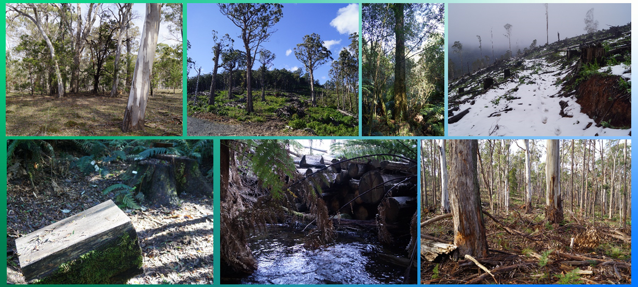

Audit of timber harvesting operations in Victoria's State forests
Project No: | IS326300
Document Title: | Report of the 2019-20 Forest Audit Program
Document No.: | IS326300-03
Revision: | RevC
Date: | 30/10/2020
Client Name: | Department of Environment, Land, Water and Planning
Client No: | Contract 345723
Project Manager: | Craig Clifton
Author: | Craig Clifton
File Name: | is326300-03 fap2019-20 audit report-revC
Jacobs Group (Australia) Pty Limited
ABN 37 001 024 095
50 Mitchell St
PO Box 952
Bendigo VIC 3552 Australia
T +61 3 5444 1861
F +61 3 5444 1862
www.jacobs.com
© Copyright 2020 Jacobs Group (Australia) Pty Limited. The concepts and information contained in this document are the property of Jacobs. Use or copying of this document in whole or in part without the written permission of Jacobs constitutes an infringement of copyright.
Limitation: This document has been prepared on behalf of, and for the exclusive use of Jacobs’ client, and is subject to, and issued in accordance with, the provisions of the contract between Jacobs and the client. Jacobs accepts no liability or responsibility whatsoever for, or in respect of, any use of, or reliance upon, this document by any third party.
Document history and status
Revision | Date | Description | Author | Checked | Reviewed | Approved
Rev A | 26/8/2020 | Draft for internal review | CC | DE
Rev B | 28/8/2020 | Draft for DELWP and VicForests review | CC | DE | DE | DE
Rev C | 7/12/2020 | Final | CC |  | DE | DE
Contents
Executive Summary i
Glossary 1
1. Introduction 4
1.1 Sustainable Forest Management in Victoria 4
1.2 Forest Audit Program 5
1.3 About this report 5
2. Audit scope 7
2.1 Audit objectives 7
2.2 Audit scope 7
2.3 Audit timing 8
2.4 Audit team 9
3. Audit approach 11
3.1 Coupe selection 11
3.2 Audit criteria and workbook 14
3.3 Field assessments 15
3.4 Environmental impact assessment 16
4. Audit results 18
4.1 Overall compliance findings 18
4.2 Environmental compliance theme 19
4.2.1 Compliance elements related to the protection of forest soils 19
4.2.2 Compliance elements related to the protection of water flows, water quality and river health 21
4.2.3 Compliance elements related to the protection of biodiversity values 22
4.3 Roading compliance theme 24
4.3.1 Compliance elements related to in-coupe road and waterway crossing design 24
4.3.2 Compliance elements related to in-coupe road and waterway crossing construction 25
4.3.3 Compliance elements related to in-coupe road and waterway crossing maintenance and closure 27
4.4 Infrastructure compliance theme 27
4.5 Coupe planning and management 29
5. Discussion 31
5.1 Overall audit findings 31
5.2 Comparison between coupes in Central Highlands and Western Victoria RFA regions 34
5.3 Comparison with previous audits 36
5.4 Potential improvements to coupe planning, harvesting and rehabilitation practices 38
5.4.1 Coupe planning 38
5.4.2 Design, construction and maintenance of in-coupe roads and waterway crossings 38
5.4.3 Coupe infrastructure 42
5.4.4 VicForests’ Road Design, Construction and Maintenance Instruction 46
5.5 Potential improvements to the regulatory framework for timber harvesting 47
5.6 Inclusion of community forestry activities in Western Victorian within the FAP’s scope 47
6. Conclusions and recommendations 48
6.1 Conclusions 48
6.2 Recommendations 51
7. References 52

Appendix A. Audit compliance elements
Appendix B. Environmental impact assessment tool
B.1 Extent and location of impact
B.2 Extent and duration of recovery
B.3 Asset
B.4 Overall environmental risk
Appendix C. Incidents leading to assessments of non-conformance with audit criteria and the regulatory framework for timber harvesting
Appendix D. VicForests’ comments on draft audit report

Executive Summary

Audit scope and objectives
This report documents the methods, results and key findings of an environmental audit of timber harvesting operations in Victoria’s State forests. Jacobs Group (Australia) Pty Ltd (Jacobs) was commissioned by the Department of Environment, Land, Water and Planning (DELWP) to deliver the 2019-20 audit, as part of its Forest Audit Program (FAP). The audit addresses mandatory compliance elements, based on the Code of Practice for Timber Production (the Code) and the Management Standards and Procedures for Timber Harvesting Operations in Victoria’s State forests 2014 (the MSPs).
The FAP has been in operation since 2002 and has been managed by DELWP since 2010. The audit is commissioned by the Timber Harvesting Compliance Unit (THCU), within DELWP’s Office of the Conservation Regulator. FAP audits are designed to assess compliance with the regulatory framework for timber harvesting operations in State forests and identify and assess any risk of harm they pose to the environment. The FAP plays an important role in continuous improvement in sustainable forest management within Victoria’s State forests.
The specific regulatory compliance criteria that were considered in this years’ audit were selected by DELWP’s THCU from Code mandatory criteria relating to:
- Protection of soil, water and biodiversity values
- Execution of in-coupe road design, construction and maintenance
- Construction and rehabilitation of coupe infrastructure
- Implementation of forest coupe planning.
Conformance with the regulatory framework was assessed for timber harvesting and related roading operations conducted in 15 coupes listed in VicForests’ Timber Release Plan (TRP) in the Central Highlands Regional Forest Agreement (RFA) region and a further 15 coupes listed in VicForests’ Timber Utilisation Plan (TUP) within the Western Victoria RFA region (Figure ES.1) Three of the coupes in the Central Highlands RFA region were located in Melbourne Water catchment areas.
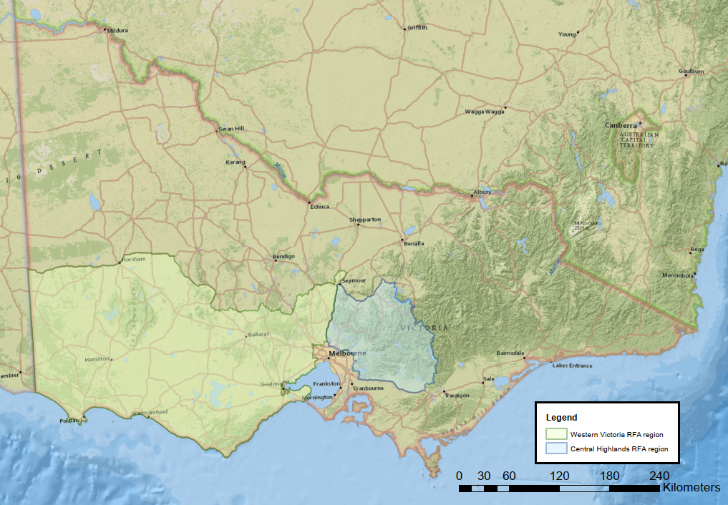
Figure ES.1 The 2019-20 FAP audit program was conducted in the Central Highlands and Western Victoria Regional Forest Agreement (RFA) regions

Audit approach
Prospective coupes for the audit were selected from a list of coupes included in VicForests’ current TRP and TUP. Selection was randomised, but weighted towards coupes with higher risk features, including: waterway crossings; long lengths of in-coupe road; steep slopes, more erosive soils; records of presence of rainforest vegetation, threatened flora and/or fauna; Special Protection or Special Management Zones (SPZ and SMZ respectively).
As coupe selection was risk-based, rather than fully randomised, the findings of this audit cannot be taken as being statistically representative of VicForests’ operations overall.
Compliance criteria considered in the audit drew on mandatory requirements of the Code, with many of these relating to applicable clauses of the MSPs and associated Planning Standards (PS). Compliance criteria were grouped into four themes, with several sub-themes, as follows:
- Environment: compliance criteria drew on Section 2.2 of the Code (Environmental values in State forests) and related compliance elements from the MSPs and PS. There were three environmental sub-themes: soil, water (incorporating flows, water quality and river health) and biodiversity. Some audit criteria related to more than one of these sub-themes.
- Roading: compliance criteria drew on Section 2.4 of the Code (Roading for timber harvesting operations) and related compliance elements from the MSPs. There were three roading sub-themes: design, construction and maintenance-closure. Some of these compliance elements are also relevant to the water and biodiversity sub-themes.
- Coupe infrastructure: compliance criteria drew on Section 2.5.2 of the Code (Coupe infrastructure) and related compliance elements from the MSPs addressing the construction and rehabilitation of coupe infrastructure, including landings, snig tracks and boundary tracks.
- Coupe planning: compliance criteria drew on parts of Section 2.5 of the Code (Timber Harvesting) relating to conformance of timber harvesting operations with coupe plans (developed as per Section 2.3 of the Code).
Audits of individual harvest coupes considered up to 146 compliance criteria. An audit workbook was completed for each coupe, based on observations by the audit team and their review of VicForests’ Forest Coupe Plan (FCP). Where instances of non-conformance with the regulatory framework were detected, their potential environmental impact was assessed using a recently revised version of the FAP’s environmental impact assessment (EIA) tool. Field assessments for the audit were undertaken in May 2020.
VicForests personnel accompanied the audit team on all coupe assessments. This enabled useful discussions about planning and management practices, applicable elements of the regulatory framework and of any non-conformances that were observed.

Audit findings
On average, the audited coupes fully conformed with 95% of applicable criteria, with the level of full conformance for individual coupes ranging between 80% and 100%. The average level of full conformance varied across audit themes, as follows:
Environmental compliance elements: | Roading compliance elements:
- Protection of forest soils: 96% (75-100%)  - Protection of water flows, water quality and river health: 96% (62-100%)  - Protection of biodiversity values: 98% (84-100%) | - Road design: 81% (58-100%)  - Road construction: 85% (73-100%)  - Road maintenance and closure: 96% (60-100%).
Infrastructure compliance elements | Coupe planning compliance elements
- 88% (67-100%) | - 96% (80-100%)
Some incidents (e.g. inappropriately constructed waterway crossings) are assessed against several criteria and result in multiple non-conformances. A total of 27 individual incidents were observed in this audit, of which 26 were detected in coupes in the Central Highlands RFA region and one was detected from the 15 Western Victoria RFA region coupes. As many as six non-conformance incidents and as few as zero were observed in a single coupe.
The level of full conformance with applicable audit criteria was greater for the (generally) less intensively managed coupes in Western Victoria RFA region than for coupes in the Central Highlands RFA region (97% and 94% overall, respectively). The higher level of conformance in Western Victoria RFA region coupes was observed across all audit themes.
The FAP’s EIA tool was revised in this audit and used to assess the potential environmental impact associated with each non-conformance. EIA ratings ranged between negligible and major; with one incident assessed to have major potential environmental impact. This was associated with the incursion of a regeneration burn into a Leadbeaters Possum SPZ that was intended to be left unburnt.
There were 26 non-conformances with moderate potential environmental impact. These related to several types of incident, as follows:
- Disturbance of rehabilitated snig track waterway crossings by a machine being used to prepare for rough heaping
- Construction of an in-coupe road waterway crossing with a culvert outlet that was elevated above the downstream bed of the temporary stream
- Excessive lengths of in-coupe road draining directly into waterway crossings
- Excessive spacing between effective cross-drainage structures on snig and boundary tracks
- Construction of a long length of in-coupe road without any cross-drainage features
- Accidental felling of a tree into a Leadbeaters Possum SPZ.
The EIA ratings given reflected the sensitivity of locations at which they occurred and, in many cases, the actual level of environmental risk or harm.
Most non-conformance incidents were of types that have been observed in recent FAP audits, however their frequency and the severity of potential environmental impact were generally much less than was observed for coupes in the Central Highlands RFA region in the 2018-19 FAP audit.

Recommendations
Findings of this audit and reflections on previous audits have led to a series of recommendations from the audit team to VicForests (Table ES.1) on potential improvements in the management of timber harvesting operations and related roading activities. All recommendations have a high priority, which reflects the potential environmental impact associated with the aspect of harvesting or roading practice. No specific recommendations are made for DELWP as the regulator of timber harvesting activities in State forest.
Table ES.1 Recommendations of the 2019-20 Forest Audit Program
Recommendations for VicForests
High priority:
V-01: That VicForests and its roading and harvesting contractors fully adopt the Road design, construction and maintenance instruction for use in the design and construction of all new in-coupes roads and any new waterway crossings.
V-02: That VicForests develop or improve guidance for contractors on the placement of snig, boundary or other tracks, particularly to ensure they: a) avoid constructing tracks along drainage depressions in which overland and sub-surface water flows will concentrate; b) where reasonably practicable, avoid having multiple tracks converge downhill on locations with limited drainage capacity and, where this cannot be avoided, manage risks associated with overland flows and excessive water infiltration; and c) avoid unnecessary waterway crossings.
V-03: That VicForests develop specific guidance or instruction on the design, construction and rehabilitation of in-coupe road and snig track waterway crossings.

Glossary
Audit criteria | Criteria used to assess whether timber harvesting and related activities are consistent with mandatory requirements of the Code and MSP.
Code | The Code of Practice for Timber Production 2014, which lists mandatory actions for timber harvesting activities in native forests and plantations in Victoria.
Conformance | Conformance with audit criteria. Activities were assessed to:  - Fully conform (or fully comply) with audit compliance element  - Not fully conform with the audit compliance element, but pose no direct risk of environmental harm  - Not fully conform with the audit compliance element and either have potential to pose a risk of harm to the environment or cause observable environmental harm. The severity of risk or actual harm is assessed using the FAP’s environmental impact assessment (EIA) rating tool (Appendix B).
Coupe | An individual management unit within forests and plantations where timber harvesting or thinning activities are planned and conducted. Under the Sustainable Forests (Timber) Act 2004, a coupe is a specific area of State forest identified for the purposes of timber harvesting and regeneration in a Timber Release Plan.
DELWP | Department of Environment, Land, Water and Planning: DELWP has responsibility for environmental regulation of timber production activities in State forests. DELWP were formerly known as the Department of Environment and Primary Industries (DEPI) and the Department of Sustainability and Environment (DSE).
EI | Environmental impact, as assessed using the EIA rating tool (Appendix B).
EIA, EIA rating tool | Environmental Impact Assessment. The EIA rating tool was developed for the FAP (see Appendix B) to provide a consistent basis for assessing the potential environmental implications of non-compliance with audit criteria.
FAP | Forest Audit Program, an annual program of environmental audits coordinated by DELWP to ensure that timber production operations in State forests provide for sustainable forest management.
Filter strip | A protective boundary around a drainage line, temporary stream or buffer strip. Trees may be harvested from within the filter strip, although they may not generally be entered by harvesting machines.
FCP | Forest Coupe Plan, a plan that is prepared for each coupe that describes the biophysical character of the coupe and the nature of planned harvesting operations. The minimum FCP content requirements are specified in the Code. The FCP is contained within a coupe file that includes other information, including coupe monitoring records, traffic management provisions and silvicultural operations. The coupe file may also refer to information about the coupe and its operations that is held within a VicForests or DELWP information management system.
FMA | Forest Management Area, the basic regional unit for forest planning used for public land in Victoria. These forest planning units are not administrative units.
ICR | In-coupe road, a constructed road or track that is constructed to provide log trucks with access to a log landing.
Incident | An event, action or lack of action on a coupe that gives rise to an assessment of non-conformance with an audit criterion. The nature of the audit criteria and various prescriptions mean that a single incident may result in multiple non-conformances.
In-coupe road | A temporary or, in some cases, permanent road constructed to provide access to landings and/or allow haulage of timber from the coupe. Sometimes abbreviated as ICR
Landing | An area within the coupe that is specifically developed to sort, process and/or load trees or parts of trees for transport from the forest. Top soil is removed before landings are developed. Landings must be rehabilitated at coupe closure (including by re-spreading top soil) unless they are to be used for an adjacent coupe.
MSP | Management standards and procedures for timber harvesting operations in Victoria’s State forests 2014. They are designed to help interpret the Code for timber harvesting and related activities in State forests. They are a secondary source of mandatory prescriptions for forest management.
MRT | Montane Riparian Thicket, a vegetation community containing at least 40% canopy cover of Mountain Tea-tree (Leptospermum grandifolium) and with understorey composition as per the MSPs.
OCR | Office of the Conservation Regulator, an office within DELWP that administers the regulatory framework for timber harvesting in State forests.
PS | Planning standards for timber harvesting operations in Victoria’s State forests 2014. Appendix 5 to the MSPs.
Rainforest stand | Patch of rainforest vegetation that meets the minimum species composition, size and projected foliage cover requirements of MSP 4.4.7 and 4.4.8 for recognition as a rainforest stand.
Rainforest vegetation | A patch of vegetation comprised of recognised rainforest canopy species, as per MSP 4.4.7. Rainforest vegetation may or may not form a stand, as described in the MSPs.
RFA | Regional Forest Agreement. The 2019-20 FAP considered coupes in each of two RFA regions, Central Highlands and Western Victoria.
Rough heaping | A method of preparing coupes for regeneration. Woody residue from harvesting is pushed into heaps and burnt. Soils, understorey and coupe infrastructure are disturbed by machinery to create a receptive seed bed.
Snig track | A track through a harvested coupe along which harvested logs are towed or winched, normally towards a landing.
SMZ | Special Management Zone, a forest management zone that is managed to conserve specific features or values, with allowing timber harvesting operations to proceed under special management.
Soil erosion hazard | Soil erosion hazard (or SEH) is a composite index of the potential for soil erosion to occur within a forest coupe. SEH is based on field assessments of soil texture, aggregate stability, structure, colour, organic content, mottling and stoniness. It also takes account of the erosivity of rainfall at the location, average slope, slope length, tree size and revegetation capacity. The method of calculation is described in the MSP (DEPI, 2014b). SEH is assessed for each coupe during harvest planning.
SPZ | Special Protection Zone, a forest management zone that it managed for specific conservation values. SPZs form a network within State forests that is meant to complement the formal conservation reserve system.
State forest | Publicly-owned and managed forest estate. Victoria has 3.4 million ha of State forest. State forest is managed for multiple beneficial uses, including conserving flora and fauna, protecting water catchments and water supply, providing timber for sustainable forestry, protecting landscape, archaeological and historic values, and providing recreational and educational opportunities.
STX | Snig track crossing, a constructed crossing through a waterway for a snig track.
TRP | Timber Release Plan. Timber resources in State forests in eastern Victoria are allocated to VicForests for the purposes of harvesting and/or selling through the Allocation to VicForests Order 2004 (as amended). The Allocation Order specifies the extent and location of the forest stands to which VicForests has access under this Order. VicForests must prepare a Timber Release Plan for allocated areas.  Timber Release Plans (TRPs) are publicly available documents that must include: a schedule of coupes selected for timber harvesting and associated access road requirements; details of the location and approximate timing of timber harvesting in the proposed coupes; and details of the location of any associated access roads. They are prepared by VicForests in accordance with Part 5 of the Sustainable Forests (Timber) Act 2004 and may be reviewed and changed in accordance with Section 43.
TUP | Timber Utilisation Plan. VicForests prepare a Timber Utilisation Plan (TUP) to allow timber harvesting in areas not subject to the Allocation (Amendment) Order 2019. TUP documents provide details of the location and approximate timing of proposed timber harvesting operations and associated management activities. The TUP covers community forestry activities, most of which take place in Western Victoria.
UP | VicForests’ Utilisation Procedures. Operational procedures used by VicForests and its contractors in their management of harvesting and in-coupe roading operations. The UPs typically apply Code and MSP requirements.
VBA | Victorian Biodiversity Atlas, a database with records showing the distribution of native flora and fauna species, including listed threatened species.
WWX | Waterway crossing constructed for an in-coupe road.

Introduction

Sustainable Forest Management in Victoria
The legislative framework for the harvesting and management of timber resources in Victoria’s State forests is provided by five main pieces of legislation (based on DELWP, 2019):
- Forests Act 1958: provides the legislative basis for the development and implementation of Forest Management Plans and Forest Management Zones, which influence timber harvesting activities in State forests. This Act also allows the granting of Forest Produce Licences, under which timber harvesting operations in areas outside an Allocation Order can be authorised (i.e. for harvesting in western Victoria).
- Wildlife Act 1975: provides a framework for regulating interactions with wildlife and must be complied with when undertaking timber harvesting in State forests.
- Conservation, Forests and Lands (CFL) Act 1987: provides the legislative basis for the creation and enforcement of codes of practice (including the Code of Practice for Timber Production 2014 [the Code; DEPI, 2014a]) which specify standards and procedures for carrying out timber harvesting operations (among other activities).
- Flora and Fauna Guarantee (FFG) Act 1988: provides the legislative basis for Action Statements for threatened species and communities. These statements inform updates to the Code when undertaking timber harvesting in State forests.
- Sustainable Forests (Timber) (SFT)Act 2004: provides a framework for sustainable forest management and sustainable timber harvesting in State forests and establishes the Allocation Order, Timber Release Plans and compliance obligations provisions for timber harvesting in State forests. The SFT Act requires VicForests and persons who have entered into an agreement with VicForests for the supply and sale of timber resources to comply with the Code.
The SFT Act also provides the legislative basis for commissioning audits of compliance with relevant codes of practice (including the Code) by VicForests. It also requires VicForests to respond to any adverse findings of such an audit, including details of measures it has or intends to undertake to improve compliance with the relevant code of practice. The SFT Act also provides for the publication of audit reports and VicForests’ responses to these.
Under the SFT Act, harvesting of timber from public land by VicForests is to be conducted in a manner which has regard to the principles of ecologically sustainable development. The Act provides for the development of a Sustainability Charter, which sets out the State’s objectives for sustainable forest management. These objectives (DSE, 2006) are to:
Maintain and conserve biodiversity in State forests;
Maintain and improve the capacity of forest ecosystems to produce wood and non-wood products;
Promote healthy forests by actively managing disturbance;
Maintain and conserve the soil and water resources of State forests;
Maintain and better understand the role of Victoria’s State forests in global carbon cycles;
Maintain and enhance the socio-economic benefits of State forests to Victorian communities;
Ensure Victoria’s legal, institutional and economic frameworks effectively support the sustainable management of State forests.
In reviewing VicForests’ Allocation Order, the SFT Act requires that the Minister will also have regard to VicForests’ compliance with applicable codes of practice.
The primary instrument used to regulate timber harvesting activities in State forests is the Code. This is now administered by the DELWP’s Office of the Conservation Regulator (OCR).
The purpose of the Code is to provide direction to timber harvesting managers, harvesting entities and operators to deliver sound environmental performance when planning for and conducting timber harvesting activities in a way that:
- Permits an economically viable, internationally competitive, sustainable timber industry
- Is compatible with conservation of the wide range of environmental, social and cultural values associated with forests
- Provides for the ecologically sustainable management of native forests proposed for cyclical timber harvesting operations
- Enhances public confidence in the management of timber production in Victoria’s forests and plantations.
The Code includes a set of operational goals and mandatory actions for various aspects of planning and implementation of timber harvesting operations and applies to native forests and plantations on private and public land. It is supported by the Management Standards and Procedures for Timber Harvesting Operations in Victoria’s State Forests 2014 (the MSPs; DEPI, 2014b), which specify (often in greater detail) mandatory standards and procedures for timber harvesting activities in State forests (only).

Forest Audit Program
Since 2002, environmental auditors appointed under the Environment Protection Act 1970 have been engaged to undertake independent audits of timber harvesting operations in Victoria’s State forests, as provided for by the SFT Act. These audits have assessed compliance with the Code and related standards and management procedures. This annual program of audits has been delivered by DELWP, under its Forest Audit Program (FAP) since 2010. Independent auditors are engaged by OCR to undertake FAP audits.
As FAP audits are carried out by independent environmental auditors, they do not have a direct regulatory function. They help to monitor VicForests’ compliance with the regulatory framework and contribute to continuous improvement in sustainable native forest management. In keeping with the latter, field components of the audit are undertaken with VicForests personnel present. This informs the auditors of the history of operations on the coupe and any challenges faced. It also allows for on-site discussion about any potential non-conformance issues that have been observed by the audit team.
Following the audit field components, VicForests may be requested to provide additional information to enable the auditors to determine whether coupe planning or operations comply with regulatory requirements. VicForests is provided, via DELWP, with a copy of the draft audit report and may provide “matters of fact” comments. This allows them to contest draft compliance findings and offer further evidence for the audit team to consider. VicForests’ comments and any additional evidence are considered by the audit team in finalising the audit report. For transparency, VicForests’ substantive comments and the audit team’s responses are documented in the final audit report.

About this report
This is the final report of the 2019-20 Forest Audit Program. The remainder of the document includes five main sections, as follows:
- Section 2 Audit scope: a description of the scope of the audit, including the audit objectives, the regulatory scope it addresses, the audit timing and audit team.
- Section 3 Audit approach: describes the coupe selection process, development of audit compliance elements and the methods by which conformance with the regulatory framework was assessed.
- Section 4 Audit results: presents the main results of the audit, in terms of both the level of conformance with audit criteria and the assessed actual or potential environmental impact associated with any observed non-conformance incidents. Audit results are organized by the compliance themes included in the audit scope developed by DELWP.
- Section 5 Discussion: a discussion of the overall audit findings, comparison (to the extent appropriate) of audit results with previous FAP audits and potential improvements to coupe planning and timber harvesting that are suggested by observations during the field audit.
- Section 6 Conclusions and recommendations: a summary of the main findings of the audit and recommendations for improvements in timber harvesting operations.

Audit scope

Audit objectives
The FAP enables DELWP to commission an environmental auditor to provide an objective and independent assessment of:
- Compliance by VicForests and their contractors with prescriptions for timber harvesting and related activities outlined in Victoria’s regulatory framework; and
- Environmental performance of the audited timber harvesting operations and any associated risks of harm to the environment.
The FAP is a key contributor to continuous improvement to systems of sustainable management for Victoria’s State forests.

Audit scope
The audit addresses mandatory Code compliance elements. These were selected by DELWP’s Timber Harvesting Compliance Unit (THCU; a unit within the OCR) prior to commissioning of the audit and addressed four main compliance themes:
- Environmental values in State Forests: measures to protect water quality, river health and soils during timber harvesting and associated roading activities and to conserve biodiversity by (e.g.) protecting listed threatened species and vegetation communities, avoiding harvesting in rainforests, habitat retention and maintaining forest hygiene
- Roading for timber harvesting operations: measures to ensure the design, construction and maintenance of in-coupe roads protect soil, water and biodiversity values
- Operational planning and record keeping: measures that are undertaken to ensure that timber harvesting operations are planned to satisfy applicable regulatory requirements and that the operations are conducted according to these plans
- Coupe infrastructure: measures that are undertaken to ensure the construction and rehabilitation of coupe infrastructure (e.g. landings, snig tracks, boundary tracks) protect soil, water and biodiversity values.
Additional compliance elements for the audit (see Appendix A) were selected from mandatory requirements of the MSPs and their Planning Standards (PS; Planning Standards for timber harvesting operations in Victoria’s State forests 2014; DEPI, 2014c). These additional elements were selected by the auditors, based on the Code compliance elements specified by DELWP, and agreed prior to commencing the audit.
Collectively, the compliance elements seek to ensure that coupe planning, harvesting and associated forest roading activities are conducted so that the range, quantity and quality of environmental goods and services provided by State forests are maintained.
The audit included 15 coupes that were listed in VicForests’ current Timber Release Plan (TRP; for intensive harvesting operations in eastern Victoria). These coupes were located within the Central Highlands Regional Forest Agreement (RFA) region, which includes parts of the Central, Dandenong and Central Gippsland Forest Management Areas (FMAs; Figure 2.1). A further 15 Timber Utilisation Plan (TUP; generally for community forestry activities in western Victoria) coupes were included in the audit. These were all located in the Western Victoria RFA region, with coupes distributed between the Horsham, Midlands and Otway FMAs (Figure 2.2).
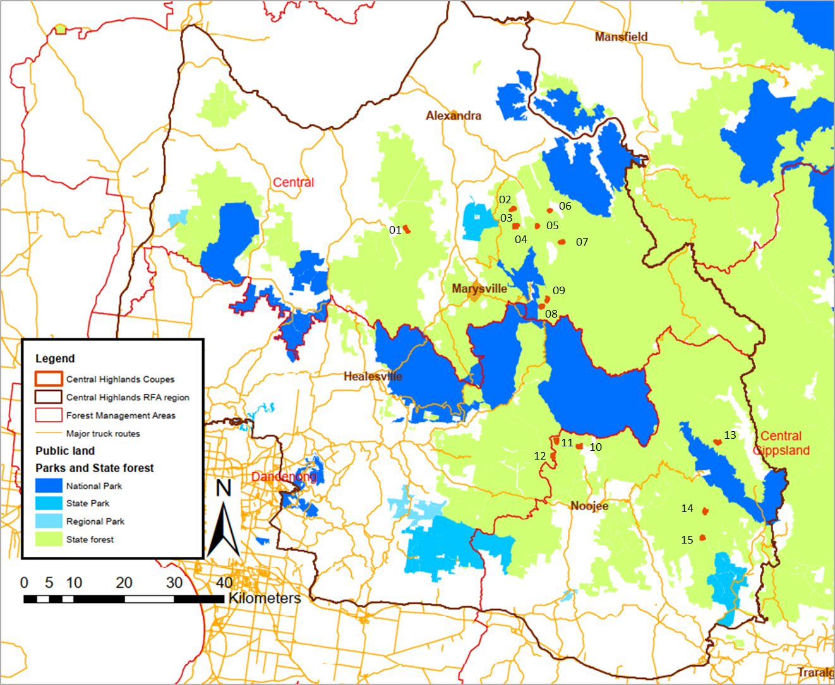
Figure 2.1 Locations of TRP coupes included in 2019-20 Forest Audit Program within the Central Highlands RFA region. Numbers refer to the number assigned to audit coupes, as per Table 3.1.

Audit timing
Field assessments of the coupes included in this audit were undertaken during May 2020. Audit reporting was carried out in two stages, with an initial conformance summary report on the results of the audit submitted to DELWP in May 2020. The conformance summary (Jacobs, 2020) provided preliminary information on compliance assessments and the potential environmental impact of any non-conformances. However, it did not draw out any overall findings or conclusions. The second stage of reporting involves the production of the full audit report – of which this is the final version.
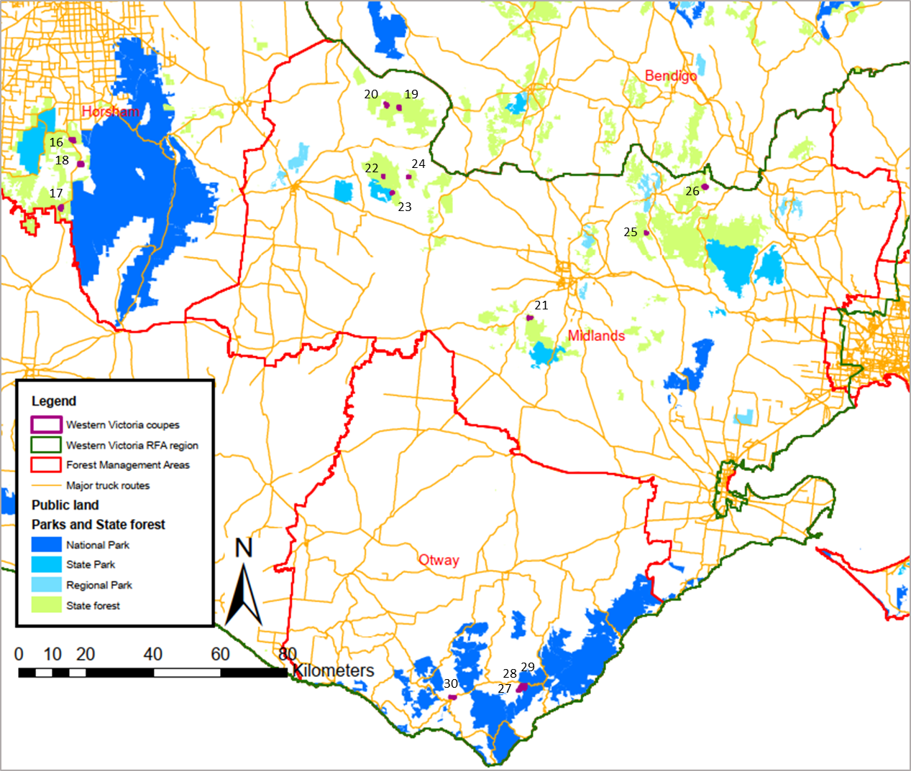
Figure 2.2 Locations of TUP coupes included in 2019-20 Forest Audit Program within the Western Victoria RFA region. Numbers refer to the number assigned to audit coupes, as per Table 3.1. Coupes with the R prefix were reserve coupes.

Audit team
The audit team (below) were all employed by Jacobs Group (Australia) Pty Ltd (Jacobs):
- Craig Clifton (Project Manager and lead auditor): Craig is an EPA-appointed natural resources environmental auditor and has undergraduate and post-graduate qualifications in Forest Science. He developed the audit methodology, led the field assessments and their analysis and is lead author of this audit report. Craig has led audit teams undertaking seven previous audit projects as part of the FAP.
- David Endersby (Project Director): David is a principal terrestrial ecologist, with specialist expertise in botany, plant ecology and geomorphology. He has participated in several previous FAP audits as a field team member, project director and technical reviewer. David is the internal technical reviewer for this report and Jacobs’ project director.
- Dr Drew King (Audit team member): Drew has post-graduate qualifications in Botany and over 15 years’ experience in ecological research and consulting. He has been involved in previous timber harvesting compliance investigations and FAP audits. Drew was lead field ecologist for some of the field audits in coupes located in the Central Highlands RFA region.
- Andrew Stephens (Audit team member): Andrew is a senior ecologist with specialisations in vegetation ecology and bushfire ecology. Andrew was the lead field ecologist for audits in the Western Victoria RFA region.
- Mike Timms (Audit team member): Mike is a field ecologist with experience in a range of field assessment and compliance reporting projects. Mike has previously participated in a FAP audit and was lead ecologist for field audits in several coupes in the Central Highlands RFA region.

Audit approach

Coupe selection
Target coupes for the audit were selected from the set of VicForests’ TRP and TUP coupes in the Central Highlands and Western Victoria RFA regions (respectively) which were operational or under regeneration during the 2018-19 financial year. As per DELWP’s terms of reference for this audit, 15 coupes were selected from each RFA region. Reserve coupes were also selected in each region in case the initial target coupes were inaccessible at the time of the field audit or otherwise unavailable. None of the reserve coupes were required.
A risk-based selection process was used to identify the target coupes for auditing. The process was based on the characterisation of the coupes in information provided to DELWP by VicForests. The factors influencing selection included:
- Waterway crossing was to be constructed to access the coupe
- Rainforest and/or Montane Riparian Thicket (MRT) vegetation were identified as being present within the gross coupe boundary
- The length of in-coupe road required to access the landing(s)
- Soil erosion hazard in the A or B horizon
- Average coupe slope
- Presence of land zoned as special protection and/or special management zone (SPZ/SMZ, respectively) within or adjacent to the coupe
- Records of Victorian Biodiversity Atlas (VBA) listed threatened species from the coupe
- Location in a Melbourne Water catchment area (minimum of two coupes).
Coupes in Central Highlands RFA region with multiple risk factors were preferentially selected for auditing. The level of risk associated with coupes in the Western Victorian RFA region was generally much less than in Central Highlands RFA region and, as a result, the overall risk factor score did not particularly differentiate between coupes.
One of the coupes in the Central Highlands RFA region had previously been included in a FAP audit (in 2016/17; 462-506-0003 Tropical). The current audit only considered a new area of harvesting and new coupe features (including sections of in-coupe road that were constructed to access the new harvest area) in that coupe. Three of the selected coupes are located in Melbourne Water catchments. Details of the target coupes are given in Table 3.1 and their locations are shown in Figure 2.1 and Figure 2.2.
The characteristics of coupes in the two RFA regions differ markedly (Table 3.1). Coupes in the Central Highlands RFA region are typically steeper and smaller than those in the Western Victoria RFA region. Many of the audit coupes in Central Highlands RFA region had in-coupe roads, waterway crossings and landings; all had snig and/or boundary tracks. Coupes in the Western Victoria RFA region typically have no developed coupe infrastructure (i.e. in-coupe roads, landings, snig tracks), although some have a network of historical, informal tracks that are used to extract forest products.
Vegetation modelling suggests that 11 of the Central Highlands RFA region coupes and four Western Victoria RFA region coupes (all in the Otway FMA) have rainforest vegetation present within them or nearby. Listed, threatened native flora or fauna have been recorded in or nearby many of the coupes in both RFA regions.

Table 3.1 Location and characteristics of harvest coupes included in 2018-19 FAP
Audit # | Coupe address | Coupe Name | FMA | Gross coupe area (ha) | Rainforest vegetation | Waterway crossing¹ | In-coupe road length² | Average slope | Maximum soil erosion hazard | SMZ or SPZ | Listed flora or fauna³
Central Highlands RFA region
1 | 283-503-0010 | Sea Monkey | Central | 47.7 | No | STX | 1-400 m | <15° | High | SPZ | In coupe
2 | 286-505-0027 | Buzz | Central | 37.1 | Yes | WWX | >400 m | ≥15° | Medium | SPZ | <500 m
3 | 286-510-0009 | Harrison | Central | 15.5 | Yes | WWX | 1-400 m | ≥15° | Low | Nil | <500 m
4 | 286-510-0010 | Sutcliffe | Central | 42.1 | Yes | STX | <100 m | <15° | High | SPZ | <500 m
5 | 287-512-0024 | Dorset | Central | 17.4 | Yes | STX | 1-400 m | ≥15° | Medium | SPZ | In coupe
6 | 288-512-0002 | Snobs 14 | Central | 25.2 | Yes | Nil | 1-400 m | ≥15° | Medium | SPZ | In coupe
7 | 288-519-0002 | Ivanhoe | Central | 39.8 | Yes | Nil | 1-400 m | ≥15° | Medium | SPZ | In coupe
8 | 312-011-0015 | Dejavu | Central | 31.5 | Yes | Nil | 1-400 m | ≥15° | Medium | SPZ | In coupe
9 | 312-509-0007 | Bayern Munich | Central | 29.5 | Yes | Nil | 1-400 m | ≥15° | Low | SPZ | In coupe
10 | 462-504-0026 | Litaize Road | Central Gippsland | 39.9 | No | WWX | 1-400 m | ≥15° | Medium | SPZ | <500 m
11 | 462-506-0003 | Tropical | Central Gippsland | 41.7 | No | Nil | 1-400 m | ≥15° | High | SPZ | Nil
12 | 462-506-0017 | Teamwork | Dandenong & Central Gippsland | 38.5 | Yes | Nil | 1-400 m | ≥15° | Medium | SPZ | In coupe
13 | 480-506-0019 | Axemans | Central Gippsland | 35.3 | Yes | Nil | 1-400 m | ≥15° | Medium | SPZ | In coupe
14 | 483-504-0001 | Lure | Central Gippsland | 35.4 | Yes | Nil | 1-400 m | ≥15° | Medium | SPZ | In coupe
15 | 485-507-0013 | Mid Week | Central Gippsland | 30.1 | No | WWX | 1-400 m | <15° | Medium | SMZ | In coupe
Western Victoria RFA region
16 | 035-016-0128 | Cherry Cola | Horsham | 82.0 | No | Nil | 0 | 0 | Low | SPZ | Nil
17 | 035-016-0166 | Clip go the Shears | Horsham | 90.5 | No | Nil | 0 | 0 | Low | SPZ | Nil
18 | 035-016-0200 | Briers | Horsham | 77.3 | No | Nil | 0 | 0 | Medium | SPZ | In coupe
19 | 172-501-0107 | Tea Break | Midlands | 31.0 | No | Nil | 0 | 10 | High | SPZ | <500 m
20 | 172-518-0107 | Mallee Boy | Midlands | 40.5 | No | Nil | 0 | 10 | Low | SPZ | Nil
21 | 175-501-0103 | Margherita | Midlands | 30.2 | No | Nil | 0 | 0 | Medium | SPZ | In coupe
22 | 185-514-0101 | Hickery Dickery | Midlands | 9.4 | No | Nil | 0 | 10 | Low | SPZ | In coupe
23 | 185-535-0106 | Camp Link Road | Midlands | 24.6 | No | Nil | 0 | 10 | Low | SPZ | In coupe
24 | 186-545-0104 | String Line | Midlands | 25.2 | No | Nil | 0 | 10 | Low | SPZ | Nil
25 | 195-517-0012 | Full Sun | Midlands | 21.4 | No | Nil | 0 | 5 | Low | SPZ | Nil
26 | 208-503-0024 | Pack of Cards | Midlands | 84.4 | No | Nil | 0 | 5 | Low | SPZ | In coupe
27 | 226-502-0012 | Peek-a-boo ST | Otway | 65.6 | Yes | Nil | 0 | 15 | Medium | Nil | Nil
28 | 226-502-0013 | Glimpse ST | Otway | 20.6 | Yes | Nil | 0 | 5 | Medium | Nil | Nil
29 | 226-502-0014 | Eye Spy ST | Otway | 65.1 | Yes | Nil | 0 | 10 | Medium | Nil | In coupe
30 | 234-501-0008 | Marina ST | Otway | 64.6 | Yes | Nil | 0 | 10 | Medium | Nil | Nil
Note:
- Waterway crossing. Type of crossing present: WWX – in-coupe road crossing, STX snig track crossing, Nil – no crossing. Colour code: pale blue – coupe flagged by VicForests planning as having a crossing, but the feature was not present; green – coupe correctly flagged as having or not having a waterway crossing; yellow – coupe not flagged as having a waterway crossing but having a snig or in-coupe road crossing present in the field.
- In-coupe road length colour code: pale blue – in coupe road length less than estimate; green – road length accurately estimated; orange – actual in-coupe road length greater than estimated.
- Presence of listed threatened flora or fauna: Victorian Biodiversity Atlas (VBA) records either within coupe (In coupe), within 500 m of the coupe (<500 m) or not present within 500 m (Nil)

Soils in the harvest audit coupes were generally relatively stable, with only four of the 30 coupes recording soil erosion hazard (SEH) values of high or greater. Coupes in the Western Victoria RFA region were generally located in areas with relatively low slope. Only one of the 15 coupes were reported to have average slope of more than 10°. Twelve of the 15 coupes in the Central Highlands RFA region have an average slope of more than 10°.

Audit criteria and workbook
Audit criteria were based on mandatory requirements of the Code selected by DELWP’s THCU. Most commonly, these referenced compliance elements from the MSPs and its PS, as these provide more detailed interpretations of Code requirements. Compliance criteria were grouped into several themes and sub-themes, as follows:
- Environment: compliance criteria developed for the audit drew on Section 2.2 of the Code (Environmental values in State forests) and related compliance elements from the MSPs and PS. There were three environmental sub-themes: soil, water (incorporating flows, water quality and river health) and biodiversity. Some audit criteria related to more than one of these sub-themes.
- Roading: compliance criteria developed for the audit drew on Section 2.4 of the Code (Roading for timber harvesting operations) and related compliance elements from the MSPs. There were three roading sub-themes: design, construction and maintenance-closure. Some of these compliance elements are also relevant to the water and biodiversity sub-themes.
- Coupe infrastructure: compliance criteria developed for the audit drew on Section 2.5.2 of the Code (Coupe infrastructure) and complementary compliance elements from the MSPs relating to the rehabilitation of coupe infrastructure, including landings, snig tracks and boundary tracks.
- Coupe planning: compliance criteria for the audit drew on parts of Section 2.5 of the Code (Timber Harvesting) relating to conformance of timber harvesting operations with coupe plans (developed as per Section 2.3 of the Code).
Audits considered up to 146 compliance criteria (see Appendix A). These were assessed, as applicable, for each of the target coupes. A digital audit workbook was developed to capture assessments against all applicable criteria for each individual coupe. Assessments recorded in the workbook were based on observations by the audit team and their review of VicForests’ (digital) Forest Coupe Plan (FCP). They considered the applicability of each criterion, as well as the operations’ conformance with the audit criteria or compliance element. The latter was assessed using the descriptors in Table 3.2.
Table 3.2 Descriptors used to assess conformance with audit criteria
Level of compliance | Fully conforms | Non-conforming with no environmental impact  (Non-no EI)) | Non-conforming with environmental impact  (full non-conformance, Non-EI)
Description | All requirements of the compliance element are fully satisfied. | All requirements of the compliance element are not fully satisfied. However, the non-conformance is procedural and poses no direct risk of harm to the environment. | All requirements of the compliance element are not fully satisfied. The non-conformance has potential to pose a risk of harm to the environment.
The workbook was also used to capture the basis for any non-conformance assessment. Photographs of coupe features were taken, particularly where/if non-conformances were observed.

Field assessments
Field assessments of relevant coupe characteristics (Table 3.3) were carried out in each of the target coupes. Global positioning systems (GPS) were used in most coupes to track the field team’s movements and some coupe observations were made digitally using the ESRI Collector platform.
Table 3.3 Field assessment methods for harvesting coupes
Attribute being assessed | Criteria | Method
- Waterway classification and correct provision of riparian filters and/or buffers. | 1, 3, 5 | Assessment of waterway as drainage line, temporary stream or permanent stream, based on Code definitions. Streams and widths of filters/buffers assessed along up to 600 m of waterway per coupe, if present. Adequacy of filter and buffer widths assessed with a range finder, supported by ground traverses to locate the centreline of the stream (as required).
- Soil erosion hazard | 2 | Comparison of VicForests assessment of soil erosion hazard with observations of erosion within the coupe. Soil erosion hazard is assessed using MSP methods where evidence of soil conditions and soil erosion suggests to the auditor that the initial assessment may have been incorrect or only applicable for one of multiple soil types present within the coupe.
- Extent to which harvesting was conducted on slopes >30°. | 4 | Visual observation, using a clinometer, if required. Supported by subsequent GIS analysis using VicForests’ lidar data, if available, or slope mapping in VicForests’ Forest Coupe Plan (FCP).
- Adequacy of protection provided to soils, waterways and river health. | 6, 7, 8 | Visual observations and auditors’ interpretations, based on the presence of excessive disturbance and/or activities which are not compliant with elements of the regulatory framework. Considers in-coupe roads (ICR) and coupe infrastructure (snig tracks [ST] and landings).
- Presence of in-coupe roads or snig tracks in riparian habitats. | 7 | Visual observations and auditors’ interpretations of the reasonable practicability of alternative placements which avoided riparian areas.
- Waterway crossings and culverts. | 7, 24, 25, 26 | Assessment of culverts, embankments and road drainage against MSP requirements. Observations and auditors’ interpretation of crossings in which the culvert had been removed (if observed). Observations of sediment entry into the waterway.
- Habitat trees. | 9, 10 | Assessment of the density and distribution of habitat trees, their location in relation to other habitat and their potential to develop hollows.
- If listed threatened fauna or flora are recorded as being present, whether prescribed management actions been followed. | 9, 11 | Comparison of observed coupe conditions with management actions specified in the MSP, PS and forest coupe plan (FCP).
- Harvesting and/or road construction in or near heathland or montane riparian thicket (MRT) if present within or near the coupe. | 12, 13 | Confirmation of the presence of the vegetation community and observation of its proximity to in-coupe roads. Auditors’ assessment as to the reasonable practicability of alternative road location if the road entered the protected vegetation community. Presence of harvesting in or in proximity to heathlands or MRT.
- Old growth forest | 14 | Provision of buffers around verified old growth forest within Leadbeaters Possum range.
- Rainforest buffers. | 16 | Identification of rainforest stands, as per MSP definitions. Assessment of provision of any required buffers as per MSP compliance requirements for up to 600 m length of rainforest boundary in each coupe.
- Protection of exclusion areas | 17, 28 | Identification and assessment of any effect of harvesting operation (including roading, regeneration burning and machinery movement) on exclusion areas.
- Biosecurity. | 18,19 | Observation of harvesting related damage to or wounding of Myrtle Beech trees, in applicable coupes. Implementation of any management plans where harvesting operations appear to have led to disease or pest introduction.
- In-coupe road construction | 21, 22 | Assessment of whether road construction follows any documented plan or design.  Identification of any evidence that road construction was inconsistent with need to minimise risk of erosion and water quality impact. Identification of any evidence that table drains were constructed by subsequent excavation.  For in-coupe roads through retained vegetation, assess whether clearing width was consistent with MSP requirements.  Observation and auditors’ interpretation of the adequacy of road maintenance and any road closure works.
- Fill batters | 23 | Evidence of soil movement and instability. Observation of instances where fill batters cover bases of live trees to be retained post-harvest.
- Road drainage | 24 | Compliance with MSP drain spacing requirements, based on soil erosion hazard and gradient, for any in-coupe road (up to 1000 m length). Assessment of effectiveness of drainage and appropriateness of drainage disposal, considering Code and MSP requirements.  Conformance of culvert construction and management with MSP requirements.  Appropriateness and avoidability of disturbance to stream beds during and following crossing construction and removal.
- ICR and waterway crossing (WWX) closure | 26 | Have any WWX (and snig track crossings; STX) that are no longer required been removed and rehabilitated as per MSP requirements.  Has an ICR that is no longer required been closed permanently?
- Coupe management | 27 | Observation of the consistency between the FCP and the timber harvesting operation.
- Coupe infrastructure | 29 | Assess if ST have been progressively rehabilitated and rehabilitated in a way that prevents soil movement into streams and consistent with MSP requirements. Assess adequacy of ST and boundary track drainage and its conformance to MSP requirements. Assess up to 600 m length of ST and/or boundary track (BT), where present.  Assess adequacy of landing rehabilitation, including removal of any cording, bark and/or slash.

Environmental impact assessment
The EIA tool provided by DELWP (Appendix B) was initially used to assess the potential environmental impacts of any instances of non-conformance with audit criteria and the regulatory framework for timber harvesting. The tool was revised following the production of the conformance summary report (Jacobs, 2020) to enable more consistent and transparent assessments of potential environmental impact. EIA tool assessments are based on:
- Extent and location of impact: an auditor’s assessment based on one or more of several factors:
- Proportion of the harvestable coupe area affected by the non-conformance
- Length of in-coupe road and/or snig/boundary track without conforming drainage
- Suitability of landing rehabilitation
- Extent of soil mass movement
- Number of retained trees whose base is covered by in-coupe road, landing or snig track embankment materials
- The number and/or extent of incidences of inappropriate disturbances (i.e. disturbances to planned timber harvesting exclusions areas which are not permitted by the Code or MSPs) to waterways, riparian buffers or filters or other areas within or adjacent to the gross coupe area.
- Duration of impact/recovery time: an assessment by the auditor of the likely time required for the coupe to recover from any impact or disturbance associated with the non-conformance incident.
- Values affected: an assessment based on the value or environmental aspect experiencing or potentially experiencing an impact stemming from the non-conformance. General forest areas are valued less than riparian or rainforest buffers and SPZ, for example.
The overall five-point EIA rating is based on the total score for each component. Ratings may range between negligible and severe.
If a non-conformance did not directly pose a risk of harm to the environment, it was assessed as non-conforming with no environmental impact (EI), as per Table 3.2.

Audit results
The following discussion summarises the results of the assessments of conformance with compliance criteria based on mandatory elements of the regulatory framework for timber harvesting in State forests, as listed in Appendix A. Overall results are presented first, with those for each compliance theme and sub-theme following. As the coupe selection method was risk-based, rather than random, these results are not statistically representative of VicForests’ operations overall.
Due to space constraints in the figures, coupes are represented by the number assigned in Table 3.1. In the narrative accompanying these figures, coupes are referred to by that number (rather than the TRP/TUP coupe number) and the coupe name.

Overall compliance findings
A total of 146 criteria were identified from the various compliance elements applicable to timber harvesting coupes (Appendix A). Of these, 29 criteria did not actually apply to any of the selected coupes. The overall level of full conformance with applicable audit criteria ranged between 80% (2 Buzz) and 100% (six coupes, Figure 4.1), with the average being 94% (Figure 4.1). Harvesting operations in six of the 30 coupes fully complied with all applicable audit criteria. Some of the non-conformances identified in 14 of the 30 coupes had potential for environmental impact.
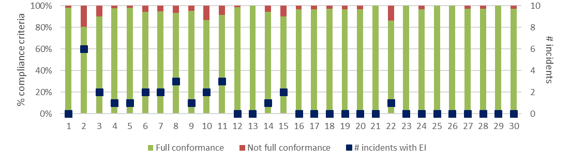
a) Level of conformance with audit criteria and number of non-conformance incidents with assessable environmental impact. Conformance as per Table 3.2, with not full compliance including all criteria with which the coupe did not fully comply, regardless of the potential for environmental impact.
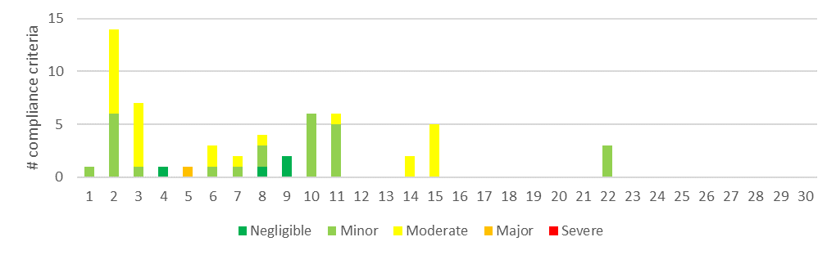
b) Number of compliance criteria with assessable environmental impact and the assessed level of impact for each instance of non-conformance.
Figure 4.1 Overall compliance findings and assessed environmental impact for instances of non-conformance for harvest coupes. The x-axis refers to the coupe numbers, as per Table 3.1.
Figure 4.1 also shows the actual number of incidents resulting in non-conformance with one or more audit criteria. These ranged between zero (16 coupes, as above) and six (2 Buzz), with an average of 0.9 incidents per coupe. A list of the incidents leading to assessments of non-conformance with audit criteria and the regulatory framework for timber harvesting is given in Appendix C.
The EIA tool (Appendix B) was used to assess the potential environmental impact associated with each non-conformance incident. This ranged between negligible and major (Figure 4.1). Non-conformances which were assessed to have major environmental impact were detected in only one of the 30 coupes included in the audit (5 Dorset). This related to the incursion of a regeneration burn into a Leadbeaters Possum SPZ.

Environmental compliance theme
The environmental compliance theme included three main groups of compliance element and audit criteria, those relating to soil, water and biodiversity values. Several compliance elements relating of other audit themes were also applicable.

Compliance elements related to the protection of forest soils
Compliance elements related to the protection of forest soils (Appendix A) primarily relate to the avoidance of erosion or mass soil movement, as well as to mitigating the risk of entry of sediments into waterways, should they be mobilised. The entry of mobilised sediments into waterways is primarily dealt with under the water sub-theme (Section 4.2.2). The avoidance of erosion and mass movement of soils is achieved by:
- Assessing and understanding soil erosion hazard within the coupe and adjusting operations accordingly
- Not harvesting in excessively steep areas
- Application of seasonal closures to coupes in water supply catchments to reduce the risk of mobilising sediment when harvesting or snigging machinery would disturb wet soils
- Appropriate location, construction, maintenance, closure and/or removal of in-coupe roads, road drainage and road or snig track waterway crossings.
A total of 37 audit criteria were relevant to the protection of forest soils, two of which were not applicable to any of the target coupes. The average level of full conformance with applicable criteria was found to be 96%, with the level of conformance ranging between 75% (2 Buzz) and 100% (18 coupes; Figure 4.2). The assessed environmental impact associated with non-conformances ranged between negligible and moderate.
Non-conformance incidents resulting in actual or potential environmental impacts on forest soils were identified in 11 coupes. None resulted in assessed environmental impact of major or severe. The types of incidents resulting in assessed environmental impact of moderate included:
- Two snig track crossings (2 Buzz) that were constructed across a temporary waterway were heavily disturbed by machinery traffic. The temporary logfill crossings had been removed. However, machinery brought to the coupe for regeneration crossed the waterway at both points and disturbed wet soil in and adjacent to the waterways (see Figure 4.3).
- Sections of snig track and boundary track (8 Dejavu, 11 Tropical) with spacings between effective drainage structures that exceed those prescribed in per VicForests’ Utilisation Procedures (139 m and 178 m of assessed track in excess of prescribed drain spacing at >11°). This resulted in potential for and actual erosion and sediment movement along the tracks (Figure 4.3).
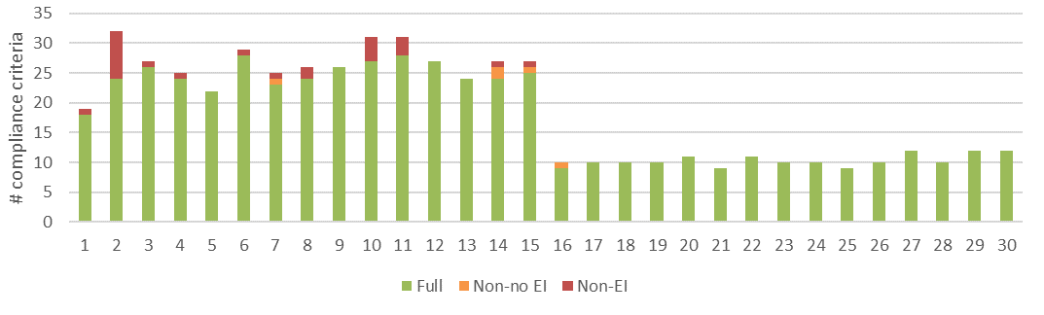
a) Level of conformance with audit criteria. Conformance definitions (Full, Non-no EI, Non-EI) as per Table 3.2.
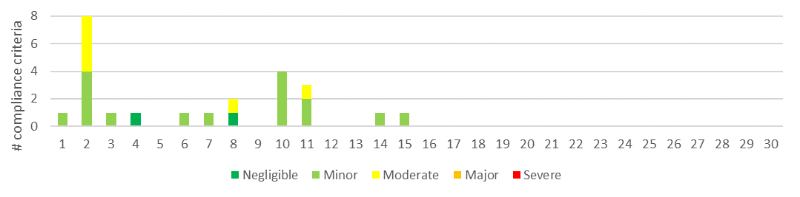
b) Number of compliance criteria with assessable environmental impact and the assessed level of impact for each instance of non-conformance.
Figure 4.2 Compliance findings and assessed environmental impact for instances of non-conformance for criteria applicable to the protection of forest soils. The x-axis refers to the coupe numbers, as per Table 3.1.
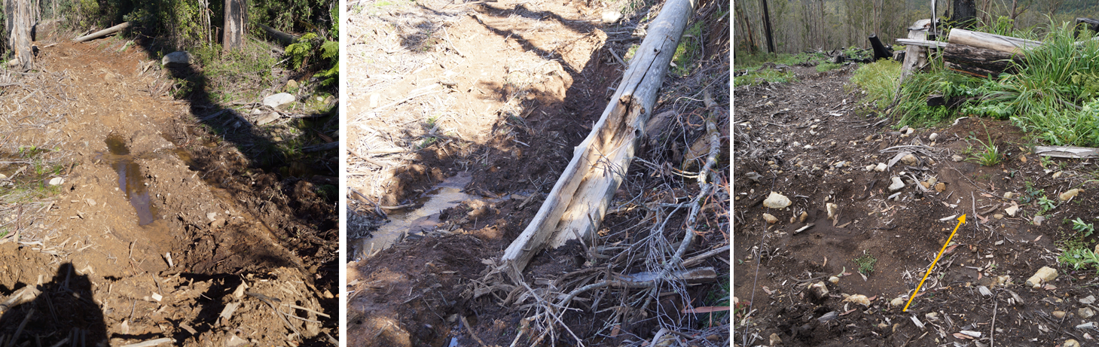
This snig track crossing on 2 Buzz had been rehabilitated. A small bulldozer being used for rough heaping crossed this temporary waterway, causing considerable soil disturbance and potentially mobilising sediment downstream. | A second temporary stream waterway crossing on 2 Buzz was damaged by a bulldozer that accessed the coupe for rough heaping. The machine caused considerable soil disturbance in a quite sensitive location. | Snig track in 8 Dejavu. The drainage structure was bypassed (arrow), allowing water to drain along an excess length of track. The coupe included multiple segments of snig track with damaged or ineffective drainage structures.
Figure 4.3: Examples of non-conformance incidents with potential or actual environmental impacts on forest soils.

Compliance elements related to the protection of water flows, water quality and river health
Compliance elements relevant to this theme (Appendix A) seek to protect water flows, water quality and river health by:
- Classifying waterways present in the coupe and applying at least the minimum width of filters and/or buffers required
- Application of seasonal closures to reduce the risk of sediment mobilisation during wet weather in water supply catchments
- Appropriate design, construction and maintenance of in-coupe roads, road drainage and waterway crossings.
Many of the compliance requirements (and criteria) are also applicable to the protection of forest soils and to the management of impacts from in-coupe road construction. A total of 42 audit criteria were relevant to this theme, five of which were not applicable to any of the target coupes.
The average level of full conformance with applicable criteria was found to be 96%, with the level of conformance ranging between 62% (22 Hickery Dickery) and 100% (24 coupes). The assessed environmental impact associated with non-conformances ranged between minor and moderate (Figure 4.4). Non-conformances which were assessed to have moderate environmental impact were identified on three coupes (2 Buzz, 3 Harrison, 15 Mid Week). The only other coupe in which water-related non-conformances with environmental impact were observed was 22 Hickery Dickery (one incident, resulting in three non-conformances with minor potential environmental impact).
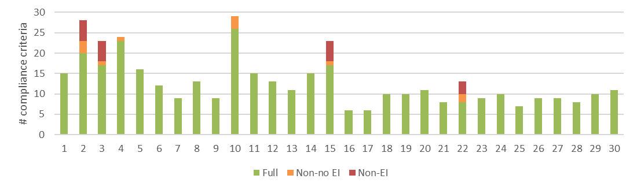
a) Level of conformance with audit criteria. Conformance definitions (Full, Non-no EI, Non-EI) as per Table 3.2.
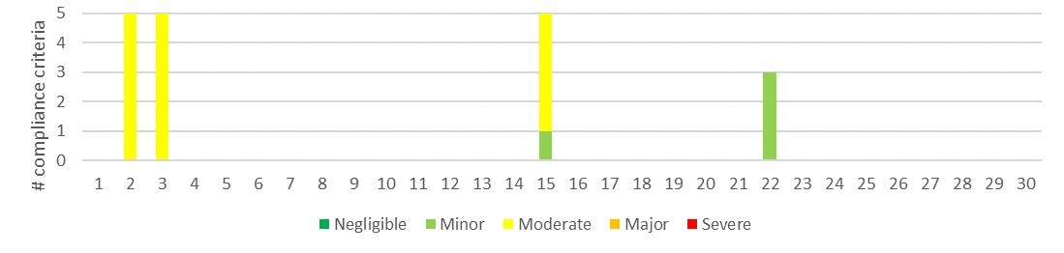
b) Number of compliance criteria with assessable environmental impact and the assessed level of impact for each instance of non-conformance.
Figure 4.4 Compliance findings and assessed environmental impact for instances of non-conformance for criteria applicable to the protection of water quality, flows and river health. The x-axis refers to the coupe numbers, as per Table 3.1.
Several of the incidents with moderate environmental impact relating to water quality, flows and river health were also non-conforming with forest soils compliance criteria. There were no incidents assessed to have major or severe potential environmental impact. The types of incident with moderate potential environmental impact included:
- In-coupe roads draining (for: ~65 m 3 Harrison; ~78 m 15 Mid Week) directly to waterways without road run-off being intercepted and sediment captured.
- The culvert inlet on an in-coupe road waterway crossing at 2 Buzz was elevated above the downstream bed of the temporary stream (Figure 4.5).
- Bulldozer being used for rough heaping crossed two rehabilitated snig track crossings, leading to soil disturbance in a sensitive temporary stream environment (Figure 4.3).
The first two of these issues relate to waterway crossings and have historically been a significant source of non-conformance in previous audits (e.g. Jacobs, 2016; 2018a; 2018b; 2019), often with moderate or major potential environmental impact.
Access by harvesting machines into what should have been a drainage line filter was observed at 22 Hickery Dickery. The small drainage line was not identified during marking and hence machines accessed the area and deposited large quantities of logging debris (Figure 4.5). This was the only non-conformance with potential environmental impact that was recorded in the 15 coupe assessed as part of the Western Victorian component of the audit.
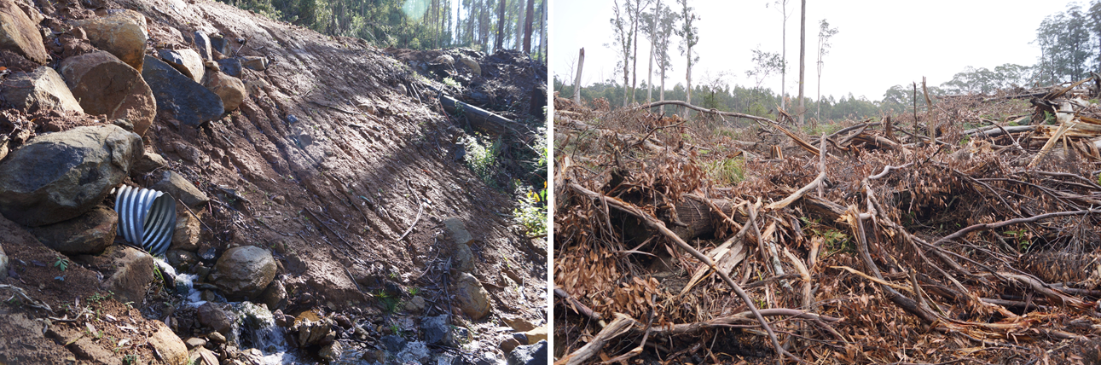
Culvert inlet is elevated above the bed of a temporary stream (2 Buzz). Assessed environmental impact is moderate, reflecting the sensitivity of the location in which the non-conformance was observed. | This drainage line (22 Hickery Dickery) was not identified during marking and no filter strip was put in place. Harvesting machines were allowed access to the area and large amounts of logging debris were accumulated.
Figure 4.5 Examples of non-conformance incident with potential to affect water flows, water quality and/or river health.

Compliance elements related to the protection of biodiversity values
Compliance elements relevant to this theme (Appendix A) seek to protect biodiversity values by:
- Retaining trees and other habitat within the gross coupe and/or harvested area, including old growth elements and trees with or with potential to form hollows
- Preventing harvesting activities, roading and regeneration burning from taking place within and/or adjacent to sensitive vegetation communities (e.g. heathlands, montane riparian thickets, rainforest stands) and other retained vegetation within the coupe
- Identifying listed, threatened species of native flora and fauna which have been recorded within or adjacent to the coupe and applying the management measures prescribed by the MSPs and PS
- Not harvesting in (or otherwise disturbing) Special Protection Zones (SPZ) established to protect important native fauna habitats (e.g. for Leadbeater’s Possum, Long-footed Potoroo, Owls)
- Maintaining passage for fish or other aquatic fauna along permanent streams
- Managing the risk of entry or spread of weeds and soil-borne or other plant diseases.
A total of 64 audit criteria are relevant to the protection of biodiversity values, of which 19 were not applicable to any of the selected coupes. The average level of full conformance with applicable criteria was found to be 98%, with the level of full conformance ranging between 84% (2 Buzz) and 100% (23 coupes; Figure 4.6).
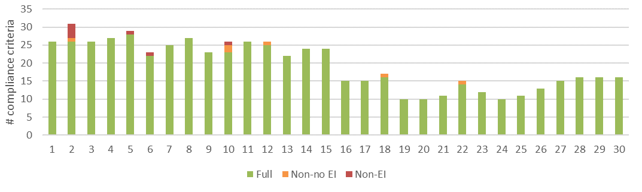
a) Level of conformance with audit criteria. Conformance definitions (Full, Non-no EI, Non-EI) as per Table 3.2.
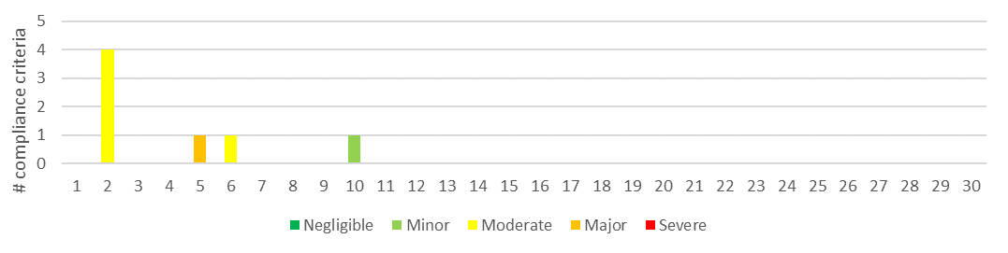
b) Number of compliance criteria with assessable environmental impact and the assessed level of impact for each instance of non-conformance.
Figure 4.6 Compliance findings and assessed environmental impact for instances of non-conformance for criteria applicable to the protection of biodiversity values. The x-axis refers to the coupe numbers, as per Table 3.1.
Biodiversity-related non-conformances with environmental impact were observed in four of the 30 coupes. The assessed environmental impact ranged between minor and major (Figure 4.6), with one non-conformance with major assessed environmental impact and five non-conformances with moderate potential environmental impact. The major and moderate non-conformances were associated with:
- Regeneration burns: the non-conformance with major potential environmental impact (5 Dorset) resulted from the incursion of the regeneration burn into a Leadbeaters Possum SPZ. About 0.1 ha of the SPZ was affected (Figure 4.7). Incursions of regeneration burns into planned unharvested areas (especially SPZ, riparian buffers) were observed much less frequently in this audit than in the 2018-19 FAP (Jacobs, 2019; recorded in seven of 30 coupes, with five coupes assessed as having major potential environmental impact). The regeneration burn incursion in 5 Dorset has at least temporarily affected biodiversity values associated with understorey habitat and has severely scorched the crown of overstorey eucalypt trees.
- Waterway crossings: three non-conformance incidents in 2 Buzz were assessed to have moderate potential environmental impact, with implications for aquatic biodiversity. These incidents (discussed in Sections 4.2.1 and 4.2.2) were associated with machinery damage to two snig track waterway crossings and the outlet of an in-coupe road waterway crossing culvert being placed above the downstream bed of a waterway (Figure 4.3 and Figure 4.5, respectively).
- Tree felled into SPZ: a tree was reportedly accidentally felled into a Leadbeaters Possum SPZ in 6 Snobs 14, resulting in an assessment of moderate potential environmental impact.
Non-conformances (with no environmental impact) associated with stand hygiene/biosecurity were less common in this audit that in the previous one. This reflected a stronger evidence base to demonstrate the proactive engagement with and management of such issues.
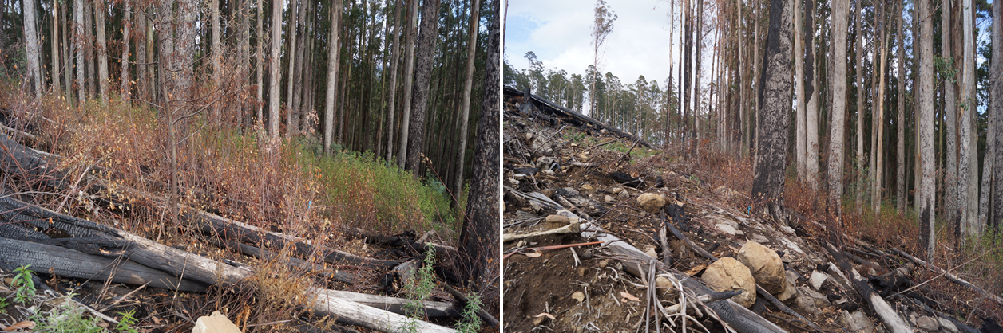
Regeneration burn incursion into Leadbeaters Possum SPZ 5 Dorset showing:.
- Disturbance to understorey | - Disturbance to understorey vegetation and scorch to stems and canopy of overstorey trees
Figure 4.7 Examples of non-conformance incidents with potential/actual environmental impact on biodiversity values.

Roading compliance theme
The roading theme included three main groups of compliance element and audit criteria, those relating to: in-coupe road and waterway crossing design; construction; and maintenance and closure. Many of the roading compliance elements and criteria were also applicable to the environmental sub-themes.
As no in-coupe roads were constructed in any of the coupes located in the Western Victorian RFA region, the results reported under the roading theme are only applicable to the Central Highlands RFA region. Several of the Central Highlands RFA region also did not have in-coupe roads (1 Sea Monkey, 5 Dorset, 12 Teamwork, 13 Axemans).

Compliance elements related to in-coupe road and waterway crossing design
The 19 compliance elements relevant to this theme (Appendix A) seek to ensure that appropriate design protects soil and water values from risks associated with the construction of road embankments, waterway crossings and road drainage structures. Design is intended to ensure the stability of roads and road embankments, safe passage of high flow events through crossings and culverts and to prevent erosion of roads and crossings and associated sediment generation. Five of the criteria were not applicable to any of the audited coupes.
The average level of full conformance with applicable criteria was found to be 81%, with the level of full conformance ranging between 58% (15 Mid Week) and 100% (10 coupes; Figure 4.8). The main design-related non-conformance issue was the FCP having no recorded engineering basis for design of the in-coupe road, larger embankment and/or waterway crossing (e.g. as required by Code 2.4.2.4, 2.4.3.1, 2.4.3.2; MSP 6.2.2.3, 6.2.5.4). Mostly, these non-conformances did not directly result in assessments of potential environmental impact.
In three of the audited coupes, road design non-conformances were assessed to have moderate potential environmental impact (Figure 4.8; 2 Buzz, 3 Harrison, 15 Mid Week). Two of these (3 Harrison, 15 Mid Week) related to the absence of drainage structures to divert or intercept road run-off before entering a waterway at an in-coupe road crossing. The incident in 2 Buzz was associated with the outlet of an in-coupe road waterway crossing culvert being elevated above the bed of the downstream waterway. Both incidents have been discussed previously.
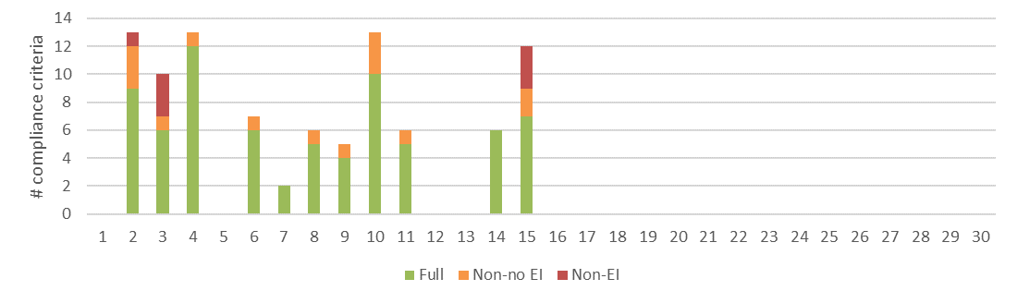
a) Level of conformance with audit criteria. Conformance definitions (Full, Non-no EI, Non-EI) as per Table 3.2.
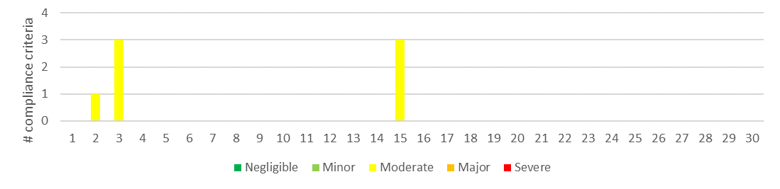
b) Number of compliance criteria with assessable environmental impact and the assessed level of impact for each instance of non-conformance.
Figure 4.8 Compliance findings and assessed environmental impact for instances of non-conformance for criteria applicable to the road design. The x-axis refers to the coupe numbers, as per Table 3.1.

Compliance elements related to in-coupe road and waterway crossing construction
The 40 compliance elements relevant to this theme (Appendix A), like those for road design, largely seek to protect soil and water values from risks associated with road drainage and the construction of road embankments and waterway crossings. Six of these compliance elements were not applicable to any of the audit coupes.
The average level of full conformance with applicable criteria was found to be 85%, with the level of conformance ranging between 73% (11 Tropical) and 100% (2 coupes; Figure 4.9). Non-conformances with potential environmental impact were identified in seven of the audited coupes, with incidents ranging in severity of potential environmental impact from negligible to moderate. Incidents with moderate potential environmental impact related to in-coupe roads being constructed:
- Without drainage structures to divert road runoff from directly entering temporary waterways (3 Harrison, 15 Mid Week)
- With the culvert elevated above the bed of the downstream waterway (2 Buzz; Figure 4.5)
- With a long section having no formal drainage structures at the time of audit (14 Lure; Figure 4.10).
A similar non-conformance to that observed at 14 Lure was identified at 11 Tropical, but with lesser assessed environmental impact. In that case, an almost 300 m section of in-coupe road was constructed without drainage. However, drainage structures (bar and breach) were constructed following regeneration of the coupe and hence the duration of the potential impact was assessed to be lower than for the incident at 14 Lure.
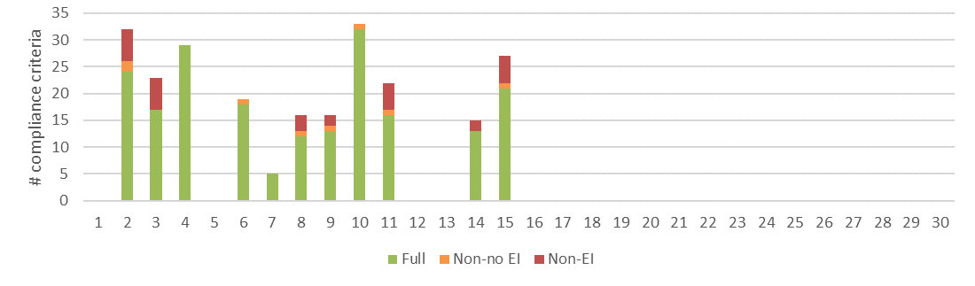
a) Level of conformance with audit criteria. Conformance definitions (Full, Non-no EI, Non-EI) as per Table 3.2.
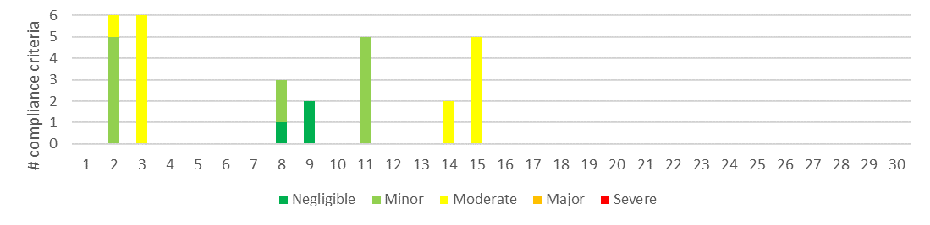
b) Number of compliance criteria with assessable environmental impact and the assessed level of impact for each instance of non-conformance.
Figure 4.9 Compliance findings and assessed environmental impact for instances of non-conformance for criteria applicable to road construction. The x-axis refers to the coupe numbers, as per Table 3.1.

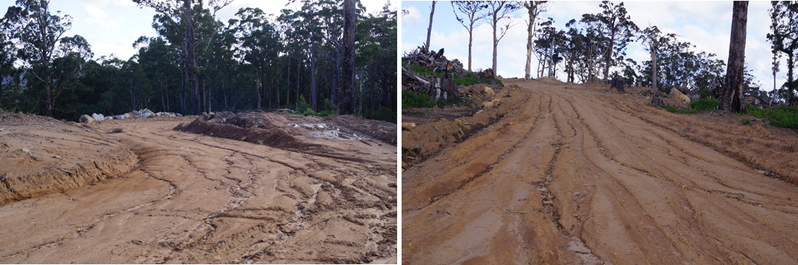
Section of in-coupe road beyond the landing at 14 Lure. This section of road was constructed to access an adjacent coupe but has no formally constructed drainage (for >185 m at approximately 6° slope and medium soil erosion hazard). As the road has not been surfaced and there is no drainage, the road has experienced significant erosion.
Figure 4.10: Condition of an undrained and unsurfaced section of in-coupe road at 14 Lure.

Compliance elements related to in-coupe road and waterway crossing maintenance and closure
Only seven compliance criteria relevant to road maintenance or closure were considered in this audit (Appendix A), all of which were applicable to at least one coupe. Like compliance elements for road design and construction, they are largely concerned with protecting soil and water values from risks associated with the use of in-coupe roads, their closure following the completion of harvesting operations and the removal of any waterway crossings. The average level of full conformance with applicable criteria was found to be 96%, with the level of conformance ranging between 60% (10 Litaize) and 100% (10 coupes; Figure 4.11). There were no non-conformance incidents with potential environmental impact.
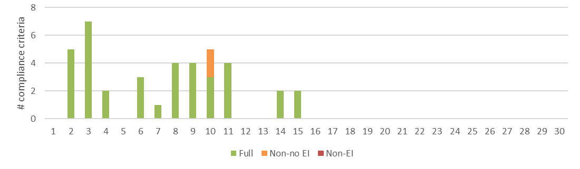
Level of conformance with audit criteria. Conformance definitions (Full, Non-no EI, Non-EI) as per Table 3.2.
Figure 4.11 Compliance findings and assessed environmental impact for instances of non-conformance for criteria applicable to road maintenance and closure. The x-axis refers to the coupe numbers, as per Table 3.1.

Infrastructure compliance theme
Compliance elements considered under the infrastructure theme have a similar function to those for in-coupe roading, in that they seek to protect soil and water values from risks associated with the construction, use and rehabilitation of snig tracks, boundary tracks and landings. Twenty-six audit criteria were identified (Appendix A), with all but one of these applying to at least one of the audited coupes. Only one of the Western Victorian RFA coupes (22 Hickery Dickery) had constructed coupe infrastructure.
The average level of full conformance with applicable criteria was found to be 88%, with the level of full conformance ranging between 67% (2 Buzz) and 100% (3 coupes; Figure 4.12). The highest level of assessed environmental impact resulting from non-conformances was moderate, in 2 Buzz, 8 Dejavu and 11 Tropical. These issues arose from:
- Machinery damage to the sites of two previously removed snig track crossings (2 Buzz; Figure 4.3)
- Spacing between effective drainage structures on snig tracks exceeding limits for slope and soil erosion hazard prescribed by VicForests UPs (8 Dejavu, 11 Tropical).
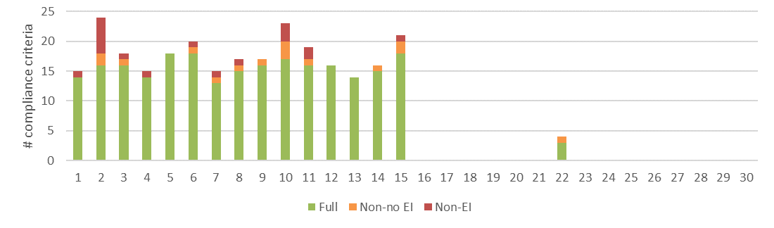
a) Level of conformance with audit criteria. Conformance definitions (Full, Non-no EI, Non-EI) as per Table 3.2.
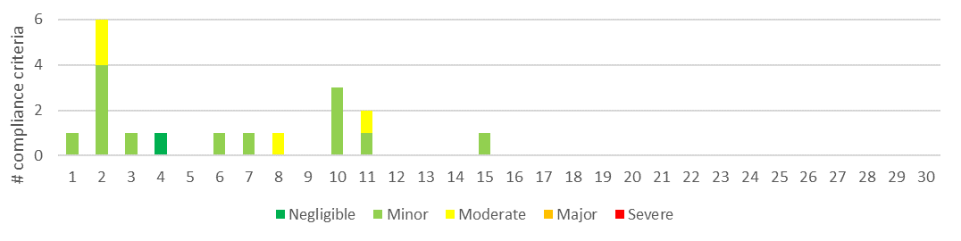
b) Number of compliance criteria with assessable environmental impact and the assessed level of impact for each instance of non-conformance.
Figure 4.12 Compliance findings and assessed environmental impact for instances of non-conformance for criteria applicable to coupe infrastructure. The x-axis refers to the coupe numbers, as per Table 3.1.
The landing at 10 Litaize Road has experienced significant mass soil movement and erosion following its rehabilitation and a large rainfall event (Figure 4.13). Mass soil movement is evident along most of the edge of the former landing embankment. While the landing was ripped approximately along the contour and stockpiled soil replaced, water was able to create pathways and channels during the rainfall event (images b, c, d). These resulted in large quantities of soil being mobilised (images d, e). Fortunately, most of the sediment was captured by a snig track below the landing embankment (image e). None of the sediment was able to reach the waterway at the bottom of the coupe.
While there was no evidence that the landing was inappropriately rehabilitated, it was assessed to not conform with Code and MSP requirements to protect soils and minimise erosion and mass soil movement. The assessed environmental impact associated with the landing was minor, which reflected that sediment was captured by snig tracks and did not enter a waterway. The incident highlights what may happen to soils during extreme rainfall events, even with well-managed rehabilitation.
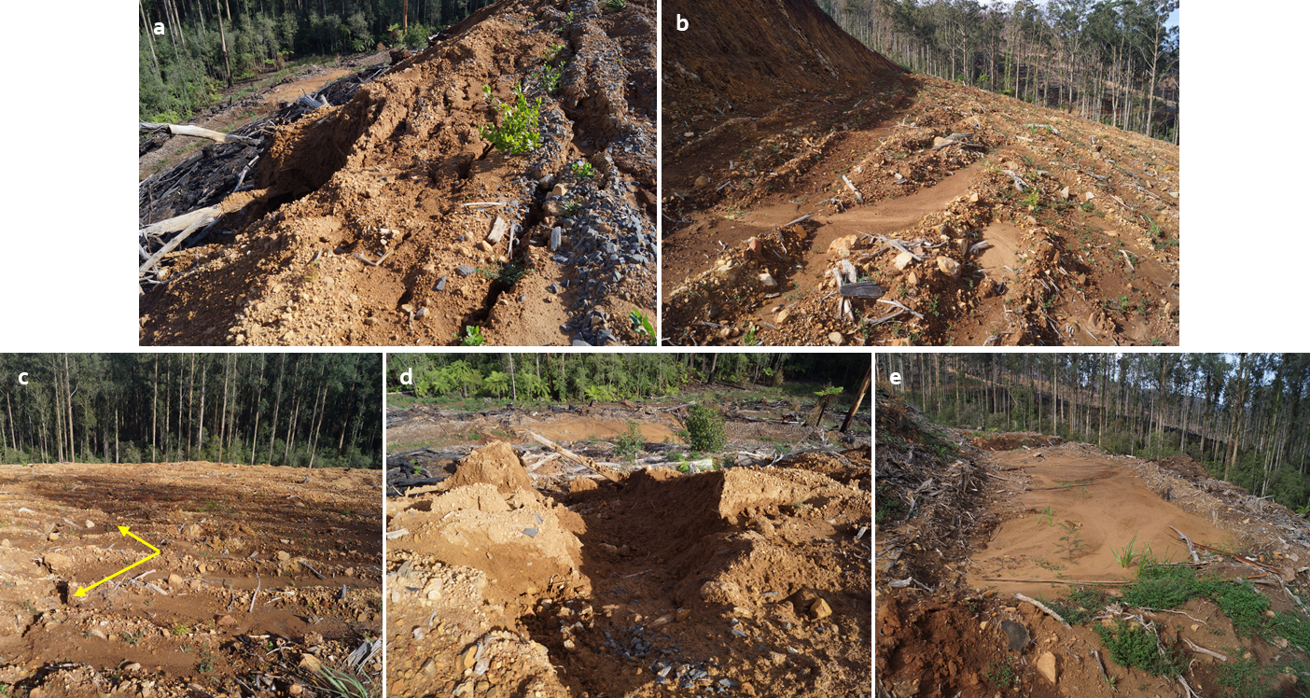
a) Evidence of mass soil movement on rehabilitated landing embankment. b) Starting point for overland flow pathway, immediately below landing cutting. c) Erosion channel (arrow). d) Washout on lower edge of landing. e) sediment from landing that has been captured by snig track directly below landing.
Figure 4.13: Mass soil movement and erosion, landing at 10 Litaize Road

Coupe planning and management
Compliance elements considered under this theme are concerned with the development of the FCP in conformance with the Code and MSPs and the consistency of coupe operations with that plan. The compliance elements seek to protect soil, water and biodiversity values from risks associated with harvesting, roading and regeneration operations. Fifty audit criteria were identified (Appendix A), with 11 of these not applying to any of the audited coupes.
The average level of full conformance with applicable criteria was found to be 96%, with the level of full conformance ranging between 80% (2 Buzz) and 100% (10 coupes; Figure 4.14). Potential environmental impact resulting from non-conformances was assessed to be major for one coupe and moderate for four coupes (Figure 4.14). The incidents giving rise to the non-conformances have been discussed previously and include:
- Damage to rehabilitated snig track waterway crossings caused by the passage of a bulldozer during preparations for rough heaping (2 Buzz)
- Constructing an in-coupe road waterway crossing (2 Buzz) whose culvert outlet was elevated above the downstream bed of the waterway
- Drainage of long lengths of in-coupe road into waterway crossings (3 Harrison, 15 Mid week)
- Incursion of a regeneration burn into a Leadbeaters Possum SPZ (5 Dorset)
- Felling of a tree into a Leadbeaters Possum SPZ (6 Snobs14)
The incidents relate to timber harvesting operations not having been conducted in accordance with the FCP (Code 2.5.1.2) and/or Code and MSP requirements or harvesting activities (specifically, regeneration burns) being carried out within SPZs (Code 2.5.1.5, MSP 7.1.2.1).
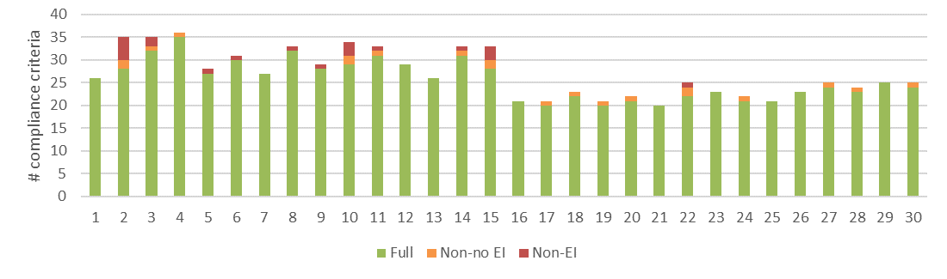
a) Level of conformance with audit criteria. Conformance definitions (Full, Non-no EI, Non-EI) as per Table 3.2.
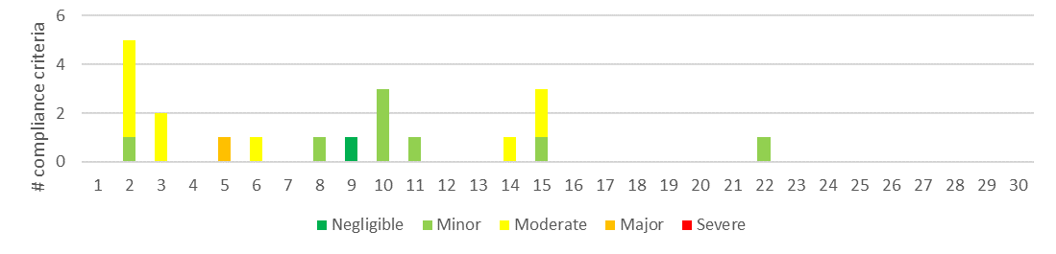
b) Number of compliance criteria with assessable environmental impact and the assessed level of impact for each instance of non-conformance.
Figure 4.14 Compliance findings and assessed environmental impact for instances of non-conformance for criteria applicable to coupe planning and management. The x-axis refers to the coupe numbers, as per Table 3.1.
The audit identified several instances where coupe planning was inconsistent with specific Code or MSP requirements but did not directly result in an incident with potential environmental impact, namely:
- Not formally planning (or designing) in-coupe roads and associated waterway crossings
- Not correctly identifying and marking a drainage line within a coupe
- Not identifying all threatened/protected biodiversity values associated with the coupe
- The coupe plan not correctly stating the net area to be harvested.
Further, the FCP for several coupes with slopes reaching or potentially exceeding 30° did not include maps indicating slope and/or areas that should be excluded from harvesting on the basis of slope. While such a map is not explicitly required, they are implicit in MSP 2.3.1.2, which requires that FCPs include a map which clearly and accurately identifies …areas … to which special prescriptions apply (including biodiversity protection or habitat enhancement, water quality and aquatic habitat protection…).

Discussion

Overall audit findings
The audit is intended to assess VicForests’ conformance with selected elements of the regulatory framework for timber harvesting activities in State forests, as well as any environmental risks posed by non-conformances. This section provides a summary of the audit’s overall findings in relation to these objectives.
The audit considered 30 coupes located in State forests distributed throughout Victoria, 15 in Central Highlands RFA region and 15 in Western Victoria RFA region. Since coupe selection (particularly in the Central Highlands region) was weighted towards those with higher risk natural and constructed features (e.g. rainforest vegetation, waterway crossings, in-coupe roads, steeper slopes, more erodible soils), the findings of the audit are not necessarily statistically representative of VicForests’ operations overall.
The audit found that full conformance was achieved with 95% of applicable audit criteria, overall (Figure 5.1). The level of full conformance varied between compliance themes, ranging between 81% (road design) and 98% (biodiversity). Non-conformances with direct or potential environmental impact were associated with 27 unique incidents in 14 of the 30 coupes included in the audit.
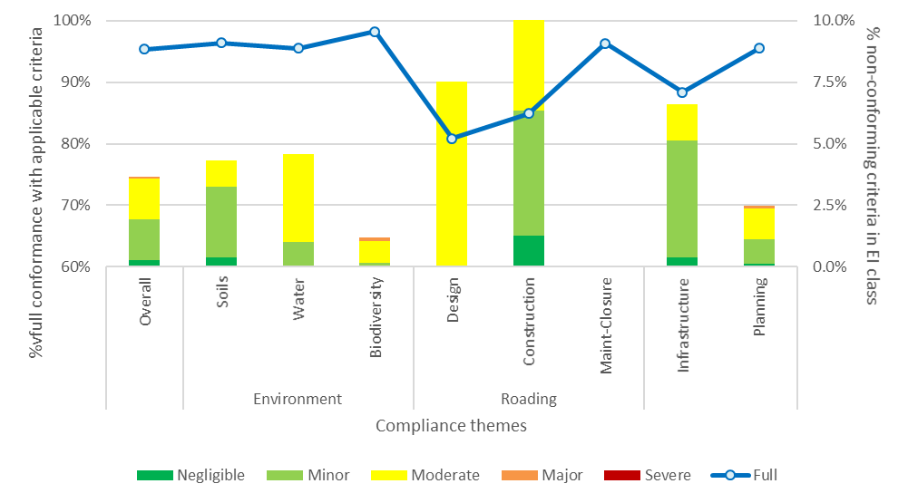
% full conformance with applicable audit criteria overall and in each harvest coupe audit theme (left Y axis). % non-conformances with environmental impact overall and for audit themes and sub-themes (right Y axis)
Figure 5.1 Summary of overall audit findings for conformance with the regulatory framework for timber harvesting and related activities in State forests in Victoria.
Instances of non-conformance with audit criteria were identified across all audit themes and each sub-theme apart from road maintenance and closure. The assessed environmental impact associated with non-conformances is summarised by audit theme and sub-theme in Figure 5.1. Non-conformances with potential environmental impact were most common (proportionally) in the road design, road construction, infrastructure and planning compliance sub-themes. Overall, non-conformances with potential environmental impact were recorded for approximately 2% of applicable criteria.
Assessed environmental impact for non-conformances ranged between negligible and major. Only one non-conformance incident was identified with major environmental impact; this was reported against biodiversity and planning sub-themes.
Ten types of incident were found to result in non-conformances with potential environmental impact (Table 5.1). Six of these were assessed to have environmental impact ratings of moderate (five incidents) or major (one incident), including:
- Incursion of regeneration burns into a SPZ
- Snig and boundary tracks and in-coupe roads having excessive distances between effective drainage structures, due either to these not being constructed at appropriate spacings (for slope and soil erosion hazard) or to post-construction damage that limited their effectiveness
- Mass movement along high in-coupe road or landing embankments which were constructed without engineered design
- Waterway crossings being designed and constructed without appropriate placement of culverts or construction of drainage to intercept in-coupe road runoff before it enters the waterway
- Felling of trees into SPZ
- Disturbance of rehabilitated snig track waterway crossings by machinery being used to prepare a coupe for rough-heaping.
Environmental impact ratings for these incidents reflected the sensitivity of the locations at which the incidents occurred and/or the extent and severity of actual impact.
Table 5.1 Types of incident resulting in non-conformances with the regulatory framework that have potential or actual environmental impact, including comparison with 2017-18 and 2018-19 FAP
Type of incident | # incidents |  |  | Maximum EI rating (2019-20) | Code (C), MSP (M) or PS (P) reference
Type of incident | 2019-20 | 2018-19 | 2017-18¹ | Maximum EI rating (2019-20) | Code (C), MSP (M) or PS (P) reference
- Spacing of effective drains along snig tracks or boundary tracks exceeded permitted value (from UP) based on soil erosion hazard and slope  Potential consequences: soil erosion, sediment deposition into waterways, impairment of aquatic habitat, reduced water quality. | 8 | 14 | Not in scope | Moderate | C2.5.2.5
- In-coupe road drainage structure spacing exceeded permitted value based on soil erosion hazard and slope  Potential consequences: soil erosion, sediment deposition into waterways, impairment of aquatic habitat, reduced water quality. | 5 | 10 | 8 | Moderate | C2.4.2.5, M6.2.4.1
- Engineer not engaged in design of road or landing embankment. Embankment subject to mass movement of soil  Potential consequences: soil mass movement and erosion, damage to regenerating forest. | 4 | 9 | Not observed | Minor | C2.2.1.2/14/15, 2.4.3.3, M6.2.2.3
- Waterway crossing design and/or construction that does not conform with the regulatory framework (including culvert installation, management of road drainage in the vicinity of the crossing)  Potential consequences: soil erosion, sediment deposition into waterways, impairment of aquatic habitat, reduced water quality. | 3 | 8 | 5 | Moderate | C2.2.1.2/6/8, M6.2.5.5
- Regeneration burn entering exclusion areas within or adjacent to coupe or vegetation in exclusion area damaged by regeneration burn that remains within the planned burn boundary  Potential consequences: soil erosion, sediment deposition into waterways, impairment of aquatic and terrestrial habitat, reduced water quality, loss of fire-sensitive biodiversity values. | 2 | 5 | 4 | Major | C2.2.1.2, 2.2.2.4/5, 2.5.1.2, M4.1.4.5
- Machinery disturbance in temporary stream following removal of a snig track waterway crossing  Potential consequences: soil erosion, sediment deposition into waterways, impairment of aquatic habitat, reduced water quality. | 2 | 0 | 0 | Moderate | C2.2.1.2/6/8, 2.2.2.4/5, 2.3.1.1, 2.5.1.2, M7.2.2.1
- Tree felled into SPZ  Potential consequences: minor damage to retained understorey vegetation. | 2 | 0 | 0 | Moderate | C2.2.2.5, 2.1.5.2, M7.1.2.1
- Rehabilitation of infrastructure (landing, snig track, in-coupe road) has contributed to soil mass movement and/or erosion  Potential consequences: soil erosion, sediment deposition into waterways, impairment of aquatic habitat, reduced water quality, loss of production from regenerating forest. | 1 | 5 | Not in scope | Minor | C2.2.1.2/12/14, 2.5.1.2, M6.4.1.2 , 7.2.2.2
- Excessive soil disturbance associated with a snig/ regeneration burning track located in an area at which surface and sub-surface water flows converge | 1 | 0 | Not in scope | Minor | C2.2.1.2
- Entry of harvesting machinery into and/or deposit of harvesting debris in riparian filter strip  Potential consequences: soil erosion, sediment deposition into waterways, impairment of aquatic habitat, reduced water quality. | 1 | 1 | 1 | Minor | C2.2.1.2/12, 2.5.1.2
- Landing not fully rehabilitated  Potential consequences: reduced productive capacity of regenerating forest. | 0 | 5 | Not in scope |  | M7.2.2.2
- Snig track crosses into drainage line filter, without apparent sanction and/or when reasonably practicable alternatives existed  Potential consequences: soil erosion, sediment deposition into waterways, impairment of aquatic habitat, reduced water quality. | 0 | 3 | Not in scope |  | C2.2.1.2, 2.2.1.5, 2.5.1.2, M3.3.1.1, 3.5.1.1/3, 7.1.4.1
- Machinery entry into SPZ or other exclusion areas within or adjacent to coupe  Potential consequences: soil compaction/disturbance, reduction in habitat values. | 0 | 3 | 0 |  | C2.2.1.2/5, 2.5.1.2, M3.5.1.1, 4.2.1.1, 7.1.2.1, P4.3.1.1
- Damage to adjacent coupe due to regeneration burn crossing a coupe boundary  Potential consequences: soil erosion, loss of productive capacity of regenerating forest. | 0 | 1 | 0 |  | C2.2.2.5, 2.5.1.2
- Harvesting of tree outside coupe boundary  Minimal potential consequence. | 0 | 1 | 0 |  | C2.5.1.2
- Inadequate maintenance of road drainage structure (silt trap) leading to impairment of effectiveness  Potential consequences: soil erosion, sediment deposition into waterways, impairment of aquatic habitat, reduced water quality. | 0 | 1 | 4 |  | M2.2.1.8/12
- Part of the base of a tree retained in a coupe covered by in-coupe road or landing embankment materials  Potential consequences: (minimal) reduction in productive capacity of regenerating forest. | 0 | 1 | 3 |  | M6.2.2.1
Note:
- Not observed: non-conformance not observed in 2017-18 FAP audit; Not in scope: non-conformance relates to compliance requirement that was not with the scope of the 2017-18 FAP audit.
Table 5.1 compares the types of incident detected in this audit, with the types and frequency of incidents detected in the two previous FAP audits (Jacobs, 2018b; 2019). The four most common incidents with potential environmental impact included: excessive drainage structure spacing on in-coupe roads; inappropriately designed and constructed waterway crossings; excessive drainage structure spacing on snig and boundary tracks; and mass movement of in-coupe road and landing embankments. Six of the main non-conformance incidents with potential environmental impact were observed less frequently in the current audit than in the 2018-19 FAP and three of the incidents were observed more frequently (Table 5.1; several other kinds of incident were not observed in this audit but were in the 2018-18 audit). Three types of incident were identified in this audit that were not observed in the previous audit.
Almost all incidents posed a risk to soil and water values. Several threatened (to varying extents) the productive capacity of the regenerating forest and some posed a risk to biodiversity values (Table 5.1).

Comparison between coupes in Central Highlands and Western Victoria RFA regions
The intensity of timber harvesting operations in audited coupes located in the Central Highlands and Western Victoria RFA regions differed markedly (e.g. Figure 5.2). Operations in the Central Highlands RFA region all used clearfell or similar silvicultural systems (e.g. seed tree retention, regrowth retention), had extensive snig and boundary track networks and were either burned or rough-heaped to promote regeneration. Most coupes had landings and in-coupe roads, some had in-coupe road or snig track waterway crossings. Except for 22 Hickery Dickery, operations on audit coupes in the Western Victoria RFA region were much less intensive, with significant levels of retained tree cover within the harvest area and little or no developed coupe infrastructure.
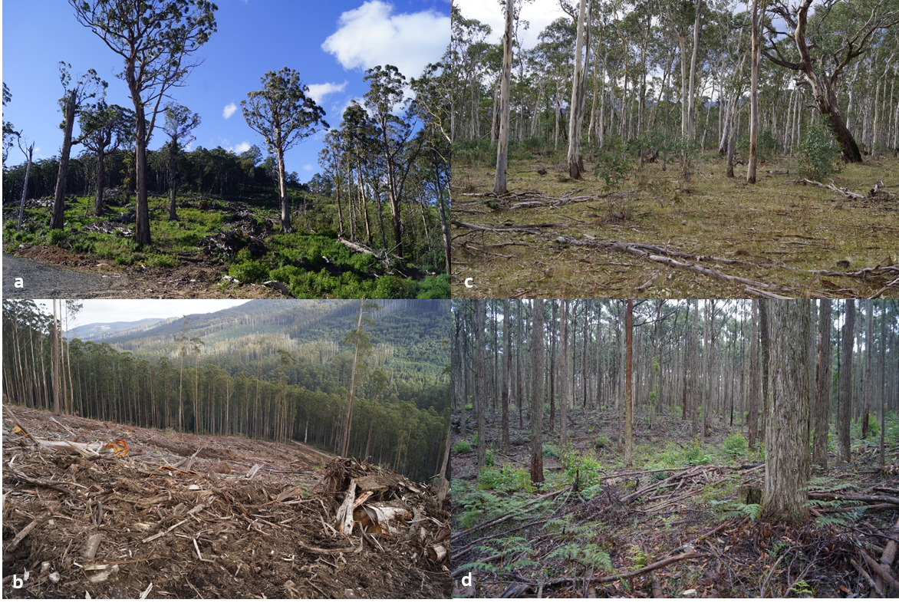
Central Highlands RFA region: a) 14 Lure, b) 6 Snobs14; Western Victoria RFA region: c) 18 Briers, d) 25 Full Sun
Figure 5.2: Examples of completed or in-progress timber harvesting operations in audit coupes in Central Highlands and Western Victoria RFA regions
The differing intensities of operations in the two regions mean that the numbers of applicable audit criteria were greater in Central Highlands than Western Victorian. Therefore, the potential for non-conformance incidents might also be expected to be greater.
Figure 5.3 compares the level of full conformance with applicable audit criteria for the two RFA regions overall and for each compliance sub-theme. It shows that the overall level of full conformance was lower for the coupes with more intensive operations in Central Highlands RFA region than those in Western Victoria RFA region (92% and 99% full conformance, respectively). The level of full conformance was greater than 95% for all audit sub-themes in Western Victoria RFA region (except for coupe infrastructure, which was constructed in just one of the coupes), but only exceeded 95% for biodiversity and road maintenance-closure sub-themes in Central Highlands RFA region and was less than 90% for road design, road construction and infrastructure.
The audit detected a total of 26 non-conformance incidents with potential environmental impact in Central Highlands RFA region (1.7/coupe) but detected just one such incident in the 15 coupes located in the Western Victoria RFA region.
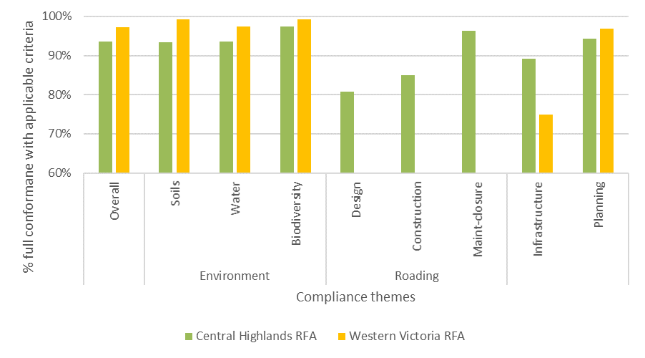
Figure 5.3: Average overall level of full conformance with applicable audit criteria and for each audit compliance sub-theme for coupes in Central Highlands and Western Victoria RFA regions. There were no in-coupe roads in audited coupes located in the Western Victoria RFA region.

Comparison with previous audits
As has been noted previously, coupe selection for the audit is risk-based, rather than fully randomised. This means that audit results are not statistically representative of VicForests’ operations overall and audit results therefore not be directly comparable between years. Further, this audit included 15 coupes from Western Victoria RFA region, which as demonstrated in Section 5.2, has a different compliance profile to those in Central Highlands RFA region. Thus, the overall results of the 2019-20 and 2018-19 audits are not directly comparable.
However, since there has been a broadly consistent approach to coupe selection and compliance criteria for all audit sub-themes for this and the previous audit and for environmental and roading themes for earlier audits, there is some basis for comparison of audit results over time. That comparison (Table 5.2) only considers coupes located in Central Highlands RFA region, of which there were 12 and 14 coupes, respectively in the 2017-18 and 2018-19 audits.
The overall level of full conformance for Central Highland RFA region coupes in the 2019-20 audit was 94%, compared with 83% and 90% for the 2018-19 and 2017-19 audits, respectively. The level of full conformance for Central Highland coupes was greater in 2019-20 than in 2018-19 in all sub-themes, except in-coupe road construction. The level of full conformance in 2019-20 exceeded that in 2017-18 for each theme or sub-theme, except for road construction.
The count of non-conformances with potential environmental impact overall and the number with environmental impact assessed to be major showed a similar pattern. There were fewer non-conformances with environmental impact in 2019-20 than in 2018-19 overall and fewer for each theme and sub-theme, apart from infrastructure. Despite there being one fewer Central Highlands coupe in 2018-19 than in the current audit, there were 23 more non-conformances with major potential environmental impact.
Non-conformances incidents with potential environmental impact were generally lower in 2017-18 than in 2019-20. The main differences were in the lower incidence of non-conformance with potential environmental impact for road construction. The overall number of non-conformances in 2017-18 is not directly comparable with the two subsequent audits, because the scope did not include infrastructure and coupe planning and both themes have been significant sources of non-conformance (Table 5.2).
Table 5.2 highlights that Central Highlands coupes included in the 2018-19 FAP had a particularly high incidence of non-conformances with potential environmental impact and, particularly, non-conformances with major environmental impact. The latter were often associated incursion of regeneration burns into areas that were not planned to be affected by timber harvesting and associated regeneration activities. A similar set of incident types were most commonly associated with non-conformances with potential environmental impact in the two audits (Table 5.1), however there were fewer of these and they were generally assessed to have lower potential environmental impact in the current audit than in the previous one.
Table 5.2 Comparison of audit results for recent FAP audits for coupes in Central Highlands RFA region
 | % Full conformance with applicable audit criteria |  |  | # Non-conformances with EI (at any level) | major potential EI¹
# Central Highlands RFA region coupes |  |  |  | 12 | 14 | 15
FAP compliance theme and sub-theme | 2017-18² | 2018-19³ | 2019-20 | 2017-18² | 2018-19³ | 2019-20
Overall⁴ | 90% | 83% | 94% | 24 | 0⁵ | 71 | 24 | 57 | 1
Environment
- Soils | 90% | 76% | 93% | 24 | 0 | 32 | 2 | 24 | 0
- Water | 90% | 84% | 94% | 15 | 0 | 43 | 12 | 18 | 0
- Biodiversity | 90% | 81% | 97% | 5 | 0 | 17 | 13 | 7 | 1
Roading
- Design | 74% | 58% | 81% | 2 | 0 | 7 | 1 | 7 | 0
- Construction | 91% | 80% | 85% | 12 | 0 | 24 | 5 | 29 | 0
- Maintenance and closure | 79% | 85% | 96% | 3 | 0 | 7 | 2 | 0 | 0
Infrastructure | n/a | 88% | 89% | n/a | 12 | 0 | 18 | 0
Planning | n/a | 90% | 94% | n/a | 11 | 6 | 20 | 1
Notes:
- Note that individual incidents may give rise to non-conformances against more than one audit criterion.
- Jacobs 2018b
- Jacobs 2019
- The overall assessment result for the 2017-18 audit is based on only the environment and roading themes, whereas the overall assessments for 2018-19 and the current audit also include infrastructure and planning themes.
- The number of non-conformances with potential environmental impact | major environmental impact for 2017-18 is not directly comparable with the other two years because it does not include infrastructure and planning themes.

Potential improvements to coupe planning, harvesting and rehabilitation practices
Observations from the current audit and reflections on non-conformance incidents from previous audits suggests several potential areas for improvement in coupe planning, timber harvesting and coupe rehabilitation practices, as discussed in the following sections.

Coupe planning
Coupe planning and its documentation by VicForests typically conforms well with Code and MSP requirements. Most non-conformance issues relating to coupe planning, particularly those with potential environmental impact, result from the operations not following what was planned, including not following VicForests own UPs, as specified in the FCP. Several of these issues related to the design and construction of in-coupe roads and are discussed in Section 5.4.2.
The 2018-19 audit report made comment on potential improvements in coupe planning practice, including the explicit mapping of waterway classification, inclusion of maps of coupe slope for coupes with slopes that approach or exceed the limit for harvesting and inclusion of geology maps for coupes in East Gippsland to confirm identification of granite-derived soils and any need to apply the mandated 25° slope limit for harvesting in coupes with these types of soils. None of these were issues of conformance/non-conformance, but of improved practice.
In comments on the draft 2018-19 audit report, VicForests reported recent changes in practice (and provided evidence of this to the audit team) to address the latter two issues. Explicit mapping of waterway classification was included as a recommendation in the 2018-19 FAP audit report, as it had been in several previous audit reports by this team.
Experience from the current audit was that practice in explicitly mapping waterway classification remains inconsistent across VicForests. Inclusion of lidar-based slope maps or other forms of mapping of high slope areas was more common in coupes included in the current audit than in previous audits but was not universal. This may reflect that VicForests’ practice change had not taken effect at the time of planning for the particular coupes. As the 2019-20 audit did not include coupes in East Gippsland, no comment is made on the extent to which geology and slope mapping have been used to flag areas with granite-derived soils that for reasons of high slope are not available for harvesting.

Design, construction and maintenance of in-coupe roads and waterway crossings
FAP audits by this team (Jacobs, 2016; 2018a; 2018b, 2019) have consistently identified deficiencies in the design, construction and maintenance of in-coupe roads and associated waterway crossings. Even accounting for the inclusion of coupes in the Western Victorian RFA region in this audit, these deficiencies were less commonly observed in this audit than in 2018-19 and generally had lower assessed environmental impact (see Table 5.1, Table 5.2).
It was reported in the 2018-19 FAP audit report that VicForests had developed new procedures and instructions for the planning, design and construction of in-coupe roads (O’Reilly, 2019), with the intent of improving the quality, consistency and regulatory conformance of roading practices. As this instruction has only recently be adopted, it had no direct influence on the road design or construction practices assessed in the current audit. Comments on the document, in the context of related audit recommendations are provided in Section 5.4.4.
Three main non-conformance issues with actual or potential environmental impact were observed in this year’s audit, all of which have been detected in previous audits. The issues reflect the absence of intentional design of in coupe roads, road embankments and waterway crossings, as well as insufficient oversight or review of road construction to ensure in-coupe roads conform to Code and/or MSP requirements. The issues are as follows:
- Construction of long sections of in-coupe roads without drainage: the Code (2.4.2.5) requires that appropriate drainage is provided for in-coupe roads, with the spacing of drainage outlets taking account of soil erodibility, rainfall frequency and intensity and the proximity of the road to streams. Table 21 in the MSPs specifies the maximum distance between drainage structures for a given road grade and soil erosion hazard. Three instances were observed in this audit of extended lengths of in-coupe road being constructed without cross-drainage (2 Buzz; 11 Tropical; 14 Lure).
In 2 Buzz, ~180 m of in-coupe road (at 1° then 3° grade) ran from the landing towards a waterway crossing. Machinery brought to the coupe to prepare for rough heaping damaged cross-drainage on parts of the landing, leading to the in-coupe road’s table drain collecting run-off and sediment from two segments of the landing as well as the road itself. Fortunately, the waterway crossing was constructed with “roll through” cross drain about 20 m in advance of the crossing. This intercepted water and sediment moving along the table drain and diverted it into vegetation rather than allowing it to run directly into the waterway (Figure 5.4).
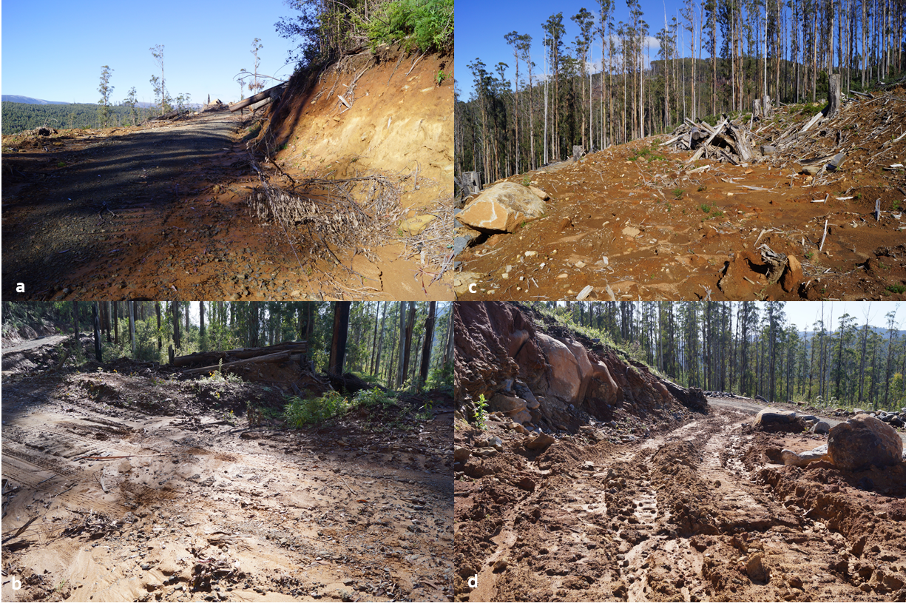
The in-coupe road (a) drained approximately 180 m to a “roll through” cross drain (b) that diverted water and sediment into vegetation before reaching the temporary stream crossed by the waterway crossing. Some water and sediment carried by the table drain was generated on the landing (c) and was enabled due to machinery damage to cross-drainage on tracks leading to upper segments of the landing (d).
Figure 5.4: In-coupe road used to access landing in 2 Buzz
In 11 Tropical, the in-coupe road was constructed to access a second harvest area and landing within the coupe (Figure 5.5). The road included an ~300 m section (at 4-5°) whose table drain ran uninterrupted to a culvert at the head of a drainage feature. “Bar and breach” cross drainage was constructed along the in-coupe road (at intervals consistent with MSP Table 21) following the completion of harvesting and regeneration, but there were no cross-drainage structures present when the road was being used. The road embankment experienced extensive erosion and some mass movement during a rainfall event that followed the construction of the cross-drainage structures.
The cross drains were effective in limiting the amount of sediment moving along the table drain towards the drainage feature. Sediment eroded from the road embankment was captured by vegetation below the embankment and appears unlikely to reach a waterway.
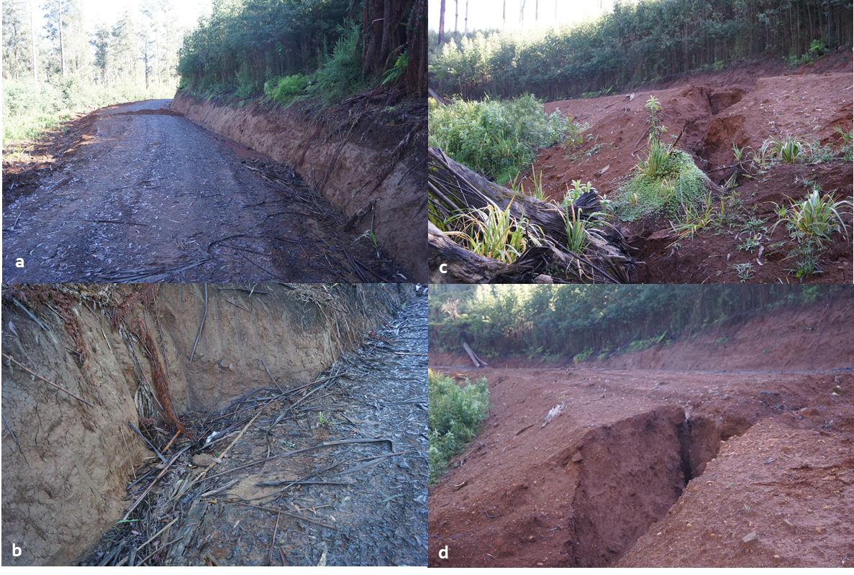
The in-coupe road (a) had an ~300 m segment without cross drainage during the harvest period. The table drain ran to a culvert (b) that drained towards a drainage feature. Cross-drainage was constructed following regeneration. A recent rainfall event led to considerable erosion of the road embankment (c and d).
Figure 5.5: In-coupe road used to access secondary harvest area within 11 Tropical.
The ~200 m undrained section of in-coupe road in 14 Lure (at ~6° grade) is shown in Figure 4.10. This section of road was constructed to access an adjacent coupe but had not been completed at the time of the audit. Recent rainfall events had caused significant rilling of the unfinished road surface. There was no evidence that sediment generated by this section of road would be deposited in nearby waterways.
Erosion associated with these three in-coupe roads highlights the potential for sediment mobilisation from in-coupe roads during large rainfall events, the importance of appropriately constructed drainage and the need to intercept and divert road drainage before it can enter a waterway.
- Non-conforming waterway crossings: the Code and MSPs include a variety of prescriptions (e.g. Code 2.2.1.2, 2.2.1.6, 2.2.1.8) that are intended to prevent unnecessary waterway crossings and to protect water and aquatic biodiversity values in waterways that must be crossed by in-coupe roads. Non-conformance with these requirements have frequently been observed and commented on in recent FAP audits. While the frequency and severity (of environmental impact) of non-conformances in relation to waterway crossings has declined, issues were observed in the current audit (for coupes in Central Highlands RFA region). These were associated with:
Culvert outlets being elevated above the downstream bed of the waterway, with potential for erosion, sediment mobilisation and water quality impacts and preventing any opportunity for upstream movement of aquatic fauna. This was observed in one of the four coupes with in-coupe road waterway crossings included in this audit (2 Buzz; Figure 5.6a).
Lack of cross drainage on the approach of a table drain to a waterway crossing to divert drain flows into vegetation rather than allow them to enter the waterway. MSP 6.2.4.3 requires that drainage be constructed about 20 m from the crossing of a permanent or temporary stream to allow discharge onto undisturbed vegetation. Following rehabilitation of the waterway crossing in 3 Harrison (Figure 5.6b), the table drain ran uninterrupted for ~65 m into a temporary stream.
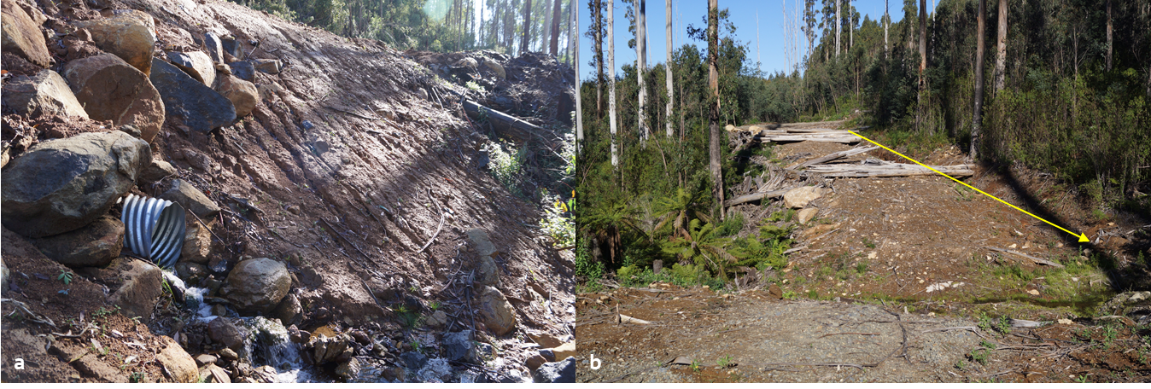
a) 2 Buzz: culvert outlet elevated above downstream bed of temporary stream, providing a barrier to the upstream passage of aquatic fauna. | b) 3 Harrison: table drain on in-coupe road runs ~65 m into temporary stream at rehabilitated waterway crossing. Arrow highlights the table drain that runs directly into the temporary stream.
Figure 5.6: Observed non-conformances with Code and MSP requirements for waterway crossings
- Mass soil movement from in-coupe road embankments: the Code (2.2.2.14) requires that harvesting operations minimise the potential for soil erosion and mass movement by planning and using operational methods and restrictions appropriate for the assessed soil erosion risk and slope. Observations of signs of mass soil movement from in-coupe road (and landing) embankments are typically taken as evidence that the design and construction of the embankments has not conformed with the Code requirements. Similarly, MSP 6.2.2.3 requires the use of engineer approved methods of mechanical consolidation of fill batters. Signs of failure of the embankment batters in the absence of evidence of the use of engineer-approved methods is also taken as a sign of non-conformance.
Early signs of mass movement on in-coupe road embankments were observed in three coupes (2 Buzz; 8 Dejavu; 11 Tropical). This was pronounced in 2 Buzz (Figure 5.7), with the edge of the embankment obviously falling away. The impacts of mass movement at the time of audit were minimal. Given the location of the in-coupe road embankments, it is likely that any effects would be confined to soils and regenerating vegetation. None of the in-coupe roads appear to pose a threat to waterways or water quality.
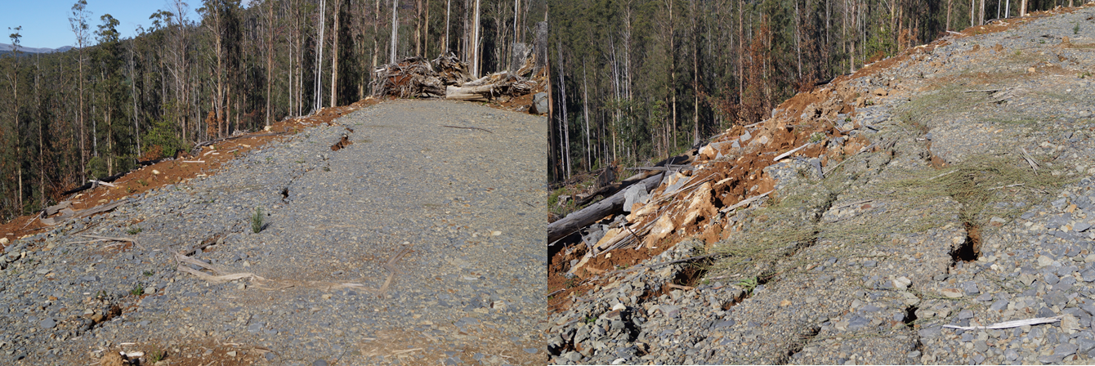
Figure 5.7: Signs of mass movement of soil on in-coupe road/landing embankment, 2 Buzz.
Recommendation V-01 High priority
That VicForests and its roading and harvesting contractors fully adopt the Road design, construction and maintenance instruction for use in the design and construction of all new in-coupes roads and any new waterway crossings.

Coupe infrastructure
Construction and rehabilitation of coupe infrastructure was reintroduced into the FAP’s scope in 2018-19. Three main non-conformance issues with coupe infrastructure were detected in that audit (Jacobs 2019), two of which were observed in the current audit (inadequate drainage of snig and boundary tracks, snig tracks located near or crossing waterways).
Of the 16 coupes included in this audit with snig and/or boundary tracks (15 Central Highlands RFA region coupes; 22 Hickery Dickery coupe, Western Victoria RFA) eight had instances where snig and/or boundary tracks did not have effective drainage features at the spacings specified in VicForests’ UPs (Table 5.1). All coupes with defective drainage were located in Central Highlands RFA region.
As was noted during the 2018-19 audit, excessive separation between effective drainage features is typically the result of damage to drainage structures inflicted by machinery traffic during coupe regeneration or the removal of drainage structures to enable vehicle access for regeneration burning. In both cases, the (presumed) lack of post-regeneration monitoring of tracks meant that the defective drainage was not rectified.
Four of the coupes included in this year’s audit had temporary snig track crossings (1 Sea Monkey; 2 Buzz; 4 Sutcliffe; 5 Dorset). Crossings in three of the coupes used temporary logfill structures, one of which was still in place at the time of the audit (Figure 5.8 a-c; 5 Sutcliffe). The crossing on 5 Dorset was a lightly-used track through a drainage line (Figure 5.8 d).
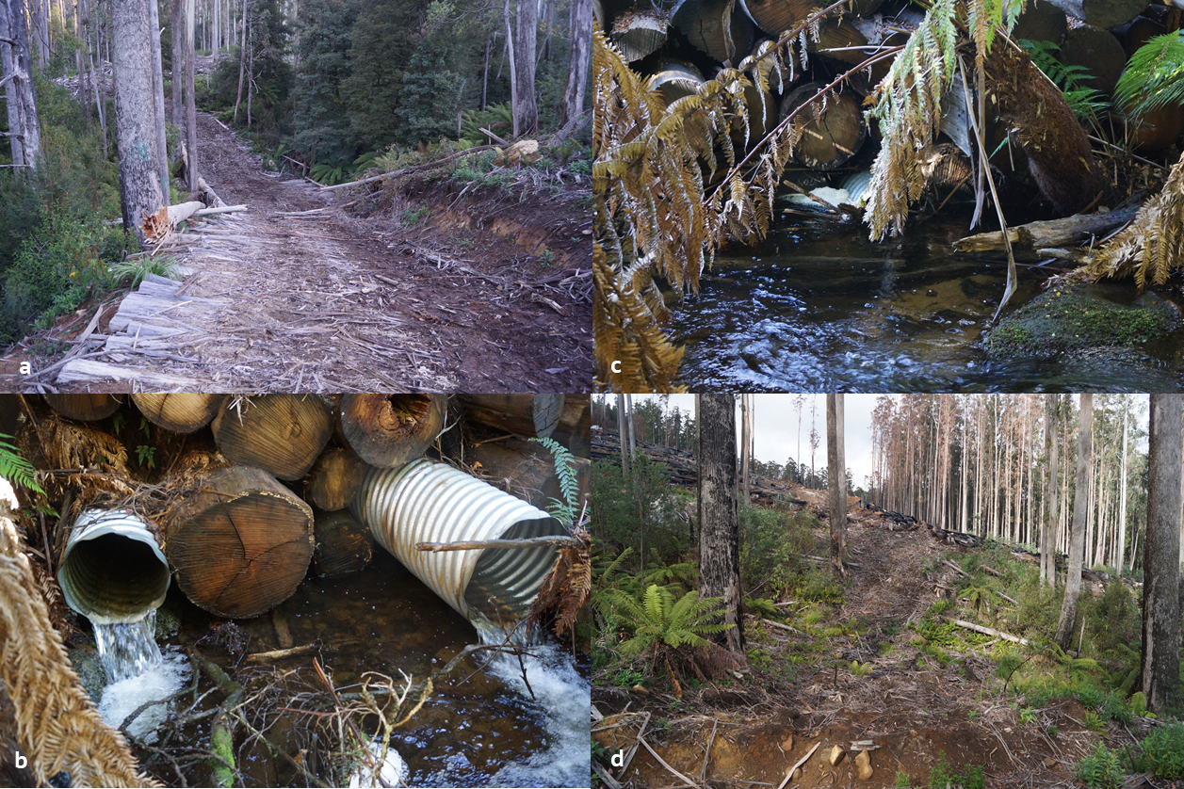
Figure 5.8: Snig track waterway crossings in (a-c) 4 Sutcliffe and (d) 5 Dorset
The crossing on 5 Sutcliffe was used to provide access to harvest areas across a permanent stream and was based on a generic engineered design for logfill crossings (provided to the audit team by VicForests). In the auditor’s opinion, the design was appropriate for the setting and compliant with Code and MSP requirements (apart from a reference to culverts being designed to pass a 1 in 2-year event, rather than the 1 in 10-year event mandated by the MSPs; MSP 6.2.5.3). The crossing was assessed to be located appropriately and appeared to have adequate cross drainage (provided by four culverts and the porous crossing). There was no evidence at the time of audit of the crossing having a detrimental impact water quality or aquatic fauna passage.
Snig track waterway crossings had been removed from 1 Sea Monkey and 2 Buzz and rehabilitated at the time of the audit. Rehabilitation was assessed to be successful in 1 Sea Monkey. However the two crossings in 2 Buzz were used by machines (being used to prepare for rough heaping) following removal of the crossing, resulting in extensive soil disturbance (as per Figure 4.3 and discussion in Sections 4.2 and 4.4) and temporary water quality impairment. Disturbance at the sites of the snig track crossings resulted from poor decisions by the machine operator rather than inappropriate location, construction or rehabilitation of the crossing.
Erosion and mass soil movement issues associated with the rehabilitated landing at 10 Litaize Road (Figure 4.13) were discussed in Section 4.4. Mass soil movement on the embankment may reflect insufficient compaction during construction, exacerbated by an extreme rainfall event. There was no known use of engineering advice in the design and construction of the landing embankment, as is required by the MSPs (6.2.2.3) for large fill batters.
Erosion of the rehabilitated landing was treated as a non-conformance with the Code requirement to minimise soil erosion and mass movement (2.2.1.14). However, the audit team’s assessment of the site did not identify any clear departures from standard landing rehabilitation practices or deficiencies in the work that was undertaken. The severity of erosion appears to at least partly reflect the unfortunate coincidence of a large rainfall event with the rehabilitated landing being in its most vulnerable state (i.e. with soil freshly disturbed and no grass or understorey regeneration). However, intense rainfall events are not uncommon and rehabilitation practices should be developed that seek to control the associated risk. The key additional measure that might be considered to protect rehabilitated landings in areas with moderate to high slope and significant areas upslope of the landing (as was the case for 10 Litaize Road) is the use of a diversion bank or similar structure to prevent overland flows running onto the rehabilitation area.
An incident observed in 15 Mid Week highlights the need for harvesting and/or regeneration contractors to carefully consider the placement of snig, boundary or other tracks in harvesting coupes. Figure 5.9 shows that a track was constructed along the head of a drainage feature above the point at which it develops into a formal drainage line (as per Code definitions). Due to its topographic location, the removal of trees and understorey vegetation and (some) disturbance to soil, water flowed along the track during and after rainfall events. This resulted in the pugging of soil and generation of sediment along the lower part of the track and at the point at which it intersected another track that was constructed around the head of the formal drainage line (which formed a riparian buffer). The sediment did not appear to have been carried to the temporary stream.
The incident was assessed as a non-conformance (with respect to Code 2.2.1.2) because the management actions (track construction and usage) did not protect the soil nor adequately address the risk to water quality posed by the pugging of soil immediately above a drainage line filter. The EIA rating of the incident was assessed to be minor. In the auditor’s opinion, the effect on soil conditions within the coupe could have been avoided by locating the track away from what would inevitably become the wettest part of the hillslope.
Similar issues of inappropriate track location have been reported on in previous audits (e.g. Jacobs, 2019). Some of these incidents (e.g. Oracle and Mulloway coupes) have related to the convergence, downslope, of snig tracks on landings or drainage line crossings. The configuration of snig tracks, in both cases, resulted in overland flows being concentrated at poorly drained points, leading to damage to soil structure, erosion and/or sediment generation. Both situations could have been avoided by choosing alternative routes for snig tracks.
Recommendation V-02 High priority
That VicForests develop or improve guidance for contractors on the placement of snig, boundary or other tracks, particularly to ensure they: a) avoid constructing tracks along drainage depressions in which overland and sub-surface water flows will concentrate; b) where reasonably practicable, avoid having multiple tracks converge downhill on locations with limited drainage capacity and, where this cannot be avoided, manage risks associated with overland flows and excessive water infiltration; and c) avoid unnecessary waterway crossings.

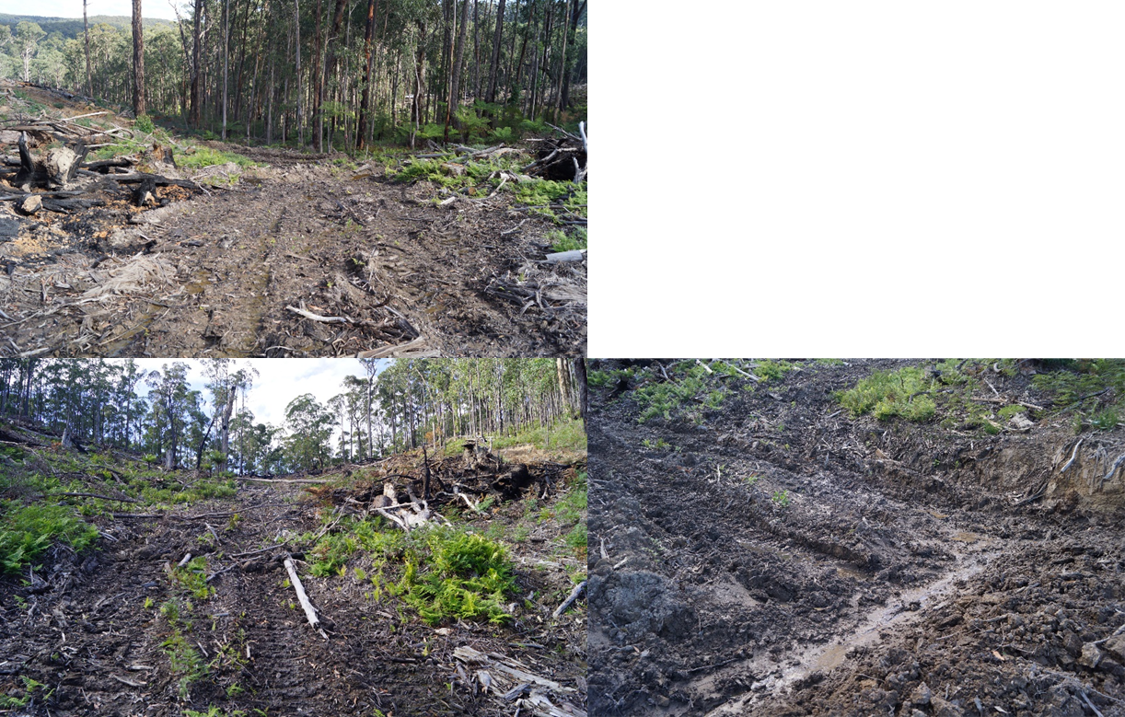
The track depicted in these photographs is located along a drainage depression that overland flows converge towards. The track drains onto another track with limited drainage and allow puddles to form, soil pugging to occur and sediment to be mobilised.
Figure 5.9: Issues associated with an inappropriately located snig/regeneration burning track, 15 Mid Week
Many areas of wet eucalypt forest in the Central Highlands RFA region have deep, granite-based soils that are at least moderately dispersive at depth. Snig tracks with significant side cuts and/or deep cross drains sometimes expose such soils and initiate localised points of erosion and sediment movement (e.g. Figure 5.10). If cross-drainage on such tracks is too widely separated or one or several structures fail, an erosion issue may be set up that may not be quickly stabilised by the regenerating forest. While it may not always be practicable to avoid cutting into the pale C horizon, contractors should be aware of the vulnerability of those soils to erosion and the need to base cross-drain spacing for the snig tracks on the soil erosion hazard category of that soil layer rather than the very stable surface soils. This is particularly important for tracks that are near drainage lines.
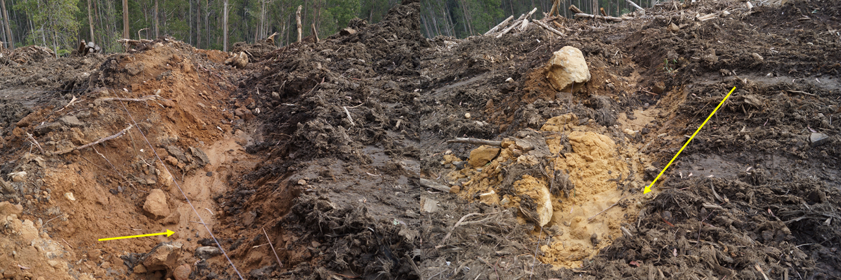
Cross drains in the snig tracks have exposed dispersive sub-soil (arrows), which has resulted in sediment generation and movement. This has potential to set up longer term issues if the cross-drain spacing is to wide or they fail. The cross-drains depicted were assessed to conform with regulatory requirements.
Figure 5.10: Construction of cross drains on snig tracks into dispersive sub-soil, 6 Snobs14

VicForests’ Road Design, Construction and Maintenance Instruction
As noted above, VicForests have recently prepared an instruction (O’Reilly, 2019) to guide the design, construction, maintenance and, as relevant, rehabilitation of roads and landings. The document is intended to support compliance with related Code and MSP mandatory requirements and sets minimum standards and requirements for roads and drainage structures constructed or maintained by VicForests.
The instruction provides a good overview of road construction and design, reinforces specific Code and MSP mandatory requirements and provides useful additional guidance on sediment control during construction, cross drainage, culvert installation, construction of fish ladders for culverts and road maintenance. Its adoption by VicForests and its contractors should help to improve roading practices and conformance with relevant regulatory requirements
The instruction only partly addresses recommendations of the 2016-17 and 2017-18 FAP audits (Jacobs, 2018a; 2018b) for VicForests to thoroughly review its approach to the design, construction and rehabilitation of waterway crossings to significantly improve their compliance with regulatory requirements. The 2016-17 FAP audit report (Jacobs, 2018a) proposed that VicForests:
- Establish a standardized engineering basis for design and construction of waterway crossings: this is addressed by the instruction with respect to some aspects of the sizing and installation of culverts and construction of fish ladders. However, it includes no standardised engineering designs for representative crossing types, as was proposed. It also does not recommend any specific documentation of the adopted crossing design.
- Design and construction review: this proposal was made in recognition of the variability in settings for waterway crossings and the almost inevitable need to vary from a standard design. It was recommended variances and their rationale be recorded, with additional comments on how any risks to the environment would be managed. This is not addressed by the instruction
- Use of sediment traps: wider use of sediment traps to capture sediment in table drain flows was recommended. The instruction addresses this and broader sediment control issues appropriately.
- Rehabilitation plan: planning for rehabilitation of temporary crossings was proposed to be included in design so that construction sets up appropriate environmental outcomes. Crossing removal and rehabilitation is not addressed by the instruction.
- Rehabilitation review: given the many possibilities for variance from an original plan for crossing design and construction, it was proposed that the rehabilitation of temporary crossings be reviewed to ensure the works are appropriate to the setting, provide the required environmental outcome and that any defects are addressed. Since the instruction does not address the rehabilitation of temporary crossings, this aspect is not considered.
While the use of VicForests’ new instruction on road design, construction and maintenance should help to improve conformance with related regulatory requirements, we consider that it does not adequately address the design of waterway crossings, the rehabilitation of temporary crossings or their documentation. Table 5.1 highlights that this has been a persistent source of non-conformance for VicForests that has only partly been rectified.
Recommendation V-03 High priority
That VicForests develop specific guidance or instruction on the design, construction and rehabilitation of in-coupe road and snig track waterway crossings.

Potential improvements to the regulatory framework for timber harvesting
Comments on potential improvements in the regulatory framework for timber harvesting and in management of the audit program have been made in previous audit reports (Jacobs 2018a; 2018b, 2019). These related to:
- Addressing errors or deficiencies in the text of the Code and MSPs
- Revision of the method for assessing soil erosion hazard and water quality risk
- Strengthening prescriptions for the management of biosecurity risks associated with machinery movement and the importation of gravel during construction of in-coupe roads
- Development of specifications for maximum cross drain spacing for snig and boundary tracks
As the regulatory framework for sustainable forest management, particularly the Code and MSPs, has not been revised recently, there has been no specific opportunity to address these recommendations. In our opinion they continue to be applicable.
No new comments on the regulatory framework for timber harvesting are made on the basis of this audit.

Inclusion of community forestry activities in Western Victorian within the FAP’s scope
The 2019-20 FAP was the first for some time to comprehensively consider timber harvesting operations in non-intensive forestry operations in western Victoria. It identified that the nature of these operations means that fewer regulatory requirements are triggered and that there are higher levels of conformance with that framework than is observed to be the case for more intensive operations in the Central Highlands RFA region (and, based on previous audits, other areas of eastern Victoria).
While, in our opinion, it is appropriate to periodically include these operations in the scope of the FAP, we believe that its focus should be on the more intensive timber harvesting operations in eastern Victoria. This is consistent with the risk-based approach to coupe selection for the audit and lower levels of conformance with regulatory requirements.

Conclusions and recommendations

Conclusions
The objectives of the FAP are to assess VicForests’ conformance with the regulatory framework for timber harvesting activities in State forests and the environmental risks associated with any non-conformances. The 2019-20 FAP addressed Code and MSP mandatory compliance elements relating to four main themes:
- Protection of soil, water and biodiversity values
- Design, construction, maintenance and closure of in-coupe roads
- Construction and rehabilitation of coupe infrastructure
- Implementation of forest coupe planning.
Conformance of coupe planning, harvesting and roading activities with the regulatory framework was assessed for 15 coupes each in State forests with the Central Highlands and Western Victoria RFA regions, respectively. The selection of coupes was risk-based, meaning that audit findings cannot be taken as being statistically representative of VicForests’ operations in either region.

Overall conformance findings
A total of 146 compliance criteria were identified from Code and related MSP prescriptions included within the audit scope. The applicability of and conformance with these criteria was assessed for each of the 30 selected coupes during site inspections undertaken in May 2019.
The overall level of full conformance with applicable audit criteria ranged between 80% and 100%, with the average being 95%. Non-conformance incidents in 14 of the 30 harvest coupes included in the audit were assessed to have potential for environmental impact. There was an average of 0.9 such incidents per coupe, with as many as six incidents recorded on one coupe. The assessed level of potential environmental impact associated with these incidents ranged up to major.

Protection of soil, water and biodiversity values
Environment-themed audit criteria were grouped into three sub-themes focusing on soil, water and biodiversity values. The main findings for each sub-theme were:
- Protection of forest soils: the level of full conformance with applicable criteria ranged between 75% and 100%, with an average of 96%. There were no non-conformances that were assessed to have major potential environmental impact and six that were assessed to have moderate environmental impact. These related to two types of incident:
Disturbance of two temporary waterway crossings by machinery being used in 2 Buzz to prepare for rough heaping. The crossings were the sites of rehabilitated snig track crossings
Excessive lengths of snig track and boundary track in 8 Dejavu and 11 Tropical without effective cross-drainage structures and potential for erosion along the tracks.
- Protection of water flows, water quality and river health: the level of full conformance with applicable criteria ranged between 62% and 100%, with an average of 96%. There were no non-conformances that were assessed to have major potential environmental impact and 13 that were assessed to have moderate environmental impact. These related to three types of incident:
Excessive lengths of in-coupe road in 3 Harrison and 15 Mid Week draining directly to waterways without road run-off being intercepted and sediment captured
The culvert outlet on an in-coupe road waterway crossing at 2 Buzz was elevated above the downstream bed of the temporary stream
Machinery being used for rough heaping crossed two rehabilitated snig track crossings, leading to soil disturbance in a sensitive temporary stream environment (as noted above; 2 Buzz).
- Protection of biodiversity values: the average level of full conformance with applicable criteria was 98%, with the range being 84-100%. One non-conformance incident was detected that was assessed to have major potential environmental impact and five non-conformances were identified with moderate potential environmental impact. These related to four incident types:
Incursion of the regeneration burn in 5 Dorset into a Leadbeaters Possum SPZ (major potential environmental impact)
Disturbance to two temporary stream crossings by machinery being used to prepare for rough heaping in 2 Buzz
Elevation of the outlet of an in-coupe road waterway crossing in 2 Buzz above the downstream bed of a temporary stream
Felling of a tree into a Leadbeaters Possum SPZ in 6 Snobs 14.

Design, construction, maintenance and closure of in-coupe roads
Roading criteria were grouped for the audit into sub-themes for design, construction and maintenance-closure. Only coupes in the Central Highlands RFA region had constructed in-coupe roads. The main findings for each sub-theme were:
- Road design: the level of full conformance with applicable criteria ranged between 58% and 100%, with the average being 81%. The main design-related non-conformance issue was FCPs having no recorded engineering basis for design of the in-coupe road, larger embankment and/or waterway crossing. Road design non-conformances did not generally directly result in assessments of potential environmental impact. However, the lack of appropriate drainage in the vicinity of a waterway crossing (3 Harrison, 15 Mid Week) and elevation of the outlet of a waterway crossing culvert above the downstream bed of a waterway (2 Buzz) were partly attributed to the lack of formal road design. Each incident was assessed to have moderate potential environmental impact.
- Road construction: the average level of full conformance with applicable criteria was 85%, with the level of conformance ranging between 73% and 100%. Ten non-conformances were identified with moderate potential environmental impact. These included the three incidents described above in relation to road design (2 Buzz, 3 Harrison, 15 Mid Week) and long sections of in-coupe road in 14 Lure being constructed without formal or effective cross-drainage structures.
- Road maintenance and closure: the average level of full conformance with applicable criteria was 96%, with the level of full compliance ranging between 60% and 100%. No non-conformances were identified with potential environmental impact.

Construction and rehabilitation of coupe infrastructure
The level of full conformance with applicable criteria ranged between 67% and 100%, with the average being 88%. Four non-conformance incidents were assessed to have moderate potential environmental impact, the disturbance of two rehabilitated snig track crossings (2 Buzz) and damage to snig track drainage (8 Dejavu, 11 Tropical), which meant that there were excessive lengths without effective cross-drainage structures.
Only one of the coupes in the Western Victoria (22 Hickery Dickery) had any constructed coupe infrastructure that was included in the overall assessment.

Implementation of forest coupe planning
The average level of full conformance with applicable criteria was 96%, with the level for individual coupes ranging between 80% and 100%. One non-conformance incident with major potential environmental impact was identified (incursion of the regeneration burn in 5 Dorset into an SPZ). Non-conformance incidents on four other coupes were assessed to have moderate potential environmental impact. These were associated with:
- Damage to rehabilitated snig track waterway crossings (2 Buzz)
- Construction of an in-coupe road waterway crossing with a culvert outlet elevated above the downstream bed of the waterway (2 Buzz)
- Drainage of an excessive length of in-coupe road directly into a waterway crossing (3 Harrison, 15 Mid Week)
- Accidental felling of a tree into a Leadbeaters Possum SPZ (6 Snobs 14)

Timber harvesting operations in Central Highlands and Western Victoria RFA regions
The intensity of timber harvesting operations in audited coupes located in the Central Highlands and Western Victoria RFA regions differed markedly, with those in Central Highlands RFA region being far more intensive and having much less retained tree cover within the harvest area. As a result, there were fewer applicable audit criteria for coupes in Western Victorian RFA region than in Central Highlands.
The average level of full conformance with application criteria was greater in coupes in Western Victoria RFA region than in Central Highlands (97% and 94%, respectively). Higher levels of conformation were observed across all audit themes. Twenty-six individual incidents that resulted in non-conformances with potential environmental impact were observed in Central Highlands coupes (in 13 of 15 coupes) and only one such incident was observed in Western Victoria RFA region coupes.

Comparison with previous audits
Coupe selection for the audit is risk-based, which means that audit results are not necessarily statistically representative of VicForests’ operations overall and audit results may not be directly comparable between years. Comparison of the results of this audit with previous audits is also confounded by the inclusion of 15 less intensively harvested community forestry coupes from Western Victoria RFA region. However, if the comparison with previous audits is confined to coupes within the Central Highlands RFA region (12 coupes in 2017-18m, 14 coupes in 2018-19), there is a reasonable basis for doing so.
The overall level of full conformance for Central Highland RFA region coupes in the 2019-20 audit was 94%, compared with 83% and 90% for the 2018-19 and 2017-19 audits, respectively. The level of full conformance for Central Highland coupes was greater in 2019-20 than in 2018-19 in all sub-themes. The level of full conformance in 2019-20 exceeded that in 2017-18 for each theme or sub-theme, except for road construction.
Despite there being one fewer Central Highlands coupe in 2018-19 than in the current audit, there were 23 more non-conformances with major potential environmental impact. A similar set of incident types were most commonly associated with non-conformances with potential environmental impact in the two most recent audits. However, there were fewer incidents in the current audit and those that were observed were generally assessed to have lower potential environmental impact in the current audit than in the previous one.

Recommendations
The findings of this audit have contributed to a series of recommendations for VicForests for potential improvements in coupe planning and timber harvesting practices. No new recommendations to DELWP regarding the regulatory framework for timber harvesting are made beyond those from our previous audits that have not yet been addressed.
The priority given to recommendations reflects either the potential environmental impact associated with the aspect of harvesting practice. All recommendations to VicForests are considered to have high priority.

Recommendations for VicForests
Recommendation | Rationale
V-01: High priority  That VicForests and its roading and harvesting contractors fully adopt the Road design, construction and maintenance instruction for use in the design and construction of all new in-coupes roads and any new waterway crossings. | The instruction has been developed for VicForests to support compliance with related Code and MSP mandatory requirements. It sets minimum standards and requirements for roads and drainage structures constructed or maintained by VicForests. The instruction provides a good overview of road construction and design, reinforces specific Code and MSP mandatory requirements and provides useful additional guidance in many aspects of road design, construction and maintenance. Its adoption by VicForests and its contractors should lead to improved conformance with regulatory requirements and better environmental outcomes from the construction and use of in-coupe roads.
V-02 High priority  That VicForests develop or improve guidance for contractors on the placement of snig, boundary or other tracks, particularly to ensure they: a) avoid constructing tracks along drainage depressions in which overland and sub-surface water flows will concentrate; b) where reasonably practicable, avoid having multiple tracks converge downhill on locations with limited drainage capacity and, where this cannot be avoided, manage risks associated with overland flows and excessive water infiltration; and c) avoid unnecessary waterway crossings. | The inclusion of coupe infrastructure into the scope of the FAP in this and the previous audit highlighted several areas where practice is deficient and significant improvements in environmental performance of snig and boundary track networks could be achieved. Most improvements could be made cost-effectively, by better placement of snig tracks, more careful consideration of the management of convergence points and avoidance, where practicable, of waterway crossings.
V-03 High priority  That VicForests develop specific guidance or instruction on the design, construction and rehabilitation of in-coupe road and snig track waterway crossings. | VicForests’ new Road design, construction and maintenance instruction only partly addresses previous audit recommendations regarding the provision of specific engineering guidance on the construction and rehabilitation of waterway crossings. Specifically, it does not provide standardised engineering designs for crossings that would provide a basis for individual crossing installations and satisfy Code and MSP mandatory requirements (for crossing design). It also does not address either planning for or implementation of crossing rehabilitation.  Given that waterway crossings have been a key area of non-conformance for VicForests in recent audits, we are concerned that the new roading instruction will not adequately address what we have found to be the most serious deficiency in VicForests roading practices. We therefore propose that the new roading instruction be supplemented by additional material specific to in-coupe road and snig track waterway crossings.

References
Department of Environment, Land, Water and Planning [DELWP] 2019. Regulating timber harvesting in State forests under the Allocation Order. Statement of Regulatory Intent. DELWP.
Department of Environment and Primary Industries [DEPI] 2014a. Code of practice for timber production 2014. DEPI.
DEPI 2014b. Management standards and procedures for timber harvesting operations in Victoria’s State forests 2014. DEPI.
DEPI 2014c. Planning standards and procedures for timber harvesting operations in Victoria’s State forests 2014. Appendix 5 to the Management standards and procedures for timber harvesting operations in Victoria’s State forests 2014. DEPI.
Department of Sustainability and Environment [DSE] 2006. Sustainability charter for Victoria’s State forests. DSE.
Jacobs 2016. Forest Audit Program 2015: Audit of in-coupe roads. Environmental audit of the construction and maintenance of in-coupe roads. V2.3 Report to DELWP. March 2016.
Jacobs 2018a. Audit of timber harvesting and forest regeneration in State forests in eastern Victoria. Report on the 2016-17 Forest Audit Program. IS206000-P2-001. Report to DELWP. April 2018.
Jacobs 2018b. Forest Audit Program 2017-18. 2017-18 Audit Summary Report. IS247800-RP-001. Report to DELWP. June 2018.
Jacobs 2019. Forest Audit Program 2018-19. 2018-19 Audit Summary Report. IS284400-RP-001. Report to DELWP. June 2019.
Jacobs 2020. Forest Audit Program 2019-20. Conformance summary. IS326300-02. Report to DELWP. May 2020.

Spatial data sources:
- Victorian government: www.data.vic.gov.au
- ESRI
Limitation statement
The purpose of this report and the associated services performed by Jacobs was to conduct an environmental audit of timber harvesting operations in Victorian State forests. The work has been undertaken in accordance with the scope of services set out in the contract between Jacobs and the Department of Environment, Land, Water and Planning (DELWP).
Jacobs derived the data in this report from field observations and information sourced from DELWP, VicForests and/or available in the public domain at the time or times outlined in this report. The passage of time, manifestation of latent conditions or impacts of future events may require further examination of the project and subsequent data analysis, and re-evaluation of the data, findings, observations and conclusions expressed in this report.
Jacobs has prepared this report in accordance with the usual care and thoroughness of the consulting profession, for the sole purpose described above and by reference to applicable standards, guidelines, procedures and practices at the date of issue of this report. For the reasons outlined above, however, no other warranty or guarantee, whether expressed or implied, is made as to the data, observations and findings expressed in this report, to the extent permitted by law.
This report should be read in full and no excerpts are to be taken as representative of the findings. No responsibility is accepted by Jacobs for use of any part of this report in any other context.
This report has been prepared on behalf of, and for the exclusive use of DELWP and is subject to, and issued in accordance with, the provisions of the contract between Jacobs and DELWP. Jacobs accepts no liability or responsibility whatsoever for, or in respect of, any use of, or reliance upon, this report by any third party.

Audit compliance elements
Regulatory compliance elements considered in the audit are included in Table A.1. They were drawn from the Code, the MSPs and their PS. Code compliance elements were selected by DELWP’s THCU. Supporting compliance elements from the MSPs and PS were selected by the audit team.
Compliance criteria (stated as a question) were developed by the audit team to enable assessments of compliance with each element of the regulatory framework. Criteria generally refer to individual MSP or PS compliance elements, rather than a more overarching Code requirement. However, in some cases criteria refer to individual Code compliance elements. Compliance elements have been incorporated with criteria in Table A.1. The compliance theme(s) to which each criterion relates is also given in the table.
Table A.1 also provides a summary of the percentage of applicable coupes recording full-conformance with each criterion.
Table A.1 Selected regulatory compliance elements for 2019-20 FAP audit and associated audit criteria. A summary of the level of full conformance with each criterion and the compliance theme or sub-theme to which each criterion relates is also shown
Source | # | Code compliance elements and audit compliance questions | Theme(s) | % full conformance
C |  | 2.2 Environmental Values in State forests
C |  | 2.2.1 Water Quality, River Health and Soil Protection
C |  | 2.2.1.1 Planning and management of timber harvesting operations must comply with relevant water quality, river health and soil protection measures specified within the Management Standards and Procedures.
M |  | 3.1.1.1 Use the following categories when determining buffer (B) and filter (F) widths for waterways within and immediately adjacent to each coupe. Aids to the identification of each class of waterway are provided in the Code Glossary. (a) Permanent streams, pools and wetlands. (b) Temporary streams. c) Drainage lines.
 | 1.01 | Have the categories prescribed in the MSPs been used in classifying waterways present on the coupe? | W,P | 100%
 | 1.02 | Are the classification assessed to have been applied correctly? | W,P | 96%
M |  | 3.2.1.1 Conduct field assessments to determine the soil erosion hazard and soil permeability classifications for an area proposed for any soil disturbing timber harvesting operations as follows (3.2.1.2-3.2.1.11, Table 8).
 | 2.01 | Has soil erosion hazard and soil permeability been assessed using the method prescribed in the MSPs? | S,P | 100%
 | 2.02 | Has the methodology been followed correctly? | S | 97%
 |  | 3.2.1.2 Collect soil profile samples that reflect the variety of soils represented within the coupe.
 | 2.03 | If there are significant changes in soil and/or vegetation types within the coupe, ITAO have an adequate number of soil profile samples been taken to assess soil erosion hazard for the coupe? | S,P | 100%
M |  | 3.3.1.1 Apply appropriate protection to class of waterway as outlined in MSP Table 9.
M |  | 3.3.1.2 Apply appropriate protection to class of waterway as outlined in table 10 below for coupes in catchments up to 1 km upstream of verified and potential Spotted Tree Frog sites or coupes in Barred Galaxias and Mountain Galaxias SMZs where specified in section 4.2.
 | 3.01 | If applicable, have the buffer and filter strip widths prescribed in MSP Table 9 been applied to the coupe? | W | 95%
 | 3.02 | If applicable, have the buffer and filter strip widths prescribed in MSP Table 10 been applied to the coupe? | W | 100%
M |  | 3.4.1.1 Exclude timber harvesting operations from slopes over 30 degrees.
M |  | 3.4.1.2 Up to 10% of the net harvest area of any coupe can contain areas greater than 30 degrees, where the risk of mass soil movement has been managed accordingly.
 | 4.01 | Does the FCP show areas of the coupe with slope >30°? | S,P | 88%
 | 4.02 | Has timber harvesting been excluded from areas with slopes >30° (unless the area >30° slope is ≤10% net harvest area and ITAO the risk of mass soil movement has been managed accordingly)? | S | 100%
 | 4.03 | If timber harvesting is undertaken in areas with slope >30°, does the area harvested exceed 10% of net harvest area and has the risk of soil mass movement been managed accordingly? | S | 100%
M |  | 3.5.1.1 Apply the slope limits, seasonal closures, buffer and filter strip widths and other relevant management actions specified in MSP Appendix 3 Table 11 (Water supply protection areas) for timber harvesting operations and associated roading and regeneration in water supply protection areas.
M |  | 3.5.1.2 Refer to Table 2 in Appendix 5 the PS for management actions that apply to water supply protection area SMZs in the Midlands FMA
M |  | 3.5.1.3 Obtain approval from the Minister or delegate in accordance with section 1.4 for any timber harvesting operations that are not conducted in accordance with clauses 3.5.1.1 or 3.5.1.2.
M |  | 3.5.1.4 Special water supply catchments and water supply protection areas not listed  in Appendix 3 Table 11 (Water supply protection areas) or table 2 in Appendix 5  the Planning Standards do not require protection in addition to existing Code  requirements.
M |  | 3.5.1.5 In addition to Appendix 3 Table 11 (Water supply protection areas), in the Bunyip, Thomson and Tarago special water supply catchments and the Yarra Tributaries State forests the area harvested must not exceed the following limits measured as a rolling average:  (a) Thomson ‐ Ash forests 150 ha/year, Mixed species forests 15ha/year;  (b) Tarago ‐ Ash forests 55 ha/year, Mixed species forests 23ha/year;  (c) Yarra Tributaries – Ash forest 52 ha/year, Mixed species forests 15 ha/year; and  (d) Bunyip – Ash forest 15 ha/year, Mixed species forests 15 ha/year.
M |  | 3.5.1.6 In addition to Appendix 3 Table 11 (Water supply protection areas), harvesting in the Learmonths Creek special water supply catchment must not exceed 7 ha per annum in Ash forests or 3 ha per annum in Mixed species forests, averaged over the previous 10-year period.
 | 5.01 | Does the FCP correctly note that the coupe is or is not located in a water supply catchment? | W,P | 100%
 | 5.02 | For relevant couples located in WSPA/DWSC, have the applicable slope limits, seasonal closures, buffer and filter strip widths and other relevant management actions specified in Appendix 3 Table 11 been correctly applied on the coupe? | S,W | 100%
 | 5.03 | For relevant couples located in WSPA/DWSC, are the applicable stream buffers correctly applied on the coupe? | W | 93%
 | 5.04 | For relevant couples located in WSPA/DWSC, are the applicable maximum annual areas harvested noted in the FCP and correctly applied on the coupe? | W,P | 100%
 | 5.05 | For relevant couples located in WSPA/DWSC, if timber harvesting operations are not conducted in accordance with the relevant MSP prescriptions, has Ministerial approval been obtained in accordance with MSP section 1.5 and Appendix 1 prior to harvesting commencing? | W,P | n/a
C |  | 2.2.1.2 Management actions to protect waterways, river health and soil must be appropriate to the waterway class, soil category, and potential water quality risk posed by timber harvesting operations at each site.
 | 6.01 | ITAO is there evidence from the coupe which suggests that management actions to protect waterways, river health and soil have not been appropriate to protect waterways, river health and soil? | S,W,D,C, M,P | 87%
C |  | 2.2.1.5 Where practical exclude roads and snig tracks from aquatic and riparian habitats.
C |  | 2.2.1.6 Where crossings are required, minimise the extent of habitat damage, constriction to stream flow and barriers to fish and other aquatic fauna.
C |  | 2.2.1.7 Remove temporary crossings immediately after harvesting or any subsequent regeneration work is complete using a technique that minimises soil and habitat disturbance.
C |  | 2.2.1.8 Use drainage, artificial structures, buffers and filters of effective width to slow and disperse surface flows and deposit sediment before reaching waterways.
C |  | 2.2.1.12 Design, construct and maintain roads, crossings, coupe infrastructure and drainage structures to withstand foreseeable rainfall events and traffic conditions and protect water quality.
 | 7.01 | If roads and snig tracks have not been excluded from aquatic and riparian habitats, ITAO was it reasonably practicable to have done so? | W, B,D,C,I, P | 89%
 | 7.02 | For coupes with road and/or snig track waterway crossings, ITAO did the crossing minimise the extent of habitat damage and, where relevant, constriction to stream flow and/or barriers to fish and other aquatic fauna? | W,B,D,C,I | 86%
 | 7.03 | ITAO has the crossing been removed as soon as reasonably practicable following harvesting or regeneration work? | W,B,M,I | 80%
 | 7.04 | ITAO has removal of the crossing been undertaken in a manner that has minimised soil and habitat disturbance? | S,W,B,M, I | 100%
 | 7.05 | ITAO have drainage, artificial structures, buffers and filters of effective width been appropriately used to try to slow and disperse surface flows and deposit sediment before reaching waterways? | W,D,C | 71%
 | 7.06 | Have the measures put in place to slow and disperse surface flows and deposit sediment before reaching waterways been effective? | W,D,C | 78%
C |  | 2.2.1.14 Minimise potential for soil erosion or mass movement by planning and using operational methods and restrictions appropriate to the assessed soil erosion risk and slope.
C |  | 2.2.1.15 Locate coupe infrastructure and roads to minimise soil erosion and degradation.
C |  | 2.2.1.18 Employ topsoil conservation techniques in timber harvesting areas affected by coupe infrastructure and roads.
 | 8.01 | ITAO have planning (including locating coupe infrastructure and roads) and operations methods applied on the coupe been appropriate for the assessed soil erosion risk and slope? | S,D,C,I,P | 100%
 | 8.02 | Is there evidence within the coupe of soil erosion or mass movement resulting from harvesting operations, including from roading, snig tracks and/or landings? | S,C,I | 93%
 | 8.03 | ITAO has topsoil conservation been used as appropriate in areas affected by coupe infrastructure and/or roads? | S,I | 100%
C |  | 2.2.2 Conservation of Biodiversity
C |  | 2.2.2.1 Planning and management of timber harvesting operations must comply with relevant biodiversity conservation measures specified within the Management Standards and Procedures.
C |  | 2.2.2.4 During planning identify biodiversity values listed in the Management Standards and Procedures prior to roading, harvesting, tending and regeneration. Address risks to these values through management actions consistent with the Management Standards and Procedures such as appropriate location of coupe infrastructure, buffers, exclusion areas, modified harvest timing, modified silvicultural techniques or retention of specific structural attributes.
 | 9.00 | Is there evidence from the FCP and coupe planning process of attempts to identify biodiversity values listed in the MSPs within or near the coupe? | B,P | 97%
 | 9.01 | Where listed biodiversity values are present, is there evidence that risks to these values from timber harvesting operations have been assessed? | B | 100%
 | 9.02 | Where listed biodiversity values are present, have management actions applied on the coupe to protect those values been consistent with MSP prescriptions. | B | 95%
 |  | MSP4.1 Habitat retention
C |  | 2.2.2.10 Retain and protect habitat trees or habitat patches and long-lived understorey species to provide for the continuity and replacement of old hollow-bearing trees and existing vegetation types within each coupe.
M |  | 4.1.1.1 Retain habitat trees in accordance with the FMA summary provided in Appendix 3 Table 12 (Habitat tree prescriptions).
M |  | 4.1.1.2 Trees in buffers or other exclusion areas that have been extended beyond minimum required widths can contribute to habitat tree retention requirements.
 | 10.01 | Have the required number of habitat trees been retained on the coupe (as per MSP Appendix 3, Table 12) - including in areas where buffers and other exclusion areas extended beyond the minimum required widths? | B | 100%
 | 10.02 | Have habitat patches of long-lived understorey species been retained to represent existing vegetation types within the coupe? | B | 100%
 |  | MSP 4.1.3 Box-Ironbark forests in the Midlands FMA
M |  | 4.1.3.1 Permanently retain:  (a) all trees (both standing dead or living) greater than 20 cm DBHOB with visible hollows where safe and practicable to do so. These trees may count towards retention requirements in clause (b) and (c);  (b) at least 10 living trees per hectare between 30 cm and 39.9 cm DBHOB;  (c) where they exist: i). 2 living trees per hectare between 40 cm and 49.9 cm DBHOB inclusive; and  ii). 2 living trees per hectare between 50 and 59.9 cm DBHOB inclusive. Non‐merchantable trees with healthy crowns should be preferentially retained;  (d) all trees greater than 60 cm DBHOB in high quality sawlog harvesting operations;  (e) all trees greater than 40 cm DBHOB in low quality sawlog and firewood harvesting operations;  (f) within SMZ’s all trees greater than 40 cm DBHOB in high and low quality sawlog and firewood harvesting operations;  (g) all standing dead trees greater than 40 cm DBHOB;  (h) all living Yellow Box, Fryers Range Scentbark and Bealiba Ironbark trees. These trees may count towards retention requirements.
M |  | 4.1.3.2 A whole of coupe approach should be adopted (numbers averaged over coupe area) to ensure that the best habitat trees are retained, including where these occur in groups.
M |  | 4.1.3.3 Firewood harvesting within a SMZ must be managed to ensure coarse woody debris levels are not reduced below pre‐harvest levels.
M |  | 4.1.3.4 All log sections larger than 40cm diameter with hollows larger than 10cm diameter must be retained.
M |  | 4.1.3.5 The period between the next and subsequent sawlog harvesting operations will be at least 25 years to allow recruitment across all habitat classes. Habitat trees intended for permanent retention will not be permanently tagged or labelled. It is expected that these trees will be evident from their form.
 | 10.03 | In Midlands FMA B-I forests, is there evidence of the retention of hollo-bearing trees as per MSP 4.1.3.1 a? | B | n/a
 | 10.04 | In Midlands FMA B-I forests, is there evidence that the habitat retention requirements of MSP 4.1.3.1 b-h, 4.1.3.2/4/5 have been satisfied? | B | n/a
 | 10.05 | In Midlands FMA B-I forests where SMZ areas have been used for firewood harvesting, is there evidence that coarse woody debris levels have not been reduced below pre-harvest levels? | B | n/a
 |  | MSP4.1.4 Central Highlands FMAs
M |  | 4.1.4.1 In Central Highlands FMAs, when selecting habitat trees, prioritise hollow‐bearing trees where they are present and trees most likely to develop hollows in the short term.
M |  | 4.1.4.2 Scatter habitat trees across the timber harvesting coupe in mixed‐species forest.
M |  | 4.1.4.3 Where possible, retain potential hollow‐bearing ash eucalypts in clumps to increase their protection from exposure, windthrow and fire.
M |  | 4.1.4.4 No gap between retained vegetation is to be greater than 150 m.
M |  | 4.1.4.5 Retain habitat trees where they can be most easily protected from damage during harvesting and site preparation treatment.
 | 10.06 | Based on evidence from the coupe and ITAO, have hollow-bearing or potential hollow-bearing trees, where present, been prioritised for habitat retention | B | 100%
 | 10.07 | In mixed species forests, if there are retained habitat trees, have they been scattered evenly across the coupe? | B | 100%
 | 10.08 | If present, have hollow bearing ash eucalypts been retained in clumps. | B | 100%
 | 10.09 | Are gaps between retained vegetation ≤ 150 m? | B | 100%
 | 10.10 | ITAO, are any retained habitat trees located where they can most easily be protected from damage during harvesting and site preparation treatment? | B | 93%
 | 10.11 | Is there evidence of damage to retained vegetation from harvesting or regeneration? | B | 100%
 |  | MSP4.1.6 Horsham FMA
M |  | 4.1.6.1 Retain trees currently being utilised by wildlife as a priority over potential habitat trees and dead trees.
M |  | 4.1.6.2 Habitat trees; (a) are large actively growing trees with a spreading form; and/or (b) have hollows present and forming.
M |  | 4.1.6.3 Trees growing in ephemeral wetlands and within 20 m of the edge of the wetland may only be harvested using single tree selection. A 20 m buffer from the water line or saturated zone, wherever it occurs at the time of harvesting, also applies.
 | 10.12 | Is there evidence that harvesting has targeted trees that are being utilised by wildlife? | B | 100%
 | 10.13 | Are retained habitat trees large actively growing trees with a spreading form and/or have hollows present and forming? | B | 100%
 | 10.14 | Have trees growing within or within 20 m of an ephemeral wetland been harvested using single tree selection? | B | 100%
 | 10.15 | Have trees from within 20 m of the water line or saturated zone (at the time of harvesting) not been harvested? | W,B | 100%
 |  | MSP4.1.7 Midlands FMA, not Box-Ironbark forests
M |  | 4.1.7.1 In the non-Box Ironbark forests habitat tree numbers in Appendix 3 Table 12  (Habitat tree prescriptions) are the maximum required.
M |  | 4.1.7.2 Prioritise retention of hollow trees or gum species as habitat trees.
 | 10.16 | Is there evidence that hollow trees and/or gum species have been prioritised as habitat trees? | B | 100%
 |  | MSP4.1.9 Otway FMA
M |  | 4.1.9.1 Habitat tree numbers in Appendix 3 Table 12 (Habitat tree prescriptions) are a minimum requirement.
M |  | 4.1.9.2 Retain existing and potential habitat trees in regularly configured clusters or on the edges of coupes.
M |  | 4.1.9.3 Design coupe boundaries and habitat tree clusters so there is no more than 200 m between areas of retained habitat.
M |  | 4.1.9.4 Where located on or adjacent to a coupe boundary, habitat patches are not included in the net harvest area of adjoining coupes.
 | 10.17 | Have habitat trees been retained in regularly configured clusters or on the edge of the coupe? | B | 100%
 | 10.18 | Is the spacing between habitat clusters less than or equal to 200 m? | B | 100%
 | 10.19 | Is there evidence that habitat patches on or adjacent to a coupe boundary have been included in the net harvest area of another coupe? | B | n/a
 |  | MSP 4.2 and 4.3 Fauna and flora
M |  | 4.2.1.1 Apply management actions for rare and threatened fauna identified within areas affected by timber harvesting operations as outlined in Appendix 3 Table 13 (Rare or threatened fauna prescriptions).
M |  | 4.3.1.1 Apply management actions for rare and threatened fauna identified within areas affected by timber harvesting operations as outlined in Appendix 3 Table 14 (Rare or threatened flora prescriptions).
 | 11.01 | Does the FCP correctly note record(s) of rare or threatened fauna–based on the VBA-on the coupe? | B | 100%
 | 11.02 | Have the management actions for fauna (as per MSP Appendix 3, Table 13) been carried out? | B | 100%
 | 11.03 | Does the FCP correctly note record(s) of rare or threatened flora-based on the VBA-on the coupe? | B | 100%
 | 11.04 | Have the management actions for fauna (as per MSP Appendix 3, Table 14) been carried out? |  | 100%
P |  | 4.2.1.1 Plan management actions for rare and endangered fauna in accordance with Table 3 (fixed FMZ rules for fauna).
 | 11.05 | Have the management actions specified in PS Table 3 for fixed FMZ rules for fauna been implemented? | B | n/a
P |  | 4.3.1.1 Apply the management actions outlined in Table 4 (Detection based FMZ rules for fauna) for zoned rare or threatened fauna.
 | 11.06 | Have the management actions specified in PS Table 4 for detection based FMZ rules for fauna been implemented? | B | 100%
P |  | 4.5.1.1 Apply the management actions outlined in Table 5 (Detection based FMZ rules for flora) for zoned rare or threatened for all values.
 | 11.07 | Have the management actions specified in PS Table 5 for detection based FMZ rules for flora been implemented? | B | n/a
 |  | MSP 4.4 Vegetation communities
 |  | MSP 4.4.2 Heathland
M |  | 4.4.2.1 Avoid road construction across areas of heathland or within 40 m of heathlands unless no reasonable alternative exists.
M |  | 4.4.2.3 In the Otway FMA where evidence of heathland is found in the field and it isn’t already classified as SPZ, application must be made to the Secretary or delegate prior to commencement of the timber harvesting operation to create an SPZ in accordance with table 7 in Appendix 5 the Planning Standards.
 | 12.01 | If a road was constructed through or within 40 m of a heathland EVC, ITAO, was it reasonably practicable to construct the road in another location? | B | n/a
 | 12.02 | In the Otway FMA, if evidence of heathland was found in the coupe and it was not already classified as SPZ, has application been made to the Secretary to create an SPZ in accordance with Table 7 in Appendix 5 the Planning Standards? | B | n/a
 | 12.03 | Have the SPZ conditions been followed in the management of harvesting? | B | n/a
 |  | MSP 4.4.3 Montane Riparian Thicket
M |  | 4.4.3.2 In all other FMAs (than Tambo) apply the heathland prescriptions listed above in 3.4.2 (sic – actually 4.4.2) – i.e. protect with a 40 m buffer and do not construct a road through or within 40 m of MRT, except where not practicable alternative exists.
M |  | MRT stands must contain at least 40 % canopy cover of Mountain Tea‐tree (Leptospermum grandifolium) and up to two key understorey species from the MRT definition in the Glossary. Gaps in the Mountain Tea‐tree canopy may occur at intervals up to 10 m in length. Discrete areas of Mountain Tea‐tree having canopy gaps greater than 10 m are to be treated as individual stands.
 | 13.01 | In FMAs other than Tambo, if stands of MRT are present and a road has been constructed through or within 50 m, was it reasonably practical to have constructed the road in an alternative location? | W,B,D,C | n/a
 | 13.02 | In FMAs other than Tambo, if stands of MRT are present, has harvesting been conducted within 40 m of an MRT stand? | B | n/a
 |  | MSP 4.4.4 Old growth
M |  | 4.4.4.1 Within the Leadbeater’s Possum range apply a 100 m buffer around all stands of modelled Ash old growth forest that are depicted in the DEPI old growth spatial layer (MOG2009.shp) and verified during field assessment by the Managing Authority or DEPI to be Ash type forest.
 | 14.01 | Have 100 m buffers been provided around all stands noted in MSP 4.4.4.1? | B | n/a
 |  | MSP 4.4.6 Snow Gum and Swamp Gum
M |  | 4.4.6.1 For vegetation communities dominated by Snow Gum (Eucalyptus pauciflora) on Mt Cole and Swamp Gum (Eucalyptus ovata) near Enfield in the Midlands FMA that aren’t already classified as SPZ, application must be made to the Secretary or delegate prior to commencement of the timber harvesting operation to create an SPZ in accordance with table 7 in Appendix 5 the Planning Standards.
 | 15.01 | If vegetation communities dominated by Snow Gum (Eucalyptus pauciflora) on Mt Cole and Swamp Gum (Eucalyptus ovata) near Enfield in the Midlands FMA are not already classified as SPZ, has application been made to classify them as SPZs prior to timber harvesting? | B | n/a
 |  | MSP 4.4.9 Rainforest protection measures
C |  | 2.2.2.7 Rainforest communities must not be harvested.
M |  | 4.4.9.1 Protect all rainforest from timber harvesting operations as follows: (a) Exclude non-linear stands that are 0.1 ha or more in size but less than 0.4 ha from timber harvesting operations. These stands do not require a buffer. (b) Exclude linear stands that are at least 0.1 ha but are less than 0.2 ha from timber harvesting operations. These stands do not require a buffer. (c) Exclude linear stands that are at least 0.2 ha but are less than 0.4 ha from timber harvesting operations. Protect these stands with a 20 m buffer. (d) Exclude all rainforest stands (including linear stands) equal to or exceeding 0.4 ha from timber harvesting operations. Protect these stands with a 40 m buffer except for rainforest stands in the Central Highlands FMAs and the Gippsland FMAs where 3.4.8.2 (MSP 4.4.9.2) below must be complied with. (e) Distribute slash away from retained rainforest stands or buffers.
M |  | 4.4.9.2 In areas categorised as being of National, State or Regional significance in the Sites of Significance for Rainforest spatial layer where evidence of rainforest is found in the field and it isn’t already classified as SPZ, application must be made to the Secretary or delegate prior to commencement of the timber harvesting operation to create a SPZ in accordance with table 6 in Appendix 5 the Planning Standards.
 | 16.01 | Has the existence of mapped/modelled rainforest EVC and any status as a RFSOS been noted within the FCP? | B | 100%
 | 16.02 | Have any rainforest stands present within/adjacent to the coupe been provided with appropriate buffers as per MSP 4.4.9.1 | B | 100%
C |  | 2.2.2.5 Protect areas excluded from harvesting from the impacts of timber harvesting operations.
 | 17.01 | Have areas that were excluded from harvesting been affected by impacts from timber harvesting operations, including roading and regeneration burning? | S,W,B,P | 85%
 |  | MSP4.5 Pests, weeds and diseases
C |  | 2.2.2.13 Implement appropriate vehicle and equipment hygiene precautions when moving from areas of known pest plant, pest animal and pathogen infestations.
C |  | 2.2.2.14 Implement appropriate control actions where timber harvesting operations have introduced or exacerbated a pathogen or weed.
M |  | 4.5.1.1 Minimise the risk of introduction or movement of Cinnamon Fungus (Phytophthora cinnamomi) and Root Rot (Armillaria) from known infected areas, into uninfected areas by: (a) washing machinery before moving into uninfected areas; (b) restricting activities where the movement of soil or gravel is likely to cross from infected sites into healthy vegetation; (c) minimising the relocation or movement of infected gravel or soil during road and track construction or maintenance works, or logging operations; (d) restricting or controlling drainage water run‐off from roads and tracks away from healthy vegetation; (e) testing gravel from infected areas and using only uncontaminated gravel in uninfected areas; and (f) cleaning and disinfecting vehicles, machinery, tools and equipment used in infected areas.
 | 18.01 | Does the FCP include any record of the PC or Armillaria status of a coupe? | B | 100%
 | 18.02 | If a coupe is not known to be infected by PC or Armillaria, has machinery moving to the coupe been washed down prior to entry? | B | 100%
 | 18.03 | If a new ICR has been constructed, is there evidence in the FCP that any gravel or other road-making materials imported to the site are from a quarry or another coupe that is known to be free of PC or Armillaria? | B,C,P | 100%
 | 18.04 | If the coupe is located in an area known to be affected by PC or Armillaria, is road drainage from infected areas diverted away from healthy vegetation? | B,D,C | n/a
 | 18.05 | If the coupe is located in an area known to be affected by PC or Armillaria, does the FCP have evidence that vehicles, machinery, tools and equipment was cleaned and disinfected prior to being removed from the coupe? | B | n/a
 | 18.06 | If timber harvesting operations have introduced a pathogen to a timber harvesting coupe, has an appropriate control program been developed and implemented? | B | n/a
M |  | 4.5.1.2 Minimise the spread of Myrtle Wilt (Chalara australis) when operating in areas where it is known to exist by: (a) protecting individual Myrtle Beech (Nothofagus cunninghamii) trees; (b) sterilising equipment with anti‐fungal agent or warm water and soap prior to moving into a new area; (c) pruning Myrtle Beech (Nothofagus cunninghamii) that are subject to ongoing damage by vehicles; and (d) immediately treating wounds on Myrtle Beech (Nothofagus cunninghamii) (including those left by pruning) with a commercial, waterproof wound sealant.
 | 18.07 | Does the FCP include record of the Myrtle Wilt status of a coupe, if there is cool temperate rainforest in the immediate vicinity? | B,P | 100%
 | 18.08 | If the coupe is located in a known Myrtle Wilt risk area, have appropriate protection measures been used to minimise the spread of the disease, as per MSP4.5.1.2? | B | 83%
M |  | 4.5.2.1 Conduct a pre‐harvest assessment to determine the type and extent of weeds on the coupe and on associated access roads.
M |  | 4.5.2.2 Conduct a post-harvest assessment to determine the type and extent of weeds on the coupe and associated access roads in the first spring after completion of site preparation and establishment and during the stocking survey.
M |  | 4.5.2.3 Where the assessments identify the timber harvesting operation has introduced weeds, prepare a weed management plan and implement a weed control program.
M |  | 4.5.2.4 Record any areas to be treated on a map in the FCP and mark in the field as necessary prior to treatment.
 | 19.01 | Does the FCP provide evidence that a pre-harvest assessment for weeds of the coupe and roads was undertaken? | B | 100%
 | 19.02 | If appropriate to the life cycle of the coupe (following spring after completion of site preparation and establishment) does the FCP provide evidence that a post-harvest assessment for weeds of the coupe and roads was undertaken? | B | n/a
 | 19.03 | If weed surveys suggest that timber harvesting has introduced weeds to the coupe, has a weed control plan been developed and implemented? | B | n/a
 | 19.04 | Is there evidence in the FCP of any weed control plan being implemented? | B | n/a
C |  | 2.3 Operational planning and record keeping  2.3.1.1 All timber harvesting operations must be planned to meet the requirements of this Code and the Management Standards and Procedures.
C
 | 20.01 | ITAO, have timber harvesting operations been planned to meet the requirements of the Code and MSPs? | S,W,B,P | 93%
C |  | 2.3.1.2 A Forest Coupe Plan must:  i. be prepared by the managing authority prior to the commencement of a timber harvesting operation including road construction or upgrades;  ii. communicate the intended boundaries, activities and requirements in adequate detail to enable operators to complete work to the required standard, comply with the Code and comply with the Management Standards and Procedures for the life of the coupe, and to support the Secretary in reviewing compliance;  iii. be sanctioned;  iv. be approved and provide evidence of the approval for timber harvesting operations occurring within SPZ or outside the area identified in an Allocation Order or licensed to the harvesting entity;  v. record details of the type of timber harvesting operation; and  vi. document all variations to operational requirements and sanctions (such as the removal of trees from buffers for safety purposes) until the timber harvesting coupe is approved as successfully regenerated and rehabilitated.
M |  | 2.3.1.1 Forest Coupe Plans prepared for timber harvesting operations must:  (a) state the net area that is planned to be harvested or tended;  (b) state the start date and season during which operations are scheduled to occur;  (c) identify the silvicultural systems or tending methods to be employed;  (d) identify requirements for the location*, design, construction, maintenance and use of roads, and closure of temporary roads;  (e) identify requirements for the design, siting*, construction, use, and rehabilitation of log landings and dumps and, where necessary, siting and rehabilitation measures for major snig tracks;  (f) describe regeneration procedures to be applied;  (g) identify and describe management actions for all relevant coupe values specified within the Code, these Management Standards and Procedures and the forest management zoning scheme;  (h) describe measures employed to protect biodiversity such as: I. habitat tree retention; II. provision for the continuity and replacement of old hollow‐bearing trees within the harvestable area; and III. retention of long‐lived understorey species in appropriate numbers and configurations to allow for the regeneration of the vegetation types that existed within the coupe before the timber harvesting operation commenced.  (i) describe soil erosion hazard classes present within the coupe and measures employed to protect and rehabilitate soils and to maintain water quality and river health.
M |  | 2.3.1.2 Forest Coupe Plans must include a map which clearly and accurately identifies:  (a) the net area that is planned to be harvested;  (b) areas within and adjacent to a coupe that are to be excluded from harvesting and associated activities, or to which special prescriptions apply (including biodiversity protection or habitat enhancement, water quality and aquatic habitat protection, landscape protection, or cultural heritage sites and places); and  (c) waterway, historic tramway and water race crossing locations.
 | 20.02 | ITAO, does the FCP adequately communicate the intended boundaries, activities and requirements in adequate detail to enable operators to complete work to the required standard, comply with the Code and MSPs for the life of the coupe, and to support the Secretary in reviewing compliance | P | 100%
 | 20.03 | Has the FCP been sanctioned prior to the commencement of harvesting? | P | 100%
 | 20.04 | If timber harvesting activities have been carried out in an SPZ or outside the area designated in the AO, is there evidence that this has been approved prior to the activity occurring? | P | n/a
 | 20.05 | Does the FCP document all variations to operational requirements and sanctions (such as the removal of trees from buffers for safety purposes) until the timber harvesting coupe is approved as successfully regenerated and rehabilitated? | P | n/a
 | 20.06 | Does the FCP state the net area that is planned to be harvested or tended? | P | 77%
 | 20.07 | Does the FCP state the start date and season during which operations are scheduled to occur | P | 100%
 | 20.08 | Does the FCP identify the silvicultural systems or tending methods to be employed? | P | 100%
 | 20.09 | Does the FCP identify requirements for the location*, design, construction, maintenance and use of roads, and closure of temporary roads? | D,C,M,P | 100%
 | 20.10 | Does the FCP identify requirements for the design, siting*, construction, use, and rehabilitation of log landings and dumps and, where necessary, siting and rehabilitation measures for major snig tracks? | I,P | 100%
 | 20.11 | Does the FCP describe regeneration procedures to be applied? | B,P | 100%
 | 20.12 | Does the FCP identify and describe management actions for all relevant coupe values specified within the Code and MSPs and the forest management zoning scheme | S,W,B,P | 100%
 | 20.13 | Does the FCP describe measures employed to protect biodiversity such as: I. habitat tree retention; II. provision for the continuity and replacement of old hollow‐bearing trees within the harvestable area; and III. retention of long‐lived understorey species in appropriate numbers and configurations to allow for the regeneration of the vegetation types that existed within the coupe before the timber harvesting operation commenced | B,P | 100%
 | 20.14 | Does the FCP describe soil erosion hazard classes present within the coupe and measures employed to protect and rehabilitate soils and to maintain water quality and river health? | S,P | 100%
 | 20.15 | Does the FCP include a map(s) that clearly and accurately identifies (a) the net area that is planned to be harvested; (b) areas within and adjacent to a coupe that are to be excluded from harvesting and associated activities, or to which special prescriptions apply (including biodiversity protection or habitat enhancement, water quality and aquatic habitat protection, landscape protection, or cultural heritage sites and places); and (c) waterway, historic tramway and water race crossing locations? | W,B,P | 100%
C |  | 2.3.1.3 Coupes associated with roading, must be approved with adequate time to construct the required standard of access without compromising safety, water quality and other values.
 | 20.16 | If the coupe is a roading coupe, has coupe planning been be approved with adequate time to construct the required standard of access without compromising safety, water quality and other values? | D,C,P | n/a
C |  | 2.4 Roading For Timber Harvesting Operations
C |  | 2.4.2 Road Design
C |  | 2.4.2.1 Planning and management of timber harvesting operations must comply with this Code and relevant road design measures specified within the Management Standards and Procedures unless the road is covered by a formal roading agreement with DEPI that would supersede this requirement.
M |  | 6.1.1.3 Seek engineering advice for road alignments traversing cross slopes of ≥30° or ≥25° in areas of high soil erodibility
 | 21.01 | For coupes with ICRs traversing these slopes, is there evidence in the FCP of engineering advice contributing to the design of the road? | S,D,P | n/a
M |  | 6.1.1.4 Identify the intended class of a new road or road upgrade in accordance with the appropriate service function description in Appendix 4 Table 18 (Road classification system).
 | 21.02 | Does the FCP specify the intended class of a new in coupe road or road upgrade in accordance with MSP Appendix 4 Table 18? | C,P | 100%
M |  | 6.1.2.4 Limit clearing widths to those specified in MSP Appendix 4 Table 20 (Minimum clearing widths (m) required for typical road construction) plus any additional width required to construct batters.
 | 21.03 | Does the minimum clearing width for an in-coupe road not located within the harvest area conform to the specifications in MSP Appendix 4 Table 20? | C | 100%
C |  | 2.4.2.4 Stream crossings must be designed according to traffic requirements and the nature, size and period of flow (both pre and anticipated post-harvest) and characteristics of the bed and banks of the stream.
 | 21.04 | 24.1 Does the FCP include evidence of design for the stream crossing, considering the elements specified in Code 2.4.2.4? | W,D,I,P | 20%
C |  | 2.4.3 Road Construction
C |  | 2.4.3.1 Planning and management of timber harvesting operations must comply with this Code and relevant road construction measures specified within the Management Standards and Procedures unless the road is covered by a formal roading agreement with DEPI that would supersede this requirement
C |  | 2.4.3.2 Road construction must be conducted in a manner consistent with plans and designs.
 | 22.01 | Does the FCP provide evidence of planning and design prior to construction of the ICR? | D,P | 100%
 | 22.02 | ITAO, has construction of the ICR appropriately followed any documented plan and/or design? | C,P | 30%
M |  | MSP 6.2.1.1 Undertake road construction when rainfall and soil conditions minimise the risk of erosion and impact on water quality, and when soil moisture is adequate to achieve compaction and stabilisation of the sub‐grade.
 | 22.03 | ITAO, is there evidence that the timing of road construction was inconsistent with the requirement to minimise the risk of erosion and impact on water quality? | C | 100%
M |  | 6.2.1.5 Create table drains by extending the road when it is formed, and not by subsequent excavation.
 | 22.04 | Is there evidence that table drains have been formed by subsequent excavation? | C | 100%
M |  | 6.2.1.6 Limit earthworks to the least possible to achieve the road design specification.
 | 22.05 | ITAO are the earthworks for an ICR a reasonable minimum to achieve the road design specification? | S,C | 100%
 |  | MSP 6.2.2 Fill batter construction
C |  | 2.4.3.3 All fill disposal areas and embankments must be appropriately stabilised. Where revegetation is used to stabilise fills or embankments, the species must be suitable for the site and where possible indigenous to the area.
 | 23.01 | Is there evidence of instability and sediment movement from any fill disposal areas or embankments? | S,C,I | 50%
M |  | 6.2.2.1 Prevent fill batters from covering the base of live trees.
M |  | 6.2.2.3 Use engineer approved methods of mechanical consolidation of fill batters.
 | 23.02 | Do any fill batters cover the base of live, retained trees? | B,C,I | 100%
 | 23.03 | For large fill batters (for embankments >2 m high), does the FCP include evidence of engineer approval of mechanical consolidation methods? | D,C,I | 0%
 | 23.04 | Is there evidence of failure of large fill batters? | S,D,C,I | 50%
 |  | MSP 6.2.4 Road drainage
C |  | 2.4.2.5 Appropriate drainage must be provided. Spacing of drainage outlets along a road must take into account the soil erodibility, rainfall frequency and intensity, and the proximity of the road to streams.
M |  | 6.2.4.1 The maximum distance between drainage structures for road grade and soil erosion hazard is specified in Appendix 4 Table 21.
M |  | 6.2.4.2 Construct cross‐drains at an angle sufficient to discharge any water from the surface of the road.
M |  | 6.2.4.3 On soils of high erosion hazard, use temporary sediment traps to prevent erosion during road construction
 | 24.01 | Does the spacing between road drainage structures conform with the specifications of MSP Appendix 4 Table 21? | C | 55%
 | 24.02 | Have cross drains been constructed at sufficient angle to discharge any water from the surface of the road? | C | 100%
 | 24.03 | On coupes with soils of high erosion hazard, have temporary sediment traps been used to prevent erosion using road construction? | S,W,C | n/a
C |  | 2.4.2.9 Before entering a waterway road drainage must discharge onto vegetation or through a structure that effectively dissipates the velocity of drainage flows.
M |  | 6.2.4.4 Appropriate discharge areas for drainage include: (a) a strip of undisturbed vegetation at least 20 m wide; (b) a rock spill; or (c) some other structure that dissipates the velocity of drainage flows.
M |  | 6.2.4.5 Place drainage structures approximately 20 m from permanent or temporary streams, to allow discharge onto undisturbed vegetation and to maximise the flow distance between the drainage outlet and the waterway.
M |  | 6.2.4.6 Within 20 m of a permanent or temporary stream: (a) use crown or cross fall techniques to drain roads into undisturbed vegetation; or (b) pass drainage through an appropriate sediment control structure such as a sediment pond or silt trap before entering a permanent or temporary stream.
 | 24.04 | Do drainage discharge areas comply with MSP 6.2.4.4 specifications? | W,C | 100%
 | 24.05 | Do drainage structures allow interception and discharge of road drainage prior to a stream crossing, as per MSP 6.2.4.5? | W,C | 50%
 | 24.06 | Does road construction appropriately manage road drainage in the final 20 m prior to a stream crossing, as per MSP 6.2.4.6? | W,C | 100%
M |  | 6.2.4.7 Construct table drains to: (a) allow water to flow, without ponding; (b) include run‐offs of sufficient length to allow the table drain and run‐offs to be cleaned; (c) be supported by rock or otherwise stabilised in soils of a high erosion hazard; and (d) have silt traps constructed at the end if discharging directly into a stream or wetland buffer.
 | 24.07 | Does construction of any table drain comply with the requirement of MSP 6.2.4.7? | C | 83%
 |  | MSP6.2.5 Culverts
M |  | 6.2.5.1 Culverts used in permanent roads are a minimum of 375 mm in diameter.
M |  | 6.2.5.2 Culverts used in temporary roads are a minimum of 300 mm in diameter.
 | 24.08 | Is the size of the culvert consistent with the type of road, as per MSP 6.2.5.1 and 2? | W,D | 100%
M |  | 6.2.5.3 All culverts are designed to withstand a 1 in 10 year rainfall event.
M |  | 6.2.5.4 Construct culverts in catchment areas exceeding 100 ha in accordance with engineering advice.
 | 24.09 | Is there evidence in the FCP that the size of the culvert is consistent with flow requirements in a 10% AEP rainfall event? | W,D | 25%
 | 24.10 | Where the catchment area for a road culvert exceeds 100 ha, is there evidence in the FCP that engineering advice has been provided on culvert construction? | W,D | 100%
 | 24.11 | Where the catchment area for a road culvert exceeds 100 ha, has the culvert/WWX been constructed consistently with the engineering advice provided? | W,C | 100%
M |  | 6.2.5.5 On drainage lines, stream and river crossings or soils of High Erosion Hazard place sandbags, timber, concrete or rock at the head of the culvert and at the point of discharge to hold the culvert in place and protect it from erosion.
 | 24.12 | Have the head and outlet of culvert(s) been constructed as specified in MSP 6.2.5.5 to hold them in place and protect from erosion? | S,W,C | 100%
 | 24.13 | Is there evidence of erosion at the head and/or outlet of the culvert? | S,W,C | 100%
M |  | 6.2.5.7 If constructed of concrete, have a minimum cover of 600 mm as measured from the road surface to the top of the pipe and a maximum cover as specified in the Installation of Steel‐Reinforced Concrete Drainage Pipelines, Concrete Pipe Association of Australasia.
M |  | 6.2.5.8 If constructed of a material other than concrete, have a minimum cover over the pipe as recommended in the manufacturer’s specifications.
 | 24.14 | Does the cover provided satisfy MSP 6.2.5.7/8 requirements, given the construction material? | C | n/a
 | 24.15 | Does the minimum cover for the culvert(s) satisfy the manufacturer’s specifications for non-concrete culverts? | C | 100%
M |  | 6.2.5.9 On permanent streams, include a fish ladder if the diameter of the culvert is greater than 750 mm.
 | 24.16 | If the culvert is >750 mm (on a permanent stream) does it include a fish ladder? | W,D | n/a
M |  | 6.2.5.11 Ensure culverts do not project above the bed of a waterway in a way which may prevent the passage of aquatic fauna.
M |  | 6.2.5.12 Where culvert construction diverts water from its natural course, return water to its natural course over a flume, rock spill, or other hard surface.
 | 24.17 | Does the culvert protect above the bed of the downstream waterway and prevent the passage of aquatic fauna? | W,B,C | 67%
 | 24.18 | If the culvert diverts water from its natural course, does it return water to its natural course via a flume, rock spill, or other hard surface? | W,C | n/a
C |  | 2.4.3.6: Road construction must ensure that: disturbance to stream beds and banks is kept to a minimum; soil and rock fill is not pushed into waterways, nor placed into a position where there is a risk that it can erode into a waterway; and cement, raw concrete, soil fill and other road making materials are not spilt or disposed of into waterways during road construction.
 | 25.01 | ITAO has the road been constructed in a way that the stream bed and/or banks are unnecessarily disturbed or there is an unnecessary risk of erosion into a waterway? | S,W,D,C | 80%
 | 25.02 | Have road construction materials been spilt or disposed of into a waterway? | W,C | 100%
C |  | 2.4.6 Road Closure
C |  | 2.4.6.2 Roads no longer required for timber harvesting operations or other forest management purposes, must be permanently closed to vehicle traffic and effectively drained following completion of the timber harvesting operation
M |  | 6.4.1.1 Close temporary roads (including removal of all bridges, crossings and culverts on streams or drainage lines) as soon as possible after harvesting and/or regeneration is complete in all coupes that use the road.
M |  | 6.4.1.2 Drain the approach to any bridge, culvert of log fill crossing that has been removed to restrict soil movement into the stream or waterway.
 | 26.01 | If use of the ICR has ceased, have all crossings and culverts been removed? | M | 80%
 | 26.02 | ITAO have the approaches to any crossing been drained appropriately to restrict soil movement into the stream or waterway? | W,C | 67%
 | 26.03 | Is there evidence that removal of a crossing or culvert has led to soil movement into the waterway? | W,M | 100%
M |  | 5.4.1.3 Use an effective barrier to close to all vehicles temporary roads that will not be used to access a coupe for a period of 12 months or more.
 | 26.04 | If the road is no longer required for harvesting or other forest management purposes, has it been permanently closed to traffic? | M | 100%
C |  | 2.5 - Timber Harvesting
C |  | 2.5.1 Coupe Management
C |  | 2.5.1.2 Timber harvesting operations must be conducted in accordance with the Forest Coupe Plan and all applicable Special Management Zone plans – see audit criteria 20.01-20.16
 | 27.01 | ITAO has the timber harvesting operation been conducted in accordance with the FCP and all applicable SMZ plans. | P | 97%
 |  | MSP 7.1.2 Exclusion areas, MSP 7.1.3 Operations in buffers
C |  | 2.5.1.5 Timber harvesting operations (excluding haulage on existing or approved roads) are not permitted in special protection zones, buffers, or other exclusion areas identified on the Forest Coupe Plan, except where: i. the removal of a limited number of trees is necessary for the construction and use of stream crossings or for river health; or ii. the operator has been sanctioned to remove a limited number of trees to protect public or worker safety or for forest health.
M |  | 7.1.2.1 Timber harvesting operations must be excluded from: (a) SPZs; (b) areas of SMZs where timber harvesting operations are excluded; (c) buffers and other exclusion areas created in accordance with these Management Standards and Procedures; and (d) within 10 m of vertical or near vertical sided gullies with a depth of half a metre or more that are actively eroding (or within 20 m where slope exceeds 20 degrees) in the Bendigo FMA.
M |  | 7.1.2.3 Exclusion areas must be protected from damage during rough heaping or windrowing operations.
M |  | 7.1.3.1 Trees can only be harvested within buffer areas if sanctioned for safety purposes.
M |  | 7.1.3.2 Machinery is to be excluded from buffers except where involved in the construction of a sanctioned stream crossing or when using an established stream crossing.
M |  | 7.1.3.3 Keep fill, harvesting debris and drainage structures out of buffers except where constructing a sanctioned stream crossing.
 | 28.01 | Is there evidence from the FCP or observations on the coupe of timber harvesting activities having been conducted and/or machinery access provided in exclusion areas identified on the FCP, except where permitted? | P | 93%
 | 28.02 | Have rough heaping or windrowing activities during regeneration resulted in damage to exclusion areas? | S,W,B | 100%
 | 28.03 | Has fill, harvesting debris or drainage structures been kept out of buffers, except for construction of a sanctioned stream crossing? | W,C | 93%
C |  | 2.5.2 Coupe Infrastructure
C |  | 2.5.2.3 Coupe infrastructure must be rehabilitated on completion of timber harvesting operations, where not required for future timber harvesting operations or an approved purpose for which native vegetation is not compatible. Rehabilitation techniques must ensure that suitable soil conditions are provided for the regeneration and growth of vegetation existing on the site prior to harvesting (refer to section 2.6). Progressive rehabilitation of coupe infrastructure during timber harvesting operations must be undertaken where operationally possible.
 |  | MSP 7.2.2 Snig track and landing rehabilitation
M |  | 7.2.2.1 Following closure of the timber harvesting operation rehabilitate all snig tracks to prevent: (a) unacceptable movement of soil down or from the track surface; and (b) soil movement into streams.
 | 29.01 | Have snig tracks been progressively rehabilitated during timber harvesting operations? | S,I | 100%
 | 29.02 | Have all snig tracks been rehabilitated in a way that has prevented unacceptable soil movement along tracks? | S,I | 100%
 | 29.03 | Have all snig tracks been rehabilitated in a way that prevents soil movement into streams? | S,I | 93%
M |  | 7.2.2.2 Rehabilitate landings following completion of timber harvesting operations, and before the coupe is vacated, unless they are required for: (a) future Shelterwood 2 operations; (b) harvesting of adjacent coupes within 3 years; or (c) any other DEPI approved purpose for which native vegetation is not compatible.
M |  | 7.2.2.3 Identify any landings that do not require rehabilitation in the Forest Coupe Plan.
 | 29.04 | Have landings that are no longer required been rehabilitated successfully? | S,B,I | 100%
 | 29.05 | If a landing is to be retained, is this indicated on the FCP? | I | n/a
M |  | 7.2.2.4 Lift and aerate corded and matted snig tracks to allow burning.
 | 29.06 | If snig tracks are corded and matted have, they been lifted and aerated prior to regeneration burning? | S,I | 100%
M |  | 7.2.2.5 Remove cording and as much matting, bark and slash as possible from landings before rehabilitation works occur.
 | 29.07 | ITAO have cording, matting, bark and slash been removed from landings as much as reasonably practicable before coupe regeneration works? | S,I | 100%
M |  | 7.2.2.6 Rip/cultivate any snig track, landing or other area where machinery has compacted the soil. Ripping of snig tracks should be extended for at least 30 m from the landing.
 | 29.08 | Has coupe infrastructure and other areas that have been compacted by machinery been ripped or cultivated to assist rehabilitation? | S,I | 100%
 | 29.09 | Have snig tracks been ripped for at least 30 m distance from the landing? | S,I | 85%
M |  | 7.2.2.7 Where removed and stockpiled, replace topsoil to a consistent depth across the landing
 | 29.10 | For landings whose topsoil has been removed and stockpiled, has topsoil been replaced to a consistent depth across the landing? | S,I | 100%
 |  | MSP 7.2.3 Boundary Trails
M |  | 7.2.3.4 Rehabilitate boundary trails as soon as practical after any regeneration burns and before commencement of any relevant closure periods.
 | 29.11 | Have any boundary trails been rehabilitated as soon as reasonably practicable following regeneration burning? | S,I | 100%
C |  | 2.5.2.5 Tracks must have effective drainage to prevent soil erosion. Cross-drains, where used, must be spaced and angled as appropriate to the soil erosion hazard, to disperse surface run-off and prevent discharge of turbid water into streams or drainage lines.
 | 29.12 | Is snig track and boundary track drainage spacing consistent with soil erosion hazard and slope as per guidance in VicForests’ Utilisation Procedures? | S,I | 47%
 | 29.13 | ITAO has the snig track drainage been constructed to disperse surface run-off and prevent discharge of turbid water into streams? | S,I | 100%

Notes:
- Source: C – Code, M – MSPs, P – PS. Numbers indicate the number of the specific audit compliance criterion
- Theme: audit theme or sub-theme. S – soil, W – water quality and river health, B – biodiversity, D – road design, C – road construction, M – road maintenance and closures, I – infrastructure, P – coupe planning, R – regeneration
- ITAO: abbreviation for in the auditor’s opinion

Environmental impact assessment tool
The assessment of risk of harm to the environment resulting from any instance of non-conformance with the regulatory framework for timber harvesting is assessed using an environmental impact assessment (EIA) tool, as described below.
  - Extent and location of impact
The first criterion (Table B.1) considers the extent and location of the potential impact resulting from a non-compliance incident.
Table B.1 Extent and location of impact assessment criteria and scoring
Extent and location of impact | Score
Non-conformance leading to impact on general harvest area affects 0-10% marked (net) coupe area.  ≤25/25/20 m total length of ICR in excess of permitted effective drainage spacings (for low/mod/high soil erosion hazard; SEH). <30/20/10 m total length of assessed ST or BT (for low/mod/high SEH) in excess of permitted drainage spacing for slopes up to 11° and 20/15/10 m for slopes >11°.  Small section (≤20 m) of in-coupe road or landing embankment that is well-removed (>100 m) from a waterway showing signs of failure/mass movement. ≤5 trees that are retained following harvest with bases partly/fully covered by in-coupe road or landing embankment. | 1
Non-conformance leading to impact on general harvest area affects 11-25% marked coupe.  26-50/26-45/20-40 m total length of ICR in excess of permitted drainage spacings (for low/mod/high SEH). 31-60/21-30/11-20 m total length of assessed ST or BT (for low/mod/high SEH) in excess of permitted drainage spacing for slopes up to 11° and 21-40/16-30/11-20 m for slopes >11°. Following completion of harvesting and regeneration, landing and adjacent compacted areas have not been effectively rehabilitated to provide suitable conditions for regeneration.  Section of in-coupe road or landing embankment >20 m that is well-removed (>100 m) from a waterway showing signs of failure/mass movement. Shorter section of embankment within 100 m of a waterway with signs failure/mass movement or having failed. >5 trees that are retained following harvest with bases partly/fully covered by in-coupe road or landing embankment.  Landing and surrounding areas that have been compacted by machinery traffic have not been rehabilitated in a way that provides suitable conditions for regeneration.  Single/localised and low impact incidence(s) of unplanned/unauthorised disturbance within drainage line filter (or buffer) area (e.g. entry of harvesting machine) affecting <10% of filter area. | 2
Non-conformance leading to impact on general harvest area affects 26-50% marked coupe.  51-100/46-90/41-80 m total length of ICR in excess of permitted drainage spacings (for low/mod/high SEH). 61-90/41-60/21-30 m total length of assessed ST or BT (for low/mod/high SEH) in excess of permitted drainage spacing for slopes up to 11° and 41-60/31-45/21-30 m for slopes >11°.  Section of in-coupe road or landing embankment >20 m that is within 100 m of a waterway showing signs of failure/mass movement or having failed.  Single/localised and high impact incidence(s) of unplanned/unauthorised disturbance within drainage line filter (or buffer) area (e.g. entry of harvesting machine) affecting <10% of filter area or low impact disturbance affecting much of a small drainage line filter. Localised (<10% of filter or buffer area) and low impact unplanned/unauthorised disturbance to temporary stream filter or buffer (e.g. single entry of harvesting machine, escape of regeneration burn). | 3
Non-conformance leading to impact on general harvest area affects >50% marked coupe. Retained overstorey and/or understory habitat and/or basal area within marked coupe does not meet minimum requirements of MSPs or coupe plan.  101-200/91-175/81-155 m total length of ICR in excess of permitted drainage spacings (for low/mod/high SEH). 91-120/61-80/31-40 m total length of assessed ST or BT (for low/mod/high SEH) in excess of permitted drainage spacing for slopes up to 11° and 61-80/46-60/31-40 m for slopes >11°.  Multiple and/or widespread (>10% of filter area) unplanned/unauthorised disturbance within drainage line filter or buffer area. Localised (<10% of filter or buffer area) but high impact unplanned/unauthorised disturbance to temporary stream filter or buffer (e.g. single entry of harvesting machine, escape of regeneration burn). Localised and low impact unplanned/unauthorised disturbance of permanent stream buffer.  Non-compliant waterway crossing on temporary stream with sediment movement contained within 10 m of the crossing. | 4
>200/>175/>155 m total length of ICR in excess of permitted drainage spacings (for low/mod/high SEH). >120/80/40 m total length of assessed ST or BT (for low/mod/high SEH) in excess of permitted drainage spacing for slopes up to 11° and 80/60/40 m for slopes >11°.  Multiple and/or widespread (>10% of filter area) unplanned/unauthorised disturbance within temporary stream filter or buffer area. Localised (<10% of buffer area) but high impact unplanned/unauthorised disturbance to permanent stream buffer (e.g. single entry of harvesting machine, escape of regeneration burn).  Low impact disturbance (including regeneration burn escape with minimal effect on understorey and little/no canopy scorch) to or harvesting of small area within gross coupe area that should have been excluded from harvesting (e.g. threatened species habitat, rainforest stand and/or rainforest stand buffer, SPZ). Incursion extends ≤10m into and affects no more than 10% of exclusion area.  Non-compliant waterway crossing on temporary stream with sediment movement extending significantly beyond 10 m from the crossing. Non-compliant waterway crossing disturbs permanent stream, but with sediment largely contained within 10 m of the crossing. | 5
Multiple and/or widespread (>10% of buffer area) unplanned/unauthorised disturbance to permanent stream buffer (e.g. single entry of harvesting machine, escape of regeneration burn).  High impact disturbance (including regeneration burn escape, with significant impact on understory vegetation and significant canopy scorch) to or harvesting up to 100 m into area within gross coupe area that should have been excluded from harvesting (e.g. threatened species habitat, rainforest stand/rainforest stand buffer, SPZ). Incursion affects no more than 50% of exclusion area. Low impact harvesting related disturbance that extends <10 m beyond gross coupe boundary.  Non-compliant waterway crossing disturbs permanent stream, with sediment extending beyond 10 m from the crossing. Non-compliant waterway crossing does not allow passage of aquatic fauna. | 6
Impact involves high impact disturbance or harvesting within gross coupe area that extends >100m into an area that should have been excluded from harvesting (e.g. threatened species habitat, rainforest stand/rainforest stand buffer, SPZ). Incursion affects >50% of exclusion area. High impact disturbance that extends beyond the gross coupe boundary into an area which should not have been harvested or affected by harvesting activities. | 7
  - Extent and duration of recovery
The second criterion considers the expected duration of impact and its likelihood of recovery, as per Table B.2.
Table B.2 Assessment of the duration and extent of recovery
Duration and recovery from impacts | Score
Near full recovery from impact or disturbance within 1 year | 1
Near full recovery from impact or disturbance within 1-3 years | 2
Near full recovery from impact or disturbance within 3-10 years | 3
Near full recovery unlikely within harvest cycle. | 4
  - Asset
The third criterion (Table B.3) assesses the consequence or significance of the environmental risk resulting from non-compliance with the regulatory framework.
Table B.3 Asset or value significance score
Asset or value | Score
General forest | 1
Riparian filters | 2
Riparian, rainforest or visual buffers | 3
Special Protection Zones or other areas that are intended to remain unharvested to protected special forest values (e.g. threatened species habitat; National Parks or other formally acknowledged reserves). | 4
  - Overall environmental risk
Overall environmental risk associated the non-compliance issue is taken as the sum scores for the criteria in Tables B.1-B.3. This is ranked in five classes as per Table B.4.
Table B.4 Ranking of EIA scores
EIA class | Overall score
Negligible | 3-4
Minor | 5-7
Moderate | 8-10
Major | 11-13
Severe | 14-15

Incidents leading to assessments of non-conformance with audit criteria and the regulatory framework for timber harvesting
This appendix (Table C.1) describes the incidents resulting in non-conformances with audit criteria and their link to the regulatory framework for timber harvesting. The analysis only considers non-conformances with potential environmental impact.
Table C.1: Summary of incidents resulting in non-conformances with potential or actual environmental impact
# | Name | Area¹ | Non-conformance incident resulting in actual or potential environmental impact (EI) | Audit criteria² | Compliance element³ | EI rating⁴
1 | Sea Monkey | 47.7 | Lengths of ST/BT with excessive spacing between effective drainage structures | 29.12 |  M2.5.2.5 | Minor
2 | Buzz | 37.05 | Damage to STX by machine crossing when wet | 6.01, 7.02/06, 9.02, 17.01, 20.01, 27.01, 29.03 |  M2.2.1.2/6/12, M2.2.2.1/4, C2.2.2.5, C2.3.1.1, C2.5.1.2, M7.2.2.1 | Moderate
2 | Buzz | 37.05 | Damage to (second) STX by machine crossing when wet | 6.01, 7.02/06, 9.02, 17.01, 20.01, 27.01, 29.03 |  M2.2.1.2/6/12, M2.2.2.1/4, C2.2.2.5, C2.3.1.1, C2.5.1.2, M7.2.2.1 | Moderate
2 | Buzz | 37.05 | WWX with culvert outlet projecting above downstream bed of waterway | 6.01 |  M2.2.1.2 | Moderate
2 | Buzz | 37.05 | Mass movement of ICR embankment | 8.01, 23.01/04 |  M2.2.14, C2.4.3.3, M6.2.2.3 | Minor
2 | Buzz | 37.05 | ICR with excessive length between effective drainage structures | 22.02, 24.01 |  C2.4.2.5, C2.3.4.2, M6.2.4.1 | Minor
2 | Buzz | 37.05 | Lengths of ST/BT with excessive spacing between effective drainage structures (resulting from damage by machinery post ST/BT construction | 20.01, 29.12 |  C2.3.1.1, C2.5.2.5 | Minor
3 | Harrison | 15.56 | ~65 m of ICR drains directly to temporary stream at location where WWX has been removed | 6.01, 7.05/06, 22.02, 24.05, 26.02 |  C2.2.1.2/8/12, C2.4.3.2, M6.2.4.5 | Moderate
3 | Harrison | 15.56 | Lengths of ST/BT with excessive spacing between effective drainage structures | 29.12 |  M2.5.2.5 | Minor
4 | Sutcliffe | 42.06 | Lengths of ST/BT with excessive spacing between effective drainage structures | 29.12 |  M2.5.2.5 | Negligible
5 | Dorset | 17.41 | Regeneration burn incursion into Leadbeaters Possum SPZ, approximately 10 m deep and 100 m long | 17.01 |  C2.2.2.5 | Major
6 | Snobs 14 | 25.15 | Tree accidentally felled into Leadbeaters Possum SPZ | 17.01, 28.01 |  C2.2.2.5, C2.5.1.5, M7.1.2.1 | Moderate
6 | Snobs 14 | 25.15 | Lengths of ST/BT with excessive spacing between effective drainage structures | 29.12 |  M2.5.2.5 | Minor
7 | Ivanhoe | 39.83 | Tree accidentally felled into Leadbeaters Possum SPZ | 28.03 |  C2.5.1.5, M7.1.2.1 | Moderate
7 | Ivanhoe | 39.83 | Lengths of ST/BT with excessive spacing between effective drainage structures | 29.12 |  M2.5.2.5 | Minor
8 | Dejavu | 31.49 | Lengths of ST/BT with excessive spacing between effective drainage structures | 29.12 |  M2.5.2.5 | Moderate
8 | Dejavu | 31.49 | Lengths of ICR with excessive spacing between effective drainage structures (with structures damaged during regeneration burning) | 22.02, 24.01 |  C2.4.3.2, C2.4.2.5, M6.2.4.1 | Minor
8 | Dejavu | 31.49 | Commencement of mass movement along ICR embankment | 23.01 |  C2.4.3.3 | Negligible
9 | Bayern Munich | 29.46 | Lengths of ICR with excessive spacing between effective drainage structures | 22.02, 24.01 |  C2.4.3.2, C2.4.2.5, M6.2.4.1 | Minor
10 | Litaize Road | 39.90 | Small incursion of regeneration burn into riparian buffer | 17.01, 28.01 |  C2.2.2.5, C2.5.1.5, M7.1.2.1 | Minor
10 | Litaize Road | 39.90 | Mass movement and soil erosion from rehabilitated landing | 6.01, 8.02, 23.01/04 |  C2.2.1.2/14, c2.4.3.3, M6.2.2.3 | Minor
11 | Tropical | 41.72 | Lengths of ST/BT with excessive spacing between effective drainage structures. Damage results from regeneration burning operations. | 29.12 |  M2.5.2.5 | Moderate
11 | Tropical | 41.72 | Erosion and mass movement of ICR batter | 23.01/04 |  C2.4.3.3, M6.2.2.3 | Minor
11 | Tropical | 41.72 | ICR constructed without any drainage for ~290 m (pre-construction of bars and breaches following closure of coupe. | 22.02, 24.01/07 |  C2.4.3.2, C2.4.2.5, M6.2.4.1/7 | Minor
12 | Teamwork | 38.45
13 | Axemans | 35.33
14 | Lure | 35.44 | ICR constructed with two sections having excessing length between effective drains. | 22.02, 24.01 |  C2.4.3.2, C2.4..5, M6.2.4.1 | Moderate
15 | Mid Week | 30.05 | WWX with no effective drainage ~20 m prior to crossing | 6.01, 7.05, 22.02, 24.05, 25.01 |  C2.2.1.8, C2.4.2.9, c2.4.3.2, M6.2.4.5, C2.4.3.6 | Moderate
15 | Mid Week | 30.05 | Track for regeneration burning located along drainage depression, leading to soil pugging and sediment generation | 6.01 |  C2.2.1.2 | Minor
16 | Cherry Cola | 81.95
17 | Clip go the sheers | 90.47
18 | Briers | 77.27
19 | Tea Break | 30.98
20 | Mallee Boy | 40.47
21 | Margherita | 30.21
22 | Hickery Dickery | 9.36 | Harvesting operations, with machinery, in unidentified drainage line filter strip | 3.01, 5.03, 20.01 |  M3.3.1.1, M3.5.1.4, C2.3.1.1 | Minor
23 | Camp Link Road | 24.63
24 | String Line | 25.24
25 | Full Sun | 21.41
26 | Pack of Cards | 84.44
27 | Peek-a-boo ST | 65.55
28 | Glimpse ST | 20.60
29 | Eye Spy ST | 65.11
30 | Marina ST | 64.56
Note:
- Area: gross coupe area (ha)
- Audit criteria: criteria (from Appendix A) used to assess coupe planning and management
- Compliance element: Code and/or MSP compliance requirements for which non-conformance has been reported
- EI rating: assessed potential environmental impact, using the FAP’s EIA tool (Appendix B)
- Orange-shaded cells: no non-conformance incidents with potential for environmental impact observed in the coupe

VicForests’ comments on draft audit report
The draft version of this audit report was provided to VicForests, as auditees, for comment. A summary of VicForests’ substantive comments and the auditors’ responses are given in Table D.1.
Table D.1 : Summary of substantive comments on draft audit report provide by VicForests and auditors’ response
Document reference | VicForests’ comment | Auditors’ response
Executive Summary Recommendation V-02 (also Section 6.2) | Suggest rewording of part b) of recommendation, to words to the effect of “avoid multiple tracks converging downhill on locations with limited drainage capacity where possible or manage accordingly” | Suggestion is accepted. It may not be possible in all situation (as was suggested by the original recommendation) to avoid multiple converging tracks. Part b) of recommendation reworded as follows:  b) where reasonably practicable, avoid having multiple tracks converge downhill on locations with limited drainage capacity and, where this cannot be avoided, manage risks associated with overland flows and excessive water infiltration  The recommendation follows the language of the EPA General Environmental Duty of reducing environmental risks as far as “reasonably practicable”.
4.2.2 Non-conformance incident in 22 Hickery Dickery (and other reference to the incident through the document). | The assessment of moderate environmental impact seems excessive, given the small area of drainage line involved and that “impact” was largely limited to placement of head material within the drainage line. | The incident was reviewed and the comment accepted.  The EIA rating for location and extent of potential impact (Table B.1) was seen to not adequately address low impact disturbances to drainage lines and was revised accordingly. The EIA was reassessed as minor. As a result, graphs and text that referred to this coupe have been revised through the document.  The EIA rating applicable to other similar non-conformance incidents was reviewed, but no other changes were made.
4.2.2 Non-conformance incident in 2 Buzz associated with culvert outlet being elevated above downstream bed of temporary stream. | This was a well-constructed crossing near the uppermost end of the stream that had rock supporting the culvert and beneath the outflow so there was no drop from the end of the culvert. The moderate EI seems excessive. | The waterway crossing was generally well-constructed. The culvert outlet projected well above (~1 m) the downstream bed of the waterway. Some sediment appears to have been washed out of the embankment. Rock is present below the outlet to help protect the embankment from erosion., but disturbance was assessed by the auditors to be likely during high flow events.  The rating of moderate is consistent with the EIA scoring scheme and with how such incidents have been assessed in previous audits.  No action proposed.
4.2.3 Non-conformance incident at 5 Dorset associated with entry of regeneration burn into Leadbeaters Possum SPZ and canopy scorch of eucalypt trees (and other references to this incident through the document). | Not clear that there was any measurable effect on biodiversity values within area understorey that was burnt. The value of the SPZ is based on Leadbeaters Possum habitat. It is not clear that the regeneration burn materially affected habitat values.  In addition, the SPZ had a ~5 m GMW area around its boundary, with the burn going no more than ~5 m in.  On this basis, the EIA rating of major appears excessive. | Auditor’s GPS track along the regeneration burning boundary was <5 m from the SPZ boundary.  Agree that the rating of “major” EIA overstates the level of actual environmental impact. However, the canopies of retained overstorey eucalypts was scorched and this will have a persistent environmental impact. The assessment for the incident was reviewed and is consistent with the EIA rating scheme and the very sensitive location at which it occurred.  No action proposed.
4.5 Reference to incursion of regeneration burn into SPZ (5 Dorset) and felling of a tree into an SPZ (6 Snobs 14) as incidents recorded under coupe planning and management | It is not appropriate that these incidents are listed under planning? They were accidental and occurred despite knowing and documenting the presence of the SPZ and values and incorporating these into the relevant plans (coupe plans and burn plans). | The category is coupe planning and management. The two non-conformances were assessed against criterion 17.01 “Have areas that were excluded from harvesting been affected by impacts from timber harvesting operations, including roading and regeneration burning?”. These areas were planned to be protected from the effects of harvesting, but the plan was not successfully executed in these two cases – hence an assessment of non-conformance. We accept that the incidents were not intentional.  No action proposed.
5.4.2 Comment on Figure 5.7, signs of mass movement of soil on in-coupe road and landing at 2 Buzz. | To avoid this incident, we would need to heavily compact the fill batter, which would then not be able to be readily revegetated and would erode if not armored. To fix a minor short term issue, we would need to create a bigger long term problem. | Comment is noted.  However, the Code (2.2.1.14/15, 2.4.2.3, 2.4.3.3) very specifically addresses the need to avoid mass movement when constructing roads and other infrastructure. Mass movement poses a risk to soils and (in some locations, but not in this coupe) water quality. It cannot be overlooked in an audit of this kind.  No action proposed.
5.4.3 Reference to incident observed on 15 Mid Week where a track constructed on an overland flow line or depression became wet and vehicle traffic led to soil pugging (and other references to this incident). | We do not believe this incident is a non-conformance with the Code. We accept the comments and recommendation regarding it not being reflective of best practice.  This was a depression in the landscape and is not defined as a drainage line as per the Code. We therefore consider that there is no clause in the Code or MSPs that would restrict construction of the snig track in that location. However, it was noted that the soil at the bottom of the depression had become saturated and an alternative location of the track could have minimized this. | We agree that the affected area was not a drainage line as defined in the Code – hence the reference to a “drainage depression”. The Code and MSPs do not prohibit construction of a track in this location.  The non-conformance was assessed against Code 2.2.1.2, which requires that “Management actions to protect waterways, river health and soil must be appropriate to the waterway class, soil category, and potential water quality risk posed by timber harvesting operations at each site.” Machinery traffic resulted in damage to the soil (pugging) and was not considered by the auditors to an appropriate management action under this clause – hence the non-conformance assessment.  No action proposed.
Appendix A, comment on level of conformance with criterion 22.01 and 22.02 | The level of conformance should not be 0%. There is evidence of in-coupe road planning in Table 3.1 of this report. Every coupe plan has basic minimum planning for access that is initially entered at the tactical planning stage and refined as planning progresses. The minimum information includes location, slope (grade), length, number of stream crossings, soil classification and assumed class of 5D unless otherwise stated. Some plans would have a lot more detail where required. We don’t disagree that there is room for improvement | We note that the original assessment was 0% full conformance and not that there was no planning or design evident. Generally, coupes were assessed to partly conform with the criteria.  Our assessment against the 22.01 and 22.02 have been reconsidered in the light of this comment. We accept that with the operations plan and UPs, there is sufficient evidence for planning and design of the in-coupe road to comply with 22.01. The reassessment results in this criterion now being rated as 100% full conformance.  Reconsideration of 22.01 required 22.02 to also be reassessed. If it is now considered that there is an appropriate minimal level of in-coupe road planning and design, then roading related non-conformances (e.g. with waterway crossings, in-coupe road drain spacings) are considered to be non-conformances against 22.02.  This affects 2 Buzz, 3 Harrison, 8 Déjà vu, 9 Bayern Munich, 11 Tropical, 14 Lure and 15 Midweek. While there was no new incident, these coupes were assessed to have a non-conformance with 22.02. Other coupes with in-coupe roads, but no non-conformances, were assessed to fully conform with 22.02.  The overall results and summaries for road design, road construction and coupe planning and management (which reference these criteria) have been revised to reflect reassessments of these two criteria.
Appendix A, comment on criterion 23.03 | MSP 6.2.2.3 “Use engineer approved methods of mechanical consolidation of fill batters” does not seek engineer approval of mechanical consolidation methods in the way suggested by the wording of criterion 23.03. | Criterion 23.03 “For large fill batters (for embankments >2 m high), does the FCP include evidence of engineer approval of mechanical consolidation methods?” is seeking evidence to confirm that methods used to consolidate embankments have been approved/endorsed by an engineer (as required by the MSP). The approval could be generic approval of a type of construction method or specific to the coupe.  No evidence has ever been provided of formal engineering approval of generic methods used by VicForests’ contractors to consolidate fill batters. This has been addressed in VicForests’ new Road design, construction and maintenance instruction and will be applicable to coupes whose roading was designed with reference to this document.  No action proposed.

Not all the compliance criteria were applicable to any of the audited coupes. Some criteria were not applicable to any of the selected coupes.
The EIA tool was revised by this audit team following an initial assessment of the potential environmental impact associated with non-conformances.
The audits have been delivered by DELWP and its predecessor agencies, the Departments of Sustainability and Environment (DSE) and Environment and Primary Industries (DEPI).
Not all the compliance criteria for harvest or regeneration were applicable to any of the audited coupes. Some criteria were found not to be applicable to any of the selected coupes.
This information was used to track the field assessments, but was not necessarily of sufficient quality to provide survey-grade information on buffer boundaries, in-coupe road locations, etc.
Multiple incidences of non-conforming drainage structure spacings on in-coupe roads, snig tracks and boundary were counted as single incidences of non-compliances (in each case).
Which may have been recorded against multiple instances of non-conformance with audit criteria.
Excessive slope is defined in the MSPs and is 25° (for granite derived soils in East Gippsland), 30° (elsewhere) or as specified in Table 11, Appendix 3 for water supply catchment areas.
The average number of applicable criteria per coupe in Central Highlands RFA region was 72, compared with 32 for Western Victoria RFA region.
This difference may have been partly due, for some coupes, to the modification of the FAP’s EIA tool. The modification resulted in an increased level of description for extent and intensity ratings and in some cases may have resulted in higher scores. However, the values score may have been lower than previously for some non-conformances. However, there were clearly more, higher potential EI non-conformances observed in 2018-19 than in 2019-20.
Noting that mapping of coupe slope is only relevant in areas (e.g. many areas in Central Highlands RFA region, some coupes in Otways FMA) where slopes approach the limits for harvesting (generally 30° but may be 25° in some designated water supply catchments).
Note that the drainage features developed below the culvert outlet. The point at which the culvert was constructed was not classified as a waterway of any kind and was not assessed to be a waterway crossing.
Noting that erosion observed in 11 Tropical (Figure 5.5) occurred after conforming in-coupe road drainage had been constructed.
It is not known whether cross drainage was in place prior to rehabilitation of the waterway crossing.
VicForests’ UPs were used as the standard for drainage spacing on snig and boundary tracks, as Table 21 of the MSPs is only applicable to in-coupe roads and does not consider track grades in excess of 11°. Grades up to and in excess of 20° are not uncommon for snig tracks.
However, the catchment of the permanent stream exceeds 100 ha, and as there was no evidence of an engineer’s advice on culvert size, a non-conformance with no direct EI was recorded.
Noojee Forestry Bureau of Meteorology station (085292) recorded a 51.2 mm rainfall event on 15/2/2020 (with an additional 50 mm falling over the following 5 days. The 51.2 mm daily rainfall event has a return period of approximately 1.4 years.
The temporary logfill crossing design used for 4 Sutcliffe would satisfy this recommendation.
ITAO: in the Auditors’ opinion

