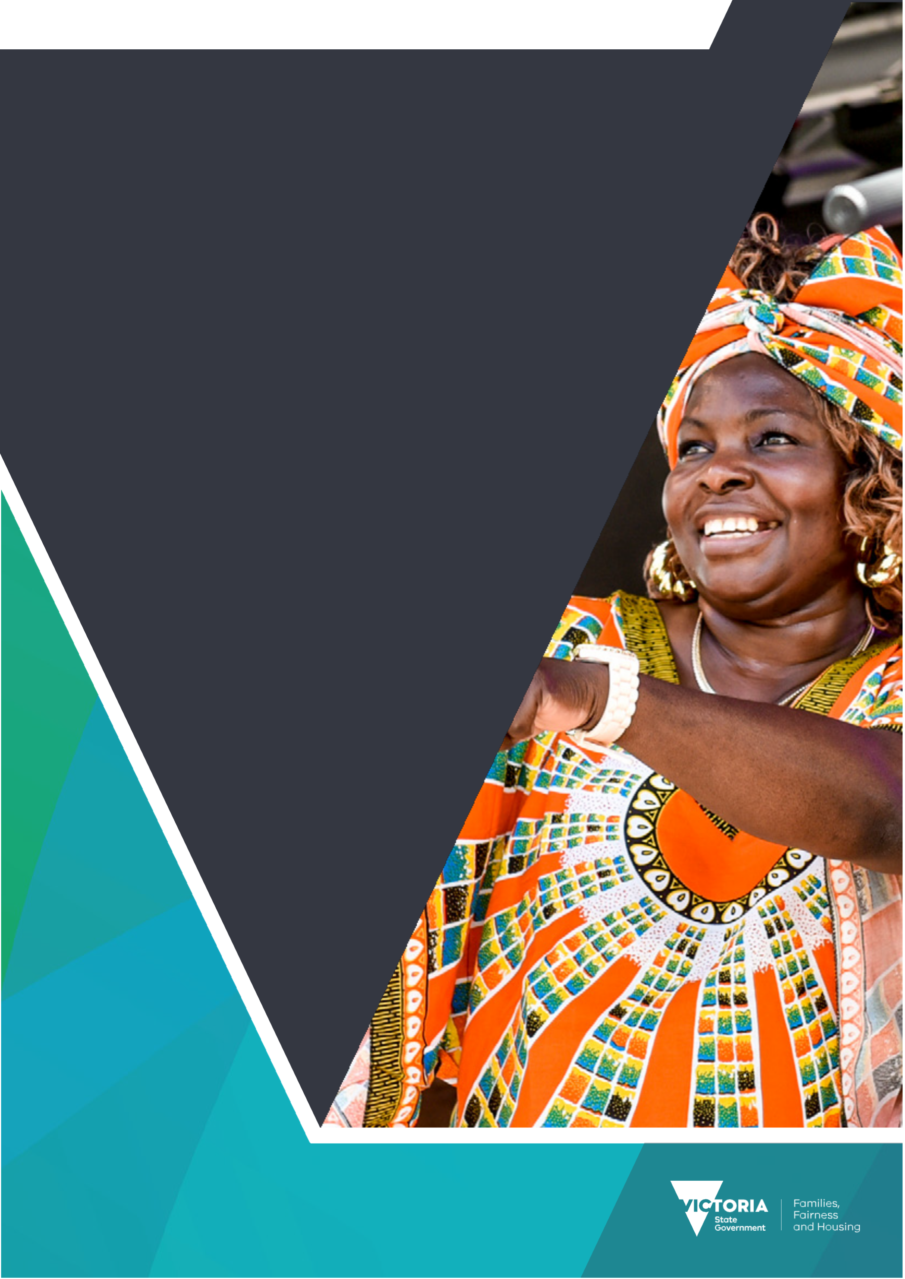
Victorian Government report on multicultural affairs 2019–2020
OFFICIAL

To receive this document in another format, email Multicultural Affairs <multicultural@dffh.vic.gov.au>.
Authorised and published by the Victorian Government, 1 Treasury Place, Melbourne.
© State of Victoria, Australia, Department of Families, Fairness and Housing, June 2021.
Except where otherwise indicated, the images in this document show models and illustrative settings only, and do not necessarily depict actual services, facilities or recipients of services. This document may contain images of deceased Aboriginal and Torres Strait Islander peoples.
In this document, ‘Aboriginal’ refers to both Aboriginal and Torres Strait Islander people. ‘Indigenous’ or ‘Koori/Koorie’ is retained when part of the title of a report, program or quotation.
ISSN 2205-8265 (online/PDF/Word)
Available at the Victorian Government website’s Victorian Government report in multicultural affairs page <https://www.vic.gov.au/victorian-government-report-multicultural-affairs>.
This work is licensed under a Creative Commons Attribution 4.0 International licence. You are free to re-use the work under that licence, on the condition that you credit the State of Victoria as author. The licence does not apply to any images or branding, including the Victorian Coat of Arms and the Victorian Government logo.
To view a copy of this licence, visit the Creative Commons website’s Attribution 4.0 International (CC BY 4.0) page <https://creativecommons.org/licenses/by/4.0>.
Machinery of government changes
On 1 February 2021 the Multicultural Affairs portfolio moved from the Department of Premier and Cabinet (DPC) to the newly created Department of Families, Fairness and Housing (DFFH). However, for the 2019–2020 reporting period the portfolio was supported within DPC. No reporting against DFFH is included as the department did not exist during 2019–2020.
Disclaimer
This publication is provided for information purposes only. No claim is made as to the accuracy or authenticity of the information contained herein. Information is provided on the basis that all persons accessing the information undertake responsibility for assessing its relevance and accuracy.
DFFH makes no representations, either expressed or implied, as to the suitability of the said information for any particular purpose and disclaims all liability for any error, loss or other consequence which may arise from you relying on any information in this publication.
Privacy
Your personal information will be dealt with in accordance with the Privacy and Data Protection Act 2014 (Vic) and the Public Records Act 1973 (Vic). DFFH is committed to protecting the privacy of personal information. At the time DFFH collects personal information about an individual from the individual, DFFH will advise you about how you can contact DFFH, the fact that you are able to gain access to the information, the purposes for which the information is collected and to whom DFFH usually discloses information of that kind.
Enquiries about access to personal information held by DFFH should be directed to multicultural@dffh.vic.gov.au.

Contents
Acknowledgements 5
Message from the Minister 6
Legal and policy frameworks that underpin this report 7
Working to achieve positive outcomes 8
Terminology, abbreviations and frequently used terms 9
Terminology used in this report 9
List of government departments 9
List of abbreviations and acronyms 9
The Victorian Government’s responses to crises 11
Bushfire supports 11
COVID-19 initiatives 12
Promoting multiculturalism 18
Victorians are safe and secure 18
Victorians are healthy and well 26
Improving health outcomes 26
Improving mental health outcomes 27
Housing security for all Victorians 28
Victorians are able to participate fully 30
Communicating with Victoria’s culturally and linguistically diverse communities 30
Disability support for multicultural communities 35
Multicultural communities education initiatives 35
Sports initiatives 38
Employment initiatives and projects 40
Multicultural community business support 41
Victorians are connected to culture and community 43
Community infrastructure projects 43
Multicultural festivals and events 43
Multicultural arts and culture initiatives 44
Victorians have equal rights and opportunities 48
Promoting rights and responsibilities 48
Freedom from discrimination – eliminating racism 49
Promoting human rights within government departments 50
Progress in departmental cultural diversity plans 52
Background 52
Departmental cultural diversity plans 53
Appendix 1: Culturally diverse representation on government boards, authorities and committees 66
Appendix 2: Indicators 68
Frequently used abbreviations in this section 68
Benefits of diversity 68
Social cohesion and participation 76
Accessible and responsive services 84

Acknowledgements
Victorian Government acknowledges Victoria’s Aboriginal and Torres Strait Islander communities and pays respect to their Elders past, present and emerging. We acknowledge Aboriginal and Torres Strait Islander people as Australia’s first people and as the Traditional Owners and Custodians of the land on which we live.
The Victorian Government would also like to acknowledge the important role of government partners, including local councils and service agencies, in the delivery of programs and initiatives reflected in this report. We would also like to thank all those who contribute to supporting multicultural communities across our state.
We would finally like to thank our government colleagues for their assistance in collating the data for this report as well as all the community members who shared their powerful stories in this report.

Message from the Minister
After a year of challenges, Victoria’s multicultural communities have emerged stronger than ever.
I am proud to present the Victorian Government report on multicultural affairs 2019–2020.
2019–2020 was an unprecedented period in the history of our state. As a result of the challenges Victorians faced, the government’s response was also unprecedented.
The 2019–2020 Victorian bushfires were extraordinary in their intensity and scope. Over the course of the summer, up to 55 consecutive fires burned 1.9 million acres of Victorian public and private land, resulting in the tragic loss of two lives and a State of Disaster being declared by the Premier.
The bushfire crisis was quickly followed by the COVID-19 pandemic, which lead to further loss of life and significantly affected the Victorian economy and the lives of all Victorians.
The Victorian Government has sought to help Victorians navigate these crises, with broad spending and investment commitments of over $49 billion being made over the next four years.
Our multicultural and faith communities faced unique issues in responding to these challenges due to additional language, cultural and socio-economic barriers.
This is why, in addition to the supports for the Victorian community more broadly, we have sought to deliver targeted support that is specifically tailored to multicultural communities.
In 2019–2020 the Victorian Government released several COVID-19 specific packages for multicultural communities including the COVID-19 Response Package, the International Student Emergency Relief Fund and the COVID-19 Multicultural Recovery Package. The government also invested $55 million in translating and interpreting services to communicate more effectively with multicultural communities.
While 2019–2020 was in large part overshadowed by the pandemic, it was not all about COVID-19. Life and our work went on. This report details many of the programs and projects the Victorian Government funded in 2019–2020 to continue to progress and uphold our commitment to multiculturalism in Victoria. This report highlights the many ways in which Victoria’s multicultural and faith communities continued to rise to the challenges presented by the pandemic.
I would finally like to acknowledge the efforts of all contributing government departments and staff who worked on this report, as well as thanking our community members who dedicate their time, effort and passion to supporting their communities and improving the lives of all Victorians. Now more than ever, it is imperative that we work together to realise the ideal of a vibrant, inclusive and multicultural Victoria.

The Hon Ros Spence MP
Minister for Multicultural Affairs

Legal and policy frameworks
that underpin this report
Victoria is among the largest and fastest growing states in Australia with over 28 per cent of our population born overseas from more than 200 countries. While this creates many exciting opportunities and benefits, it also requires the Victorian Government to have strategies and frameworks in place to guide multicultural policy and ensure effective service delivery to the Victorian communities.
The following are a range of legislative and policy documents used to guide our mission to create a community where all Victorians can enjoy the social, cultural and economic benefits of a dynamic and multicultural society.
This report fulfils a requirement of the Multicultural Victoria Act 2011, which requires government departments to report annually to the Minister for Multicultural Affairs and to the Victorian Parliament on programs and initiatives that support Victoria’s multicultural community.
Table 1: Victoria's multicultural frameworks
Type | Description
Acts of Parliament | - Multicultural Victoria Act 2011: Provides the framework for a whole of government approach to Multiculturalism in Victoria. The Act also establishes the Victorian Multicultural Commission as a statutory authority and requires the development and implementation of cultural diversity plans by Victorian Government departments.  - Equal Opportunity Act 2010: All Victorian departments and service providers have a positive duty under this Act to take reasonable and proportionate measures to identify and eliminate discrimination.  - Charter of Human Rights and Responsibilities Act 2006: Sets outs the basic rights of Victorians to live with freedom, respect, equality and dignity, and requires public authorities to act compatibly with the Charter.  - The Racial and Religious Tolerance Act 2001: Prohibits behaviours that incite or encourage hatred, serious contempt, revulsion or severe ridicule against another person or group of people because of their race or religion.
Victorian Government multicultural statement | A publicly available policy statement that sets out the Victorian Government’s vision and commitment to multiculturalism in Victoria
Departmental cultural diversity plans | Plans created by government departments to facilitate diversity and multiculturalism both internally and when delivering services and programs to the Victorian community.
Individual departmental policies, plan and strategies | Departments undertake reviews of policies, strategies and planning frameworks on an ongoing basis to respond to the changing needs of culturally diverse communities and to reflect the government’s commitment to multiculturalism

Working to achieve
positive outcomes
Our vision is to drive tangible improvements across government and ensure that every Victorian can belong, contribute, achieve and succeed.
At the heart of everything we do is the Whole of government multicultural affairs outcomes framework, which outlines the Victorian Government’s approach to multiculturalism in Victoria.
Table 2: Whole of government multicultural affairs outcomes framework
Goal | Desired outcomes for Victorians
Victorians are safe and secure | - Victorians live free from abuse, violence and fear  - Victorians have suitable and stable housing
Victorians are healthy and well | - Victorians have good physical and mental health  - Victorians have equitable access to health and human services
Victorians are able to participate fully | - Victorians participate in learning and education  - Victorians participate and contribute to the economy  - Victorians have financial security  - Victorians understand, are empowered by and exercise their rights  - Victorians have access to an environment that promotes liveability, sustainability and inclusion
Victorians are connected to culture and community | - Victorians are socially engaged and live in inclusive communities  - Victorians can safely identify with and connect with their culture and identity
Victorians have equal rights and opportunities | - Victorians live free from discrimination  - Opportunities to participate in the workforce are available to all Victorians
Within this report, programs and projects have been grouped under the framework’s five goals.
This report does not capture the full range of activities undertaken by Victorian Government departments and portfolio agencies. The purpose is rather to provide a snapshot of activities and achievements supporting multicultural and faith communities between 1 July 2019 and 30 June 2020 across the Victorian Government. Case studies to demonstrate the impact of initiatives on local communities have also been included.

Terminology, abbreviations
and frequently used terms

Terminology used in this report
To remain consistent and uniform, the term ‘multicultural communities’ has been used throughout this report to describe culturally, religiously and linguistically diverse Victorians.

List of government departments
Acronym | Department
DET | Department of Education and Training
DELWP | Department of Environment, Land, Water and Planning
DHHS | Department of Health and Human Services
DJCS | Department of Justice and Community Safety
DJPR | Department of Jobs, Precincts and Regions
DPC | Department of Premier and Cabinet
DoT | Department of Transport
DTF | Department of Treasury and Finance

List of abbreviations and acronyms
Acronym | Definition
CALD | Culturally and linguistically diverse
CCT | Cultural competency training
CDP | Cultural diversity plan
CFA | Country Fire Authority
CSV | Court Services Victoria
ESB | English-speaking background
LBOTE | Language background other than English
LGBTIQ+ | Lesbian, gay, bisexual, trans and gender diverse, intersex, and queer
LOTE | Language other than English
MESC | Main English-speaking countries
MFB | Metropolitan Fire Brigade
NMESC | Non-main English-speaking country
NDIS | National Disability Insurance Scheme
NESB | Non-English-speaking background
RRT 2001 | Racial and Religious Tolerance Act 2001
VEOHRC | Victorian Equal Opportunity and Human Rights Commission
VLA | Victoria Legal Aid
VLF | Victoria Law Foundation
VMC | Victorian Multicultural Commission
VRGF | Victorian Responsible Gambling Foundation

The Victorian Government’s
responses to crises
2019–2020 was a year like no other. In light of this, the Victorian Government extended a range of supports to Victorians and our multicultural communities to assist them in navigating the twin crises of bushfires and COVID-19.

Bushfire supports
The 2019–2020 Victorian Bushfires affected large parts of regional Victoria and with it emerging multicultural regional communities including the Bhutanese, Congolese and Sudanese communities. Significantly, there were also many examples of Victoria’s multicultural communities banding together to provide support for those impacted by the bushfires.
The 2019–2020 Victorian State budget provided $483 million for bushfire support to the Victorian community, including $124 million for Bushfire Recovery Victoria, a new agency working with bushfire-affected communities on clean-up assistance, rebuilding and personal support to survivors of the 2019–2020 bushfires. These supports provided to all bushfire affected Victorians, including multicultural community members.
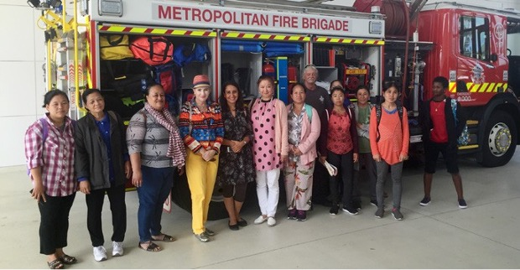
Children are among the most vulnerable groups in natural disasters. The Department of Education and Training (DET) supported children in bushfire affected areas to participate in a funded kindergarten program through the Bushfire Kindergarten Fee Subsidy (DET – $650,000). The Bushfire Kindergarten Fee Subsidy allowed multicultural Victorian children, in the bushfire affected local government areas of East Gippsland, Alpine and Toowong, to attend a funded kindergarten program free of charge in 2020.
The trauma and uncertainty of natural disaster can exacerbate family conflict, leading to heightened incidences of family violence. In 2019–2020 Gender and Disaster (GAD) Pod Sessions (Bushfire Recovery Victoria – $60,648 and MFB in-kind hours) were conducted by Fire Rescue Victoria Firefighter, Diversity and Inclusion and GAD Pod personnel in order to educate emergency management personnel to refer women experiencing family violence (including from multicultural communities) to services and provide support to them in emergencies and after disaster. The modules are based on research with Black Saturday survivors and health and community professionals who have worked in fire-affected communities and seek to deal with family violence in the unique circumstances of a disaster-type environment.
The Department of Justice and Community Safety (DJCS) also allocated $2.5 million for family violence from its Financial Counselling Program (DJCS – $12.5 million). Funding was provided to 13 agencies for the provision of face-to-face and telephone financial counselling to Victorian community members who are financially disadvantaged or experiencing family violence, including members of multicultural communities. Dedicated financial counselling was also provided to Victorians impacted by the 2020 Bushfires in the North East and East Gippsland areas.

COVID-19 initiatives
The ongoing COVID-19 pandemic was (and remains) an unparalleled global public health and economic crisis which resulted in the largest global recession since the Great Depression. In Victoria, employment fell by 180,000 between the March and September quarters in 2020.
Victoria’s multicultural communities were disproportionately affected by the impacts of COVID-19 due to language and cultural barriers, socioeconomic barriers and the fact that many multicultural Victorians work in industries that were most impacted by the pandemic.
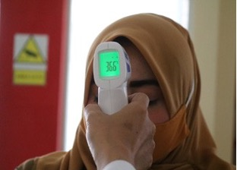
Without record levels of government support, these impacts would have been more significant. To counter the challenges posed by the pandemic, the Victorian Government committed $29.2 billion over four years in spending and $19.8 billion of investment in Victoria’s economic recovery.
The government also provided direct packages to support Victoria’s multicultural communities in recognition of the unique issues and challenges faced during this difficult time. While several major COVID-19-specific supports are listed below, many are also interspersed throughout other sections of this report.
The Department of Premier and Cabinet (DPC) in collaboration with the Department of Health and Human Services (DHHS), DJCS and Family Safety Victoria were allocated $11.27 million over two years (2019–2021) for the COVID-19 Response Package (DPC – $11.27 million over two years). The funding package includes nearly $5 million to support vulnerable and at-risk multicultural youth and families in financial hardship who need essential items such as food and clothing. It also provided basic needs assistance to thousands of asylum seekers and $1.1 million toward culturally appropriate family violence prevention and early intervention services.
Income insecurity was a big issue in the early stages of the COVID-19 pandemic with many companies reducing staff due to uncertainty about the future. The Migrant Workers Centre (DPC – $210,000) continued to respond to mistreatment and workplace issues faced by migrant workers and international students. During 2019–2020 the Centre helped migrant workers to recover over $1 million in stolen wages and worker entitlements. The Centre also referred 505 migrant workers to appropriate services and delivered 39 culturally appropriate training sessions on workplace rights and safety to migrant worker communities.
International students were also greatly affected by the COVID-19 pandemic with many students finding themselves in Australia much longer than anticipated with limited employment or financial supports. On 29 April 2020 the Victorian Government via the Department of Jobs, Precincts and Regions (DJPR) announced the International Student Emergency Relief Fund (ISERF) (DJPR – $12.65 million). The fund was the largest single investment in Australia to support the international student community during the COVID-19 pandemic. ISERF provided grants of up to $1,100 to eligible international students and was delivered in partnership with Victoria’s tertiary education providers. It also provided immediate support to international students in Victoria experiencing substantial hardship through lost wages and work as a result of the COVID-19 pandemic and reinforced Victoria’s reputation as a high-quality, safe and welcoming study destination.
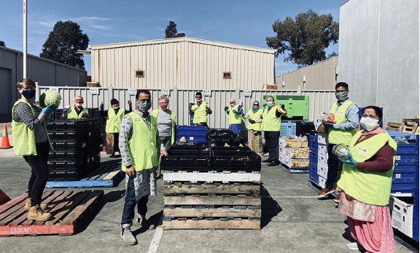
Access to safe and secure housing is a fundamental tenet of the Victorian Government’s approach to social equity. DHHS provided COVID-19 Rent Relief Grants (DHHS – $3.62 million) to alleviate rental hardship within the Victorian community during the pandemic with payments of up to $3,000 available to Victorian tenants who lost income as a result of COVID-19. Multicultural Victorians without permanent residency or citizenship were also eligible to apply for the grant and were a key target demographic due to the particular financial vulnerabilities experienced by this group.
DHHS also provided basic needs and homelessness assistance to multicultural communities within the Mental Health COVID-19 support package (DHHS – $450,000), which funded community organisations including International Students Victoria, the Red Cross and the Asylum Seeker Resource Centre. The funding enabled these organisations to deliver more case work, basic needs assistance and homelessness support to asylum seekers and other temporary migrants suffering hardship due to the impacts of COVID-19 on their living conditions
Aware of the significant challenges of remote learning faced by Victorian children in 2019–2020, DET created a COVID-19 component, named the ‘Learning from Home’ menu item for the School Readiness Funding (SRF) Project (DET – total funding of $160 million over four years). Children’s Services specifically updated their Cultural Inclusion Support Packages item on the SRF menu to include support for kindergarten services to engage multilingual families and children learning from home and to support returning to kindergarten. DET also implemented several learning adaptations to better cater to multicultural students including:
- expanding and promoting its telephone interpreting services
- translating resources into languages not previously translated, with a priority on key languages spoken by refugee communities
- creating a multicultural campaign to communicate the staged return to on-site schooling.
The COVID-19 pandemic required many faith-based community organisations to suspend in-person religious gatherings, activities and services. The Victorian Government recognises that the continuation of faith-based supports and practices is critical to community wellbeing. With funding provided by DHHS, the Multicultural Affairs Portfolio within DPC coordinated support to faith-based communities through the Digital Engagement for Faith Communities Program (DHHS – $300,000) to support religious organisations to video or audio record and broadcast their services and prayers digitally and provide pastoral care and support over the phone rather than in person.
The Multicultural Community Connections Program (MCCP) (DPC – $1.13 million over two years) also supported multicultural and multifaith organisations to strengthen community connections that had been impacted by social distancing and health and economic restrictions due to COVID-19. To ensure broad coverage of faith and multicultural communities, the program provided over 200 grants of between $4,000 and $25,000 to multicultural and multifaith community organisations to enhance information technology capacity and cover volunteer costs associated with the delivery of community programs during the pandemic.
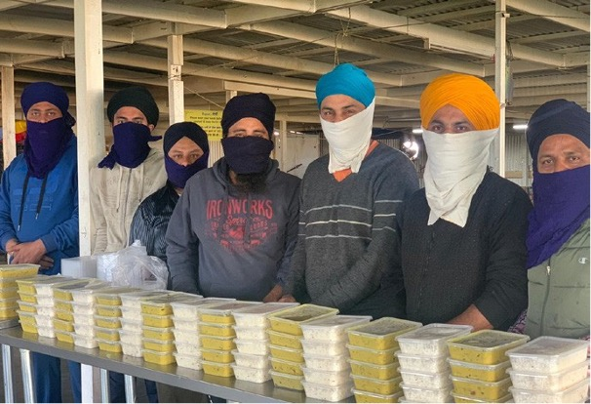
The Victorian Government also allocated funding to the Digitising Outreach for Migrants and Asylum Seekers Program (DPC – $220,000). The program enabled community organisations to provide quick and remote support to asylum seekers and vulnerable multicultural communities while broader supports were adjusted to deal with the crisis. Projects funded included initiatives such as: emergency support for asylum seekers, bilingual volunteer settlement mentors, a work skills database for newly arrived communities, local anti-racism campaigns and digital literacy training.
The Northern Community Support Group (DJCS – $547,000) was funded to assist Muslim communities in the northern suburbs within the City of Hume, Darebin and Moreland to transition existing services to online platforms including multilingual public health information streamed online by community leaders and young Imams. Webinars were hosted on issues related to mental health and family violence. A youth lecture series was delivered, addressing issues around identity and belonging, and online fitness classes were run for young women.
DHHS provided additional COVID-19 Funding to Family Safety Victoria Agencies (DHHS – $465,000) to enhance their capabilities to continue to support victim survivors of family violence from marginalised multicultural communities during the pandemic.
The Victorian Multicultural Commission, through its Community Support Fund and the repurposing of other funds, allocated $187,000 to support projects aimed to enhance social cohesion and connection during the pandemic (VMC – $187,000).

Funded projects included:
- professional development for early career refugees and people seeking asylum in regional Victoria
- an online mental health hub for multicultural and multifaith Victorians
- refugee and asylum seeker emergency food relief
- training for multicultural frontline workers to respond to family violence
- a skills and support program for women impacted by abuse, trauma and isolation.
Digitising outreach for migrants and asylum seekers: the Karen community COVID-19 hotline
As part of the Digitising Outreach for Migrants and Asylum Seeker Program, Bendigo Community Health Services used available funding to provide a free telephone hotline for the Karen language community. Community members were able to call the hotline to talk with Karen speaking staff about questions or concerns regarding COVID-19.
This allowed community members with limited English and literacy skills to receive critical and tailored health information during a time when restrictions were changing regularly and helped the local community to stay safe and comply with current public health directions.
The Karen hotline answered questions relating to restrictions and directions, the COVID-19 testing process and access to testing sites, general health access, emergency support (financial and food relief) and how to deal with social isolation. The program was a resounding success and, although the hotline was established to assist local Karen speaking residents in Bendigo, it ended up receiving calls from all over the state, with more than 1,000 calls being answered.
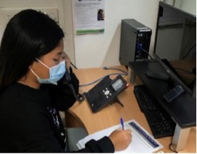
One of the Karen hotline staff working with an incoming call

Promoting
multiculturalism
Victoria is at its best when our multiculturalism is embraced, promoted and celebrated. Below are some of the programs the Victorian Government delivered in 2019–2020 to realise our vision of a strong, vibrant and multicultural Victoria.

Victorians are safe and secure
A successful multicultural society is underpinned by a sense of security, safety and justice. The Victorian Government remains deeply committed to building a safe, inclusive and vibrant multicultural Victoria that is free from crime and the scourge of family violence.

Family violence prevention
Domestic violence inflicts a pervasive and harmful toll on the victims of abuse and on the community more broadly. In 2019–2020 Victorian Government departments worked to deliver family violence preventative measures and supports to assist victims of family violence within multicultural communities.
In 2019–2020 DHHS provided funding to two agencies (DHHS – $3.9 million) – inTouch Multicultural Centre Against Family Violence and the Australian Muslim Women’s Centre for Human Rights – to deliver a range of culturally appropriate and tailored initiatives to support victims of family violence including dedicated victim support, assistance finding emergency housing and counselling to victims of family violence in multicultural communities.
Family Safety Victoria (a statutory authority reporting to DHHS) also continued its work on the Safety and Support Hubs Initiative (DHHS – $34.19 million) via the Orange Door Program which provides supports to adults and children experiencing family violence. To specifically support multicultural communities in the context of family violence, the Orange Door provides interpreting and translating services, displays language assistance posters in all Orange Door hubs, conducts cultural safety and responsiveness training for the Orange Door workforce and provides targeted information sessions for multicultural community members such as women on temporary visas.
The Building the Evidence – Interventions for People Who Use Violence in Diverse and Minoritised Communities (DHHS – $391,310) initiative builds on a recommendation by the Royal Commission into Family Violence for perpetrator interventions in specific cohorts (including multicultural communities). The program focuses on the culturally appropriate use of interpreters and facilitators who belong to the Hazara and South Asian communities, to change family violence behaviours.
It is recognised that women on temporary visas (most of whom have one or more children), are particularly vulnerable and have extremely limited exit options when experiencing family violence due to language barriers, primary care giving responsibilities and financial power imbalances.
To address this, DHHS provided funding support for the Women on Temporary Visas in Refuges Project (DHHS – $1.7 million). The funding support assists refuges to cover living costs, material aid and fees associated with migration applications for women on temporary visas while they seek more permanent shelter.

Keeping our multicultural communities safe
Every Victorian deserves to live in a safe community free of crime, violence and preventable accidents and the Victorian Government continues to be committed to supporting our multicultural communities in combating crime and violence and accidents involving fire and water safety.
The Youth Crime Prevention Grants Program (DJCS – $18 million over four years) supports a range of community projects across Victoria designed to prevent youth crime, with many projects supporting multicultural young people. For example, a Youth Crime Prevention Grant project in the Wyndham area of Melbourne ($1.4 million over four years) provides a targeted and collaborative community response to youth offending, catering to young people aged 15 to 24 years who are demonstrating recidivist behaviour, with the project including specific provisions to support young people from migrant and refugee backgrounds.
Prevention is also the focus of DJCS’s Sports Alliance for Crime Prevention (DJCS), which is a partnership with the AFL, Melbourne Storm, Basketball Victoria, Football Victoria and Netball Victoria to support and better engage young people from multicultural backgrounds to participate in sport and address risk factors that contribute to youth offending.
Also in the early intervention space, the Northern Community Support Group (DJCS – $1.4 million) supports Melbourne’s Muslim communities with employment, education and community resilience programs for women, families and young people, as well as building connections with police and support services to reduce disadvantage, anti-social behaviour (including violent extremism) and improve a sense of belonging.
Prompt and culturally sensitive support are important factors in reducing youth recidivism and in light of this the Embedded Youth Outreach Project (Victoria Police – $1.4 million) embeds a specially trained youth worker with members of Victoria Police to respond as secondary units to police events involving multicultural youth. Young people are engaged by the social worker at the critical time of police contact with referrals to culturally appropriate support services to minimise repeated contacts with police.
DJCS has employed Community Engagement Officers and Cultural Liaison Officers to bolster cultural understanding and engagement with young African Victorians in contact with the youth justice system. The officers develop supportive linkages between young people, their families, justice agencies and African communities. They also work with youth justice case managers to strengthen cultural practice in the case management of young offenders. Cultural Liaison Officers operate in custodial centres.
Community engagement and support are also important when it comes to local crime prevention. In 2019–2020 Victoria Police held several community forums within the Hume and Moonee Valley council areas to allow multicultural community voices to be heard on local policing and crime prevention matters.
South Sudanese community leaders and elders also met with Youth Justice custodial leadership several times in 2019–2020 to discuss and work towards improving outcomes for young South Sudanese Victorians in custody. The Youth Parole Board ran a consultation forum on young South Sudanese Victorians involved in Youth Justice with key leaders and representatives from the South Sudanese community.
Embedding multicultural community members at all levels of the justice system is also key to creating a criminal justice system that works well and better meets the diverse needs and challenges faced by multicultural communities. The Jobs Victoria Innovation Fund (JVIF) (DJPR – $174,000) works in conjunction with Victoria Police and the Protective Services Cultural Inclusion Employment Initiative, to provide pathways for African Victorians to become police or protective service officers. The program takes a collaborative approach with several community organisations working together to deliver preparatory training to help applicants pass the Victoria Police Entrance Exam and successfully complete the recruitment process.

Road safety and transport
Many multicultural Victorians originate from countries with different road rules, signage and social norms. The Victorian Government is committed to providing adequate supports to these community members to improve driver safety outcomes for themselves and all road users.
In 2019–2020 DoT continued to deliver the VicRoads L2P Mentoring Program (DoT – $6.1 million) which supports refugees and people from newly arrived communities to complete the 120 hours of supervised driving required to obtain a car driver licence. Community partners delivering the program are trained in cultural awareness and mentors are drawn from the multicultural communities they serve where possible. The Road Safety for New Arrivals Program (DoT – $208,300) likewise assists newly arrived migrants and people from multicultural backgrounds to enable them to increase their road safety knowledge, awareness and skills, the program also provides funding towards professional driving lessons.

Road safety for new arrivals: Zainab’s story
Zainab was a participant in the Road Safety for New Arrivals Program. Zainab’s family were refugees from Afghanistan who moved to Australia and were relocated to Mildura. Living in the region, coupled with the fact she did not have a driving licence, limited Zainab’s study and work opportunities.
Before participating in the program, Zainab had almost no familiarity with driving and was unfamiliar with Victorian road rules, which is a common experience for newly arrived communities. The program was designed to help people learn the rules and improve driver safety outcomes.
As a result of participating in the program, Zainab was able to learn driving skills and Victorian road rules and obtain a licence, which enabled her to take up additional work and study opportunities.
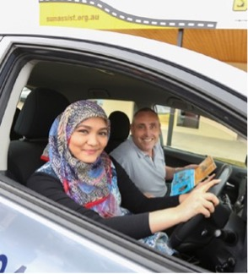
Zainab participating in the RSNAP

Fire and water safety
International students are a particular focus of the Victorian Government’s fire education programs because many are living away from home for the first time. In light of this, Fire Rescue Victoria and a partnership of fire and rescue agencies delivered joint messaging to international students via ‘orientation week’ programs across university sites in 2019–2020.
New guards in the swim: African lifeguards employed in Melbourne’s north west
A trailblazing team of lifeguards and swim instructors, who once struggled in the water themselves, have taken to pools across Melbourne’s north. Fifteen young men and women of Somali background have trained for nearly two years as part of an effort to tackle worrying levels of water safety skills among multicultural communities.
‘It was a long process but they stuck with it,’ Life Saving Victoria’s Manager of Multicultural Projects, David Holland said. ‘They pushed through it and now they are giving back to the wider community. These people are paving the way for others.’
As a result of the program, six female Somali swim teachers and nine male Somali lifeguards, aged from 17 to 30, are now working at public pools in Northcote, Reservoir, Coburg and Maribyrnong.
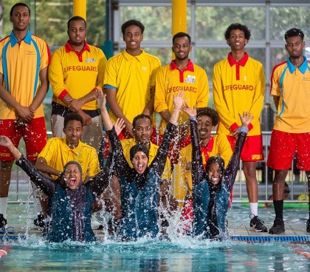
The graduating class of new lifesavers
Agencies also reinforced the need to have working smoke alarms and handed out kitchen utensils with messaging such as ‘never leave cooking unattended’ in several target student language groups.
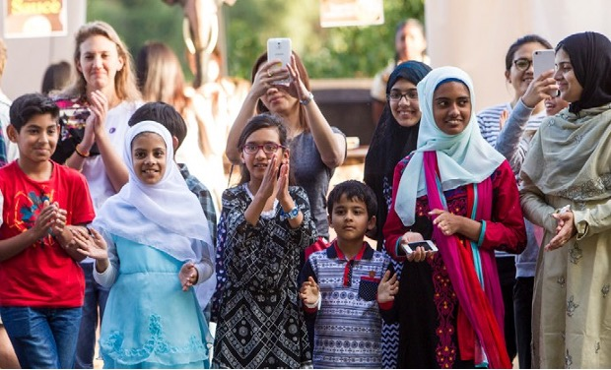
The Country Fire Authority (CFA) also funded the Home Fire Safety Advice Visit Service (CFA – $15,578 for the multicultural community engagement component). The CFA provided tailored education to multicultural communities with bilingual staff running fire safety sessions over the phone during 2020 with support of external providers. Karen and Afghani communities were the focus of this initiative. The Home Fire Safety Advice Visit Service also provided smoke alarms and fire blankets to new migrants and refugees who participated in the fire safety education through the New Arrivals Orientation Program.
Victoria is a state that has some of the world’s most beautiful yet treacherous ocean waters. This presents specific challenges to multicultural community members who often come from landlocked countries or cities with little exposure to the unique and potentially dangerous nature of ocean water.
Life Saving Victoria through DJCS funded the Lifesaving Victoria Program (DJCS – $365,000). The program had 21,500 people participate in water safety education. Initiatives included ‘meet a lifeguard’ sessions, ‘resuscitate a mate’ training and a month-long multicultural ‘play it safe by the water’ campaign targeted at multicultural community members.

Tackling gambling harm in multicultural communities
Multicultural community members can be particularly vulnerable to gambling harm due to language and social barriers as well as feeling isolated and alone in a strange place.
In order to address this, the Victorian Responsible Gambling Foundation (VRGF) funds the CALD Gambler’s Help Program (VRGF – $1.1 million).
During 2019–2020, the program provided funding to several community organisations to enable them to deliver counselling and gambling harm prevention activities, as well as a mix of in-language culturally appropriate therapeutic and financial counselling by counsellors. The organisations also provide culturally appropriate education and gambling harm prevention activities to their communities. Other gambling harm assistance programs included Chinese Peer Connection (VRGF – $139,028), which provides telephone-based confidential peer support services across Victoria to Chinese Victorians impacted by gambling harm whether they be gamblers or, gamblers’ friends or family. The service is delivered in Cantonese, Mandarin and English by trained volunteers who have lived experience of gambling harm.
The Victorian Responsible Gambling Foundation is also funding gambling help innovation via the Prevention Partnerships Program (VRGF – $958,760) which aims to prevent gambling-related harm through initiatives that test new ideas and deliver prevention activities to at-risk communities across Victoria.
During 2019–2020, the Victorian Responsible Gambling Foundation awarded grants for 14 projects including reducing gambling harm through alternative recreation activities for young people with migrant and refugee backgrounds, building the capacity of Cambodian community leaders (including monks) in Melbourne’s South East to raise awareness of gambling harm within the community and engaging leaders in the Somali community in prevention strategies that empower community members to take ownership of the ‘conversation’ about gambling harm.

Culturally appropriate gambling harm support
Samir (deidentified), a 45-year-old Lebanese refugee from Syria, sought support from the ‘QOWEH’ gambling counselling service offered through Arabic Welfare under the CALD Gambler’s Help Program, funded through the Victorian Responsible Gambling Foundation.
While travelling to Australia, he suffered significant trauma including witnessing the drowning of his two close companions as their boat sank and enduring horrific cold temperatures and harsh treatment by people smugglers.
Living alone in Australia while his family remained in Syria, Samir was introduced to pokies by a neighbour. What initially started as a social activity, quickly became a way for Samir to mask his psychological pain. This escalated into an addiction which led to him waiting all night in the CBD near an ATM to access his Centrelink payment only to quickly lose it to gambling.
An initial assessment by a therapeutic counsellor named Roba allowed Samir to build trust in Arabic Welfare and the counselling process.
Roba’s unique understanding of the Arabic language, culture and politics, as well as experience working with clients with experience of trauma associated with war and forced displacement, was critical in allowing Samir to feel safe ‘opening up’ and to share his problems with gambling.
Roba connected Samir with mainstream mental health clinicians, including a trauma specialist, and helped him to sign up to the ‘self-exclusion’ list banning him from all pokies venues in Melbourne including the casino.
Samir now reports feeling more in control of his gambling, has reduced negative self-talk and feels a sense of achievement and hope. QOWEH will continue to work with Samir as he rebuilds his life.
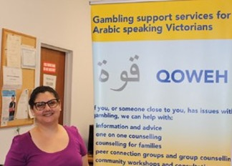
Roba is a therapeutic counsellor at QOWEH, the Arabic Gambler’s help service delivered by Arabic Welfare

Victorians are healthy
and well
The Victorian Government is committed to effective and accessible healthcare for all Victorians and understands that the healthcare challenges faced by Victoria’s multicultural communities are unique and varied and require a culturally sensitive approach.

Improving health outcomes
The COVID-19 pandemic shone a light on the importance of health education and good practice as well as the mental health challenges faced by vulnerable Victorians including multicultural communities. In 2019–2020 the Victorian Government allocated funding to the following programs and initiatives to assist multicultural Victorians with better health and mental health awareness and treatment.
The Healthy Mothers Healthy Babies Initiative (DHHS – $3.96m) is a non-clinical support program that aims to maximise the health and wellbeing of vulnerable pregnant women and their babies during the ante-natal period with refugee mothers being among the priority groups. The program seeks to address poor birth outcomes associated with risky behaviours such as smoking, alcohol and drug use, inadequate nutrition and insufficient exercise.
Continued funding was provided for the Refugee Health Program (DHHS – $6.314 million). Started in 2005, the program seeks to increase refugee access to primary health services to improve their short and long-term health outcomes through early health assessment, referrals to healthcare providers and doctors and active healthy lifestyle promotion.
DHHS also provided health and mental health support to asylum seekers via the Stepping in to Support Asylum Seekers Program (DHHS – $3.01 million). This initiative delivered case coordination, employment pathways support, basic needs and homelessness assistance, legal assistance and mental health and GP support to people seeking asylum who were ineligible for Commonwealth safety net supports. The program provides case coordination and the provision of basic needs such as food, transport, medicine, infant necessities and clothing, as well as face-to-face and teleconference legal assistance.
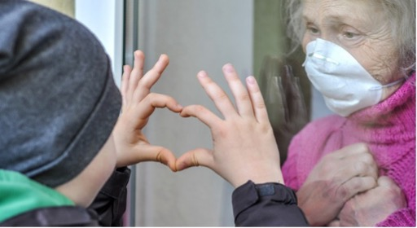

Improving mental health outcomes
Having a solid mental health framework for Victoria’s multicultural communities is extremely important because many multicultural community members come from troubled or war-torn environments that have left lingering traumas and mental scars. The Victorian Government seeks to provide culturally sensitive supports to multicultural Victorians so they can overcome mental health challenges and live happy, fulfilling lives within the Victorian community. In 2019–2020 more than 4,000 hours in targeted mental health support was delivered to vulnerable members of Victoria’s multicultural communities.
DHHS also committed to a one-off $598,000 payment for a COVID-19 Mental Health Component (DHHS – $598,000) within the Federal Government’s broader April 2020 COVID-19 Mental Health Funding Package. Under this component, funding for mental health services was provided to a range of mental health partners and included a range of services to work with people of refugee and asylum seeker backgrounds as well as members of multicultural communities to help manage the changing and challenging mental health conditions brought on by the COVID-19 pandemic.
Victorian students were also greatly affected during protracted lockdowns and DET committed $6.25 million for the Mental Health Practitioners Initiative (DET – $6.25 million in 2019–2020 with a program total of $51.2 million). The initiative expanded mental health support to Victorian students and allowed secondary schools across the state to employ over 190 qualified mental health professionals such as social workers, psychologists, occupational therapists and mental health nurses. Many of these practitioners will work specifically with students from multicultural communities and will seek to provide a nuanced and culturally appropriate mental health service to best meet students’ needs.
Victoria Police also developed the Youth Suicide Postvention Protocol in response to a spate of suicides of young men from Victoria’s South Sudanese community. The project aims to coordinate the involvement of government agencies immediately following a young person’s suicide to create a culturally sensitive response with a focus on minimising the risk of clusters following a youth suicide event.

Housing security for all Victorians
The Victorian Government is committed to safe and affordable housing for all Victorians and understands that multicultural community members face significant housing challenges which have been exacerbated by the impacts of the COVID-19 pandemic.
Both the Mental Health COVID-19 Support Package and the Support for Victoria’s Multicultural and Faith Communities included a casework, basic needs and homelessness assistance component (DHHS – $450,000 and $925,000). These components funded caseworkers, the purchase of basic needs and homelessness assistance for people seeking asylum and other temporary migrants experiencing vulnerability and housing insecurity due to the impacts of the pandemic.
The Tenancy and Consumer Program (DJCS – $3.8 million) provided funding to 12 community agencies for the provision of information and advocacy assistance for vulnerable tenants including members of CALD communities. In 2019–20 the program assisted 8,155 disadvantaged tenants and consumers.
Support was also provided to multicultural community members experiencing (or at risk of experiencing) homelessness via the Housing Support for Multicultural Community Members Program (DHHS – $337,378). The program focused on connecting vulnerable multicultural community members with services including a housing-related range of family, disability, aged care, mental health, employment and alcohol and drug services.

Public Housing Renewal Program
The Public Housing Renewal Program (funded by DHHS and delivered by Homes Victoria) is redeveloping seven ageing public housing estates across Melbourne. Housing staff worked closely with tenants on their relocation to a new home of their choice.
Cindy (deidentified) is a single parent with one child and speaks only Mandarin so, from initial contact, program staff utilised an interpreting service.
The interpreter was able to help Cindy to feel comfortable in this very stressful and unfamiliar situation. The interpreter attended multiple interviews with Cindy regarding her application and also attended numerous property viewings with her. This was important as it assisted the Homes Victoria team to find an appropriate home with the attributes and amenities Cindy and her daughter required.
When the time came to sign a new lease, the interpreter was able to ensure details were conveyed to Cindy accurately from English to Mandarin. This was a great comfort and relief to Cindy as she was highly anxious about the relocation process. Cindy was relocated to a suitable two-bedroom home that she and her daughter have now resided in for over 15 months.


Victorians are able to
participate fully
Victorians from multicultural communities often come to Victoria facing significant challenges including, language and cultural unfamiliarity, financial disadvantage and a lack of vital support and community networks. The Victorian Government understands that the participation of all Victorians is what makes our state the dynamic and vibrant place it is and regularly invests in communicating with and engaging our multicultural communities.

Communicating with Victoria’s culturally and linguistically diverse communities
The impacts of COVID-19 in Victoria highlighted the critical importance of effective and clear communication with our multicultural communities. DHHS, in particular, communicated with 56 specific linguistically diverse groups impacted by COVID-19 via interpreting and media campaigns. This required significant grassroots community engagement through trusted community leaders, providing community members with information through a variety of mediums and languages on symptomology, testing, precautionary measures and further supports available.

Interpreting and translation services
While the COVID-19 pandemic engaged significant language resources, other interpreting and translation services to multicultural communities continued. DET’s Language Services Program (DET – $2.5 million) continued to provide funding to Victorian Government schools to access interpreting and translation services.
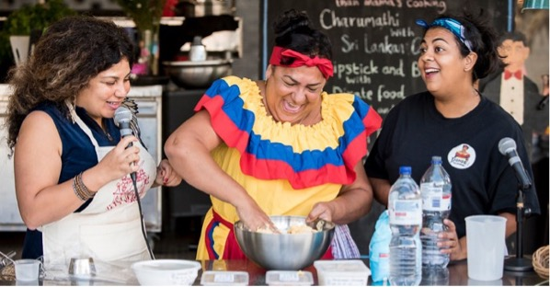
The program also enables multicultural families to provide and receive key information about their child’s education in their own language and enables families to provide and receive information regarding their child’s health and development including at the kindergarten and early childhood stages.
Other language services in 2019–2020 included the continuation of the DHHS Language Services Innovation Grants (DHHS – $155,000). The 2019–2020 funding round delivered several grants of between $22,500 and $45,000 to improve language services in hospitals.
Projects goals included:
- Better video-interpreting for home-based patient care
- Improving communication with people from diverse linguistic backgrounds in a healthcare setting
- Improving patient access to interpreting services in emergency departments
- Exploration of the accuracy of an instant translation device and design
- Development of a multi-language maternal health education video.
DPC also continued to fund the Interpreter Scholarship Program (DPC – $418,525). The program aims to bolster Victoria’s supply of qualified interpreters so that non-English speakers can better access crucial government services, such as health care and housing support. 367 students completed their qualifications via the program in 2019–2020. Many of them will go on to complete their National Accreditation Authority for Translators and Interpreters certification within two years.
Table 3: Departmental expenditure on interpreting, translating and language allowance services
Department | Amount spent on interpreting and translation 2019–2020 | Percentage of total departmental expenditure on translation
CSV | $4,452,792 | 8.08
DELWP | $22,332 | 0.04
DET | $2,427,200 | 4.40
DHHS | $42,563,516 | 77.20
DJCS | $3,180,629 | 5.76
DoT | $1,986,702 | 3.60
DPC | $152,154 | 0.27
DJPR | $207,845 | 0.37
DTF | $137,473 | 0.24
Total | $55,130,643 | 100
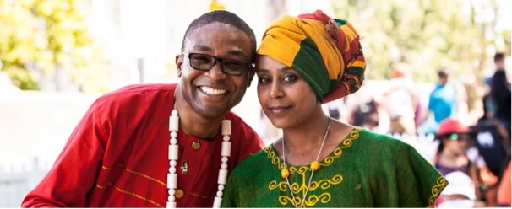

Culturally and linguistically diverse multicultural media campaigns
Multicultural media campaigns are an effective and targeted way of informing and connecting with diverse communities in languages and mediums that are familiar. In light of this, all Victorian Government departments have a longstanding requirement that departments and agencies must spend a minimum of 5 per cent of their campaign media budget on multicultural media.
Media campaigns vary by departmental function and the service they seek to provide. Examples of multicultural media campaigns in 2019–2020 include:
- Introduced during the peak of the COVID-19 pandemic, DELWP’s energy and affordability media campaign aimed to raise the awareness of Victorians, including multicultural Victorians, that they were eligible to receive help with energy bills if they were experiencing financial difficulty. DELWP also identified that people in the Vietnamese and Iraqi communities face barriers to energy affordability, including language and business understanding barriers. To counter this DELWP launched an Energy Information for CALD Communities Campaign that produced in-language energy information pamphlets to assist in understanding one’s rights in the energy market and how to save money on energy bills.
- DJPR’s multicultural community business support fund campaign promoted $10,000 Victorian Government grants available to Victorian businesses impacted by the COVID-19 pandemic. This advertising campaign was complemented by an online multicultural stakeholder campaign via the Victorian Multicultural Commission and community organisations.
- DoT, via the Victorian Fisheries Authority, took a lead role in providing water safety information, in multiple languages, to reduce drownings associated with fishing. The campaign was primarily targeted at Chinese and Vietnamese communities.
- The Victorian Responsible Gambling Foundation funded the Effects of Gambling campaign aimed at multicultural communities to raise awareness and understanding of gambling harm.
- DHHS produced multiple COVID-19 public information campaigns to inform Victorians how to not catch COVID-19 and how to stop the spread of the virus and to share key public health advice.
- DPC’s ‘Staying Apart Keeps Us Together’ campaign commenced in May 2020 in light of the increase in COVID-19 infections and was translated into 18 languages. It highlighted the actions and behaviours necessary to keep communities and the broader Victorian community safe.
- DET also ran the Three-Year-Old Kinder Communications Campaign, targeting Victorian parents and carers and their influencers in 15 rural and regional local government areas. The campaign included in-language, geo-targeted advertising on social and digital channels to drive audiences to translated materials (12 languages) on the campaign website. This advertising approach was complemented by translated communications assets provided to the early childhood sector, including local kindergarten services and providers, to assist with promotion to families.
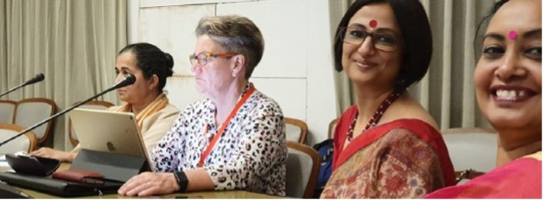
Table 4: Multicultural media campaign expenditure as percentage of total media campaign expenditure by departments, 2018–2019 and 2019–2020
Department | 2018–2019 (%) | 2019–2020 (%)
DELWP | 4.0 | 7.4
DET | 4.6 | 5.5
DHHS | 6.9 | 7.9
DJCS | 8.8 | 5.0
DTF | 0 | 0
DoT | 6.2 | 5.5
DJPR | 0.5 | 5.4
DPC | 4.6 | 8.9

Table 5: Total departmental multicultural media campaign expenditure as percentage of total media campaign expenditure
Financial year | Multicultural expenditure as percentage of total expenditure
2019–2020 | 7.6%
2018–2019 | 5.0%
2017–2018 | 5.2%
2016–2017 | 6.0%
2015–2016 | 5.5%
2014–2015 | 5.8%

Rail Projects Victoria: community engagement in Kensington
The suburb of Kensington is diverse with a high percentage of community members having both parents born overseas, with many community members speaking Mandarin, Cantonese and Vietnamese.
Due to the Metro Tunnel works, Rail Projects Victoria (RPV) launched media campaigns to advise residents about associated disruptions that were scheduled to occur in the area.
As there were low levels of English speaking within the community, traditional forms of communication distributed to the broader community like eDMs (electronic direct mailing) and community reference groups did not produce high engagement with several key multicultural community groups.
To address this problem and better engage with the community, translated fact sheets were developed in the three target languages, advising multicultural community members and businesses about the project and associated disruptions.
The translated fact sheets provided benefits to the community including increased engagement with historically under-engaged cohorts in the Kensington area, increased awareness of project activities and disruptions and a demonstration of RPV’s ongoing commitment to engaging diverse community.
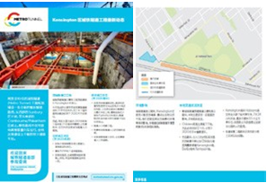
Translated community information brochures

Disability support for multicultural communities
Victorians with disabilities are amongst our most vulnerable and disadvantaged citizens. Members of multicultural communities in Victoria may be further marginalised due to the fact they also often face language, socio-economic and cultural barriers in accessing disability support services. The Victorian Government is committed to helping all Victorians with disabilities to lead productive and fulfilling lives. Here are some of the projects worked on in 2019–2020 to assist multicultural Victorians with disabilities.
DET’s Early Childhood Intervention Services Funding to Non-Australian Resident Children with Disabilities (DET – $1.2 million) provides therapy, counselling, information and parent education to support non-Australian children with disabilities and their families. The 2019–2020 funding allocation provided assistance to 120 young children aged 0 to 6 years with a disability or developmental delay who were ineligible for the National Disability Insurance Scheme (NDIS) due to non-Australian residency.
The Equipment Boost for Schools Initiative (DET – $5.1 million) also served to enhance inclusive education practices to provide better supports for the diverse learning needs of multicultural students with disabilities and additional learning needs by funding new equipment and assistive technologies to enable students to fully participate, learn, develop and succeed in school.
Demand for workers within the NDIS has outstripped supply and DHHS has sought to address this via the Future Social Services Institute (DHHS – $2 million). The program seeks to attract people from multicultural communities to undertake a career in the disability sector. A group of women from East African communities is currently being supported to complete a Certificate III in Individual Support (Ageing and Disability). DHHS also provided funding for the Victorian Regional Readiness Fund (DHHS – $120,000). The funds support the AMES Australia ‘CALD Workforce Ready’ Program to engage multicultural community members in the Gippsland area to work within the disability care sector, with the majority of participants having Sudanese or Filipino cultural heritage.

Multicultural communities education initiatives
In DET’s August 2019 school census, it was revealed that 33.1 per cent of all students (209,239) from Foundation to Year 12 were identified as being from a language background other than English (LBOTE). Education is a key pillar of the Victorian Government’s commitment to multiculturalism because it allows children and young people from multicultural communities to better participate in and prepare for, life within the Victorian community.
DET’s Middle Years Literacy and Numeracy Support Initiative (MYLNS) (DET – $38.4 million) provided funding to government secondary schools to provide individualised needs-based support to prioritised students who are at risk of leaving school below national minimum standards in reading or numeracy, with many children from multicultural communities being beneficiaries of this program. The English as an Additional Language (DET – $150 million) Program also provides targeted English language support to more than 70,000 English as an additional language students, including newly arrived migrants and students from refugee and asylum seeker backgrounds.
In 2019–2020 DET funded DET’s Languages and Multicultural Education Resource Centre (DET – $255,300) which provides access to physical and digital resources as well as advice about resources to teachers so they can create a welcoming and inclusive classroom environment. In 2019–2020 over 10,000 physical resources were accessed and 70 schools outside Melbourne metropolitan area received culturally and linguistically diverse resources that were posted to them at no cost.
The Refugee Education Support Programs (DET – $10.7 million across 2020–2023) to strengthen the capacity of schools, homework clubs and early childhood services to support students and families from refugee backgrounds. The programs include intensive support to schools, professional learning, advice and resources to teachers, school leaders and homework club coordinators and tutors to improve student achievement, engagement and wellbeing.
The Victorian Government is committed to promoting multicultural inclusion and funds a range of resources and programs in schools to promote respectful relationships, acceptance of diversity, knowledge of other cultures and an understanding of global and local issues. These include:
- the Student leaders for multicultural inclusion resource, developed by students, supports schools to strengthen intercultural capability, foster a positive climate for learning, and empower students to promote inclusion
- Courage to Care workshops that use the Holocaust and other genocides to explore racism, prejudice, discrimination and bullying and promote and empower students to take positive action and to stand up against bullying and prejudice.
- the Victorian Young Leaders Program enabled a total of 342 Year 9 students to be involved in cultural and language immersion programs in China, Indonesia and India in 2019–2020. The Program had a positive effect on students’ global awareness and contributed to improvements in intercultural competence and social cohesion in their school communities.
Support for high school and tertiary education multicultural programs are also a key tenet of the Victorian Government’s multicultural platform with programs such as the Study Melbourne Student Centre (DJPR – $605,000) providing a ‘one-stop-shop’ for international students to complement the support offered by Victorian education providers and agencies. The centre, which is an Australian-first initiative, provides 24-hour, seven day a week support by a team of multilingual social workers who conduct both preventative activities and case work for the international student community in Victoria. The centre provides advice and capability building for education providers, welfare agencies and services and offers a comprehensive program of events covering the spectrum of needs, from welfare, industry engagement and entrepreneurialism.
DET with Victorian primary and secondary government schools provided additional learning and welfare services for international students to offset the impact of COVID-19. This included academic support, provision of online classroom learning, checks on physical and mental health as well as support for students and their families in quarantine, particularly for them to access medical facilities, food or alternative accommodation when required.
DTF also provided a Diversity Scholarship which supported a recipient from a multicultural background to undertake tertiary study in the 2020 academic year. The scholarship provided mentoring and financial support and includes an opportunity to participate in a work placement with DTF.
The Victorian Government is also committed to building meaningful connections with the originating communities of multicultural Victorians. The Connecting Schools with Indian Communities Pilot Program (DET – $100,000) was participated in by schools across Victoria. The program was announced as part of Victoria’s India Strategy and is one of three educational initiatives intended to further strengthen personal connections between Victoria and India.
The program provided funding and advice for Victorian Government schools to undertake activities with Victoria’s Indian community to build students’ understanding of India and deepen their engagement with Indian communities.
DPC also provided funding to DET to deliver a range of education initiatives as part of the implementation of the Victorian African Communities Action Plan (VACAP) (DET – $2 million) which established a network of School-community Liaison Officers to work across schools in priority areas, and delivered grants for afterhours homework clubs, as well as grants of up to $125,000 to 12 community organisations to ensure African young people and their families have a safe, inclusive, and culturally appropriate learning environment.
Connecting Schools with Indian Communities (CSIC) Pilot Program
Wheelers Hills Secondary College is located in the City of Monash where there is a large Indian community.
The school wished to strengthen its connections with the Indian community and to provide opportunities for students who are not from Indian backgrounds to build connections with people who are. Through Connecting Schools with Indian Communities (CSIC), Wheelers Hill Secondary College was awarded $12,300 to create partnerships with local Indian businesses and groups to support the school’s Business Management students and faculty.
Engaging with the Indian community as ‘business people’ enabled students to develop a stronger understanding of Indian businesses and culture. Students built connections with local business owners and broadened their knowledge of their economic practices. Staff reported that students thoroughly enjoyed these diverse modes of learning.
The CSIC pilot program provided guidance and funding to schools to build activities and initiatives that support collaborative partnerships between schools, the Indian diaspora and the broader community. Eleven schools were allocated funding under the scheme and delivered their individual projects between July 2019 and November 2020.
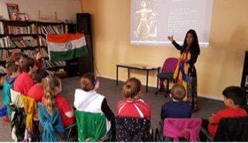
An Indian culture class at a participating primary school

Sports initiatives
Sport in Victoria is a shared obsession and is a useful and effective way to encourage social engagement and connection within the Victorian community.
The Supporting Young People’s Package (DJPR – $200,000 over 2019–2021), delivered by Sport and Recreation Victoria, initiated The Huddle (North Melbourne Football Club Multicultural Youth Mentoring Project) and Western Bulldogs Foundation GOAL Program. The Huddle leverages the power of sport to build the capability of young people from multicultural backgrounds (with a focus on Pacific Islander and African communities) across Wyndham, by providing them with access to unique, innovative and engaging leadership, education and employment opportunities. Young people are employed in a casual capacity to interview sports people and athletes from high participation sports, helping to build their communication skills, confidence, networks and experiences to inform career pathways and transition into further education or long-term employment opportunities.
The Western Bulldogs Foundation GOAL Program is an African Australian Youth Mentoring Program. The program is designed as a twelve-week initiative to increase student engagement, job skills and confidence and provide information about employment and training pathways and opportunities.
Together More Active (DJPR – $178,900) provided funding for several sporting organisations to deliver projects with sport and recreation outcomes for multicultural communities. The Centre for Multicultural Youth South East Women’s Sports Hub was also designed to create a safe space for young women from migrant and refugee backgrounds living in the city of Greater Dandenong and Casey. The project supported young women to build their capacity as leaders, volunteers and accredited coaches and referees in the sports sector. Sports included soccer, ultimate frisbee and badminton.
Fishing is also a much-loved Victorian pastime that transcends language and cultural barriers with the Victorian Fisheries Authority (VFA) issuing in excess of 264,000 fishing licences per year. In 2019–2020 DoT in partnership with the VFA funded the Fishing for Culture Education Program (DoT – $19,000). The program recognises the fact that fishing rules in Victoria are not always the same as in other countries and that Victorian fishing rules can be confusing and hard to understand for newly arrived multicultural community members. To help people understand the basic rules and why we have them, VFA staff conduct special education programs aimed at encouraging newly arrived communities to fish responsibly, which includes personal safety and stewardship of aquatic habitats as well as teaching people how to measure fish and get a licence.

Leadership through adversity: Kaina’s story
Kaina has been a participant in the South East Women’s Sports Hub’s soccer program, funded through Sport and Recreation Victoria, for the last three years. As a passionate young soccer player, Kaina initially travelled from Noble Park English Language School to Dandenong High, overcoming barriers such as transport and language to participate in the program.
Over the next three years she excelled as team member but also as young leader. At the start of 2020, participants in the soccer program were set to assist in hosting a large women’s soccer event planned for June 2020, however all plans were put on hold as a result of COVID-19.
In April 2020 it was decided that the South East Women’s Sports Hub would go online in an effort to keep participants engaged during the lockdown. Kaina stepped up and, even though she was in Year 12, she made time to assist in any way she could. With most of the participants struggling with the amount of time they had to spend online during the lockdown, they had to come up with an alternative to an online program. Discussing different options, Kaina and the group came up with a solution: get everyone their own soccer ball and cones with which to practice.
At the start of this year, Kaina took another step as a young leader – putting her hand up to train as a community soccer coach. In addition to starting a nursing qualification, Kaina wants to help young women with the same passion that she has for soccer to have the opportunity to participate.
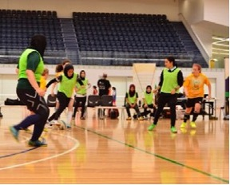
The South East Women’s Sports Hub’s soccer program in full swing

Employment initiatives and projects
Victoria’s open, cosmopolitan and vibrant reputation attracts tourism, migration, international students and investment to our state. Leveraging our multicultural diversity fills skill gaps, drives employment growth and investment within our state and generates a plethora of exciting opportunities.
Our multicultural communities can face barriers to employment due to a range of reasons, including cultural and language barriers. Helping multicultural community members directly find employment is an integral part of creating benefits and economic opportunities for all.
The Jobs Victoria Employment Network (DJPR – $29.72 million) provides individually tailored services to support and connect jobseekers and employers. The program includes specialist multicultural services that are supporting recently arrived migrants and other multicultural jobseekers to connect to employment opportunities.
The Reconnect Program (DET – $11.7 million) also provides Victorian adults experiencing disadvantage, with access to tailored wrap-around services that enable them to re-engage and succeed in vocational education and training. While Reconnect is offered to all Victorians, the program has consistently demonstrated success in working with multicultural communities and since 2016, 27 per cent of the nearly 7500 participants have identified as multicultural community members.
The EPIC Program (DoT – $230,000) is an 18-month employment program associated with the Level Crossing Removal Project. Its aim is to transition refugee and asylum seekers with engineering backgrounds into major transport infrastructure. It Includes a funded and customised Graduate Certificate in Infrastructure Engineering Management delivered over 12 months on the job. The 2019–2020 intake took five graduates into the program. The Gen44 Program (DoT – $75,000) is also designed to build a diverse pipeline of graduates ready for careers in rail and transport. The 2019–2020 intake took 5 summer interns with three of these being from refugee and asylum seeker communities.
Attracting and retaining the best worldwide talent also contributes to our economic success and the competitiveness of our state. The Skilled and Business Migration Program (DJPR – $2.33 million) seeks to attract talent to Victoria by providing state visa nomination to selected high-calibre skilled professionals, businesspeople and investors from around the world. The team works to attract and retain migrants who have skills that will contribute to Victoria’s economic growth, work in industries of advanced knowledge, have the ability to create jobs, bring innovation to Victoria and support our state’s start-up ecosystem.
Vocational training is also important to ensure multicultural community members are able to upskill and improve their economic outcomes. The Asylum Seeker VET Program (DET – $10 million) supports eligible asylum seekers and refugees with temporary residence access to Government subsidised accredited training. The 2018-21 program is on target to deliver up to 3,000 Skills First enrolments by the end of the 2021 period to eligible asylum seekers and refugees with temporary residence.
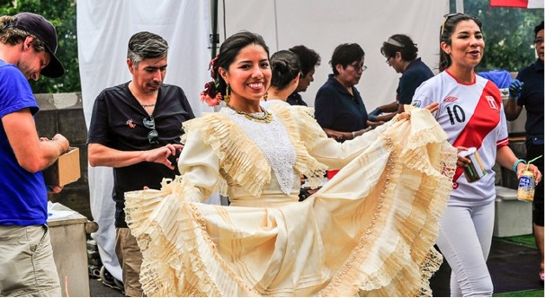

Multicultural community business support
Business support is at the forefront of the Victorian COVID-19 recovery story, and supporting multicultural community members in creating and growing their businesses is integral to the recovery and growth of our state. While general business supports are available to all Victorians including those in multicultural communities, the following are business support programs that are specifically targeted to multicultural community members.
The Now to Launch Free to Feed (DJPR – $246,000) incubator project supported 45 Victorian food entrepreneurs of refugee and new migrant backgrounds to explore various food-related business ideas from across Victoria. Small Business Workshops (DJPR – $78,000) which were delivered by Small Business Victoria also partnered with community groups to present 78 Small Business Workshops to 1,253 participants from multicultural community groups facing barriers to start a business. The workshops were designed to explore topics on starting a business, marketing, finance, taking a business online and business planning.
The African Entrepreneurs Program (DJPR – $33,885) partnered with RMIT to deliver the Business Literacy and Entrepreneurship Program for African Victorians living in Shepparton, with support from St Paul’s African House and the City of Greater Shepparton. It represents part of DJPR’s contribution to the Victorian Government’s African Communities Action Plan. Workshops included topics such as financial management, pricing, marketing and customer service.

Flemington Works: supporting other women, helping our community
The Flemington Works Community Centre Micro-Entrepreneurship Program seeks to support micro-catering enterprises that are owned and operated by women from the Flemington public housing estate.
To assist with entrepreneurship, Flemington Works wanted to hear from women who were residents in the Flemington Housing Estate to better understand their barriers to work and their skills and interests. The idea for micro-catering enterprises emerged through this process, with the women highlighting that flexibility is key – allowing them to work while also supporting their family.
Since then, some of the participants have started catering enterprises using the Flemington Community Centre commercial kitchen. Nine catering micro-businesses have been established delivering 42 catering events and grossing approximately $35,000.
Reflecting on the program, participant Awatif said, ‘When we find the problem, we can tackle the employment gap and help women that can’t find jobs.’ Fellow participant, Khadijo summed up the most important aspect of the program: ‘The most important change is getting employed’.
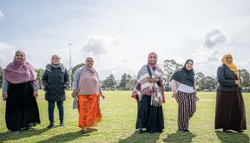
Participants in the Flemington Works Women’s Co-Design program

Victorians are connected to
culture and community
Sharing of culture and traditions is something that makes Victoria a vibrant and successful multicultural society, it fosters respect and understanding of our differences and promotes community harmony.

Community infrastructure projects
Investment in community infrastructure supports multicultural communities to upgrade their facilities and encourages participation in a stronger, safer and more harmonious society.
These dedicated community facilities and spaces are vital in fostering social cohesion, community understanding and cultural connections.
The Multicultural Community Infrastructure Fund (DPC – $1.1 million) supports Victoria’s culturally diverse communities to build, upgrade and maintain important community infrastructure. In 2019–2020, funding was awarded to support 23 community infrastructure projects, with 16 based in regional Victoria, supporting 17 ethnicities, 14 faiths and 27 languages. Projects included the renovation of a community kitchen run by a group of multicultural women at Wellsprings for Women in Dandenong, major repair works at the Sunraysia Alevi Centre in Mildura, and renovations for Sri Guru Nanak Satsang Sabha’s Senior Citizens Activity Centre in Wyndham.
Victoria is proudly home to more than 169,000 people of Indian heritage, making it the largest Indian community in Australia. The Indian Community Infrastructure Fund (DPC – $2.4 million) delivers on an election commitment to support Victoria’s Indian communities to help maintain, upgrade, renovate and construct buildings and facilities. In 2019–2020, funding was awarded to support 13 projects which included upgrades for the Shree Swaminarayan Temple in Boronia, Black Box Theatre upgrade in Dandenong and a community school toilet upgrade for Dawoodi Bohra Community in Heidelberg West.

Multicultural festivals and events
Cultural celebrations foster respect and understanding of other cultures, allowing us to come together to celebrate our differences, as well as common values and interests. Victoria is Australia’s most multicultural state, hosting hundreds of culturally significant events throughout the year.
The Multicultural Festivals and Events (DPC – $2.2 million) program supports diverse communities to celebrate, preserve and share their customs and traditions in meaningful ways. In 2019–2020, funding was awarded to support 850 multicultural festivals and events across Victoria.
Events included a Lunar New Year celebration in early 2020 which received $40,000 to support the delivery of a multi-day event throughout Melbourne CBD. The celebration included participation from African communities, Cook Islander, Chinese, Vietnamese, and Indian communities, showcasing and sharing cultures with each other and the 120,000 members of the public who attended.
Approximately 270 funded festivals and events scheduled to take place between 1 January and 30 June 2020 were cancelled or postponed due to the impacts of the COVID-19 pandemic. In light of this, the Multicultural Affairs portfolio of DPC worked closely with organisations to extend project timelines or amend project activities.
Some events, like the Premier’s Iftar Dinner shifted to an online format. The 2020 dinner included a smaller group given the virtual setting allowing each community representative to interact and talk with the Premier. The event included delivery of meals to guests’ locations by the Asylum Seekers Resource Centre Catering whose aim is to create employment pathways for people seeking asylum by offering training and paid work. Each meal purchased for the Premier’s Virtual Iftar Dinner also provided a meal for an asylum seeker family in need.
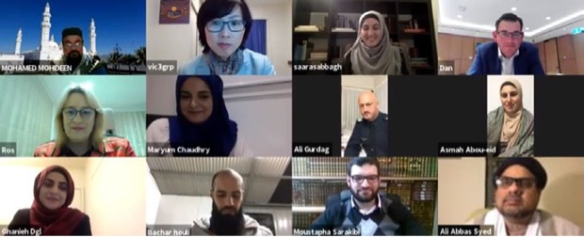

Multicultural arts and culture initiatives
Victoria is a long established and vibrant contributor to the Australian art and cultural scene and in 2019–2020 arts and culture provided a pathway to a sense of community connection which was more important than ever before.
Now in its second iteration, the Asia-Pacific Triennial of Performing Arts Festival (Asia TOPA) Festival (DJPR – $4 million) returned to celebrate the creativity of artists and cultures in the Asia-Pacific region. The three-month long festival explored the connections between contemporary Australia and its growing diaspora with art spanning music, dance, theatre, film, digital and visual art and more. The festival was a resounding success with total attendance being 926,146 people attending over 351 separate events.
The Victorian Government recognises the important contribution of the Victorian film industry to both sharing differing cultural and societal views as well as contributing to our state and economy more broadly. We also understand how greatly the film and entertainment industries were impacted during the COVID-19 pandemic.
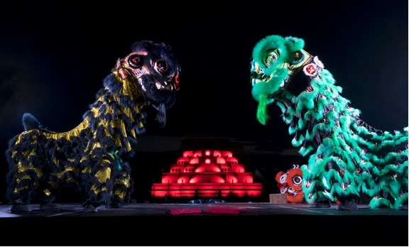
The Film Victoria Production Investment Program (FVPIP) (DJPR) Is making ongoing investments in film and television to support multiculturalism and social cohesion. The FVPIP supported several projects in 2019–2020 including:
- New Gold Mountain (television series) – A new drama series for SBS that tells the untold story of the gold rush in Victoria from the perspective of Chinese miners
- Mustangs FC (children’s television series) – A comedy-drama that follows an all-girls soccer team. The cast and crew of Mustangs FC was more than 60 per cent female and from a wide range of ethnic backgrounds including Aboriginal and Torres Strait Islander, Vietnamese, Sri Lankan, Indian, Lebanese and Sudanese communities
- Palazzo Di Cozzo (documentary feature film) – A documentary that follows Melbourne furniture icon Franco Cozzo’s journey from rural Sicily to the high streets of Melbourne, his fortune and family drama. The documentary also tells the story of an aspirational migrant class that has been evolving since the post-war era.
Film Victoria is also funding ongoing film project development via its Project Development Programs (DJPR) which evaluates and funds film and television projects that promote multiculturalism and community harmony designed to bring compelling stories from diverse community voices to our screens. Multicultural projects in development included:
- Our African Roots (television documentary one-off) – An African migrant unearths Australia’s forgotten black history and reveals the central role people of African ancestry played in events that shaped modern Australia – from the First Fleet to the Eureka Rebellion
- Voices in Deep (fiction feature film) – A tragedy at sea connects the lives of an Australian humanitarian and two orphaned refugees as they fight for survival in present-day Athens
- The Shahab Shiri Show (documentary feature film) – Shahab Shiri, an Iranian gay activist living in Canada, uses Instagram as a platform to create awareness about the issues facing his LGBTIQ+ community. Just like his idol, Ellen DeGeneres, he uses humour and entertainment to challenge homophobia and transphobia.
The Organisations Investment Program (OIP) (DJPR – $21.5 million) supports creative organisations that make a valuable cultural contribution to the Victorian community. In 2019–2020, while many organisations’ programs were suspended during the pandemic in line with health restrictions, many continued to connect with their communities via online programs and experiences. Organisations that received funding under the OIP in 2019–2020 included:
- Footscray Community Arts Centre – A multi-platform, multi-arts-based organisation working with culturally and linguistically diverse communities
- Multicultural Arts Victoria – Victoria’s peak arts organisation for the promotion of cultural diversity in the arts which offered commissioning opportunities during COVID-19 so creatives and artists could continue work during Victoria’s lockdowns
- Western Edge Youth Arts – provides high-quality arts experiences for young people, particularly those from culturally diverse and disadvantaged backgrounds
- Westside Circus, Brunswick – uses circus and physical theatre to build the creative capacity of young people from diverse social, economic and cultural backgrounds
- The Boîte, Fitzroy – supports multicultural artists such as an Iranian women’s choir program
- The Chinese Museum – located in the heart of Melbourne’s Chinatown, the museum showcases the heritage and cultural contribution Chinese Victorians have made to our state
- The Jewish Museum of Australia – at the intersection of art and Jewish culture, the museum is a place for all people to share in the Australian Jewish experience.
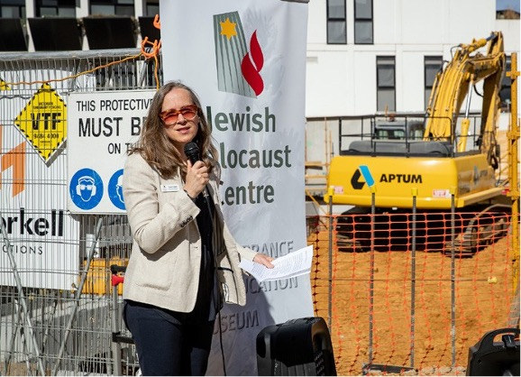

Arts Centre Melbourne Asia TOPA Festival: A Mile in My Shoes
A Mile in My Shoes by Empathy Museum was a free participatory, travelling audio work presented during the Asia TOPA festival that invited visitors to walk a mile in someone else’s shoes – literally. Housed in a giant shoe shop set on Arts Centre Melbourne’s forecourt, it was composed of 35 stories – and shoes – from people in Melbourne and across the world. Melbourne’s iteration of A Mile in My Shoes explored the relationship of the storytellers with bodies of water, including the Birrarung (Yarra River).
Reflecting on how empathy can transform our relationships with others by experiencing the world through someone else’s experience, Arts Centre Melbourne engaged a group of international students to transcribe some of the stories into other languages to break language barriers, reinforcing the message of access and inclusion. Arts Centre Melbourne also partnered with MPavilion and The School of Life to present Empathy Hour, a public talk to discuss how art projects like A Mile in My Shoes can help tackle global challenges such as prejudice, conflict and inequality.
The project was a resounding success. A Mile in My Shoes achieved the following results:
- 4,994 active participants
- 80 people attended Empathy Hour at MPavilion
- 30 artists and arts professionals were engaged – 66 per cent Australian artists, 33 per cent international
- 95 per cent of those surveyed provided positive feedback
- 93 per cent of those surveyed said they were exposed to new ideas, people and perspectives
- 49 per cent of those surveyed were experiencing Arts Centre Melbourne for the first time.

Victorians have equal rights
and opportunities
All Victorians should be treated equally and in a way that fully adheres to Victoria’s Charter of Human Rights. It is also a fundamental principle of the Victorian legal system that all Victorians are subject to the law and are seen as equal before the law.

Promoting rights and responsibilities
The Legal Practice Essentials Cultural Awareness and Working with Interpreters Workshop (Victorian Legal Aid (VLA) – $2,500) is delivered by the Centre for Culture, Ethnicity and Health and is focused on legal practitioners working with interpreters. The workshop is compulsory training for VLA lawyers and sessions aim to enable participants to use culturally appropriate strategies when working with people from refugee and migrant backgrounds and to assess the need for and undertake the process to engage an interpreter. Evaluation of the training demonstrated that most respondents were confident with the learning objectives.
The Tenancy and Consumer Program (DJCS – $3.8 million) provided funding to 12 community agencies for the provision of information and advocacy assistance for vulnerable tenants including members of CALD communities. In 2019– 20 the program assisted 8,155 disadvantaged tenants and consumers.
VLA also provides ongoing Community Legal Education Sessions for CALD communities with staffing costs funded via Community Legal Education and Family Violence Program budgets. In 2019–2020 VLA delivered 49 community legal education sessions for multicultural audiences across Victoria, reaching a total of 1,450 people. Sessions covered a range of legal topics, including family law, family violence, discrimination, drugs and alcohol, child protection, forced marriage, sexting, bullying and police powers. The Victoria Law Foundation (VLF) also made a grant to Afri-Aus Care Inc (VLF – $19,814) via the VLF Community Legal Grants Program to provide legal support and education to South Sudanese and other African young people in Melbourne’s south-eastern suburbs.
The Settled and Safe Project is an ongoing legal education program delivered by VLA which provides tailored legal education for newly arrived communities looking at the laws and legal processes that affect families, including family violence, child protection and family law. The program has two components: a two-day worker training for frontline workers supporting newly arrived communities; as well as legal information sessions held directly with members of Victoria’s multicultural community. In 2019–2020 education sessions included members of the Myanmar, Ethiopian and Iranian communities.
The Daughters of Jerusalem Justice Project was a partnership between the Daughters of Jerusalem Youth and Family Agency, a community led association for the South Sudanese Australian community, Springvale Monash Legal Service and VLA Dandenong. The aim of the project was to deliver monthly evening information sessions with community members on topics of their choice. These were hosted at the VLA Dandenong office, with both Nuer and Dinka interpreters provided by VLA. These sessions covered topics including drugs and alcohol, discrimination and legal advice on fines and financial counselling.

Freedom from discrimination – eliminating racism
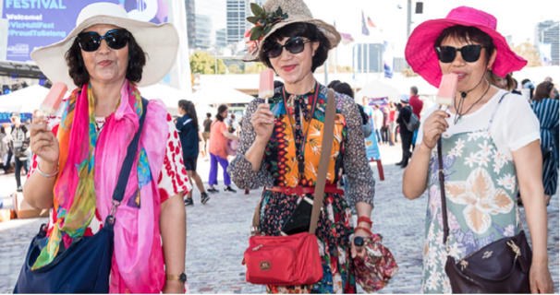
Racism and discrimination are unacceptable and incompatible with Victoria’s multicultural society. The Victorian Government is working tirelessly to eliminate racism and its harmful impact in the Victorian community.
The Reducing Racism Project (Victorian Equal Opportunity and Human Rights Commission ((VEOHRC)) – $118,000) is a three-year project led by VEOHRC with the aim to empower multicultural and multifaith communities to report racism and exercise their rights. In 2019–2020, the project responded to increased incidents of racism and discrimination as a result of the COVID-19 pandemic. The Victorian Multicultural Commission (VMC) also worked in partnership with the VEOHRC to increase awareness of how to respond to racism and where to lodge a complaint. Launched in June 2019, the Commission’s Community Reporting Tool (CRT) has provided a quick, easy and secure way for people to report incidents of racism and other discrimination directly to VEOHRC. Over a 12-month period, VEOHRC received 147 reports of which 51 per cent pertained to racism. VEOHRC also delivered 27 tailored community information sessions on racial discrimination in partnership with community organisations, Victoria Police and the VMC reaching a total of 879 people in 2019–2020.
Online resources to support Muslim Families Dealing with Islamophobia (DJCS – $44,500) were provided to the Australian Muslim Women’s Centre for Human Rights to publish resources to support Muslim families experiencing islamophobia. The resources were developed from the findings of research funded by the Victorian Government in 2019. The research offers valuable insights into the experiences and impacts of Islamophobia on young Muslims and the specific role that families play in supporting children to develop understanding and resilience through conversations about Islamophobia and terrorism. These insights supported the development of a targeted resource for Muslim families in the form of a storybook ‘Being Muslim, Being Me!’ for parents to read with their children. The storybook is designed to simplify the conversation around terrorism and Islamophobia and to facilitate conversations between children and parents.

Promoting human rights within government departments
The Victorian Government is committed to building multicultural capacity in our departments and embedding human rights knowledge and practices at every level of government. Initiatives undertaken in individual departments are outlined as follows.

Department of Transport (DoT)
DoT soft launched its DoT E-Learn: Charter of Human Rights and Responsibilities Program using Charter modules developed by the VEOHRC. These modules provide DoT employees with an overview and awareness of rights and obligations under the Victorian Charter of Human Rights (‘the Charter’) which they can then put into practice in their interactions with community members.

Department of Justice and Community Safety
Victoria Police continues to provide ongoing access to tailored human rights training and support on human rights to assist Victoria Police in areas including the Public Order Response team, Professional Standards Command and frontline staff from across the State. The training is designed to support members to fully consider and act compatibility with the Victorian Charter of Human Rights in their everyday duties.

Department of Education and Training (DET)
DET encourages new and current staff to access its online Charter of Human Rights Training Module. The module assists staff in understanding their responsibilities and rights under the Charter, including the right to equality, freedom of religion and cultural rights. In addition, DET provided targeted training on human rights to executives and celebrated Human Rights Week promoting a range of events including VEOHRC’s program. DET held a Human Rights Week event focused on human rights in action through case study presentations.

Department of Premier and Cabinet (DPC)
DPC coordinated Victorian Government submissions to the Parliamentary Inquiry into Anti-vilification Protections in December 2019. The submissions were developed following consultation with stakeholders including:
- multicultural and multifaith groups
- LGBTIQ+ communities
- people with disabilities
- women.
The COVID-19 pandemic exacerbated racism and vilification towards some multicultural communities and the ongoing Inquiry provided the Victorian Government with the opportunity to lodge a supplementary submission in June 2020 which focused specifically on vilification and hate conduct linked to the COVID-19 pandemic.

Department of Treasury and Finance (DTF)
DTF promotes the VEOHRC Human Rights Charter E-learning Modules and Human Rights Week. The department holds face-to-face Victorian Charter of Human Rights training, facilitated by VEOHRC. Training focuses on building knowledge of human rights under the Charter and the obligations on staff to act compatibly with human rights when making decisions in their day-to-day roles. 457 DTF employees (62 per cent of the DTF cohort) have participated in 30 VEOHRC education sessions.
DTF also celebrated Human Rights Week commencing Monday 9th December 2019. Several events were promoted including the ‘Equality Talks’ and ‘Human Rights Oration’ events. In 2019–2020 DTF also promoted NAIDOC week, Human Rights Week, the African Music and Cultural Festival, Harmony Day, National Reconciliation Week, Refugee Week and World Refugee Day.

Department of Health and Human Services (DHHS)
DHHS actively promotes human rights through its broader Orange Door Program. The practice guidance for the program states that the Orange Door Program will provide safe and inclusive services that are tailored to the needs of Victoria’s diverse community including:
- Aboriginal people
- multicultural communities
- people with disabilities
- people who identify as LGBTIQ+
- older people
- children and young people.
DHHS also provides Unconscious Bias Training which is offered across the Department to help employees learn how to understand and address their own unconscious bias, support change and improve diversity outcomes.

Department of Jobs, Precincts and Regions (DJPR)
DJPR is committed to upholding the principles enshrined in the Victorian Charter of Human Rights and Responsibilities and provides anti-discrimination and equal opportunity training to all employees. DJPR also embeds human rights obligations in external contracts with third party providers. DJPR provides funding to ACMI to host the AMCI Human Rights and Arts Film Festival, which presents a variety of international works that explore human rights and cultural diversity.

Progress in departmental
cultural diversity plans

Background
Victorian Government departments are required to develop cultural diversity plans (CDPs) to enhance the delivery of accessible and responsive services to Victorians from culturally diverse communities. The Multicultural Victoria Act 2011 mandates that departments report progress against their CDPs.
Departments have plans focused on achieving workforce diversity, participation and inclusion as well as cultural competency in the delivery of services in response to cultural diversity.
The following are Victorian Government department CDPs as at 30 June 2020.
Departments | Cultural diversity plans
Department of Education and Training | Our cultural diversity plan 2019–2021
Department of Environment, Land, Water and Planning | Diversity and inclusion strategy 2019–2022
Department of Health and Human Services | Delivering for diversity: cultural diversity plan 2016–2019
Department of Justice and Community Safety | Cultural diversity plan 2017–2021
Department of Jobs, Precincts and Regions | Multicultural diversity action plan 2018–2021
Department of Transport | The Department of Transport multicultural action plan 2018–2021
Department of Premier and Cabinet | Diversity and inclusion strategy 2019–2021
Department of Treasury and Finance | Diversity and inclusion framework 2018–2020

Departmental cultural diversity plans

Department of Education and Training: Our cultural diversity plan 2019–2021

Vision
To improve Victoria’s learning and development services to meet the needs of families, children and young people from culturally and linguistically diverse backgrounds, particularly recent immigrants and to work to equip all children and young people to understand and navigate cultural and linguistic differences within an increasingly interconnected world.

Goals
The goals of the DET cultural diversity plan (CDP) are to:
- build the intercultural capability of both learners and their teachers
- make the Victorian learning and development system welcoming and inclusive to all
- provide appropriate and accessible information to culturally and linguistically diverse communities
- sustain and improve supports for refugees and other new immigrants to respond to their needs
- engage with culturally and linguistically diverse communities to inform planning and delivery of services
- improve our information and reporting systems and program evaluation so the effectiveness and value of services to culturally and linguistically diverse Victorians can be monitored.

Governance and ownership
DET’s CDP is overseen by the department’s Culture and People Committee and the Executive Board.

Cultural competence training
DET continues to participate in the Whole of Victorian Government (WoVG) working group with the Multicultural Affairs and Social Inclusion branches of the DFFH to develop a WoVG online cultural competency training module.
DET also has a Respectful Workplaces training module, which is a requirement for all DET’s VPS staff. This training focuses on treating others with respect and consideration, including consideration for equal opportunities and human rights.
Finally, as part of its VPS workforce diversity and inclusion strategy, DET is developing a Cultural Diversity and Inclusion Learning Pathway to build staff knowledge, understanding and practice using ‘bite sized’ learning and development activities available online.

Decision-making processes and program evaluation
DET has a register of community stakeholders for departmental staff to facilitate consultation for program and policy development when appropriate. The department has also created internal processes for consulting directly with multicultural community stakeholders and organisations.
The department expects that all programs, including those that are ongoing or recurrent, will undergo some form of periodic review or evaluation informed by best practice methodology. This includes incorporating the views of diverse or vulnerable groups in evaluation design and implementation.

Department of Environment, Land, Water and Planning: Diversity and inclusion strategy 2019–2022

Vision
DELWP aims to create a culture that embraces individual differences in all forms and fosters innovation and inclusion, to support:
- liveable, inclusive and sustainable communities and thriving natural environments
- all staff to achieve their full potential and work in a flexible way that meets their needs
- a community charter that emphasises the diversity and inclusion values of building enduring and genuine partnerships.

Goals
The goals of DELWP’s cultural diversity plan (CDP) are to:
- support diversity at all levels of the department and improve services to the Victorian community, including multicultural communities
- utilise a community-centred approach that engages communities and key stakeholders in decisions and policies that affect them through co-design and co-delivery
- improve service delivery and decision-making through strong, inclusive leadership and training and development opportunities
- foster attitudes and practices that better support diversity and inclusion
- create opportunities to recruit and retain staff from diverse groups in the community.

Governance and ownership
The Diversity and Inclusion Council, including leadership and staff representatives from each business group, oversees DELWP’s CDP. Four deputy secretaries are on the council and the Secretary attends when available.
The Diversity and Inclusion Council is responsible for overseeing development and implementation of the strategy and associated plans. This includes linking plans and actions to legislative obligations and Victorian Government policy requirements, including monitoring, evaluation and review.
DELWP’s People and Culture unit has also appointed a Manager of Diversity and Inclusion to the team to drive key commitments outlined in the CDP.

Cultural competence training
The Inclusive Leaders, Inclusive Teams training program, which focuses on understanding diversity, subtle exclusion, privilege and unconscious bias to create inclusive workplaces, was included in regularly scheduled training offerings throughout 2019 and 2020, with more than 130 people attending.
DELWP’s online learning management system also includes mandatory Appropriate Workplace Behaviour Training including content related to human rights and equal opportunities. As an extension of the Appropriate Workplace Behaviours Training, Safe and Respectful Workplaces Training has been rolled out across the department, creating a safe space for conversation around creating an inclusive workplace within teams. Specific cultural competence training is currently offered in relation to Aboriginal and LGBTIQ+ communities and the department is investigating further programs that focus on cultural and linguistic diversity.

Decision-making processes and program evaluation
DELWP’s Community Charter assists the department to build better relationships with stakeholders and communities, including local councils, Catchment Management Authorities, water corporations, the building industry and environment groups.
DELWP has also commenced development of a new engagement framework, Engage@DELWP, that enables more confident and effective engagement and stronger relationships with multicultural communities leading to more culturally informed decision-making.
DELWP measures its performance against its community charter commitments through:
- the biannual Customer and Stakeholder Intelligence research
- self-evaluation through the People Matter Survey and the Organisational Cultural Inventory survey
- regular review and reflection by the DELWP leadership team on staff feedback and on the delivery of engagement activities
- community feedback through established feedback channels, attendance at events and formal and informal interactions.

Department of Health and Human Services: Delivering for diversity: cultural diversity plan 2016–2019

Vision
We strive to embed cultural diversity in all our policies, practices and programs and want to ensure we deliver inclusive, safe and accessible services to all Victorians.

Goals
The main goals in responding to cultural and linguistic diversity in health and human services are in the following outcomes areas:
- equitable and responsive services and programs
- a culturally responsive workforce
- partnerships with diverse communities
- effective and evidence-based approaches to service delivery.

Governance and ownership
The DHHS Executive Board has had primary ownership of the cultural diversity plan (CDP) including ensuring that the plan is embedded in the department’s core business. All deputy secretaries have been required to report on relevant activities in their areas through the Quality, Safety and Experience Sub-Committee of the Board and to ensure that core business includes culturally responsive considerations and service design.

Cultural competence training
DHHS is building the cultural competence of staff in several ways:
- Cultural competence workshops and resources continue to be rolled out to staff across the department. Unconscious Bias training has also been delivered across the department.
- DHHS will focus on building the capacity of front-line staff to better support and work with clients from multicultural communities.
- The Leading with Respect Program is required for all people managers providing managers with the tools to lead diverse teams and promote a respectful team culture accounting for all cultural backgrounds.

Decision-making processes and program evaluation
DHHS consults stakeholders across multicultural community sectors on policy and program design, continuously developing in-language resources and building the capacity of DHHS staff to better engage diverse communities.
DHHS seeks to ensure that policies and programs reflect and respond to the changing needs of multicultural communities. The department continues to identify barriers and implement improvements through formal and rigorous evaluation and partnerships with communities and stakeholders.
The DHHS Centre for Evaluation and Research supports program areas to evaluate policies and programs across all portfolios using consistent guidelines and templates. The department’s Evaluation guide includes advice on conducting evaluations using culturally aware and ethical methods.

Department of Jobs, Precincts and Regions: Multicultural diversity action plan 2018–2021

Vision
To foster a culturally diverse and inclusive workplace that reflects the sectors and communities we work with and to provide inclusive service delivery to culturally diverse clients and communities that fosters greater inclusion in Victoria’s economy.

Goals
- Leadership: Our leaders will champion the cultural diversity plan to foster engagement at all levels. We will all support cultural diversity through ownership at all levels.
- Information building: We will build our understanding of internal cultural diversity. We will build our understanding of the cultural diversity of the communities we work with.
- A culturally diverse workforce: We will support opportunities to grow cultural diversity at all levels of the organisation. Our workforce will reflect the communities we work with.

Governance and ownership
The Executive Director, People and Culture in Corporate Services has ownership of the departmental CDP.
The CDP is part of the department’s Diversity, Equality and Inclusion Framework. The framework’s progress is monitored and reviewed by the department’s Diversity, Equality and Inclusion Committee, a sub-committee of the Executive Board.

Cultural competence training
All staff are encouraged to develop their cultural competence through professional development opportunities. In 2019–2020, two cultural competence training programs were available to support the professional development of staff, including:
- a cultural competence e-learning program available to all staff on the DJPR Learning Management System
- cultural intelligence virtual workshops, which all Creative Victoria staff were encouraged to participate in.
- all departmental hiring managers are also required to complete the ‘Unconscious Bias’ module of the online cultural competence program prior to conducting job interviews.

Decision-making processes and program evaluation
DJPR’s CDP requires that all business areas consult with the community when evaluating programs and services. This is done by:
- consulting culturally diverse communities and advisory boards when making decisions about programs, policies and services that directly affect culturally diverse communities
- using available demographic and service data on cultural diversity to support decision making for programs, policies and service delivery
- embedding cultural diversity considerations when designing, implementing and evaluating policies, programs and services.

Department of Justice and Community Safety: Cultural diversity plan 2017–2021

Vision
An inclusive and accessible justice and regulation system that enables culturally and linguistically diverse communities to fulfil their potential as equal citizens.

Goals
- A fair justice system that promotes equal rights and opportunities.
- An accessible and inclusive justice system.
- A department that recognises and values diversity.

Governance and ownership
Ownership of DJCS’s CDP was the responsibility of the Diversity Issues Unit until the end of 2019. From 2020, responsibility for the plan is with the department’s newly formed Inclusion and Intersectionality team within the Stakeholder Engagement, Intergovernmental and Inclusion Unit. The team has responsibility for development, monitoring and reporting against activities associated with the plan.

Cultural competence training
The department has entered into a contract with LinkedIn Learning to provide eLearning content on a broad range of topics. The following topics, each an hour in length, are now available for all staff to complete to provide knowledge and skills in cultural competence:
- developing cross cultural intelligence
- cultivating cultural competence and inclusion
- communicating about culturally sensitive issues
- communicating across cultures.
- dedicated cultural competency and awareness training is also included in the induction for all Youth Justice custodial staff.

Decision-making processes and program evaluation
DJCS’s relevant business units and regions undertake consultations to ensure that services are responsive to the range of cultural, religious and linguistic needs of Victoria’s diverse communities. Planners are encouraged to consult culturally specific organisations and examine local requirements in order to tailor the provision of services in a culturally sensitive way.

Department of Premier and Cabinet: Diversity and inclusion strategy 2019–2021

Vision
To lead the Victorian Public Service (VPS) by working for the people of Victoria to help the government achieve its strategic objectives. We are committed to a stronger, fairer, better Victoria by pursuing excellence in whole of government outcomes in delivery and reform.
As a department we are committed to diversity, inclusion and equity ensuring that all people are treated with dignity and respect, have equitable access to employment opportunities and outcomes, have the ability to participate in all aspects of work life and can achieve their full potential.

Goals
In the implementation of DPC’S CDP the department will seek to achieve:
- increased representation of women and people from diverse backgrounds in senior leadership positions and overcoming structural barriers to employment due to personal circumstance or characteristics
- the establishment of an accurate workforce profile to measure and track performance of our CDP
- ensure that culture surveys consistently show safety, visibility and inclusion for all employees across all levels of the organisation
- the setting of measurable targets and ensuring accountability for meeting our goals
- continuing to elevate the reputation and public image of DPC as a diverse and inclusive workplace.

Governance and ownership
DPC has a three-limbed approach to governance and ownership of its CDP:
- Executive sponsors and champions will be appointed by DPC Board of Management for all key priority areas including gender, disability, LGBTIQ+, Aboriginal, culturally and linguistically diverse (including faith), inclusion and age
- the People and Culture team will provide annual performance reports and dashboard data to each executive sponsor with an assessment against existing strategies
- DPC reference groups and committees will be encouraged to work with executive sponsors and People and Culture team to identify and implement initiatives within the strategy, informed by the annual dashboard data.

Cultural competence training
- The People and Culture team of DPC provides a range of diversity and inclusion training programs. These help employees to:
- understand their rights and responsibilities and to create an inclusive environment free from discrimination and harassment and to identify discrimination and exclusion in the workplace
- understand their role and strategies for creating a diverse and inclusive workplace
- understand the complex and varied experiences of diverse communities
- identify and address unconscious bias practices

Decision-making processes and program evaluation
DPC has created an Organisational Diversity and Inclusion Maturity Model showing the five stages of maturity including measures, indicators and enablers. This model is evaluated yearly.

Department of Transport: The Department of Transport multicultural action plan 2018–2021

Vision
To foster a culturally diverse and inclusive workplace that reflects the sectors and communities we work with, by building team member capability to support an inclusive economy with equitable access to services and economic participation.

Goals
DoT’s CDP goals include the following:
- leadership – our leaders will champion the cultural diversity plan to foster engagement and supporting cultural diversity through ownership at all levels
- information building – we will strengthen our understanding of internal cultural diversity, the communities we work with and we will capture cultural diversity initiatives to share internally and report annually
- building a culturally diverse workforce – we will support opportunities to grow cultural diversity at all levels of the organisation and our workforce will reflect the communities we work with.

Governance and ownership
The DoT Executive Director People and Culture has current ownership of the implementation of the DoT CDP. Under the 2021 CDP, the Deputy Secretary of Information and Technology and the Deputy Secretary, People and Business will have ownership of the implementation of the new CDP.
The department ensures that responsibility for delivering against the existing CDP is implemented into its overarching Inclusion and diversity strategy reporting and accountability mechanisms. Upon the launch of the new DoT CDP, an implementation group will be convened which will comprise of representatives from across the department with accountability for actions under the CDP.

Cultural competence training
During the 2019–2020 financial year, due to Machinery of Government (MoG) changes that directly impacted the department and due to COVID-19, no stand-alone cultural competence training was delivered in this period.
Core foundational training developed by DoT concerning unconscious bias, bystander action and inclusive leadership focus on fostering cultural humility, cultural awareness and the impact of racism on culturally diverse staff in the workplace. However, this falls outside of the current reporting period. In July 2021, DoT will recommence its delivery of CCT training.

Decision-making processes and program evaluation
DoT undertakes a significant amount of community engagement each year. Engagement is designed and implemented to be inclusive of Victoria’s diverse communities that will be impacted by the decisions made by the department.

DoT’s current CDP requires that all business areas consult with the community when evaluating programs and services. This includes consulting community organisations and advisory boards about programs and policies that affect multicultural communities, using demographic and service data to inform decision making.

Department of Treasury and Finance: Diversity and inclusion framework 2018-2020

Vision
DTF’s CDP outlines its commitment to building a workplace that is grounded in respect, fosters inclusion, promotes diversity and embraces the unique skills and qualities of all our people.
The focus areas of DTF’s CDP are for the following five diversity groups:
- multicultural communities
- all abilities
- LGBTIQ+
- age
- Aboriginal and Torres Strait Islander.

Goals
The objective of the framework is to ensure the department has a workforce that is representative of the Victorian population and makes the most of the talents and skills of all employees. DTF wants to ensure it is an inclusive and appealing organisation for talented people with varied experiences and backgrounds. DTF embraces and encourages all individuals to excel, regardless of their gender and gender identity, mental or physical disability, age, family responsibility or cultural background.

Governance and ownership
To ensure effective implementation, DTFs People and Culture team regularly review the progress of the plan and monitor employee engagement in Diversity and Inclusion practices through People Matter Survey results year on year.

Cultural competence training
Cultural diversity training is embedded into DTFs induction training program. DTF also runs Respectful Workplace Training sessions as part of its People Matter action plan to promote a culture of respectful inclusiveness for all.
The CDP also include promotion of and staff participation in days of significance such as Harmony Day, International Human Rights Day, Refugee Week and the African Music and Cultural Festival.
Furthermore, DTF ensures regular Secretary communications encourage staff involvement in such diversity initiatives and events and DTF leaders host, present and participate in key diversity events and encourage staff involvement in all diversity and inclusion activities. Events are also posted on LinkedIn to promote DTF leaders as ‘Champions of diversity’.

Appendix 1: Culturally diverse
representation on government
boards, authorities and
committees
Table 6: Composition of Victorian Government boards as at 30 June 2020
Composition | Number
Total number of boards as at June 2020 | 380
Total board appointments | 3374
Culturally diverse appointments | 1029
Culturally diverse percentage of boards | 30.4%
Table 7: Appointments and re-appointments to Victorian Government boards as at 30 June 2020
Appointment | Number
Number of boards with new appointments or reappointments in 2019–2020 | 290
Total new appointments or reappointments | 1348
Culturally diverse appointments or reappointments | 429
Culturally diverse percentage of appointments and reappointments | 31.8%
Table 8: Year on year proportion of Victorian Government department board appointments or members with culturally diverse backgrounds
Department | At 30 June 2020 (%) | At 30 June 2019 (%)
DET | 29.7 | 20.1
DELWP | 32.6 | 32.7
DHHS | 27.2 | 30.1
DJPR | 35.9 | 33.7
DJCS | 33.0 | 31.7
DPC | 29.0 | 19.6
DoT | 28.1 | 28.1
DTF | 20.5 | NA

Appendix 2:
Indicators

Frequently used abbreviations in this section
- ESB: English-speaking background
- LBOTE: Language background other than English
- MESC: Main English-speaking country
- NESB: Non-English-speaking background
- NMESC: Non-main English-speaking country

Benefits of diversity
A1 Proportion of Victorians born in non-main English-speaking countries who have completed Year 12 or equivalent, compared to the proportion of all Victorians who have completed Year 12 or equivalent
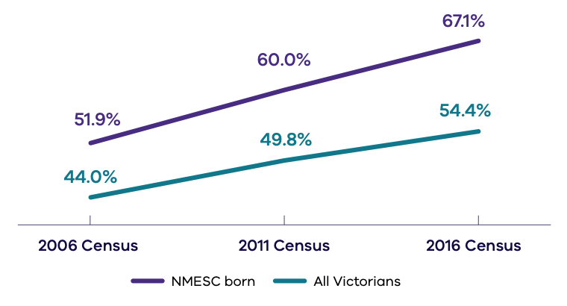
Census year | NMESC-born | All Victorians (%)
2016 | 67.1 | 54.4
2011 | 60.0 | 49.8
2006 | 51.9 | 44.0
A2 Proportion of Victorians born in non-main English-speaking countries attending a university or other tertiary institution, compared to the proportion of all Victorians attending a university or other tertiary institution.
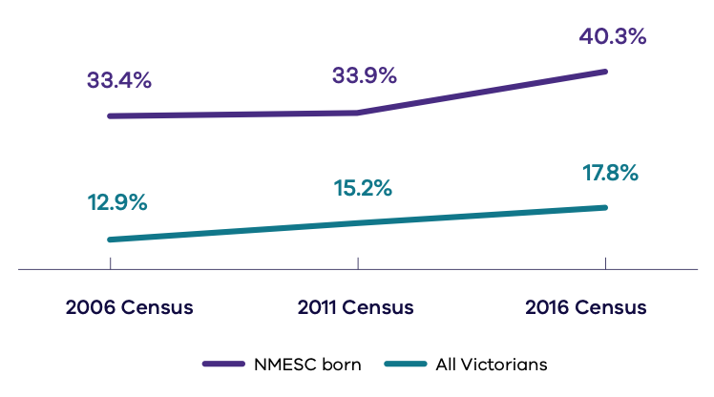
Census year | NMESC-born | All Victorians (%)
2016 | 40.3 | 17.8
2011 | 33.9 | 15.2
2006 | 33.4 | 12.9
A3 Proportion of Victorians born in non-main English-speaking countries who were self-employed, compared to the proportion of all Victorians
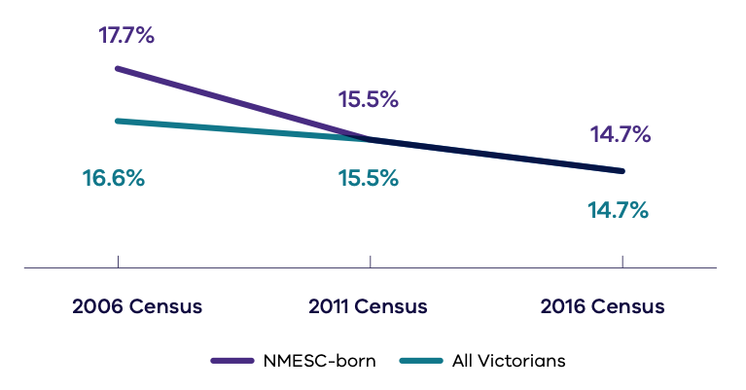
Census year | NMESC-born | All Victorians (%)
2016 | 14.7 | 14.7
2011 | 15.5 | 15.5
2006 | 17.7 | 16.6
A4 Proportion of international visitors to Victoria whose purpose of visit was to ‘visit friends and relatives’
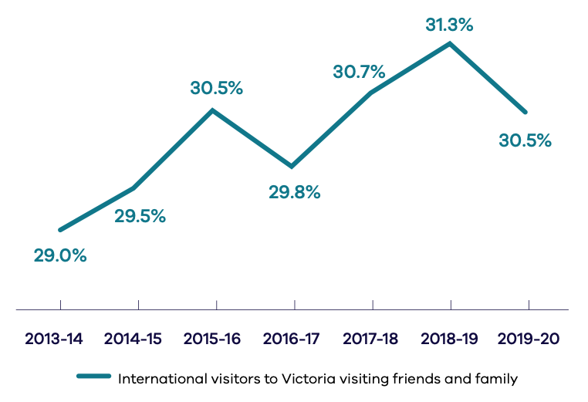
Year | International visitors to Victoria visiting friends and relatives (%)
2019–2020 | 30.5
2018–2019 | 31.3
2017–2018 | 30.7
2016–2017 | 29.8
2015–2016 | 30.5
2014–2015 | 29.5
2013–2014 | 29.0
A5 Proportion of international students in Australia studying in Victoria
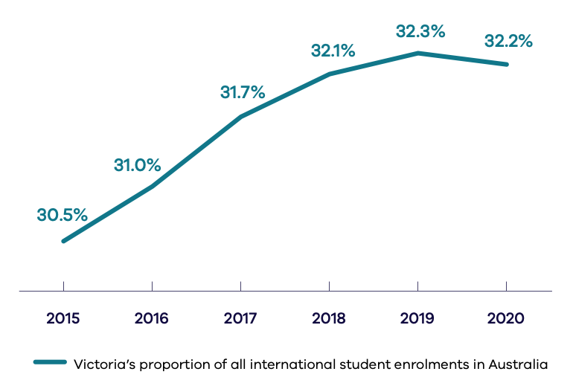
Year | Victoria’s proportion of all international student enrolments in Australia (%)
2020 | 32.2
2019 | 32.3
2018 | 32.1
2017 | 31.7
2016 | 31.0
2015 | 30.5
A6 Proportion of state-nominated skilled migrants working in nominated fields
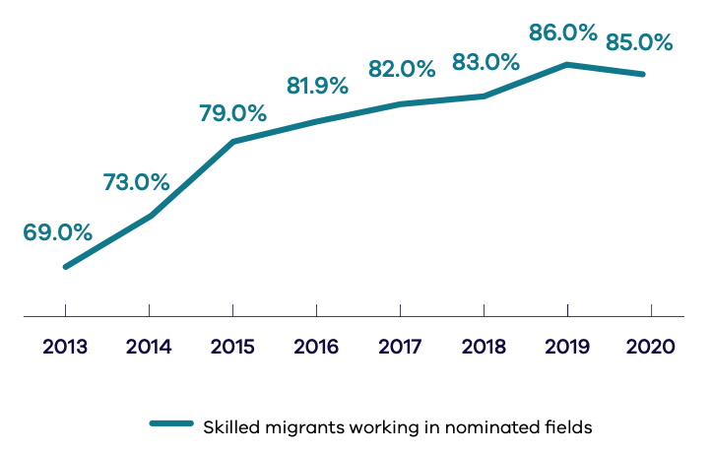
Year | Working in nominated fields (%)
2020 | 85.0
2019 | 86.0
2018 | 83.0
2017 | 82.0
2016 | 81.0
2015 | 79.0
2014 | 73.0
2013 | 69.0
A7 Proportion of students in Victorian Government primary and secondary schools learning languages
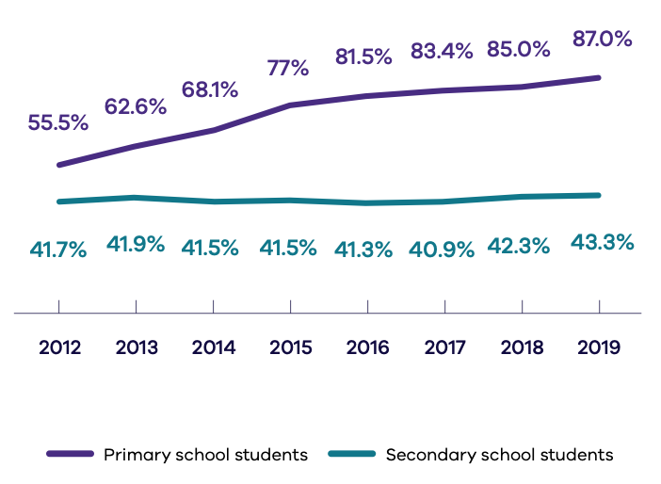
Year | Primary school students (%) | Secondary school students (%)
2019 | 87.0 | 43.3
2018 | 85.0 | 42.3
2017 | 83.4 | 40.9
2016 | 82.0 | 41.3
2015 | 77.0 | 41.5
2014 | 68.1 | 41.5
2013 | 62.6 | 41.9
2012 | 55.5 | 41.7
A8 Proportion of Victorian Government primary and secondary schools providing a languages program
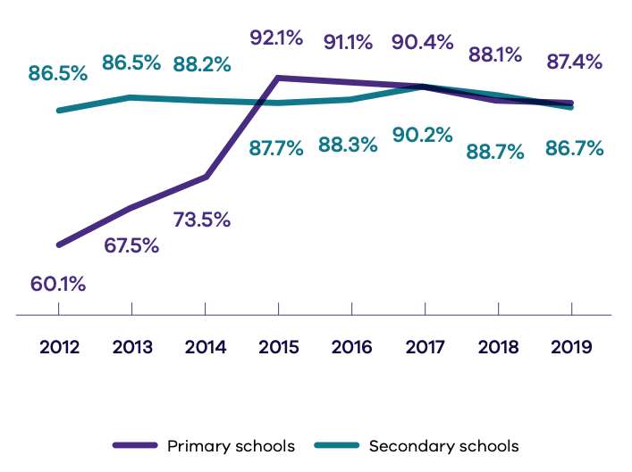
Year | Primary school students (%) | Secondary school students (%)
2019 | 87.4 | 86.7
2018 | 88.1 | 88.7
2017 | 90.4 | 88.8
2016 | 91.1 | 88.3
2015 | 92.1 | 87.7
2014 | 73.5 | 88.2
2013 | 67.5 | 88.9
2012 | 60.1 | 86.5

Social cohesion and participation
B1 Proportion of Victorians from a non-English speaking background who report that they sometimes or definitely helped out a local group as a volunteer
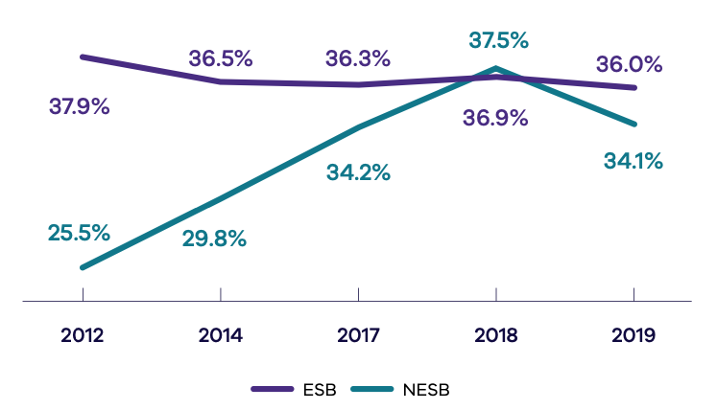
Year | ESB (%) | NESB (%)
2019 | 36.0 | 34.1
2018 | 36.9 | 37.5
2017 | 36.3 | 34.2
2014 | 36.5 | 29.8
2012 | 37.9 | 25.5
B2 Proportion of Victorians from a non-English speaking background who are members of an organised group
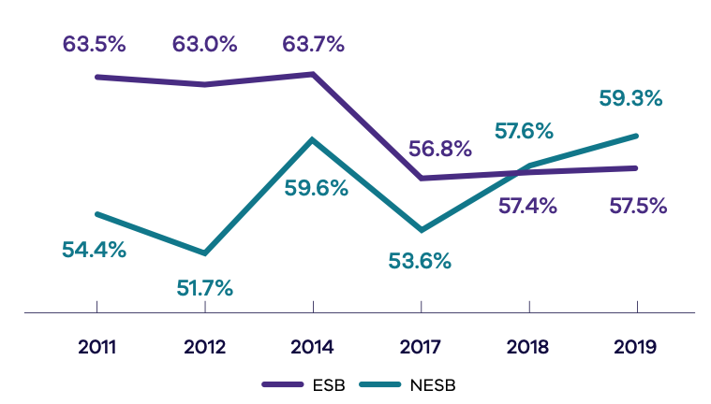
Year | ESB (%) | NESB (%)
2019 | 57.5 | 59.3
2018 | 57.4 | 57.6
2017 | 56.8 | 53.6
2014 | 63.7 | 59.6
2012 | 63.0 | 51.7
2011 | 63.5 | 54.4
B3 Proportion of total membership of government boards, authorities and committees from culturally diverse backgrounds (where data is collected)
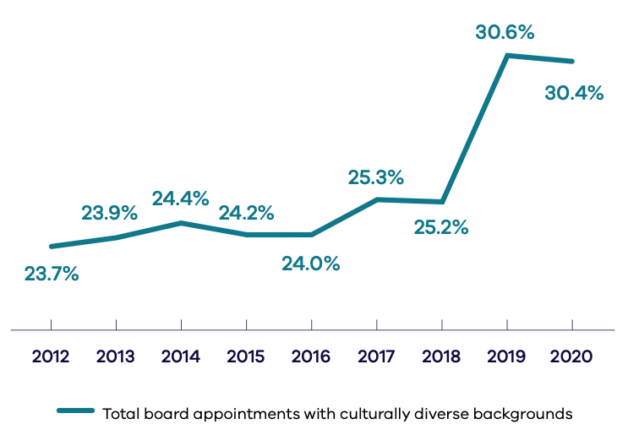
Year | Total board appointments with culturally diverse backgrounds (%)
2020 | 30.4
2019 | 30.6
2018 | 25.2
2017 | 25.3
2016 | 24.0
2015 | 24.2
2014 | 24.3
2013 | 23.9
2012 | 23.7
B4 Proportion of Victorians from a non-English speaking background who feel multiculturalism at least sometimes makes life better in their area
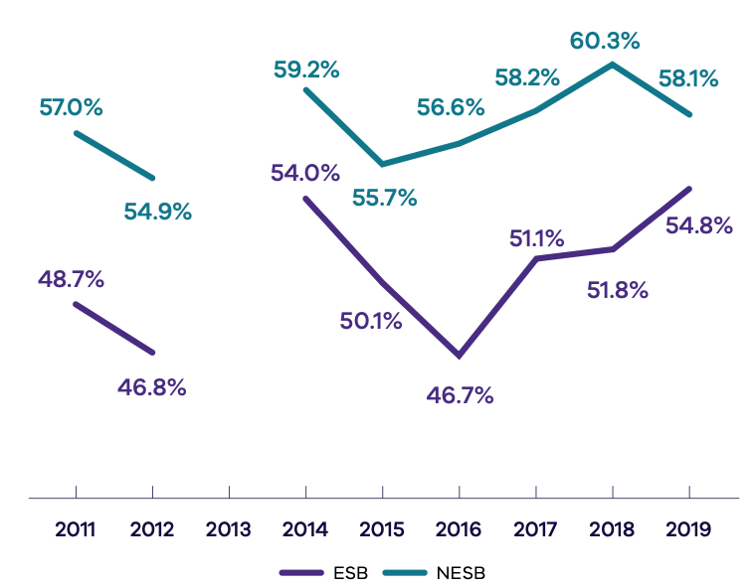
Year | ESB (%) | NESB (%)
2019 | 54.8 | 58.1
2018 | 51.8 | 60.3
2017 | 51.1 | 58.2
2016 | 46.7 | 56.6
2015 | 50.1 | 55.7
2014 | 54.0 | 59.2
2013 | - | -
2012 | 46.8 | 54.9
2011 | 48.7 | 57.0
B5 Proportion of survey respondents who think the number of immigrants accepted into Australia at present is ‘too high’
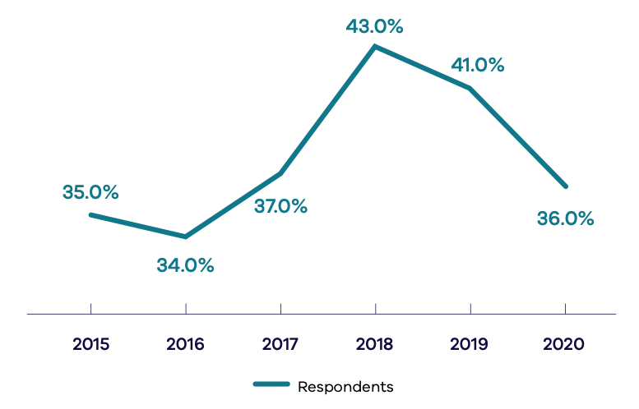
Year | Survey respondents (%)
2020 | 36.0
2019 | 41.0
2018 | 43.0
2017 | 37.0
2016 | 34.0
2015 | 35.0
B6 Proportion of survey respondents who ‘agree’ or ‘strongly agree’ that accepting immigrants from many different countries makes Australia stronger
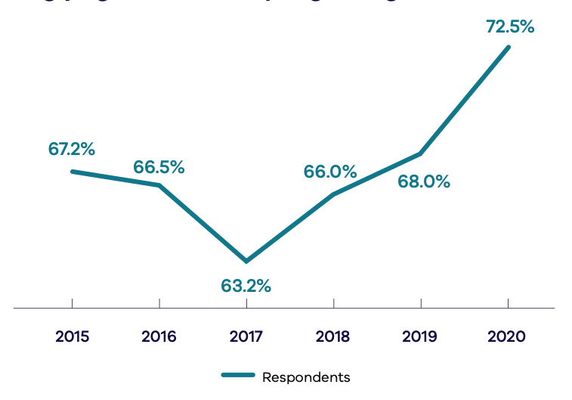
Year | Survey respondents (%)
2020 | 72.5
2019 | 68.0
2018 | 66.0
2017 | 63.2
2016 | 66.5
2015 | 67.2
B7 Number of complaints made to the Victorian Equal Opportunity and Human Rights Commission (VEOHRC) under the Racial and Religious Tolerance Act 2001 (RRT)
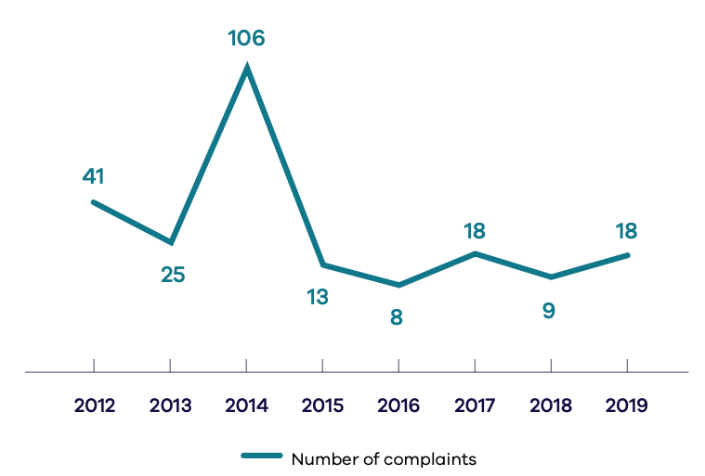
Year | Number of complaints
2019–2020 | 18
2018–2019 | 9
2017–2018 | 18
2016–2017 | 8
2015–2016 | 13
2014–2015 | 106
2013–2014 | 25
2012–2013 | 41
B8 Number of complaints made to the Victorian Equal Opportunity and Human Rights Commission (VEOHRC) in relation to discrimination on the basis of race and religious belief under the Equal Opportunity Act 2010 (EOA)
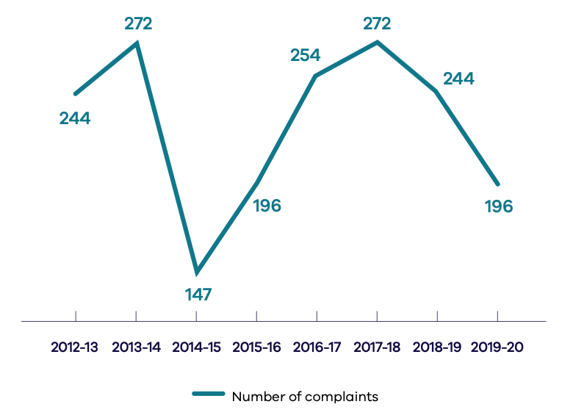
Year | Number of complaints
2019–2020 | 196
2018–2019 | 244
2017–2018 | 272
2016–2017 | 254
2015–2016 | 196
2014–2015 | 147
2013–2014 | 272
2012–2013 | 244

Accessible and responsive services
C1 Number of Victorian children from a non-English-speaking background (NESB) enrolled in a Victorian Government funded kindergarten program
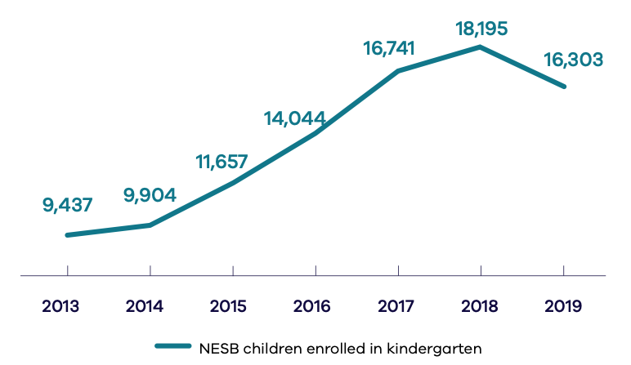
Year | NESB children enrolled in kindergarten
2019 | 16,303
2018 | 18,195
2017 | 16,741
2016 | 14,044
2015 | 11,657
2014 | 9,904
2013 | 9,437
C2 Proportion of Victorian children and young people from language backgrounds other than English (LBOTE) meeting expected reading, writing and numeracy standards
Percentage of students at or above minimum standards Year 3
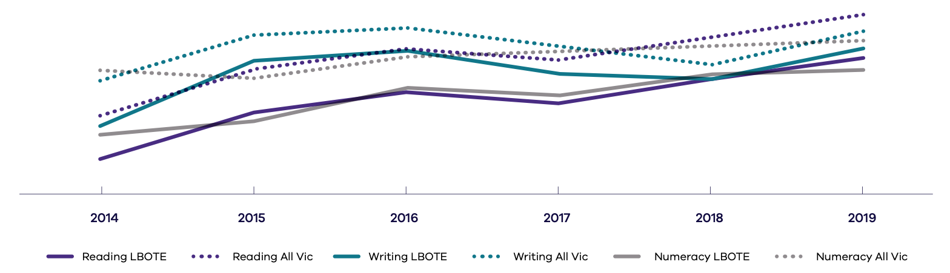
Year of Study | Reading LBOTE | Reading All Vic | Writing LBOTE | Writing All Vic | Numeracy LBOTE | Numeracy All Vic
2019 | 95.9 | 96.6 | 96.2 | 96.6 | 95.5 | 96.4
2018 | 95.3 | 96.2 | 95.3 | 95.7 | 95.4 | 96.3
2017 | 94.6 | 95.8 | 95.4 | 96.3 | 94.8 | 96.0
2016 | 94.9 | 95.8 | 96.1 | 96.7 | 95.0 | 95.9
2015 | 94.3 | 95.5 | 95.8 | 96.5 | 94.1 | 95.3
2014 | 92.9 | 94.6 | 93.9 | 95.2 | 93.7 | 95.5

Percentage of students at or above minimum standards Year 5
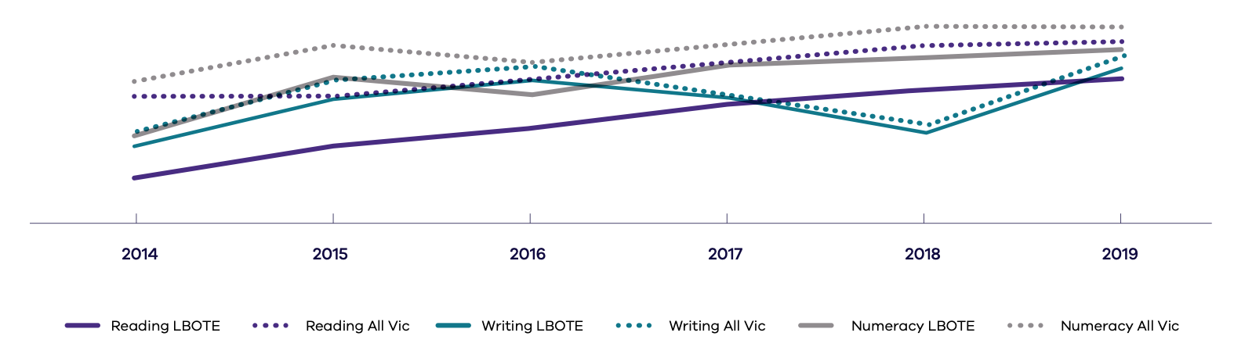
Year of Study | Reading LBOTE | Reading All Vic | Writing LBOTE | Writing All Vic | Numeracy LBOTE | Numeracy All Vic
2019 | 94.8 | 95.9 | 95.1 | 95.3 | 95.7 | 96.4
2018 | 94.4 | 95.8 | 93.1 | 93.4 | 95.4 | 96.4
2017 | 93.9 | 95.2 | 94.2 | 94.2 | 95.2 | 96.0
2016 | 93.2 | 94.6 | 94.7 | 95.0 | 94.3 | 95.3
2015 | 92.7 | 94.3 | 94.1 | 94.7 | 94.8 | 95.8
2014 | 91.7 | 94.2 | 92.7 | 93.2 | 93.0 | 94.7
Percentage of students at or above minimum standards Year 7
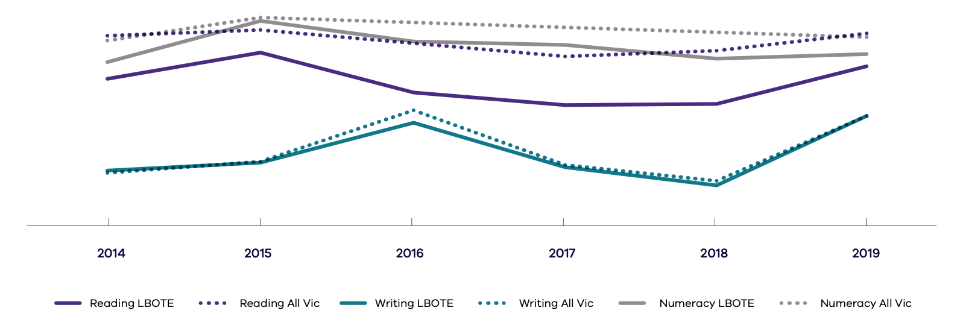
Year of Study | Reading LBOTE | Reading All Vic | Writing LBOTE | Writing All Vic | Numeracy LBOTE | Numeracy All Vic
2019 | 94.5 | 95.7 | 92.6 | 92.6 | 95.0 | 95.7
2018 | 93.1 | 95.1 | 90.1 | 90.2 | 94.8 | 95.9
2017 | 93.0 | 94.9 | 90.7 | 90.8 | 95.3 | 96.0
2016 | 93.5 | 95.3 | 92.4 | 92.8 | 95.4 | 96.1
2015 | 95.0 | 95.9 | 90.9 | 90.9 | 96.2 | 96.3
2014 | 94.0 | 95.6 | 90.5 | 90.5 | 94.7 | 95.5
Percentage of students at or above minimum standards Year 9
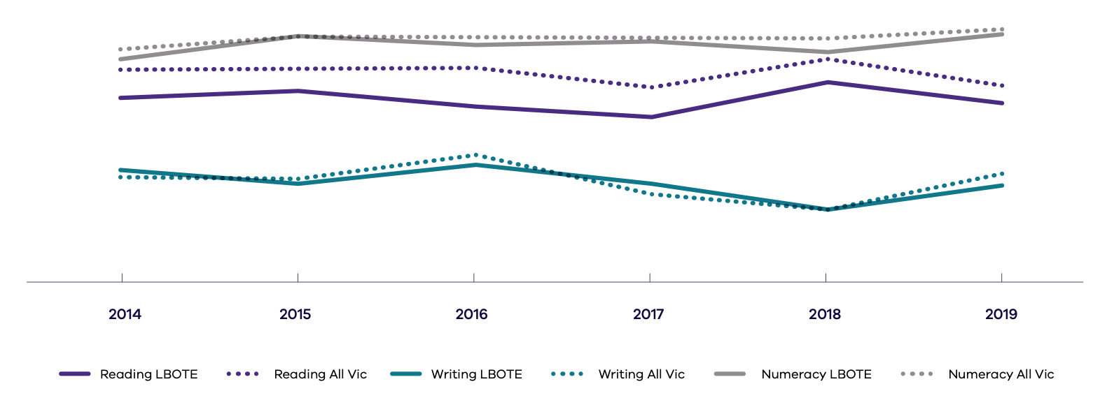
Year of Study | Reading LBOTE | Reading All Vic | Writing LBOTE | Writing All Vic | Numeracy LBOTE | Numeracy All Vic
2019 | 91.0 | 92.4 | 84.9 | 85.8 | 95.9 | 96.2
2018 | 92.3 | 94.1 | 83.2 | 83.4 | 94.7 | 95.5
2017 | 89.9 | 92.0 | 84.9 | 84.4 | 95.3 | 95.5
2016 | 90.6 | 93.4 | 86.3 | 87.1 | 95.1 | 95.4
2015 | 91.7 | 93.5 | 85.0 | 85.3 | 95.7 | 95.6
2014 | 91.3 | 93.3 | 85.7 | 85.4 | 94.1 | 94.8
C3 Proportion of Year 12 completers from language backgrounds other than English (LBOTE) participating in education or training six months after school, compared with all Year 12 completers surveyed in Victoria
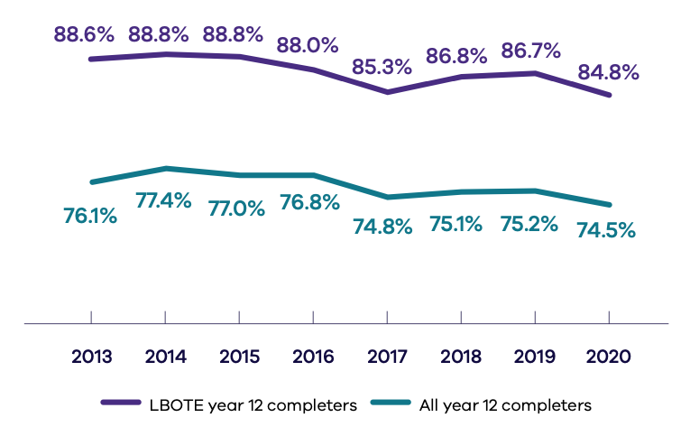
Year | LBOTE year 12 completers (%) | All year 12 completers (%)
2020 | 84.8 | 74.5
2019 | 86.7 | 75.2
2018 | 86.8 | 75.1
2017 | 85.3 | 74.8
2016 | 88.0 | 76.8
2015 | 88.8 | 77.0
2014 | 88.8 | 77.4
2013 | 88.6 | 76.1
C4 Unemployment rate of Victorians born in non-main English-speaking countries compared to the unemployment rate of all Victorians
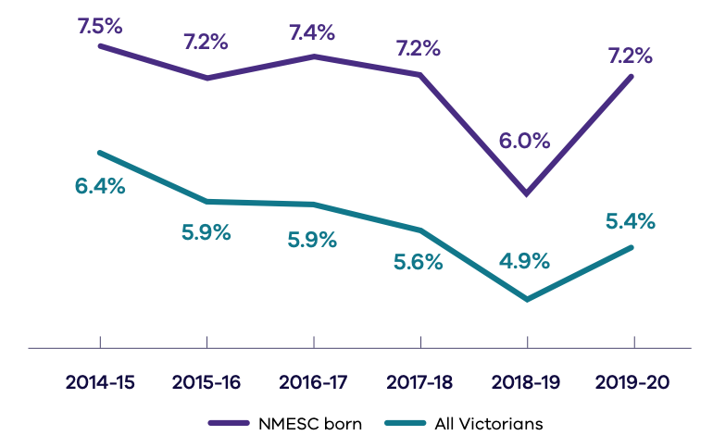
Year | NMESC-born (%) | All Victorians (%)
2019–2020 | 7.2 | 5.4
2018–2019 | 6.0 | 4.9
2017–2018 | 7.2 | 5.6
2016–2017 | 7.4 | 5.9
2015–2016 | 7.2 | 5.9
2014–2015 | 7.5 | 6.4
C5 Workforce participation rate of Victorians born in non-main English-speaking countries compared to the workforce participation rate of all Victorians
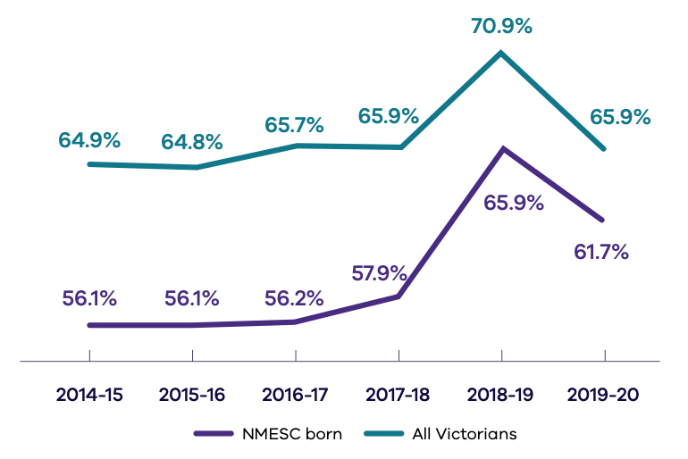
Year | NMESC-born (%) | All Victorians (%)
2019–2020 | 61.7 | 65.9
2018–2019 | 65.9 | 70.9
2017–2018 | 57.9 | 65.9
2016–2017 | 56.2 | 65.7
2015–2016 | 56.1 | 64.8
2014–2015 | 56.1 | 64.9
C6 BreastScreen Australia Program participation rate of NESB Victorian women aged 50 to 74 years compared to the participation rate of all Victorian women in the program aged 50 to 74 years
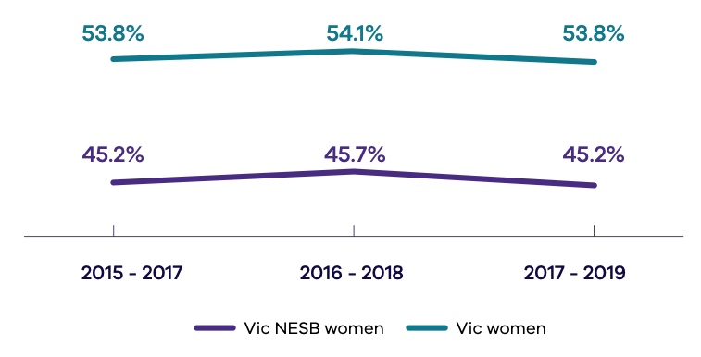
Two-year period | Vic NESB women (%) | Vic women (%)
2018–2020 | Not yet released | Not yet released74
2017–2019 | 45.2 | 53.8
2016–2018 | 45.7 | 54.1
2015–2017 | 45.2 | 53.8
C7 Proportion of Victorians from English-speaking background (ESB), compared to non-English-speaking only (NESB) who report doctor-diagnosed diabetes mellitus
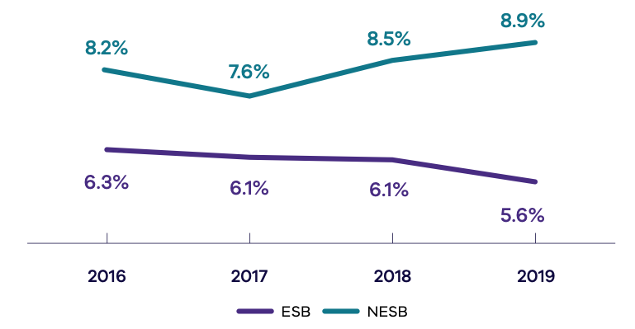
Year | ESB (%) | NESB (%)
2019 | 5.6 | 8.9
2018 | 6.1 | 8.5
2017 | 6.1 | 7.6
2016 | 6.3 | 8.2
C8 Proportion of Victorians from non-English speaking backgrounds who reported ‘insufficient’ physical activity during the week before the survey
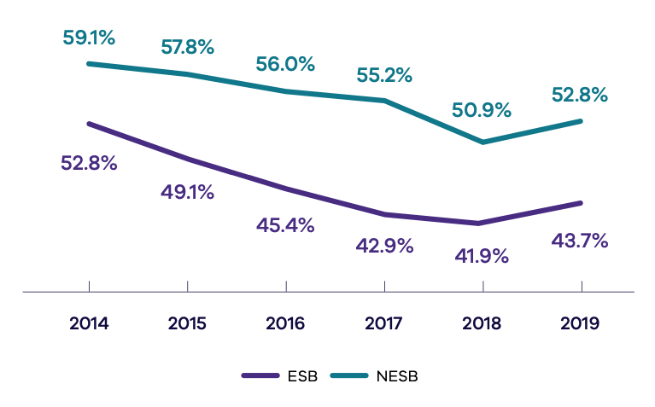
Year | ESB (%) | NESB (%)
2019 | 43.7 | 52.8
2018 | 41.9 | 50.9
2017 | 42.9 | 55.2
2016 | 45.4 | 56.0
2015 | 49.1 | 57.8
2014 | 52.8 | 59.1
C9 Proportion of Victorians from non-English speaking backgrounds with high or very high levels of psychological distress
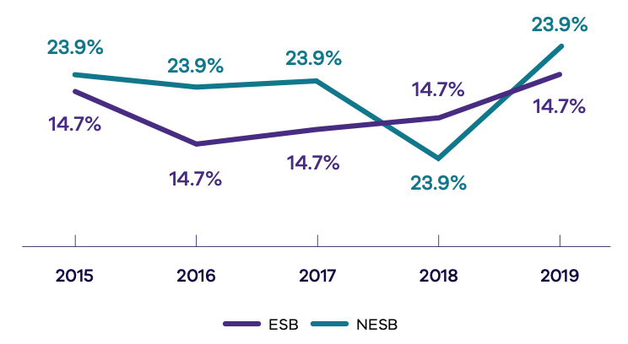
Year | ESB (%) | NESB (%)
2019 | 18.3 | 19.6
2018 | 15.8 | 13.8
2017 | 15.0 | 17.5
2016 | 14.3 | 17.3
2015 | 17.1 | 18.0
C10 Proportion of Victorian home and community care clients aged 0 to 65 years born in a non-main English-speaking country (NMESC), compared to the proportion of all Victorians aged 0 to 65 years born in a NMESC
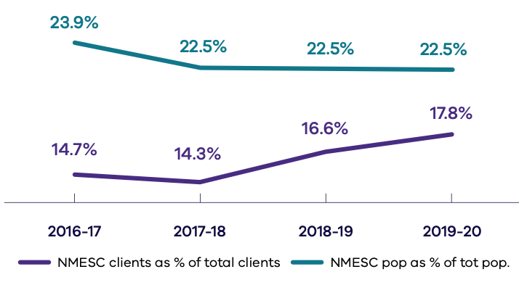
Year of Survey | NMESC clients as % of total clients | NMESC pop as % of total population
2019–2020 | 17.8 | 22.5
2018–2019 | 16.6 | 22.5
2017–2018 | 14.3 | 22.5
2016–2017 | 14.7 | 23.9

C11 National Disability Agreement (NDA) non-English-speaking background service users per 1,000 population, compared with English-speaking background service users per 1,000 population
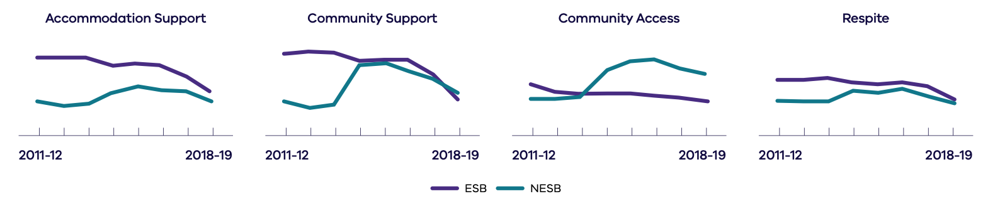
Type of service | Group | 2011–2012 | 2012–2013 | 2013–2014 | 2014–2015 | 2015–2016 | 2016–2017 | 2017–2018 | 2018–2019
Accommodation support | NESB | 0.3 | 0.2 | 0.2 | 0.6 | 0.8 | 0.7 | 0.6 | 0.4
Accommodation support | ESB | 1.7 | 1.7 | 1.7 | 1.4 | 1.5 | 1.4 | 1.1 | 0.6
Community support | NESB | 3.1 | 2.7 | 2.9 | 7.9 | 8.2 | 7.2 | 6.1 | 4.2
Community support | ESB | 9.4 | 9.8 | 9.7 | 8.5 | 8.7 | 8.5 | 6.6 | 3.7
Community access | NESB | 1.1 | 1.1 | 1.3 | 3.9 | 4.7 | 5.1 | 4.1 | 3.6
Community access | ESB | 2.7 | 1.7 | 1.7 | 1.6 | 1.6 | 1.5 | 1.2 | 0.9
Respite | NESB | 1.0 | 0.8 | 0.8 | 1.8 | 1.8 | 1.9 | 1.3 | 0.7
Respite | ESB | 2.9 | 3.0 | 3.2 | 2.7 | 2.6 | 2.7 | 2.1 | 1.0
C12 Proportion of Victorian clients from non-main English-speaking countries whose needs were met at specialist homelessness services, compared to all Victorian clients
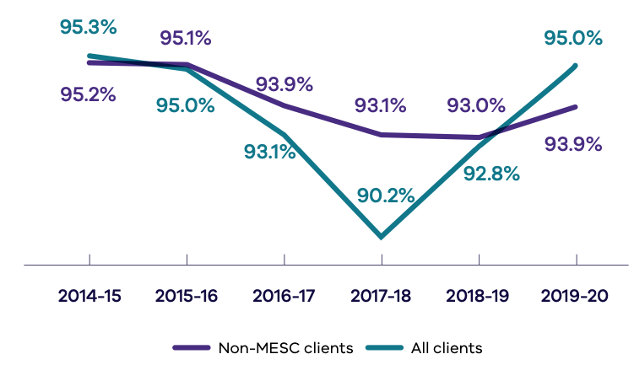
Year | Non-MESC clients (%) | All clients (%)
2019–2020 | 93.9 | 95.0
2018–2019 | 93.0 | 92.8
2017–2018 | 93.1 | 90.2
2016–2017 | 93.9 | 93.1
2015–2016 | 95.1 | 95.0
2014–2015 | 95.2 | 95.3
C13 Percentage increase in whole-of-government expenditure on interpreting and translating services
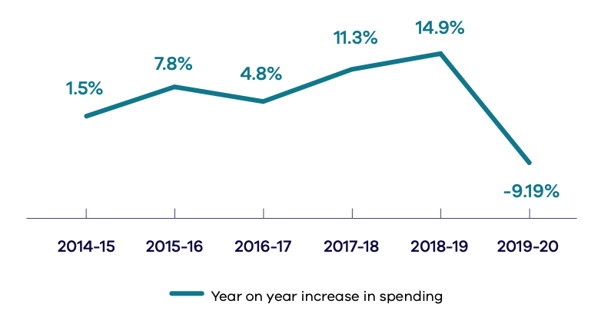
Financial year | Year-on-year increase in spending (%)
2019–2020 | -9.19
2018–2019 | 14.9
2017–2018 | 11.3
2016–2017 | 4.8
2015–2016 | 7.8
2014–2015 | 1.5
C14 Percentage of total government expenditure on advertising campaigns in multicultural media against target of five per cent
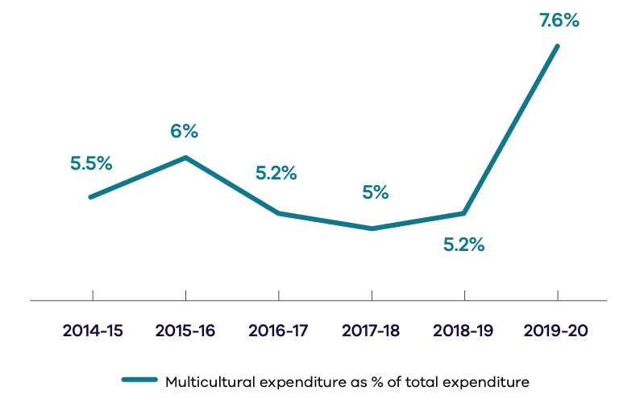
Financial year | Multicultural expenditure as % of total expenditure
2019–2020 | 7.6
2018–2019 | 5.2
2017–2018 | 5
2016–2017 | 5.2
2015–2016 | 6
2014–2015 | 5.5

Australian Bureau of Statistics, Australian Census 2016.
The policy statement can be accessed at the Victorian Government website’s Multicultural policy statement page <https://www.vic.gov.au/multicultural-policy-statement>.
Victorian multicultural policy statement p.25. Available at Victorian Government website’s Multicultural policy statement page <https://www.vic.gov.au/multicultural-policy-statement>.
On 1 February 2021 the Department of Health and Human Services was split into the Department of Health and the Department of Families, Fairness and Housing
On 1 January 2019, the Department of Economic Development, Jobs, Transport and Resources (DEDJTR) transitioned to the new Department of Jobs, Precincts and Regions (DJPR) and the new Department of Transport (DoT). These two departments reported separately in the previous Victorian Government report on multicultural affairs 2019-20 for the 2019-20 reporting year
Premier of Victoria Website <https://www.premier.vic.gov.au/helping-multicultural-victorians-through-coronavirus/>.
Ibid
As at 30 June 2020, the fund had helped over 12,800 international students in need and it will continue to do so in 2020–2021
The agencies funded were Switchboard, Thorne Harbour Health, the Australian Muslim Women’s Centre for Human Rights and InTouch Multicultural Centre Against Family Violence
The Orange Door website has been translated into 50 different languages
Royal Commission into Family Violence (Final Report, March 2016) Recommendation 87
69 per cent of women who were assisted had one or more children (DHHS data submission for 2019-2020 Victorian Government report on multicultural affairs).
This funding was part of the Victorian Government’s broader $6.5 million COVID-19 Response Package
The Australian Multicultural Foundation, Preston Mosque and MyCentre are funded to deliver the Northern Community Support group, which was established in 2018.
Some forums had to be rescheduled due to COVID-19 restrictions.
JVIF is delivered by Jesuit Social Services, Victoria Police and Victoria University Polytechnic, with support from partners including Africause (previously the African Australian Multicultural Employment and Youth Services), AMES Australia, Maurice Blackburn and MatchWorks
Fire Rescue Victoria, Victoria Police and Life Saving Victoria
Programs were conducted before the commencement of COVID-related lockdowns in March 2020
Organisations included Arabic Welfare, Victorian Arabic Social Services, Australian Vietnamese Women’s Association, Springvale Indochinese Mutual Assistant Association, the Federation of Chinese Associations and the Multicultural Centre for Women’s Health
Foundation House, Multicultural Centre for Women’s Health, Orygen, the Asylum Seeker Resource Centre and Cabrini
The Red Cross and the Asylum Seeker Resource Centre delivered the Mental Health COVID-19 Support Package component. In Touch Multicultural Centre Against Family Violence, Safe Steps, Red Cross and the Asylum Seeker Resource Centre delivered the supports for the Support for Victoria’s Multicultural and Faith Communities component
In the 2019–2020 period the languages supported in the diploma and advanced diploma were: Arabic, Italian, Spanish, Thai, Vietnamese, Persian Turkish, Assyrian, Chaldean, Karen and Punjabi
While not a line department, CSV’s expenditure is included here due to its large amount
DTF is an exception as it is an internal facing department and does not usually deal with external stakeholders
DTF is an internal facing line agency and does not usually deal with external stakeholders
This is one program that is part of a more than $2 million investment in the institute from Keeping our sector strong: Victoria’s workforce plan for the NDIS
The other school education programs included in The Strategy are the Women in School Leadership Pilot Program ($100,000) and The Victorian Young Leaders to India Program ($385,225).
Organisations were The Centre for Multicultural Youth, Golf Victoria, AFL Victoria and Baseball Victoria
VFA Annual Report 2018–2019, pg 10. Available on the VFA’s Planning and reporting page <https://vfa.vic.gov.au/about/planning-and-reporting>
As of June 2020, more than 4000 CALD Victorians have been supported into work to date, including over 1700 refugee and asylum seekers and 1300 people with African or Pasifika backgrounds
Ballarat Regional Multicultural Council, Ballarat African Association, Brotherhood of St Laurence Stepping Stones Program and the Thrive Refugee Network
Table 1: Victoria Overseas Country of Birth Census 2016. Figure is now higher and will be updated after 2021 national census. See the Victorian Government website’s Discover Victoria’s diverse population page <https://www.vic.gov.au/discover-victorias-diverse-population>
Now residing within DFFH
Formerly known as Australian Centre for the Moving Image
Formerly Multicultural Affairs unit of DPC
The Learning Pathway is currently being refined and will be available for staff to complete in 2021
The impact of COVID-19 on the department’s resources meant that an action plan for 2019–2020 could not be prepared – instead the previous year’s plan was used as a continuation of the department’s focus on multicultural communities
On 1 February 2021 the Department of Health and Human Services was split into the Department of Families, Fairness and Housing and the Department of Health. Both departments will require individual CDPs, which will be provided in the 2020–2021 Victorian Government report on multicultural affairs
Work to progress an implementation plan under the CDP was disrupted due to COVID-19 and the reprioritising of staffing resources during this time
DPC, Diversity and inclusion strategy 2019–2020, pg 24. Available at the Victorian Government website’s DPC Diversity and inclusion strategy 2019–2021 page <https://www.vic.gov.au/dpc-diversity-and-inclusion-strategy-2019-2021>.
The DoT is currently operating under the existing DoT Multicultural Diversity Action Plan 2018-2021 until the new, integrated DoT CALD Inclusion Action Plan is finalised in early 2021
Data for tables 6 to 8 provided by the Victorian Public Sector Commission
Due to technical issues discovered in 2020 between the database and reporting tool, some records were erroneously attributed a CALD indicator. The error mainly impacted the CALD self-described and language values for records under DTF. All impacted records have been remediated and the reporting tool replaced with one managed by the VPSC
The Australian Bureau of Statistics uses the term NMESC to represent non-main English-speaking countries, while MESC represents main English-speaking countries. MESC are the United Kingdom, Ireland, New Zealand, Canada, USA and South Africa. NMESC cover all other countries of birth. Where appropriate and specifically relevant, some departments and agencies use the term NESB to stand for non-English-speaking background and ESB to stand for English-speaking background. LBOTE stands for language background other than English while LOTE is for language other than English
Source: ABS Census of Population and Housing. The Census is conducted every five years
The data includes international students who have stated an intention to reside in Victoria, Australia for 12 months or more and are therefore counted in the Census as usual residents and not as overseas visitors
Source: ABS Census of Population and Housing. The Census is conducted every 5 years
Source: ABS Census of Population and Housing. The Census is conducted every 5 years
Note: This variable is not applicable to persons who are unemployed, whose labour force status is not mentioned and who are not in the labour force
DJPR, International Visitor Survey, Tourism Research Australia. The data is collected quarterly
Source: International Student Data, Department of Education, Austrade Market Information Package. Data is released on a monthly basis and for a full year
Source: DJPR, Resolve Database. The data is collected annually
Source: DET Languages Report. The data is collected annually
Source: DET Languages Report. The data is collected annually. 2019 is the most current data
Source: DHHS, Victorian Population Health Survey, annual. The latest published survey data available at time of report
Data unavailable for 2015 to 2016
Source: Victorian Population Health Survey, annual. The latest published survey data available at time of report
Source: Victorian Public Sector Commission. Data is collected annually
Step change between 2018 and 2019 is due to remediation and improved data capture methods. From 2019 survey fields about cultural diversity are now mandatory
Source: DHHS, Victorian Population Health Survey, annual survey. The latest published survey data available at time of report
No data was available for 2013, as the question was not asked. Data for 2015 onwards cannot be compared to previous years due to a change in survey methodology
Source: The Scanlon Foundation’s Mapping Social Cohesion Survey reports. The surveys are conducted annually
In 2020 the question was asked twice. Once in July 2020 (38 per cent) and November 2020 (34 per cent). We have reported the median value
Source: The Scanlon Foundation’s Mapping Social Cohesion Survey reports. The surveys are conducted annually
Source: Victorian Equal Opportunity and Human Rights Commission (VEOHRC) Annual Reports. The data is collected annually
Source: Victorian Equal Opportunity and Human Rights Commission (VEOHRC) Annual Reports. The data is collected annually
Source: DET Kindergarten Census Collection. Data is collected annually. The data represents the number of children who were enrolled in a funded kindergarten program and who indicated that they speak another main language at home other than English. It is not feasible to calculate a kindergarten participation rate for NESB children as there is no suitable NESB population denominator for four-year-olds
2020 data was unavailable at the time of publication. In 2019 and 2020, there was a system error in the Kindergarten Information Management System, which has removed the ability for service providers to select ‘other’ under the question for ‘Main language spoken at home (if not English)’. Kindergarten services who would have usually entered data in this field may have left this blank. (In 2018 almost 3,500 children had ‘other’ entered in this field)
Source: Annual NAPLAN assessments of Year 3, 5, 7 and 9 students across Australia. This data is published annually by the Australian Curriculum, Assessment and Reporting Authority in the National NAPLAN Report. No data was collected in 2020 as the NAPLAN assessment was cancelled due to the COVID19 pandemic
Source: DET On Track post school destinations survey. Annual collection runs in April-May
Source: Australian Bureau of Statistics, Labour Force Survey. Monthly. The data is collected monthly, quarterly and for each financial year
Source: Australian Bureau of Statistics, Labour Force Survey. Monthly. The data is collected monthly, quarterly and for each financial year
Source: Productivity Commission Report on Government Services. Data is collected yearly and recorded over a two-year period. Data for 2015 onwards is not comparable with previous years as the target age group changed from ‘50 to 69 years’ to ‘50 to 74 years’. As such, a new trend chart has been included in this report
COVID-19 has impacted BreastScreen participation between March and June 2020. When available, the data for July 2018 to June 2020 will reflect reduced participation rates resulting from the temporary pause in service delivery commencing 25 March 2020 and reduced capacity upon resumption of services in May 2020
Victorian Population Health Survey. Annual survey
DHHS Victorian Population Health Survey. Annual survey
Source: DHHS Victorian Population Health Survey. Annual survey
Source: Productivity Commission Reports on Government Services (RoGS). The reports are published annually but with a two-year time lag
Australian Institute of Health and Welfare, Specialist Homelessness Services Collection (SHSC). Data is reported annually though the Report on Government Services (ROGS)
DPC, Victorian Government initiatives and reporting in Multicultural Affairs. The data is collected annually
This reduction is due to a decrease of in-person service delivery due to widespread Victorian lockdowns during the early stages of 2020 with telephone interpreting services instead being used
DPC, Victorian Government initiatives and reporting in Multicultural Affairs. The data is collected annually

