

Inclusive Victoria: state disability plan 2022-26 – newsletter article
Easy Read
OFFICIAL

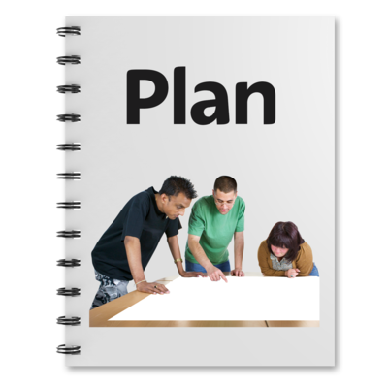 | The Victorian Government has made a new plan.
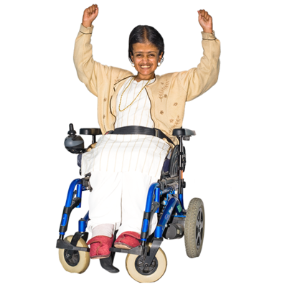 | This plan explains how we want to make life better for people with disability in Victoria.
 | It’s called Inclusive Victoria: State Disability Plan 2022–2026.
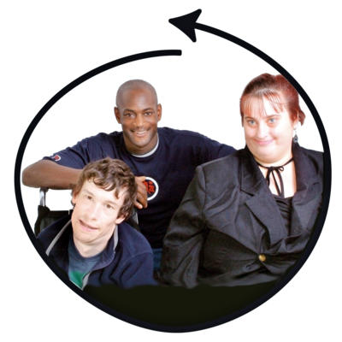 | This plan will make Victoria more inclusive for people with disability.
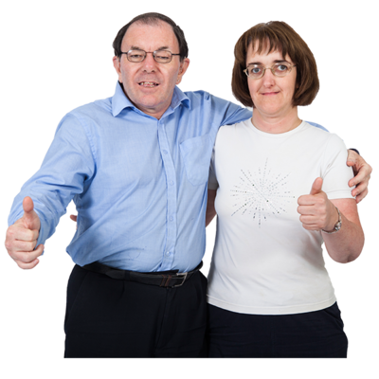 | If something is inclusive it means everyone can join in and is welcome.
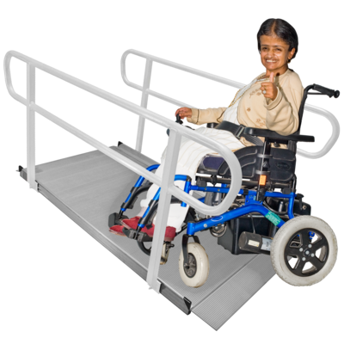 | The plan will make the state more accessible for people with disability.
 | If something is accessible it means people with disability can use it.
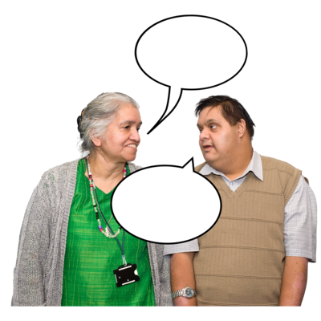 | To make the plan the Victorian Government spoke to people with disability, including self advocates.
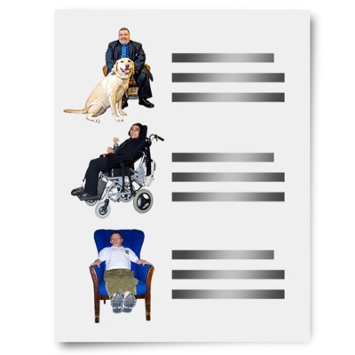 | The plan lists all the things we will do make things fairer for people with disability.
 | You can find an Easy Read version of the plan on our website here <https://www.vic.gov.au/state-disability-plan>
 | To find out more you can contact the Office for Disability via email <ofd@dffh.vic.gov.au>
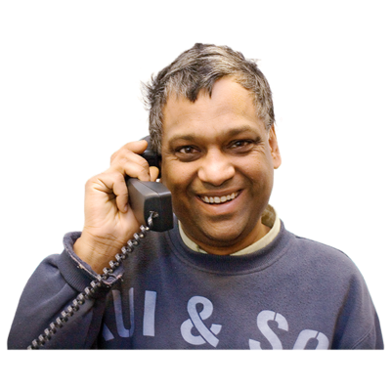 | You can also call the Office for Disability on 1300 880 043.

To receive this document in another format, phone 1300 880 043, using the National Relay Service 13 36 77 if required, or email Office for Disability <ofd@dffh.vic.gov.au>.
Authorised and published by the Victorian Government, 1 Treasury Place, Melbourne.
© State of Victoria, Australia, Department of Families, Fairness and Housing, February 2022.

Except where otherwise indicated, the images in this document show models and illustrative settings only, and do not necessarily depict actual services, facilities or recipients of services. This document may contain images of deceased Aboriginal and Torres Strait Islander peoples.


