
Victorian Government report in multicultural affairs 2020-2021
OFFICIAL

If you would like to receive this publication in an alternative format, such as large print or audio, email Multicultural Affairs <multicultural@dffh.vic.gov.au>.
Authorised and published by the Victorian Government, 1 Treasury Place, Melbourne.
© State of Victoria, Australia, Department of Families, Fairness and Housing, May 2022
With the exception of any images, photographs or branding (including, but not limited to the Victorian Coat of Arms, the Victorian Government logo or the Department of Families, Fairness and Housing logo), this work, Victorian Government report in multicultural affairs 2020-2021, is licensed under a Creative Commons Attribution 4.0 licence.
The terms and conditions of this licence, including disclaimer of warranties and limitation of liability, are available at Creative Commons’ Attribution 4.0 International (CC BY 4.0) web page <https://creativecommons.org/licenses/by/4.0>
You are free to re-use the work under that licence on the condition that you credit the State of Victoria, Australia (Department of Families, Fairness and Housing) as the author, indicate if any changes have been made to the work and comply with the other licence terms.
Except where otherwise indicated, the images in this document show models and illustrative settings only, and do not necessarily depict actual services, facilities or recipients of services. This document may contain images of deceased Aboriginal and Torres Strait Islander peoples.
In this document, ‘Aboriginal’ refers to both Aboriginal and Torres Strait Islander people. ‘Indigenous’ or ‘Koori/Koorie’ is retained when part of the title of a report, program or quotation.
ISSN 2205-8265 (online/PDF/Word)
Available at Victorian Government website's Victorian Government report in multicultural affairs page <https://www.vic.gov.au/victorian-government-report-multicultural-affairs>
(2203200)
Machinery of government changes
On 1 February 2021 the Department of Health and Human Services (DHHS) was split into the Department of Health (DH) and the Department of Families, Fairness and Housing (DFFH). On the same day, the Multicultural Affairs portfolio moved from the Department of Premier and Cabinet (DPC) to the newly created Department of Families, Fairness and Housing (DFFH).
Disclaimer
This publication is provided for information purposes only. No claim is made as to the accuracy or authenticity of the information contained herein. Information is provided on the basis that all persons accessing the information undertake responsibility for assessing its relevance and accuracy.
DFFH makes no representations, either expressed or implied, as to the suitability of the said information for any particular purpose and disclaims all liability for any error, loss or other consequence which may arise from you relying on any information in this publication.

Acknowledgements
The Victorian Government acknowledges Victoria’s Aboriginal and Torres Strait Islander communities and pays respect to their Elders past and present. We acknowledge Aboriginal and Torres Strait Islander people as Australia’s first people and as the Traditional Owners and Custodians of the land on which we live.
The Victorian Government would also like to acknowledge the important role of government partners, including local councils and service agencies, in the delivery of programs and initiatives reflected in this report. We would also like to thank all community leaders and volunteers who contribute to supporting multicultural communities across our state. The last two years have seen significant demands on community leaders in the response to COVID-19 and these contributions have been invaluable.
We would also like to thank our government colleagues for their assistance in collating the data for this report as well as all the community members who shared their powerful stories in this report.

Message from the Minister

Amidst continued challenges to public health arising from the COVID-19 pandemic, and disruptions to the economy and everyday life, Victoria’s multicultural communities demonstrated unwavering strength, resilience and patience to overcome extraordinary challenges.
The Victorian Government report in multicultural affairs 2020-2021 records the many programs and initiatives delivered across government to help multicultural and multifaith communities progress in what was an extremely challenging year.
As the COVID-19 pandemic affected our lives and livelihoods, the Victorian Government continued to innovate. It partnered with community organisations to help culturally and linguistically diverse (CALD) Victorians maintain vital community connections and access to employment opportunities, while keeping themselves and their fellow Victorians safe.
The CALD Communities Taskforce was formed in August 2020 to help multicultural communities respond promptly to the effects of COVID-19. In 2020-2021, the taskforce allocated more than $33 million in funding to support multicultural communities. This meant every effort could be made to ensure the government’s COVID-19 response was culturally sensitive and appropriate, with CALD communities better informed and resourced to manage outbreaks, increase uptake of testing and vaccination, and facilitate social and economic recovery. This funding generated 280 partnerships with community organisations and helped people stay safe and secure.
The Tenancy and Consumer program helped to deliver information and advocacy assistance to more than 7,000 vulnerable renters. Stepping in to Support Asylum Seekers program helped people who were ineligible for Commonwealth safety net support get assistance with utilities, and access mental health, clinical care and legal services. In 2020-2021, the International Student Emergency Relief Fund provided $21.6 million in grants, supporting more than 20,600 international students.
Anti-discrimination and social inclusion remained a priority. The Local Anti-Racism Initiatives Grants program was launched in early 2021, investing over $3.85 million to help 42 organisations deliver activities to tackle racism, promote intercultural understanding and strengthen social cohesion.
I thank all government departments and staff who contributed to this report. I also commend the enormous efforts undertaken by community partners to support our multicultural communities throughout such difficult and uncertain times.
Victoria’s multiculturalism is one of our greatest strengths. I am confident that this report will further highlight our government’s commitment to embracing and celebrating diversity.

The Hon Ros Spence MP
Minister for Multicultural Affairs
Contents
Acknowledgements 3
Message from the Minister 4
Legal and policy frameworks underpinning this report 7
Working to achieve positive outcomes 8
Terminology, abbreviations and frequently used terms 9
Terminology used in this report 9
List of government departments 9
List of abbreviations and acronyms 10
The Victorian Government’s response to COVID-19 11
COVID-19 initiatives 11
Victorians are safe and secure 14
Secure accommodation amidst uncertainty 14
Keeping CALD Victorians safe and supported 14
Victorians are healthy and well 16
Managing the impact of COVID-19 16
Equal access to health and sports 16
Victorians are able to participate fully 20
Communicating with Victoria’s CALD communities 20
Disability support 23
Opportunities to learn and grow 23
Sports initiatives 24
Employment assistance and career development 26
Multicultural community business support 26
Victorians are connected to culture and community 28
Multilingual initiatives 28
Arts and cultural celebration 28
Cultural exchange program 29
Victorians have equal rights and opportunities 30
Anti-racism 30
Promoting human rights within government departments 31
Progress in departmental cultural diversity plans 34
Background 34
Departmental cultural diversity plans 35
Appendix 1: Culturally diverse representation on government boards, authorities and committees 43
Appendix 2: Indicators 45
Benefits of diversity 45
Social cohesion and participation 47
Accessible and responsive services 51

Legal and policy frameworks underpinning this report
Victoria continues to be one of the most multicultural societies in the world, with more than a quarter of the population born overseas. This report details the Victorian Government’s efforts to implement strategies and policies that support multicultural communities.
This report fulfils a requirement of the Multicultural Victoria Act 2011 for government departments to report annually to the Minister for Multicultural Affairs and to the Victorian Parliament on programs and initiatives that support Victoria’s multicultural community.
The following are legislative and policy documents that guide the government’s mission to build an inclusive, engaged and cohesive community.
Table 1: Victoria's multicultural frameworks
Type | Description
Acts of Parliament | - Multicultural Victoria Act 2011: The framework for a whole-of-government approach to multiculturalism in Victoria. The Act also establishes the Victorian Multicultural Commission as a statutory authority and requires Victorian government departments to develop and implement cultural diversity plans.  - Equal Opportunity Act 2010: All Victorian government departments and service providers have a positive duty under this Act to take reasonable and proportionate measures to identify and eliminate discrimination.  - Charter of Human Rights and Responsibilities Act 2006: Sets out the basic rights of Victorians to live with freedom, respect, equality and dignity, and requires public authorities to act compatibly with the Charter.  - The Racial and Religious Tolerance Act 2001: Prohibits behaviours that incite or encourage hatred, serious contempt, revulsion or severe ridicule against another person or group of people because of their race or religion.
Departmental cultural diversity plans | Plans created by government departments to facilitate diversity and multiculturalism both internally and when delivering services and programs to the Victorian community.
Individual departmental policies, plans and strategies | Departments undertake reviews of policies, strategies and planning frameworks on an ongoing basis to respond to the changing needs of culturally diverse communities and to reflect the government’s commitment to multiculturalism.

Working to achieve positive outcomes
The Whole of government multicultural affairs outcomes framework explains the Victorian Government’s approach to multiculturalism throughout the state.
Table 2: Whole of government multicultural affairs outcomes framework
Goal | Desired outcomes for Victorians
Victorians are safe and secure | - Victorians live free from abuse, violence and fear  - Victorians have suitable and stable housing
Victorians are healthy and well | - Victorians have good physical and mental health  - Victorians have equitable access to health and human services
Victorians are able to participate fully | - Victorians participate in learning and education  - Victorians participate and contribute to the economy  - Victorians have financial security  - Victorians understand, are empowered by, and exercise their rights  - Victorians have access to an environment that promotes liveability, sustainability and inclusion
Victorians are connected to culture and community | - Victorians are socially engaged and live in inclusive communities  - Victorians can safely identify with and connect with their culture and identity
Victorians have equal rights and opportunities | - Victorians live free from discrimination  - Opportunities to participate in the workforce are available to all Victorians
Programs and initiatives are grouped under the framework’s five goals. This report does not capture the full range of activities undertaken by Victorian Government departments and portfolio agencies. Instead, it provides a snapshot of activities and achievements supporting multicultural and multifaith communities between 1 July 2020 and 30 June 2021 across government. The case studies demonstrate the impact of initiatives on local communities.

Terminology, abbreviations and frequently used terms

Terminology used in this report
To remain consistent and uniform, the term ‘multicultural communities’ has been used throughout this report to describe culturally, religiously and linguistically diverse Victorians.

List of government departments
Acronym | Department
DELWP | Department of Environment, Land, Water and Planning
DET | Department of Education and Training
DFFH | Department of Families, Fairness and Housing
DH | Department of Health
DHHS | Department of Health and Human Services
DJCS | Department of Justice and Community Safety
DJPR | Department of Jobs, Precincts and Regions
DoT | Department of Transport
DPC | Department of Premier and Cabinet
DTF | Department of Treasury and Finance

List of abbreviations and acronyms
Acronym | Definition
CALD | Culturally and linguistically diverse
CAV | Consumer Affairs Victoria
CCT | Cultural competency training
CDP | Cultural diversity plan
ESB | English-speaking background
LBOTE | Language background other than English
LGBTIQ+ | Lesbian, gay, bisexual, trans and gender diverse, intersex, and queer
LOTE | Language other than English
MESC | Main English-speaking country
NMESC | Non-main English-speaking country
NDIS | National Disability Insurance Scheme
NESB | Non-English-speaking background
VEOHRC | Victorian Equal Opportunity and Human Rights Commission
VMC | Victorian Multicultural Commission
VPS | Victorian Public Service
VPSC | Victorian Public Sector Commission

The Victorian Government’s response to COVID-19
With the COVID-19 pandemic affecting Victorians in different ways, the Victorian Government responded to the unprecedented needs of CALD communities.
Programs and services were implemented to help people from multicultural backgrounds build resilience and emerge stronger from the pandemic.

COVID-19 initiatives
The CALD Communities Taskforce was established in August 2020 to work with multicultural communities during the COVID-19 pandemic. The taskforce partners with CALD communities to:
- support culturally-appropriate responses to COVID-19 outbreaks
- improve government’s preparedness to prevent and respond effectively to future outbreaks
- increase uptake of testing and vaccination
- support the social and economic recovery of CALD communities.
The CALD Communities Taskforce’s leadership and coordination across government played a critical role in alleviating the compounding effects of COVID-19 on CALD communities.
Through allocated funding in 2020-2021 (DFFH: $33.13m), a broad range of initiatives were delivered to build deeper engagement and partnerships with community. These include:
- $17.97 million to support more than 280 partnerships with community organisations and multicultural services providers to work locally with CALD communities on emergency relief, outreach supports and community-led communications and in-language messaging. This helped more than 70,000 individuals to isolate and stay safe.
- $3.47 million to partner across government to develop short-term initiatives to mitigate risks in CALD communities.
- $1.80 million to help translation and interpreting services meet demand from across government departments and community. For example, a partnership with the National Ethnic and Multicultural Broadcasters’ Council (NEMBC) to operate a regular multilingual news service in priority languages. This was broadcast across 15 ethnic community radio stations and four regional radio stations.
- $2.17 million to address immediate needs in CALD communities and support the taskforce’s operations.
- $7.72 million to establish local partnerships with six local councils to:
  - undertake targeted engagement and communications activities
  - support more than 900 multicultural seniors’ organisations during the pandemic
  - develop tailored responses for high-risk groups, including temporary migrants, international students and migrant workers.
Victoria’s multicultural leaders regularly engaged with health experts about COVID-19 and the vaccination program to help them support their communities. Senior representatives of the Victorian Government were also present to answer questions. VMC continues to be an important link between CALD communities and government departments and agencies. In partnership with other government departments, VMC hosted several briefing sessions and roundtables for CALD community leaders.
During the COVID-19 pandemic, DH’s Priority Communities Engagement COVID-19 Response team ensured that priority cohorts had culturally appropriate health information on the COVID-19 vaccine. This resulted in steadily increasing vaccination rates. This dedicated team informed, consulted and empowered CALD communities to feel safe about the COVID-19 vaccine. Target communities included:
- temporary visa holders, refugees and asylum seekers
- CALD seniors
- people with disability
- newly arrived communities overrepresented in high-risk industries, such as meat processing and transport.
Broader engagement and communication efforts also targeted women and young people. Key outcomes included:
- holding 47 co-designed community information sessions in partnership with cross-government partners, and multicultural agencies and community groups
- presenting four capacity building workshops in collaboration with Murdoch Children's Research Institute for community group leaders, health advocates, multifaith leaders and multicultural service providers.
The Victorian Government continued to give immediate support to international students in Victoria who were experiencing hardship through lost wages and work because of the COVID-19 pandemic. The $45 million International Student Emergency Relief Fund (DJPR: $24.169m in 2020-2021) opened on 19 May 2020 and closed on 31 December 2020. In 2020-2021, the fund gave $21.6 million in grants of up to $1,100 to more than 20,600 international students enrolled in Victorian universities, TAFEs and private education providers who experienced financial hardship from income loss. Across the two financial years, the fund provided over $34.25 million assistance to 33,497 international students. The remaining funding was allocated to food relief and the Extreme Hardship Support program for temporary migrants (accessible to international students).
In Term 3 of 2020, Learning from Home grants (DET: $1.6m over four years) enabled kindergarten services to stay engaged with vulnerable children and communities during COVID-19 restrictions. Foundation House and FKA Children’s Services were appointed as direct contacts for early childhood services needing more advice on engaging and maintaining connections with CALD families. Examples of support given to CALD families included:
- tip sheets for kindergarten services to build partnerships with families from refugee backgrounds and work effectively with interpreters
- free interpreting service through the Victorian Interpreting and Translating Services (VITS) Language Loop
- key messages (such as returning to kindergarten in Term 3 and the importance of play-based learning) were translated to community languages and distributed.
The 2020-2021 State Budget allocated funding to eight local councils to engage CALD outreach workers to work directly with early childhood education and care (ECEC) services and vulnerable CALD families. These CALD outreach workers:
- supported CALD families with kindergarten registrations and enrolment
- gave advice on upskilling ECEC teachers and educators
- increased awareness of Early Start Kindergarten eligibility for children from refugee and asylum-seeking backgrounds.
At the same time, the Brotherhood of St Laurence was engaged to implement the Family Learning Support program. They gave intensive outreach support to highly vulnerable CALD families and children living in public housing sites to access ECEC services. The program’s bicultural workers worked directly with vulnerable CALD families and children, promoted COVID-19 health and vaccination messages, and improved social connectedness. Clients included families from Eritrean, Ethiopian, Vietnamese, Somali, Pakistani, Turkish, Sudanese, and Pacific Islander backgrounds.
The DH-funded Victorian Refugee Health Network engages and coordinates refugee health and settlement organisations. It also advises the government on the needs of refugee communities. The network provided the latest COVID-19 information to more than 1,000 specialist refugee health and settlement service providers. These providers in turn reached some of Victoria’s most at-risk multicultural community members. The network also gave DH regular sector feedback and community insights, enabling responsiveness to emerging issues in the rapidly changing pandemic.
DJCS helped multicultural communities in the private rental sector understand their rights and obligations during the COVID-19 pandemic, including the rental evictions moratorium and other rental emergency measures. Tenants Victoria was funded (DJCS: $27,500) to translate and distribute resources to help renters from multicultural backgrounds better understand their renting rights and obligations during the pandemic. These included:
- audio guides and shareable online publications in Arabic, Dinka, Dari, Punjabi and Chinese
- digital content for the Tenants Victoria website on amendments to the Residential Tenancies Act 1997 and new regulations in 25 languages.
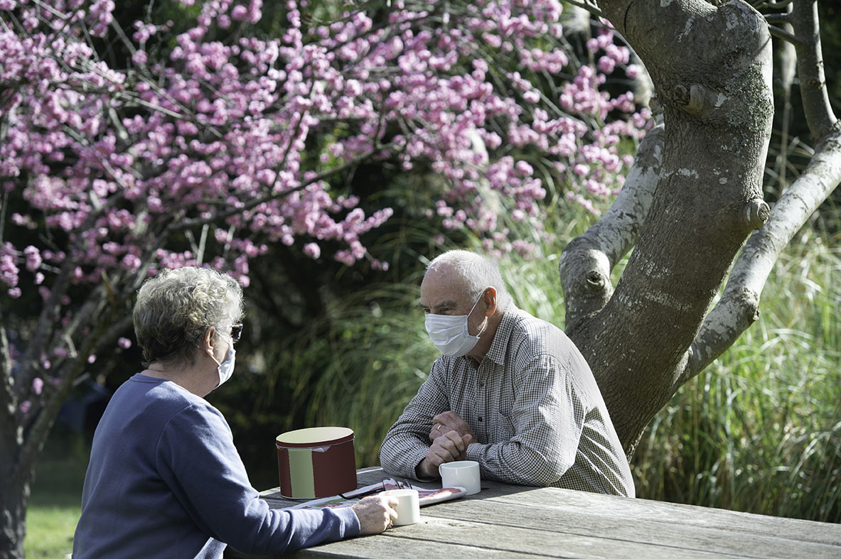

Victorians are safe and secure

Secure accommodation amidst uncertainty
CAV’s Tenancy and Consumer program (DJCS: $5,821,866) funded 14 community agencies to provide information and advocacy assistance to vulnerable renters, including members of multicultural communities. In 2020-2021, the program helped 7,070 disadvantaged renters and consumers, including those from multicultural communities.
Funding for communication and education on the Residential Tenancies Dispute Resolution Scheme and rental reforms was also given to community sector agencies, including multicultural communities. This included:
- $250,000 to Tenants Victoria to update its communications and training for Tenancy Assistance and Advocacy program staff
- $85,000 to the Victorian Council of Social Service to facilitate feedback between CAV and community sector groups on rental reforms and the COVID-19 rental evictions moratorium
- $25,000 to Financial Counselling Victoria to train financial counsellors
- $25,000 to many community sector agencies, including multicultural communities, to educate rooming house operators.
The Study Melbourne Student Centre (SMSC) and International Student Employment and Accommodation Legal Service (ISEALS) (DJPR: $1,119,000) gave free, confidential and independent legal advice to international students on work rights and tenancy matters. In 2020-2021, they provided information, referrals and casework support to 4,400 international students. Over $190,000 in material aid (such as emergency rent assistance and food vouchers) was given through more than 200 payments to international students. There were also 108 appointments seeking employment legal advice and 125 appointments seeking accommodation legal service through ISEALS. With the end of the eviction moratorium in March 2021, the service helped to prevent international students from being evicted.
My Rental Rights (DFFH and Tenants Union of Victoria) involved co-design, development and promotion of a communications campaign to tackle racism and rental discrimination in the private rental market in Melbourne’s west. This included online tools, interactive training and resources in both English and Dinka. The program reached over 200 community members through workshops and training sessions.

Keeping CALD Victorians safe and supported
Youth Justice delivered a number of initiatives to help CALD young people in contact with the justice system. These included CALD or cultural liaison officers and a program coordinator (DJCS: $1.467m) from African and Pasifika communities employed as part of the Youth Justice custodial workforce. Their role was to:
- ensure that young people in custody from multicultural backgrounds and their families have access to culturally appropriate support, programs, and information
- increase engagement with key stakeholders in the community
- develop programs and activities that foster a sense of cultural identity (cultural engagement programs)
- encourage cultural awareness among the broader client group
- enhance the cultural competency of the custodial workforce.
Cultural engagement programs supported young people from African and Pasifika communities to build protective factors against further offending. This included cultural activities in custodial centres combining the cultural needs of young people with their interests in music, art, food and sport.
The Community Road Safety Grants program (DoT: $233,464) empowered communities to prevent and reduce the number of lives lost and injuries on Victoria’s roads. The program, built on the notion of shared responsibility, supported CALD communities to address road safety problems with local solutions. In 2020-2021, DoT funded 16 community organisations to deliver 50 Road Safety for New Arrivals program activities. The program funded professional driving lessons to help 641 participants from newly arrived migrant and CALD backgrounds increase their road safety knowledge, awareness and skills.


Victorians are healthy and well

Managing the impact of COVID-19
The Summer Holiday program 2020-2021 for International Students (DET: $178,084) was designed for international students who could not return to their home countries during the 2020-2021 summer school holidays due to the COVID-19 pandemic. The program focussed on engagement and wellbeing for students and their host families. Students from 52 Victorian government schools participated in the program. This involved:
- more than 740 tickets to Victorian tourist attractions for 214 host families
- 15 hours of an English enrichment course for 170 students
- a pre-tertiary English course for five students
- 15 online recreational activities involving about 60 students.
Grants of up to $5,000 were given to schools to organise local activities and monitor student wellbeing.

Equal access to health and sports
Stepping in to Support Asylum Seekers (DH: $3,900,000) helps people seeking asylum who were not eligible for Commonwealth safety net supports, including Medicare and income support. Thousands of people received support for utilities and homelessness assistance, mental health, clinical care and legal assistance. The program achieved significant outcomes.
- More than 600 hours in primary health care to identify health issues early and prevent hospital admissions in target communities.
- Almost 4,000 hours in mental health support to help people cope with mental health distress and improve their family and social connections.
- More than 2,000 people received case coordination support. More than 95 per cent of program participants now have an asylum seeker transport concession card which enables easier access to health and other services.
- Over 5,000 people received help with basic needs, including for food, medicine, education, infant necessities, housing and clothing.
- Homelessness assistance was provided on more than 5,000 occasions, enabling people to find and maintain employment and connections with health services.
The Multicultural Health and Support Service (DH: $1,068,706) is led by the Centre for Culture, Ethnicity and Health (CEH). It aims to reduce transmission of blood-borne viruses (BBV) and sexually transmissible infections (STIs) in refugees and asylum seekers, migrant communities and international students. The service increased BBV and STI knowledge, screening and testing in CALD community members. In 2020-2021, the service held 39 community education sessions for 619 community members from different ethnic groups. More than 32,500 people accessed health information through CEH’s website and social media channels.
The Victorian Foundation for Survivors of Torture (Foundation House) (DH) provided a range of trauma-informed services to people from refugee backgrounds, including those born in Iraq, Iran, Afghanistan, Burma and Sri Lanka.

These services included:
- counselling
- advocacy
- family support
- group work
- psychoeducation
- community engagement and development activities to build mental health literacy and improve access to information and services for refugee communities.
These activities resulted in more than 10,800 hours of trauma-informed mental health support.
Together More Active (DJPR: $291,120) was a grants program that enhanced capability within the sport and recreation sector and promoted safe, welcoming and inclusive participation for everyone. The program gave funding to several organisations for sport and recreation outcomes for multicultural communities.
- AFL Victoria recruited a cultural diversity participation coordinator to work across the Cities of Hume, Greater Dandenong and Whitehorse. It ran 15 multicultural after-school Auskick programs to move children to community Auskick and football. 1,320 primary school children from diverse backgrounds participated in a four-week program. Local community clubs collaborated to deliver the program and provide participants with opportunities to join their club.
- The Multicultural Golf project implemented two national participation programs for diverse populations in Victoria, MyGolf and Get into Golf. MyGolf had 829 participants (14.75 per cent of total participants) either born overseas or who had parents that migrated to Australia. Get into Golf had 602 participants (28.05 per cent of total participants) who identified as being born overseas.

Wellsprings for Women
More than 300 women from different ethnic backgrounds and faiths attend Wellsprings every week for a range of education and support services. They may come to:
- learn English, computer skills or financial training,
- receive support and help to access to services
- learn more about health, safety and wellbeing, including prevention of violence, gender equity, and respectful relationships.
Wellsprings offers women free child minding, allowing people to attend classes without having to worry about childcare. The beneficiaries are women of all backgrounds, including refugees and newly arrived residents.
DFFH awarded the organisation $40,000 from the Multicultural Community Infrastructure Fund (MCIF) for kitchen upgrades for the Cultural Cuisines program. These works were completed in March 2021. Cultural Cuisines is a highly sought-after program that helps migrant and refugee women build on their existing skills and talents in cooking to earn an income.
Cultural Cuisines began in 2018 and has gathered momentum since then. It received a Multicultural Excellence Award for Innovation in 2019. The program engages migrant and refugee women in weekly cooking workshops. They enhance their cooking skills and develop new skills in food presentation and handling, marketing, business, financial literacy, catering and event management.
Having the kitchen space better designed and fit for purpose enables the facilitators to run more effective workshops. The renovated kitchen benefits all participants from a variety of cultural and faith backgrounds who attend Wellsprings for Women. They use the kitchen for workshops, cooking and helping themselves to cups of tea and coffee during breaks.
Upgraded kitchen at Wellsprings for Women
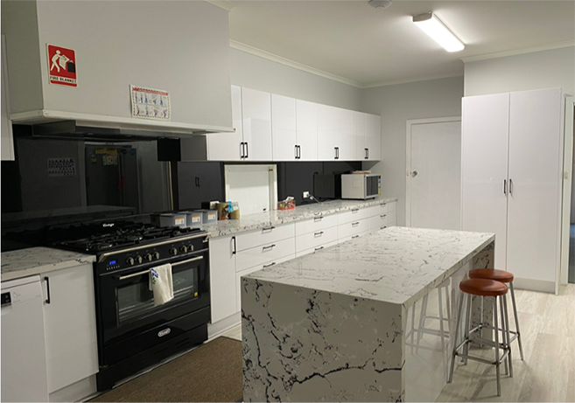

NEAMI National: My Health and Wellbeing
DH partnered with VICSEG NEW Futures (The Victorian Cooperative on Children’s Services for Ethnic Groups) and NEAMI National for group sessions focussed on ‘my health and wellbeing’. There were 15 participants from an existing VICSEG Coburg and Fawkner women’s group. All participants were women from South Asian countries, such as India and Pakistan.
In the first session, the group discussed wellbeing, what they could do to keep well and what mental health meant between genders in different cultures.
The second session focused on identifying stressors and early warning signs, and developing a wellness plan. Participants reflected on COVID-19-related restrictions and how feeling helpless to their extended families in their home countries could be stressful. Participants shared self-care tips and strategies to cope with their stressors. They recognised the opportunity to learn from peers in a safe setting as a helpful coping strategy. The session ended with a mindfulness activity.
All the participants were given resources to help them after the sessions, including a wellness planning guide and coping skills worksheet.


Victorians are able to participate fully

Communicating with Victoria’s CALD communities

Interpreting and translation services
Table 3: Departmental expenditure on interpreting, translating and language allowance services
Department | Amount spent on interpreting and translation 2020-2021 ($) | Percentage of total departmental expenditure on translation (%)
DELWP | 54,521 | 0.12
DET | 2,638,806 | 5.74
DFFH | 1,045,000 | 2.28
DH | 35,719,284 | 77.74
DJCS | 4,229,552 | 9.21
DJPR | 902,667 | 1.96
DPC | 1,248,403 | 2.72
DoT | 61,717 | 0.13
DTF | 45,553 | 0.10
Total | 45,945,503 | 100

Multicultural media campaigns
Table 4: Multicultural media campaign expenditure as percentage of total media campaign expenditure by departments
Department | 2019-2020 (%) | 2020-2021 (%)
DELWP | 7.4 | 32
DET | 5.5 | 7.9
DFFH | 0 | 5.1
DH | 0 | 16.4
DHHS | 7.9 | 12.7
DJCS | 5.0 | 7.3
DJPR | 5.4 | 10
DPC | 8.9 | 13.4
DoT | 5.5 | 5.8
DTF | 6 | 0
Table 5: Total Victorian Government multicultural media campaign expenditure as percentage of total media campaign expenditure
Financial year | Multicultural expenditure as percentage of total expenditure (%)
2020-2021 | 9.6
2019-2020 | 7.6
2018-2019 | 5.0
2017-2018 | 5.2
2016-2017 | 6.0
2015-2016 | 5.5
2014-2015 | 5.8
Waterways of the West CALD engagement toolkit
The Waterways of the West region, comprising the Werribee, Maribyrnong and Moonee Ponds catchments, is one of the most multicultural regions in Melbourne. In developing the Waterways of the West 50-year community vision, it was essential to engage with the CALD community to ensure their voices were heard by the Victorian government.
DELWP engaged a social impact agency, Ellis Jones, to undertake a series of focus groups with the Vietnamese community and new and emerging migrants of this region. The focus groups were delivered in a culturally safe, fun, and educational way. Participants were able to share their thoughts and experiences on the waterways. Key recommendations indicated that targeted engagement was necessary to increase awareness of:
- major issues around waterways and their lands in the west
- Traditional Owner perspectives and cultural knowledge
- safe and sustainable ways for CALD communities to enjoy the waterways.
DELWP and Ellis Jones workshopped ideas with key stakeholders. Collectively, they determined that a set of guidelines that outlined best practice, case studies and resources to engage CALD communities would address these recommendations. This led to the development of the Waterways of the West CALD engagement toolkit.
The toolkit seeks to address this engagement gap by providing guidelines and resources to help organisations better engage with and educate CALD communities about the waterways. This will in turn strengthen CALD communities’ ability to shape the future of the Waterways of the West, enjoy their abundant benefits and care for them.
The toolkit was co-designed with local councils, community groups, Wadawurrung Traditional Owners and other public agencies. It will be available to other public agencies to improve their CALD community engagement and educational practices.
Waterways of the West CALD Engagement Toolkit
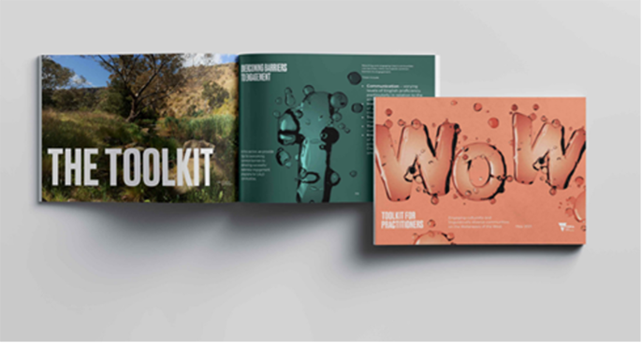

Disability support
The Early Childhood Intervention Services Continuity of Support program provided early childhood intervention services to support children with disability and their families who are not Australian citizens or permanent residents. This included therapy, counselling, service planning and coordination, and help to access services such as kindergarten and childcare. The 2020-2021 funding allocation helped around 200 young children aged zero to six years with a disability or developmental delay who were ineligible for the National Disability Insurance Scheme (NDIS) because they did not have Australian residency.

Opportunities to learn and grow
The Kindergarten Fee Subsidy (KFS) promoted kindergarten participation by letting children with a refugee or humanitarian visa attend a funded kindergarten program free of charge in the year before school. KFS is paid in addition to per capita grants. The KFS is statewide as it is an entitlement based on children’s eligibility.
The Victorian Foundation for Survivors of Torture (Foundation House) delivered the Early Years program to build the capacity of early childhood education and care services to work effectively with children and families of refugee backgrounds. Through the program, Foundation House provided resources, professional learning, consultancy and place-based collaborative projects to promote the full inclusion of families from refugee backgrounds in early childhood services.
The English as an Additional Language (EAL) program (DET: $156.7m) provided targeted teaching support to more than 70,000 EAL learners to become proficient in English, including newly arrived migrants, students from refugee and asylum seeker backgrounds, and Australian-born students. Mainstream schools used EAL funding for specialist classes, withdrawal for EAL specialist teaching and in-class support. In addition, English language schools and centres provided intensive English language programs for students to attend full-time for six to twelve months.
The Multicultural Learning Partnership (MLP) (DET: $128,125) was established between:
- AMES Australia
- Australian Centre of Further Education (ACFE) Board
- Victorian Trades Hall Council,
- Migrant Workers Centre
- VMC
- DJPR
- DET.
The partnership supported activities that improved core skills awareness and engagement in multicultural communities. The MLP produced a position paper to articulate the critical issues pivotal to multicultural learners’ participation in the economy through COVID and recovery. It included an inventory of current initiatives and recommended future research and project work.

Sports initiatives
As one of the leading sports cities in the world, Victoria is actively helping CALD individuals to stay physically active and connect with the broader community.
Women’s Basketball program: an initiative by DJCS
The Northern Community Support Group (NCSG) supports Muslim communities in Melbourne’s northern suburbs with initiatives focused on employment, training, culturally and religiously appropriate support services, community resilience and social participation. The NCSG is grounded in strong community-based partnerships and underpinned by the social cohesion themes of belonging, social justice, acceptance and worth.
To address a lack of sporting opportunities that were culturally and religiously sensitive for women, NCSG established a sports program to help Muslim women improve their health and fitness, maintain connections and reduce social isolation. In its humble beginnings, women from Preston Mosque and MyCentre gathered once a week for basic basketball drills and casual matches under the guidance of a qualified coach. The program became popular and participation grew considerably. The NCSG eventually organised a women’s basketball tournament involving fifteen teams from across Melbourne and over 100 staff, volunteers and spectators.
Planning is now in place to make the tournament a regular annual event. The NCSG women’s sporting program has expanded even further. Project sites have established an all-women’s basketball league consisting of teams from other community groups, including Himilo Community Connect and the Inner Melbourne African Australian Partnership.
NCSG Women’s Basketball program participants enjoying a game
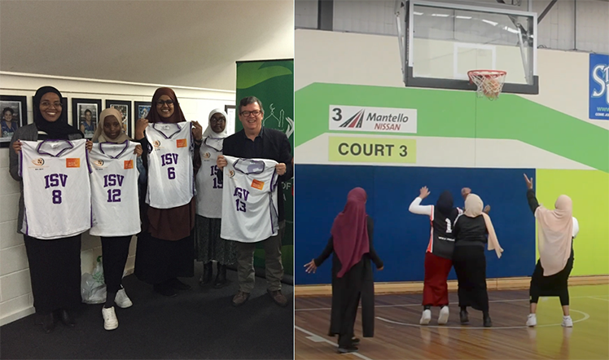

South-East Women’s Sports Hub: Centre for Multicultural Youth
The South-East Women’s Sports Hub creates a safe space for young women aged between 15 and 30 years from migrant and refugee backgrounds living in the Cities of Greater Dandenong and Casey to participate in sports.
In 2020-2021, the program expanded to nurture young women to become leaders, volunteers, accredited coaches and referees in the sports sector. Sports in the 2020-2021 program included football (soccer), ultimate frisbee and badminton.
Funding through Sport and Recreation Victoria’s (DJPR) Together More Active program allowed the Sports Hub to employ necessary staff. This ensured the group met regularly, coaching for the young women, the purchase of equipment and coach training opportunities for participants.
By November 2020, there were 50 young participants – two went on to be trained in an accredited coaching course. Despite lockdowns, women were supported with activities they could do at home to maintain their physicality and connection.
Atiq Abed, Coach at South-East Women’s Sports Hub, shared her experience. ‘I started as a volunteer. I was very committed because of my background and the settlement journey challenges I had experienced. A colleague and I came up with the idea of establishing a women’s hub. I provide a safer space so the participants can feel connected. There is nothing worse than not feeling valued. Sport is the language bringing people together.’
Engela van der Klashortst, Project Officer at Centre for Multicultural Youth, commented, ‘I take real pride in seeing young women come into the program with little confidence because of their lack of English and then grow over time. You start seeing leadership skills, a sense of ownership and a sense of community’.
South-East Women’s Sports Hub participants
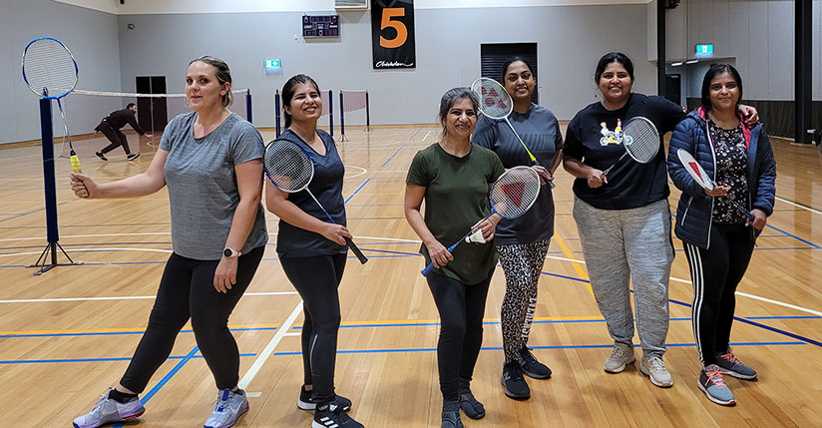

Employment assistance and career development
Since Jobs Victoria was established in October 2016, it has supported more than 8,400 people from CALD backgrounds into a job. Jobs Victoria works with 34 Community Employment Connectors at DFFH to give support to multicultural young people.
Culturally diverse jobseekers represent the largest target cohort of specialist services provided by Jobs Victoria Mentors (DJPR: $6.1m). Jobs Victoria mentors have given employment support to people from over 170 countries who speak over 130 languages. Over 15 specialist services are currently working directly with CALD jobseekers, including humanitarian migrants, to support them into sustainable employment. In addition, 112 Jobs Victoria advocates navigated and supported Victorians in 33 languages. Multicultural communities are prioritised under the Jobs Victoria Fund, which provided wage subsidies of $10,000 to $20,000. Eligible employers could access wage subsidies to hire new staff, including people seeking asylum or refugees, and newly arrived migrants from non-English speaking backgrounds.
In 2020, DTF participated in the launch of the VPS Women of Colour Network, a VPS staff-led initiative to uplift and support women of colour. Programs such as Mentoring Women and Recruit Smarter helped to support gender equality for women of colour within DTF. The six-month Mentoring Women program women in university and high school the opportunity to connect with female economists at DTF. In 2021, the program had four successful applicants. The department consulted with the VPS Women of Colour Network President in 2021 to improve DTF’s approach to intersectionality in its Gender equality action plan 2021–2025. DTF met with the President of the Women of Colour Network a number of times, face-to-face and through email.
The Victorian African Communities Action Plan (VACAP) was launched in 2018. Over 10 years, it aims to address disadvantage and create lasting opportunities for African communities in Victoria. VACAP was developed by the African Ministerial Working Group, convened by the Victorian Government between 2017 and 2018.
Funding for initiatives under VACAP has been allocated to focus areas in the action plan (education, employment, health and wellbeing, inclusion and empowerment, and leadership). In 2020-2021 VACAP funded:
- School Communities Liaison Officer program
- Homework Clubs program
- COVID-19 emergency response grants
- Community Innovation grant program
- Employment Brokers program
- drug and alcohol outreach program.

Multicultural community business support
The Cultural Safety Training and Career Mentors for Multicultural Learners project (DET: $199,875) was developed to promote online cultural safety training to employers. It aimed to:
- facilitate culturally safe workplaces
- encourage culturally safe work placement experiences to increase employability of multicultural learners
- counter impacts of COVID-19 on multicultural workforces.
The program would also match and train volunteer mentors to help multicultural learners improve work and life skills for successful retraining and transition to in-demand jobs. Online cultural safety modules are currently in development.
Community revitalisation by DJPR
Greater Dandenong City Council uses Community Revitalisation funds to help humanitarian settlers and CALD residents find work through career counselling, pre-employment programs and building professional networks through industry workshops.
In 2020-2021, the Greater Dandenong Community Revitalisation program engaged 85 humanitarian settlers and CALD residents living in Dandenong and Doveton. This led to 39 jobs.
The Work Ready initiative provides one-on-one careers counselling along with the Employment Readiness Scale, helping jobseekers to identify their skills and career aspirations.
The LaunchMe program, overseen by the Greater Dandenong Regional Employment Taskforce and funded by DJPR, has helped participants like Hassan to be ready for work.
Hassan is now building a photography business. ‘I hope to further develop my business and entrepreneurial skills to launch my own business as a professional photographer,’ he said.
‘I have recently obtained some contract work developing six short videos.’

Victorians are connected to culture and community

Multilingual initiatives
The Early Childhood Language program (DET: $5.1m) helps four-year-old kindergarten children get the best start in life by giving them the opportunity to learn in another language. This program offers these modes:
- Learn languages at kindergarten – children in around 200 state-funded kindergartens learn in another language for three hours a week.
- Bilingual kindergarten – children in 10 state-funded kindergartens learn in another language for 12 hours a week.
The program is delivered in 22 languages including six different Aboriginal languages, Arabic, Auslan, Cantonese, Chinese, Chin Hakha, French, Greek, Hebrew, Hindi, Indonesian, Italian, Japanese, Karen, Punjabi, Spanish and Vietnamese. The program reaches around 8,000 children each year at no additional cost to parents.
The VCE First Language and Classical Languages study designs (DET: $6,000) were developed in 2019-2020 and reaccredited in 2020 for implementation for Units 1 to 4 in 2022. Professional learning materials were prepared for implementation for schools in 2021. The languages included:
- Chinese first language
- Classical Greek
- Classical Hebrew
- Indonesian first language
- Japanese first language
- Korean first language
- Latin
- Vietnamese first language.
The reaccredited study designs allowed these VCE languages to be reviewed to ensure a contemporary curriculum and assessment to attract students for enrolment. VCE first language and classical languages contribute to the overall education of students, particularly in the areas of communication, cross-cultural understanding, literacy and general knowledge. The study promotes understanding of different attitudes and values within the wider Australian community and beyond.

Arts and cultural celebration
The Multicultural Festivals and Events (MFE) program (DFFH: $2.8m) supported diverse communities to celebrate, preserve and share their customs and traditions in meaningful ways. Due to COVID-19, significant amendments were made to the program to ensure communities were able to connect, including helping organisations build their digital capacity and adapt their events to be delivered online.
In 2020-2021, funding was awarded to support 365 digital, hybrid or face-to-face COVIDSafe multicultural festivals and events between October 2020 and June 2021. These events took place online and across Victoria, and reached around 500,000 people. Funding from this round included $3,000 awarded to the Indochinese Elderly Refugees Association to buy digital equipment and complete Zoom training for their seniors. These funds increased their digital capability to run their online Lunar New Year Festival in early 2021 for the Vietnamese and wider Victorian community during COVID-19 restrictions.
The MFE program also gave the Islamic Society of Victoria $10,000 for their Ramadan Festivities in 2021, reaching over 10,000 people. The Islamic community celebrated with the wider Victorian community by combining and sharing the traditions of different cultures with food, decorative crafts, music and live events.
The African Music and Cultural Festival prides itself on promoting cross-cultural awareness and intercultural relationships to emphasise mutual respect, understanding and unity in Victoria. In 2021, DTF was not only a proud sponsor of this event, it also engaged with the audience through a stall at the festival.

Cultural exchange program
The Victorian Young Leaders (VYL) program (DET: $352,000) offers Year 9 students the opportunity to spend time at an international host school and immerse themselves in the culture of the host country (China, India, and Indonesia). Students participating in the program develop their leadership and global citizenship skills, language skills and intercultural understanding and awareness.
Since offshore VYL programs were cancelled in 2020-2021 because of COVID-19, innovative virtual onshore alternative programs have been introduced to Victorian schools, such as the VYL Global Youth Forums and VYL India Virtual Pilot program (delivered in 2021-2022). These focus on student advocacy, intercultural capability and global citizenship.
Global Learning and Engagement (GLE) virtual programs make it possible for students to develop global competencies through an immersion-type experience by increasing their knowledge and curiosity of global issues. Students strengthen their peer-to-peer engagement with students in China, India, Vietnam, Indonesia and Japan on science, technology, engineering and mathematics (STEM) design challenges, and language and culture-focussed activities.
280 students participated in the highly successful VYL Global Youth Forums. This GLE student engagement program helps to realise the Victorian Government’s ambitions for inclusive and cohesive multicultural communities. Teachers and students are given tangible and authentic opportunities to engage as global citizens and strengthen their leadership and pride in their local school communities.

Victorians have equal rights and opportunities

Anti-racism
In early 2021, DFFH’s Fairer Victoria division launched the Local Anti-Racism Initiatives Grants program 2021. $3.857 million in grants supported 42 organisations to empower local communities to tackle racism. The program:
- helps all Victorians prevent and respond to racism and discrimination
- promotes positive intercultural understanding
- strengthens the evidence of the challenges faced by CALD communities.
The objectives of the program are to:
- improve community reporting of racist incidents
- increase awareness and understanding of people’s rights
- help local communities and community organisations build their capacity to respond to racism and support affected people
- support programs and initiatives involving the broader Victorian community to increase resilience and social cohesion
- increase the availability of anti-racism materials, resources and supports within local community infrastructure
- enable Aboriginal self-determination by resourcing community-led anti-racism initiatives
- build the capacity of communities to engage in constructive intercultural and interfaith dialogue as a means of addressing local challenges to social cohesion.
Funded activities included:
- develop and run anti-racism and Indigenous cultural competency courses in regional Victoria
- increasing young people’s knowledge of their rights around racism
- media campaigns to support reporting of racist incidents.
In June 2021, the Anti-Racism Taskforce was established and convened by the Minister for Multicultural Affairs and the Minister for Aboriginal Affairs. The taskforce gives advice and guidance on the development of a new statewide anti-racism strategy, aiming to proactively prevent and address racism and discrimination experienced by Aboriginal, multicultural and multifaith Victorians.
The taskforce is co-chaired by Sheena Watt MP, a proud Yorta Yorta woman and Member for Northern Metropolitan Region, and Josh Bull MP, Parliamentary Secretary for Multicultural Affairs and Member for Sunbury. The taskforce includes 11 community members from diverse cultural, religious and professional backgrounds. Representatives from the VMC and VEOHRC also sit on the taskforce.
Reducing Racism project (DJCS: $129,800) is a three-year project led by VEOHRC to empower multicultural and multifaith communities to report racism and exercise their rights. In 2020-2021, VEOHRC developed an evidence-based digital communication and engagement strategy to increase reporting by multicultural and multifaith community members experiencing racism. As part of this work, a social media campaign, #ReducingRacism, was created to raise awareness of Victoria’s human rights laws and encourage the community to respond to racism. The campaign reached over 59,000 people, who shared the content 297 times. VEOHRC also ran 44 community information sessions on racial discrimination in partnership with community organisations and Victoria Police, reaching 982 people in 2020-2021.

Promoting human rights within government departments
The Victorian Government is committed to building multicultural capacity in our departments and embedding human rights knowledge and practices at every level of government. All Victorian government departments have contributed to and participated in the VEOHRC-led Charter Education program. The program leads education initiatives to build a culture of human rights across the VPS. Initiatives undertaken in individual departments are outlined as follows.

Department of Education and Training (DET)
All DET corporate staff must complete the eLearning package, Human rights and responsibilities. The module focuses on human rights and responsibilities as an anchor for respectful workplace practices. It enables participants to understand the Victorian Charter of Human Rights and Responsibilities, including their obligations and responsibilities. DET’s commitment also included an article to all corporate staff honouring Human Rights Week and Human Rights Day. These articles brought awareness to these observances and encouraged staff to act through a week-long pledge.

Department of Environment, Land, Water and Planning (DELWP)
The department has no major initiatives to report for the period 1 July 2020 to 30 June 2021.

Department of Families, Fairness and Housing (DFFH)
DFFH’s mandatory induction training includes an eLearning module on the Charter of Human Rights. DFFH acknowledges key events annually that celebrate human rights, including Cultural Diversity Week, Human Rights Day, Harmony Day, NAIDOC Week, Reconciliation Week, International Women’s Day, International Day of People with Disability and International Day Against Homophobia, Transphobia and Biphobia.
Additionally, Fairer Victoria is leading and influencing policy and program development for diversity and inclusion across government. The Charter of Human Rights in considered during the design and implementation of all initiatives and policies.

Department of Health (DH)
DH worked with VEOHRC in 2021 to upskill 15 department human rights champions. These delegates were nominated to complete the five modules in the Human Rights Charter Education program to help them:
- apply a decision-making framework
- mitigate risks
- provide leadership in human rights issues.
DH also continues to make compliance training on the Charter of Human Rights mandatory.

Department of Jobs, Precincts and Regions (DJPR)
DJPR supports team members to increase their capacity to make decisions and give advice consistent with the Victorian Charter of Human Rights and Responsibilities, including through tailored learning, guides and resources, events and activities.
To better understand the Charter, DJPR encourages all staff to complete the first three modules in the VEOHRC’s online education program:
- Introducing the Charter
- Rights and obligations under the Charter
- Embedding a human rights culture in Victoria.
The Charter of Human Rights and Responsibilities Act: a guide for public sector workers is available on the intranet to help team members understand their responsibilities under the Charter and how to implement human rights in their work.
DJPR also acknowledges key events that celebrate human rights annually, including Cultural Diversity Week, Harmony Day, Human Rights Week and the International Day of Human Rights.

Department of Justice and Community Safety (DJCS)
The Charter Capability program was developed and implemented by VEOHRC, with support from Victoria Police’s Priority and Safer Communities division. The program was designed to deepen members’ understanding of the Charter of Human Rights and Responsibilities’ legislative requirements, and help members identify and respond to human rights risk in frontline policing. The program was piloted in the Western Region and developed for sergeants and senior sergeants.
The program involved five iterative learning modules over 12 weeks. The program took members through contemporary human rights and policing challenges. It created a productive space for members to reflect on how these situations could be approached differently by placing human rights at the centre of the response.
Since completing the program, participants have been actively looking for opportunities to reinforce human rights protection and improve their practice. These include:
- outlining the Charter requirements in safety briefings
- ensuring human rights protections are visible in operational orders
- considering human rights impacts when authorising searches of people in custody.

Department of Premier and Cabinet (DPC)
DPC’s mandatory induction training includes an eLearning module on the Charter of Human Rights in Victoria. DPC acknowledges key events annually that celebrate human rights, including Cultural Diversity Week, Human Rights Day, Harmony Day, NAIDOC Week, Reconciliation Week, International Women’s Day, International Day of People with Disability and International Day Against Homophobia, Transphobia and Biphobia.

Department of Transport (DoT)
A four-part training program developed by VEOHRC is mandatory for all staff. It aims to increase awareness of upholding human rights in the workplace, including promoting the human rights of colleagues from CALD backgrounds.

Department of Treasury and Finance (DTF)
VEOHRC Human Rights Charter eLearning modules are part of DTF’s mandatory induction and compliance training. Staff complete this at the start of employment and then every two years as a refresher.
In 2020-2021, DTF promoted the following events.
- Cultural Diversity Week (21 to 28 March 2021): DTF’s intranet highlighted to staff the International Day for the Elimination of Racial Discrimination webinar, Laneway Festival, and Curious Conversations panel discussion.
- National Reconciliation Week (27 May to 3 June 2021): DTF promoted several local and virtual events to staff through the Reconciliation Australia website.
- Refugee Week and World Refugee Day (20 to 26 June 2021): DTF’s intranet promoted the online film screening of Beyond Refuge.
- NAIDOC Week (4 to 11 July 2021): DTF’s intranet promoted events such as NAIDOC Week programming on the National Indigenous Television (NITV) network, team discussions on how 'Heal Country, heal our nation' resonated with staff, and the use of Australian Institute of Aboriginal and Torres Strait Islander Studies’ (AIATSIS) Map of Indigenous Australia.
- Human Rights Week (3 December 2021): DTF’s intranet promoted the ‘Pledge to make right real event’ and the human rights email banner to staff.

Progress in departmental cultural diversity plans

Background
Cultural diversity plans (CDPs) help Victorian government departments deliver more inclusive, accessible and responsive services to CALD communities. They cover a wide range of considerations, including workforce diversity, engagement, participation, inclusion and cultural competency in service delivery. As required under the Multicultural Victoria Act 2011, departments report their progress on their CDPs every year.
The following table lists Victorian government department CDPs at 30 June 2021.
Table 6: Victorian government department cultural diversity plans
Department | Cultural diversity plans
Department of Education and Training | Our cultural diversity plan 2019–2021
Department of Environment, Land, Water and Planning | Diversity and inclusion strategy 2019–2022
Department of Families, Fairness and Housing | DFFH will launch a new Diversity and inclusion framework with a supporting implementation plan in June 2022. This framework will ensure that the workplace is inclusive for all department staff and reflects the communities that the department serves.
Department of Health | As a newly established department, DH is in the process of developing a new CDP.
Department of Jobs, Precincts and Regions | Multicultural diversity action plan 2018–2021
Department of Justice and Community Safety | Cultural diversity plan 2017–2021
Department of Premier and Cabinet | Diversity and inclusion strategy 2019–2021
Department of Transport | Multicultural action plan 2018–2021
Department of Treasury and Finance | Diversity and inclusion framework 2021–2025

Departmental cultural diversity plans

Department of Education and Training (DET): Our cultural diversity plan 2019–2021

Vision
To improve Victoria’s learning and development services to meet the needs of families, children and young people from culturally and linguistically diverse backgrounds, particularly recent immigrants, and to work to equip all children and young people to understand and navigate cultural and linguistic differences within an increasingly interconnected world.

Goals
The goals of the DET CDP are to:
- build the intercultural capability of both learners and their teachers
- make the Victorian learning and development system welcoming and inclusive to all
- provide appropriate and accessible information to culturally and linguistically diverse communities
- sustain and improve supports for refugees and other new immigrants to respond to their needs
- engage with culturally and linguistically diverse communities to inform service planning and delivery
- improve our information and reporting systems and program evaluation so the effectiveness and value of services to culturally and linguistically diverse Victorians can be monitored.

Governance and ownership
DET’s Culture, People and Integrity Committee and the Executive Board oversee the CDP.

Cultural competence training
DET continues to advocate for the development of a whole-of-Victorian government eLearning module for cultural diversity awareness for Victorian public servants. DET is working with the VPSC on progressing this project.
All new staff complete Respectful Workplaces training during induction and on-boarding. This training focusses on treating others with respect and consideration, including understanding equal opportunities and human rights. It is available on DET’s learning hub, LearnEd. 392 staff members completed this course in 2020-2021.
All staff also complete a mandatory human rights and responsibilities eLearning module that helps build respectful workplace practices.

Decision-making processes and program evaluation
DET has a register of community stakeholders that departmental staff can use to organise consultations for program and policy development. The department created internal processes for consulting directly with multicultural community stakeholders and organisations. The department expects all programs to undergo periodic review or evaluation, informed by best practice methodology. This includes incorporating the views of diverse or vulnerable groups in evaluation design and implementation.

Department of Environment, Land, Water and Planning (DELWP): Diversity and inclusion strategy 2019–2022

Vision
DELWP aims to create a culture that embraces individual differences in all forms and fosters innovation and inclusion to support:
- liveable, inclusive and sustainable communities and thriving natural environments
- all staff to achieve their full potential and work in a flexible way that meets their needs
- a community charter that emphasises the diversity and inclusion values of building enduring and genuine partnerships.

Goals
The goals of DELWP’s CDP are to:
- improve service delivery and decision making through strong, inclusive leadership and training and development opportunities
- foster attitudes and practices that better support diversity and inclusion
- create opportunities to recruit and retain staff from diverse groups in the community.

Governance and ownership
All People and Culture decisions require consultation with key stakeholders across the department, including our seven staff-led networks, workforce people partners working group, People and Culture’s leadership team and Stewardship Committee, and the Executive Board.
The Manager, Diversity and Inclusion, drives key commitments in the CDP. Within the Diversity and Inclusion team, a team leader and two staff are working on the CDP. Two voluntary staff-led networks, Multicultural@DELWP and DELWP’s Women of Colour Network, inform and progress the CDP and action plans.

Cultural competence training
SBS inclusion and cultural competency training modules are available to all staff. In the starter induction package, DELWP highlights diversity and inclusion learning opportunities to new staff. In 2020-2021, the Multicultural@DELWP network organised activities for R U OK Day and Cultural Diversity Week targeting CALD communities. It also released the 2021-2022 inclusion plan on cultural diversity to promote inclusivity and belonging amongst CALD staff.

Decision-making processes and program evaluation
DELWP’s Community Charter helps the department build better relationships with stakeholders and communities, including local councils, catchment management authorities, water corporations, the building industry and environment groups. The department uses local networks, processes, tools and resources to enhance interactions and engagement in policy planning and delivery of programs and projects.
DELWP began a review of the engagement framework, Engage@DELWP. This enables more confident and effective engagement, stronger relationships with multicultural communities and more informed decision making. The completion of the review will bring the Engage@DELWP framework in line with the whole of VPS engagement framework.

Department of Families, Fairness and Housing (DFFH) and Department of Health (DH): Delivering for diversity: cultural diversity plan 2016–2019

Vision
The department recognises that at the heart of its work are people from CALD backgrounds and their communities. Considering cultural diversity in all policies, practices and programs will ensure the department delivers inclusive, safe and accessible services.

Goals
Priorities in responding to cultural and linguistic diversity in health and wellbeing services relate to the following outcomes:
- equitable and responsive services and programs
- a culturally responsive workforce
- partnerships with diverse communities
- effective and evidence-based approaches.

Governance and ownership
The department’s Executive Board has had primary ownership of the CDP, including ensuring the plan is embedded in the department’s core business.

Cultural competence training
Cultural competence workshops and unconscious bias training continue to be rolled out to staff across the department. All executives have a diversity performance outcome in their personal development plans to improve diversity and inclusion across the department. All people managers must complete the Leading with Respect program. The program gives them tools to lead and promote a respectful team culture, accommodating all cultural backgrounds. The department worked with VEOHRC in 2021 to upskill 15 human rights champions. These delegates completed the five modules in the Human Rights Charter Education program to help them deal effectively with human rights issues and promote leadership in such issues to others

Decision-making processes and program evaluation
The department supports consumers, carers, communities and patients from CALD backgrounds to make decisions about their health and wellbeing through a range of policies, guidelines and approaches. This includes consulting with stakeholders on policy and program design, developing in-language resources, ensuring translators are provided where required, supporting bicultural workers to engage communities, and building the capacity of other department staff to better engage diverse communities.
The department also provides employment pathways for refugees and people seeking asylum, particularly through the Career Seeker Internship initiative, bringing people from diverse communities into the public service and the heart of decision-making. After the program, 75 per cent of participants secure ongoing employment at the department or in the health and human services sector and provide valuable lived experiences to decision making.

Department of Jobs, Precincts and Regions (DJPR): Multicultural diversity action plan 2018–2021

Vision
To foster a culturally diverse and inclusive workplace that reflects the sectors and communities we work with and to provide inclusive service delivery to culturally diverse clients and communities that fosters greater inclusion in Victoria’s economy.

Goals
- Leadership: our leaders will champion the CDP to foster engagement at all levels. We will all support cultural diversity through ownership at all levels.
- Information building: we will build our understanding of internal cultural diversity. We will build our understanding of the cultural diversity of the communities we work with.
- A culturally diverse workforce: we will support opportunities to grow cultural diversity at all levels of the organisation. Our workforce will reflect the communities we work with.

Governance and ownership
The Executive Director, People and Culture in Corporate Services has ownership of the CDP. The CDP is part of the department’s Diversity, equality and inclusion framework. The framework’s progress is monitored and reviewed by the department’s Diversity, Equality and Inclusion Committee, a sub-committee of the Executive Board.

Cultural competence training
All staff are encouraged to develop their cultural competence through professional development opportunities. In 2020-2021, two cultural competence training programs were available to support the professional development of staff, including:
- a cultural competence eLearning program available to all staff on the DJPR Learning Management System
- cultural intelligence virtual workshops, which all staff were encouraged to participate in.
All departmental hiring managers must also complete the unconscious bias module of the online cultural competence program before conducting job interviews.

Decision-making processes and program evaluation
DJPR’s CDP requires that all business areas consult with the community when evaluating programs and services. This is done by:
- consulting culturally diverse communities and advisory boards when making decisions about programs, policies and services that directly affect culturally diverse communities
- using available demographic and service data on cultural diversity to support decision making for programs, policies and service delivery
- embedding cultural diversity considerations when designing, implementing and evaluating policies, programs and services.

Department of Justice and Community Safety (DJCS): Cultural diversity plan 2017–2021

Vision
An inclusive and accessible justice and regulation system that enables CALD communities to fulfil their potential as equal citizens.

Goals
A fair justice system that promotes equal rights and opportunities:
- CALD Victorians exercise their rights and participate in the wider community
- our paid and volunteer workforce reflects a diverse cross-section of the population and our people are given opportunities, experience and career pathways.
An accessible and inclusive justice system:
- experiences of people from CALD backgrounds inform and shape our decisions
- our workforce has the attitude and capability to provide appropriate and culturally responsive services, information and support to people from CALD backgrounds.
A department that recognises and values diversity:
- the department demonstrates leadership and accountability in improving outcomes for people from CALD backgrounds and attracts talent from diverse backgrounds
- cultural inclusion is supported by our tools, policies, procedures and data.

Governance and ownership
Responsibility for the plan is with the department’s Inclusion and Intersectionality team (within the Stakeholder Engagement, Intergovernmental and Inclusion unit, Service Delivery Reform, Coordination and Workplace Safety group). The team liaises with business units on developing, monitoring and reporting against activities in the CDP. A new multicultural and multifaith action plan will be developed in 2022.

Cultural competence training
In 2020-2021, Youth Justice worked with the Centre for Multicultural Youth to deliver a foundation training program on working with young people from CALD backgrounds to custodial and community staff. This was in addition to the cultural competency and awareness training delivered during induction for all Youth Justice custodial staff. It is also available as part of induction for all Youth Justice community staff. Cultural competence training is also offered to new and existing staff as well as volunteers at Life Saving Victoria.

Decision-making processes and program evaluation
The department’s relevant business units and regions undertake consultations to ensure that services are responsive to the cultural, religious and linguistic needs of Victoria’s diverse communities. Business planners are encouraged to examine local requirements and tailor the service provision accordingly. In addition, relevant culturally-specific organisations are consulted in the delivery of programs.
A departmental stakeholder engagement framework is in the final stages of development, complementing the whole-of-Victorian government public engagement framework.

Department of Premier and Cabinet (DPC): Diversity and inclusion strategy 2019–2021

Vision
To lead the VPS by working for the people of Victoria to help the government achieve its strategic objectives. We are committed to a stronger, fairer, better Victoria by pursuing excellence in whole-of-government outcomes in delivery and reform. We are committed to diversity, inclusion and equity. We ensure that all people are treated with dignity and respect, have equitable access to employment opportunities and outcomes, have the ability to participate in all aspects of work life and can achieve their full potential.

Goals
The department aims achieve the following:
- increase representation of women and people from diverse backgrounds in senior leadership positions, and overcome structural barriers to employment due to personal circumstances or characteristics
- establish an accurate workforce profile to measure and track performance of our CDP
- ensure that culture surveys consistently show safety, visibility and inclusion for all employees across all levels of the organisation
- set measurable targets and ensure accountability for meeting our goals
- elevate the reputation and public image of DPC as a diverse and inclusive workplace.

Governance and ownership
Executive sponsors and champions are appointed by DPC Board of Management for all key priority areas including gender, disability, LGBTIQ+, Aboriginal, CALD (including faith), inclusion and age. The People and Culture team provides annual performance reports and dashboard data to each executive sponsor, with an assessment against existing strategies. DPC reference groups and committees are encouraged to work with executive sponsors and the People and Culture team to identify and implement initiatives within the strategy.

Cultural competence training
The People and Culture team offers diversity and inclusion training programs to help employees to:
- understand their rights and responsibilities, create an inclusive environment free from discrimination and harassment, and identify discrimination and exclusion in the workplace
- understand their role and strategies for creating a diverse and inclusive workplace
- understand the complex and varied experiences of diverse communities
- identify and address unconscious bias practices.

Decision-making processes and program evaluation
An organisational diversity and inclusion maturity model shows the five stages of maturity including measures, indicators and enablers. This model is evaluated yearly.

Department of Transport (DoT): Multicultural diversity action plan
2018–2021

Vision
To provide an inclusive workplace culture where all our people, including those identifying as from CALD backgrounds, feel safe, engaged, respected and valued to bring their whole selves to work. An inclusive culture will enable DoT to recruit and retain a diverse workforce that reflects the community we serve, and to deliver a transport system that is inclusive and safe for all Victorians.

Goals
- Leadership: our leaders will champion the CDP to foster engagement and support cultural diversity through ownership at all levels.
- Information building: we will strengthen our understanding of internal cultural diversity and the communities we work with, and we will capture cultural diversity initiatives to share internally and report annually.
- Building a culturally diverse workforce: we will support opportunities to grow cultural diversity at all levels of the organisation, and our workforce will reflect the communities we work with.

Governance and ownership
The Deputy Secretary, People and Business Services, along with the Executive Director, People and Culture, have overall accountability and responsibility for the implementation of the DoT Multicultural diversity action plan 2018-2021. The new action plan is due to be finalised in 2022. All areas of the business are responsible for implementing the actions in the plan. The People and Culture team is notified when an accountable officer moves to a different role or leaves the organisation. The team is also advised of their replacement.

Cultural competence training
Since July 2020, core foundation training called ‘DoT inclusion fundamentals and unconscious bias’ has been given to DoT employees. This five-hour training includes modules on unconscious bias, bystander action and inclusive leadership, fostering cultural humility, cultural awareness and the impact of racism on culturally diverse staff in the workplace. 116 employees attended the training in 2020-2021.

Decision-making processes and program evaluation
Community engagement is designed and implemented to be inclusive of CALD communities that are affected by DoT’s decisions. Engagement methods involve the IAP2 (International Association of Public Association) spectrum, such as social media, website project updates, surveying, community meetings, consultation committees and translator services. In developing DoT policies, processes and programs, feedback and contributions are sought from the CALD Working Group to ensure that lived experience informs the end result.

Department of Treasury and Finance (DTF): Diversity and inclusion framework 2021–2025

Vision
The Diversity and inclusion framework outlines the department's commitment to building a workplace that is grounded in respect, fosters inclusion, promotes diversity and embraces the unique skills and qualities of all our people. The key focus areas of the framework are five diversity groups: multicultural or CALD, all abilities, LGBTIQ+, age and Aboriginal and Torres Strait Islander.

Goals
The objective of the framework is to ensure the department has a workforce that is representative of the Victorian population and makes the most of the talents and skills of all employees. DTF wants to ensure it is an inclusive and appealing organisation for talented people with varied experiences and backgrounds. It embraces and encourages all individuals to excel, regardless of their gender and gender identity, mental or physical disability, age, family responsibility or cultural background.

Governance and ownership
The framework is overseen by the department’s People Committee, which reports to the DTF Board. To ensure effective implementation, DTF’s People and Culture team regularly reviews the progress of the plan and monitors employee engagement in diversity and inclusion practices through People Matter Survey results annually. DTF runs respectful workplace training sessions as part of its People matter action plan to promote a culture of respectful inclusiveness for all.

Cultural competence training
Cultural competence training is embedded in the framework, which is included in DTF’s induction program. The department promotes staff participation in days of significance, such as Harmony Day, Human Rights Day and Refugee Week. Regular Secretary communications encourage staff involvement in diversity initiatives and events. Regular conversational ‘catch ups’ have also been established for diversity groups with DTF’s Diversity and Inclusion Deputy Security Champion. So far, these conversations have been with staff from CALD, LGBTIQ+ and disability backgrounds.

Decision-making processes and program evaluation
The new Advancing self-determination at DTF plan is committed to ensuring the department continues to consult with Aboriginal key stakeholders within the VPS and the community.

Appendix 1: Culturally diverse representation on government boards, authorities and committees
Table 7: Composition of Victorian Government boards at 30 June 2021
Composition | Number
Total number of boards at June 2021 | 396
Total board appointments | 3578
Culturally diverse appointments | 1140
Culturally diverse percentage of boards | 31.9%
Table 8: Appointments and re-appointments to Victorian Government boards at 30 June 2021
Appointment | Number
Number of boards with new appointments or reappointments in 2020-2021 | 298
Total new appointments or reappointments | 1610
Culturally diverse appointments or reappointments | 536
Culturally diverse percentage of appointments and reappointments | 33.3%
Table 9: Year on year proportion of Victorian Government department board appointments or members with culturally diverse backgrounds
Department | At 30 June 2021 (%) | At 30 June 2020 (%)
DET | 33.5 | 31.2
DELWP | 34.1 | 31.4
DFFH | 30.7 | 30.0
DH | 28.7 | 28.5
DJPR | 37.9 | 35.9
DJCS | 33.1 | 31.5
DPC | 9.1 | 14.3
DoT | 28.6 | 29.5
DTF | 19.8 | 19.5

Appendix 2: Indicators

Benefits of diversity
A1 Proportion of students in Victorian Government primary and secondary schools learning languages
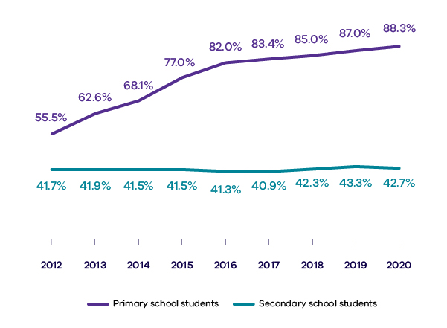
Year | Primary school students (%) | Secondary school students (%)
2020 | 88.3 | 42.7
2019 | 87.0 | 43.3
2018 | 85.0 | 42.3
2017 | 83.4 | 40.9
2016 | 82.0 | 41.3
2015 | 77.0 | 41.5
2014 | 68.1 | 41.5
2013 | 62.6 | 41.9
2012 | 55.5 | 41.7
A2 Proportion of Victorian Government primary and secondary schools providing a languages program
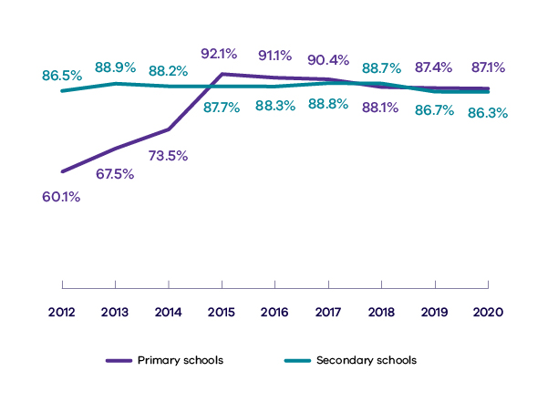
Year | Primary schools (%) | Secondary schools (%)
2020 | 87.1 | 86.3
2019 | 87.4 | 86.7
2018 | 88.1 | 88.7
2017 | 90.4 | 88.8
2016 | 91.1 | 88.3
2015 | 92.1 | 87.7
2014 | 73.5 | 88.2
2013 | 67.5 | 88.9
2012 | 60.1 | 86.5

Social cohesion and participation
B1 Proportion of Victorians from a non-English speaking background who feel multiculturalism at least sometimes makes life better in their area
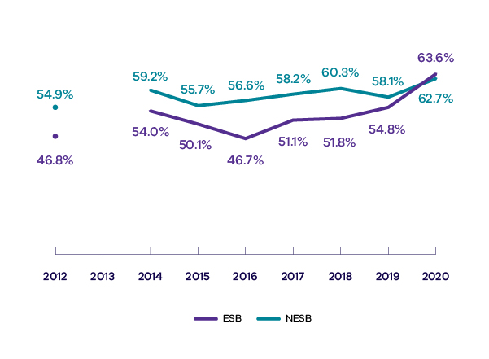
Year | ESB (%) | NESB (%)
2020 | 63.6 | 62.7
2019 | 54.8 | 58.1
2018 | 51.8 | 60.3
2017 | 51.1 | 58.2
2016 | 46.7 | 56.6
2015 | 50.1 | 55.7
2014 | 54.0 | 59.2
2013 | - | -
2012 | 46.8 | 54.9
B2 Proportion of survey respondents who ‘agree’ or ‘strongly agree’ that accepting immigrants from many different countries makes Australia stronger
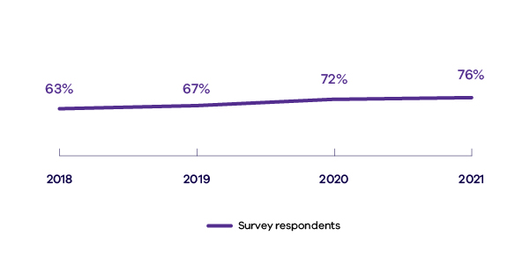
Year | Survey respondents (%)
2021 | 76
2020 | 72
2019 | 67
2018 | 63
B3 Number of complaints made to the Victorian Equal Opportunity and Human Rights Commission (VEOHRC) under the Racial and Religious Tolerance Act 2001
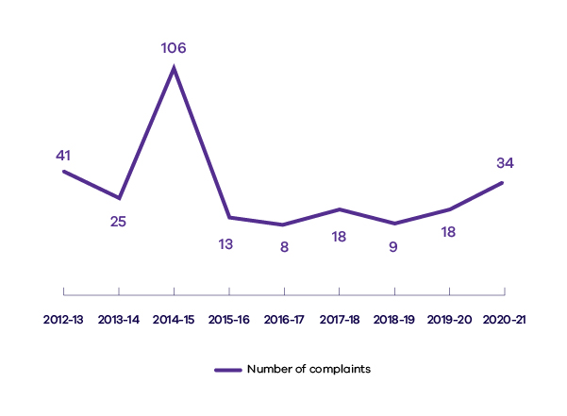
Year | Number of complaints
2020-2021 | 34
2019-2020 | 18
2018-2019 | 9
2017-2018 | 18
2016-2017 | 8
2015-2016 | 13
2014-2015 | 106
2013-2014 | 25
2012-2013 | 41
B4 Number of complaints made to VEOHRC about discrimination on the basis of race and religious belief under the Equal Opportunity Act 2010
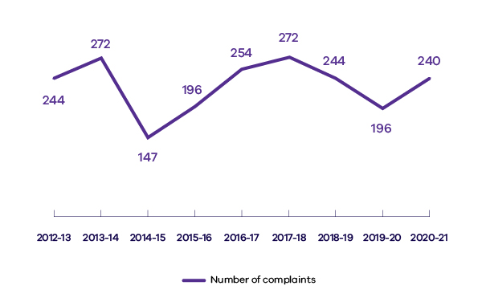
Year | Number of complaints
2020-2021 | 240
2019-2020 | 196
2018-2019 | 244
2017-2018 | 272
2016-2017 | 254
2015-2016 | 196
2014-2015 | 147
2013-2014 | 272
2012-2013 | 244

Accessible and responsive services
C1 Number of Victorian children from a non-English-speaking background (NESB) enrolled in a Victorian Government funded kindergarten program
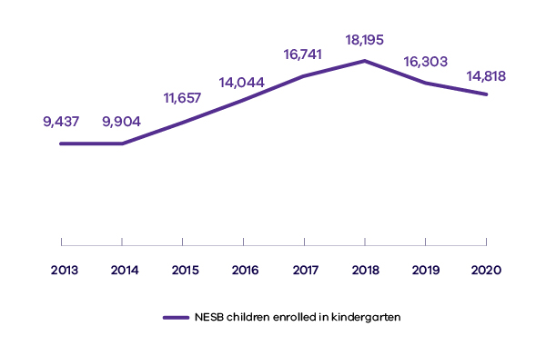
Year | NESB children enrolled in kindergarten
2020 | 14,818
2019 | 16,303
2018 | 18,195
2017 | 16,741
2016 | 14,044
2015 | 11,657
2014 | 9,904
2013 | 9,437
C2 Unemployment rate of Victorians born in non-main English-speaking countries compared to the unemployment rate of all Victorians
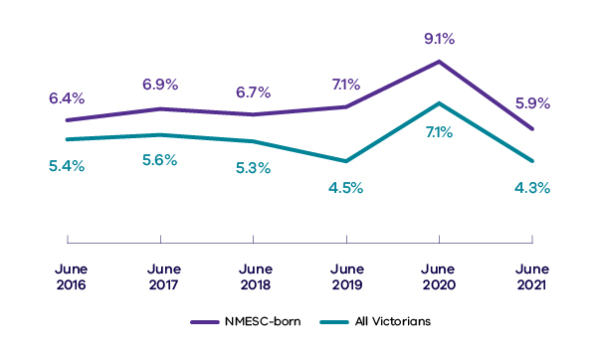
Year | NMESC-born (%) | All Victorians (%)
June 2021 | 5.9 | 4.3
June 2020 | 9.1 | 7.1
June 2019 | 7.1 | 4.5
June 2018 | 6.7 | 5.3
June 2017 | 6.9 | 5.6
June 2016 | 6.4 | 5.4
C3 Workforce participation rate of Victorians born in non-main English-speaking countries compared to the workforce participation rate of all Victorians
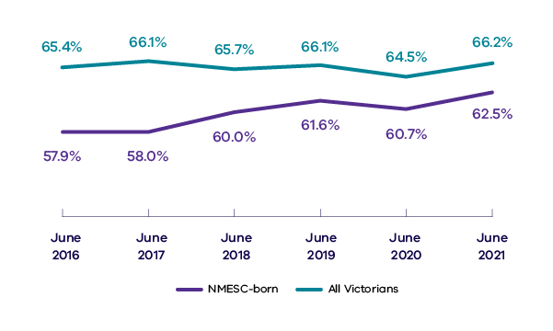
Year | NMESC-born (%) | All Victorians (%)
June 2021 | 62.5 | 66.2
June 2020 | 60.7 | 64.5
June 2019 | 61.6 | 66.1
June 2018 | 60.0 | 65.7
June 2017 | 58.0 | 66.1
June 2016 | 57.9 | 65.4

Victorian multicultural policy statement, p.25. Available on the Victorian Government website’s Multicultural policy statement page <https://www.vic.gov.au/multicultural-policy-statement>.
On 1 February 2021, the Department of Health and Human Services (DHHS) was split into the Department of Health (DH) and the Department of Families, Fairness and Housing (DFFH).
The Australian Bureau of Statistics uses the term NMESC to represent non-main English-speaking countries, while MESC represents main English-speaking countries. MESC are the United Kingdom, Ireland, New Zealand, Canada, USA and South Africa. NMESC covers all other countries of birth. Where appropriate and specifically relevant, some departments and agencies use the term NESB to stand for non-English-speaking background, and ESB to stand for English-speaking background.
The reported amount is inclusive of GST.
Table includes campaign advertising undertaken via ‘non-digital’ media (it does not include social or digital media expenditure). On 1 February 2021, DHHS was split into DH and DFFH. Part-year figures are included for DHHS, DH and DFFH due to the machinery of government changes affecting the three departments from 1 February 2021.
DTF is an internal facing line agency and does not usually deal with external stakeholders. The department traditionally does not undertake public advertising campaigns.
On 1 February 2021, DHHS split into DFFH and DH. DH and DFFH have been using DHHS’s CDP since then. New plans for DH and DFFH, delayed by the COVID-19 pandemic, are currently being developed.
Victorian Government website’s DPC Diversity and inclusion strategy 2019–2021 page <https://www.vic.gov.au/dpc-diversity-and-inclusion-strategy-2019-2021>.
DoT is operating under the DoT Multicultural diversity action plan 2018–2021. This action plan aligns with commitments in the DoT Inclusion and diversity strategy 2020–2023.
Data for tables 7 to 9 provided by VPSC. Data excludes cemeteries, school councils and small committees of Crown Land Management. Where the Public Administration Act status is neither public entity nor special body, and where DPC classification is not applicable, the data is not reported. Figures may differ from previously published data for previous years due to ongoing remediation, increased completeness of data or an appointee’s decision to disclose or no longer disclose additional characteristics. Data includes machinery of government changes that can affect department figures compared to numbers in publications and reports in previous years.
Source: DET languages report, Languages provision in Victorian government schools, 2020. The data is collected annually.
Source: DET languages report, Languages provision in Victorian government schools, 2020. The data is collected annually. 2020 is the most current data.
Source: DH, Victorian Population Health Survey, annual survey. The latest published survey data available at time of report. Estimates before 2015 are not directly comparable to estimates from 2015 onwards due to a significant change in the survey methodology.
No data was available for 2013, as the question was not asked. Data for 2015 onwards cannot be compared to previous years due to a change in survey methodology
Source: The Scanlon Foundation’s Mapping Social Cohesion Survey reports. The surveys are conducted annually. Results collected earlier than 2018 are not included for comparison as a different survey mode was used.
Source: VEOHRC Annual Reports. The data is collected annually
Source: VEOHRC Annual Reports. The data is collected annually
Source: DET Kindergarten Census Collection. Data is collected annually. The data represents the number of children who were enrolled in a funded kindergarten program and whose family indicated that they speak another main language at home other than English. It is not feasible to calculate a kindergarten participation rate for NESB children as there is no suitable NESB population denominator for four-year-olds. 2021 data was unavailable at the time of publication. In 2019 and 2020, there was a system error in the Kindergarten Information Management System, which has removed the ability for service providers to select ‘other’ under the question for ‘Main language spoken at home (if not English)’. Kindergarten services who would have usually entered data in this field may have left this blank. (In 2018 almost 3,500 children had ‘other’ entered in this field).
Australian Bureau of Statistics (March 2022) 'Table 5 - Labour force status by Sex, Victoria', ABS website's Labour Force, Australia page <https://www.abs.gov.au/statistics/labour/employment-and-unemployment/labour-force-australia/latest-release>. Accessed 1 May 2022.
Australian Bureau of Statistics (March 2022) 'LM7 - Labour force status by elapsed years since arrival, main English-speaking countries, sex, state and territory, January 1991 onwards', ABS website's Labour Force, Australia page <https://www.abs.gov.au/statistics/labour/employment-and-unemployment/labour-force-australia/latest-release>. Accessed 1 May 2022.

