Audit of timber harvesting operations in Victoria's State forests
Report of the 2020-21 Forest Audit Program
IS377900-03 | Final
20/12/2021
Department of Environment, Land, Water and Planning

Contract CMS102697
Report of the 2020-21 Forest Audit Program
Department of Environment, Land, Water and Planning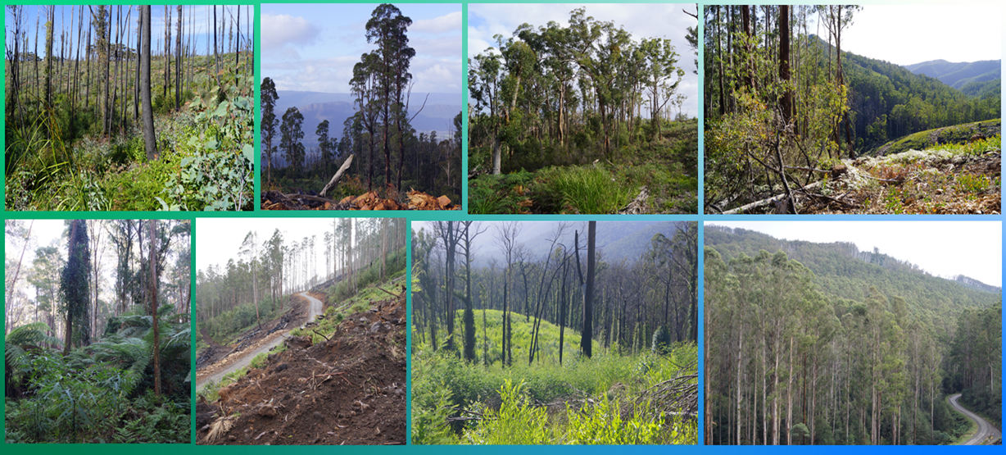

Audit of timber harvesting operations in Victoria's State forests
Project No: | IS377900
Document Title: | Report of the 2020-21 Forest Audit Program
Document No.: | IS377900-03
Revision: | Final
Date: | 20/12/2021
Client Name: | Department of Environment, Land, Water and Planning
Client No: | Contract CMS102697
Project Manager: | Craig Clifton
Author: | Craig Clifton
File Name: | is377900-03 fap2020-21 audit report-final
Jacobs Group (Australia) Pty Limited
ABN 37 001 024 095
Floor 11, 452 Flinders Street
Melbourne, VIC 3000
PO Box 312, Flinders Lane
Melbourne, VIC 8009
Australia
T +61 3 8668 3000
F +61 3 8668 3001
www.jacobs.com
© Copyright 2021 Jacobs Group (Australia) Pty Limited. The concepts and information contained in this document are the property of Jacobs. Use or copying of this document in whole or in part without the written permission of Jacobs constitutes an infringement of copyright.
Limitation: This document has been prepared on behalf of, and for the exclusive use of Jacobs’ client, and is subject to, and issued in accordance with, the provisions of the contract between Jacobs and the client. Jacobs accepts no liability or responsibility whatsoever for, or in respect of, any use of, or reliance upon, this document by any third party.
Document history and status
Revision | Date | Description | Author | Checked | Reviewed | Approved
Rev A | 6/9/2021 | Draft for internal review | CC | PN | DE | DE
Final | 20/12/2021 | Final submission to DELWP | CC | KM | DE | DE
Contents
Executive Summary i
Glossary 1
1. Introduction 4
1.1 Sustainable Forest Management in Victoria 4
1.2 Forest Audit Program 5
1.3 About this report 6
2. Audit scope 7
2.1 Audit objectives 7
2.2 Audit scope 7
2.3 Audit timing 8
2.4 Audit team 8
3. Audit approach 10
3.1 Coupe selection 10
3.2 Audit criteria and workbook 13
3.3 Field assessments 14
3.4 Environmental impact assessment 16
4. Audit results 17
4.1 Overall compliance findings 17
4.2 Environmental compliance theme 18
4.2.1 Compliance elements related to the protection of forest soils 18
4.2.2 Compliance elements related to the protection of water flows, water quality and river health 19
4.3 Conservation of biodiversity 21
4.4 Operational planning and record-keeping 25
4.5 Coupe infrastructure for harvesting operations 26
4.5.1 Compliance elements related to in-coupe road and waterway crossing design 26
4.5.2 Compliance elements related to in-coupe road and waterway crossing construction 27
4.5.3 Compliance elements related to in-coupe road and waterway crossing maintenance and closure 28
4.5.4 Compliance elements related to non-road infrastructure compliance theme 30
5. Discussion 31
5.1 Overall audit findings 31
5.2 Comparison with previous audits 35
5.3 Fire salvage harvesting 37
5.4 Potential improvements to coupe planning, harvesting and rehabilitation practices 39
5.4.1 Coupe planning 39
5.4.2 Design, construction and maintenance of in-coupe roads and waterway crossings 40
5.4.3 Coupe infrastructure 42
5.5 Potential improvements to the regulatory framework for timber harvesting 43
5.6 Improvements in the Forest Audit Program 45
6. Conclusions and recommendations 47
6.1 Conclusions 47
6.2 Recommendations 50
7. References 52

Appendix A. Audit compliance elements
Appendix B. Environmental impact assessment tool
B.1 Extent and location of impact
B.2 Extent and duration of recovery
B.3 Asset
B.4 Overall environmental risk
Appendix C. Incidents leading to assessments of non-conformance with audit criteria and the regulatory framework for timber harvesting
Appendix D. VicForests’ comments on draft audit report

Executive Summary

Audit scope and objectives
This report documents the methods, results, findings and recommendations of an environmental audit of timber harvesting operations in Victoria’s State forests. Jacobs Group (Australia) Pty Ltd (Jacobs) was commissioned by the Department of Environment, Land, Water and Planning (DELWP) to deliver the 2020-21 audit, as part of its Forest Audit Program (FAP). The audit addresses mandatory compliance elements from the Code of Practice for Timber Production (the Code) and the Management Standards and Procedures for Timber Harvesting Operations in Victoria’s State forests 2014 (the MSPs).
The FAP has been in operation since 2002 and has been managed by DELWP since 2010. The audit is commissioned by the Timber Harvesting Compliance Unit (THCU), within DELWP’s Office of the Conservation Regulator (OCR). FAP audits are designed to assess conformance with the regulatory framework for timber harvesting operations in State forests and identify and assess any risk of harm non-conformances pose to the environment. The FAP plays an important role in continuous improvement in sustainable forest management within Victoria’s State forests.
The specific regulatory compliance criteria that were considered in this years’ audit were selected by DELWP’s THCU from Code mandatory actions relating to:
- Protection of soil, water and river health values
- Conservation of biodiversity
- Operational planning and record-keeping
- Coupe infrastructure for timber harvesting operations.
Conformance with the regulatory framework was assessed for 30 coupes listed in VicForests’ Timber Release Plan (TRP) in the Central Highlands, Gippsland and East Gippsland Regional Forest Agreement (RFA) regions (Figure ES.1) and with harvesting activity reported in 2019-20. Two of the coupes in the Central Highlands RFA region were located in Melbourne Water catchment areas.
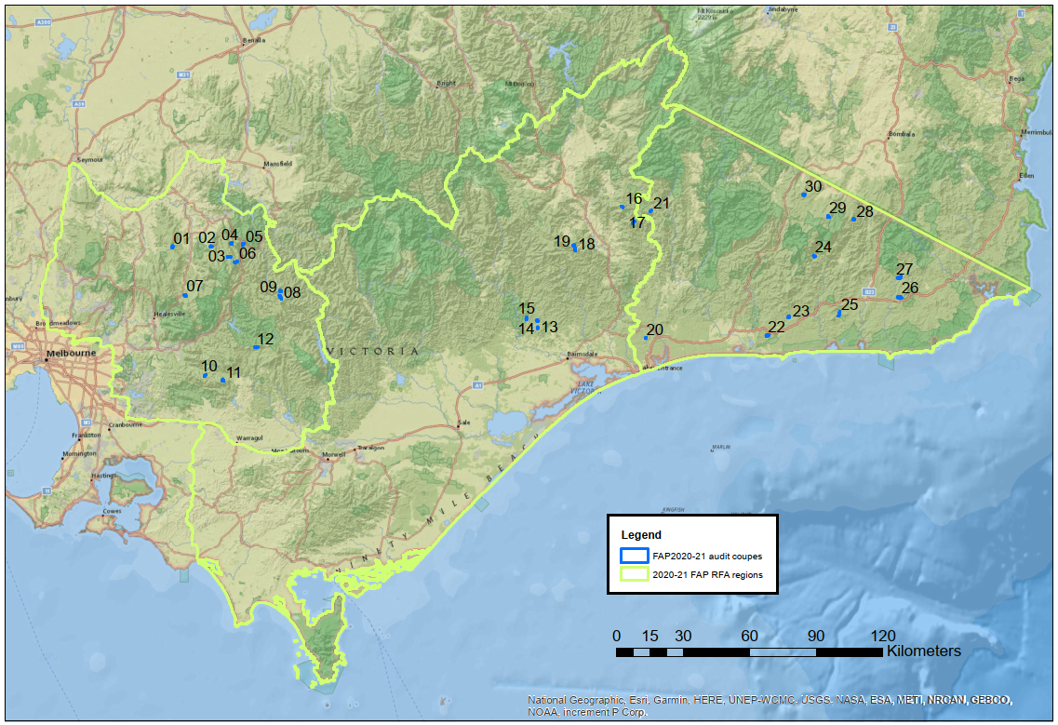
Figure ES.1 The 2020-21 FAP audit program was conducted in the Central Highlands, Gippsland and East Gippsland RFA regions. Sources: ESRI, DELWP.

Audit approach
Prospective coupes for the audit were selected using a risk-based procedure that emphasised coupes with: waterway crossings; long lengths of in-coupe road; steep slopes, more erosive soils; rainforest vegetation in close proximity; presence of threatened flora and/or fauna; Special Protection or Special Management Zones (SPZ and SMZ respectively) in close proximity.
As coupe selection was risk-based, rather than fully randomised, the findings of this audit cannot be taken as being statistically representative of VicForests’ operations overall.
Compliance criteria considered in the audit drew on mandatory requirements of the Code and related clauses of the MSPs and their Planning Standards. Audits of individual coupes considered up to 169 compliance criteria. An audit workbook was completed for each coupe, based on observations by the audit team and their review of VicForests’ Forest Coupe Plan (FCP) and related coupe planning information. Where instances of non-conformance with the regulatory framework were detected, their potential environmental impact was assessed using the FAP’s environmental impact assessment (EIA) tool. Field assessments for the audit were undertaken in May and June 2021.
VicForests personnel accompanied the audit team on all coupe assessments. This enabled useful discussions about planning and management practices, applicable elements of the regulatory framework and of any non-conformances that were observed.

Audit findings
The overall level of full conformance with applicable audit criteria ranged between 77% and 100%, with the average being 94%. Non-conformance incidents which were assessed to have potential for environmental impact were recorded in 19 of the 30 audited coupes. There was an average of 1.3 incidents with potential environmental impact per coupe, with as many as five incidents recorded in one coupe. While the assessed level of potential environmental impact associated with these incidents ranged up to major, only one such incident with major potential environmental impact was observed.
Audit criteria were grouped into four themes, and several sub-themes. A summary of audit results against each theme and sub-theme is given below:
- Environment: compliance criteria focus on the protection of soil and water values. The average level of full conformance with applicable audit criteria was:
Forest soils: 92% of applicable criteria
Water flows, water quality and river health: 91% of applicable criteria.
The potential environmental impact associated with non-conformance incidents ranged up to moderate for both sub-themes.
- Conservation of biodiversity: the average level of conformance for applicable criteria addressing biodiversity conservation was 95%. Incidents resulting from non-conformance were assessed to have potential environmental impacts ranging up to major.
- Operational planning and record-keeping: the average level of conformance for applicable criteria addressing operational planning and record-keeping was 97%. Non-conformance incidents for this theme that were assessed to have potential environmental impact typically resulted from either failure to plan properly or to implement the plan. Potential environmental impacts of non-conformances ranged up to major.
- Coupe infrastructure: criteria focus on measures to protect soil and water (particularly) from effects associated with roading, snig tracks, landings and other coupe infrastructure. Four sub-themes were identified:
In-coupe road design: the average level of full conformance was 89% of applicable criteria.
In-coupe road construction: the average level of full conformance was 86% of applicable criteria
Maintenance and closure of in-coupe roads and waterway crossings: the average level of full conformance was 88% of applicable criteria
Other infrastructure (i.e., snig tracks, landings, boundary tracks): the average level of full conformance was 95% of applicable criteria.
Potential environmental impacts for non-conformance incidents ranged up to moderate for all the four sub-themes.
The only incident assessed to have major potential environmental impact resulted from the construction of a boundary track into a Leadbeaters Possum SPZ (08 McAdams Sliver). Disturbance associated with the track affected about 1000 m² within the SPZ (<1% of the SPZ).
Other incident types with lesser potential environmental impact were observed in this audit. Several of these have been observed in multiple coupes in recent audits, including:
- Incursion of regeneration burns into buffers or other areas that were planned to be protected from timber harvesting and regeneration activities
- Poorly executed in-coupe road waterway crossing rehabilitation
- Excessive spacing (relative to slope and soil erosion hazard) between effective cross-drainage structures on in-coupe roads, and snig and boundary tracks.

Recommendations
Findings of this audit and reflections on previous audits have led to several recommendations from the audit team to VicForests and DELWP (Table ES.1). These cover:
- Potential improvements in the management of timber harvesting operations
- Operation of the FAP
- Victoria’s timber harvesting regulatory framework.
Table ES.1 Recommendations of the 2020-21 Forest Audit Program
Recommendations for VicForests
V-01 Medium priority: That VicForests undertake an assessment of fire salvage coupes in which live, fire-affected Ash-type eucalypts were retained. The assessment should consider the extent to which such trees survive the effects of fire and offer habitat or other benefits to the coupe when retained and the appropriateness of prioritising more severely burnt trees and forest areas for salvage harvesting.
V-02 High priority: That VicForests and/or its roading and harvesting contractors develop and implement waterway crossing rehabilitation plans for all temporary in-coupe road and snig track crossings to ensure conformance with the Code and MSPs and reduce, to the extent practicable, the mobilisation of sediment into waterways. Implementation of the plans should be confirmed by VicForests and any defects rectified before all harvesting/regeneration machinery is removed from the coupe.
V-03 Medium priority: That the data VicForests provides DELWP to assist in coupe selection is based on actual rather than planned in-coupe roads and waterway crossings.
Recommendations for DELWP
D-01 Medium priority: That DELWP review and reconsider limits on slash piles (currently 10 m³ MSP 7.2.4.2), particularly for rough heaping operations.
D-02 Medium priority: That during its forthcoming major review of the Code and MSPs, DELWP:
- Clarify the wording of revised MSP clauses 4.3.9.1 and 4.3.9.2 to explicitly address rainforest stands >0.4 ha in area located in Central Highlands and Gippsland FMAs that are not Rainforest Sites of Significance.
- Include a table linked to MSP clauses 7.2.2.1 and 7.2.3.3 that specifies maximum distances between snig track and boundary track drainage structures, based on slope and soil erosion hazard.

Glossary
Audit criteria | Criteria used to assess whether timber harvesting and related activities are consistent with mandatory requirements of the Code and MSP.
Boundary track | Track constructed in some harvest coupes that follows the marked boundary and is often used to support the containment of regeneration burns. Some boundary tracks may be used as snig tracks. Abbreviated as BT at places in this report.
Buffer strip | A protective margin of vegetation excluded from any harvesting activity abutting a waterway or an area of rainforest or other special area, which protects it from potentially detrimental disturbances in the surrounding forest.
Code | The Code of Practice for Timber Production 2014, which lists mandatory actions for timber harvesting activities in native forests and plantations in Victoria.
Conformance | Conformance with audit criteria. Activities were assessed to:  - Fully conform (or fully comply) with audit compliance element  - Not fully conform with the audit compliance element, but pose no direct risk of environmental harm  - Not fully conform with the audit compliance element and either have potential to pose a risk of harm to the environment or cause observable environmental harm. The severity of risk or actual harm is assessed using the FAP’s environmental impact assessment (EIA) rating tool (Appendix B).
Cording | Log material (>15 cm diameter) placed in a corduroy fashion on landings and snig tracks to distribute loading over a greater area and reduce soil disturbance. Cording is typically accompanied by matting, which is bark or head material that is used to cover cording on snig tracks and landings.
Coupe | An individual management unit within forests and plantations where timber harvesting or thinning activities are planned and conducted. Under the Sustainable Forests (Timber) Act 2004, a coupe is a specific area of State forest identified for the purposes of timber harvesting and regeneration in a Timber Release Plan.
DELWP | Department of Environment, Land, Water and Planning: DELWP has responsibility for environmental regulation of timber production activities in State forests. DELWP were formerly known as the Department of Environment and Primary Industries (DEPI) and the Department of Sustainability and Environment (DSE).
EI | Environmental impact, as assessed using the EIA rating tool (Appendix B).
EIA, EIA rating tool | Environmental Impact Assessment. The EIA rating tool was developed for the FAP (see Appendix B) to provide a consistent basis for assessing the potential environmental implications of non-compliance with audit criteria.
FAP | Forest Audit Program, an annual program of environmental audits coordinated by DELWP to ensure that timber production operations in State forests provide for sustainable forest management.
Filter strip | A protective boundary around a drainage line, temporary stream or buffer strip. Trees may be harvested from within a filter strip, although they may not generally be entered by harvesting machines.
FCP | Forest Coupe Plan, a plan that is prepared for each coupe that describes the biophysical character of the coupe and the nature of planned harvesting operations. The minimum FCP content requirements are specified in the Code. The FCP is contained within a coupe file that includes other information, including coupe monitoring records, traffic management provisions and silvicultural operations. The coupe file may also refer to information about the coupe and its operations that is held within a VicForests or DELWP information management system.
FMA | Forest Management Area, the basic regional unit for forest planning used for public land in Victoria. These forest planning units are not administrative units.
In-coupe road | A temporary or, in some cases, permanent road constructed to provide access to landings and/or allow haulage of timber from the coupe. Abbreviated ICR in some tables in this report.
Incident | An event, action or lack of action on a coupe that gives rise to an assessment of non-conformance with an audit criterion. The nature of the audit criteria and various prescriptions mean that a single incident may result in multiple non-conformances.
Landing | An area within the coupe that is specifically developed to sort, process and/or load trees or parts of trees for transport from the forest. Topsoil may be removed before landings are developed. Landings must be rehabilitated at coupe closure (including by ripping and re-spreading topsoil) unless they are to be used for an adjacent coupe.
MSP | Management standards and procedures for timber harvesting operations in Victoria’s State forests 2014. They are designed to help interpret the Code for timber harvesting and related activities in State forests. They are a secondary source of mandatory prescriptions for forest management.
MRT | Montane Riparian Thicket, a vegetation community containing at least 40% canopy cover of Mountain Tea-tree (Leptospermum grandifolium) and with understorey composition as per the MSPs.
OCR | Office of the Conservation Regulator, an office within DELWP that administers the regulatory framework for timber harvesting in State forests.
PS | Planning standards for timber harvesting operations in Victoria’s State forests 2014. Appendix 5 to the MSPs.
Rainforest stand | Patch of rainforest vegetation that meets the minimum species composition, size and projected foliage cover requirements of MSP 4.4.7 and 4.4.8 for recognition as a rainforest stand.
Rainforest vegetation | A patch of vegetation comprised of recognised rainforest canopy species, as per MSP 4.4.7. Rainforest vegetation may or may not form a stand, as described in the MSPs.
RFA | Regional Forest Agreement. The 2020-21 FAP considered coupes in three RFA regions, Central Highlands, Gippsland and East Gippsland.
Rough heaping | A method of preparing coupes for regeneration. Woody residue from harvesting is pushed into heaps and burnt. Soils, understorey and coupe infrastructure are disturbed by machinery to create a receptive seed bed.
Snig track | A track through a harvested coupe along which harvested logs are towed or winched, normally towards a landing. Abbreviated ST in some tables in this report.
SMZ | Special Management Zone, a forest management zone that is managed to conserve specific features or values, with allowing timber harvesting operations to proceed under special management.
Soil erosion hazard | Soil erosion hazard (or SEH) is a composite index of the potential for soil erosion to occur within a forest coupe. SEH is based on field assessments of soil texture, aggregate stability, structure, colour, organic content, mottling and stoniness. It also takes account of the erosivity of rainfall at the location, average slope, slope length, tree size and revegetation capacity. The method of calculation is described in the MSP (DEPI, 2014b). SEH is assessed for each coupe during harvest planning.
SPZ | Special Protection Zone, a forest management zone that is managed for specific conservation values. SPZs form a network within State forests that is meant to complement the formal conservation reserve system.
State forest | Publicly-owned and managed forest estate. Victoria has 3.4 million ha of State forest. State forest is managed for multiple beneficial uses, including conserving flora and fauna, protecting water catchments and water supply, providing timber for sustainable forestry, protecting landscape, archaeological and historic values, and providing recreational and educational opportunities.
STX | Snig track crossing, a constructed crossing through a waterway for a snig track.
THCU | Timber Harvesting Compliance Unit. The group within OCR that is responsible for regulatory compliance in timber harvesting operations conducted within State forest.
TRP | Timber Release Plan. Timber resources in State forests in eastern Victoria are allocated to VicForests for the purposes of harvesting and/or selling through the Allocation to VicForests Order 2004 (as amended). The Allocation Order specifies the extent and location of the forest stands to which VicForests has access under this Order. VicForests must prepare a Timber Release Plan for allocated areas.  Timber Release Plans (TRPs) are publicly available documents that must include: a schedule of coupes selected for timber harvesting and associated access road requirements; details of the location and approximate timing of timber harvesting in the proposed coupes; and details of the location of any associated access roads. They are prepared by VicForests in accordance with Part 5 of the Sustainable Forests (Timber) Act 2004 and may be reviewed and changed in accordance with Section 43.
UP | VicForests’ Utilisation Procedures. Operational procedures used by VicForests and its contractors in their management of harvesting and in-coupe roading operations. The UPs typically apply Code and MSP requirements.
VBA | Victorian Biodiversity Atlas, a database with records showing the distribution of native flora and fauna species, including listed threatened species.
Waterway | A permanent stream, temporary stream, drainage line, pool, spring or wetland, as defined in the Code.
WWX | Waterway crossing constructed for an in-coupe road.

Introduction

Sustainable Forest Management in Victoria
The legislative framework for the harvesting and management of timber resources in Victoria’s State forests is provided by five main pieces of legislation (based on DELWP, 2019):
- Forests Act 1958: provides the legislative basis for the development and implementation of Forest Management Plans and Forest Management Zones, which influence timber harvesting activities in State forests.
- Wildlife Act 1975: provides a framework for regulating interactions with wildlife and must be complied with when undertaking timber harvesting in State forests.
- Conservation, Forests and Lands (CFL) Act 1987: provides the legislative basis for the creation and enforcement of codes of practice (including the Code of Practice for Timber Production 2014 [the Code; DEPI, 2014a]) which specify standards and procedures for carrying out timber harvesting operations (among other activities).
- Flora and Fauna Guarantee (FFG) Act 1988 and Flora and Fauna Guarantee Amendment Act 2019: provide the legislative basis for biodiversity conservation in Victoria. Action Statements for threatened species and communities are published under the auspices of the FFG Act. These statements inform updates to the Code when undertaking timber harvesting in State forests.
- Sustainable Forests (Timber) (SFT) Act 2004: provides a framework for sustainable forest management and sustainable timber harvesting in State forests and establishes the Allocation Order, Timber Release Plans (TRPs) and compliance obligations provisions for timber harvesting in State forests. The SFT Act requires VicForests and persons who have entered into an agreement with VicForests for the supply and sale of timber resources to comply with the Code.
The SFT Act also provides the legislative basis for commissioning audits of compliance with relevant codes of practice (including the Code) by VicForests. It also requires VicForests to respond to any adverse findings of such an audit, including details of measures it has or intends to undertake to improve compliance with the relevant code of practice. The SFT Act also provides for the publication of audit reports and VicForests’ responses to these.
Under the SFT Act, harvesting of timber from public land by VicForests is to be conducted in a manner which has regard to the principles of ecologically sustainable development. The Act provides for the development of a Sustainability Charter, which sets out the State’s objectives for sustainable forest management. These objectives (DSE, 2006) are to:
Maintain and conserve biodiversity in State forests
Maintain and improve the capacity of forest ecosystems to produce wood and non-wood products
Promote healthy forests by actively managing disturbance
Maintain and conserve the soil and water resources of State forests
Maintain and better understand the role of Victoria’s State forests in global carbon cycles
Maintain and enhance the socio-economic benefits of State forests to Victorian communities
Ensure Victoria’s legal, institutional and economic frameworks effectively support the sustainable management of State forests.
In reviewing VicForests’ Allocation Order, the SFT Act requires that the Minister will also have regard to VicForests’ compliance with applicable codes of practice.
The primary instrument used to regulate timber harvesting activities in State forests is the Code. This is now administered by the DELWP’s Office of the Conservation Regulator (OCR).
The purpose of the Code is to provide direction to timber harvesting managers, harvesting entities and operators to deliver sound environmental performance when planning for and conducting timber harvesting activities in a way that:
- Permits an economically viable, internationally competitive, sustainable timber industry
- Is compatible with conservation of the wide range of environmental, social and cultural values associated with forests
- Provides for the ecologically sustainable management of native forests proposed for cyclical timber harvesting operations
- Enhances public confidence in the management of timber production in Victoria’s forests and plantations.
The Code includes a set of operational goals and mandatory actions for various aspects of planning and implementation of timber harvesting operations and applies to native forests and plantations on private and public land. It is supported by the Management Standards and Procedures for Timber Harvesting Operations in Victoria’s State Forests 2014 (the MSPs; DEPI, 2014b), which specify (often in greater detail) mandatory standards and procedures for timber harvesting activities in State forests (only).
Revised versions of the Code and MSPs, with minor modifications, were released in November 2021 (DELWP, 2021a,b). A more extensive revision of the timber harvesting regulatory framework is scheduled planned to be undertaken by DELWP. Given the timing of release for the revised versions of the Code and MSPs (well after planning and harvesting on the coupes selected for audit have been completed), they cannot be considered by the 2020-21 FAP audit.

Forest Audit Program
Since 2002, independent environmental auditors have been engaged to undertake audits of timber harvesting operations in Victoria’s State forests, as provided for by the SFT Act. These audits have assessed compliance with the Code and related standards and management procedures. This annual program of audits has been delivered by DELWP, under its Forest Audit Program (FAP) since 2010. Independent auditors are engaged by the OCR to undertake FAP audits.
FAP audits do not have a direct regulatory function. They help to monitor VicForests’ compliance with the regulatory framework and are intended to contribute to continuous improvement in sustainable native forest management. In keeping with the latter, field components of the audit are undertaken with VicForests personnel present. This informs the auditors of the history of operations on the coupe and any challenges faced. It also allows for on-site discussion about any potential non-conformance issues that have been observed by the audit team.
Following the audit field components, VicForests was requested to provide additional information to enable the auditors to determine whether coupe planning or operations comply with regulatory requirements. VicForests was provided, via DELWP, with a copy of the draft audit report. This allows them to contest draft compliance findings and offer further evidence for the audit team to consider. VicForests’ comments and any additional evidence are considered by the audit team in finalising the audit report. For transparency, VicForests’ substantive comments and the audit team’s responses are documented in Appendix D.

About this report
This is the final report of the 2020-21 Forest Audit Program. The remainder of the document includes five main sections, as follows:
- Section 2 Audit scope: describes the scope of the audit, including the audit objectives, the regulatory scope it addresses, the audit timing and audit team.
- Section 3 Audit approach: describes the coupe selection process, development of audit compliance elements and the methods by which conformance with the regulatory framework is assessed during the audit.
- Section 4 Audit results: presents the main results of the audit, including the level of conformance with audit criteria and the assessed potential environmental impact associated with any observed non-conformance incidents. Audit results are organized by the compliance themes included in the audit scope developed by DELWP.
- Section 5 Discussion: of the overall audit findings and comparison (to the extent appropriate) of 2020-21 audit results with previous FAP audits. The discussion also draws on observations made during the field audit to suggests potential improvements in coupe planning and timber harvesting activities.
- Section 6 Conclusions and recommendations: summarises the main findings of the audit and outlines recommendations for improvements in timber harvesting operations and the regulatory framework.

Audit scope

Audit objectives
The FAP enables DELWP to commission an environmental auditor to provide an objective and independent assessment of:
- Compliance by VicForests and their contractors with mandatory prescriptions for timber harvesting and related activities that are outlined in Victoria’s regulatory framework
- Environmental performance of the audited timber harvesting operations and any associated risks of harm to the environment.
The FAP is a key contributor to continuous improvement in sustainable management of Victoria’s State forests.

Audit scope
The audit addresses a suite of mandatory Code compliance elements that were selected by DELWP’s Timber Harvesting Compliance Unit (THCU; a unit within the OCR). It focusses on four main areas of compliance priority under the Code, namely:
- Environmental values in State Forests: specific measures to protect water quality, river health and soils
- Conservation of biodiversity: measures during coupe planning and operations which are designed to protect listed threatened species and vegetation communities, avoid harvesting in rainforests, and maintain forest hygiene
- Operational planning and record-keeping: measures that are undertaken to ensure that timber harvesting operations are planned to satisfy applicable regulatory requirements
- Coupe infrastructure for timber harvesting operations: measures to ensure the design, construction, decommissioning and rehabilitation of in-coupe roads and other coupe infrastructure (e.g., landings, snig tracks, boundary tracks) protect key environmental values.
Audit compliance elements that are based on the Code are supplemented by elements drawn from mandatory requirements of the MSPs and their Planning Standards (PS; Planning Standards for timber harvesting operations in Victoria’s State forests 2014; DEPI, 2014c). These additional elements were selected by the auditors, based on the Code compliance elements specified by DELWP, and agreed with THCU prior to commencing the audit.
Collectively, the compliance elements seek to ensure that coupe planning, harvesting and associated forest roading activities are conducted so that the range, quantity and quality of environmental goods and services provided by State forests are maintained.
The audit included 30 coupes that were listed in VicForests’ TRP (for intensive harvesting operations in eastern Victoria) and harvested during the 2019-20 financial year. These coupes are located within the Central Highlands, Gippsland and East Gippsland Regional Forest Agreement (RFA) regions (Figure 2.1).
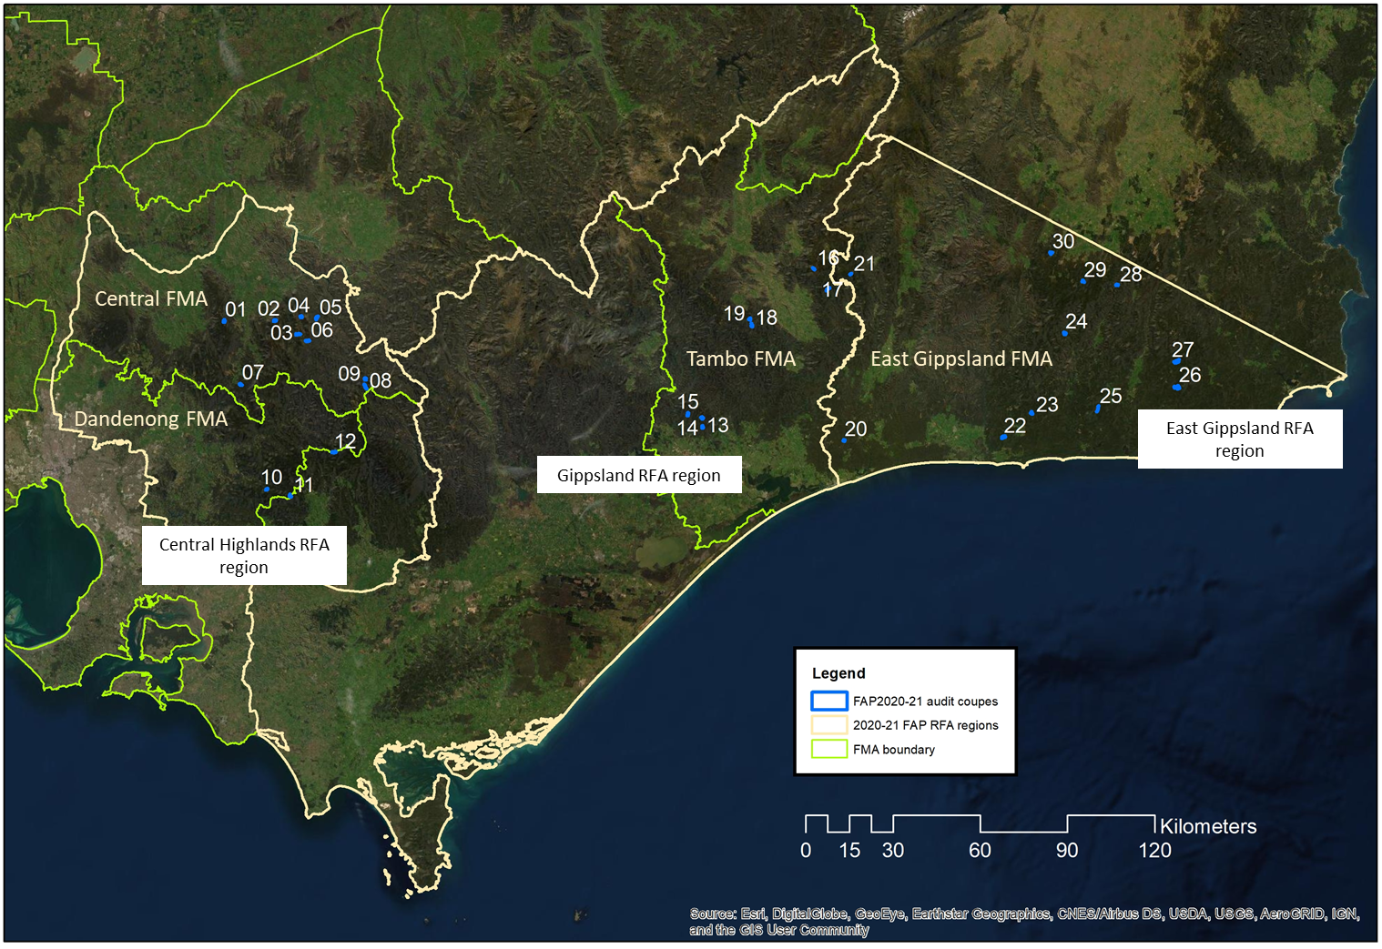
Note: numbers 01-30 represent the assigned coupe number (see Table 3.1 for details).
Figure 2.1 Locations of coupes included in 2020-21 Forest Audit Program, with references to Victorian Forest Management Areas (FMA) and Regional Forest Agreement (RFA) regions. Sources: ESRI, DELWP.

Audit timing
Field assessments of the coupes included in this audit were undertaken during May and June 2021. Audit reporting was carried out in two stages, with an initial conformance summary report on the results of the audit submitted to DELWP in June 2021. That document (Jacobs, 2021) provided preliminary information on compliance assessments and the potential environmental impact of any non-conformances. However, it did not draw out any overall findings or conclusions. The second stage of reporting involves the production of the full audit report (this report). The general content and format of the full audit report were specified by DELWP.

Audit team
The audit team (below) were all employed by Jacobs Group (Australia) Pty Ltd (Jacobs):
- Craig Clifton (Project Manager and lead auditor): Craig is an EPA-appointed natural resources environmental auditor and has undergraduate and post-graduate qualifications in Forest Science. He developed the audit methodology, led the field assessments and their analysis and is lead author of this audit report. Craig has led audit teams undertaking eight previous FAP audit projects.
- David Endersby (Project Director): David is a principal terrestrial ecologist, with specialist expertise in botany, plant ecology and geomorphology. He has participated in several previous FAP audits as a field team member, project director and technical reviewer. David is the internal technical reviewer for this report and Jacobs’ project director.
- Dr Drew King (Audit team member): Drew has graduate and post-graduate qualifications in Botany and over 15 years’ experience in ecological research and consulting. He is a senior ecologist with extensive experience in plant identification and vegetation community analysis. Drew participated in field audits in the Gippsland Regional Forest Agreement (RFA) region.
- Andrew Stephens (Audit team member): Andrew is a senior ecologist with specialisations in vegetation and bushfire ecology. Andrew works closely with statutory authorities for environmental approvals including state and nationally protected matters. He has also assisted in implementing native vegetation offsets as an accredited assessor, preparing management plans and monitoring implementation of restoration works. Andrew participated in 2019-20 FAP field audits and field audits in the East Gippsland RFA region as part of this audit.
- Dr Petter Nyman (Audit team member): Petter is senior consultant with specialist expertise in forest hydrology, bushfire management and spatial data analytics. He has deep research and consulting experience in investigation and management of bushfire impacts on catchments and water quality and in sediment generation from forest roads. Petter participated in field audits in Central Highlands and Gippsland RFA regions.

Audit approach

Coupe selection
The field component of the audit examined 30 timber harvesting coupes located across eastern Victorian (Figure 2.1). A risk-based selection process was used to identify the target coupes for auditing. The process was based on the characterisation of the coupes in information provided to DELWP by VicForests. All coupes were active for harvesting at some stage during 2019-20.
The factors influencing coupe selection included:
- An in-coupe road or snig track waterway crossing was to be constructed to access the coupe and/or timber within it
- Mapped or modelled rainforest and/or Montane Riparian Thicket (MRT) vegetation was identified as being present within or adjacent to the coupe
- Length of in-coupe road to be constructed within the coupe
- Soil erosion hazard in the A or B horizon
- Average coupe slope
- Presence of land zoned as special protection and/or special management zone (SPZ/SMZ, respectively) within or adjacent to the coupe
- Records of listed threatened native flora and/or fauna species located within or adjacent to the coupe
- Salvage harvesting having been carried out in the coupe.
Coupes that had been audited in the 2019-20 FAP were excluded from selection for this audit. Parts of two of the 30 selected coupes were located in Melbourne Water catchment areas.
The audit was initially planned to include several coupes within the North East Forest Management Area (FMA). However, access and safety constraints meant that the coupes could not be audited in the time available. North East FMA coupes were substituted for addition coupes located in the Tambo FMA.
A summary of key characteristics of the selected coupes is given in Table 3.1. The average net harvest area for the selected coupes is 19.4 ha, compared with an average gross coupe area of 47.3 ha. Thirteen of the coupes were located within 500 m of modelled rainforest vegetation communities, few of which were rainforest stands requiring protection under the Code and MSPs. Only four of the coupes had in-coupe road or snig track waterway crossings. The length of in-coupe road required to access landings that serviced the coupes ranged between zero and about 1600 m. Average coupe slope was 10-15°, with maximum slope exceeding 30° in unharvested areas of some coupes. Most coupes included or were adjacent to land zoned as SPZ and/or SMZ. Threatened native plant and animal species had been recorded on or within 500 m of all but two of the coupes.
The analysis in Table 3.1 shows that the data reported by VicForests on key risk characteristics, particularly the presence of waterway crossings and in-coupe roads, is unreliable. Eight of 30 coupes were reported as being planned to have waterways crossings but did not. Planned lengths of in-coupe road were within 100 m of the actual length at only seven of the 30 audit coupes.

Table 3.1 Location and characteristics of harvest coupes included in 2020-21 FAP
Audit # | Coupe address | Coupe Name | FMA | Coupe size (net ha) | Rainforest vegetation¹ | Waterway crossing² | In-coupe road length³ | Average slope | Maximum soil erosion hazard | SMZ or SPZ | Listed flora or fauna⁴
Central Highlands RFA region
01 | 284-502-0008 | Crusoe | Central | 17.6 | No | Nil | 150 (400) | 10 | Medium | SPZ | <500 m
02 | 286-505-0029 | Onyx | Central | 5.93 | Yes | WWX+STX | 110 (200) | 10 | Medium | SPZ+SMZ | coupe
03 | 287-515-0010 | Mongoose | Central | 15.39 | Yes | Nil | <50 (100) | 15 | Medium | SPZ | coupe
04 | 288-509-0001 | Shackle | Central | 5.41 | Yes | Nil | 300⁵ (300) | 25 | Medium | SPZ | coupe
05 | 289-504-0010 | Triple Don | Central | 9.47 | No | Nil | <50 (300) | 10 | Medium | SMZ | coupe
06 | 290-523-0006 | Yogi | Central | 8.55 | Yes | Nil | <50 (50) | 20 | High | SPZ | coupe
07 | 309-502-0002 | Mammoth Tooth | Central | 16.38 | No | Nil | <50 (370) | 5 | Medium | SPZ+SMZ | coupe
08 | 318-512-0027 | McAdams Sliver | Central | 18.6 | No | Nil | 500 (300) | 20 | Medium | SPZ | coupe
09 | 318-512-0029 | Charcuterie | Central | 16.06 | No | Nil | 400⁶ (512) | 20 | High | SPZ | coupe
10 | 349-503-0014 | Jolimont | Dandenong | 9.57 | No | Nil | 150⁶ (960) | 25 | Medium | SPZ | <500 m
11 | 349-515-0001 | Even Steven⁷ | Dandenong | 32.86 | Yes | STX | 640 (1215) | 20 | Low | SPZ | coupe
12 | 462-503-0006 | Road 20⁷ | Central Gippsland | 4.91 | Yes | Nil | 100 (275) | 20 | Low | SPZ | coupe
Gippsland RFA region
13 | 735-508-0018 | Selection | Tambo | 31.76 | No | Nil | 300 (350) | 10 | Medium | SMZ | <500 m
14 | 735-510-0026 | Bull Dust | Tambo | 24.22 | No | WWX + STX | 340 (647) | 5 | Medium | SMZ | Nil
15 | 735-516-0007 | Wattle Hill | Tambo | 43.59 | No | Nil | <50 (40) | 10 | Low | Nil | coupe
16 | 765-502-0102 | Spike Jones | Tambo | 28.74 | No | Nil | 350 (200) | 15 | Medium | Nil | <500 m
17 | 766-503-0028 | Long One | Tambo | 16.87 | Yes | Nil | <50 (200) | 10 | Medium | SPZ | coupe
18 | 775-508-0007 | Angora Middle South | Tambo | 43.29 | No | Nil | 1600 (1000) | 20 | Medium | SPZ | Nil
19 | 776-504-0027 | Ghostly | Tambo | 6.65 | No | Nil | <50 (300) | 15 | Low | SPZ | <500 m
East Gippsland RFA region
20 | 801-507-0013 | Repeat | East Gippsland | 29.77 | No | WWX | 1100 (600) | 5 | Medium | SPZ+SMZ | <500 m
21 | 814-505-0003 | Galicia | East Gippsland | 4.71 | Yes | Nil | 100 (500) | 10 | Low | SPZ | coupe
22 | 828-505-0004 | Monster | East Gippsland | 22.53 | No | Nil | 600 (600) | 5 | Low | SPZ+SMZ | coupe
23 | 831-502-0009 | Moatize | East Gippsland | 17.94 | Yes | Nil | 450 (450) | 15 | Low | SPZ+SMZ | coupe
24 | 837-515-0003 | On Sight | East Gippsland | 51.88 | No | Nil | 50 (900) | 20 | Medium | SPZ+SMZ | coupe
25 | 866-501-0018 | Vegeta | East Gippsland | 33.52 | Yes | Nil | <50 (0) | 5 | Low | SPZ+SMZ | coupe
26 | 874-501-0010 | Lyme Disease | East Gippsland | 10.16 | Yes | Nil | 300 (100) | 5 | Low | SPZ | coupe
27 | 874-512-0008 | Brave Duck | East Gippsland | 8.18 | Yes | Nil | 450 (50) | 10 | Medium | SPZ+SMZ | <500 m
28 | 889-506-0033 | Wheel | East Gippsland | 21.31 | Yes | Nil | <50 (700) | 20 | High | Nil | coupe
29 | 892-515-0005 | Devo | East Gippsland | 9.14 | Yes | Nil | <50⁶ (200) | 10 | Medium | SMZ | coupe
30 | 895-505-0015 | Shazam | East Gippsland | 17.25 | No | Nil | 350 (700) | 10 | Medium | SPZ+SMZ | coupe
Notes:
- Rainforest vegetation (but not necessarily a stand as per MSP 4.4.8) present within 500 m of coupe. Note that ecological vegetation class (EVC) mapping for 12 Road 20 does not show modelled rainforest vegetation. The field audit found that rainforest species were present in and near the coupe, but there were no rainforest stands as defined by the MSPs. VicForests records did not indicate the presence of rainforest (vegetation or stands).
- Waterway crossing. Type of crossing present: WWX – in-coupe road crossing, STX snig track crossing, Nil – no crossing. Colour code: pale blue – coupe flagged by VicForests planning as having a crossing, but the feature was not present; green – coupe correctly flagged as having or not having a waterway crossing.
- In-coupe road length: actual ICR length (ICR length reported by VicForests). Colour code: pale blue – ICR length >100 m less than estimate; green – road length accurately estimated (±100 m); orange – actual ICR length >100 m more than estimated.
- Presence of listed threatened flora or fauna: Victorian Biodiversity Atlas (VBA) records either within coupe (In coupe), within 500 m of the coupe (<500 m) or not present within 500 m (Nil)
- ICR within 04 Shackle extended from landing in that coupe to an adjacent coupe. This ICR segment not reported by VicForests.
- ICR in 09 Charcuterie extended >800 m from a landing on an adjacent coupe. ICR in 10 Jolimont extended additional 450 from an adjacent coupe. ICR to landing used by 29 Devo 350 m through adjoining coupe.
- Parts of 11 Even Steven and 12 Road 20 were located in Melbourne Water catchment areas.

Audit criteria and workbook
Audit criteria were based on mandatory requirements of the Code selected by DELWP’s THCU. Generally, the criteria referenced additional compliance elements from the MSPs and the PS, which provide more detailed interpretations of Code requirements. Compliance criteria were grouped into several themes and sub-themes, as follows:
- Environment: compliance criteria developed for the audit drew on Section 2.2.1 of the Code (Water quality, river health and soil protection) and related compliance elements from the MSPs. There are two sub-themes, soil and water, with the latter incorporating flows, water quality and river health.
- Conservation of biodiversity: compliance criteria developed for the audit drew on Section 2.2.2 of the Code and related MSP and PS compliance elements.
- Operational planning and record-keeping: compliance criteria for the audit drew on Sections 2.3 and 2.5.1 of the Code and related MSP compliance elements.
- Coupe infrastructure for timber harvesting operations: compliance criteria were organised into four sub-themes, three related to roading for timber harvesting operations (based on Code Section 2.4; 2.4.2 Road design, 2.4.3 Road construction, 2.4.4 Road maintenance) and one sub-theme relating to other coupe infrastructure (i.e. landings, snig, forwarding and boundary tracks; Code Section 2.5.2). As with other compliance themes, audit criteria also drew on relevant MSP mandatory compliance elements.
The audits considered 169 individual compliance criteria (see Appendix A). These were assessed, as applicable, for each of the audit coupes. A digital audit workbook was developed to capture assessments against all applicable criteria for each individual coupe. Assessments recorded in the workbook were based on observations by the audit team and their review of VicForests’ (digital and, in many cases, hard copy) Forest Coupe Plans (FCP). They considered the applicability of each criterion, as well as the operations’ conformance with the audit criteria or compliance element. The latter was assessed using the descriptors in Table 3.2.
Table 3.2 Descriptors used to assess conformance with audit criteria
Level of compliance | Fully conforms | Non-conforming with no environmental impact  (Non-no EI)) | Non-conforming with environmental impact  (full non-conformance, Non-EI)
Description | All requirements of the compliance element are fully satisfied. | All requirements of the compliance element are not fully satisfied. However, the non-conformance is procedural and poses no direct risk of harm to the environment. | All requirements of the compliance element are not fully satisfied. The non-conformance has potential to pose a risk of harm to the environment.
The workbook was also used to capture the basis for any non-conformance assessment. Photographs were taken of coupe features, particularly where/if non-conformances were observed.

Field assessments
Field assessments of relevant coupe characteristics (Table 3.3) were carried out in each of the target coupes. Handheld global positioning system (GPS) devices were used in most coupes to track the field team’s movements and some coupe observations were recorded digitally using the ESRI Collector platform.
Table 3.3 Field assessment methods for harvesting coupes
Attribute being assessed | Criteria | Method
Waterway classification and correct provision of riparian filters and/or buffers | 1, 3, 5, 15 | Assessment of waterway as drainage line, temporary stream, permanent stream, wetland or spring, based on Code definitions. Streams and widths of filters/buffers will be assessed along at least 600 m of waterway per coupe if present. Adequacy of filter and buffer widths are assessed with a range finder, supported by ground traverses to locate the centreline/edge of the waterway (as required).
Soil erosion hazard | 2 | Comparison of VicForests assessment of soil erosion hazard with observations of soil conditions and any soil movement within the coupe. Soil erosion hazard is assessed using MSP methods where evidence of soil conditions and soil erosion suggests to the auditor that the initial assessment may have been incorrect or only applicable for one of multiple soil types present within the coupe.
Extent to which harvesting was conducted on slopes >30°/25° (for coupes on granite-derived soils in East Gippsland FMA) | 4,5 | Visual observation, using a clinometer, if required. Supported by analysis of VicForests’ contour mapping and LIDAR data, if available.
Adequacy of protection provided to soils, waterways, and river health | 6, 7, 8, 15, 21 | Visual observations and auditors’ interpretations based on the presence of excessive disturbance, evidence of erosion or mass soil movement and/or activities which are not compliant with elements of the regulatory framework. Assessments consider in-coupe roads (ICR) and coupe infrastructure (snig tracks [ST], boundary tracks [BT] and landings).
Presence of in-coupe roads or snig tracks in riparian habitats | 7, 15, 21 | Visual observations and auditors’ interpretations of the reasonable practicability of alternative placements which avoided or were more remote from riparian areas.
Waterway crossings and culverts | 7, 18, 19, 20, 21, 22 | Assessment of culverts, embankments, and road drainage against MSP requirements. Observations and auditors’ interpretation of crossings in which the culvert or logfill had been removed (if observed). Observations of sediment entry into the waterway during use of the crossing and/or following its rehabilitation.
Habitat trees | 10 | Assessment of the density and distribution of habitat trees, their location in relation to other habitat and their potential to develop hollows. Observations of the distribution, extent, and any harvest-related disturbance of habitat patches.
If listed threatened fauna or flora are recorded as being present, whether prescribed management actions been followed | 9, 11 | Comparison of observed coupe conditions with management actions specified in the MSP Planning Standards and forest coupe plan (FCP).
Harvesting and/or road construction in or near box-ironbark, heathland, or montane riparian thicket (MRT) if present within or near the coupe | 12 | Confirmation of the presence of the vegetation community and observation of its proximity to in-coupe roads. Auditors’ assessment as to the reasonable practicability of alternative road location if the road entered the protected vegetation community. Presence of harvesting in or in proximity to box-ironbark forests, heathlands or MRT.
Old growth forest (OGF) | 12 | Provision of buffers around verified OGF within Leadbeater’s Possum (LBP) range.
Rainforest buffers | 12 | Identification of rainforest stands, as per MSP definitions. Assessment of provision of any required buffers as per MSP requirements in parts of coupe with rainforest stands present.
Protection of exclusion areas and areas outside gross coupe boundaries | 12, 15, 21 | Identification and assessment of any effect of harvesting operation (including roading, regeneration burning, tree felling, ST/BT, and machinery movement) on exclusion areas or areas outside the coupe boundary, including retained habitat patches.
Biosecurity | 13 | Observation of harvesting related damage to or wounding of Myrtle Beech trees, in applicable coupes. Implementation of any management plans where harvesting operations appear to have led to disease or pest introduction.
In-coupe road design and construction | 16, 17, 18, 19 | Assessment of whether road construction follows any documented plan or design.  Identification of any evidence that road construction was inconsistent with need to minimise risk of erosion and water quality impact.  Identification of any evidence that table drains were constructed by subsequent excavation.  For ICR through retained vegetation, assess whether clearing width was consistent with MSP requirements.  Assessment of the appropriateness of the intensity of earthworks for ICR.  Observation and auditors’ interpretation of the adequacy of road maintenance and any road closure works.
Fill batters | 18 | Evidence of soil movement and instability of fill batters on ICR or landings. Observation of instances where fill batters cover base of live trees to be retained post-harvest.
Road drainage | 19 | Compliance with MSP drain spacing requirements, based on soil erosion hazard (nominated in the FCP) and gradient, for full length of in-coupe road. Assessment of effectiveness of drainage and appropriateness of drainage disposal, considering Code and MSP requirements.  Conformance of culvert construction and management with MSP requirements.  Appropriateness and avoidability of disturbance to stream beds during and following crossing construction and removal.
ICR and waterway crossing closure | 20 | Assessment of whether any crossings (by ICR or ST) that are no longer required been removed and rehabilitated as per MSP requirements.  Assessment of the effectiveness of closure of an ICR that is no longer.
Coupe management | 21 | Observation of the consistency between the FCP and the timber harvesting operation.
Coupe infrastructure – ST & BT | 22 | Assess if ST have been progressively rehabilitated and rehabilitated in a way that prevents soil movement into streams and consistent with MSP requirements. Assess adequacy of ST and BT drainage and its conformance to MSP requirements. Assess >500 m length of ST and/or BT, where present. Drainage on ST and BT is assessed against standards in VicForests’ Utilisation Procedures (VicForests, 2018; Schedule 5).  Assess adequacy of landing rehabilitation, including removal of any cording, bark and/or slash.
Coupe infrastructure – landings | 21 | Assess adequacy of landing rehabilitation, including removal of cording and matting, ripping of landing and final 30 m of ST, placement of bark piles and storage and redistribution of stockpiled soil.
Slash and bark piles | 22 | Assessment of whether slash and bark been placed and piled appropriately (as per MSPs) in preparation for regeneration burning.
Campsites | 22 | Determine if placement and management of any campsites are consistent with MSP prescriptions.
Fire salvage harvesting | 15 | Assess conformance of coupe operations with applicable salvage harvesting prescriptions as per Section 8 of the MSP.

Environmental impact assessment
The EIA tool provided by DELWP (Appendix B) was used to assess the potential environmental impacts of non-conformance with audit criteria and the regulatory framework for timber harvesting. EIA tool assessments are based on:
- Extent and location of impact: an auditor’s assessment based on one or more of several factors:
- Proportion of the harvestable coupe area affected by the non-conformance
- Length of in-coupe road and/or snig/boundary track without conforming drainage
- Suitability of landing rehabilitation
- Extent of soil mass movement
- Number of retained trees whose base is covered by in-coupe road, landing or snig track embankment materials
- The number and/or extent of incidences of inappropriate disturbances (i.e. disturbances to planned timber harvesting exclusions areas which are not permitted by the Code or MSPs) to waterways, riparian buffers or filters or other areas within or adjacent to the gross coupe area.
- Duration of impact/recovery time: an assessment by the auditor of the likely time required for the coupe to recover from any impact or disturbance associated with the non-conformance incident.
- Values affected: an assessment based on the value or environmental aspect experiencing or potentially experiencing an impact stemming from the non-conformance. General forest areas are valued less than riparian or rainforest buffers and SPZ, for example.
The overall five-point EIA rating is based on the total score for each component. Ratings may range between negligible and severe. The assessed potential environmental impact is not necessarily reflective of the actual environmental impact of a non-conformance incident. Incidents that occur in sensitive locations (e.g., SPZ, riparian buffers) may be assessed to have relatively high potential environmental impact even if the actual impact is minimal.
Non-conformances for which there is no direct pathway to cause harm to the environment (and not just that they do not cause environmental harm) were assessed as non-conforming with no environmental impact (Non-no EI), as per Table 3.2.

Audit results
This section summarises the results of the assessments of conformance with compliance criteria based on mandatory elements of the regulatory framework for timber harvesting in State forests, as listed in Appendix A. Overall results are presented first, with those for each compliance theme and sub-theme following. As the coupe selection method was risk-based, rather than random, these results are not necessarily statistically representative of VicForests’ operations overall.
Due to space constraints in the figures, coupes are represented by the number assigned in Table 3.1. In the narrative accompanying these figures, coupes are referred to by that number (rather than the TRP coupe number) and the coupe name.

Overall compliance findings
A total of 169 criteria were identified from the various compliance elements applicable to timber harvesting coupes (Appendix A). Of these, 25 criteria were found to not actually apply to any of the audit coupes. The overall level of full conformance with applicable audit criteria ranged between 77% (20 Repeat) and 100% (05 Triple Don, 17 Long One, 19 Ghostly, 22 Monster, 24 On Sight), with the average being 94% (Figure 4.1a). Non-conformances identified in 19 of the 30 coupes had potential for environmental impact.
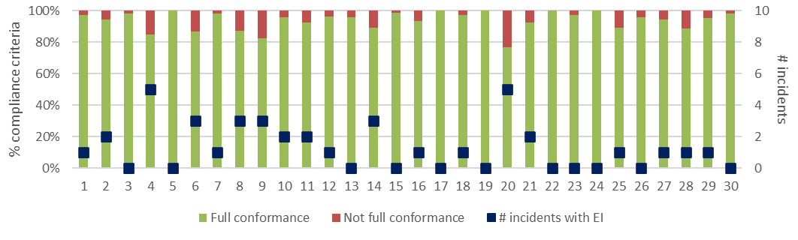
a) Level of conformance with audit criteria and number of non-conformance incidents with assessable environmental impact. Conformance as per Table 3.2, with not full compliance including all criteria with which the coupe did not fully comply, regardless of the potential for environmental impact.
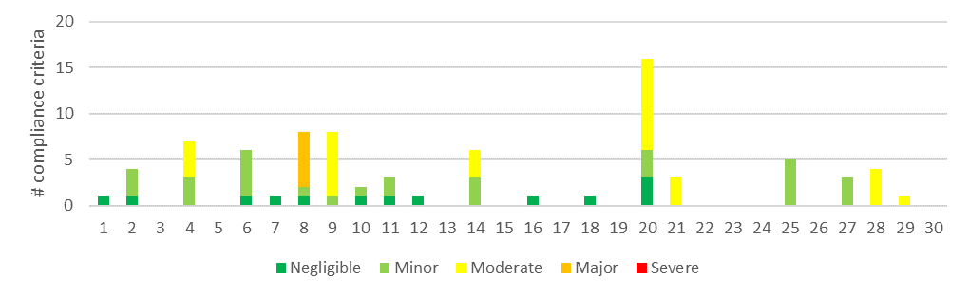
b) Number of compliance criteria with assessable environmental impact and the assessed level of impact for each instance of non-conformance.
Figure 4.1 Overall compliance findings and assessed environmental impact for instances of non-conformance for harvest coupes. The x-axis refers to the coupe numbers, as per Table 3.1.
Figure 4.1b shows the number of incidents resulting in non-conformance with one or more audit criteria leading to actual or potential environmental impact. These ranged between zero (11 coupes) and five (04 Shackle, 20 Repeat), with an average of 1.3 incidents per coupe. A list of the incidents associated with non-conformance with audit criteria and the regulatory framework for timber harvesting is given in Appendix C.
The EIA tool (Appendix B) was used to assess the potential environmental impact associated with each non-conformance incident. This ranged between negligible and major (Figure 4.1). Non-conformances which were assessed to have major environmental impact were detected in only one of the 30 coupes included in the audit (08 McAdams Sliver). Incidents with moderate potential environmental impact were detected in seven of the 30 coupes (Figure 4.1). These incidents are discussed in greater detail in the following sections.

Environmental compliance theme
The environmental compliance theme included two main groups of compliance element and audit criteria, those relating to soils, and water and river health.

Compliance elements related to the protection of forest soils
Compliance elements related to the protection of forest soils (Appendix A) relate to the avoidance of erosion or mass soil movement, as well as to mitigating the risk of entry of sediments into waterways, should they be mobilised. The entry of mobilised sediments into waterways is primarily dealt with under the water and river health sub-theme (Section 4.2.2). The avoidance of erosion and mass movement of soils is achieved by:
- Assessing and understanding soil erosion hazard within the coupe and adjusting planning and operations accordingly
- Not harvesting in excessively steep areas
- Application of seasonal closures to coupes in water supply catchments to reduce the risk of mobilising sediment when harvesting or snigging machinery would disturb wet soils
- Appropriate location, construction, maintenance, closure and/or removal of in-coupe roads, road drainage and road or snig track waterway crossings.
A total of 34 audit criteria were relevant to the protection of forest soils, three of which were not applicable to any of the target coupes. The average level of full conformance with applicable criteria was found to be 92%, with the level of conformance ranging between 53% (20 Repeat) and 100% (15 coupes; Figure 4.2). The assessed environmental impact associated with non-conformances ranged between negligible and moderate.
Non-conformance incidents resulting in actual or potential environmental impacts on forest soils were identified in 14 coupes. The types of incidents with moderate potential environmental impact included:
- Potential for disturbance of soil (during an intense rainfall event) exposed by a large incursion (up to 30 m deep × >200 m long) of the regeneration burn in 21 Galicia into a planned exclusion area (see Figure 4.8).
- Potential disturbance of soil following small regeneration burn incursions (04 Shackle, 09 Charcuterie) into planned habitat retention patches. While potential environmental impact of these two incidents was rated moderate, as was that at 21 Galicia, the latter was more severe and had a higher potential environmental impact score (but the same overall rating).
- Excessive lengths of in-coupe road (09 Charcuterie) or snig track (28 Wheel) where drainage spacing exceeded MSP or VicForests Utilisation Procedure (UP) requirements based on slope and the soil erosion hazard rating recorded in the FCP.
- Poorly constructed drainage on the approaches to a waterway crossing following its removal, resulting in the mobilisation of road sediments towards the waterway (20 Repeat; see Figure 4.5).
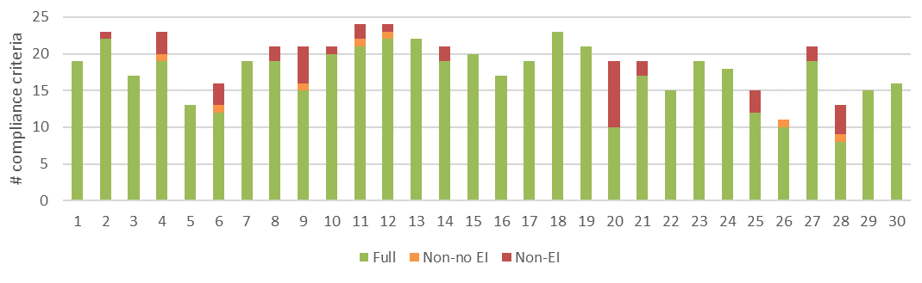
a) Level of conformance with audit criteria. Conformance definitions (Full, Non-no EI, Non-EI) as per Table 3.2.
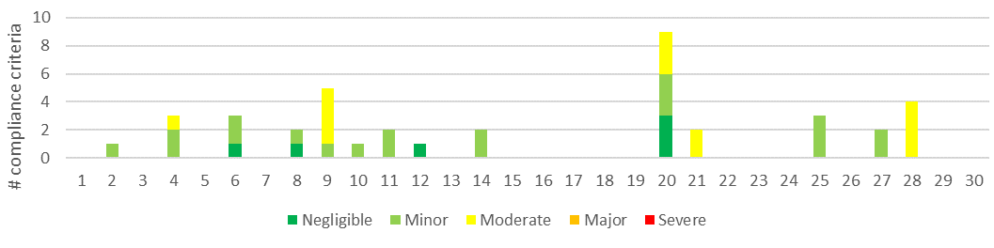
b) Number of compliance criteria with assessable environmental impact and the assessed level of impact for each instance of non-conformance.
Figure 4.2 Compliance findings and assessed environmental impact for instances of non-conformance for criteria applicable to the protection of forest soils. The x-axis refers to the coupe numbers, as per Table 3.1.

Compliance elements related to the protection of water flows, water quality and river health
Compliance elements relevant to this theme (Appendix A) seek to protect water flows, water quality and river health by:
- Classifying waterways present in the coupe, applying at least the minimum width of filters and/or buffers required and excluding harvesting activities and/or machinery from those areas
- Application of seasonal closures to reduce the risk of sediment mobilisation during wet weather in water supply catchments
- Appropriate design, construction and maintenance of in-coupe roads, road drainage and waterway crossings
- Applying appropriate methods to remove and rehabilitate waterway crossings following the completion of timber harvesting and regeneration activities.
Many of the compliance requirements (and criteria) are also applicable to the protection of forest soils and to the management of impacts from construction of in-coupe roads and snig or boundary tracks. A total of 63 audit criteria were relevant to this theme, nine of which were not applicable to any of the audit coupes.
The average level of full conformance with applicable criteria was found to be 91%, with the level of conformance ranging between 52% (20 Repeat) and 100% (17 coupes). The assessed potential environmental impact associated with non-conformances ranged between negligible and moderate (Figure 4.3). Non-conformances which were assessed to have moderate potential environmental impact were identified at five coupes (04 Shackle, 09 Charcuterie, 14 Bull Dust, 20 Repeat, 28 Wheel).
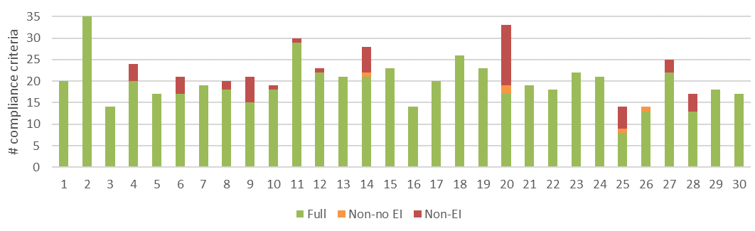
a) Level of conformance with audit criteria. Conformance definitions (Full, Non-no EI, Non-EI) as per Table 3.2.
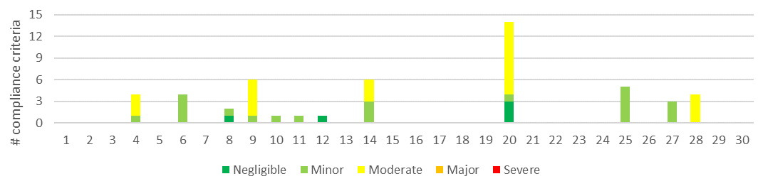
b) Number of compliance criteria with assessable environmental impact and the assessed level of impact for each instance of non-conformance.
Figure 4.3 Compliance findings and assessed environmental impact for instances of non-conformance for criteria applicable to the protection of water quality, flows and river health. The x-axis refers to the coupe numbers, as per Table 3.1.
The types of incidents resulting in assessed moderate potential environmental impact included:
- Inadequate management of road drainage (and other) sediments from 04 Shackle (Figure 4.4). Sediments generated on the coupe were mobilised onto an adjacent road (Snobs Creek Rd; part of DELWP forest road network) and towards a nearby permanent stream. Coir logs and a sump had been installed to capture sediment in the table drain on the upslope side of Snobs Creek Rd, but were bypassed during an extended wet period, with several very wet days.
Controls to prevent sediment movement towards Snobs Creek were well-planned, but only partly effective under the conditions experienced. Environmental impacts on the waterway are likely to have been transient and masked by flows along the creek and sediment delivery by other stretches of the DELWP road network.
- Construction of a boundary track in what should have been drainage line filter strip in 14 Bull Dust.
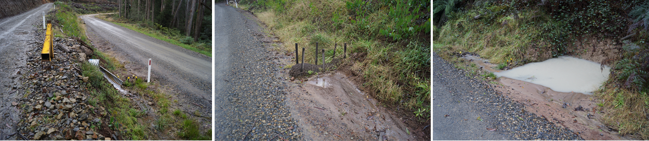
Run-off from 04 Shackle in-coupe road is delivered by culverts and constructed drains along Snobs Creek Rd. | Sediment traps were installed in the table drain along Snobs Creek Road but were bypassed by water and sediment. | A sump on Snobs Creek Rd is intended to catch sediment before a culvert diverts road drainage towards Snobs Creek. The sump achieved its purpose, but has been filled with sediment bypassed (at the time of the audit).
Figure 4.4 Management of water and sediment generated on 04 Shackle and delivered onto Snobs Creek Road.
- Excessive lengths of in-coupe road (09 Charcuterie) or snig track (28 Wheel) where drainage spacing exceeds MSP or UP requirements based on slope and the recorded soil erosion hazard (as discussed in Section 4.2.1).
- Inappropriate rehabilitation of an in-coupe road waterway crossing (20 Repeat), that allowed large quantities of road sediment to be deposited into a temporary stream (Figure 4.6). Drainage structures that were supposed to have diverted road drainage into vegetation to prevent sediment reaching the waterway were not properly constructed and ineffective. Some of the drainage structures were larger than required, which contributed additional sediment to the waterway.
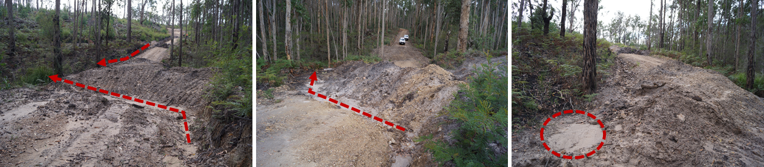
Road drainage runs 87 m along right hand side of road to drainage structure and then to temporary stream. Drainage on far side of waterway runs 25 m directly into waterway. | Drainage structure intercepts road run-off about 25 m before waterway and diverts through vegetation. Sediment filtered before reaching waterway. | Road sediment deposited in temporary stream from poorly designed drainage structures.
Figure 4.5 Former in-coupe road waterway crossing over temporary stream on entry to 20 Repeat. Culvert from crossing was removed prior to audit. Large quantities of sediment from the road have been deposited into the waterway due to poorly executed post-closure drainage.

Conservation of biodiversity
Compliance elements relevant to this theme (Appendix A) seek to protect biodiversity values by:
- Retaining trees and understorey elements within the gross coupe and/or harvested area, including old growth elements and trees with or with potential to form hollows
- Preventing harvesting activities, roading and regeneration burning from taking place within and/or adjacent to sensitive vegetation communities (e.g., heathlands, montane riparian thickets, rainforest stands) and other retained vegetation within the coupe
- Identifying listed, threatened species of native flora and fauna which have been recorded within or adjacent to the coupe and applying the management measures prescribed by the MSPs and PS
- Not harvesting in (or otherwise disturbing) Special Protection Zones (SPZ) established to protect important native fauna habitats (e.g. for Leadbeater’s Possum, Long-footed Potoroo, Owls)
- Maintaining passage for fish or other aquatic fauna along permanent streams
- Protecting water quality from sediment movement to waterways from in-coupe roads, snig tracks and other coupe infrastructure
- Managing the risk of entry or spread of weeds and soil-borne or other plant diseases.
A total of 64 audit criteria are relevant to the protection of biodiversity values, of which 14 were not applicable to any of the selected coupes. The average level of full conformance with applicable criteria was found to be 95%, with the level of full conformance ranging between 75% (08 McAdams Sliver) and 100% (18 coupes; Figure 4.6).
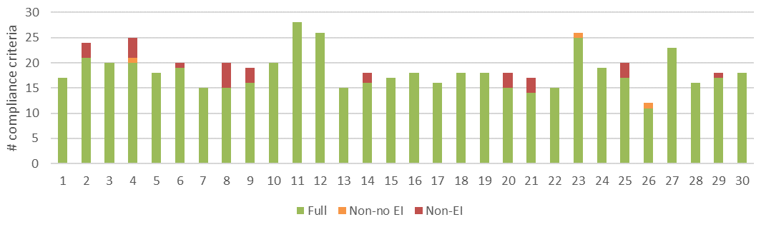
a) Level of conformance with audit criteria. Conformance definitions (Full, Non-no EI, Non-EI) as per Table 3.2.
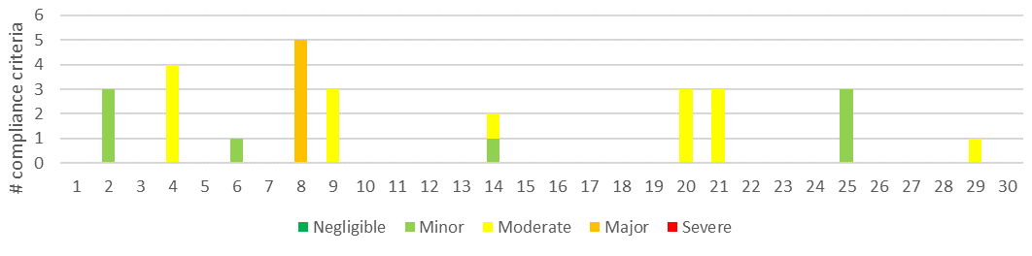
b) Number of compliance criteria with assessable environmental impact and the assessed level of impact for each instance of non-conformance.
Figure 4.6 Compliance findings and assessed environmental impact for instances of non-conformance for criteria applicable to the protection of biodiversity values. The x-axis refers to the coupe numbers, as per Table 3.1.
Biodiversity-related non-conformances with environmental impact were observed in ten of the 30 coupes. The assessed environmental impact ranged between negligible and major (Figure 4.6). A non-conformance incident in one coupe was assessed to have major potential environmental impact. Incidents in six coupes were assessed to have moderate potential environmental impact, as described below.
Major potential environmental impact:
- Two sections of boundary track in 08 McAdams Sliver crossed into a Leadbeater’s Possum SPZ. Disturbances associated with track extended up to 15 m into the SPZ and affected over 1000 m² (<1% of the feature; Figure 4.7). The severity of assessed potential environmental impact was more a reflection of the sensitivity of the area that was disturbed than the actual environmental impact on the values for which the SPZ was established.
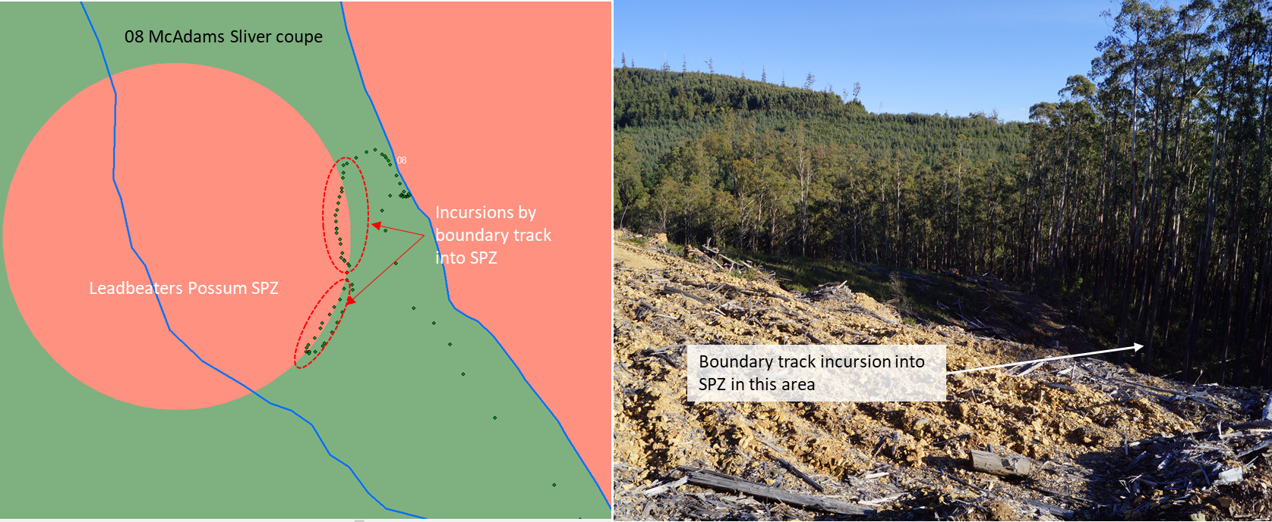
a) Map of coupe, with GPS track log showing incursion of boundary track into SPZ. | b) Photo of Leadbeater’s Possum SPZ into which the boundary track diverted.
Figure 4.7: 08 McAdams Sliver, showing where the boundary track diverted into a Leadbeater’s Possum SPZ.
Moderate potential environmental impact:
- A large incursion by the regeneration burn at 21 Galicia affected a planned exclusion area for large trees (and leading towards, but not actually affecting a rainforest buffer) along the southern edge of the coupe. The incursion was up to 40 m deep and extended along an approximately 200 m front; Figure 4.8). Understorey vegetation was largely consumed by the regeneration burn incursion, the canopies of many trees along the edge of the coupe were scorched and fire partly burnt out the bases of some of the trees that were intended to be to be protected by the buffer.
- Small incursions from regeneration burns into planned exclusion areas (04 Shackle, 09 Charcuterie, 21 Galicia). These typically only affected the understorey and are unlikely to have persistent effects on biodiversity values. The burning of rough heaps in 29 Devo also affected understorey habitat in nearby retained vegetation. Environmental impacts associated with these incidents were less severe than the larger incursion at 21 Galicia, but were still rated moderate.
- Inadequate management of road drainage (and other) sediments from 04 Shackle (Figure 4.4). As described in Section 4.2.2, water and sediments generated on the coupe were mobilised onto an adjacent forest road and towards a permanent stream, thus posing a threat to aquatic biodiversity values.
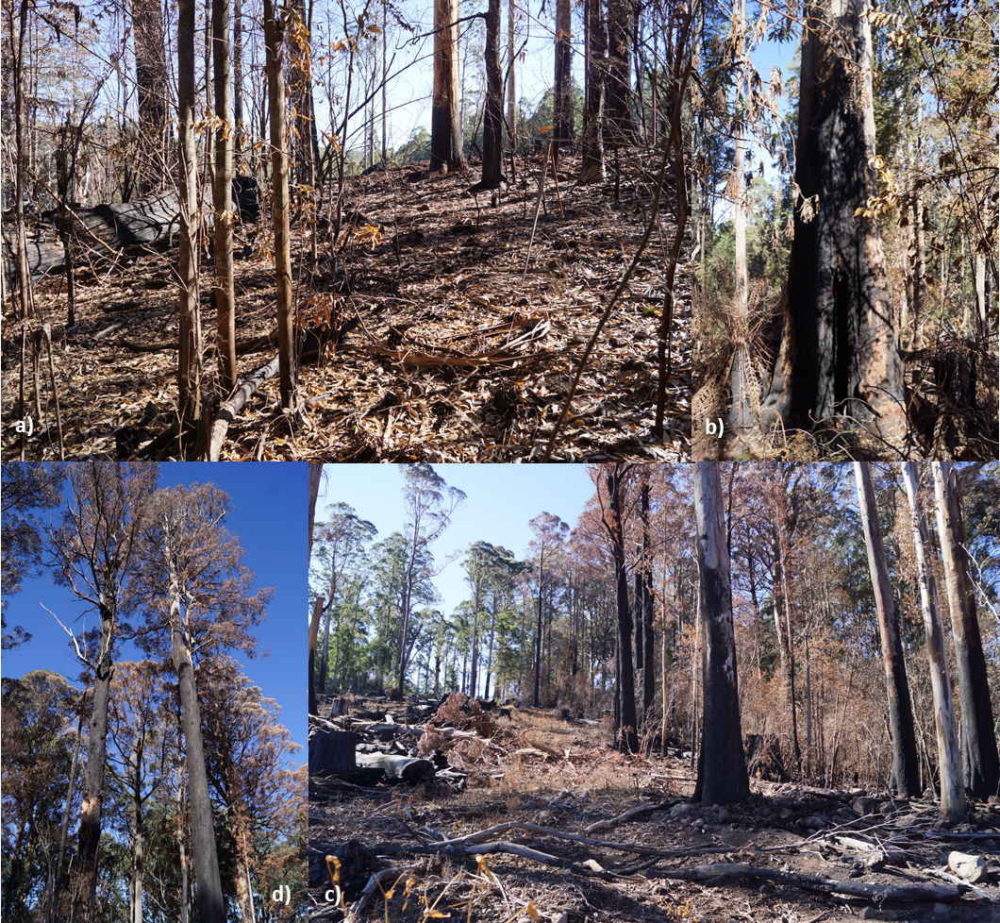
Figure 4.8: Incursion of regeneration burn in 20 Galicia into buffer created to protect retained very large trees and cool temperate rainforest stand. Fire damaged understorey vegetation (a, c), scorched the canopy of edge trees (c, d) and partly burnt out the base of some of the large trees that were to be protected by the buffer (b).
- Construction of a boundary track in what should have been drainage line filter strip in 14 Bull Dust (as noted in Section 4.2.2).
- Inappropriate rehabilitation of an in-coupe road waterway crossing (20 Repeat), that allowed large quantities of road sediment to be deposited into a temporary stream (Figure 4.6, Figure 4.9; Section 4.2.2). The sediment deposited into the temporary stream will continue to impair downstream water quality for aquatic fauna and flora for some time.
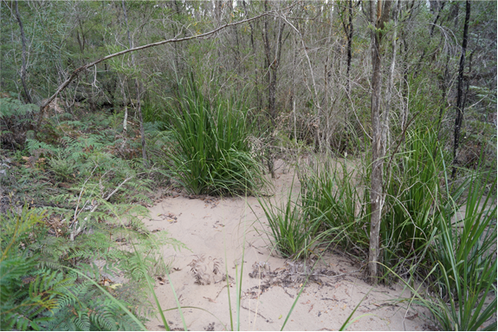 | Figure 4.9: Sediment deposited in temporary stream downstream of poorly rehabilitated in-coupe road waterway crossing at 20 Repeat. Sediment currently extends ~30 m beyond the point of entry into the waterway and poses a risk to water quality and aquatic biodiversity values.

Operational planning and record-keeping
Compliance elements considered under this theme are concerned with the development of the FCP in conformance with the Code and MSPs and the consistency of coupe operations with that plan. The compliance elements seek to protect soil, water and biodiversity values from risks associated with poorly planned and executed harvesting, roading and regeneration operations. Seventy-five audit criteria were identified (Appendix A), with nine of these found not to apply to any of the audited coupes.
The average level of full conformance with applicable criteria was found to be 97%, with the level of full conformance ranging between 87% (28 Wheel) and 100% (15 coupes; Figure 4.10). One non-conformance incident with major potential environmental impact was observed. Incidents with moderate potential environmental impact were observed at a further three coupes (Figure 4.10). The types of incidents resulting in assessed potential environmental impact of moderate or major included:
Major potential environmental impact:
- A short section of boundary track in 08 McAdams Sliver was constructed within a Leadbeater’s Possum SPZ (Figure 4.7, as per Section 4.3).
Moderate potential environmental impact:
- Excessive spacing between drainage structures on the in-coupe road in 09 Charcuterie and failure to limit road slope to below 8° where soil erosion hazard was recorded as high (see Section 4.2.1).
- Construction of a boundary track in a drainage line filter strip in 14 Bull Dust (as noted in Section 4.2.2).
- Excessive spacing between temporary drainage structures on the main snig track in 28 Wheel. Drainage structure spacing was based on low soil erosion hazard, rather than high, as recorded in the FCP.
The incidents relate to timber harvesting operations not having been conducted in accordance with the FCP (Code 2.5.1.2) and/or Code and MSP requirements. As has been identified in previous audits, several instances were identified where coupe planning was inconsistent with specific Code or MSP requirements but did not directly result in an incident with potential environmental impact.
The main issues identified in the current audit were:
- Soil erosion hazard and/or soil permeability assessment not appropriately representing the soils wthin the coupe. For two of the coupes in which this was identified, the soil erosion hazard recorded in the FCP appeared to overstate the erosion potential of soils within the coupe.
- Not identifying all threatened/protected biodiversity values associated with the coupe. In some instances this may have included not updating the FCP to account for species records that post-dated the original coupe planning process.
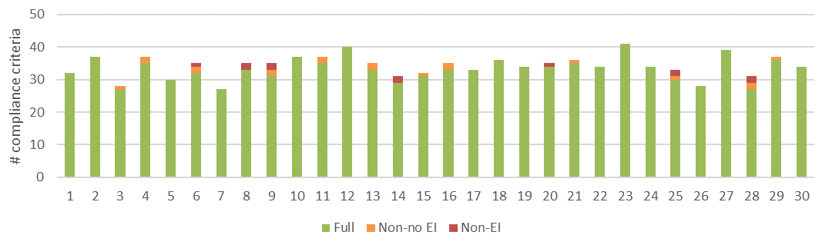
a) Level of conformance with audit criteria. Conformance definitions (Full, Non-no EI, Non-EI) as per Table 3.2.
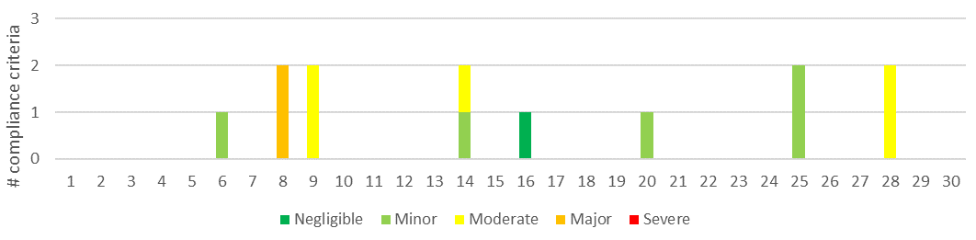
b) Number of compliance criteria with assessable environmental impact and the assessed level of impact for each instance of non-conformance.
Figure 4.10 Compliance findings and assessed environmental impact for instances of non-conformance for criteria applicable to coupe planning and management. The x-axis refers to the coupe numbers, as per Table 3.1.

Coupe infrastructure for harvesting operations
The coupe infrastructure theme includes four main groups of compliance element and audit criteria. The first three relate to in-coupe roading (design, construction, maintenance and closure) and the fourth relates to other forms of coupe infrastructure, including landings and snig and boundary tracks.
Eight of the audit coupes had no in-coupe roads or only very short lengths of in-coupe road («50 m) and were not assessed against the three in-coupe roading sub-themes.

Compliance elements related to in-coupe road and waterway crossing design
The 15 compliance elements relevant to this theme (Appendix A) seek to ensure that appropriate design protects soil and water values from risks associated with the construction of fill batters for roads, waterway crossings and road drainage structures. Design is intended to ensure the stability of roads and road embankments, safe passage of high flow events through crossings and culverts and to prevent erosion of roads and crossings and associated sediment generation. Four of the criteria were not applicable to any of the audited coupes. This sub-theme was not applicable to the eight coupes that had no in-coupe road or only a minimal length («50 m).
The average level of full conformance with applicable criteria was found to be 89%, with the level of full conformance ranging between 56% (20 Repeat) and 100% (16 coupes; Figure 4.11). Non-conformance incidents assessed to have moderate potential environmental impact were observed at two coupes (09 Charcuterie, 20 Repeat; Figure 4.11).
Incidents with moderate potential environmental impact on 09 Charcuterie and 20 Repeat have been described previously (Section 4.2.2) and relate to excessive spacing between drainage structures (given slope and recorded soil erosion hazard) and a poorly rehabilitated waterway crossing, respectively.
Key non-conformances (generally without direct potential environmental impact) were having no evidence of formal designs for waterway crossings (14 Bull Dust and 20 Repeat) and there being no evidence of large in-coupe road or landing fill batters having been constructed on the basis of direct engineering advice (11 Even Steven, 12 Road 20, 19 Angora Middle South).

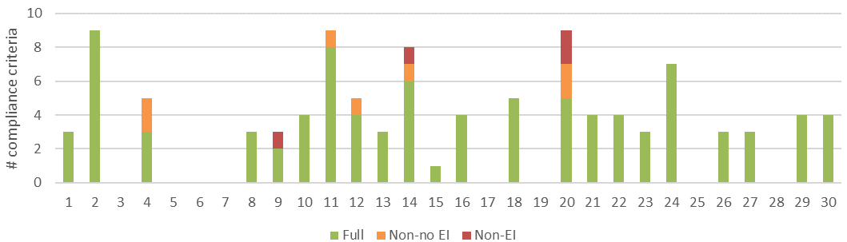
a) Level of conformance with audit criteria. Conformance definitions (Full, Non-no EI, Non-EI) as per Table 3.2.
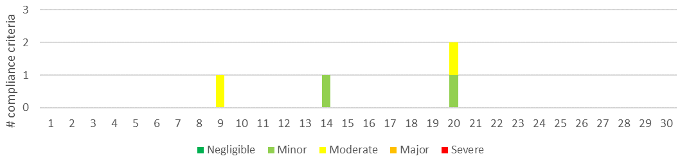
b) Number of compliance criteria with assessable environmental impact and the assessed level of impact for each instance of non-conformance.
Figure 4.11 Compliance findings and assessed environmental impact for instances of non-conformance for criteria applicable to the road design. The x-axis refers to the coupe numbers, as per Table 3.1.

Compliance elements related to in-coupe road and waterway crossing construction
The 43 compliance elements relevant to this theme (Appendix A), like those for road design, largely seek to protect soil and water values from impacts associated with road drainage and the construction of road embankments and waterway crossings. Ten of these compliance elements were found to not be applicable to any of the audit coupes. This sub-theme was not applicable to the eight coupes that had no in-coupe road or only a minimal length («50 m).
The average level of full conformance with applicable criteria was found to be 86%, with the level of conformance ranging between 52% (20 Repeat) and 100% (15 Wattle Hill, 22 Monster, 24 On Sight; Figure 4.12). Non-conformances with potential environmental impact were identified in eight of the audited coupes, with incidents ranging in severity of potential environmental impact from negligible to moderate.
The non-conformance incidents giving rise to moderate potential environmental impact (04 Shackle, 09 Charcuterie, 20 Repeat) have all been described previously (Section 4.2.2; see Figure 4.4, Figure 4.5).
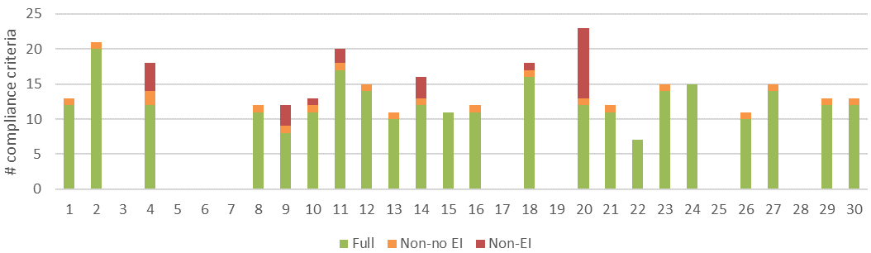
a) Level of conformance with audit criteria. Conformance definitions (Full, Non-no EI, Non-EI) as per Table 3.2.
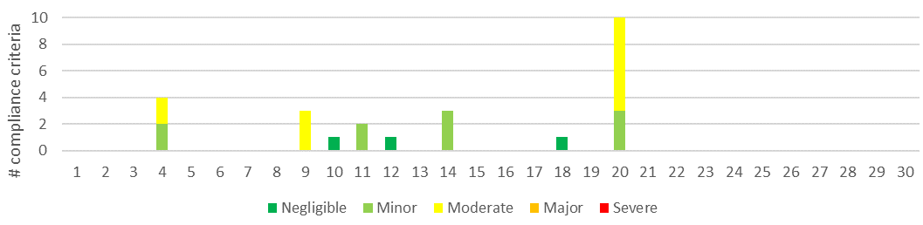
b) Number of compliance criteria with assessable environmental impact and the assessed level of impact for each instance of non-conformance.
Figure 4.12 Compliance findings and assessed environmental impact for instances of non-conformance for criteria applicable to road construction. The x-axis refers to the coupe numbers, as per Table 3.1.

Compliance elements related to in-coupe road and waterway crossing maintenance and closure
Only ten compliance criteria relevant to road maintenance or closure were considered in this audit (Appendix A), all of which were applicable to at least one coupe. Like compliance elements for road design and construction, they are largely concerned with protecting soil and water values from risks associated with the use of in-coupe roads, their closure following the completion of harvesting operations and the removal of any waterway crossings.
The average level of full conformance with applicable criteria was found to be 88%, with the level of conformance ranging between 38% (20 Repeat) and 100% (17 coupes; Figure 4.13). Non-conformance incidents with potential environmental impact were recorded at four coupes, with potential environmental impact ranging up to moderate.
The non-conformance incidents giving rise to moderate potential environmental impact (04 Shackle, 20 Repeat) have all been described previously (Section 4.2.2; see Figure 4.4, Figure 4.5). The in-coupe road waterway crossing at 14 Bull Dust was also not rehabilitated appropriately (Figure 4.14), with no drainage structure constructed on one approach to the waterway and apparently no attempt to rehabilitate the site following removal of the culvert. As the waterway was a drainage line, rather than a temporary stream the potential environmental impact was assessed to be lower than was the case for 20 Repeat.
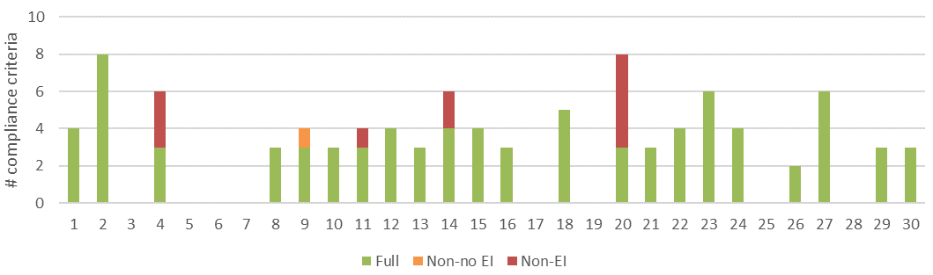
a) Level of conformance with audit criteria. Conformance definitions (Full, Non-no EI, Non-EI) as per Table 3.2.
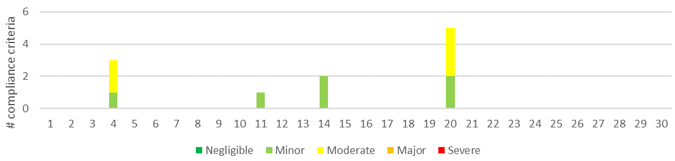
b) Number of compliance criteria with assessable environmental impact and the assessed level of impact for each instance of non-conformance.
Figure 4.13 Compliance findings and assessed environmental impact for instances of non-conformance for criteria applicable to road maintenance and closure. The x-axis refers to the coupe numbers, as per Table 3.1.
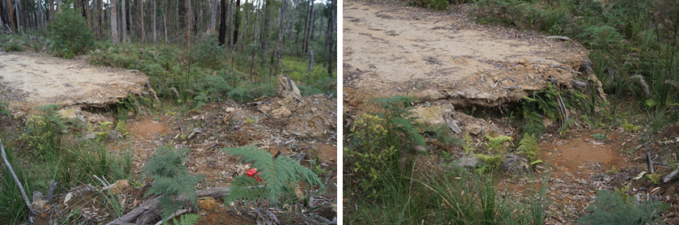
Figure 4.14: Location where an in-coupe road waterway crossing over a drainage line has been removed on completion of harvesting and regeneration. Soil has been pulled out of the drainage line towards the right of the photographs, but no attempt had been made to intercept road drainage before it enters the waterway from the segment of road on the left, or to rehabilitate that segment of the road.

Compliance elements related to non-road infrastructure compliance theme
Compliance elements considered under the non-road infrastructure sub-theme have a similar function to those for in-coupe roading, in that they seek to protect soil and water values from risks associated with the construction, use and rehabilitation of snig tracks, boundary tracks and landings. Forty-three audit criteria were identified, with all of these applying to at least one of the audited coupes.
The average level of full conformance with applicable criteria was found to be 95%, with the level of full conformance ranging between 75% (06 Yogi) and 100% (15 coupes; Figure 4.15). Non-conformance incidents with potential environmental impact were observed in 13 coupes, with the assessed level of potential environmental impact ranging to moderate. Issues associated with non-conformances with moderate potential environmental impact related to:
- Construction of a boundary track in a drainage line filter at 14 Bull Dust (as per Section 4.2.2).
- Excessive spacing (relative to slope and recorded soil erosion hazard) between temporary drainage structures on the main snig track in 28 Wheel (as per Section 4.4).
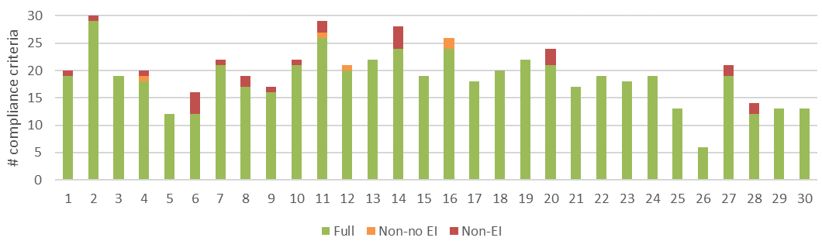
a) Level of conformance with audit criteria. Conformance definitions (Full, Non-no EI, Non-EI) as per Table 3.2.
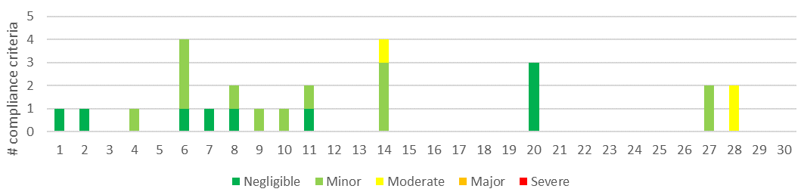
b) Number of compliance criteria with assessable environmental impact and the assessed level of impact for each instance of non-conformance.
Figure 4.15 Compliance findings and assessed environmental impact for instances of non-conformance for criteria applicable to coupe infrastructure. The x-axis refers to the coupe numbers, as per Table 3.1.

Discussion

Overall audit findings
FAP audits are conducted to assess VicForests’ conformance with selected elements of the regulatory framework for timber harvesting activities in State forests, as well as any environmental risks posed by non-conformances. This section provides a summary of the audit’s overall findings in relation to these objectives.
The audit considered 30 coupes located in State forests distributed throughout eastern Victoria. Since coupe selection was weighted towards those with higher risk features (e.g., rainforest vegetation, waterway crossings, in-coupe roads, steeper slopes, more erodible soils), the findings of the audit are not necessarily statistically representative of VicForests’ operations overall.
The audit found that full conformance was achieved with 94% of applicable audit criteria overall (Figure 5.1). The level of full conformance varied between compliance themes, ranging between 86% (road construction) and 97% (planning and record keeping). Non-conformances with direct or potential environmental impact were associated with 39 unique incidents in 19 of the 30 coupes included in the audit.
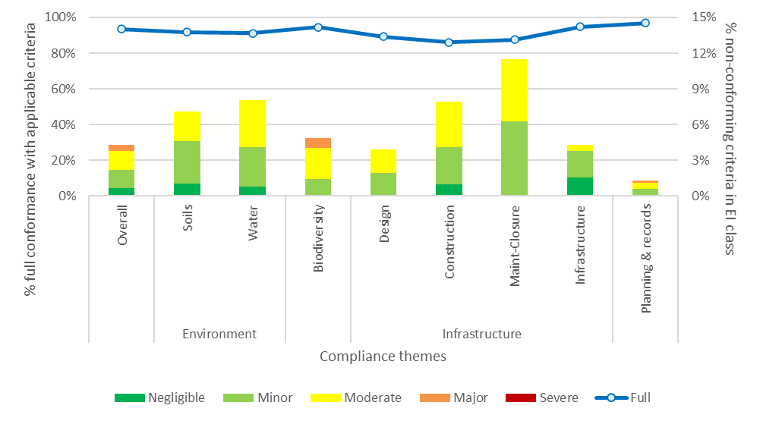
% full conformance with applicable audit criteria overall and in each harvest coupe audit theme (left Y axis). % non-conformances with environmental impact overall and for audit themes and sub-themes (right Y axis)
Figure 5.1 Summary of overall audit findings for conformance with the regulatory framework for timber harvesting and related activities in State forests in Victoria.
Instances of non-conformance with audit criteria were identified across all audit themes and each sub-theme. The assessed environmental impact associated with non-conformance incidents is summarised by audit theme and sub-theme in Figure 5.1. Non-conformances with potential environmental impact were most common (proportionally) in road maintenance-closure, road construction, water and soil sub-themes. Overall, non-conformances with potential environmental impact were recorded for approximately 4% of applicable criteria.
Assessed environmental impact for non-conformances ranged between negligible and major. Only a single non-conformance incident with major potential environmental impact was identified in the audit, at 08 McAdams Sliver. This incident was reported against biodiversity and operational planning themes (Figure 5.1).
Eleven types of incident were found to result in non-conformances with potential environmental impact (Table 5.1). As noted above, one of these was assessed to have up to major potential environmental impact rating and six incident types were assessed to have up to moderate potential environmental impact. Environmental impact ratings for these incidents reflect the sensitivity of the locations at which the incidents occurred, as well as, in some cases, the extent and severity of actual impact.
Table 5.1 Types of incident resulting in non-conformances with the regulatory framework that have potential or actual environmental impact, including comparison with 2018-19 and 2019-20 FAP audits (Jacobs, 2020a,b)
Type of incident | # incidents |  |  | Maximum EI rating (2020-21) | Code (C), MSP (M) or PS (P) reference
Type of incident | 2018-19 | 2019-20 | 2020-21 | Maximum EI rating (2020-21) | Code (C), MSP (M) or PS (P) reference
- Spacing of effective drains along snig tracks or boundary tracks exceeded permitted value (from UP) based on recorded soil erosion hazard and slope.¹  Potential consequences: soil erosion, sediment deposition into waterways, impairment of aquatic habitat, reduced water quality. | 14 | 8 | 9 | Moderate | C2.5.2.5
- Regeneration burn (including burn of rough heap windrows) entering and/or affecting exclusion areas within or adjacent to coupe and/or vegetation in exclusion areas damaged by regeneration or rough heap burn that remains within the planned burn boundary.  Potential consequences: soil erosion, sediment deposition into waterways, impairment of aquatic and terrestrial habitat, reduced water quality, loss of fire-sensitive biodiversity values. | 5 | 2 | 6 | Moderate | C2.2.1.2, 2.2.2.4/5, 2.5.1.2, M4.1.4.5, 7.1.2.3
- Piles of slash, bark or other debris formed at landing in preparation for regeneration burning exceed prescriptions.  Potential consequences: damage to soil structure and chemistry due to heat of fire, poor regeneration and seedling recruitment. | 0 | 0 | 5 | Negligible | M7.2.4.2
- In-coupe road drainage structure spacing exceeded permitted value based on recorded soil erosion hazard and slope. Slope of in-coupe road exceeds permitted range for soil erosion hazard.¹  Potential consequences: soil erosion, sediment deposition into waterways, impairment of aquatic habitat, reduced water quality. | 10 | 5 | 4 | Moderate | C2.4.2.5, M6.2.4.1
- Waterway crossing design, construction and/or rehabilitation does not conform with the regulatory framework (including culvert installation, management of road drainage in the vicinity of the crossing, rehabilitation of crossing).  Potential consequences: soil erosion, sediment deposition into waterways, impairment of aquatic habitat, reduced water quality. | 8 | 3 | 4 | Moderate | C2.2.1.2/6/7/8/12, 2.4.2.9, 2.4.6.2, M6.2.5.5, 6.2.4.1/2/4/5.6
- In-coupe road or landing cut or fill batter subject to mass movement and/or other form of erosion (as per Figure 5.2).² No evidence of engineer being engaged in design of high (>2 m) road, landing or snig track embankment or fill batter.  Potential consequences: soil mass movement and erosion, water quality and aquatic biodiversity impairment, damage to regenerating forest. | 9 | 4 | 4 | Minor | C2.2.1.2/14/15, 2.4.3.3, M6.2.2.3
- Machinery entry into SPZ or other exclusion areas within or adjacent to coupe, including for unauthorised construction of boundary or regeneration burning tracks.  Potential consequences: soil compaction/disturbance, reduction in habitat values. | 3 | 0 | 2 | Major | C2.2.1.2/5, 2.5.1.2, M3.5.1.1, 4.2.1.1, 7.1.2.1, P4.3.1.1
- Entry of harvesting machinery into and/or deposit of harvesting debris in riparian filter strip.  Potential consequences: soil erosion, sediment deposition into waterways, impairment of aquatic habitat, reduced water quality. | 1 | 1 | 2 | Moderate | C2.2.1.2/12, 2.5.1.2
- Controls for management of runoff and sediment from coupe to forest road drainage system and external waterways insufficient to prevent sediment movement.  Potential consequences: soil erosion, sediment deposition into waterways, impairment of aquatic habitat, reduced water quality. | 0 | 0 | 1 | Moderate | C2.2.1.2/3/14, 2.5.1.1
- Size of in-coupe road drainage structures excessive and construction unnecessarily disturbs soil.  Potential consequences: soil erosion, sediment deposition into waterways, impairment of aquatic habitat. | 0 | 0 | 1 | Minor | C2.2.1.14, 2.4.3.1, M6.2.1.6
- Excessive movement of sediment from a rehabilitated coupe.  Potential consequences: soil erosion, sediment deposition into waterways, impairment of aquatic habitat. | 0 | 0 | 1 | Negligible | M7.2.2.1
- Rehabilitation of infrastructure (landing, snig track, in-coupe road) has contributed to soil mass movement and/or erosion.  Potential consequences: soil erosion, sediment deposition into waterways, impairment of aquatic habitat, reduced water quality, loss of production from regenerating forest. | 5 | 1 | 0 | Minor | C2.2.1.2/12/14, 2.5.1.2, M6.4.1.2, 7.2.2.2
- Tree felled into SPZ.  Potential consequences: minor damage to retained understorey vegetation. | 0 | 2 | 0 | Moderate | C2.2.2.5, 2.1.5.2, M7.1.2.1
- Excessive soil disturbance associated with a snig/ regeneration burning track located in an area at which surface and sub-surface water flows converge.  Potential consequences: soil erosion, water quality impairment, impairment of regeneration. | 0 | 1 | 0 | Minor | C2.2.1.2
- Landing not fully rehabilitated  Potential consequences: reduced productive capacity of regenerating forest. | 5 | 0 | 0 | Minor | M7.2.2.2
- Snig track crosses into drainage line filter, without apparent sanction and/or when reasonably practicable alternatives existed  Potential consequences: soil erosion, sediment deposition into waterways, impairment of aquatic habitat, reduced water quality. | 3 | 0 | 0 | Moderate | C2.2.1.2, 2.2.1.5, 2.5.1.2, M3.3.1.1, 3.5.1.1/3, 7.1.4.1
- Damage to adjacent coupe due to regeneration burn crossing a coupe boundary  Potential consequences: soil erosion, loss of productive capacity of regenerating forest. | 1 | 0 | 0 | Moderate | C2.2.2.5, 2.5.1.2
- Harvesting of (a single) tree outside coupe boundary  Minimal potential consequence. | 1 | 0 | 0 | Moderate | C2.5.1.2
- Inadequate maintenance of road drainage structure (silt trap) leading to impairment of effectiveness  Potential consequences: soil erosion, sediment deposition into waterways, impairment of aquatic habitat, reduced water quality. | 1 | 0 | 0 | Minor | C3.3.2.1/2
- Part of the base of a tree retained in a coupe covered by in-coupe road or landing embankment materials  Potential consequences: (minimal) reduction in productive capacity of regenerating forest. | 1 | 0 | 0 | Minor | M6.2.2.1
Note:
- Several incidents of drainage spacings along snig or boundary tracks and in-coupe roads exceeding permitted values given slope and recorded soil erosion hazard were found at coupes in which the recorded soil erosion hazard was incorrect and overstated the actual hazard. While drain spacing may have been appropriate to the actual erosion hazard rating, the management action did not appropriately respond to the level of risk suggested by coupe planning documentation and hence was considered to a non-conformance with potential environmental impact.
- The Code and MSP are clear that embankments and fill batters are to be constructed in ways that minimise soil erosion and mass movement. Construction is to be informed by “engineer approved methods” (as per MSP 6.2.2.3). From a practicability perspective, the audit team only consider this for large embankments and fill batters (>2 m height). If there is no reference to engineering advice in the FCP and there is evidence of erosion or soil mass movement the incident is recorded as non-conforming with potential environmental impact.
Table 5.1 also compares the types of incident detected in this audit, with the types and frequency of incidents detected in the two previous FAP audits (Jacobs, 2020a; 2020b). Five of the six most common types of incident with potential environmental impact have been observed relatively frequently in previous audits: excessive drainage structure spacing on snig or boundary tracks and in-coupe roads; inappropriately designed, constructed and/or rehabilitated waterway crossings; incursion of regeneration burns into buffers or other areas that were intended to not be affected by harvesting or regeneration activities; and mass movement of in-coupe road, landing or snig track fill and cut batters. The two previous FAP audits did not identify non-conformances associated with excessively large piles of bark or slash at landings (identified at five coupes in this audit).
Nine types of non-conformance incident with potential environmental impact that were observed in at least one of the previous two audits were not observed in this audit.
Almost all incidents identified in Table 5.1 pose a risk to soil and water values. Several threatened biodiversity values and some (e.g. excessively large slash or bark piles or in-coupe road or snig/boundary track drainage structures, in-coupe road or landing embankments experiencing mass soil movement) have capacity to affect the productive capacity of parts of the regenerating forest.
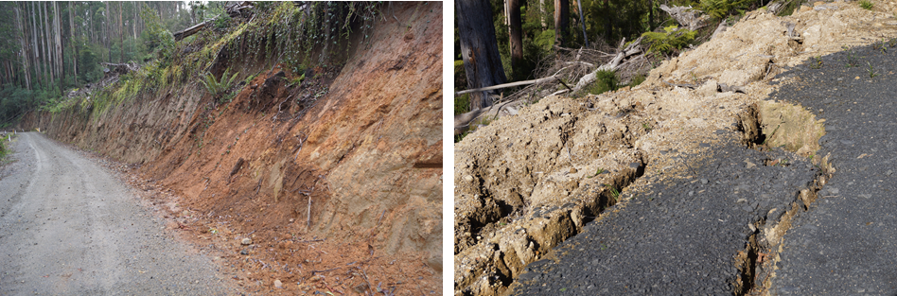
a) 04 Shackle: erosion and mass movement of soil from an in-coupe road cut batter. Slumping of the cut batter provides a source of sediment that may affect water quality in the nearby waterway. | b) 20 Repeat: mass movement of soil on the edge of an in-coupe road and landing fill batter/embankment. While mass movement has mobilised large quantities of soil, the area is well removed from waterways and poses minimal threat to water quality.
Figure 5.2: Soil erosion and mass movement on in-coupe and landing fill cuts and fill batters/embankments.

Comparison with previous audits
As has been noted previously, coupe selection for the audit is risk-based, rather than randomised. This means that audit results are not statistically representative of VicForests’ operations overall and audit results may not be directly comparable between years. Further, the 2019-20 audit included 15 coupes from Western Victoria RFA region, which has a different compliance profile to RFA regions in eastern Victoria (Jacobs, 2020b; as represented by coupes in the Central Highlands RFA region).
However, since there has been a broadly consistent approach to coupe selection and compliance criteria for all audit sub-themes for audits going back to 2018-19 and for environmental, biodiversity and roading themes to 2017-18, there is some basis for comparison of audit results over time. The comparison in Table 5.2 only considers coupes located in Central Highlands RFA region, for which reasonably comparable data are available back to 2017-18. Table 5.3 provides a complementary analysis for all audit coupes in eastern Victoria, regardless of their distribution between eastern Victorian RFA regions.
The overall level of full conformance for Central Highland RFA region coupes in the 2020 -21 audit was 93%, compared with 83-94% in the three preceding FAP audits. Performance in the most recent audit was better for some themes/sub-themes than in the 2019-20 audit and worse for other themes/sub-themes. The comparison with the 2017-18 audit is similar. Audit performance in 2018-19 was worse in every theme or sub-theme than in other years, apart from non-road infrastructure.
The count of non-conformances with potential environmental impact overall was less in 2020-21 than in the two previous FAP audits. The number of incidents with major potential environmental impact was greater than in 2019-20 and 2017-18 FAP audits, but much less than in 2018-19.
The high incidence of non-conformances with high potential environmental impact in the 2018-19 audit was mainly associated with incursion of regeneration burns into areas that were not planned to be affected by timber harvesting and associated regeneration activities. This group of incidents was the second most common type observed in this audit (Table 5.1), however there were no incidents of this kind in the Central Highlands RFA region that were assessed in the current audit to have major potential environmental impact.
Table 5.2 Comparison of results for recent FAP audits for coupes in Central Highlands RFA region
 | % Full conformance with applicable audit criteria |  |  |  | # Non-conformances with potential environmental impact (at any level) | major potential environmental impact¹
# Central Highlands RFA region coupes |  |  |  |  | 12 | 14 | 15 | 12
FAP compliance theme and sub-theme | 2017-18² | 2018-19³ | 2019-20⁴ | 2020-21 | 2017-18² | 2018-19³ | 2019-20⁴ | 2020-21
Overall⁵ | 90% | 83% | 94% | 93% | 24 | 0⁵ | 71 | 24 | 54 | 1 | 41 | 6
Environment
- Soils | 90% | 76% | 93% | 91% | 12 | 0 | 32 | 2 | 24 | 0 | 18 | 0
- Water | 90% | 84% | 94% | 93% | 15 | 0 | 43 | 12 | 15 | 0 | 19 | 0
Biodiversity | 90% | 81% | 97% | 93% | 5 | 0 | 17 | 13 | 7 | 1 | 16 | 5
Infrastructure
- Road design | 74% | 58% | 81% | 87% | 2 | 0 | 7 | 1 | 7 | 0 | 1 | 0
- Road construction | 91% | 80% | 85% | 84% | 12 | 0 | 24 | 5 | 29 | 0 | 11 | 0
- Road maintenance & closure | 79% | 85% | 96% | 88% | 3 | 0 | 7 | 2 | 0 | 0 | 4 | 0
- Non-road⁶ | n/a | 88% | 89% | 93% | n/a | 12 | 0 | 18 | 0 | 14 | 0
Planning & record keeping⁶ | n/a | 90% | 94% | 97% | n/a | 11 | 6 | 19 | 1 | 5 | 2
Notes:
- Note that individual incidents may give rise to non-conformances against more than one audit criterion.
- Jacobs, 2019
- Jacobs, 2020a
- Jacobs, 2020b
- The overall assessment result for the 2017-18 audit is based on the environment, biodiversity and roading themes, whereas the overall assessments for all subsequent audits also include non-road infrastructure and planning and record keeping themes. Results for 2017-18 are therefore not directly comparable with those for subsequent audits.
- Non-road infrastructure and planning and record keeping themes were not within the scope of the 2017-18 audit.
When all audit coupes in eastern Victorian RFA regions are considered in the assessment (Table 5.3), overall audit performance in 2020-21 is again slightly poorer than in 2019-20, but significantly better than in 2018-19.
Unlike in the 2018-19 FAP audit, where higher potential severity incidents were commonly associated with incursion of regeneration burns into buffers and other areas that were not planned to be harvested, there was no common type of non-conformance incident with higher (major) potential environmental impact in the current audit. As in 2019-20, there was only one incident in the current audit with major potential environmental impact (08 McAdams Sliver). However, this incident was assessed as a non-conformance against six criteria (Table 5.2).

Table 5.3 Comparison of results for recent FAP audits for coupes in eastern Victorian RFA regions
 | % Full conformance with applicable audit criteria |  |  |  | # Non-conformances with EI (at any level) | major potential environmental impact¹
FAP compliance theme and sub-theme | 2017-18² | 2018-19³ | 2019-20⁴ | 2020-21 | 2017-18² | 2018-19³ | 2019-20⁴ | 2020-21
Overall⁵ | 91% | 84% | 94% | 94% | 44 | 4 | 156 | 31 | 54 | 1 | 81 | 6
Environment
- Soils | 87% | 74% | 93% | 92% | 25 | 2 | 76 | 2 | 24 | 0 | 40 | 0
- Water | 90% | 81% | 94% | 91% | 29 | 4 | 103 | 16 | 15 | 0 | 51 | 0
Biodiversity | 92% | 84% | 97% | 95% | 5 | 0 | 23 | 18 | 7 | 1 | 28 | 5
Infrastructure
- Road design | 81% | 67% | 81% | 89% | 5 | 0 | 12 | 1 | 7 | 0 | 4 | 0
- Road construction | 92% | 81% | 85% | 86% | 23 | 0 | 53 | 5 | 29 | 0 | 25 | 0
- Road maintenance & closure | 71% | 83% | 96% | 88% | 6 | 0 | 14 | 2 | 0 | 0 | 11 | 0
- Non-road⁶ | n/a | 84% | 89% | 95% | n/a | 42 | 0 | 18 | 0 | 25 | 0
Planning & record keeping⁶ | n/a | 92% | 94% | 97% | n/a | 19 | 10 | 19 | 1 | 13 | 2
Notes: as per Table 5.2

Fire salvage harvesting
This audit was the first for some years to include coupes harvested under fire salvage harvesting provisions of the MSPs (MSP Section 8). Fire salvage prescriptions prioritise harvesting of more severely burnt forests, enable harvesting (in Ash forests) to be conducted in larger coupes and provide additional protections to regenerating understorey and water quality.
Four fire salvage coupes were included in the audit, 18 Angora Middle South, 19 Ghostly, 23 Moatize and 27 Brave Duck. Several other coupes in Tambo and East Gippsland FMAs were affected by the 2019-20 bushfires after harvesting had been completed.
Harvesting in 18 Angora Middle South and 19 Ghostly (Tambo FMA, Figure 5.3) targeted fire-killed Mountain Ash, which occupied (in both cases) less than 25% of the gross coupe area. In these coupes, trees with less canopy scorch were retained and those without green canopy were harvested. Targeting only fire-killed Mountain Ash meant that the coupes more than adequately addressed habitat requirements (MSP 8.1.4). Harvesting activities in these coupes were not conducted near waterways and so no particular provision for additional filter or buffer widths were required (MSP 8.1.5). Applicable biosecurity measures were followed (MSP 8.1.6).
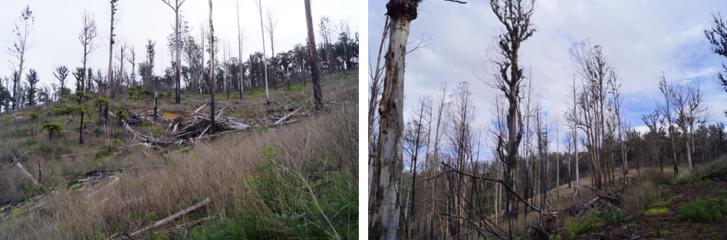
Figure 5.3: Fire salvage harvesting operations in 18 Angora Middle South (left) and 19 Ghostly (right). The photographs highlight the poor condition of retained Mountain Ash trees that were not killed outright by the 2019-20 bushfires.
Many of the retained Mountain Ash trees were in poor condition or dead at the time of audit in these two coupes and hence it is not clear that their retention by VicForests provided any particular long-term value to the coupe. Retaining trees with partial canopy scorch is not specifically required by the MSPs (in Section 8 on Fire salvage harvesting). MSP 8.1.2 requires that fire severity class is considered when prioritising harvesting of State forest areas, but does not explicitly require that canopy damage is considered when harvest planning is being undertaken in a specific coupe (as appears to have been the case in 18 Angora Middle South and 19 Ghostly).
It is not clear that VicForests’ practice of retaining Ash trees with partial green canopies provided much long-term value to these two coupes. However, the two coupes provide too small a sample to support a more general conclusion regarding the merits of retaining live fire-affected Ash trees.
Recommendation V-01 Moderate priority
That VicForests undertake an assessment of fire salvage coupes in which live, fire-affected Ash-type eucalypts were retained. The assessment should consider the extent to which such trees survive the effects of fire and offer habitat or other benefits to the coupe when retained and the appropriateness of prioritising more severely burnt area within coupes for salvage harvesting. Depending on the outcome of the assessment, the ways in which fire salvage harvesting is planned by VicForests in coupes with variable levels of fire damage may need to be revised.
The two East Gippsland FMA fire salvage coupes (23 Moatize and 27 Brave Duck) had been thinned in the year leading up to the 2019-20 bushfires. The salvage harvest removed almost all the remaining merchantable trees (mostly Eucalyptus sieberi). Scattered habitat patches were retained throughout the coupes, however the young stand age meant that these rarely contained mature trees with hollows or other habitat features.
Both coupes included waterways, and these were protected with buffers and/or filters whose width reflected fire salvage prescriptions (MSP 8.1.5) and were greater than those provide in the initial thinning operations. Logs were extracted using forwarders and lightly trafficked forwarding tracks rather than snig tracks. These were generally covered with logging slash (as in a thinning operation) to manage drainage. No cross-drainage structures were constructed on these tracks. One instance was observed on 27 Brave Duck, where the forwarding track ran for 200 m (at 6° slope) without either slash or cross drainage to manage runoff along the track. This is inconsistent with VicForests UPs and was assessed as a non-conformance with minor potential environmental impact.
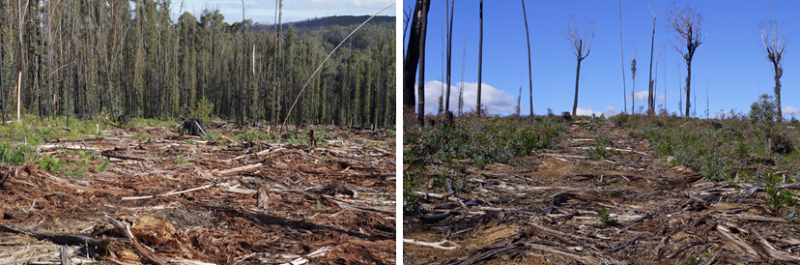
23 Moatize showing forwarding track and extended waterway buffer | 27 Brave Duck showing forward track with debris that contain runoff and any sediment movement.
Figure 5.4: Results of salvage harvesting at 23 Moatize (left) and 27 Brave Duck (right).

Potential improvements to coupe planning, harvesting and rehabilitation practices
Observations from the current audit and reflections on non-conformance incidents from previous audits suggests several potential areas for improvement in coupe planning, timber harvesting and coupe rehabilitation practices, as discussed in the following sections.

Coupe planning
Coupe planning and its documentation by VicForests typically conforms well with Code and MSP requirements. As has been found in previous FAP audits, most planning-related non-conformance issues with potential environmental impact result from the operations not following what was planned, rather than any specific planning shortcomings.
Previous audits (e.g. Jacobs, 2019; 2020a; 2020b) have commented on potential improvements in coupe planning practice, including the explicit mapping of waterway classification, inclusion of slope maps for coupes with slopes that approach or exceed the limit for harvesting and inclusion of geology maps for coupes in East Gippsland to confirm identification of granite-derived soils and any need to apply the mandated 25° slope limit.
Experience from the current audit was that practice in explicitly mapping waterway classification remains inconsistent across VicForests.
LIDAR-based slope maps for more steeply sloping coupes (with geology maps in East Gippsland coupes with granite geology; as per MSP 3.4.1.3) appeared with greater frequency than in previous audits, although are not yet universal. These maps are typically based on 1 m resolution digital elevation models (DEMs). It is not clear that this resolution is relevant to field conditions and appropriate for or practically useful in harvest planning.
Explicit planning for habitat retention is now commonplace. More recently planned coupes typically provide for the retention of undisturbed patches of overstorey and understorey vegetation throughout the coupe, as well as along waterways and/or in areas where slopes are too steep for harvesting (Figure 5.5). In some of the audited coupes (e.g. 21 Galicia, 30 Shazam), habitat patches were also planned around large or giant trees (>2.5/4.0 m diameter at breast height, respectively) to provide additional protection from harvesting and regeneration activities.
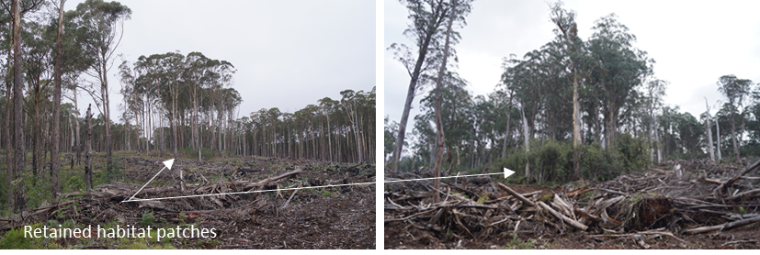
02 Onyx | 30 Shazam
Figure 5.5: Examples of planned habitat retention patches within coupes

Design, construction and maintenance of in-coupe roads and waterway crossings
FAP audits by this team have consistently identified deficiencies in the design, construction and maintenance of in-coupe roads and associated waterway crossings. The most commonly occurring types of incident have been (Table 5.1):
- Spacing of in-coupe road drainage structures exceeded the permitted value, based on MSP Table 21, given slope and recorded soil erosion hazard
- Mass movement of soil on in-coupe road fill and cut batters
- Waterway crossing construction and rehabilitation not conforming with applicable Code and MSP requirements.
The frequency of these three types of incident has declined from 27 in 2018-19 to 12 in this audit.
Waterway crossings, particularly, appear to be less common than they were several years ago. Avoiding construction of crossings and the subsequent need for rehabilitation eliminates a potential source of non-conformance and environmental impact and (based on standard risk hierarchies) is the preferred method of control for the risks associated with waterway crossings. Where crossings cannot be avoided and are constructed, conformance continues to be variable across VicForests’ operations. Poor practice in crossing rehabilitation was observed in two coupes in this audit (14 Bull Dust, Figure 4.14; 20 Repeat, Figure 4.5), with the latter incident contributing to the delivery of large quantities of sediment to a temporary stream (Figure 4.9).
Good practice in waterway crossing rehabilitation was observed in 02 Onyx (Figure 5.6). In contrast to what was observed at 20 Repeat (Figure 4.5), road drainage is appropriately managed, and the embankment material has been successfully stabilised. While some material has (inevitably) been washed away along the bed of the waterway, the former crossing is not a significant source of sediment.
Clearly the soils at 02 Onyx are less dispersive than those at 20 Repeat and hence the likelihood of something going awry in rehabilitation of the crossing was lower. However, the high sensitivity of soils at 20 Repeat should have resulted in greater attention being paid to crossing rehabilitation and to post-rehabilitation inspection and defect rectification than appears to have been the case.
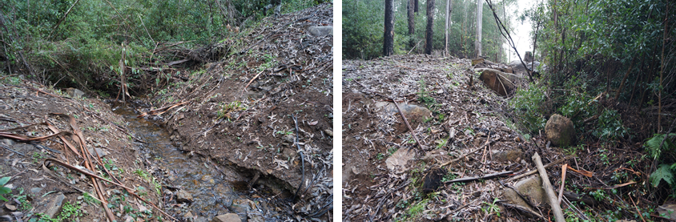
a) In-coupe road waterway crossing: fill materials pulled out of waterway and successfully stabilized. Drainage flow paths along edge of in-coupe road slowed by rocks, allowing any sediment being carried to settle.
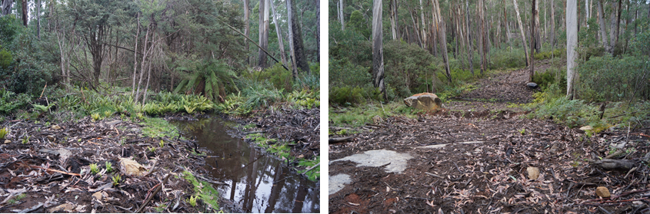
b) Snig track waterway crossing: fill materials pulled out of waterway and stabilized. Drainage structures intercept overland flows along snig tracks and divert them away from the waterway
Figure 5.6: Example of good practice in rehabilitation of in-coupe road and snig track waterway crossings, 02 Onyx.
We have previously recommended (2016-17 FAP; Jacobs, 2018) that VicForests and/or their contractors prepare specific rehabilitation plans for waterway crossings to ensure operations conform with Code and MSP mandatory requirements and that these plans are reviewed to assess the extent to which they have been implemented. This recommendation does not appear to have been taken up. In our view, explicit crossing rehabilitation planning and post-works checking for conformance against the plan and mandatory compliance elements should generally prevent the types of incident observed at 14 Bull Dust and 20 Repeat.
We reported in our 2018-19 audit report (Jacobs, 2020a) that VicForests had developed new procedures and instructions for the planning, design and construction of in-coupe roads (O’Reilly, 2019). Their intent was to improve the quality, consistency and regulatory conformance of roading practices. We found no direct reference to these procedures in our review of coupe plans and are hence unsure of the extent to which this document has directly influenced VicForests’ road and crossing design or construction practices.
While VicForests’ Road design, construction and maintenance instruction addresses waterway crossings, it provides no specific guidance on the rehabilitation of temporary crossings.

Recommendation V-02 High priority
That VicForests and/or its roading and harvesting contractors develop and implement waterway crossing rehabilitation plans for all temporary in-coupe road and snig track crossings to ensure conformance with the Code and MSPs and reduce, to the extent practicable, the mobilisation of sediment into waterways. Implementation of the plans should be confirmed by VicForests and any defects rectified before all harvesting/regeneration machinery is removed from the coupe.

Coupe infrastructure
Construction and rehabilitation of (non-road) coupe infrastructure (e.g., landings, snig tracks, boundary tracks) was reintroduced into the FAP’s scope in 2018-19. Four main types of non-conformance issue have subsequently been detected since that audit (Table 5.1):
- Spacing of drains along snig tracks or boundary tracks exceeded the permitted value, based on VicForests’ Utilisation Procedures (UP), Schedule 1, given slope and recorded soil erosion hazard
- Mass movement of soil on landing fill and cut batters
- Snig track waterway construction and rehabilitation not conforming with applicable Code and MSP requirements
- Rehabilitation of coupe infrastructure (landing or snig track) has contributed to mass soil movement and/or erosion.
As was the case in the three most recently completed audits, the first incident type was the most common type of non-conformance incident observed. Non-conforming snig and/or boundary track drainage structure spacings were observed in nine of the 30 coupes included in the audit. While the potential environmental impact associated with the issue was generally minor or negligible, in one case (28 Wheel), it was assessed to be moderate. The consistent identification of this type of incident over multiple audits suggests that further work with harvesting contractors is required to reduce their occurrence.
Of the other three common incident types, mass movement of landing fill batters was observed in two coupes in the current audit (11 Even Steven, 12 Road 20) and a poorly rehabilitated snig track waterway crossing was observed in 14 Bull Dust. Potential environmental impact for the two types of incident ranged up to minor.
The current audit was the first (in recent years) to consider conformance with MSP 7.2.4 Slash and bark management. Non-conforming bark or slash piles (MSP 7.2.4.2) were observed at five coupes (Table 5.1; Figure 5.7). Potential environmental impact was assessed to be minor or negligible. These were only considered in proximity to landings.
Rough heaping operations (Figure 5.7) routinely create slash piles that greatly exceed the 10 m³ limit specified in MSP 7.2.4.2. It is not clear how this particular prescription can be satisfied in any regeneration operation that involves rough heaping nor what the rationale is for the 10m³ limit is.
Recommendation D-01 Moderate priority
That DELWP review and reconsider limits on slash piles (currently 10 m³ MSP 7.2.4.2), particularly for rough heaping operations.
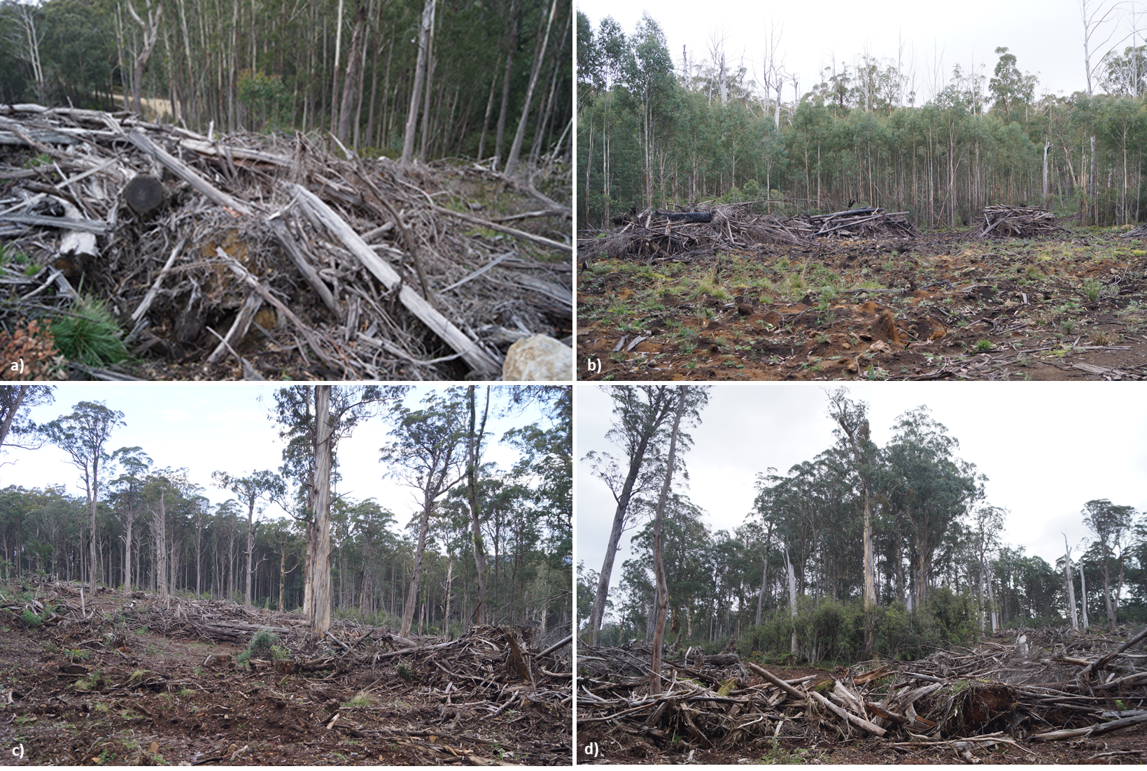
Figure 5.7: Slash piles near landings at a) 16 Spike Jones, b) 02 Onyx and for rough heaping operations at 30 Shazam (c, d). Slash piles exceed MSP ground area volume prescriptions.
Heavy rainfall in some areas (e.g. Noojee received almost 200 mm of rain in 3 days in June 2021, 153 mm of which fell in one day) enabled the audit to assess the effectiveness of snig and boundary track drainage and rehabilitation. Drainage structures typically proved effective, except where they had been damaged by post-construction machinery traffic (e.g., prior to regeneration burning). This highlights the importance of reinstatement of those structures on tracks that have been used in management of regeneration burning.

Potential improvements to the regulatory framework for timber harvesting
Comments on potential improvements in the regulatory framework for timber harvesting have been made in previous audit reports. Until recently, the regulatory framework for sustainable forest management (i.e., Code and MSPs) had not been revised and there was no specific opportunity to address these recommendations. This opportunity was provided in 2021, with DELWP undertaking revisions of both the Code and MSPs (DELWP 2021a,b). The update was intended to, “ensure they [the Code and MSP requirements] are clear, accurate and enforceable.” The scope of the amendments was modest and focussed on clarifying definitions, roles, responsibilities, and obligations, as well as correcting administrative errors.
A summary of our recommendations (from 2015-16) on minor modifications to the Code and MSPs is provided in Table 5.4. The table provides an analysis of the status of these recommendations with the recent Code and MSP amendments. Only two of our recommendations have been addressed at all and one of these, regarding buffers for rainforest stands, has not been fully adopted.
Table 5.4: FAP recommendations regarding modification to the regulatory framework for timber harvesting in State forests and their status with proposed modifications to the Code and MSPs
Recommendation | Status with proposed 2021 Code and MSP modification
FAP 2015-16 (Jacobs, 2016)
DE-01: DELWP should modify the wording of MSP section 6.1.1.3 regarding the requirement to seek engineering advice for road construction across steep slopes. The revised wording should reflect the limited accuracy of slope measurements taken from available topographic data or taken in the field in unharvested coupes.  It is suggested that engineering advice is sought for the design of roads traversing areas where it is possible (>50% chance) that: side slopes will be within 5° of the respective MSP limit; and/or cut or fill batters greater than 2 m in height will need to be constructed. | No further clarification on the requirement to seek engineering advice for road construction on steep slopes has been provided.
DE-02: VicForests does not routinely construct cross drainage on many temporary in-coupe roads in lower risk settings until heavy rainfall is forecast or harvesting is suspended or completed. While this practice is arguably not compliant with the MSP, it is operationally effective, and the audit found no evidence it poses a significant environmental risk. It is recommended that this practice be explicitly incorporated within the regulatory framework to specify conditions under which it can be safely adopted.  The prescriptions for road drainage (MSP Section 6.2.4) should be amended to describe conditions under which temporary in-coupe roads need not be drained until harvesting is suspended or completed. Suggested conditions include:  - The coupe is planned to be harvested within 6 months of roading and road use will only occur within a single harvesting season  - Average slope of the in coupe road is 4° or less and never greater than 6°  - Soil erosion hazard is low or moderate  - The road is located well away from waterways and there is limited or no potential for sustained overland sediment flow  - Appropriate cross drainage is constructed when: heavy rainfall is forecast; harvesting is suspended (for any reason or period) and harvesting machinery is removed from the coupe; and harvesting is completed and roads are no longer required for operational purposes. | No amendments have been made in response to this recommendation.
DE-05: In the response to the challenges in controlling access to coupes following the completion of harvesting and of the damage that this may cause to drainage structures, DELWP should provide an alternative to the Code’s mandatory requirement to close coupe access following harvesting completion.  This alternative should require the construction of effective drainage structures along in-coupe roads which will be resilient to post-harvest vehicle traffic for at least 3 years, while the coupe is regenerating, and ground cover being restored. After this period, regrowth will typically stabilise soils, trap any sediment flow and prevent further erosion. | No amendments have been made in response to this recommendation.
DE-07: DELWP should strengthen mandatory actions in the Code, to reduce the potential for weeds and pathogens to be spread by road construction and maintenance activities. Suggested improvements are that:  - All harvesting and road construction machinery are thoroughly cleaned and inspected before being brought onto a new coupe (unless it is adjacent to/near the one from which the machinery is being moved)  - Quarries from which materials are sourced for forest road construction are checked annually by a competent, independent party to confirm disease and weed free status  - Gravel obtained from quarries which are not confirmed as weed and disease free should be treated to mitigate any weed or disease threat prior to use within a harvest coupe. Evidence of machinery inspections, disease and weed free status of quarries and/or treatment should be retained in the FCP for all applicable coupes. | The amended Code includes a new definition for a 'forest disease control area’. These are an area identified by either the managing authority, Secretary or delegate that contains a known forest disease such as Cinnamon Fungus (Phytophthora cinnamomi) and Root Rot (Armillaria) or Myrtle Wilt (Chalara australis).  Forest hygiene prescriptions in the MSP (4.4.1) have been amended to reference forest disease control areas and prescribe specific management measures to reduce disease risk in these areas.
FAP 2016-17 (Jacobs, 2018)
D1 DELWP should revise the wording of the Management Standards and Procedures and their Planning Standards to provide consistent, unambiguous guidance on the requirements for providing unharvested buffers around rainforest stands equal to or larger than 0.4 ha in area, including those associated with rainforest sites of significance. | Wording in (now) MSP 4.3.9 Rainforest protection measures has been modified to improve clarity. However, as currently worded, the prescriptions do not explicitly address rainforest stands greater than 0.4 ha in area in Central Highlands and Gippsland FMAs that are not rainforest sites of significance.
FAP 2017-18 (Jacobs, 2019)
No applicable recommendations
FAP 2018-19 (Jacobs, 2020a)
D-02: DELWP should revise Code and MSP prescriptions in relation to pests, weeds, and diseases to provide improved rigour and transparency in biosecurity risk management practices. Consideration should be given to mandatory washdown of harvesting and road construction machinery being moved onto a coupe, assessment of quarry disease and weed status and reporting of these in FCPs. | Recommendation has effectively been address as described above (FAP 2015-16, DE-07)
D-03: In its next revision of the MSPs, DELWP should develop and include a table that specifies appropriate maximum drainage structure spacings for snig and boundary tracks. | No amendments have been made in response to this recommendation.
FAP 2019-20 (Jacobs, 2020b)
No applicable recommendations

Recommendation D-02 Medium priority
That during its forthcoming major review of the Code and MSPs, DELWP:
- Clarify the wording of revised MSP clauses 4.3.9.1 and 4.3.9.2 to explicitly address rainforest stands >0.4 ha in area located in Central Highlands and Gippsland FMAs that are not Rainforest Sites of Significance.
- Include a table linked to MSP 7.2.2.1 and 7.2.3.3 that specifies maximum distances between snig track and boundary track drainage structures, based on slope and soil erosion hazard.
No new comments on the regulatory framework for timber harvesting arise from this audit.

Improvements in the Forest Audit Program
As noted in Section 3.1, coupe selection is risk-based, with coupes prioritised that have high risk features (e.g., waterway crossings, long lengths of in-coupe road, steep slopes, erodible soils) and/or are associated with special values (rainforest vegetation, threatened species, SPZ/SMZ). Due to the risk to environmental values associated with waterway crossings and long in-coupe roads, these features are particularly influential on coupe selection.
Data reported in Table 3.1 highlight deficiencies in the information base used to select coupes for inclusion in the audit. Information provided on the presence of waterway crossing and length of in-coupe road are particularly unreliable. Of the 11 coupes that were reported by VicForests to have waterway crossings, only four had in-coupe road or snig track crossings. The actual length of in-coupe road was within 100 m of VicForests’ initial planning estimate for only nine of the 30 audit coupes.
The data reported by VicForests is understood to be based on the initial operational planning rather than the actual coupe operations. These can differ significantly, and in our experience those differences often result in reduced environmental risks associated with the harvesting activities (e.g. by eliminating waterway crossings or shortening in-coupe road lengths, often to <50 m). As data from planned coupe operations is not necessarily reflective of the risk posed by the actual operations, lower risk coupes may be prioritised for audit selection above higher risk coupes.
While this may result in the audit being more representative of VicForests’ operations overall, the intent of the audit is to focus activities on higher risk coupes in each of the RFA regions/FMAs in which DELWP require the audit to be conducted.
Recommendation V-03 Medium priority
That the data VicForests’ provide DELWP to assist in coupe selection is based on actual rather than planned in-coupe roads and waterway crossings.

Conclusions and recommendations

Conclusions
The objectives of the FAP are to assess VicForests’ conformance with the regulatory framework for timber harvesting activities in State forests and the environmental risks associated with any non-conformances. The 2020-21 FAP addressed Code and MSP mandatory compliance elements relating to four main themes:
- Protection of soil, water and river health values
- Conservation of biodiversity
- Operational planning and record-keeping
- Coupe infrastructure for timber harvesting operations.
Conformance of coupe planning, harvesting and roading activities with the regulatory framework provided by the Code and MSPs was assessed for 30 coupes distributed across the Central Highlands, Gippsland and East Gippsland RFA regions. The selection of coupes was risk-based, meaning that audit findings cannot be taken as being statistically representative of VicForests’ operations.

Overall conformance findings
A total of 169 compliance criteria were identified from Code and related MSP prescriptions included within the audit scope. The applicability of and conformance with these criteria was assessed for each of the 30 selected coupes during site inspections undertaken in May and June 2020.
The overall level of full conformance with applicable audit criteria ranged between 77% and 100%, with the average being 94%. Non-conformance incidents in 19 of the 30 harvest coupes included in the audit were assessed to have potential for environmental impact. There was an average of 1.3 such incidents per coupe, with as many as five incidents recorded in one coupe. The assessed level of potential environmental impact associated with these incidents ranged up to major.

Protection of soil, water and river health values
Environment-themed audit criteria were grouped into two sub-themes focusing on soil and water values. The main findings for each sub-theme were:
- Protection of forest soils: the level of full conformance with applicable criteria ranged between 53% and 100%, with an average of 92%. Non-conformance incidents at five coupes were assessed to have moderate potential environmental impact. The main types of incident contributing to these non-conformances were:
Incursion of regeneration burns into areas that were planned not to be harvested
Excessive lengths of in-coupe road or snig track without effective cross-drainage structures (compared with slope and recorded soil erosion hazard) and potential for erosion
Inappropriate rehabilitation practices following removal of a temporary in-coupe road waterway crossing.
- Protection of water flows, water quality and river health: the level of full conformance with applicable criteria ranged between 52% and 100%, with an average of 91%. Non-conformance incidents at five coupes were assessed to have moderate potential environmental impact. The main types of incident contributing to these non-conformances were:
Insufficiently effective controls for management of runoff and sediment from coupe to forest road drainage system and external waterways
Construction of a boundary track along what should have been a drainage line filter strip
Excessive lengths of in-coupe road or snig track without effective cross-drainage structures (compared with slope and recorded soil erosion hazard) and potential for erosion
Inappropriate rehabilitation practices following removal of a temporary in-coupe road waterway crossing.

Conservation of biodiversity
The average level of full conformance with applicable biodiversity conservation criteria was 95%, with the range being 75-100%. One non-conformance incident was assessed to have major potential environmental impact and incidents in six other coupes were assessed to have moderate potential environmental impact. These related to several incident types:
- Incursion of a boundary track into a Leadbeater’s Possum SPZ
- Incursion of regeneration burns into areas that were planned not to be harvested or adverse impact of rough heap burn on nearby habitat protection areas
- Insufficiently effective controls for management of runoff and sediment from coupe to forest road drainage system and external waterways, leading to sediment movement and risk to aquatic biodiversity
- Construction of a boundary track along what should have been a drainage line filter strip
- Inappropriate rehabilitation practices following removal of a temporary in-coupe road waterway crossing.

Operational planning and record keeping
The average level of full conformance with applicable criteria was 97%, with the level for individual coupes ranging between 87% and 100%. One non-conformance incident was assessed to have major potential environmental impact and incidents in another three coupes were assessed to have moderate potential environmental impact. These were associated with:
- Incursion of a boundary track into a Leadbeater’s Possum SPZ
- Excessive lengths of in-coupe road or snig track without effective cross-drainage structures (compared with slope and recorded soil erosion hazard) and potential for erosion
- Construction of a boundary track along what should have been a drainage line filter strip

Coupe infrastructure for harvesting operations
Infrastructure-themed audit criteria were grouped into four sub-themes focusing on design, construction, maintenance of in-coupe roads, as well as placement and construction of non-road coupe infrastructure such as landings and snig or boundary tracks. The main findings for each sub-theme were:
- Road design: the level of full conformance with applicable criteria ranged between 56% and 100%, with the average being 89%. Non-conformance incidents at two coupes were assessed to have moderate potential impact. These non-conformance incidents related to:
Excessive lengths of in-coupe road without effective cross-drainage structures (compared with slope and recorded soil erosion hazard) and potential for erosion
Inappropriate rehabilitation practices following removal of a temporary in-coupe road waterway crossing.
- Road construction: the average level of full conformance with applicable criteria was 86%, with the level of conformance ranging between 52% and 100%. Non-conformance incidents at three coupes were assessed to have moderate potential environmental impact. These non-conformance incidents related to:
Excessive lengths of in-coupe road without effective cross-drainage structures (compared with slope and recorded soil erosion hazard) and potential for erosion
Insufficiently effective controls for management of runoff and sediment from coupe to forest road drainage system and external waterways to prevent sediment movement
Inappropriate rehabilitation practices following removal of a temporary in-coupe road waterway crossing.
- Road maintenance and closure: the average level of full conformance with applicable criteria was 88%, with the level of full compliance ranging between 38% and 100%. Non-conformance incidents with moderate potential environmental impact were observed at two coupes. These incidents involved:
Insufficiently effective controls for management of runoff and sediment from coupe to forest road drainage system and external waterways to prevent sediment movement
Inappropriate rehabilitation practices following removal of a temporary in-coupe road waterway crossing.
- Non-road coupe infrastructure: the average level of full conformance with applicable criteria was 95%, with the level of full conformance ranging between 75% and 100%. Non-conformance incidents with moderate potential environmental impact were observed at two coupes. These involved:
Construction of a boundary track in what should have been drainage line filter strip
Excessive lengths of boundary track without effective cross-drainage structures (compared with slope and recorded soil erosion hazard) and potential for erosion

Comparison with previous audits
Coupe selection for the audit is risk-based, which means that audit results are not necessarily statistically representative of VicForests’ operations overall and audit results may not be directly comparable between years. Comparison of the results of this audit with previous audits is also confounded by the inclusion of 15 less intensively harvested community forestry coupes from Western Victoria RFA region in the 2019-20 FAP audit. However, if the comparison with previous audits is confined to coupes within the Central Highlands RFA region (12 coupes in 2017-18, 14 coupes in 2018-19, 15 coupes in 2019-20, 12 coupes in 2020-21), there is a reasonable basis for doing so.
The overall level of full conformance for Central Highland RFA region coupes in the 2020-21 audit was 93%, compared with 83-94% in the three preceding FAP audits. The level of full conformance for Central Highland coupes in the current audit was within a few percentage points of 2019-20 and 2017-18 FAP audits for most audit themes and sub-themes. Audit performance in 2018-19 was substantially worse in most themes or sub-themes than in other years.
The count of non-conformances with potential environmental impact overall was less in 2020-21 than in the two previous FAP audits. The number of incidents with major potential environmental impact was greater than in 2019-20 and 2017-18 FAP audits, but much less than in 2018-19.
The high incidence of non-conformances with high potential environmental impact in the 2018-19 audit was mainly associated with incursion of regeneration burns into areas that were not planned to be affected by timber harvesting and associated regeneration activities. This group of incidents was the second most common type observed in this audit (Table 5.1), however there were no incidents of this kind in the Central Highlands RFA region that were assessed in the current audit to have this major potential environmental impact.

Fire salvage harvesting
This audit was the first for some years to include coupes harvested under fire salvage harvesting provisions of the MSPs (Section 8). As only four fire salvage coupes were included in the audit (two each in Tambo and East Gippsland FMAs), it is not possible to make any generalisations about the extent to which such operations conform with mandatory Code and MSP requirements.
We found only one instance of non-conformance with fire salvage harvesting prescriptions, in 27 Brave Duck. This related to insufficient constructed drainage or other controls on snig/forwarding tracks and was assessed to have minor potential environmental impact. Apart from this, the operations were observed to effectively manage the increased risk to water quality and any regenerating understorey from harvesting.
The overall average level of full conformance for fire salvage coupes was 97%, compared with 94% overall for this audit.

Recommendations
The findings of this audit have contributed to a series of recommendations for VicForests and DELWP. Recommendations to VicForests regard potential improvements in coupe planning and timber harvesting practices and operation on the FAP. Recommendations for DELWP concern fire salvage harvesting in Ash-type forests and what we consider to be important clarifications to include in the current round of minor modifications to the regulatory framework for timber harvesting.
The priority given to recommendations reflects either the potential environmental impact associated with the aspect of harvesting practice and/or the urgency of any improvement to practice or the regulatory system.

Recommendations for VicForests
Recommendation | Rationale
V-01: Medium priority  That VicForests undertake an assessment of fire salvage coupes in which live, fire-affected Ash-type eucalypts were retained. The assessment should consider the extent to which such trees survive the effects of fire and offer habitat or other benefits to the coupe when retained and the appropriateness of prioritising more severely burnt trees and forest areas for salvage harvesting. | Our observations from the two coupes with fire salvage harvesting of Ash-type eucalypts indicated that most trees with any significant canopy damage are unlikely to survive long-term. If this is generally applicable in Ash-type eucalypt forests, there may be little value gained in not harvesting fire-affected trees that retain partly unburnt canopies in fire salvage coupes.  We recognise that two coupes are too small a sample to vary harvesting practice in fire salvage coupes, hence this recommendation to understand the extent to which partly burnt ash eucalypts recover from fire damage and/or provide other on-going habitat or other values to coupes.
V-02: High priority  That VicForests and/or its roading and harvesting contractors develop and implement waterway crossing rehabilitation plans for all temporary in-coupe road and snig track crossings to ensure conformance with the Code and MSPs and reduce, to the extent practicable, the mobilisation of sediment into waterways. Implementation of the plans should be confirmed by VicForests and any defects rectified before all harvesting/regeneration machinery is removed from the coupe. | Waterway crossing construction and rehabilitation has been a major source of non-conformances with actual or potential environmental impact over many FAP audits. While instances of good practice have been observed in this and previous audits, instances of poor practice are at least as common.  We have previously recommended that specific plans be developed for construction and rehabilitation of waterway crossings, that these are checked against to ensure conformance with plans and Code and MSP requirements and that any significant defects are rectified before machinery is withdrawn from the coupe. This recommendation was not taken up in VicForests’ revised roading instructions.  Our view is that the legacy of poor waterway crossing construction and rehabilitation could be largely avoided if waterway crossing plans were developed, implemented and monitored against.
V-03 Medium priority  That the data VicForests provides DELWP to assist in coupe selection is based on actual rather than planned in-coupe roads and waterway crossings. | It has been noted in this and previous audits that there are often significant discrepancies between the data provided by VicForests to support audit coupe selection and the actual coupe conditions, particularly in relation to the presence/number of waterway crossings. This results in coupes being prioritised for selection in a risk-based process that do not have the higher risk features they were selected for and dilutes the effectiveness of the risk-based selection process.

Recommendations for DELWP
Recommendation | Rationale
D-01 Medium priority  That DELWP review and reconsider limits on slash piles (currently 10 m³ MSP 7.2.4.2), particularly for rough heaping operations. | While the limits on the size of bark and slash piles (MSP 7.2.4.2) may be appropriate in the context of landings, it is not clear that they are workable for rough heaping operations. The latter typically form windrows with much greater volume than allowed by MSP 7.2.4.2. Limiting piles to 10 m³/4 m² would be difficult for operations with large volumes of unmerchantable wood for which regeneration burns are not practicable.
D-02: Medium priority  That during its forthcoming major review of the Code and MSPs, DELWP:  - Clarify the wording of revised MSP clauses 4.3.9.1 and 4.3.9.2 to explicitly address rainforest stands >0.4 ha in area located in Central Highlands and Gippsland FMAs that are not Rainforest Sites of Significance.  - Include a table linked to MSP clauses 7.2.2.1 and 7.2.3.3 that specifies maximum distances between snig track and boundary track drainage structures, based on slope and soil erosion hazard. | DELWP’s recent minor review of the Code and MSPs addressed some issues previously identified in our FAP reports but did not address these issues. The proposed major review of the Code and MSPs provides an opportunity to address these two important shortcomings:  - MSP4.3.9.1 and 4.3.9.2: recent modifications to these clauses do not address one of the deficiencies in their original wording, namely that they do not directly address buffer requirements for the particular class of rainforest stand referenced in our recommendation.  - Snig and boundary track drainage spacing: the MSPs do not currently specify drainage structure spacing on rehabilitated snig and boundary tracks in the way they do for drainage on in-coupe roads (i.e., via MSP Table 21). Given the relatively high frequency of non-conformance with VicForests standards for drainage structure spacing observed over several audits and the potential for this to lead to soil movement and (less commonly) sediment deposition into waterways, it is suggested that these standards be elevated as mandatory compliance elements during the current process of amending the Code and MSPs.

References
Department of Environment, Land, Water and Planning [DELWP] 2019. Regulating timber harvesting in State forests under the Allocation Order. Statement of Regulatory Intent. DELWP.
DELWP 2021a. Code of practice for timber production 2014 (as amended November 2021). DELWP.
DELWP 2021b. Management standards and procedures for timber harvesting operations in Victoria’s State forests 2021. DELWP.
Department of Environment and Primary Industries [DEPI] 2014a. Code of practice for timber production 2014. DEPI.
DEPI 2014b. Management standards and procedures for timber harvesting operations in Victoria’s State forests 2014. DEPI.
DEPI 2014c. Planning standards and procedures for timber harvesting operations in Victoria’s State forests 2014. Appendix 5 to the Management standards and procedures for timber harvesting operations in Victoria’s State forests 2014. DEPI.
Department of Sustainability and Environment [DSE] 2006. Sustainability charter for Victoria’s State forests. DSE.
Jacobs 2016. Forest Audit Program 2015: Audit of in-coupe roads. Environmental audit of the construction and maintenance of in-coupe roads. IS112500-010.Report to DELWP. March 2016.
Jacobs 2018. Audit of timber harvesting and forest regeneration in State forests in eastern Victoria. Report on the 2016-17 Forest Audit Program. IS206000-P2-001. Report to DELWP. April 2018.
Jacobs 2019. Audit of timber harvesting operations in Victoria’s State forests. Report on the 2017-18 Forest Audit Program. IS247800-RP-002. Report to DELWP. July 2019.
Jacobs 2020a. Audit of timber harvesting operations in Victoria’s State forests. Report of the 2018-19 Forest Audit Program. IS284400-RP-002. Report to DELWP. February 2020.
Jacobs 2020b. Audit of timber harvesting operations in Victoria’s State forests. Report of the 2019-20 Forest Audit Program 2019-20. IS326300-03. Report to DELWP. October 2020.
Jacobs 2021. Forest Audit Program 2020-21. Conformance summary report. IS377900-02. Report to DELWP, June 2021.
O’Reilly 2019. Road design, construction and maintenance instruction. Version 1.1. Report to VicForests. September 2019.
VicForests 2018. Utilisation procedures for all commercial harvesting and haulage managed by VicForests. VicForests.

Spatial data sources:
- Victorian government: www.data.vic.gov.au
- ESRI
Limitation statement
The purpose of this report and the associated services performed by Jacobs was to conduct an environmental audit of timber harvesting operations in Victorian State forests. The work has been undertaken in accordance with the scope of services set out in the contract between Jacobs and the Department of Environment, Land, Water and Planning (DELWP).
Jacobs derived the data in this report from field observations and information sourced from DELWP, VicForests and/or available in the public domain at the time or times outlined in this report. The passage of time, manifestation of latent conditions or impacts of future events may require further examination of the project and subsequent data analysis, and re-evaluation of the data, findings, observations and conclusions expressed in this report.
Jacobs has prepared this report in accordance with the usual care and thoroughness of the consulting profession, for the sole purpose described above and by reference to applicable standards, guidelines, procedures and practices at the date of issue of this report. For the reasons outlined above, however, no other warranty or guarantee, whether expressed or implied, is made as to the data, observations and findings expressed in this report, to the extent permitted by law.
This report should be read in full and no excerpts are to be taken as representative of the findings. No responsibility is accepted by Jacobs for use of any part of this report in any other context.
This report has been prepared on behalf of, and for the exclusive use of DELWP and is subject to, and issued in accordance with, the provisions of the contract between Jacobs and DELWP. Jacobs accepts no liability or responsibility whatsoever for, or in respect of, any use of, or reliance upon, this report by any third party.

Audit compliance elements
Regulatory compliance elements considered in the audit are included in Table A.1. They were drawn from the Code, the MSPs and their PS. Code compliance elements were selected by DELWP’s THCU. Supporting compliance elements from the MSPs and PS were selected by the audit team.
Compliance criteria (stated as a question) were developed by the audit team to enable assessments of compliance with each element of the regulatory framework. Criteria generally refer to individual MSP or PS compliance elements, rather than a more overarching Code requirement. However, in some cases criteria refer to individual Code compliance elements. Compliance elements have been incorporated with criteria in Table A.1. The compliance theme(s) to which each criterion relates is also given in the table.
Table A.1 also provides a summary of the percentage of applicable coupes recording full conformance with each criterion.
Table A.1 Selected regulatory compliance elements for 2020-21 FAP audit and associated audit criteria. A summary of the level of full conformance with each criterion and the compliance theme or sub-theme to which each criterion relates is also shown
Source¹ | #² | Code compliance elements and audit compliance questions | Theme³ | % Full⁴
C |  | 2.2 Environmental Values in State forests
C |  | 2.2.1 Water Quality, River Health and Soil Protection
C |  | 2.2.1.1 Planning and management of timber harvesting operations must comply with relevant water quality, river health and soil protection measures specified within the Management Standards and Procedures.
M |  | 3.1.1.1 Use the following categories when determining buffer (B) and filter (F) widths for waterways within and immediately adjacent to each coupe. Aids to the identification of each class of waterway are provided in the Code Glossary. (a) Permanent streams, pools and wetlands. (b) Temporary streams. c) Drainage lines.
 | 1.01 | Have the categories prescribed in the MSPs been used in classifying waterways present on the coupe? | W,P | 97%
 | 1.02 | ITAO⁵ has the classification been applied correctly? | W | 97%
M |  | 3.2.1.1 Conduct field assessments to determine the soil erosion hazard and soil permeability classifications for an area proposed for any soil disturbing timber harvesting operations as follows (3.2.1.2-3.2.1.11, Table 8).
 | 2.01 | Has soil erosion hazard and soil permeability been assessed using the method prescribed in the MSPs? | P | 100%
 | 2.02 | ITAO, does the soil erosion hazard and soil permeability assessment appropriately represent the soils in disturbed areas on the coupe? | S,P | 90%
 |  | 3.2.1.2 Collect soil profile samples that reflect the variety of soils represented within the coupe.
 | 2.03 | ITOA, is/are the soil sampling location(s) used to characterise soil erosion hazard and permeability appropriately representative of the coupe. | P | 90%
M |  | 3.3.1.1 Apply appropriate protection to class of waterway as outlined in MSP Table 9.
M |  | 3.3.1.2 Apply appropriate protection to class of waterway as outlined in table 10 below for coupes in catchments up to 1 km upstream of verified and potential Spotted Tree Frog sites or coupes in Barred Galaxias and Mountain Galaxias SMZs where specified in section 4.2.
 | 3.01 | If applicable, have the buffer and filter strip widths prescribed in MSP Table 9 been applied to the coupe? | W,P | 92%
 | 3.02 | If applicable, have the buffer and filter strip widths prescribed in MSP Table 10 been applied to the coupe? | W,B,P | 100%
M |  | 3.4.1.1 Exclude timber harvesting operations from slopes over 30 degrees.
M |  | 3.4.1.2 Up to 10% of the net harvest area of any coupe can contain areas greater than 30 degrees, where the risk of mass soil movement has been managed accordingly.
M |  | 3.4.1.3 Exclude timber harvesting operations from slopes over 25 degrees in the East Gippsland FMA in areas with granite based soils
 | 4.01 | Does the FCP show areas of the coupe with slope >30°/25° if granite soils in East Gippsland FMA? | S,W,P | 100%
 | 4.02 | Has timber harvesting been excluded from areas with slopes >30° (unless the area >30° slope is ≤10% net harvest area and ITAO the risk of mass soil movement has been managed accordingly)? | S,W,P | 100%
 | 4.03 | Is timber harvesting is undertaken in areas in East Gippsland FMA with granite based soils and slope >25°? | S,W,P | N/A
M |  | 3.5.1.1 Apply the slope limits, seasonal closures, buffer and filter strip widths and other relevant management actions specified in MSP Appendix 3 Table 11 (Water supply protection areas) for timber harvesting operations and associated roading and regeneration in water supply protection areas.
M |  | 3.5.1.2 Refer to Table 2 in Appendix 5 the PS for management actions that apply to water supply protection area SMZs in the Midlands FMA
M |  | 3.5.1.3 Obtain approval from the Minister or delegate in accordance with section 1.4 for any timber harvesting operations that are not conducted in accordance with clauses 3.5.1.1 or 3.5.1.2.
M |  | 3.5.1.4 Special water supply catchments and water supply protection areas not listed in Appendix 3 Table 11 (Water supply protection areas) or table 2 in Appendix 5 the Planning Standards do not require protection in addition to existing Code requirements.
M |  | 3.5.1.5 In addition to Appendix 3 Table 11 (Water supply protection areas), in the Bunyip, Thomson and Tarago special water supply catchments and the Yarra Tributaries State forests the area harvested must not exceed the following limits measured as a rolling average: (a) Thomson ‐ Ash forests 150 ha/year, Mixed species forests 15ha/year; (b) Tarago ‐ Ash forests 55 ha/year, Mixed species forests 23ha/year; (c) Yarra Tributaries – Ash forest 52 ha/year, Mixed species forests 15 ha/year; and (d) Bunyip – Ash forest 15 ha/year, Mixed species forests 15 ha/year.
M |  | 3.5.1.6 In addition to Appendix 3 Table 11 (Water supply protection areas), harvesting in the Learmonths Creek special water supply catchment must not exceed 7 ha per annum in Ash forests or 3 ha per annum in Mixed species forests, averaged over the previous 10 year period.
 | 5.01 | Does the FCP correctly note that the coupe is or is not located in a water supply catchment? | P | 100%
 | 5.02 | For relevant coupes located in WSPA/DWSC, have the applicable slope limits, seasonal closures, buffer and filter strip widths and other relevant management actions specified in Appendix 3 Table 11 been correctly applied on the coupe? | W,P | 100%
 | 5.03 | For relevant coupes located in WSPA/DWSC, are the applicable stream buffers correctly applied on the coupe? | W | 100%
 | 5.04 | For relevant coupes located in WSPA/DWSC, are the applicable maximum annual areas harvested noted in the FCP and correctly applied on the coupe? | W,P | 100%
 | 5.05 | For relevant coupes located in WSPA/DWSC, if timber harvesting operations are not conducted in accordance with the relevant MSP prescriptions, has Ministerial approval been obtained in accordance with MSP section 1.5 and Appendix 1 prior to harvesting commencing? | P | N/A
C |  | 2.2.1.2 Management actions to protect waterways, river health and soil must be appropriate to the waterway class, soil category, and potential water quality risk posed by timber harvesting operations at each site.
C |  | 2.2.1.3 Additional measures to protect water quality and aquatic habitat (including widening buffers or filter strips) must be adopted within coupes where there is a high local risk due to: i. local topography; i. the intensity and magnitude of the timber harvesting operation; ii. events such as wildfire that reduce the effectiveness of protection measures; or iii. the location of the timber harvesting operation in a declared Special Water Supply Catchment or any other water supply protection area.
 | 6.01 | ITAO is there evidence from the coupe which suggests that management actions to protect waterways, river health and soil have not been appropriate to protect waterways, river health and soil? | S, W, B, C, M, I | 86%
 | 6.02 | If ITAO additional measures were required to protect water quality and aquatic habitat due to local risk factors, were any undertaken? | S, W, B, C, M, I, P | 100%
 | 6.03 | Where ITAO additional measures were required and undertaken, were they effective in protect water quality and aquatic habitat | S, W, B, C, M, I | 80%
C |  | 2.2.1.5 Where practical exclude roads and snig tracks from aquatic and riparian habitats.
C |  | 2.2.1.6 Where crossings are required, minimise the extent of habitat damage, constriction to stream flow and barriers to fish and other aquatic fauna.
C |  | 2.2.1.7 Remove temporary crossings immediately after harvesting or any subsequent regeneration work is complete using a technique that minimises soil and habitat disturbance.
C |  | 2.2.1.8 Use drainage, artificial structures, buffers and filters of effective width to slow and disperse surface flows and deposit sediment before reaching waterways.
C |  | 2.2.1.12 Design, construct and maintain roads, crossings, coupe infrastructure and drainage structures to withstand foreseeable rainfall events and traffic conditions, and protect water quality.
 | 7.01 | If roads and snig tracks have not been excluded from aquatic and riparian habitats, ITAO was it reasonably practicable to have done so? | W, B, D, C, I | 100%
 | 7.02 | For coupes with road and/or snig track waterway crossings, ITAO did the crossing minimise the extent of habitat damage and, where relevant, constriction to stream flow and/or barriers to fish and other aquatic fauna? | W, B, D, C, I | 100%
 | 7.03 | ITAO has the crossing been removed as soon as reasonably practicable following harvesting or regeneration work? | W, M, I | 100%
 | 7.04 | ITAO has removal of the crossing been undertaken in a manner that has minimised soil and habitat disturbance? | S, W, B, M, I | 67%
 | 7.05 | ITAO have drainage, artificial structures, buffers and filters of effective width been appropriately used to try to slow and disperse surface flows and deposit sediment before reaching waterways? | W, D, C, I | 80%
 | 7.06 | Have the measures put in place to slow and disperse surface flows and deposit sediment before reaching waterways been effective? | W, C, I | 60%
C |  | 2.2.1.14 Minimise potential for soil erosion or mass movement by planning and using operational methods and restrictions appropriate to the assessed soil erosion risk and slope.
C |  | 2.2.1.15 Locate coupe infrastructure and roads to minimise soil erosion and degradation.
C |  | 2.2.1.18 Employ topsoil conservation techniques in timber harvesting areas affected by coupe infrastructure and roads.
 | 8.01 | ITAO have planning (including locating coupe infrastructure and roads) and operations methods applied on the coupe been appropriate for the assessed soil erosion risk and slope? | S, W, D, C, M, I, P | 86%
 | 8.02 | Is there evidence within the coupe of soil erosion or mass movement resulting from harvesting operations, including from roading, snig tracks and/or landings? | S, S, M, I | 87%
 | 8.03 | ITAO has topsoil conservation been used as appropriate in areas affected by coupe infrastructure and/or roads? | S, C, I | 100%
C |  | 2.2.2 Conservation of Biodiversity
C |  | 2.2.2.1 Planning and management of timber harvesting operations must comply with relevant biodiversity conservation measures specified within the Management Standards and Procedures.
C |  | 2.2.2.4 During planning identify biodiversity values listed in the Management Standards and Procedures prior to roading, harvesting, tending and regeneration. Address risks to these values through management actions consistent with the Management Standards and Procedures such as appropriate location of coupe infrastructure, buffers, exclusion areas, modified harvest timing, modified silvicultural techniques or retention of specific structural attributes.
 | 9.01 | Is there evidence from the FCP and coupe planning process of attempts to identify biodiversity values listed in the MSPs within or near the coupe? | P | 90%
 | 9.02 | Where listed biodiversity values are present, is there evidence that risks to these values from timber harvesting operations have been assessed? | P | 100%
 | 9.03 | Where listed biodiversity values are present, have management actions applied on the coupe to protect those values been consistent with MSP prescriptions. | B | 100%
 |  | MSP4.1 Habitat retention
C |  | 2.2.2.10 Retain and protect habitat trees or habitat patches and long-lived understorey species to provide for the continuity and replacement of old hollow-bearing trees and existing vegetation types within each coupe.
M |  | 4.1.1.1 Retain habitat trees in accordance with the FMA summary provided in Appendix 3 Table 12 (Habitat tree prescriptions).
M |  | 4.1.1.2 Trees in buffers or other exclusion areas that have been extended beyond minimum required widths can contribute to habitat tree retention requirements.
 | 10.01 | Have the required number of habitat trees been retained on the coupe (as per MSP Appendix 3, Table 12) - including in areas where buffers and other exclusion areas extended beyond the minimum required widths? | B | 100%
 | 10.02 | Have habitat patches of long-lived understorey species been retained to represent existing vegetation types within the coupe? | B, P | 100%
 |  | MSP4.1.4 Central Highlands FMAs
M |  | 4.1.4.1 In Central Highlands FMAs, when selecting habitat trees, prioritise hollow‐bearing trees where they are present and trees most likely to develop hollows in the short term.
M |  | 4.1.4.2 Scatter habitat trees across the timber harvesting coupe in mixed‐species forest.
M |  | 4.1.4.3 Where possible, retain potential hollow‐bearing ash eucalypts in clumps to increase their protection from exposure, windthrow and fire.
M |  | 4.1.4.4 No gap between retained vegetation is to be greater than 150 m.
M |  | 4.1.4.5 Retain habitat trees where they can be most easily protected from damage during harvesting and site preparation treatment.
 | 10.03 | Based on evidence from the coupe and ITAO, have hollow-bearing or potential hollow-bearing trees, where present, been prioritised for habitat retention | B, P | 100%
 | 10.04 | In mixed species forests, if there are retained habitat trees, have they been scattered evenly across the coupe? | B | 100%
 | 10.05 | If present, have hollow bearing ash eucalypts been retained in clumps. | B | 100%
 | 10.06 | Are gaps between retained vegetation ≤ 150 m? | B, P | 100%
 | 10.07 | ITAO, are any retained habitat trees located where they can most easily be protected from damage during harvesting and site preparation treatment? | B, P | 100%
 | 10.08 | Is there evidence of damage to retained vegetation from harvesting or regeneration? | B | 82%
 |  | MSP4.1.5 East Gippsland and Gippsland FMAs
M |  | 4.1.5.1 When selecting habitat trees, prioritise old living trees with a range of hollow sizes. Where these are absent or not present in sufficient numbers, prioritise trees that are old enough to develop hollows during the next 50 years.
M |  | 4.1.5.2 Stags and younger, smaller trees may be counted as habitat trees if trees of the type described in 3.1.5.1 are absent or not present in sufficient numbers.
M |  | 4.1.5.3 Where possible, retain habitat trees in small clusters which include younger regrowth and understorey.
M |  | 4.1.5.4 Distribute habitat tree clusters across the coupe with consideration of the proximity of other retained vegetation.
 | 10.09 | Is there evidence that selection of habitat trees has prioritised living trees with a range of hollow sizes, where present, or trees that are old enough to develop hollows during the next 50 years. | B, P | 100%
 | 10.10 | Have habitat trees been retained in small clusters that include younger regrowth and understorey (where ITAO this is reasonably practicable)? | B, P | 100%
 | 10.11 | Have habitat tree clusters been distributed across the coupe, with (ITAO) apparent consideration of the proximity of other retained habitat? | B, P | 100%
 |  | MSP 4.2 and 4.3 Fauna and flora
M |  | 4.2.1.1 Apply management actions for rare and threatened fauna identified within areas affected by timber harvesting operations as outlined in Appendix 3 Table 13 (Rare or threatened fauna prescriptions).
M |  | 4.3.1.1 Apply management actions for rare and threatened flora identified within areas affected by timber harvesting operations as outlined in Appendix 3 Table 14 (Rare or threatened flora prescriptions).
 | 11.01 | Does the FCP correctly note record(s) of rare or threatened fauna–based on the VBA-on the coupe? | P | 95%
 | 11.02 | Have the management actions for fauna (as per MSP Appendix 3, Table 13) been carried out? | B | 91%
 | 11.03 | Does the FCP correctly note record(s) of rare or threatened flora-based on the VBA-on the coupe? | P | 56%
 | 11.04 | Have the management actions for fauna (as per MSP Appendix 3, Table 14) been carried out? | B | 100%
P |  | 4.2.1.1 Plan management actions for rare and endangered fauna in accordance with Table 3 (fixed FMZ rules for fauna).
 | 11.05 | Have the management actions specified in PS Table 3 for fixed FMZ rules for fauna been implemented? | B | N/A
P |  | 4.3.1.1 Apply the management actions outlined in Table 4 (Detection based FMZ rules for fauna) for zoned rare or threatened fauna.
 | 11.06 | Have the management actions specified in PS Table 4 for detection based FMZ rules for fauna been implemented? | B | 89%
P |  | 4.5.1.1 Apply the management actions outlined in Table 5 (Detection based FMZ rules for flora) for zoned rare or threatened flora values.
 | 11.07 | Have the management actions specified in PS Table 5 for detection based FMZ rules for flora been implemented? | B | 100%
 |  | MSP 4.4 Vegetation communities
 |  | MSP 4.4.1 Box-Ironbark
M |  | 4.4.1.1 In the Gippsland FMAs exclude selective harvesting from Box Ironbark forests typically containing Forest Red Gum (Eucalyptus tereticornis), Yellow Box (Eucalyptus melliodora), Coast Grey Box (Eucalyptus bosistoana) and Red Ironbark (Eucalyptus tricarpa). Silvicultural practices that promote regeneration of these species is permitted.
M |  | 4.4.1.2 In the East Gippsland FMA exclude selective harvesting from Box Ironbark forests typically containing Red Ironbark (Eucalyptus tricarpa), Gippsland Grey Box (Eucalyptus bosistoana), Red Box (Eucalyptus polyanthemos), Blue Box (Eucalyptus baueriana) and Yellow Stringybark (Eucalyptus muelleriana). The use of seed‐tree regeneration systems is permitted to restore the original species mix when combined with: a) cutting stumps of desired species to a maximum height of 30 cm, to encourage coppice growth; b) supplementary planting and sowing where necessary; c) removing unproductive trees of the less-preferred species to remove overwood competition; and d) thinning of advanced regrowth
 | 12.01 | In Gippsland FMAs, has selective harvesting been excluded from Box-Ironbark forests, as per MSP 4.4.1.1/2? | B | N/A
 |  | MSP 4.4.2 Heathland
M |  | 4.4.2.1 Avoid road construction across areas of heathland or within 40 m of heathlands unless no reasonable alternative exists.
M |  | 4.4.2.2 In the Gippsland FMAs, exclude Wet Heathland, Clay Heathland and Riparian Scrub Mosaic EVCs from harvesting. Protect these heathland EVCs with a 40 m buffer.
M |  | 4.4.2.3 In the East Gippsland FMA where evidence of heathland is found in the field and it isn’t already classified as SPZ, application must be made to the Secretary or delegate prior to commencement of the timber harvesting operation to create an SPZ in accordance with table 7 in Appendix 5 the Planning Standards.
 | 12.02 | If a road was constructed through or within 40 m of a heathland EVC, ITAO, was it reasonably practicable to construct the road in another location? | B, C, P | 100%
 | 12.03 | In the Gippsland FMAs, has harvesting been excluded from Wet Heathland, Clay Heathland and Riparian Scrub Mosaic EVCs and have these heathland EVCs been protected with a 40 m buffer, where present? | B, P | N/A
 | 12.04 | In the EG FMA, if evidence of heathland was found in the coupe and it was not already classified as SPZ, has application been made to the Secretary to create an SPZ in accordance with Table 7 in Appendix 5 the Planning Standards? | B, P | N/A
 | 12.05 | Have the SPZ conditions been followed in the management of harvesting? | B, P | 100%
 |  | MSP 4.4.3 Montane Riparian Thicket
M |  | 4.4.3.1 In the Tambo FMA protect small stands of MRT between 0.01ha and 0.5ha and less than 10m wide with a 10m filter strip and stands of MRT wider than 10m with a 20m wide filter strip.
M |  | 4.4.3.2 In all other FMAs (than Tambo) apply the heathland prescriptions listed above in 3.4.2 (sic – actually 4.4.2) – i.e. protect with a 40 m buffer and do not construct a road through or within 40 m of MRT, except where not practicable alternative exists.
M |  | MRT stands must contain at least 40 % canopy cover of Mountain Tea‐tree (Leptospermum grandifolium) and up to two key understorey species from the MRT definition in the Glossary. Gaps in the Mountain Tea‐tree canopy may occur at intervals up to 10 m in length. Discrete areas of Mountain Tea‐tree having canopy gaps greater than 10 m are to be treated as individual stands.
 | 12.06 | In Tambo FMA, have stands of MRT been protected from harvest as per MSP4.4.3.1 | B, P | 100%
 | 12.07 | In FMAs other than Tambo, if stands of MRT are present and a road has been constructed through or within 50 m, was it reasonably practical to have constructed the road in an alternative location? | B, B , P | 100%
 | 12.08 | In FMAs other than Tambo, if stands of MRT are present, has harvesting been conducted within 40 m of an MRT stand? | B, P | 100%
 |  | MSP 4.4.4 Old growth
M |  | 4.4.4.1 Within the Leadbeater’s Possum range apply a 100 m buffer around all stands of modelled Ash old growth forest that are depicted in the DEPI old growth spatial layer (MOG2009.shp) and verified during field assessment by the Managing Authority or DEPI to be Ash type forest.
 | 12.09 | Have 100 m buffers been provided around all stands noted in MSP 4.4.4.1? | B, P | N/A
 |  | MSP 4.4.9 Rainforest protection measures
C |  | 2.2.2.7 Rainforest communities must not be harvested.
M |  | 4.4.9.1 Protect all rainforest from timber harvesting operations as follows: (a) Exclude non-linear stands that are 0.1 ha or more in size but less than 0.4 ha from timber harvesting operations. These stands do not require a buffer. (b) Exclude linear stands that are at least 0.1 ha but are less than 0.2 ha from timber harvesting operations. These stands do not require a buffer. (c) Exclude linear stands that are at least 0.2 ha but are less than 0.4 ha from timber harvesting operations. Protect these stands with a 20 m buffer. (d) Exclude all rainforest stands (including linear stands) equal to or exceeding 0.4 ha from timber harvesting operations. Protect these stands with a 40 m buffer except for rainforest stands in the Central Highlands FMAs and the Gippsland FMAs where 3.4.8.2 (MSP 4.4.9.2) below must be complied with. (e) Distribute slash away from retained rainforest stands or buffers.
M |  | 4.4.9.2 In areas categorised as being of National, State or Regional significance in the Sites of Significance for Rainforest spatial layer where evidence of rainforest is found in the field and it isn’t already classified as SPZ, application must be made to the Secretary or delegate prior to commencement of the timber harvesting operation to create a SPZ in accordance with table 6 in Appendix 5 the Planning Standards.
 | 12.10 | Has the existence of mapped/modelled rainforest EVC and any status as a RFSOS been noted within the FCP? | P | 100%
 | 12.11 | Have any rainforest stands present within/adjacent to the coupe been provided with appropriate buffers as per MSP 4.4.9.1 | B, P | 100%
C |  | 2.2.2.5 Protect areas excluded from harvesting from the impacts of timber harvesting operations.
 | 12.12 | Have areas that were excluded from harvesting been affected by impacts from timber harvesting operations, including roading and regeneration burning? | S, W, B, C | 85%
 |  | MSP4.5 Pests, weeds and diseases
C |  | 2.2.2.13 Implement appropriate vehicle and equipment hygiene precautions when moving from areas of known pest plant, pest animal and pathogen infestations.
C |  | 2.2.2.14 Implement appropriate control actions where timber harvesting operations have introduced or exacerbated a pathogen or weed.
M |  | 4.5.1.1 Minimise the risk of introduction or movement of Cinnamon Fungus (Phytophthora cinnamomi) and Root Rot (Armillaria) from known infected areas, into uninfected areas by: (a) washing machinery before moving into uninfected areas; (b) restricting activities where the movement of soil or gravel is likely to cross from infected sites into healthy vegetation; (c) minimising the relocation or movement of infected gravel or soil during road and track construction or maintenance works, or logging operations; (d) restricting or controlling drainage water run‐off from roads and tracks away from healthy vegetation; (e) testing gravel from infected areas and using only uncontaminated gravel in uninfected areas; and (f) cleaning and disinfecting vehicles, machinery, tools and equipment used in infected areas.
 | 13.01 | Has machinery moving to the coupe been washed down prior to entry? | B, C | 100%
 | 13.02 | If a new ICR has been constructed, is there evidence in the FCP that any gravel or other road-making materials imported to the site are from a quarry or another coupe that is known to be free of PC or Armillaria? | B, C | 90%
 | 13.03 | If the coupe is located in an area known to be affected by PC or Armillaria, is road drainage from infected areas diverted away from healthy vegetation? | B, C | N/A
 | 13.04 | If the coupe is located in an area known to be affected by PC or Armillaria, does the FCP have evidence that vehicles, machinery, tools and equipment was cleaned and disinfected prior to being removed from the coupe? | B, C | N/A
 | 13.05 | If timber harvesting operations have introduced a pathogen to a timber harvesting coupe, has an appropriate control program been developed and implemented? | B, P | N/A
M |  | 4.5.1.2 Minimise the spread of Myrtle Wilt (Chalara australis) when operating in areas where it is known to exist by: (a) protecting individual Myrtle Beech (Nothofagus cunninghamii) trees; (b) sterilising equipment with anti‐fungal agent or warm water and soap prior to moving into a new area; (c) pruning Myrtle Beech (Nothofagus cunninghamii) that are subject to ongoing damage by vehicles; and (d) immediately treating wounds on Myrtle Beech (Nothofagus cunninghamii) (including those left by pruning) with a commercial, waterproof wound sealant.
 | 13.06 | If the coupe is located in a known Myrtle Wilt risk area, have appropriate protection measures been used to minimise the spread of the disease, as per MSP4.5.1.2? | B | 100%
M |  | 4.5.2.1 Conduct a pre‐harvest assessment to determine the type and extent of weeds on the coupe and on associated access roads.
M |  | 4.5.2.2 Conduct a post-harvest assessment to determine the type and extent of weeds on the coupe and associated access roads in the first spring after completion of site preparation and establishment and during the stocking survey.
M |  | 4.5.2.3 Where the assessments identify the timber harvesting operation has introduced weeds, prepare a weed management plan and implement a weed control program.
M |  | 4.5.2.4 Record any areas to be treated on a map in the FCP and mark in the field as necessary prior to treatment.
 | 13.07 | Does the FCP provide evidence that a pre-harvest assessment for weeds of the coupe and roads was undertaken? | B, P | 100%
 | 13.08 | If appropriate to the life cycle of the coupe (following spring after completion of site preparation and establishment) does the FCP provide evidence that a post-harvest assessment for weeds of the coupe and roads was undertaken? | B, P | 100%
 | 13.09 | If weed surveys or auditors’ observations suggest that timber harvesting has introduced weeds to the coupe, has a weed control plan been developed and implemented? | B, P | N/A
 | 13.10 | Is there evidence in the FCP of any weed control plan being implemented? | B | N/A
C |  | 2.3 Operational planning and record keeping
C |  | 2.3.1.1 All timber harvesting operations must be planned to meet the requirements of this Code and the Management Standards and Procedures.
 | 14.01 | ITAO, have timber harvesting operations been planned to meet the requirements of the Code and MSPs? | S, W, B, P | 86%
C |  | 2.3.1.2 A Forest Coupe Plan must: i. be prepared by the managing authority prior to the commencement of a timber harvesting operation including road construction or upgrades; ii. communicate the intended boundaries, activities and requirements in adequate detail to enable operators to complete work to the required standard, comply with the Code and comply with the Management Standards and Procedures for the life of the coupe, and to support the Secretary in reviewing compliance; iii. be sanctioned; iv. be approved and provide evidence of the approval for timber harvesting operations occurring within SPZ or outside the area identified in an Allocation Order or licensed to the harvesting entity; v. record details of the type of timber harvesting operation; and vi. document all variations to operational requirements and sanctions (such as the removal of trees from buffers for safety purposes) until the timber harvesting coupe is approved as successfully regenerated and rehabilitated.
M |  | 2.3.1.1 Forest Coupe Plans prepared for timber harvesting operations must: (a) state the net area that is planned to be harvested or tended; (b) state the start date and season during which operations are scheduled to occur; (c) identify the silvicultural systems or tending methods to be employed; (d) identify requirements for the location*, design, construction, maintenance and use of roads, and closure of temporary roads; (e) identify requirements for the design, siting*, construction, use, and rehabilitation of log landings and dumps and, where necessary, siting and rehabilitation measures for major snig tracks; (f) describe regeneration procedures to be applied; (g) identify and describe management actions for all relevant coupe values specified within the Code, these Management Standards and Procedures and the forest management zoning scheme; (h) describe measures employed to protect biodiversity such as: I. habitat tree retention; II. provision for the continuity and replacement of old hollow‐bearing trees within the harvestable area; and III. retention of long‐lived understorey species in appropriate numbers and configurations to allow for the regeneration of the vegetation types that existed within the coupe before the timber harvesting operation commenced. (i) describe soil erosion hazard classes present within the coupe and measures employed to protect and rehabilitate soils and to maintain water quality and river health.
M |  | 2.3.1.2 Forest Coupe Plans must include a map which clearly and accurately identifies: (a) the net area that is planned to be harvested; (b) areas within and adjacent to a coupe that are to be excluded from harvesting and associated activities, or to which special prescriptions apply (including biodiversity protection or habitat enhancement, water quality and aquatic habitat protection, landscape protection, or cultural heritage sites and places); and (c) waterway, historic tramway and water race crossing locations.
 | 14.02 | ITAO, does the FCP adequately communicate the intended boundaries, activities and requirements in adequate detail to enable operators to complete work to the required standard, comply with the Code and MSPs for the life of the coupe, and to support the Secretary in reviewing compliance? | P | 97%
 | 14.03 | Has the FCP been sanctioned prior to the commencement of harvesting? | P | 100%
 | 14.04 | If timber harvesting activities have been carried out in an SPZ or outside the area designated in the AO, is there evidence that this has been approved prior to the activity occurring? | P | 50%
 | 14.05 | Does the FCP document all variations to operational requirements and sanctions (such as the removal of trees from buffers for safety purposes) until the timber harvesting coupe is approved as successfully regenerated and rehabilitated? | P | N/A
 | 14.06 | Does the FCP state the net area that is planned to be harvested or tended? | P | 100%
 | 14.07 | Does the FCP state the start date and season during which operations are scheduled to occur | P | 97%
 | 14.08 | Does the FCP identify the silvicultural systems or tending methods to be employed? | P | 100%
 | 14.09 | Does the FCP identify requirements for the location*, design, construction, maintenance and use of roads, and closure of temporary roads? | D, P | 95%
 | 14.10 | Does the FCP identify requirements for the design, siting*, construction, use, and rehabilitation of log landings and dumps and, where necessary, siting and rehabilitation measures for major snig tracks? | P | 97%
 | 14.11 | Does the FCP describe regeneration procedures to be applied? | P | 100%
 | 14.12 | Does the FCP identify and describe management actions for all relevant coupe values specified within the Code and MSPs and the forest management zoning scheme | P | 100%
 | 14.13 | Does the FCP describe measures employed to protect biodiversity such as: I. habitat tree retention; II. provision for the continuity and replacement of old hollow‐bearing trees within the harvestable area; and III. retention of long‐lived understorey species in appropriate numbers and configurations to allow for the regeneration of the vegetation types that existed within the coupe before the timber harvesting operation commenced | B, P | 100%
 | 14.14 | Does the FCP describe soil erosion hazard classes present within the coupe and measures employed to protect and rehabilitate soils and to maintain water quality and river health? | P | 100%
 | 14.15 | Does the FCP include a map(s) that clearly and accurately identifies (a) the net area that is planned to be harvested; (b) areas within and adjacent to a coupe that are to be excluded from harvesting and associated activities, or to which special prescriptions apply (including biodiversity protection or habitat enhancement, water quality and aquatic habitat protection, landscape protection, or cultural heritage sites and places); and (c) waterway, historic tramway and water race crossing locations? | P | 100%
C |  | 2.3.1.3 Coupes associated with roading, must be approved with adequate time to construct the required standard of access without compromising safety, water quality and other values.
 | 14.16 | If the coupe is a roading coupe, has coupe planning been be approved (ITAO) with adequate time to construct the required standard of access without compromising safety, water quality and other values? | P | 100%
C |  | 2.3.1.4 In addition to the requirements outlined in this code, Forest Coupe Plans for salvage harvesting operations must complement any additional recovery strategies and rehabilitation plans.
M |  | 8.1.3.1 120 ha is the maximum coupe size for fire salvage operations in Alpine or Mountain Ash dominated forest. No size restrictions apply to aggregates of Alpine or Mountain Ash fire salvage coupes.
 | 15.01 | If the coupe is a salvage coupe in Mountain Ash or Alpine Ash dominated forest does the coupe size exceed 120 ha? | P | 100%
M |  | 8.1.4.1 Plan the coupe so there is no more than 200 m between areas of retained habitat. Retained habitat includes habitat tree exclusion areas, filters and buffers, green patch exclusion areas and any forest adjacent to the coupe.
M |  | 8.1.4.2 Exclude machinery from a minimum of 15 % of the gross coupe area to facilitate the recovery of understorey species. All exclusion areas and stream filters that are additional to standard stream protection prescriptions within the coupe may count towards the 15 % of gross coupe area from which machinery is excluded. 20 m is the minimum width for machinery exclusion areas set aside exclusively for understorey recovery. Where present, locate in areas with evidence of tree ferns. Tree felling is permitted in these areas. Cording and matting may remain on landings after salvage harvesting operations (replaces clause 7.2.2.5).
 | 15.02 | If the coupe is a salvage coupe is there more than 200 m between areas of retained habitat as defined in 8.1.4.1? | B, P | 100%
 | 15.03 | If the coupe is a salvage coupe has machinery been excluded from at least 15% of the gross coupe area? | S, W, B, P | 100%
 | 15.04 | Are machinery exclusion areas for understorey recovery in salvage coupes at least 20 m wide? | B, P | 100%
 | 15.05 | If tree ferns are/were present in the salvage coupe, are the machinery exclusion areas located in areas where there is evidence of tree ferns? | W, B, I, P | 100%
M |  | 8.1.5.1 Except in restricted access and special water supply catchments locate landings, where possible: (a) at least 40 m for slopes of 15º or less, or 60 m for slopes of greater than 15º, from any permanent stream, or wetland; and (b) at least 20 m for slopes of 15º or less, or 30 m for slopes of greater than 15º, from any temporary stream and any drainage line.
M |  | 8.1.5.2 In restricted access and special water supply catchments locate landings, where possible: (a) at least 60 m for slopes of 15º or less, or 80 m for slopes of greater than 15º, from any permanent stream, or wetland; or (b) at least 40 m from any temporary stream drainage line.
 | 15.06 | If the coupe is a salvage coupe and not located in restricted access or special water supply catchment, is the landing located as per 8.1.5.1? | W, I, P | 100%
 | 15.07 | If the coupe is a salvage coupe and is located in restricted access or special water supply catchment, is the landing located as per 8.1.5.2? | W, P | 100%
M |  | 8.1.5.3 Locate boundary tracks at least 40 m from any permanent stream or wetland.
M |  | 8.1.5.4 Apply the buffer and filter prescriptions for sites with high or very high water quality risk as specified in section 3.3 Table 9 (Minimum widths in metres for buffers and filter strips applicable to various waterway categories, in relation to water quality risk and slope).
M |  | 8.1.5.5 Install drainage structures for all coupe and haulage infrastructure at an appropriate frequency to mitigate increased risks to water quality due to potential sediment loads associated with water flow in the fire affected terrain.
M |  | 8.1.5.6 In restricted access and special water supply catchments establish a drainage structure between 20 m to 40 m upslope of where a road or vehicle route crosses any waterway.
 | 15.08 | If the coupe is a salvage coupe are the boundary tracks located at least 40 m from any permanent stream or wetland? | W, I | 100%
 | 15.09 | If the coupe is a salvage coupe have buffer and filter prescriptions followed those applicable to high or very high water quality risk at per Table 9 of the MSP? | W, P | 100%
 | 15.10 | If the coupe is a salvage coupe, have drainage structures for all infrastructure been installed at appropriate frequency to mitigate risks to water quality from sediment movement? | W, C, I | 67%
 | 15.11 | If the coupe is a salvage coupe and the coupe is restricted access or in a special water supply catchment, have drainage structures been constructed 20-40 m upslope of where a road or vehicle rout crosses any waterway? | W, C | N/A
M |  | 8.1.6.1 Clean soil from all harvesting machinery (excluding trucks and passenger vehicles) before floating to or from a salvage coupe. Replaces clause 4.5.1.1 where pre‐harvest disease and weed infestations cannot be assessed due to fire effects.
 | 15.12 | If the coupe is a salvage coupe is there evidence that all soil from harvesting machinery has been removed prior to floating to or from the coupe? | B | 100%
M |  | 8.1.10.1 Apply the minimum stream buffer and filter strip widths below in Table 23 (Salvage harvesting Barred Galaxia minimum buffer and filter strip widths) upstream of Barred Galaxias populations (all soils). Replaces section 3.3 Table 10 (Minimum widths in metres for buffer strips and filter strips applicable to various waterway categories, in relation to water quality risk and slope for coupes in catchments up to 1 km upstream of known Spotted Tree Frog sites and or coupes in Barred Galaxias and Mountain Galaxias SMZs where specified in section 4.2)
M |  | 8.1.10.2 Retain harvesting slash in filter strips, and aligned parallel to the stream, to slow the flow of water and reduce the potential for sediment to enter the stream or wetland
 | 15.13 | If the coupe is a salvage coupe and located up to 1 km upstream of Barred/Mountain Galaxid or Spotted Tree Frog sites have the filter and buffer strip widths been applied as per Table 23? | B, P | 100%
 | 15.14 | If the coupe is a salvage coupe and located up to 1 km upstream of Barred/Mountain Galaxid has harvesting slash been retained in any filter strips and aligned parallel to the stream? | B, P | N/A
C |  | 2.4 Roading For Timber Harvesting Operations
C |  | 2.4.2 Road Design
C |  | 2.4.2.1 Planning and management of timber harvesting operations must comply with this Code and relevant road design measures specified within the Management Standards and Procedures unless the road is covered by a formal roading agreement with DEPI that would supersede this requirement.
M |  | 6.1.1.3 Seek engineering advice for road alignments traversing cross slopes of ≥30° or ≥25° in areas of high soil erodibility
 | 16.01 | For coupes with ICRs traversing these slopes, is there evidence in the FCP of engineering advice contributing to the design of the road? | S, D | N/A
M |  | 6.1.1.4 Identify the intended class of a new road or road upgrade in accordance with the appropriate service function description in Appendix 4 Table 18 (Road classification system).
 | 16.02 | Does the FCP specify the intended class of a new in coupe road or road upgrade in accordance with MSP Appendix 4 Table 18? | P | 100%
M |  | 6.1.2.4 Limit clearing widths to those specified in MSP Appendix 4 Table 20 (Minimum clearing widths (m) required for typical road construction) plus any additional width required to construct batters.
 | 16.03 | Does the minimum clearing width for an in-coupe road not located within the harvest area conform to the specifications in MSP Appendix 4 Table 20? | D, C, P | 100%
C |  | 2.4.2.4 Stream crossings must be designed according to traffic requirements and the nature, size and period of flow (both pre and anticipated post-harvest) and characteristics of the bed and banks of the stream.
 | 16.04 | Does the FCP include evidence of design for the stream crossing, considering the elements specified in Code 2.4.2.4? | W, D | 60%
C |  | 2.4.3 Road Construction
C |  | 2.4.3.1 Planning and management of timber harvesting operations must comply with this Code and relevant road construction measures specified within the Management Standards and Procedures unless the road is covered by a formal roading agreement with DEPI that would supersede this requirement
C |  | 2.4.3.2 Road construction must be conducted in a manner consistent with plans and designs.
 | 17.01 | Does the FCP provide evidence of planning and design prior to construction of the ICR? | D, P | 100%
 | 17.02 | ITAO, has construction of the ICR appropriately followed any documented plan and/or design? | C | 10%
M |  | MSP 6.2.1.1 Undertake road construction when rainfall and soil conditions minimise the risk of erosion and impact on water quality, and when soil moisture is adequate to achieve compaction and stabilisation of the sub‐grade.
 | 17.03 | ITAO, is there evidence that the timing of road construction was inconsistent with the requirement to minimise the risk of erosion and impact on water quality? | S, W, C | 95%
M |  | 6.2.1.5 Create table drains by extending the road when it is formed, and not by subsequent excavation.
 | 17.04 | Is there evidence that table drains have been formed by subsequent excavation? | C | 100%
M |  | 6.2.1.6 Limit earthworks to the least possible to achieve the road design specification.
 | 17.05 | ITAO are the earthworks for an ICR a reasonable minimum to achieve the road design specification? | S, C | 95%
 |  | MSP 6.2.2 Fill batter construction
C |  | 2.4.3.3 All fill disposal areas and embankments must be appropriately stabilised. Where revegetation is used to stabilise fills or embankments, the species must be suitable for the site and where possible indigenous to the area.
 | 18.01 | Is there evidence of instability and sediment movement from any fill disposal areas or embankments? | S, W, C | 60%
M |  | 6.2.2.1 Prevent fill batters from covering the base of live trees.
M |  | 6.2.2.3 Use engineer approved methods of mechanical consolidation of fill batters.
 | 18.02 | Do any fill batters cover the base of live, retained trees? | B, C | 100%
 | 18.03 | For large fill batters (for embankments >2 m high), does the FCP include evidence of engineer approval of mechanical consolidation methods? | S, D, I | 25%
 |  | MSP 6.2.4 Road drainage
C |  | 2.4.2.5 Appropriate drainage must be provided. Spacing of drainage outlets along a road must take into account the soil erodibility, rainfall frequency and intensity, and the proximity of the road to streams.
M |  | 6.2.4.1 The maximum distance between drainage structures for road grade and soil erosion hazard is specified in Appendix 4 Table 21.
M |  | 6.2.4.2 Construct cross‐drains at an angle sufficient to discharge any water from the surface of the road.
M |  | 6.2.4.3 On soils of high erosion hazard, use temporary sediment traps to prevent erosion during road construction
 | 19.01 | Does the spacing between road drainage structures conform with the specifications of MSP Appendix 4 Table 21? | C | 84%
 | 19.02 | Have cross drains been constructed at sufficient angle to discharge any water from the surface of the road? | C | 95%
 | 19.03 | On coupes with soils of high erosion hazard, have temporary sediment traps been used to prevent erosion using road construction? | S, W, C | 100%
C |  | 2.4.2.9 Before entering a waterway road drainage must discharge onto vegetation or through a structure that effectively dissipates the velocity of drainage flows.
M |  | 6.2.4.4 Appropriate discharge areas for drainage include: (a) a strip of undisturbed vegetation at least 20 m wide; (b) a rock spill; or (c) some other structure that dissipates the velocity of drainage flows.
M |  | 6.2.4.5 Place drainage structures approximately 20 m from permanent or temporary streams, to allow discharge onto undisturbed vegetation and to maximise the flow distance between the drainage outlet and the waterway.
M |  | 6.2.4.6 Within 20 m of a permanent or temporary stream: (a) use crown or cross fall techniques to drain roads into undisturbed vegetation; or (b) pass drainage through an appropriate sediment control structure such as a sediment pond or silt trap before entering a permanent or temporary stream.
 | 19.04 | Do drainage discharge areas comply with MSP 6.2.4.4 specifications? | W, C | 67%
 | 19.05 | Do drainage structures allow interception and discharge of road drainage prior to a stream crossing, as per MSP 6.2.4.5? | W, C | 50%
 | 19.06 | Does road construction appropriately manage road drainage in the final 20 m prior to a stream crossing, as per MSP 6.2.4.6? | W, C | 50%
M |  | 6.2.4.7 Construct table drains to: (a) allow water to flow, without ponding; (b) include run‐offs of sufficient length to allow the table drain and run‐offs to be cleaned; (c) be supported by rock or otherwise stabilised in soils of a high erosion hazard; and (d) have silt traps constructed at the end if discharging directly into a stream or wetland buffer.
 | 19.07 | Does construction of any table drain comply with the requirement of MSP 6.2.4.7? | C | 100%
 |  | MSP6.2.5 Culverts
M |  | 6.2.5.1 Culverts used in permanent roads are a minimum of 375 mm in diameter.
M |  | 6.2.5.2 Culverts used in temporary roads are a minimum of 300 mm in diameter.
 | 19.08 | Is the size of the culvert consistent with the type of road, as per MSP 6.2.5.1 and 2? | D | 100%
M |  | 6.2.5.3 All culverts are designed to withstand a 1 in 10 year rainfall event.
M |  | 6.2.5.4 Construct culverts in catchment areas exceeding 100 ha in accordance with engineering advice.
 | 19.09 | Is there evidence in the FCP that the size of the culvert is consistent with flow requirements in a 10% AEP rainfall event? | W, D | 50%
 | 19.10 | Where the catchment area for a road culvert exceeds 100 ha, Is there evidence in the FCP that engineering advice has been provided on culvert construction? | D | N/A
 | 19.11 | Where the catchment area for a road culvert exceeds 100 ha, has the culvert/WWX been constructed consistently with the engineering advice provided? | W, D | N/A
M |  | 6.2.5.5 On drainage lines, stream and river crossings or soils of High Erosion Hazard place sandbags, timber, concrete or rock at the head of the culvert and at the point of discharge to hold the culvert in place and protect it from erosion.
 | 19.12 | Have the head and outlet of culvert(s) been constructed as specified in MSP 6.2.5.5 to hold them in place and protect from erosion? | W, C | N/A
 | 19.13 | Is there evidence of erosion at the head and/or outlet of the culvert? | S, W, C | N/A
M |  | 6.2.5.7 If constructed of concrete, have a minimum cover of 600 mm as measured from the road surface to the top of the pipe and a maximum cover as specified in the Installation of Steel‐Reinforced Concrete Drainage Pipelines, Concrete Pipe Association of Australasia.
M |  | 6.2.5.8 If constructed of a material other than concrete, have a minimum cover over the pipe as recommended in the manufacturer’s specifications.
 | 19.14 | Does the cover provided satisfy MSP 6.2.5.7/8 requirements, given the culvert material? | C | 100%
M |  | 6.2.5.9 On permanent streams, include a fish ladder if the diameter of the culvert is greater than 750 mm.
 | 19.15 | If the culvert is >750 mm (on a permanent stream) does it include a fish ladder? | B, D, C | N/A
M |  | 6.2.5.11 Ensure culverts do not project above the bed of a waterway in a way which may prevent the passage of aquatic fauna.
M |  | 6.2.5.12 Where culvert construction diverts water from its natural course, return water to its natural course over a flume, rock spill, or other hard surface.
 | 19.16 | Does the culvert project above the bed of the downstream waterway and prevent the passage of aquatic fauna, where this is a relevant consideration? | W, B, C | N/A
 | 19.17 | If the culvert diverts water from its natural course, does it return water to its natural course via a flume, rock spill, or other hard surface? | W, B, C | N/A
C |  | 2.4.3.6: Road construction must ensure that: disturbance to stream beds and banks is kept to a minimum; soil and rock fill is not pushed into waterways, nor placed into a position where there is a risk that it can erode into a waterway; and cement, raw concrete, soil fill and other road making materials are not spilt or disposed of into waterways during road construction.
 | 19.18 | ITAO has the road been constructed in a way that the stream bed and/or banks are unnecessarily disturbed or there is an unnecessary risk of erosion into a waterway? | W, C | N/A
 | 19.19 | Have road construction materials been spilt or disposed of into a waterway? | W, C | N/A
C |  | 2.4.6 Road Closure
C |  | 2.4.6.2 Roads no longer required for timber harvesting operations or other forest management purposes, must be permanently closed to vehicle traffic and effectively drained following completion of the timber harvesting operation
M |  | 6.4.1.1 Close temporary roads (including removal of all bridges, crossings and culverts on streams or drainage lines) as soon as possible after harvesting and/or regeneration is complete in all coupes that use the road.
M |  | 6.4.1.2 Drain the approach to any bridge, culvert of log fill crossing that has been removed to restrict soil movement into the stream or waterway.
 | 20.01 | If use of the ICR has ceased, have all crossings and culverts been removed? | W, M | 100%
 | 20.02 | ITAO have the approaches to any crossing been drained appropriately to restrict soil movement into the stream or waterway? | W, C | 50%
 | 20.03 | Is there evidence that removal of a crossing or culvert has led to soil movement into the waterway? | W, M | 50%
M |  | 6.4.1.3 Use an effective barrier to close to all vehicles temporary roads that will not be used to access a coupe for a period of 12 months or more.
 | 20.04 | If the road is no longer required for harvesting or other forest management purposes, has it been permanently closed to traffic? | M | 92%
C |  | 2.5 - Timber Harvesting
C |  | 2.5.1 Coupe Management
C |  | 2.5.1.1 Planning and management of timber harvesting operations must comply with relevant coupe management measures specified in the Management Standards and Procedures
C |  | 2.5.1.2 Timber harvesting operations must be conducted in accordance with the Forest Coupe Plan and all applicable Special Management Zone plans – see audit criteria 20.01-20.16
 | 21.01 | ITAO has the timber harvesting operation been conducted in accordance with the MSPs, FCP and all applicable SMZ plans. | S, W, B | 69%
 |  | MSP 7.1.2 Exclusion areas, MSP 7.1.3 Operations in buffers
C |  | 2.5.1.4 Timber harvesting operations must only be undertaken within established coupe boundaries as indicated on the Forest Coupe Plan and where required marked in the field, unless the timber harvesting operation is specifically sanctioned or exempted in accordance with this Code.
 | 21.02 | Have timber harvesting operations only been undertaken within established coupe boundaries, except where harvesting outside the boundary is explicitly sanctioned in accordance with the Code? | P | 100%
 | 21.03 | Have timber harvesting operations only been undertaken within marked harvest boundaries, except where harvesting outside the boundary is explicitly sanctioned in accordance with the Code | P | 97%
C |  | 2.5.1.5 Timber harvesting operations (excluding haulage on existing or approved roads) are not permitted in special protection zones, buffers, or other exclusion areas identified on the Forest Coupe Plan, except where: i. the removal of a limited number of trees is necessary for the construction and use of stream crossings or for river health; or ii. the operator has been sanctioned to remove a limited number of trees to protect public or worker safety or for forest health.
C |  | 2.5.1.6 Areas outside the coupe boundary or within special protection zones, buffers and other exclusion areas must be protected from damage caused by trees felled in adjacent areas. Trees accidentally felled into these areas may be removed only where sanctioned. Sanction will only be given if significant damage and disturbance of soil and vegetation outside the harvestable area can be avoided.
M |  | 7.1.2.1 Timber harvesting operations must be excluded from: (a) SPZs; (b) areas of SMZs where timber harvesting operations are excluded; (c) buffers and other exclusion areas created in accordance with these Management Standards and Procedures; and (d) within 10 m of vertical or near vertical sided gullies with a depth of half a metre or more that are actively eroding (or within 20 m where slope exceeds 20 degrees) in the Bendigo FMA.
M |  | 7.1.2.3 Exclusion areas must be protected from damage during rough heaping or windrowing operations.
M |  | 7.1.3.1 Trees can only be harvested within buffer areas if sanctioned for safety purposes.
M |  | 7.1.3.2 Machinery is to be excluded from buffers except where involved in the construction of a sanctioned stream crossing or when using an established stream crossing.
M |  | 7.1.3.3 Keep fill, harvesting debris and drainage structures out of buffers except where constructing a sanctioned stream crossing.
 | 21.04 | Is there evidence from the FCP or observations on the coupe of timber harvesting activities having been conducted and/or machinery access provided in exclusion areas identified on the FCP, except where permitted? | W, B | 83%
 | 21.05 | Have rough heaping or windrowing activities during regeneration resulted in damage to exclusion areas? | W, B | 100%
 | 21.06 | Has fill, harvesting debris or drainage structures been kept out of buffers, except for construction of a sanctioned stream crossing? | W, B, C | 96%
 | 21.07 | If trees have been removed from exclusion areas for reasons other than construction or a stream crossing or for river health, has the operator been sanctioned to do so for safety or forest health purposes? | B | 100%
C |  | 2.5.2 Coupe Infrastructure
C |  | 2.5.2.1 Planning and management of timber harvesting operations must comply with relevant coupe infrastructure measures specified within the Management Standards and Procedures.
C |  | 2.5.2.3 Coupe infrastructure must be rehabilitated on completion of timber harvesting operations, where not required for future timber harvesting operations or an approved purpose for which native vegetation is not compatible. Rehabilitation techniques must ensure that suitable soil conditions are provided for the regeneration and growth of vegetation existing on the site prior to harvesting (refer to section 2.6). Progressive rehabilitation of coupe infrastructure during timber harvesting operations must be undertaken where operationally possible.
 |  | MSP 7.2.1 Snig track and landing construction
M |  | 7.2.1.1 Crossing standards and procedures for roads also apply to snig track crossings.
 | 22.01 | Have any snig track crossings been constructed to the same standards for drainage as ICR waterway crossings (as per MSP 6.2.4 and 6.2.5)? | W, I | 100%
M |  | 7.2.1.2 Avoid placing bark on uncorded snig tracks (this does not apply to thinning outrows).
 | 22.02 | Is there evidence of bark being placed on uncorded snig tracks? | I | 100%
M |  | 7.2.1.3 Where cording is to be used, it should not be placed on snig tracks if machinery caused soil damage already exists.
 | 22.03 | Is there evidence that cording has been placed on snig tracks following machinery caused soil damage? | S, I | 100%
M |  | 7.2.1.4 Stockpile any existing topsoil during landing construction for later use in rehabilitation, this is not required if the operation uses suitable soil protection techniques (such as cording and matting).
 | 22.04 | Is there evidence that top soil has been stockpiled for later use in rehabilitation (unless landings have been corded and matted or landing soil has otherwise been protected)? | S, I | 100%
 |  | MSP 7.2.2 Snig track and landing rehabilitation
M |  | 7.2.2.1 Following closure of the timber harvesting operation rehabilitate all snig tracks to prevent: (a) unacceptable movement of soil down or from the track surface; and (b) soil movement into streams.
 | 22.05 | Have snig tracks been progressively rehabilitated during timber harvesting operations? | I | 100%
 | 22.06 | Have all snig tracks been rehabilitated in a way that ITAO has prevented unacceptable soil movement along tracks? | S, W, I | 95%
 | 22.07 | Have all snig tracks been rehabilitated in a way that prevents soil movement into streams? | S, W, I | 100%
M |  | 7.2.2.2 Rehabilitate landings following completion of timber harvesting operations, and before the coupe is vacated, unless they are required for: (a) future Shelterwood 2 operations; (b) harvesting of adjacent coupes within 3 years; or (c) any other DEPI approved purpose for which native vegetation is not compatible.
M |  | 7.2.2.3 Identify any landings that do not require rehabilitation in the Forest Coupe Plan.
 | 22.08 | Have landings that are no longer required been rehabilitated successfully? | S, I | 100%
 | 22.09 | If a landing is to be retained, is this indicated on the FCP? | I, P | 100%
M |  | 7.2.2.4 Lift and aerate corded and matted snig tracks to allow burning.
 | 22.10 | If snig tracks were corded and matted have they been lifted and aerated prior to regeneration burning? | I | 100%
M |  | 7.2.2.5 Remove cording and as much matting, bark and slash as possible from landings before rehabilitation works occur.
 | 22.11 | ITAO have cording, matting, bark and slash been removed from landings as much as reasonably practicable before coupe regeneration works? | S, I | 100%
M |  | 7.2.2.6 Rip/cultivate any snig track, landing or other area where machinery has compacted the soil. Ripping of snig tracks should be extended for at least 30 m from the landing.
 | 22.12 | Has coupe infrastructure and other areas that have been compacted by machinery been ripped or cultivated to assist rehabilitation? | S, I | 100%
 | 22.13 | Where necessary, due to compaction from machinery traffic, have snig tracks been ripped for at least 30 m from the landing? | S, I | 100%
M |  | 7.2.2.7 Where removed and stockpiled, replace topsoil to a consistent depth across the landing
 | 22.14 | For landings whose topsoil has been removed and stockpiled, has topsoil been replaced to a consistent depth across the landing? | S, I | 100%
 |  | MSP 7.2.3 Boundary Trails
M |  | 7.2.3.1 Locate boundary trails within the gross coupe boundary and outside buffers, filters and exclusion areas except for sanctioned crossings identified in the Forest Coupe Plan.
 | 22.15 | Are boundary trails located consistently with the requirements of MSP 7.2.3.1? | W, I | 91%
 | 22.16 | If the boundary trail includes a waterway crossing, is there evidence in the Forest Coupe Plan of the crossing having been sanctioned? | W, I | 100%
M |  | 7.2.3.2 Minimise debris deposited outside the coupe boundary when constructing boundary trails.
 | 22.17 | ITAO has the boundary trail been constructed in a way that has minimised debris deposit outside the gross coupe boundary? | I | 100%
M |  | 7.2.3.3 Maintain adequate drainage of boundary trails at all times until rehabilitation is complete.
 | 22.18 | Has the boundary track been appropriately drained between its construction and rehabilitation? | S, W | 86%
M |  | 7.2.3.4 Rehabilitate boundary trails as soon as practical after any regeneration burns and before commencement of any relevant closure periods.
 | 22.19 | Have any boundary trails been rehabilitated as soon as reasonably practicable following regeneration burning? | S, W | 100%
 |  | MSP 7.2.4 Slash and bark management
M |  | 7.2.4.1 Where regeneration burning is planned: (a) place bark piles at least 10 m inside the coupe boundary; (b) place windrows at least 3 m from excluded areas; and (c) ensure slash is not permitted to accumulate within 3 m of the base of any retained habitat tree or Shelterwood 1 tree.
 | 22.20 | Is there evidence that bark piles have been located in conformance with MSP 7.2.4.1, where regeneration burning is planned? | I | 100%
M |  | 7.2.4.2 Limit slash and bark piles to a maximum of 4 m2 (ground area) and 10 m3 (total volume).
 | 22.21 | Is there evidence that slash and bark piles have been restricted to no more than the area and volume specified in MSP 7.2.4.2? | I | 55%
 |  | MSP 7.2.5 Campsites and facilities
M |  | 7.2.5.1 Obtain approval from the Minister or delegate in accordance with section 1.4 for any camp site or shower units associated with timber harvesting operations that are not located on a sanctioned coupe.
 | 22.22 | If a campsite or shower unit associated with the timber harvesting operation is located outside a sanctioned coupe, has the appropriate approval been provided? | P | N/A
M |  | 7.2.5.2 Situate camp sites and shower units in a location which requires no additional tree clearance.
 | 22.23 | If a camp site and/or shower unit has been set up, is there evidence that it was located in an area that did not necessitate additional tree clearance? | B, P | N/A
M |  | 7.2.5.3 In the Thomson, Tarago and Yarra Tributaries, special water supply catchments serviced sanitary facilities must accompany any operation that is conducted on the land for any extended period.
 | 22.24 | If the coupe is located in the Thomson, Tarago and Yarra Tributaries special water supply catchments and harvesting is conducted for an extended period, have services sanitary facilities been provided? | W, P | N/A
C |  | 2.5.2.4 Snigging and forwarding tracks must be placed at the greatest practicable distance from waterways without compromising operator safety.
 | 22.25 | ITAO have snig or forwarding tracks been placed at the greatest practicable distance from waterways without compromising operator safety? | W, I | 100%
C |  | 2.5.2.5 Tracks must have effective drainage to prevent soil erosion. Cross-drains, where used, must be spaced and angled as appropriate to the soil erosion hazard, to disperse surface run-off and prevent discharge of turbid water into streams or drainage lines.
 | 22.26 | Is snig track and boundary track drainage spacing consistent with soil erosion hazard and slope as per guidance in VicForests’ Utilisation Procedures? | S, W, I | 70%
 | 22.27 | ITAO has the snig track drainage been constructed to disperse surface run-off and prevent discharge of turbid water into streams? | W, I | 100%
Notes:
- Source: C – Code, M – MSPs, P – PS
- #: Compliance element number
- Theme: audit theme or sub-theme. S – soil, W – water quality and river health, B – biodiversity, D – road design, C – road construction, M – road maintenance and closures, I – infrastructure, P – coupe planning
- % Full: % coupes with full conformance with audit criterion
- ITAO: abbreviation for in the auditor’s opinion

Environmental impact assessment tool
The assessment of risk of harm to the environment resulting from any instance of non-conformance with the regulatory framework for timber harvesting is assessed using an environmental impact assessment (EIA) tool, as described below.
  - Extent and location of impact
The first criterion (Table B.1) considers the extent and location of the potential impact resulting from a non-compliance incident.
Table B.1 Extent and location of impact assessment criteria and scoring
Extent and location of impact | Score
Non-conformance leading to impact on general harvest area affects 0-10% marked (net) coupe area.  ≤25/25/20 m total length of ICR in excess of permitted effective drainage spacings (for low/mod/high soil erosion hazard; SEH). <30/20/10 m total length of assessed ST or BT (for low/mod/high SEH) in excess of permitted drainage spacing for slopes up to 11° and 20/15/10 m for slopes >11°.  Small section (≤20 m) of in-coupe road or landing embankment that is well-removed (>100 m) from a waterway showing signs of failure/mass movement. ≤5 trees that are retained following harvest with bases partly/fully covered by in-coupe road or landing embankment. | 1
Non-conformance leading to impact on general harvest area affects 11-25% marked coupe.  26-50/26-45/20-40 m total length of ICR in excess of permitted drainage spacings (for low/mod/high SEH). 31-60/21-30/11-20 m total length of assessed ST or BT (for low/mod/high SEH) in excess of permitted drainage spacing for slopes up to 11° and 21-40/16-30/11-20 m for slopes >11°. Following completion of harvesting and regeneration, landing and adjacent compacted areas have not been effectively rehabilitated to provide suitable conditions for regeneration.  Section of in-coupe road or landing embankment >20 m that is well-removed (>100 m) from a waterway showing signs of failure/mass movement. Shorter section of embankment within 100 m of a waterway with signs failure/mass movement or having failed. >5 trees that are retained following harvest with bases partly/fully covered by in-coupe road or landing embankment.  Landing and surrounding areas that have been compacted by machinery traffic have not been rehabilitated in a way that provides suitable conditions for regeneration.  Single/localised and low impact incidence(s) of unplanned/unauthorised disturbance within drainage line filter (or buffer) area (e.g. entry of harvesting machine) affecting <10% of filter area. | 2
Non-conformance leading to impact on general harvest area affects 26-50% marked coupe.  51-100/46-90/41-80 m total length of ICR in excess of permitted drainage spacings (for low/mod/high SEH). 61-90/41-60/21-30 m total length of assessed ST or BT (for low/mod/high SEH) in excess of permitted drainage spacing for slopes up to 11° and 41-60/31-45/21-30 m for slopes >11°.  Section of in-coupe road or landing embankment >20 m that is within 100 m of a waterway showing signs of failure/mass movement or having failed.  Single/localised and high impact incidence(s) of unplanned/unauthorised disturbance within drainage line filter (or buffer) area (e.g. entry of harvesting machine) affecting <10% of filter area or low impact disturbance affecting much of a small drainage line filter. Localised (<10% of filter or buffer area) and low impact unplanned/unauthorised disturbance to temporary stream filter or buffer (e.g. single entry of harvesting machine, escape of regeneration burn). | 3
Non-conformance leading to impact on general harvest area affects >50% marked coupe. Retained overstorey and/or understory habitat and/or basal area within marked coupe does not meet minimum requirements of MSPs or coupe plan.  101-200/91-175/81-155 m total length of ICR in excess of permitted drainage spacings (for low/mod/high SEH). 91-120/61-80/31-40 m total length of assessed ST or BT (for low/mod/high SEH) in excess of permitted drainage spacing for slopes up to 11° and 61-80/46-60/31-40 m for slopes >11°.  Multiple and/or widespread (>10% of filter area) unplanned/unauthorised disturbance within drainage line filter or buffer area. Localised (<10% of filter or buffer area) but high impact unplanned/unauthorised disturbance to temporary stream filter or buffer (e.g. single entry of harvesting machine, escape of regeneration burn). Localised and low impact unplanned/unauthorised disturbance of permanent stream buffer.  Non-compliant waterway crossing on temporary stream with sediment movement contained within 10 m of the crossing. | 4
>200/>175/>155 m total length of ICR in excess of permitted drainage spacings (for low/mod/high SEH). >120/80/40 m total length of assessed ST or BT (for low/mod/high SEH) in excess of permitted drainage spacing for slopes up to 11° and 80/60/40 m for slopes >11°.  Multiple and/or widespread (>10% of filter area) unplanned/unauthorised disturbance within temporary stream filter or buffer area. Localised (<10% of buffer area) but high impact unplanned/unauthorised disturbance to permanent stream buffer (e.g. single entry of harvesting machine, escape of regeneration burn).  Low impact disturbance (including regeneration burn escape with minimal effect on understorey and little/no canopy scorch) to or harvesting of small area within gross coupe area that should have been excluded from harvesting (e.g. threatened species habitat, rainforest stand and/or rainforest stand buffer, SPZ). Incursion extends ≤10m into and affects no more than 10% of exclusion area.  Non-compliant waterway crossing on temporary stream with sediment movement extending significantly beyond 10 m from the crossing. Non-compliant waterway crossing disturbs permanent stream, but with sediment largely contained within 10 m of the crossing. | 5
Multiple and/or widespread (>10% of buffer area) unplanned/unauthorised disturbance to permanent stream buffer (e.g. single entry of harvesting machine, escape of regeneration burn).  High impact disturbance (including regeneration burn escape, with significant impact on understory vegetation and significant canopy scorch) to or harvesting up to 100 m into area within gross coupe area that should have been excluded from harvesting (e.g. threatened species habitat, rainforest stand/rainforest stand buffer, SPZ). Incursion affects no more than 50% of exclusion area. Low impact harvesting related disturbance that extends <10 m beyond gross coupe boundary.  Non-compliant waterway crossing disturbs permanent stream, with sediment extending beyond 10 m from the crossing. Non-compliant waterway crossing does not allow passage of aquatic fauna. | 6
Impact involves high impact disturbance or harvesting within gross coupe area that extends >100 m into an area that should have been excluded from harvesting (e.g. threatened species habitat, rainforest stand/rainforest stand buffer, SPZ). Incursion affects >50% of exclusion area. High impact disturbance that extends beyond the gross coupe boundary into an area which should not have been harvested or affected by harvesting activities. | 7
  - Extent and duration of recovery
The second criterion considers the expected duration of impact and its likelihood of recovery, as per Table B.2.
Table B.2 Assessment of the duration and extent of recovery
Duration and recovery from impacts | Score
Near full recovery from impact or disturbance within 1 year | 1
Near full recovery from impact or disturbance within 1-3 years | 2
Near full recovery from impact or disturbance within 3-10 years | 3
Near full recovery unlikely within harvest cycle. | 4
  - Asset
The third criterion (Table B.3) assesses the consequence or significance of the environmental risk resulting from non-compliance with the regulatory framework.
Table B.3 Asset or value significance score
Asset or value | Score
General forest | 1
Riparian filters | 2
Riparian, rainforest or visual buffers | 3
Special Protection Zones or other areas that are intended to remain unharvested to protected special forest values (e.g. threatened species habitat; National Parks or other formally acknowledged reserves). | 4
  - Overall environmental risk
Overall environmental risk associated the non-compliance issue is taken as the sum scores for the criteria in Tables B.1-B.3. This is ranked in five classes as per Table B.4.
Table B.4 Ranking of EIA scores
EIA class | Overall score
Negligible | 3-4
Minor | 5-7
Moderate | 8-10
Major | 11-13
Severe | 14-15

Incidents leading to assessments of non-conformance with audit criteria and the regulatory framework for timber harvesting
This appendix (Table C.1) describes the incidents resulting in non-conformances with audit criteria and their link to the regulatory framework for timber harvesting. The analysis only considers non-conformances with potential environmental impact.
Table C.1: Summary of incidents resulting in non-conformances with potential or actual environmental impact
# | Name | Area¹ | Non-conformance incident resulting in actual or potential environmental impact (EI) | Audit criteria² | Compliance element³ | EI rating⁴
01 | Crusoe | 45.85 | Slash piles exceed ground area and total volume prescriptions | 22.21 |  M7.2.4.2 | Negligible
02 | Onyx | 45.94 | Incursion of regeneration burn into retained habitat | 10.08, 12.12, 21.04|  C2.2.2.5, C2.5.1.5, M4.1.4.5, M7.1.2.1 | Minor
02 | Onyx | 45.94 | Slash piles exceed ground area and total volume prescriptions | 22.21 |  M7.2.4.2 | Negligible
03 | Mongoose | 52.72 |  |  | ⁵
04 | Shackle | 41.84 | Insufficient control of drainage water from coupe and in-coupe road to prevent sediment movement towards permanent stream via DELWP forest road. Sediment management structures constructed but not fully effective given the amount of run-off from coupe. | 6.01/03, 8.01, 21.01|  C2.2.1.2/3, C2.5.1.1/2 | Moderate
04 | Shackle | 41.84 | Mass movement in in-coupe road cut batter | 8.02 |  C2.2.1.14 | Minor
04 | Shackle | 41.84 | Incursion of regeneration burn into retained habitat | 12.12, 21.04 |  C2.2.2.5, C2.5.1.5, M4.1.4.5, M7.1.2.1 | Moderate
04 | Shackle | 41.84 | Section of in-coupe road with excessive distance between effective drainage structures | 19.01 |  C2.4.2.5, M6.2.4.1 | Minor
04 | Shackle | 41.84 | Section of snig/boundary track with excessive distance between effective drainage structures | 22.26 |  C2.5.2.5 | Minor
05 | Triple Don | 50.93
06 | Yogi | 49.39 | Boundary track crosses marked coupe boundary | 21.03/04, 22.15 |  C2.5.1.4, M7.1.2.1, M7.2.3.1 | Minor
06 | Yogi | 49.39 | Section of snig/boundary track with excessive distance between effective drainage structures | 22.18/26 |  C2.5.2.5, M7.2.3.3 | Minor
06 | Yogi | 49.39 | Mass movement on steep/large snig track fill batter | 8.02  C2.2.1.14 | Negligible
07 | Mammoth Tooth | 37.96 | Slash piles exceed ground area and total volume prescriptions | 22.21 |  M7.2.4.2 | Negligible
08 | McAdams Sliver | 48.37 | Boundary track incursion into Leadbeater’s Possum SPZ | 11.02/06, 14.01/04, 21.01/04 |  C2.3.1.1/2, C2.5.1.1, M4.2.1.1, M4.3.1.1, M7.1.2.1 | Major
08 | McAdams Sliver | 48.37 | Section of boundary track with excessive distance between effective drainage structures | 22.18/26 |  C2.5.2.5, M7.2.3.3 | Minor
08 | McAdams Sliver | 48.37 | Section of snig track with excessive distance between effective drainage structures | 22.26 |  C2.5.2.5 | Negligible
09 | Charcuterie | 43.96 | In-coupe road with slope exceeding maximum permissible slope for the high soil erosion hazard recorded for the coupe in the FCP | 8.01, 14.01, 19.01, 21.01 |  C2.2.1.14/15, C2.3.1.1, C2.5.1.1, M6.2.4.1 | Moderate
09 | Charcuterie | 43.96 | Incursion of regeneration burn into retained habitat | 10.08, 12.12, 21.04|  C2.2.2.5, C2.5.1.5, M4.1.4.5, M7.1.2.1 | Moderate
09 | Charcuterie | 43.96 | Section of snig/boundary track with excessive distance between effective drainage structures | 22.26 |  C2.5.2.5 | Minor
10 | Jolimont | 24.97 | Section of in-coupe road with excessive distance between effective drainage structures | 19.01 |  C2.4.2.5, M6.2.4.1 | Negligible
10 | Jolimont | 24.97 | Section of snig/boundary track with excessive distance between effective drainage structures | 22.26 |  C2.5.2.5 | Minor
11 | Even Steven | 47.42 | Mass movement along sections of in-coupe road and landing fill batters | 8.02, 18.01 |  C2.2.1.14, C2.4.3.3 | Minor
11 | Even Steven | 47.42 | Slash piles exceed ground area and total volume prescriptions | 22.21 |  M7.2.4.2 | Negligible
12 | Road 20 | 48.05 | Mass movement commencing and tunnels developing in landing fill batter | 18.01 |  M6.2.2.3 | Negligible
13 | Selection | 50.05
14 | Bull Dust | 40.03 | Incursion of boundary track into filter along temporary stream/drainage line | 3.01, 6.01, 8.01, 21.01, 22.15 |  C2.2.1.1/2/14, C2.5.1.1, M3.3.1.1, M7.2.3.1 | Moderate
14 | Bull Dust | 40.03 | Quality of drainage on approach to in-coupe road waterway crossing does not adequately address water quality risk | 6.01, 7.06, 8.01 |  C2.2.1.2/12/14 | Minor
14 | Bull Dust | 40.03 | Quality of drainage on approach to snig track waterway crossing does not adequately address water quality risk | 6.01, 7.06, 8.01 |  C2.2.1.2/12/14 | Minor
15 | Wattle Hill | 43.59
16 | Spike Jones | 28.74 | Slash piles exceed ground area and total volume prescriptions | 22.21 |  M7.2.4.2 | Negligible
17 | Long One | 38.57
18 | Angora Middle South | 43.29 | In-coupe road cross drains do not breach road cutting/window and disperse to nearby vegetation | 19.02 |  M6.2.4.2 | Negligible
19 | Ghostly | 31.05
20 | Repeat | 29.73 | Rehabilitated in-coupe road waterway crossing has non-conforming drainage, disturbed bed of waterway and has deposed significant quantities of sediment into temporary stream (classified as two incidents) | 6.01, 7.04/05/06, 19.04/05/06, 20.02/03, 21.01 |  C2.2.1.2,/7/8/12, C2.4.2.9, C2.4.6.2, C2.5.1.1, M6.2.4.4/5/6, M6.4.1.2 | Moderate
20 | Repeat | 29.73 | Cross drainage structures along segment of in-coupe road are excessive in size, given dispersibility of soil | 8.01/02, 17.05  C2.2.1.14, M6.2.1.6 | Minor
20 | Repeat | 29.73 | Excessive sediment movement from rehabilitated snig track | 22.06 |  M7.2.2.1 | Negligible
20 | Repeat | 29.73 | Section of snig/boundary track with excessive distance between effective drainage structures | 22.18/26 |  C2.5.2.5, M7.2.3.3 | Negligible
21 | Galicia | 19.07 | Incursion of regeneration burn into marked buffer | 12.12, 21.01/04 |  C2.2.2.5, C2.5.1.1, M7.1.2.1 | Moderate
21 | Galicia | 19.07 | Incursion of regeneration burn into retained habitat | 12.12, 21.01|  C2.2.2.5, C2.5.1.2 | Moderate
22 | Monster | 70.46
23 | Moatize | 46.48
24 | On Sight | 47.46
25 | Vegeta | 35.17 | Harvesting/machinery movement through ephemeral chain of ponds located within coupe – that were not identified in reconnaissance and not marked as filter | 1.02, 3.01, 6.01, 14.01, 21.01 |  C2.2.1.1/2, C2.3.1.1, C2.5.1.1, M3.1.1.1, M3.3.1.1, | Minor
26 | Lyme Disease | 117.88
27 | Brave Duck | 119.64 | Sections of snig/forwarding track with excessive distance between effective drainage structures or without adequate bark coverage to infiltrate overland flows | 15.10, 21.01, 22.26|  C2.5.1.1, C2.5.2.5, M8.1.5.5 | Minor
28 | Wheel | 38.16 | Main snig track with drain spacing based on soil erosion classification of low when FCP classified soil as high | 8.01, 14.01, 21.01, 22.26 |  C2.2.1.14, C2.3.1.1, C2.5.1.1, C2.5.2.5 | Moderate
29 | Devo | 35.15 | Escape from rough heap burn has damaged retained habitat | 21.05 |  M7.1.2.3 | Moderate
30 | Shazam | 40.09
Note:
- Area: gross coupe area (ha)
- Audit criteria: criteria (from Appendix A) used to assess coupe planning and management
- Compliance element: Code and/or MSP compliance requirements for which non-conformance has been reported
- EI rating: assessed potential environmental impact, using the FAP’s EIA tool (Appendix B)
- Pale orange-shaded cells: no non-conformance incidents with potential for environmental impact observed in the coupe

VicForests’ comments on draft audit report
The draft version of this audit report was provided to VicForests, as auditees, for comment. A summary of VicForests’ substantive comments and the audit team’s responses are given in Table D.1. Given the repetition of some comments, these have been consolidated to represent (in the audit team’s opinion) the key VicForests issues. Some comments are general and others relate to specific incidents at particular coupes.
Each recorded non-conformance was reassessed by the lead auditor in finalising the report. In part, this was based on consideration of VicForests comments on the draft report (as per Table D.1) and VicForests provision of additional information. This reassessment resulted in changes in reported levels of full conformance between draft and final reports and in the assessed severity of potential environmental impact of some incidents.
Table D.1: Summary of substantive comments on draft audit report provided by VicForests and auditor’s response
Coupe | Document reference | VicForests’ comment | Auditor’s response
General | Executive Summary, Recommendations  Recommendation V-02: data for coupe selection should be based on actual rather than planned roads and waterway crossings. | The viability Section on coupe plans for the last 2-years has been updated prior to the commencement of coupes, as these coupes come up for audit, there should be an improvement in the accuracy of this data.  Change from initial planning to commencement highlights how frequently VicForests proactively avoids environmental impact in coupes by not building steam crossings and by reducing in coupe road length. | Noted, no specific comment required.  Agree that elimination of crossings and long-lengths of in-coupe road are important controls for soil and water quality related risks. See note in Section 5.6
General | Section 3.4 Environmental impact assessment. | VicForests has general concerns that in this year’s audits that there appear to be multiple cases where EIA scores appear to be significantly higher than what the tool recommends based on the description of the incident. See further details below. | Noted.  Potential environmental impacts associated with all non-conformance incidents have been reviewed during finalisation of the report. See below for specific responses.
General | Various comments on non-conformance incidents where in-coupe road and/or snig track drainage spacing exceeds MSP or UP requirements, respectively. | How many of these non compliance are due to incorrect soil data in the FCP, rather than inadequate drainage space for the actual soils in the harvested coupe?  This is a consistent non-compliance and easily measured. It would be interesting to understand the actual environmental impact of non compliance and the rate of failure. Are we being assessed the same for structures that are non existent as we are for those that fall a few meters short of where they should be? The MSP should reflect the variability of the landscape and site conditions and make a 20% allowance for error. | Several instances of this type of incident (09 Charcuterie and 28 Wheel) reflect incorrectly reported soil erosion hazard values. As explained in footnote #8 on p19, drainage structures should be constructed with spacings that are consistent with the recorded soil erosion hazard to demonstrate that risks associated with excessive drainage spacing distances are being managed appropriately.  In most cases with this type of incident, the assessed potential environmental impact ratings for these kinds of incident overstate the actual level of impact. This is mainly because the in-coupe roads and snig/boundary tracks are often well-removed from waterways. Excessive drain spacing may have significant environmental impact potential where the defect is close to a waterway or soils are highly dispersive.
General | Various comments on seeking engineering input into the design of roads in steeply sloping areas and for fill disposal areas and “embankments”. | In-coupe roads are built to engineered designed standards within VicForests Road Design, Construction and Maintenance Instruction 2019. Source material for this document is from multiple appropriate sources and the document was authored by an experience forest road consultant. | We are aware of the Instruction.  From our review of this document it makes no specific reference to traversing slopes >30° or 25° in areas with high soil erodibility, as per MSP 6.1.1.3. The document refers (p19) to protection of high fill batters by diversion of water and compaction. No specific engineering advice is provided for roads traversing areas with slopes of 30/25°.  We found no specific reference to the document in our review of the FCPs, hence our comment in Section 5.4.2 of being unsure of the extent to which the Instruction is being used.
General |  | Neither Code nor MSP define embankments, nor do they refer to 2 m, as is used in the audit report.  While the Code 2.4.3.3 discusses the "stabilisation" (unreferenced in the CFP glossary) of "Fill Disposal Areas" and "Embankments" it is therefore assumed that MSP 6.2.2.3 is an attempt to include any area of fill in that CFP requirement. However the CFP does not discuss "Fill Batters" anywhere and I would suggest that engineer approved methods of compaction are not the only effective means of "stabilisation" nor do I believe it is the intent of the CFP to mandate such. | Agree that “embankments” are not defined by the Code or MSPs (although embankment is referred to in Code 2.4.2.3). Common use of this term was applied in the draft Audit report. It has generally been replaced with fill batter in the final report, which is a term used in the MSP, but not specifically defined either.  The audit team have used 2m as the minimum height of fill batters or embankments where we would look for specific reference in coupe planning documents to the use of engineering insights into how the batter is consolidated (as per MSP 6.2.2.3). This (consolidation of fill batters) is addressed on p19 of the 2019 Instruction document, but we found no specific reference to this in coupe planning documentation.
General |  | If this recommendation DE-01 in Table 5.4 is acted upon VF will find it requires engineering advice for at least small sections of most of the roads it builds. The term “engineering advice” is ambiguous, what does it mean? | The point of the recommendation is to ensure that roads in high-risk areas (i.e., those with high side slope) are appropriately designed to minimise the risk of failure (from human safety and environmental concerns). This could be via generic engineering advice in VicForests’ Road construction design and maintenance instruction (which it does not provide, in our opinion), and (possibly) guidance on the circumstances under which specific advice should be sought.
General | 5.4.2 Incident: mass soil movement on road embankments | Updates to the Code and MSP which properly define these terms will help ensure that there is no confusion or misinterpretation regarding these issues. Without firm definitions it is difficult to measure any such impacts, especially at the lower end of the scale of severity? (Example: Is a small shrinkage crack in the road construction waste as soil dries, a out sign of potential mass soil movement?) | Agreed that the term “mass movement” is not defined in the Code or MSP, however it has general use.  It is not clear that “shrinkage cracks” appear as the soil dries. Mostly such cracks appear to be the first sign that the fill batter is starting to fail. The opening allows water to enter the batter, most likely hastening its failure. The severity of such incidents is assessed based on size and what values are threatened if the batter collapses. Small cracks on the edge of the fill batter typically rate as negligible.
General | 5.4.2 First audit to consider conformance with Slash and bark management | With the implementation of higher retention of habitat and recruitment trees in VicForests harvesting operations. It is now more common for slash to be formed into small informal windrows, as slash is pull away from values to protect from the risk of impacts from regeneration burning. Potentially need to discuss, when is an non compliant slash pile, actually a compliant small windrow? | Any non-conformances identified in this audit were associated with landings and not windrows formed during rough heaping.  As per our recommendation D-01 (final report only), we recommend that the MSPs specifically make provision for rough heaping.
General | Figure 5.6 Non-conforming slash piles | MSPs permit “small windrows” as depicted in Figure 5.6. | While the MSPs refer to windrows (e.g., 7.2.4.1), we can see no reason to suggest that their size can be greater than 10m³ as per MSP 7.2.4.2). Our recommendations D-01 in our final report seeks to address this.
04 Shackle | 4.2.2 Waterways; major potential environmental impact, first dot point: sediments mobilised from road and other references to this incident. | VF believe drainage water was and continues to be sufficiently managed at this site as there is no evidence of any downstream or off site environmental impact. While VF accept that at the time of audit the silt management devices were close to being full, they appear to still be functioning as designed as the photos don’t show any sediment below them. The audit is only a snap shot in time and the devices had been, have since been and continue to be maintained on a regular basis. VF would like to better understand how this seemingly negligible non conformance has been rated “Major”.  Photo 2 shows sediment behind silt trap but none in front of it, it appears that it is functioning as it should. Photo 3 shows some sediment on the outflow of the silt pit but the silt does not appear to extend all the way through the grass to the next drainage structure so I would suggest this installation is also functioning. The white suspended sediment is from new gravel on the road surface which had been put on Snobs Creek Road as part of resheeting work around the time of the audit.  Snobs Creek Road is a Toll Road, and maintenance of DELWP installed Sumps and Culverts on Snobs Creek Road is a DELWP responsibility. VicForests increased protection by installing the coir sediment traps. | Audits are based on our observations at the time. The non-conformance at 04 Shackle reflects that the management actions put in place to control water and sediment movement from the coupe were not adequate under the conditions that were experienced. We note that considerable thought had been given to how potential impacts of the coupe on water flows into Snobs Creek could be managed.  The sediment trap in the middle photo (Figure 4.4 in draft report) had been bypassed by flows along the drain. That would mean that sediment was carried with the bypassing water rather than being deposited behind the coir log. Evidence for this is that the sump (right photo Figure 4.4) was full.  The sump had clearly been effective at capturing sediment moving along the road. It was near full at the time of the audit and being bypassed as evident from the photo. Again water bypassing the sump would carry sediment with it. Since the road drains to Snobs Ck with little opportunity for further sediment drop (a DELWP issue), we concluded that during the rainfall event sediment would have run directly into the stream.  The EIA tool does not clearly describe this kind of incident. It was initially assessed as 5-2-4. An extent score of 5 seemed to best fit the descriptors. Duration of impact has subsequently been revised to 1, as given the amount of water flowing through the catchment (and along Snobs Ck) at the time, any effect of the sediment on WQ is likely to have been transient rather than persisting for 1-3 years (as for score of 2). Given that Snobs Ck is a permanent stream in an SPZ, 4 is considered correct for asset. This revision changes the EIA rating to moderate.  The language used to describe the incident has been modified to note that the incident relates to the control measures being in place but not fully effective.  We accept that 04 Shackle is unlikely to have been the sole source of sediment draining into the sediment trap and that DELWP is responsible for the road. However, as VicForests’ operations deliver water and sediment from 04 Shackle, it shares responsibility for protection of Snobs Creek.
04 Shackle |  | In any case the photos do not show that the Sump is full, otherwise no water would be standing in it, nor do any of the photos show sediment getting past the coir logs. The EIA scoring for this issue is also problematic. Firstly Extent was scored at 5, even though no evidence of sediment reaching Snobs creek was present. A score of 2 for duration despite no actual impact being record is difficult to understand. An Asset score of 4 correlates with SPZ, Snobs Creek road for 300 meters downhill of the coupe road is in GMZ, and the SPZ is approximately 30-40 meters below the road for much of this. There was certainly no evidence that sediment travel that far below the road. VicForests disagrees that there is an issue here, but even the issue that is alleged should be scored lower than Major.
04 Shackle | Table 5.1, point 20: M2.2.1.8/12 | This MSP section doesn’t exist and compliance elements draw on the Code. Code 2.2.1.8 has been implemented in the field. Devices getting towards full at time of audit, but don’t appear to be failing. | Reference to 04 Shackle in this incident type has been removed and the compliance reference corrected.  We accept that what we observed was not a maintenance issue and it is not assessed as such in the final report.
06 Yogi | 4.2.2 Waterways; moderate potential environmental impact, first dot point: boundary track incursion towards a waterway SPZ  4.3 Biodiversity; moderate potential environmental impact, second dot point: boundary track crosses marked coupe boundary  4.5.4 Boundary track crossed beyond marked (but not actual) coupe boundary | The description of a boundary trail infringing on GMZ by less than 2 meters, which by rights could have been harvested does not correlate with an extent score of 5. I would rank harvestable GMZ lower the hydrology buffer in terms of value, so why would the extent score of 2 or lower not more appropriate making this incident score as negligible.  This should not be considered a moderate impact. | This issue been reassessed as 4-2-1 and re-rated as minor. The unharvested area into which the boundary trail intruded is general forest and does not form part of the SPZ.  Note that while the area could have been harvested, it was marked to not be harvested and hence there was an impact outside the planned harvest area.
08 McAdams Sliver | 4.3 Biodiversity; major potential environmental impact, second dot point: boundary track crossed into Leadbeater’s Possum SPZ | VicForests is currently investigating this incident as the THCU has launched an investigation on this matter following the release of the Draft FAP. The GPS points for the blue marking tapes where in the GMZ, not evidence was seen that harvesting went over the tapes. It appears that this may be due to GPS error at the time of marking. VicForests would say an Extent Score of 5 rather than 6 might be more appropriate due to the small extent of disturbance, however this change would not change the overall score of Major. | Note that we subsequently attended the coupe and tracked around the outer boundary of disturbance from the track. The area of the SPZ affected was ~0.1ha, but still <1% coupe area. Extent of 6 seems consistent with size, location and intensity of disturbance as per the EIA tool descriptions.
09 Charcuterie | 4.4 Operational planning and record-keeping; moderate potential environmental impact, first dot point: road design  4.5.2 Road drainage construction to manage sediment and water | Soil erosion hazard in the coupe plan has been assessed incorrectly as Moderate, should be Low see Run Through South (adjacent) Coupe Plan. | Soil erosion classification recorded in FCP is high. At this recorded classification, slopes of 8° or more are not permitted (MSP Table 21) and hence the road should not have been constructed to this slope.  We agree that the soil erosion hazard was not high. However given this was what was recorded, the road was not constructed to manage the apparent soil erosion risk.
14 Bull Dust  20 Repeat | 5.4.2 Poor practice in crossing rehabilitation | VicForests is investigating options to improve in this area. | Noted.
21 Galicia | 4.2.1 Forest soils; major potential environmental impact, first dot point: potential soil disturbance following a large incursion of the regeneration burn into a planned exclusion area  4.3 Biodiversity; major potential environmental impact, third dot point: incursion of regeneration burn into a vegetation protection buffer | If the value of Forest Soils has does not have the potential to be majorly impacted with this incident. Then why has is been described as a major potential environmental impact under the soil and water category? Shouldn’t the heading be minor or moderated potential for environmental impact?  Buffer for the S1 rainforest is 60 meters, however buffers along this edge were significantly larger generally over 80 meters than this to protect some trees large trees and non merchantable trees, which the Code does not require. The majority of the retained forest which was subject to scorch on the edge and low intensity ground fire, damaging understory vegetation was GMZ which could have been harvested. The amount, if any actual rainforest buffer itself was impact by the regeneration burn was not quantified, and none of the rainforest itself was impacted. Its VicForests opinion that demonstrates that the Rainforests buffer and the additional retained forests providing addition protect to the values itself has been highly successful in its role of buffering the actual value from impacts. Due to this the EIA scoring appears inconsistent with the actual values impacted. VicForests doesn’t understand why an Asset score of 4 has been picked, when harvesting rainforests itself would score a 3. Impacting harvestable forests should score a 1. I would have though 4,2,1, Minor would have been appropriate. | The EIA score is based on the incident and does not necessarily reflect the potential severity of environmental risk against each or any specific theme.  The boundary that the regeneration burn crossed is marked as buffer in the coupe plan and given the level of damage to understorey and full canopy scorch to mature trees, the impact could only be described as “high” and hence rated 6 for extent by the EIA tool.  We were not suggesting that the regeneration burn burnt into the 60m rainforest buffer.  We have revised score to 6-3-1, as the area to be protected by the buffer was general forest as VicForests asserted and not a prescribed rainforest or waterway buffer. Duration was increased to 3 (3-10 years) to reflect the level of damage to understorey, fully crown scorch and burning at base of retained trees. The revised scoring rates the incident as moderate.
25 Vegeta | 4.2.1 Forest soils; major potential environmental impact, second dot point: soil disturbance during harvesting in an apparent wetland  4.2.2 Waterways; major potential environmental impact, second dot point: harvesting in apparent wetland  4.4 Operational planning and record-keeping; major potential environmental impact, third point: harvesting in apparent wetland | No evidence of major soil disturbance, or potential for major soil disturbance. Standing water in a coupe, when over 150mm of rain has fallen in the preceding 3 weeks doesn’t meet the code definition of a Wetland. No evidence of distinct riparian vegetation around this standing water.  In May 2021 there was over 150 mm of rainfall in the 3 weeks prior to the audit (Orbost BOM Data). Rainfall is generally higher in the hills. Standing water after a period of heavy rain with no distinct riparian vegetation does not meet the code definition of a wetland and as such should not have been audited as being a wetland. There was no water here when the coupe was marked or harvested nor was there any distinct riparian vegetation. As such VicForests does not agree that it has harvested to the edge of a wetland. VicForests whilst disagreeing with the issue as a whole, it also questions the EIA scoring for this situation. VicForests does not understand how the asset was scored a 4, when the value alleged to be impacted on is riparian and is in GMZ, which should be scored 3. No allegation of harvesting into the SPZ has been made. | Note that the incident referred to at 25 Vegeta is not described in the final audit report, as it was reclassified as minor.  In our draft report we classified areas of standing water (see photograph below) as a wetland.  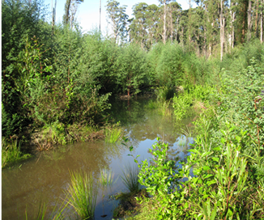  Wetland in Code means a permanent spring (or) swamy ground (or) wetland (or) (an)other body of standing water. A wetland may dry out seasonally. A wetland will support distinctive riparian vegetation.  We assessed the operation at this coupe to have harvested through a wetland, a non-conformance with major potential environmental impact.  We concede VicForests’ point that what we originally called wetland may have been dry when the coupe was marked. However, this is not inconsistent with the Code definition.  Defining what was effectively an ephemeral chain of ponds as a wetland rests on the presence of distinctive riparian vegetation. We accept that this was limited and perhaps lacking entirely. However we note that the area was harvested, burnt and then regenerated densely with eucalypts and fire-responsive understorey. Any distinctive riparian vegetation (other than reeds and sedges) may have been eliminated and may only recover over time.  We note that there is no or little regrowth within the ponds, suggesting that the May 2021 rainfall event was not the first time since regeneration that the ponds had standing water.  In the absence of definitive evidence of distinctive riparian species at the time of audit we no longer classify the area as a wetland. The ephemeral chain of ponds has been reclassified as a drainage line (as per Code definition). This was not identified in coupe planning and the required filter not marked and protected from harvesting machine entry (noting that harvesting is allowed). We consider there is a non-conformance incident and that the potential environmental impact is minor.
28 Wheel | 4.4 Operational planning and record-keeping; moderate potential environmental impact, third dot point: road design  4.5.4 Excessive spacing between temporary drainage structures on the main snig track | VicForests believes this issue which occurred in several coupes to be a planning issue, rather than an issue with moderate potential for environmental impact. Our observations in the field is that the soil test was incorrect and listed the soil erosion hazard at high when our observations in the field was that the soil erosion hazard was low to moderate. This being the case shouldn’t the main issue be a failure in planning rather than of environmental impact?  Drainage spacing was only inadequate in the field on the actual soil risk observed in one or two discrete locations. No significant movement of sediment was observed, all sediment was captured in the vegetation directly blow the outflow point, and no sediment was at risk of leaving the site or moving towards a stream. Extent score appears high base on the low soil erosion risk which was observed in the field. | We agree that the actual soil erosion hazard was not high and there was minimal evidence of soil movement along the main snig track.  However, as with 09 Charcuterie, drain spacing to manage the apparent risk of erosions should have been based on the recorded soil erosion hazard. As there is direct link between the drain spacing and potential erosion, the non-conformance was not considered to be only procedural.

Not all the compliance criteria were applicable to any of the audited coupes. Some criteria were found to not be applicable to any of the selected coupes.
The audits have been delivered by DELWP and its predecessor agencies, the Departments of Sustainability and Environment (DSE) and Environment and Primary Industries (DEPI).
Not all the compliance criteria were applicable to any of the audited coupes. Some criteria were found not to be applicable to any of the selected coupes.
This information was used to track the field assessments, but was not necessarily of sufficient quality to provide survey-grade information on buffer boundaries, in-coupe road locations, etc.
Multiple incidences of non-conforming drainage structure spacings on in-coupe roads, snig tracks and boundary were counted as single incidences of non-compliances (in each case).
Which may have been recorded against multiple instances of non-conformance with audit criteria.
Excessive slope is defined in the MSPs and is 25° (for granite derived soils in East Gippsland), 30° (elsewhere) or as specified in Table 11, Appendix 3 for water supply catchment areas.
In both cases, the recorded soil erosion rating was found by the auditor to be excessive. In most cases, drainage spacings were consistent with the actual soil erosion hazard. However, to effectively mitigate the potential erosion hazard, drainage spacing should have been constructed in response to the recorded erosion hazard.
Note that the regeneration burn incursion recorded here for 21 Galicia is a separate incident to the one assessed to have major potential environmental impact.
Note that the auditors assessed soil erosion hazard for 28 Wheel using the methods prescribed by the MSPs and considered that the rating for the B horizon was medium rather than high, as recorded in the FCP.
Note that as the waterway is a drainage line, the lack of a drainage structure is not, in itself, a nonconformance with MSP
Harvesting in 28 Wheel was interrupted by the 2019-20 fires and has not been recommenced at the time of audit field assessment.
There were 13 such incidents recorded in 2019-20, however 14 of 15 coupes in the Western Victorian RFA region did not have in-coupe roads (compared with eight in the current audit).
An example of good practice in snig track waterway crossing rehabilitation is shown (02 Onyx) in Figure 5.6
See https://engage.vic.gov.au/code-practice-timber-production. The period for public consultation closed 11:59 pm 29 July 2021.

