Electricity Safety (Registration and
Licensing) Amendment Regulations 2022
Regulatory Impact Statement

XXX Regulations 2022
  - Regulatory Impact Statement

delwp.vic.gov.au

Title
  - Subtitle

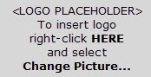 | 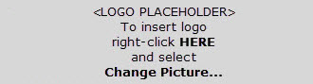


Acknowledgment
We acknowledge and respect Victorian Traditional Owners as the original custodians of Victoria's land and waters, their unique ability to care for Country and deep spiritual connection to it. We honour Elders past and present whose knowledge and wisdom has ensured the continuation of culture and traditional practices.
We are committed to genuinely partner, and meaningfully engage, with Victoria's Traditional Owners and Aboriginal communities to support the protection of Country, the maintenance of spiritual and cultural practices and their broader aspirations in the 21st century and beyond.
This publication may be of assistance to you but the State of Victoria and its employees do not guarantee that the publication is without flaw of any kind or is wholly appropriate for your particular purposes and therefore disclaims all liability for any error, loss or other consequence which may arise from you relying on any information in this publication.

Executive Summary
The safety of electricity supply and use is regulated within Victoria by the Electricity Safety Act 1998 (the Act). One of the unique safety mechanisms contained within the Act is a requirement for all prescribed electrical installations to be inspected and certified by a Licensed Electrical Inspector (LEI) prior to energisation. The Electricity Safety (Registrations and Licensing) Regulations 2020 (the 2020 Regulations) set out a framework of five classes of LEI, one of which is only available to existing holders of the licence class. These LEI licence classes reflect the broad types of prescribed electrical installations and their associated risk levels. Licences are granted by Energy Safe Victoria based on the ability of candidates to demonstrate the necessary qualifications, proficiency, and experience.
Currently, renewable electrical systems fall within Class G, a licence class which captures any prescribed electrical installations not included within the scope of any of the specialised licence classes. This Regulatory Impact Statement (RIS) considers the merits of removing renewable electrical systems from the broad remit of the Class G licence by introducing a new, risk-based class of LEI. The proposed Electricity Safety (Registration and Licensing) Amendment Regulations 2022 (Proposed Regulations) will amend the existing Electricity Safety (Registration and Licensing) Regulations 2020.
This RIS is part of Energy Safe Victoria’s commitment, in partnership with the Department of Environment, Land, Water and Planning (DELWP), to assess and identify the best option for creating a new licence for renewable electrical systems. The Proposed Regulations have been prepared in line with:
- The problems highlighted in the findings of the 2021 Review of entire electrical inspection regime prepared for Energy Safe Victoria (the 2021 Review)
- Energy Safe Victoria’s Response to the 2021 Review, which identified several key actions to improve the safety of electrical installations
- An Options Paper prepared by KPMG for the Minister for Energy, Environment and Climate Change, which summarised stakeholder consultations and assessed the risks and benefits of creating a new renewables class of LEI.
The scope of this RIS is limited to the installation-related safety issues associated with the inspection of prescribed renewable electrical installations. Energy Safe Victoria, Solar Victoria and DELWP are separately progressing other agreed actions to improve safety as outlined in Energy Safe Victoria’s Response to the 2021 Review. Any proposed regulatory changes to the broader LEI regime, including the application, audit and compliance framework, will, if required, be dealt with separately.
This RIS is prepared in accordance with the Victorian Guide to Regulation (2016), which provides a step-by-step guide to drafting a RIS.

The problem being addressed in the Regulations
The characteristics of renewable electrical systems include, but are not limited to:
- Being subject to regular change in technology and safety standards;
- Greater complexity than other low voltage systems or other prescribed works covered under the Class G licence;
- More likely to be exposed to harsh environments and often located in less accessible locations, which is a challenge for ongoing safety monitoring, thus reducing the margin of error in installation and inspection practices;
- Can be difficult to be de-energised. For example, solar panels are energised by sunlight and with batteries operating as a stored source of energy, despite being switched off; and
- A current-limited source which makes traditional electrical safety practices, such as short circuit protection, not applicable.
As outlined in the 2021 Review, the rate of unsafe and technical defects in prescribed renewable electrical systems, while improving, continues to be a residual problem in the current regime. Stakeholder consultations undertaken to inform the Options Paper prepared for the Minister for Energy, Environment and Climate Change, and this RIS, validated that the safety issues are considered a problem with the current regulations, specifically the broad remit of the existing Class G LEI licence.
In 2020-21, targeted audits of the Solar Homes program, which covers 80 per cent of domestic solar and battery installations in Victoria, indicated that 1.2 per cent of sampled solar installations had unsafe defects and 19.6 per cent of installations had technical defects requiring rectification. All installations had been inspected by an LEI as part of the energisation process and the defects had not been identified. This is particularly noteworthy as the Solar Homes program has additional quality and safety measures not currently available for renewable electricity system installations outside of the program – renewable installations outside of the program may have a higher rate of defects.
The poor identification of installation-related safety risks is a key residual problem of the existing Regulations. The number of defects identified by LEIs through the Certificate of Electrical Safety (COES) system is significantly lower than the number of defects identified in the findings of post-installation audits conducted by Energy Safe Victoria in 2019. While Licensed Electrical Installation Workers who are engaged by customers to install an electrical system have a responsibility to correctly install renewable electrical systems, LEIs are the final line of defence in ensuring only safe and compliant systems are energised.
The addressable rate of installation-related safety risks not being identified in renewable electrical system inspections is driven, in part, by the broad remit of the Class G licence. A range of industry stakeholders highlighted the importance of having LEIs with sufficient proficiency with renewable systems to reduce the safety risks of unsafe installations being certified. Prescribed renewable electrical systems have a unique risk profile which requires specialised skills that should be assessed at a level beyond what is currently required for the Class G licence.
In addition to ensuring LEIs who inspect renewable electrical systems have a baseline level of competency, the introduction of a renewable licence class will enable Energy Safe Victoria to introduce specialised continuing professional development. These development opportunities will be targeted at identifying issues with new and emerging renewable technologies.
Without further government action to mitigate the level of installation-related safety risk, the proportion of unsafe installations is likely to continue as the volume, size, and complexity of installed renewable electrical systems increases significantly. Stakeholders highlighted that a key source of safety risk arises from the existing LEI workforce having limited experience and competency working with the relatively newer renewable systems that have emerged in the industry in recent years. This risk is compounded by the small and ageing LEI workforce profile. Going forward, Victoria’s renewable electrical generation is expected to increase from 25 per cent of total capacity in 2020 to 56 per cent by 2030. This transition is supported by a range of Victorian Government initiatives, including the $1.3 billion Solar Homes program, the $540 million Renewable Energy Zone fund, and the Victorian Renewable Energy Auction scheme. As the volume of renewable systems grows into the future, there is likely to be a corresponding increase in unsafe installations if LEIs lack the necessary expertise to identify and resolve or report safety and compliance issues in renewable systems.

Objectives of the Proposed Regulations
The primary objective of the Proposed Regulations is to ensure the safety of electrical installations by inspecting them for compliance with safety and regulatory requirements prior to energisation. This objective is in line with the Victorian Government’s broader energy policy as well as the objectives of the Electricity Safety (Registration and Licensing) Regulations 2020 and the Electricity Safety Act 1998 to ensure the safety of electricity supply and use, the reliability and security of electricity, and the efficiency of electrical equipment.
In meeting the primary objective of the LEI regime, the objectives of the Proposed Regulations are to:
- Ensure electrical inspection work of prescribed renewable electrical installations is being undertaken by competent persons with appropriate skills and experience
- Improve the safety of renewable electrical installations for the public, electricity customers and electrical workers.
In meeting the primary objective of the LEI regime, the Proposed Regulations also aim to achieve three secondary objectives: minimising the impact and burden of any change on the LEI workforce, minimising the impact on the rollout of renewables, and minimising the impact on Energy Safe Victoria.
It should be noted that the Proposed Regulations do not explicitly refer to renewable energy systems but instead define the scope of the new licence class in reference to electricity generation systems and battery systems. This captures the fundamental functionality of renewable electricity systems whilst maintaining a degree of ‘future proofing’ by not utilising a prescriptive list of types of renewable electricity systems.

Options for addressing the problem
To address the problem in line with the objectives of the Proposed Regulations the analysis in the RIS has been undertaken in two parts. Part A of the analysis identifies several options relating to the introduction of a new specialised class of LEI to cover prescribed renewable electrical systems. Part B of the analysis assumes that a new specialised licence class for inspecting renewable systems has been introduced. Part B examines whether holders of the new licence also need to hold a Class G licence alongside the new licence (Option A2) against the Base Case - Status quo no requirement to hold the Class G Licence alongside the new specialised renewables licence class (Option A1).
The options have been evaluated against an assessment framework with scores assigned against each criterion ranging from minus five to five, with five representing a high alignment to the criterion in reference to the status quo and negative five representing low alignment. For each option identified, the following criteria was used to assess the benefits and costs:
- Safety outcomes (50 per cent weighting)
- Impact on LEIs – financial and administrative burden (25 per cent weighting)
- Impact on the rollout of renewables (15 per cent weighting)
- Impact on Energy Safe Victoria – administrative burden (10 per cent).
The options outlined in Part B assume that the preferred option in Part A, to introduce a new licence class, has been agreed to. The incremental burden of the impact analysis in Part B is the same regardless of whether the licence conditions are specified within or outside the Regulations (either Option A1 or Option A2 in Part A).
- Part A: The introduction of a new specialised class of LEI to cover renewable electrical systems
The Options analysed are:
- Base Case – Status quo (no new LEI licence class, meaning that prescribed renewable systems would continue to be inspected by LEIs with a Class G licence)
- Option A1 – New LEI licence class covering all renewable systems with conditions for small- and large-scale systems specified within the Regulations
- Option A2 – New LEI licence class covering all renewable systems with conditions for small- and large-scale systems specified outside the Regulations.
Under Options A1 and A2, there would be a transition period to allow existing Class G licence holders to inspect renewable electrical installations while applying for the new licence class. Energy Safe Victoria would assess the competency of existing licence holders based on experience without requiring them to sit an exam to be awarded the new renewables licence class.
Analysis of the options found that Options A1 and A2 are more aligned to improving safety outcomes than the status quo as they both ensure that LEIs would be required to demonstrate sufficient competency in inspecting and certifying the safety of prescribed renewable systems. Option A2 will achieve better safety outcomes as it does not list the licence conditions in the Regulations. This allows for ‘future-proofing’ of the LEI regime and flexibility to better address installation-related safety risks that may arise from emerging renewable system technologies. Furthermore, it does not have a broader cost to government to amend the Regulations if new technology types arise, as in Option A1.
Introducing a new licence class under both Options A1 and A2 has a financial impact on the LEI workforce associated with the cost and time taken to complete an LEI application, renew a licence, undertake further training and meet Continuing Professional Development (CPD) requirements. Under both options, the collective financial burden for the 46 Class G LEIs conducting 80 per cent of inspections under the Solar Homes program, if they only inspect renewable electrical systems are estimated to be $3,164 in upfront costs and savings of $0 in renewal costs every five years. There is an upfront cost of $68.78 (per LEI) for this cohort as it would take additional time to complete an LEI application for the new licence class compared to the status quo. As detailed in Error! Reference source not found. below, these costs only relate to Option A1 and Option A2 for existing Class G LEIs who only inspect renewables. Refer to Table 16 (page 32) for further detail on costs for other LEI cohorts and the assumptions behind these cost estimates.
Table 1: Estimated financial burden on Existing Class G LEIs who only inspect renewables (per LEI)
 | Status Quo | Cost of Options A1 & A2 compared to the status quo
Upfront costs | $0 as LEI already holds a Class G licence | $68.78 for the additional time taken to apply for the new licence class
Renewal costs every five years | $1,123.31 for the cost and time associated with undertaking CPD and licence renewal for the Class G licence | Savings of $0 as the new licence has the same total required hours of CPD compared to the status quo
* Note: Assumes that the preferred Option A2 is implemented.

However, the cost burden on the industry is expected to be greater than this because the size of the total workforce inspecting renewable installations is larger than the 46 Class G LEIs operating under the Solar Homes program. Data to estimate the total workforce size does not currently exist. Due to the nature of the industry, it is challenging to ascertain the likely financial impact of these options on the end-consumer. Option A2 may have a slightly greater negative impact on the LEI workforce than Option A1 due to the cost of uncertainty created by potential changes to the requirements and licensing conditions outside of the Regulations.
The introduction of a new licence will have some impact on the rollout of renewables under Options A1 and A2, in comparison to the status quo, as it may reduce the size of the LEI workforce eligible to inspect renewable systems. This is expected to be minimised by the introduction of a transition period and other measures currently underway to support LEI applicants. Energy Safe Victoria will incur increased financial costs to upgrade their systems and administer the new licence class under both Options A1 and A2 in comparison to the status quo.
The preferred option for Part A is therefore Option A2, to introduce a new class of LEI covering all prescribed renewable systems with licensing conditions specified outside of the Regulations.
- Part B: Requirement for the existing Class G licence to be held concurrently with the new licence class
Note that the Base Case in Part B assumes that a new, specialised licence class for inspecting renewable systems has been introduced. This section considers the following options:
- Base Case – Status quo (no requirement to hold the Class G licence alongside the new specialised renewables licence class)
- Option B1 – Require the Class G licence to be held alongside the new renewables LEI licence class.
Analysis of the options found that Option B1 is more aligned to improving safety outcomes than the status quo. It would ensure that LEIs have the foundational level of competency (through the Class G licence) in a broad range of electrical installations by being required to demonstrate a thorough knowledge and understanding of the AS/NZS 3000 Wiring Rules Standard and responsibilities of an LEI. Introducing a new class to address certain safety issues without requiring LEIs to also hold a Class G licence would increase the risk of additional issues arising in the future as renewable energy inspectors may not be competent in identifying safety issues related to the interaction with broader electricity systems.
Compared to the status quo, existing LEIs who only inspect renewables and prospective LEIs seeking to inspect renewables would face additional costs associated with applying for and maintaining the Class G licence as a second licence class. As illustrated in Table 2 below, while there is no additional application fee for holding two or more licence classes as the fee is waived for existing licence holders, there are other costs incurred by these cohorts associated with income forgone and meeting CPD requirements of the Class G licence. Only one application is required to apply for (or renew) one or more licence classes. Option B1 may cause some disruption to the rollout of renewables by restricting the supply of LEIs qualified to inspect renewable systems if the additional burden causes some LEIs to stop inspecting renewable systems. However, industry stakeholders indicated that an appropriate transition period alongside several measures, which are currently underway to support LEI applicants, would minimise any short-term impact to the rollout of renewables from this option. However, it is assumed that the impact on Energy Safe Victoria would be marginal as the cost of upgrading ESVConnect could be absorbed within the same system upgrades outlined in Part A and delivered at the same time. Refer to Table 18 (page 41) for further detail on costs for other LEI cohorts.
Table 2: Estimated financial burden on Existing Class G LEIs who only inspect renewables (per LEI)
 | Additional cost of Option B1 on top of Options A1 or A2*
Upfront costs | $0 as LEI would already hold a Class G and renewables licence class
Renewal costs every five years | $520.12 for the cost and time taken to undertake CPD for the Class G licence in addition to the renewable class (under Option A1 or A2, LEIs would not be required to hold a Class G licence ongoing alongside the renewable class)

The preferred option for Part B is therefore Option B1, to introduce a requirement for LEIs who hold the new renewables LEI licence class to also hold a Class G licence. This new requirement would only apply for the new renewables licence class. The Class H, V, M and L licences do not currently require the Class G licence to be held concurrently, and the Proposed Regulations would not change this.
In total, Table 3 below shows that the combined financial burden of preferred Option A2 and Option B1 for the 46 Class G LEIs conducting 80 per cent of inspections under the Solar Homes program, assuming that they would be required to maintain the Class G licence as well, is estimated to be $3,164 in upfront costs and $23,926 in renewal costs every five years. However, the cost burden on the industry is expected to be greater than this because the size of the total workforce inspecting renewable installations is larger than the 46 operating under the Solar Homes program. Data to estimate the total workforce size does not currently exist.
Table 3: Estimated financial burden on Existing Class G LEIs (46) who only inspect renewables (per LEI)
 | Status Quo | Cost of Options A1 & A2 compared to the status quo | Additional cost of Option B1 on top of Options A1 or A2* | Total additional cost of Options A1 or A2 + Option B1
Upfront costs | $0 as LEI already holds a Class G licence | $68.78 for the additional time taken to apply for the new licence class | $0 as LEI would already hold a Class G and renewables licence class | $68.78 in upfront costs
Renewal costs every five years | $1,123.31 for the cost and time associated with undertaking CPD and licence renewal for the Class G licence | Savings of $0 as the new licence has the same total required hours of CPD compared to the Class G licence under the status quo | $520.12 for the cost and time taken to undertake CPD for the Class G licence in addition to the renewable class (under Option A1 or A2, LEIs would not be required to hold a Class G licence ongoing) | $520.12 in renewal costs every five years

Implementation and evaluation plans
The Proposed Regulations will be implemented by Energy Safe Victoria through well-established, existing processes for changes to regulatory requirements. To support implementation, Energy Safe Victoria will undertake the following key actions:
- Develop licensing conditions for the new renewables licence class
- Develop the application process, including assessment and training requirements for the various licensing conditions
- Develop CPD requirements for the new renewables licence class
- Update ESVConnect and its website for the new renewables licence class
- Communicate the proposed changes to stakeholders.
These key actions will be undertaken alongside steps to mitigate potential risks identified as part of the risk assessment. Identified risks include disruption to the rollout of renewables, a potential reduction in the size of the LEI workforce, and the new licence class becoming not fit for purpose due to new safety risks from emerging technologies and subsequent changes to industry standards.
The Proposed Regulations will be evaluated by Energy Safe Victoria in conjunction with the timing of the review outlined in the Electricity Safety (Registration and Licensing) Regulations 2020 Regulatory Impact Statement, which proposed a mid-term review in three to five years. The Proposed Regulations will enable the collection of new data insights into the installation-related safety issues of a broader range of renewable systems than what is currently available through Energy Safe Victoria and Solar Victoria’s audit programs.
The Proposed Regulations will enable Energy Safe Victoria to collect detailed information about the size of the renewable electrical LEI workforce and the number of prescribed renewable electrical installations to complement existing audit data of solar installations. This will provide additional data to that which is currently available in Energy Safe Victoria’s audits of prescribed electrical installations and will enable the Proposed Regulations to be evaluated over time.

Summary of questions to stakeholders
In preparing this RIS, stakeholders from industry and government together with consumer representatives were consulted on a number of questions to support the development and evaluation of the proposed options. DELWP welcomes further responses to the questions below from stakeholders as they review this RIS.

Table 4: Summary of questions to stakeholders
Questions for stakeholders
- Are there any other problems within the existing LEI regime related to the inspection of prescribed renewable electrical systems?
- Does the assessment in Part A accurately represent the financial and administrative costs to LEIs associated with the options to introduce a new class of renewable licence class?
- Which option in Part A best ensures that only competent LEIs are inspecting and certifying renewable systems?
- Are there any additional impacts on LEIs, the rollout of renewables or Energy Safe Victoria that are not reflected in the options analysis of Part A?
- Does the assessment in Part B accurately represent the financial and administrative costs to LEIs associated with the proposal to require LEIs to hold a Class G licence alongside the new renewables licence class?
- Which option in Part B best ensures that only competent LEIs are inspecting and certifying renewable electrical systems?
- Are there any additional impacts on LEIs, the rollout of renewables and Energy Safe Victoria that are not reflected in the options analysis of Part B?

Contents
Executive Summary 1
The problem being addressed in the Regulations 1
Objectives of the Proposed Regulations 2
Options for addressing the problem 3
Part A: The introduction of a new specialised class of LEI to cover renewable electrical systems 3
Part B: Requirement for the existing Class G licence to be held concurrently with the new licence class 5
Implementation and evaluation plans 6
Summary of questions to stakeholders 7
Contents 8
Abbreviations used in this document 10
1 Introduction 11
1.1 Scope of this RIS 11
1.2 Overview of the Licensed Electrical Inspector (LEI) regime 11
1.3 Overview of the Electricity Safety (Registration and Licensing) Regulations 2020 12
1.4 Overview of the work to-date 13
2 The nature of the problem 15
2.1 The primary problem addressed through the LEI regime 15
2.2 The problem addressed in the Proposed Regulations 15
Unsafe and technical defects in renewable electrical systems are not being identified under the current inspection regime 16
The broad mandate for the existing Class G licence does not support positive safety outcomes for renewable electricity systems 19
Safety risks are expected to increase into the future as the volume of renewable installations continues to increase 20
3 Objectives 23
4 Options 24
4.1 Overview of options 24
Part A: Introduction and design of a new specialised class of LEI to cover renewable electrical systems 24
Part B: Requirement for the existing Class G licence to be held alongside the new licence class 25
4.2 Options not progressed to impact analysis 26
4.3 Non-regulatory options 27
5 Impact Analysis 28
5.1 Introduction and Analysis Framework 28
Assessment of benefits 28
Assessment of costs 28
5.2 Analysis of options 30
Part A: Introduction and design of a new specialised class of LEI to cover renewable electrical systems 30
Part B: Requirement for the existing Class G licence to be held alongside the new licence class 40
6 Preferred Option 44
6.1 Summary of the Proposed Regulations 44
Part A: Introduction and design of a new specialised class of LEI to cover renewable electrical systems 44
Part B: Requirement for the existing Class G licence to be held alongside the new licence class 44
6.2 Impact on Small Business 44
6.3 Statement of Compliance with National Competition Policy 45
7 Implementation Plan 46
7.1 Overview of key actions 46
7.2 Monitoring 47
7.3 Risk Assessment 47
8 Evaluation Strategy 50
Appendix A: Stakeholders 51
Appendix B: Proposed Electricity Safety (Registration and Licensing Amendment 52

Abbreviations used in this document
Acronym | Meaning
2019 Regulations | Electricity Safety (General) Regulations 2019
2021 Review | Review of entire electrical inspection regime
AEMO | Australian Energy Market Operator
COES | Certificate of Electrical Safety
CPD | Continuing Professional Development
DELWP | Department of Environment, Land, Water and Planning
EBA | Enterprise Bargaining Agreement
ESV | Energy Safe Victoria
ETU | Electrical Trades Union
LEI | Licensed Electrical Inspector
Proposed Regulations | Electricity Safety (Registration and Licensing) Amendment Regulations
PV | Photovoltaic
RIS | Regulatory Impact Statement

Introduction

Scope of this RIS
This Regulatory Impact Statement (RIS) analyses the implementation of Victoria’s Licensed Electrical Inspector (LEI) regime as it applies to renewable electrical systems for the proposed Electricity Safety (Registration and Licensing) Amendment Regulations 2022 (Proposed Regulations). The Proposed Regulations are intended to make minor amendments to the existing Electricity Safety (Registration and Licensing) Regulations 2020.
The purpose of this RIS is to:
- Identify and define the problem
- Articulate the desired objectives of addressing the identified problem
- Identify a set of viable options to address the identified problem
- Assess the impacts of these options, and the expected effectiveness of each option in addressing the problem
- Identify and describe a preferred option to achieve the desired objectives
- Develop an implementation plan and evaluation strategy for the preferred option
- Establish the nature and extent of the problem that would exist if the existing Electricity Safety (Registration and Licensing) Regulations 2020 were not amended.
This RIS is part of Energy Safe Victoria’s commitment, in partnership with the Department of Environment, Land, Water and Planning (DELWP), to assess and identify the best option for creating a new, risk-based licence for renewable electrical systems. The Proposed Regulations have been prepared in line with:
- The problems highlighted in the findings of the 2021 Review of entire electrical inspection regime prepared for Energy Safe Victoria (2021 Review)
- Energy Safe Victoria’s Response to the Review, which identified several key actions to enhance the LEI regime
- An Options Paper prepared for the Minister for Energy, Environment and Climate Change, which summarised stakeholder consultations and assessed the risks and benefits of creating a new renewables class of LEI.
This RIS and the corresponding Proposed Regulations focus only on the problems related to the inspection of prescribed renewable electrical installations under the broad remit of the Class G licence. The other agreed actions to improve safety contained in Energy Safe Victoria’s Response to the 2021 Review are being progressed separately by Energy Safe Victoria, Solar Victoria and DELWP. Any proposed regulatory changes to the broader LEI regime, including the application, audit and compliance framework, will be dealt with separately, if required.
This RIS is prepared in accordance with the Victorian Guide to Regulation (2016), which provides a step-by-step guide to drafting a RIS.

Overview of the Licensed Electrical Inspector (LEI) regime
The purpose of the LEI regime is to ensure the safety, reliability, and efficiency of electrical installations across Victoria. Under the Electricity Safety Act 1998 and Electricity Safety (General) Regulations 2019 (2019 Regulations)., LEIs are responsible for inspecting and certifying all prescribed electrical installations, including renewable electrical systems. LEIs are required to identify and report any non-compliant installations to the Licenced Electrical Installation Worker who did the work for rectification prior to an installation’s energisation. These non-compliances are also required to be noted on the Certificate of Inspection, completed by the LEI, unless they can be rectified at the time of inspection. All electrical installation work is categorised as prescribed or non-prescribed work, with prescribed electrical installation work being more complex or posing a higher risk if non-compliant. Prescribed works require certification by an LEI prior to the energisation of the system.
Energy Safe Victoria licences LEIs who are then independently engaged and paid for by electricians or contractors to inspect prescribed works. To be issued with a licence, Energy Safe Victoria must be satisfied that an individual has demonstrated the necessary qualifications, experience, competence, and proficiency to carry out inspection work. Applicants for the Class G licence are required to pass the Class G Theory, Safe Approach and Class G Practical Assessments conducted by Future Energy Skills.
LEIs perform inspections of electrical installations for safety and compliance with the regulatory requirements listed under the 2019 Regulations. The 2019 Regulations detail the inspection process and requirements.
Installations that are deemed compliant with the relevant standards receive a signed Certificate of Inspection by an LEI to record compliance on the Certificate of Electrical Safety (COES). A copy of the COES is provided to the customer, relevant distribution business, and Energy Safe Victoria. As the regulator, Energy Safe Victoria also conducts periodic audits following inspection and energisation of a number of prescribed and non-prescribed works to monitor the rate and nature of identified defects.

Overview of the Electricity Safety (Registration and Licensing) Regulations 2020
The Electricity Safety (Registration and Licensing) Regulations 2020 set out the framework for issuing of licences to LEIs, including the:
- Issuance of separate licence classes of electrical inspection work for general and specialised inspections, including restrictions on the type of work that can be inspected
- Qualification, competency, and experience requirements to attain a licence
- Registration and renewal processes for licences, including the ability for Energy Safe Victoria to set Continuing Professional Development (CPD) requirements
- Setting of fees for the issuance and renewal of electrical licences
- Penalties for non-compliance with the Regulations and infringement notices for some offences.
The LEI scheme has a general Class G licence and several specialised classes of licences for installations requiring specialised knowledge and competencies (refer to
Table ). Applicants are required to demonstrate specific competencies and requirements to be issued a specialised class in recognition of the different risk profiles and standards that exist across various types of electrical installations. Currently, a Class G licence is not a prerequisite for any of the specialised classes. Prescribed renewable electrical systems can be inspected with a Class G licence under the existing LEI scheme.

Table 5: Licence classes of electrical inspectors
Licence | Description
Class G | Allows inspection of any low voltage installation (including renewable electrical systems such as solar photovoltaics (PV), except those specified under Class H, V, and M.
Class H | Allows inspection of electrical equipment installed in a hazardous area and / or associated with the protection of the hazardous area.
Class V | Allows inspection of high voltage installations (specific restrictions apply).
Class M | Allows inspection of fixed electrical equipment installed in a patient area (e.g., medical equipment).
Class L | Allows inspection of single-phase consumer mains, main earthing systems, main switchboards and consumer terminals connection devices only. This class is currently being phased out and only existing holders are permitted to renew their licence.

Overview of the work to-date
Prior to the development of this RIS, several key activities have been undertaken by Energy Safe Victoria, DELWP and other stakeholders to address the prevalence of installation-related safety issues within the existing LEI scheme. This RIS is informed by an Options Paper prepared for the Minister for Energy, Environment and Climate Change in late 2021 by KPMG in consultation with key stakeholders. Table 6 below outlines the scope and outcomes of these activities as it relates to the Proposed Regulations.

Table 6: Overview of work to-date
Key activity | Description
Review of entire electrical inspection regime (2021) | The Review was undertaken in two parts to examine the installation-related safety issues identified through the Solar Victoria audit program and concerns of broader systemic issues across the LEI regime. Issues identified during audits were not reported (or identified) by the LEI who certified the electrical installation at the time of inspection.  - An interim 2020 Review made three short-term recommendations to improve safety outcomes in solar system installations. (https://esv.vic.gov.au/pdfs/final-report-review-of-entire-electrical-inspection-regime/)  - The final 2021 Review made the following eight comprehensive strategic recommendations related to improving the entire inspection regime. (https://esv.vic.gov.au/pdfs/interim-review-report-solar-systems/)  - Institute additional training requirements and strengthen LEI assessments  - Introduce additional risk-based LEI licence classes  - Mandate Continuous Professional Development  - Implement robust, risk-based and data-driven auditing  - Establish a professional institute for LEIs or assist the Institute of Electrical Inspectors (IEI) to increase its effectiveness and reach  - Use insights derived from improved audits to inform regulatory activities  - Strengthen enforcement of obligations on LEIs and electricians  - Improve communications and educative activities.  Recommendation 2 of the Review: Introduce additional risk-based LEI licence classes, specifically for renewable electricity systems, e.g., solar photovoltaic (PV) systems, by seeking amendments to the Electricity Safety (Registration and Licensing) Regulations 2020. It identified that the broad mandate of the Class G licence within the scheme was a significant issue resulting in inspectors not being sufficiently competent to inspect and certify renewable electrical systems.
Energy Safe Victoria’s Response to the Review (2021) | Energy Safe Victoria’s Response to the Review acknowledges the need for improvements to the LEI regime and outlines a number of detailed actions to improve safety in broad areas for improvement. These include:  - Increased industry education / communication  - Training and assessment of LEIs  - Continuing to work with Solar Victoria to establish solar-specific training for LEIs  - CPD requirements for electrical workers, including LEIs  - Additional technical support to LEIs  - Collection of audit data for inspections arising from submitted COES  - Increased analysis and use of data extracted from COES  - Increased data sharing between Solar Victoria and Energy Safe Victoria  - Energy Safe Victoria is strengthening compliance and enforcement approaches.  In response to the Review, Energy Safe Victoria committed to working with DELWP to assess the risks and benefits of introducing a new class under the “Training and assessment of LEIs” area for improvement.
Options Paper – Introduction of a Renewable Electrical Systems Class of Licensed Electrical Inspectors (2021) | The Options Paper explores and evaluates options related to the introduction of a new class of LEI to cover renewable systems as part of Energy Safe Victoria’s commitment to address Recommendation 2 of the 2021 Review in partnership with DELWP. The Options Paper was prepared for the Minister for Energy, Environment and Climate Change and informed by stakeholder consultations. It concluded that:  - There is a need for a new renewable electrical systems class of LEI which covers all types of prescribed renewable electrical systems, is a single class of LEI with multiple licensing conditions, and is held concurrently with the Class G licence  - No further changes to the oversight and compliance regime are required at this time  - Additional measures to support the implementation of the regulatory changes need to be progressed.
Complementary initiatives that are planned or currently underway | - Energy Safe Victoria will introduce mandatory requirements for CPD training for all licence renewals in 2023 to ensure the ongoing competency of existing licence holders.  - Energy Safe Victoria has improved LEI assessment policies and their data sharing capabilities to proactively address safety issues and has established a dedicated renewable electricity team whose focus is on increasing compliance in those systems.  - Energy Safe Victoria is working with Future Energy Skills on a Workforce Training and Innovation Fund application for government funding to develop the full Certificate IV in Electrical Inspection, which will include basic and solar inspection components.  - Solar Victoria has appointed Future Energy Skills to develop learning and assessment material for prospective inspectors seeking a specialisation in renewable electrical systems, which includes investing $11 million over the life of the Solar Homes program to deliver this subsidised training and upskill the workforce.

The nature of the problem

The primary problem addressed through the LEI regime
Electrical work and unsafe installations are inherently dangerous. Electricity has the potential to cause serious injuries or death through contact with live electrical parts, or through fires and explosions.
Consistent with the objectives of the Electricity Safety Act 1998, the primary objective of the LEI regime is to ensure the safety of prescribed electrical installations by inspecting them for compliance with regulatory requirements prior to energisation, independent of the Licenced Electrical Installation Worker.
The privatised inspection regime is unique to Victoria and is one of many mechanisms that government uses to guard against electrical safety risk. Mechanisms to promote electrical safety include:
- Qualified electricians: restrictions to ensure appropriate training, assessment, and capability
- Product standards: stringent specifications for appliances and equipment, and the ability to recall products
- Installation standards and requirements: the rules electricians must follow when conducting installations
- Electrical inspection regime: appropriately qualified personnel checking installation compliance (including LEIs inspecting every prescribed installation)
- Electrical audit regime: Energy Safe Victoria audits a percentage of prescribed installations that have been certified by LEIs. In addition, Solar Victoria performs a risk-based, independent audit on solar and battery systems installed under the Solar Homes program.

The problem addressed in the Proposed Regulations
While the existing LEI regime is set up for specialised classes of LEI, a renewables class of licence is not currently offered, and inspections of renewable systems are conducted under the remit of the Class G licence. The Proposed Regulations respond to the problem outlined in Energy Safe Victoria’s two-stage Review of entire electrical inspection regime, which identified a high rate of addressable installation-related safety risks in renewable electrical systems that were not identified or reported on the COES by the LEI prior to energisation. The 2021 Review identified that this residual problem relates to the broad mandate of the Class G licence.
Energy Safe Victoria has formally responded to the 2021 Review and is progressing several actions outside the scope of this RIS to improve safety. This RIS examines Energy Safe Victoria’s commitment to assess the risks and benefits of introducing additional specialised LEI licence classes, with the assistance of DELWP, in response to the level of installation-related safety risk in these systems. As detailed in Section 1.4, the other recommendations and findings of the two-stage 2021 Review are not within the scope of this RIS or the Proposed Regulations.
Under the status quo option, Class G LEIs inspecting and certifying renewable systems are not required to be assessed in their knowledge and expertise with such specialised systems. Renewable electrical installations include a range of small and large-scale solar and battery storage systems, wind and hydropower technologies. These installations are classified as prescribed electrical installation work due to their greater complexity, higher risk profile, inability to be easily de-energised, and being in often inaccessible locations such as on a rooftop. As prescribed installations, they must be inspected and certified by an independent LEI prior to being connected to a premises’ electrical system and the broader electricity grid. Stakeholders indicated that most renewable electrical installations currently undertaken are small-scale, rooftop solar PV systems.
This section will outline the need for further government action to address safety risks relating to renewable energy installations within the LEI regime. It outlines how:
- Instances of unsafe and technical defects in renewable electrical systems are not being identified under the current inspection regime, as outlined in the 2021 Review
- The broad mandate for the Class G licence is a key driver of poor safety outcomes as there is no explicit requirement for inspectors to demonstrate relevant experience, competency, or training to certify renewable electrical systems
- Renewable electrical systems have a different risk profile and require specialised knowledge for their inspection
- While the prevalence of safety risks has steadily reduced, they are expected to proportionately increase into the future as the volume of more complex renewable installations grow.
The analysis in this section is limited by the availability of data held by government agencies, with comprehensive audit data available only from Solar Victoria. This data covers approximately 80 per cent of domestic solar installations in Victoria. Quantitative data on other new and emerging renewable technologies is not currently available. Stakeholder consultation confirms that the problem exists outside of the solar industry and is an issue across prescribed renewable electrical systems more broadly.

Question for stakeholders
- Are there any other problems within the existing LEI regime related to the inspection of prescribed renewable electrical systems?

Unsafe and technical defects in renewable electrical systems are not being identified under the current inspection regime
Audit findings and complaints received by Energy Safe Victoria and Solar Victoria have identified that an addressable level of installation-related safety risks in renewable electrical systems continues to be a significant concern. Under the current inspection regime, there are two types of installation-related safety risks: technical defects and unsafe defects.
According to Energy Safe Victoria, technical defects are defined as when an electrical installation does not comply with applicable legislation, regulations and standards. These vary from minor clerical issues with certificates to higher risk issues such as incorrect switchboard labelling. When an installation does not comply with appropriate safety regulations and poses an imminent and significant risk to life or property, the identified defect is classified as ‘Unsafe’.
Common types of technical and safety defects for solar installations include mismatched DC connectors, inadequate earthing, the inverter not being affixed correctly, non-compliant mounting frame installation, cable entries to electrical enclosures, and damage to low voltage cables (refer to Table 7).
Unsafe systems have the potential to cause damage to both property and life. Random inspections undertaken by the Clean Energy Regulator across Australia of small-scale PV systems found that half of the systems rated as unsafe or potentially unsafe have issues with DC isolators. According to Fire Rescue Victoria, approximately 85 per cent of fire incidents caused by solar PV systems between January 2014 and January 2019 were attributed to DC isolators. Additionally, between January 2015 and December 2020, the Country Fire Authority reported that DC isolators were believed to be the cause of 65 fire incidents out of a total of 188 fires involving solar installations. Fires spread to the surrounding building structure in 11 of these incidents due to the placement of the DC isolator.
Table 7: Examples of safety and quality issues identified through Energy Safe Victoria and Solar Victoria audits
Safety and Quality Issue
Mismatched DC connectors | 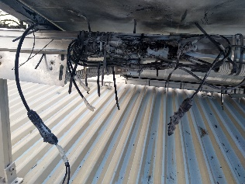  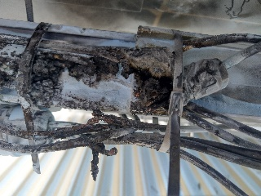 | Inadequate earthing | 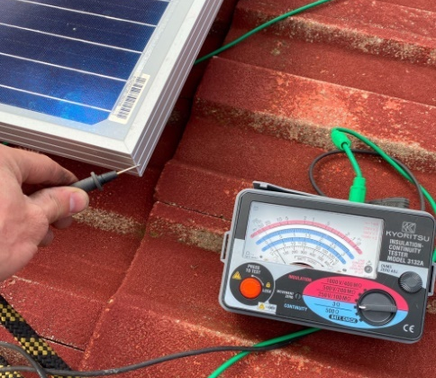  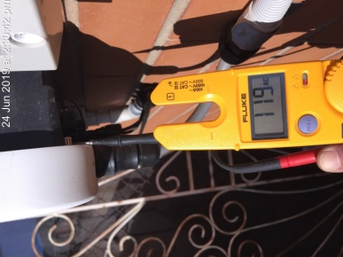
DC isolator at the array(s) not correctly wired | 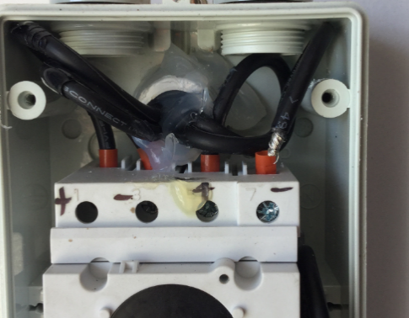  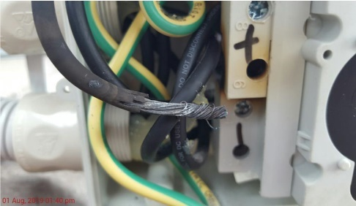 | Water damage and signs of water ingress to the ground and roof DC isolator | 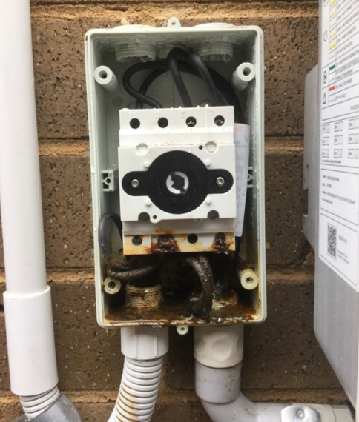  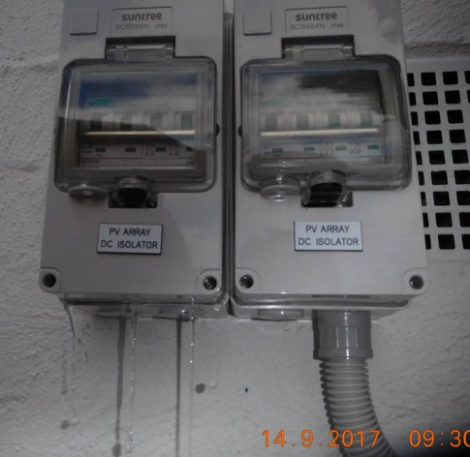

While Licenced Electrical Installation Workers have a responsibility to correctly install renewable electrical systems, LEIs are the final line of defence in ensuring only safe, compliant systems are energised and that defective installations are reported to Energy Safe Victoria through the COES.
The compliance regime in Victoria is unique in that each installation is required to be inspected by an LEI. A like-for-like comparison between each jurisdiction is not possible given that there are several variables, such as defined interpretations of safety risk measures, audit checklists and practices, and government incentive programs that influence demand. Other jurisdictions place a higher emphasis on post-energisation audits and adopt a sampling approach pre-energisation (or in some cases do not require an inspection), whereas Energy Safe Victoria requires LEIs to inspect all prescribed installations prior to energisation in addition to post-energisation audits. Notwithstanding these limitations,
Table outlines the differing compliance regimes for the inspection of renewable electrical installations across Australian jurisdictions.

Table 8: Inspections of renewable electrical installations across Australian jurisdictions prior to energisation
VIC | NSW | QLD | TAS | ACT | NT | SA | WA
Inspection by an LEI (and Distribution Business for new connections) | No inspection is required | Auditor appointed by the regulator | Auditor contracted by the regulator | Inspected by distribution businesses / network operator
Source: Review of entire electrical inspection regime (2021), Energy Safe Victoria.

Despite each renewable electrical installation being certified as compliant by an LEI, targeted audits undertaken of the Solar Homes program in 2020-21 indicate that 1.2 per cent of solar installations sampled had unsafe defects and 19.6 per cent of installations had technical defects requiring rectification (refer to Figure 1). Approximately five per cent of Victoria’s installations completed under the Solar Homes program are audited. The Solar Victoria audit program is risk-based, with 60 per cent of audited solar installations classified as high risk. These audit findings show that, while safety outcomes are steadily improving, there is room for further improvement to both achieve and maintain the target of less than one per cent unsafe defects and become an industry leader in safety. While technical defects may not pose an immediate risk to life or property, in some instances they may result in long-term safety issues.
The Solar Victoria audit findings data is limited to the installations in the Solar Homes program, which includes domestic solar PV systems and more recently battery installations. This data is not fully representative of the entire renewables sector as it does not include the approximately 20 per cent of solar electrical systems installed outside the Solar Homes program, which are subject to lower rates of audit activity and program compliance obligations and have a potentially higher degree of safety risks than those outlined in Figure 1.
The Solar Homes program has additional safety and compliance measures to reduce the level of installation-related safety risks. These include requiring all installers under the Solar Homes program to attain the Clean Energy Council’s Solar Accreditation Certificate, and a pilot six-month mentorship program for LEIs in partnership with National Electrical and Communications Association. Solar Victoria also notifies Energy Safe Victoria if a PV installation is found to be unsafe or has major non-compliance issues.
Figure 1: Solar Victoria audit findings and compliance rate (2018-2021)
Source: Solar Victoria Audit Program Snapshot, 30 August 2021.
Energy Safe Victoria’s audit findings in 2019 also found a significant discrepancy between the number of defects identified by Energy Safe Victoria and those reported by LEIs for solar installations (refer to
Table 9). Energy Safe Victoria audited approximately two per cent of all prescribed works. The findings suggest that the poor identification of defects is, in part, driven by a lack of appropriate LEI competency. It should be noted that compliance data outlined above was limited to solar installations and excludes other types of renewable electrical systems, such as battery installations, which stakeholders indicated were likely to have fewer installation-related issues but still posed safety issues.

Table 9: Comparison of rate of defects in solar installations (2019)
% | Unsafe defects | Technical defects | Total defects
Energy Safe Victoria audit | 1.7 | 14.2 | 15.9
LEI reported | - | - | 0.1
Source: Review of entire electrical inspection regime (2021).
Note: LEI reported figure is based on Energy Safe Victoria’s analysis of COES data.

The broad mandate for the existing Class G licence does not support positive safety outcomes for renewable electricity systems
The broad remit of the Class G licence, which allows for the inspection of all prescribed installations not covered by the existing specialised classes, has contributed to addressable installation-related safety risks not being identified through inspections of renewable electrical system installations. This is, in part, a result of applicants not being required to be assessed on their knowledge and expertise with such specialised systems. Ensuring LEIs are competent in the systems they are inspecting is important, with the 2020 Interim Report on solar systems noting that many installers lack the knowledge and skillset to safely install renewable electrical systems.
LEIs need to be sufficiently qualified to inspect prescribed works (including renewable electrical systems) prior to energisation to ensure installed works are safe and compliant with the relevant standards. Prescribed works are typically more complex and pose a higher level of risk than non-prescribed works, which can be self-certified by a Licenced Electrical Installation Worker. If an issue is identified and cannot be rectified on-site, the LEI is required to notify the electrician or contractor responsible for the installation.
While some LEIs have a sufficient understanding of renewable electrical systems, a range of industry stakeholders indicated that renewable electrical systems have a different risk profile and require specialised knowledge for their inspection. Renewable electrical systems are:
- Subject to regular changes in technology and safety standards
- More complex than other low voltage systems or other prescribed works covered under the Class G licence
- More likely to be exposed to the harsh environments and often located in less accessible locations, which is a challenge for ongoing safety monitoring, thereby reducing the margin of error in installation and inspection practices
- Can be difficult to de-energise, with solar panels, for example, energised by sunlight and with batteries operating as a stored source of energy despite being switched off
- A current-limited source which makes traditional electrical safety practices, such as short circuit protection, not applicable.
Applicants for the Class G licence are required to have held an Electrician’s licence and to pass the theoretical and practical assessments. Under the proposed changes, an LEI holding a Class G licence will still be eligible to inspect a significant portion of the prescribed electrical installation work defined under the 2019 Regulations. This includes such works as, but not limited to: consumers’ mains, main earthing systems, consumers’ terminals, connection devices for consumers’ mains and replacement or upgrade of a main switchboard. While attaining the Class G licence would provide LEIs with a foundational level of competency in the technical aspects for a broad range of electrical installations, it is not sufficient to ensure coverage of the specific skills required to inspect and certify solar and other renewable electrical systems. Aside from the broad Class G licence assessment, there are no specific training or knowledge requirements for an LEI to inspect renewable electrical systems or any of the other prescribed installations covered under the Class G licence. Refer to
Table for further detail on assessment requirements of the Class G licence.

Table10: Assessment requirements of the Class G licence
Requirements | Description
Class G Theory assessment | Involves a written examination on a broad range of electrical knowledge.
Safe Approach assessment | Inspection and testing of electricity supply for construction purposes.
Class G Practical assessment | Inspection and testing of domestic/commercial/industrial electrical installations.
Source: Energy Safe Victoria
Note: The minimum pass mark for each assessment is 75 per cent.

Solar Victoria has developed a training program in partnership with Future Energy Skills to upskill its LEI workforce in renewable electrical systems, although it is not currently a prerequisite to be granted a Class G licence. There is scope in the existing Regulations to mandate a training course as part of an LEI application or CPD requirements, however, this does not address the identified residual problem. Furthermore, it would be impractical to require prospective Class G licence holders to undertake training in all renewable systems as not all Class G LEIs would seek to inspect renewable systems. The LEI assessment for the Class G licence includes a limited number of questions on solar installations and does not require applicants to demonstrate sufficient knowledge of the installation standards for renewable electrical systems. Inspectors are not required to demonstrate ongoing competency in solar installations or any expertise in other types of renewable electrical systems, such as battery storage or wind installations. This means an applicant can be granted a Class G licence to inspect renewable electrical systems without holding a licence or demonstrating sufficient understanding of these systems.

Safety risks are expected to increase into the future as the volume of renewable installations continues to increase
The Victorian Government has committed to achieving net zero emissions by 2050 under the Climate Change Act 2017. The legislation mandates interim targets every five years to ensure this goal is reached. Achieving this goal will require significant changes to Victoria’s electricity landscape. It is supported by Victoria’s Renewable Energy Target. Under the Renewable Energy (Jobs and Investment) Act 2017, 50 per cent of Victoria’s electricity generation must come from renewable sources by 2050.
The Victorian Government has implemented a range of programs to realise this goal. This includes support for the 300 MW Victorian Big Battery project in Geelong, the establishment of six Renewable Energy Zones across the State enabled by a $540 million fund, and the Victorian Renewable Energy Auction Scheme. The $1.3 billion Solar Homes program, administered by Solar Victoria, has underpinned the widespread adoption of rooftop solar systems across the State. This program has provided rebates for more than 80 per cent of the 70,000 residential solar panel installations in 2020. Under the program, eligible Victorian households can also access a Solar Homes’ battery rebate of up to $3,500 when they bundle their new rooftop solar with battery storage, as of October 2021. Alongside changing consumer preferences and an awareness of the need to respond to climate change, these programs have contributed to renewable energy accounting for an increased share of electricity generation in Victoria over the last decade.
Going forward, Victoria’s renewable electrical generation is expected to increase from 25 per cent of total capacity in 2020 to 56 per cent by 2030. The increased adoption of residential solar systems, as well as the commissioning of larger solar panel and wind turbine farms, are expected to contribute to a considerable amount of this growth, with battery storage playing a key role in improving the reliability of renewable energy generation. Coupling batteries with renewable energy generation allows that energy to be stored during times of low demand and released (or dispatched) at times of peak demand. In 2019-20, the major contributions to renewable generation in Victoria were wind generation (about 12.2 per cent of total generation), solar power, including both large-scale and rooftop solar (about 6.6 per cent of generation), and hydroelectricity (around 4.5 per cent of generation). Other types of renewable electrical systems include geothermal, bioenergy and ocean energy, with technologies such as hydrogen fuel cells potentially playing a role in the future.
Despite the prevalence of unsafe installations decreasing historically (refer to Figure 1), stakeholders indicated the increased adoption of renewable energy requires a fit-for-purpose inspection regime. Victoria’s future energy landscape will have a diverse mix of commercial and residential scale installations from a range of renewable energy sources. The Australian Energy Market Operator (AEMO) reported that more than 80 per cent of proposed energy projects in Victoria are expected to be from renewable electrical systems, including wind, solar and battery storage (refer to
Figure 2). Thus, the installation-related safety risks are expected to increase as Class G licence holders are currently able to inspect renewable installations without demonstrating competency in the specific safety requirements.
The safety risks are expected to increase into the future due to the size and composition of the existing LEI workforce. Stakeholders highlighted that as the LEI workforce is ageing, with many of the current LEIs becoming inspectors several years ago, it is difficult for them to have attained a sufficient level of experience and competency in working with relatively newer renewable systems.

Figure 2: Proposed projects by type of generation and National Electricity Market region, beyond those already committed
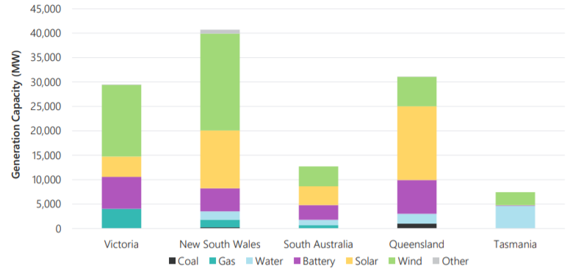
Source: AEMO July 2021
New renewable electrical systems have a higher risk-profile, with modern systems typically larger and more complex than in previous years. For example, the average small-scale solar installation in Australia had doubled in capacity to 8.7 kilowatts in December 2019, in comparison to an average of 3.6 kilowatts in the period between 2001 to 2017. Victoria’s Renewable Energy Zones will also see the proliferation of large-scale solar and wind installations. Technological advances, and the increasing size and complexity of renewable electrical systems, have significant consequences for safety as LEIs, under the existing inspection regime, may lack sufficient competency to identify non-compliant installations.
Battery storage systems will also play an increasingly important role into the future as more renewable electrical systems are commissioned. Battery infrastructure is required to store the excess capacity generated by renewable energy generating systems that are more volatile than traditional fossil-fuel burning powerplants. These complex systems pose their own unique safety challenges as they are off-grid power sources. LEIs are not required to demonstrate competency and/or experience working with batteries to be granted a Class G licence and are unlikely to fully comprehend the significant safety issues posed by battery storage, which may continue to generate electricity into a system even when the main switch is turned off.

Objectives
The Victorian Government’s energy policy emphasises the sustainable, secure, reliable, and affordable supply of electricity and other forms of energy. Relevant to this RIS is that the government has articulated a goal of promoting the safe supply and use of electricity in the Electricity Safety Act 1998.
The objectives of the Electricity Safety (Registration and Licensing) Regulations 2020 give effect to the objectives of the Electricity Safety Act 1998, which are to ensure the safety of electricity supply and use, the reliability and security of electricity, and the efficiency of electrical equipment.
Options to address the problem identified in Section 2.2 are expected to support the achievement of the primary objective of the LEI regime to ensure the safety of electrical installations by inspecting electrical installations for compliance with regulatory requirements prior to energisation.
In meeting the primary objective of the LEI regime, the objectives of the Proposed Regulations are to:
- Ensure electrical inspection work of prescribed renewable electrical installations is being undertaken by competent persons with appropriate skills and knowledge of the relevant installation requirements in renewable electrical installations
- Improve the safety of renewable electrical installations for the public, electricity customers and electrical workers.
In meeting the primary objective of the LEI regime, the Proposed Regulations aim to achieve three secondary objectives. These are minimising the impact and burden of any change on the LEI workforce, on the rollout of renewables, and on Energy Safe Victoria.

Options
Options have been identified in reference to the objectives and the nature of the problem outlined in the previous two sections of this RIS. Options determined to be feasible are subjected to a consistent impact analysis framework set out in Section 5.1.
Proposed options have been identified in two parts:
- Part A: The introduction and design of a new specialised class of LEI to cover renewable electrical systems
- Part B: The requirement for the existing Class G licence to be a prerequisite for the new licence class.
Options in Part A have been designed with an appropriate transition period to minimise any impact on the LEI workforce and disruption to the rollout of renewable electrical installations. Energy Safe Victoria would assess the competency of existing licence holders based on experience without requiring them to sit an exam to be awarded the new renewables licence class.
The option in Part B requiring the existing Class G licence to be held concurrently with the new class of licence assumes that a new LEI licence class covering all prescribed renewable installations be introduced.
Several other options have been considered but not progressed to the impact analysis due to being infeasible, unworkable or inappropriate as they would not achieve the desired objectives (see Section 4.2 for further detail). These options may introduce requirements that are exceptionally prohibitive for applicants seeking a pathway to becoming an LEI or for Energy Safe Victoria administering the Regulations.
Options not progressed to impact analysis include:
- Bolster the existing Class G licence with extra competencies related to renewable systems
- Introduce a new LEI licence class covering solar installations only
- Introduce a new LEI licence class covering all types of prescribed renewable electrical installations, without any licensing conditions to limit the type of renewable electrical installations an LEI may inspect.

Overview of options
- Part A: Introduction and design of a new specialised class of LEI to cover renewable electrical systems
Introducing a new class of LEI to cover renewable electrical systems would require LEIs to demonstrate appropriate levels of competency and experience related to renewable electrical systems before being able to carry out electrical inspection work. A new licence class would operate in a similar manner to the existing specialised licence classes for electrical equipment in a hazardous area (Class H), high voltage installations (Class V) and medical electrical equipment located in a patient area, such as an intensive care unit (Class M). These classes require applicants to demonstrate a specialised level of competency that reflects a higher level of installation-related safety risk.
Both Option A1 and Option A2, outlined below, would involve a transition period to the new class of LEI to minimise the impact on the existing LEI workforce and the rollout of renewable electrical installations in Victoria. LEIs who already hold a Class G licence would be able to continue to be able to inspect prescribed renewable electrical installations for 18 months from the introduction of the licence class. Refer to Section 4.3 for further detail on the non-regulatory initiatives currently being undertaken that will assist in supporting positive safety outcomes during the transition period.
Introducing a new licence class without a transition period would mean that existing LEIs would not be able to inspect prescribed renewable electrical installations while they are applying for the new licence class. This is not feasible and poses a significant risk of impeding the rollout of renewable energy due to a lack of LEIs qualified to inspect installations, impacting the rollout of renewable installation systems. This could also potentially lead to significant additional safety risks if renewable systems were illegally installed without certification and inspection by an LEI.

Base Case – Status quo (no new LEI licence class)
Retaining the status quo would involve making no amendments to the existing regulations. This means that LEIs holding a Class G licence would be allowed to continue to inspect renewable electrical systems. LEIs would continue to be supported by separate training and development programs run by government agencies and industry bodies.

Option A1 – New LEI licence class covering all renewable systems with licensing conditions for small- and large-scale systems specified in the Regulations
This option would introduce a new class of LEI for all prescribed renewable electrical systems, with licensing conditions specified in the Proposed Regulations. The conditions would recognise the different risks and standards associated with small- and large-scale renewable electrical technologies and energy sources (including battery storage systems).
Table 11 provides an overview of the preliminary licence conditions that would be introduced under this option.

Table 11: Example of preliminary condition types for a renewables class of LEI
Condition types
- Renewables Class – Small-scale energy sources and battery storage systems (≤30kW).
- Renewables Class – Large-scale energy sources and battery energy storage systems (>30kW).

Prospective applicants would be required to attain the ≤30kW licence condition before applying for the >30kW licensing condition. Energy Safe Victoria would assess each applicant for competency against the requirements for the licence condition an applicant is seeking to obtain. This would be the first instance of a specialised licence class utilising licensing conditions on all licences issued in a licence class. Currently, only the Class M licence, which allows LEIs to inspect prescribed medical installations, has imposed conditions upon some LEIs to restrict them to inspecting one type of installation.

Option A2 – New LEI licence class covering all renewable systems with licensing conditions for small- and large-scale systems specified outside the Regulations
This option would introduce a new class of LEI for all prescribed renewable electrical systems, with licensing conditions specified outside of the Proposed Regulations and applied to the new licence class as conditions. Under this option, Energy Safe Victoria would issue guidance to LEIs and industry regarding the licensing conditions LEIs can apply for. This would allow the list of conditions to change over time to reflect technology changes and respond to changing risk profiles without the need for regulatory amendments. Changes would not be subject to the RIS process and would be made as required rather than at scheduled points in time. The Proposed Regulations empower Energy Safe Victoria to impose licensing conditions where a candidate lacks the demonstrated expertise for parts of the licence class.
Similar to Option A1, prospective applicants would be able to apply for one or multiple conditions and be assessed by Energy Safe Victoria for competency against the requirements for the conditions an applicant is seeking to obtain. A transition period would also apply for this option.
- Part B: Requirement for the existing Class G licence to be held alongside the new licence class
The options outlined below assume the introduction of a new LEI licence class for renewable electrical systems as set out in the previous section (either Option A1 or Option A2). Stakeholders supported the introduction of a requirement to hold a Class G licence alongside any new renewables licence class. This was viewed positively as an additional measure to support improved safety outcomes assuming that a new class of LEI for renewables systems is created. The Class G licence requires applicants to demonstrate a thorough knowledge and understanding of the AS/NZS 3000 Wiring Rules Standard, responsibilities of an LEI and penalties that Energy Safe Victoria may apply in instances of malpractice. Refer to
Table (page 16) for further detail on the assessment requirements for the Class G licence.

Base Case – Status quo (no requirement to hold the Class G licence alongside a specialised licence)
Retaining the status quo would involve making no amendments to the existing Regulations beyond the introduction of a new renewables licence class (either Option A1 or Option A2 in Part A). This means that applicants for the new class of LEI would not be required to hold the Class G licence concurrently. LEIs can currently hold a specialised licence class without being required to simultaneously hold a Class G licence. However, having no requirement to hold the Class G licence alongside a renewables licence class would lead to significant knowledge gaps in the foundational level of technical competency applicable to a broad range of electrical installations, including renewables. Approximately 77 per cent of specialised licence holders also hold the Class G licence. Note that some LEIs may choose to hold or apply for the Class G licence alongside the renewables class, without being required to do so, to inspect Class G prescribed installations.

Option B1 – Require the Class G licence to be held alongside the new LEI licence class
This option would introduce a requirement for an LEI to hold a Class G licence alongside the proposed renewable electrical systems licence class. Existing and prospective LEIs seeking to inspect and certify prescribed renewable electrical systems would be required to hold a Class G licence alongside the new LEI licence class. While 77 per cent of existing LEIs with a specialised licence class also hold a Class G licence, this option would formalise this requirement as the Class G licence would provide a foundational level of competency in technical aspects for a broad range of electrical installations, including renewable electrical systems. Stakeholders noted that this would complement the specialised training and competency requirements of a new renewables class of LEI.

Options not progressed to impact analysis
As well as the options detailed above, the options outlined in this section were considered but not progressed to impact analysis, as they were identified as being infeasible or unworkable due to technical difficulties in their implementation. This was informed by analysis in the Options Paper prepared by KPMG for the Minister for Energy, Environment and Climate Change in late 2021.

Bolster the existing Class G licence with extra competencies related to renewable systems
Energy Safe Victoria could bolster the existing Class G licence to assess extra competencies related to renewable electrical systems. Doing so would create inefficiencies in the LEI regime as only one-third of Class G licence holders actively undertake solar inspections. Requiring all prospective and existing Class G LEIs to demonstrate competencies in all renewable systems would render the existing LEI scheme unworkable for industry and Energy Safe Victoria. Such a requirement would be exceptionally prohibitive for those seeking a pathway to becoming an LEI.

Introduce a new LEI licence class covering solar installations only
Introducing a specialised licence class covering only solar installations does not address the problem outlined in Section 2. While solar installations currently make up a significant share of the renewable electrical installations and were the focus of the interim 2020 Report, it does not address the installation-related safety risks of other new and emerging renewable technologies. These new and emerging renewable systems may present significant safety risks due to LEIs having a lack of familiarity and experience with inspecting them. Consequently, this option has not been progressed for analysis.

Introduce a new LEI licence class covering all types of prescribed renewable electrical installations, without licence conditions
Introducing a new specialised licence class that would require applicants to demonstrate competency and experience in all types and sizes of prescribed renewable electrical installations, including large- and small-scale wind, solar and hydropower technology, is not considered practical. This is not how the LEI market currently operates, and it would be unrealistic to expect an applicant to demonstrate detailed knowledge across all these systems if they only intend to inspect rooftop solar, for example. It would also be significantly burdensome on Energy Safe Victoria to assess all applicants for competency in all types and sizes of renewable electrical installations for each LEI, given the highly specialised nature of certain types of renewable installations. Additionally, requiring LEIs to demonstrate competency in all renewable electrical systems would likely reduce the pipeline of qualified LEIs and slow the rollout of renewables. As such, this option has not been progressed to analysis.

Non-regulatory options
Several non-regulatory initiatives have been implemented or are currently being undertaken by Energy Safe Victoria and Solar Victoria to reduce the prevalence of installation-related safety risks. This includes the following measures to improve safety outcomes and the competency of LEIs:
- Energy Safe Victoria has improved a number of its policies to assess the competency of prospective LEIs, including increasing the complexity and rigour of the assessments that applicants undertake
- Energy Safe Victoria and Solar Victoria have improved their data sharing capabilities to proactively address safety issues
- Energy Safe Victoria has established a dedicated renewable energy team focussed on increasing compliance in renewable systems.
Solar Victoria also has appointed a training provider, Future Energy Skills, which has developed learning and assessment material for prospective LEIs seeking to specialise in renewable electrical systems. Solar Victoria will invest $11 million over the life of the Solar Homes program to deliver this subsidised training initiative to upskill the workforce. The two-part training program will include basic LEI training for prospective LEIs to attain their Class G licence as well as a specialised training component for renewable systems such as solar electrical systems. This program has been supported and endorsed by Energy Safe Victoria. Subject to the successful implementation of this pilot program, Energy Safe Victoria has agreed to consider mandating this Class G course of instruction for a Class G licence application under existing provisions in the Electricity Safety (Registration and Licensing) Regulations 2020.
Energy Safe Victoria is also working with Future Energy Skills on a Workforce Training and Innovation Fund application to apply for government funding to develop the full Certificate IV in Electrical Inspection which extends on the current Certificate IV. Note that this initiative is currently on hold as the outcomes of this RIS will have implications for the structure of the full certificate course. The current Certificate IV in Electrical Inspection volume of learning is typically 0.5 – 2 years, with recognition of prior learning on a case-by-case basis. It provides the core skills and knowledge required for the Class G licence with an elective stream option for further specialisation in the Class H, V and M licences. The full certificate course will include basic and solar inspection components, alongside other components not currently addressed, such as heavy current switchboards, and the specialist inspection areas of medical, hazardous, and high voltage. It may also incorporate a mentoring function.
However, the majority of industry stakeholders consulted as part of the preparation of this RIS indicated these non-regulatory measures are, on their own, insufficient to address the problems identified in Section 2. Regulation is an important tool to respond to installation-related safety risks.
Consistent with the findings of the 2021 Review, stakeholders made the case that further government action is required to reduce the prevalence of installation-related safety risk, ensure that inspectors are sufficiently competent and qualified to certify renewable electrical system installations, and mitigate future safety issues arising from the increased development of renewable electrical systems. Stakeholders made clear that regulatory changes, supported in tandem by the measures outlined above, should be implemented to best respond to the installation-related safety risk in the existing electrical inspection regime.

Impact Analysis

Introduction and Analysis Framework
The purpose of this section is to identify and analyse the impacts of the options identified in Section 5.2 to follow. For consistency of analysis, these impacts have been appraised according to the analysis framework outlined below which classifies and rates each option based on their impact on:
- Safety outcomes
- LEIs
- The rollout of renewables in Victoria
- Energy Safe Victoria as the regulator.
Impacts have been assessed relative to the status quo under the current Electricity Safety (Registration and Licensing) Regulations 2020. Table 11 below outlines the criteria used to assess the impacts of each feasible option. Each criterion has been assigned a weighting based on its importance, with costs and benefits weighted equally overall.

Assessment of benefits
- The primary benefit of the LEI regime and the Proposed Regulations is to support safety outcomes by inspecting electrical installations for compliance with regulatory requirements. This has been given a weighting of 50 per cent. Stakeholders indicated a need to focus on having a scheme that promoted safety outcomes could not be under-valued, given that non-compliant renewable electrical systems pose significant risks to surrounding property, life and, in some cases, the broader electricity grid.

Assessment of costs
- The cost to LEIs has been given a weighting of 25 per cent. Options should look to minimise the direct financial and administrative costs on the LEI workforce. The higher weighting for this criterion reflects the fact that the cost of any additional regulatory burden will be felt more directly by the LEI workforce than by other stakeholders.
- The impact of delays on the energisation of installations and public confidence in the rollout of renewables in Victoria has been given a weighting of 15 per cent. The government is committed to the rollout of renewable electrical systems in Victoria to support its policy objective of achieving net zero emissions. Options should look to minimise any impact on the rollout, consistent with the government’s policy intent.
- The cost to Energy Safe Victoria as the regulator has been given a weighting of 10 per cent. Options should reduce the administrative burden on the regulator associated with administering the LEI regime. The lower weighing for this criterion reflects the government’s commitment to prioritise minimising the total financial and administrative costs on LEIs compared to the regulator.
Table 11: Analysis framework and criteria
Criteria | Assessment against the status quo | Weighting
Safety outcomes | Options should support improved safety outcomes and compliance with regulatory requirements to reduce installation-related safety risk. | 50%
Impact on LEIs | Options should look to minimise the financial and administrative burden on the LEI workforce. | 25%
Impact on the rollout of renewables | Options should minimise the impact on the rollout of renewable electrical systems. | 15%
Impact on Energy Safe Victoria | Options should minimise the administrative burden on Energy Safe Victoria (and other relevant government agencies) associated with administering the LEI regime. | 10%

For each option, scores are assigned against each criterion, ranging from minus five to five, with five representing a high alignment to the criterion against the status quo. The scoring framework is outlined in
Table . The analysis framework has a limited scale (five points in the positive and negative scale) in order not to give the analysis a sense of false precision, as there are difficulties in quantifying much of the impact discussed here. For this reason, it is especially important that the evaluation framework outlined later in Section 7 of this RIS is implemented, to measure the actual impact of the Proposed Regulations.

Table 2: Licence classes of electrical inspectors
Score | Description
5 | A score of five will be provided where the option is significantly more aligned with the criterion than with the status quo.
4 | A score of four will be provided where the option is much more aligned with the criterion than with the status quo.
3 | A score of three will be provided where the option is more aligned with the criterion than with the status quo.
2 | A score of two will be provided where the option is somewhat more aligned with the criterion than with the status quo.
1 | A score of one will be provided where the option is slightly more aligned with the criterion than with the status quo.
0 | A score of zero will be provided where there is no change to the status quo.
-1 | A score of minus one will be provided where the option is slightly less aligned with the criterion than with the status quo.
-2 | A score of minus two will be provided where the option is somewhat less aligned with the criterion than with the status quo.
-3 | A score of minus three will be provided where the option is less aligned with the criterion than with the status quo.
-4 | A score of minus three will be provided where the option is much less aligned with the criterion than with the status quo.
-5 | A score of minus five will be provided where the option is significantly less aligned with the criterion than with the status quo.

Analysis of options
This section uses the above analysis framework to assess the status quo under the current Electricity Safety (Registration and Licensing) Regulations 2020, and then appraises each option detailed in Section 4. The option in Part B requiring the existing Class G licence to be held alongside the new class assumes that a new LEI licence class covering all prescribed renewable installations is introduced. The incremental burden of the impact analysis in Part B is the same, irrespective of whether the new conditions are specified within or outside the Regulations (either Option A1 or Option A2 in Part A).
Where appropriate, cost estimates are taken from the 2020 RIS prepared for the Electricity Safety (Registration and Licensing) Regulations 2020.
- Part A: Introduction and design of a new specialised class of LEI to cover renewable electrical systems
A summary of the options for the introduction and design of a new specialised class of LEI, along with their relative scores compared to the status quo, is as follows:

Table 3: Summary of the introduction of renewable electrical systems class of LEI impact analysis
Option | Scores
Option | Safety outcomes (50%) | Impact on LEIs (25%) | Impact on the rollout of renewables (15%) | Impact on Energy Safe Victoria (10%) | Weighted score
Base Case – Status quo (no new LEI licence class) | 0 | 0 | 0 | 0 | 0
Option A1 – New LEI licence class covering all renewable systems with licencing conditions specified in the Regulations | +3 | -2 | -2 | -2 | 0.50
Option A2 – New LEI licence class covering all renewable systems with licencing conditions specified outside the Regulations | +4 | -3 | -1 | -1 | 1.00
The rationale for these scores is summarised for each option in the following sub-sections.

Analysis of the base case - status quo
The status quo is analysed to provide a point of comparison for the options which follow. The status quo would leave the LEI regime as it is, without introducing a new specialised class of licence for prescribed renewable electrical systems and would continue to allow LEIs holding a Class G licence to inspect and certify renewable electrical systems. As outlined in Section 2, maintaining the status quo would mean there would continue to be unsafe and technical defects in renewable electrical systems that are not being identified under the current inspection regime. Safety risks undermine confidence in the rollout of renewables in Victoria.

Option A1 – New LEI licence class covering all renewable systems with licence conditions for small- and large-scale systems specified in the Regulations

Safety outcomes
This option is more aligned with the criterion compared to the status quo as it will improve safety outcomes.
Under this option, LEIs would be required to demonstrate competency and expertise in renewable electrical systems, reducing the proportion and volume of unsafe or non-compliant systems installed across Victoria by ensuring the LEI workforce is competent in the systems they are inspecting. This would ensure that before being allowed to sign-off relevant systems for energisation, inspectors holding this new licence class would have demonstrated they have the necessary skills and experience for the licence conditions an applicant is seeking to obtain.
With renewable electrical systems playing an increasing role in Victoria’s energy system, ensuring LEIs have the necessary skills and knowledge to sign-off renewable electrical systems is expected to:
- Protect electrical workers conducting an inspection and reduce the risk of electrical shock and injury which may result in long-term health issues and, in rare instances, be fatal.
- Protect consumers and reduce the risk of property damage resulting from defective installations. Depending on the capacity and nature of the system, the impact may be isolated to a single household or have more wide-spread damage. Refer to Section 2.2 for examples of installation-related safety risks.
- Reduce the risk of impacts to the broader electricity network. Large disruptions may have consequences for the safety of the broader community relying on a stable supply of electricity.
- Reduce the need for rectification work of safety issues identified during an audit conducted by Energy Safe Victoria or Solar Victoria.
However, specifying the categories of licence conditions in the Regulations creates a risk of emerging renewable technologies rendering the proposed conditions out-of-date over time due to the lengthy process of amending the Regulations. This would result in a scenario similar to the status quo, where the Regulations become not-fit-for-purpose due to new and emerging technologies presenting unique safety risks.
Therefore, this option has been scored +3 for this criterion.

Impact on LEIs
This option is somewhat less aligned with the criterion compared to the status quo as it will increase financial costs for LEIs. However, including the licence conditions in the Regulations would provide greater certainty to LEIs about the regime.
A new class of LEI for renewable systems, with multiple licence conditions, would impose an additional financial cost on existing and prospective LEIs. The estimated financial and economic costs of initially obtaining and maintaining a licence class is outlined in Table , overleaf. These include the financial cost of a new licence application (noting existing licence holders are not required to pay an additional application fee when applying for multiple licence classes), an examination fee, licence renewal and CPD, as well as the opportunity costs of time taken / productivity forgone to complete these actions. These cost impacts are consistent with the approach taken in the Electricity Safety (Registration and Licensing) Regulations 2020 Regulatory Impact Statement (2020 RIS). The costs have been updated in line with advice from Energy Safe Victoria to reflect changes in the length of the Class G examination, revised examination and CPD fees, and guidance around the proposed requirements for the new renewables licence class. The hourly rate used to calculate income foregone has also been updated to reflect the new rate from 1 March 2021 in the Electrical Trades Union (ETU) Contracting Industry Enterprise Bargaining Agreement (EBA) 2017-2021.

Table 4: Estimated financial and economic costs per LEI
 | Cost | Frequency
Upfront costs
Cost of licence application if no existing licence is held | $635.21* | One-off
Time taken to complete the application (one hour) – Income foregone | $68.78** | One-off
Class G – Cost of examination | $1,277.00 | One-off
Class G – Time taken to complete examination (7.75 hours) | $533.05** | One-off
Renewables Class – Cost of examination | $220.00 | One-off
Renewables Class – Time taken to complete examination (2 hours) | $137.56 | One-off
Renewal cost every five years
Cost of licence renewal application | $305.14* | Every five years
Time taken to complete the renewal application (0.33 hours) – Income foregone | $22.93** | Every five years
Cost of continuing professional development per licence class*** | $245.00 | Every five years
Core CPD – Time taken to undertake core unit of CPD for all LEIs (4 hours) – Income foregone | $275.12** | Every five years
Additional CPD – Time taken to undertake additional unit of CPD per licence (4 hours) – Income foregone | $275.12** | Every five years
Source: Appendix B, Electricity Safety (Registration and Licensing) Regulations 2020 Regulatory Impact Statement.
* Note: Only one application is required to apply for (or renew) one or more licence classes. The application fee for a new licence class is waived for existing LEIs.
** Note: ETU Contracting Industry EBA 2017-2021 Construction Rates (from 1 March 2021) EW8 ‘A Grade’ - $68.78 per hour.
*** Note: The cost and time taken to meet CPD requirements and competencies of a specific licence class is incurred by LEIs during the five-year period in which their licence is valid, rather than at the time of renewal. This cost is estimated to be $245 per applicant based on advice from Energy Safe Victoria.

The additional cost impact of this option will differ by LEI cohort. Options A1 and A2 in Part A assume that LEIs would be allowed to obtain the new renewables class licence without being required to hold the Class G licence (see Part B for an assessment of the impact of introducing a requirement to hold the Class G licence alongside the new licence). It is important to note that some LEIs may voluntarily choose to hold both the Class G licence and new renewables class licence if they seek to inspect renewables and other Class G prescribed installations.

Figure 3 outlines the impact of Options A1 and A2 on key LEI cohorts, including existing and prospective LEIs in comparison to the status quo.

Figure 3: Impact on key LEI cohorts

Table below analyses the expected additional burden on the key LEI cohorts impacted by this option and estimates the additional cost of introducing a new LEI licence class with multiple licence conditions in comparison to the status quo. As part of the transition to the new licence class, Energy Safe Victoria would assess the competency of existing licence holders based on experience without requiring them to sit an exam to be awarded the new renewables licence class.
Table 5: Estimated financial burden on key LEI cohorts compared to the status quo
Cohort | Cost under status quo | Cost under Options A1 and A2 | Additional cost compared to status quo | Assumptions
Existing Class G LEIs who only inspect renewables | $0 in upfront costs:  - No upfront costs as this cohort already hold the Class G licence.  $1,123.31 in renewal costs every five years:  - Cost of continuing professional development (Class G only) – $245.00  - Core CPD – Time taken to undertake core unit of CPD - $275.12  - Additional CPD – Time taken to undertake additional unit of CPD (Class G only) - $275.12  - Cost of licence renewal – $305.14  - Time taken to complete renewal – $22.93 | $68.78 in upfront costs:  - Time taken to complete application – $68.78  $1,123.31 in renewal costs every five years:  - Cost of continuing professional development (Renewables Class only) – $245.00  - Core CPD – Time taken to undertake core unit of CPD - $275.12  - Additional CPD – Time taken to undertake additional unit of CPD (Renewables Class only) - $275.12  - Cost of licence renewal – $305.14  - Time taken to complete renewal – $22.93 | $68.78 in upfront costs  Savings of $0 in renewal costs every five years | This group would be required to apply for the new specialised class of licence.  Assumes that the LEI would not maintain their Class G licence going forward and would not be required to sit the renewables class examination as they already inspect renewables.
Existing Class G LEIs who inspect renewables and other Class G prescribed installations | $0 in upfront costs:  - No upfront costs as this cohort already hold the Class G licence.  $1,123.31 in renewal costs every five years:  - Cost of continuing professional development (Class G only) – $245.00  - Core CPD – Time taken to undertake core unit of CPD - $275.12  - Additional CPD – Time taken to undertake additional unit of CPD (Class G only) - $275.12  - Cost of licence renewal – $305.14  - Time taken to complete renewal – $22.93 | $68.78 in upfront costs:  - Time taken to complete application – $68.78  $1,643.43 in renewal costs every five years:  - Cost of continuing professional development (Class G) – $245.00  - Cost of continuing professional development (Renewables Class only) – $245.00  - Core CPD – Time taken to undertake core unit of CPD - $275.12  - Additional CPD – Time taken to undertake additional unit of CPD (Class G only) - $275.12  - Additional CPD – Time taken to undertake additional unit of CPD (Renewables Class only) - $275.12  - Cost of licence renewal – $305.14  - Time taken to complete renewal – $22.93 | $68.78 in upfront costs  $520.12 in renewal costs every five years | This group would be required to apply for the new specialised class of licence.  As this group would hold both licence classes, this group would be required to meet the relevant CPD requirements for the new class in addition to the Class G licence. Under the proposed transition arrangements, this cohort would not be required to sit the renewables class examination as they already inspect renewables.
Prospective LEIs seeking a licence to inspect renewables for the first time (do not hold any other class of licence) | $2,514.04 in upfront costs:  - Cost of licence application – $635.21  - Time taken to complete application – $68.78  - Class G – Cost of examination – $1,277.00  - Class G – Time taken to complete examination – $533.05  $1,123.31 in renewal costs every five years:  - Cost of continuing professional development (Class G only) – $245.00  - Core CPD – Time taken to undertake core unit of CPD - $275.12  - Additional CPD – Time taken to undertake additional unit of CPD (Class G only) - $275.12  - Cost of licence renewal – $305.14  - Time taken to complete renewal – $22.93 | $1,061.55 in upfront costs:  - Cost of licence application – $635.21  - Time taken to complete application – $68.78  - Renewables Class – Cost of examination – $220.00  - Renewables Class – Time taken to complete examination – $137.56  $1,123.31 in renewal costs every five years:  - Cost of continuing professional development (Renewables Class only) – $245.00  - Core CPD – Time taken to undertake core unit of CPD - $275.12  - Additional CPD – Time taken to undertake additional unit of CPD (Renewables Class only) - $275.12  - Cost of licence renewal – $305.14  - Time taken to complete renewal – $22.93 | Savings of $1,452.49 in upfront costs  Savings of $0 in renewal costs every five years | There is no additional burden for this group compared to the status quo as they would apply for the new renewables class to inspect renewables instead of the Class G licence. As the burden of attaining the new renewables class is less than the Class G licence there will be net savings for this cohort.
Source: Table page 31
Note: The costs incurred by each LEI for meeting CPD requirements of the renewables class will only be incurred in 2028 when CPD requirements are likely to be mandated for this licence.
The analysis in Table 16 above assumes that existing LEIs who inspect renewables would meet sufficient competency requirements for the new renewables class. Solar Victoria estimated that future technical training for LEIs seeking to develop a competency in renewable systems would cost approximately $1,500 for a three-day training course. However, it is not currently mandatory for applicants to undertake this training.

Impact on LEIs cont’d
The size of each LEI cohort in Table is difficult to ascertain as data on LEIs specialising or seeking to specialise in renewables is not available. For the Solar Homes program, there are currently 46 inspectors holding a Class G licence who completed approximately 80 per cent of the nearly 60,000 inspections conducted in 2020-21. This is out of a total number of 236 existing Class G LEIs, who could potentially be impacted by this option. Given the uncertainty around the total size of the workforce conducting renewable inspections, for the purposes of this analysis the RIS only estimates the cost impact on the 46 LEIs from the Solar Homes program who conduct a majority of renewable system inspections.
- Assuming all these inspectors are existing Class G LEIs who only inspect renewables, the overall additional burden for this cohort is estimated to be $3,163.88 in upfront costs and savings of $0 in renewal costs every five years. The cost is comprised of 46 LEIs taking the time to complete an LEI application for the new class at a cost of $68.78 each in upfront costs.
- If these inspectors sought to also maintain their Class G licence voluntarily alongside the new renewables licence class, the overall additional burden for this cohort is estimated to be $3,163.88 in upfront costs and $23,925.52 in renewal costs every five years. This cost involves 46 LEIs taking the time to complete an LEI application for the new class at a cost of $68.78 each in upfront costs. There is also the cost of undertaking and meeting CPD requirements of the renewables class in addition to the Class G licence at a cost of $520.12 each in renewal costs every five years.
These calculations are based on assumptions related to the 46 LEIs participating in the Solar Homes program. Given that data on the size of the entire LEI workforce inspecting renewables, including LEIs not participating in the Solar Homes program, is not available, it is challenging to estimate the financial burden on the industry. Refer to Table for a breakdown of the costs per LEI.
Stakeholders indicated this option may result in some LEIs, who are not competent, no longer being allowed to inspect renewable systems because they cannot meet the competency requirements of the new class. The new licence class may screen out a small number of LEIs, some of whom may be part of the Solar Homes program who perform a proportionally greater number of inspections each year. While this has potential workforce implications, preventing LEIs from inspecting installations they are not competent in will have a positive impact on safety outcomes.
Specifying the conditions within the Regulations creates a level of certainty for the LEI workforce regarding the licence conditions and their associated requirements.
Therefore, Option A1 has been scored -2 for this criterion.

Impact on the rollout of renewables
This option is somewhat less aligned with the criterion compared to the status quo as, although it would support confidence in the rollout of renewables, it may cause delays due to the risk of a reduction in the size of the LEI workforce eligible to inspect renewable systems.
Stakeholders indicated that this option could play a role in supporting the long-term growth in renewable electrical systems by providing government, industry, and consumers a greater degree of confidence and trust in the safety of the systems being installed. Specifying the categories and requirements of licence conditions in the Regulations is not expected to have a material impact on the rollout of renewables.
Public confidence is key to an effective rollout, with consumer demand (alongside government subsidies) driving installation of renewable electrical systems. The negative impacts of a small number of highly publicised safety incidents resulting from the addressable rate of installation-related safety risks could have a major impact on public confidence. Therefore, the benefits of the perception of a better regulated industry would outweigh any concerns over potential short- to medium-term delays in the rollout of renewables. Industry stakeholders indicated that improving the safety of installations helps improve the longevity and avoids the installation of unsafe systems, which are often cheaper to replace than to fix. Having a designated class of renewable energy inspectors would also provide Energy Safe Victoria and DELWP with a more clearly defined workforce to grow and support as they look to promote the uptake of renewable energy in Victoria.
However, compared to the status quo, the introduction of a new class licence with multiple licence conditions would pose an additional requirement on experienced electrical licence holders, or a person with an equivalent qualification or experience, for attaining this new class. This may have a small impact on the supply of LEIs and lead to subsequent delays in the energisation of renewable electrical systems across Victoria, although stakeholders indicated that they did not expect this impact to be significant if a transition period to the new class were introduced.
The negative impacts on LEIs under this option would be minimised by the introduction of an 18-month transition period for existing LEIs to apply for the new licence class, while continuing to inspect installations under their current Class G licence. Stakeholders indicated that an appropriate transition period is particularly important for regional areas where fewer LEIs operate over a large catchment. Any impact on the size of the LEI workforce would, therefore, have a relatively bigger impact on the rollout of renewables regionally than in urban areas. According to Energy Safe Victoria data, there is already a delay under the status quo, with nearly 23 per cent of solar installations in 2020 not inspected within 14 days despite the Regulations requiring an inspection within eight days of installation. As prescribed electrical installations are not permitted to be energised without first being inspected by an LEI, the delays may have broader implications on the collection of rebates from the Solar Homes program for approved products which are released only upon energisation. While COVID-19 stay-at-home orders may have played a small role, stakeholders highlighted that the delay was primarily due to the shortage of LEIs and potentially due to Licenced Electrical Installation Workers not referring inspection work to LEIs within the required timeframe.
Therefore, Option A1 has been scored -2 for this criterion.

Impact on Energy Safe Victoria
This option is somewhat less aligned with the criterion compared to the status quo as it has increased financial costs and administrative burden for Energy Safe Victoria.
Under this option, Energy Safe Victoria would be required to:
- Update systems and processes to accommodate the addition of a new LEI class licence with multiple licence conditions
- Administer the new LEI class licence with multiple licence conditions, including screening and assessing prospective applicants for competency against the requirements specified in the Regulations.
The introduction of a new class of licence with multiple licence conditions would have a higher cost on Energy Safe Victoria than the status quo, although this is not expected to be substantial. Energy Safe Victoria already has systems in place, such as ESVConnect, to manage several other specialised licence classes. These systems would need to be updated to reflect the introduction of a new class of licence with functionality for different conditions. Upgrades to ESVConnect are estimated to cost approximately $56,000. This option would have an administrative burden on Energy Safe Victoria to assess prospective applicants against the competencies associated with the licence conditions for which they are applying.
Although Energy Safe Victoria is currently expanding its training and assessment capabilities as part of its Response to the 2021 Review, a new class of licence with multiple conditions for categories of renewable systems would increase the administrative burden of managing relevant assessments and competencies of applicants. Costs associated with the assessment of applications from existing LEIs, developing the technical competency requirements for the new renewables class and designing the theoretical assessments for the new renewables class is estimated to cost approximately $25,650.
The cost of upgrading ESVConnect and supporting the introduction of the new licence class is not expected to be a significant burden for Energy Safe Victoria compared to the scale of the agency’s entire operations, with many of the broader costs associated with implementing this option likely to be absorbed within Energy Safe Victoria’s existing budget.
Specifying the categories and requirements of conditions in the Regulations may limit Energy Safe Victoria’s capacity to adapt to technological changes associated with each condition type into the future. This may limit Energy Safe Victoria’s ability to regulate and promote safety outcomes if the Regulations become outdated in the future. Under this option, the need to amend the Regulations to address emerging safety risks for renewable electrical installations will have a broader cost to government and relevant agencies.
Therefore, Option A1 has been scored -2 for this criterion.

Option A2 – New LEI licence class covering all renewable systems with licence conditions for small- and large-scale systems specified outside the Regulations

Safety outcomes
This option is much more aligned with the criterion compared to the status quo as it will improve safety outcomes and future-proof the licence.
As with Option A1, this option would ensure that only LEIs who have demonstrated the necessary skills and knowledge to certify the safety of specific types of renewable electrical systems will be allowed to do so. This would reduce the installation-related safety risks outlined in Option A1. Multiple licence conditions would recognise the differing risk profiles between the different types of renewable electrical systems. This would significantly reduce the risk of several installation-related safety issues (as outlined in Option A1) compared to the status quo.
By not specifying the conditions in the Regulations, this option would ‘future-proof’ the renewable systems class of licence, ensuring that new technologies – posing new safety risks – could easily be covered by new or existing licencing conditions, if appropriate. Currently, Energy Safe Victoria actively monitors the electrical industry for new safety risks and this option would allow it to better respond to the emerging safety risks in the renewables industry outside the Regulations. Refer to Section 2.2(page 13) for examples of installation-related safety risks that could be avoided as this option would eliminate the need to amend or implement additional licence classes in the Regulations to reflect changing technology and system sizes into the future. Option A2 would ensure that the Regulations are fit-for-purpose to better address emerging safety risks associated with technological developments in comparison to Option A1.
Therefore, Option A2 has been scored +4 for this criterion.

Impact on LEIs
This option is less aligned with the criterion compared to the status quo as it will increase financial costs for LEIs, while creating uncertainty for LEIs that the licence conditions may change into the future.
This option would have the same additional costs and burden on LEIs as outlined in Option A1 (see the estimated additional costs of obtaining a new licence class for each LEI cohort outlined in Table , page 32). As in Option A1, this option would require applicants to demonstrate a competency and expertise in the type of renewable electrical systems they are seeking to inspect and certify. Similarly, it would prevent poor performing LEIs from gaining this new class of licence until they can demonstrate sufficient competency.
Compared to Option A1, there may be some negative impacts of uncertainty for the LEI workforce if the requirements and categories of licensing conditions were to regularly change over time outside of the Regulations compared to the status quo, however this is not anticipated to be the case.
Therefore, Option A2 has been scored -3 for this criterion.

Impact on the rollout of renewables
This option is slightly less aligned with the criterion compared to the status quo as, although it would support confidence in the rollout of renewables, it may cause delays due to the risk of a reduction in the size of the LEI workforce eligible to inspect renewable systems.
The impact of this option on the rollout of renewables is expected to be the same as outlined for Option A1. This option would:
- Potentially support the long-term growth in renewable electrical systems by providing key stakeholders with a greater degree of confidence and trust in the safety of the systems being installed
- Provide Energy Safe Victoria with a more clearly defined workforce to grow and support
- Pose an additional requirement on experienced LEIs and new applicants for attaining a new class which may impact the pipeline of future LEIs and potentially cause delays with inspections and consequently slow the rollout of renewables. This impact would be greater regionally where fewer LEIs operate over a large catchment area.
However, any negative impacts on LEIs in introducing a new class of licence for renewable systems would be minimised by the proposed 18-month transition period for existing LEIs to apply for relevant conditions, while continuing to inspect installations under their current Class G licence.
By not specifying the types of licence conditions in the Regulations, this option would ‘future-proof’ the licence, ensuring that new technologies, if appropriate, could be easily covered by the licence, thereby ensuring a fit-for-purpose inspection regime in a shorter timeframe. This would minimise any potential disruption to the rollout of emerging renewable technologies in comparison to the longer time required to amend Regulations under Option A1 and promote greater public confidence while enabling Energy Safe Victoria to take appropriate action in response to remerging safety risks.
Therefore, Option A2 has been scored -1 for this criterion.

Impact on Energy Safe Victoria
This option is slightly less aligned with the criterion compared to the status quo as it has increased financial costs and administrative burden for Energy Safe Victoria.
The impact of this option on Energy Safe Victoria is expected to be similar to Option A1 with the following administrative burdens on Energy Safe Victoria:
- Updating systems such as ESVConnect to manage a new class of licence that has multiple condition types
- Further resourcing to screen applicants for competency and expertise against the requirements of the conditions an applicant is seeking to obtain.
Based on advice from Energy Safe Victoria, upgrades to ESVConnect are estimated to cost approximately $56,000. Costs associated with the assessment of applications, developing the technical competency requirements for the new licence class and designing the theoretical exam for the new renewables class is estimated to cost approximately $25,650. The costs of upgrading ESVConnect and supporting the introduction of the new licence class is not expected to be a significant burden for Energy Safe Victoria compared to the scale of the agency’s entire operations as Victoria’s safety regulator for electricity, gas and pipelines. Some associated costs of implementing this option will likely be absorbed within Energy Safe Victoria’s existing budget.
However, introducing requirements for each of the condition types outside of the Regulations is likely future-proof Energy Safe Victoria’s capacity to adapt to technological changes and emerging safety risks into the future. While Energy Safe Victoria would be responsible for preparing guidance, this option avoids the broader cost on government and relevant agencies of amending the Regulations in comparison to Option A1. It relies on Energy Safe Victoria having effective processes and necessary capabilities in place to administer electrical licensing regulations as new technologies emerge into the future.
Therefore, this option has been scored -1 for this criterion.

Questions for stakeholders
- Does the assessment in Part A accurately represent the financial and administrative costs to LEIs associated with the options to introduce a new class of renewable licence class?
- Which option in Part A best ensures that only competent LEIs are inspecting and certifying renewable systems?
- Are there any additional impacts on LEIs, the rollout of renewables or Energy Safe Victoria that are not reflected in the option analysis of Part A?

- Part B: Requirement for the existing Class G licence to be held alongside the new licence class
One option, Option B1, is analysed in Part B. This option is analysed against a Base Case where the current arrangements continue and a new LEI licence class for renewable electrical systems, as outlined in Part A, is introduced (either Option A1 or Option A2).
Alongside the introduction of a new specialised licence class, stakeholders proposed an additional measure to support improved safety outcomes by requiring the Class G licence to be held alongside any new renewables licence class. This proposal would only introduce this requirement for the new renewable licence class and would not apply to other existing specialised licence classes.
A summary of the options for requiring the Class G licence to be held alongside the new LEI licence class, along with their relative scores compared to the Base Case, is as follows:

Table 6: Summary of impact analysis mandating the existing Class G licence to be held alongside the new licence class
Option | Scores
Option | Safety outcomes (50%) | Impact on LEIs (25%) | Impact on the rollout of renewables (15%) | Impact on Energy Safe Victoria (10%) | Weighted score
Base Case – No requirement to hold the Class G licence alongside a new renewables licence class | 0 | 0 | 0 | 0 | 0
Option B1 – Require the Class G licence to be held alongside the new LEI licence class | +3 | -2 | -2 | -1 | 0.60
The rationale for these scores is summarised for each option in the following sub-sections.

Analysis of the Base Case
The Base Case is analysed to provide a point of comparison for the options which follow. The Base Case would leave the LEI regime as it is, where the new specialised renewable licence class could be issued without an LEI being required to simultaneously hold a Class G licence. LEIs specialising in renewables would be allowed to certify and inspect renewable system installations without being required to demonstrate a foundational level of competency in technical aspects for a broad range of electrical installations, which multiple stakeholder groups identified as posing a significant risk to the electrical safety of renewable installations. Stakeholders indicated this would further undermine the consumer confidence in the rollout of renewables in Victoria.

Option B1 – Require the Class G licence to be held alongside the new LEI licence class

Safety outcomes
This option is more aligned with the criterion compared to the Base Case as it will improve safety outcomes.
Industry stakeholders indicated that the new renewable electrical systems class should be held concurrently with a Class G licence to maximise improved safety outcomes. Introducing a new class to address certain safety issues without this option would increase the risk of additional issues arising in the future as renewable energy inspectors may not be competent in identifying safety issues related to the interaction with broader electricity systems.
The Class G licence would provide a foundational level of competency in technical aspects for a broad range of electrical installations, including renewable electrical systems and thereby improve safety outcomes in comparison to the Base Case. Specifically, applicants are required to demonstrate a thorough knowledge and understanding of the AS/NZS 3000 Wiring Rules Standard, responsibilities of an LEI and penalties that Energy Safe Victoria may apply in instances of malpractice.
Stakeholders indicated that these requirements are key to ensuring prospective applicants of the new specialised licence are competent in identifying and rectifying safety issues in renewable electrical installations. A foundational level of competency provided by the Class G licence is particularly relevant for domestic installations which may have additional challenges posed by existing electrical connections. Under this option, a prerequisite would reduce the risk of inspectors certifying non-compliant renewable electrical systems installations.
Therefore, Option B1 has been scored +3 for this criterion.

Impact on LEIs
This option is somewhat less aligned with the criterion compared to the Base Case as it will increase financial costs for LEIs.
There would be some burden on prospective LEIs who do not have a Class G licence as they would be required to successfully apply and demonstrate competency for two classes of licence before being able to inspect renewable electrical systems. This could be burdensome, with the failure rate of the two practical components of the existing Class G assessment sitting at around 67 per cent in 2021. However, as the status quo requires LEIs to hold a Class G licence to inspect prescribed renewable electrical systems, the additional burden would come from the introduction of the specialised class in addition to the Class G licence. Table (page 41) analyses the additional burden on key LEI cohorts impacted by this option and estimates the additional cost of introducing a requirement for the Class G licence to be held alongside the new LEI licence class with multiple licence conditions in comparison to the Base Case of having no requirements. The estimated financial and economic costs are taken from the 2020 RIS prepared for the existing Regulations, which are summarised in Table (page 31) earlier in this section.
Figure 4 below outlines the impact of Option B1 on key LEI cohorts including existing and prospective LEIs in comparison to the Base Case. The Base Case assumes that a new, specialised licence class for inspecting renewable systems has been introduced (either Option A1 or Option A2 in Part A).

Figure 4: Impact on key LEI cohorts

Table 7: Estimated financial burden on the LEI workforce
Cohorts | Assumptions | Additional cost of Option B1 |  | Additional cost of Options A1 or A2  (from Table 15) | Total additional cost of Option A1 or A2 + Option B1
Existing LEIs who only inspect renewables | This group would be required to retain their Class G licence in addition to obtaining the new specialised class of licence.  This group would be required to undertake mandatory CPD for both licence classes each renewal period as a result of retaining their Class G licence.  There are no additional renewal costs as this group would already currently hold an LEI licence and be required to apply to renew it every five years. | $0 in upfront costs:  - N/A  $520.12 in renewal costs every five years:  - Cost of continuing professional development (Class G) – $245.00  - Additional CPD – Time taken to undertake additional unit of CPD (Class G only) - $275.12 |  | $68.78 in upfront costs  Savings of $0 in renewal costs every five years | $68.78 in upfront costs  $520.12 in renewal costs every five years
Existing LEIs who inspect renewables and other Class G prescribed installations | There is no additional burden for this group as they would already voluntarily maintain two classes to inspect renewables and Class G prescribed installations. | $0 in upfront costs:  - N/A  $0 in renewal costs every five years:  - N/A |  | $68.78 in upfront costs  $520.12 in renewal costs every five years | $68.78 in upfront costs  $520.12 in renewal costs every five years
Prospective LEIs seeking a licence to inspect renewables for the first time (do not hold any other class of licence) | This group would be required to obtain the Class G licence in addition to the new specialised class of licence.  There are no additional upfront costs as this group would currently be required to submit an LEI application and renew their licence every five years. | $1,810.05 in upfront costs:  - Class G – Cost of examination - $1,277.00  - Class G – Time taken to complete examination - $533.05  $520.12 in renewal costs every five years:  - Cost of continuing professional development (Class G) – $245.00  - Additional CPD – Time taken to undertake additional unit of CPD (Class G only) - $275.12 |  | Savings of $1,452.49 in upfront costs  Savings of $0 in renewal costs every five years | $357.56 in upfront costs  $520.12 in renewal costs every five years
Source: Table , page 32
Note: The costs incurred by each LEI for meeting CPD requirements of the renewables class will only be incurred in 2028 when CPD requirements are likely to be mandated this licence.

It should be noted that the estimated additional costs outlined above are likely to ultimately be borne by the consumer if LEIs increase the price they charge to Licenced Electrical Installation Workers for inspections. While this impact is likely to be minimal as the additional cost would be spread across all the inspections conducted by an LEI, it is unable to be quantified at this stage. Due to the nature of the market, where LEIs are employed by Licenced Electrical Installation Workers to inspect an installation and Licenced Electrical Installation Workers are employed by customers to install an electrical system, it is challenging to ascertain the proportion of costs that will be passed through to the customer by this option.
Therefore, Option B1 has been scored -2 for this criterion.

Impact on the rollout of renewables
This option is somewhat less aligned with the criterion compared to the Base Case as it may have some impact on the rollout of renewables due to the risk of a reduction in the size of the LEI workforce eligible to inspect renewable systems.
Requiring LEIs to hold both a renewable electrical systems licence class with multiple conditions and a Class G licence may reduce the pipeline of new LEIs and therefore negatively impact the rollout of renewables. Stakeholders from the industry and peak bodies acknowledged this requirement may have an impact on the LEI pipeline and the prompt certification of installations but were of the strong view that this trade-off was necessary to achieve improved safety outcomes.
Currently, there is a shortage of LEIs undertaking solar inspections, which can cause up to an eight-week delay in solar inspections in extreme circumstances. Existing LEIs, however, would already hold a Class G licence and will be transitioned to the new specialised licence class of LEI. It is unlikely that this option would result in a reduction in the number of certified LEIs compared to the Base Case. Alongside a transition period, several measures are currently underway to support LEI applicants with adequate training, resources and mentoring support which would minimise any short-term impact on the rollout of renewables from this option.
Competent inspectors certifying renewable electrical systems would benefit the industry by ensuring safety and quality controls are not compromised. This would play a role in supporting the rollout of the Solar Homes program and of renewables more generally across Victoria in the long-term.
Therefore, Option B1 has been scored -2 for this criterion.

Impact on Energy Safe Victoria
This option is slightly less aligned with the criterion compared to the Base Case as it will increase administrative costs for Energy Safe Victoria.
The administrative burden on introducing this requirement is expected to be limited, with Energy Safe Victoria supporting the proposal. Energy Safe Victoria will be required to assess prospective applicants and communicate guidance on the new requirements. Systems would need to be updated to ensure an applicant holds a Class G licence before being issued with a renewables class licence. However, this cost would be marginal and could be absorbed under the scope of ESVConnect upgrades required to introduce a new renewables licence class as outlined in Part A.
Therefore, this option has been scored -1 for this criterion.
Questions for stakeholders
- Does this assessment in Part B accurately represent the financial and administrative costs to LEIs associated with the proposal to require LEIs to hold a Class G licence alongside the new renewables licence class?
- Which option in Part B best ensures that only competent LEIs are inspecting and certifying renewable systems?
- Are there any additional impacts on LEIs, the rollout of renewables and Energy Safe Victoria that are not reflected in the option analysis of Part B?

Preferred Option
This section summarises the preferred options for addressing the problems relating to the inspection of prescribed renewable electrical systems identified in Section 2 of this RIS.

Summary of the Proposed Regulations
The analysis conducted in Section 2 of this RIS outlines the problems relating to the inspection of prescribed renewable electrical systems under the existing LEI regime and the merit in amending the existing Electricity Safety (Registration and Licensing) Regulations 2020.

Part A: Introduction and design of a new specialised class of LEI to cover renewable electrical systems
It is proposed to introduce a new LEI licence class for prescribed renewable electrical systems, with conditions to be specified outside of the Regulations. This would allow an LEI to apply for the small- and large-scale conditions of the renewables licence (and any future condition categories introduced by Energy Safe Victoria in response to evolving technology) and be endorsed to inspect renewable systems in which they have competency. There would be an 18-month transition period, whereby an LEI could continue to inspect prescribed renewable electrical systems using a Class G licence to provide the LEI workforce time to apply for the new licence class.
Compared to the status quo, the new licence class would support improved safety and compliance outcomes in prescribed renewable electrical systems. This is consistent with the role of the LEI workforce to support safety outcomes by inspecting electrical installations for compliance with regulatory requirements.
This change can be found in Regulation 7 of the Proposed Regulations.

Part B: Requirement for the existing Class G licence to be held alongside the new licence class
It is proposed to introduce a requirement for LEIs who hold the new renewables LEI licence class to also hold a Class G licence. The Class G licence would provide a foundational level of competency in technical aspects for a broad range of electrical installations, including renewable electrical systems, thereby improving safety outcomes in comparison to the status quo.
This change can be found in Regulation 8 of the Proposed Regulations.

Impact on Small Business
The purpose of this section is to analyse the Proposed Regulations and assess whether any elements of the Proposed Regulations impose a disproportionate burden on small business compared to the status quo under the existing Electricity Safety (Registration and Licensing) Regulations 2020. The definition used for small business is derived from the Australian Bureau of Statistics that defines a small business as having less than 20 employees.
As outlined in the 2020 RIS prepared for the Electricity Safety (Registration and Licensing) Regulations 2020, electrical installation work is primarily carried out by small businesses. Most Registered Electrical Contractors and LEIs are sole traders or businesses with fewer than 20 employees. The 2020 RIS estimated this accounts for around 96 per cent of the workforce. Accordingly, the impact of the Proposed Regulations will fall almost entirely on small business and sole traders.
As is the case with the existing regulatory regime, the burden of the Proposed Regulations does not disproportionally fall on small business. The licensing arrangements primarily focus on the individual not the organisation, and there are no administrative economies of scale associated with licence applications or other requirements. Competencies and qualification requirements apply equally to licensees from small or larger businesses. The needs of small business will be addressed by Energy Safe Victoria. This will be done through the issuance of clear guidance on the proposed changes, new licensing conditions, and an 18-month transition period which will support small business to adapt to the Proposed Regulations. Established feedback mechanisms, such as regular industry consultations and reference groups, including with small businesses, will continue to be employed by Energy Safe Victoria in the design, implementation and evaluation of the Proposed Regulations. These measures will assist small business in meeting the compliance requirements of the Proposed Regulations which larger businesses may find easier to respond to due to their additional resources.

Statement of Compliance with National Competition Policy
The National Competition Policy agreements set out specific requirements arising out of new legislation adopted by jurisdictions which are party to those agreements. Clause 5(1) of the Competition Principles Agreement sets out the basic principle which must be applied to both existing legislation, under the legislative review process, and to proposed legislation:
The guiding principle is that legislation (including Acts, enactments, Ordinances or Regulations) should not restrict competition unless it can be demonstrated that:
a) The benefits of the restriction to the community outweigh the costs; and
b) The objectives of the regulation can only be achieved by restricting competition.
Clause 5(5) imposes a specific obligation on parties to the agreement about newly proposed legislation:
Each party will require proposals for new legislation that restrict competition to be accompanied by evidence that the restriction is consistent with the principle set out in sub-clause (1).
Therefore, every RIS must provide evidence that the proposed regulatory instrument is consistent with these National Competition Policy obligations. The Organisation for Economic Co-operation and Development (OECD) Competition Assessment Toolkit provides a checklist for identifying potentially significant negative impacts on competition in the RIS context. This is based on the following four questions:
- Does the proposed regulation limit the number or range of suppliers?
- Does the proposed regulation limit the ability of suppliers to compete?
- Does the proposed regulation limit the incentives for suppliers to compete?
- Does the proposed regulation limit the choices and information available to consumers?
According to the OECD, if all four of these questions can be answered in the negative, it is unlikely that the Proposed Regulations will have any significant negative impact on competition and further investigation of competition impacts is not likely to be warranted.
The Proposed Regulations may limit the number of suppliers by making it more difficult for new LEIs to enter the market to inspect renewable electrical systems due to the introduction of new licensing requirements. The proposal may also reduce the size of the existing market for LEIs who are licenced to inspect renewable systems by preventing LEIs who are not competent in renewables from inspecting renewable electrical systems. The burden is in addition to the status quo, which requires LEIs to only hold a Class G licence to inspect renewable electrical systems. The Proposed Regulations would restrict this further by requiring LEIs to also hold a renewables licence class alongside the Class G licence.
The Proposed Regulations would not limit the ability of suppliers to complete as the overall framework for licensing electrical inspectors to inspect prescribed electrical installations would remain the same.
The Proposed Regulations would not limit the ability or incentives for suppliers to compete once they meet the licensing requirements.
The Proposed Regulations would not limit the choice and information available to consumers. The creation of a new licence will also provide additional information to consumers (in this case the consumers are primarily electrical contractors) to make an informed decision about the competencies of LEIs they wish to contract to undertake inspection work.
Overall, it is necessary to impose these additional restrictions on competition to achieve the policy objectives of electrical safety in relation to prescribed renewable electrical systems.

Implementation Plan
The Proposed Regulations align with the existing regulatory LEI regime. As such, Energy Safe Victoria will implement the Proposed Regulations through well-established, existing processes that it undertakes for changes to regulatory requirements. These changes provide detail on the transitional provisions that will be communicated to industry stakeholders online, with further information communicated through existing regular communication channels. Energy Safe Victoria will work with relevant stakeholders to implement the key actions outlined in Section 7.1.

Overview of key actions
Table 8: Overview of key actions to support the implementation of the Regulations
Action | Description | Responsibility | Expected timeframe
Develop guidance on the categories of licensing conditions for the new renewables licence class | - Energy Safe Victoria will draft guidance document/s internally and in consultation with DELWP to prepare a draft document for a public consultation. The drafting process will take approximately four months, followed by up to two months of public consultation. A further four months will be required to finalise the guidance to be submitted for approval by the Energy Safe Victoria Commission.  - A clear definition and guidance on the types of renewable systems covered in the various conditions under the new licence class.  - A detailed outline of the specific categories of licensing conditions under the new licence class needs to be developed and published, including competency requirements and potential restrictions. | Energy Safe Victoria | During the 10-month period from the commencement of the Proposed Regulations.
Develop application process, including assessment and training requirements for each condition type | - Determine how Energy Safe Victoria will determine competency for the new licence class.  - Application requirements could be met by completing a specific course of training or demonstrating a working knowledge through previous experience based on existing audit data or data collected by Energy Safe Victoria proving their competency.  - Where training and examinations are to be introduced for a specific condition type, Energy Safe Victoria to engage with training providers to support development of courses and training. | Energy Safe Victoria | During the 10-month period from the commencement of the Proposed Regulations.
Develop CPD requirements for the new renewables licence class | - A detailed outline of the ongoing skills maintenance requirements for CPD under each condition needs to be developed (including consideration of course content and training providers).  - This action would be separate to work undertaken to develop the CPD requirements for the existing licence classes, which have already been finalised. | Energy Safe Victoria | During the 10-month period from the commencement of the Proposed Regulations.
Update ESVConnect and Energy Safe Victoria’s website for the new renewables licence class | - ESVConnect will need to be updated to integrate the additional categories of conditions under the new renewables licence class. The development and testing phase are expected to take approximately one month each (a total of two months).  - Energy Safe Victoria’s website and guidance will need to be updated to reflect the introduction of the new licence class. | Energy Safe Victoria | 10 to 12 months from the commencement of the Proposed Regulations.
Communicate the proposed changes to stakeholders | - Proposed changes will be communicated to stakeholders through existing mechanisms on an ongoing basis and additional consultations as required.  - Further information on the Proposed Regulations, the transitional period, and the assessment and CPD requirements of the new conditions needs to be communicated to existing LEIs, relevant industry stakeholders and training providers. | Energy Safe Victoria | Communication to stakeholders will be made on an ongoing basis over the 12 months from the commencement of the Proposed Regulations. In addition, ongoing communication with stakeholders will be made for the remaining 6 months till the end of the 18-month transition period.

Monitoring
Energy Safe Victoria, along with DELWP, will be responsible for monitoring the implementation of the Proposed Regulations. These agencies will be assisted by strong existing relationships with industry stakeholders who supported implementation of the existing Regulations in 2020 and Energy Safe Victoria’s Response to the 2021 Review.

Risk Assessment
The risk assessment framework outlines the approach undertaken to assess the risk rating of identified risks. Each risk is assigned a rating of ‘low’, ‘medium’ or ‘high’ based on the likelihood of the risk occurring and the materiality of its consequences (refer to
Table ).

Table 20: Risk rating matrix
 |  | Consequences
 |  | Minor | Moderate | Major
Likelihood | Likely | Medium | High | High
Likelihood | Possible | Low | Medium | High
Likelihood | Unlikely | Low | Low | Medium
Table 21 outlines the potential risks associated with implementing the Proposed Regulations as well as suggested mitigation strategies.
Table 21: Potential risks and mitigation strategies
Risk | Description | Risk rating | Mitigation Strategy | Post-mitigation risk rating
Disruption to the rollout of renewables | There is a significant risk that the introduction of a new licence class may delay the rollout of renewable systems. Existing LEIs applying for the new class of licence would be, for a time, unable to inspect and certify renewable installations. This is more likely to be experienced regionally where there are fewer LEIs covering a larger geographical area. This would cause significant disruption to the renewables industry and may lead to additional safety risks if renewable systems were illegally installed without certification by an LEI. | High | The Proposed Regulations include an appropriate transition period, alongside proactive communication and engagement from Energy Safe Victoria, to enable LEIs who already hold a Class G licence to continue to inspect prescribed renewable electrical installations for 18 months from the introduction of the licence class. This would give existing Class G licence holders the time and support to apply for the new class, while still undertaking inspections. This will mitigate the risk of any disruption to the rollout by ensuring that enough LEIs are available across regional and urban areas. | Low
New licence class becoming not fit-for-purpose – technology change | Over time, there is a moderate risk that the emerging technologies will render the renewables class of licence as not fit-for-purpose. This may result in similar installation-related safety issues as under the status quo. | Medium | The categories and requirements of the conditions under the new renewables class of licence will be monitored regularly by Energy Safe Victoria, which has improved its data sharing and engagement with Solar Victoria following the Review. Additionally, improvements have also been made to Energy Safe Victoria’s audit sampling methodology to focus on the highest risk installations and enhance its data-driven analysis. These measures will help proactively identify safety risks with emerging technologies.  By having the requirement specified outside of the Proposed Regulations, Energy Safe Victoria will have greater flexibility to adapt the LEI regime to address safety issues that may arise from emerging renewable technologies. | Low
LEI regime becoming not fit-for-purpose – standards change | There is a moderate risk that, due to the rapidly evolving nature of standards and regulations in the renewables industry, LEIs qualified for the new renewables licence class may find it challenging to maintain their competency. | Medium | The introduction of CPD requirements from 2023 onwards, as well as pilot skills maintenance training courses, will mitigate this risk.  Energy Safe Victoria will ensure that LEIs are aware of their responsibility to monitor changes in standards and practices in the renewables industry. | Low
Reduction in the size of the LEI workforce | There is a moderate risk that the introduction of a new licence class and the licence class requirements specified by Energy Safe Victoria would reduce the size of the LEI workforce. This could occur due to LEIs deciding not to apply for the new licence class, requirements being too strict, or existing LEIs not being able to meet the new requirements. This would impact the operation of the market and cause further disruption to the rollout of renewables across Victoria. | Medium | Energy Safe Victoria will work closely with key stakeholders to ensure that the proposed requirements will not be prohibitive to the broader renewables industry and the LEI workforce.  Existing programs and initiatives will support LEIs to apply for the new licence class, ensuring there is a pipeline of suitably qualified LEIs to inspect renewable electrical installations. Energy Safe Victoria and Solar Victoria are working with Future Energy Skills to develop training courses (e.g., Certificate IV in Electrical Inspection) to support prospective applicants to navigate the pathway to becoming an LEI and help them develop sufficient competency and knowledge. Refer to Section 4.3, page 25, for further detail. | Low
The risks outlined above will be continually monitored and assessed through the risk rating matrix and any new risks identified will equally be subject to this risk assessment framework. Actions will be taken by Energy Safe Victoria as required to mitigate risks.

Evaluation Strategy
Energy Safe Victoria will implement an evaluation strategy for the Proposed Regulations. Where possible, for the purposes of efficiency, it is recommended these changes are reviewed in accordance with the timing of the review of the existing Electricity Safety (Registration and Licensing) Regulations 2020. The 2020 RIS for the existing Regulations proposed a mid-term review in three to five years.
The evaluation of the Proposed Regulations will be assessed against their objectives, as outlined in Section 3:
- To improve electrical safety of renewable electrical installations for the public, electricity customers and electrical workers
- To ensure that electrical inspection work of prescribed renewable electrical installations is being undertaken by competent persons with appropriate skills and experience.
These objectives will be assessed using both existing and new data sources. Currently, indicators that assess the compliance rates in solar installations are available through Solar Victoria and Energy Safe Victoria’s audit programs. The Proposed Regulations will enable Energy Safe Victoria to better measure the compliance rates of different types of prescribed renewable electrical systems and the size of the LEI workforce inspecting renewable installations. These measures will provide Energy Safe Victoria with additional detailed information to complement the existing audit data of solar installations and allow them to evaluate the Proposed Regulations over time.
Energy Safe Victoria also has several established mechanisms that will allow the regulator to monitor the performance of the Proposed Regulations, including regular consultation with industry participants and stakeholders that will ensure any implementation issues or unintended outcomes are quickly identified and addressed. Energy Safe Victoria will continue to work closely with Solar Victoria, including through the Solar Victoria Industry and Consumer Reference Group, to evaluate the impact of the Proposed Regulations on the solar industry.

Appendix A: Stakeholders
The following stakeholders were consulted to inform the preparation of the RIS:
- Clean Energy Council
- Electrical Trades Union Victoria
- Energy Safe Victoria
- Institute of Electrical Inspectors Australia
- National Electrical and Communications Association
- Smart Energy Council
- Solar Victoria
- Solar Victoria’s Industry and Consumer Reference Group
- TechSafe Australia
- Victorian Master Electricians

Appendix B: Proposed Electricity Safety (Registration and Licensing Amendment

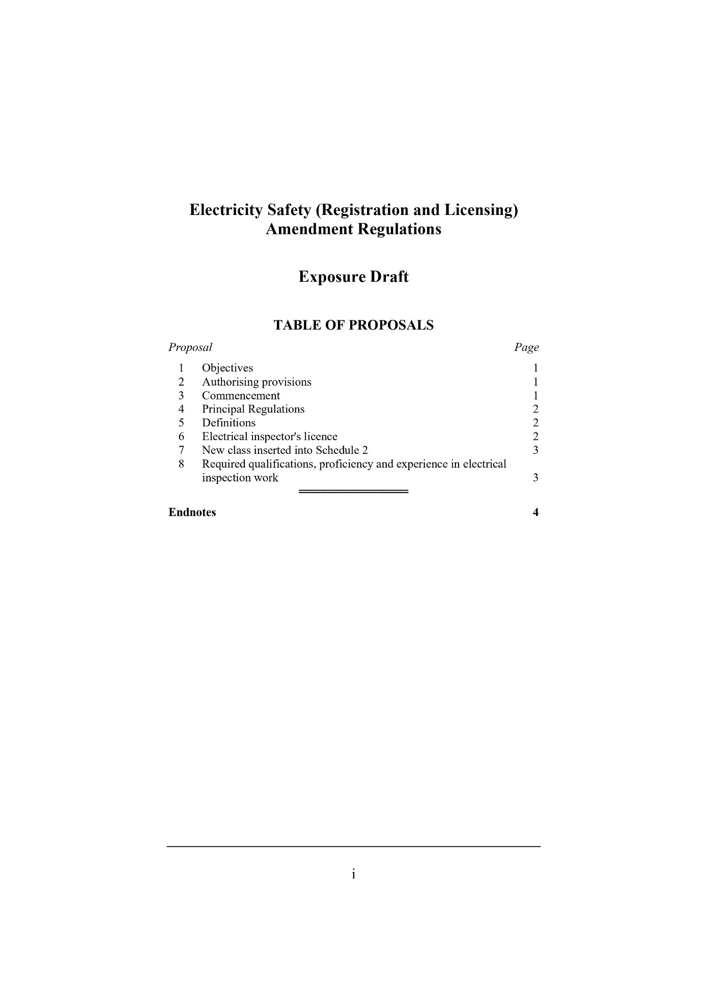
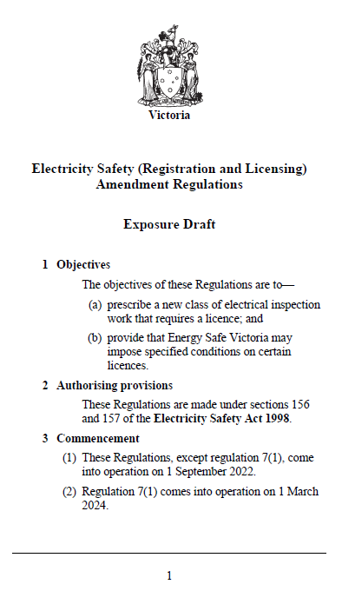

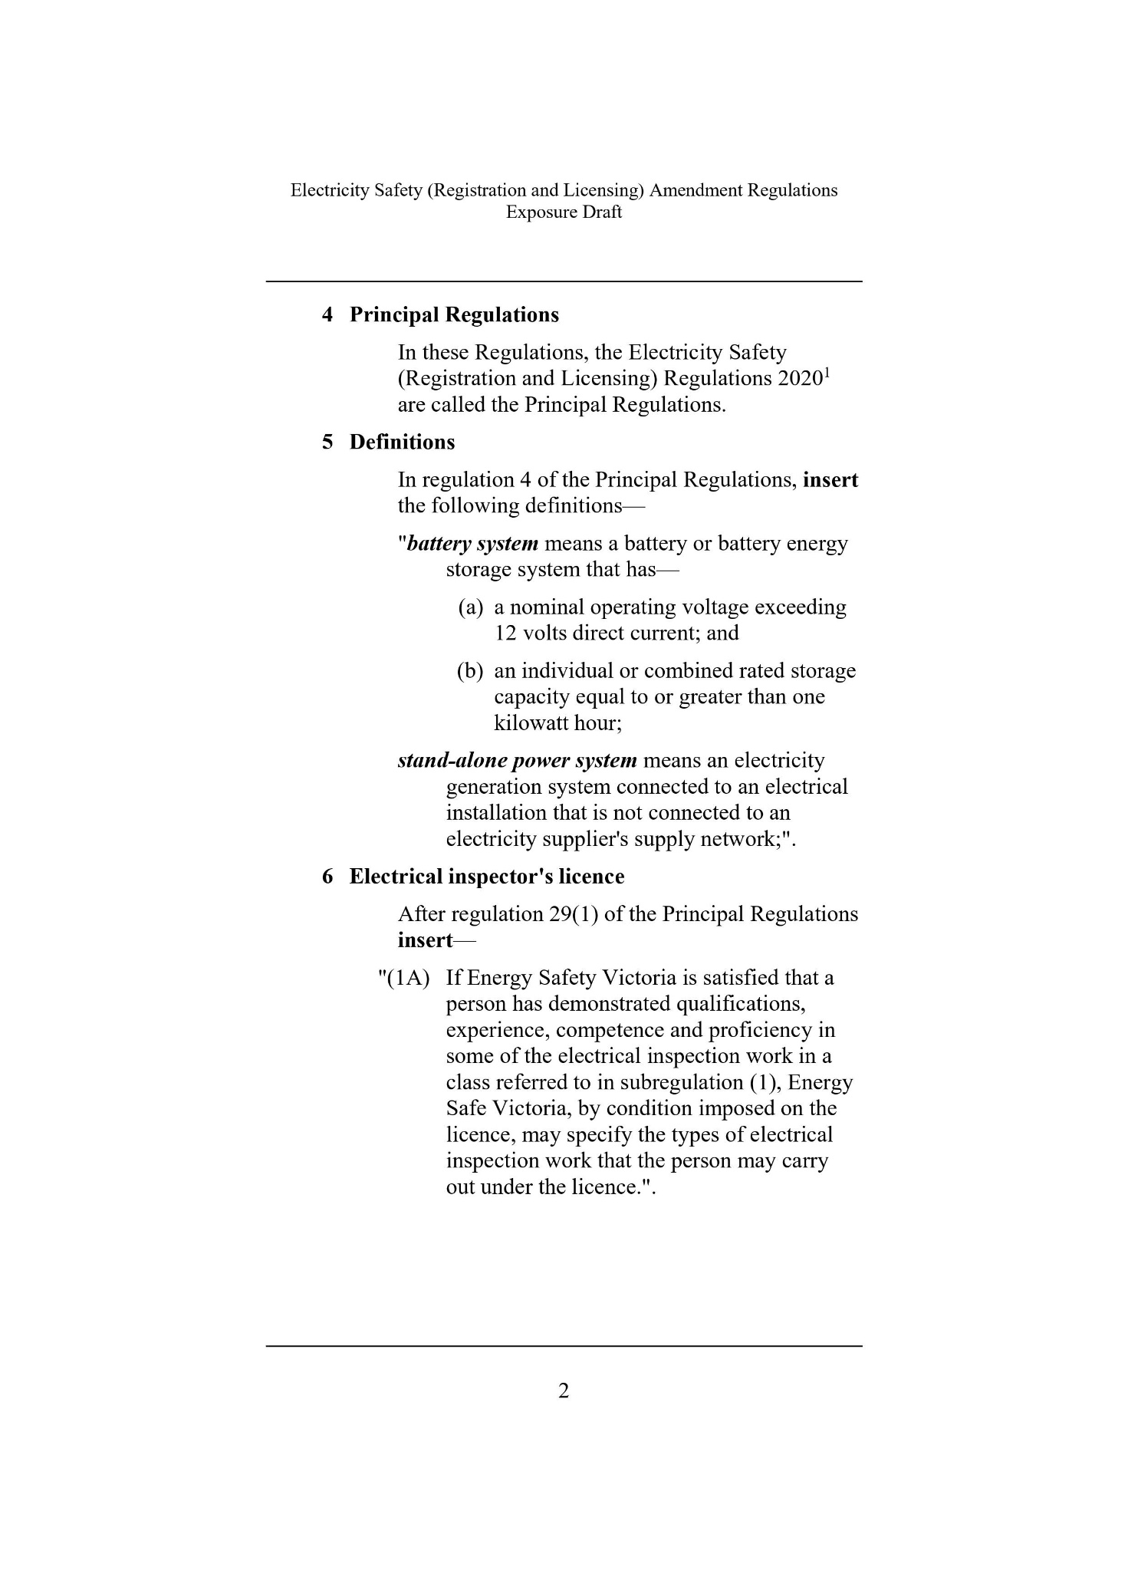

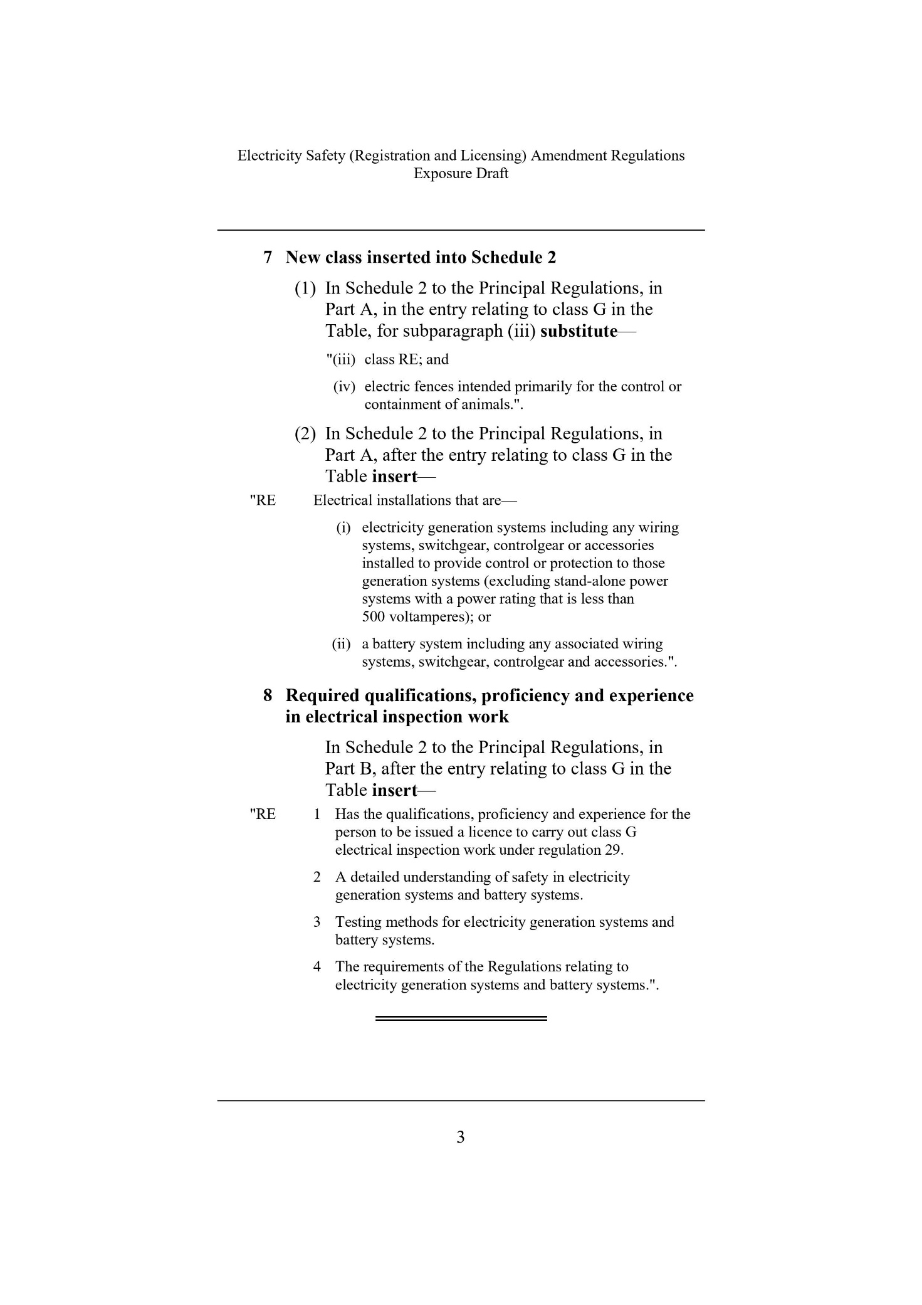

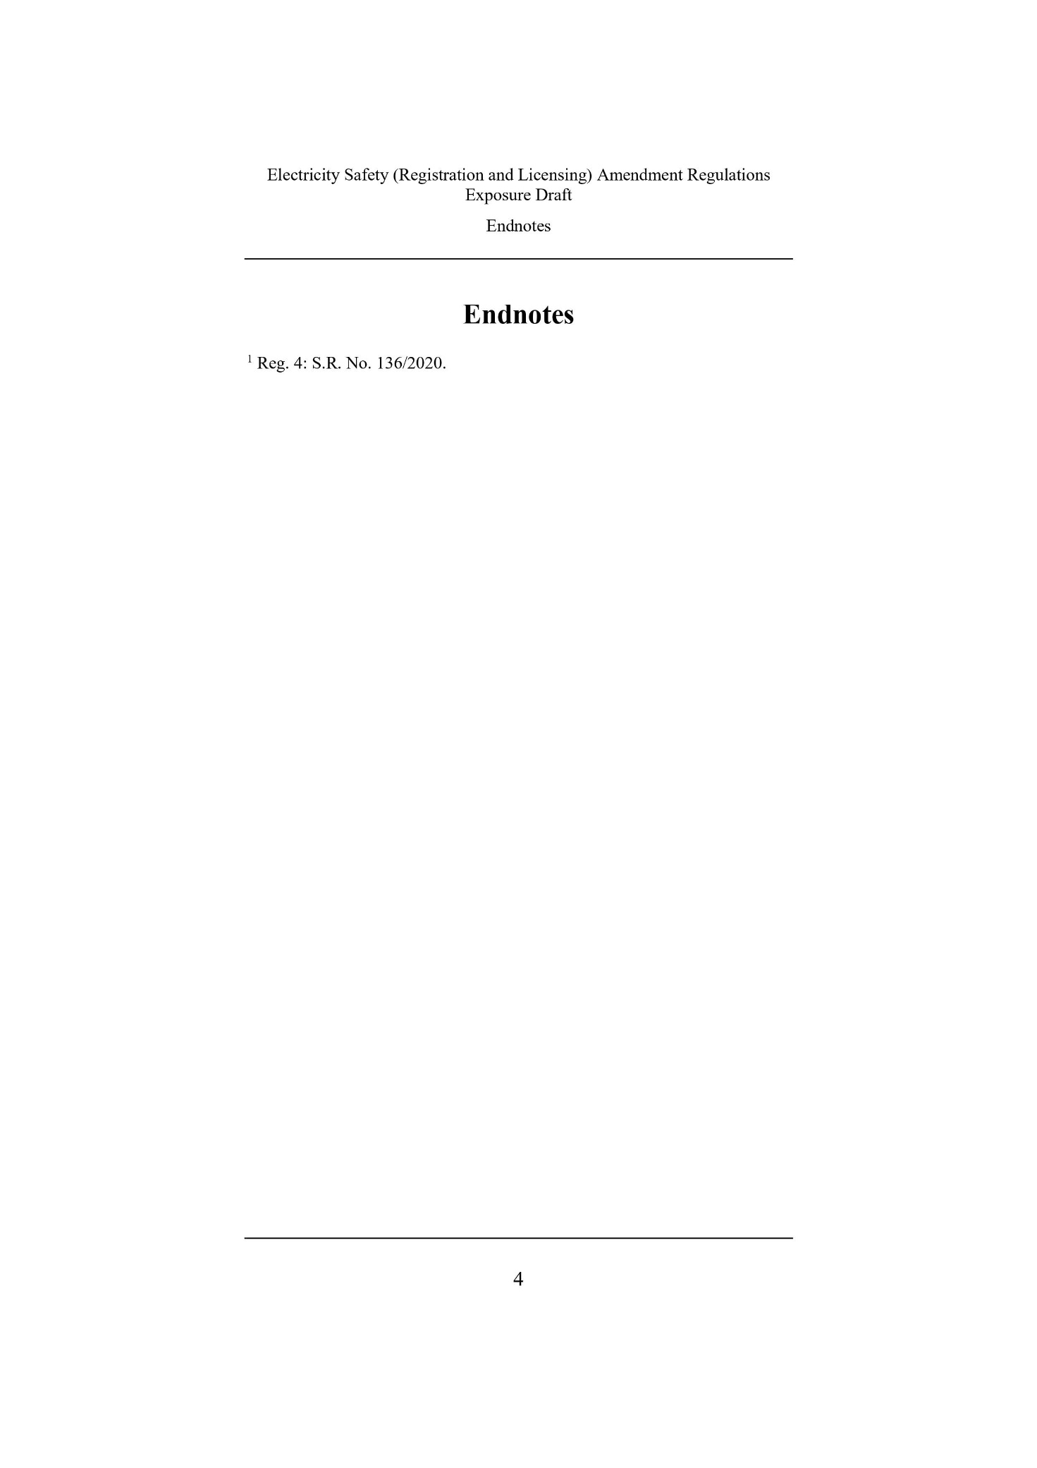

Prescribed electrical installations are more complex and pose a higher hazard risk than non-prescribed installations. Prescribed works, such as a solar PV installation, require certification by an LEI prior to the energisation of the system.
Solar Victoria, Notice to Market 2021-22, https://www.solar.vic.gov.au/notice-to-market page 3.
Solar Victoria undertakes a risk-based audit of an approximately five per cent sample of all solar installations benefiting from the Solar Homes program, generally three to six months after the installation.
Electricity Safety (Registration and Licensing) Regulations 2020, Regulatory Impact Statement, prepared by Regulatory Impact Solutions Pty Ltd.
ESVConnect is the primary system for online regulation of the electrical industry in Victoria – licensing, COES and registration of cathodic protection systems., https://esv.vic.gov.au/esvconnect/
Electricity Safety (Registration and Licensing) Regulations 2020, Regulatory Impact Statement, prepared by Regulatory Impact Solutions Pty Ltd.
Nous Group, Review of entire electrical inspection regime, 2021.
Nous Group, Review of entire electrical inspection regime, 2021.
Clean Energy Regulator, Inspections Update No. 20, 2020.
Energy Safe Victoria, Enhancing the safety of direct current (DC) isolators in photovoltaic (PV) systems – Consultation Paper, September 2021.
Energy Safe Victoria, Enhancing the safety of direct current (DC) isolators in photovoltaic (PV) systems – Consultation Paper, September 2021.
Nous Group, Interim report (solar systems, short-term), 2020.
Victorian Renewable Energy Target 2029-20 Progress Report, Victorian Government.
NEM Electricity Statement of Opportunities 2021 Report, AEMO.
Clean Energy Regulator Data, Postcode data for small-scale installations 2019.
Electricity Safety (Registration and Licensing) Regulations 2020, Regulatory Impact Statement, prepared by Regulatory Impact Solutions Pty Ltd.
Electricity Safety (Registration and Licensing) Regulations 2020, Regulatory Impact Statement, prepared by Regulatory Impact Solutions Pty Ltd.
Australian Bureau of Statistics, ‘Small Business in Australia’ (Catalogue No 1321.0, 23 October 2002).
Electricity Safety (Registration and Licensing) Regulations 2020, Regulatory Impact Statement, prepared by Regulatory Impact Solutions Pty Ltd.
Electricity Safety (Registration and Licensing) Regulations 2020, Regulatory Impact Statement, prepared by Regulatory Impact Solutions Pty Ltd.

