
Victorian Government report in multicultural affairs
2021-2022
OFFICIAL

If you would like to receive this publication in an alternative format, such as large print or audio, email Multicultural Affairs <multicultural@dffh.vic.gov.au>.
Authorised and published by the Victorian Government, 1 Treasury Place, Melbourne.
© State of Victoria, Australia, Department of Families, Fairness and Housing, June 2023.
With the exception of any images, photographs or branding (including, but not limited to the Victorian Coat of Arms, the Victorian Government logo or the Department of Families, Fairness and Housing logo), this work, Victorian Government report in multicultural affairs 2020-2021, is licensed under a Creative Commons Attribution 4.0 licence.
The terms and conditions of this licence, including disclaimer of warranties and limitation of liability, are available at Creative Commons’ Attribution 4.0 International (CC BY 4.0) web page <https://creativecommons.org/licenses/by/4.0>
You are free to re-use the work under that licence on the condition that you credit the State of Victoria, Australia (Department of Families, Fairness and Housing) as the author, indicate if any changes have been made to the work and comply with the other licence terms.
Except where otherwise indicated, the images in this document show models and illustrative settings only, and do not necessarily depict actual services, facilities or recipients of services. This document may contain images of deceased Aboriginal and Torres Strait Islander peoples.
In this document, ‘Aboriginal’ refers to both Aboriginal and Torres Strait Islander people. ‘Indigenous’ or ‘Koori/Koorie’ is retained when part of the title of a report, program or quotation.
ISSN 2205-8265 (online/PDF/Word)
Available at Victorian Government website's Victorian Government report in multicultural affairs page <https://www.vic.gov.au/victorian-government-report-multicultural-affairs>

Acknowledgements

Acknowledgment to Country
The Victorian Government acknowledges Victoria’s First Peoples and their ongoing strength in practising the world’s oldest living culture. We acknowledge the Traditional Owners of the lands and waters on which we live and work and pay our respect to their Elders past and present.
We recognise that from time immemorial, First Peoples in Victoria have practised their law and lore, customs and languages, and nurtured Country through their spiritual, cultural, material and economic connections to land, water and resources.
We acknowledge the long-lasting, far-reaching and intergenerational consequences of the dispossession of First Peoples of their Country are a direct result of colonisation and the establishment of the State of Victoria. The reality of colonisation involved establishing Victoria with the specific intent of excluding Aboriginal people and their laws, customs, and traditions, including through horrific violence perpetuated at individual, societal and systemic levels. This history, and the systems it gave rise to, continue to harm First Peoples today. It is only through true Aboriginal self-determination that we can begin to right the wrongs of the past.
We acknowledge the strength and resilience of First Peoples in the face of historical and ongoing injustices, and the survival of their living cultures, knowledge and traditions.

Acknowledgment of Treaty and Truth
We acknowledge the impact of colonisation to this day and seek ways to rectify past wrongs, including through truth-telling and the development of Treaty.
We are deeply committed to Aboriginal self-determination and to supporting Victoria’s Treaty and truth-telling processes.
We acknowledge that treaty will have wide-ranging impacts for the way we work with Aboriginal Victorians. We seek to create respectful and collaborative partnerships and develop policies and programs that respect Aboriginal self-determination and align with Treaty aspirations.
We acknowledge that Victoria’s Treaty process will provide a framework for the transfer of decision-making power and resources to support self-determining Aboriginal communities to take control of matters that affect their lives. We commit to working proactively to support this work in line with the aspirations of Traditional Owners and Aboriginal Victorians.

Thank you
The Victorian Government would also like to acknowledge the important role of government partners, including local councils and service agencies, in the delivery of programs and initiatives reflected in this report. We would also like to thank all community leaders and volunteers who contribute to supporting multicultural communities across our state. The last two years have seen significant demands on community leaders in the response to COVID-19 and these contributions have been invaluable.
We would also like to thank our government colleagues for their assistance in collating the data for this report as well as all the community members who shared their powerful stories in this report.

Message from the Minister
Victoria has developed an enviable reputation as one of the most successful multicultural societies in the world, built through a proactive commitment to delivering programs and initiatives that support dynamic, diverse and inclusive communities.
I am proud to present the Victorian Government report in multicultural affairs 2021–2022, demonstrating our ongoing promise to uplift, empower and celebrate our culturally diverse communities.
I would like to express my gratitude to The Hon. Ros Spence MP for her leadership as the Minister for Multicultural Affairs from 2020 to 2022. This was an exceptionally challenging time for all Victorians – and disproportionately so for our multicultural communities. During this period, Minister Spence worked tirelessly alongside culturally and linguistically diverse (CALD) Victorians to support them to maintain vital community connections and access to employment opportunities, while keeping themselves and their fellow Victorians safe.
I have seen incredible contributions from Victoria’s diverse communities in my time so far as Minister. I look forward to continuing the important work of delivering programs that support self-determination, tackle discrimination and racism, and show that when culturally diverse communities thrive all Victorians benefit.
In 2021-2022, the Victorian Government committed $103.3 million in funding through the Multicultural Affairs portfolio for programs and initiatives that support Victoria's multicultural communities. This included $7.2 million top-up funding in September 2021 to continue supporting multicultural communities to respond to and recover from the pandemic. An $8.4 million investment over four years was allocated to improve settlement outcomes for new arrivals to Victoria. Eight million dollars over four years was also provided to support multicultural seniors’ organisations to help their members come together and continue sharing their cultures and traditions.
The highly-regarded Multicultural Festivals and Events program received $2.6 million to continue offering opportunities for Victorians to celebrate diverse cultures, while providing a much-needed boost for the events and hospitality industry.
I would like to thank all government departments and staff who have contributed to this report. Thanks also go to our community members who have tirelessly devoted their time and efforts to supporting their communities and enhancing the lives of all Victorians. Your hard work and commitment are invaluable and greatly appreciated.
I am committed to continue working with multicultural Victorians in the delivery of our investments. Together, we can create a stronger, fairer and more vibrant Victoria.
The Hon Colin Brooks MP
Minister for Multicultural Affairs

Contents
Acknowledgements 3
Acknowledgment to Country 3
Acknowledgment of Treaty and Truth 3
Thank you 3
Message from the Minister 4
Introduction 6
Legal and policy frameworks underpinning this report 6
Working to achieve positive outcomes 7
Terminology, abbreviations and frequently used terms 8
The Victorian Government’s response to COVID-19 10
COVID-19 initiatives 10
Victorians are safe and secure 14
Providing security during uncertainty 14
Ensuring safety for multicultural Victorians 14
Responding to overseas conflicts and crises 15
Victorians are healthy and well 17
Equal access to health and wellbeing 17
Equal access to utilities 17
Victorians are able to participate fully 19
Communicating with Victoria’s multicultural communities 19
Disability support 20
Opportunities to learn and grow 20
Sports initiatives 22
Employment assistance and career development 23
Multicultural community business support 25
Victorians are connected to culture and community 28
Multilingual initiatives 28
Arts and cultural celebrations 28
Victorians have equal rights and opportunities 32
Anti-racism 32
Promoting human rights within government departments 33
Progress on department cultural diversity plans 37
Departmental cultural diversity plans 38
Appendix 1: Multicultural representation on government boards, authorities
and committees 51
Appendix 2: Indicators 52

Introduction
Victoria is home to one of the fastest growing and most culturally diverse states in Australia, with about one third of the population born overseas.
Over forty per cent of Victorians report having both parents born overseas. Almost one third of Victoria’s total population speak a language other than English at home.
This report provides a snapshot of the Victorian Government’s efforts to support multicultural communities and progress multiculturalism.

Legal and policy frameworks underpinning this report
The following are legislative and policy documents that guide the government’s mission to build an inclusive, engaged, and cohesive community.
This report fulfils a requirement of the Multicultural Victoria Act 2011 (Vic). The Act requires government departments to report annually to the Minister for Multicultural Affairs and to the Victorian Parliament on programs and initiatives that support Victoria’s multicultural community.
Table 1: Victoria's multicultural frameworks
Type | Description
Acts of Parliament | - Multicultural Victoria Act 2011: Provides the framework for a whole of government approach to Multiculturalism in Victoria. The Act also establishes the Victorian Multicultural Commission as a statutory authority and requires the development and implementation of cultural diversity plans by Victorian Government departments.  - Equal Opportunity Act 2010: All Victorian departments and service providers have a positive duty under this Act to take reasonable and proportionate measures to identify and eliminate discrimination.  - Charter of Human Rights and Responsibilities Act 2006: Sets outs the basic rights of Victorians to live with freedom, respect, equality and dignity, and requires public authorities to act compatibly with the Charter.  - The Racial and Religious Tolerance Act 2001: Prohibits behaviours that incite or encourage hatred, serious contempt, revulsion or severe ridicule against another person or group of people because of their race or religion.
Victorian Government multicultural statement | A publicly available policy statement that sets out the Victorian Government’s vision and commitment to multiculturalism in Victoria.
Departmental cultural diversity plans | Plans created by government departments to facilitate diversity and multiculturalism both internally and when delivering services and programs to the Victorian community.
Individual departmental policies, plan and strategies | Departments undertake reviews of policies, strategies and planning frameworks on an ongoing basis to respond to the changing needs of culturally diverse communities and to reflect the government’s commitment to multiculturalism.

Working to achieve positive outcomes
The Whole of government multicultural affairs outcomes framework outlines the Victorian Government’s approach to multiculturalism throughout the state.
Programs and initiatives are grouped under the framework’s five goals (see Table 2).
Table 2: Goals of the Whole of government multicultural affairs outcomes framework
Goal | Desired outcomes for Victorians
Victorians are safe and secure | - Victorians live free from abuse, violence and fear  - Victorians have suitable and stable housing
Victorians are healthy and well | - Victorians have good physical and mental health  - Victorians have equitable access to health and human services
Victorians are able to participate fully | - Victorians participate in learning and education  - Victorians participate and contribute to the economy  - Victorians have financial security  - Victorians understand, are empowered by, and exercise their rights  - Victorians have access to an environment that promotes liveability, sustainability and inclusion
Victorians are connected to culture and community | - Victorians are socially engaged and live in inclusive communities  - Victorians can safely identify with and connect with their culture and identity
Victorians have equal rights and opportunities | - Victorians live free from discrimination  - Opportunities to participate in the workforce are available to all Victorians
This report does not capture the full range of activities undertaken by Victorian Government departments and portfolio agencies. Instead, it provides a snapshot of activities and achievements supporting multicultural and multifaith communities between 1 July 2021 and 30 June 2022 across the Victorian Government. Included case studies highlight the positive impact of initiatives on local communities.

Terminology, abbreviations and frequently used terms

Language statement
Language is important and can change over time, and words can have different meanings for different people.
We recognise the diversity of First Peoples, communities and culture throughout Victoria. While the terms ‘Koorie’ or ‘Koori’ are commonly used to describe First Peoples of southeast Australia, we have used the term ‘First Peoples’ and ‘Aboriginal’ to include all people of Aboriginal and Torres Strait Islander descent who live in Victoria.
The term ‘multicultural community’ refers to the vast number of diverse cultural and ethnic groups in Victoria.
The term ‘multifaith community’ refers to the diverse faith groups in Victoria.
The words ‘our’ and ‘we’ in this document refer to the Victorian Government.
The phrase ‘racism and discrimination’ in this document includes all forms of discrimination on the basis of ethnicity, cultural background, country of origin and faith.

List of government departments
Acronym | Department
DE | Department of Education
DEECA | Department of Energy, Environment and Climate Action
DFFH | Department of Families, Fairness and Housing
DH | Department of Health
DJCS | Department of Justice and Community Safety
DJSIR | Department of Jobs, Skills, Industry and Regions
DPC | Department of Premier and Cabinet
DTP | Department of Transport and Planning
DTF | Department of Treasury and Finance

List of abbreviations and acronyms
Acronym | Definition
CALD | Culturally and linguistically diverse
CAV | Consumer Affairs Victoria
CCT | Cultural competency training
CDP | Cultural diversity plan
ESB | English-speaking background
LBOTE | Language background other than English
LGBTIQ+ | Lesbian, gay, bisexual, trans and gender diverse, intersex, and queer
LOTE | Language other than English
MESC | Main English-speaking countries
NMESC | Non-main English-speaking country
NDIS | National Disability Insurance Scheme
NESB | Non-English-speaking background
RRT 2001 | Racial and Religious Tolerance Act 2001
VEOHRC | Victorian Equal Opportunity and Human Rights Commission
VMC | Victorian Multicultural Commission
VPS | Victorian Public Service
VPSC | Victorian Public Service Commission

The Victorian Government’s response to COVID-19
Victorian communities continued to be affected by the pandemic in distinct and unique ways in 2021-2022.
As the Victorian Government rolled out the statewide vaccination program, it focused on helping multicultural communities respond to and recover from the pandemic.
The government put in place programs and services to further build capability and resilience to help people from multicultural backgrounds live with COVID-19 in society.

COVID-19 initiatives
Comprised of government representatives, including the Victorian Multicultural Commission (VMC), the CALD Communities Taskforce was a key governance and coordination mechanism during the COVID-19 pandemic. The taskforce worked with Victoria’s multicultural communities to put in place evidence-based initiatives.
Between August 2020 and June 2022, the taskforce partnered with community to:
- support culturally-appropriate responses to COVID-19 outbreaks
- provide tailored public health information and advice
- increase uptake of testing and vaccination
- build capability and capacity of multicultural and multifaith community organisations
- support the social and economic recovery of multicultural communities.
The taskforce provided essential leadership and coordination to continue tailoring the Victorian Government’s COVID-19 response according to the diverse and unique needs of different communities. Victoria’s multicultural leaders were regularly invited to hear from health experts about COVID-19 and the vaccination program to help them support their communities. Senior representatives of the Victorian Government, including VMC, were also present to answer their questions.
The taskforce funded initiatives through the Priority Response for Multicultural Communities (PRMC) grants program. This strengthened relationships and built deeper engagement between government and community.
Since May 2020, the Victorian Government has invested in supporting Victoria’s multicultural and multifaith communities with localised and targeted supports (DFFH: $68.6m over three years). These include:
- Supporting 380 community organisations in through the PRMC grants program to provide immediate emergency support and culturally-appropriate food.
- Supporting 12 local government areas through the Local Partnerships model for targeted engagement and communications activities with priority communities.
- Partnering with the National Ethnic Multicultural Broadcasters Council to create emergency in-language audio broadcasts in up to 19 languages.
- $11.3 million to support services that help multicultural and multifaith Victorians:
  - deal with social isolation
  - engage young people
  - fund culturally-specific family violence support agencies.

- $14.3 million support for multicultural organisations to:
  - provide emergency relief
  - expand the distribution of vital health advice in a range of languages
  - increase the availability of translation and interpreter services.
- $18.8 million to support multicultural organisations to continue to lead local responses to the pandemic, including:
  - emergency relief
  - food and clothing supplies
  - outreach support.
- $12.1 million to help community organisations provide:
  - immediate support
  - targeted multicultural communications, translations and community engagement activities
  - support for organisations at a local level.
- $7.2 million top-up funding in response to the August 2021 outbreak for more targeted support to multicultural communities to respond to and recover from the pandemic.
In addition, the Victorian Small Business Commission (VSBC) supported tenants and landlords following the reintroduction of the Commercial Tenancy Relief Scheme in July 2021 (and extension in January 2022). VSBC developed translated rent relief guidance, retail leasing and website enhancements to help Victorian tenants and landlords find information on their rights and obligations (DJSIR: $40,800 in 2021-2022).
During the pandemic, DH’s Priority Communities Engagement team used an intensive, localised partnership model of care to ensure multicultural communities accessed the COVID-19 Vaccination program. This included providing public health information and advice on COVID-19 vaccinations.
Key outcomes included:
- 15 multicultural partners in the CALD Ambassadors Network contributed to more than 1,000 community sessions on the vaccination program. This helped empower multicultural communities and gave them greater ownership of public health decisions.
- More than 35,000 vaccinations given over a six-week period through innovative vaccination pop-ups. This included 70 school pop-ups and kinder pops-ups at the aquarium, zoos and other sites.
- Vaccination rates increased from 35 per cent to 80 per cent in Hume in October 2021. CALD clinical champions and Vaccine community and faith champions, including a bicultural workforce, worked together to achieve this.
- 253 targeted events were held across Victoria between July 2021 and June 2022 to support multicultural communities with booster vaccination and COVIDSafe practices. Events included four Diverse Community Capacity Building Forums and 32 COVID-19 community roundtables,.
These outcomes helped Victoria lead the country for COVID-19 vaccination coverage, achieving 80 per cent double dose coverage across Victoria by the end of September 2021.
Youth Justice funded five local multicultural and multifaith organisations through their COVID-19 Vaccine Engagement Initiatives (DJCS: $75,500 over two years) to build vaccine confidence and support vaccine uptake among the African diaspora and South Sudanese Australian young people. Initiatives included outreach support, information sessions and social media efforts to engage and educate young people about COVID-19 health information in the community.

The Victorian Government provided support for regional multicultural communities experiencing challenges getting timely, localised and tailored COVID-19 advice and assistance. The CALD Partners for Change program (DH: $600,000 in 2021-2022) funded:
- three targeted ethnic communities councils in Shepparton, Albury-Wodonga and Sunraysia-Mallee
- the not-for-profit Point of Difference Studio in Shepparton.
These councils are seen as trusted local sources of public health information. They provide targeted outreach programs through the collaborative efforts of bicultural workers and local public health units.
DTP’s Mask Wearing on Public Transport initiative promoted the importance of mask wearing and COVIDSafe behaviours on public transport to key multicultural communities. The initiative included a paid media campaign comprising radio, out-of-home advertising and social media promotions in Mandarin, Cantonese, Vietnamese, Hindi and Punjabi.
The 2021-2022 State Budget dedicated funds to DEECA’s Seasonal Workforce program, which focused on addressing key workforce issues in response to COVID-19 (DEECA: $84m over two years). The initiatives provided information and support services to multicultural seasonal workers, including:
- in-language resources
- help accessing services
- accommodation
- transportation.
Key initiatives included:
- Agriculture Workforce Plan ($50 million)
- Seasonal Workforce Accommodation program ($6 million)
- Seasonal Harvest Sign-on Bonus program ($10.5 million)
- Pacific Mobility Scheme Pathway ($15.8 million)
- Seasonal Workforce Industry Support program ($1 million).
In September 2021, the Victorian Government allocated funds to the International Education Resilience Fund (DJSIR: $50m over two years) to help universities maintain international education programs and support international students in the wake of international border closures. Through the IERF, the Victorian Government is supporting Victorian universities to:
- maintain international education programs
- provide international student with enhanced welfare and support services
- improve delivery of remote and offshore teaching
- increase student engagement programs and events.
Through DE, the Victorian Government continued to provide support for international students during the COVID-19 border restrictions (DE: $200,000 over two years). This initiative included:
- online learning for students remaining in their home countries (until they could arrive in Victoria)
- providing travel exemptions and quarantine support for Year 11 and 12 Victorian Certificate of Education (VCE) students to enable them to complete their final school years onshore
- welfare, wellbeing and mental and physical health support, including student experience initiatives.

The Multicultural Education Aides (MEA) Initiative committed an extra 60 staff members across 67 schools with the highest need in the 2021 school year (DE: $4.268 million over 2 years). Foundation House was funded to operate peer support networks and provide professional learning for multicultural education aides. Key outcomes included:
- three new MEA networks and three expanded existing MEA networks
- 17 professional learning sessions for MEAs
- 10 new resources developed and published on the Schools In for Refugees website (which has a dedicated section for MEAs).
With funding from the Victorian Government, Foundation House continues to support MEAs through the School Support program. The program includes professional learning, information and resources to support schools, as part of a suite of refugee education support initiatives.
The 2021-2022 State Budget funded 15 local government areas to continue engaging multicultural outreach workers to work directly with early childhood education and care (ECEC) services and multicultural families. These outreach workers helped kindergarten children and their families take part in kindergarten and transition to school. The workers also shared advice to:
- upskill ECEC teachers and educators
- increase awareness of eligibility for Early Start Kindergarten for children from refugee and asylum seeker backgrounds
- increase awareness of other early childhood supports in their local area.
The Brotherhood of St Laurence was funded to continue providing the Family Learning Support Program. The program gives multicultural families and children living in public housing intensive outreach support. The program’s bicultural workers supported and engaged with families and children to help them:
- access ECEC services
- improve social connectedness
- reduce pandemic-related stress and isolation.
The DTF-funded Interpreter Services provided Commonwealth interpreter services to communicate effectively with non-English speaking taxpayers (DTF: $41,145 in 2021-2022).
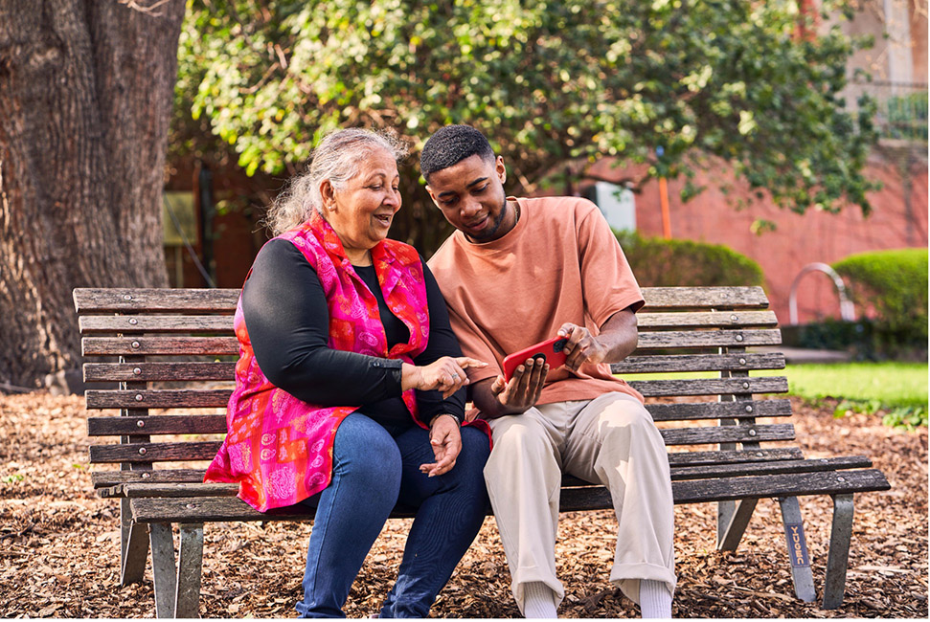

Victorians are safe and secure

Providing security during uncertainty
The Study Melbourne Student Centre (SMSC) and International Student Employment and Accommodation Legal Service (ISEALS) provided information, referrals and casework support to more than 1,550 international students experiencing financial, employment, mental health, accommodation and COVID-related issues (DJSIR: $1.107m in 2021-2022).
More than $65,000 in emergency rent assistance and food vouchers was given to international students.
ISEALS offered free, confidential and independent legal advice to international students on work rights and tenancy matters.
In 2021-2022, ISEALS managed 120 cases and recovered around $115,000 in unpaid wages and rent for international students.

Ensuring safety for multicultural Victorians
Initiatives under the Crime prevention strategy supported multicultural and multifaith communities (DJCS: $2.15 million in 2021-2022).
Funding announced in 2021-2022 included:
- six multicultural projects through the Crime Prevention Innovation Fund ($1.63 million in total).
- more investment ($519,730) in the Ubuntu Empowering Mothers project, which has supported more than 365 mothers and family members from African-Australian backgrounds to date.
In addition to projects and programs specifically focused on multicultural and multifaith communities, other crime prevention programs continued to run activities in 2021-2022 that benefitted and supported multicultural Victorians. This includes:
- Empowering Communities Partnerships – several of the nine sites running activities focused on safety for multicultural communities
- Youth Crime Prevention Grants program – many of the 15 initiatives focused on helping multicultural young people prevent contact with the justice system.
Emergency Management Victoria’s VicEmergency Uplift CALD-enabled app was established in 2021-2022 to give the public critical information and real-time warnings for emergencies such as fires, floods and storms (DJSC: $416,000 in 2021-2022). The app will be piloted in Arabic and Chinese (Simplified or Mandarin) in 2023 to provide text-to-text translations using an AI translator in real time during emergencies.
The TAC L2P program helps young learner drivers having trouble completing the compulsory 120 hours of driving practice because they do not have access to a supervising driver or a suitable vehicle (DTP: $33.4m over four years). The program connects young people with fully licenced 'driver-mentors'. Around 17 per cent of participants were born overseas. Individual program providers ensure people with multicultural backgrounds have access to culturally appropriate driver-mentors to help young people get the driving practice needed to obtain a driver’s license.
DTP’s VicRoads Community Safety Grants program provided the Road Safety for New Arrivals initiative to support newly arrived migrants and people from multicultural backgrounds who are over 21 years of age (DTP: $289,261 in 2021-2022). DTP funded 16 community organisations to run 42 Road Safety for New Arrivals programs to 634 participants and provide more than 1,800 driving lessons.

Responding to overseas conflicts and crises
In 2021-2022, the Victorian Government donated to various humanitarian aid initiatives in recognition of the adverse impact overseas conflicts and crises have on Victoria’s multicultural communities (DPC: $205,000 in 2021-2022). This included:
- $75,000 one-off donation to fund a Ukrainian Community Organisations Support Programme
- $100,000 one-off donation to the Victorian Maronite community to contribute to urgent charitable work in Lebanon
- $30,000 one-off donation to allow the Melkite Charitable Foundation to support the provision and distribution of lifesaving medication in Lebanon.
The Victorian Government’s Refugee Legal program enabled new Afghan arrivals affected by the humanitarian crisis to access free legal advice (DFFH: $1.0m in 2021-2022). This helped more than 2,500 asylum seekers and 2,300 Afghan community members get crucial legal assistance when they needed it.

Case study
Afghan evacuees’ health response
Between August and December 2021, following the fall of Kabul to Taliban rule, more than 2,700 Afghan evacuees arrived in Victoria seeking safety.
After leaving in distressing circumstances, many evacuees arrived with significant health needs and very few possessions – and into an escalating COVID-19 pandemic outbreak. Their first experience of Australia was hotel quarantine. High-density short-term accommodation and Medicare registration delays exacerbated the health and public health challenges.
DH worked quickly to set up a multi-faceted health response, working with refugee health sector partners and settlement services.
Cohealth started a nurse-led outreach clinic in Melbourne city, within walking distance of the short-term accommodation for around 1,500 Afghan evacuees. Within days, the clinic was providing health care, advice and referrals to a pro-bono GP network and allied health partners, including maternal health, dental and catch-up immunisation services.
Refugee health teams across Melbourne worked together to create a responsive surge capacity, including IPC Health, Monash Health, EACH and Your Community Health. Collectively, they performed 1,500 on-arrival health assessments and 2,000 comprehensive refugee health assessments between September 2021 and March 2022.
DH’s COVID-19 testing and vaccination partners ran pop up sessions at the short-term accommodation. DH also conducted site assessments and provided infection prevention and public health advice to settlement services.
The Victorian Refugee Health Network facilitated weekly coordination meetings, including logging risks and escalating systemic issues to Australian and Victorian government departments.
Foundation House provided culturally responsive mental health services through community engagement, individual and family counselling, group work, referrals and schools support.
Foundation House conducted more than 570 assessments and therapeutic interventions to help people and families manage a range of post-traumatic stress symptoms. Between August 2021 and June 2022, they also ran more than 40 psycho-education and sector professional development sessions in community languages and in partnership with legal services. This helped Afghan community members understand trauma symptoms and signs of mental ill health. Community members felt better equipped to support their families and communities.
Many people and families supported through this initiative reported:
- improved mental health and wellbeing
- a greater sense of control over previously distressing symptoms
- better connection with family, community and services.

Victorians are healthy and well

Equal access to health and wellbeing
The Support Asylum Seekers program (DH: $3.9m in 2021-2022) helps people seeking asylum who are not eligible for Australian Government safety net supports, including Medicare and income support. Thousands of people received support for homelessness assistance, utilities, mental health, clinical care and legal assistance. The program’s significant achievements include:
- Providing holistic support to more than 10,000 people managing multiple vulnerabilities, particularly families and people with complex physical and mental health needs.
- Providing at least 800 hours of GP care to people without Medicare, including many people with multiple morbidities or illnesses, or whose health is very likely to worsen. This care reduced presentations to hospital emergency departments and prevented deterioration of health conditions.
- Providing more than 6,500 hours of specialist mental health support (including counselling, case management and psychiatric assessment) to people experiencing mental health distress.
- Reduced socio-economic vulnerability for more than 7,000 people by providing casework and help with homelessness and basic needs. This assistance included emergency relief for food, pharmacy waivers and utilities, as well as improving utility bill literacy.
The Diverse Communities Mental Health and Wellbeing Grants program provides grants to community-led organisations to support the mental health and wellbeing of their communities (DH: $9.6 from 2021-2022 to 2024-25). The program addressed findings from the Royal Commission into Victoria’s Mental Health System. Communities supported by these grants included multicultural communities, LGBTIQ+ people and people with disability.
DH’s Mental Health and Wellbeing Hubs provided place-based free and confidential support for Victorians. Targeted engagement with multicultural and multifaith communities helped ensure equitable access to a culturally responsive and informed service. Victorian Transcultural Mental Health provided tailored early training for hub service providers. Hub resources were translated into 25 languages. Since launching in October 2021, the hubs have helped 1,365 people from multicultural backgrounds facing social isolation, anxiety, financial difficulties and housing stress.

Equal access to utilities
The Waterways of the West action plan ensures Melbourne’s western waterways are healthy and thriving for generations to come (DEECA: $67,000 in 2021-2022). The community vision is the first overarching, long-term vision for the complex, connected, living system of waterways and parklands in the region. The action plan includes several actions that promote and advocate for better engagement with culturally diverse communities who live in western metropolitan Melbourne.
The My Victorian Waterway Survey was conducted in 2022 to investigate Victorian communities’ connection to the various bodies of water throughout the state. The study is critical for understanding community usage, expectations and attitudes towards waterways. It will help shape waterway management policy, guide investments and inform waterway programs and community engagement. The survey was offered in English, Chinese (Simplified and Traditional), Hindi, Punjabi, Arabic (Modern Standard) and Vietnamese. 6,240 online surveys were completed.
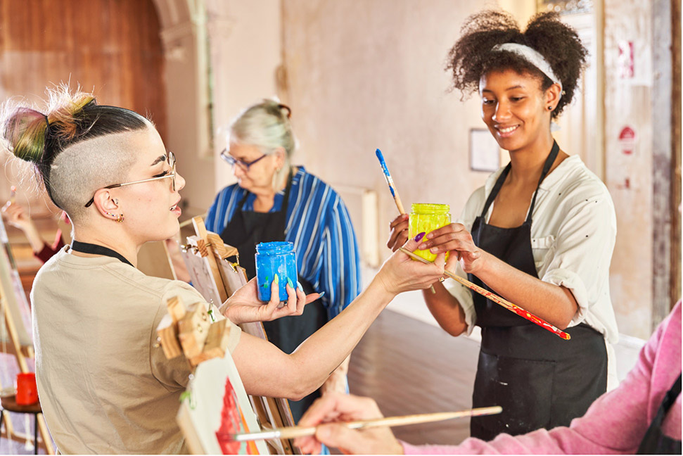

Victorians are able to participate fully

Communicating with Victoria’s multicultural communities
Culturally competent communication is critical for programs and initiatives to create meaningful outcomes for communities. Effective communication is key to:
- breaking down barriers
- improving access to services
- better outcomes for Victoria’s multicultural and multifaith communities.

Interpreting and translation services
Table 3: Expenditure on interpreting, translating and language allowance services, 2021-2022
Department | Expenditure (including GST) | Percentage of total government expenditure on translation (%)
DEECA | $124,294.20 | 0.39
DE | $2,111,660 | 6.68
DFFH | $4,570,000 | 14.44
DH | $21,281,121 | 67.27
DJCS | $2,139,322 | 6.76
DJSIR | $1,074,225 | 3.40
DPC | $71,640 | 0.23
DTP | $220,859 | 0.70
DTF | $41,145 | 0.13
Total | $31,634,266.20 | 100

Multicultural media campaigns
The Victorian Government has committed that departments and agencies spend at least five per cent of campaign advertising budget on multicultural media.
Table 4: Departmental multicultural media campaign expenditure as percentage of total media campaign expenditure
Department | 2020-2021 expenditure (%) | 2021-2022 expenditure (%)
DEECA | 32.0 | 10.56
DE | 7.9 | 10.51
DFFH | 5.1 | 7.50
DH | 16.4 | 15.99
DJCS | 7.3 | 9.24
DJSIR | 10.0 | 12.72
DPC | 13.4 | 19.68
DTP | 5.8 | 7.30
DTF | 0 | 5.27
Table 5: Total Victorian Government multicultural media campaign expenditure as percentage of total media campaign expenditure
Financial year | Multicultural expenditure (%)
2021-2022 | 10.4
2020-2021 | 9.6
2019-2020 | 7.6
2018-2019 | 5.0
2017-2018 | 5.2
2016-2017 | 6.0
2015-2016 | 5.5
2014-2015 | 5.8

Disability support
The Home and Community Care (HACC) Program for Younger People provided over 46,000 hours of community support across Victoria to younger people from multicultural backgrounds with moderate, severe or profound disabilities through 32 ethno-specific organisations (DH: $2.4 million in 2021-2022). The program reached over 1,600 young people with psychosocial and functional impairment, chronic illness and short-term health needs.
More than 68 per cent of support provided in 2021-2022 connected socially isolated people with their communities. 21 per cent of support activities enabled people to maintain independence through personal and in-home supports, including:
- cleaning
- shopping
- meal preparation
- intimate support.

Opportunities to learn and grow
The Kindergarten Fee Subsidy (KFS) enabled children with a refugee or humanitarian visa to attend a funded kindergarten program free of charge in the year before school. KFS is paid in addition to per capita grants. KFS is statewide as it is an entitlement based on children’s eligibility.
The Victorian Foundation for Survivors of Torture (Foundation House) ran the Early Years Program. The program builds the capacity of early childhood education and care services to work effectively with children and families of refugee backgrounds. Through the program, Foundation House provided resources, professional learning, consultancy and place-based collaborative projects. This encourages full inclusion of families from refugee backgrounds in early childhood services.
The Victorian African Communities Action Plan aims to build welcoming communities, improve outcomes and create lasting opportunities for Victorians of African heritage (DE: $2.5m in 2021-2022). In 2021, 13 community organisations were given grants of up to $126,0000 to maximise the engagement of young people in education. Additionally, eight school community liaison officers were employed by schools in South West, South East and North West metropolitan Melbourne. The liaison officers work across 23 schools to support African young people and their families.
The English as an Additional Language (EAL) program provided targeted teaching support to help more than 70,000 EAL learners become proficient in English (DE: $144.9m in 2021-2022). This included:
- newly arrived migrants
- students from refugee and asylum seeker backgrounds
- Australia-born students.
Mainstream schools used the EAL funding to provide specialist classes, withdrawal for EAL specialist teaching and in-class support. English language schools and centres also provided intensive English language programs for students to attend full-time for six to twelve months.
DE’s Place Based Partnerships to Support School Engagement and Completion initiative funded 26 school communities with large populations from African and Pasifika backgrounds to co-design and provide place-based approaches to increase school participation and completion rates (DE: $1.9m in 2021-2022). DE convened two Youth Offending Principal Roundtables with principals from Catholic and government schools. Participants shared approaches for engaging African and Pasifika young people and reducing involvement in the youth justice system.
The Multicultural Communities Leadership in Action program provided two full-day sessions covering topics such as:
- governance
- applying for grants
- building collaborative relationships with government and stakeholders.
317 people attended the sessions, which were funded by DFFH and run by VMC. Participants reported that they felt more confident engaging effectively with government and mobilising their own communities.


Sports initiatives
The Victorian Government actively supports multicultural and multifaith individuals to take part in physical activities and connect with their broader community.

Case study
Reclink Australia Women’s Basketball League
The Reclink Australia Women’s Basketball League offers Muslim and culturally diverse women a safe space to play competitive sport in the City of Banyule. The program is unique in that it is a culturally safe environment for women that caters for different skill levels and cultural practices.
The popularity of the program continues to grow. From the six teams in 2019, the program fielded 13 teams across two grades in 2021-2022.
Funding received through Sport and Recreation Victoria’s ActiVIC project has kept staff employed and ensured the group was connected and met regularly through COVID-19 lockdowns.
Program participant Anisa says the league has given her opportunities and joy beyond simply playing basketball.
‘There was never a place that was culturally diverse and a safe environment for Muslim women to play [sport] and I was not willing to give up practices for it. Because of this, I never got the chance to play sports outside of school like most kids do.
This program is in its own league and is beyond just playing basketball. Although it is amazing that we get to take care of our physical health by playing competitively against other women, it is also a league built on support, sisterhood and growth – all while being able to practice our faith.
This league has created such a supportive environment for culturally diverse women and Muslim women. The constant growth of the league shows the demand there has been for a program of this sort.’
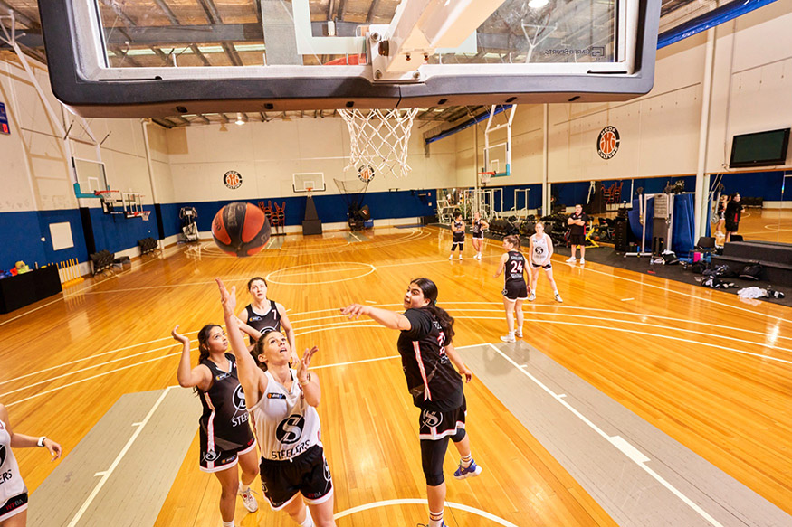


Employment assistance and career development
Jobs Victoria (DJSIR) was established in October 2016 to support people into employment and help employers connect with job-ready staff. Since the $619.4 million Jobs for Victoria investment in 2020, Jobs Victoria has expanded its statewide network of face-to-face employment services to include mentors, advocates and career counsellors. Between October 2016 and June 2022, Jobs Victoria has:
- supported more than 43,000 people into a job – both in person and through the enhanced Jobs Victoria Online Platform
- provided over 10,000 secure 12-month jobs through the Jobs Victoria Fund.
Culturally diverse Victorians represent 47 per cent of total job placements by Jobs Victoria’s employment services. In 2021-2022, Jobs Victoria provided employment services in 70 languages. This includes Jobs Victoria-funded specialist Jobs Victoria mentors to support CALD community members in both metropolitan Melbourne and regional Victoria into employment.
The Victorian Skilled and Business Migration program attracts and retains talent in Victoria by providing state visa nomination to selected high-calibre skilled professionals, businesspeople, entrepreneurs and investors from around the world. Services include:
- visa nomination (skilled and business)
- the Live in Melbourne website and market outreach
- advocacy and collaboration with the Australian Government on skilled and business migration programs and policies
- free overseas qualifications assessments.
The Victorian Government-funded group training organisations (GTOs) and Victoria’s infrastructure program to create high-quality skills pathways for apprentices and trainees. More than 600 apprentices and trainees were employed by GTOs on major projects in 2021-2022. Of these, around six per cent have multicultural backgrounds.

Case studies
Mid-career internships
CareerSeekers is a non-profit social enterprise that helps humanitarian arrivals to establish and restart their careers in Australia.
The Department of Health has been partnering with Career Seekers since 2016 to improve employment pathways for refugees and people seeking asylum.
In 2021-2022, a paid 12-week internship at the Department of Health gave program participants opportunities to:
- build confidence
- get local work experience
- make connections
- get references to support their search for ongoing professional employment.
Maryam
Maryam (name changed for privacy reasons) is originally from Syria and arrived in Australia on a humanitarian visa. Maryam holds degrees in Arabic Art and Business Administration.
In 2021, she interned at the Department of Health for three months.
Following the internship, she was employed by the Department of Health for almost a year. Maryam credits the internship and her work in the department with providing a solid foundation. She has continued to build her career in administration.
She found her experience in the public sector to be meaningful and fulfilling. She reported feeling very well supported.

Supporting employment through Jobs Victoria’s ‘earn and learn’
As a 50-year-old single mother, Chin Chin returned to study after 20 years with support from Jobs Victoria.
Through the Jobs Victoria Early Childhood Educator Traineeships Priority Workforce project, Chin Chin is completing a traineeship to become an early childcare worker.
The project’s ‘earn and learn’ model enables Chin Chin to complete a Certificate III in Early Childhood Education and Care with Chisholm TAFE, while she earns income by working at a Ballarat childcare centre. Chin Chin also has access to mentoring and wraparound support.
‘I haven't studied for the last 20 years,’ Chin Chin said, ‘But you're never too late to learn. I receive lots of achievement daily. I learn from the kids.’
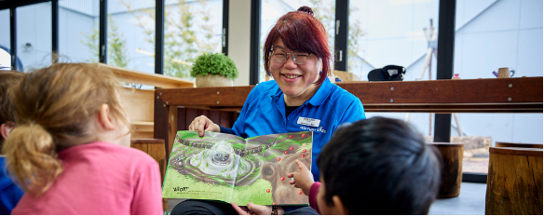
Chin Chin reads a book to children at a Ballarat childcare centre

Multicultural community business support
The Cultural Safety and Career Mentors project provided employers with online cultural safety training (DE: $809,000 over four years). The project includes volunteer and mentor training for employers that offer practical placements to vocational learners with culturally diverse backgrounds.
The training aims to:
- promote and facilitate culturally safe workplaces
- encourage culturally safe work placement experiences for learners with multicultural backgrounds
- counter the effect of COVID-19 on multicultural workforces.
Online cultural safety modules have been developed for aged care and disability industries. Facilitated training materials are also available to support the modules.
VMC funded 21 projects through its Community Support Fund (DFFH: $150,000 in 2021-2022). Community organisations received grants of up to $10,000 for community activities that addressed:
- recovery of micro-businesses
- full participation of multicultural Victorians in civic life
- established leadership and employment pathways for young people
- emerging community issues that needed rapid localised responses.

Case study
Starting a new career with support from Jobs Victoria
Moving to Australia in 2015 after the loss of her husband, Verena wanted to pursue her passion for food but struggled to find work.
With the support of the Jobs Victoria Growth Sector Jobs (Hairdressing and Hospitality) Priority Workforce project, Verena was able to complete hospitality training at Box Hill Institute while working at Free to Feed, a not-for-profit social enterprise. The ‘earn and learn’ model enabled Verena to build the skills she needed for her new career.
Through Free to Feed, Verena’s energy and her authentic Colombian street food have made her a foodie legend with the locals.
‘Studying and working this year gives me the opportunity to grow up as a person because I am getting knowledge at the same time that I get experience and improve my English,’ said Verena. ‘It means I am getting prepared to join the workforce and Australian community.’
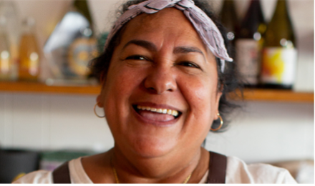
Verena’s Colombian street food has made her a foodie legend with the locals

Supporting multicultural employment through Jobs Victoria employment services
For most staff at Fresh Select, English is their second language. Many are humanitarian migrants from Myanmar starting new lives in Australia.
Wyndham Community and Education Centre, a Jobs Victoria partner, helps Fresh Select recruit staff. Together, they’re finding innovative ways to help staff understand their roles.
Using hand signals and colour coding makes communication easier around the pack house. Inviting bilingual workers into staff meetings and producing in-language documents helps employees gain confidence. Fresh Select also provides English language classes onsite during work hours.
As a result, employees like Sheh Paw (originally from Myanmar) have stayed at Fresh Select for years. She enjoys working in a supportive environment. A sustainable income has meant she could buy a house.
‘It makes me happy,’ Sheh said, ‘Because the work here is everyone helping each other and also the employers support me all the time.
Elisa Walerys, Fresh Select’s Chief Human Resources Officer, says the recruitment support from Jobs Victoria is highly valued. ‘We couldn’t do it without the Wyndham Community and Education Centre.’
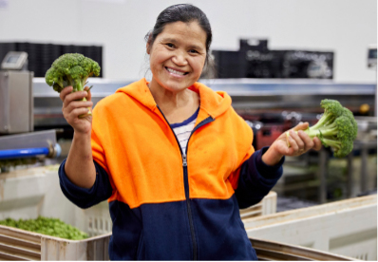
Sheh Paw is happy she feels supported working at Fresh Select

Victorians are connected to culture and community

Multilingual initiatives
The Early Childhood Language program gives four-year-old children the opportunity to learn in another language at their kindergarten (DE: $5.19m in 2021-2022). The program consists of two streams:
- learn languages – children in around 200 kindergartens learn another language for three hours each week
- bilingual kindergarten – children in 10 kindergartens learn in another language for 12 hours each week
The program is run in 21 languages, including:
- five different Aboriginal languages
- Arabic
- Auslan
- Cantonese
- Chinese
- Chin Hakha
- French
- Greek
- Hebrew
- Hindi
- Indonesian
- Italian
- Japanese
- Karen
- Punjabi
- Spanish
- Vietnamese.
In 2021-2022, the program reached around 8,000 children at no additional cost to parents.
The program employs 200 language teachers, many of whom are women from multicultural backgrounds.

Arts and cultural celebrations
The Multicultural Festivals and Events (MFE) program supported diverse communities to celebrate, preserve and share their customs and traditions in meaningful ways (DFFH: $2.6m in 2021-2022). In 2021-2022, community organisations received funding to run over 500 face-to-face, digital or hybrid events. This enabled communities to showcase and share cultures and traditions.
The African Music and Cultural Festival celebrated its eighth year as the largest African festival in Australia. The event aims to promote cross-cultural awareness and foster intercultural relationships. Over 35 African Australian communities and organisations were involved in the festival. More than 40,000 people attended the event, which was free and inclusive for all family members.
Cultural Diversity Week was celebrated from 19 to 27 March 2022. It included a week of activities and festivities that recognised contributions made by multicultural Victorians across all areas of society. Led by VMC, Cultural Diversity Week kicked off with the Victorian Multicultural Gala Dinner. 1,400 multicultural and multifaith Victorians attended the dinner, along with community and government representatives.
The Multicultural Seniors Support (MSS) program helps multicultural seniors groups run activities to support their members and build stronger community connections (DFFH: $8.0m over four years). More than 850 seniors organisations were funded for:
- social and cultural activities
- improving digital accessibility and literacy
- providing practical support
- purchasing essential equipment and resources
- running costs.
In 2021-2022, the Victorian Government donated funding for the Rabbinical Council of Victoria to build organisational capacity and cover increased costs (DPC: $120,000 in 2021-22). The Victorian Government also committed a $10,000 donation to Zionism Victoria for Yom Ha'atzmaut celebrations.
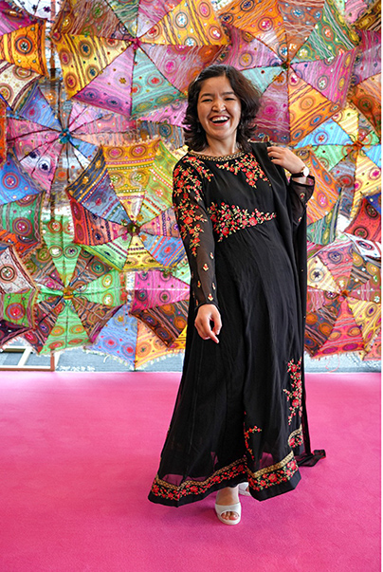

Case studies
Multicultural Seniors Support program: Pimpinan Cabang Istimewa Aisyiyah Australia
Pimpinan Cabang Istimewa Aisyiyah Australia is a multicultural seniors club in the City of Casey. The group’s 100 enthusiastic members with Indonesian backgrounds joined to celebrate and preserve Indonesia’s rich and diverse culture.
The club provides support and information on health, wellbeing, spiritual growth, nutrition and community involvement.
In 2021-2022, the club received $8,000 through the MSS program to run an eco-print workshop in collaboration with the University of Muhammadiyah Yogyakarta (Indonesia).
The workshop included lunch and afternoon tea for all attendees.
Members created their own eco-print fabrics and eco-print scarves to commemorate the event.
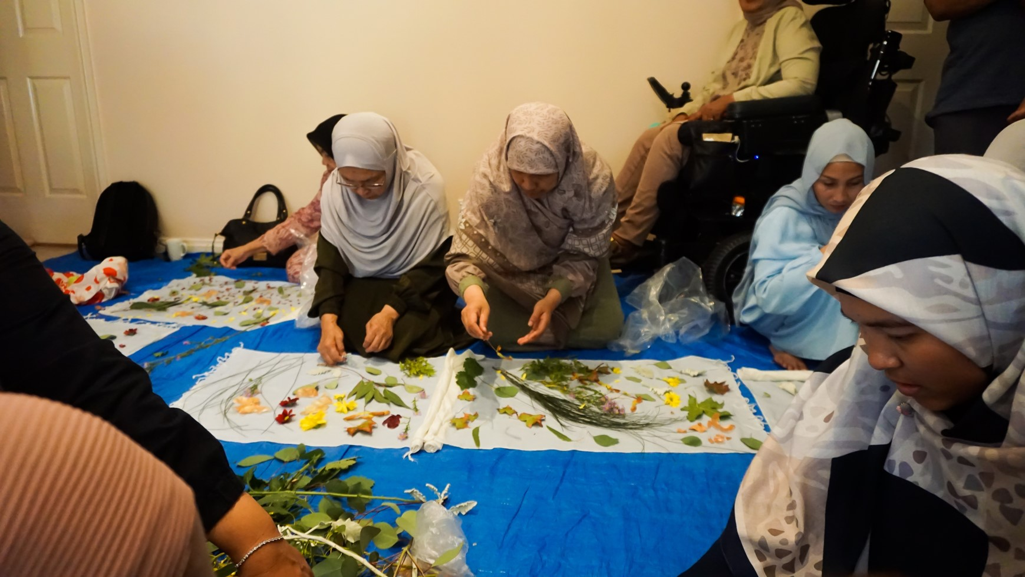
Two members create eco-print fabrics at the workshop

2021 Multicultural Film Festival and Schools Competition
In partnership with Swinburne University, VMC presented the Multicultural Film Festival to explore cultural diversity through short film. The festival included a short film competition.In 2021, there were 121 entries to the competition that showcased the creative and technical talents of emerging and established filmmakers.
Five award-winning films and five films that received honourable mentions were celebrated at an online event (due to COVID-19) in August 2021, with 142 virtual attendees.
All ten films were screened:
- at Federation Square
- on SBS OnDemand
- on VMC’s YouTube channel
- at an online screening event in September 2021 by the City of Casey’s Bunjil Place.

Victorian Refugee Awards
The Victorian Refugee Awards recognise and promote the accomplishments of Victorians who arrived in Australia as refugee or asylum seekers and who excel through study, work, entrepreneurship or volunteering.
The 2022 Awards were held during World Refugee Week in June 2022. Awards were presented across four categories: Youth Leader, Achievement, Leadership and Business.
The 14 recipients were honoured in front of 140 people at the State Library of Victoria.

Victorians have equal rights and opportunities

Anti-racism
The Anti-Racism Taskforce was established in June 2021 to support the development of an anti-racism strategy to prevent and address race- and faith-based discrimination in Victoria. This support includes providing advice on:
- the ways that racism occurs
- the settings it occurs in
- ways to effectively respond to and reduce the prevalence of racism.
The taskforce comprises 11 community members from culturally and religiously diverse backgrounds and is co-chaired by two members of Parliament. There are also three ex officio members from VMC, the Ethnic Communities Council of Victoria and the Victorian Equal Opportunity and Human Rights Commission (VEOHRC).
Since establishing the taskforce, the Victorian Government has been working closely with its members and the broader community on the Anti-racism strategy. The strategy will provide a five-year plan for preventing and addressing race- and faith-based discrimination in Victoria.
The drafting of the strategy has been informed by the wealth of insights from community consultations undertaken between October to December 2021. The following groups participated in these consultations:
- multicultural, multifaith and First Peoples community leaders and representatives
- government, local government and service delivery officials, including in regional areas
- subject matters experts across different sectors, including employment, health, education, justice, sports, creative industries and housing
- wider Victorian population through an online survey on the Engage Vic website.

Case study
Greater Shepparton Cultural Inclusion Roundtable
In 2021, the Victorian Government established the Greater Shepparton Cultural Inclusion Roundtable to strengthen cultural inclusion across Shepparton.
Co-chaired by the VMC chairperson and local community leader Betul Tuna, the roundtable included representatives from local multicultural and Aboriginal communities and local government.
The roundtable brought these representatives together to consider actions and implement strategies to address racism. The roundtable focused on:
- youth engagement within both secondary college and the broader community
- organising a celebratory and educational event.
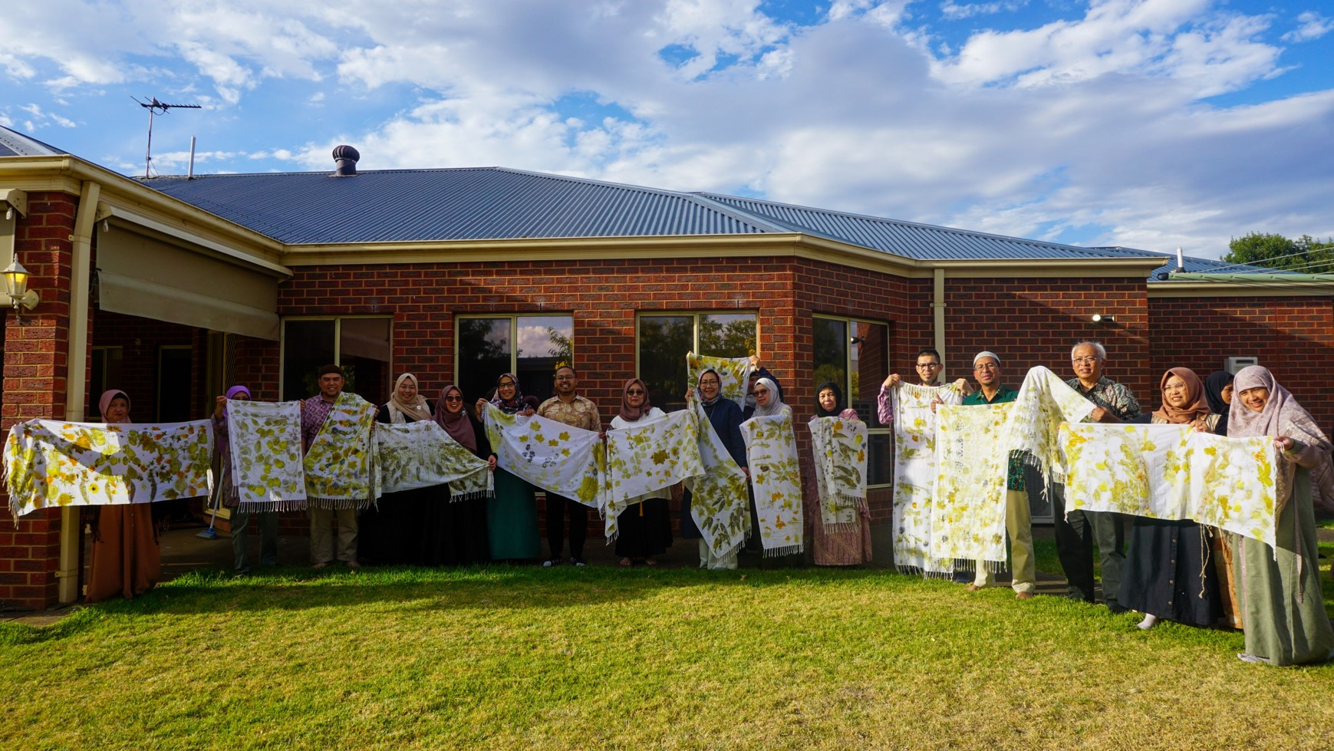

Promoting human rights within government departments
The Victorian Government is committed to building multicultural capacity in our departments and embedding human rights knowledge and practices at every level of government.
All Victorian government departments have contributed to and participated in the VEOHRC-led Charter Education program. The program supports education initiatives that build a culture of human rights across the VPS.
Initiatives undertaken in individual departments are outlined as follows.

Department of Education (DE)
All DE corporate staff must complete the eLearning training, Human Rights and Responsibilities. The module focuses on human rights and responsibilities as the foundation for respectful workplace practices. It enables participants to understand the Victorian Charter of Human Rights and Responsibilities (the Charter), and their obligations and responsibilities.
DE’s commitment also included promoting Human Rights Week and Human Rights Day in staff newsletters. DE encouraged staff to take action through a week-long pledge.

Department of Energy, Environment and Climate Action (DEECA)
DEECA participated in the VEOHRC Charter Education program in 2021-2022. This included eight sessions run for DEECA, the Environment Protection Authority and Parks Victoria. The modules focused on building knowledge and skills to embed good human rights practices in teams and across organisations.
DEECA also ran several tailored cultural training programs to managers, supervisors and staff in 2021-2022. The programs were run in partnership with DJSIR and the Jobs Victoria program, which supports people looking for work and connects employers with staff.

Department of Families, Fairness and Housing (DFFH)
DFFH’s mandatory induction training includes the eLearning module on the Charter. DFFH acknowledges key events annually that celebrate human rights, including:
- Cultural Diversity Week
- Human Rights Day
- Harmony Day
- NAIDOC Week
- Reconciliation Week
- International Women’s Day
- International Day of People with Disability
- International Day Against Homophobia, Transphobia and Biphobia (IDAHOBIT).
Additionally, Fairer Victoria is leading and influencing policy and program development for diversity and inclusion across the whole of Victorian Government.
All initiatives and policies consider the Charter through design and implementation.

Department of Health (DH)
DH continued to implement human rights eLearning training developed by VEOHRC in 2021-2022. The training is mandatory for all DH employees when they start their employment and also as a refresher. The course aims to help employees understand their obligations under the Charter and to embed a human rights culture into everyday work.
Since September 2021, more than 3,000 staff at DH have completed this training.

Department of Jobs, Skills, Industry and Regions (DJSIR)
DJSIR supports team members to increase their capacity to make decisions and provide advice in line with the Charter, including through:
- tailored learning
- guides and resources
- events and activities.
To better understand the Charter, DJSIR encourages all staff to complete the first three modules in the VEOHRC’s online education program:
- Introducing the Charter
- Rights and Obligations under the Charter
- Embedding a Human Rights Culture in Victoria.
Charter of Human Rights and Responsibilities Act: a guide for public sector workers is available on the intranet to help staff understand their responsibilities under the Charter and how to implement human rights in their work.
Creative State 2025 is Creative Victoria’s strategic plan for developing Victoria’s creative industries between 2021 and 2025. The strategy is underpinned by five key implementation principles, the second of which is a commitment to supporting multiculturalism. Creative State 2025 specifically supports the Charter in relation to multicultural communities by promoting:
- freedom of expression (section 15 of the Charter)
- cultural rights (section 19).

Department of Justice and Community Safety (DJCS)
Training on the Charter is given to all Youth Justice operational staff as part of induction, to ensure that they understand the rights of children and young people. Additionally, all training and practice instructions cover the United Nations Convention on the Rights of the Child.
All DJCS staff have access to six online modules developed by the VEOHRC through Nexus, the department’s learning management system. VEOHRC developed this education program to make high quality and accurate foundational training on the Charter easy to access. The six modules in the online education program introduce the Charter and provide a baseline awareness of its rights and obligations.
VEOHRC designed these modules for staff in Victorian public authorities, including:
- all staff in the VPS
- contractors working on behalf of public authorities
- local government.
Public authorities and their staff have obligations under the Charter to act compatibly with human rights. They must also consider human rights during all decision making.

Department of Premier and Cabinet (DPC)
DPC’s mandatory induction training includes the eLearning module on the Charter.
DPC acknowledges key events annually that celebrate human rights, including:
- Cultural Diversity Week
- Human Rights Day
- Harmony Day
- NAIDOC Week
- Reconciliation Week
- International Women’s Day
- International Day of People with Disability
- International Day Against Homophobia, Transphobia and Biphobia (IDAHOBIT).

Department of Transport and Planning (DTP)
A four-part training program developed by VEOHRC is mandatory for all staff. It aims to increase awareness of upholding human rights in the workplace, including promoting the human rights of colleagues from multicultural backgrounds.
DTP also offers two SBS inclusion programs, including a core inclusion and culture course. These programs are designed to improve staff understanding of inclusion and give staff practical skills they can use both in the workplace and everyday life.
DTP acknowledges key days of significance by organising hybrid events annually that celebrate human rights, including:
- Cultural Diversity Week
- Human Rights Day
- NAIDOC Week
- Reconciliation Week
- International Women’s Day
- International Day of People with Disability
- International Day Against Homophobia, Transphobia and Biphobia.

Department of Treasury and Finance (DTF)
DTF offers eLearning modules as part of the department’s mandatory induction and compliance training. The training is mandatory for new starters. Refresher training is required every two years for all employees. During 2021-2022, 544 employees completed the online training.
During the 2021-2022 financial year, DTF promoted the following events.
NAIDOC week (4 to 11 July 2021): This occasion was celebrated by promoting an article on DTF’s intranet which highlighted several events during that week, including:
- special NAIDOC Week programming on the National Indigenous Television network
- having team discussions on how 'Heal Country, heal our nation' resonates with them
- promoting the use of the AIATSIS Map of Indigenous Australia.
International Women’s Day (8 March 2022): DTF held an online event with over 350 participants. Two women from multicultural backgrounds were invited as guest speakers to share their stories.
Cultural Diversity Week (19 to 27 March 2022): An article was published on DTF’s intranet to promote the week, International Day for the Elimination of Racial Discrimination and Harmony Day.
IDAHOBIT (17 May 2022): An article was published on DTF’s intranet promoting the day, learning modules and events.
National Reconciliation Week (27 May to 3 June 2022): DTF recognised the week by:
- sharing an Acknowledgement of Country
- promoting various VPS events and DTF Aboriginal and Torres Strait Islander Awareness workshops
- promoting the SBS Reconciliation Film Club and its curated selection of indigenous movies and documentaries.
DTF also held two Diversity and Inclusion Committee meetings.


Progress on department cultural diversity plans
Cultural diversity plans help Victorian Government departments provide more inclusive, accessible and responsive services to multicultural and multifaith communities.
Cultural diversity plan (CDPs) cover many areas, including:
- workforce diversity
- engagement
- participation
- inclusion
- cultural competency in service delivery.
Departments report their progress on their CDPs every year, in line with the Multicultural Victoria Act 2011. Table 6 shows Victorian Government department CDPs at 30 June 2022.
Table 6: Department cultural diversity plans
Departments | Cultural diversity plans
Department of Education | DE is developing a new CDP, which has been delayed due to COVID-19.  The new CDP will include revised objectives and actions to meet the emerging needs of multicultural communities and reflect the evolution of the department’s operating context.
Department of Energy, Environment and Climate Action | Diversity and inclusion strategy 2019–2022.
Department of Families, Fairness and Housing | In June 2022, DFFH launched a new Diversity and inclusion framework 2022–2027 and Gender equality action plan 2022–2025, with supporting implementation action plans.
Department of Health | DH is developing a new CDP, which will be finalised in 2023. Progress was delayed due to the department’s focus on responding to the COVID-19 pandemic.
Department of Jobs, Skills, Industries and Regions | Multicultural diversity action plan 2018–2021.  DJSIR is developing a new CDP in consultation with key stakeholders.
Department of Justice and Community Safety | Cultural diversity plan framework 2019–2022.
Department of Premier and Cabinet | Diversity and inclusion strategy 2019–2021.  Plans to update this strategy are underway.
Department of Transport and Planning | DoT inclusion and diversity strategy 2019–2023.
Department of Treasury and Finance | Diversity and inclusion framework 2021–2025.

Departmental cultural diversity plans

Department of Education (DE): Our cultural diversity plan 2019–2021

Vision
- To improve Victoria’s learning and development services to meet the needs of families, children and young people from CALD backgrounds, particularly recent immigrants.
- To equip all children and young people with the knowledge and skills to understand and navigate cultural and linguistic differences in an increasingly interconnected world.

Goals
There are six objectives in the department’s CDP:
- build the intercultural capability of both learners and their teachers
- make the Victorian learning and development system welcoming and inclusive to all
- provide appropriate and accessible information to CALD communities
- sustain and improve supports for refugees and other new immigrants to respond to their needs
- engage with CALD communities to inform planning and delivery of services
- improve our information and reporting systems and program evaluation so the effectiveness and value of services to CALD Victorians can be monitored.

Governance and ownership
The CDP is overseen by DE’s Culture, People and Integrity Committee and Executive Board.

Cultural competence training
DE continues to advocate for the development of a whole of Victorian Government eLearning module for cultural diversity awareness among Victorian public servants. DE is working with the Victorian Public Sector Commission on this.
All new staff complete Respectful Workplaces training during induction and on-boarding. This training focuses on treating others with respect and consideration, including understanding equal opportunities and human rights. 317 staff members completed this course in 2021-2022.
All staff complete the mandatory Human Rights and Responsibilities eLearning module, which helps build respectful workplace practices. 3252 staff members completed this course in 2021-2022.
In 2022, DE ran a free professional learning program for Victorian secondary school teachers to provide mandatory Holocaust education to students in years nine and 10. 177 teachers from 44 schools attended the program in 2022. There is funding for the program until the end of 2023.

Decision-making processes and program evaluation
DE has a register of community stakeholders and organisations for consultation on program and policy development. The department has established internal processes for consulting directly with multicultural community stakeholders and organisations.
DE also provides immersive placement experiences to develop intercultural capability of pre-service teachers. The department committed to undergo periodic reviews or evaluations of all programs, informed by best practice methodology. This includes incorporating the views of diverse or vulnerable groups in evaluation design and implementation.

Department of Environment, Energy and Climate Action (DEECA): Diversity and inclusion strategy 2019–2022

Vision
DEECA aims to create a culture that embraces individual differences in all forms and fosters innovation and inclusion to support:
- liveable, inclusive and sustainable communities and thriving natural environments
- all staff to achieve their full potential and work in a flexible way that meets their needs
- a community charter that emphasises the diversity and inclusion values of building enduring and genuine partnerships.

Goals
The goals of DEECA’s CDP are to:
- improve service delivery and decision making through strong, inclusive leadership, and training and development opportunities
- foster attitudes and practices that better support diversity and inclusion
- create opportunities to recruit and retain staff from diverse groups in the community
- adopt an intersectional lens when developing key diversity and inclusion initiatives that are fit-for-purpose in addressing systemic barriers to social cohesion and equity.

Governance and ownership
All People and Culture decisions require consultation with key stakeholders across the department, including:
- DEECA’s six staff-led networks
- Workforce People Partners Working Group
- People and Culture’s leadership team and Stewardship Committee
- Executive Board.
The Manager, Diversity and Inclusion, drives key commitments in the CDP. Within the Diversity and Inclusion team, a team leader and two staff work on the CDP.
Two voluntary staff-led networks, Multicultural@DELWP and DEECA’s Women of Colour Network, inform and progress the CDP and action plans.
For an intersectionality lens, DEECA also consults with other staff-led networks, including:
- Place of Pride
- All Abilities Network
- Emerging Professionals Network
- Aboriginal Staff-led Network
- Autism Success Network.
The department also consults with broader VPS-wide networks.

Cultural competence training
SBS Inclusion and Cultural Competency training modules are available to all staff.
In the starter induction package, DEECA highlights diversity and inclusion learning opportunities to new staff.

Decision-making processes and program evaluation
DEECA’s Community charter helps the department build better relationships with stakeholders and communities, including:
- local councils
- catchment management authorities
- water corporations
- the building industry
- environment groups.
The department uses local networks, processes, tools and resources to improve interactions and engagement in policy planning and delivery of programs and projects.
DEECA’s Engage@DEECA framework enables:
- more confident and effective engagement
- stronger relationships with multicultural communities
- more informed decision making.
The current framework is being reviewed. Once complete, the review will bring the framework in line with the whole of VPS engagement framework.
The department has also developed an internal Gender equality action plan and conducts external-facing gender impact assessments as part of key diversity and inclusion initiatives. These initiatives adopt a strong intersectional lens, considering multicultural perspectives and initiative impacts.

Department of Families, Fairness and Housing (DFFH), Department of Health (DH): Delivering for diversity: cultural diversity plan 2016–2019

Vision
The department recognises that at the heart of its work are people from multicultural backgrounds and their communities. Considering cultural diversity in all policies, practices and programs will ensure the department delivers inclusive, safe and accessible services.

Goals
Priorities for responding to cultural and linguistic diversity in health and wellbeing services are in the following outcomes:
- equitable and responsive services and programs
- a culturally responsive workforce
- partnerships with diverse communities
- effective and evidence-based approaches.

Governance and ownership
The department’s Executive Board has primary ownership of the CDP, including ensuring that the plan is embedded in the department’s core business.

Cultural competence training
All department staff must complete the mandatory Workforce Diversity, Equity and Inclusion eLearning training. This course is designed to increase staff understanding and knowledge of key priority areas for building diverse workforces, including:
- Aboriginal and Torres Strait peoples
- people with disabilities
- people from culturally diverse backgrounds
- lesbian, gay, bisexual, trans, gender-diverse, intersex, queer and questioning employee communities (LGBTIQ+).
Unconscious bias training is also given to staff in both eLearning and instructor-led formats.
All executives have a diversity performance outcome in their personal development plans to improve diversity and inclusion across the department.

Decision-making processes and program evaluation
The department supports consumers, carers, communities and patients from multicultural backgrounds to make decisions about their health and wellbeing through policies, guidelines and approaches.

This includes:
- consulting stakeholders on policy and program design
- developing in-language resources
- ensuring translators are provided where required
- supporting bicultural workers to engage communities
- building the capacity of other department staff to better engage diverse communities.
The department also provides employment pathways for refugees and people seeking asylum, particularly through the Career Seeker Internship initiative. This initiative brings people from diverse communities into the public service and the heart of decision making.
After the program, 75 per cent of participants secure ongoing employment at the department or in the health and human services sector. They provide valuable lived experiences that inform decision making.

Department of Jobs, Skills, Industries and Regions (DJSIR): Multicultural diversity action plan 2018–2021

Vision
- To foster a culturally diverse and inclusive workplace that reflects the sectors and communities we work with.
- To provide inclusive service delivery to culturally diverse clients and communities that fosters greater inclusion in Victoria’s economy.

Goals
- Leadership: Our leaders will champion the CDP to foster engagement at all levels. We will all support cultural diversity through ownership at all levels.
- Information building: We will build our understanding of internal cultural diversity. We will build our understanding of the cultural diversity of the communities we work with.
- A culturally diverse workforce: We will support opportunities to grow cultural diversity at all levels of the organisation. Our workforce will reflect the communities we work with.

Governance and ownership
The Executive Director, People and Culture, in Corporate Services has ownership of the CDP.
The CDP is part of the department’s Diversity, equality and inclusion framework. The framework’s progress is monitored and reviewed by the Diversity, Equality and Inclusion Committee, a sub-committee of the Executive Board.

Cultural competence training
All staff are encouraged to develop their cultural competence through professional development opportunities.
In 2021–2022, staff had access to many cultural competence training opportunities including:
- a cultural competence eLearning program on the DJSIR learning management system
- a suite of cultural diversity online courses from LinkedIn Learning
- presentations and panel discussions organised by DJSIR’s staff-led People of Colour Network.
All departmental hiring managers must complete online unconscious bias training before conducting job interviews.

Decision-making processes and program evaluation
DJSIR’s CDP requires that all business areas consult with the community when evaluating programs and services. This is done by:
- consulting culturally diverse communities and advisory boards when making decisions about programs, policies and services that directly affect culturally diverse communities
- using available demographic and service data on cultural diversity to support decision making for programs, policies and service delivery
- embedding cultural diversity considerations when designing, implementing and evaluating policies, programs and services.

Department of Justice and Community Safety (DJCS): Cultural Diversity Plan Framework 2019-2022

Vision
An inclusive and accessible justice and regulation system that enables multicultural and multifaith communities to fulfil their potential as equal citizens.

Goals
A fair justice system that promotes equal rights and opportunities:
- Multicultural and multifaith Victorians exercise their rights and participate in the wider community.
- Our paid and volunteer workforce reflects a diverse cross-section of the population, and our people are given opportunities, experience and career pathways.
An accessible and inclusive justice system:
- Experiences of people from multicultural and multifaith communities inform and shape our decision making.
- Our workforce has the attitude and capability to provide appropriate and culturally responsive services, information and support to people from multicultural and multifaith communities.
A department that recognises and values diversity:
- The department demonstrates leadership and accountability in improving outcomes for people from multicultural backgrounds and attracts talent from diverse backgrounds.
- Cultural inclusion is supported by our tools, policies, procedures and data.

Governance and ownership
DJSR’s Inclusion and Intersectionality team (within the People, Safety, Culture and Communications Group) is responsible for the CDP. The team liaises with business units on development, monitoring and reporting against activities in the CDP.
A new Multicultural and multifaith action plan will be launched in the second half of 2023.

Cultural competence training
Cultural competency and awareness training is available as part of regular induction for all Youth Justice custodial staff.
Additionally, the Centre for Multicultural Youth worked with Youth Justice in 2020-2021 to develop a foundational training program on working with young people from multicultural and multifaith backgrounds for custodial and community staff. This training is ongoing as part of induction for all Youth Justice community staff.
Life Saving Victoria’s Diversity and Inclusion (Outreach) department promotes its cultural diversity workshops and information sessions to its partner aquatic centres and lifesaving clubs.

Decision-making processes and program evaluation
The department’s relevant business units and regions undertake consultations to ensure that services are responsive to the cultural, religious and linguistic needs of Victoria’s diverse communities.
Business planners are encouraged to examine local requirements and tailor services accordingly. Relevant culturally specific organisations are also consulted on the delivery of programs.

Department of Premier and Cabinet (DPC): Diversity and inclusion strategy 2019–2021

Vision
DPC is committed to diversity, inclusion and equity to ensure that all people:
- are treated with dignity and respect
- have equitable access to employment opportunities and outcomes
- have the ability to participate in all aspects of work life
- can achieve their full potential.

Goals
Across the various diversity and inclusion plans, the department aims for:
- visible leadership and accountability for diversity and inclusion
- attracting, developing and retaining a diverse, gender-balanced and talented workforce
- creating a safe (including culturally safe), respectful and inclusive workplace
- facilitating and promoting a flexible and accessible workplace
- measuring, monitoring and reporting on diversity and inclusion.

Governance and ownership
Executive sponsors and champions are appointed by DPC Board of Management for all key priority areas, including:
- gender
- disability
- LGBTIQ+
- Aboriginal.
The People and Culture team reports annually against each of the diversity and inclusion plans. DPC reference groups and committees are encouraged to work with executive sponsors and the People and Culture team to identify and implement initiatives in the strategy.

Cultural competence training
The People and Culture team of DPC provides diversity and inclusion training programs to help employees to:
- understand their rights and responsibilities to create an inclusive environment free from discrimination and harassment, and to identify discrimination and exclusion in the workplace
- understand their role in and strategies for creating a diverse and inclusive workplace
- understand the complex and varied experiences of diverse communities
- identify and address unconscious bias practices.

Decision-making processes and program evaluation
DPC engages with various networks including:
- Aboriginal Staff Network
- Enables Network
- Gender Equality Network
- LGBTIQ+ Network.

Department of Transport and Planning (DTP): DoT inclusion and diversity strategy 2019–2023

Vision
Inclusion is embedded into our workplace culture so that:
- we feel a sense of belonging
- people are empowered to contribute fully to the organisation’s success
- we represent the rich and diverse needs of the Victorian community.

Goals
The CDP’s objectives include:
- promoting a culturally diverse and inclusive work environment and improving cultural capability and competency
- providing inclusive services to culturally diverse clients and communities, and greater inclusion in Victoria’s economy.
The CDP’s goals include:
- leadership – our leaders will champion the CDP to foster engagement and support cultural diversity through ownership at all levels
- information building
  - we will strengthen our understanding of internal cultural diversity and the communities we work with
  - we will capture cultural diversity initiatives to share internally and report annually
- building a culturally diverse workforce
  - we will support opportunities to grow cultural diversity at all levels of the organisation
  - our workforce will reflect the communities we work with.

Governance and ownership
The Deputy Secretary, People and Business Services, along with the Executive Director, People and Culture, have overall accountability and responsibility for driving implementation of the department’s Inclusion and diversity strategy 2020–2023. An Inclusion and Diversity Council also influences, advises, oversees and tracks progress against implementation measures of the strategy.
The new Multicultural action plan is due to be finalised in 2022. All areas of the business are responsible for implementing the actions in the plan.
The People and Culture team is notified when an accountable officer moves to a different role or leaves the organisation. The team is also advised of their replacement.

Cultural competence training
From July 2020 onwards, core foundation training called Inclusion Fundamentals and Unconscious Bias has been given to DTP employees. This five-hour training includes modules on:
- unconscious bias
- bystander action and inclusive leadership
- fostering cultural humility
- cultural awareness
- impact of racism on culturally diverse staff in the workplace.
107 employees including managers and senior leaders attended the training in 2021-2022.

Decision-making processes and program evaluation
Community engagement is designed and implemented to be inclusive of multicultural communities that are affected by the decisions of the department. DTP uses the International Association of Public Association (IAP2) spectrum of public participation and a range of engagement methods, including:
- social media
- website project updates
- surveying
- community meetings
- consultation committees
- translator services.
In developing policies, processes and programs, DTP seeks feedback and contributions from the CALD Working Group to ensure that lived experience informs the final products.

Department of Treasury and Finance (DTF): Diversity and inclusion framework 2021–2025

Vision
The Diversity and inclusion framework outlines DTF's commitment to building a workplace that:
- is grounded in respect
- fosters inclusion
- promotes diversity
- embraces the unique skills and qualities of all our people.
The key focus areas of the framework are for the five diversity groups:
- multicultural
- all abilities
- LGBTIQ+
- age
- Aboriginal and Torres Strait Islander.

Goals
To ensure the department has a workforce that is representative of the Victorian population and makes the most of the talents and skills of all employees.
DTF wants to ensure it is an inclusive and appealing organisation for talented people with varied experiences and backgrounds. It embraces and encourages all people to excel, regardless of their:
- gender and gender identity
- mental or physical disability
- age
- family responsibility
- cultural background.

Governance and ownership
The Diversity and inclusion framework is overseen by DTF’s People Committee, which reports to the DTF Board.
To ensure effective implementation, DTF’s People and Culture team:
- regularly reviews the progress of the plan
- monitors employee engagement in diversity and inclusion practices through yearly People Matter Survey results.
DTF runs Respectful Workplace training sessions as part of its People matter action plan to promote a culture of respectful inclusiveness for all.

Cultural competence training
Cultural competence training is embedded in DTF’s Diversity and inclusion framework. The framework is included in DTF’s induction program.
The department promotes staff participation in days of significance, such as Harmony Day, International Human Rights Day and Refugee Week. Regular Secretary communications encourage staff involvement in diversity initiatives and events.
Regular conversational ‘catch ups’ have been established for diversity groups with DTF’s Diversity and Inclusion Deputy Security Champion. So far, these conversations have been with staff from multicultural, LGBTIQ+ and disability backgrounds.

Decision-making processes and program evaluation
The new Advancing self-determination at DTF plan is committed to ensuring the department continues to consult with Aboriginal key stakeholders in the VPS and the community.

Appendix 1: Multicultural representation on government boards, authorities and committees
Table 7: Composition of Victorian Government boards as at 30 June 2022
Composition | Number
Total number of boards as at June 2022 | 382
Total board appointments | 3541
Culturally diverse appointments | 1163
Culturally diverse percentage of boards | 32.8%
Table 8: Appointments and re-appointments to Victorian Government boards as at 30 June 2021
Appointment | Number
Number of boards with new appointments or reappointments in 2021-2022 | 308
Total new appointments or reappointments | 1405
Culturally diverse appointments or reappointments | 471
Culturally diverse percentage of appointments and reappointments | 33.5%
Table 9: Year-on-year proportion of Victorian Government department board appointments or members with culturally diverse backgrounds
Department | At 30 June 2022 (%) | At 30 June 2021 (%)
DE | 33.9 | 34.4
DEECA | 37.4 | 35.8
DFFH | 26.2 | 29.1
DH | 30.6 | 29.3
DJSIR | 37.0 | 38.2
DJCS | 32.0 | 32.1
DPC | 19.7 | 9.0
DTP | 26.9 | 30.3
DTF | 20.3 | 20.0

Appendix 2: Indicators

Frequently used abbreviations in this section
- ESB: English-speaking background
- LBOTE: Language background other than English
- MESC: Main English-speaking country
- NESB: Non-English-speaking background
- NMESC: Non-main English-speaking country

Benefits of diversity
A1 Number of children and students being funded to learn languages in community language schools (CLS)
Year | Number of funded CLS | Number of languages being learned | Total children or students
2021 | 189 | 49 | 38,970
Top 20 government funded languages being learned in Victorian CLS in 2021
Language | Number of children or students funded
Chinese | 16026
Vietnamese | 4209
Greek | 4428
Arabic | 3039
Tamil | 1409
Sinhala | 1005
Japanese | 788
Dari | 768
Bangla | 760
Russian | 522
Somali | 432
Korean | 415
Persian | 412
Greek (Classical) | 320
Punjabi | 290
Assyrian | 275
Hebrew | 271
Italian | 226
Serbian | 223
Dinka | 219
A2 Students enrolled in VCE language studies (Unit 4) in Victorian schools in 2021
Language | Enrolments
French | 1,641
Japanese Second Language | 1,120
Chinese First Language | 1,059
Italian | 682
Chinese Second Language | 620
Chinese Second Language Advanced | 613
German | 536
Indonesian Second Language | 440
Vietnamese First Language | 287
Latin | 253
Greek | 201
Vietnamese Second Language | 168
Arabic | 140
Chinese Language Culture and Society | 138
Spanish | 110
Turkish | 98
Persian | 64
Korean Second Language | 54
Hebrew | 50
Khmer | 40
Auslan | 34
Punjabi | 34
Chin Hakha | 33
Karen | 33
Hindi | 31
Tamil | 31
Russian | 28
Serbian | 28
Polish | 19
Croatian | 18
Macedonian | 17
Portuguese | 16
Sinhala | 13
Dutch | 11
Classical Greek | 10

Historic data
A3 Proportion of students in Victorian Government primary and secondary schools learning languages
Year | Primary school students (%) | Secondary school students (%)
2020 | 88.3 | 42.7
2019 | 87.0 | 43.3
2018 | 85.0 | 42.3
2017 | 83.4 | 40.9
2016 | 82.0 | 41.3
2015 | 77.0 | 41.5
2014 | 68.1 | 41.5
2013 | 62.6 | 41.9
2012 | 55.5 | 41.7
A4 Proportion of Victorian Government primary and secondary schools providing a languages program
Year | Primary school (%) | Secondary school (%)
2020 | 87.1 | 86.3
2019 | 87.4 | 86.7
2018 | 88.1 | 88.7
2017 | 90.4 | 88.8
2016 | 91.1 | 88.3
2015 | 92.1 | 87.7
2014 | 73.5 | 88.2
2013 | 67.5 | 88.9
2012 | 60.1 | 86.5

Social cohesion and participation
B1 Proportion of survey respondents who ‘agree’ or ‘strongly agree’ that accepting immigrants from many different countries makes Australia stronger
Year | Survey respondents (%)
2022 | 78
2021 | 76
2020 | 72
2019 | 67
2018 | 63
B2 Number of complaints made to the Victorian Equal Opportunity and Human Rights Commission (VEOHRC) under the Racial and Religious Tolerance Act 2001 (RRT)
Year | Number of complaints
2021-2022 | 12
2020-2021 | 34
2019-2020 | 18
2018-2019 | 9
2017-2018 | 18
2016-2017 | 8
2015-2016 | 13
2014-2015 | 106
2013-2014 | 25
2012-2013 | 41

B3 Number of complaints made to the Victorian Equal Opportunity and Human Rights Commission (VEOHRC) in relation to discrimination on the basis of race and religious belief under the Equal Opportunity Act 2010 (EOA)
Year | Number of complaints
2021-2022 | 165
2020-2021 | 240
2019-2020 | 196
2018-2019 | 244
2017-2018 | 272
2016-2017 | 254
2015-2016 | 196
2014-2015 | 147
2013-2014 | 272
2012-2013 | 244

Historic data
B4 Proportion of Victorians from a non-English speaking background who feel multiculturalism at least sometimes makes life better in their area
Year | ESB (%) | NESB (%)
2021 | N/A | N/A
2020 | 63.6 | 62.7
2019 | 54.8 | 58.1
2018 | 51.8 | 60.3
2017 | 51.1 | 58.2
2016 | 46.7 | 56.6
2015 | 50.1 | 55.7
2014 | 54.0 | 59.2
2013 | - | -
2012 | 46.8 | 54.9
B5 Proportion of Victorians from a non-English speaking background who feel they have experienced discrimination or have been treated unfairly by others because of their skin colour, nationality, race or ethnic group, or religious beliefs
Ethnicity of adults who experienced racism | Proportion (%) of adults who experienced racism in the past 12 months
East Asian | 20.7
Aboriginal | 17.0
Other | 13.8
Indian Subcontinental | 11.4
South-East Asian | 11.1
Middle Eastern | 7.9
Southern European | 6.7
Did not know, refused to say or undetermined | 6.6
All Victorian adults | 5.7
Eastern European | 5.2
Northern and Western European | 2.6
Anglo-Celtic | 1.7

Accessible and responsive services
C1 Number of Victorian children from a non-English-speaking background (NESB) enrolled in a Victorian Government funded kindergarten program
Year | NESB children enrolled in kindergarten
2021 | 16,305
2020 | 14,818
2019 | 16,303
2018 | 18,195
2017 | 16,741
2016 | 14,044
2015 | 11,657
2014 | 9,904
2013 | 9,437
C2 Unemployment rate of Victorians born in non-main English-speaking countries compared to the unemployment rate of all Victorians
Year | NMESC-born (%) | All Victorians (%)
June 2022 | 4.0 | 3.1
June 2021 | 5.9 | 4.3
June 2020 | 9.1 | 7.1
June 2019 | 7.1 | 4.5
June 2018 | 6.7 | 5.3
June 2017 | 6.9 | 5.6
June 2016 | 6.4 | 5.4
C3 Workforce participation rate of Victorians born in non-main English-speaking countries compared to the workforce participation rate of all Victorians
Year | NMESC-born (%) | All Victorians (%)
June 2022 | 63.8 | 67.1
June 2021 | 62.5 | 66.2
June 2020 | 60.7 | 64.5
June 2019 | 61.6 | 66.1
June 2018 | 60.0 | 65.7
June 2017 | 58.0 | 66.1
June 2016 | 57.9 | 65.4

The policy statement can be found on the Victorian Government website’s Multicultural policy statement page <https://www.vic.gov.au/multicultural-policy-statement>.
Victorian multicultural policy statement p.25. Available at Victorian Government website’s Multicultural policy statement page <https://www.vic.gov.au/multicultural-policy-statement>.
On 1 January 2023 the Department of Education and Training (DET) became the Department of Education (DE).
On 1 January 2023 the Department of Environment, Land, Water and Planning (DELWP) became the Department of Energy, Environment and Climate Action (DEECA).
On 1 January 2023 the Department of Jobs, Precincts and Regions (DJPR) became the Department of Jobs, Skills, Industries and Regions (DJSIR).
On 1 January 2023 the Department of Transport (DoT) became the Department of Transport and Planning (DTP).
This represents funding for multicultural and multifaith communities announced under the Crime prevention strategy in 2021-2022. The strategy was released in June 2021, with over $42 million invested since 2019-2020.
These figures represent campaign advertising only and exclude expenditure on interstate and international advertising in 2020-2021. 2021-2022 figures include campaign advertising undertaken via all channels, including both digital and non-digital.
DE was the Department of Education and Training for the reporting period 2021-2022.
DEECA was the Department of Environment, Land, Water and Planning for the reporting period 2021-2022.
DJSIR was the Department of Jobs, Precincts and Regions for the reporting period 2021-2022.
DTP was the Department of Transport for the reporting period 2021-2022.
On 1 February 2021, the Department of Health and Human Services (DHHS) split into DFFH and DH. DH and DFFH used DHHS’s CDP for the 2021-2022 reporting period. A new DH plan will be finalised in 2023. DFFH launched a new Diversity and inclusion framework 2022–2027 and Gender equality action plan 2022–2025 in June 2022.
DJSIR is currently updating its CDP in consultation with key stakeholders.
The Victoria Police Culturally and linguistically diverse inclusion action plan 2022–2024 was launched in February 2023. This will contribute to the broader Victoria Police Workforce diversity and inclusion framework 2022–2030.
DTP is currently working to finalise a new three-year strategy to extend the current strategy to 2026. Work to finalise a new three-year Multicultural action plan 2023–2026 is also underway. All business areas will be responsible for implementing actions in the plan.
Data for tables 7 to 9 provided by VPSC. Data exclude cemeteries, school councils and small committees of Crown Land Management. Where the Public Administration Act status is neither public entity nor special body, and where DPC classification is not applicable, the data is not reported. Figures may differ to previously published data for prior years due to ongoing remediation, increased completeness of data or an appointee’s decision to disclose or no longer disclose additional characteristics. Data include machinery of government changes, which can impact department figures compared to numbers in publications and reports in previous years.
The Australian Bureau of Statistics uses the term NMESC to represent non-main English-speaking countries, while MESC represents main English-speaking countries. MESC are the United Kingdom, Ireland, New Zealand, Canada, USA and South Africa. NMESC cover all other countries of birth. Where appropriate and specifically relevant, some departments and agencies use the term NESB to stand for non-English-speaking background and ESB to stand for English-speaking background. LBOTE stands for language background other than English while LOTE is for language other than English.
This is a new data collection indicator for the 2021-2022 period.
This is a new data collection indicator for the 2021-2022 period.
Source: DET Languages Report, Languages Provision in Victorian Government Schools, 2020. The data was collected annually until 2021. The department did not collect languages information from government schools during the COVID-19 pandemic in 2021 and 2022.
Source: DET Languages Report, Languages Provision in Victorian Government Schools, 2020. The data was collected annually until 2021. The department did not collect languages information from government schools during the COVID-19 pandemic in 2021 and 2022.
Source: The Scanlon Foundation’s Mapping Social Cohesion Survey reports. The surveys are conducted annually. Results collected earlier than 2018 are not included for comparison as a different survey mode was used.
Source: Victorian Equal Opportunity and Human Rights Commission (VEOHRC) Annual Reports. The data is collected annually
Source: Victorian Equal Opportunity and Human Rights Commission (VEOHRC) Annual Reports. The data is collected annually.
Source: DH, Victorian Population Health Survey, annual survey 2020. The Victorian Population Health Survey was not conducted in 2021 due to the COVID-19 pandemic. The survey was resumed in 2022. Estimates prior to 2015 are not directly comparable to estimates from 2015 onwards due to a significant change in the survey methodology.
No data was available for 2013, as the question was not asked. Data for 2015 onwards cannot be compared to previous years due to a change in survey methodology
Source: DH, Victorian Population Health Survey, annual survey 2020..
Source: DET Kindergarten Census Collection. Data is collected annually. The data represents the number of children who were enrolled in a funded kindergarten program and whose family indicated that they speak another main language at home other than English. It is not feasible to calculate a kindergarten participation rate for NESB children as there is no suitable NESB population denominator for four-year-olds. In 2019, 2020 and 2021, there was a system error in the Kindergarten Information Management System, which has removed the ability for service providers to select ‘other’ under the question for ‘Main language spoken at home (if not English)’. Kindergarten services who would have usually entered data in this field may have left this blank. (In 2018 almost 3,500 children had ‘other’ entered in this field).
Australian Bureau of Statistics (February 2023) 'Table 5 - Labour force status by Sex, Victoria', Labour Force, Australia, accessed 27 February 2023. <https://www.abs.gov.au/statistics/labour/employment-and-unemployment/labour-force-australia/latest-release>
Australian Bureau of Statistics (February 2023) 'LM7 - Labour force status by elapsed years since arrival, main English-speaking countries, sex, state and territory, January 1991 onwards', Labour Force, Australia, Detailed, accessed 27 February 2023. <https://www.abs.gov.au/statistics/labour/employment-and-unemployment/labour-force-australia/latest-release>

