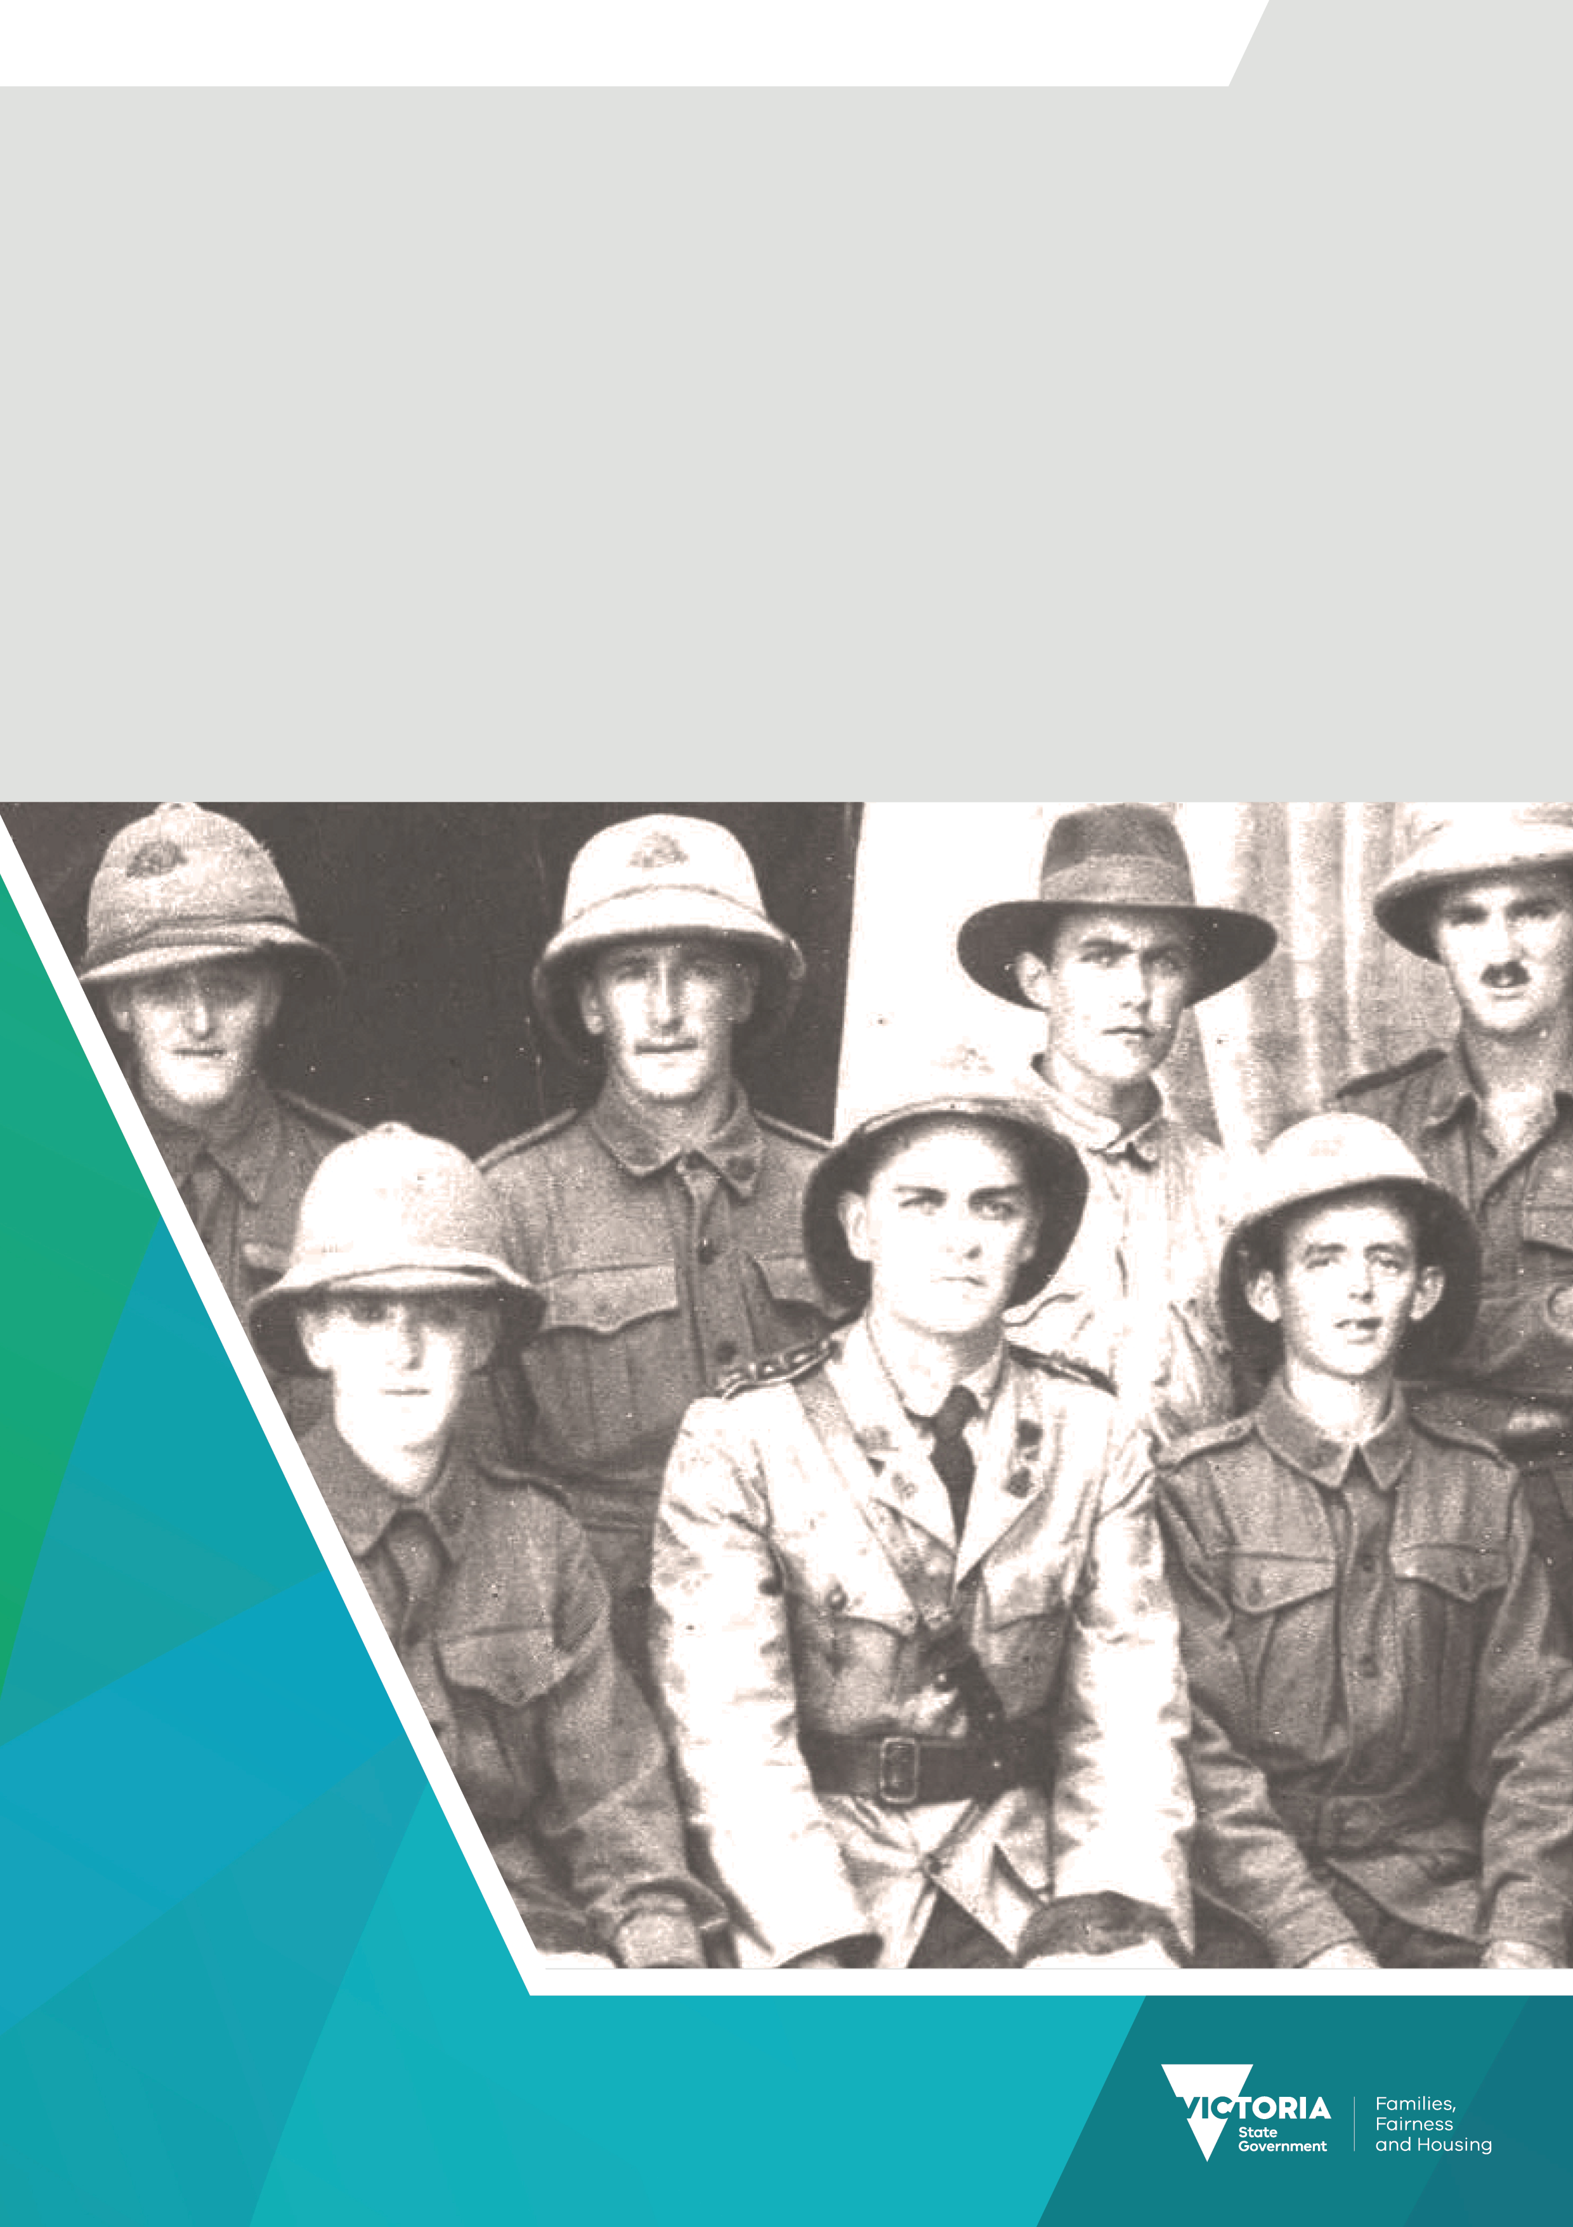

Premier’s Spirit of Anzac Prize
Lesson five
Teacher notes

Contents
Primary source analysis: war photographs 3
Task 3

Primary source analysis: war photographs
Primary sources, such as photographs, are a rich source of evidence for historians to examine and find out more about the period they are studying.

Task
Examine each of the photographs below, taking particular note of their source lines, and answer the following questions for each of photographs A, B, and C.
- Where and when was the photograph taken?
- Who or what is the subject of the photograph?
- Describe what you see in the photograph.
- How reliable is the source?
- What is the significance or relevance of each photo? In terms of:
- the war to which it relates
- what differences, if any, it depicts between the three wars: World War I, World War II and the
Vietnam War.
- How useful is the source to a historian?
[NOTE: You may find it useful to write your answers to questions 1 to 4 in a table and then answer questions 5 and 6 in a paragraph each.]
A.
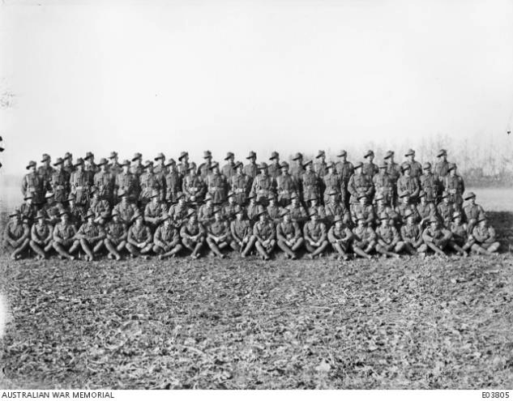
Source: Huppy, France.23 November 1918. Group portrait of the NCO's 59th Battalion, Australian Infantry. (Australian War Memorial)

B.
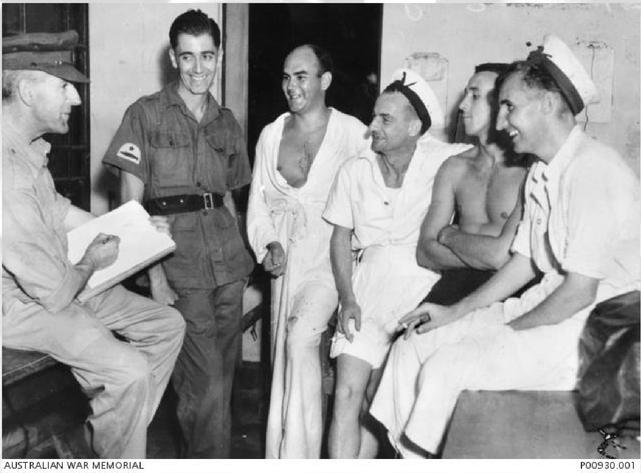
Source: Ernest Buckmaster, war artist, at work drawing a group of servicemen, World War II. (Australian War Memorial)
C.
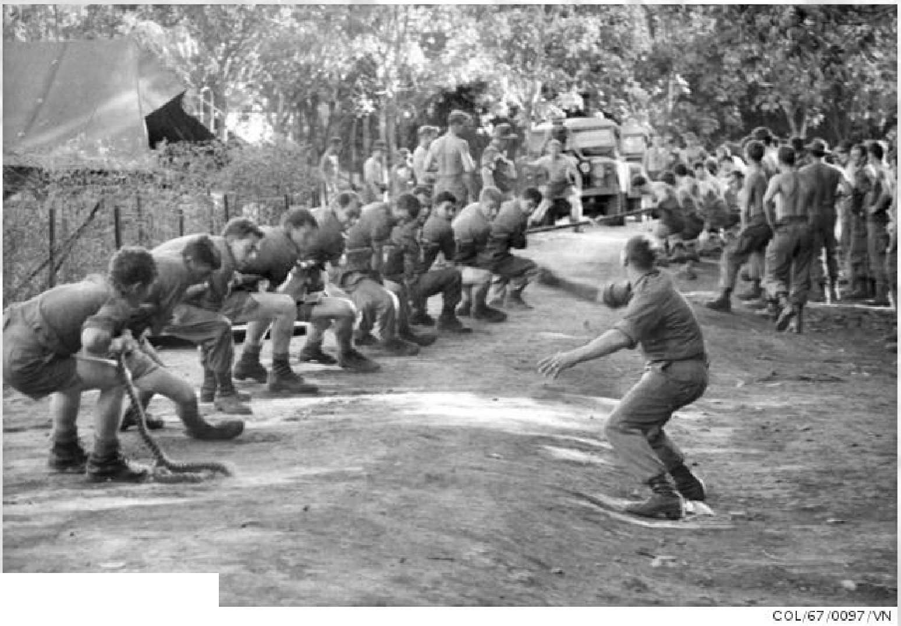
AUSTRALl.oN WAR MEMORIAL
Source: Vietnam, 1967. Soldiers pulling on a rope, enjoying a game of tug of war. (Australian War Memorial)

1-4.
Source | When/where | Who/what | Describe | Reliability
A | Huppy, France, 23/11/1918. | NCO's 59th Battalion, Australian Infantry. | A formal group portrait of a battalion of Australian soldiers. | This source is reliable as it comes from the archives of the Australian War Memorial, a reliable institution
B | Unknown, but probably on board a ship (because of the sailors’ caps), 1939–1945. | World War II servicemen and war artist Ernest Buckmaster. | War artist Ernest Buckmaster is drawing a group of off-duty servicemen, most likely onboard a ship. | This source is reliable as it comes from the archives of the Australian War Memorial, a reliable institution.
C | Vietnam, 1967. | Australian soldiers. | Australian soldiers off duty playing tug of war. | This source is reliable as it comes from the archives of the Australian War Memorial, a reliable institution.
5. Student answers will vary. A sample answer is given below.
All three photographs can be considered significant as they all capture a moment of time when soldiers are not actually engaged in battle. Source A is dated twelve days after Armistice Day (Nov. 11), so it was most likely taken to record the final time that the battalion was together before the soldiers were sent home.
Source B was probably taken at sea en route to somewhere in Europe, or elsewhere. Source C was most likely taken at an Australian army camp in Vietnam. The World War I photograph differs quite a lot from the photographs taken during the other two wars. It is a very formal shot, perhaps signifying the solemnity of the finality of the war, while the other two photos are far more relaxed shots. In Source B, the sailors are relaxed, at ease and seem happy, and in Source C, the soldiers are totally engaged in the tug-of-war game.
6. Student answers will vary. A sample answer is given below
These photographs are useful to historians as they depict a moment in time. Source A could be used to identify soldiers of the 59th Battalion who were still alive at the time of the Armistice. Sources B and C show servicemen, who were not on duty, looking relaxed. It can give us an insight to some extent as to how they were feeling at the time.
To receive this document in another format email the Premier's Spirit of Anzac Prize team
<soap@dffh.vic.gov.au>.
Authorised and published by the Victorian Government, 1 Treasury Place, Melbourne.
© State of Victoria, Australia, Department of Families, Fairness and Housing, July 2023.
ISBN 978-1-76130-180-3 (pdf/online/MS word)
Available at SOAP Classroom resources <www.vic.gov.au/premiers-spirit-anzac-prize-classroom-resources>
(2306250)

