Application Form Guidance
2023-24 Multicultural Community Infrastructure Fund (MCIF)
OFFICIAL
Contents
Introduction 2
Document purpose 2
Program Details 2
Step 1: Privacy Statement 2
Step 2 & 3: Eligibility Questions 2
Organisational eligibility 2
Auspice 3
Social Enterprise 3
Financial Statements 3
Step 4: Applicant Organisation 3
Step 5: Contacts 4
First and Second Signatory / Authorised Person 4
Primary Contact Person (day to day) 4
Step 6: Project Details 4
Project description and partners 4
Project Audience 5
Step 7: Assessment Criteria 7
Step 8: Budget 10
Attachments 12
DFFH Grants Gateway 14
Logging on to the DFFH Grants Gateway 14
Navigating the DFFH Grants Gateway 14
Helpful Tips 15

Introduction

Document purpose
This document has been prepared to help you complete the 2023-24 Multicultural Community Infrastructure Fund (MCIF) online application form. It should be used with the 2023-24 MCIF Program Guidelines to help you prepare your responses to the application form questions and your mandatory documents.
The document includes information on:
- Each step of the application form, including questions asked in each step and guidance on how to respond to certain questions.
- How to add the budget of you project to the application form
- How to attach documents to your application form
- How to use the DFFH Grants Gateway to complete and submit your application.

Program Details
The MCIF program aims to support multicultural community groups to undertake pre-construction activities, upgrades, renovations, extensions, or new construction of community facilities to provide a space for communities to celebrate and share their history and traditions, build connections, and thrive.
The program funds multicultural community infrastructure projects that include smaller upgrade projects such as replacing a community centre kitchen, the addition of event spaces and meeting rooms, and larger projects such as building new multipurpose facilities and cultural centres.

Step 1: Privacy Statement
- This step is for your information only. Please read the privacy statement and other information on this page carefully before completing your application.
- Please note: applications close at 3pm sharp on 6 December 2023. Late applications will not be accepted and extensions will not be provided.

Step 2 & 3: Eligibility Questions

Organisational eligibility
- The questions in steps 2 and 3 form part of the 2023-24 MCIF program organisation eligibility assessment. Your organisation must meet the required eligibility criteria to apply.
- Please refer to page 13 of the 2023-24 MCIF Program Guidelines for further information on organisation eligibility.

Auspice
- If your organisation is not incorporated and is supporting a priority group, you can apply to 2023-24 MCIF program under an auspice arrangement. You are required to provide the details of the auspice organisation to confirm the eligibility of the auspice organisation supporting your organisation.
- You will also need to provide a letter of support from the auspice organisation that is dated no more than three months prior to 6 December 2023. This letter must:
  - Be on an official letterhead of the auspice organisation
  - Include the full legal name, Australian Business Number (ABN), and address of the auspice organisation
  - Include the full legal name, ABN, and address of the applicant organisation
  - Comments that the auspice organisation understands it is acting for your organisation and is responsible for the management of your grant funds and successful completion of your project.
  - Be signed by auspice organisations chief executive officer, president or similar.
- Please refer to page 17 of the 2023-24 MCIF Program Guidelines for further information on auspiced applications.

Social Enterprise
- Social enterprises are eligible to apply to the 2023-24 MCIF program. If your organisation is a social enterprise, you must attach your organisations constitution / rules to your application.
- Please refer to page 16 of the 2023-24 MCIF Program Guidelines for further information on social enterprise eligibility.
- For more information on social enterprises see the Victorian Social Enterprise Strategy.

Financial Statements
- You are required to provide copies of your organisation’s financial statements for the last 2 financial years (2021-22 and 2022-23). These documents form part of the of the merit assessment process and relates to the 2023-24 MCIF program financial viability assessment criteria and the 2023-24 MCIF program risk assessment process.
- If you cannot provide this information, please contact multicultural.infrastructure@dffh.vic.gov.au in order to agree on an acceptable alternative with DFFH as part of the application submission process. A submitted application without any form of financial statements will be ineligible.

Step 4: Applicant Organisation
- This step forms part of the 2023-24 MCIF program eligibility assessment. You are required to provide information on your organisation, even if you have previously applied for a grant with DFFH.

Step 5: Contacts
- All applicants are required to provide details and contact information for the following:
  - First Signatory / Authorised Person
  - Second Signatory / Authorised Person
  - Primary Contact Person (day to day)
- Successful organisations may be required to confirm or provide additional contact information when the offer of funding is made.

First and Second Signatory / Authorised Person
- Each organisation must provide the details of two representatives from your organisation who are authorised to enter into a contract between your organisation and DFFH. The authorised representatives usually hold the positions of either President, Chief Executive Officer, Treasurer, or Secretary.
- The two authorised representatives will act as signatories to the Victorian Common Funding Agreement (VCFA) between your organisation and DFFH.
- Please Note: The first and second authorised representatives cannot be the same person and cannot have the same email address.

Primary Contact Person (day to day)
- The primary contact person is a member of your organisation who will be the point of contact between your organisation and DFFH. This person should be the person responsible for the delivery of your project and be able to provide DFFH with updates on the status of your project when requested.
- Please Note: The primary contact person can be the same person as either of the authorised representatives from your organisation.

Step 6: Project Details
- Your responses provided in this step are used as part of the 2023-24 MCIF eligibility assessment and merit assessment processes. Your responses will be assessed and scored against the 2023-24 MCIF assessment criteria outlined on page 20 of the 2023-24 MCIF guidelines.
- To assist you in responding to the questions in this step, guidance has been provided below on what assessment criteria the question relates to and what you should consider in your response.

Project description and partners

Application form question: Project description:
- This question forms part of the 2023-24 MCIF program project eligibility assessment process. Your response to this question is used to determine if the eligibility of the proposed project activities.
- This is a free text question with a 250-word limit.
- Consider including in your response:
  - What activities will your organisation complete with this project?
  - How will the grant funding be used?
- Please refer to page 8 and 9 of the 2023-24 MCIF Program Guidelines for further information on eligible and ineligible grant activities.

Application form question: Please provide a list of all key partners.
- This question forms part of the 2023-24 MCIF program eligibility assessment and merit assessment processes. Your response to this question is used to confirm the details of any partner organisations, determine the partner organisations eligibility, and confirm the roles and responsibilities of the organisations in the partnership.
- This is a free text question with a 250-word limit.
- Consider including in your response:
  - How will your organisation and your partner organisation share the roles and responsibilities of the project?
  - What is the project and grant management experience of your partner organisation.
- Please Note: All applications involving a partnership arrangement must contact muliticultural.infrastructure@dffh.vic.gov.au to discuss the partnership application before the application is submitted.
- Please refer to page 17 of the 2023-24 MCIF Program Guidelines for further information on partnership applications.

Project Audience
- You are required to provide details of the intended audience of your project. These are the groups that will benefit from your project.
- The questions in this section are drop down lists where you can select 1 or more options that best match your project.
- For each of the following questions you can select a maximum of three options:
  - What age groups will your project target or support?
  - What cultural or ethnic groups will your project target or support?
  - What language groups will your project target or support?
  - What faith groups will your project target or support?
- Please Note: You are encouraged to provide details on how your project will benefit the target audiences identified when responding to questions in Step 7: Assessment Criteria.

- To add expenses to this question, select + Add.
- To add an option to these questions, select the search field.
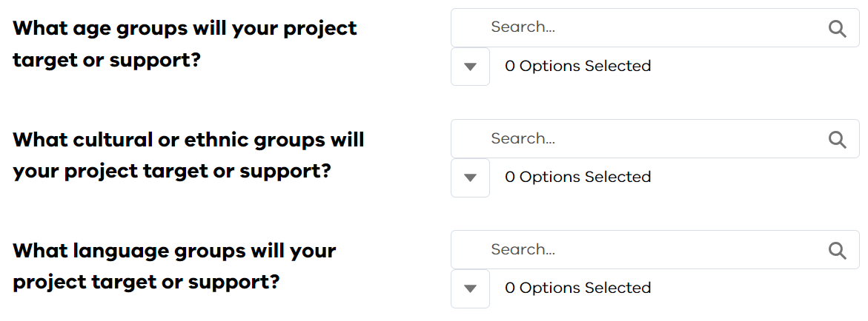
- An options drop-down list will appear. Select up to 3 options that best match you project.
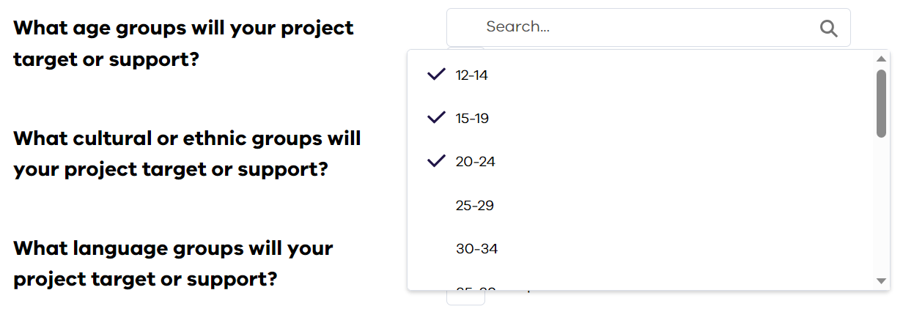
- When you have finished selecting your options, click on the search field again to close the options drop-down list.
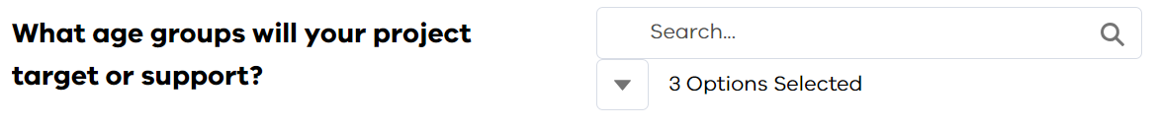
- To view the options you selected, click on the icon below the search field.
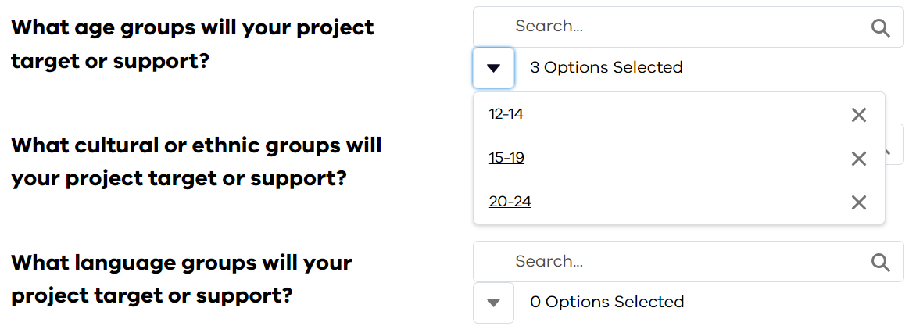

Step 7: Assessment Criteria
- Your responses provided in this step form part of the 2023-24 MCIF eligibility assessment and merit assessment processes. Your responses will be assessed and scored against the 2023-24 MCIF assessment criteria. To assist you in responding to the questions in this step, guidance has been provided below on what assessment criteria the question relates to and what you should consider in your response.
- Please refer to page 19 and 20 of the 2023-24 MCIF Program Guidelines for further information on the assessment process and assessment criteria.

Application form question: Application form question: What is the purpose of your organisation?
- This question forms part of the organisation eligibility assessment.
- This is a free text question with a 250-word limit.
- Consider including in your response:
  - What is the focus and purpose of your organisation?
  - What does your organisation want to achieve?

Application form question: Please describe how your project will benefit the funding priority group(s) you selected above?
- Please note: The ‘funding group(s) you have selected above’ refers to the funding groups selected the question ‘Please pick the funding priority groups that best match your organisation and your project:’.
- This question forms part of the merit assessment process and relates to the 2023-24 MCIF program aim of supporting the following priority community groups:
  - Regional and rural multicultural communities
  - New and emerging multicultural communities
  - Projects focused on achieving positive outcomes for women and gender diverse multicultural people.
- This is a free text question with a 250-word limit, and only applies to applicants who meet the priority group eligibility requirements.
- Consider including in your response:
  - What facilities, activities, events, or services will be available to the priority group on completion on the project?
  - Why is the project needed to support the priority groups access to your communities’ facilities, activities, events or services?
- Please refer to page 10 of the 2023-24 MCIF Program Guidelines for further information on priority groups and projects.

Application form question: Why does your community need this project?
- This question forms part of the merit assessment process and relates to the 2023-24 MCIF program aim of identifying community need and gaps in multicultural community infrastructure.
- This is a free text question with a 250-word limit.
- Consider including in your response:
  - How will the project increase community participation in community events and activities?
  - How will this project help your community preserve and share your history, culture, and traditions?
  - How will the project help your community share your history, culture, and traditions with the broader Victorian community?

Application form question: How will the project help your community come together to celebrate and share their history and traditions?
- This question forms part of the merit assessment process and relates to the 2023-24 MCIF program aim of supporting communities to celebrate and share their history and traditions.
- This is a free text question with a 250-word limit.
- Consider including in your response:
  - How will the project support your community to build networks and connections with other members of your community?
  - What traditions or celebrations will your community celebrate because of the project.

Application form question: How will the project help your community to build connections and networks, so they have more opportunities to participate in society?
- This question forms part of the merit assessment process and relates to the 2023-24 MCIF program aim of supporting communities to build community connections and networks to participate in society.
- This is a free text question with a 250-word limit.
- Consider including in your response:
  - How will the project support your community to build networks and connections outside of your community?
  - What opportunities will become available to your community because of the project?
  - How will the project support your community members to participate in society?

Application form question: How will the project assist your community to share their culture and traditions with the broader Victorian community?
- This question forms part of the merit assessment process and relates to the 2023-24 MCIF program aim of supporting communities to build community connections and networks to participate in society.
- This is a free text question with a 250-word limit.
- Consider including in your response:
  - How will your project increase engagement between your community and the broader Victorian community?
  - What traditions and celebrations will your community be able to share with the broader Victorian community because of the project?

Application form question: How will the project increase your organisations capacity to deliver social outcomes for your community?
- This question forms part of the merit assessment process and relates to the 2023-24 MCIF program aim of supporting communities to access opportunities and deliver social outcomes.
- This is a free text question with a 250-word limit.
- Consider including in your response:
  - How will the project support your organisation to provide public services to your community?
  - How will the project increase your communities access to public services?
  - What new public services will your organisation be able to provide to your community following the completion of the project?

Application form question: What are the short and long-term outcomes and benefits of this project and how these will benefit your community into the future?
- This question forms part of the merit assessment process and relates to the 2023-24 MCIF program aim of providing long-term benefits to multicultural communities and the broader Victorian community, and the assessment criteria of value for public money.
- This is a free text question with a 250-word limit.
- Consider including in your response:
  - How will the project help your community grow?
  - How will the project increase your organisations sustainability?
  - How will you ensure the project has long term benefits for your community?

Application form question: Please provide the details of your organisation member that will manage your project and describe their experience in managing and delivering projects:
- This question forms part of the merit assessment process and relates to the 2023-24 MCIF program organisational capability assessment criteria and the 2023-24 MCIF program risk assessment process.
- Your response to this question is used to determine the project management experience of your organisation, and its ability and readiness to undertake your project.
- This is a free text question with a 250-word limit.
- Consider including in your response:
  - What previous projects has your organisation member delivered?
  - Has your organisation member previously completed any infrastructure projects?

Application form question: Tell us about previous grants that your organisation has received and completed.
- This question forms part of the merit assessment process and relates to the 2023-24 MCIF program organisational capability assessment criteria and the 2023-24 MCIF program risk assessment process.
- Your response to this question is used to determine the grant management experience of your organisation, and its ability and readiness to undertake the grant management responsibilities of the 2023-24 MCIF program.
- This is a free text question with a 250-word limit.
- Consider including in your response:
  - What previous infrastructure grants has your organisation received? How did you your organisation successfully deliver the funded grant activities?
  - What previous non-infrastructure grants has your organisation received? How did you your organisation successfully deliver the funded grant activities?
  - What benefit did the grant have for your organisation?
  - What processes did your organisation put in place to manage previous projects and grants?

Step 8: Budget
- This step forms part of the 2023-24 MCIF program eligibility assessment and merit assessment processes. The information captured in this step is used to determine the eligibility of your proposed grant funded activities, and how your activities align with the objectives of the 2023-24 MCIF program.
- You will be asked to provide the following information in this step:
  - What is the expected total cost of the project?
  - Amount requested from this grant program (income)
  - What do you intend to spend funding from this grant on?
  - What other income sources contribute to this total project cost (other than the amount requested from this program)?
- Please Note: All income and expense figures added in this step must be exclusive of GST.
- Please refer to page 8 and 9 of the 2023-24 MCIF Program Guidelines for further information on eligible and ineligible grant activities.

Application form question: What do you intend to spend funding from this grant on?
- To add expenses to this question, select + Add.
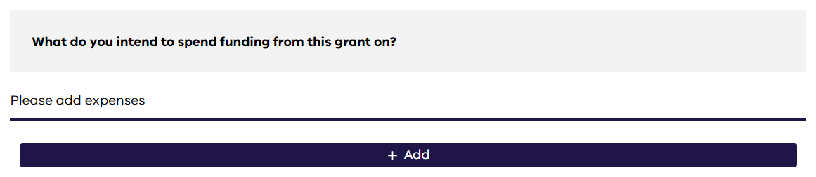
- The expenses field will appear where you can add each of you project activities.
  - Category: select the option that best matches your activity.
  - Description: Provide a short description of the activity.
  - Amount: This is the total amount of the expense exclusive of GST.
  - Supporting Documents: attach all quotes, detailed cost estimates and other supporting documents relating to this expense.
- An example of a completed expense field is shown below.
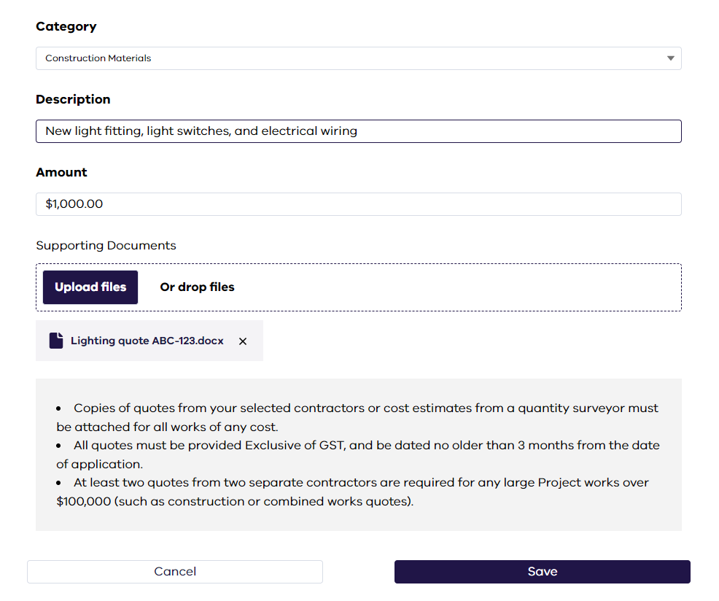
- To add as many expense items as need to include all expenses for your project, select + Add To include the additional expense items.
- Please Note: The total expenses you intend to spend funding from this grant on, must be the same as the grant amount requested. See example below.
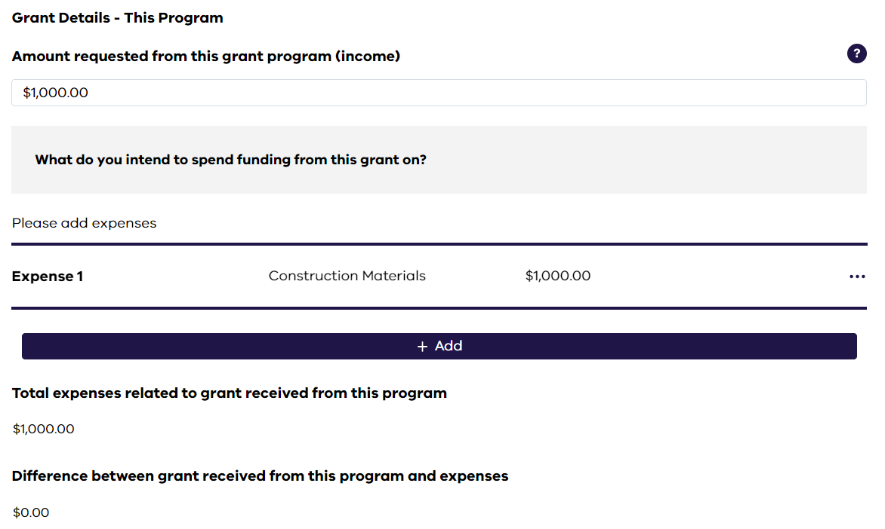

What other income sources contribute to the total project cost (other than the amount requested from this program)?
- If your project has funding sources other than the 2023-24 MCIF program, you are required to provide details of the funding source and how the funds will be used. If your project has more than one funding sources (excluding the 2023-24 MCIF program) you need to provide the income and expenses details for each funding source.
- Please Note: This is mandatory for organisations who must contribute matched funding.
- Please refer to page 18 of the 2023-24 MCIF Program Guidelines for further information on matched funding requirements.

Attachments
- Throughout the application you will be required to attach documents to support your application. The documents you need to provide will depend on the type of project you are applying for.
- You can attach more than one document to each attachment field by either selecting the Upload files option, or by clicking and dragging the file onto the Or drop files option.

DFFH Grants Gateway
All applications for the 2023-24 MCIF program must be submitted via the DFFH Grants Gateway online portal.

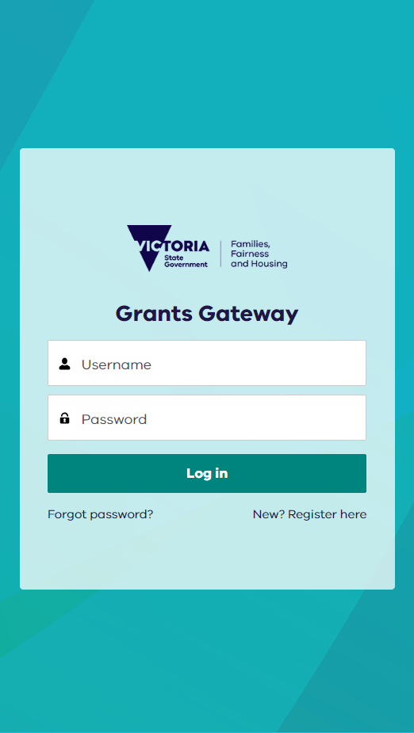
Logging on to the DFFH Grants Gateway
- If you have not used the DFFH Grants Gateway before, you will need to register. Select ‘New? Register’ on the DFFH Gateway log in page, then follow the prompts.
- If you have used the DFFH Grants Gateway before, however you have forgotten your password, you can reset your password by selecting ‘Forgot password?’

Navigating the DFFH Grants Gateway
- Resources are available on the DFFH Grants Gateway to help you navigate and use the platform. Select ‘Help Guides and Documents’ to view these resources.
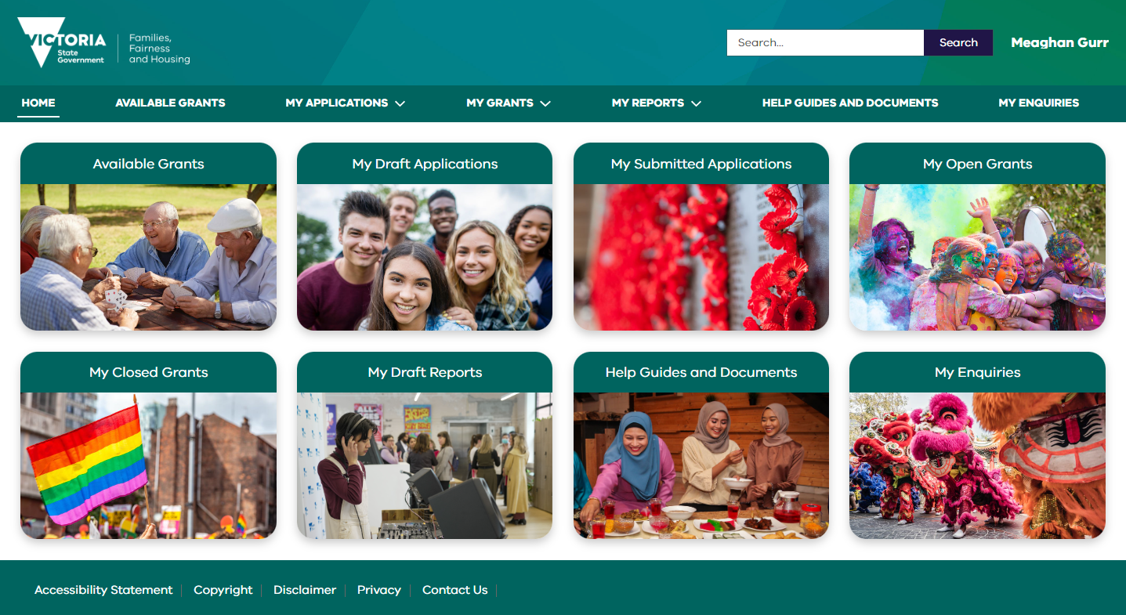

Helpful Tips

- Carefully read the 2023-24 MCIF Guidelines before starting your application, including the eligibility criteria to be sure you organisation and proposed activities are eligible to apply.
- Help text is provided throughout the online application form where you see this symbol.
- Not all applicants will be required to answer all questions in the online application form. Your responses to certain questions may require additional information from you. In these cases, additional questions will appear.
- Be clear in your responses to free text questions and provide as much information as possible. This information will assist the assessment team to review your application.
- Have someone review your application before you submit your application. This will help improve the quality of your application and pick up any issues before you submit.
- You can save your application by selecting the Save & resume later option at the top right of each page. You can then resume completing your application at a later date by selecting ‘My Draft Applications’ on the DFFH Grant Gateway home page.


