

Transport Safety Investigation
Report No 2009/06

Passenger Coach Rollover
Princes Highway Heathmere
16 April 2009

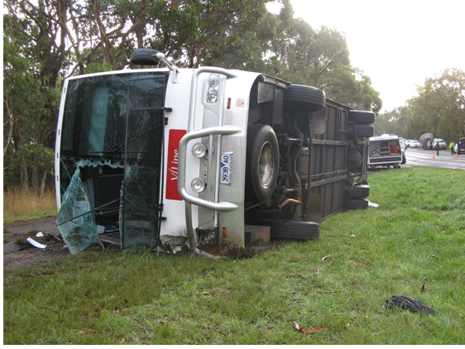

TABLE OF CONTENTS
The Chief Investigator 5
Executive Summary 7
1. Circumstances 9
2. Factual Information 11
2.1 Coach 3938 11
2.2 Personnel information 15
2.3 Coach CCTV recording 26
2.4 Omnibus construction standards 27
2.5 Post-incident testing of coach 29
2.6 Road infrastructure 31
2.7 Traffic volumes and accident history 41
2.8 Road safety funding and treatment programs 41
2.9 Environment 42
3. Analysis 43
3.1 The incident 43
3.2 Coach 3938 44
3.3 Occupant survivability 45
3.4 Road design and condition 45
4. Conclusions 47
4.1 Findings 47
4.2 Contributing factors 48
5. Safety Actions 49
5.1 Safety Actions taken since the event 49
5.2 Recommended Safety Actions 49
6. Appendixes 51
Appendix A - Minimum Radii Calculation 51
Appendix B - Calculation of Maximum Design Speed 54
7. References 56

The Chief Investigator
The Chief Investigator, Transport Safety is a statutory position under Part 7 of the Transport Integration Act 2010. The objective of the position is to seek to improve transport safety by providing for an independent no-blame investigation of transport safety matters consistent with the vision statement and the transport system objectives.

The primary focus of an investigation is to determine what factors caused the incident, rather than apportion blame for the incident, and to identify issues that may require review, monitoring or further consideration. In conducting investigations, the Chief Investigator will apply the principles of ‘just culture’ and use a methodology based on systemic investigation models.

The Chief Investigator is required to report the results of investigations to the Minister for Public Transport and/or the Minister for Roads and Ports. However, before submitting the results of an investigation to the Minister, the Chief Investigator must consult in accordance with section 85A of the Transport (Compliance and Miscellaneous) Act 1983.

The Chief Investigator is not subject to the direction or control of the Minister(s) in performing or exercising his or her functions or powers but the Minister may direct the Chief Investigator to investigate a transport safety matter.

Executive Summary
A passenger coach was conducting a scheduled V/Line road service from Warrnambool, Victoria to Mount Gambier, South Australia when the vehicle skidded, rolled over onto its right side, slewed off the highway and came to rest on a grass embankment.

At the time of the incident the coach was carrying 11 passengers. Of these, a two year old child, a 19 year old female and a 20 year old male sustained fatal injuries. One passenger sustained serious injuries while the driver of the coach and seven other passengers sustained minor injuries.

The right-hand side of the coach was extensively damaged in the incident.
The investigation found that a section of the incident road had a low coefficient of friction and the 100 km/h speed designation for the approach curve was excessive for the existing geometry of the road.
The investigation determined that the existing ‘Slippery When Wet’ sign was inadequate in providing sufficient guidance to drivers and mitigating the risk of the low friction road surface conditions.

The investigation also found that the coach was not fitted or provided with child safety harnesses and several of the coach passengers were not wearing seat belts at the time of the incident.

The investigation recommends that VicRoads reviews its roads management and monitoring system in order to more critically evaluate road conditions and to provide where appropriate improved mitigation through additional road treatment and guidance to road users.

The investigation also makes recommendations in the areas of coach design, child safety harnesses and seat belts.

Circumstances
Warrnambool Bus and Motor Company operate the V/Line coach service C263 from Warrnambool Railway Station, Victoria to Mount Gambier Information Centre, South Australia once a day every weekday. The coach had scheduled intermediate stops at Port Fairy, Portland, Heywood and Dartmoor. The service was scheduled to depart Warrnambool at 1655, stop at Portland at 1825 and arrive at Mount Gambier at 1925.

On 16 April 2009 the coach departed Warrnambool on time and arrived at Portland at about 1825, picked up passengers and departed Portland at about 1830. At about 1840, approximately 600 metres north of Levetts Road, the vehicle slewed off the Princes Highway, rolled over and came to rest on a grass embankment about eight metres from the bitumen edge of the highway.

At the time of the incident the coach was carrying 11 passengers including a two year old female child. The child and two other passengers, a 19 year old female and 20 year old male, sustained fatal injuries. The deceased female passenger was the mother of the deceased child and was reported to be pregnant at the time of her death.

A 35 year old passenger sustained serious spinal injuries and was flown to Royal Melbourne Hospital for treatment. The driver of the coach and seven passengers sustained minor injuries. The two fatally injured adult passengers were trapped under the overturned coach until they were extricated by the emergency services.

All the right side windows on the bus were shattered; the right front windscreen was also shattered but due to it being laminated stayed intact. The right front exterior of the coach was also extensively damaged.
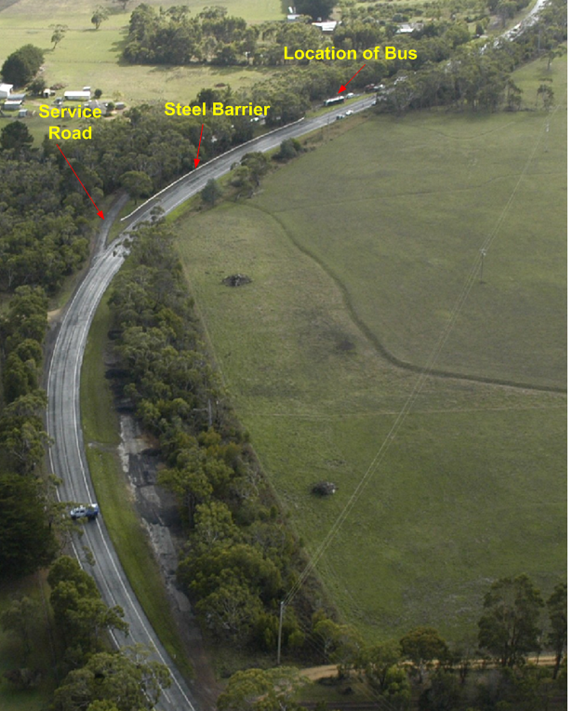
Figure 1 – Incident section of road

Factual Information

Coach 3938

Chassis and body
The passenger coach chassis was an Iveco Euro Rider model built by Iveco Trucks Limited of Italy. It was imported to Australia in ‘buggy’ format and had an original length of 8.62 metres. The chassis is of ladder construction. The assembled frame supports the engine and transmission and locates the front axle and is the platform for the framed coach body structure. The engine, transmission and batteries were located behind the axle of the rear wheels.

A space of approximately two cubic metres exists forward and above the fuel tank of the vehicle and this space is open to the road from the underside.

The body was built by Coach Design, Brisbane and the chassis was lengthened to 12.5 metres to suit the purchaser’s requirements. The body structure consisted of a fabricated steel frame made with square and rectangular hollow sections which formed the coach floor, walls and roof. Luggage storage space was constructed under a raised floor with the coach occupant space accessed via a set of steps on the left side of the vehicle.

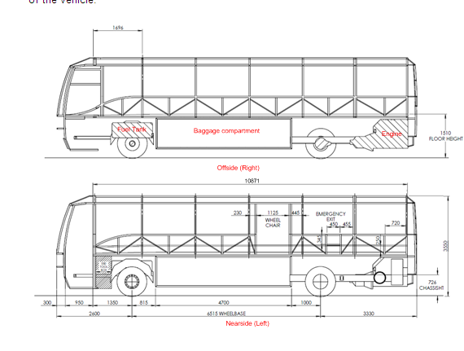
Figure 2 - Passenger coach - Iveco Euro Rider
The coach was designed for long-distance passenger operations and provided 53 fixed seats; all forward-facing and fitted with lap-sash seat belts. There are 13 rows of passenger seats and the first three rows are provided with anchor points for ‘child restraints’. However, this vehicle was not fitted with child restraints. Twelve rows consisted of twin seats on either side of the centre aisle and the last row was a bench of five seats. Post incident inspection indicated that all the seat belts were intact and in good condition.

Steering system
The steering system of this vehicle consisted of a hydraulic power assembly model ZF 8098 manufactured by ZF Lenksysteme GmbH, Germany. The system consisted of a fluid reservoir, an engine driven power steering pump, a power steering box mounted to the right hand chassis rails and secondary and primary steering shafts connected to a 90º bevel box mounted at the front in order to transmit driver steering input to a secondary steering shaft connected to the steering box.

An inspection of the steering components revealed a minor hydraulic leak from the steering box. No other leaks were found in the system and the oil reservoir had the required quantity of hydraulic oil. The drag link in the assembly appeared to be a recently installed component. All links were intact with no excessive wear in linkages and the steering was free to move from lock-to-lock.

Suspension system
The front suspension assembly of this vehicle consisted of a raised centre, forged steel, I-beam axle with one air spring on each side. An electronically controlled single levelling control valve provided a constant ride height at the front of the vehicle. The air springs were inflated and no structural abnormalities were noted. The assembly was fully functional.

The rear suspension assembly consisted of four air springs mounted on an H-frame. Two electronically controlled height control valves are installed on the suspension at a point transversely as far apart as possible in order to maximize roll stability at the rear of the vehicle. No structural abnormalities were noted and the assembly was fully functional.

Braking system
The braking system on this vehicle consisted of a dual-circuit pneumatic assembly. The front brakes were twin disc, hydraulically actuated air boosted units and the rear brakes were drum brakes actuated by pneumatic brake cylinders. The vehicle is equipped with pneumatically controlled park brakes (emergency) that act on the drive axle wheels.

A visual inspection of both steering axle and drive axle assemblies did not reveal any abnormalities. The vehicle was equipped with anti-lock brake assistance controls (ABS) and a traction control system (ASR).

The six tyres fitted to this vehicle were roadworthy and did not reveal any excessive wear patterns. The right hand rear tyre showed coarse abrasion of its shoulder consistent with it having slid along the road surface inclined at an angle.

Damage
The vehicle body structure showed minor deformation on the forward right bottom corner panel, pillar and bull bar, which was pushed back by approximately 350 mm. A roof panel was ripped near the forward right upper corner and roof panels above Nos.5, 6 and 7 right side windows were also ripped. There was general abrasion damage to panels on the right side of the vehicle and soil debris was observed on the front right side panel.

The exterior fibreglass panel forward and above the right rear wheel was forced inwards and abraded. The fibreglass panel rearward of the right side engine access door was broken and the right side of the rear bumper bar was broken.

The driver’s side front windscreen and all the windows on the right side were also shattered. When the coach was lifted upright, shattered window glass was found scattered on the grass verge adjacent to No.3 window. Some minor distortion of the interior right side panel approximately five rows from the front of the coach was observed.

The welded connections for the attachment of the front and rear chassis rails and the body structure to the space frame were all found to be intact.

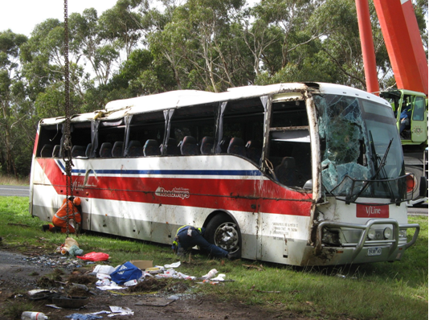
Figure 3 - Vehicle damage

Maintenance & modifications
Warrnambool Bus & Motor Company

Company coaches were maintained by company-employed mechanics in Portland and Warrnambool in accordance with the bus industry standard maintenance regime Quality Assured Maintenance System (QAMS). The system requires a daily inspection of coaches by the driver and a signature on the bus maintenance sheet to signify that the check was conducted. Any defects found during operations are recorded on a maintenance sheet that is given to a mechanic at the end of each driver’s shift.

During a shift, if a driver is unsure as to the suitability of the coach to continue the service they are to contact a company mechanic who would provide advice as to the suitability of the coach to continue the service. If a mechanic determines that the coach should not continue, they organise on-site maintenance or arrange a replacement coach. The company advised that only mechanics are authorised to sign off reported defects.

Each coach is also subjected to 10,000 kilometre/3 month inspections, whichever comes first and to an annual independent inspection by a VicRoads inspector. The last VicRoads inspection conducted on the incident coach was carried out on 28 October 2008, when the vehicle had completed 232,733 kilometres. A defect notice was issued which required the company to ‘Rectify excessive movement in front drag link’. The company advised the investigation that the ‘drag link’ was replaced and that a notice of completion was provided to VicRoads within 14 days of the inspection.

The company management advised that, just prior to the incident, they were not aware of any maintenance issues with the coach and that none of their staff had indicated there were any defects with the coach. However, the management advised the investigation that there had been an issue relating to the handling of the coach not long after it was delivered. They recalled that there were incident notifications from two drivers that stated that the incident vehicle “had left the road a couple of times, while making medium turns at approximately 75-90 km/h”. The drivers had stated that “the front end had lost traction at the apex of the corner”. The company could not find the incident notification documents. The company management advised that they contacted Iveco Trucks Australia and the problem was resolved under warranty. The management did not recall the details of the problem or what corrective actions were taken.

Iveco Trucks Australia

Iveco advised the investigation that several months after delivery, the bus company informed them that some drivers had complained that there was a problem with the suspension of the coach. They advised that the report they received related to a section of road which consisted of a straight road leading to a right hand curve called ‘Crossley Corner’ on the Koroit-Port Fairy road and on approaching the curve the vehicle experienced severe body roll and skidded sideways.

An Iveco representative who carried out trials of the coach at ‘Crossley Corner’ advised the investigation that he observed that both sides of the road were bordered by tall trees and foliage and when approaching the corner there was a break in the trees. He stated that the coach was subjected to “wind gusts” as it was going around the corner, which “caused the coach to become unstable”, but could not recall the “coach slipping or moving sideways”.

Iveco advised that they contacted their head office in Italy regarding the issue with the coach and they suggested the fitting of firmer shock absorbers. Iveco advised that the specialist shock absorber company Koni had been consulted by Iveco Italy. They advised that Koni ‘maps’ shock absorbers to vehicles and that involves measuring the compression and extension rates for the shock absorbers and matching them to European specifications for this type of road coach.

The coach was then fitted with firmer Koni shock absorbers, and tested satisfactorily. He stated that the vehicle had completed approximately 49,900 kilometres when the shock absorbers were replaced. Iveco advised that they had not received any complaints regarding the incident coach after the shock absorber replacement was carried out.

The vehicle engine management system and suspension system data were downloaded by Iveco and compared with the specifications for this vehicle. The data did not show any variations from the specified parameters for this vehicle.

Personnel information

Incident coach driver
The driver of the coach was a 57 year old male, holding a valid and current Victorian heavy vehicle driver licence. The driver also held a ‘driver accreditation certificate’ issued by the Director of Public Transport. Both his driver licence and driver accreditation certificate were valid until 20 July 2011.

The driver advised that he had been driving coaches for about eight years. He said that he commenced charter bus driving in 2001 and prior to that he had driven hire cars in Melbourne from 1999 to 2001.

The driver stated that immediately prior and at the time of the incident he was rostered to drive on the Warrnambool - Mt Gambier service. He said that the coach service originates in Mt Gambier each week day and was driven to Portland by a driver who is resident in Mt Gambier. The coach departs Mt Gambier at about 0740 and arrives in Portland at about 0940. During the day the coach then operates various services around the district before returning to Portland about mid-afternoon.

The driver said that he was rostered for the afternoon shift which commences at Portland at 1430. He said that drivers scheduled for the Mt Gambier run take over the coach at about 1510 and drive it to Warrnambool.

At Warrnambool the coach is loaded with passengers, mainly from the V/Line train arriving from Melbourne, and leaves for Mt Gambier at 1655 via Koroit, Port Fairy, Portland and Heywood.

When the coach arrives in Mt Gambier it is garaged, and the driver uses a company car to return to Portland. Drivers arrive in Portland at about 2230.

The driver advised that he was rostered and had driven the Portland – Heywood section of the highway at least four times a day since August 2008. He stated that he was off duty on Saturday 11 April and Sunday 12 April 2009. He returned to work on Monday 13 April 2009 and commenced his shift at 1100. He drove a coach from Portland to Mt Gambier then Warrnambool before returning to Portland at about 2000.

On Tuesday 14 April 2009 he commenced the afternoon shift at 1430 and finished at about 2230. He then drove home to Heywood, had his dinner and retired for the night at about 0030.

The driver stated that on the day before the incident (Wednesday) he got up at about 0800 and worked the afternoon shift from 1430 to 2215 and followed the same routine as the previous day.

On the day of the incident he stated that he got up at about 0900 walked his dog for about 20-30 minutes then instructed workmen who were erecting a carport at his home. He commented that it had started to rain earlier in the day but had ceased during the time he walked the dog. The driver stated that the rain resumed before he left for work. He stated that he left for Portland at about 1330, which was earlier than normal. He said that on his way to work he stopped at a hardware store to buy some paint and arrived at work at about 1415.

On arriving at the Portland depot he took over the coach from another driver and carried out a short inspection of the coach. He stated that a comprehensive inspection of the coach is only required to be carried out prior to commencing the morning shift. As there were no issues with the coach he loaded the baggage and departed Portland at about 1515 for Warrnambool via Port Fairy. The driver stated that he was not sure of the number of passengers on the coach. On arrival at Warrnambool he said that he unloaded and reloaded baggage and that there were 27 passengers on board the coach for the return journey.

Prior to departing from Warrnambool the driver advised that he carried out his usual pre-trip announcements on the PA system with respect to ‘not smoking on board’ and ‘the requirement to wear seatbelts’. The coach departed Warrnambool at about 1655 and arrived at Portland at about 1825 without incident. The driver stated that in Portland, nine to ten passengers disembarked and two passengers boarded the coach, one for Heywood, the other for Mt Gambier. The driver stated that he requested two female passengers who were talking outside the coach to board the coach as he was ready to depart. He said that they left Portland at about 1830 with 11 passengers, including a young child.

After departure, the coach headed north towards Heywood. The driver stated that it was dark and he had the headlights on and occasionally used the high beam. He said that the road was wet as it had been raining before and although it did not rain during the trip, he had to use the wipers intermittently to clear the windscreen. He said that there was “a bit” of traffic going towards Portland from Heywood, but not much going towards Heywood and did not recall any vehicles following him.

After leaving Portland the driver stated that he maintained a speed of 100 km/h. He said that the coach is speed limited to 100 km/h and that he had previously checked the speed against his GPS which recorded a speed of 99 km/h at the limited speed. He stated that as he approached the township of Bolwarra he reduced speed to 80 km/h due to the speed limit through the town, and then eased back up to 100 km/h. The driver stated that he did not use cruise control while driving coaches and that the cruise control in this coach had been unserviceable for about 12 months.

He stated that at the time of the incident it was not raining but rained afterwards. He estimated that the speed of the coach at the time of the incident was between 90 and 100 km/h. He said that as he approached the incident site he observed two vehicles approaching from the Heywood direction and that the first vehicle was a white ‘4-wheel drive’. He said that he dipped the headlights as the coach went around the right hand bend in the road and that he “imagined” that the coach was going across the road centreline to the ‘wrong’ side of the road. He said that he “felt” that if he didn’t turn left the coach would keep going to the right and hit the oncoming vehicles. He turned the coach to the left and it started to go sideways and then “flipped” onto its right side.

After the coach came to a stop the driver said that he collected his thoughts and could hear someone screaming. He said that he observed that the windscreen was cracked and that he tried to kick it out but was unable to do so. He then went to the roof hatches opened them to get the passengers out. He stated that he checked the female passenger with the young child who was at the back of the coach but could not find a pulse and concluded that she was deceased. He said that he also checked a male passenger who was at the front of the coach and concluded that he was also deceased. He said that he looked for the child but was unable to find her.

He said that he became aware that there were people outside the coach and that he had lost his mobile telephone. He went to the front of the coach and realised that the engine was still running and switched it off, but left the master switch on so that the coach lights would stay on. He commented that people outside the coach were shining vehicle headlights on the coach.

The driver commented that the passengers could not get out of the entry door of the coach as they were unable to climb up to the door and that he thought that some of the passengers got out through the windscreen.

The driver said that after he got out of the coach, he told the people around that he was unable to find the young child. He said that he also checked on the condition of the passengers. He said that he attempted to get people to go to the nearby coach shelter. He commented that he observed a lady taking care of a male who was apparently cold so he gave his jacket to him.

He said that he was disoriented as it took him some time to work out the direction of Portland. He commented that the police got to the site quickly; about five minutes after the incident.

He said that he attempted to ring the manager of the bus company, but the phone in the coach didn’t work as the engine was turned off. He then contacted the manager using his mobile phone that had been found by a passenger. He also telephoned the Mt Gambier driver to tell him what had happened and then his partner in Heywood and told her not to come to the scene.

He stated that he received a telephone call from another company driver who lived in Heywood who later visited the site and helped the emergency services shut the power off to the coach.

He stated that he was then taken to the Portland Hospital where he stayed until 0230 the next morning when he was transferred by ambulance to Warrnambool for further checks. He was discharged from hospital at 1300 that day.

The driver advised that his injuries consisted of six stitches to the index finger of his right hand and six stitches to his right elbow. He also suffered some abrasions and bruising to his ribs.

He advised that he had no first aid training.

The driver was breathalysed after the incident and recorded a zero reading.

Driving record

The only traffic offence recorded against the driver of the coach was an offence in 1992 of exceeding the speed limit in a private car.

Medical record

A medical certificate completed by a registered medical practitioner in May 2008, declared that the driver of the coach met the relevant medical criteria for an unconditional licence and met the minimum acceptable vision acuity standards.

Coach company management
The coach company management advised that they own and operate about 80 coaches and employ about 100 drivers. The company operates urban bus routes in Warrnambool and Portland and route services between Warrnambool and Mt Gambier, Warrnambool and Ballarat and Warrnambool and Geelong. The company, operating as South Western Roadways, provides the V/Line service between Warrnambool and Mt Gambier.

The management of the bus company advised the investigation that the coach involved in the incident was delivered by Iveco of Dandenong, Victoria on 16 November 2006 as a new vehicle. All 53 seats of the vehicle were fitted with lap/sash seat belts but there are no child seat belts or booster seats. The management advised that while they had given some thought to the provision of child seat belts the practical installation would present a significant problem.

The management stated that if seat belts are fitted in the coach it is a legal requirement that they are worn by the occupants. However, they stated that the driver is not responsible for ensuring that the belts are worn and that the coach displayed ‘Please fasten seat belt’ signs.

The company management advised that there was an induction program for new drivers and that there was an Induction Manual for driver reference. The company stated that the driver was employed at the Portland depot and had been with them for two and a half years driving urban coaches, school routes and charter services before being assigned to the V/Line service in August 2008. They believe that he would have travelled the route about eleven times a week over the last two and a half years and stated that they had not encountered any issues with his driving during his employment with the company.

When asked about on-going training and checking of drivers, the company advised that they had no program to continuously check drivers. However, they stated that if complaints were received from passengers or other persons regarding coach operations, the matter was investigated. They stated that the company keeps a record of the expiry date of each driver’s licence and accreditation certificate.

Previous drivers of incident coach
The investigation interviewed several drivers who had driven coach 3938 prior to the incident.

A driver who had been driving heavy vehicles for about 35 years stated that from the beginning the coach felt different in comparison to the other coaches and that it felt light in the front. He said that on one particular occasion as he approached a right hand sweeping bend at ‘Crossley Corner’ on the Koroit-Port Fairy Road, the coach “just slipped in a straight line”. He said that the road was wet at the time. He stated that the front wheels re-gripped and he regained control of the coach and continued without further incident. He remembered receiving a memo from the company advising drivers not to go through Crossley. The driver recalled another incident where the coach continued in a straight line and “crossed onto the wrong side of the road for one to two seconds before he was able to regain control and steer it back onto the correct side of the road”. He surmised that the incident occurred because the front of the coach got lifted up due to the strong wind. The driver then advised the Warrnambool depot of the incident and the depot supervisor discontinued the service at Warrnambool.

The driver recalled that the coach was examined by Iveco and the front shock absorbers and the tyres were replaced. He stated that after the modification “the coach felt more stable but was still light in the front end” and that on a trip between Heywood and Portland the coach behaved erratically and felt the “front end move” as previously experienced.

Another driver with 45 years of heavy vehicle driving experience stated that he had also experienced a few handling problems with coach 3938, prior to the incident. He recalled one particular incident on the Koroit-Port Fairy Road where the coach “slid to the left” on approaching ‘Crossley Corner’. The driver stated that he informed the yard supervisor of the incident and approximately two weeks later met with the managing director of the bus company, representatives of VicRoads and the Moyne Shire Council to discuss the incident and the section of road. He recalled that the “VicRoads engineers did some maintenance on the road” to improve the road surface.

A driver currently employed by the company stated that he experienced a handling problem with this coach on the incident curve on Princes Highway around February 2009. He stated that it was about 1830 and the road was wet and he approached the right hand curve at approximately 80 km/h. As he drove into the bend, he stated that he was steering to the right when he felt the “front end let go” and the coach move towards the Armco barrier. He said that he felt as if he had lost grip on the front tyres. He stated that he accelerated and moved the steering to the right and the coach regained traction and he regained control of the coach. He stated that he did not make a formal report of the incident but advised a mechanic in the company regarding the incident.

Coach company mechanics
A motor mechanic employed by Warrnambool Bus and Motor Company since 1996 stated that although his main duties were as a mechanic, he also drove coaches when required by the company.

He stated that in 2006, the bus company took possession of a new Iveco 53-seat coach which was deployed on the V/Line run between Warrnambool and Mount Gambier. He stated that a couple of months after the coach went into service, an Iveco representative arrived at the Warrnambool workshops to inspect the newly acquired coach as there had been some complaints from coach drivers.

He said that one specific complaint related to the coach losing control on a corner near Tower Hill and he was requested by the company to accompany the Iveco representative and carry out some road testing of the vehicle. He road tested the coach on the Port Fairy Road towards Tower Hill with the Iveco representative in the passenger seat. He stated that at that time it was raining and that there was a fairly strong, gusty wind. Then, with the coach travelling at 80-90 km/h, it entered a gradual right curve which sharpened. The mechanic said that it “let go” at the front and travelled in a “straight line” instead of the direction he was steering. He stated that he managed to regain control of the coach and returned to the Warrnambool workshop.

He recalled that there was partial “bitumen bleeding with depressions” in the lane of the curve that that he was travelling on and that the road surface was wet. He said that there was a line of trees to the right of the road. He recalled that there was a large gap between these trees and the wind was coming through this gap from the right to the left.

The mechanic stated that he carried out an inspection of the coach at the workshop and could not detect any defects. He concluded that “stronger shock absorbers might improve the ride of the coach”. He stated that approximately two weeks later the Iveco representative returned to Warrnambool and fitted the coach with the new shock absorbers. They re-tested the coach satisfactorily and the coach was returned to service.

The mechanic could not recall receiving any ‘defect notices’ or any complaints from drivers after the modification to the coach and stated that he had not experienced any problems with the coach during the times he had driven it.

The Fleet Maintenance Manager (FMM) of the company stated that he was a qualified diesel mechanic and was employed in this position after completing a four-year apprenticeship. He stated that his current duties included training and supervision of the fleet mechanics and supervision of the spray painters and panel beaters. He said that he also looked after the administration of the workshop including tasking repairs and service scheduling.

He stated that the QAMS maintenance system requires that a comprehensive array of tests be conducted before entering a coach into service and that the incident coach was subjected to the QAMS tests prior to being put into service as an accredited coach.

The FMM stated that in May 2007 he received a telephone call from one of the fleet drivers, who reported that he had experienced a loss of traction in the incident coach during a Warrnambool to Heywood run. He recalled that the driver informed him that he was driving through Crossley, and was driving into a right hand corner when the coach lost traction in the front end “to the point where he felt uncomfortable or felt like he lost control”. He stated that he checked the tyres and in particular “tread depth” and concluded that it was the bend and the road surface that had contributed to the coach losing traction as the tyres were in satisfactory condition. However, he stated that he noticed that the tyres were at a higher pressure of 110 psi and asked the mechanics why the tyres were at a higher pressure than the normal 100 psi pressure. He said that the mechanics advised him that they had installed only Michelin tyres instead of the mix of Michelin and Bridgestone tyres originally fitted to the coach and that the dealer had advised them to pressurise these tyres to 110 psi. He stated that he instructed them that the “information was not correct” and to pressurise the tyres to the normal 100 psi.

The FMM said that he had discussions with the senior management of the company who contacted the Moyne Shire Council regarding the section of road at Crossley. He stated that they diverted coaches from that section of road until the road was resurfaced. The FMM stated that after this incident he had not received any other reports from drivers regarding the handling of coach 3938.

Motorists
There were two motorists who witnessed the incident and two motorists who arrived at the scene just after the incident occurred.

Motorist 1

A 44 year old male resident of the area stated that he and his son left Heathmere and drove towards Portland in his utility at about 1830. He stated that his wife followed him with their other two sons in her four-wheel drive. At that time, although it was not raining, he said that the road was wet and he drove with his headlights switched on as it was getting dark.

He could not recall seeing any traffic on the road and stated that he was travelling at about 80 km/h as he went past Flowers Hill Road, through the left-hand curve into the straight section of the highway. He advised that as he came out of the curve he saw a set of headlights coming towards him and they appeared about 40 metres in front. He surmised that they belonged to a large vehicle such as a truck or coach, and said that he got the impression that it was overtaking another vehicle.

He stated that initially he did not move over although the headlights kept coming towards him, but subsequently swerved to the left and onto the edge of the road as the headlights did not move out of his lane. He said that he slowed down and went right over onto the grass shoulder and kept moving slowly. He recalled that the headlights kept coming at him and that he observed a “large dark mass or blob” behind the headlights go past him. As the headlights passed him, he said that he heard a large unusual sound like “whoosh”. He described the sound as a sound similar to a sheet flapping on a clothes line. He said that he “felt really shaken up” and remarked to his son that it was a close call.

He said that he drove around the curve, pulled over to “settle himself down” and waited for his wife. He waited for about 20 to 30 seconds and although at least six cars went past his wife did not arrive and he decided to head back to the incident site. He said that he did a U-turn and followed another car that had done a U-turn before him.

As he drove around the bend, he said that he saw his wife’s car on the sealed shoulder to his left and at almost right angles to the road, with her lights shining on a V/Line coach lying on its side. He said that he drove past the coach and stopped and after putting his hazard warning lights on, ran towards the coach.

As he was approaching the coach, he said that he heard someone “yell out for an axe”. He said that he then got a "wood splitter” from his vehicle and went back to the coach, which he noted was lying on its side on the driver’s side.

When he got to the coach he said that he could see a hatch or exit vent cover on the roof which appeared “loose”, and he could hear voices and movement inside the coach. He then stated that he pulled at the hatch and it opened easily. He said that he then looked into the hatch and saw a man he thought was the coach driver standing on the other side, who looked a bit dazed and had blood on him. He recalled that he and the driver discussed getting the people out.

He remembered helping two women out of the coach and also remembered one or two males getting out of the hatch. He stated that he then went around to the front of the coach and saw a person holding the broken windscreen and peeling it back. Once the windscreen had been pulled back he said that he stepped inside the coach and noticed another person in front of him. He stated that he noticed a person he thought was a woman trapped under the coach. He said that the person in front of him told him that he had checked and could not detect a pulse; however he also checked and could not detect a pulse. He stated that he also saw a man trapped under the coach and realised that there was nothing he could do. He then went through the coach and looked for other passengers but did not find any.

He stated that he went outside, back through the driver's window and heard someone say that there was a “baby” in the coach. He said that he went back inside the coach and looked everywhere for the “baby” but could not find her. The local police officer who also came into the coach searched for the “baby” inside the coach with a torch but could not find her. He said that later on he was informed by another police officer that they had found the “baby” outside the coach.

He then stated that he went outside, realised it was raining and walked the passengers to the coach shelter. He said that he moved his vehicle towards the coach shelter and put his vehicle lights onto the shelter. He said that his wife and two other persons were at the coach shelter helping the passengers. He then asked the police officer if there was anything more he could do and the police officer replied that there was not, so he decided to take his sons home.

He stated that he had lived in the area for a number of years and had driven on that part of Princes Highway numerous times in cars, tractors, and utility vehicles and was always “wary” of that curve. He said he was aware of a number of accidents that occurred on the curve, and that he found the curve to be greasy and slippery and believed that he had never lost control as he “adjusted his driving” on this part of the road. He said that he was aware that the road surface has been resealed a number of times. He said that in his opinion, this was the worst part of highway between Portland and Heywood.

Motorist 2

A 42 year old female driver stated that on Thursday 16 April 2009, she was driving from Heathmere to Portland with her two sons. She stated that she was driving a four-wheel drive vehicle and was following her husband who was driving a utility vehicle. She said that she was travelling at about 80 km/h and that her vehicle was about 50 metres behind her husband’s vehicle.

She stated that “the weather had been showery late that afternoon and early evening”. She said that it was dark and the road was wet but it was not raining at the time they got on the road. As they travelled along the highway, just before the north entrance to the truck parking bay, she noticed the brake lights of her husband’s vehicle light up and saw the vehicle swerve to the left and move onto the left of the road “to the extent that the right wheels of his vehicle were over the left-hand fog line”. She stated that her husband slowed down but did not stop and at that time she noticed what she thought was a truck coming from the other direction and towards them and saw the vehicle veer towards her husband’s vehicle.

She said that her initial thought was that a truck had pulled out to pass another vehicle as she thought she saw “low down lights behind the truck and to the left of the truck”. She stated that the ‘truck’ then swung around to its left and back towards its side of the road with the tail swinging around towards her husband’s vehicle. She stated that she initially thought that the driver had “righted the vehicle” as it swung past her husband’s vehicle. She then said that she observed the vehicle go onto its two right hand side wheels and then “seemed to gracefully slide in an anti-clockwise direction” and that was when she realised that the vehicle was a coach. She stated that the coach continued to spin in an anti-clockwise direction on two wheels, “before it rolled onto its side and slid off the road and onto the grass near the truck parking area” and came to a rest facing the direction it had come from.

She said that her son “grabbed the phone and rang 000”, while she put her hazard warning lights on and pulled across the road onto the grass area of the truck parking bay and “pointed the headlights of her car towards the coach to light it up”. When she stopped her car she stated that she saw two men standing between her car and the coach and she asked them how many people were on the coach and was told there were about a dozen and some were trapped in the coach. She said that both the men appeared fine.

She said that she saw another person trying to pull the front windscreen off the coach and a passenger who appeared to have “cuts all over him” come from the side of the coach. She stated that she directed four male passengers to the side of the coach, assessed their injuries and concluded that they were relatively minor and asked them to stay together.

She stated that she saw a person take an axe that her husband was carrying and smash the front windscreen of the coach and get into the coach. She said that she observed her husband and another person take the roof hatch off the coach. There were a number of passengers coming out of the coach and she said that she grouped them together. As it had started raining, she said that she directed the passengers to shelter in a parked car and also drove another car towards the coach and pointed its headlights towards the coach.

She then looked inside the coach and asked her husband and another person in the coach if there was anyone else in there and the person replied "No, they are both gone; there is no pulse." She said that she noticed the bodies and realised that they “couldn’t administer CPR anyway”. She said that one of the female passengers then asked her “how the baby was”. She said that she asked her where the “baby” was seated and the passenger replied, "towards the back of the coach." She then asked her husband if he saw a “baby” and her husband replied that he had not.

She said that she went back to the coach shelter where a group of passengers had gathered and said that she became concerned about the driver who was “worried about everyone else, but not himself”. She said that she told him that she had observed how slippery the road was and that he said, "That bloody coach. We have all told them about that bloody coach, it drifts”. She clarified that ‘drifts’ was not the word he used and could not recall the exact word he used, but understood it to mean the word ‘drifts’. She also said that he said “We've all complained about it."

She stated that the ambulances and the police started to arrive and she assisted them where she could.

Other motorists

At about 1830 two motorists were driving together along the Princes Highway on their way to the Port of Portland. They advised the investigation that it was just getting dark and they had the headlights operating on the car. They stated that the road was wet, but recalled that it was not raining at that time.

They had been travelling for about fifteen minutes and passed Flowers Hill Road when they saw a coach lying on its side off the road to their right. They observed that the coach was facing Portland and was lying on its driver side on the grassed area between the highway and the truck parking bay.

As they passed the coach they said that they saw two people standing in front of the coach and were uncertain if they were “hailing for assistance”. As they had driven past they immediately decided to turn back.

They stopped in front of the coach and observed people inside the coach and also standing near the roof side of the coach. They noticed that the windscreen of the coach was shattered but still in place.

They stated that they attempted to remove the windscreen with their hands but were unable to do so and had to use a “Canadian splitter” to cut out the windscreen. They said that they entered the coach and started to search for people that may be been trapped but it appeared that most people had made their way out by the windows or by crawling out from under the coach.

They stated that they discovered two deceased passengers that they thought were trapped by the coach and dialled 000 to report the incident and then stayed at the scene to provide assistance and support to the passengers.

One motorist stated that he had conversed with the driver of the vehicle “which almost collided with the coach” and the driver had told him that “the coach was on his side of the road and nearly ran him off the road forcing him to take evasive action”.

Incident coach passengers
Five of the eight surviving passengers had a reasonable recollection of the events prior to, during and after the incident. Their accounts of how the event unfolded are summarised below.

A 63 year old female passenger, who was travelling to Heywood, stated that the coach departed Warrnambool at 1656. She recalled that she was sitting in the fourth row aisle seat behind the driver with no other passengers in front of her. She stated that she was wearing a seat belt. She said that the coach arrived in Portland at about 1830 and stopped at Portland for about five minutes, before re-commencing its service.

She stated that she was not paying attention to the road until she felt a movement at the back of the coach that felt like “the coach was going around a bend”. She stated that she heard a “whoosh” sound and the coach driver utter an expletive. She said that she couldn’t recall what he said but hearing his voice made her “look up”. She said she “craned her neck” to look at the front and could only see the windscreen wipers working. She said that the coach was travelling at an angle which would have taken it onto the right side (oncoming) of the road had it continued on its path. She said she looked out of the window and noticed a smaller car travelling towards the coach followed by a larger vehicle, which was possibly a four-wheel drive.

She recalled pushing herself to the left, away from the window. She then stated that her “attention went back to the driver” to see where the coach was going. She recalled thinking that the driver had regained control of the coach and felt that he was “back on course on the road”. She then stated that she noticed the driver “pull the wheel down hard to the left as she could see his hands and body move down to the left from where she was sitting”. She stated that the coach seemed “to roll and it felt like it was spinning on the spot in gravel”.

As the coach stopped, she stated that she braced herself and her leg came into contact with an object that she thought may have been a seat. She then looked up and saw the bright headlights, of what appeared to be a car, coming straight at the coach. She said she observed the coach driver trying to kick in the windscreen and she attempted to assist him. She stated that the driver eventually opened a window and she was able to exit the coach. The passenger stated that she was then taken to the Portland Hospital.

A 35 year old male passenger who was seated in the rear left-hand side recalled that it was a damp day and was drizzling on and off, but not raining at the time of the incident. He stated that he was “pretty sure” that he put on his seatbelt after he got on the bus. He stated that “the bulk” of the passengers were in the middle of the coach. He said that he noticed a young woman in the back seat behind him who was asleep. Seated beside this woman was a young girl who was about two years old; the child was lying across her seat and asleep.

He stated that the coach had been travelling for about ten minutes out of Portland along the Princes Highway, before approaching a bend near the truck stop and coach shelter. The passenger recalled having a car accident in this area approximately eight months prior and stated that the “seal of the road had changed and he believed the camber of the road was faulty”.

He also opined that the coach was unlikely to have to been driving at 100 km/h when it entered the bend. He said that he felt that “all the back wheels were sliding to the left, while the front of the coach was going straight”. He remembered the coach starting to tip over, but could not recall the complete rolling over of the coach. He remembered hearing the windows smashing and then found himself walking around when he saw police and ambulance officers near the coach stop. He said that he noticed that his white shoes were “filthy and black” and that his trousers were wet from the knees down and realised that he was also still carrying his back pack. He said that he advised the ambulance officer that he had a sore back and was taken to the Portland Hospital. He stated that a specialist advised him that he had fractured vertebrae in his neck and that he would be flown to the Alfred Hospital that night.

A 32 year old male passenger travelling to Mt Gambier stated that he was seated about five to six seats from the front of the coach in the right hand window seat. He said that the roads were wet but it was not raining at the time of the incident.

The passenger stated that a short time after leaving Portland he felt “the coach lose control as it was going around a bend" and held onto the seat in front as the coach swerved to the left. He recalled hearing the “windows popping as the coach tilted over” and being thrown out of the coach. He stated that he found himself on the road about fifteen metres on the Portland side of the coach. He stated that the coach was on its right side and was facing Portland. The passenger stated that he had minor injuries and was taken to the Portland Hospital. He stated that he was not wearing his seat belt.

A 16 year old passenger stated that he was seated in the right aisle seat, about seven rows from the rear of the coach and was not wearing a seatbelt. The passenger stated that he knew the road very well as he travelled to school on the same road. He stated that when the coach was in the middle of the right-hand bend of the road he felt as if the back of the coach slid to the left. He said that he then looked down the aisle and out the front window and could see the “front of the coach was now heading into the other lane of traffic and two cars heading for the front of the coach”. He recalled that the coach then “swerved to the left and tipped over to its right hand side still on the bitumen”. He recalled that as the coach started to roll over, the overhead lights went out.

The passenger stated that another passenger who was seated in the adjacent left side seat fell onto him as the coach rolled and he was knocked against the window when the coach began to slide along the road.

He stated that when he hit the window, he could feel “burning on his back as the coach slid along the road”. He said that he felt himself sliding on grass and ending up in a ditch on the western side of the road. He said that he looked up and saw the coach sliding and could see the wheels of the coach.

The passenger said that he injured his elbow in the accident and was treated at the scene of the collision by ambulance staff and then taken to Portland Hospital where he was kept overnight for observation.

A 21 year old female passenger stated that she was seated in the middle of the coach on the left hand aisle seat. She said that as soon as the coach left Portland she went to sleep. She said that she was wearing a seat belt.

She stated that she woke up “to the feel of the coach rolling over”. She said that she felt like the coach rolled over three or four times. She stated that she had been lying on her side and got bounced around the compartment. She said that she slid out of her seat belt when the coach came to a rest and ended on the ground, but was still inside the coach. She said that she noticed that the “side of the coach had ripped away and the windows weren’t there anymore”. She recalled that she was winded and that a person helped her out of the coach.

Deceased passengers
In this incident a two year old child, a 19 year old female and a 20 year old male sustained fatal injuries. The deceased female was the mother of the deceased child and was reported to be pregnant at the time of her death. The two fatally injured adults were trapped under the overturned coach. The adult female was found partially ejected from the last window between seat row 12 and 13 and the adult male was found partially ejected from the third window between seat row 6 and 7. The child was found outside the coach, with her right hand trapped under the rear right side wheels of the overturned vehicle.

Coach CCTV recording
The coach was equipped with three on-board closed circuit television recorders (CCTV).

Fifteen seconds prior to the vehicle rolling over, the recording shows the coach marginally tracking over the centre double lines of the Princes Highway. A steering correction is made by the driver and the vehicle returns to the left lane. The vehicle is then observed travelling in the left lane and appears to be under control for the next 10 seconds. Approximately five seconds before the coach rolls over, the vehicle tracks across the centre double lines and in this instance crosses the centre lines by a greater margin and at a more severe angle to the centre line of the road. The recording shows approaching headlights and the driver making a significant correction of the steering wheel to the left. The recordings then show passengers falling over inside the coach as the vehicle rolls over.

Omnibus construction standards
The Motor Vehicle Standards Act 1989 enables the Australian Government to establish nationally uniform standards for road vehicles when they are first supplied to the market in Australia. The Act applies to vehicles irrespective of whether they are manufactured in Australia or are imported as new or secondhand vehicles.

Vehicle Standards 2006 (Australian Design Rules – ADR) are made under the above Act. Under the ADR categorisation, coach 3938 is categorised as a ‘Heavy Omnibus’ and given the ‘ME’ code as its GVM is over 5 tonnes. The function of the ADR is to specify design and construction standards for vehicles operating on Australian Roads. ADR 59/00 – Omnibus Rollover strength and ADR 68/00 – Occupant Protection in Coaches are the applicable standards with respect to Omnibus superstructure strength and occupant protection.

The standards require that each type of vehicle is verified according to tests approved by the ‘Administrator of Vehicle Standards’ of the Vehicle Safety Standards section of the Department of Infrastructure, Transport, Regional Development and Local Government.

ADR 59/00 standard requires that the superstructure of the vehicle is of sufficient strength to ensure that during and after it has been subjected to one of the methods of test in the ADR 59/00 standard, no displaced part of the vehicle intrudes into the residual space and no part of the residual space projects outside the deformed structure.

ADR 68/00 standard specifies the requirements for seatbelts, the strength of 'Seats', seat-anchorages, seatbelt 'Anchorages' and 'Child Restraint Anchorages', and provisions for protecting occupants from impact with 'Seat' backs and accessories on 'Seats' and armrests. All seats in coach 3938 were fitted with lap-sash seat belts and six seats were fitted with child restraint anchorages. The purpose of a child restraint anchorage is to provide a method of safely and securely tethering a child restraint device to the existing seating of a vehicle.

The design and construction of the body structure for the coach involved in the incident was approved to ADR Standard 59/00 and ADR68/00 on 12 September 2006 and issued Approval No: 9295 by the Administrator of Vehicle Standards. The authority also approved ‘Coach Design’ to affix an identification plate which certifies that the coach complied with all the requisite design rules cited in the National Standards Determinations, made under section 7 of the Motor Vehicles Standards Act.

Occupant protection
Mechanisms of injury causation from a coach rollover incident are described in a study by Botto (1994). The study outlined four main injury mechanisms in severe coach crashes.

- Projection - Occupant interaction with other occupants and the interior of the coach.

- Total ejection - the occupant being ejected or thrown out of the vehicle.

- Partial ejection - part of the occupant’s body being thrown out of the compartment.

- Intrusion - the occupant being injured inside the vehicle, due to structural deformation or intrusion of an object.

Intrusion is the mechanism of injury causation which ADR 59 is required to address, whereas Projection, Total and Partial Ejection are the mechanisms of injury causation which ADR 68 is expected to address.

Seat Strength and padding requirements in ADR 68/00 are there to reduce ‘projection’, while lap-and-sash belts help spread out the energy of the moving body in a collision over the chest, pelvis, and shoulders, while preventing total or partial ejection.

The report Australian Bus Safety published in Nov 2001 by the Australian Transport Safety Bureau (ATSB), states that out of the 17,840 road fatalities on Australian roads, between 1990 and 1998, coach occupant fatalities constituted a very small proportion of only 0.6 per cent. Statistical analysis of injury data shows a downward trend in both occupant fatalities and injuries from 1990 to 1998.

A Regulatory Impact Statement (RIS) – ADR 59/00 Standards for Omnibus Rollover Strength, published in 2007, by the former Department of Transport and Regional Services (DOTARS) states that “with the application of ADR 59 and ADR 66 from 1992 and ADR 68 in 1994, all ADRs have combined to reduce the trauma to occupants from coach accidents. However, the result of this combination has created the condition that makes it difficult to readily isolate the performance indicators of an isolated ADR and therefore assessing the individual success of any one ADR applicable to coaches”.

Safety harness regulations
Current Victorian road rules require that passengers over 16 years of age travelling in a motor vehicle must wear a seatbelt if the seating position is fitted with one. Drivers of motor vehicles other than buses are required to ensure that passengers under the age of 16 years are wearing a seat belt or child restraint. Presently there is no legal requirement for coaches to carry child restraints.

The Bus Industry Confederation (BIC) advised the investigation that the fitting of child safety harnesses is still being discussed at national level within the Industry and there is no Industry policy adopted as yet. They advise that there are practical difficulties with attaching child seats to existing seats and using the safety restraints to secure them.

Emergency exits
ADR 44/02 sets out minimum requirements for emergency exits for buses built after 1993.

ADR44/02 requires single deck buses to have emergency exits in at least three separate faces (e.g. roof, right and rear), exterior steps for exits that are more than 1m from the ground and the size of the exits is sufficient to allow an injured person to be extricated. Each exit must have a clear opening area of at least 0.7 square metres and no side less than 500 mm in length.

Post-incident testing of coach
The incident coach was tested after repairs were completed on the vehicle. No modifications or repairs were carried out to the suspension system of the vehicle. Prior to the testing of the coach the vehicle was weighed on a weighbridge. The total weight of the vehicle was 12.4 t, with a load distribution of 4.32 t (35 per cent) at the front steering axle and 8.08 t (65 per cent) at the rear drive axle.

At the time of testing the weather conditions were dry with light winds, the temperature was approximately 24 degrees Celsius and the road surface was dry.

The incident coach was fitted with a lateral accelerometer and data acquisition accessories. The vehicle was tested on the incident section of Princes Highway and was driven at a 50 km/h initial speed and thereafter in 10 km/h speed increments on the test site. Vehicle speed, lateral acceleration, and body roll were recorded during the testing. Figure 4 shows the lateral acceleration performance curves. At the 100 km/h trial speed the lateral acceleration values peak at approximately 0.19g, 0.22g, 0.24g and 0.23g at different points of the road.

Typically, coaches of this type are capable of accommodating lateral acceleration values of about 0.4g to 0.6g before reaching their roll-over threshold.

A gyroscope situated on the centreline of the vehicle and connected to the data acquisition system recorded the body roll during testing. The maximum body roll experienced by the vehicle was approximately three degrees and at no time did the vehicle feel unstable nor was its handling affected.

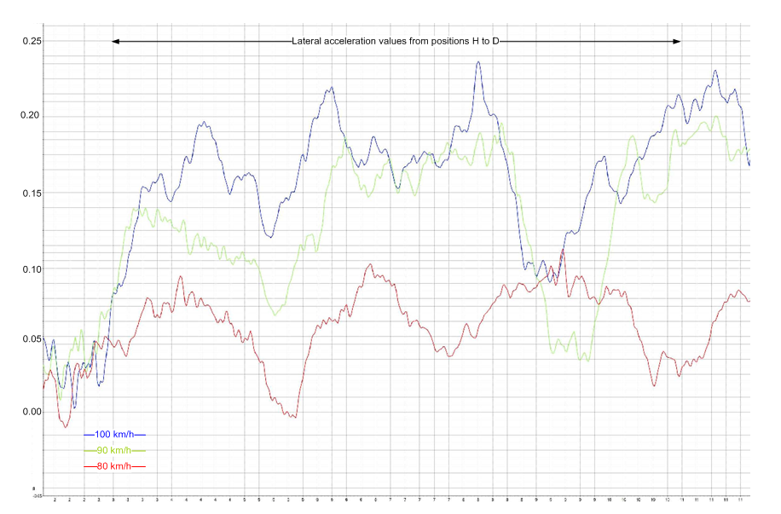
Figure 4 - Lateral Acceleration Performance Curves

Road infrastructure

Road management
Victoria enacted the Road Management Act 2004, for the purposes of reforming the law relating to road management in Victoria and make amendments to related Acts, including the Transport Act 1983 and the Local Government Act 1989. The Act established a new statutory framework for the management of the road network and the general principles that apply to road management. The Act provides for the role, functions and powers of a road authority, provides for the making of Codes of Practice, facilitates the making of road management plans as part of the management system to be implemented by a road authority and provides a new process for the declaration and classification of roads. The Roads Corporation is established under Part II of the Transport Act 1983 and operates under the name ‘VicRoads’.

VicRoads manages a road network of 22,748 kilometres in Victoria. They are required to maintain, upgrade, vary and extend the State's declared road network in accordance with the Road Management Act 2004 and to develop and implement road safety strategies, to develop and implement traffic management strategies and practices and to specify road accident prevention practices.

Road design standards and guidelines
The standards applicable to roads in Victoria are documented in the VicRoads Road Design Guidelines (RDG). These guidelines are applied to the design of new sections of road. Existing roads may also be assessed against their requirements. VicRoads has also prepared and published Traffic Engineering Manual, Volume 1, dealing with traffic management and Volume 2 containing detail of signs and line marking for roads in Victoria.

The association of Australian and New Zealand road transport and traffic authorities (Austroads) has also produced National Road Design Guidelines. The Austroads guidelines are considered an additional resource rather than minimum design standards in Victoria.

Road classification & responsibility
The section of Princes Highway at which the incident occurred, forms part of the National Road Network and is classified an ‘A’ route by VicRoads under the state-wide route numbering scheme. An ‘A’ classified road is a two-way single carriageway which connects capital cities and major provincial centres, and link major centres of production with Victoria’s export terminals. ‘A’ roads serve the same function as freeways but carry less traffic and do not necessarily have controlled access.

On a State level, the functional classification of the Princes Highway in this region is a VicRoads Declared Arterial Highway and under the Road Management Act, VicRoads is responsible for its management and maintenance. As per the VicRoads road management plan the incident section of Princes Highway is a category 3 road.

Road inspection and maintenance
The VicRoads Road Infrastructure Management System sets out details for the inspection, maintenance and repair of roads under its management. The management system states that the maintenance program is developed using the results of annual road infrastructure condition surveys, together with maintenance standards and road infrastructure performance targets. The document also states that inspection; maintenance and repair standards and road infrastructure performance targets will be established using a risk management approach. Once an inspection is carried out and a hazard has been identified, it is codified into one of six response codes ‘A’ to ‘F’. With respect to road surface defects, treatment of a ‘slippery surface’ for a category 3 road would be assigned a response code of ‘C’. A response code ‘C’ hazard requires the provision of an appropriate warning or rectification within one week of inspection.

On 02 July 2007 VicRoads conducted a Surface Rating Inspection and Pavement Condition Survey and identified that re-seal was the appropriate treatment for a section of road between chainage 358607 and 358740 (Figure 10) and the treatment was completed on 24 February 2009.

VicRoads carried out a Road Condition Survey between chainage 358217 and 358855 (includes low friction section and incident site) on 11 March 2009. They advised that photographs and data were collected but a report for the Road Condition Survey was not completed and no further actions were taken as a result of the survey.

After a post incident inspection of the road, VicRoads stated that “It is most likely that the extreme temperatures experienced during the summer heatwave in late January and early February 2009 caused instability in the binder and resulted in flushing of the road surface”.

VicRoads advised the investigation that funding for maintenance of roads is available through the Federal and State Black Spot Programs and the Transport Accident Commissioner’s Safer Road Infrastructure Programs (SRIP). Amongst other requirements, the key criteria for eligibility for these funding programs are the number of casualty crashes on a section of road within a specified period. VicRoads state that they regularly undertake analysis of crash statistics to identify locations requiring treatment. Once identified for treatment all funding proposals are then prioritised and this section of Princes Highway received funding and was treated in 2006. VicRoads further state that a casualty crash at a location can only be used once for justification of a road safety project, irrespective of the funding source.

Site inspection
A site inspection was carried out on 17 April 2009. The incident road is a two-way single carriage rural highway heading in an approximate northerly direction, with a 7.3 metre sealed carriageway, a 4.1 metre sealed shoulder to the left and a 1.6 metre shoulder to the right. A steel barrier of approximately 172 metre length is located outside the left sealed shoulder and around the approach curve heading in the northerly direction. Clear of the barrier, the left shoulder reduces to approximately 1.6 metres, similar to the right shoulder. A ‘Slippery When Wet’ sign is located about 700 metres south of the incident site and the maximum speed for this section of Princes Highway is 100 km/h.

The current road had been improved and re-aligned (in 1961 as shown by VicRoads drawings) leaving remnants of the old road on the right side approaching the subject curve from the south and on the left side toward the end of the curve, now used as a service road with a school bus stop and public bus shelter.

The road surface inspection revealed a distinct change of seal at the point where the road was re-sealed in February 2009. The road surface prior to the seal change point (Figure 10) was observed to have a sheen due to ‘bleed-through’ of bitumen and/or stripping of the screening (Figure 5).

Yaw marks observed on the road start at approximately 42 metres south of the final resting position of the coach. The gouge and scrape marks on the road and grass embankment indicate that the vehicle rolled onto its side, then impacted the embankment approximately 12 metres prior to its final position of rest (Figure 6).

Due to rutting, water ponding was observed in several spots on this section of the road at the time of the inspection (Figure 7). Specifically, rutting was observed in the left wheel path on the northbound traffic lane. The investigation was unable to establish if water was ponding at the time of the incident.

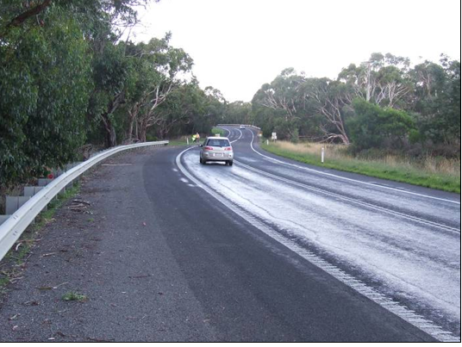
Figure 5 – Road surface south of coach location
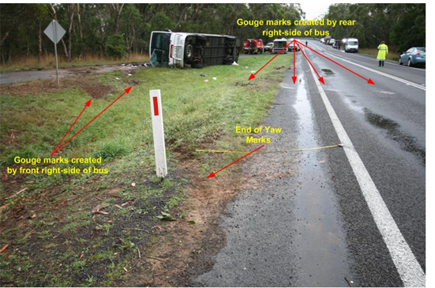
Figure 6 – Gouge and Scrape marks on road and grass embankment

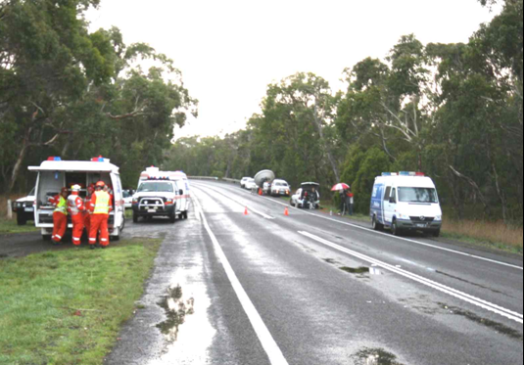
Figure 7 - Rutting of road surface
Profiled edge lines (tactile strips) on both sides of the road and a profiled double centreline up to the start of the new seal were observed on this section of the road. Over the length of the new seal, the double centreline profiling continues but the edge-line is not profiled but painted. The profiled lines incorporate bars of thermoplastic material to create an audible warning to drivers running a wheel along the line.

Alignment
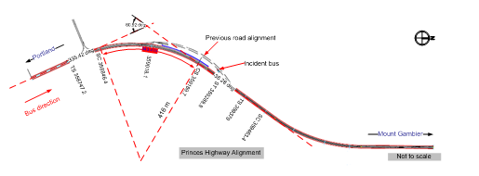
Figure 8 - Princes Highway Alignment
The drawings of the realignment prepared by VicRoads in 1961 indicate two tangents at 335.42° and 36.28° giving an intersection angle of 60.92°. At entry to the curve a tangent is connected by a 99.0 metre transition spiral to a 343.4 metre long circular arc of 416.0 metre radius and at exit a tangent is connected by a 99.0 metre transition spiral to a straight section of road. The coach came to rest close to the tangent point at the exit end of the curve.

Superelevation and radii
Superelevation is the banking of the curve to the left or right depending on whether it is a right or left hand curve. The main purpose of superelevation is to tilt the roadway to offset the lateral forces developed when a vehicle traverses a curve. In practice, the superelevation on a curve is the one-way cross-fall needed that will allow a vehicle to safely traverse a curve at a given design speed without lateral movement.

The realignment drawings provided by VicRoads indicate a superelevation of 3 per cent (0.03) on the incident curve.

In order to measure superelevation and the radii of this section of road, segments with a chord length of 40 metres were selected starting from a reference point adjacent to the ‘Children Crossing Sign’ and in close proximity to the resting position of the coach (Figure 9). The radius of each segment was calculated by measuring the length of a perpendicular from the centre of the chord to the curve. The superelevation was measured with the use of digital rotating laser instruments.

Measurements taken of the incident curve indicate superelevation values ranging from 2.8 per cent (0.028) to 5.4 per cent (0.054). The road then transitions to a two-way cross-fall on straight sections of road, to assist with drainage of water from the road surface.

Measurement of the radii of the road segments indicate a radius of 448 metres from H to G, 376 metres from G to F, 375 metres from F to E, 442 metres from E to D and 386 metres from D to C.

Design guidelines for calculation of radii & speed
The VicRoads, Road Design Guidelines uses a formula to calculate the requirements for the theoretical minimum curve radii on high speed roads, taking into account the superelevation, car operating speed and a friction factor. For a superelevation of 3 per cent, operating speed of 100 km/h and a friction factor of 0.16 for a car, the guidelines show that this curve should have a theoretical minimum radius of 415 metres.

Although the curve radius of 416 metres meets the above requirement, the guidelines also note that: ‘These radii are not recommended for practical use on high speed roads, because the formula applies to a theoretical point mass, and does not allow for body roll and other dynamic and aerodynamic effects’. Further, the operating speeds are for cars and not for taller vehicles with higher centres of gravity. For practical applications the guidelines recommend a desirable minimum radius of 440 metres for a high speed rural road with a superelevation of 6 per cent (Appendix A - Figure 16).

Using the formula in the RDG, a lateral friction factor for trucks of 0.1, (Appendix A – Figure 13), and operating speed of 100 km/h, radii for various values of superelevation have been calculated and shown in table (Appendices A – Table 14). The calculation shows that a minimum radius required at a superelevation of 6 per cent is 492 metres and at a superelevation of 3 per cent is 605 metres. Using the RDG (Appendix A - Figure 15), at an operating speed of 100 km/h, the radius required at a superelevation of 6 per cent is 440 metres and at a superelevation of 3 per cent the radius is approximately 870 metres.

Alternatively calculating the maximum speed for the existing design radius of 416 metres shows that for a superelevation of 6 per cent the maximum speed is 91.9 km/h and at a superelevation of 3 per cent the speed is 82.8 km/h (Appendix B – Table 17).

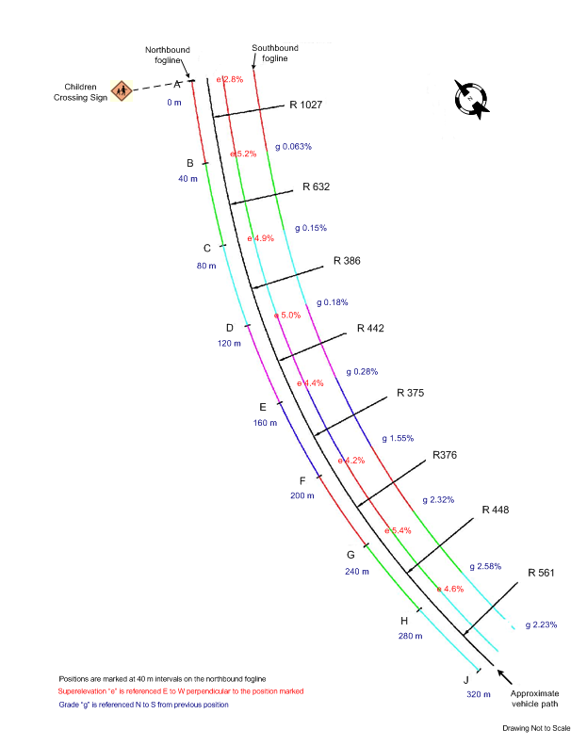
Figure 9 - Superelevation and Curve Radius Drawing

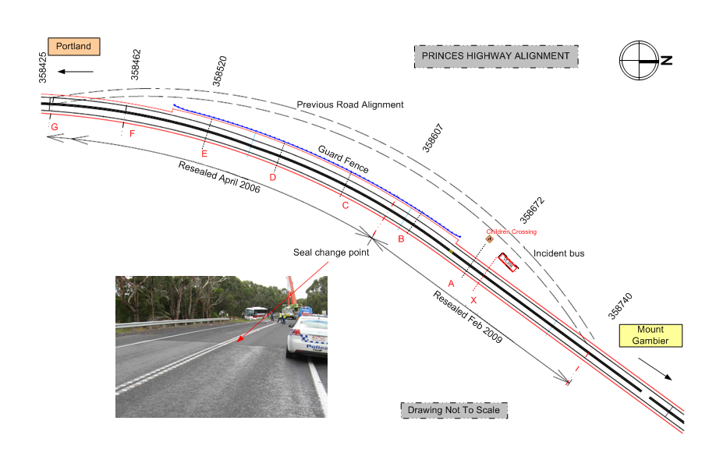Figure 10 - Princes Highway Alignment

Sighting distance
For this incident site, only the Stopping Sight Distance (SSD) conditions need to be considered as it is the minimum sight distance which should be provided at mid-block locations. SSD is the distance a driver travels during the aggregate of the time required to perceive the need to stop, and apply the brakes and come to a stop.

Sight distance is affected by roadside features such as vegetation and obstructions. Assessment of this section of road for sighting distances as per the RDG show that the required SSD is met in this section of road.

Signage
The signage at the incident site consisted of the W5-20 ‘Slippery’ sign and the W8-7 ‘When Wet’ sign, as outlined in VicRoads Traffic Engineering Manual and was located approximately 700 metres south of the final location of the coach. VicRoads advised that the sign was installed in August 2004, prior to the road being resurfaced and stated that “it is installed to indicate the type of condition which result in a slippery road. It is not intended to imply that the road has a defect or fault that requires fixing. It is an indication of possible road condition”. The manual also prescribes the positioning of such signs, and states that in a rural environment for an 85th percentile approach speed of greater than 90 kilometres per hour, the sign should be placed between 180 and 250 metres prior to the hazard. In this case, the sign was placed approximately 207 metres prior to the start of the curve and therefore was located according to specification.

The manual specifies that: ‘Warning signs are used to warn drivers of potentially hazardous conditions on, or adjacent to the road, and of conditions which may require them to stop, slow down, or prepare for some other possible manoeuvre which may not be apparent from other sign or devices, or from road or traffic conditions’.

Apart from the 100 km/h speed restriction sign there were no other speed warning signs.

Pavement construction and surface texture
For rural roads the preferred pavement design usually comprises of granulated crushed rock base layers with an initial treatment of prime and seal. The initial application of a bitumen-based primer seal is designed to penetrate the surface of the crushed rock upper base layer. When the primer seal dries, it provides adhesion while the seal is still liquid between the pavement layers. The graded aggregate is then placed on top.

The microtexture of the surfacing aggregate is the main contributor to sliding contact-resistance at low to moderate speeds. Skid resistance of wet roads is reduced by the lubricating action of the film of water on the road surface. At high speeds macrotexture of the surface aggregate becomes the dominant contributor to wet surface skid resistance by providing rapid drainage routes between the tyre and the road surface, facilitating good microtexture contact.

Road surface friction & tests
On curved roads, sideways forces imparted on tyres have to be countered by road surface friction and the superelevation of the road. A routine method of measuring skid resistance is by the use of the Sideways-force Coefficient Routine Investigation Machine (SCRIM). Testing is conducted at 50 km/h and both wheel paths are tested simultaneously. Two parameters, Sideways Force Coefficient (SFC) and Differential Friction Level (DFL) are evaluated. The SFC is the ratio of sideways force to the vertical reaction of an angled, rubber-tyred test wheel on a surface that is wet and DFL is the difference in the SCRIM readings between the left and right wheel paths.

The Roads and Traffic Authority (RTA) of New South Wales was contracted by VicRoads to carry out the skid resistance testing of the incident road and the results were provided to the investigation. Testing was conducted over a 700-metre section of road at the accident site on the 26th and 27th May 2009. One test was completed before, and one after water-blast treatment to the road. The SCRIM test results obtained before the water blast treatment are shown in Figure 11.

The RTA provides a ‘Guide for the Measurement and Interpretation of Skid Resistance Using SCRIM’, which refers to the friction coefficient below which an investigation is advised for different site geometric characteristics. This site would be classed Category 4 as per the guide and an acceptable SCRIM Reading (SR) for this site is 40 (SFC₅₀ of 0.40). It can be seen from the test result graph that the measured values prior to water blasting were generally between 10 and 30 from test chainage 380 to the start of the new seal at chainage 520. SCRIM test results for the remainder of the 2006 seal show an average reading above 40. The document also advises that SFC values need to be considered along with the DFL values. The DFL values in this section of road complied with the requirements for a highway having a speed limit in excess of 60 km/h.
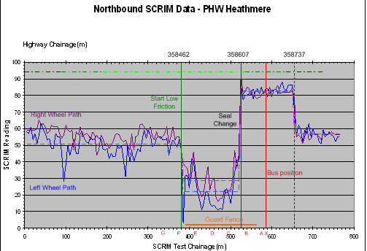
Figure 11 - SCRIM test results
A technical circular, ‘Use and Interpretation of Skid Resistance Data’ by VicRoads advises that a site inspection should be undertaken where testing or crash history indicates that surface friction may be a factor in reduced safety at the site’. The circular further advises that where low surface friction has been found to be a potential factor to loss-of-control crashes, temporary ‘Slippery When Wet’ signs should be erected until the site is treated. Although a ‘Slippery When Wet’ sign was erected at the site the speed limit at the site was maintained at 100 km/h.

Traffic volumes and accident history
Traffic volume data for the one-way mid-block section on Princes Highway, north of Robertsons Road, Bolwarra, was provided by VicRoads. The traffic volumes provided were obtained after counting on weekdays between 17 March 2006 and 27 March 2006. The samples show a daily traffic volume of 1729 vehicles per day (VPD) in the northbound direction.

Level of Service is an index of the operational performance of traffic on a given traffic lane, carriageway, road or intersection, based on service measures such as speed, travel time and degree of saturation during a given flow period. There are six Levels of Service, designated from ‘A to F’ with ‘A’ representing free flowing traffic with no delays and ‘F’ being congested traffic with no flow and major delays. A Level of Service of up to ‘C’ is generally considered acceptable in road design.

The RDG specify capacities of around 18,000-20,000 VPD for one lane of a two lane, single-carriage highway and as the daily volumes observed on this section of Princes Highway are about 10 per cent of the road’s capacity the road is classified as operating at a Level of Service ‘A’.

The available accident history for the area of the incident site, between 1 January 2003 and 31 December 2007 was accessed via the VicRoads web site. The data indicate a total of six casualty accidents over the five-year period for the mid-block section between Nashs Road and Golding Road indicating 0.34 accidents/km/annum and two casualty accidents between Levetts Road and Golding Road indicating 0.23 accidents/kilometre/annum. VicRoads advised the investigation that the accident history for the section; 1000 metres either side of the crash site indicates that there was one fatal accident, one accident resulting in a serious injury and two other road run-off accidents in the five year period prior to the incident. They state that there have been no ‘wet weather crashes’ since the ‘Slippery When Wet’ sign was installed, until this incident.

In the five-year period analysed, five out of the six accidents listed are noted to be similar in characteristics to the accident under investigation. These five accidents were all single vehicles running off the edge of the carriageway in a mid-block section of the highway. Of the five accidents, three were located on straight alignments with two located on bends; three in the southbound direction and two in the northbound direction.

Road safety funding and treatment programs
The Australian Federal Government’s National Road Safety Strategy and Action Plan (Federal Black Spot program) assigns additional funding for instituting safety measures at identified sections of roads or specific locations. The program defines a number of criteria for a site or length of road to be considered a Black Spot.

- For individual sites such as intersections, mid-block or short road sections, there should be a history of at least three casualty crashes over a five-year period.
- For lengths of road, there should be an average of 0.2 casualty (fatality or serious injury) crashes/kilometre/annum over the length in question over five years; or
- The road length to be treated should be amongst the top 10 per cent of sites with a demonstrated higher crash rate than other roads in a region.
Once a site has been identified as meeting the above criteria the road authority is required to submit a project proposal to the federal government. The proposal should be able to demonstrate a benefit to cost ratio of at least 2:1.
The State Black Spot program defines ‘Blackspots’ and ‘Blacklengths’ and the criteria for a site or length of road to be considered under this program are:
Blackspot
- At least three casualty crashes over the most recent five year period
Blacklength for rural roads
- At least three casualty crashes and a minimum rate of 1 casualty crash per kilometre based on the most recent five year period.
The Transport Accident Commissioner’s Safer Road Infrastructure Program (SRIP) provided funding for rural road run-off minimisation programs from 2005 to 2007. Sites that had a minimum of three serious casualty crashes including at least two serious crashes over the latest five year period were eligible for funding under this program.
VicRoads advised the investigation that this section of Princes Highway received funding in 2006 under the SRIP and therefore was not eligible for further funding under the Black Spot programs. Further, they advised that as there had been no reports of “extraordinary events” on this road, funding proposals for further works were given lower priority to other proposals for road works throughout the State.

Environment
The closest Bureau of Meteorology observation site, Cashmore Airport, is located about 15 kilometres to the west south west of the incident site. Weather radar imagery and automated visibility sensors at Cashmore Airport indicate that at the time of the incident there may have been light drizzle with fluctuating visibility. The temperature was approximately 13 degrees Celsius. The sun was at an azimuth of 277⁰ 02’ 36’’ and an altitude of -7⁰ 37’07’’ (below the horizon). At the time of the incident the wind speed was approximately 15 knots gusting to 27 knots from the west.

Analysis

The incident
Analysis of the CCTV recordings and witness accounts indicate that the coach tracked across the centre double lines and moved significantly into the opposite lane of the highway. On observing the oncoming vehicle headlights and realising that the bus was tracking incorrectly the driver turned the steering wheel to the left. This action returned the coach to the left lane but in the process it rotated and travelled broadside on the highway. The coach then rolled over as the front wheels dug into the grass verge. As the coach rolled, its right rear section impacted the road creating the paint and gouge marks on the surface. It then slid onto the grass and rotated anticlockwise as its front right corner impacted a grass mound. The coach came to rest on its side, facing south, on an embankment.

The investigation could not determine with certainty, the reason the coach crossed to the oncoming side of the road. However, the most probable scenarios are outlined below:

- The steer axle lost traction and continued in a straight line. To correct this, the driver increased the steering angle to the right. The front wheels regained traction and as a result of the over-steer moved over the centreline and into the southbound lane.

- The drive axle lost traction and the rear of the coach moved to the left. Regaining some traction the coach moved across the centreline and into the oncoming lane. This hypothesis is supported by the evidence of two passengers who believed that “the back let go”.

In both of the above scenarios the initiating factor is the loss of adhesion between the wheels of the coach and the road surface. The maximum lateral acceleration values measured during the subsequent bus trials indicate that a sufficient lateral force may have been imparted on the incident vehicle tyres to overcome the reduced friction of the road surface.

The investigation also considered the speed of the coach and the driver’s actions. The evidence suggests that the coach was travelling between 90 and 100 km/h when negotiating the curve. It is evident that the driver did not significantly reduce the vehicle speed on passing the ‘Slippery When Wet’ sign and the speed was excessive for the existing road geometry and conditions.

There was no evidence to suggest that driver fatigue or any medical condition of the driver contributed to the incident.

Coach 3938

Coach condition & maintenance
Prior to the incident, this vehicle was certified as being in a roadworthy condition. Post incident inspection of the vehicle did not reveal any contributory defects. In particular, all steering, suspension and brake system components were in a serviceable condition and the vehicle had been mechanically well maintained.

Coach handling
Evidence from the tests conducted by the investigation indicate that the maximum lateral acceleration value and the maximum roll angle experienced under relatively normal road conditions did not affect the handling of the coach.

Taller vehicles such as road coaches have a large area of windage and are generally affected more than other vehicles by cross-winds. Depending on the loading of the vehicle, the centre of gravity of a road coach can be relatively high compared to passenger cars. In this instance the coach was only carrying 11 passengers and the luggage compartment was minimally loaded. It is most probable that at higher speeds, the void space around the fuel tank (Figure 12) of this particular vehicle may have been buffeted by the wind and contributed to the lifting of the front end of the vehicle. The above factors and the load distribution of 35 per cent at the steering axle and 65 per cent at the rear drive axle may give the driver the effect of ‘floating’ as described by several drivers who had driven this coach prior to the incident.

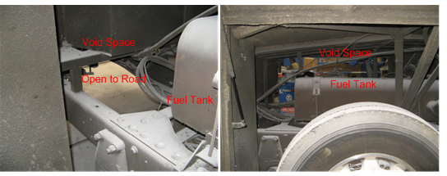
Figure 12 - Void Space around fuel tank of coach
All vehicles have handling characteristics specific to them and drivers are required to alter their driving style accordingly. These characteristics may require additional attention to the steering of the coach.

Vehicle damage
The damage to Coach 3938 was consistent with the vehicle tipping onto its right side, sliding along the road and impacting into the grass embankment.

Despite the deflection of the structure of the vehicle, occupant survival volume was retained in accordance with ADR 59/00.

Occupant survivability
There were 11 passengers, including a two year old child on the coach. Of these, five adults claimed to be wearing the provided seatbelts. All of these passengers survived the incident. Although one passenger who was ejected from the coach believed he had put on his seatbelt after boarding the bus, it is unlikely that he had his seatbelt on at the time of the incident. Post-incident inspection of the coach did not find any failure of either seatbelt anchor points or the seatbelts and all appeared in good condition.

A total of four passengers, including the child, were completely ejected and two passengers were partially ejected from the coach. The child and the two passengers who were partially ejected were trapped under the coach and received fatal injuries.

It is evident that in the above incident the wearing of seatbelts minimized injury and greatly enhanced passenger survivability.

Safety harness regulations
It is evident that neither the announcement to passengers that ‘it was a requirement to wear seatbelts’ nor the ‘Fasten Seat Belt’ sign were heeded by several passengers. Coach drivers are not required to ensure that passengers wear their seatbelts. Mandating this requirement may not be practical or feasible as monitoring passengers during the coach passage would be onerous and distracting for drivers.

All the vehicle seats were fitted with lap/sash seat belts, but there were no child safety harnesses. Although the provision of child seat belts has been discussed at several national and state forums the industry has not adopted a policy with respect to the carriage or fitting of child safety harnesses. This aspect of travel in long distance road coaches is worthy of further review and consideration.

Road design and condition

Road alignment and speed
Conditions such as poor alignment, insufficient superelevation and poor surface condition can contribute to road run-off accidents. The existence of such conditions along with adverse weather conditions increases the risk of an incident. The designated speed of 100 km/h was in excess of the maximum desirable speed specified in the Road Design Guidelines for the existing radius and superelevation.

Although a radius of 416 metres is shown over a 343 metre long circular arc of road south of the location of the coach, measurements over 40-metre road segments indicated lesser radii for some segments from J to B (Figure 9). The peaking of the lateral acceleration values during the testing of the coach provides evidence that an increased steering input is required when negotiating this curve. This feature in the road alignment may also require additional attention to steering by the driver to keep a vehicle within the confines of its lane.

Road surface condition and monitoring
The road surface in the incident section of the road was found to be in poor condition as evidenced by the SCRIM test values. A section of the road surface was observed to have a sheen due to ‘stripping’ of the aggregate and/or ‘flushing’ or ‘bleed-through’ of the bitumen. Loss of aggregate can occur due to insufficient primer seal binder being applied or the seal being applied at a lower than optimal temperature. Flushing or bleed-through occurs when the primer is on top or near the top of the aggregate. This may be caused by too much primer for the road surface condition at the time of sealing, non-uniformity of the original surfacing or embedment of the aggregate. Any of the above factors may have contributed to the deterioration in quality of the 2006 seal.

VicRoads carried out a Road Condition Survey of the incident road on 11 March 2009; 38 days before the incident. A report for the above survey was not completed and no action was taken after the survey by VicRoads. It is most unlikely that the road surface could have changed significantly during these 38 days. While it is not known if the low friction surface was identified, it is considered that an adequate inspection would have identified this issue. If it was identified, it may be possible that no action was taken as the VicRoads guidelines allow for the road to be treated or for signage to be installed.

Warning signs and speed designation
Warning signs are required to be installed if a set of road conditions relating to potential hazards are met. The SCRIM test results validate the erection of the ‘Slippery When Wet’ sign. This sign was erected in 2004 prior to the 2006 reseal of this section of road. Further, the erection of warning signs is normal practice for isolated curves that do not meet design speed requirements on highways and major roads.

The incident coach driver was well experienced on this route and in the operation of the bus. He drove over this section of the Princes Highway several times each week, both in the coach and his private car. It is most likely that he would have previously encountered conditions similar to the conditions that prevailed on the day of the incident. Therefore, it is reasonable to assume that he operated the coach as he normally did but for some reason the conditions present on the day of the incident and his reaction to them caused him to lose control of the bus. The evidence suggests that the coach was being driven at a speed less than the maximum speed for the road and it is apparent that the guidance given by the ‘Slippery When Wet’ sign was not an adequate indication of the low friction road surface condition even to an experienced professional driver. Additionally, the alignment of this section of road warranted at least an advisory speed warning, as the calculated design speed for the section is below the designated 100 km/h.

Road Safety funding and treatment
Under the Black Spot programs, once an allocation of funding has been made for a section of road, other sections of the same road within a specified distance become ineligible for any further road safety funding, until the minimum number of casualty crashes re-occurs on the road. In this instance only a part of the incident section of road surface was resealed in March 2009 and the other section with the low surface friction, previously resealed in 2006 was not treated as it was given lower priority as there had been no reports of “extraordinary events” on this section of road. It would be prudent for VicRoads to ensure that when sections of road are treated, significant variations in road surface friction between the treated and untreated sections are avoided.

Conclusions

Findings
- The coach driver was appropriately licensed and accredited to drive the incident coach.
- Warrnambool Bus & Motor Company was an accredited public transport organisation.
- The coach was maintained appropriately and was in good mechanical condition.
- The section of Princes Highway was designated a maximum speed of 100 km/h.
- A ‘Slippery When Wet’ sign was appropriately located about 700 metres before the incident site.
- All existing road furniture meets the standard requirements for this class of road.
- The Road Design Guidelines specify a minimum desirable radius of 440 metres for a speed of 100 km/h and 6 per cent superelevation. The incident section of the road had a radius of 416 metres.
- The road had a low coefficient of friction on a section of the curve corresponding to the approximate point of loss-of-control.
- The road surface was wet and it was dark at the time of the incident.
- There were wheel-rut depressions on the road surface.
- Several passengers were not wearing seat belts at the time of the incident, including the passengers who sustained fatal injuries.
- Although it is a mandatory requirement to wear seat belts in Victoria, drivers of road coaches have no powers to enforce this requirement.
- The coach was not fitted or provided with child safety harnesses.

Contributing factors
- The designated speed limit was excessive for the existing road geometry and conditions.

- The road surface was wet and had a low coefficient of friction.

- The existing ‘Slippery When Wet’ sign was inadequate in providing sufficient guidance to drivers and mitigating the risk of the low friction road surface conditions.

- The coach was travelling at a speed that was not appropriate for the existing road geometry and conditions.

Safety Actions

Safety Actions taken since the event
Following the incident, the section of Princes Highway with the low SFC reading was water-blasted by VicRoads in order to increase the surface friction. VicRoads has also repainted the side and centreline markings.

Recommended Safety Actions
Safety Issue

A combination of the road geometry and the reduced road surface friction increased the risk to road users. The road was surveyed in March 2009 but no additional mitigation was provided to the existing ‘Slippery When Wet’ sign.

RSA 2009023

That VicRoads reviews its roads management and monitoring system in order to more critically evaluate road conditions and to provide where appropriate improved mitigation through additional road treatment and guidance to road users, such as reduced speed limits.

Safety Issue

The designated speed limit for the curve was excessive for the existing road geometry.

RSA 2009024

That VicRoads undertakes a design assessment of this section of road and develops appropriate mitigations.

Safety Issue
Although there were reports from drivers of handling difficulties with the coach, post incident testing of the coach did not indicate any handling issues. However, the coach has design features which may lead to a lighter front-end particularly during high wind conditions.
RSA 2009025

That Warrnambool Bus & Motor Company considers obtaining an expert assessment of the design of the coach.

Safety Issue
The coach was not fitted or provided with child safety harnesses.
RSA 2009026

That the Public Transport Division in consultation with the Bus Industry Confederation reviews the requirement for child safety harnesses on long-distance road coaches.

Safety Issue
Several of the coach passengers were not wearing seat belts.
RSA 2009027

That the Public Transport Division in consultation with coach operators consider a program of education with respect to the wearing of seatbelts for passengers of long-distance coaches.

Appendixes

Appendix A - Minimum Radii Calculation
VicRoads Road Design Guidelines derive the following formula for the calculation the theoretical minimum radii for High Speed Roads.

Where:

R – Radius (metres)
V – Vehicle speed (km/h)
E – Superelevation (m/m)
F – Friction factor

The RDG Part 2 states “For design purposes, friction factors have to be defined which are less than the maximum at which vehicles lose control. The design friction factors for cars and trucks are shown in Fig 2.4B1”.
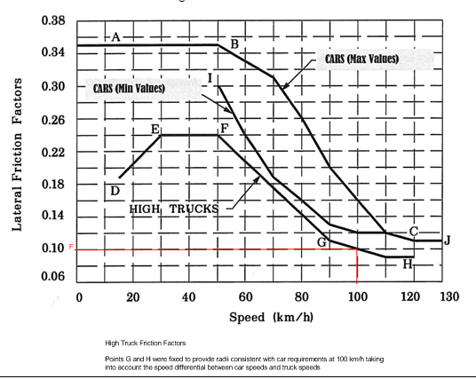
Figure 13 - Variation of Friction Factors with Speed (Extract from RDG Part 2 - Fig 2.4 B 1)
Using the formula 1, lateral friction factor for trucks (F = 0.1) from Figure 11, and operating speed of 100 km/h, radii for various values superelevation have been calculated and is shown in table (Figure13).

Truck Operating Speed (km/h) | Superelevation (m/m%)
Truck Operating Speed (km/h) | 6% | 5% | 4% | 3%
Truck Operating Speed (km/h) | Radius (m)

90 | 398.62 | 425.20 | 455.57 | 490.61
100 | 492.13 | 524.93 | 562.43 | 605.69
110 | 595.47 | 635.17 | 680.54 | 732.89
Table 14 – Theoretical Min. Radii for High Speed Roads using Lateral Friction Factor for Trucks
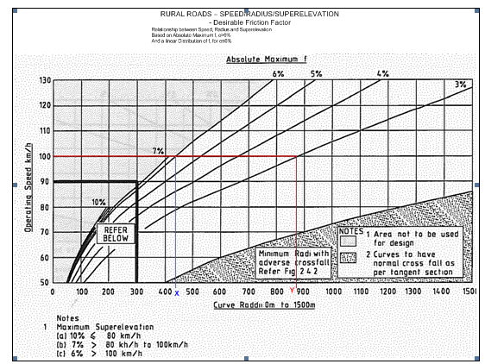
Figure 15 – RDG Part2 - Fig 2.7.1(a)

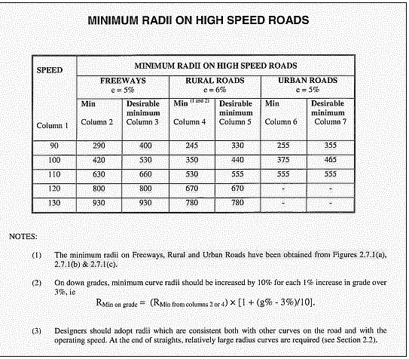

Figure 16 - RDG Part 2 - Fig 2.4.1

Appendix B - Calculation of Maximum Design Speed
Transposing formula 1 to calculate speed for various superelevation values, for a lateral friction factor of 0.10 for trucks:

……………2

Radius of Curve  (metres) | Superelevation (m/m)
Radius of Curve  (metres) | 0.06 | 0.05 | 0.04 | 0.03
Radius of Curve  (metres) | Speed (km/h)

416 | 91.94 | 89.02 | 86.00 | 82.87
Table 17 – Speed calculations for varying superelevation values

Appendix – C

Date | Time | Map Ref* | Location | Vehicles | Direction | Conditions | Injury Level | DCA Code | Sub DCA
27/06/04 | 02:15 | 88 C5 | b/w Golding Rd and Levetts Rd | Car | Northbound | Wet Road  Dark | Driver – Killed | 171 Left off carriageway into object/parked vehicle | Hit tree – shrub/scrub  No vehicle struck
24/08/04 | 02:20 | 88 B6 | b/w Nashs Rd and Keillers Rd | Utility | Northbound | Dry Road  Dark | Driver – Other Injury | 173 Right off carriageway into object/parked vehicle | Hit tree – shrub/scrub  No vehicle struck
14/11/04 | 11:45 | 88 B6 | Intersection w/ Keillers Rd | Car  Car | Southbound  Southbound | Dry Road  Day | Driver – Not Injured  Driver – Other Injury  Passenger - Other Injury | 136 Right turn sideswipe | Intersection
09/12/04 | 12:50 | 88 C5 | b/w Golding Rd and Levetts Rd | Car | Southbound | Dry Road  Day | Driver – Serious Injury | 171 Left off carriageway into object/parked vehicle | Hit tree – shrub/scrub  No vehicle struck
21/03/05 | 15:15 | 88 B6 | b/w Levetts Rd and Pennys Rd | Car | Southbound | Dry Road  Day | Driver – Other Injury | 181 Off right bend into object/parked vehicle | Hit tree – shrub/scrub  No vehicle struck  Leaves carriageway to left
07/04/06 | 01:05 | 88 C5 | b/w Golding Rd and Levetts Rd | Semi Trailer | Southbound | Dry Road  Dark | Driver – Other Injury | 183 Off left bend into object/parked vehicle | Hit tree – shrub/scrub  No vehicle struck  Hit embankments

References
Australian Transport Safety Bureau - Australian Bus Safety; Report Nov 2001

Botto, P. Caillieret, M. Tarrier, C. Got, C. & Patel, A. 1994, Evaluation of Restraint System for Coach Passengers. Paper presented at the Fourteenth international technical conference on enhanced safety of vehicles, Munich, Germany.

Regulation Impact Statement, ADR 59/00, Standards for Omnibus Rollover Strength, Department of Transport and Regional Services, 2007.

A shortened, compact unit that can be extended to suit customer specifications.
ASR - Anti Slip Regulation is a traction control system that is an addition to the ABS braking system.
The ‘shoulder’ is the transition section of a tyre from tread to the sidewall.
Gross Vehicle Mass.
“Superstructure" means the parts of a vehicle structure which contribute to the strength of the vehicle in the event of a roll-over accident.
"Residual space" means the space to be preserved in the passenger compartment during and after the structure has been subjected to one of the tests in ADR 59/00.
VicRoads Road Management Plan – version 30 October 2004, page 15
VicRoads Road Management Plan – version 30 October 2004, page 17
Yaw marks are created by a rotating tyre that is skidding sideways across the road surface
Between intersections.
Fine-scale texture of less than 0.5mm depth of the surface aggregate.
Coarse texture of 0.5mm to 15.0mm depth of the surface aggregate.

