Transport
Climate Change Adaptation Action Plan
2022–2026



This Transport Climate Change Adaptation Action Plan 2022–2026 was produced after extensive targeted and public consultation.

Acknowledgement of Aboriginal Victorians
The State Government acknowledges Aboriginal* people as Australia’s first peoples, and as the Traditional Owners and custodians of the land on which we live and work.
The State Government recognises the strength of Aboriginal people and communities and the value of their contribution to enriching Victorian life through their daily work and involvement at key events.
The State Government recognises that all Aboriginal cultures and communities are diverse and should be celebrated.
The State Government acknowledges that the land is of spiritual, cultural and economic importance to Aboriginal people.
The State Government looks forward to continuing to work with Aboriginal Victorians across the entire transport portfolio in genuine partnership, according to the Transport Portfolio Aboriginal Self-Determination Plan 2020-2023.
* The term ‘Aboriginal’ is used to refer to all people of Aboriginal and/or Torres Strait Islander descent who are living in Victoria.

© The State of Victoria Department of Transport 2022

For more information
Refer to the transport website at https://transport.vic.gov.au/ Authorised by the Hon. Ben Carroll MP
Minister for Roads and Road Safety
Department of Transport, 1 Spring Street Melbourne Victoria 3000 Telephone (03) 9655 6666

 This work is licensed under a Creative Commons Attribution 4.0 International licence. You are free to re-use the work under that licence, on the condition that you credit the State of Victoria as author. The licence does not apply to any images, photographs or branding, including the Victorian Coat of Arms and the Victorian Government logo. To view a copy of this licence, visit creative commons licences.

ISBN 978-1-76105-875-2 (pdf/online/MS word)

Disclaimer
This publication may be of assistance to you, but the State of Victoria and its employees do not guarantee that the publication is without flaw of any kind or is wholly appropriate for your particular purpose and therefore disclaims all liability for any error, loss or other consequence that may arise from you relying on any information in this publication.

Accessibility
This document is also available in an accessible format at transport.vic.gov.au.



Minister’s foreword
The Climate Change Act 2017 requires the Victorian Government to develop plans to respond or adapt to the impacts of climate change. The Act identifies seven key systems requiring an adaptation action plan (AAP), including one for transport. Our Transport system is vulnerable to the effects of climate change and we need to manage the risks and consequences on our transport assets and users.

Victoria is leading the way on climate change action. As required by the Climate Change Act 2017, the Victorian Government has done three things:
- published Victoria’s Climate Change Strategy
- issued a whole-of-Victorian Government pledge to reduce emissions
- developed adaptation action plans, including this Transport Climate Change Adaptation Action Plan 2022–2026.
Adaptation action is both urgent and necessary. The current evidence tells us that there is a lag of around 20 years for the system to balance. Temperatures will keep rising over the next two decades, and even with mitigation (future low emissions), warming is inevitable.
This plan focuses on adaptation actions and is consistent with our responsibilities under the Transport Integration Act 2010 and other legislation. It also helps us to build a climate- resilient, liveable and prosperous Victoria.
The plan focuses on three key whole-of-Victorian-Government priorities of how we:
- address current climate change impacts that are already severely affecting Victoria
- reduce barriers to climate change adaptation planning and action
- lay the foundations for transformational change.
It builds on the key enablers of action set out in Victoria’s Climate Change Strategy: governance and strategic planning, building capacity and partnerships, sustainable adaptation finance, and leadership and innovation.
This plan is the first of a series of five-year plans to 2050. It focuses on how to prepare for ongoing changes in the frequency, intensity, location and timing of extreme weather and climate events; present strategies for adaptation across the whole lifecycle of the Transport system; and respond to changes in external impacts, such as population migration. Action may be as simple as helping people make sustainable decisions about how they move around and access goods and services.
Together, we can progressively adapt and continue to deliver a world-class Transport system that enables Victoria in 2050 to be resilient, flourishing and highly liveable.

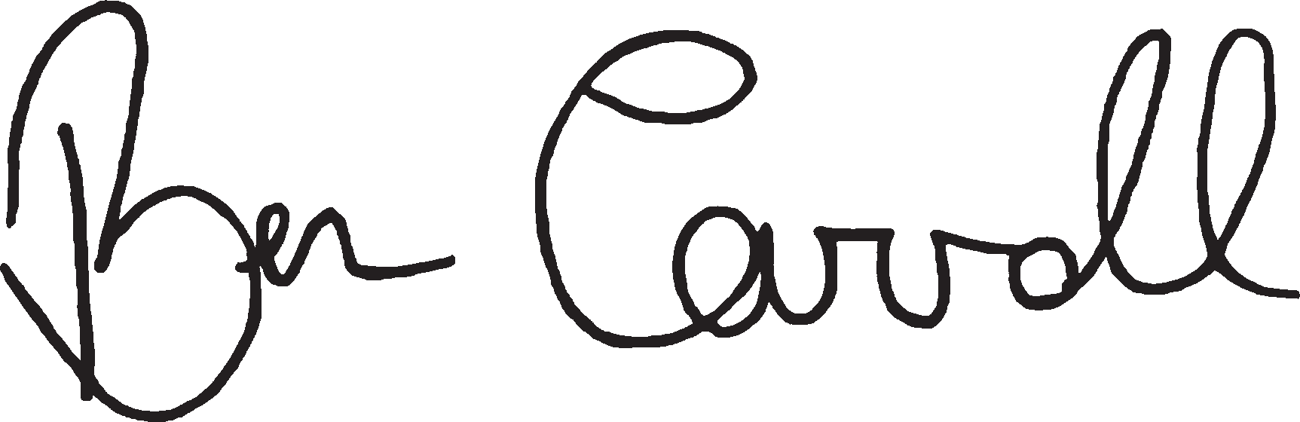

The Hon. Ben Carroll MP
Minister for Roads and Road Safety

Contents
Minister’s foreword 3
Executive summary 5
- Introduction 6
  - System-wide adaptation strategy 7
  - Public and targeted consultation 7
  - Plans to adapt to – and meet – the challenges ahead 7
  - A systems approach to adaptation 7
  - Objectives of the Transport system adaptation action plan 8
  - Scope of the Transport system 11
  - Interdependencies with other systems 12
  - Interdependencies with cross-cutting policy areas 13
- Governance, roles and responsibilities 15
- Climate change and the Transport system 16
  - Climate change in Victoria 16
  - Climate change impacts on the Transport system 17
  - Transport system projected impacts and adaptation actions – evidence base 18
- Key climate change risks and opportunities for the Transport system 19
- Existing climate change adaptation policies, programs and projects, and gap analysis 20
- Transport system climate change adaptation actions: 5-year plan 21
  - Strategy for action 21
Priority 1. Address current climate change impacts 22
Priority 2. Reduce barriers to action 25
Priority 3. Lay the foundations for transformational change 27
  - Monitoring, evaluation, reporting and improvement 29
Appendices 30
Appendix 1: Key terms and acronyms 30
Appendix 2: Development of the Transport system adaptation actions 32
Appendix 3: Consultation with key stakeholders 33
Appendix 4: Risks and opportunities 34

Executive summary

Our Transport system is critical to our way of life, helping us move around and access jobs, education, goods, services and recreation opportunities. Like all aspects of life, transport is under threat from climate change.
Our climate is changing, and while the Victorian Government has developed a Climate Change Strategy, and set ambitious and achievable interim emissions reduction targets on a path to net-zero emissions by 2050 (pledges), reducing our emissions will not be enough to prevent further climate change. We know that, even under future low emissions, warming is inevitable and adaptation is both urgent and necessary. We must adapt Victoria’s Transport system to meet both the present and future challenges and impacts of climate change.
Climate change threatens Victoria’s Transport system’s resilience, the integrity of its assets and its ability to provide reliable services. Decisive adaptation action will help reduce current and future risks, build social and economic resilience, and protect our natural environment.
The climate change objective for the Transport system over the next 5 years is to build the system’s capacity to adapt to climate change – while meeting community
expectations for service levels and environmental sustainability. This includes further:
- improving the Transport system’s contribution to emergency planning and preparedness, response and recovery
- planning for climate change impacts and assessing transport infrastructure to determine its ability to avoid, withstand and recover from climate change impacts
- continuing to provide essential services and support community health and wellbeing
- supporting resilience across all relevant systems, including the Built Environment, Education and Training, Health and Human Services, Natural Environment, Primary Production, and the Water
Cycle, optimised to adapt to – or potentially capitalise on – climate change impacts.
Working together to adapt to future challenges
Consultation and collaboration are critical to this plan’s successful implementation. The Department of Transport (DoT) will work with Transport system owners, operators and managers, local government, and the community to implement the actions identified in this plan. Actions will account for uncertainties
in future climate change projections and consider issues across systems.
We have already established climate change adaptations within the Transport system. However, in some areas we still need a better understanding of the system, service and cross-system risks before deciding on the best actions to take. The Transport system will prioritise those actions in consultation with:
- Transport system owners, operators and managers
- local government
- other systems developing and implementing adaptation
action plans
- the community, including transport users, vulnerable communities and peak advocacy bodies.
Transport system adaptation actions will consider and address (where possible) climate change projection uncertainties, including uncertainties impacting other systems. Future 5-year plans will extend Transport system adaptation actions to help build a stronger, more resilient and thriving Victoria by 2050.

Introduction

Climate science tells us that many climate-related hazards are likely to be exacerbated in the future. Climate change threats to the Transport system are both direct and indirect, and include threats that impact multiple systems.
Climate change adaptation work is underway, but additional action is needed. While Victoria and other jurisdictions around the world have set targets to reduce
greenhouse gas emissions, global emissions continue to rise. Global warming may exceed 1.5 degrees Celsius above pre-industrial levels
as soon as the 2030s, so we need to prepare for a changing climate. To prepare for the increasing hazards of climate change, we need to build on Victoria’s existing adaptation actions to:
- develop resilience
- protect transport assets and infrastructure
- address the needs of transport users and vulnerable communities.
Governments, industry and transport users all have roles to play in adapting to climate change, including in making decisions about how we move around, and how we access goods and services.

Figure 1. Scope of the Transport system

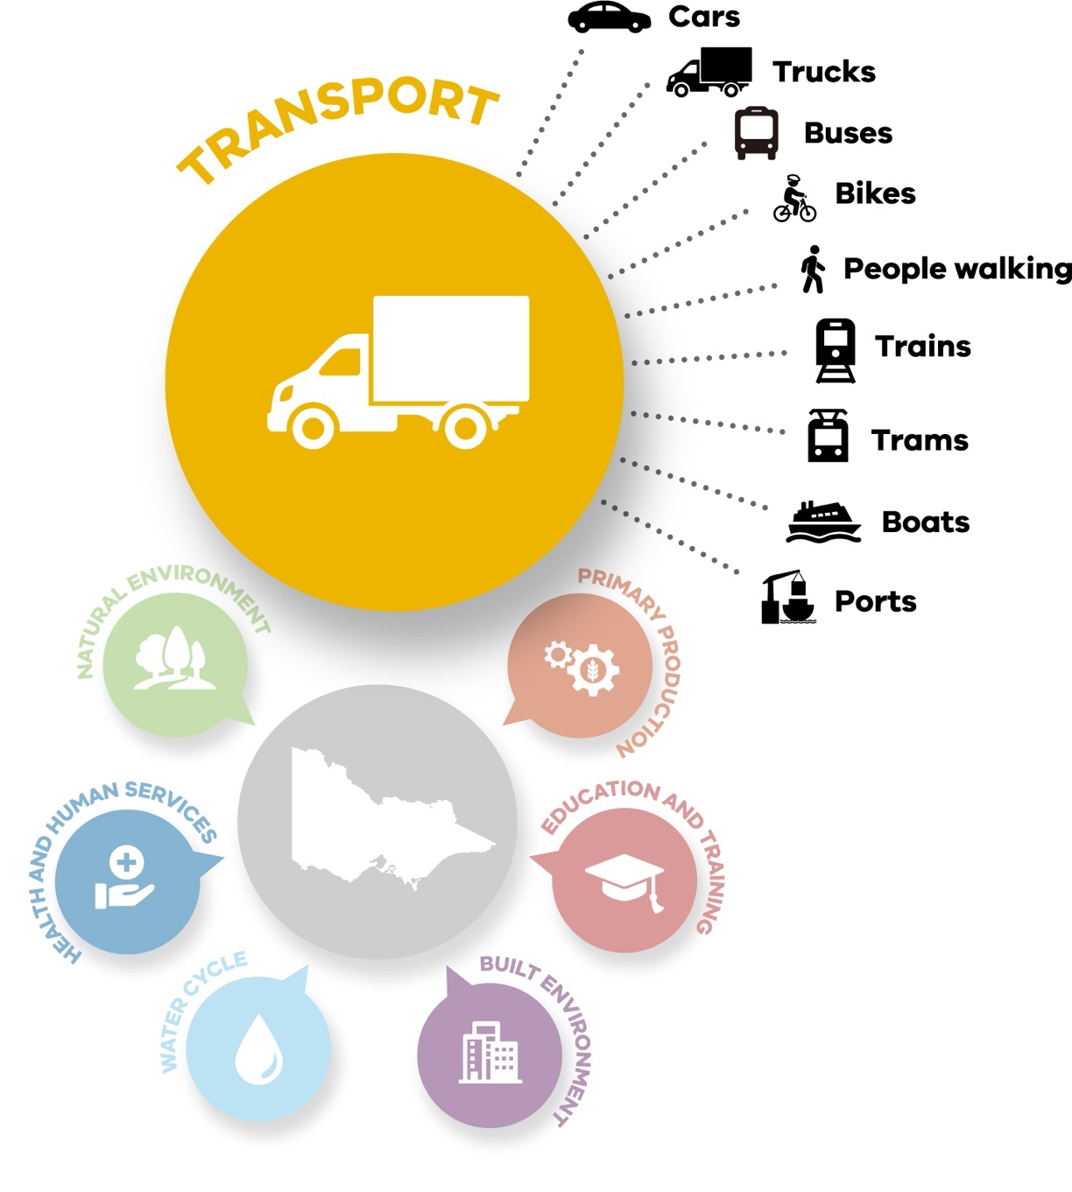
Spotlight: Systems-based approach to climate change adaptation
The Victorian Government is preparing adaptation action plans across 7 systems, to ensure Victoria’s climate resilience now and in the future. The 7 systems are:
- Built Environment • Primary Production
- Education and Training • Transport
- Health and Human Services • Water Cycle.
- Natural Environment

SYSTEM-WIDE ADAPTATION STRATEGY
In Victoria, action on climate change is underpinned by the Climate Change Act 2017 (the Act).
Victoria’s 7 adaptation action plans collectively harness available opportunities and tackle the impacts of climate change, while caring for our environment and bolstering our economy. The plans identify actions that we need to take now to respond to emergencies, cope with climate change hazards
and transform the Transport system.
Transport system adaptations will be led by the Minister for Roads and Road Safety.

PUBLIC AND TARGETED CONSULTATION
Communities, businesses and governments can and must work together to tackle the impacts of climate change.
We sought input from the Victorian community and key stakeholders to produce this first set of adaptation actions and Transport Adaptation Action Plan (AAP). This first plan will set a solid foundation for a climate-resilient Victoria
for the long term.

PLANS TO ADAPT TO – AND MEET – THE CHALLENGES AHEAD
This is the first in a series of adaptation action plans for the Transport system. Each consecutive plan will cover a 5-year period, up to 2050. This plan aligns with the guiding principles and
policy objectives of Victoria’s Climate Change Act 2017 and Victoria’s Climate Change Strategy and is consistent with legislative responsibilities
under the Transport Integration Act 2010.

A SYSTEMS APPROACH TO ADAPTATION
The Victorian Government is taking strong and lasting action to reduce Victoria’s
emissions to net zero by 2050 and build resilient communities prepared to deal with the impacts of climate change.
Victoria was one of the first jurisdictions in the world to legislate a net-zero emissions target with the Climate Change Act 2017, and set a strong foundation for future climate resilience with action under Victoria’s Climate Change Adaptation Plan 2017–20.
Victoria’s Climate Change Strategy sets out the Victorian Government’s current action on climate change and our next steps.
Reducing our emissions will help lessen the impact of climate change, but it will not prevent it – some degree of climate change is already locked in due to historical emissions. Under all scenarios, even under
low future emissions, global surface temperatures will continue to rise until at least mid-century. Warming is inevitable and adaptation is a necessary response. Adapting to the impacts of climate change will help reduce current and future risks,
build social and economic resilience, and protect the environment.
Victoria’s Climate Change Strategy sets our adaptation objectives for the next decade and priorities for the next 5 years, consisting of priority focus areas to:
- address the current impacts of climate change on Victoria
- reduce barriers to adaptation
- lay the foundations for transformational adaptation.

The strategy also outlines the enablers that will support:
- capacity building and partnerships
- governance and strategic planning
- sustainable adaptation finance
- leadership and innovation.
Guided by the strategy, the Victorian Government is planning for climate impacts and delivering adaptation action at multiple scales.
The Victorian Government’s first set of 5-year climate change adaptation action plans (AAPs) are for 7 systems that are either vulnerable to climate change impacts or are essential to ensure that
Victoria is prepared: the Built Environment, Education
and Training, Health and Human Services, Natural Environment, Primary Production, Transport, and Water Cycle systems.
The Transport AAP is part of the set. This systems-based approach to climate change adaptation enables a targeted response to climate change that focuses on the unique characteristics and needs of each system.
It is complemented at a regional scale by regional adaptation strategies (RASs), developed in partnership
with regional communities to identify, prioritise and deliver place-based action informed
by local knowledge and needs. These strategies are for Greater Melbourne, Gippsland, Hume, Loddon Mallee, Grampians and Barwon South West and each complements the Transport AAP.
Implementation of the Transport AAP will require ongoing consultation and collaboration with local governments and community groups to understand and address the risks posed
by climate change to local communities and vulnerable groups.
This Transport AAP will iteratively guide adaptation efforts over the next 5 years, building on strong foundations and seizing opportunities to accelerate adaptation.

OBJECTIVES OF THE TRANSPORT SYSTEM ADAPTATION ACTION PLAN
The objective of this Transport Climate Change Adaptation Action Plan 2022–2026 is:
We will build capacity to adapt to climate change while meeting community expectations on service levels and environmental sustainability.
Three further objectives (Table 1) informed the development of this plan. These objectives will shape the identification and delivery of short-term (2026), medium- term (2031), and long-term (2050) Transport system adaptation actions. They are
also concurrent and apply immediately. We will not wait until 2026, for example, to act on creating high-priority asset resilience – actions that we take now will contribute to realising this objective in the future. Transport sector agencies have been and will continue to factor climate change into their infrastructure, operations and maintenance activities.
The objectives shown in Table 1 are also dynamic. They may be redefined in the future, depending on how climate change impacts the Transport system over time. They are progressive, systematic and focus on the whole-of-system lifecycles. They balance the need to meet community expectations for service and environmental sustainability with economic objectives
and with the need to develop community resilience. They support resilience across the key systems, optimised to exploit or at least adapt to climate change.

Table 1. Transport system adaptation objectives

Timing Objectives

Short-term (2026)
Build knowledge, capacity, capability and decision-making processes
This plan will build knowledge, capacity, capability and decision-making processes through actions to:
- establish governance to address climate change risks
- ensure that infrastructure at high risk of frequent and severe climate-related impacts is managed with strategic planning and investment decisions
- build knowledge, capability and partnerships to address climate change risks
- establish systems to quantify and report on climate-related transport network incidents
- assess risk management processes (and management strategy effectiveness) to understand when to defend, accommodate or retreat from climate-related hazards
- trial innovative solutions to prepare transport infrastructure for the future safe and sustainable movement of people (including vulnerable or disadvantaged people) and goods
- review existing legislation, policies and engineering standards, particularly for long-lived infrastructure.

Medium- term (2031)
Substantially develop resilience for high- priority assets
This plan will support the substantial resilience development of high-priority assets through actions to:
- improve the Transport system’s emergency planning and preparedness, response and recovery approaches to address potential critical user and asset risks from fire, flood and heat climate- related hazards
- improve infrastructure’s robustness to avoid, withstand and recover from climate change impacts while continuing to provide essential services and support community wellbeing.

Long-term (2050)
Develop built-in resilience across the Transport system
This plan will support the development of built-in resilience across the Transport system through actions to:
- respond to gradual sea level rise where it impacts the transport network across our coastal regions, including storm surge inundation, wave action, erosion and rising groundwater
- respond to increased risk of disruption or damage to transport infrastructure due to riverine flooding
- build on the Transport system’s medium-term (2031) adaptation objectives.

This plan proposes 15 strategic actions the Transport system can take during the next 5 years to address the
3 priority focus areas for adaptation in Victoria’s Climate Change Strategy: current climate change impacts,
reduce barriers to adaptation planning and action, and
lay the foundations for transformational adaptation.
The strategic actions for 2026 are summarised in Table 2 and detailed in Section 6.
Future plans will extend Transport system adaptation actions to help build a stronger, more resilient and thriving Victoria by 2050.

Table 2. Proposed Transport system adaptation actions to 2026

Priority 1. Address current climate change impacts
Action 1. Collaborate with transport agencies and industry partners. Action 2. Strengthen the transport portfolio governance framework. Action 3. Strengthen transport assets, infrastructure and services.
Action 4. Identify, audit and understand parts of the Transport system that are at high risk, vulnerable or face the greatest exposure.
Action 5. Work with other systems to better plan, prepare and protect the Transport system from the impacts of climate change.

Priority 2. Reduce barriers to action
Action 6. Develop staff capability and capacity.

Action 7. Map climate change projection data against the statewide transport system.

Action 8. Analyse the current approaches, gaps and barriers to adaptation planning in transport policies, plans and procedures.

Action 9. Facilitate emerging and innovative technologies, market responses, and funding models. Action 10. Support governance structures that facilitate knowledge-sharing for transport leaders.
Action 11. During decision making, take a broader view of environmental impacts.

Priority 3. Lay the foundations for transformational change
Action 12. Consult and collaborate with transport regions to understand their work on the needs of local communities, including vulnerable and Aboriginal communities.

Action 13. Monitor, review and evaluate adaptation actions.

Action 14. Prepare transport assets and infrastructure for future climate change.

Action 15. Learn from global best practice and support trials and pilot projects that test transformational adaptation approaches.

SCOPE OF THE TRANSPORT SYSTEM
The Climate Change Act 2017 requires the government to appropriately take account
of climate change by having regard to the policy objectives and the guiding principles set out under the Act when making any decision about policy, program or process developed or implemented. These objectives and principles are relevant and must be taken into account when making decisions about the Transport system.
The Climate Change Act 2017 defines Victoria’s Transport system as the physical and services components that facilitate the movement of persons and goods. The Transport Integration Act 2010 helps define these components as well other components that make up the Transport system for the movement of people and goods. The following components are relevant to this plan:
- physical, including the transport networks and facilities, systems and vehicles that use those networks
- management, including strategic and operations planning
- labour, including all the persons involved in the planning, setting policy for and operating the Transport system
- services, including those relating to passenger and freight that move people and goods.
These components are owned, operated and managed by various agencies and private operators (including tourism operators), as shown in
Table 3.

Table 3. Transport system components and owners, operators and managers

Transport system components Component owners, operators and managers

• Major arterial roads, bridges and tunnels
• Rail (including asset storage and stabling)
• Freight infrastructure, port and airport land access (via road and rail) structures
• Electrical assets (such as signs, signals, lighting, overhead electrical lines and track components)
- Department of Transport (DoT)
- Transport agencies, (such as V/Line and VicTrack)
- Train, tram and bus franchisees (such as Metro Trains and Yarra Trams)
- Private operators (such as Transurban, SkyBus, commercial passenger vehicles and share bike operators)
- Major projects (such as the Major Transport Infrastructure Authority [MTIA] and contractors)

- Municipal roads
- Walking, shared and cycling paths
- Bridges and tunnels

- Local governments

- Roads, trails, bridges and tunnels within state parks, national parks and reserves

- Department of Environment, Land, Water and Planning (DELWP)
- Parks Victoria

- Heritage and tourism assets (such as Puffing Billy Railway, Bendigo Tramways)

- Private operators

- Commercial ports and their supporting waterside assets (such as shipping channels, swing basins, berth pockets and dredge material grounds)

- Port authorities (such as Ports Victoria)
- Private operators

- Local ports, boating facilities, jetties, piers, seawalls and other components

- Management authorities (such as Gippsland Ports)

1.7 INTERDEPENDENCIES WITH OTHER SYSTEMS
Shared decision making and coordinated action is essential to ensuring effective adaptation, to reduce unintended consequences (maladaptation) and avoid duplication of services and actions – and this plan has not been developed in isolation. The Transport system consulted with other systems
whilst preparing adaptation action plans under the Climate Change Act 2017, and this plan aligns with their key systems’ adaptation actions. Across government, all systems will continue to collaborate in implementing shared actions to effectively manage cross- system dependencies.
Collaboration will continue throughout the life of Victoria’s Climate Change Strategy.
Examples of the Transport system’s cross-system dependencies and connections are shown in Figure 2.

Figure 2. Key Transport system connections and dependencies

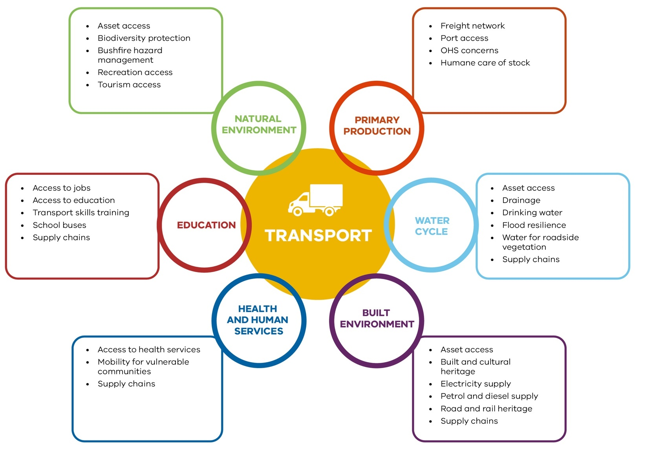

1.8 INTERDEPENDENCIES WITH CROSS-CUTTING POLICY AREAS
The day-to-day operations of the Transport system also
intersect with other important policy areas, including emergency management, active and public transport,
supply chains, and the natural environment. Moreover, consultation and collaboration with local government and communities, including vulnerable communities and Aboriginal Victorians, will
help define how the Transport system can respond in a fair and equitable manner to the
impacts of climate change and contribute to self-determination for Traditional Owners and Aboriginal Victorians. These key themes are further highlighted and discussed.

SPOTLIGHT ON INTERDEPENDENCIES

Emergency management, emergencies and the Transport system: a key cross-system dependency
The Department of Justice and Community Safety coordinates emergency management across all Victorian Government departments, organisations and agencies. But to be effective in preventing, preparing for, responding to and recovering from emergencies, Victoria’s emergency management function depends on the Transport system. Roads, bridges, and ports all provide access and egress in emergencies such as fire and flood. Victoria’s Transport system supports emergency management activities such as actions to:
- evacuate and ensure the welfare of transport workers, people and their pets, vulnerable communities and tourists
- transport essential supplies and goods, including food and water
- keep routes open, safe and clear of debris for emergency vehicle access, and to allow, when safe, people to move between homes, jobs, education and services
- ensure access for services to repair and rebuild critical infrastructure
- facilitate access to livestock and wildlife to ensure their humane care
- facilitate access to vulnerable and threatened species to ensure their care and protection.
Building the Transport system’s capacity and capability to help respond to and recover from emergencies is critical to building climate resilience. Transport adaptation planning aligns with and plays a key role in the emergency management cycle.
Emergency management depends on all agencies, departments, industry, business, and all levels of government and community working together to fully realise a sustainable and efficient emergency management system that reduces the likelihood, effect and consequences of emergencies. Emergency management is a shared responsibility across all systems. Integrating it into adaptation planning will position Victoria to better prevent, prepare for, respond to and recover from emergencies.
Parts of Victoria’s transport network are classified by government as vital critical infrastructure. Operators of these assets and networks undertake a range of risk management and resilience- building activities and have legislative risk management obligations under Part 7A of the Emergency Management Act 2013.

Active transport, shade, vegetation, and the Transport system
Climate change can impact active transport modes such as walking and cycling. Summer heat may be a deterrent to active transport, especially for vulnerable communities, for which active transport may be the only affordable or available option. Flooding can impact shared and recreational paths along and across waterways. Bushfires threaten natural tracks, especially in regional Victoria and the urban fringe. Sea level rise and storm surges jeopardise coastal paths, jetties and piers.
Adaptation options for active transport include to provide shade over shared paths, protect existing vegetation, minimise urban heat, reconsider road space allocation, and enhance connectivity – that is, ease of movement between places. The Department of Transport will continue to work with peak advocacy organisations to identify needs, and with other systems to prioritise and improve shade, enhance the provision of potable water, and improve ease of movement, especially around public transport, school and health precincts.
The Transport system also needs to beware of maladaptation in mitigation and adaptation actions, if not done well. For example, charging infrastructure for electric vehicles should be placed on roadways, so as not to obstruct footpath movement, particularly where space is at a premium.

Local government, regional communities, vulnerable communities, and the Transport system: consultation and collaboration
Climate change impacts will be experienced differently across Victorian society as a result of varied social, economic and environmental contexts. Local government is well-placed to understand the diverse needs of local communities, address Transport needs in the Regional Adaptation Strategies, and help implement local adaptation actions. Community-based organisations also provide a perspective on the needs of different vulnerable communities and how those needs evolve with climate change. Successful implementation of this plan will rely on regular and ongoing consultation and collaboration on a range of issues related to the Transport system and services, including:
- understanding impacts on the elderly, people with disabilities, families with prams and young children, young people, those with temporary or chronic health issues, minority groups with language barriers, remote communities and the underemployed
- regions taking the lead in communicating with local Traditional Owner groups
- understanding complex needs, such as assistance with communication, mobility or complex forms of personal support, coordinated services, consistency of drivers, and family or social network support
- maintenance and betterment of transport infrastructure, such as roads, rail, bridges, tunnels, trails, local ports and boating facilities
- planning for transport, such as the location of transport corridors
- precinct planning, such as shade provision and improved connectivity ease of movement between places – to encourage active transport.

Freight, supply chains and the Transport system: interdependencies
The movement of goods, produce and medicines across sectors relies heavily on the Transport system, particularly the freight network. Efficient freight and logistics systems contribute to the state’s liveability by connecting people with jobs and connecting products with markets. Coordinating the development of an efficient freight and logistics network ensures that Victorian factories and farms are able to receive inputs to the production process and can supply products to local and export markets.
Victorian food and fibre already comprises about a third of Australia’s export market and is important to the state’s economic and social wellbeing. Predicted population growth for Victoria and increases in freight volume mean that it is paramount that the freight and logistics industry can rely on road, rail and ports infrastructure that is able to operate normally – even during climate events and emergencies.
To keep moving goods during a climate or other event (especially fresh foods, potable water and medicines), consideration can be given to the resilience of our road, rail and port infrastructure, the use of local or short supply chains and networks, better use of rail freight assets, and the costs to regional communities of local road maintenance and upgrades to carry heavier road vehicles.

Governance, roles and responsibilities

Responsibility for the Victorian Transport system is shared between multiple ministers.
Under the Climate Change Act 2017, the Minister for Energy, Environment and Climate Change may nominate ministers for the purposes
of preparing an adaptation action plan. The Minister for Roads and Road Safety was nominated as the responsible minister for preparing the Transport adaptation action plan, supported by the Ministers for Public Transport, Ports and Freight, and Transport Infrastructure. The Department of Transport is providing support, and has ongoing working relationships with the broader transport community. This includes:
- the franchisees, who operate the Transport system
- the agencies and private operators, who build, own, operate, manage and maintain road, rail, port and boating infrastructure, walking and cycling paths and rolling stock
- local government, which cares for the majority of the road network
- the transport community, who rely on its services to move people and goods.
With oversight from the Minister for Roads and Road Safety, DoT will also play
a lead role in championing and implementing many of the actions proposed in this
plan. DoT will collaborate and consult with key stakeholders to implement many of these actions.
DoT will also continue working with regional communities
to help action their regional adaptation strategies (RASs) addressing region-specific adaptation priorities.

Climate change and the Transport system

CLIMATE CHANGE IN VICTORIA
Long-term observed records show Victoria’s climate
is changing due to global warming. Since official records began in 1910, Victoria has warmed by 1.2 degrees Celsius.¹ With this amount of warming, Victoria is already experiencing:2
- a decrease in average rainfall, especially in cooler months
- an increase in the frequency of extreme heat events
- an increase in dangerous fire weather and the length of the bushfire season.
Understanding the drivers and impacts of these changes, and understanding what we can expect in the future, will help us to plan and adapt. The climate trends and associated impacts that Victoria has
experienced during the past few decades are expected to continue (Figure 3).
The latest climate projections for Victoria suggest:
- Warming is inevitable – under all scenarios, global surface temperatures will continue to rise until at least mid-century due to historical emissions.⁴ By the 2050s, in a high-emissions scenario, the state’s average annual temperature may increase up to 2.4 degrees Celsius compared to the 1986–2005 average, and the number
of very hot days is likely to double.⁵
- Across Victoria, annual rainfall is projected to decrease, especially in the cool season. However, due to natural variability, extreme rainfall events will still occur, and these are likely to be
more intense, potentially increasing the risk of flash flooding in some locations
- The number of high fire- danger days in Victoria is expected to increase, and potentially double.⁶ Sea levels will continue
to rise. By the 2050s, sea level is projected to rise by around 24 cm (relative to 1986–2005) under both
medium and high-emissions scenarios.
The magnitude of climate change impacts will depend on how quickly the international community reduces emissions. Reducing greenhouse gas emissions is the most effective strategy for reducing climate change impacts. However even if emissions. ceased today, the climate would continue to warm for decades due to historical emissions.

Figure 3. Current and projected climate change impacts for Victoria under high emissions³
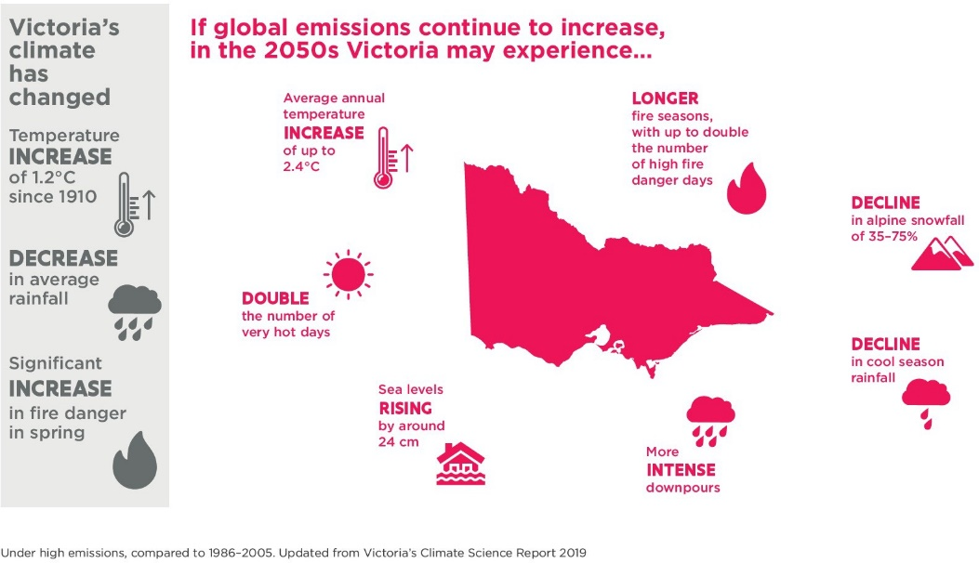

- CSIRO, Victorian Climate Projections 2019.
- Department of Environment, Land, Water and Planning, Victoria’s Climate Science Report 2019.
- Victorian Government 2021, Victoria’s Climate Change Strategy, Melbourne, Victoria.
- IPCC 2021, Intergovernmental Panel on Climate Change Report.
- CSIRO 2019, Victorian Climate Projections 2019: Technical Report, Aspendale, Australia, CSIRO Climate Science Centre, https://www. climatechange.vic.gov.au/ data/assets/pdf_file/0016/435121/Vic-Climate-Projections-2019-Technical-Report_20200218.pdf.
- CSIRO 2019, Victorian Climate Projections 2019: Technical Report, Aspendale, Australia, CSIRO Climate Science Centre, https://www. climatechange.vic.gov.au/ data/assets/pdf_file/0016/435121/Vic-Climate-Projections-2019-Technical-Report_20200218.pdf.

CLIMATE CHANGE IMPACTS ON THE TRANSPORT SYSTEM
Climate change has the potential to impact all aspects of the Transport system’s operations, maintenance and construction, causing:
- harm to assets
- disruption of transport services, operations, maintenance and construction
- disrupted access
- health and wellbeing issues for transport workers and discomfort for users
- increased public safety hazards.
The Department of Transport has been factoring climate
change into its construction, operations and maintenance activities, including action to:
- design assets for the long term, ensuring they are fit- for-purpose and resilient to withstand degrading forces, including climate impacts
- apply adaptation-based standards and policies to asset planning and design, construction, operations and maintenance
- establish emergency management plans to, where possible, prevent, prepare for, respond to and recover from events and emergencies, including climate events
- assign asset management priorities according to each
asset’s level of service (that is, their importance, monetary value, community value and level of use).
Port agencies have also been designing infrastructure and factoring climate change consequences into port operations, maintenance and long-term planning.
Transport assets have long lifecycles, and major
project agencies have been considering climate change in project design, planning,
construction and maintenance for many years.

SPOTLIGHT ON CLIMATE CHANGE IMPACTS

Major transport infrastructure projects and climate change planning
For example, for the Mordialloc Freeway project, the Major Transport Infrastructure Authority (MTIA) and Melbourne Water worked together to build climate change scenarios into the project’s flood and drainage models, standards and design outputs. This approach is business-as-usual for transport projects and for agencies responsible for drainage, catchment and flood management.

Cost of climate-related incidents: why we need to be better prepared
Road and rail climate-related incidents cost VicRoads and PTV around $220 million (including insurance claims) between 2004 and 2020. Flood damage accounted for about 80% ($176 million) of the total cost (Figure 4), mostly due to 2011 flooding. Bushfire-related costs ($37 million) made up most of the balance– 17% of the total cost. Landslides, storms and wind accounted for about 3% of the total costs.
The Transport system, as these figures demonstrate, already incurs significant costs (and maintenance requirements) as a direct result of climate-related events. Preparing for, and adapting to, a future where climate-related events and costs are likely to be higher is essential. Making informed decisions on Transport system preparation and planning is vital to ensuring that this system supports government responses to (and recoveries from) climate-related events likely to be exacerbated by climate change.

Figure 4. Key hazards, vulnerabilities and risks for the Transport system (DoT analysis)

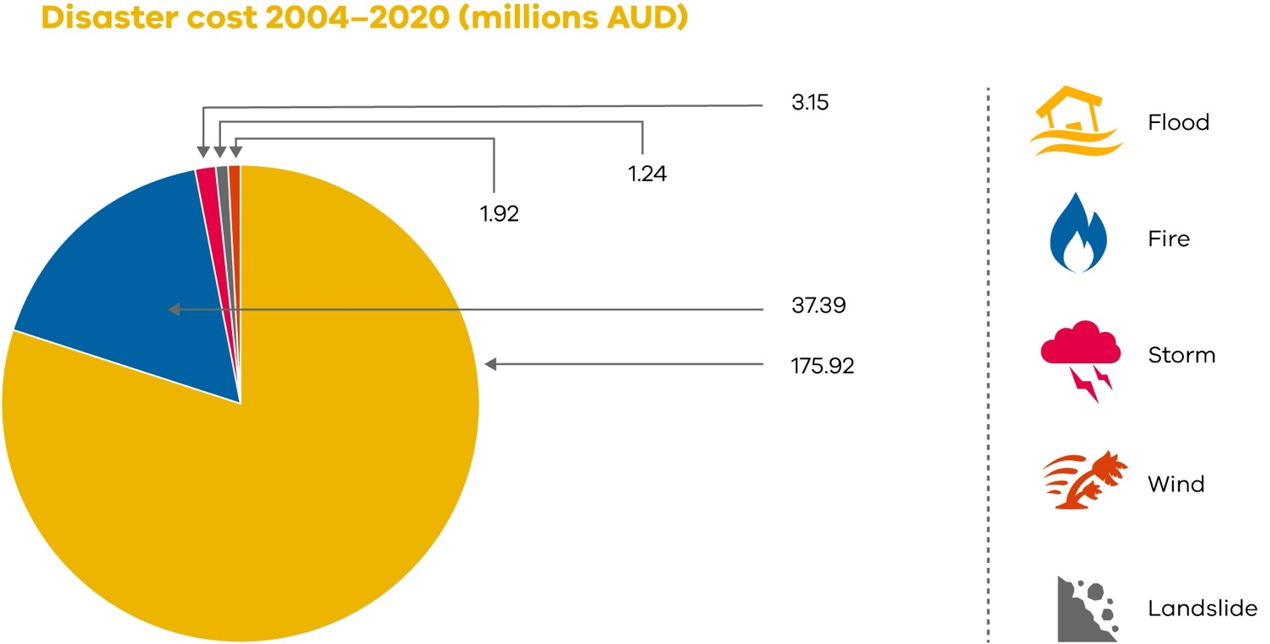

TRANSPORT SYSTEM PROJECTED IMPACTS AND ADAPTATION ACTIONS – EVIDENCE BASE
The Department of Environment, Land, Water and Planning (DELWP) partnered with CSIRO to produce
local-scale projections for Victoria. The Victorian Climate Projections 2019 cover
two emissions pathways
– medium emissions and high emissions – out to the 2090s, providing a range of possible future climates to inform the Transport system’s
adaptation planning. For more
information on the emissions scenarios, see the Victorian Climate Projections emissions scenarios fact sheets.
Ensuring that the Transport system can withstand the potential impacts of climate change under multiple climate pathways will prepare Victoria’s transport users
and providers for a range of possible climate futures. This will support Victoria’s future success, including through providing essential support to systems that are connected to and dependent on the Transport system.

4. Key climate change risks and opportunities for the Transport system

Climate change risks to the Transport system fall into three categories:
- Physical risks from climate change itself.
- Transitional risks that are a consequence of actions to mitigate or adapt to climate change.
- Cross-system risks, where climate risk affects more than one system, for example:
  - a climate risk effect on one system that has a consequent effect on another system
  - the response to a climate risk on one system that has a consequent effect on another system.
Climate change may also deliver potential opportunities for the Transport system.
A high-level summary of anticipated risks and
opportunities is provided in Appendix 4.

Existing climate change adaptation policies, programs and projects, and gap analysis

There are a number of transport policies and programs relevant to climate change adaptation or climate risk management.
Many policies would benefit from either being reviewed, updated or consolidated, particularly those that are historical, and have not sufficiently referred to, or considered adaptation.
Action 2 proposed in this plan is designed to address existing
policy gaps and strengthen the transport governance framework to facilitate planning and decision making through:
- incorporating evidence- based climate science, and engineering, environmental, social and economic analyses into policies and plans
- reviewing policies, risk assessment and decision- making processes
- consolidating existing processes, tools, skills and knowledge, and utilising the DELWP Climate Futures Toolkit when preparing and reviewing plans and policies.

SPOTLIGHT: CASE STUDY
For example, Transport system Emergency Management frameworks are continuously updated against guidelines to ensure compliance with the National Disaster Risk Reduction Framework (NDRRF), State Emergency Management Plan (SEMP), Victoria’s Preparedness Framework and other key guidance.

Transport system climate change adaptation actions: 5-year plan

The Transport system’s proposed adaptation actions for 2022–26 collectively support the Transport system’s short-term climate change adaptation objective: to
build knowledge, capacity, capability and decision-making processes. These proposed actions will establish a solid foundation for us to progress and to meet our medium- and long-term objectives.

STRATEGY FOR ACTION
The 15 high-level actions proposed are aligned with Victoria’s Climate Change Strategy’s 3 priority focus areas for 2026, to:
- address the current impacts of climate change on Victoria
- reduce barriers to climate change adaptation
- lay the foundations for transformational adaptation.
The 15 actions also align with the strategy’s 4 key enablers:
- capacity building and partnerships
- governance and strategic planning
- sustainable adaptation finance
- leadership and innovation.

PRIORITY 1. ADDRESS CURRENT CLIMATE CHANGE IMPACTS

ENABLER 1. BUILD CAPABILITY
ACTION 1. Collaborate with transport agencies and industry partners to identify opportunities that build Victoria’s capability to better respond to and restore transport services and infrastructure after climate change incidents, focusing on actions to:
- ensure preparedness for all emergencies, including bushfires, floods, and other climate events, by better understanding and planning for resource needs (trained staff and ensure preparedness for all emergencies, infrastructure needs, such as road warning signage)
- build in support for all transport workers and users, including those in regional, rural and remote communities and vulnerable and disadvantaged community members, to continue to access transport services or alternative transport services and provide appropriate levels of occupational health and safety under different climate conditions
- ensure that lessons learnt are used to inform future emergency preparedness and to review current practices.
What this will look like
  - A more proactive and planned approach to emergency management, to:
- increase coordination with local government and emergency management partners, transport operators, other State Government departments, water, catchment management and energy authorities, the State Emergency Service, fire authorities and Traditional Owners, to help restore and recover impacted services on a case-by-case basis
- incorporate the DoT Emergency Management Framework and Plan 2020 to better plan for emergencies
- include emergency management as a priority in risk assessments and identification of emerging risks
- ensure clear chains of command during emergencies
- support Emergency Management Victoria in planning and implementing safe routes for evacuations during climate-related emergencies
- inform emergency management by mapping and assessment of local bridges and roads to evaluate their ability to carry heavy or wide emergency vehicles or evacuate people and their pets if major road access is interrupted during an emergency
- reconsider options for single-road access to remote towns, particularly coastal settlements, forested and mountain areas
- ensure safe access to maintain and operate marine navigation aids or plan for the appropriate deployment of water transport assets in emergency rescue operations.
  - An increased focus on the needs of all passengers during emergencies and in particular, vulnerable communities, during climate events, to:
- understand the needs of different vulnerable communities and their transport needs during emergencies but also under different climate conditions
- prioritise care for vulnerable communities affected by disruption to transport services by, for example, providing shade, shelter and drinking water and unlocking toilet facilities for stranded passengers
- build on, and learn from, actions already underway to assist all passengers, but particularly vulnerable passengers, during different climate events, such as:
  - Metro Trains Melbourne is working with Melbourne Water to provide drinking water for passengers at selected stations
  - V/Line has installed defibrillators at its 47 staffed stations (in response to heatwave events exacerbating health conditions)
- recognise the significance of cumulative impacts of climate events on health and wellbeing, particularly on vulnerable communities
- empower Aboriginal Victorians to take self- determined transport adaptation actions
(Action 12.4)
- continue to provide tourists to Victoria with equitable and safe access to the Transport system during climate emergencies and events.
  - Continue a localized approach to emergencies and to:
- identify and respond to local transport risks in conjunction with local government
- help empower local, regional, and rural communities to understand and take adaptation actions that will better prepare them for climate change incidents and emergencies.

ENABLER 2. GOVERNANCE AND STRATEGIC PLANNING
ACTION 2. Strengthen the transport portfolio adaptation planning and decision-making for transport services, assets and infrastructure.

What this will look like
2.1 Operational policies and decision- making processes that:
- adopt best-practice, evidence-based climate science and modelling
- incorporate adaptation thinking in all phases of asset and project lifecycles (including asset life, procurement, design, construction and maintenance requirements and costs, and service levels)
- incorporate climate change risk assessment into all decision making, enabling decisions to maintain levels of service, design life, and minimise whole-of-life costs.
ACTION 3. Strengthen transport assets, infrastructure and services to increase resilience to future climate change impacts.
What this will look like
  - New assets and asset upgrades (irrespective of whether those assets relate to active transport, or road, rail or ports) are better adapted to climate change emergencies because:
- adaptation has been considered as part of the design life, materials, standards and specifications
- climate change scenario modelling has been integrated into the planning phase.
  - An increased understanding by all partners involved in planning, managing, operating and repairing components of the Transport system about how to strengthen it against the impacts of climate change, including by:
- managers (at federal, state and local levels) reviewing roadside and rail reserve maintenance programs, to consider how to plan for clear and unfettered access for maintenance and upgrades and to carry out routine and emergency works expediently, with least interruption to transport
- critical infrastructure operators to better manage risks and increase resilience in all operations and long-term planning, including SEMPs, business continuity plans, audits and exercises
- commercial and local port and boating operators, emergency services and landside infrastructure managers to allow for an integrated and collaborative approach to operations, construction and maintenance
- bus and rail operators to better plan for, respond to, and facilitate alternative transport options during climate events (particularly around appropriate air conditioning, the use of older public transport vehicles during high- heat days (in excess of 36 degrees Celsius) or consider options for the provision of bicycle-compatible public transport
- managers (at state and local levels) of walking, shared and cycling paths and other recreational facilities to consider the impacts of urban heating, mitigate the heat island effect, provide clear footpath access, weather protection (either by shop canopies, shelters or tree canopies), rest areas, and potable water, as far as practicable
- road managers (at state and local levels) to reduce waiting times (and consequent exposure to weather) at signalled pedestrian crossings, as far as practicable
- rail infrastructure project managers to consider weather protection on platforms (new builds and extended platforms for high-capacity trains), where vulnerable passengers may need to wait for driver assistance to board.

ENABLER 3. SUSTAINABLE ADAPTATION FINANCE
ACTION 4. Identify, audit and understand parts of the Transport system that are at high risk, vulnerable or face greatest exposure of being impacted by potential short-term climate change; and plan to understand any insurance gaps or prioritise the protection of those transport assets, infrastructure and services.
What this will look like
4.1 Assets and infrastructure that have been assessed to identify those most exposed to climate change events in the short, medium and long term, to enable:
- transport assets at highest risk of being most impacted by climate events to be prioritised for maintenance and upgrades during the next 30 years
- increased understanding of the insurance risks for infrastructure and assets that may be vulnerable to climate change events
- consideration of the occupational health and safety of transport system workers and users with respect to climate extremes.
4.2 Where resilience and adaptation options are not economically feasible or practicable on a large scale, consider lower priority or smaller scale adaptation alternatives, including those that may facilitate green infrastructure or the maintenance of existing flora or tree canopies.

ENABLER 4. LEADERSHIP AND INNOVATION
ACTION 5. In recognising that cross-system dependencies may exacerbate climate change impacts on the Transport system (and vice versa), DoT will work across relevant systems to better understand broader cross-system risks.
What this will look like
  - Ongoing consultation with other systems to ensure an active understanding of new or emerging cross-system risks arising as a result of climate change.
  - Work with other systems to develop options and solutions for diverse and complex cross-system dependencies, arising from transport infrastructure, assets and services impacted by climate events, including:
- impacts on freight, food supply and supply chains, including the health and safety of livestock and the safe transport of perishable goods and medical supplies
- impacts on physical and mental health (including cumulative impacts).

PRIORITY 2. REDUCE BARRIERS TO ACTION

ENABLER 1. BUILD CAPABILITY
ACTION 6. Develop the capability and capacity of staff across the transport portfolio to build in adaptation considerations and options when planning, building, restoring, and maintaining transport assets and infrastructure and to integrate the cost benefits of adaptative solutions.
What this will look like
6.1 Staff across the transport portfolio:
- aim to have an increased understanding of adaptation options for transport projects, including retreat and nature-based solutions, the cost benefits of having a resilient Transport system, alongside having an increased understanding of maladaptation and mitigation
- may undertake training modules relating to climate change, adaptation (as well as mitigation and maladaptation)
- where relevant, will build adaptation into their staff performance as a technical and decision-making skill
- where relevant, will undertake Rail Academy and Signals training (adjusted to include climate change and adaptation modules)
- where relevant, will undertake region-specific training on key area risks, such as coastal climate issues that may impact transport assets, infrastructure and services.

ENABLER 2. GOVERNANCE AND STRATEGIC PLANNING
ACTION 7. Map climate change projection data against the Victorian Transport system to identify priority actions.

What this will look like
  - High-risk assets and processes (including active transport, road, rail and port assets) are assessed to prioritise asset-by-asset response and action, informed by statewide mapping that informs emergency management planning, preparedness, response and recovery.
  - Risk analyses and asset mapping against climate change risks enable the transport portfolio to prioritise assets requiring priority treatment or maintenance to ensure that they are fit-for-purpose under climate change, informed by:
- criteria to evaluate and prioritise climate change impacts
- an evaluation of the strengths and weaknesses in the Transport system
- comparison of data to identify and prioritise areas of transport infrastructure that have known areas of vulnerability, and the greatest potential risk of negative climate change impacts.
  - Risk analyses and mapping enable the transport portfolio to understand the parts of the system that are more vulnerable to climate change events, and, in that respect:
- consider linkages between transport modes and services included in vulnerability assessments
- understand where the greatest vulnerabilities exist in the system, particularly for:
  - moving passengers, and in particular, vulnerable communities
  - occupational health and safety risks for transport workers
  - materials used that may reduce or increase vulnerability (for example, permeable materials)
- identify parts of the system that may be vulnerable as a result of built infrastructure being damaged by climate change events (such as overhead wiring damaged by extreme heat)
- identify threats to key coastal and riverine paths from increased flooding and sea level rises
- identify risks to the Transport system associated with changes in soil moisture. This may include mapping underground water movement.
ACTION 8. Analyse the current approaches, gaps and barriers to adaptation planning in transport policies, plans and procedures, by stress-testing them against climate scenarios and identifying opportunities to incorporate adaptive practices, planning and principles, consistent with the most-up-to-date science for Victoria.

What this will look like
8.1 The DELWP Victoria’s Future Climate Tool is used to:
- increase the transport portfolio’s general understanding of the physical risks of climate change to transport planning and activities
- prepare transport plans, policies, processes and practices to ensure that climate change scenarios are taken into account, where practicable
- collate data on all aspects of the transport system to facilitate climate change adaptation planning.

ENABLER 3. SUSTAINABLE FINANCE FOR ADAPTATION ACTIONS
ACTION 9. Facilitate emerging and innovative technologies, market responses and funding models that may provide effective adaptation solutions for the Transport system.
What this will look like
  - Cost-benefit analysis is undertaken of new and emerging adaptation options and measured against service levels, asset life and whole-of-project-life costs.
  - Use technologies that can assess adaptive options for the transport industry and transport projects for the whole-of-project lifecycle.
  - Where relevant, prioritise and support community engagement using co-design principles and locally-led delivery of new adaptation options.

ENABLER 4. LEADERSHIP AND INNOVATION
ACTION 10. Support governance structures that facilitate knowledge-sharing with transport leaders across transport network interfaces and better support learning and collaboration regarding adaptation actions.

What this will look like
  - Ongoing knowledge sharing with critical infrastructure transport operators through the Transport Sector Resilience Network (TSRN).
  - Increased knowledge sharing across the transport portfolio through a DoT Climate Change Adaptation Case Study Register that consolidates existing case studies and lessons learnt about adaptation options for transport projects.
ACTION 11. Take a broader view, during decision making, of environmental impacts. This includes: considering emissions reduction actions being pursued by the department; and enabling the adjustment of adaptation actions in response to emissions reduction measures.

What this will look like
  - Adaptation actions are seen as part of the bigger Climate Change Strategy picture and sit alongside priorities identified under the whole-of-Victorian Government pledge.
  - Climate change impacts and how those impacts will affect the resilience of infrastructure and assets are considered in all design, maintenance and construction contracts.

PRIORITY 3. LAY THE FOUNDATIONS FOR TRANSFORMATIONAL CHANGE ENABLER 1. BUILD CAPABILITY
ACTION 12. Consult and collaborate with transport regions to understand their work on the needs of local communities, including vulnerable and Aboriginal communities, to identify and understand adaptation priorities for local areas and regions and empower them to pursue adaptation actions for their communities.
What this will look like
  - Vulnerable communities are supported to develop community resilience plans.
  - Regional adaptation strategies will help guide actions in regional communities.
  - Adaptation actions are considerate of the need to reduce barriers to safe accessible journeys, which is actively considered in developing and implementing adaptation actions, guided by the Accessible Public Transport in Victoria Action Plan 2020– 2024 and its principles of:
- accessible transport and services
- valuing confidence and inclusion
- eliminating discrimination.
  - DoT and its transport agencies will implement the adaptation actions consistent with the 2020–2023 Transport Portfolio Aboriginal Self-Determination Plan: Whole of Country, Whole of Transport that embeds Aboriginal self-determination guiding principles in delivering better outcomes, and acknowledges:
- Victoria’s Aboriginal people and their ongoing strength in practising the world’s oldest living culture and managing the lands and waters on which we live and work
- the use of Song Lines as an integral part of Aboriginal Culture that allowed them to easily connect their journeys; Song Lines’ cultural significance as trade routes and ceremonial paths – and that some transport networks and assets are on those traditional Song Line routes
- the responsibility to transform the Transport system and service delivery so that Aboriginal Victorians can hold decision- making power on matters affecting their lives
- the fundamental human right for Aboriginal self-determination, enshrined in the United Nations Declaration on the Rights of Indigenous Peoples 2007

ENABLER 2. GOVERNANCE AND STRATEGIC PLANNING
ACTION 13. Monitor, review and evaluate adaptation actions being undertaken across the Transport system.
What this will look like
  - An implementation plan that supports the monitoring, review and evaluation of the adaptation actions outlined in this plan.
  - A DoT Risk Register that incorporates environmental and climate change risks.
  - An ongoing partnership with DELWP to:
- consider energy reliability in its risk assessments and actions development
- seek advice on energy reliability issues and standards for consideration when assessing risks and developing actions
- ensure safe and reliable operation of the energy system across the Transport system
- improve energy efficiency and ensure reliability of supply across the system
- plan for energy resilience.

ENABLER 3. SUSTAINABLE FINANCE FOR ADAPTATION ACTIONS
ACTION 14. Consider how to better incorporate and budget for climate resilience throughout the lifecycle of transport assets and infrastructure, including during renewal and maintenance activities.
What this will look like
14.1 Working with the Department of Treasury and Finance as whole-of-Victorian-Government lead to develop ways to better embed climate change considerations in procurement, business cases, tender processes and life cycle planning.

ENABLER 4. LEADERSHIP AND INNOVATION
ACTION 15. Learn from global best practice and support trials and pilot projects (existing and new) that test adaptation solutions, to facilitate learning and understanding of new adaptive approaches or technologies that could be beneficial for the Transport system.
What this will look like
  - Prioritise adaptation trials and projects relating to nature-based solutions and green infrastructure, thereby potentially reducing urban heat island effects that exacerbate climate change impacts and deliver additional environmental benefits.
  - Consider new technologies and methods for restoring transport infrastructure after damage caused by climate events to increase future resilience.
  - Support innovative trials of technology that enable the Transport system to adapt more quickly, while monitoring cross-dependencies and unintended issues.
  - Test, monitor and evaluate trials and pilot projects (existing and new) for their ability to withstand climate events, and facilitate adaptive Transport system infrastructure, assets and services.

6.2 MONITORING, EVALUATION, REPORTING AND IMPROVEMENT
All proposed actions were agreed to after extensive consultation and review.
Detailed decisions about the actions’ implementation (including monitoring, evaluation and reporting) and timing will be made in line with usual government policy and budget processes.

Appendices

APPENDIX 1: KEY TERMS AND ACRONYMS

Table 3. Glossary of terms used in this plan
Term Definition
Adaptation Changes made in response to the anticipated threats and opportunities arising from climate change. Adaptation measures Actions intended to reduce impact of threats or to exploit opportunities arising from climate change.
Adaptive capacity Ability of the Transport system to respond to climate change, to moderate potential damages, take advantage of opportunities, or cope with consequences.
Assets Something that has actual or potential value to the Transport system.

Climate Average weather based on the statistical description in terms of the mean and variability of relevant quantities, such as temperature, precipitation and wind, over an extended period of time.

Climate change A statistically significant variation in either the mean state of the climate or its variability, persisting for an extended period (typically, decades or longer).
Climate scenario Coherent description of a possible future state of the climate. Climate change scenario Difference between a climate scenario and the current climate.
Co-benefits An additional benefit from an action that is undertaken to achieve a particular purpose that is not directly related to that purpose.

Communication and consultation
Processes that an organisation conducts to provide, share or obtain information and to engage in dialogue with stakeholders and others regarding the management of risk.

Community engagement Communication and consultation focused on local communities. Consequence Outcome of an event affecting objectives.
Contingency plan Any plan of action that allows an organisation to respond to events should they occur. Control Measure that is modifying risk.
Drivers of change New climate information; triggers and signals; social, cultural and economic change.

Emergency management The process of planning and preparing for, responding to and recovering from emergencies, which could be bushfires or floods.

Emissions In the context of this AAP, emissions means greenhouse gases such as carbon dioxide and nitrous oxide that are produced by human activity and contribute to climate change.
Event Occurrence or change of a particular set of circumstances.

Extreme weather event Weather phenomena that are at the extremes of the historical distribution, including especially severe or unseasonal weather.

Flexible / reversible actions Actions that can be easily retrofitted or upgraded.

Governance The framework of rules, relationships, systems and processes by which an enterprise is directed, controlled and held to account, and whereby authority within an organisation is exercised and maintained.

Green infrastructure The network of natural and built landscape assets, including green spaces and water systems (sometimes referred to as blue infrastructure) within and between settlements.
Hazard A situation that has the potential to cause loss of service from a system or damage to people or assets.

Impact A threat or an opportunity that may arise as a result of either the weather or climate change, both in the short and long term, and represents the fact that an issue is one that is constantly evolving.

Infrastructure Assets or systems of assets that support our society.

Lifecycle Time interval that commences with the identification of the need for an asset and terminates with the decommissioning of the asset or any associated liabilities.

Likelihood Chance of something happening.

Monitoring Continual checking, supervising, critically observing or determining the status in order to identify change from the performance level required or expected.

Natural variability The degree to which climate varies from day to day or year to year in the absence of long-term climate change.
No regrets actions Actions that have no net costs even in the absence of climate change. Outcome The way a thing turns out.

Pathways Scenarios that describe how global society and hence greenhouse gas emissions may change in the future. Physical risks Risk of actual harm to assets due to climate change.
Resilience Adaptive capacity of an individual, community or organisation in a complex and changing environment.

Retreat Large-scale relocation of infrastructure or settlement away from a hazard, such as removing housing from coastal areas subject to sea level rise.

Review Activity undertaken to determine the suitability, adequacy and effectiveness of the subject matter to achieve established objectives.
Risk Effect of uncertainty on objectives.

Risk assessment Overall process of identifying, analysing and evaluating risk.

Safety margin Degree to which a system is designed to cope with greater than the anticipated full extent of stressors.

Stakeholder Person or organisation that can affect, be affected by, or perceive themselves to be affected by a decision or activity.

Acronym |  | Definition
 | AAP |  | Adaptation Action Plan
 | CSIRO |  | Commonwealth Scientific and Industrial Research Organisation
 | DELWP |  | Department of Environment, Land, Water and Planning
 | DoT |  | Department of Transport
 | DTF |  | Department of Treasury and Finance
 | MTIA |  | Major Transport Infrastructure Authority
 | NDRRF |  | National Disaster Risk Reduction Framework
 | RAS |  | Regional Adaptation Strategy
 | TSRN |  | Transport Sector Resilience Network
 | SEMP |  | State Emergency Management Plan
System The 7 systems listed in the Climate Change Act (including the Transport system). Transitional risks Risks that are created as a result of action to mitigate or adapt to climate change.

Table 4. Acronyms used in this plan

APPENDIX 2: DEVELOPMENT OF THE TRANSPORT SYSTEM ADAPTATION ACTIONS

‘An adaptation action plan must include … a list of further actions over the next five years that could address the statement of priorities of a climate change strategy’
– Section 35 (Climate Change Act, 2017).
Strategy for action
The 15 high-level actions proposed in this plan address 3 key priorities supported by 4 key enablers. Many of the proposed actions are already business-as-usual for the Transport system, including actions to plan and prepare for, respond to and recover from climate change impacts.
Actions target transport users, freight operators, agencies, assets and infrastructure, including networks, interchanges, vehicles, rolling stock, systems, technology, information and equipment, as well as cross-system dependencies.
These actions:
- support the Transport system to address the 5-yearly priorities in
Victoria’s Climate Change Strategy
- address additional climate change risks or
vulnerabilities identified by the Transport system in developing this plan.
The order in which the actions are presented does not reflect an order of priority.
Definition of actions
Actions developed for the Transport adaptation action plan (Section 6) include:
- direct actions that directly adapt the system or part of the system to a changing climate or directly reduce climate risk
- supporting actions that are required to support direct adaptation to occur, including activities to build adaptive capacity
- enabling actions that allow for greater adaptation
action in the future, including adaptation research and policy development.
Action requirements
As far as practicable, adaptation actions included in this plan will be completed before 2026. Actions:
- state the deliverable and intended outcome
- identify who is responsible for leading the action
- define outcome indicators to measure the success of the action
- describe any additional benefits and/or trade-offs of the adaptation action.
Adaptation best practice
Adaptation actions reflect best-practice climate change adaptation, including:
- accounting for uncertainties in future climate projections
- avoiding any unintended system or cross-system issues.
Existing policies
For more than 10 years, Victorian Government transport agencies have had policies supporting the consideration of long- term climate change in the
planning, design, construction, and operation of transport infrastructure. This plan builds on these policies.

APPENDIX 3: CONSULTATION WITH KEY STAKEHOLDERS

This plan has been informed by discussions with Transport system stakeholders and community consultation.
Transport system stakeholders included:
- transport users, including road, rail, shared path, port, boating and fishing facility users
- transport operators, maintenance and construction, including critical infrastructure transport operators
- transport asset owners, managers and funders, including the Department of Transport, local government, DELWP, Parks Victoria and Victorian Government and private infrastructure owners
- the broader transport portfolio, including transport bodies such as V/Line, Port authorities and channel managers, and peak advocacy organisations.
Throughout the life of this plan, the Department of Transport will continue to consult with key stakeholders and the community. What is learnt through future consultation will be used to review and update the specific actions within the action plan. Implementation will need to be flexible to reflect ongoing changes in
the climate, cross-system dependencies and other non- climate factors.

APPENDIX 4: RISKS AND OPPORTUNITIES

Climate change risks to the Transport system fall into 3 categories:
- Physical risks from climate change itself (Table 6).
- Transitional risks that are a consequence of actions to mitigate or adapt to climate change (Table 7).
- Cross-system risks (Table 8), where climate risk affects more than one system, for example:
  - a climate risk effect on one system has a consequent effect on another system
  - the response to a climate risk on one system has
a consequent effect on another system.
Climate change may also deliver potential opportunities for the Transport system.
A high-level summary of anticipated risks and opportunities to 2050 is presented below.

Physical risks
Table 6. Potential physical risks to the Transport system from climate change

Physical risk | Likelihood | Consequence | Risk rating
Projected increases in extreme heat events (unusually hot days | Likely | Major | High
and / or heatwaves) may disrupt or damage transport assets and
infrastructure; for example, rail tracks compromised and delays to
train services, or electrical wiring compromised and interruptions to
tram services.
Projected more intense rainfall, potentially leading to flash flooding | Moderate | Major | High
could increase damage to transport assets and infrastructure, and
disruptions to transport services; for example, increasing frequency
of flooding, potentially damaging roads and bridges.
Failure of climate change adaptation | Moderate | Major | High
Increased maintenance costs | Likely | Moderate | Medium
Projected increases in risk of bushfires that could increase damage | Likely | Major | High
to transport assets and infrastructure.
Projected rising sea levels and increased risk of coastal inundation | Likely | Major | High
and erosion may cause damage to coastal transport assets and
infrastructure such as roads.

Transitional risks
Table 7. Possible Transport system transitional climate-change risks

Transitional risk | Likelihood | Consequence | Risk rating
Failure to meet decarbonisation objectives | Moderate | Major | High
Rapid mode-shift overwhelming the public transport (PT) system | Unlikely | Moderate | Medium
Investment in stranded assets such as diesel/petrol buses | Likely | Moderate | Medium
Investing in long-term high capital expenditure infrastructure that is outmoded by climate change at completion | Moderate | Moderate | Medium
Failure to provide, or mistimed provision of, PT services to major precinct (re)developments | Unlikely | Moderate | Medium
Inequitable costs to low socio-economic transport-dependent groups | Moderate | Moderate | Medium
Transport infrastructure Business Case development impacted, with over- investment in roads | Unlikely | Moderate | Medium
Skills shortage to service and operate new transport technologies | Moderate | Moderate | Medium
Preference for electric vehicles, resulting in less investment in PT and increased congestion | Moderate | Minor | Medium
Decreased efficiency and relative attractiveness of buses and trams due to increased congestion | Unlikely | Minor | Low
Decreased public transport demand | Unlikely | Minor | Low
Delay of major infrastructure projects | Moderate | Moderate | Medium
Failure to use infrastructure due to inappropriate user design under a changed climate scenario | Unlikely | Minor | Low

Cross-system risks
Table 8. Possible cross-system climate-change risks

Cross-system risks | Likelihood | Consequence | Risk rating
Loss of biodiversity in road/rail reserves | Moderate | Major | High
Climate-related failure of electricity supply | Moderate | Major | High
Increased electricity prices | Moderate | Moderate | Medium
Loss of transport support for other systems | Likely | Moderate | Medium

Opportunities
Table 9. Possible Transport system climate change adaptation opportunities

Transitional risk Likelihood Consequence Risk rating

Projected reductions in rainfall may reduce need for dredging around some ports
In some locations, projected reductions in rainfall may increase active transport
Moderate Minor Beneficial

Moderate Minor Beneficial

