Audit of timber harvesting operations in Victoria’s State forests: Report of the 2022 Forest Audit Program
Document no: IS427600-03
Revision no: B.1
Department of Energy, Environment and Climate Action
CMS104990
Forest Audit Program 2022

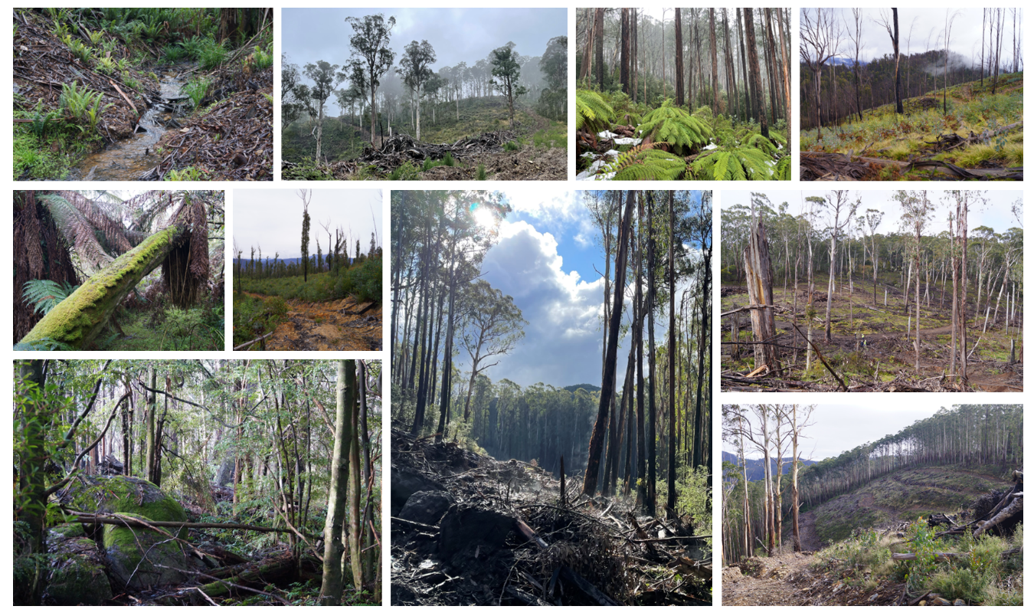

Audit of timber harvesting operations in Victoria’s State forests: Report of the 2022 Forest Audit Program
Client name: | Department of Energy, Environment and Climate Action
Project name: | Forest Audit Program 2022
Client reference: | CMS104990 | Project no: | IS427600
Document no: | IS427600-03 | Project manager: | [Project manager]
Revision no: | B.1 | Prepared by: | [Prepared by]
Date: | 31/3/2023 | File name: | is427600-03 forest audit program 2022-revB.1_clean
Document history and status
Revision | Date | Description | Author | Checked | Reviewed | Approved
A | 06/12/22 | Draft for review & comment
B | 31/3/23 | Final following review by CR and VF
Distribution of copies
Revision | Issue approved | Date issued | Issued to | Comments
A |  |  | DEECA - CR, VicForests
B |  |  | DEECA - CR

Jacobs Group (Australia) Pty Limited
Floor 13, 452 Flinders Street  Melbourne, VIC 3000  PO Box 312, Flinders Lane  Melbourne, VIC 8009  Australia | T +61 3 8668 3000  F +61 3 8668 3001  www.jacobs.com
Copyright Jacobs Group (Australia) Pty Limited © 2023.
All rights reserved. The concepts and information contained in this document are the property of the Jacobs group of companies. Use or copying of this document in whole or in part without the written permission of Jacobs constitutes an infringement of copyright. Jacobs, the Jacobs logo, and all other Jacobs trademarks are the property of Jacobs.
NOTICE: This document has been prepared exclusively for the use and benefit of Jacobs’ client. Jacobs accepts no liability or responsibility for any use or reliance upon this document by any third party.

Executive summary

Audit scope and objectives
This report documents the methods, results, findings and recommendations of an environmental audit of timber harvesting operations in Victoria’s State forests. Jacobs Group (Australia) Pty Ltd (Jacobs) was commissioned by the Department of Energy, Environment and Climate Action (DEECA) to deliver the audit, as part of its Forest Audit Program (FAP). The audit addresses mandatory compliance elements from the Code of Practice for Timber Production (the Code) and the Management Standards and Procedures for Timber Harvesting Operations in Victoria’s State forests (the MSPs).
The FAP has been in operation since 2002 and has been managed by DEECA since 2010. The audit is commissioned by the Timber Harvesting Compliance Unit (THCU), within DEECA’s Conservation Regulator. FAP audits are designed to assess conformance with the regulatory framework for timber harvesting operations in State forests and identify and assess any risk of harm non-conformances pose to the environment. The FAP plays an important role in the continuous improvement in sustainable forest management within Victoria’s State forests.
The specific regulatory compliance criteria that were considered in this years’ audit were selected by Conservation Regulator staff from Code mandatory actions relating to:
- Protection of soil, water and river health values
- Conservation of biodiversity
- Operational planning and record-keeping
- Coupe infrastructure for timber harvesting operations.
Conformance with the regulatory framework was assessed for 32 coupes listed in VicForests’ Timber Release Plan (TRP) in the Central Highlands, East Gippsland, Gippsland and North East Regional Forest Agreement (RFA) regions (Figure ES-1) and with harvesting activity reported in 2020-21. Four of the coupes in the Central Highlands RFA region were located in Melbourne Water catchment areas.
Figure ES-1. Location of target coupes for 2022 FAP

Audit approach
Prospective coupes for the audit were selected using a risk-based procedure that emphasised coupes with: waterway crossings; long lengths of in-coupe road; steep slopes; more erosive soils; rainforest vegetation in close proximity; presence of threatened flora and/or fauna; Special Protection or Special Management Zones (SPZ and SMZ respectively) in close proximity.
As coupe selection was risk-based rather than fully randomised, the findings of this audit cannot be taken as being statistically representative of VicForests’ operations overall.
Compliance criteria considered in the audit drew on mandatory requirements of the Code and related clauses of the MSPs. Audits of individual coupes considered up to 171 compliance criteria. An audit workbook was completed for each coupe, based on observations by the audit team and their review of VicForests’ Forest Coupe Plan (FCP) and related coupe planning information. Where instances of non-conformance with the regulatory framework were detected, their potential environmental impact was assessed using the FAP’s environmental impact assessment (EIA) tool. Field assessments for the audit were undertaken in June, July and October 2022.
VicForests personnel accompanied the audit team on all coupe assessments. This enabled useful discussions about planning and management practices, applicable elements of the regulatory framework and any non-conformances that were observed.

Audit findings
The overall level of full conformance with applicable audit criteria across the 32 coupes ranged between 87% and 100%, with the average being 96%. Non-conformance incidents in 20 of the 32 coupes included in the audit were assessed to have the potential for environmental impact. There was an average of 1.4 such incidents per coupe, with as many as six incidents recorded (in one coupe). The assessed level of potential environmental impact associated with these incidents ranged between negligible and major, with moderate being the most common rating.
Audit criteria were grouped into four themes and several sub-themes. A summary of audit results against each theme and sub-theme is given below:
- Environment: compliance criteria focus on the protection of soil and water values. The average level of full conformance with applicable audit criteria was:
  - Forest soils: 95% of applicable criteria
  - Water flows, water quality and river health: 94% of applicable criteria.
The potential environmental impact associated with non-conformance incidents ranged up to major for both sub-themes. Incidents with major potential environmental impact were all linked to defective waterway crossings.
- Conservation of biodiversity: the average level of conformance for applicable criteria addressing biodiversity conservation was 96%. Incidents resulting from non-conformance were assessed to have potential environmental impacts ranging up to major. These posed risks to either terrestrial or aquatic biodiversity values and related to a small incursion into a Leadbeaters Possum special protection zone (SPZ) and defective waterway crossings, respectively.
- Operational planning and record-keeping: the average level of conformance for applicable criteria addressing operational planning and record-keeping was 97%. Non-conformance incidents for this theme that were assessed to have potential environmental impact typically resulted from failure to properly implement coupe planning. Potential environmental impacts of non-conformances ranged up to major.
- Coupe infrastructure: criteria focus on measures to protect soil and water (particularly) from effects associated with roading, snig tracks, landings and other coupe infrastructure. Four sub-themes were identified:
  - In-coupe road design: the average level of full conformance was 96% of applicable criteria.
  - In-coupe road construction: the average level of full conformance was 93% of applicable criteria
  - Maintenance and closure of in-coupe roads and waterway crossings: the average level of full conformance was 99% of applicable criteria
  - Other infrastructure (i.e., snig tracks, landings, boundary tracks): the average level of full conformance was 96% of applicable criteria.
Potential environmental impacts for non-conformance incidents ranged up to major for all sub-themes apart from maintenance and closure. Incidents with major potential environmental impact related to defective in-coupe road or snig track waterway crossings.
Other incident types with lesser potential environmental impact were observed in this audit. Many of these have been observed in multiple coupes in recent audits, including:
- Incursion of regeneration burns into buffers, habitat islands or other areas that were planned to be protected from timber harvesting and regeneration activities
- Excessive spacing (relative to slope and soil erosion hazard) between effective cross-drainage structures on in-coupe roads, and snig and boundary tracks
- Formation of bark and debris piles whose ground area and volume exceed those specified in the MSPs.

Recommendations
Findings of this audit and reflections on previous audits have led to several recommendations from the audit team to VicForests and DEECA (Table ES.1). These cover:
- Potential improvements in the management of timber harvesting operations
- Operation of the FAP
- Victoria’s timber harvesting regulatory framework.
Table ES-1 Recommendations of the 2020-21 Forest Audit Program
Recommendations for VicForests
V-01 High priority: That VicForests retain records of the full search effort, using surveys and habitat modelling, to identify threatened species that may be present within a coupe or may be affected by nearby harvesting activities.
V-02 High priority: That VicForests develop and implement an initiative to improve the quality and consistency of waterway crossing design, construction, maintenance and rehabilitation, addressing both in-coupe road and snig track crossings
V-03 Medium priority: That the data VicForests’ provide to DEECA to assist in audit target selection is based on actual rather than planned coupe conditions. Maximum coupe slope and the presence of modelled rainforest within the coupe rather than within 500 m of it are reported
Recommendations for DEECA
D-01 Moderate priority: That DEECA review MSP fire salvage prescriptions and explicitly define how soil erosion hazard is to be treated in fire salvage coupes.
D-02 Medium priority: That DEECA review and reconsider ground area and volumetric limits on bark and slash piles (currently 4 m² and 10 m³, respectively; MSP 7.2.4.2).
D-03 High priority: That DEECA review snig track crossing “design”, operational and rehabilitation requirements and develop new and more tailored management prescriptions.

Contents
Executive summary i
Audit scope and objectives i
Audit approach i
Audit findings ii
Recommendations iii
Glossary viii
1. Introduction 1
1.1 Sustainable Forest Management in Victoria 1
1.2 Forest Audit Program 2
1.3 About this report 2
2. Audit scope 4
2.1 Audit objectives 4
2.2 Audit scope 4
2.3 Audit timing 5
2.4 Audit team 6
3. Audit approach 7
3.1 Coupe selection 7
3.2 Audit criteria and workbook 10
3.3 Field assessments 10
3.4 Environmental impact assessment 12
4. Audit results 14
4.1 Overall compliance findings 14
4.2 Environmental compliance theme 15
4.2.1 Compliance elements related to the protection of forest soils 15
4.2.2 Compliance elements related to the protection of water flows, water quality and river health 17
4.3 Conservation of biodiversity 19
4.4 Operational planning and record-keeping 21
4.5 Coupe infrastructure for harvesting operations 22
4.5.1 Compliance elements related to in-coupe road and waterway crossing design 23
4.5.2 Compliance elements related to in-coupe road and waterway crossing construction 23
4.5.3 Compliance elements related to in-coupe road and waterway crossing maintenance and closure 24
4.5.4 Compliance elements related to non-road infrastructure compliance theme 25
5. Discussion 27
5.1 Overall audit findings 27
5.1.1 Conformance with audit criteria and potential environmental impact 27
5.1.2 Incidents resulting in non-conformances with audit criteria 28
5.2 Comparison with previous audits 31
5.3 Fire salvage harvesting 35
5.4 Precautionary principle 36
5.4.1 Preharvest flora and fauna surveys 36
5.4.2 Application of habitat distribution models 37
5.4.3 Management responses 37
5.4.4 Application of precautionary principle 37
5.5 Potential improvements in coupe planning, harvesting and rehabilitation practices 40
5.5.1 Coupe planning 40
5.5.2 Design, construction and maintenance of waterway crossings 40
5.5.3 In-coupe road and snig track drainage 42
5.5.4 Snig tracks through wet areas 42
5.5.5 Landing rehabilitation 43
5.6 Potential improvements to the regulatory framework for timber harvesting 44
5.7 Improvements in the Forest Audit Program 45
6. Conclusions and recommendations 46
6.1 Conclusions 46
Overall conformance findings 46
Protection of soil, water and river health values 46
Conservation of biodiversity 46
Operational planning and record keeping 46
Coupe infrastructure for harvesting operations 47
Comparison with previous audits 47
Fire salvage harvesting 47
Application of the precautionary principle 47
6.2 Recommendations 48
Recommendations for VicForests 48
Recommendations for DEECA 49
7. References 50
Spatial data sources: 50
Limitation statement 51

Appendices
Appendix A. Audit compliance elements 52
Appendix B. Environment impact assessment tool 70
B.1 Extent and location of impact 70
B.2 Extent and duration of recovery 71
B.3 Asset 71
B.4 Overall environmental risk 72
Appendix C. Incidents leading to assessments of non-conformance with audit criteria and the regulatory framework for timber harvesting 73
Appendix D. VicForests’ substantive comments on the draft audit report 76

Tables
Table 3-1. Summary of audit targets by Regional Forest Agreement area and Forest Management Area 7
Table 3-2. Location and characteristics of coupes included in 2022 Forest Audit Program audits 8
Table 3-3. Descriptors used to assess conformance with audit criteria 10
Table 3-4. Field assessment methods for 2022 Forest Audit Program 10
Table 5-1. Numbers of incidents resulting in non-conformances with audit criteria 28
Table 5-2. Types of incident resulting in non-conformances with the regulatory framework that have potential or actual environmental impact, including comparison with 2019-20 and 2020-21 FAP audits (Jacobs, 2020; Jacobs,2021) 28
Table 5-3. Comparison of results for recent Forest Audit Program Audits: Central Highlands RFA region coupes only 33
Table 5-4. Comparison of results for recent Forest Audit Program Audits: all coupes in eastern Victorian RFA regions 34
Table 5-5. Application of precautionary principle to coupes in East Gippsland FMA 38
Table B-1 70
Extent and location of impact assessment criteria and scoring 70
Table B-2. Assessment of the duration and extent of recovery 71
Table B.3 Asset or value significance score 71
Table B.4 Ranking of EIA scores 72
Table C-1. Summary of incidents resulting in non-conformances with potential or actual environmental impact 73
Table D-1 VicForests substantive comments on the draft 2022 FAP audit reports and audit team’s responses 76

Figures
Figure 2-1. Locations of coupes included in 2022 Forest Audit Program, with references to Victorian Forest Management Areas (FMA; green text and boundaries) and Regional Forest Agreement (RFA; blue text and boundaries) regions. Sources: ESRI, DEECA. 5
Figure 4-1. Overall compliance findings and assessed environmental impact for instances of non-conformance for harvest coupes. The x-axis refers to the coupe numbers, as per Table 3-1. 14
Figure 4-2. Compliance findings and assessed environmental impact for instances of non-conformance for criteria applicable to the protection of forest soils. The x-axis refers to the coupe numbers, as per Table 3-1. 16
Figure 4-3. Defects on waterway crossing at 02 Dragonfly leading to mobilisation of sediment into permanent stream. 16
Figure 4-4. Defects on waterway crossing at 07 Lemon Lime leading to mobilisation of road and fill batter sediment into a temporary stream 17
Figure 4-5. Compliance findings and assessed environmental impact for instances of non-conformance for criteria applicable to the protection of water quality, flows and river health. The x-axis refers to the coupe numbers, as per Table 3-1. 18
Figure 4-6. In-coupe road drainage onto the waterway crossing on the approach to 24 Bayled Up is allowed to drain directly across the fill batter and has mobilised batter sediments into the permanent stream. 18
Figure 4-7. Examples of outlets of waterway crossing culverts being elevated above the downstream bed of temporary stream, potentially blocking aquatic fauna movement and contributing to erosion and sediment mobilisation. 19
Figure 4-8. Drainage along the in-coupe road at 18 South Buck runs for significantly greater than 20 m into a temporary stream (highlighted by yellow arrows). Photograph on the right shows evidence of sediment deposition. 19
Figure 4-9. Compliance findings and assessed environmental impact for instances of non-conformance for criteria applicable to the protection of biodiversity values. The x-axis refers to the coupe numbers, as per Table 3-1. 20
Figure 4-10. Incursion of harvesting into Leadbeaters Possum SPZ at 10 Amity Island 21
Figure 4-11. Incursion of regeneration burn at 01 Turnbuckle into retained vegetation patches. The regeneration burn did not scorch the crowns of retained trees but destroy retained understorey vegetation. 21
Figure 4-12. Compliance findings and assessed environmental impact for instances of non-conformance for criteria applicable to coupe planning and management. The x-axis refers to the coupe numbers, as per Table 3-1. 22
Figure 4-13. Compliance findings and assessed environmental impact for instances of non-conformance for criteria applicable to the road design. The x-axis refers to the coupe numbers, as per Table 3-1. 23
Figure 4-14. Compliance findings and assessed environmental impact for instances of non-conformance for criteria applicable to road construction. The x-axis refers to the coupe numbers, as per Table 3-1. 24
Figure 4-15. Compliance findings and assessed environmental impact for instances of non-conformance for criteria applicable to road maintenance and closure. The x-axis refers to the coupe numbers, as per Table 3-1. 25
Figure 4-16. Compliance findings and assessed environmental impact for instances of non-conformance for criteria applicable to coupe infrastructure. The x-axis refers to the coupe numbers, as per Table 3-1. 26
Figure 5-1. Summary of overall audit findings for conformance with the regulatory framework for timber harvesting and related activities in State forests in Victoria. 27
Figure 5-2. Examples where snig tracks have been constructed across wet areas in coupes (05 Whitehorse) or temporary streams (13 Jandles) that were most likely dry at the time. Subsequent wet conditions have resulted in water flowing across the tracks and mobilising sediment. 31
Figure 5-3. Compliance findings and assessed environmental impact for instances of non-conformance for fire salvage prescription criteria. The x-axis refers to the coupe numbers, as per Table 3-1. Fifteen of the 32 coupes included in the audit were subject to fire salvage prescriptions. 35
Figure 5-6 Cumulative monthly rainfall anomalies for locations “near” coupes targeted for audit. 43

Glossary
Audit criteria | Criteria used to assess whether timber harvesting and related activities are consistent with mandatory requirements of the Code and MSP.
Boundary track | Track constructed in some harvest coupes that follows the marked boundary and is often used to support the containment of regeneration burns. Some boundary tracks may be used as snig tracks. Abbreviated as BT at places in this report.
Buffer strip | A protective margin of vegetation excluded from any harvesting activity abutting a waterway or an area of rainforest or other special area, which protects it from potentially detrimental disturbances in the surrounding forest.
Code | The Code of Practice for Timber Production 2014 (revised 2021), which lists mandatory actions for timber harvesting activities in native forests and plantations in Victoria.
Conformance | Conformance with audit criteria. Activities were assessed to:  - Fully conform (or fully comply) with audit compliance element  - Not fully conform with the audit compliance element, but pose no direct risk of environmental harm  - Not fully conform with the audit compliance element and either have potential to pose a risk of harm to the environment or cause observable environmental harm. The severity of risk or actual harm is assessed using the FAP’s environmental impact assessment (EIA) rating tool (Appendix B).
CR | Conservation Regulator, an office within DEECA that administers the regulatory framework for timber harvesting in State forests.
Cording | Log material (>15 cm diameter) placed in a corduroy fashion on landings and snig tracks to distribute loading over a greater area and reduce soil disturbance. Cording is typically accompanied by matting, which is bark or head material that is used to cover cording on snig tracks and landings.
Coupe | An individual management unit within forests and plantations where timber harvesting or thinning activities are planned and conducted. Under the Sustainable Forests (Timber) Act 2004, a coupe is a specific area of State forest identified for the purposes of timber harvesting and regeneration in a Timber Release Plan.
DEECA | Department of Energy, Environment and Climate Action: DEECA has responsibility for environmental regulation of timber production activities in State forests. DEECA were formerly known as the Department of Environment, Land, Water and Planning (DELWP), Department of Environment and Primary Industries (DEPI) and the Department of Sustainability and Environment (DSE).
EI | Environmental impact, as assessed using the EIA rating tool (Appendix B).
EIA, EIA rating tool | Environmental Impact Assessment. The EIA rating tool was developed for the FAP (see Appendix B) to provide a consistent basis for assessing the potential environmental implications of non-compliance with audit criteria.
FAP | Forest Audit Program, an annual program of environmental audits coordinated by DEECA to ensure that timber production operations in State forests provide for sustainable forest management.
Filter strip | A protective boundary around a drainage line, temporary stream or buffer strip. Trees may be harvested from within a filter strip, although they may not generally be entered by harvesting machines.
FCP | Forest Coupe Plan, a plan that is prepared for each coupe that describes the biophysical character of the coupe and the nature of planned harvesting operations. The minimum FCP content requirements are specified in the Code. The FCP is contained within a coupe file that includes other information, including coupe monitoring records, traffic management provisions and silvicultural operations. The coupe file may also refer to information about the coupe and its operations that is held within a VicForests or DEECA information management system.
FMA | Forest Management Area, the basic regional unit for forest planning used for public land in Victoria. These forest planning units are not administrative units.
FPSP | Forest Protection Survey Program. Program of pre-harvest flora and/or fauna surveys conducted by ecological contractors engaged by DEECA. FPSP surveys are undertaken of coupes listed on VicForests’ Timber Release Plan (TRP) and scheduled for harvesting.
HDM | Habitat Distribution Model. Ecological model showing likely distribution of threatened flora and fauna species in native vegetation areas.
In-coupe road (ICR) | A temporary or, in some cases, permanent road constructed to provide access to landings and/or allow haulage of timber from the coupe. Abbreviated ICR in some tables in this report.
Incident | An event, action or lack of action on a coupe that gives rise to an assessment of non-conformance with an audit criterion. The nature of the audit criteria and various prescriptions mean that a single incident may result in multiple non-conformances.
Landing | An area within the coupe that is specifically developed to sort, process and/or load trees or parts of trees for transport from the forest. Topsoil may be removed before landings are developed. Landings must be rehabilitated at coupe closure (including by ripping and re-spreading topsoil) unless they are to be used for an adjacent coupe.
MSP | Management standards and procedures for timber harvesting operations in Victoria’s State forests 2014 (revised 2021). They are designed to help interpret the Code for timber harvesting and related activities in State forests. They are a secondary source of mandatory prescriptions for forest management.
MRT | Montane Riparian Thicket, a vegetation community containing at least 40% canopy cover of Mountain Tea-tree (Leptospermum grandifolium) and with understorey composition as per the MSPs.
Rainforest stand | Patch of rainforest vegetation that meets the minimum species composition, size and projected foliage cover requirements of MSP 4.3.7 and 4.3.8 for recognition as a rainforest stand.
Rainforest vegetation | A patch of vegetation comprised of recognised rainforest canopy species, as per MSP 4.3.7. Rainforest vegetation may or may not form a stand, as described in the MSPs.
RFA | Regional Forest Agreement. The 2020-21 FAP considered coupes in three RFA regions, Central Highlands, Gippsland and East Gippsland.
Rough heaping | A method of preparing coupes for regeneration. Woody residue from harvesting is pushed into heaps and burnt. Soils, understorey and coupe infrastructure are disturbed by machinery to create a receptive seed bed.
Snig track | A track through a harvested coupe along which harvested logs are towed or winched, normally towards a landing. Abbreviated ST in some tables in this report.
SMZ | Special Management Zone, a forest management zone that is managed to conserve specific features or values, allowing timber harvesting operations to proceed under special management.
Soil erosion hazard | Soil erosion hazard (or SEH) is a composite index of the potential for soil erosion to occur within a forest coupe. SEH is based on field assessments of soil texture, aggregate stability, structure, colour, organic content, mottling and stoniness. It also takes account of the erosivity of rainfall at the location, average slope, slope length, tree size and revegetation capacity. The method of calculation is described in the MSP (DEPI, 2014b). SEH is assessed for each coupe during harvest planning.
SPZ | Special Protection Zone, a forest management zone that is managed for specific conservation values. SPZs form a network within State forests that is meant to complement the formal conservation reserve system.
State forest | Publicly-owned and managed forest estate. Victoria has 3.4 million ha of State forest. State forest is managed for multiple beneficial uses, including conserving flora and fauna, protecting water catchments and water supply, providing timber for sustainable forestry, protecting landscape, archaeological and historic values, and providing recreational and educational opportunities.
STX | Snig track crossing, a constructed crossing through a waterway for a snig track.
THCU | Timber Harvesting Compliance Unit. The group within the CR that is responsible for regulatory compliance in timber harvesting operations conducted within State forest.
TRP | Timber Release Plan. Timber resources in State forests in eastern Victoria are allocated to VicForests for the purposes of harvesting and/or selling through the Allocation to VicForests Order 2004 (as amended). The Allocation Order specifies the extent and location of the forest stands to which VicForests has access under this Order. VicForests must prepare a Timber Release Plan for allocated areas.  TRPs are publicly available documents that must include: a schedule of coupes selected for timber harvesting and associated access road requirements; details of the location and approximate timing of timber harvesting in the proposed coupes; and details of the location of any associated access roads. They are prepared by VicForests in accordance with Part 5 of the Sustainable Forests (Timber) Act 2004 and may be reviewed and changed in accordance with Section 43.
UP | VicForests’ Utilisation Procedures. Operational procedures used by VicForests and its contractors in their management of harvesting and in-coupe roading operations. The UPs typically apply Code and MSP requirements.
VBA | Victorian Biodiversity Atlas, a database with records showing the distribution of native flora and fauna species, including listed threatened species.
Waterway | A permanent stream, temporary stream, drainage line, pool, spring or wetland, as defined in the Code.
WWX | Waterway crossing constructed for an in-coupe road.

Introduction

Sustainable Forest Management in Victoria
The legislative framework for the harvesting and management of timber resources in Victoria’s State forests is provided by five main pieces of legislation (based on DELWP, 2019):
- Forests Act 1958: provides the legislative basis for the development and implementation of Forest Management Plans and Forest Management Zones, which influence timber harvesting activities in State forests.
- Wildlife Act 1975: provides a framework for regulating interactions with wildlife and must be complied with when undertaking timber harvesting in State forests.
- Conservation, Forests and Lands (CFL) Act 1987: provides the legislative basis for the creation and enforcement of codes of practice (including the Code of Practice for Timber Production 2014 [amended 2021; DELWP, 2021a]; the Code) which specify standards and procedures for carrying out timber harvesting operations (among other activities).
- Flora and Fauna Guarantee (FFG) Act 1988: provide the legislative basis for biodiversity conservation in Victoria. Action Statements for threatened species and communities are published under the auspices of the FFG Act. These statements inform updates to the Code when undertaking timber harvesting in State forests.
- Sustainable Forests (Timber) (SFT) Act 2004: provides a framework for sustainable forest management and sustainable timber harvesting in State forests and establishes the Allocation Order, Timber Release Plans (TRPs) and compliance obligations provisions for timber harvesting in State forests. The SFT Act requires VicForests and persons who have entered into an agreement with VicForests for the supply and sale of timber resources to comply with the Code.
The SFT Act also provides the legislative basis for commissioning audits of compliance with relevant codes of practice (including the Code) by VicForests. It also requires VicForests to respond to any adverse findings of such an audit, including details of measures it has or intends to undertake to improve compliance with the relevant code of practice. The SFT Act also provides for the publication of audit reports and VicForests’ responses to these.
Under the SFT Act, harvesting of timber from public land by VicForests is to be conducted in a manner which has regard to the principles of ecologically sustainable development. The Act provides for the development of a Sustainability Charter, which sets out the State’s objectives for sustainable forest management. These objectives (DSE, 2006) are to:
- Maintain and conserve biodiversity in State forests
- Maintain and improve the capacity of forest ecosystems to produce wood and non-wood products
- Promote healthy forests by actively managing disturbance
- Maintain and conserve the soil and water resources of State forests
- Maintain and better understand the role of Victoria’s State forests in global carbon cycles
- Maintain and enhance the socio-economic benefits of State forests to Victorian communities
- Ensure Victoria’s legal, institutional and economic frameworks effectively support the sustainable management of State forests.
In reviewing VicForests’ Allocation Order, the SFT Act requires that the Minister will also have regard to VicForests’ compliance with applicable codes of practice.
The primary instrument used to regulate timber harvesting activities in State forests is the Code. This is now administered by DEECA’s Conservation Regulator (CR).
The purpose of the Code is to provide direction to timber harvesting managers, harvesting entities and operators to deliver sound environmental performance when planning for and conducting timber harvesting activities in a way that:
- Permits an economically viable, internationally competitive, sustainable timber industry
- Is compatible with conservation of the wide range of environmental, social and cultural values associated with forests
- Provides for the ecologically sustainable management of native forests proposed for cyclical timber harvesting operations
- Enhances public confidence in the management of timber production in Victoria’s forests and plantations.
The Code includes a set of operational goals and mandatory actions for various aspects of planning and implementation of timber harvesting operations and applies to native forests and plantations on private and public land. It is supported by the Management Standards and Procedures for Timber Harvesting Operations in Victoria’s State Forests 2014 (amended 2021; the MSPs=;DELWP, 2021b), which specify (often in greater detail) mandatory standards and procedures for timber harvesting activities in State forests (only).
Revised versions of the Code and MSPs, with minor modifications, were released in November 2021 (DELWP, 2021a,b). A more extensive revision of the timber harvesting regulatory framework is planned. These updated versions of the Code and MSPs underpin the audit framework for the 2022 Forest Audit Program.

Forest Audit Program
Since 2002, independent environmental auditors have been engaged to undertake audits of timber harvesting operations in Victoria’s State forests, as provided for by the SFT Act. These audits have assessed compliance with the Code and related standards and management procedures. This annual program of audits has been delivered by DELWP, under its Forest Audit Program (FAP) since 2010. Independent auditors are engaged by the CR to undertake FAP audits.
FAP audits do not have a direct regulatory function. They help to monitor VicForests’ compliance with the regulatory framework and are intended to contribute to continuous improvement in sustainable native forest management. In keeping with the latter, field components of the audit are undertaken with VicForests personnel present. This informs the auditors of the history of operations on the coupe and any challenges faced. It also allows for on-site discussion about any potential non-conformance issues that have been observed by the audit team.
Following the audit field components, VicForests was requested to provide additional information to enable the auditors to determine whether coupe planning or operations comply with regulatory requirements. VicForests was provided, via DELWP, with a copy of the draft audit report. This allows them to contest draft compliance findings and offer further evidence for the audit team to consider. VicForests’ comments and any additional evidence are considered by the audit team in finalising the audit report.

About this report
This is the final audit report for the 2022 Forest Audit Program. The remainder of the document includes five main sections, as follows:
- Section 2 Audit scope: describes the scope of the audit, including the audit objectives, the regulatory scope it addresses, the audit timing and audit team.
- Section 3 Audit approach: describes the coupe selection process, development of audit compliance elements and the methods by which conformance with the regulatory framework is assessed during the audit.
- Section 4 Audit results: presents the main results of the audit, including the level of conformance with audit criteria and the assessed potential environmental impact associated with any observed non-conformance incidents. Audit results are organized by the compliance themes included in the audit scope developed by DEECA.
- Section 5 Discussion: of the overall audit findings and comparison (to the extent appropriate) of the 2022 audit results with previous FAP audits. The discussion also draws on observations made during the field audit to suggests potential improvements in coupe planning and timber harvesting activities.
- Section 6 Conclusions and recommendations: summarises the main findings of the audit and outlines recommendations for improvements in timber harvesting operations and the regulatory framework.
The report’s appendices incorporate the following:
- Appendix A Audit compliance elements: which lists the audit compliance elements and conformance criteria and provides a summary of the overall level of full conformance with each applicable audit criterion.
- Appendix B Environment impact assessment tool: which describes the method for assessing potential environmental impacts associated with non-conformances with audit criteria.
- Appendix C Incidents leading to assessments of non-conformance with audit criteria and the regulatory framework for timber harvesting: which describes the various non-conformance incidents observed that had direct potential for environmental impact.
- Appendix D VicForests’ substantive comments on the draft audit report: which summarises VicForests’ substantive comments on the draft of this report and how these have been responded to in finalising this report.

Audit scope

Audit objectives
The FAP is delivered by an independent environmental auditor commissioned by DEECA. The audit is intended to provide an objective and independent assessment of:
- Compliance by VicForests and their contractors with mandatory prescriptions for timber harvesting and related activities that are outlined in the applicable regulatory framework for Victoria
- Environmental performance of the audited timber harvesting operations and any associated risks of harm to the environment resulting from non-conformances with the regulatory framework for timber harvesting activities.
The FAP also contributes to continuous improvement in sustainable management of Victoria’s State forests.

Audit scope
The audit addresses a suite of mandatory Code compliance elements that were selected by DEECA’s Timber Harvesting Compliance Unit (THCU; a unit within the CR). It focusses on four main areas of compliance priority under the Code, namely:
- Environmental values in State Forests: specific measures to protect water quality, river health and soils
- Conservation of biodiversity: measures during coupe planning and operations which are designed to protect listed threatened species and vegetation communities, avoid harvesting in rainforests, and maintain forest hygiene
- Operational planning and record-keeping: measures that are undertaken to ensure that timber harvesting operations are planned to satisfy applicable regulatory requirements
- Coupe infrastructure for timber harvesting operations: measures to ensure the design, construction, decommissioning and rehabilitation of in-coupe roads and other coupe infrastructure (e.g., landings, snig tracks, boundary tracks) protect key environmental values.
Audit compliance elements that are based on the Code are supplemented by elements drawn from mandatory requirements of the MSPs. These additional elements were selected by the auditors, based on the Code compliance elements specified by DELWP, and agreed with THCU prior to commencing the audit.
Collectively, the compliance elements seek to ensure that coupe planning, harvesting and associated forest roading activities are conducted so that the range, quantity and quality of environmental goods and services provided by State forests are maintained.
The audit included 32 coupes that were listed in VicForests’ TRP (for intensive harvesting operations in eastern Victoria) and harvested during the 2020-2021 financial year. These coupes are located within the Central Highlands, Gippsland, East Gippsland and North East Regional Forest Agreement (RFA) regions (Figure 2-1).
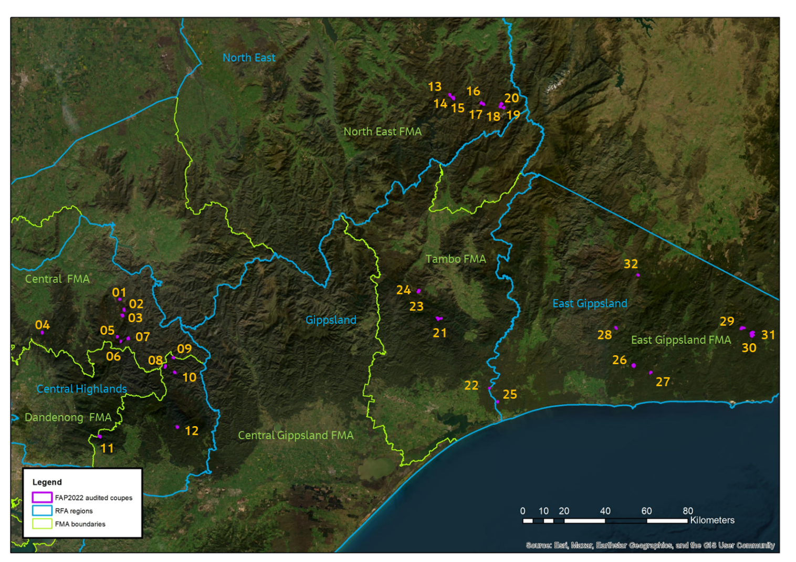
Note: numbers 01-32 represent the assigned coupe number (see Table 3-1 for details).
Figure 2-1. Locations of coupes included in 2022 Forest Audit Program, with references to Victorian Forest Management Areas (FMA; green text and boundaries) and Regional Forest Agreement (RFA; blue text and boundaries) regions. Sources: ESRI, DEECA.

Audit timing
Field assessments of the coupes included in this audit were undertaken in two tranches, between June and September 2022. The first tranche included 24 coupes located in Central Highlands, Gippsland and East Gippsland RFA regions. The second tranche included eight coupes in North East RFA region; auditing of these coupes was delayed due to access issues.
Audit reporting was carried out in three stages:
- Initial conformance summary report: on the preliminary results of the audit of the 24 coupes in tranche 1. This was submitted to DEECA (then DELWP) in July 2022
- Updated conformance summary: which included the preliminary results of audits in tranche 1 and 2 coupes and was submitted to DEECA (then DELWP) in October 2022
- Main audit report: a full report on the revised audit results, key findings and recommendations, of which this is the final version.
The conformance summary provided preliminary information on compliance assessments and the potential environmental impact of any non-conformances. Unlike this main audit report, it did not discuss the audit results, draw out any overall findings or conclusions or make recommendations.
The general content and format of the conformance summary and audit report were specified by DEECA.

Audit team
The audit team (below) were all employed by Jacobs Group (Australia) Pty Ltd (Jacobs):
- Craig Clifton (Project Manager and lead auditor): Craig is an EPA-appointed natural resources environmental auditor and has undergraduate and post-graduate qualifications in Forest Science. He developed the audit methodology, led the field assessments and their analysis and is lead author of this audit report. Craig has led audit teams undertaking nine previous FAP audit projects.
- David Endersby (Project Director): David is a principal terrestrial ecologist, with specialist expertise in botany, plant ecology and geomorphology. He has participated in most of the previous FAP audits delivered by Jacobs as a field team member, project director and/or technical reviewer. David is the internal technical reviewer for this report and Jacobs’ project director.
- Andrew Stephens (Audit team member): Andrew is a senior ecologist with specialisations in vegetation and bushfire ecology. Andrew works closely with statutory authorities for environmental approvals including state and nationally protected matters. He has also assisted in implementing native vegetation offsets as an accredited assessor, preparing management plans and monitoring implementation of restoration works. Andrew participated in field audits in two previous FAP audits and was an audit team member for field audits in the East Gippsland and Gippsland RFA regions as part of this audit.
- John Sharp (Audit team member): John is an experienced ecologist who specialises in zoology and fauna survey. In a former role, John undertook Forest Protection Survey Program (FPSP) pre-harvest fauna surveys in many prospective timber harvesting coupes, mainly in the Central Highlands. John participated in field audits in the Central Highlands RFA area.
- Austen Hawkins (Audit team member): Austen is an environmental scientist with wide bushfire management, modelling and policy experience. Austen participated in the final eight field audits in the North East RFA area.
- Mike Timms (Audit team member): Mike is an experienced ecologist with extensive ecological survey experience in urban and regional areas of Victoria. Mike participated in one of the field audits in the Central Highlands RFA area.

Audit approach

Coupe selection
Target coupes for the audit were selected from the set of VicForests’ Timber Release Plan (TRP) coupes which were operational or regenerating during the 2020-21 financial year. The coupes are located in the Central Highlands, East Gippsland, Gippsland and North East RFA areas. Thirty-two coupes were selected for inclusion in the audit, distributed as listed in Table 3-1. Reserve coupes were selected in each RFA area in case the initial target coupes were inaccessible and/or unsafe at the time of the field audit.
Table 3-1. Summary of audit targets by Regional Forest Agreement area and Forest Management Area
RFA area | # coupes
Central Highlands: Central, Central Gippsland and Dandenong Forest Management Areas (FMAs) | 12
East Gippsland: East Gippsland FMA | 8
Gippsland: Tambo FMA | 4
North East: North East FMA | 8
Access issues meant that two of the planned reserve coupes (one each in East Gippsland and Tambo FMAs) were included in the audit.
A risk-based selection process was used to identify the target and reserve coupes. The process uses data from VicForests that characterises inherent coupe conditions and details of planned harvesting activities. The factors influencing selection for target coupes included:
- Waterway crossing was constructed to access the coupe
- Rainforest and/or montane riparian thicket vegetation was identified as being present within or near the gross coupe boundary
- Length of in-coupe road required to access the landing(s)
- Soil erosion hazard in the A or B horizon
- Presence of special protection or special management zones (SPZ/SMZ) within or adjacent to the coupe
- Recorded presence of listed threatened flora and/or fauna within or near the coupe
- Coupe is located within a designated water supply catchment
- Average slope within coupe.
Coupes were preferentially selected where multiple risk factors were present. Coupes were excluded from selection if they had previously been included in FAP audits.
Four coupes located in Melbourne Water catchment areas were selected for audit. Selection of these coupes was informed by both the risk-based selection process and Melbourne Water priorities
A summary of key characteristics of the selected coupes is given in Table 3-2. The average net harvest area for the selected coupes is 12.6 ha, compared with an average gross coupe area of 50.6 ha. Nine of the coupes were located within about 100 m of modelled rainforest vegetation communities, few of which were rainforest stands requiring protection under the Code and MSPs. Twelve of the coupes had in-coupe road or snig track waterway crossings. The length of in-coupe road required to access landings that serviced the coupes ranged between zero and about 1500 m. Average coupe slope was 10-15°, with maximum slope exceeding 30° in areas of some coupes. Most coupes included or were adjacent to land zoned as SPZ and/or SMZ. Threatened native plant and animal species had been recorded on or within 500 m of all but two of the coupes.
The analysis in Table 3-2 shows that the data reported by VicForests on key risk characteristics, particularly the presence of waterway crossings and in-coupe roads, is not completely reliable. Three of the coupes that were reported as having waterway crossings did not. Planned lengths of in-coupe road were significantly shorter on eight coupes and significantly longer than actual on one coupe.

Table 3-2. Location and characteristics of coupes included in 2022 Forest Audit Program audits
Audit # | Coupe address |  |  | Coupe Name | FMA | Coupe status  end 2020-21 |  | Coupe net harvest area (ha) | Rainforest vegetation² | Waterway crossing³ | ICR⁴  (m) | Ave slope  (degrees) | Soil erosion hazard (max) | SMZ⁵ or SPZ | Thr flora⁶/ fauna
Central Highlands RFA area
1 | 288-509-0002 |  |  | Turnbuckle | CT | Active - Harvest |  | 12.74 | Yes | Yes | <50 | 25 | High | Yes | Coupe
2 | 288-517-0006 |  |  | Dragonfly | CT | Active - Harvest |  | 9.24 | Yes | Yes | 200 | 15 | High | Yes | Coupe
3 | 288-520-0007 |  |  | Gnu | CT | Active - Harvest |  | 5.53 | Yes | No | 200 | 20 | Low | Yes | Coupe
4 | 297-507-0003 |  |  | Sun Downies | CT | Active - Harvest |  | 22.4 | No | Yes | 200 | 10 | Low | Yes | Coupe
5 | 312-009-0010 |  |  | Whitehorse | CT | Regenerating |  | 7.6 | Yes | Yes | <50 | 20 | Low | Yes | <500 m
6 | 312-511-0003 |  |  | Real Madrid | CT | Active - Harvest |  | 1.78 | Yes | Yes | <50 m | 20 | Low | Yes | Coupe
7 | 314-502-0009 |  |  | Lemon Lime | CT | Regenerating |  | 20.15 | No | Yes | 600 | 15 | Med | Yes | Coupe
8¹ | 457-501-0033 |  |  | Philadelphia | CG | Regenerating |  | 13.34 | No | No | <50 | 15 | Low | Yes | Coupe
9 | 457-504-0009 |  |  | Quinn | CG | Regenerating |  | 3.98 | No | No | 330 | 20 | Low | Yes | Coupe
10 | 457-505-0009 |  |  | Amity Island | CG | Regenerating |  | 11.08 | No | No | <50 | 20 | Med | Yes | Coupe
11 | 464-506-0018 |  |  | Annex | CG | Active - Harvest |  | 10.25 | No | No | 100 | 15 | Med | Yes | Coupe
12 | 484-501-0043 |  |  | Puerile | CG | Regenerating |  | 5.91 | No | Yes | 400 | 15 | Low | Yes | Coupe
North East RFA area and FMA
13 |  | 676-520-0004 |  | Jandles | NE | Active - Harvest |  | 5.39 | No | No | <50 | 10 | Medium | Yes | <500 m
14 |  | 697-519-0001 |  | Gibb Range 1 | NE | Regenerating |  | 17.05 | No | No | 600 | 30 | High | Yes | Coupe
15 |  | 697-519-0003 |  | Lower Gibb | NE | Regenerating |  | 6.61 | No | No | <50 | 15 | High | Yes | Coupe
16 |  | 698-506-0001 | Sheik |  | NE | Regenerating | 10.23 |  | No | Yes | <50 m | 15 | High | No | No
17 |  | 698-511-0003 | Olin |  | NE | Regenerating | 17.83 |  | No | No | <50 | 5 | Medium | Yes | Coupe
18 |  | 699-519-0002 | South Buck |  | NE | Active - Harvest | 9.59 |  | No | Yes | 450 | 20 | High | No | No
19 |  | 699-520-0001 | Rossignol |  | NE | Regenerating | 16.64 |  | No | Yes | 200 | 10 | High | Yes | <500 m
20 |  | 699-524-0003 | Telemark |  | NE | Regenerating | 13.18 |  | No | No | <50 | 10 | High | Yes | Coupe
Tambo FMA
21 | 727-507-0005 |  |  | Dow Jones | TB | Regenerating |  | 46.25 | No | Yes | 500 | 15 | Medium | Yes | Coupe
22 | 743-502-0001 |  |  | Yazoo | TB | Regenerating |  | 11.6 | No | No | 454 | 5 | Medium | Yes | Coupe
23 | 770-507-0002 |  |  | Bayliss Spur | TB | Regenerating |  | 12.75 | No | No | <50 | 15 | Medium | Yes | Coupe
24 | 770-507-0005 |  |  | Bayled Up | TB | Regenerating |  | 20.65 | No | Yes | 500 | 15 | Medium | No | Coupe
East Gippsland RFA area
25 | 801-511-0005 |  |  | Lior | EG | Regenerating |  | 6.49 | No | No | 500 | 10 | High | Yes | Coupe
26 | 831-501-0015 |  |  | Electromotive | EG | Active - Harvest |  | 6.68 | Yes | No | <50 | 15 | Medium | Yes | Coupe
27 | 834-504-0007 |  |  | Grandfinal | EG | Regenerating |  | 13.96 | Yes | No | 700 | 10 | Medium | Yes | Coupe
28 | 842-501-0028 |  |  | Scarface | EG | Regenerating |  | 3.20 | No | No | <50 | 20 | Medium | Yes | <500 m
29 | 875-510-0004 |  |  | Pinball Wizard | EG | Regenerating |  | 3.51 | No | No | 1500 | 10 | Low | Yes | Coupe
30 | 876-510-0002 |  |  | Plastic Moon | EG | Regenerating |  | 19.81 | Yes | No | 200 | 10 | Low | Yes | Coupe
31 | 876-511-0010 |  |  | Harkerscorner | EG | Regenerating |  | 26.18 | No | No | 700 | 10 | Medium | Yes | Coupe
32 | 891-516-0034 |  |  | Paw Print | EG | Regenerating |  | 22.24 | Yes | No | >500 | 10 | High | Yes | Coupe
Notes:
- Pale orange shading indicates coupes located in Melbourne Water catchment area
- Rainforest vegetation: dark yellow shading indicates VicForests information suggests modelled rainforest ecological vegetation community (EVC) within or adjacent to coupe, but found not to be the case. Rainforest may be beyond 100m from coupe
- Waterway crossing: dark yellow indicates snig track crossing, yellow indicates in-coupe road waterway crossing, green indicates both snig track and in-coupe road crossing, red indicates waterway crossing planned by VicForests but found to not have been constructed
- ICR: In-coupe road length. Green shading indicates VicForests information significantly overstates actual length of in-coupe road. Dark yellow indicates VicForests information significantly understates the actual length of in-coupe road
- SMZ/SPZ: forest management zones, Special Management Zone and Special Protection Zones
- Thr flora/fauna: listed threatened native flora and/or fauna present within coupe (coupe), within 500m of coupe (<500m) or not present (no)

Audit criteria and workbook
Audit criteria were based on mandatory requirements of the Code selected by the THCU. Generally, the criteria referenced additional compliance elements from the MSPs and the PS, which provide more detailed interpretations of Code requirements. Compliance criteria were grouped into several themes and sub-themes, as follows:
- Environment: compliance criteria developed for the audit drew on Section 2.2.1 of the Code (Water quality, river health and soil protection) and related compliance elements from the MSPs. There are two sub-themes, soil and water, with the latter incorporating flows, water quality and river health.
- Conservation of biodiversity: compliance criteria developed for the audit drew on Section 2.2.2 of the Code and related MSP and PS compliance elements.
- Operational planning and record-keeping: compliance criteria for the audit drew on Sections 2.3 and 2.5.1 of the Code and related MSP compliance elements.
- Coupe infrastructure for timber harvesting operations: compliance criteria were organised into four sub-themes, three related to roading for timber harvesting operations (based on Code Section 2.4; 2.4.2 Road design, 2.4.3 Road construction, 2.4.4 Road maintenance) and one sub-theme relating to other coupe infrastructure (i.e., landings, snig, forwarding and boundary tracks; Code Section 2.5.2). As with other compliance themes, audit criteria also drew on relevant MSP mandatory compliance elements.
The audits considered 171 individual compliance criteria (see Appendix A). These were assessed, as applicable, for each of the audit coupes. A digital audit workbook was used to capture assessments against applicable criteria for each individual coupe. Assessments recorded in the workbook were based on observations by the audit team and their review of VicForests’ Forest Coupe Plans (FCPs). They considered the applicability of each criterion, as well as the operations’ conformance with the audit criteria or compliance element. The latter was assessed using the descriptors in Table 3-3.
Table 3-3. Descriptors used to assess conformance with audit criteria
Level of conformance | Fully conforms | Non-conforming with no environmental impact | Non-conforming with environmental impact  (Full non-conformance)
Description | All requirements of the compliance element are fully satisfied. | All requirements of the compliance element are not fully satisfied. However, the non-conformance is procedural and will pose no direct risk of harm to the environment. | All requirements of the compliance element are not fully satisfied. The non-conformance has potential to pose a risk of harm to the environment.
The workbook was also used to capture the basis for any non-conformance assessment. Photographs were taken of coupe features, particularly where/if non-conformances were observed.

Field assessments
Field assessments of relevant coupe characteristics (Table 3-4) were carried out in each of the target coupes. Handheld global positioning system (GPS) devices and satellite-linked mobiles phones were used in most coupes to track the field team’s movements and record field observations (using either ESRI Field Maps or Avenza).
Table 3-4. Field assessment methods for 2022 Forest Audit Program
Attribute being assessed | Audit criteria | Method
- Waterway classification and correct provision of riparian filters and/or buffers. | 1, 3, 5, 15 | Assessment of waterway as drainage line, temporary stream or permanent stream, based on Code definitions. Streams and widths of filters/buffers will be assessed along ≤600 m of waterway per coupe (if present). Adequacy of filter and buffer widths will be assessed with a range finder, supported by ground traverses to locate the centreline of the stream (as required).  For fire salvage coupes, conformance with additional filter & buffer requirements will be noted.
- Soil erosion hazard | 2 | Comparison of VicForests assessment of soil erosion hazard with observations of erosion within the coupe. Soil erosion hazard will be assessed using MSP methods where evidence of soil conditions and soil erosion suggests to the auditor that the initial assessment may have been incorrect or only applicable for one of multiple soil types present within the coupe.
- Extent to which harvesting was conducted on slopes >30°/25° (EG granite-derived soils). | 4,5 | Pre-field audit GIS analysis using lidar data (where available) to target investigations. Traverse across high slope areas (within harvest area) to locate and measure area of any locations where harvesting conducted on land with >30°/25° slope.
- Adequacy of protection provided to soils, waterways and river health. | 6, 7, 8, 15, 21 | Visual observations and auditors’ interpretations, based on the presence of excessive disturbance and/or activities which are not compliant with elements of the regulatory framework. Considers in-coupe roads (ICR) and coupe infrastructure (snig tracks [ST], boundary tracks [BT, where present] and landings).
- Presence of in-coupe roads or snig tracks in riparian habitats. | 7, 15, 21 | Visual observations and auditors’ interpretations of the reasonable practicability of alternative placements which avoided or were more remote from riparian areas.
- Waterway crossings and culverts. | 7, 18, 19, 21, 22 | Assessment of culverts, fill batters and road drainage against MSP requirements. Observations and auditors’ interpretation of crossings in which the culvert had been removed (if observed). Observations of sediment entry into the waterway.
- Habitat trees. | 10 | Assessment of the density and distribution of habitat trees, their location in relation to other habitat and their potential to develop hollows.
- If listed threatened fauna or flora are recorded as being present, whether prescribed management actions been followed. | 9, 11 | Comparison of observed coupe conditions with management actions specified in the MSPs and forest coupe plan (FCP).
- Harvesting and/or road construction in or near box-ironbark, heathland or montane riparian thicket (MRT) if present within or near the coupe. | 12 | Confirmation of the presence of the vegetation community and observation of its proximity to in-coupe roads. Auditors’ assessment as to the reasonable practicability of alternative road location if the road entered the protected vegetation community. Presence of harvesting in or in proximity to box-ironbark forests, heathlands or MRT.
- Old growth forest (OGF) and large or giant trees | 12 | Provision of buffers around verified OGF within Leadbeater’s Possum (LBP) range. Retention of large or giant trees in accordance with MSP requirements.
- Rainforest buffers. | 12 | Identification of rainforest stands, as per MSP definitions. Assessment of provision of any required buffers as per MSP compliance requirements.
- Protection of exclusion areas and areas outside gross coupe boundaries | 12, 15, 21 | Identification and assessment of any effect of harvesting operation (including roading, regeneration burning, tree felling, ST/BT and machinery movement) on exclusion areas or areas outside the coupe boundary.
- Biosecurity. | 13 | Observation of harvesting related damage to or wounding of Myrtle Beech trees, in applicable coupes. Implementation of any management plans where harvesting operations appear to have led to disease or pest introduction.
- In-coupe road design and construction | 16, 17, 18, 19 | Assessment of whether road construction follows any documented plan or design.  Identification of any evidence that road construction was inconsistent with need to minimise risk of erosion and water quality impact.  Identification of any evidence that table drains were constructed by subsequent excavation.  For in-coupe roads through retained vegetation, assess whether clearing width was consistent with MSP requirements.  Assessment of the appropriateness of the intensity of earthworks for ICR.  Observation and auditors’ interpretation of the adequacy of road maintenance and any road closure works.
- Fill batters | 18 | Evidence of soil movement and instability. Observation of instances where fill batters cover base of live trees to be retained post-harvest.
- Road drainage | 19 | Compliance with MSP drain spacing requirements, based on soil erosion hazard and gradient, for full length of in-coupe road. Assessment of effectiveness of drainage and appropriateness of drainage disposal, considering Code and MSP requirements. Assess full length of ICR.  Conformance of culvert construction and management with MSP requirements  Appropriateness and avoidability of disturbance to stream beds during and following crossing construction and removal.
- ICR and waterway crossing (WWX) closure | 20 | Determine whether any WWXs that are no longer required have been removed and rehabilitated as per MSP requirements.  Determine whether an ICR that is no longer required been closed permanently.
- Coupe management | 21 | Observation of the consistency between the FCP and the timber harvesting operation.
- Coupe infrastructure – ST & BT | 22 | Assess if ST have been progressively rehabilitated and rehabilitated in a way that prevents soil movement into streams and consistent with MSP requirements. Assess adequacy of ST and BT drainage and its conformance to MSP requirements. Assess up to 600 m length of ST and/or BT, where present.
- Coupe infrastructure – landings | 21 | Assess adequacy of landing rehabilitation, including removal of cording and matting, ripping of landing and final 30 m of ST, placement of bark piles and storage and redistribution of stockpiled soil.
- Slash and bark piles | 22 | Has slash and bark been placed and piled appropriately in preparation for regeneration burning?
- Campsites | 22 | Are any campsites located appropriately?
- Fire salvage harvesting | 15 | Assess conformance of coupe operations with applicable salvage harvesting prescriptions as per Section 8 of the MSP.

Environmental impact assessment
The EIA tool provided by the CR (Appendix B) was used to assess the potential environmental impacts of non-conformance with audit criteria and the regulatory framework for timber harvesting. EIA tool assessments are based on:
- Extent and location of impact: an auditor’s assessment based on one or more of several factors:
  - Proportion of the harvestable coupe area affected by the non-conformance
  - Length of in-coupe road and/or snig/boundary track without conforming drainage
  - Suitability of landing rehabilitation
  - Extent of soil mass movement
  - Number of retained trees whose base is covered by in-coupe road, landing or snig track embankment materials
  - The number and/or extent of incidences of inappropriate disturbances (i.e., disturbances to planned timber harvesting exclusions areas which are not permitted by the Code or MSPs) to waterways, riparian buffers or filters or other areas within or adjacent to the gross coupe area.
- Duration of impact/recovery time: an assessment by the auditor of the likely time required for the coupe to recover from any impact or disturbance associated with the non-conformance incident.
- Values affected: an assessment based on the value or environmental aspect experiencing or potentially experiencing an impact stemming from the non-conformance. General forest areas are valued less than riparian or rainforest buffers and SPZ, for example.
The overall five-point EIA rating is based on the total score for each component. Ratings potentially range between negligible and severe. The assessed potential environmental impact is not necessarily reflective of the actual environmental impact of a non-conformance incident. Incidents that occur in sensitive locations (e.g., SPZ, buffers of permanent streams) may sometimes be assessed to have relatively high potential environmental impact even if the actual impact observable at the time of audit is minimal.
Descriptors for extent and location of impact were revised for waterway crossings from those in the original EIA tool, with agreement from the THCU. This helped to align the EIA rating more closely with the actual level of environmental impact of the non-conformance incident.
Non-conformances for which there is no direct pathway to cause harm to the environment (and not just that they did not cause material environmental harm) were assessed as non-conforming with no environmental impact, as per Table 3-3.

Audit results
This section summarises the results of the assessments of conformance with compliance criteria based on mandatory elements of the regulatory framework for timber harvesting in State forests, as listed in Appendix A. Overall results are presented first, with those for each compliance theme and sub-theme following. As the coupe selection method was risk-based, rather than random, these results are not necessarily statistically representative of VicForests’ operations overall.
Due to space constraints in the figures, coupes are represented by the number assigned in Table 3-2. In the narrative accompanying these figures, coupes are referred to by that number (rather than the TRP coupe number) and the coupe name.

Overall compliance findings
A total of 171 criteria were identified from the various compliance elements applicable to the target coupes (Appendix A). Of these, 20 criteria were found not to apply to any of the audit coupes. The overall level of full conformance with applicable audit criteria ranged between 87% (07 Lemon Lime, 18 South Buck, 24 Bayled Up) and 100% (08 Philadelphia, 11 Annex, 15 Lower Gibb, 22 Yazoo, 23 Bayliss Spur, 25 Lior, 26 Electromotive, 27 Grandfinal, 28 Scarface, 30 Plastic Moon, 31 Harkerscorner, 32 Paw Print), with the average being 96% (Figure 4-1). Non-conformances identified in 20 of the 32 coupes had potential for environmental impact.
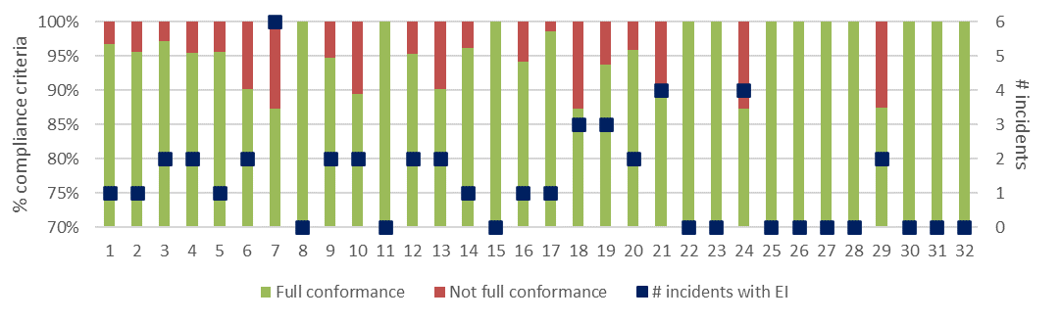
a) Level of conformance with audit criteria and number of non-conformance incidents with assessable environmental impact. Conformance as per Table 3-3, with not full compliance including all criteria with which the coupe did not fully comply, regardless of the potential for environmental impact.
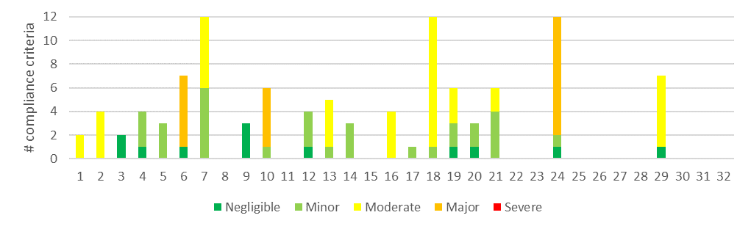
b) Number of compliance criteria with assessable environmental impact and the assessed level of impact for each instance of non-conformance.
Figure 4-1. Overall compliance findings and assessed environmental impact for instances of non-conformance for harvest coupes. The x-axis refers to the coupe numbers, as per Table 3-1.
Figure 4-1a shows the number of incidents resulting in non-conformance with actual or potential environmental impact. These ranged between zero (12 coupes) and six (07 Lemon Lime), with an average of 1.4 incidents per coupe. Descriptions of the incidents associated with non-conformance with audit criteria and the regulatory framework for timber harvesting are given in Appendix C.
The EIA tool (Appendix B) was used to assess the potential environmental impact associated with each non-conformance incident. This ranged between negligible and major (Figure 4-1b). Non-conformances which were assessed to have major potential environmental impact were detected in three of the 32 coupes included in the audit (06 Real Madrid, 10 Amity Island, 24 Bayled Up). Incidents with moderate potential environmental impact were detected in nine coupes (Figure 4-1b). These incidents are discussed in greater detail in the following sections.

Environmental compliance theme
The environmental compliance theme included two main groups of compliance element and audit criteria, those relating to soils, and water and river health.

Compliance elements related to the protection of forest soils
Compliance elements related to the protection of forest soils (Appendix A) focus on the avoidance of erosion or mass soil movement, as well as on mitigating the risk of entry of sediments into waterways, should they be mobilised. The entry of mobilised sediments into waterways is primarily dealt with under the water and river health sub-theme (Section 4.2.2). The Code and MSPs seek to avoid erosion, soil mass movement and unrectified compaction of soils by achieved:
- Assessing and understanding soil erosion hazard within the coupe and adjusting planning and operations accordingly
- Not harvesting in excessively steep areas
- Application of seasonal closures to coupes in water supply catchments to reduce the risk of harvesting or snigging machinery disturbing wet soils, leading to sediment mobilisation or soil compaction
- Appropriate location, construction, maintenance, closure, rehabilitation and/or removal of landings, in-coupe roads, road drainage and road or snig track waterway crossings.
A total of 38 audit criteria were relevant to the protection of forest soils, all of which were applicable to at least one of the target coupes. The average level of full conformance with applicable criteria was found to be 95%, with the level of conformance ranging between 78% (07 Lemon Lime) and 100% (16 coupes; Figure 4-2). The assessed environmental impact associated with non-conformances ranged between negligible and major.
Non-conformance incidents resulting in actual or potential environmental impacts on forest soils were identified at 16 coupes. The incidents with major potential environmental impact all related to waterway crossings and the (actual or potential) mobilisation of sediment into permanent streams, as follows:
- In-coupe road sediment allowed to enter a permanent stream by defects in drainage on a waterway crossing (24 Bayled Up)
- Culvert on a snig track waterway crossing discharges directly onto the fill batter and has mobilised fine sediments into a permanent stream (06 Real Madrid)
Non-conformance incidents on a further six coupes (02 Dragonfly, 07 Lemon Lime, 13 Jandles, 16 Sheik, 18 South Buck, 19 Rossignol; Figure 4-2) were assessed to have moderate potential environmental impact. All related to defects in in-coupe road waterway crossing construction (02 Dragonfly, 07 Lemon Lime, 18 South Buck, 19 Rossignol) or snig track crossing defects (13 Jandles, 16 Sheik) with potential to mobilise sediments into temporary streams. Poor management of road drainage at 07 Lemon Lime led to discharge of water over the waterway crossing fill batter and failure of geotextile (on the downstream side of the crossing), leading to erosion and mobilisation of sediment into a temporary stream. These are also discussed in Section 4.2.2.
Non-conformance incidents relating to the protection of forest soils at 02 Dragonfly and 07 Lemon Lime are shown in Figure 4-3 and Figure 4-4, respectively.

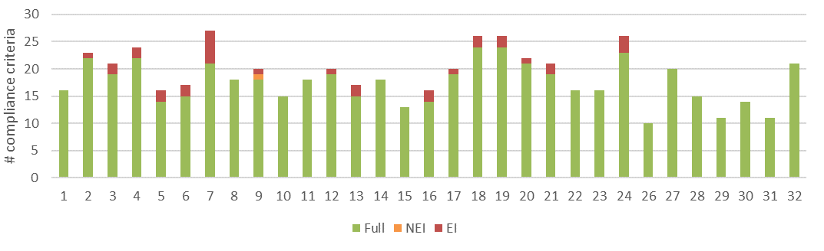
a) Level of conformance with audit criteria. Conformance definitions (Fully conforms [full], Non-conforming with no environmental impact [NEI], Non-conforming with environmental impact [EI]) as per Table 3-3.
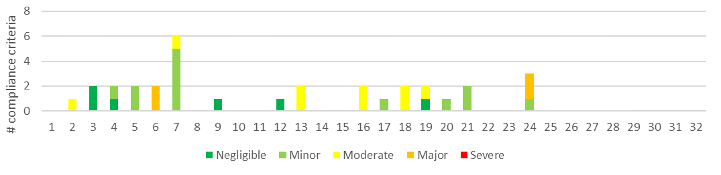
b) Number of compliance criteria with assessable environmental impact and the assessed level of impact for each instance of non-conformance.
Figure 4-2. Compliance findings and assessed environmental impact for instances of non-conformance for criteria applicable to the protection of forest soils. The x-axis refers to the coupe numbers, as per Table 3-1.

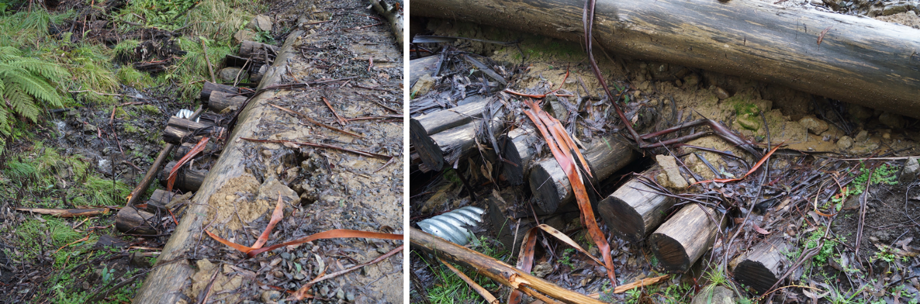
Runoff along the in-coupe road as allowed to pond on the “deck” of the crossing and has washed sediment embedded in the log crossing into the permanent stream.
Figure 4-3. Defects on waterway crossing at 02 Dragonfly leading to mobilisation of sediment into permanent stream.
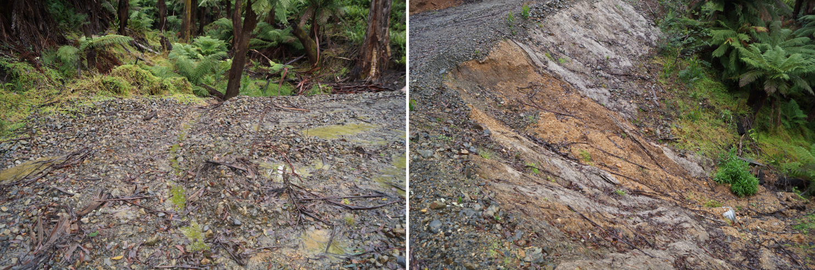
Inappropriate informal drainage on this waterway crossing diverts some drainage along the in-coupe road directly into temporary stream at the waterway crossing. | Road drainage across the fill batter has resulted in failure of the geotextile on the waterway crossing, allowing large sections to collapse and carry sediment into the temporary stream. Sediment deposition was observable up to 10 m from the crossing.
Figure 4-4. Defects on waterway crossing at 07 Lemon Lime leading to mobilisation of road and fill batter sediment into a temporary stream

Compliance elements related to the protection of water flows, water quality and river health
Compliance elements relevant to this theme (Appendix A) seek to protect water flows, water quality and river health by:
- Classifying waterways present in the coupe, applying at least the minimum width of filters and/or buffers required and excluding harvesting activities and/or machinery from those areas
- Application of seasonal closures to reduce the risk of sediment mobilisation and soil compaction during wet weather in water supply catchments
- Appropriate design, construction and maintenance of in-coupe roads, road drainage and waterway crossings
- Applying appropriate methods to remove and rehabilitate waterway crossings following the completion of timber harvesting and regeneration activities.
Many of the compliance requirements (and criteria) are also applicable to the protection of forest soils, conservation of aquatic biodiversity and to the management of impacts from construction of in-coupe roads and snig or boundary tracks. A total of 61 audit criteria were relevant to this theme, three of which were not applicable to any of the audit coupes.
The average level of full conformance with applicable criteria was found to be 94%, with the level of conformance ranging between 67% (29 Pinball Wizard) and 100% (17 coupes). The low level of conformance for 29 Pinball Wizard related to a single incident where part of an intended 20 m buffer on a temporary stream was harvested (EIA rating of moderate).
The assessed potential environmental impact associated with non-conformances ranged between negligible and major (Figure 4-5). Non-conformances which were assessed to have major potential environmental impact were identified at two coupes (06 Real Madrid, 24 Bayled Up). These incidents were also applicable to forest soils (Section 4.2.1) and related to in-coupe road or snig track waterway crossings on permanent streams. Figure 4-6 shows a further example where deficiencies in waterway crossing drainage have allowed fill batter sediment to be mobilised into a permanent stream (24 Bayled Up).
Non-conformance incidents on a further eight coupes (02 Dragonfly, 07 Lemon Lime, 16 Sheik, 18 South Buck, 19 Rossignol, 21 Dow Jones, 29 Pinball Wizard; Figure 4-5) were assessed to have moderate potential environmental impact. With the exception of 29 Pinball Wizard, the incidents related to waterway crossing defects. Details of the non-conformance incidents with moderate potential environmental impact are as follows:
- Mobilisation of sediment across the fill batter of a waterway crossing (02 Dragonfly, 07 Lemon Lime - Figure 4-4)
- Outlet of waterway crossing culvert above downstream bed of temporary stream (07 Lemon Lime, 18 South Buck, 19 Rossignol), with potential to block aquatic fauna passage (if relevant) and/or create an erosion point that would mobilise sediment during flow events (Figure 4-7).
- Lengths of in-coupe road much greater than 20 m draining directly into a temporary stream waterway crossing (18 South Buck; Figure 4-8) or drainage line waterway crossing in a fire salvage coupe (21 Dow Jones).
- Snig track crossing rehabilitation (16 Sheik) has resulted in sediment being mobilised into a temporary stream.
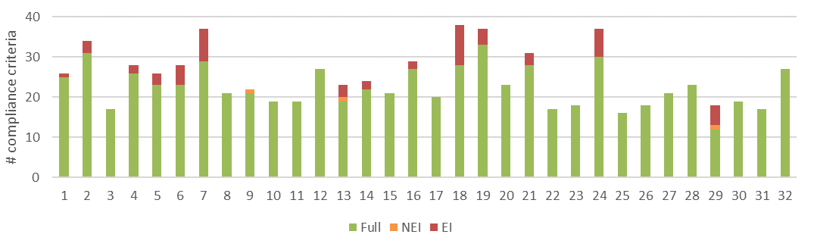
a) Level of conformance with audit criteria. Conformance definitions (Fully conforms [full], Non-conforming with no environmental impact [NEI], Non-conforming with environmental impact [EI]) as per Table 3-3.
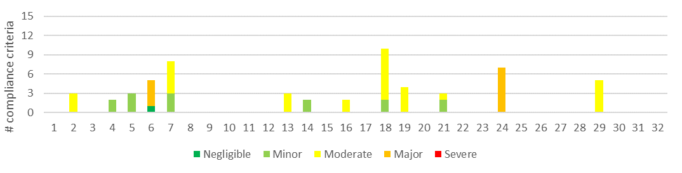
b) Number of compliance criteria with assessable environmental impact and the assessed level of impact for each instance of non-conformance.
Figure 4-5. Compliance findings and assessed environmental impact for instances of non-conformance for criteria applicable to the protection of water quality, flows and river health. The x-axis refers to the coupe numbers, as per Table 3-1.
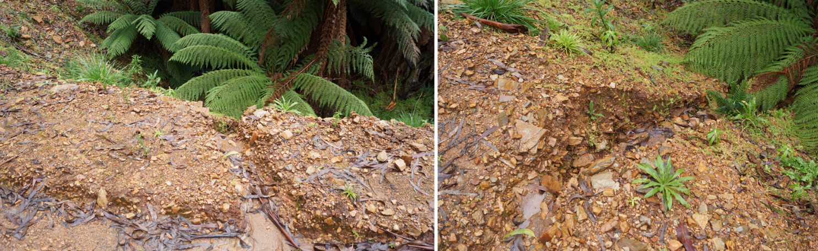
Figure 4-6. In-coupe road drainage onto the waterway crossing on the approach to 24 Bayled Up is allowed to drain directly across the fill batter and has mobilised batter sediments into the permanent stream.
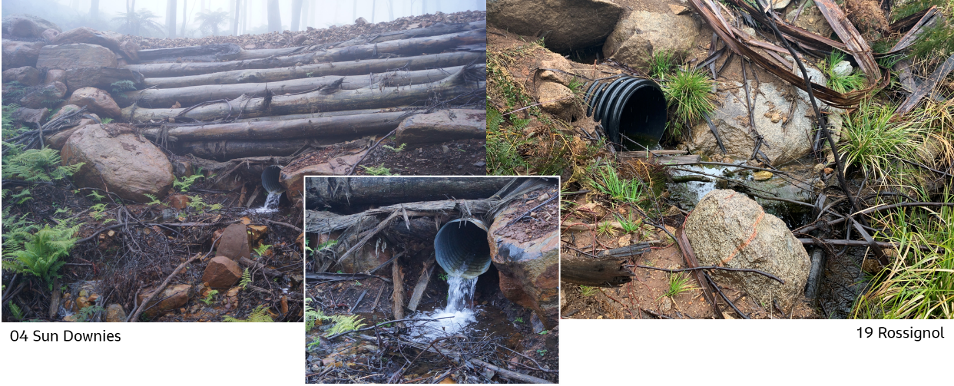
Figure 4-7. Examples of outlets of waterway crossing culverts being elevated above the downstream bed of temporary stream, potentially blocking aquatic fauna movement and contributing to erosion and sediment mobilisation.
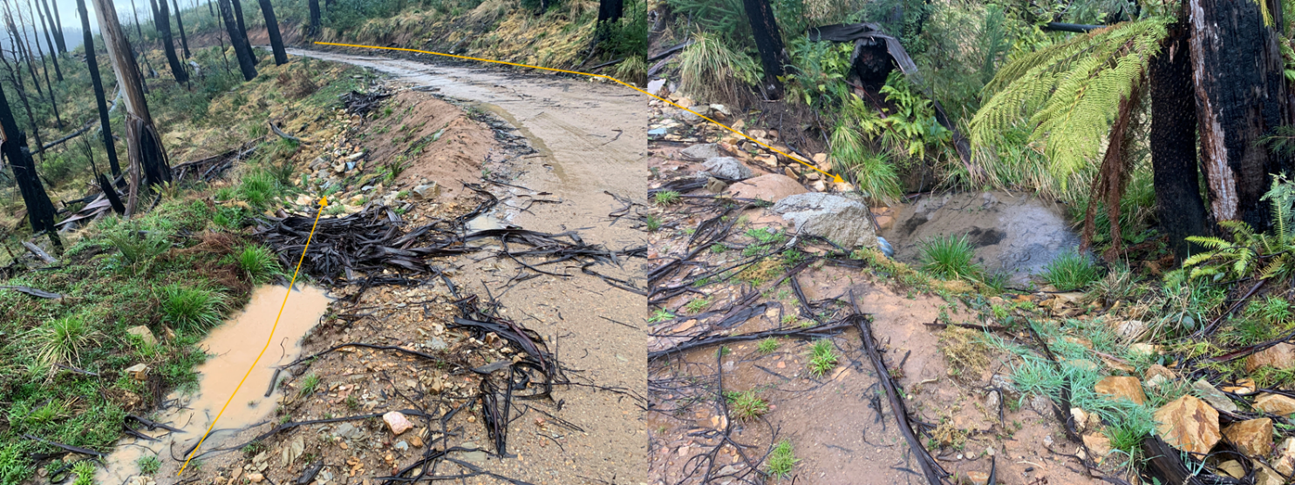
Figure 4-8. Drainage along the in-coupe road at 18 South Buck runs for significantly greater than 20 m into a temporary stream (highlighted by yellow arrows). Photograph on the right shows evidence of sediment deposition.

Conservation of biodiversity
Code and MSP compliance elements relevant to this theme (Appendix A) seek to protect biodiversity values by:
- Retaining trees and understorey elements within the gross coupe and/or harvested area, including old growth elements and trees with or with potential to form hollows
- Preventing harvesting activities, roading and regeneration burning from taking place within and/or adjacent to sensitive vegetation communities (e.g., heathlands, montane riparian thickets, rainforest stands) and other retained vegetation within the coupe
- Identifying listed, threatened species of native flora and fauna which have been recorded within or adjacent to the coupe and applying the management measures prescribed by the MSPs
- Not harvesting in (or otherwise disturbing) Special Protection Zones (SPZ) established to protect important native fauna habitats (e.g., for Leadbeater’s Possum, Long-footed Potoroo, Owls)
- Maintaining passage for fish or other aquatic fauna along permanent streams
- Protecting water quality from sediment movement to waterways from in-coupe roads, snig tracks and other coupe infrastructure
- Managing the risk of entry or spread of weeds and soil-borne or other plant diseases.
A total of 64 audit criteria are relevant to the protection of biodiversity values, of which 14 were not applicable to any of the selected coupes. The average level of full conformance with applicable criteria was found to be 96%, with the level of full conformance ranging between 85% (06 Real Madrid, 07 Lemon Lime, 10 Amity Island) and 100% (18 coupes; Figure 4-9).
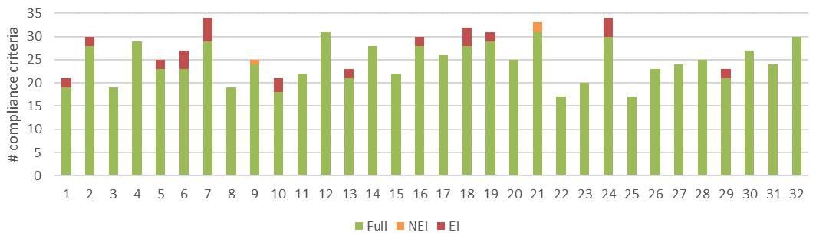
a) Level of conformance with audit criteria. Conformance definitions (Fully conforms [full], Non-conforming with no environmental impact [NEI], Non-conforming with environmental impact [EI]) as per Table 3-3.
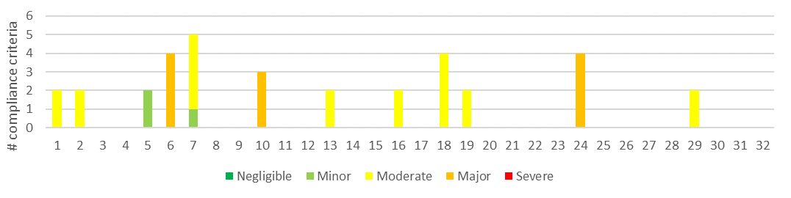
b) Number of compliance criteria with assessable environmental impact and the assessed level of impact for each instance of non-conformance.
Figure 4-9. Compliance findings and assessed environmental impact for instances of non-conformance for criteria applicable to the protection of biodiversity values. The x-axis refers to the coupe numbers, as per Table 3-1.
Biodiversity-related non-conformances with potential environmental impact were observed at 14 of the coupes. The assessed environmental impact ranged between minor and major (Figure 4-9). Non-conformance incidents with major potential environmental impact were observed at three coupes (06 Real Madrid, 10 Amity Island, 24 Bayled Up). Incidents at 06 Real Madrid and 24 Bayled Up were associated with waterway crossings and related to potential impacts on aquatic biodiversity. These have been discussed in Sections 4.2.1and 4.2.2.
The non-conformance incident at 10 Amity Island with major potential environmental impact involved apparent incursions of harvesting disturbance into two small sections of Leadbeaters Possum SPZ (Figure 4-10). The incursions were both less than 5 m and (based on the audit team’s GPS track log) affected less than 30 m² of the SPZ (<0.03%). From the track log and satellite imagery, it appears that one tree may have been removed. VicForests believe this to be the result of a GPS error and is understood to have self-reported this incident to DEECA.
Incidents with moderate potential environmental impact on biodiversity values were observed at six coupes (01 Turnbuckle, 02 Dragonfly, 07 Lemon Lime, 13 Jandles, 16 Sheik, 18 South Buck, 19 Rossignol, 29 Pinball Wizard). With the exception of 01 Turnbuckle, these were associated with waterway crossings or were otherwise related to potential impacts on aquatic biodiversity (see discussion in Section 4.2.2). The incident with moderate potential environmental impact at 01 Turnbuckle (Figure 4-11) was associated with incursions of the regeneration burn into retained vegetation patches located within the gross coupe area.
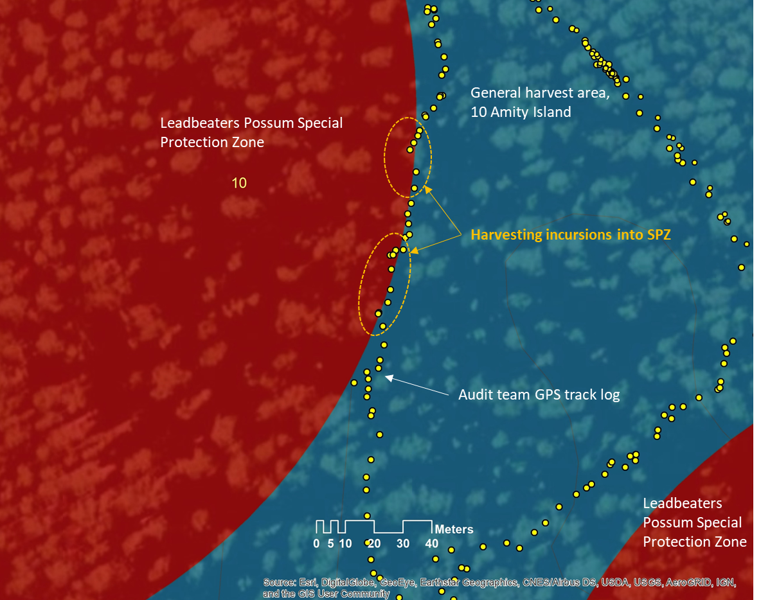
Figure 4-10. Incursion of harvesting into Leadbeaters Possum SPZ at 10 Amity Island
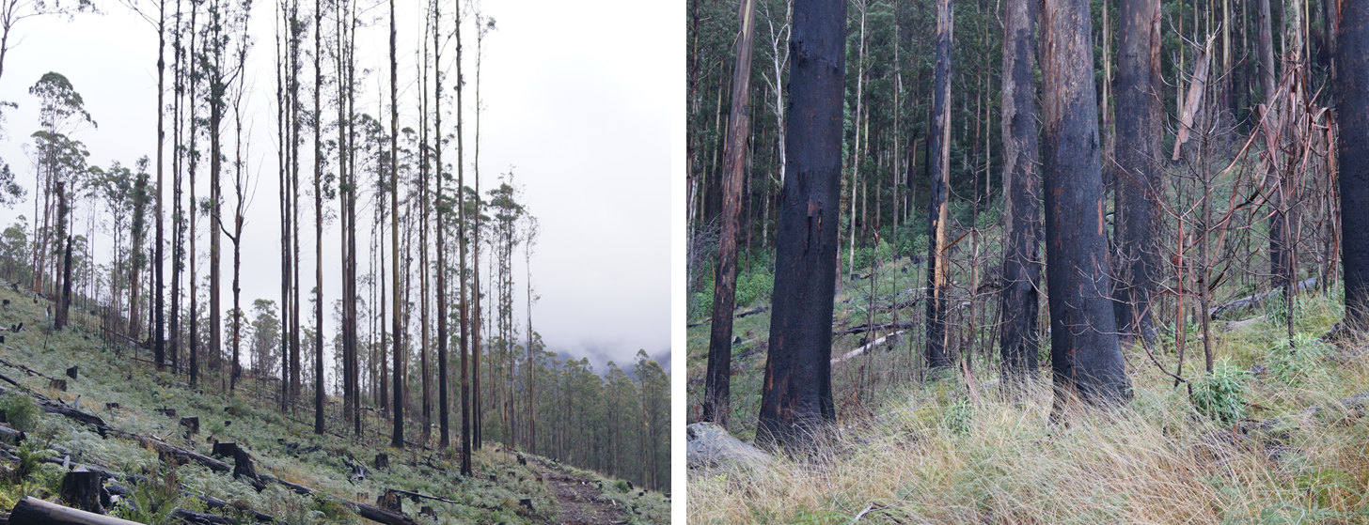
Figure 4-11. Incursion of regeneration burn at 01 Turnbuckle into retained vegetation patches. The regeneration burn did not scorch the crowns of retained trees but destroy retained understorey vegetation.

Operational planning and record-keeping
Compliance elements considered under this theme are concerned with the development of the FCP in conformance with the Code and MSPs and the consistency of coupe operations with that plan. The compliance elements seek to protect soil, water and biodiversity values from risks associated with poorly planned or executed harvesting, roading and regeneration operations. Ninety-two audit criteria were identified (Appendix A), with 13 of these found not to apply to any of the audited coupes.
The average level of full conformance with applicable criteria was found to be 97%, with the level of full conformance ranging between 89% (24 Bayled Up) and 100% (17 coupes; Figure 4-12). Non-conformance incidents with major potential environmental impact were observed at three coupes (06 Real Madrid, 10 Amity Island, 24 Bayled Up). Incidents with moderate potential environmental impact were observed at a further eight coupes (Figure 4-12). In all cases, the issue underpinning the non-conformance was that coupe planning was not executed correctly rather than being deficient.
Incidents resulting in assessed potential environmental impact of moderate or major have all been discussed previously (see Sections 4.2.1, 4.2.2 and 4.3) and relate to defective in-coupe road or snig track waterway crossings, incursion of harvesting activity into an SPZ and incursion of a regeneration burn into retained habitat patches.
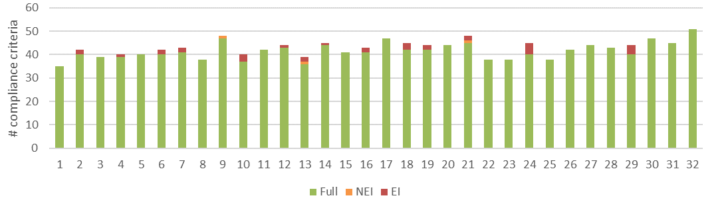
a) Level of conformance with audit criteria. Conformance definitions (Fully conforms [full], Non-conforming with no environmental impact [NEI], Non-conforming with environmental impact [EI]) as per Table 3-3.
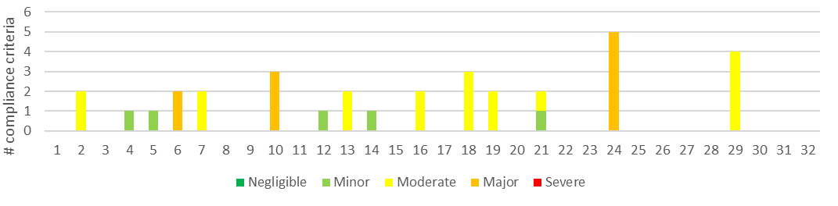
b) Number of compliance criteria with assessable environmental impact and the assessed level of impact for each instance of non-conformance.
Figure 4-12. Compliance findings and assessed environmental impact for instances of non-conformance for criteria applicable to coupe planning and management. The x-axis refers to the coupe numbers, as per Table 3-1.
Instances where coupe planning was inconsistent with specific Code or MSP requirements but did not directly result in an incident with potential environmental impact were few in this audit.

Coupe infrastructure for harvesting operations
The coupe infrastructure theme includes four main groups of compliance element and audit criteria. The first three relate to in-coupe roading (design, construction, maintenance and closure) and the fourth relates to other forms of coupe infrastructure, including landings and snig and boundary tracks.
Thirteen of the audit coupes had either no in-coupe road or only very short lengths of in-coupe road (significantly less than 50m) and were not assessed against the three in-coupe roading sub-themes.

Compliance elements related to in-coupe road and waterway crossing design
The 13 compliance elements relevant to this theme (Appendix A) seek to ensure that appropriate design protects soil and water values from risks associated with the construction of fill batters for roads, waterway crossings and road drainage structures. Design is intended to ensure the stability of roads and road embankments, safe passage of high flow events through crossings and culverts and to prevent erosion of roads and crossings and associated sediment generation. One of the criteria were not applicable to any of the audited coupes. This sub-theme was not applicable to coupes that had no in-coupe road or only a minimal length (<50 m).
The average level of full conformance with applicable criteria was found to be 96%, with the level of full conformance ranging between 78% (07 Lemon Lime) and 100% (12 coupes; Figure 4-13). Non-conformance incidents assessed to have major potential environmental impact were observed at one coupe (24 Bayled Up; Figure 4-13). Incidents with moderate potential environmental impact were observed at 02 Dragonfly, 07 Lemon Lime and 18 South Buck. Each of these incidents relates to the design and construction of waterway crossings and all have been discussed in Sections 4.2.1and 4.2.2. The key issues include:
- Road drainage not being intercepted and diverted into or through a sump, intact vegetation or silt trap prior to discharge into a waterway.
- Elevation of a waterway crossing outlet above the downstream bed of the waterway.
- Road drainage on the waterway crossing being “managed” in a way that allows it to mobilise fill batter sediments into the waterway.
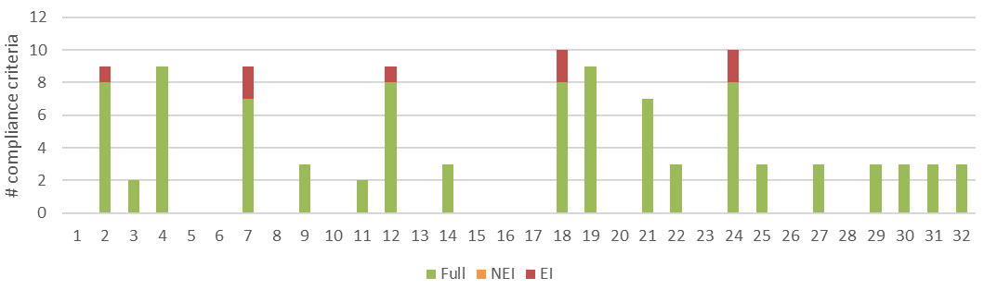
a) Level of conformance with audit criteria. Conformance definitions (Fully conforms [full], Non-conforming with no environmental impact [NEI], Non-conforming with environmental impact [EI]) as per Table 3-3.
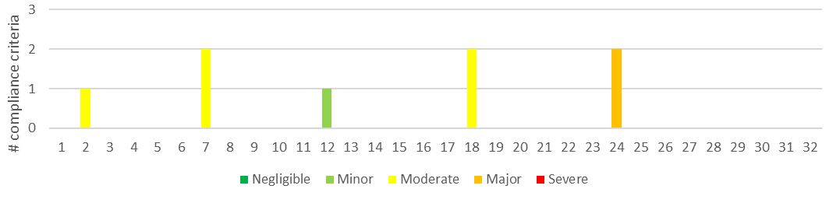
b) Number of compliance criteria with assessable environmental impact and the assessed level of impact for each instance of non-conformance.
Figure 4-13. Compliance findings and assessed environmental impact for instances of non-conformance for criteria applicable to the road design. The x-axis refers to the coupe numbers, as per Table 3-1.

Compliance elements related to in-coupe road and waterway crossing construction
The 44 compliance elements relevant to this theme (Appendix A) largely seek to protect soil and water values from impacts associated with road drainage and the construction of road embankments and waterway crossings. Five of these compliance elements were found to not be applicable to any of the audit coupes. This sub-theme was not applicable to the coupes that had no in-coupe road or only a minimal length (<50 m).
The average level of full conformance with applicable criteria was found to be 93%, with the level of conformance ranging between 66% (07 Lemon Lime) and 100% (8 coupes; Figure 4-14). Non-conformances with potential environmental impact were identified in nine coupes, with incidents ranging in severity of potential environmental impact from negligible to major.
The non-conformance incidents giving rise to major and moderate potential environmental impact (24 Bayled Up and 02 Dragonfly, 07 Lemon Lime, 18 South Buck, 19 Rossignol, 21 Dow Jones, respectively) all relate to the construction of waterway crossings and have been described previously (Sections 4.2.1, 4.2.2).
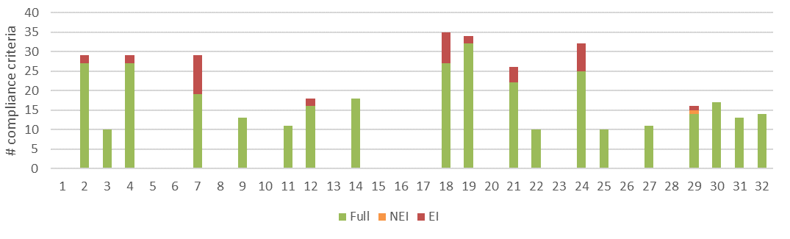
a) Level of conformance with audit criteria. Conformance definitions (Fully conforms [full], Non-conforming with no environmental impact [NEI], Non-conforming with environmental impact [EI]) as per Table 3-3.
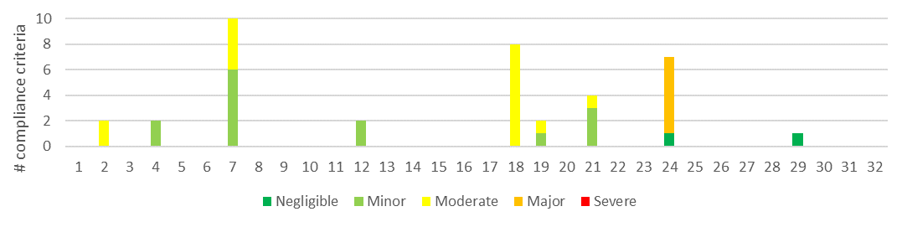
b) Number of compliance criteria with assessable environmental impact and the assessed level of impact for each instance of non-conformance.
Figure 4-14. Compliance findings and assessed environmental impact for instances of non-conformance for criteria applicable to road construction. The x-axis refers to the coupe numbers, as per Table 3-1.

Compliance elements related to in-coupe road and waterway crossing maintenance and closure
Only nine compliance criteria relevant to road maintenance or closure were considered in this audit (Appendix A), of which all but one was applicable to at least one coupe. Like compliance elements for road design and construction, they are largely concerned with protecting soil and water values from risks associated with the use of in-coupe roads, their closure following the completion of harvesting operations and the removal of any waterway crossings.
The average level of full conformance with applicable criteria was found to be 99%, with the level of conformance ranging between 75% (09 Quinn) and 100% (16 coupes; Figure 4-15). Non-conformance incidents with potential environmental impact were only recorded at 09 Quinn. Potential environmental impact of this incident (removal and non-reinstatement of a barrier to coupe entry) was assessed to be negligible.

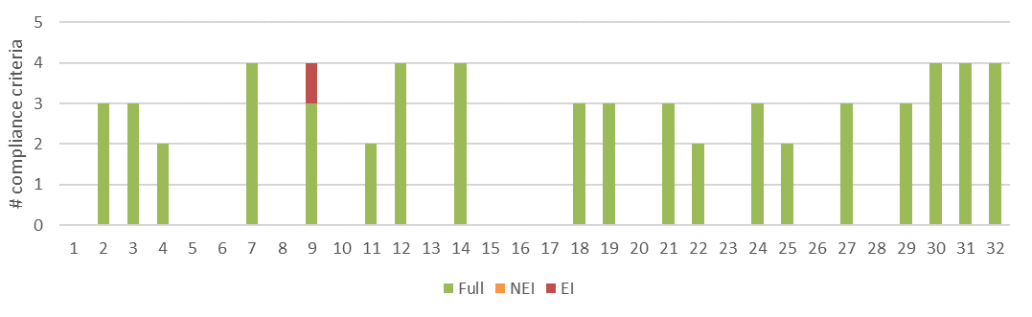
a) Level of conformance with audit criteria. Conformance definitions (Fully conforms [full], Non-conforming with no environmental impact [NEI], Non-conforming with environmental impact [EI]) as per Table 3-3.
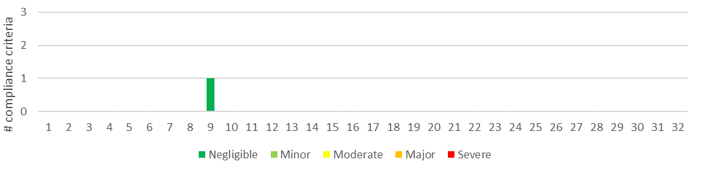
b) Number of compliance criteria with assessable environmental impact and the assessed level of impact for each instance of non-conformance.
Figure 4-15. Compliance findings and assessed environmental impact for instances of non-conformance for criteria applicable to road maintenance and closure. The x-axis refers to the coupe numbers, as per Table 3-1.

Compliance elements related to non-road infrastructure compliance theme
Compliance elements considered under the non-road infrastructure sub-theme have a similar function to those for in-coupe roading, in that they seek to protect soil and water values from risks associated with the construction, use and rehabilitation of snig tracks, boundary tracks and landings. Fifty-four audit criteria were identified, with all of these applying to at least one of the audited coupes.
The average level of full conformance with applicable criteria was found to be 96%, with the level of full conformance ranging between 81% (06 Real Madrid) and 100% (15 coupes; Figure 4-16). Non-conformance incidents with potential environmental impact were observed at 15 coupes, with the assessed level of potential environmental impact ranging to major.
Incidents assessed to have major and moderate potential environmental impact were observed at 06 Real Madrid, 13 Jandles and 16 Sheik (Figure 4-16). These related to:
- A culvert in the snig track waterway crossing at 06 Real Madrid (major potential environmental impact) discharges onto the fill batter, with water then running 1-2 m down to the elevation of the bed of the permanent stream. Sediment has been mobilised as a result, although at the time of audit, the batter slope seemed stable.
- A snig track crossed the path of a temporary stream at 13 Jandles without any formal crossing structure, leading to soil disturbance and sediment movement (Figure 5-2).
- Rehabilitation of the snig track waterway crossing at 16 Sheik has mobilised sediments into the temporary stream. Observations suggest coarse sediments from the crossing fill batter have moved up to 10 m from the crossing point.
These incidents were noted in Section 4.2.2.
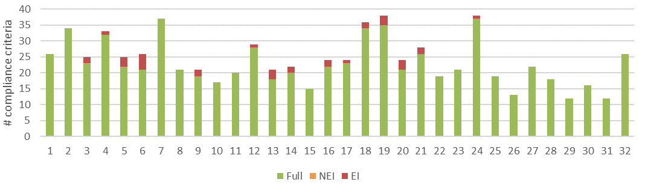
a) Level of conformance with audit criteria. Conformance definitions (Fully conforms [full], Non-conforming with no environmental impact [NEI], Non-conforming with environmental impact [EI]) as per Table 3-3.
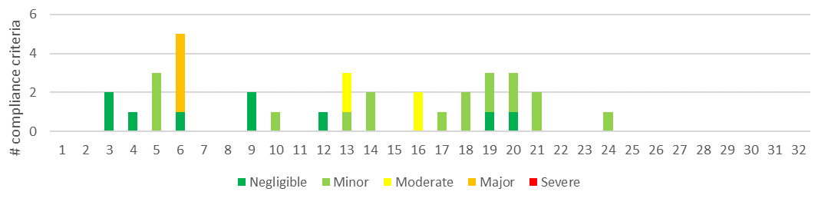
b) Number of compliance criteria with assessable environmental impact and the assessed level of impact for each instance of non-conformance.
Figure 4-16. Compliance findings and assessed environmental impact for instances of non-conformance for criteria applicable to coupe infrastructure. The x-axis refers to the coupe numbers, as per Table 3-1.

Discussion

Overall audit findings

Conformance with audit criteria and potential environmental impact
FAP audits are conducted to assess VicForests’ conformance with selected elements of the regulatory framework for timber harvesting activities in State forests, as well as any environmental risks posed by non-conformances. This section provides a summary of the audit’s overall findings in relation to these objectives.
The audit considered 32 coupes located in State forests distributed throughout eastern Victoria. Since coupe selection was weighted towards those with higher risk features (e.g., rainforest vegetation, waterway crossings, in-coupe roads, steeper slopes, more erodible soils), the findings of the audit are not necessarily statistically representative of VicForests’ operations overall.
The audit found that full conformance was achieved with 96% of applicable audit criteria overall (Figure 5-1). The level of full conformance varied between compliance themes, ranging between 93% (road construction) and 99% (road maintenance and closure). Non-conformances with direct or potential environmental impact were associated with 44 unique incidents at 20 of the 32 coupes included in the audit.
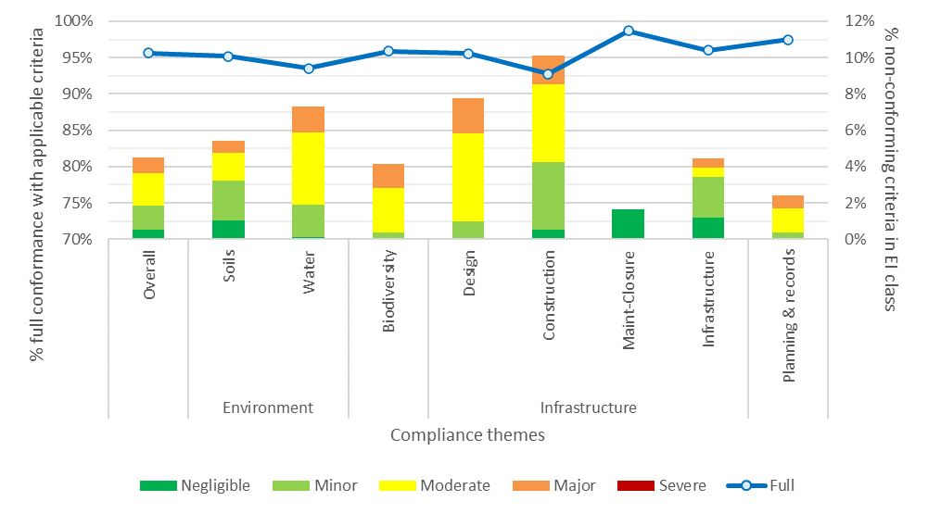
% full conformance with applicable audit criteria overall and in each coupe audit theme and sub-theme (left Y axis). % non-conformances in each potential environmental impact (EI) class overall and for audit themes and sub-themes (right Y axis)
Figure 5-1. Summary of overall audit findings for conformance with the regulatory framework for timber harvesting and related activities in State forests in Victoria.
Instances of non-conformance with audit criteria were identified across all audit themes and sub-themes (Figure 5-1). Non-conformances with potential environmental impact were most common (proportionally) in road construction, road design and water sub-themes. Overall, non-conformances with potential environmental impact were recorded for approximately 4% of applicable criteria.
Assessed environmental impact for non-conformances ranged between negligible and major. Three individual non-conformance incidents with major potential environmental impact were observed in the audit. These were observed at 06 Real Madrid, 10 Amity Island and 24 Bayled Up. Incidents with major potential environmental impact were reported against all compliance themes and sub-themes apart from road maintenance and closure (Figure 5-1).

Incidents resulting in non-conformances with audit criteria
Forty-four individual incidents that resulted in non-conformance assessments with audit criteria were observed overall in this year’s audit, of which three were assessed to have major potential environmental impact (Table 5-2). Each incident aligned with one or more of the audit themes or sub-themes. At least half of the incidents had potential impacts on soil and water values or related to non-road coupe infrastructure (Table 5-2). Of the three incidents assessed to have major potential environmental impact, all had potential to affect either terrestrial or aquatic biodiversity values and two had potential to affect water quality/riparian habitat and soils. They most-commonly resulted from issues related to design and construction of in-coupe road waterway crossings and mismatches between coupe planning and its implementation.
Table 5-1. Numbers of incidents resulting in non-conformances with audit criteria
Audit theme | Sub-theme | # incidents¹ | # incidents with major potential environmental impact¹
Overall |  | 44 | 3
Environment | Soils | 31 | 2
 | Water | 22 | 2
Biodiversity |  | 15 | 3
Infrastructure | Road design | 7 | 1
 | Road construction | 18 | 1
 | Road maintenance & closure | 1 | 0
 | Non-road infrastructure | 22 | 1
Planning & record keeping |  | 18 | 3
Note:
- Incidents may align with multiple audit themes/sub-themes.
Thirteen different incident types in this year’s audit were found to result in non-conformances with potential environmental impact (Table 5-2). Two types of incident were found to have up to major potential environmental impact and three additional incident types was found to have up to moderate potential environmental impact. Potential environmental impact ratings for these incidents reflect the sensitivity of the locations at which the incidents occurred, and, in some cases, the extent, severity and likely duration of actual impact. Incidents with major potential environmental impact were all associated with permanent streams or SPZ.
Table 5-2. Types of incident resulting in non-conformances with the regulatory framework that have potential or actual environmental impact, including comparison with 2019-20 and 2020-21 FAP audits (Jacobs, 2020; Jacobs,2021)
Type of incident | # incidents observed in FAP program |  |  | Maximum EI rating (2021-22) | Code (C) or MSP (M) reference
Type of incident | 2019-20 | 2020-21 | 2021-22 | Maximum EI rating (2021-22) | Code (C) or MSP (M) reference
- In-coupe road or snig track waterway crossing design, construction and/or rehabilitation does not conform with the regulatory framework, including culvert installation, management of road drainage in the vicinity of the crossing, rehabilitation of crossing.  Potential consequences: soil erosion, sediment deposition into waterways, impairment of aquatic habitat, reduced water quality. | 3 | 4 | 12 | Major | C2.2.1.2/6/7/8/12, 2.4.2.9, 2.4.6.2, M6.2.5.5, 6.2.4.1/2/4/5.6, 8.1.5.6
- Spacing of effective drains along snig or boundary tracks exceed permitted value (from UP) based on recorded soil erosion hazard and slope.¹  Potential consequences: soil erosion, sediment deposition into waterways, impairment of aquatic habitat, reduced water quality | 8 | 9 | 8 | Minor | C2.5.2.5
- Piles of slash, bark or other debris formed at landing in preparation for regeneration burning exceed prescriptions.  Potential consequences: damage to soil structure and chemistry due to heat of fire, poor regeneration and seedling recruitment | 0 | 5 | 5 | Minor | M7.2.4.2
- In-coupe road drainage structure spacing exceed permitted value based on recorded soil erosion hazard and slope. Slope of in-coupe road exceeds permitted range for soil erosion hazard.¹  Potential consequences: soil erosion, sediment deposition into waterways, impairment of aquatic habitat, reduced water quality | 5 | 4 | 4 | Minor | C2.4.2.5, M6.2.4.1
- Snig track constructed through flow path of temporary stream or other wet area that required protection from machinery disturbance.  Potential consequences: soil compaction, sediment mobilisation, reduced water quality, impairment of aquatic habitat. | 0 | 0 | 2 | Moderate | C2.2.1.2/3/8/15
- Regeneration burn has entered and/or affected exclusion areas within or adjacent to coupe and/or vegetation in exclusion areas/habitat patches has been damaged by regeneration or rough heap burn that remains within the planned burn boundary.  Potential consequences: soil erosion, sediment deposition into waterways, impairment of aquatic and terrestrial habitat, reduced water quality, loss of fire-sensitive biodiversity values. | 2 | 6 | 1 | Moderate | C2.2.1.2, 2.2.2.4/5, 2.5.1.2, M4.1.4.5, 7.1.2.3
- In-coupe road or landing cut or fill batter subject to mass movement and/or other form of erosion (as per Figure 5.2).  Potential consequences: soil mass movement and erosion, water quality and aquatic biodiversity impairment, damage to regenerating forest. | 4 | 4 | 2 | Moderate | C2.2.1.2/14/15, 2.4.3.3, M6.2.2.3
- Machinery entry into SPZ or other exclusion areas within or adjacent to coupe, including for unauthorised harvesting or construction of boundary or regeneration burning tracks.  Potential consequences: soil compaction/disturbance, reduction in habitat values. | 0 | 2 | 2 | Major | C2.2.1.2/5, 2.5.1.2, M3.5.1.1, 4.2.1.1, 7.1.2.1, P4.3.1.1
- Bark placed on uncorded snig track.  Potential consequences: impairment of regeneration, soil erosion. | 0 | 0 | 2 | Negligible | M7.2.1.2
- Controls for management of runoff and sediment from coupe to forest road drainage system and external waterways insufficient to prevent sediment movement.  Potential consequences: soil erosion, sediment deposition into waterways, impairment of aquatic habitat, reduced water quality. | 0 | 1 | 1 | Minor | C2.2.1.2/3/14, 2.2.4.1, 2.5.1.1
- Barrier to entry to coupe removed and not reinstated following regeneration activities.  Potential consequences: soil compaction and erosion, impairment of regeneration. | 0 | 0 | 1 | Negligible | M6.4.1.3
- Damage to snig track by traffic following initial rehabilitation.  Potential consequences: soil erosion, sediment mobilisation. | 0 | 0 | 1 | Negligible | M7.2.2.1
- Compacted area near landing not ripped during landing rehabilitation.  Potential consequences: soil compaction, impairment of regeneration | 0 | 0 | 1 | Minor | M7.2.2.6
- Rehabilitation of infrastructure (landing, snig track, in-coupe road) has contributed to soil mass movement and/or erosion.  Potential consequences: soil erosion, sediment deposition into waterways, impairment of aquatic habitat, reduced water quality, loss of production from regenerating forest. | 1 | 0 | 0 |  | C2.2.1.2/12/14, 2.5.1.2, M6.4.1.2, 7.2.2.2
- Tree felled into SPZ.  Potential consequences: minor damage to retained understorey vegetation. | 2 | 0 | 0 |  | C2.2.2.5, 2.1.5.2, M7.1.2.1
- Excessive soil disturbance associated with a snig/ regeneration burning track located in an area at which surface and sub-surface water flows converge.  Potential consequences: soil erosion, water quality impairment, impairment of regeneration. | 1 | 0 | 0 |  | C2.2.1.2
Note:
1. Some incidents of drainage spacings along snig or boundary tracks and in-coupe roads exceeding permitted values given slope and recorded soil erosion hazard were found at coupes in which the recorded soil erosion hazard was incorrect and overstated the actual hazard. While drain spacing may have been appropriate to the actual erosion hazard rating, the management action did not appropriately respond to the level of risk suggested by coupe planning documentation and hence was considered to a non-conformance with potential environmental impact.
Table 5-2 also compares the types of incident detected in this audit with the types and frequency of incidents detected in the two previous FAP audits (Jacobs, 2020; 2021). Eight of the ten most common types of incident with potential environmental impact observed in this audit have been observed in at least one of the two previous audits and all but one of these has been observed multiple times. Those incident types include:
- Effective drainage structure spacing on snig or boundary tracks and in-coupe roads exceeding MSP or UP prescriptions for slope and soil erosion hazard
- Inappropriately designed, constructed and/or rehabilitated waterway crossings
- Formation of excessively large piles of bark or slash at landings
- Incursion of regeneration burns into areas of retained vegetation, buffers or harvesting exclusion areas
- Mass movement and other forms of erosion of in-coupe road, landing or snig track fill or cut batters
- Machinery entry and/or harvesting in SPZ, riparian buffers or other planned exclusion areas
Almost all incidents identified in Table 5-2 pose a risk to soil, water and aquatic biodiversity values. Several threaten terrestrial biodiversity values and some (e.g., excessively large slash or bark piles, bark on snig tracks, in-coupe road or landing embankments experiencing mass soil movement) have capacity to affect the productive capacity of parts of the regenerating forest.
Several new types of incident were observed in this audit. The most significant of these related to the construction of snig tracks through the courses of temporary streams or other wet areas that required protection from disturbance by harvesting machinery (as per Code 2.2.1.2). The most significant of these incidents were observed at 05 Whitehorse and 13 Jandles (Figure 5-2). Snig tracks were constructed across naturally wet areas that were dry at the time of harvest. Heavy rain during winter and spring 2022 resulted in water flowing across the tracks and mobilising sediment, highlighting that management actions in constructing the tracks were not appropriate to the potential water quality risk.

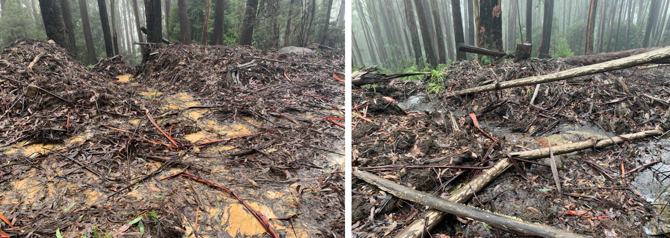
05 Whitehorse: Snig track constructed across naturally wet area in coupe. Snow and rain during winter 2022 resulted in water flowing across the track and, at some points, mobilising sediment towards a waterway.in a Barred Galaxia catchment.
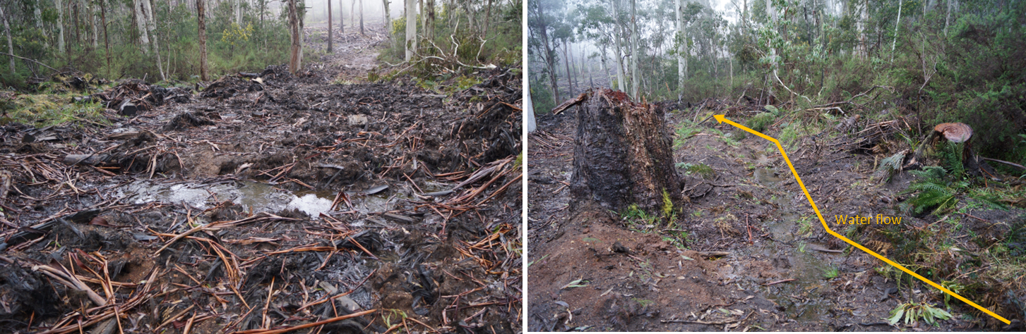
13 Jandles: Snig track constructed across the path of a temporary stream (to the right of the main photo). During the wet winter-spring of 2022, the temporary stream carried water, which drained onto and across the snig track
Figure 5-2. Examples where snig tracks have been constructed across wet areas in coupes (05 Whitehorse) or temporary streams (13 Jandles) that were most likely dry at the time. Subsequent wet conditions have resulted in water flowing across the tracks and mobilising sediment.

Comparison with previous audits
Coupe selection for the FAP is risk-based, rather than randomised. This means that audit results are not necessarily statistically representative of VicForests’ operations overall and may not be directly comparable between years. Comparisons between past audits are further confounded by the modification of aspects of the EIA tool and inclusion, in the 2019-20 audit, of 15 coupes from Western Victoria RFA region, which have a different compliance profile to RFA regions in eastern Victoria (Jacobs, 2020b; as represented by coupes in the Central Highlands RFA region).
However, since there has been a broadly consistent approach to coupe selection and compliance criteria for all audit sub-themes for audits going back to 2018-19 and for environmental, biodiversity and roading themes to 2017-18, there is some basis for comparison of audit results over time for coupes in the Central Highlands RFA region (Table 5-3). Table 5-4 provides a complementary analysis for all audit coupes in eastern Victoria, regardless of their distribution between the respective RFA regions.
The overall level of full conformance for Central Highland RFA region coupes in this audit was 95%, compared with 83-94% in the four preceding FAP audits. Performance in the most recent audit was equivalent to or greater than the best previous full conformance rating for six of the eight audit themes and sub-themes and slightly less than the highest previous full conformance rating for biodiversity and road maintenance/closure (Table 5-3).
The count of non-conformances with potential environmental impact overall was greater in the current audit than in 2020-21 and 2017-18. The number of non-conformances with major potential environmental impact was greater than in previous recent audits, apart from 2018-19 (21 non-conformances with major potential environmental impact in the current audit, compared with 6, 1 and 5, in 2020-21, 2019-20 and 2017-18, respectively; Table 5-3). The high incidence of non-conformances with major potential environmental impact in the current audit mainly reflects defects with in-coupe road waterway crossings (Table 5-4).
When all audit coupes in eastern Victorian RFA regions are considered in the assessment (Table 5-4), the percentage of full conformance with applicable audit criteria is better overall in 2021-22 than in the previous four audits and better for most of the audit themes and sub-themes. However, there was a much higher count of non-conformances with major potential environmental impact in the current audit (overall and for several themes or sub-themes) than in the two previous audits. As noted, this mainly reflects defects with in-coupe road waterway crossings.

Table 5-3. Comparison of results for recent Forest Audit Program Audits: Central Highlands RFA region coupes only
 | % Full conformance with applicable audit criteria |  |  |  |  | # Non-conformances with potential environmental impact | # Non-conformances with major potential environmental impact¹
# Central Highlands RFA region coupes |  |  |  |  |  | 12 | 14 | 15 | 12 | 14
FAP compliance theme and sub-theme | 2017-18² | 2018-19³ | 2019-20⁴ | 2020-21⁵ | 2021-22 | 2017-18² | 2018-19³ | 2019-20⁴ | 2020-21⁵ | 2021-22
Overall⁶ | 90% | 83% | 94% | 93% | 95% | 24 | 5 | 71 | 24 | 54 | 1 | 41 | 6 | 47 | 11
Environment
- Soils | 90% | 76% | 93% | 91% | 93% | 12 | 0 | 32 | 2 | 24 | 0 | 18 | 0 | 17 | 2
- Water | 90% | 84% | 94% | 93% | 94% | 15 | 0 | 43 | 12 | 15 | 0 | 19 | 0 | 21 | 4
Biodiversity | 90% | 81% | 97% | 93% | 94% | 5 | 0 | 17 | 13 | 7 | 1 | 16 | 5 | 18 | 7
Infrastructure
- Road design | 74% | 58% | 81% | 87% | 94% | 2 | 0 | 7 | 1 | 7 | 0 | 1 | 0 | 4 | 0
- Road construction | 91% | 80% | 85% | 84% | 92% | 12 | 0 | 24 | 5 | 29 | 0 | 11 | 0 | 16 | 0
- Road maintenance & closure | 79% | 85% | 96% | 88% | 96% | 3 | 0 | 7 | 2 | 0 | 0 | 4 | 0 | 1 | 0
- Non-road⁷ | n/a | 88% | 89% | 93% | 95% | n/a | 12 | 0 | 18 | 0 | 14 | 0 | 15 | 4
Planning & record keeping⁷ | n/a | 90% | 94% | 97% | 98% | n/a | 11 | 6 | 19 | 1 | 5 | 2 | 12 | 5
Notes:
- Note that individual incidents may give rise to non-conformances against more than one audit criterion.
- Jacobs, 2019
- Jacobs, 2020a
- Jacobs, 2020b
- Jacobs, 2021
- The overall assessment result for the 2017-18 audit is based on the environment, biodiversity and roading themes, whereas the overall assessments for all subsequent audits also include non-road infrastructure and planning and record keeping themes. Results for 2017-18 are therefore not directly comparable with those for subsequent audits.
- Non-road infrastructure and planning and record keeping themes were not within the scope of the 2017-18 audit.
Table 5-4. Comparison of results for recent Forest Audit Program Audits: all coupes in eastern Victorian RFA regions
 | % Full conformance with applicable audit criteria |  |  |  |  | # Non-conformances with potential environmental impact | # Non-conformances with major potential environmental impact¹
FAP compliance theme and sub-theme | 2017-18² | 2018-19³ | 2019-20⁴ | 2020-21⁵ | 2021-22 | 2017-18² | 2018-19³ | 2019-20⁴ | 2020-21⁵ | 2021-22⁸
Overall⁶ | 91% | 84% | 94% | 94% | 96% | 44 | 4 | 156 | 31 | 54 | 1 | 81 | 6 | 106 | 21
Environment
- Soils | 87% | 74% | 93% | 92% | 95% | 25 | 2 | 76 | 2 | 24 | 0 | 40 | 0 | 32 | 4
- Water | 90% | 81% | 94% | 91% | 94% | 29 | 4 | 103 | 16 | 15 | 0 | 51 | 0 | 57 | 11
Biodiversity | 92% | 84% | 97% | 95% | 96% | 5 | 0 | 23 | 18 | 7 | 1 | 28 | 5 | 34 | 11
Infrastructure
- Road design | 81% | 67% | 81% | 89% | 96% | 5 | 0 | 12 | 1 | 7 | 0 | 4 | 0 | 8 | 2
- Road construction | 92% | 81% | 85% | 86% | 92% | 23 | 0 | 53 | 5 | 29 | 0 | 25 | 0 | 38 | 6
- Road maintenance & closure | 71% | 83% | 96% | 88% | 99% | 6 | 0 | 14 | 2 | 0 | 0 | 11 | 0 | 1 | 0
- Non-road⁷ | n/a | 84% | 89% | 95% | 96% | n/a | 42 | 0 | 18 | 0 | 25 | 0 | 34 | 4
Planning & record keeping⁷ | n/a | 92% | 94% | 97% | 98% | n/a | 19 | 10 | 19 | 1 | 13 | 2 | 33 | 10
Notes 1-7 as per Table 5-3
- The 2021-22 audit included 32 coupes, whereas all previous audits included 30 coupes.

Fire salvage harvesting
This and the previous audit included coupes harvested under MSP fire salvage provisions (MSP Section 8). Fire salvage prescriptions prioritise harvesting of more severely burnt forests, enable harvesting (in Ash forests) to be conducted in larger coupes and provide additional protections to regenerating understorey, soils and water quality. Fifteen fire salvage coupes were included in the audit. These were located in East Gippsland (7 coupes), Tambo (1 coupe) and North East (7 coupes) FMAs and all were affected by fires during the summer of 2019-20. A summary of the results of conformance with fire salvage prescriptions for these coupes is given in Figure 5-3.
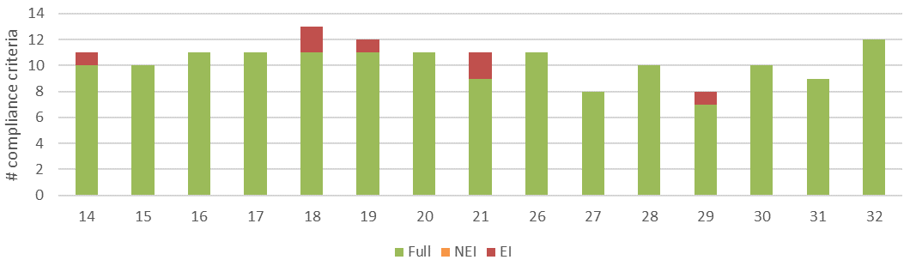
a) Level of conformance with audit criteria. Conformance definitions (Fully conforms [full], Non-conforming with no environmental impact [NEI], Non-conforming with environmental impact [EI]) as per Table 3-3.
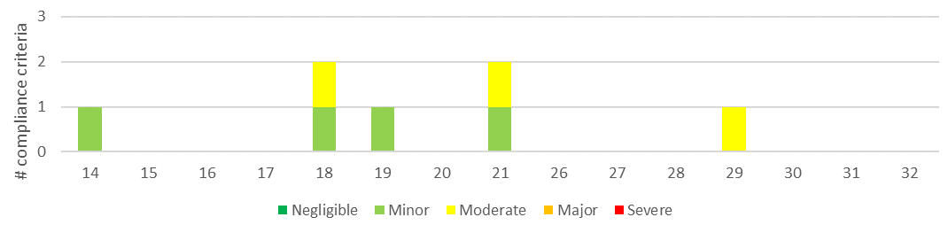
b) Number of compliance criteria with assessable environmental impact and the assessed level of impact for each instance of non-conformance.
Figure 5-3. Compliance findings and assessed environmental impact for instances of non-conformance for fire salvage prescription criteria. The x-axis refers to the coupe numbers, as per Table 3-1. Fifteen of the 32 coupes included in the audit were subject to fire salvage prescriptions.
The average level of full conformance with applicable fire salvage prescriptions was 96%, which is similar to the overall level of full conformance for all aspects of the regulatory framework. The level of full conformance ranged between 82% (21 Dow Jones) and 100% (10 coupes). Non-conformances with potential environmental impact were observed at five of the 15 fire salvage coupes, with the assessed level of impact being either minor or moderate (Figure 5-3).
Non-conformances with fire salvage prescriptions resulted from seven individual incidents on five of the 15 coupes. Four of these related to excessive spacing between effective drainage structures on snig tracks (three incidents) or the in-coupe road (one incident). Two incidents related to waterway crossings and one incident involved harvesting in the planned riparian buffer (29 Pinball Wizard).
One of the waterway crossing incidents (21 Dow Jones) relates to the crossing of a drainage line by the in-coupe road. The crossing did not have drainage structures to take water away from the waterway at 20-40 m from the crossing point. As the crossing was of a drainage line, this would ordinarily not be inconsistent with the MSPs. However, under salvage harvesting prescriptions (MSP 8.1.5.6), in restricted access and special water supply catchments a drainage structure must be located “between 20 m to 40 m upslope of where a road or vehicle route crosses any waterway”. As such, the drainage interception structures are required in advance of waterway crossings on drainage lines, as well as temporary and permanent streams.
Discussion with VicForests staff accompanying some of the audits of fire salvage coupes highlighted ambiguity in appropriate drain spacing on in-coupe roads and snig tracks. As per MSP 8.1.5.4, buffer and filter widths in salvage coupes assume high or very high water quality risk, regardless of the actual soil conditions. On this basis VicForests staff typically assume that soil erosion hazard is also set to high and that drain spacings on in-coupe roads and snig and boundary tracks reflect their slope and high soil erosion hazard. This is not explicitly required by MSP 8.1.5.5, which requires that “drainage structures for all coupe and haulage infrastructure (are installed) at an appropriate frequency to mitigate increased risks to water quality due to potential sediment loads associated with water flow in the fire affected terrain”. Assuming soil erosion hazard is high is a precautionary response to the risk posed by infrastructure to water quality, as the areas onto which road or track drainage is disposed are likely less able to infiltrate it. However, the conditions on the roads and tracks themselves are not necessarily different to those in unburnt areas.

Recommendation D-01: Moderate priority
That DEECA review MSP fire salvage prescriptions and explicitly define how soil erosion hazard is to be treated in fire salvage coupes, including for spacings between drainage structures on in-coupe roads and snig or boundary tracks.

Precautionary principle
The Code 2.2.2.2 states,
The precautionary principle must be applied to the conservation of biodiversity values. The application of the precautionary principle will be consistent with relevant monitoring and research that has improved the understanding of the effects of forest management on forest ecology and conservation values.
The Code’s glossary defines “precautionary principle” to mean that if there are threats of serious or irreversible environmental damage, lack of full scientific certainty should not be used as a reason for postponing measures to prevent environmental degradation. In his findings on Environment East Gippsland Inc v VicForests, Osborn (2010) identified requirements to consider on-going monitoring and research and the advice of relevant experts at all stages of planning and operations. This was coupled with a requirement to modify coupe size and dispersal in the landscape, as appropriate. Osborn (2010), drawing on legal precedent, also found that the precautionary principle was triggered where there was a threat of serious or irreversible environmental damage and there is the requisite degree of scientific uncertainty.
The specification for the 2022 Forest Audit Program included a request to consider compliance measures under the precautionary principle for audit coupes in East Gippsland FMA. It listed species to be considered and posed four questions, as follows:
- To what extent where pre-harvest flora and fauna surveys undertaken at each coupe?
- Where habitat distribution modelling indicates that a coupe is likely to contain habitat for species of concern to what extent was that species considered by VicForests in pre-harvest surveys or coupe planning?
- Where pre-harvest surveys were undertaken who did them? Forest Protection Survey Program (FPSP), VicForests staff, or a third-party contractor?
- Where a species was identified (or presumed to be present) was/were suitable protection(s) put in place?
Application of these questions to the eight East Gippsland FMA coupes is summarised in Table 5-5 and below.

Preharvest flora and fauna surveys
Digital FCPs prepared by VicForests for each of the eight East Gippsland coupes lists observations of threatened species recorded within and/or within 500 m of the coupe. In most cases these were apparently from Victorian Biodiversity Atlas (VBA) records or VicForests observations (particularly the calls of large owls were heard within or near the coupe). The FCPs noted that preharvest surveys conducted under DEECA’s (then DELWP’s) Forest Protection Survey Program (FPSP) were undertaken for just two of the coupes (25 Lior, 30 Plastic Moon; Table 5-5). The plans for these coupes report species that were identified and not those that were searched for. It is not apparent from FCP records that any surveys were specifically conducted by VicForests to identify the presence of threatened species or their habitat.
Locations of threatened species records (from prior VBA observations or FPSP surveys) are typically shown in the Operations Maps prepared by VicForests and provided to contractors.
Seven of the eight East Gippsland coupes (all but 25 Lior) were extensively affected by the 2019-20 bushfires and harvested under fire salvage prescriptions. In that context, pre-harvest surveys in those coupes would likely have been inappropriate, due both to the effects of the fires on fauna and flora and safety concerns for those conducting the surveys.

Application of habitat distribution models
Digital FCPs for all eight coupes record extensive use of habitat distribution models (HDM; see Table 5-5) to identify threatened flora and fauna species that may be present on the coupe (or may have been, but for the effect of the 2019-20 bushfires) and demonstrate application of the precautionary principle. The FCPs appear to only record the use of HDM where the coupe intersects modelled habitat and hence do not necessarily reflect either the full effort to identify whether threatened flora and fauna may be present or to apply the precautionary principle.

Management responses
Section 4 of the digital FCPs includes the outcomes of values checking applicable to the coupe and specifies how any values present are to be managed. Part 4 of the values checking section addresses biodiversity values and includes details on threatened ecological vegetation communities (e.g., rainforest, MRT), threatened flora and fauna species and the presence of large or giant trees.
Specific management responses are provided for each threatened species record and where HDMs indicate the likely presence of a threatened species. These responses (see Table 5-5) for the eight East Gippsland coupes fell into several categories:
- Riparian buffers and reserves: these were provided in all cases where species using waterways (e.g., Long-footed Potoroo (LFP), large frogs, crayfish, galaxids) were identified in records or habitat models. Buffer widths were based on either LFP prescriptions or fire salvage prescriptions for catchments in where galaxids are present.
- Silvicultural regime: all coupes were managed under VicForests adaptive silviculture for variable retention 1 system. This involves retention of habitat patches and at least 10 retained trees per hectare. In several of the coupes, 40% of the pre-harvest basal area was to be retained. These management actions appear to have been considered appropriate for the protection of a wide range of threatened species, including gliders, large owls and threatened flora.
- Creation of SPZ/SMZ: these would be created if nesting or roosting sites for large owls were identified. While the FCP included provision for these, no nesting or roosting sites were identified within the coupes and so no new SPZ or SMZ were created.
Observations during the field audits indicate that the proposed protection measures were put in place. In some cases, it was proposed that retained habitat be surrounded by mineral earth fire breaks to protect them from any effects of regeneration burning. While mineral earth breaks were present in some instances, these were not generally applicable due to the effects of the 2019-20 bushfires.

Application of precautionary principle
The analysis provided above and in Table 5-5 demonstrates the application of the precautionary principle to VicForests operations in East Gippsland. Direct observations and a wide suite of habitat models were used to identify threatened species that may be present within the coupe and specific management responses were proposed. Management of the coupe responds to the risks posed by timber harvesting to threatened species that may be present, by creating harvesting exclusion areas (riparian reserves and buffers, habitat patches) and modifying harvesting practice (by retaining potential habitat trees and high levels of basal area).
It is beyond the scope of the audit to assess the efficacy of the management actions.

Table 5-5. Application of precautionary principle to coupes in East Gippsland FMA
Coupe | Pre-harvest flora and fauna survey observations | Habitat distribution model species identified | Survey entity | Protection measures proposed
25 Lior | Yellow-bellied Glider (YBG)  Masked Owl (MO; heard within 500m of coupe) | YBG, Barred Galaxia (BGlx), Giant Burrowing Frog (GBF), Powerful Owl (PO), MO, Sooty Owl (S0), Glossy Black Cockatoo (GBC) | Forest Protection Survey Program (FPSP), VicForests | Riparian buffer for YBG, BGlx, GBF  Adaptive silviculture for variable retention 1, with 10 retained trees/ha and habitat patches with mineral earth fire breaks retained for YBG, PO, MO, SO, GBC  SPZ and SMZ to be created if MO roosting or nesting site observed
25 Lior | Coupe observations:  - Protection measures in place. Mineral earth fire breaks established, but now partially regrown. No regeneration burning  - Not a fire salvage coupe
26 Electromotive | YBG (VBA record)  SO (heard within coupe)  Long-footed Potoroo (LFP, VBA record)  Orbost Spiny Crayfish (OSC, VBA record) | SO, Spot-tailed Quoll (STQ), Greater Glider (GG), YBG, LFP, GBF, Large Brown Tree Frog (LBTF), OSC, Smooth Geebung (SG) | VicForests, VBA records | LFP, OSC, GBF, LBTF reserve/buffer along waterway  Adaptive silviculture for variable retention 1 and habitat patches with mineral earth fire breaks retained, 40% basal area retention and 10 retained trees/ha for SO, STQ, GG, YBG, SG  SPZ and SMZ to be created if SO roosting or nesting site observed
26 Electromotive | Coupe observations:  - Protection measures generally in place. Mineral earth fire breaks not established or required in fire salvage coupe
27 Grandfinal | LFP (VBA record)  STQ (VBA record near coupe) | PO, MO, SO, STQ, GG, YBG, GBF, OSC, SG | VBA records | LFP, GBF, OSC reserve/buffer along waterway  Adaptive silviculture for variable retention 1 and habitat patches with mineral earth fire breaks retained, 40% basal area retention and 10 retained trees/ha for PO, MO, SO, STQ, GG, YBG
27 Grandfinal | Coupe observations:  - Protection measures in place. Mineral earth fire breaks established, but now partially regrown. No regeneration burning as fire salvage coupe
28 Scarface | None completed due to fire impacts | Upright Pomaderris (UPom), PO, SO, STQ, GG, YBG, LFP, OSC | N/a | LFP, OSC riparian buffer  Adaptive silviculture for variable retention 1 and habitat patches retained and 10 retained trees/ha for UPom, PO, SO, STQ, GG, YBG
28 Scarface | Coupe observations:  - Protection measures generally in place. Mineral earth fire breaks not established or required in fire salvage coupe
29 Pinball Wizard | YBG (VBA records) | YBG | VBA records | Adaptive silviculture for variable retention 1 and habitat patches with mineral earth fire breaks retained and 10 retained trees/ha for YBG  Within THB section large hollow bearing trees retained for YBG unless unsafe
29 Pinball Wizard | Coupe observations:  - Protection measures in place
30 Plastic Moon | East Gippsland Spiny Crayfish (EGSC), SO | PO, GG, YBG, LFP, GBF, LBTF, EGSC | FPSP | EGSC, LFP, GBF, LBTF reserve/buffer along waterway  SO Management Area within 400m of coupe, SPZ/SMZ to be created if SO nesting or roosting sites identified  Adaptive silviculture for variable retention 1 and habitat patches retained and 10 retained trees/ha for PO, GG, YBG. Mineral earth breaks constructed around habitat patches
30 Plastic Moon | Coupe observations:  - Protection measures generally in place. Mineral earth fire breaks not established or required in fire salvage coupe
31 Harkerscorner | SO (heard within coupe)  YBG (VBA records) | PO, SO, STQ, GG, YBG, LFP, GBF, LBTF, EGSC, SG, Elegant Daisy, (ED) | VBA records | LFP, GBF, LBTF, EGSC reserve/buffer along waterway  SPZ and SMZ to be created if SO roosting or nesting site observed  Adaptive silviculture for variable retention 1 and habitat patches retained and 10 retained trees/ha for YBG, SO, PO, SG, ED.
31 Harkerscorner | Coupe observations:  - Protection measures in place
32 Paw Print | PO (heard within 500m of coupe)  YBG (VBA record – within 500m of coupe)  LFP site (VBA record) | SO, STQ, GG, YBG, LFP, LBTF, EGSC, Forest Geebung (FG), Veined Pomaderris (VP) | VBA records | SPZ and SMZ to be created if PO roosting or nesting site observed  LFP, LBTF, EGSC reserve/buffer along waterway  Adaptive silviculture for variable retention 1 and habitat patches retained and 10 retained trees/ha for SO, STQ, YBG, FG, VP. Large habitat tree incorporated into patch. Mineral earth fire break around retained patches. 40% basal area retained.
32 Paw Print | Coupe observations:  - Protection measures in place. Mineral earth fire breaks overgrown at time of audit, although not required in fire salvage coupe

There is a potential shortcoming in record-keeping in relation to the application of the precautionary principle in that the FCP only appears to only record the results of successful searches for threatened species using surveys and HDM. This is considered appropriate for the FCP, given that it is directed towards management of coupe activities and the protection of values that may be present. However, unless other records are retained of the full extent of searches using surveys and habitat modelling, full evidence of the application the precautionary principle may not be available.

Recommendation V-01: High priority
That VicForests retain records of the full search effort, using surveys and habitat modelling, to identify threatened species that may be present within a coupe or may be affected by nearby harvesting activities.

Potential improvements in coupe planning, harvesting and rehabilitation practices
Observations from the current audit and reflections on non-conformance incidents from previous audits suggests several potential areas for improvement in coupe planning, timber harvesting and coupe rehabilitation practices, as discussed below. Most of these issues have been considered in previous FAP audit reports prepared by this audit team (e.g., Jacobs 2018; 2019; 2020a; 2020b; 2021).

Coupe planning
As noted in our previous audit (Jacobs, 2021) coupe planning and its documentation by VicForests typically conforms well with Code and MSP requirements. Most planning-related non-conformance issues with potential environmental impact result from the operations not following what was planned, rather than any specific planning shortcomings.
Previous audits have commented on potential improvements in coupe planning practice, including the explicit mapping of waterway classification, inclusion of slope mapping in steeper areas within coupes and inclusion of geology maps for coupes in East Gippsland to confirm identification of granite-derived soils. While experience is variable across VicForests, these issues are generally addressed and coupe planning has continued to improve.
Use of FPSP outcomes and HDM (as discussed in Section 5.4) in coupe planning has strengthened the application of the precautionary principle in the protection of threatened ecological values and, improved planning for the protection of biodiversity values.

Design, construction and maintenance of waterway crossings
FAP audits by this team have consistently identified deficiencies in the design, construction, maintenance and/or rehabilitation of waterway crossings (see Table 5-2). Defects in in-coupe road and snig track waterway crossings have been the most material issues identified in many of our previous audits and have accounted for a large proportion of the non-conformances with major potential environmental impact that have been observed. Only in a few cases has this reflected the level of actual environmental impact. However, it highlights the sensitivity of the locations at which the crossings are constructed and the need for carefully considered design, sound construction and appropriate maintenance and rehabilitation.
Non-conforming waterway crossings were relatively infrequent in the two most recent audits, reflecting both reduced incidence of crossings and improving practice. Waterway crossings were considerably more common in this year’s audit, with 12 of 32 coupes having either (or both) snig track or in-coupe road waterway crossings, compared with just four of 30 coupes in 2020-21. Waterway crossing incidents were also the equal most common type of incident observed in the current audit and the main source of non-conformances with major potential environmental impact (Table 5-2). Examples of some of the deficiencies are provided in Figure 4-3 (02 Dragonfly), Figure 4-4 (07 Lemon Lime), Figure 4-6 (24 Bayled Up), Figure 4-7 (04 Sun Downies, 19 Rossignol) and Figure 4-8 (18 South Buck).
While there were multiple examples of deficient waterway crossing design and construction, examples of good practice in waterway crossing design and construction were observed (Figure 5-4; 02 Dragonfly, 19 Rossignol, 24 Bayled Up). Some good practice examples were present on the crossings that also had significant defects.
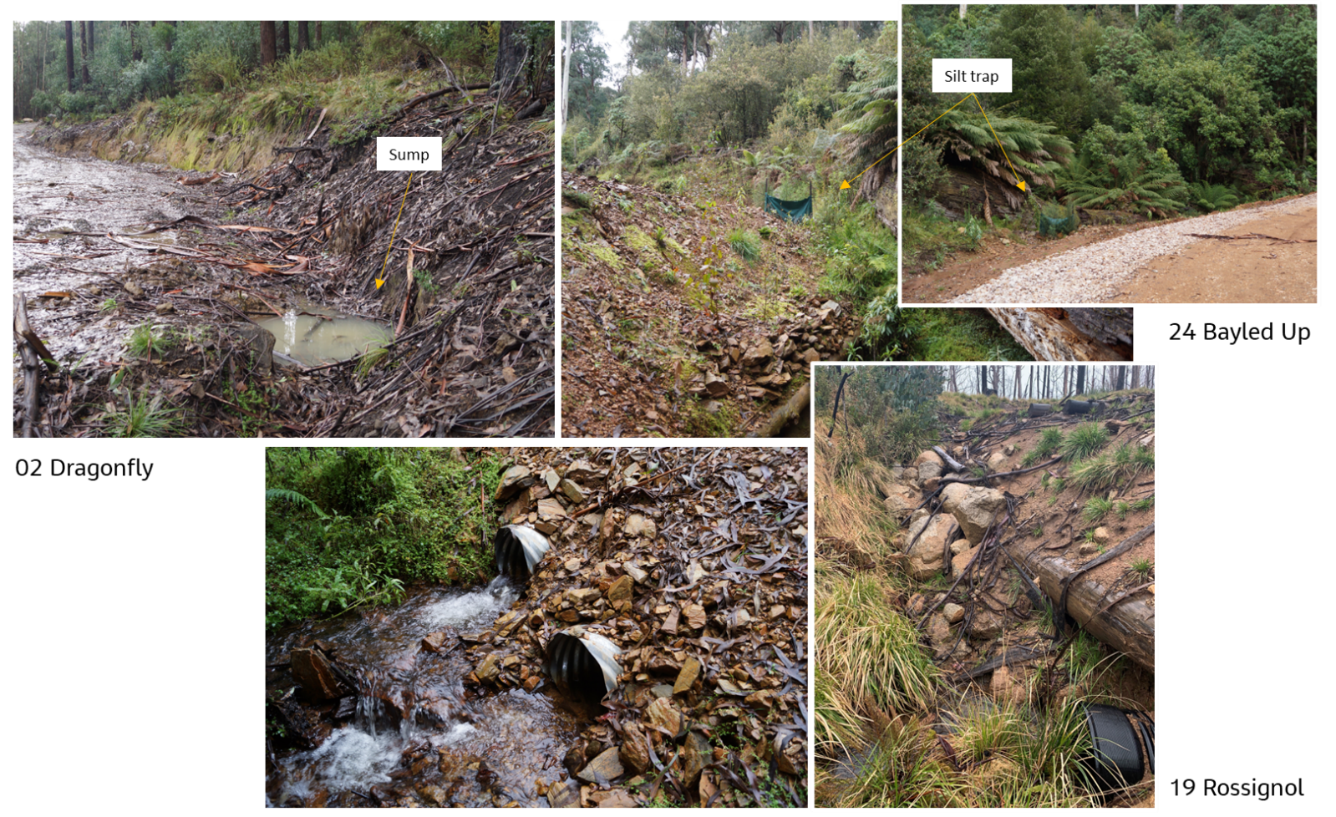
The photographs highlight examples of good practice in waterway crossing design and construction, including: a) the use of sumps (02 Dragonfly) or b) silt traps (24 Bayled Up) to intercept water that cannot be readily diverted onto retained vegetation before entering the waterway, as well as the c) placement of waterway crossing culverts outlets at the downstream bed height (19 Rossignol, 24 Bayled Up).
Figure 5-4. Examples of good practice in waterway crossing construction
All of the rehabilitated crossings observed in this audit were for snig track crossings. These were mostly stable and undertaken appropriately (e.g., 07 Lemon Lime), although in some cases (e.g., 20 Sheik), high water flows due to rain and snow fall had mobilised some of the retained fill batter sediments into the waterway (Figure 5-5).
In most of our recent audit reports, we have provided comments and recommendations regarding waterway crossing design, construction and rehabilitation. We suggest that these (e.g., Jacobs, 2018; 2020a;2020b; 2021) be revisited and applied to improve the quality and consistency of VicForests practice in relation to waterway crossings. VicForests developed new procedures and instructions for the planning, design and construction of in-coupe roads (O’Reilly, 2019). While the instruction addresses waterway crossings, we found no direct reference to these procedures in our review of coupe plans and are hence unsure of the extent to which this document has directly influenced VicForests’ crossing design or construction practices.

Recommendation V-02: High priority
That VicForests develop and implement an initiative to improve the quality and consistency of waterway crossing design, construction, maintenance and rehabilitation, addressing both in-coupe road and snig track crossings.
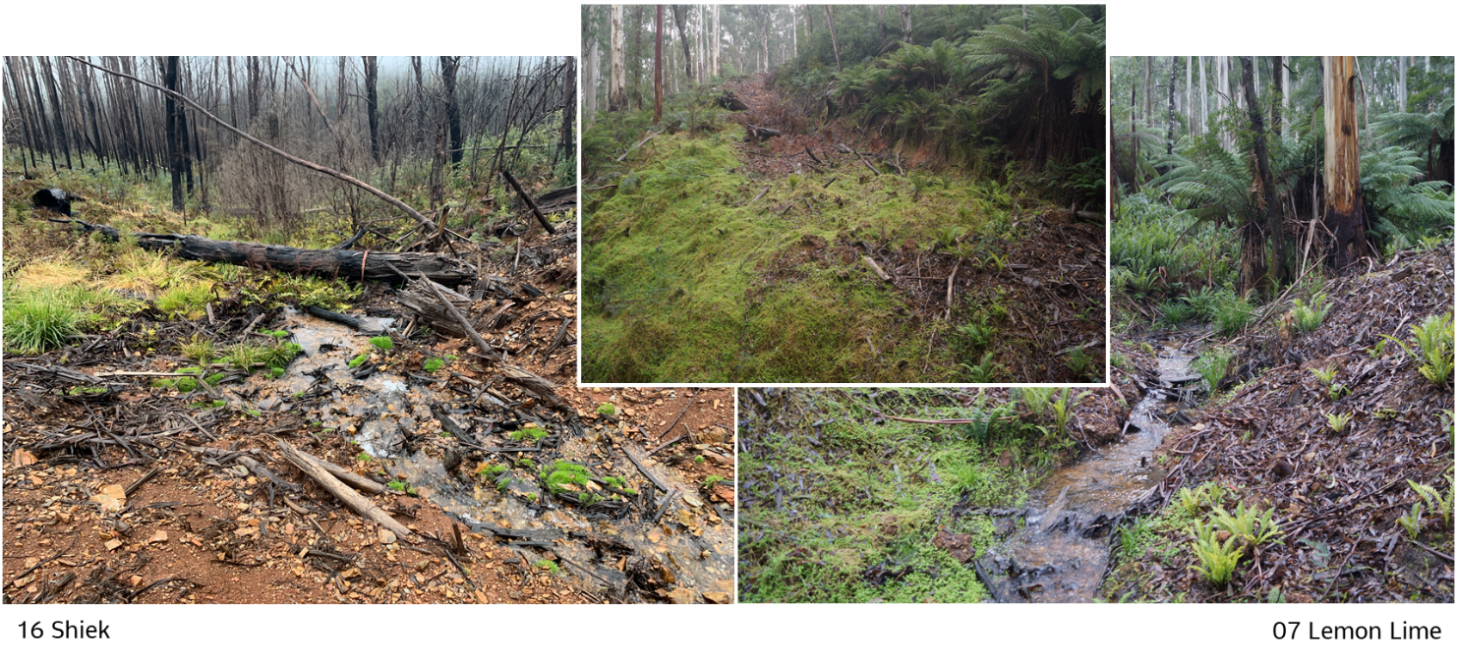
Recent heavy rain and snowfall has resulted in flows eroding fill batter sediments from the rehabilitated crossing used to extract logs from 16 Sheik. The rehabilitated crossing in steep country at 07 Lemon Lime effectively intercepts flows along the track (inset) and despite recent heavy rain and snow fall has retained most of the sediment at the crossing location.
Figure 5-5. Rehabilitated snig track crossings

In-coupe road and snig track drainage
Table 5-2 highlights that this and other recent audits have identified numerous instances where the spacing between effective drainage structures exceeds MSP or UP requirements (for in-coupe roads and snig/boundary tracks, respectively). These occur due to both the failure of drainage structures (often resulting from post-rehabilitation traffic) and failure to construct them at spacings appropriate to the slope and soil erosion hazard. These types of non-conformances typically have relatively low potential environmental impact (i.e., mostly negligible or minor), but are common. Most (apart damage resulting from post-rehabilitation traffic) could be identified during coupe monitoring and rectified relatively easily prior to machinery leaving the coupe.

Snig tracks through wet areas
The audit team observed several instances where snig tracks were constructed through naturally wet areas in coupes (e.g., 05 Whitehorse, 13 Jandles; Figure 5-2) – that were reportedly dry at the time of construction. This was generally done to avoid construction of in-coupe roads and the significantly increased expense and level of disturbance they entail. While the audit team considered these decisions to be appropriate, experience suggests that placement, design, construction and/or management of the tracks did not always appropriately consider the amount of water that may pass through these areas during winter.
At the time of audit, the track in 05 Whitehorse had multiple points of flow across it and the track in 13 Jandles was found to cross the path of a temporary stream. The result was significant soil disturbance and mobilisation of sediment towards/into streams.
It might be argued that the conditions immediately preceding the audit were exceptionally wet and that the wet areas traversed by some snig tracks were only wet because of anomalously high rainfall. It might then be argued that the tracks would have been located appropriately under “average” conditions.
We tested this hypothesis by examining rainfall records for locations "near” target coupes (Figure 5-6). At the time of audit, monthly rainfall was about average (hence cumulative anomaly curve was more or less flat) in all regions but North East RFA region. This suggests the run-off across the snig track in 05 Whitehorse might be expected under the typically wet winter conditions, whereas the situation observed at 13 Jandles might reflect unusually wet conditions (Figure 5-2).
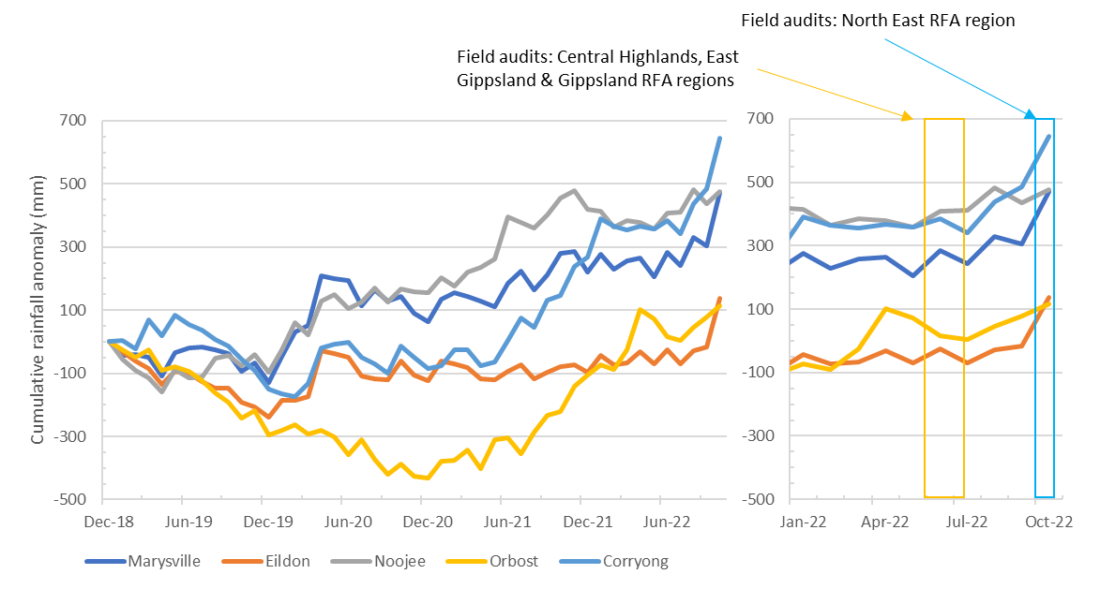
Notes:
Rainfall anomaly is the difference between long-term average monthly rainfall and the rainfall recorded in that month. The cumulative anomaly is the cumulative difference between actual and average monthly rainfall, with December 2018 as the starting point. An upwards trending graph indicates consecutive months of above average rainfall.
Data sourced from Bureau of Meteorology weather stations: 088044 for Marysville, 088023 for Eildon, 085292 for Noojee, 084093 for Orbost and 072162 for Corryong.
Figure 5-6 Cumulative monthly rainfall anomalies for locations “near” coupes targeted for audit.
In placing snig tracks through naturally wet areas (evident from landform, drainage line presence, vegetation), VicForests and their contractors need to carefully consider potential overland and underground water flow paths, the possibility that the track will need to be used during/following wet weather and the resulting risk of soil disturbance. Planning for snig tracks constructed in such sensitive areas needs to consider how to minimise soil disturbance and sediment mobilisation during wet periods, including periods that are significantly wetter than average.

Landing rehabilitation
In both this and the previous audit, there were five recorded incidents where bark and debris piles formed during rehabilitation of landings were significantly larger than the limits specified in the MSPs (7.2.4.2; 4 m² ground area, 10 m³ volume; Table 5-2). If left unburnt, they occupy space within the regenerating coupe that might otherwise be occupied by trees or understory vegetation. While they occupy significant space in a concentrated area near landings, they occupy very little of the coupe overall and are typically assessed to have no more than minor potential environmental impact. Figure 5-7 provides examples of incidents of this type observed at 03 Gnu and 21 Dow Jones.
It is not clear what the basis for the 4 m² and 10 m³ limits is. Our recommendation D-01 from the 2020-21 FAP audit proposed that DEECA review and reconsider the volume limit on slash piles, particularly for rough heaping operations. That recommendation could be extended to ground area, as it is not clear that more smaller bark heaps are better than fewer larger heaps.
VicForests reported that they were unable to burn these heaps during autumn 2022 (or undertake other regeneration burning activities) and hence unable to rectify any potential environmental impacts from their presence.
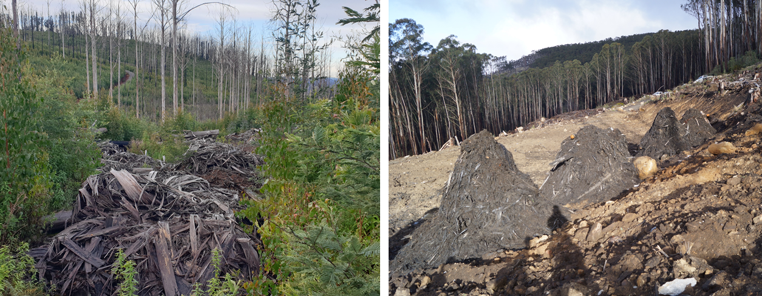
Figure 5-7. Excessively large piles of bark and other debris near landings (21 Dow Jones, left; 03 Gnu, right)

Recommendation D-02: Medium priority
That DEECA review and reconsider ground area and volumetric limits on bark and slash piles (currently 4 m² and 10 m^{3,} respectively; MSP 7.2.4.2).

Potential improvements to the regulatory framework for timber harvesting
Comments on potential improvements in the regulatory framework for timber harvesting have been made in previous audit reports. Until recently, the regulatory framework for sustainable forest management (i.e., Code and MSPs) had not been revised and there was no specific opportunity to address these recommendations. This opportunity was provided in 2021, with DELWP undertaking revisions of both the Code and MSPs (DELWP 2021a,b). The update was intended to, “ensure they [the Code and MSP requirements] are clear, accurate and enforceable.” The scope of the amendments was modest and focussed on clarifying definitions, roles, responsibilities, and obligations, as well as correcting administrative errors.
Table 5.4 in our 2020-21 FAP report provided an analysis of the status of previous recommendations with the recent Code and MSP amendments. Only two of our recommendations have been addressed at all and one of these, regarding buffers for rainforest stands, has not been fully adopted. We endorse these earlier recommendations and our recommendation D-02 from the 2020-21 audit addressing the rainforest stand definition and the lack of prescriptions for snig and boundary track drainage spacing in the MSPs.
The current audit included six coupes with snig track waterway crossings. Observations in these coupes suggest that the MSPs require more specific guidance on the construction and rehabilitation of snig track crossings. MSP 7.2.1.1 specifies that “crossing standards and procedures for roads also apply to snig track crossings”. While this may be broadly appropriate for snig track crossings in their rehabilitated state, it does not address the unique circumstances of snig track crossings during period when they area in active use.
The requirement to have drainage that intersects run-off along the tracks is appropriate for in-coupe roads and rehabilitated snig track crossings but is likely unworkable in operating snig track crossings. Further, many snig track crossings are constructed with a mix of soil and log fill, which must be removed during rehabilitation and potentially serves as a source of sediment. We therefore recommend that a review of snig track crossing “design”, operational and rehabilitation requirements is undertaken and new management prescriptions be developed to more effectively control the risk to water quality and aquatic biodiversity values from this form of crossing.
Recommendation D-03: High priority
That DEECA review snig track crossing “design”, operational and rehabilitation requirements and develop new and more tailored management prescriptions.

Improvements in the Forest Audit Program
We have noted in several previous audit reports (e.g., Jacobs, 2021), that there are regular inconsistencies between the information on coupe conditions provided by VicForests to select audit targets and the actual state of coupes. Key issues, given the weightings used in audit target selection, are the presence of waterway crossings, presence of modelled rainforest within or directly adjacent to the coupe, length of in coupe road and coupe slope.
Data reported in Table 3-2 highlight deficiencies in the information base used to select coupes for inclusion in the audit. The data reported by VicForests is understood to be based on the initial operational planning rather than the actual coupe operations. These can differ significantly, and in our experience those differences often result in reduced environmental risks associated with the harvesting activities (e.g., by eliminating waterway crossings or shortening in-coupe road lengths). As data from planned coupe operations is not necessarily reflective of the risk posed by the actual operations, lower risk coupes may be prioritised for audit selection above higher risk coupes.
While this may result in the audit being more representative of VicForests’ operations overall, the intent of the audit is to focus activities on higher risk coupes. Experience indicates that despite data deficiencies, the audit “effort” is still weighted towards higher risk coupes. However, our preference (as previously recommended) would be for the information to be provided on the coupe as implemented, rather than originally planned, that maximum slope is specified rather than average or typical slope and that the presence of modelled rainforest within the coupe rather than within 500 m of it is reported.

Recommendation V-03: Medium priority
That the data VicForests’ provide to DEECA to assist in audit target selection is based on actual rather than planned coupe conditions. Maximum coupe slope and the presence of modelled rainforest within the coupe rather than within 500 m of it are reported.

Conclusions and recommendations

Conclusions
The objectives of the FAP are to assess the conformance of VicForests’ timber harvesting operations with the regulatory framework for timber harvesting activities in State forests and the environmental risks associated with any non-conformances. The 2022 FAP addressed Code and MSP mandatory compliance elements relating to four main themes:
- Protection of soil, water and river health values
- Conservation of biodiversity
- Operational planning and record-keeping
- Coupe infrastructure for timber harvesting operations.
Conformance of coupe planning, harvesting and roading activities with the regulatory framework provided by the Code and MSPs was assessed for 32 coupes distributed across the Central Highlands, East Gippsland, Gippsland and North East RFA regions. The selection of coupes was risk-based, meaning that audit findings cannot be taken as being statistically representative of VicForests’ operations.

Overall conformance findings
A total of 171 compliance criteria were identified from Code and related MSP prescriptions included within the audit scope. The applicability of and conformance with these criteria was assessed for each of the 32 selected coupes during site inspections undertaken in June, July and October 2022.
The overall level of full conformance with applicable audit criteria across the 32 coupes ranged between 87% and 100%, with the average being 96%. Non-conformance incidents in 20 of the 32 coupes included in the audit were assessed to have potential for environmental impact. There was an average of 1.4 such incidents per coupe, with as many as six incidents recorded. The assessed level of potential environmental impact associated with these incidents ranged between negligible and major, with moderate being the most common rating.

Protection of soil, water and river health values
Environment-themed audit criteria were grouped into two sub-themes focusing on soil and water values. The main findings for each sub-theme were:
- Protection of forest soils: the level of full conformance with applicable criteria ranged between 78% and 100%, with an average of 95%. Non-conformance incidents at five coupes were assessed to have up to major potential environmental impact. The main types of incident contributing to higher potential environmental impact non-conformances all related to defective waterway crossings.
- Protection of water flows, water quality and river health: the level of full conformance with applicable criteria ranged between 67% and 100%, with an average of 94%. Non-conformance incidents were assessed to have up to major potential environmental impact. As with audit criteria relating to forest soils, both incidents contributing to major potential environmental impact non-conformances related to defective waterway crossings:

Conservation of biodiversity
The average level of full conformance with applicable biodiversity conservation criteria was 96%, with the range being 85-100%. Multiple non-conformance incidents were assessed to have major potential environmental impact for either aquatic or terrestrial biodiversity values. All of the former incidents related to defective waterway crossings and the one incident potentially affecting terrestrial biodiversity values resulted from the incursion of harvest activity into a small area of Leadbeaters Possum SPZ.

Operational planning and record keeping
The average level of full conformance with applicable criteria was 97%, with the level for individual coupes ranging between 89% and 100%. Non-conformance incidents with major potential environmental impact were observed at three coupes, all of which were the result of coupe planning not being executed correctly, rather than deficiencies in planning. Incidents with major and moderate environmental impact relate to defective in-coupe road or snig track waterway crossings, incursion of harvesting activity into an SPZ and incursion of regeneration burns into areas of retained vegetation.

Coupe infrastructure for harvesting operations
Infrastructure-themed audit criteria were grouped into four sub-themes focusing on design, construction, maintenance of in-coupe roads, as well as placement and construction of non-road coupe infrastructure such as landings and snig or boundary tracks. The main findings for each sub-theme were:
- Road design: the level of full conformance with applicable criteria ranged between 78% and 100%, with the average being 96%. A non-conformance incident at one coupe was assessed to have major potential environmental impact. This related to defective waterway crossings.
- Road construction: the average level of full conformance with applicable criteria was 92%, with the level of conformance ranging between 66% and 100%. A non-conformance incident at one coupe (a defective waterway crossing) was assessed to have major potential environmental impact.
- Road maintenance and closure: the average level of full conformance with applicable criteria was 99%, with the level of full compliance ranging between 75% and 100%. Only one non-conformance incident with potential environmental impact was observed, with the potential impact assessed to be negligible.
- Non-road coupe infrastructure: the average level of full conformance with applicable criteria was 96%, with the level of full conformance ranging between 81% and 100%. A non-conformance incident with major potential environmental impact was observed at one coupe. This involved a defective snig track waterway crossing.

Comparison with previous audits
Coupe selection for the audit is risk-based, which means that audit results are not necessarily statistically representative of VicForests’ operations overall and audit results may not be directly comparable between years. Comparison of the results of this audit with previous audits is also confounded by changes in the EIA tool, inclusion of slightly different suites of compliance element, and in the 2019-20 FAP audit, of 15 less intensively harvested community forestry coupes from Western Victoria RFA region. However, the broad consistency of the target selection process, regulatory compliance elements and audit criteria mean that reasonable comparisons between audits are possible.
Considering only coupes in the Central Highland RFA region, which have been included in all five of the most recent audits, the overall level of full conformance is greater overall and for most compliance themes and sub-themes than in previous audits (95%, compared with 83-94%, overall). Despite this, the count of non-conformances with potential environmental impact and, particularly, with major potential environmental impact was greater in the current audit than in the two previous audits. This was the case overall and for almost all compliance themes and sub-themes.
The higher incidence of non-conformances with higher potential environmental impact (i.e. moderate and major categories) largely reflected repeated observations of defective in-coupe road and snig track waterway crossings.

Fire salvage harvesting
Fifteen fire salvage coupes were included in the audit. These were located in East Gippsland, Tambo and North East FMAs and all were affected by fires during the summer of 2019-20. The average level of full conformance with applicable fire salvage prescriptions was 96%, which is similar to the overall level of full conformance for all aspects of the regulatory framework. The level of full conformance ranged between 82% and 100%. Non-conformances with potential environmental impact were observed at five of the 15 fire salvage coupes, with the assessed level of impact being either minor or moderate.
Non-conformances with fire salvage prescriptions resulted from seven individual incidents, relating to drainage structure spacing, waterway crossing construction and harvesting in a planned riparian buffer.

Application of the precautionary principle
The specification for the 2022 Forest Audit Program included a request to consider compliance measures under the precautionary principle for audit coupes in East Gippsland FMA. The focus was on the information used to identify whether threatened flora or fauna may be present within or near the coupe and the extent to which planning and management of the operations responded to risks to these species from timber harvesting. The assessment was confounded somewhat by the 2019-20 bushfires, which limited opportunities for pre-harvest surveys of threatened species in seven of the eight East Gippsland coupes. Where available, species records and observations, as well as habitat distribution models were used to identify what threatened species might be present on the coupe. Digital FCPs specified a set of management actions responding to the requirements of each species, although these fell into two main categories: provision of riparian harvest exclusion areas for species occupying or moving through these parts of the forest and adoption of a silvicultural regime with high retention of “habitat” trees (to the extent available), residual basal area and undisturbed habitat patches.

Recommendations
The findings of this audit have contributed to a series of recommendations for VicForests and DEECA. Recommendations to VicForests regard potential improvements in coupe planning and timber harvesting practices and operation on the FAP. Recommendations for DEECA concern the regulatory framework for timber harvesting.
The priority given to recommendations reflects either the potential environmental impact associated with the aspect of harvesting practice and/or the urgency of any improvement to practice or the regulatory system.

Recommendations for VicForests
Recommendation | Rationale
V-01 High priority  That VicForests retain records of the full search effort, using surveys and habitat modelling, to identify threatened species that may be present within a coupe or may be affected by nearby harvesting activities. | VicForests FCPs only include information on the values that are or are potentially present within or near the coupe and not all those searched for (physically and using HDMs). To demonstrate application of the precautionary principle, it is important that records are maintain of what was searched for as well as whether it was present or not.
V-02 High priority  That VicForests develop and implement an initiative to improve the quality and consistency of waterway crossing design, construction, maintenance and rehabilitation, addressing both in-coupe road and snig track crossings. | While there have been improvements in some aspects of the design, construction, maintenance and/or rehabilitation of in-coupe road and snig track waterway crossings, inconsistent and defective practice continues to be observed in the FAP. This is despite these issues being emphasised in multiple FAP audit reports.  The recommendation seeks a process to drive internal cultural and practice change in VicForests to address this key on-going area of regulatory non-conformance.  While details of the initiative are for VicForests to determine, the audit teams suggests that it should address each stage of the crossing life cycle and include:  - Preparation of planning and design documentation  - Strengthening of post-construction and post-rehabilitation / coupe closure monitoring and reporting  - Internal post-construction and post-rehabilitation/closure review processes.
V-03 Medium priority  That the data VicForests’ provide to DEECA to assist in audit target selection is based on actual rather than planned coupe conditions. Maximum coupe slope and the presence of modelled rainforest within the coupe rather than within 500 m of it are reported. | It has been noted in this and previous audits that there are often significant discrepancies between the data provided by VicForests to support audit target selection and the actual coupe conditions, particularly in relation to the presence/number of waterway crossings. This results in coupes being prioritised for selection in a risk-based process that do not have the higher risk features they were selected for and dilutes the effectiveness of the risk-based selection process.

Recommendations for DEECA
Recommendation | Rationale
D-01 Moderate priority  That DEECA review MSP fire salvage prescriptions and explicitly define how soil erosion hazard is to be treated in fire salvage coupes. | While fire salvage prescriptions are explicit about the assigning of high or very high water quality hazard to affected coupe, they are ambiguous about how soil erosion hazard is to be considered. At present VicForests typically assumes that soil erosion hazard is high, in line with the adjustment of water quality hazard, but this may not be necessary when establishing the spacing of drainage structures on in-coupe roads and snig tracks.
D-02 Medium priority  That DEECA review and reconsider ground area and volumetric limits on bark and slash piles (currently 4 m² and 10 m³, respectively; MSP 7.2.4.2). | It is not clear that there is an objective basis for the limits on the ground area and volume of bark and slash piles (MSP 7.2.4.2). While they may be appropriate in the context of landings, it is not clear that they are workable for rough heaping operations. The latter typically form windrows with much greater volume than allowed by MSP 7.2.4.2.  The recommendation seeks to determine the appropriateness of the ground area and size limits and the contexts in which they may be applied. Management prescriptions could be modified following the review.
D-03 High priority  That DEECA review snig track crossing “design”, operational and rehabilitation requirements and develop new and more tailored management prescriptions. | Current prescriptions for snig track waterway crossings refer to those for in-coupe road crossings and do not account for the different methods of construction, patterns of usage and landscape contexts in which they are typically located. This recommendation seeks to define a basis for more tailored and appropriate prescriptions for snig track crossings.

References
Department of Environment, Land, Water and Planning [DELWP] 2019. Regulating timber harvesting in State forests under the Allocation Order. Statement of Regulatory Intent. DELWP.
DELWP 2021a. Code of practice for timber production 2014 (as amended November 2021). DELWP.
DELWP 2021b. Management standards and procedures for timber harvesting operations in Victoria’s State forests 2021. DELWP.
Department of Sustainability and Environment [DSE] 2006. Sustainability charter for Victoria’s State forests. DSE.
Jacobs 2016. Forest Audit Program 2015: Audit of in-coupe roads. Environmental audit of the construction and maintenance of in-coupe roads. IS112500-010.Report to DELWP. March 2016.
Jacobs 2018. Audit of timber harvesting and forest regeneration in State forests in eastern Victoria. Report on the 2016-17 Forest Audit Program. IS206000-P2-001. Report to DELWP. April 2018.
Jacobs 2019. Audit of timber harvesting operations in Victoria’s State forests. Report on the 2017-18 Forest Audit Program. IS247800-RP-002. Report to DELWP. July 2019.
Jacobs 2020a. Audit of timber harvesting operations in Victoria’s State forests. Report of the 2018-19 Forest Audit Program. IS284400-RP-002. Report to DELWP. February 2020.
Jacobs 2020b. Audit of timber harvesting operations in Victoria’s State forests. Report of the 2019-20 Forest Audit Program 2019-20. IS326300-03. Report to DELWP. October 2020.
Jacobs 2021. Audit of timber harvesting operations in Victoria’s State forests. Report of the 2020-21 Forest Audit Program. IS37900-03. Report to DELWP. December 2021.
O’Reilly 2019. Road design, construction and maintenance instruction. Version 1.1. Report to VicForests. September 2019.
VicForests 2018. Utilisation procedures for all commercial harvesting and haulage managed by VicForests. VicForests.

Spatial data sources:
- Victorian government: www.data.vic.gov.au
- ESRI

Limitation statement
The purpose of this report and the associated services performed by Jacobs was to conduct an environmental audit of timber harvesting operations in Victorian State forests. The work has been undertaken in accordance with the scope of services set out in the contract between Jacobs and the Department of Energy, Environment and Climate Action (DEECA).
Jacobs derived the data in this report from field observations and information sourced from DEECA, VicForests and/or available in the public domain at the time or times outlined in this report. The passage of time, manifestation of latent conditions or impacts of future events may require further examination of the project and subsequent data analysis, and re-evaluation of the data, findings, observations and conclusions expressed in this report.
Jacobs has prepared this report in accordance with the usual care and thoroughness of the consulting profession, for the sole purpose described above and by reference to applicable standards, guidelines, procedures and practices at the date of issue of this report. For the reasons outlined above, however, no other warranty or guarantee, whether expressed or implied, is made as to the data, observations and findings expressed in this report, to the extent permitted by law.
This report should be read in full and no excerpts are to be taken as representative of the findings. No responsibility is accepted by Jacobs for use of any part of this report in any other context.
This report has been prepared on behalf of, and for the exclusive use of DEECA and is subject to, and issued in accordance with, the provisions of the contract between Jacobs and DEECA. Jacobs accepts no liability or responsibility whatsoever for, or in respect of, any use of, or reliance upon, this report by any third party.

Audit compliance elements
Source | # | Code compliance elements and audit compliance questions | Theme | % Full
C |  | 2.2 Environmental Values in State forests
C |  | 2.2.1 Water Quality, River Health and Soil Protection
C |  | 2.2.1.1 Planning and management of timber harvesting operations must comply with relevant water quality, river health and soil protection measures specified within the Management Standards and Procedures.
M |  | 3.1.1.1 Use the following categories when determining buffer (B) and filter (F) widths for waterways within and immediately adjacent to each coupe. Aids to the identification of each class of waterway are provided in the Code Glossary. (a) Permanent streams, pools and wetlands. (b) Temporary streams. c) Drainage lines.
 | 1.01 | Have the categories prescribed in the MSPs been used in classifying waterways present on the coupe? | W, P | 100
 | 1.02 | Are the classification assessed to have been applied correctly? | W, P | 97
M |  | 3.2.1.1 Conduct field assessments to determine the soil erosion hazard and soil permeability classifications for an area proposed for any soil disturbing timber harvesting operations as follows (3.2.1.2-3.2.1.11, Table 8).
 | 2.01 | Has soil erosion hazard and soil permeability been assessed using the method prescribed in the MSPs? | S, P | 100
 | 2.02 | Has the methodology been followed correctly? | S, P | 100
 |  | 3.2.1.2 Collect soil profile samples that reflect the variety of soils represented within the coupe.
 | 2.03 | If there are significant changes in soil and/or vegetation types within the coupe, ITAO have an adequate number of soil profile samples been taken to assess soil erosion hazard for the coupe? | S, P | 100
M |  | 3.3.1.1 Apply appropriate protection to class of waterway as outlined in MSP Table 9.
 | 3.01 | If applicable, have the buffer and filter strip widths prescribed in MSP Table 9 been applied to the coupe? | W, BD, P | 97
M |  | 3.4.1.1 Exclude timber harvesting operations from slopes over 30 degrees.
M |  | 3.4.1.2 Exclude timber harvesting operations from slopes over 25° in the East Gippsland FMA in areas with granite based soils.
M |  | 3.4.1.3 Up to 10% of the planned net coupe area can contain areas greater than the slope limits referred to in 3.4.1.1, 3.4.1.2, 3.5.1.1 and Table 11 Water supply protection areas, where the risk of mass soil movement has been managed accordingly.
 | 4.01 | Has timber harvesting been excluded from areas with slopes >30°/25° (unless the area exceeding the slope limit is ≤10% net harvest area and ITAO the risk of mass soil movement has been managed accordingly)? | S, W, P | 100
M |  | 3.5.1.1 Apply the slope limits, seasonal closures, buffer and filter strip widths and other relevant management actions specified in MSP Table 11 (Water supply protection areas) for timber harvesting operations and associated roading and regeneration in water supply protection areas.
M |  | 3.5.1.2 Refer to Table 11 Water supply protection areas for actions that apply to water supply protection area SMZs in the Benalla-Mansfield FMA, the East Gippsland FMA and Midlands FMA.
M |  | 3.5.1.3 Where any proposed timber harvesting operations are not in accordance with clauses 3.5.1.1 or 3.5.1.2, obtain exemption approval from the Minister or delegate in accordance with Section 1.4.
M |  | 3.5.1.4 Special water supply catchment areas and water supply protection areas not listed in Table 11 Water supply protection areas do not require protection in addition to existing Code requirements.
M |  | 3.5.1.5 In addition to Appendix 3 Table 11 (Water supply protection areas), in the Bunyip, Thomson and Tarago special water supply catchments and the Yarra Tributaries State forests the area harvested must not exceed the following limits measured as a rolling average: (a) Thomson ‐ Ash forests 150 ha/year, Mixed species forests 15ha/year; (b) Tarago ‐ Ash forests 55 ha/year, Mixed species forests 23ha/year; (c) Yarra Tributaries – Ash forest 52 ha/year, Mixed species forests 15 ha/year; and (d) Bunyip – Ash forest 15 ha/year, Mixed species forests 15 ha/year.
M |  | 3.5.1.7 In addition to Table 11 Water supply protection areas, in the Rocky and Betka River catchments in the East Gippsland FMA, no new road crossings may be built on major streams.
 | 5.01 | Does the FCP correctly note that the coupe is or is not located in a water supply catchment? | W, P | 100
 | 5.02 | For relevant couples located in WSPA/DWSC, have the applicable slope limits, seasonal closures, buffer and filter strip widths and other relevant management actions specified in Table 11 been correctly applied on the coupe? | S, W, BD, P | 100
 | 5.03 | For relevant couples located in WSPA/DWSC, are the applicable stream buffers correctly applied on the coupe? | W, BD, P | 100
 | 5.04 | For relevant couples located in WSPA/DWSC, are the applicable maximum annual areas harvested noted in the FCP and correctly applied on the coupe? | W, P | 100
 | 5.05 | For relevant couples located in WSPA/DWSC, if timber harvesting operations are not conducted in accordance with the relevant MSP prescriptions, has Ministerial approval been obtained in accordance with MSP section 1.5 and Appendix 1 prior to harvesting commencing? | W, P | n/a
C |  | 2.2.1.2 Management actions to protect waterways, river health and soil must be appropriate to the waterway class, soil category, and potential water quality risk posed by timber harvesting operations at each site.
C |  | 2.2.1.3 Additional measures to protect water quality and aquatic habitat (including widening buffers or filter strips) must be adopted within coupes where there is a high local risk due to: i. local topography; ii. the intensity and magnitude of the timber harvesting operation; iii. events such as wildfire that reduce the effectiveness of protection measures; or iv. the location of the timber harvesting operation in a declared Special Water Supply Catchment or any other water supply protection area.
 | 6.01 | ITAO is there evidence from the coupe which suggests that management actions to protect waterways, river health and soil have not been appropriate to protect waterways, river health and soil? | S, W, BD, D, C, I, P | 72
 | 6.02 | If ITAO additional measures were required to protect water quality and aquatic habitat due to local risk factors, were any undertaken? | S, W, BD, C, M, I, P | 100
 | 6.03 | Where ITAO additional measures were required and undertaken, were they effective in protect water quality and aquatic habitat | S, W, BD, C, M, I | 92
C |  | 2.2.1.5 Where practical exclude roads and snig tracks from aquatic and riparian habitats.
C |  | 2.2.1.6 Where crossings are required, minimise the extent of habitat damage, constriction to stream flow and barriers to fish and other aquatic fauna.
C |  | 2.2.1.7 Remove temporary crossings immediately after harvesting or any subsequent regeneration work is complete using a technique that minimises soil and habitat disturbance.
C |  | 2.2.1.8 Use drainage, artificial structures, buffers and filters of effective width to slow and disperse surface flows and deposit sediment before reaching waterways.
C |  | 2.2.1.12 Design, construct and maintain roads, crossings, coupe infrastructure and drainage structures to withstand foreseeable rainfall events and traffic conditions and protect water quality.
 | 7.01 | If roads and snig tracks have not been excluded from aquatic and riparian habitats, ITAO was it reasonably practicable to have done so? | W, BD, C, I, P | 100
 | 7.02 | For coupes with road and/or snig track waterway crossings, ITAO did the crossing minimise the extent of habitat damage and, where relevant, constriction to stream flow and/or barriers to fish and other aquatic fauna? | W, BD, D, C, I | 92
 | 7.03 | ITAO has the crossing been removed as soon as reasonably practicable following harvesting or regeneration work? | W, BD, M, I | 100
 | 7.04 | ITAO has removal of the crossing been undertaken in a manner that has minimised soil and habitat disturbance? | S, W, BD, M, I | 100
 | 7.05 | ITAO have drainage, artificial structures, buffers and filters of effective width been appropriately used to try to slow and disperse surface flows and deposit sediment before reaching waterways? | W, BD, D, C, I | 73
 | 7.06 | Have the measures put in place to slow and disperse surface flows and deposit sediment before reaching waterways been effective? | W, BD, D, C, I | 55
C |  | 2.2.1.14 Minimise potential for soil erosion or mass movement by planning and using operational methods and restrictions appropriate to the assessed soil erosion risk and slope.
C |  | 2.2.1.15 Locate coupe infrastructure and roads to minimise soil erosion and degradation.
C |  | 2.2.1.18 Employ topsoil conservation techniques in timber harvesting areas affected by coupe infrastructure and roads.
 | 8.01 | ITAO have planning (including locating coupe infrastructure and roads), and operations methods applied on the coupe been appropriate for the assessed soil erosion risk and slope? | S, W, CM, I, P | 91
 | 8.02 | Is there evidence within the coupe of soil erosion or mass movement resulting from harvesting operations, including from roading, snig tracks and/or landings? | S, C, M, I | 97
 | 8.03 | ITAO has topsoil conservation been used as appropriate in areas affected by coupe infrastructure and/or roads? | S, I | 100
C |  | 2.2.2 Conservation of Biodiversity
C |  | 2.2.2.1 Planning and management of timber harvesting operations must comply with relevant biodiversity conservation measures specified within the Management Standards and Procedures.
C |  | 2.2.2.2 The precautionary principle must be applied to the conservation of biodiversity values. The application of the precautionary principle will be consistent with relevant monitoring and research that has improved the understanding of the effects of forest management on forest ecology and conservation values.
C |  | 2.2.2.4 During planning identify biodiversity values listed in the Management Standards and Procedures prior to roading, harvesting, tending and regeneration. Address risks to these values through management actions consistent with the Management Standards and Procedures such as appropriate location of coupe infrastructure, buffers, exclusion areas, modified harvest timing, modified silvicultural techniques or retention of specific structural attributes.
 | 9.01 | Is there evidence from the FCP and coupe planning process of attempts to identify biodiversity values listed in the MSPs within or near the coupe by survey and/or habitat modelling? | BD, P | 100
 | 9.02 | Where listed biodiversity values are present or identified by habitat modelling, is there evidence that risks to these values from timber harvesting operations have been assessed? | BD, P | 100
 | 9.03 | Where listed biodiversity values are present or identified by habitat modelling, have management actions applied on the coupe to protect those values been consistent with MSP prescriptions. | BD | 96
 | 9.04 | Where listed biodiversity values are present or identified by habitat modelling, have management actions been consistent ITAO with the risk of serious or irreversible environmental damage? | BD, P | 93
 |  | MSP4.1 Habitat retention
C |  | 2.2.2.10 Retain and protect habitat trees or habitat patches and long-lived understorey species to provide for the continuity and replacement of old hollow-bearing trees and existing vegetation types within each coupe.
M |  | 4.1.1.1 Retain habitat trees in accordance with the FMA summary provided in Table 12 (Habitat tree prescriptions).
M |  | 4.1.1.2 Trees in buffers or other exclusion areas that have been extended beyond minimum required widths can contribute to habitat tree retention requirements.
M |  | 4.1.1.3 Retain all living large trees and protect them from the direct effects of timber harvesting operations and regeneration burning. This includes not deliberately felling, falling into or damaging large trees during harvesting and extraction, and ensuring slash is not accumulated within 3m of the base of large trees immediately prior to regeneration burns.
M |  | 4.1.1.4 Where possible, incorporate large trees in retained patches of habitat trees or expanded buffers or exclusion areas.
 | 10.01 | Have the required number of habitat trees been retained on the coupe (as per MSP Table 12) - including in areas where buffers and other exclusion areas extended beyond the minimum required widths? | BD, P | 100
 | 10.02 | Have habitat patches of long-lived understorey species been retained to represent existing vegetation types within the coupe? | BD, P | 100
 | 10.03 | Have all large (≥2.5m) living trees been retained and protected from direct effects of timber harvesting operations and regeneration burning? This includes not having accumulating slash within 3m of the base of large trees prior to regeneration burns | BD, P | 80
 | 10.04 | Where reasonably practicable (ITAO) have large trees been incorporated into retain habitat patches, buffers or exclusion areas> | BD, P | 100
 |  | MSP 4.1.2 Benalla/Mansfield and North East FMA
M |  | 4.1.2.1 When selecting habitat trees, prioritise live hollow-bearing trees where they are present and trees of younger age classes that are likely to develop hollows in the longer term.
M |  | 4.1.2.2 Where possible retain dead trees for habitat trees.
M |  | 4.1.2.3 Retain habitat trees adjacent to areas of high value habitat and areas most easily protected from damage during harvesting and regeneration operations.
M |  | 4.1.2.4 Habitat trees may be retained in groups/patches dispersed across the coupe.
M |  | 4.1.2.5 Seed trees may be counted as habitat trees.
 | 10.05 | In North-East FMA, is there evidence of that live hollow-bearing trees and dead trees have been prioritised for retention as per MSP 4.1.2.1/2? | BD, P | 100
 | 10.06 | In North-East FMA, are retained habitat trees generally located adjacent to areas of high value habitat that are most easily protected from damage during harvesting and regeneration? | BD, P | 100
 |  | MSP4.1.4 Central Highlands FMAs
M |  | 4.1.4.1 In Central Highlands FMAs, when selecting habitat trees, prioritise hollow‐bearing trees where they are present and trees most likely to develop hollows in the short term.
M |  | 4.1.4.2 Scatter habitat trees across the timber harvesting coupe in mixed‐species forest.
M |  | 4.1.4.3 Where possible, retain potential hollow‐bearing ash eucalypts in clumps to increase their protection from exposure, windthrow and fire.
M |  | 4.1.4.4 No gap between retained vegetation is to be greater than 150 m.
M |  | 4.1.4.5 Retain habitat trees where they can be most easily protected from damage during harvesting and site preparation treatment.
 | 10.07 | Based on evidence from the coupe and ITAO, have hollow-bearing or potential hollow-bearing trees, where present, been prioritised for habitat retention | BD, P | 100
 | 10.08 | In mixed species forests, if there are retained habitat trees, have they been scattered evenly across the coupe? | BD, P | 100
 | 10.09 | If present, have hollow bearing ash eucalypts been retained in clumps. | BD, P | 100
 | 10.10 | Are gaps between retained vegetation ≤ 150 m? | BD, P | 100
 | 10.11 | ITAO, are any retained habitat trees located where they can most easily be protected from damage during harvesting and site preparation treatment? | BD, P | 100
 | 10.12 | Is there evidence of damage to retained vegetation from harvesting or regeneration? | BD | 91
 |  | MSP4.1.5 East Gippsland and Gippsland FMAs
M |  | 4.1.5.1 When selecting habitat trees, prioritise old living trees with a range of hollow sizes. Where these are absent or not present in sufficient numbers, prioritise trees that are old enough to develop hollows during the next 50 years.
M |  | 4.1.5.2 Stags and younger, smaller trees may be counted as habitat trees if trees of the type described in 3.1.5.1 are absent or not present in sufficient numbers.
M |  | 4.1.5.3 Where possible, retain habitat trees in small clusters which include younger regrowth and understorey.
M |  | 4.1.5.4 Distribute habitat tree clusters across the coupe with consideration of the proximity of other retained vegetation.
 | 10.13 | Is there evidence that selection of habitat trees has prioritised living trees with a range of hollow sizes, where present, or trees that are old enough to develop hollows during the next 50 years. | BD, P | 100
 | 10.14 | Have habitat trees been retained in small clusters that include younger regrowth and understorey (where ITAO this is reasonably practicable)? | BD, P | 100
 | 10.15 | Have habitat tree clusters been distributed across the coupe, with (ITAO) apparent consideration of the proximity of other retained habitat? | BD, P | 100
 |  | MSP 4.2 Fauna and flora: 4.2.1 Detection-based management
M |  | 4.2.1.1 Detection based management obligations apply in any area that may be affected by current or planned timber harvesting operations, and in any area in which an obligation may affect the conduct of such timber harvesting operations (for example, if a protection area would include an area within which timber harvesting operations are proposed).
M |  | 4.2.1.2 If evidence of the presence of a value listed in Table 13 Rare or threatened fauna and invertebrate prescriptions or Table 14 Rare or threatened flora prescriptions is identified, the managing authority must: a) notify the Secretary, providing details (including spatial information) of evidence and the value location; and b) unless the Secretary otherwise approves, take appropriate steps to verify evidence of the presence of the value.  Note: The Secretary may otherwise approve if the Secretary intends to take steps to verify the existence of the value.
M |  | 4.2.1.3 If evidence of the presence of a value listed in Table 13 Rare or threatened fauna and invertebrate prescriptions or Table 14 Rare or threatened flora prescriptions is verified, apply and undertake any associated management action specified in the Table
M |  | 4.2.1.4 If a management action or other mandatory action includes a requirement to apply a protection area or a management area, the managing authority must (in addition to any other action): a) Provide information to the Secretary about the extent and boundary of the area proposed to be delineated as a protection area or management area; b) Follow any input or direction of the Secretary about the extent and boundary of the area (which must not be inconsistent with the Code or these Management Standards and Procedures); c) Delineate the boundary of the protection area or the management area in any applicable Forest Coupe Plan (consistently with the applicable requirement and any input or direction from the Secretary), including by updating the Forest Coupe Plan as the case requires; and d)
M |  | 4.2.1.5 In any management area that is required to be applied by these Management Standards and Procedures, the managing authority must (in addition to any other action): a) consult with the Secretary about proposed measures to ensure the persistence of a value across the management area; and b) ensure sufficient practical measures are undertaken to ensure the persistence of a value across the management area.
M |  | 4.2.1.6 The managing authority must comply with the requirements of clause 4.2.1.2, 4.2.1.3, 4.2.1.4 and 4.2.1.5, either: a) prior to the commencement of timber harvesting operations; or b) if a requirement only arises after timber harvesting operations have commenced, as soon as possible after the requirement arises.
 | 11.01 | If a listed flora or fauna value is identified and verified within or adjacent to the coupe, have the prescribed protection measures (from MSP Tables 13 and 14) been put in place? | BD, P | 96
 | 11.02 | If the management action for the threatened flora or fauna value requires application of a protection area or management area, has the boundary of the management area been delineated in the FCP? | P | 100
 | 11.03 | Is there evidence of consultation with the Secretary regarding the proposed measures to be applied to ensure the persistence of the value across the management area? | P | 100
 | 11.04 | Have the agreed management measures been carried out? | BD | 100
 |  | MSP 4.3 Vegetation communities
 |  | MSP 4.4.1 Box-Ironbark
M |  | 4.4.1.1 In the Gippsland FMAs exclude selective harvesting from Box Ironbark forests typically containing Forest Red Gum (Eucalyptus tereticornis), Yellow Box (Eucalyptus melliodora), Coast Grey Box (Eucalyptus bosistoana) and Red Ironbark (Eucalyptus tricarpa). Silvicultural practices that promote regeneration of these species is permitted.
M |  | 4.4.1.2 In the East Gippsland FMA exclude selective harvesting from Box Ironbark forests typically containing Red Ironbark (Eucalyptus tricarpa), Gippsland Grey Box (Eucalyptus bosistoana), Red Box (Eucalyptus polyanthemos), Blue Box (Eucalyptus baueriana) and Yellow Stringybark (Eucalyptus muelleriana). The use of seed‐tree regeneration systems is permitted to restore the original species mix when combined with: a) cutting stumps of desired species to a maximum height of 30 cm, to encourage coppice growth; b) supplementary planting and sowing where necessary; c) removing unproductive trees of the less-preferred species to remove overwood competition; and d) thinning of advanced regrowth
 | 12.01 | In Gippsland FMAs, has selective harvesting been excluded from Box-Ironbark forests, as per MSP 4.4.1.1/2? | BD, P | 100
 |  | MSP 4.3.2 Heathland
M |  | 4.3.2.1 Avoid road construction across areas of heathland or within 40 m of heathlands unless no reasonable alternative exists.
M |  | 4.3.2.2 In the Gippsland FMAs, exclude Wet Heathland, Clay Heathland and Riparian Scrub Mosaic EVCs from harvesting. Protect these heathland EVCs with a 40 m buffer.
M |  | 4.3.2.3 In the East Gippsland FMA and Otway FMA where evidence of heathland is found in the field and it isn’t already classified as SPZ, apply a protection area prior to commencement of the timber harvesting operation consistent with management actions listed in Table 15 Detection based rules for Heathland, Snow Gum, Swamp Gum and Heath vegetation communities.
M |  | 4.3.2.4 In the Central Highlands and North East FMAs, where evidence of heathland is found in the field and it isn’t already classified as SPZ, apply a protection area over the identified heathlands, however there is no buffer required.
 | 12.02 | If a road was constructed through or within 40 m of a heathland, ITAO, was it reasonably practicable to construct the road in another location? | BD, C, P | n/a
 | 12.03 | In the Gippsland FMAs, has harvesting been excluded from Wet Heathland, Clay Heathland and Riparian Scrub Mosaic EVCs and have these heathland EVCs been protected with a 40 m buffer, where present? | BD, P | n/a
 | 12.04 | In the East Gippsland FMA, if evidence of heathland was found in the coupe and it was not already classified as SPZ, has application been made to the Secretary to create an SPZ in accordance with Table 7 in Appendix 5 the Planning Standards? | P | n/a
 | 12.05 | In the Central Highlands or North East FMAs, where evidence of heathland is found in the field and it isn’t already classified as SPZ, has a protection area been applied over the identified heathlands, however there is no buffer required. | P | n/a
 | 12.06 | Have the SPZ/protection area conditions been followed in the management of harvesting? | BD, P | 100
 |  | MSP 4.3.3 Montane Riparian Thicket
M |  | 4.3.3.1 In the Tambo FMA protect small stands of MRT between 0.01ha and 0.5ha and less than 10m wide with a 10m filter strip and stands of MRT wider than 10m with a 20m wide filter strip. Protect stands of MRT greater than 0.5ha with a 20m buffer from the edge of the Mountain Tea-tree canopy.
M |  | 4.3.3.2 In all other FMAs (than Tambo) apply the heathland prescriptions listed above in 4.3.2 (sic – actually 4.4.2) – i.e., protect with a 40 m buffer and do not construct a road through or within 40 m of MRT, except where not practicable alternative exists.
M |  | 4.3.3.3 MRT stands must contain at least 40 % canopy cover of Mountain Tea‐tree (Leptospermum grandifolium) and up to two key understorey species from the MRT definition in the Glossary. Gaps in the Mountain Tea‐tree canopy may occur at intervals up to 10 m in length. Discrete areas of Mountain Tea‐tree having canopy gaps greater than 10 m are to be treated as individual stands.
 | 12.07 | In Tambo FMA, have any MRT stands that are present been protected as per MSP 4.3.3.1? | BD, P | n/a
 | 12.08 | In FMAs other than Tambo, if stands of MRT are present and a road has been constructed through or within 40 m, was it reasonably practical to have constructed the road in an alternative location? | BD, M, P | n/a
 | 12.09 | In FMAs other than Tambo, if stands of MRT are present, have protection areas been identified (as per 4.3.2.3/4)? | BD, P | 100
 |  | MSP 4.3.4 Old growth
M |  | 4.3.4.1 Within the Central Highland’s FMAs, apply a 100m buffer around all stands of modelled Ash old growth forest that are depicted in the Department’s corporate spatial datasetMOG2009.shp, and confirmed during field assessment by the managing authority or the Department to be Ash type forest
 | 12.10 | Have 100 m buffers been provided around all stands noted in MSP 4.3.4.1? | BD, P | n/a
 |  | MSP 4.3.9 Rainforest protection measures
C |  | 2.2.2.7 Rainforest communities must not be harvested.
M |  | 4.3.9.1 Protect all rainforest from timber harvesting operations as follows: (a) Exclude non-linear stands that are 0.1 ha or more in size but less than 0.4 ha from timber harvesting operations. These stands do not require a buffer. (b) Exclude linear stands that are at least 0.1 ha but are less than 0.2 ha from timber harvesting operations. These stands do not require a buffer. (c) Exclude linear stands that are at least 0.2 ha but are less than 0.4 ha from timber harvesting operations. Protect these stands with a 20 m buffer. (d) Exclude all rainforest stands (including linear stands) equal to or exceeding 0.4 ha from timber harvesting operations. Protect these stands with a 40 m buffer except for rainforest stands in the Central Highlands FMAs and the Gippsland FMAs where 4.3.9.2 below must be complied with. (e) Distribute slash away from retained rainforest stands or buffers.
M |  | 4.3.9.2 In areas categorised as being of National, State or Regional significance in the Sites of Significance for Rainforest spatial layer where evidence of rainforest greater in size than 0.4ha is found in the field and it isn’t already classified as SPZ, apply a protection area prior to commencement of the timber harvesting operation consistent with management actions listed in Table 16 Buffer widths for Rainforest Sites of Significance by category and priority.
 | 12.11 | Has the existence of mapped/modelled rainforest EVC and any status as a RFSOS been noted within the FCP? | P | 100
 | 12.12 | Have any rainforest stands present within/adjacent to the coupe been provided with appropriate buffers as per MSP 4.3.9.1 and 4.3.9.2 | BD, P | 100
C |  | 2.2.2.5 Protect areas excluded from harvesting from the impacts of timber harvesting operations.
 | 13.01 | Have areas that were excluded from harvesting been affected by impacts from timber harvesting operations, including roading and regeneration burning? | S, W, BD, C, I | 94
 |  | MSP4.4 Pests, weeds and diseases
C |  | 2.2.2.13 Implement appropriate vehicle and equipment hygiene precautions when moving from forest disease control areas.
C |  | 2.2.2.14 Implement appropriate control actions where timber harvesting operations have introduced or exacerbated a pathogen or weed.
M |  | 4.4.1.1 Minimise the risk of introduction or movement of Cinnamon Fungus (Phytophthora cinnamomi) and Root Rot (Armillaria) from a forest disease control area into other areas, by: (a) washing machinery before moving into uninfected areas; (b) restricting activities where the movement of soil or gravel is likely to cross from infected sites into healthy vegetation; (c) minimising the relocation or movement of infected gravel or soil during road and track construction or maintenance works, or logging operations; (d) restricting or controlling drainage water run‐off from roads and tracks away from healthy vegetation; (e) testing gravel from infected areas and using only uncontaminated gravel in uninfected areas; and (f) cleaning and disinfecting vehicles, machinery, tools and equipment used in infected areas.
 | 13.01 | Has machinery moving to the coupe been washed down prior to entry if it has come from a forest disease control area?
 | 13.02 | If a new ICR has been constructed, is there evidence in the FCP that any gravel or other road-making materials imported to the site are from a quarry or another coupe that is known to be free of PC or Armillaria? | BD, C, P | 100
 | 13.03 | If the coupe is located in a forest disease control area (with PC or Armillaria), is road drainage from infected areas diverted away from healthy vegetation? | BD, C | n/a
 | 13.04 | If the coupe is located in a forest disease control area (with PC or Armillaria), does the FCP have evidence that vehicles, machinery, tools and equipment was cleaned and disinfected prior to being removed from the coupe? | BD, C, P | n/a
 | 13.05 | If timber harvesting operations have introduced a pathogen to a timber harvesting coupe, has an appropriate control program been developed and implemented? | BD | n/a
M |  | 4.5.2.1 Conduct a pre‐harvest assessment to determine the type and extent of weeds on the coupe and on associated access roads.
M |  | 4.5.2.2 Conduct a post-harvest assessment to determine the type and extent of weeds on the coupe and associated access roads in the first spring after completion of site preparation and establishment and during the stocking survey.
M |  | 4.5.2.3 Where the assessments identify the timber harvesting operation has introduced weeds, prepare a weed management plan and implement a weed control program.
M |  | 4.5.2.4 Record any areas to be treated on a map in the FCP and mark in the field as necessary prior to treatment.
 | 13.06 | Does the FCP provide evidence that a pre-harvest assessment for weeds of the coupe and roads was undertaken? | P | 100
 | 13.06 | If appropriate to the life cycle of the coupe (following spring after completion of site preparation and establishment) does the FCP provide evidence that a post-harvest assessment for weeds of the coupe and roads was undertaken? | BD | n/a
 | 13.08 | If weed surveys or auditors’ observations suggest that timber harvesting has introduced weeds to the coupe, has a weed control plan been developed and implemented? | BD | n/a
 | 13.09 | Is there evidence in the FCP of any weed control plan being implemented, including mapping of areas proposed for treatment in the FCP? | BD, P | n/a
C |  | 2.3 Operational planning and record keeping
C |  | 2.3.1.1 All timber harvesting operations must be planned to meet the requirements of this Code and the Management Standards and Procedures.
 | 14.01 | ITAO, have timber harvesting operations been planned to meet the requirements of the Code and MSPs? | P | 91
C |  | 2.3.1.2 A Forest Coupe Plan must: i. be prepared by the managing authority prior to the commencement of a timber harvesting operation including road construction or upgrades; ii. communicate the intended boundaries, activities and requirements in adequate detail to enable operators to complete work to the required standard, comply with the Code and comply with the Management Standards and Procedures for the life of the coupe, and to support the Secretary in reviewing compliance; iii. be sanctioned; iv. be approved and provide evidence of the approval for timber harvesting operations occurring within SPZ or outside the area identified in an Allocation Order or licensed to the harvesting entity; v. record details of the type of timber harvesting operation; and vi. document all variations to operational requirements and sanctions (such as the removal of trees from buffers for safety purposes) until the timber harvesting coupe is approved as successfully regenerated and rehabilitated.
M |  | 2.4.1.1 Forest Coupe Plans prepared for timber harvesting operations must: (a) state the net area that is planned to be harvested or tended; (b) state the start date and season during which operations are scheduled to occur; (c) identify the silvicultural systems or tending methods to be employed; (d) identify requirements for the location*, design, construction, maintenance and use of roads, and closure of temporary roads; (e) identify requirements for the design, siting*, construction, use, and rehabilitation of log landings and dumps and, where necessary, siting and rehabilitation measures for major snig tracks; (f) describe regeneration procedures to be applied; (g) identify and describe management actions for all relevant coupe values specified within the Code, these Management Standards and Procedures and the forest management zoning scheme; (h) describe measures employed to protect biodiversity such as: i habitat tree retention; ii provision for the continuity and replacement of old hollow‐bearing trees within the harvestable area; and iii retention of long‐lived understorey species in appropriate numbers and configurations to allow for the regeneration of the vegetation types that existed within the coupe before the timber harvesting operation commenced. (i) describe soil erosion hazard classes present within the coupe and measures employed to protect and rehabilitate soils and to maintain water quality and river health.
M |  | 2.4.1.2 Forest Coupe Plans must include a map which clearly and accurately identifies: (a) the net area that is planned to be harvested; (b) areas within and adjacent to a coupe that are to be excluded from harvesting and associated activities, or to which special prescriptions apply (including biodiversity protection or habitat enhancement, water quality and aquatic habitat protection, landscape protection, or cultural heritage sites and places); and (c) waterway, historic tramway and water race crossing locations.
 | 14.02 | ITAO, does the FCP adequately communicate the intended boundaries, activities and requirements in adequate detail to enable operators to complete work to the required standard, comply with the Code and MSPs for the life of the coupe, and to support the Secretary in reviewing compliance | P | 100
 | 14.03 | Has the FCP been sanctioned prior to the commencement of harvesting? | P | 100
 | 14.04 | If timber harvesting activities have been carried out in an SPZ or outside the area designated in the AO, is there evidence that this has been approved prior to the activity occurring? | P | 83
 | 14.05 | Does the FCP document all variations to operational requirements and sanctions (such as the removal of trees from buffers for safety purposes) until the timber harvesting coupe is approved as successfully regenerated and rehabilitated? | P | n/a
 | 14.06 | Does the FCP state the net area that is planned to be harvested or tended? | P | 100
 | 14.07 | Does the FCP state the start date and season during which operations are scheduled to occur | P | 100
 | 14.08 | Does the FCP identify the silvicultural systems or tending methods to be employed? | P | 100
 | 14.09 | Does the FCP identify requirements for the location*, design, construction, maintenance and use of roads, and closure of temporary roads? | P | 100
 | 14.10 | Does the FCP identify requirements for the design, siting*, construction, use, and rehabilitation of log landings and dumps and, where necessary, siting and rehabilitation measures for major snig tracks? | P | 100
 | 14.11 | Does the FCP describe regeneration procedures to be applied? | P | 100
 | 14.12 | Does the FCP identify and describe management actions for all relevant coupe values specified within the Code and MSPs and the forest management zoning scheme | P | 100
 | 14.13 | Does the FCP describe measures employed to protect biodiversity such as: i habitat tree retention; ii provision for the continuity and replacement of old hollow‐bearing trees within the harvestable area; and iii retention of long‐lived understorey species in appropriate numbers and configurations to allow for the regeneration of the vegetation types that existed within the coupe before the timber harvesting operation commenced | P | 100
 | 14.14 | Does the FCP describe soil erosion hazard classes present within the coupe and measures employed to protect and rehabilitate soils and to maintain water quality and river health? | P | 100
 | 14.15 | Does the FCP include a map(s) that clearly and accurately identifies (a) the net area that is planned to be harvested; (b) areas within and adjacent to a coupe that are to be excluded from harvesting and associated activities, or to which special prescriptions apply (including biodiversity protection or habitat enhancement, water quality and aquatic habitat protection, landscape protection, or cultural heritage sites and places); and (c) waterway, historic tramway and water race crossing locations? | P | 100
C |  | 2.3.1.3 Coupes associated with roading, must be approved with adequate time to construct the required standard of access without compromising safety, water quality and other values.
 | 14.16 | If the coupe is a roading coupe, has coupe planning been approved (ITAO) with adequate time to construct the required standard of access without compromising safety, water quality and other values? | P | n/a
 |  | Fire salvage harvesting
Note that as per MSP 8.1.1.1, fire salvage prescriptions apply till the beginning of the third winter following the wildfire, except where otherwise indicated.
C |  | 2.3.1.4 In addition to the requirements outlined in this code, Forest Coupe Plans for salvage harvesting operations must complement any additional recovery strategies and rehabilitation plans.
M |  | 8.1.3.1 120 ha is the maximum coupe size for fire salvage operations in Alpine or Mountain Ash dominated forest. No size restrictions apply to aggregates of Alpine or Mountain Ash fire salvage coupes.
 | 15.01 | If the coupe is a salvage coupe in Mountain Ash or Alpine Ash dominated forest does the coupe size exceed 120 ha? | P | 100
M |  | 8.1.4.1 Plan the coupe so there is no more than 200 m between areas of retained habitat. Retained habitat includes habitat tree exclusion areas, filters and buffers, green patch exclusion areas and any forest adjacent to the coupe.
M |  | 8.1.4.2 Exclude machinery from a minimum of 15 % of the gross coupe area to facilitate the recovery of understorey species. All exclusion areas and stream filters that are additional to standard stream protection prescriptions within the coupe may count towards the 15 % of gross coupe area from which machinery is excluded. 20 m is the minimum width for machinery exclusion areas set aside exclusively for understorey recovery. Where present, locate in areas with evidence of tree ferns. Tree felling is permitted in these areas. Cording and matting may remain on landings after salvage harvesting operations (replaces clause 7.2.2.5).
 | 15.02 | If the coupe is a salvage coupe, is there more than 200 m between areas of retained habitat as defined in 8.1.4.1? | BD, P | 100
 | 15.03 | If the coupe is a salvage coupe, has machinery been excluded from at least 15% of the gross coupe area? | W, BD, P | 100
 | 15.04 | Are machinery exclusion areas for understorey recovery in salvage coupes at least 20 m wide? | BD, P | 100
 | 15.05 | If tree ferns are/were present in the salvage coupe, are the machinery exclusion areas located in areas where there is evidence of tree ferns? | BD, P | 100
M |  | 8.1.5.1 Except in restricted access and special water supply catchments locate landings, where possible: (a) at least 40 m for slopes of 15º or less, or 60 m for slopes of greater than 15º, from any permanent stream, or wetland; and (b) at least 20 m for slopes of 15º or less, or 30 m for slopes of greater than 15º, from any temporary stream and any drainage line.
M |  | 8.1.5.2 In restricted access and special water supply catchments locate landings, where possible:(a) at least 60 m for slopes of 15º or less, or 80 m for slopes of greater than 15º, from any permanent stream, or wetland; or (b) at least 40 m from any temporary stream drainage line.
 | 15.06 | If the coupe is a salvage coupe and not located in restricted access or special water supply catchment, is the landing located as per 8.1.5.1? | W, I, P | 100
 | 15.07 | If the coupe is a salvage coupe and is located in restricted access or special water supply catchment, is the landing located as per 8.1.5.2? | W, I, P | 100
M |  | 8.1.5.3 Locate boundary tracks at least 40 m from any permanent stream or wetland.
M |  | 8.1.5.4 Apply the buffer and filter prescriptions for sites with high or very high water quality risk as specified in section 3.3 Table 9 (Minimum widths in metres for buffers and filter strips applicable to various waterway categories, in relation to water quality risk and slope).
M |  | 8.1.5.5 Install drainage structures for all coupe and haulage infrastructure at an appropriate frequency to mitigate increased risks to water quality due to potential sediment loads associated with water flow in the fire affected terrain.
M |  | 8.1.5.6 In restricted access and special water supply catchments establish a drainage structure between 20 m to 40 m upslope of where a road or vehicle route crosses any waterway.
 | 15.08 | If the coupe is a salvage coupe are the boundary tracks located at least 40 m from any permanent stream or wetland? | W, I | 100
 | 15.09 | If the coupe is a salvage coupe have buffer and filter prescriptions followed those applicable to high or very high water quality risk at per Table 9 of the MSP? | W | 93
 | 15.10 | If the coupe is a salvage coupe, have drainage structures for all infrastructure been installed at appropriate frequency to mitigate risks to water quality from sediment movement? | W, C, I | 73
 | 15.11 | If the coupe is a salvage coupe and the coupe is restricted access or in a special water supply catchment, have drainage structures been constructed 20-40 m upslope of where a road or vehicle rout crosses any waterway? | W, C | 50
M |  | 8.1.6.1 Clean soil from all harvesting machinery (excluding trucks and passenger vehicles) before floating to or from a salvage coupe. Replaces clause 4.5.1.1 where pre‐harvest disease and weed infestations cannot be assessed due to fire effects.
 | 15.12 | If the coupe is a salvage coupe is there evidence that all soil from harvesting machinery has been removed prior to floating to or from the coupe? | BD | 100
M |  | 8.1.9.1 Retain an average of at least 5 habitat trees per hectare of net coupe area in (Ash forest) exclusion areas of greater than 0.1 ha. Replaces Table 12 Habitat tree prescriptions. Prescriptions protecting trees of pre-1900 origin continue to apply for Central Highlands FMAs
M |  | 8.1.9.2 Situate habitat tree exclusion areas to maximise retention of high priority habitat trees. Habitat trees have the following order of priority: a) large live hollow bearing trees; b) large live trees without hollows; c) large dead trees; d) ; d) small live trees; then e) small dead trees.  Note: In the context of salvage harvesting operations, trees greater than 50 cm DBHOB are considered to be large. Replaces habitat tree selection criteria in Section 4.1, except where the Bendigo FMA standard applies or where all trees of a particular type (e.g. hollow bearing / dead) are protected.
M |  | 8.1.9.3 Situate habitat tree exclusion areas to maximise retained forest connectivity within the coupe.
M |  | 8.1.9.4 Arrange the shape and location of habitat tree exclusion areas to reduce ongoing operational and weather related damage to habitat trees.
 | 15.13 | In salvage harvesting operations in Ash-type forests, have ≥5 habitat trees been retained per ha in exclusion areas >0.1ha? | BD | 100
 | 15.14 | In salvage harvesting operations in Ash-type forests, ITAO has habitat retention prioritised larger, hollow-bearing trees (>50 cm DBHOB)? | BD, P | 100
 | 15.15 | Have exclusion areas been located ITAO to maximise connectivity and reduce operational and weather-related damage to habitat trees? | BD, P | 100
M |  | 8.1.10.1 Apply the minimum stream buffer and filter strip widths below in Table 23 (Salvage harvesting Barred Galaxia minimum buffer and filter strip widths) upstream of Barred Galaxias populations (all soils). Replaces section 3.3 Table 10 (Minimum widths in metres for buffer strips and filter strips applicable to various waterway categories, in relation to water quality risk and slope for coupes in catchments up to 1 km upstream of known Spotted Tree Frog sites and or coupes in Barred Galaxias and Mountain Galaxias SMZs where specified in section 4.2)
M |  | 8.1.10.2 Retain harvesting slash in filter strips, and aligned parallel to the stream, to slow the flow of water and reduce the potential for sediment to enter the stream or wetland
 | 15.16 | If the coupe is a salvage coupe and located up to 1 km upstream of Barred/Mountain Galaxid or Spotted Tree Frog sites have the filter and buffer strip widths been applied as per Table 23? | W, BD, P | 100
 | 15.17 | If the coupe is a salvage coupe and located up to 1 km upstream of Barred/Mountain Galaxid has harvesting slash been retained in any filter strips and aligned parallel to the stream? | W, BD, P | 100
C |  | 2.4 Roading for Timber Harvesting Operations
C |  | 2.4.2 Road Design
C |  | 2.4.2.1 Planning and management of timber harvesting operations must comply with this Code and relevant road design measures specified within the Management Standards and Procedures unless the road is covered by a formal roading agreement with DEPI that would supersede this requirement.
M |  | 6.1.1.3 Seek engineering advice for road alignments traversing cross slopes of ≥30° or ≥25° in areas of high soil erodibility
 | 16.01 | For coupes with ICRs traversing these slopes, is there evidence in the FCP of engineering advice contributing to the design of the road? | S, D, C | 100
M |  | 6.1.1.4 Identify the intended class of a new road or road upgrade in accordance with the appropriate service function description in Appendix 4 Table 20 (Road classification system).
 | 16.02 | Does the FCP specify the intended class of a new in coupe road or road upgrade in accordance with MSP Appendix 4 Table 18? | D, P | 100
M |  | 6.1.2.4 Limit clearing widths to those specified in MSP Table 22 (Minimum clearing widths (m) required for typical road construction) plus any additional width required to construct batters.
 | 16.03 | Does the minimum clearing width for an in-coupe road not located within the harvest area conform to the specifications in MSP Appendix 4 Table 20? | C, P | 100
C |  | 2.4.2.4 Stream crossings must be designed according to traffic requirements and the nature, size and period of flow (both pre and anticipated post-harvest) and characteristics of the bed and banks of the stream.
 | 16.04 | 24.1 Does the FCP include evidence of design for the stream crossing, considering the elements specified in Code 2.4.2.4? | W, D, I | 100
C |  | 2.4.3 Road Construction
C |  | 2.4.3.1 Planning and management of timber harvesting operations must comply with this Code and relevant road construction measures specified within the Management Standards and Procedures unless the road is covered by a formal roading agreement with DEPI that would supersede this requirement
C |  | 2.4.3.2 Road construction must be conducted in a manner consistent with plans and designs.
 | 17.01 | Does the FCP provide evidence of planning and design prior to construction of the ICR? | D | 100
 | 17.02 | ITAO, has construction of the ICR appropriately followed any documented plan and/or design? | D, C | 94
M |  | MSP 6.2.1.1 Undertake road construction when rainfall and soil conditions minimise the risk of erosion and impact on water quality, and when soil moisture is adequate to achieve compaction and stabilisation of the sub‐grade.
 | 17.03 | ITAO, is there evidence that the timing of road construction was inconsistent with the requirement to minimise the risk of erosion and impact on water quality? | S, W, BD, C | 100
M |  | 6.2.1.5 Create table drains by extending the road when it is formed, and not by subsequent excavation.
 | 17.04 | Is there evidence that table drains have been formed by subsequent excavation? | C | 100
M |  | 6.2.1.6 Limit earthworks to the least possible to achieve the road design specification.
 | 17.05 | ITAO are the earthworks for an ICR a reasonable minimum to achieve the road design specification? | S, C | 100
 |  | MSP 6.2.2 Fill batter construction
C |  | 2.4.3.3 All fill disposal areas and embankments must be appropriately stabilised. Where revegetation is used to stabilise fills or embankments, the species must be suitable for the site and where possible indigenous to the area.
 | 18.01 | Is there evidence of instability and sediment movement from any fill disposal areas or embankments? | S, W, C, I | 88
M |  | 6.2.2.1 Minimise fill batters from covering the base of live trees.
M |  | 6.2.2.3 Stabilise fill batters using mechanical consolidation where practical, to manage any soil movement away from the fill area
 | 18.02 | ITAO has any coverage of the base of live, retained trees by fill batters been minimised? | BD, C, I | 100
 | 18.03 | Have larger fill batters been effectively consolidated to, where reasonably practicable, manage soil movement away from the fill area | S, C, I | 83
 |  | MSP 6.2.4 Road drainage
C |  | 2.4.2.5 Appropriate drainage must be provided. Spacing of drainage outlets along a road must take into account the soil erodibility, rainfall frequency and intensity, and the proximity of the road to streams.
M |  | 6.2.4.1 The maximum distance between drainage structures for road grade and soil erosion hazard is specified in Table 23.
M |  | 6.2.4.2 Construct cross‐drains at an angle sufficient to discharge any water from the surface of the road.
M |  | 6.2.4.3 On soils of high erosion hazard, use temporary sediment traps to prevent erosion during road construction
 | 19.01 | Does the spacing between road drainage structures conform with the specifications of MSP Table 23? | C | 76
 | 19.02 | Have cross drains been constructed at sufficient angle to discharge any water from the surface of the road? | C | 94
 | 19.03 | On coupes with soils of high erosion hazard, have temporary sediment traps been used to prevent erosion using road construction? | W, C | 0
C |  | 2.4.2.9 Before entering a waterway road drainage must discharge onto vegetation or through a structure that effectively dissipates the velocity of drainage flows.
M |  | 6.2.4.4 Appropriate discharge areas for drainage include: (a) a strip of undisturbed vegetation at least 20 m wide; (b) a rock spill; or (c) some other structure that dissipates the velocity of drainage flows.
M |  | 6.2.4.5 Place drainage structures approximately 20 m from permanent or temporary streams, to allow discharge onto undisturbed vegetation and to maximise the flow distance between the drainage outlet and the waterway.
M |  | 6.2.4.6 Within 20 m of a permanent or temporary stream: (a) use crown or cross fall techniques to drain roads into undisturbed vegetation; or (b) pass drainage through an appropriate sediment control structure such as a sediment pond or silt trap before entering a permanent or temporary stream.
 | 19.04 | Do drainage discharge areas comply with MSP 6.2.4.4 specifications? | S, W, C | 50
 | 19.05 | Do drainage structures allow interception and discharge of road drainage prior to a stream crossing, as per MSP 6.2.4.5? | W, C | 67
 | 19.06 | Does road construction appropriately manage road drainage in the final 20 m prior to a stream crossing, as per MSP 6.2.4.6? | W, C, I | 33
M |  | 6.2.4.7 Construct table drains to: (a) allow water to flow, without ponding; (b) include run‐offs of sufficient length to allow the table drain and run‐offs to be cleaned; (c) be supported by rock or otherwise stabilised in soils of a high erosion hazard; and (d) have silt traps constructed at the end if discharging directly into a stream or wetland buffer.
 | 19.07 | Does construction of any table drain comply with the requirement of MSP 6.2.4.7? | C | 100
 |  | MSP6.2.5 Culverts
M |  | 6.2.5.1 Culverts used in permanent roads are a minimum of 375 mm in diameter.
M |  | 6.2.5.2 Culverts used in temporary roads are a minimum of 300 mm in diameter.
 | 19.08 | Is the size of the culvert consistent with the type of road, as per MSP 6.2.5.1 and 2? | BD, D, I | 100
M |  | 6.2.5.3 All culverts are designed to withstand a 1 in 10 year rainfall event.
M |  | 6.2.5.4 Construct culverts in catchment areas exceeding 100 ha in accordance with engineering advice.
 | 19.09 | Is there evidence in the FCP that the size of the culvert is consistent with flow requirements in a 10% AEP rainfall event? | W, D | 100
 | 19.10 | Where the catchment area for a road culvert exceeds 100 ha, Is there evidence in the FCP that engineering advice has been provided on culvert construction? | D | 100
 | 19.11 | Where the catchment area for a road culvert exceeds 100 ha, has the culvert/WWX been constructed consistently with the engineering advice provided? | W, C, P | 0
M |  | 6.2.5.5 On drainage lines, stream and river crossings or soils of High Erosion Hazard place sandbags, timber, concrete or rock at the head of the culvert and at the point of discharge to hold the culvert in place and protect it from erosion.
 | 19.12 | Have the head and outlet of culvert(s) been constructed as specified in MSP 6.2.5.5 to hold them in place and protect from erosion? | W, C | 89
 | 19.13 | Is there evidence of erosion at the head and/or outlet of the culvert? | S, W, BD, C, I | 67
M |  | 6.2.5.7 If constructed of concrete, have a minimum cover of 600 mm as measured from the road surface to the top of the pipe and a maximum cover as specified in the Installation of Steel‐Reinforced Concrete Drainage Pipelines, Concrete Pipe Association of Australasia.
M |  | 6.2.5.8 If constructed of a material other than concrete, have a minimum cover over the pipe as recommended in the manufacturer’s specifications.
 | 19.14 | Does the cover provided satisfy MSP 6.2.5.7/8 requirements, given the culvert material? | C | 100
M |  | 6.2.5.9 On permanent streams, include a fish ladder if the diameter of the culvert is greater than 750 mm.
 | 19.15 | If the culvert is >750 mm (on a permanent stream) does it include a fish ladder? | W, BD, D, C | n/a
M |  | 6.2.5.11 Ensure culverts do not project above the bed of a waterway in a way which may prevent the passage of aquatic fauna.
M |  | 6.2.5.12 Where culvert construction diverts water from its natural course, return water to its natural course over a flume, rock spill, or other hard surface.
 | 19.16 | Does the culvert project above the bed of the downstream waterway and prevent the passage of aquatic fauna, where this is a relevant consideration? | W, BD, C, I | 33
 | 19.17 | If the culvert diverts water from its natural course, does it return water to its natural course via a flume, rock spill, or other hard surface? | W, BD, C, I | 100
C |  | 2.4.3.6: Road construction must ensure that: i disturbance to stream beds and banks is kept to a minimum; ii soil and rock fill is not pushed into waterways, nor placed into a position where there is a risk that it can erode into a waterway; and iii cement, raw concrete, soil fill and other road making materials are not spilt or disposed of into waterways during road construction.
 | 19.19 | ITAO has the road been constructed in a way that the stream bed and/or banks are unnecessarily disturbed or there is an unnecessary risk of erosion into a waterway? | S, W, BD, C, I | 100
 | 19.19 | Have road construction materials been spilt or disposed of into a waterway? | W, BD, C, I | 100
C |  | 2.4.6 Road Closure
C |  | 2.4.6.2 Roads no longer required for timber harvesting operations or other forest management purposes, must be permanently closed to vehicle traffic and effectively drained following completion of the timber harvesting operation
M |  | 6.4.1.1 Close temporary roads (including removal of all bridges, crossings and culverts on streams or drainage lines) as soon as possible after harvesting and/or regeneration is complete in all coupes that use the road.
M |  | 6.4.1.2 Drain the approach to any bridge, culvert of log fill crossing that has been removed to restrict soil movement into the stream or waterway.
 | 20.01 | If use of the ICR has ceased, have all crossings and culverts been removed? | W, M | n/a
 | 20.02 | ITAO have the approaches to any crossing been drained appropriately to restrict soil movement into the stream or waterway? | W, C, I | 100
 | 20.03 | Is there evidence that removal of a crossing or culvert has led to soil movement into the waterway? | S, W, BD, M, I | 0
M |  | 6.4.1.3 Use an effective barrier to close to all vehicles temporary roads that will not be used to access a coupe for a period of 12 months or more.
 | 20.04 | If the road is no longer required for harvesting or other forest management purposes, has it been permanently closed to traffic? | M | 88
C |  | 2.5 - Timber Harvesting
C |  | 2.5.1 Coupe Management
C |  | 2.5.1.1 Planning and management of timber harvesting operations must comply with relevant coupe management measures specified in the Management Standards and Procedures
C |  | 2.5.1.2 Timber harvesting operations must be conducted in accordance with the Forest Coupe Plan and all applicable Special Management Zone plans – see audit criteria 20.01-20.16
 | 21.01 | ITAO has the timber harvesting operation been conducted in accordance with the MSPs, FCP and all applicable SMZ plans. | P | 56
C |  | 2.5.1.4 Timber harvesting operations must only be undertaken within established coupe boundaries as indicated on the Forest Coupe Plan and where required marked in the field, unless the timber harvesting operation is specifically sanctioned or exempted in accordance with this Code and the MSPs.
 | 21.02 | Have timber harvesting operations only been undertaken within established coupe boundaries, except where harvesting outside the boundary is explicitly sanctioned in accordance with the Code/MSPs? | P | 100
 | 21.03 | Have timber harvesting operations only been undertaken within marked harvest boundaries, except where harvesting outside the boundary is explicitly sanctioned in accordance with the Code/MSPs | P | 100
C |  | 2.5.1.5 Timber harvesting operations (excluding haulage on existing or approved roads) are not permitted in special protection zones, buffers, or other exclusion areas identified on the Forest Coupe Plan, except where: i. the removal of a limited number of trees is necessary for the construction and use of stream crossings or for river health; or ii. the operator has been sanctioned to remove a limited number of trees to protect public or worker safety or for forest health.
C |  | 2.5.1.6 Areas outside the coupe boundary or within special protection zones, buffers and other exclusion areas must be protected from damage caused by trees felled in adjacent areas. Trees accidentally felled into these areas may be removed only where sanctioned. Sanction will only be given if significant damage and disturbance of soil and vegetation outside the harvestable area can be avoided.
M |  | 7.1.2.1 Timber harvesting operations must be excluded from: (a) SPZs; (b) areas of SMZs where timber harvesting operations are excluded; (c) buffers and other exclusion areas created in accordance with these Management Standards and Procedures; and (d) within 10 m of vertical or near vertical sided gullies with a depth of half a metre or more that are actively eroding (or within 20 m where slope exceeds 20 degrees) in the Bendigo FMA.
M |  | 7.1.2.3 Exclusion areas must be protected from damage during rough heaping or windrowing operations.
M |  | 7.1.3.1 Trees can only be harvested within buffer areas if sanctioned for safety purposes.
M |  | 7.1.3.2 Machinery is to be excluded from buffers except where involved in the construction of a sanctioned stream crossing or when using an established stream crossing.
M |  | 7.1.3.3 Keep fill, harvesting debris and drainage structures out of buffers except where constructing a sanctioned stream crossing.
 | 21.04 | Is there evidence from the FCP or observations on the coupe of timber harvesting activities having been conducted and/or machinery access provided in exclusion areas identified on the FCP, except where permitted? | W, BD, C, I | 94
 | 21.05 | Have rough heaping or windrowing activities during regeneration resulted in damage to exclusion areas? | S, W, BD | 100
 | 21.06 | Has fill, harvesting debris or drainage structures been kept out of buffers, except for construction of a sanctioned stream crossing? | W, I | 100
 | 21.07 | If trees have been removed from exclusion areas for reasons other than construction or a stream crossing or for river health, has the operator been sanctioned to do so for safety or forest health purposes? | P | n/a
C |  | 2.5.2 Coupe Infrastructure
C |  | 2.5.2.1 Planning and management of timber harvesting operations must comply with relevant coupe infrastructure measures specified within the Management Standards and Procedures.
C |  | 2.5.2.3 Coupe infrastructure must be rehabilitated on completion of timber harvesting operations, where not required for future timber harvesting operations or an approved purpose for which native vegetation is not compatible. Rehabilitation techniques must ensure that suitable soil conditions are provided for the regeneration and growth of vegetation existing on the site prior to harvesting (refer to section 2.6.1). Progressive rehabilitation of coupe infrastructure during timber harvesting operations must be undertaken where operationally possible.
M |  | 7.2.1.1 Crossing standards and procedures for roads also apply to snig track crossings.
 | 22.01 | Have any snig track crossings been constructed to the same standards for drainage as ICR waterway crossings (as per MSP 6.2.4 and 6.2.5? | I | 67
M |  | 7.2.1.2 Avoid placing bark on uncorded snig tracks (this does not apply to thinning outrows).
 | 22.02 | Is there evidence of back being placed on uncorded snig tracks? | S, I | 89
M |  | 7.2.1.3 Where cording is to be used, it should not be placed on snig tracks if machinery caused soil damage already exists.
 | 22.03 | Is there evidence that cording has been placed on snig tracks following machinery caused soil damage? | S, I | 100
M |  | 7.2.1.4 Stockpile any existing topsoil during landing construction for later use in rehabilitation, this is not required if the operation uses suitable soil protection techniques (such as cording and matting).
 | 22.04 | Is there evidence that top soil has been stockpiled for later use in rehabilitation (unless landings have been corded and matted or landing soil has otherwise been protected)? | S, I | 100
 |  | MSP 7.2.2 Snig track and landing rehabilitation
M |  | 7.2.2.1 Following closure of the timber harvesting operation rehabilitate all snig tracks to prevent: (a) unacceptable movement of soil down or from the track surface; and (b) soil movement into streams.
 | 22.05 | Have snig tracks been progressively rehabilitated during timber harvesting operations? | S, I | 100
 | 22.06 | Have all snig tracks been rehabilitated in a way that ITAO has prevented unacceptable soil movement along tracks? | S, I | 96
 | 22.07 | Have all snig tracks been rehabilitated in a way that prevents soil movement into streams? | S, W, BD, I | 96
M |  | 7.2.2.2 Rehabilitate landings following completion of timber harvesting operations, and before the coupe is vacated, unless they are required for: (a) future Shelterwood 2 operations; (b) harvesting of adjacent coupes within 3 years; or (c) any other DEPI approved purpose for which native vegetation is not compatible.
M |  | 7.2.2.3 Identify any landings that do not require rehabilitation in the Forest Coupe Plan.
 | 22.08 | Have landings that are no longer required been rehabilitated successfully? | I | 95
 | 22.09 | If a landing is to be retained, is this indicated on the FCP? | P | n/a
M |  | 7.2.2.4 Lift and aerate corded and matted snig tracks to allow burning.
 | 22.10 | If snig tracks were corded and matted have they been lifted and aerated prior to regeneration burning? | S, I | 100
M |  | 7.2.2.5 Remove cording and as much matting, bark and slash as possible from landings before rehabilitation works occur.
 | 22.11 | ITAO have cording, matting, bark and slash been removed from landings as much as reasonably practicable before coupe regeneration works? | S, I | 100
M |  | 7.2.2.6 Rip/cultivate any snig track, landing or other area where machinery has compacted the soil. Ripping of snig tracks should be extended for at least 30 m from the landing.
 | 22.12 | Has coupe infrastructure and other areas that have been compacted by machinery been ripped or cultivated to assist rehabilitation? | S, I | 95
 | 22.13 | Have snig tracks been ripped for at least 30 m distance from the landing? | S, I | 100
M |  | 7.2.2.7 Where removed and stockpiled, replace topsoil to a consistent depth across the landing
 | 22.14 | For landings whose topsoil has been removed and stockpiled, has topsoil been replaced to a consistent depth across the landing? | S, I | 100
 |  | MSP 7.2.3 Boundary Trails
M |  | 7.2.3.1 Locate boundary trails within the gross coupe boundary and outside buffers, filters and exclusion areas except for sanctioned crossings identified in the Forest Coupe Plan.
 | 22.15 | Are boundary trails located consistently with the requirements of MSP 7.2.3.1? | W, I | 100
 | 22.16 | If the boundary trail includes a waterway crossing, is there evidence in the Forest Coupe Plan of the crossing having been sanctioned? | P
M |  | 7.2.3.2 Minimise debris deposited outside the coupe boundary when constructing boundary trails.
 | 22.17 | ITAO has the boundary trail been constructed in a way that has minimised debris deposit outside the gross coupe boundary? | I | 100
M |  | 7.2.3.3 Maintain adequate drainage of boundary trails at all times until rehabilitation is complete.
 | 22.18 | Has the boundary track been appropriately drained between its construction and rehabilitation? | S, W, I | 95
M |  | 7.2.3.4 Rehabilitate boundary trails as soon as practical after any regeneration burns and before commencement of any relevant closure periods.
 | 22.19 | Have any boundary trails been rehabilitated as soon as reasonably practicable following regeneration burning? | S, W, I | 100
 |  | MSP 7.2.4 Slash and bark management
M |  | 7.2.4.1 Where regeneration burning is planned: (a) place bark piles at least 10 m inside the coupe boundary; (b) place windrows at least 3 m from excluded areas; and (c) ensure slash is not permitted to accumulate within 3 m of the base of any retained habitat tree or Shelterwood 1 tree.
 | 22.20 | Is there evidence that bark piles have been located in conformance with MSP 7.2.4.1, where regeneration burning is planned? | S, I | 100
M |  | 7.2.4.2 Limit slash and bark piles to a maximum of 4 m2 (ground area) and 10 m3 (total volume).
 | 22.21 | Is there evidence that slash and bark piles have been restricted to no more than the area and volume specified in MSP 7.2.4.2? | S, I | 62
 |  | MSP 7.2.5 Campsites and facilities
M |  | 7.2.5.1 Obtain approval from the Minister or delegate in accordance with section 1.4 for any camp site or shower units associated with timber harvesting operations that are not located on a sanctioned coupe.
 | 22.22 | If a campsite or shower unit associated with the timber harvesting operation is located outside a sanctioned coupe, has the appropriate approval been provided? | W, P | n/a
M |  | 7.2.5.2 Situate camp sites and shower units in a location which requires no additional tree clearance.
 | 22.23 | If a camp site and/or shower unit has been set up, is there evidence that it was located in an area that did not necessitate additional tree clearance? | W, BD, P | n/a
M |  | 7.2.5.3 In the Thomson, Tarago and Yarra Tributaries, special water supply catchments serviced sanitary facilities must accompany any operation that is conducted on the land for any extended period.
 | 22.24 | If the coupe is located in the Thomson, Tarago and Yarra Tributaries special water supply catchments and harvesting is conducted for an extended period, have services sanitary facilities been provided? | W, P | 100
C |  | 2.5.2.4 Snigging and forwarding tracks must be placed at the greatest practicable distance from waterways without compromising operator safety.
 | 22.25 | ITAO have snig or forwarding tracks been placed at the greatest practicable distance from waterways without compromising operator safety? | W, I | 100
C |  | 2.5.2.5 Tracks must have effective drainage to prevent soil erosion. Cross-drains, where used, must be spaced and angled as appropriate to the soil erosion hazard, to disperse surface run-off and prevent discharge of turbid water into streams or drainage lines.
 | 22.26 | Is snig track and boundary track drainage spacing consistent with soil erosion hazard and slope as per guidance in VicForests’ Utilisation Procedures? | W, I | 100
 | 22.27 | ITAO has the snig track drainage been constructed to disperse surface run-off and prevent discharge of turbid water into streams? | W, I | 100

Environment impact assessment tool
The assessment of risk of harm to the environment resulting from any instance of non-conformance with the regulatory framework for timber harvesting is assessed using an environmental impact assessment (EIA) tool, as described below. Additional descriptors for waterway crossings were included in the scoring scheme to better align the EIA score with the actual level of environmental impact. Revisions to the EIA scoring scheme were agreed with THCU prior to use in preparing the final audit report.
New descriptor text is given in red in Table B-1.
  - Extent and location of impact
The first criterion (Table B-1) considers the extent and location of the potential impact resulting from a non-compliance incident.
Table B-1 Extent and location of impact assessment criteria and scoring
 | Score
Non-conformance leading to impact on general harvest area affects 0-10% marked (net) coupe area.  ≤25/25/20 m total length of ICR in excess of permitted effective drainage spacings (for low/mod/high soil erosion hazard; SEH). <30/20/10 m total length of assessed ST or BT (for low/mod/high SEH) in excess of permitted drainage spacing for slopes up to 11° and 20/15/10 m for slopes >11°.  Small section (≤20 m) of in-coupe road or landing embankment that is well-removed (>100 m) from a waterway showing signs of failure/mass movement. ≤5 trees that are retained following harvest with bases partly/fully covered by in-coupe road or landing embankment. 1 | 1
Non-conformance leading to impact on general harvest area affects 11-25% marked coupe.  26-50/26-45/20-40 m total length of ICR in excess of permitted drainage spacings (for low/mod/high SEH). 31-60/21-30/11-20 m total length of assessed ST or BT (for low/mod/high SEH) in excess of permitted drainage spacing for slopes up to 11° and 21-40/16-30/11-20 m for slopes >11°. Following completion of harvesting and regeneration, landing and adjacent compacted areas have not been effectively rehabilitated to provide suitable conditions for regeneration.  Section of in-coupe road or landing embankment >20 m that is well-removed (>100 m) from a waterway showing signs of failure/mass movement. Shorter section of embankment within 100 m of a waterway with signs failure/mass movement or having failed. >5 trees that are retained following harvest with bases partly/fully covered by in-coupe road or landing embankment.  Landing and surrounding areas that have been compacted by machinery traffic have not been rehabilitated in a way that provides suitable conditions for regeneration.  Single/localised and low impact incidence(s) of unplanned/unauthorised disturbance within drainage line filter (or buffer) area (e.g., entry of harvesting machine) affecting <10% of filter area. | 2
Non-conformance leading to impact on general harvest area affects 26-50% marked coupe.  51-100/46-90/41-80 m total length of ICR in excess of permitted drainage spacings (for low/mod/high SEH). 61-90/41-60/21-30 m total length of assessed ST or BT (for low/mod/high SEH) in excess of permitted drainage spacing for slopes up to 11° and 41-60/31-45/21-30 m for slopes >11°.  Section of in-coupe road or landing embankment >20 m that is within 100 m of a waterway showing signs of failure/mass movement or having failed.  Single/localised and high impact incidence(s) of unplanned/unauthorised disturbance within drainage line filter (or buffer) area (e.g., entry of harvesting machine) affecting <10% of filter area or low impact disturbance affecting much of a small drainage line filter. Localised (<10% of filter or buffer area) and low impact unplanned/unauthorised disturbance to temporary stream filter or buffer (e.g., single entry of harvesting machine, escape of regeneration burn). Non-compliant waterway crossing on temporary stream, low impact with minimal deposited sediment present with 2 m of crossing. | 3
Non-conformance leading to impact on general harvest area affects >50% marked coupe. Retained overstorey and/or understory habitat and/or basal area within marked coupe does not meet minimum requirements of MSPs or coupe plan.  101-200/91-175/81-155 m total length of ICR in excess of permitted drainage spacings (for low/mod/high SEH). 91-120/61-80/31-40 m total length of assessed ST or BT (for low/mod/high SEH) in excess of permitted drainage spacing for slopes up to 11° and 61-80/46-60/31-40 m for slopes >11°.  Multiple and/or widespread (>10% of filter area) unplanned/unauthorised disturbance within drainage line filter or buffer area. Localised (<10% of filter or buffer area) but high impact unplanned/unauthorised disturbance to temporary stream filter or buffer (e.g., single entry of harvesting machine, escape of regeneration burn). Localised and low impact unplanned/unauthorised disturbance of permanent stream buffer.  Non-compliant waterway crossing on temporary stream with sediment deposition present but contained within 10 m of the crossing. Outlet of culvert on temporary stream elevated above downstream bed. Non-compliant waterway crossing on permanent stream, low impact with minimal sediment present within 2 m of the crossing. | 4
>200/>175/>155 m total length of ICR in excess of permitted drainage spacings (for low/mod/high SEH). >120/80/40 m total length of assessed ST or BT (for low/mod/high SEH) in excess of permitted drainage spacing for slopes up to 11° and 80/60/40 m for slopes >11°.  Multiple and/or widespread (>10% of filter area) unplanned/unauthorised disturbance within temporary stream filter or buffer area. Localised (<10% of buffer area) but high impact unplanned/unauthorised disturbance to permanent stream buffer (e.g., single entry of harvesting machine, escape of regeneration burn).  Low impact disturbance (including regeneration burn escape with minimal effect on understorey and little/no canopy scorch) to or harvesting of small area within gross coupe area that should have been excluded from harvesting (e.g., threatened species habitat, rainforest stand and/or rainforest stand buffer, SPZ). Incursion extends ≤10m into and affects no more than 10% of exclusion area.  Non-compliant waterway crossing on temporary stream with sediment movement extending significantly beyond 10 m from the crossing. Non-compliant waterway crossing disturbs permanent stream, sediment present but contained within 10 m of the crossing. | 5
Multiple and/or widespread (>10% of buffer area) unplanned/unauthorised disturbance to permanent stream buffer (e.g., single entry of harvesting machine, escape of regeneration burn).  High impact disturbance (including regeneration burn escape, with significant impact on understory vegetation and significant canopy scorch) to or harvesting up to 100 m into area within gross coupe area that should have been excluded from harvesting (e.g., threatened species habitat, rainforest stand/rainforest stand buffer, SPZ). Incursion affects no more than 50% of exclusion area. Low impact harvesting related disturbance that extends <10 m beyond gross coupe boundary.  Non-compliant waterway crossing disturbs permanent stream, with sediment extending beyond 10 m from the crossing. Non-compliant waterway crossing on a permanent stream does not allow passage of aquatic fauna. | 6
Impact involves high impact disturbance or harvesting within gross coupe area that extends >100 m into an area that should have been excluded from harvesting (e.g., threatened species habitat, rainforest stand/rainforest stand buffer, SPZ). Incursion affects >50% of exclusion area. High impact disturbance that extends beyond the gross coupe boundary into an area which should not have been harvested or affected by harvesting activities. | 7
  - Extent and duration of recovery
The second criterion considers the expected duration of impact and its likelihood of recovery, as per Table B-2.
Table B-2. Assessment of the duration and extent of recovery
Duration and recovery from impacts | Score
Near full recovery from impact or disturbance within 1 year | 1
Near full recovery from impact or disturbance within 1-3 years | 2
Near full recovery from impact or disturbance within 3-10 years | 3
Near full recovery unlikely within harvest cycle. | 4
  - Asset
The third criterion (Table B-3) assesses the consequence or significance of the environmental risk resulting from non-compliance with the regulatory framework.
Table B.3 Asset or value significance score
Asset or value | Score
General forest | 1
Riparian filters | 2
Riparian, rainforest or visual buffers | 3
Special Protection Zones or other areas that are intended to remain unharvested to protected special forest values (e.g. threatened species habitat; National Parks or other formally acknowledged reserves) | 4
  - Overall environmental risk
Overall environmental risk associated the non-compliance issue is taken as the sum scores for the criteria in Tables B-1 to B-3. This is ranked in five classes as per Table B-4.
Table B.4 Ranking of EIA scores
EIA class | Overall score
Negligible | 3-4
Minor | 5-7
Moderate | 8-10
Major | 11-13
Severe | 14-15

Incidents leading to assessments of non-conformance with audit criteria and the regulatory framework for timber harvesting
This appendix (Table C-1) describes the incidents resulting in non-conformances with audit criteria and their link to the regulatory framework for timber harvesting. The analysis only considers non-conformances with potential environmental impact.
Table C-1. Summary of incidents resulting in non-conformances with potential or actual environmental impact
# | Name | Non-conformance incident resulting in actual or potential environmental impact (EI) | Audit criteria² | Compliance element³ | EI rating⁴
01 | Turnbuckle | Damage to retained vegetation from regeneration burn | 10.12, 13.01 | C2.2.2.5, M4.1.4.5 | Moderate
02 | Dragonfly | Waterway crossing allows sediment to wash from WWX into permanent stream | 6.01, 7.06, 19.06, 21.01 | C2.2.1.2/8, 2.5.1.2, M6.2.4.6 | Moderate
03 | Gnu | Bark being placed on uncorded snig track | 22.02 | M7.2.1.2 | Negligible
 |  | Slash and bark piles exceed 4 m² ground area | 22.21 | M7.2.4.2 | Negligible
04 | Sun Downies | Culvert outlet is positioned above the downstream bed of temporary stream | 19.12, 19.13, 21.01 | C2.5.1.2, M6.2.5.5 | Minor
 |  | Slash and bark piles exceed 4 m² ground area | 22.21 | M7.2.4.2 | Negligible
05 | Whitehorse | ST track running through naturally wet area in coupe has enabled mobilisation of sediment towards waterway | 6.03, 7.06, 8.01 | C2.2.1.3/8/14 | Minor
06 | Real Madrid | ST waterway crossing allows sediment to wash across fill batter into permanent stream. | 6.01, 7.02, 19.13, 19.16, 21.01 | C2.2.1.1/6, 2.5.1.2, M6.2.5.5/11, 7.2.1.1 | Major
 |  | Effective drain spacings on ST exceeds UP prescriptions | 22.01 | C2.5.2.5 | Negligible
07 | Lemon Lime | Water draining across WWX fill batter has contributed to geotextile failure and bank erosion of into temporary stream | 6.01, 7.06, 19.06, 21.01 | C2.2.1.2/12, 2.5.1.2, M6.2.4.6 | Moderate
 |  | Waterway crossing allows sediment to wash across WWX fill batter into temporary stream | 7.05 | C2.2.1.8 | Moderate
 |  | Outlet of WWX projects above downstream bed of temporary stream, potentially disrupting movement of aquatic fauna | 19.16 | M6.2.5.11 | Moderate
 |  | Mass movement from ICR fill batter | 8.02, 18.01, 18.03 | C2.2.1.14, 2.4.3.3, M6.2.2.3 | Minor
 |  | Spacing of effective drainage structures on ICR exceeds MSP prescriptions | 19.01 | C2.4.2.5, M6.2.4.1 | Minor
 |  | Culverts on ICR drain has not proper discharge controls leading to potential for erosion | 19.04, 19.13 | C2.4.2.9, M6.2.4.4, 6.2.5.5 | Minor
08 | Philadelphia | Not applicable
09 | Quinn | Spacing between effective BT drainage structures exceeds UP prescriptions | 22.18, 22.26 | M7.2.3.3, 2.5.2.5 | Negligible
 |  | Barrier to entry to rehabilitated coupe removed and not reinstated | 20.04 | M6.4.1.3 | Negligible
10 | Amity Island | Harvesting activity incursion into Leadbeaters Possum SPZ | 9.04, 13.01, 14.04, 21.01, 21.04 | C2.2.2.4/5, 2.3.1.2, 2.5.1.2 M2.4.1.1, 7.1.2.1 | Major
 |  | Effective drain spacings on ST exceeds UP prescriptions | 22.26 | C2.5.2.5 | Minor
11 | Annex | Not applicable
12 | Puerile | Spacing of effective drainage structures on ICR exceeds MSP prescriptions | 17.02, 19.01, 21.01 | C2.4.3.2, 2.4.2.5, 2.5.1.2, M6.2.4.1 | Minor
 |  | Damage to ST drainage contributing to soil movement | 22.06 | M7.2.2.1 | Negligible
13 | Jandles | Spacing of effective drainage structures on ST exceeds UP prescriptions | 22.26 | C2.5.2.5 | Minor
 |  | ST constructed through temporary stream | 6.01, 6.03, 21.01, 22.01 | C2.2.1.1/3, 2.5.1.2, M7.2.1.1 | Moderate
14 | Gibb Range 1 | Spacing of effective drainage structures on ST exceeds UP prescriptions | 15.10, 21.01, 22.26 | C2.5.1.2, 2.5.2.5, M8.1.5.5 | Minor
15 | Lower Gibb | Not applicable
16 | Sheik | Rehabilitation of STX on entry to coupe has enabled sediment to be mobilised during flow event | 14.01, 20.03, 21.01, 22.07 | C2.3.1.1, 2.5.1.2, M6.4.1.2, 7.2.2.1 | Moderate
17 | Olin | Compacted area near landing has not been ripped during rehabilitation | 22.12 | M7.2.2.6 | Minor
18 | South Buck | WWX on temporary stream constructed without appropriate structures to intercept road drainage ~20m before waterway | 6.01, 7.05, 7.06, 14.01, 15.10, 15.11, 19.04, 19.05, 19.06, 21.01 | C2.2.1.2/8, 2.3.1.1, 2.4.2.9, 2.5.1.2, M8.1.5.5/6, 6.2.4.4/5/6 | Moderate
 |  | Culvert outlet projects above the downstream bed of a temporary stream | 19.16 | M6.2.5.11 | Moderate
 |  | Spacing of effective drainage structures on ST exceeds UP prescriptions | 15.10, 22.26 | C2.5.2.5, M8.1.5.5 | Minor
19 | Rossignol | Culvert outlet projects above the downstream bed of temporary stream | 6.01, 19.16, 21.01 | C2.2.1.2, 2.5.1.2, M6.2.5.11 | Moderate
 |  | Spacing of effective drainage structures on ST exceeds UP prescriptions | 15.10, 22.26 | C2.5.2.5, M8.1.5.5 | Minor
 |  | Bark placed on uncorded ST | 22.02 | M7.2.1.2 | Negligible
20 | Telemark | Slash and bark piles exceed 4 m² ground area | 22.08, 22.21 | M7.2.2.3, 7.2.4.2 | Minor
 |  | Spacing of effective drainage structures on ST exceeds UP prescriptions | 22.26 | C2.5.2.5 | Negligible
21 | Dow Jones | WWX on drainage line constructed without appropriate structures to intercept road drainage ~20m before waterway in fire salvage coupe | 15.11, 21.01 | C2.5.1.2, M8.1.5.6 | Moderate
 |  | Soil disturbance following construction of ST through drainage line | 8.01 | C2.2.1.14 | Minor
 |  | Spacing of effective drainage structures on ICR exceeds MSP prescriptions | 15.10, 19.01, 22.26 | C2.5.2.5, M6.2.4.1, 8.1.5.5 | Minor
 |  | Slash and bark piles exceed 4 m² ground area | 22.21 | M7.2.4.2 | Minor
22 | Yazoo | Not applicable
23 | Bayliss Spur | Not applicable
24 | Bayled Up | Management of drainage on WWX on approach to coupe enables sediment to be washed from fill batter into permanent stream | 6.01, 7.05, 7.06, 9.04, 14.01, 19.04, 19.05, 19.06, 19.11, 21.01 | C2.2.1.2/8, 2.2.2.4, 2.3.1.1, 2.5.1.2, M6.2.4.4/5/6, 6.2.5.4 | Major
 |  | Slash and bark piles exceed 4 m² ground area | 22.21 | M7.2.4.2 | Minor
 |  | Management of road drainage mobilises sediment towards a waterway in a galaxid catchment | 9.04 | C2.2.2.4 | Minor
 |  | Spacing of effective drainage structures on ICR exceeds MSP prescriptions | 19.01, 22.26 | C2.5.2.5, M6.2.4.1, | Negligible
25 | Lior | Not applicable
26 | Electromotive | Not applicable
27 | Grandfinal | Not applicable
28 | Scarface | Not applicable
29 | Pinball Wizard | Harvesting incursion into buffer on temporary stream | 3.01, 6.01, 8.01, 15.09, 21.01, 21.04 | C2.2.1.2/14, 2.5.1.2, M3.3.1.1, 8.1.5.4, 7.1.2.1 | Moderate
 |  | Drains on ICR not constructed to function as planned | 19.02 | M6.2.4.2 | Negligible
30 | Plastic Moon | Not applicable
31 | Harkerscorner | Not applicable
32 | Paw Print | Not applicable

VicForests’ substantive comments on the draft audit report
Table D-1 summarises VicForests’ substantive comments on the draft of this audit report and the audit team’s response.
Table D-1 VicForests substantive comments on the draft 2022 FAP audit reports and audit team’s responses
Section reference | VicForests’ comment | Audit team’s response
3.1 Coupe selection | Comment on text describing average and maximum slope on the coupes selected for audit. | Average slope refers to information provided by VicForests to support audit target selection. Reference to slopes exceeding 30° is in reference to the gross coupe area. The field component of the audit assessed whether any areas >30° slope were harvested.
3.4 Environmental impact assessment | Concern expressed that the EIA rating tool may overstate the severity of impact of non-conformance. Request to review the EIA rating approach. | The audit team has observed that the EIA rating scheme likely overstates the actual level of environmental impact in some situations, particularly for some waterway crossing non-conformance incidents.  Independently of this request, the lead auditor and THCU personnel reviewed the EIA tool and agreed on the modifications shown in Appendix B. This revised scheme, applied here in the final audit report, provides a more reliable assessment of the potential environmental impact of waterway crossing defects. It led to the reclassification of some, but not all, waterway crossing incidents observed in this audit.
4.2.2 Compliance elements related to the protection of water flows, water quality and river health | The report should note the extreme weather and rainfall experienced prior to the audit. | This issue is discussed in Section 5.5.4. It appears from Bureau of Meteorology records that rainfall at about the time of audit was not exceptional, with the likely exception of the time of audit for coupes in North East FMA.
 | Question regarding possibility of double counting of non-conformances against multiple themes. | Non-conformance incidents are reported overall and, independently, against each applicable audit theme or sub-theme.  “Incidents” may trigger non-conformances against multiple audit criteria that are applicable to several audit themes/sub-themes. Hence the 44 non-conformance incidents observed were responsible for 106 individual non-conformances.
4.3 Conservation of biodiversity | Question regarding the overstating of the consequence of a non-conformance incident if it is report against water and biodiversity themes. | As per response above, the reporting on each theme is independent. Incidents may affect water quality and (aquatic) biodiversity values and should be reported against each. The narrative does not dwell on issues/incidents that have been discussed previously.
 | Comment that incursion into Leadbeaters Possum SPZ was due to GPS erro preharvest. | This comment has been included in the relevant text.
 | Comment that there was no incursion of the regeneration burn on 10 Amity Island into retained vegetation. The fire impact observed was the result of wildfire in 2019. | The comment is accepted and the respective non-conformance reported in the draft report has been withdrawn. Audit results have been corrected accordingly.
4.5.2 Compliance elements related to in-coupe road and waterway crossing construction | Concern that reporting of non-conformance incidents against multiple themes skews graphs and results. Request to consider highlighting “new” non-conformances, | As per comments above, each theme is discussed independently and so there are no “new” non-conformances. Many of the criteria are relevant to multiple themes (as highlighted by Appendix A).
4.5.3 Compliance elements related to in-coupe road and waterway crossing maintenance and closure | Comment that 75% full conformance for 09 Quinn seems low, given that there were just two non-conformance incidents. | There were only four applicable criteria relevant to this theme for 09 Quinn, one of which was a non-conformance with potential environmental impact – hence the 75% score.
5.1.1 Conformance with audit criteria and potential environmental impact | Comment on Fig 5-1 that the graph suggests non-conformance (with environmental impact) is high if the right axis is not considered. | The level of full conformance is plotted against the left Y axis and the % criteria in each EIA class is plotted against the right Y axis, as per the titles for the axes and the notes below the graph.
5.1.2 Incidents resulting in non-conformance with audit criteria | Query at the reference to harvesting of a large tree (>2.5m; 24 Bayled Up). Evidence provided that the diameter at 1m was 223cm. The prescription to not harvest large trees (in 2021 MSP update was also not applicable at the time of harvest. | Evidence and challenge to draft report accepted. Non-conformance withdrawn and audit results corrected accordingly.
 | Query at reference to excessive drainage spacing. | Text has been revised to clarify. The issue is not that there are excessive cross-drainage structures, but that the spacings between effective structures exceeds MSP or UP prescriptions, based on slope and soil erosion hazard.
5.3 Comparison with previous audits | Query at reference to Central Highlands coupes in Table 5-3 | Table 5-3 is included because the 2019-20 audit included 15 coupes from western Victoria and 15 from the Central Highlands RFA region. It only includes the historical results from audits in that region. Numbers of coupes are given to calibrate readers’ interpretation of the total number of non-conformances and number with major EIA rating.
 | Query regarding whether Fig 5-3 is labelled correctly. | Non-conformances with potential environmental impact were incorrectly labelled as Non-EI in Fig 5-3. This has been corrected.
6.2 Recommendation | Comment in relation to recommendation V-01 that VicForests may keep records of all biodiversity values searched for and not just those found within 500m of the coupe. | Noted. However, given uncertainty in this response the recommendation has been retained.
Appendix A Audit compliance criteria | Comment that 10.03 “Have all large (≥2.5m) living trees been retained and protected from direct effects of timber harvesting operations and regeneration burning? This includes not having accumulating slash within 3m of the base of large trees prior to regeneration burns.” Was not applicable when some of the audit coupes were harvested | The only non-conformance against this criterion was for 24 Bayled Up, which was harvested prior to the publication of the 2021 MSP update. This non-conformance has been withdrawn and results adjusted accordingly.
Appendix C Incidents leading to assessmetns of non-conformance with audit criteria | 02 Dragonfly: query the appropriateness of the major EIA rating for the waterway crossing non-conformance. | Incident reassessed under the revised EIA rating scheme as moderate (compared with major in draft report).
 | 04 Sun Downies: waterway crossing on this coupe is constructed on a temporary stream. | Noted. This was how the non-conformance was assessed. No change made to moderate EIA assessment.
 | 07 Lemon Lime: waterway crossing on this coupe is constructed on a temporary stream. Queried there being two incidents for the waterway crossing relating to erosion of the fill batter and narrative about the role of geotextile | Noted.  Photographic records and GIS data were reviewed. We agree that the waterway was incorrectly classified as a permanent stream. EIA ratings for the crossing have been revised as moderate (from major in draft report).  The narrative regarding erosion and the geotextile has been revised to address the comment in the final report.  Note that the crossing has three moderate non-conformance incidents relating to separate defects in construction/maintenance.
 | 09 Quinn: queried the references to effective drainage spacings exceeding UP prescriptions being a non-conformance. | As per response to a similar comment above, the issue was not that there were excessive drainage structures, but that the spacing between effective drainage structures was greater than permitted by the Ups (for snig tracks).  Wording of this incident type has been revised in the text to help clarify this point.
 | 24 Bayled Up: challenged the non-conformance relating to harvesting a large tree (>2.5m diameter). | Accept both the evidence of the measurement and that this prescription was not applicable at the time of harvest (as per comments above). Non-conformance has been withdrawn.
 | 29 Pinball Wizard: query at the severity of the non-conformance relating to harvesting incursion into the temporary stream buffer, particularly given the dense regeneration. | Comment noted. However, the extended buffers are provided to protect waterways when vegetation and soil cover has been removed by fire. EIA score was reviewed but the rating remains.

This does not reflect a sampling issue, as audit target selection is weighted towards high risk features such as waterway crossings.

