

Rail Safety Investigation
No 2009/08

Brief Report

Collision
two sprinter cars
Southern Cross passenger yard
10 July 2009

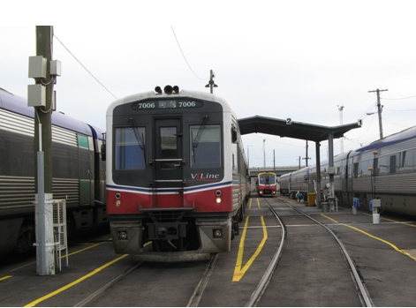

The Chief Investigator
The Chief Investigator, Transport and Marine Safety Investigations is a statutory position established on 1 August 2006 under Part V of the Transport Act 1983.
The objective of the position is to improve public transport and marine safety by independently investigating public transport and marine safety matters.
The primary focus of an investigation is to determine what factors caused the incident, rather than apportion blame for the incident, and to identify issues that may require review, monitoring or further consideration. In conducting investigations, the Chief Investigator will apply the principles of ‘just culture’ and use a methodology based on systemic investigation models.
The Chief Investigator is required to report the results of investigations to the Minister for Public Transport and/or the Minister for Roads and Ports. However, before submitting the results of an investigation to the Minister, the Chief Investigator must consult in accordance with section 85A of the Transport Act 1983.
The Chief Investigator is not subject to the direction or control of the Minister(s) in performing or exercising his or her functions or powers, but the Minister may direct the Chief Investigator to investigate a public transport safety matter or a marine safety matter.

Issuing of a Brief Report
In those cases where an investigation is curtailed or a full investigation report is not considered warranted, the Chief Investigator may issue a Brief Report.
A Brief Report will typically include the particulars of the event, a description of the incident, a summary of pertinent investigation information and key findings and, as applicable, a description of identified safety issues and recommended safety actions.

Occurrence Details
Date: 10 July 2009
Time: 1050

Location:
Southern Cross Passenger Yard (carriage sidings)
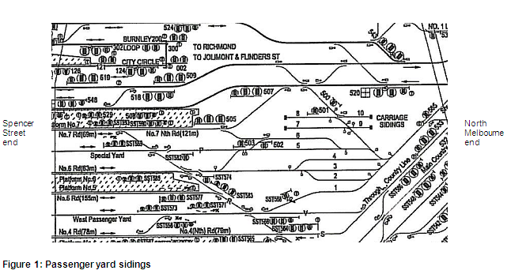
Figure 1: Passenger yard sidings

Trip/route details:
The incident occurred when a DMU (diesel multiple unit) was being shunted into No 2 siding. At that time another DMU unit was stabled at No 3 siding.

Incident outcomes:
The rear view mirror of stabled car 7006 was struck by the side of the leading car 7020 of the DMU being shunted into No 2 siding. Car 7006 rear view mirror was knocked back against the driver’s side window damaging the mirror frame and cracking the glass. Car 7020 had its saloon fifth window broken and dislodged and there were contact scratch marks on the side body above the saloon windows from the access door to the sixth window.

Vehicle details:
The moving DMU consisted of two Sprinter cars, 7020 (leading car) and 7014. The stabled DMU also consisted of two Sprinter cars, 7015 and 7006 (trailing car).

Vehicle operator
V/Line Passenger Pty Ltd

Infrastructure manager:
Connex Melbourne Pty Ltd

Environmental details:
The incident occurred in daylight hours and clear visibility. At that time the sun was about 25 degrees above the horizon bearing north north-east. The sky was partly cloudy. There was no precipitation and the ground/tracks were dry. At the time of the incident there was a northerly wind blowing at 18 to 28 km/h; the temperature was 13.5 degrees Celsius.

Other information:
There was no reported injury to personnel or delay/cancellation of regular commuter services.

Circumstances

Background/context
The Southern Cross passenger yard consists of car sidings and bank sidings where servicing, maintenance and shunting operations for V/Line commuter trains are carried out. Shunting operations in the car sidings are coordinated by the yardmaster from an office at the sidings. The yardmaster maintains a log sheet of the position of every vehicle in the sidings.

Normally only one shunter works in the car sidings however other shunters may assist when there are multiple movements. On the day of the incident there was only one shunter working in the car sidings and at the time of the incident he was stationed at the North Melbourne end of the car siding.

With regard to shunting of DMUs, in accordance with the V/Line ‘Work Instruction’ document, the yardmaster informs the shunter and the relevant train driver by two-way radio of the intended shunt movement and where the vehicle should be stabled. It is the shunter’s responsibility to ensure that the points are set correctly towards the track the DMU is assigned to take to its stabling position.

As per work practices at the car sidings, the driver of a DMU is to obtain permission from the yardmaster before commencing any movement. During the shunt the driver is responsible for ensuring that the vehicles being moved can do so without obstruction and on completion of the shunt, the driver should verify that the vehicles are stabled ‘in clear’.

VLine work practices also require all requests to move vehicles for service or maintenance be routed through the yardmaster and that the shunters and drivers have a duty of care to inform the yardmaster immediately if they observe a vehicle fouling the tracks. Other persons working in the sidings are not compelled to report fouled vehicles.

Sequence of events
On the day of the incident, there were three shunting movements authorised into No 3 siding prior to the shunting movement into No 2 siding:

- 0557 1 car (7011) shunted into No 3 siding;
- 0903 2 car DMU (7001 and 7003) shunted into No 3 siding;
- 0946 2 car DMU (7015 and 7006) shunted into No 3 siding.

At the end of the third shunt the five cars were coupled together. At that time a maintenance crew arrived and requested the driver uncouple car 7003 from car 7001 and move it clear so that they could attend to a work order for car 7003.

The driver of the DMUs in No 3 siding uncoupled and shifted the cars a few metres towards the Spencer Street end and stabled them in a position convenient for the maintenance crew to carry out their work order. He stated that when moving the cars, he was stopped by a person he presumed to be a shunter, who advised him that the cars were fouling No 2 siding and that “there was a train shunting into No 2 siding”. The driver stated that he informed the person that he believed that No 2 siding was already fouled even before he moved the cars. However, he then drove the cars back towards the North Melbourne end of No 3 siding and stabled them but car 7006 remained foul of No 2 siding.

The investigation established that the exchange claimed by the driver to be with a shunter concerning the position of his train was actually with some other yard employee and not a shunter.

Statements from the parties involved indicate that the yardmaster was not informed of the movement of the cars for maintenance but the shunter at the North Melbourne end of the sidings stated that he noticed that “there were movements in No 3 siding without authority while it was locked up”.

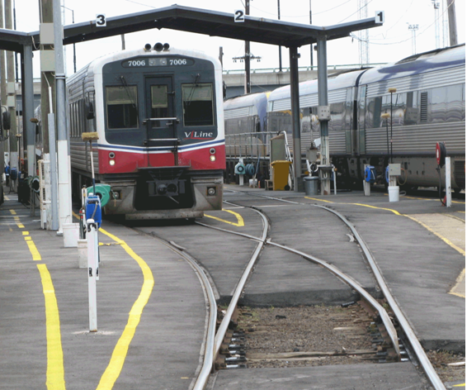
Figure 2: Car 7006 stabled in No 3 siding (picture taken after the collision)

At 1029 the two-car DMU (7020 and 7014) was authorised to shunt from platform No 6 at Southern Cross Station into No 2 siding. At 1048 it departed the platform and approached the turnout in the siding. The train was not accompanied by a shunter.

At about 1049 the driver stopped the train at the turnout to No 2 siding and checked if it was clear to proceed. The data logger of car 7020 indicates that the driver stopped the train twice more as the leading cab drew abreast of car 7006, stabled in No 3 siding. In his statement the driver stated that as the lead car (7020) of his train appeared to be clear of the train in No 3 siding, he resumed movement into No 2 siding.

The front of car 7020 cleared car 7006 but, due to the curve in the track, when the leading bogie of car 7020 swung to the left, the mid-section of the car struck the rear view mirror of car 7006. Car 7020 was travelling at about five km/h at impact. The driver stopped to check the damage then resumed driving the DMU to the North Melbourne end of the siding.

Summary investigation information and findings

Personnel
The yardmaster has about 20 years experience working in the Southern Cross yard starting as a shunter then a leading shunter and for the last five years as yardmaster.

The shunter has about 15 years experience as a shunter, the last 18 months of which have been with V/Line at the Southern Cross yard. He was last audited on 6 May 2009.

The driver of DMUs 7001 / 7003 and 7015 / 7006 in No 3 siding was reported to have extensive experience driving trains, and for the past three years has driven trains for V/Line in the Southern Cross yard. His last driver safety audit was completed on 4 May 2009.

The driver of DMUs 7020 / 7014 into No 2 siding had about 40 years experience driving trains for V/line which included shunting movements in the Southern Cross yard. His last driver safety audit was completed on 2 October 2008.

All personnel mentioned commenced their shift that morning at about 0700. All personnel were reported to be appropriately qualified and fit for duty.

Vehicle(s) and Equipment
Sprinters are high speed diesel rail carriages capable of being operated as a single car or as multiple units with up to eight cars coupled together. Each car has a length of 25 metres and width of 2.94 metres. Each side of the car extends about 0.67 metres from the rail track. The rear view mirror extends about 40 centimetres outside the width of the car.

Figure 3: S6 Sprinter

Infrastructure
Southern Cross passenger yard car sidings consist of 10 tracks. The site is operated by V/Line and used to service and stable V/Line DMUs, passenger cars and locomotives.

Siding 2 (length 110 metres), 3 (143 metres) and 4 (197 metres) are used to stable Sprinter and VLocity cars and also have facilities to refuel them. The sidings run in approximately the east-west direction.

The point of collision was in the convergence zone of No 2 and 3 sidings (see figure 2). At that point, the distance between the adjacent tracks of No 2 and 3 sidings was 1.33 metres.

Within the yard, a clearway for pedestrians has been marked by yellow lines (see figure 2). With regard to sidings 2, 3 and 4, only the North Melbourne end of the sidings have the fouling point indicator marked on each siding. At the Spencer Street end, the investigation noted that only sidings 1 and 5 were marked.

The fouling point is indicated by a sleeper painted white to indicate the end of the safe zone in that siding. Vehicles that overlap the fouling point risk obstructing the movement of vehicles on adjacent tracks or sidings.

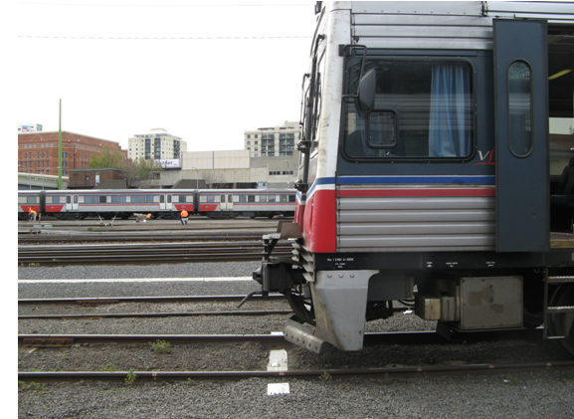
Figure 4: Fouling point indicator

Guidelines, rules and procedures
The V/Line Work Instruction document (OPWI: 123) is written in accordance with section 12 of the ‘Book of Rules and Operating Procedures 1994’.

The work instruction states that the yardmaster is to instruct all shunters and drivers on vehicle movements that are required in the car sidings. Before the shunt of any DMU, the shunter is to confirm with the yardmaster that the road is set for the impending move. Drivers shunting Sprinters and VLocities to the car sidings must receive instructions from the yardmaster on what road they are to shunt to and whether or not to leave the vehicle running or to shut down.

The ‘Book of Rules’ states that after each shunting movement, the competent employee must ensure vehicles are clear of the fouling point. However, although verbally informed to the investigation that the driver and shunter are jointly responsible, the V/Line work instruction does not stipulate who the responsible person will be to ensure that the vehicles are stabled clear of the fouling point. In addition, there is no requirement for a report to be sent back to the yardmaster once the vehicle has been stabled.

The investigation also noted that the V/Line work instruction does not advise on the procedures to follow if maintenance crew require vehicles to be shifted at the car sidings.

Regulatory systems
PTSV (Public Transport Safety Victoria) is the public transport safety regulator for Victoria, responsible for regulating the safety of all train, tram and bus operations in Victoria. PTSV’s key concern is to ensure that accredited rail operators have the competence and the capacity to manage the risks to safety associated with their rail operations.

In granting accreditation, the Safety Director PTSV needs to be satisfied that the rail operator is able to identify what the risks associated with rail transport operation actually are and to demonstrate their ability to be able to eliminate, control, reduce or mitigate those risks (as appropriate). The operator is also required to demonstrate to PTSV that appropriate measures are in place for the review of risk assessments and control measures and to take appropriate remedial action when deficiencies in the safety management system are identified.

Identified safety issues

Fouling points
Had there been a fouling point indicator at the Spencer Street end of No 3 siding, in all probability the collision would not have occurred, as it would have become immediately recognisable to both drivers that car 7006 was foul of No 2 siding.

The investigation noted that following the incident V/Line has painted fouling point indicators at each end of all car sidings in the Southern Cross passenger yard.

Unauthorised shunting movements
In this incident, there was a multiple breakdown in the operating procedures. The maintenance crew did not inform the yardmaster that they needed the cars shifted but approached the driver directly. The driver acceded to the request of the maintenance crew to shift the cars without confirming the movement with the yardmaster or the shunter.

In addition, the shunter noticed that there was an “unauthorised movement” taking place at No 3 siding but he did not exercise his responsibility to take control of the movement and to inform the yardmaster that “unauthorised movement” was taking place when No 3 siding was “locked up”.

That three parties could individually bypass the procedures indicates that it may be normal practice at the sidings to move vehicles on an ad-hoc basis without informing the yardmaster.

Previous incidents safety actions
Following a collision incident on 16 November 2007, a V/Line initiated safety action (A3) required the V/Line Safety Security and Environment Group to “review its risk management and control process to how it ensures effective safety corrective actions are systematically implemented in critical high risk sites and activities”.

Following a collision incident on 6 March 2009, another V/Line initiated safety action A186-09/A187-09 recommended that “all the fouling points in the No 9 and No 10 car sidings be marked with the fouling point sleeper painted white and that all shunters and drivers be made aware of the fouling points to ensure no vehicle is left sitting foul”.

In stating that fouling points need only be marked only on sidings 9 and 10, V/Line safety actions failed to foresee that a similar collision could occur on other sidings. Had V/Line implemented systems to provide for the safety action (A3), above, then it is possible that safety action A186-09/A187-09 would have identified that all other sidings bore the same risk as sidings 9 and 10.

Following a shunting collision incident on 15 May 2006, the V/Line investigation recommended a safety action that the V/Line Manager Safety and Accreditation ensure that “leaving shunting roads foul with stabled cars should cease immediately”.

Safe shunting operating procedures
The investigation found that V/Line’s work instruction document does not stipulate who the responsible persons will be to ensure that the vehicles are clear of the fouling point.
The investigation noted that the manual does not advise on the procedures to follow if maintenance crew require vehicles to be shifted at the car sidings and furthermore, that there is no requirement for a report to be sent back to the yardmaster once the vehicle has been relocated or stabled.

The investigation also noted that the driver assumed another yard employee to be the shunter. However, despite this employee knowing that there was a shunt intended for No 2 siding and seeing that the track was fouled, there was no requirement for him to inform the yardmaster or any other competent person.

Furthermore, the work instruction in its current form is confusing in that it does not differentiate between locomotive assisted shunts and DMU shunts, for which there are differing work practices. For example, point 6 states that the driver is to obtain permission from the shunter before commencing movement however the investigation was informed that this only applies to locomotive shunts and not DMUs, which is not stated in the work instruction.

Further incidents at Southern Cross No 2 car siding
On 16 August 2009, there was another collision incident during shunting operations at No 2 siding. The investigation found that despite the safety action taken by V/Line in painting fouling point indicators on all car sidings, a similar collision occurring had not been prevented. It therefore appears that at the operational level there is insufficient instruction to yard staff to follow safe operating procedures.

Safety actions taken
Following the July incident, V/Line has painted fouling point indicators at each end of all car sidings in the yard. The operator is currently in the process of drafting a further work instruction “Southern Cross Yard Clearance Instruction” to ensure that vehicles are left in a position where they do not obstruct the path of adjacent tracks.
V/Line has also provided the investigation with an advance copy of their “Safe Shunting Operations for Southern Cross Station”. The intent of the manual is that it will combine a number of work instructions into one document. However, the investigation has been advised it is still a work in progress consulting with all the groups involved but has not been circulated to anyone in the operations area.
The investigation noted that the draft copy of the operations manual still does not differentiate between locomotive assisted shunts and DMU shunts and does not address the “Identified Safety Issues” mentioned in this report.

Recommended safety actions
RSA 2009004: That V/Line implements systems which ensure that maintenance crew make all requests for moving vehicles through the yardmaster.

RSA 2009005: That V/Line reviews the need to provide further training and guidance to shunters and drivers regarding their roles and responsibilities when moving vehicles.

RSA 2009006: That V/Line reviews its risk management and control process to ensure effective safety corrective actions are systematically implemented across all sidings in all yards under its jurisdiction.

RSA 2009007: That V/Line updates its work instructions and procedures manual in accordance with the “Identified Safety Issues” stated above.

In clear – the point on any track where vehicles can be left without fouling or obstructing an adjacent track.
The ‘Book of Rules and Operating Procedures’ was published by the Public Transport Corporation in 1994 to ensure conformity and safety of operating procedures on the Victorian network.
Competent employee – any employee who has demonstrated by maturity and knowledge and has passed the necessary theory and practical instruction to be competent to perform the allotted task.

