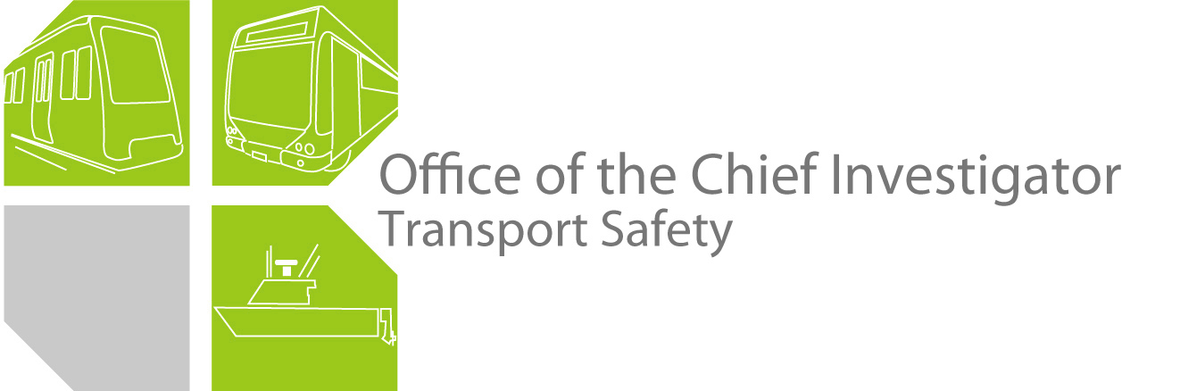

Rail Safety Investigation
Report No 2010/03

Brake Fire
V/Line Train 8025
Watergardens Station Sydenham
26 February 2010

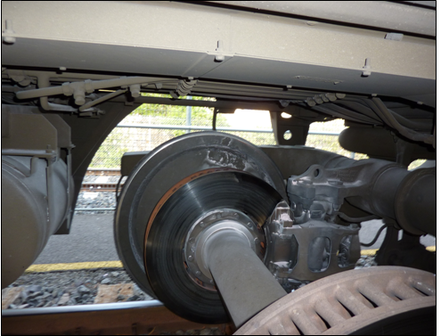

TABLE OF CONTENTS
The Chief Investigator 5
Executive Summary 7
1. Circumstances 9
2. Factual Information 11
2.1 Personnel 11
2.2 The train 12
2.3 Train Park Brake System 12
2.4 Previous incident 15
2.5 Equipment testing and fault analysis 15
2.6 Guidelines and documentation 19
3. Analysis 21
3.1 The incident 21
3.2 VLocity DMU Driver Instruction 21
3.3 Access to rear driver’s cab 22
3.4 Rear-vision mirror use 22
3.5 Control console indications and driver actions 23
3.6 Park brake control valve testing 24
4. Conclusions 27
4.1 Findings 27
4.2 Contributing factors 27
5. Safety Actions 29
5.1 Safety Actions taken since the event 29
5.2 Recommended Safety Actions 29

6. Appendixes 31
Appendix A – VLocity Park Brake Operation Matrix 31

The Chief Investigator
The Chief Investigator, Transport Safety is a statutory position under Part 7 of the Transport Integration Act 2010. The objective of the position is to seek to improve transport safety by providing for an independent no-blame investigation of transport safety matters consistent with the vision statement and the transport system objective.

The primary focus of an investigation is to determine what factors caused the incident, rather than apportion blame for the incident, and to identify issues that may require review, monitoring or further consideration. In conducting investigations, the Chief Investigator will apply the principles of ‘just culture’ and use a methodology based on systemic investigation models.

The Chief Investigator is required to report the results of investigations to the Minister for Public Transport and/or the Minister for Roads and Ports. However, before submitting the results of an investigation to the Minister, the Chief Investigator must consult in accordance with section 85A of the Transport (Compliance and Miscellaneous) Act 1983.

The Chief Investigator is not subject to the direction or control of the Minister(s) in performing or exercising his or her functions or powers, but the Minister may direct the Chief Investigator to investigate a transport safety matter.

Executive Summary
On 26 February 2010 the 1415 hours Melbourne (Southern Cross) to Bendigo V/Line service experienced fire caused by overheated brakes below the underframe of one car of the train. The train was halted at the Watergardens Station (Sydenham) whereupon it was established that the train had been running with the park brake applied on both bogies of the lead car of the intermediate Diesel Multiple Unit (DMU). The disc-brake pads of these axles were alight and the fires were extinguished by the crew. There were no injuries to passengers or crew.

The unaffected portion of the train was separated to continue to destination. The affected DMU was examined at Watergardens Station by investigators from the Chief Investigator’s office and representatives of the train manufacturer, Bombardier Transportation Australia (BTA), and moved to its Melbourne maintenance depot for inspection and testing. The investigation examined the relevant train technical systems as well as staff actions and procedures, and recommends a review of ergonomic aspects of the train driver’s control console layout, a review of the adequacy of the train driver’s operators manual, and that a modification to the fire warning and suppression system be considered. V/Line has taken interim action to raise the awareness of VLocity train drivers with regard to this incident and also to alter the VLocity control software to include an aural warning to the driver if the park brake is ‘On’ while the train is in motion.
.

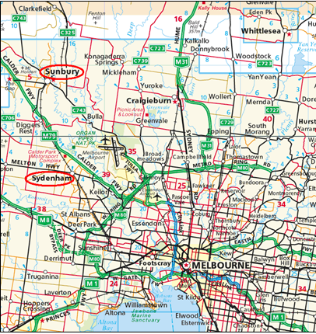
Figure 1 – Locality map

Circumstances
Train № 8025 departed Melbourne (Southern Cross) Station on time at 1415 hours bound for Bendigo. The train consisted of three, 2-car VLocity DMU sets coupled together. The triple VLocity DMU consist was to be split at Sunbury — approximately 45 kilometres from Melbourne — with the lead DMU continuing on to Bendigo and the other two sets remaining coupled to form a return service to Melbourne.

At around 1440, passengers aboard car 1205 (see Figure 2) alerted the conductor to a burning smell in the passenger saloon. The conductor alerted the driver, who halted the train at the Watergardens Station (Sydenham), approximately 29 kilometres from Southern Cross Station, whereupon four park brake assemblies under the lead car of the intermediate DMU were found to be on fire. The fires were extinguished by the drivers using portable extinguishers from the train. The attendance of emergency services was not considered necessary.

To reduce the delay to the Bendigo service, the lead DMU was detached at Watergardens to continue to destination. The remaining portion of the train — the intermediate and trailing DMUs — was moved off the main line and into a storage track to await inspection by officers of the Chief Investigator, Transport Safety and manufacturers, Bombardier Transportation Australia (BTA).

It was determined that there was no damage that would prevent the double DMU consist being returned to Melbourne under its own power in order for the damaged set to be inspected.

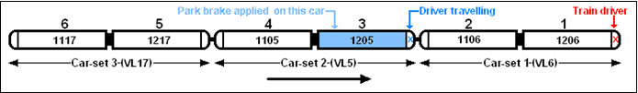
Figure 2 – Train 8025 DMU consist diagram

Factual Information

Personnel
Train № 8025 was operated by one driver. A second driver was travelling in the leading driver’s cab of the second coupled set (the third car, Figure 2), and was rostered to operate this portion of the train back to Melbourne following separation at Sunbury. Due to the lack of inter-car access between individual VLocity sets, the train was staffed by three conductors — one for each car-set. There were no injuries to passengers or crew.

In a BTA Incident Report made available to the investigation the driver stated that he had received no control display indication of the park brake being applied, or of the fire. The first indication he received of a problem was when the conductor on the second car-set radioed to advise that there was a strong burning smell in the passenger saloon and that passengers were complaining of feeling nauseous. The driver said he then noticed smoke issuing from under the train and thought ‘... it could have been anything, like engine oil burning off, but I thought I had better stop and check.’

After stopping at Watergardens Station he realised there was an underframe fire and both he and the driver travelling on the second car-set used on-board portable fire extinguishers to extinguish the fire from ground-level. In addition, the driver reported that he had not noticed any effect of dragging brakes while running the train. He had been following a suburban electric train at around 80 km/h.

The driver travelling in the middle DMU also stated that he had not noticed any warning of a park brake application in his cab.

The investigation was informed that the conductor on the second car-set had reported having ‘... thrown their bag into the drivers cab at some stage en-route ...’

The train
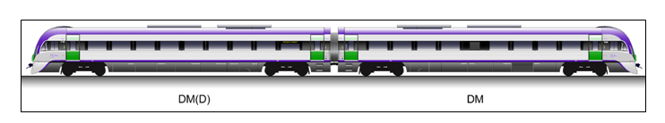
Figure 3 – Two-car VLocity DMU
The train consisted of three 2-car VLocity railcar sets; №’s VL6 (cars 1206 and 1106), VL5 (1205 and 1105) and VL17 (1217 and 1117) coupled in multiple. Each of these car-sets comprises one DM-class car (Driving Motor) and one DM(D)-class car (Driving Motor with disabled persons toilet) permanently coupled.

The brake fires occurred to car 1205, the lead car of set VL5 but resulted in no major damage.

Train Park Brake System
The VLocity DMU is equipped with one spring-operated park brake assembly on each axle; the park brake being held Released by main reservoir air pressure when air is applied to the park brake cylinders via the B23 park brake control valve. Park brake application occurs by exhausting the main reservoir air supply from the park brake cylinders (via the B23 park brake control valve), which permits spring pressure to apply the brake. Park Brake operation is not captured on the train event recorder.

Park Brake Selector switch and Fault Display Panel (FDP)
The park brakes are normally applied and released by means of a three-position rotary Park Brake Selector switch on the driver's control panel (see Figures 4 and 6). This is a momentary switch that can be placed to Release or Apply positions and will return to its central position under spring-loading. It controls an electrical feed to a solenoid valve integral to the B23 control valve. Since this wire is trainlined, all park brakes in a consist of multi-coupled railcars will apply or release when this switch is used from any driver’s cab. The park brake application is displayed to the train driver by a PARK BRAKE warning light on the FDP in the active cab and by an ‘ON’ indication in the Park Brake Indicator dial.

A park brake application initiated from the Park Brake Selector switch in a non-active (trailing) cab will apply all park brakes in the consist and will be reflected on the Park Brake Indicator dial of all cars. This application will illuminate the PARK BRAKE warning light on the FDP in the active cab only. Such an application can only be released by use of the Park Brake Selector switch in the active cab or by operation of the RELEASE manual override pushbuttons in each car (refer next page).
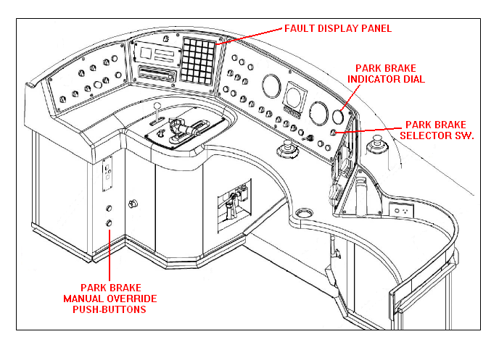
Figure 4 – Driver’s Desk and Control Console

Park Brake manual override buttons and Park Brake Indicator dial
The park brakes on each car can also be operated, by means of APPLY and RELEASE manual override pushbuttons that operate directly on the B23 park brake control valve of the individual car. When the APPLY pushbutton has been used, park brakes will apply only on that car. In this case, although the park brake warning indication input to the TCMS is trainlined, a warning light will illuminate only on the FDP of the active cab. There is no indication as to which car is affected by a dragging park brake (this must be ascertained by checking each car) and there is no aural cue in association with a PARK BRAKE warning light.

The Park Brake Indicator dial is an air pressure gauge. It indicates the park brakes are released (OFF, needle in the green sector, indicating that main reservoir air pressure is present and holding the park brake released) or that park brakes are applied (ON, needle in the Red or intermediate sectors, indicating that MR air pressure has been removed and the park brake spring is holding the brake applied.

The Park Brake Indicator only displays the park brake status on the car to which it applies.
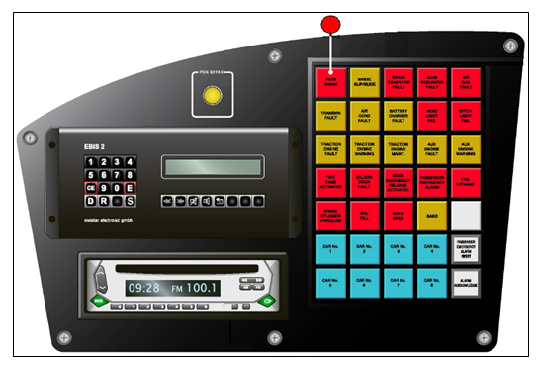
Figure 5 – VLocity DMU Driver’s Desk Control Console, left-hand side – Fault Display Panel
The extreme upper left (red) light on the FDP (Figure 5) will indicate if any park brakes are applied anywhere on the train. This warning light may illuminate, even though the local Park Brake Indicator dial (Figure 6) shows park brakes to be released. This would indicate that the park brakes were applied on a trailing car.
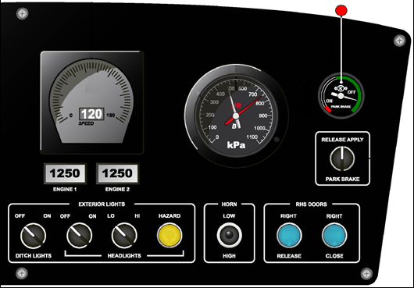
Figure 6 – VLocity DMU Driver’s Desk Control Console, right-hand side – Park Brake Indicator dial

Previous incident
At about 0600 on 10 February 2010, the driver of a Melbourne-bound 3-car VLocity set at Malmsbury reported a fire on one bogie of the middle car. The fire had originated at the disk pads of the park brake on this bogie. The train driver extinguished the fire using a portable fire extinguisher.

Although the driver reported that he had not noticed a PARK BRAKE warning light on his control console, a technical examination conducted by BTA following the second incident could find no evidence to suggest that the warning light on the FDP would not have illuminated at the time. The report from BTA stresses that the driver’s console Park Brake Indicator dial relates only to the car in which it is fitted; not the train in general. The BTA report recommends that V/Line review VLocity driver training and vehicle familiarisation to reinforce to drivers that a PARK BRAKE warning light on the FDP should not be ignored simply because the Park Brake Indicator dial shows the park brakes to be ‘Off’. The park brake circuit to the FDP is trainlined and this will display a PARK BRAKE warning from any car in the train.

Equipment testing and fault analysis
Following these two incidents, BTA carried out examination and testing of the affected DMU cars. As a result of train driver reports on both occasions it was considered that the problem may have resulted from a fault in the B23 park brake control valve. The control valves from both trains were sent to the supplier for detailed inspection.

Summary of tests of DMU cars:

- Park brake control switch functional checks were carried out on all affected cars.
- Continuity checks were carried out to ensure the PARK BRAKE light illuminated on all affected cars (plus a sample of other cars from the fleet).
- The Park Brake Selector switch was ‘flicked’ (switched quickly between APPLY and RELEASE positions) to see if it could ‘catch an individual car out’ for being too slow to respond; this test was undertaken from several cabs.
- The multi-function couplers on the affected cars received a point-to-point check.
- The B22 double check valves (see Figure 7, page 16) on the affected cars were removed and inspected.

For all of the checks above, no fault was found.

- The B23 control valves on the affected cars were removed and inspected. Nothing was observed that could adequately explain their uncommanded application.
- A controlled leak was introduced to car 1205 to simulate the effects of a leaking gasket close to the control valve (see description below).

Note that a test of the exact value at which the B17 pressure switch (see Figure 7, page 16) would cause illumination of the FDP warning light was not completed due to the need to use test equipment not carried in-house. However, even if the set pressure had drifted slightly, BTA do not expect that such variation could be of sufficient magnitude as to allow an undetected dragging brake condition.
Referring to the segment of the Brake & Pneumatic System Piping Diagram for a single VLocity car reproduced below (the park brake feed and control lines have been highlighted in blue) it can be seen that the only component capable of applying or releasing the park brakes either by normal application or by a fault is the B23 control valve. A direct feed from the trainlined Main Reservoir Equalising (MR) pipe supplies this valve. MR pressure had to have been at the correct value for the train to have operated. The output from the B23 control valve directly feeds all four of the park brake actuators on the bogies of the car (at B16 on the diagram - the blue line at the bottom of the diagram branches to all four bogie-mounted park brake cylinders). As all four park brakes on one car were applied simultaneously in both incidents the common ‘trigger’ device had to have been the B23 control valve. No aspect of the functioning of the double check valve B22, choke B19 or pressure switch B17 is capable of changing the state of the system.

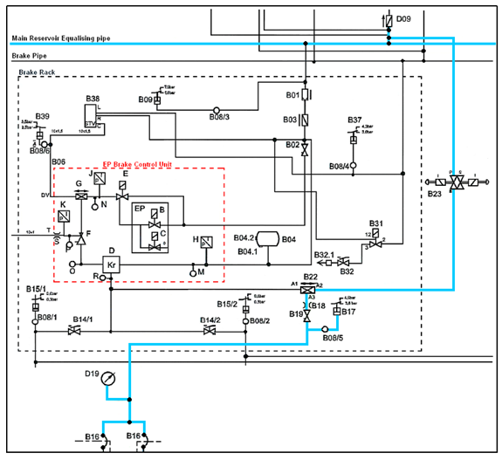
Figure 7 – Extract from VLocity Brake & Pneumatic System piping diagram
Any malfunction of the B23 control valve would be either electrical or mechanical. Electrically, the solenoids could have failed to drive the valves to their ‘open’ or ‘close’ positions in response to the trainlined electrical signal from the driver’s Park Brake Selector switch. However, the examination found no evidence to support this possibility; either on the train cabling or — as an independent function — a check of amperage drawn by the suspect solenoid valves.

Mechanically, the valves could have failed to follow their electrical signals by resisting the solenoid and the drive piston but again, testing and examination could provide no evidence to support this theory and the valve is described as having an excellent record of reliability. The only other failure mechanism considered possible was the existence of an air leak of sufficient magnitude to have bled off MR pressure, allowing the spring force at each park brake to apply the brakes. This potential scenario was investigated as follows:
To simulate a controlled variable leak condition at the B23 control valve on one car; the flexible pipe connecting it to the long underframe pipe feeding the Brake Rack was temporarily interrupted and a ball valve introduced to vent to atmosphere. Note, this ball valve was introduced very close (about 500 mm) to the B23 control valve itself for accurate representation of the system in the event that natural pressure losses arising from the run-of-pipe might otherwise influence the results.
In a stationary condition, the air system on the 2-car DMU (VL05) was fully charged to normal values with ALL park brakes applied. Immediately prior to commencement of the test, the park brakes on the test car (1205) were released via the B23 control valve manual override pushbutton (see Figure 4). MR air pressure then held the park brake released on this car only and all wheels were un-braked.
Several BTA engineers and technicians were involved in the test at the same time so that cab controls could be operated and gauge and warning light displays relayed to others beneath the train who were monitoring the park brakes for movement and operating the ball valve handle (to manually control the magnitude of the leak).
To simulate a leak in the gasket of the B23 control valve on this car the ball valve was then cracked open. The control valve is fed from MR pressure which was at around 900 kPa, so that even with a small leak the tremendous noise generated required everyone under the car to be wearing earplugs.
This initial ‘leak’ was held for several minutes before engineers were satisfied that the system was stable and that the cab gauge displays were normal. The park brakes were observed to remain Released and the MR gauge continued to indicate a ‘good’ pressure (~850 kPa).
Over the following ten minutes or so, the valve opening was incrementally increased while communication was maintained with personnel in the cab. With the ball valve ¾ open and with MR pressure depleted enough to start both air compressors (normally only one being sufficient) the massive air leak was still not enough to affect the state of the park brake. At this stage, the calipers had not moved and the Park Brake Indicator dial still showed them to be Released. It was not until a few seconds after the valve was fully opened that the MR FAULT light (low pressure warning) illuminated. Only at this point in the test did the park brakes apply.
To permit the park brakes to apply, the artificial leak created had to be so substantial as to have depleted MR pressure to around 580 kPa; well below the normal pressure required to permit operation of the train and sufficient to illuminate the MR FAULT light on the driver’s console prior to the PARK BRAKE warning light.
It was concluded that for a leak in the local B23 control valve to have caused an uncommanded application of the park brakes it would have had to have been of sufficient magnitude to have reduced the MR pressure on the whole train to below normal operating values. The cross-sectional area of the control leak artificially applied via the ball valve was around 50 mm². The only suspect seal on the B23 control valve is a gasket of approximately 70 mm x 30 mm x 0.5 mm (compressed thickness) feeding several separate chambers that was substantially intact and was only disrupted on one leg and for about 10 mm of its length. A gasket defect of this minor proportion was not considered by BTA to be capable of producing faulty operation of the B23 control valve to the extent required to cause an uncommanded park brake application.
The examination and test process conducted was unable to identify a reason for an uncommanded in-service application of the park brakes on either of the two trains involved in these brake fire incidents.
Inspection of B23 Park Brake control valves:
The B23 control valves were removed by BTA from the respective cars and sent to the supplier for detailed examination. The supplier’s report identified several apparent irregularities for which BTA were able to account;
- On one of the valves the Apply manual override pushbutton bezel had sustained crush damage. BTA stated that this button was not sourced from either of the trains but was a spare stores unit — not intended for operational use — that had been provided to the supplier along with the B23 valve to enable the assembly to be tested in its own housing. The damaged condition of the pushbutton bezel was thus irrelevant to the examination of the control valves’ condition and functional capacity.
- There was significant air leakage on both assemblies. One of the valves displayed an external leak at the valve body-to-baseplate gasket, which manifested when the APPLY manual override pushbutton was activated. The location of this leak was a point at which the gasket protruded from its proper seating location. When the valve was disassembled, a small tear in this gasket was evident at a portion of its external periphery, as was some deformation of another internal portion of the gasket that was designed to prevent communication between two galleries within the valve. The examination report stated that expected air leakage permitted by these irregularities was consistent with test results. The other valve assembly showed significant leakage when both the APPLY and RELEASE manual override pushbuttons were activated. This was internal leakage that occurred regardless of the spool position. The valve body-to-baseplate gasket for this control valve did not display any clear signs of breach or rupture.
The BTA response to this comment was that the tear in the periphery of the gasket was most likely caused by themselves in originally removing and examining the control valve from the train and reassembling it for dispatch to the supplier, and that no leak was noticed on the train by BTA engineers prior to its removal. The deformed gasket referred-to, seals communication between MR pressure and an exhaust port, and — if leaking — would have permitted only a minor seepage from the MR supply line with the B23 control valve in the Application position. That part of the gasket relating to the valve’s functionality with the park brake in Release position was in perfect condition.
- It was noticed during disassembly that the valve body-to-baseplate bolts on both control valves were tightened to dissimilar torque values. The supplier stated that since these valves are assembled at manufacture using calibrated torque drivers, this suggested that the valves had been disassembled previously, possibly for maintenance. Both control valves were re-tested using a new baseplate and new gaskets and passed inspection with no leakage.
BTA’s response to this is that the two B23 control valves had not — in fact — been subject to any maintenance as neither had reached the point of requiring it, and neither valve had been accessed on their respective cars since installation, except to remove them for this examination. The variation in bolt torque values noticed by the supplier during the inspection would have resulted from BTA’s action of removing them from the two trains, disassembling them for examination and reassembling them (without reference to specified torque values) for dispatch to the supplier.
Supplier testing of B23 control valves - summary:
The supplier Inspection Report noted that testing indicated that the baseplate gasket had failed and caused the air leakage in both cases. Inspection of the control valve internal galleries and spool did not reveal significant contamination, suggesting the reason for the gasket failure may have been related to other factors such as operating temperature (both ambient and fluid) or the age of the product. The supplier’s summary stated that it was also evident that the valves had been disassembled for maintenance and reassembled out-of-specification (refer to BTA comment, commencing with last paragraph on previous page).
Regarding both the protruding portion of the gasket evident at the valve body-to-baseplate joint plus the deformation of another internal portion also discussed on the previous page, BTA have stated that since neither of the control valves had been disturbed for maintenance since original installation, these abnormalities had existed since assembly of the valves by the supplier and had in no way been responsible for uncommanded park brake applications.

Guidelines and documentation

VLocity Operators Manual
The VLocity DMU Operator’s Manual (3EAM 0-0350, Rev. 6a) has been prepared by BTA, the train’s manufacturer, and contains important information and safety instructions for the correct operation of these vehicles. The investigation was advised that this manual forms part of the VLocity train driver’s training course and BTA recommends that operating personnel keep it at hand during railcar operation.

The manual states that the VLocity train is fitted with an underframe fire protection system and that when a fire or system fault has fused the sensor cable the train driver will receive a visual and audible warning on the drivers fault panel. This will also indicate in which car of the train the fault is located. This protection system, though, is designed to operate in the event of an engine or alternator fire only, and will not detect a fire in the vicinity of a bogie. The manual itself does not state this.

The manual provides a description of the park brake system and related Fault Display Panel indications but the interrelationship between different park brake control actions and ensuing control console displays is not clearly explained and the importance and relevance of this relationship is diminished by not being explicitly articulated in one, central place within the manual.

The manual also describes a functional characteristic of the Fault Display Panel that provides for a CAR № warning light that displays for the driver which car a fault is occurring on (maximum of eight cars). This functionality does not extend to displaying a brake application while the train is running.

Driver training
The investigation was informed that V/Line trainees ‘... study the Park Brake System as part of the entire [VLocity] Brake System lesson. They then sit a computer-based exam at the end of the entire VLocity lesson, which includes questions on the brake system. They are also required to answer various questions regarding the braking system when they partake in a practical assessment of the VLocity with a Driver Supervisor.’

Driver training Module 103 Session 1, VLocity DMU – General Data and Vehicle Systems LEARNER NOTES (Rev 08) includes — within the section describing the VLocity Brake System — a brief passage describing the Spring Park Brake.

Driver cab access
The investigation requested detail from V/Line on their policy for travel by conductors and non-operating train drivers in non-active driver's cabs

V/Line WORK INSTRUCTION, Document Number OPWI-170 (12/02/2009 - Revision Number 01) Driver Cab Access on VLocity and Sprinter Trains is applicable to all Conductor staff of V/Line Passenger services and provides instruction regarding access to a DMU driver’s cab. Regarding working on multiple units (that is to say, ‘multiple’ DMU sets) the Work Instruction authorises conductors to utilise either cab of the trailing vehicle as a workstation (unless otherwise instructed).

V/Line PROCEDURE, Document Number SAPR-003 (26/10/2009 Revision Number 02), Authority to Travel in Drivers Cab applies to all V/Line employees and other rail organisations and their contractors applying for authority to travel in drivers’ cabs of V/Line trains. Section 5.1. states, “NO PERSON is permitted to travel in the leading cab of any V/Line train, unless duly authorised and in the execution of their duty.” Section 5.4. states, “Staff, including Train Drivers, travelling to or from work, either prior to signing on, or after signing off or when rostered to travel, are NOT permitted to travel in the leading cab of any V/Line train.” The procedure also states, .“No persons, including train drivers, unless in the execution of their duty [V/Line emphasis], are permitted to travel in any rear cab of any V/Line train, or in any cab of an assisting or intervening Locomotive, Sprinter or VLocity.”

Analysis

The incident
Train № 8025 was about 20 kilometres into its journey from Melbourne to Sunbury, while in the prior incident on 10 February the train involved had travelled about 70 kilometres from Bendigo towards Melbourne. Thus, in both cases, the trains had travelled sufficient distance for the brake pads to have heated up to an extent to cause heavy smoking and then to ignite; either from the park brakes having been left applied from their originating stations or having been applied as the train was running. This had apparently not been noticed by either train driver when it first occurred, and in the first incident the driver only became aware of the problem after some time. Notification to the driver of the problem in the second (Watergardens) incident was conveyed via a train conductor who had received complaints from passengers of the burning smell in the saloon of the affected car.

The driver in the Watergardens incident stated to BTA personnel that he had not been aware that anything was amiss and that there was no control console indication of a fire or of brakes being applied. This could be taken to mean that the driver hadn’t noticed any such control indication. The train was scheduled to be divided at Sunbury and to this end a second train driver was riding as a passenger in the driver’s cab of the second (intermediate) VLocity car-set.

Testing of the park brake control valves by the equipment supplier found a number of apparent irregularities that were accounted for by BTA (refer to Section 2.5, pages 18 and 19). Testing of the park brake system on one VLocity car with reference to B23 control valve operation indicated that any leakage that may have existed at the control valves at the time of the incidents would have been minor. This testing revealed conclusively that leakage of exceptional magnitude would be required in order to cause a park brake application and that the existence of such a degree of leakage would have prevented operation of the trains in the first place. Testing of the vehicles by BTA indicated that in neither case was there any discernable reason for the expected control console indications applicable to park brake operation not to have been displayed.

IT can therefore be concluded that, in both instances, the park brake had either been left applied when the train departed its originating station or was applied en-route – in the case of the second occurrence possibly from the non-active cab of the second car-set, either as an unintentional action by the driver travelling or by the conductor in depositing their bag against a manual override pushbutton in the cab.

VLocity DMU Driver Instruction
The VLocity DMU Operator’s Manual includes sections describing the park brake system and related Fault Display Panel indications, but by not being articulated in straightforward terms in one central location within the manual the consequence of the interrelationship (see Section 3.5) between different park brake control actions and ensuing control console displays tends to be veiled and its significance diminished.

V/Line drivers undergoing VLocity DMU training are provided — within the LEARNERS NOTES for the train Braking System — with a brief passage describing the Spring Park Brake. As with the Operator’s Manual, this descriptive passage is minimalist and could not be considered as sufficient coverage of this subject. It is possible that not all drivers fully understand all operational aspects of the park brake system.

Access to rear driver’s cab
V/Line documents supplied to the investigation (refer to Section 2.6, page 20) authorise conductors to utilise non-operative driver’s cabs as workstations, and prohibit all persons (including train drivers unless in the execution of their duty), from travel in any non-active cab of any VLocity train. V/Line management personnel have advised investigators that this latter procedure is intended to also apply to drivers rostered on duty to travel prior to taking up actual driving duties (as was the case with the train involved in this occurrence).

It is clear that the reason behind this explicit prohibition — even of drivers who are travelling on duty — from being accommodated in a non-active driving cab is to prevent any untoward action occurring that might produce an unintended effect on the operating status of the train. To minimise this possibility when the cab is utilised as a conductor’s workstation, conductors are given instruction in maintaining safe occupancy of this environment. The investigation received evidence that the conductor had ‘thrown’ their bag into the rear cab occupied by the driver travelling. The bag may have been deposited against the Park Brake APPLY manual override pushbutton.

V/Line PROCEDURE, № SAPR-003 Authority to Travel in Drivers Cab is explicitly referred-to as a procedure to be used by V/Line employees and other rail organisations and their contractors when applying for authority to travel in driver’s cabs of V/Line trains. There is nothing contained within the procedure to define the emphasised phrase, “...unless in the execution of their duty...” It may be that a driver booking on duty and rostered to travel some distance as a passenger in order to take up driving duties might reasonably consider themselves to be travelling ‘in the execution of their duty’ and thus authorised and perhaps expected to travel in an available rear cab, especially one that is part of the train they will soon be operating. In the absence of some definition, the phrase, “...in the execution of their duty...” as used in this procedure is open to interpretation.

Rear-vision mirror use
V/Line Diesel Multiple Units, such as VLocity and Sprinter trainsets, are configured with large, truck-type exterior rear-vision mirrors similar to those fitted to V/Line diesel locomotives. Other Australian operators of streamlined, high-speed rolling-stock — and some overseas — have dispensed with this type of mirror by employing alternative solutions to the need for the driver to have an exterior rearward view. Despite the provision of these large mirrors in this case, they did not prove effective as a means of conveying an indication to the train driver of the smoke issuing from a portion of the train. However, since they have the use of these mirrors, it would be prudent for drivers to ensure they maintain a rearward watch during the running of trains for any abnormal indication.

A BTA Incident Report quotes the driver as stating, “I saw black smoke coming out from under the train and thought that it could have been anything, like engine oil burning off, but I thought I had better stop and check.” Due to not having been afforded the opportunity to interview the driver, investigators were unable to determine whether he was referring to observations made prior or subsequent to the advice received from on-board staff regarding smoke in the saloon.

Control console indications and driver actions
The train driver reported that he did not receive a warning indication of the park brake application or of the existence of an underframe fire. Subsequent testing did not reveal any reason for the Fault Display Panel on the control console to have not displayed an illuminated PARK BRAKE warning light. Although the driver’s control console also contains a Park Brake Indicator dial, a park brake application initiated from the manual override pushbutton on a trailing car will not produce a park brake application on the lead car; therefore the gauge in this car (the active cab) did not display any indication of such an application. For this reason, a PARK BRAKE warning light on the FDP — which may be indicating a park brake application existing on a trailing car, and would have been so in this case — should be cross-referenced by the driver with the Park Brake Indicator dial — which is located on the opposite end of the console and which only displays a local park brake application (and therefore in this case would have shown the park brake as released). The adequacy of two different park brake functional indicators being physically separated by most of the width of a wrap-around control console display panel is worthy of review by the operator and designers. The investigation has been informed that a working party comprised of representatives of BTA, V/Line, and the Rail, Tram, & Bus Union jointly designed the driver’s cab control desk and console layout.

It should also be noted that although the warning light is displayed on a Fault Display Panel, a park brake ‘On’ indication is not — of itself — considered to be a system ‘fault’. It is, however, an undesirable condition if it occurs unintentionally while the train is running. Additionally, although the VLocity DMU FDP includes individual warning lights for eight separate cars, a PARK BRAKE warning is not included and will not be identified on a CAR № display.

The driver travelling in the driver’s cab of the second car-set stated that he was also unaware of the park brake application on his car and did not see any indication on the control console. Testing of the car and systems did not reveal any reason for which the Park Brake Indicator dial on this car might not have indicated a park brake application as expected.

A park brake application initiated from the Park Brake Selector switch on the driver's console of a trailing (non-active) cab will illuminate the PARK BRAKE warning light on the FDP of the active cab only, plus the application would be reflected on the Park Brake Indicator dial. Such an application can only be released either by use of the Park Brake Selector switch in the active cab or by the RELEASE manual override pushbutton in the trailing cab(s) from which such an application may have been made.

The control console in the active cab of train № 8025 would have displayed a PARK BRAKE warning light on the FDP but the Park Brake Indicator dial would have indicated Off, while the console in a non-active cab subject to activation of a Park Brake APPLY override pushbutton would have displayed park brake On with no PARK BRAKE warning light on the FDP − in other words, the opposite set of indications.

The use of Park Brake Selector switches and manual override pushbuttons on individual cars within a VLocity DMU consist and the displays resulting therefrom is one of complex interrelationship that is not easily comprehended (refer to Appendix A for an explanatory matrix). A unique correlation between the displays for the VLocity DMU PARK BRAKE warning indication and Park Brake Indicator dial results — in instances where a park brake might be applied or become applied from a trailing car — in the provision of a critical message to a train driver that a park brake has applied and that it either is or is not on the leading car and is or is not releasable from the active cab. Despite this criticality, these two related displays are located at opposite extremities of the control console and neither is accompanied by either a visual or aural prompt to attract the driver’s attention.

Neither the current V/Locity DMU Operator’s Manual nor the applicable portion of the driver’s training course explicitly mention the Park Brake Indicator dial and how it should be interpreted, or the expected resultant control panel indications. Neither do these sources provide any cautionary instruction about the relationship between the PARK BRAKE warning light on the FDP and the Park Brake Indicator dial as discussed in the previous paragraph. Despite being extracted from the manufacturers VLocity Operator’s Manual, the Module 103 training course material includes a warning that it is not to be used as reference documentation. Since this incident, V/Line has issued an instruction to raise the awareness of VLocity drivers with regard to warning indications in the event of park brake activation from a source other than the active cab. However, the fact remains that train drivers might reasonably expect their training course to provide suitable coverage of this subject and for the operator’s manual to exist as an important, central reference source for appropriate follow-up technical information and operating instructions for their operational benefit.

With reference to an underframe fire indication (section 2.6), the detection and automatic suppression system only applies to the engine and genset areas beneath the car and for this reason, the driver would not have been provided with a fire warning. This aspect of the underframe fire detection system is not explicitly stated in the operator’s manual and may not be obvious to train drivers.

Neither the PARK BRAKE warning light indication nor the Park Brake Indicator dial display is accompanied by an aural alarm or other method (for example, being designed to flash) for attracting operator attention and it must be concluded that the two drivers either failed to notice their respective warning indications, ignored them, or noticed them and decided that — since in each case one indication was not corroborated by the other — they were false. Following this incident, V/Line have requested the manufacturer to include — as part of a forthcoming software upgrade — the provision of an aural warning tone when a park brake application occurs while the train is moving at any speed above 5 km/h.

Park brake control valve testing
In exploring the likely outcome of gasket leakage in the B23 control valve, the simulation of even a small leak generated such a noise that everyone under the car was required to wear earplugs. Neither V/Line staff present at the time of the incident nor BTA engineering staff who attended at Watergardens Station reported any such noise and it can be concluded that no such leakage existed at the time of this occurrence.

The testing also revealed that for a leak in the B23 control valve to have caused an uncommanded application of the park brakes it would have had to have been of sufficient magnitude to have reduced the MR pressure on the whole train to below its normal operating value. Since both trains were otherwise operating normally at the time their drivers became aware of the brake fires, leakage of this magnitude did not occur.

The control valve body-to-baseplate gasket damage discovered during examination by the supplier resulted — BTA suggest — from their disturbance of the valve in removing and examining it in the first instance. The protruding gasket appears to be a pre-existing defect dating back to manufacture.

Conclusions

Findings
- The train’s event recording system does not capture data related to Park Brake operation.
- The park brake was either left applied from the departure point of the train or was applied en-route.
- The prolonged park brake application caused the disc-brake pads to ignite and burn. The driver was unaware of the fire until advised by on-board staff. The train had to be stopped and portable fire extinguishers deployed.
- Testing of the trains (as well as another previously involved in a similar incident) revealed no fault that could be suspected of having caused an uncommanded park brake application. Testing of the trains did not reveal any fault that might have prevented normal control panel indications being presented to occupants of the driving cabs.
5. A driver rostered to travel on the train was not authorised to occupy a rear cab and the conductor requested that they deposit their bag in this cab. The unintended park brake application occurred on that car.

Contributing factors
1. Learning and reference sources for VLocity train drivers do not describe — with sufficient clarity or detail — the operation of the park brake system.

2. The train drivers ignored or did not notice control console displays conveying a warning of the park brake application.

Safety Actions

Safety Actions taken since the event
Following these two incidents, V/Line has:

- Issued an Information Notice to VLocity drivers to raise their level of awareness with regard to driver warning indications in the event of park brake activation from a source other than the active cab.
2. Requested the manufacturer to modify the VLocity control software to provide an aural warning to the driver if the park brake is on or becomes applied while the train is travelling at any speed above 5 km/h.

Recommended Safety Actions
Safety Issue 1
An unintended park brake application while the train is running is both a significant system irregularity and an undesirable occurrence. Such a brake application resulted in underframe fires that threatened the safety of the train and could potentially have degraded its braking performance. For these reasons, such an irregularity could be considered a ‘fault’ that would merit the presentation of an alarm at some advanced level of display status. Although the train drivers reported that they had seen no indication to warn of a park brake application, subsequent comprehensive testing of the car-sets did not reveal any fault or abnormality with the park brake system or warning circuits. In addition, the two system status displays applicable to the park brake require — for an effective response by the driver — to be co-interpreted yet they are located quite separately on the control console. This is an ergonomic design deficiency that does not support the habitual visual scan of control console displays that is critical for effective supervisory control of any complex machine, and especially for the safe operation of a passenger train.
RSA 2010003
That V/Line review human-machine interface aspects of the VLocity DMU control console layout and design intent of park brake displays to:

- Consider ways by which the PARK BRAKE warning indication on the Fault Display Panel and the Park Brake Indicator dial pressure display might be co-located for more efficient cross reference.
- Consider modifying the functionality of the FDP CAR № display to include provision for a park brake application to be annunciated should it occur while the train is moving at any speed above 5 km/h.

Safety Issue 2
The VLocity DMU Operators Manual is produced by the manufacturer and supplied to drivers as part of their training on this equipment and for follow-on technical and operational reference. The VLocity drivers training course General Data & Vehicle Systems LEARNERS NOTES material is produced for V/Line by a training contractor using content apparently extracted from the aforementioned operator’s manual. Both documents are deficient in aspects of their content. The LEARNERS NOTES contain a warning against their use as a reference source.
RSA 2010004
That V/Line and Bombardier Transportation Australia review and consider rewriting the operator’s manual (and the relevant portions of training documentation) to ensure a realistic level of detail — appropriately articulated — is provided for train drivers. In addition, that V/Line reconsiders the caveat on this training material that it cannot be used for technical reference.

Safety Issue 3
Ensuring that occupancy of non-active driver’s cabs is properly authorised is critical to the safe operation of trains. Procedural documentation regarding authority to travel in non-active driver’s cabs is not definitive and is open to interpretation.
RSA 2010005
That V/Line review (1) their requirements regarding the provision of on-board accommodation when rostering drivers to travel in order to take up driving duties, and (2) the intent and language used in procedures for the provision of cab access authorisation.

Safety Issue 4
VLocity DMU trains are provided with an underframe fire detection and automatic extinguishing system that applies to the engine and power generator areas beneath the car. The system will provide the driver with a fire warning, and its extinguishing function can be activated on the move when speed is below 5 km/h. Manual activation of the system by the train driver will also cause engines on the affected unit to shut down. However, this safety system is not intended to detect or control fires within or around the bogie.
RSA 2010006
That V/Line and BTA consider extending the underframe fire warning and suppression system to include the bogies.

Safety Issue 5
The Park Brake was found to be applied while the train was running, and this went unobserved by the driver until on-board staff drew his attention to it. It was not possible to ascertain when the Park Brake was applied or by what degree, although the investigation would have benefitted from this knowledge.
RSA 2010007
That V/Line and BTA consider including the Park Brake as one of the recorded parameters of the VLocity event recording system.

Appendixes
Appendix A – VLocity Park Brake Operation Matrix
(See next page)

Note: although the train that is the subject of this investigation was comprised of three x 2-car Diesel Multiple Unit sets, this matrix depicts a single 3-car set to more explicitly convey the total relationship between park brake control actions and resultant indications and displays.

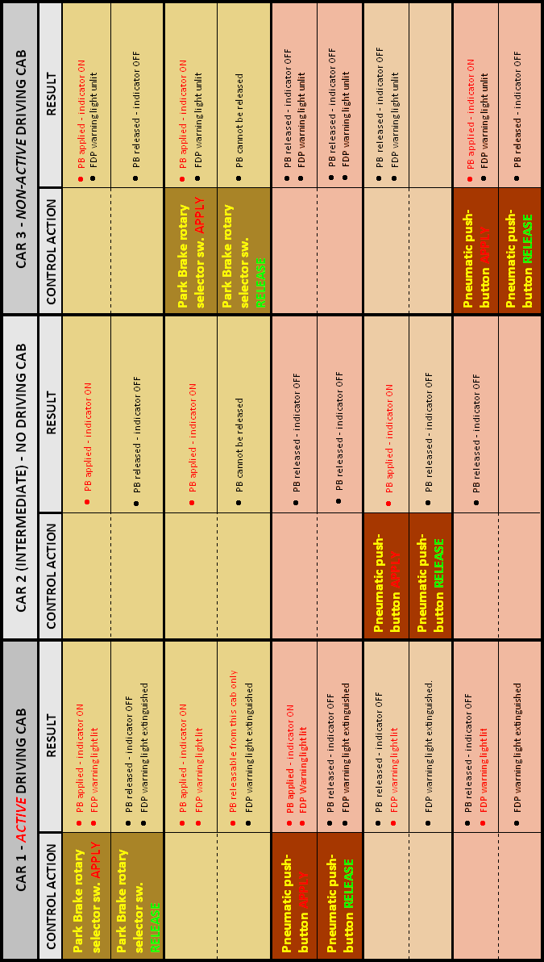

All times are expressed as Australian Daylight Saving Time.
Also refer to table at Appendix 1, page 26.
This device is the On/Off mechanism that controls the supply of air pressure to the park brake system. It is operated from a drivers cab by use of the Park Brake Selector switch or the manual override pushbuttons. See Figure 7, page 13.
A driver’s cab that is configured to be the operating cab.
The Train Control and Management System is a standard Bombardier arrangement comprising of a Vehicle Control Unit and various Input/Output units distributed throughout the train. In this instance TCMS reads the Park Brake Applied Indication trainline and illuminates the PARK BRAKE warning light on the driver’s Fault Display Panel whenever the state of the PBKI trainline indicates that the park brake is applied.
A trainlined function is one whose operating or monitoring circuit is carried between coupled vehicles in a train.
This supplier is a wholly owned Australian subsidiary of the Original Equipment Manufacturer. The subsidiary company assembled the control valves.
A deviation in the value of the original setting for the switch, possibly due to a slight in-service weakening of the spring.
A genset (‘engine/generator set’) is the term used for a self-contained and dedicated electrical generating system. It is differentiated from a generator or alternator driven from a propulsion motor.

