

Rail Safety Investigation
Report No 2010/11

Derailment
Pacific National Locomotives
Melbourne Operations Terminal
2 November 2010

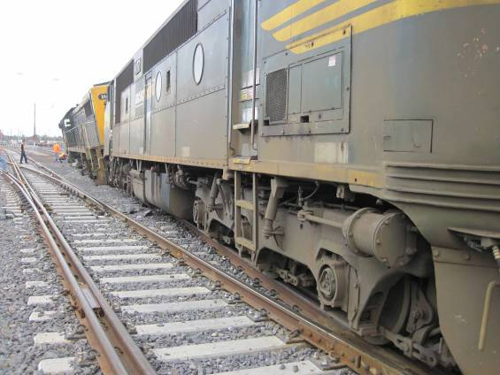

TABLE OF CONTENTS
The Chief Investigator 5
Executive Summary 7
1. Circumstances 9
2. Factual Information 11
2.1 Infrastructure 11
2.2 Recorded data 16
2.3 Personnel 19
2.4 Commissioning of points 45U 20
2.5 Phoenix screen display Factory Acceptance Test 21
3. Analysis 23
3.1 The incident 23
3.2 Commissioning of points 45U and the signalling system 24
3.3 Route knowledge 24
4. Conclusions 25
4.1 Findings 25
4.2 Contributing factors 25
5. Safety Actions 27
5.1 Safety Actions taken since the event 27
5.2 Recommended Safety Actions 27

The Chief Investigator
The Chief Investigator, Transport Safety is a statutory position under Part 7 of the Transport Integration Act 2010. The objective of the position is to seek to improve transport safety by providing for the independent no-blame investigation of transport safety matters consistent with the vision statement and the transport system objectives.

The primary focus of an investigation is to determine what factors caused the incident, rather than apportion blame for the incident, and to identify issues that may require review, monitoring or further consideration. In conducting investigations, the Chief Investigator will apply the principles of ‘just culture’ and use a methodology based on systemic investigation models.

The Chief Investigator is required to report the results of an investigation to the Minister for Public Transport or the Minister for Ports. However, before submitting the results of an investigation to the Minister, the Chief Investigator must consult in accordance with section 85A of the Transport (Compliance and Miscellaneous) Act 1983.

The Chief Investigator is not subject to the direction or control of the Minister in performing or exercising his or her functions or powers, but the Minister may direct the Chief Investigator to investigate a transport safety matter.

Executive Summary
On 2 November 2010, two locomotives of a broad-gauge Pacific National three locomotive consist travelling from the Melbourne Dock area to the South Dynon Maintenance Depot derailed when attempting to enter the Melbourne Operations Terminal in West Melbourne. The route selected did not support the track gauge that the locomotives were operating on. However, the network controller’s Visual Display Unit indicated that broad-gauge was available. A verbal authority was issued for the locomotives to proceed beyond the controlling signal, which was displaying Stop. The derailment was a consequence of the locomotives running out of gauge on a recently installed crossover that consisted of both dual and standard-gauge turnouts.

The investigation found that the in-field signalling system operated as designed and commissioned. It was also found that an anomaly with the Australian Rail Track Corporation’s network controller’s Visual Display Unit track gauge indication was not identified during the acceptance testing or the signal system commissioning processes.

The investigation also found that both Australian Rail Track Corporation and Pacific National did not provide route knowledge training for their operating personnel.

Since the event the Australian Rail Track Corporation has updated the Melbourne Metro network controller’s Visual Display Unit to correctly reflect that broad-gauge is not available within or beyond the crossover in the Melbourne Operations Terminal.

The investigation makes recommendations to the Australian Rail Track Corporation in the safety management of risks associated with the use of dual-gauge points at interfaces with single-gauge trackage and with the processes for acceptance testing of signalling control systems.

The investigation also makes recommendations to both the Australian Rail Track Corporation and Pacific National in route knowledge training for network controllers and locomotive crews whenever new track and signalling infrastructure is introduced into the network.

Circumstances
At about 2010 on 2 November 2010, two broad-gauge Pacific National locomotives derailed on a crossover connecting the Australian Rail Track Corporation (ARTC) North Dock Line with the Pacific National Melbourne Operations Terminal (MOT).

Locomotives, X44, A77 and X42 were en-route from the Westgate sidings in the Port of Melbourne to South Dynon Locomotive Depot for refuelling. With the route set for the locomotives to enter the MOT, the controlling signal would not exhibit a Proceed indication. In response to this situation a verbal authority was issued by the network controller for the movement to proceed. At the interface boundary between ARTC and Pacific National trackage, the leading locomotives X44 and A77 travelling at about 18km/h ran out of rail and derailed. Both locomotives sustained damage as did Pacific National track infrastructure. At the time of the incident the temperature was about 14 degrees Celsius with showers.

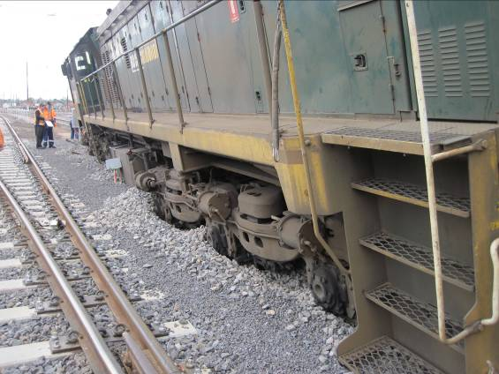
Figure 1 – Derailed state of locomotive X44

Factual Information

Infrastructure

Track
The rail infrastructure servicing the Dynon and Port of Melbourne areas consisted of standard-gauge, broad-gauge and dual-gauge lines with interfaces between the ARTC, Pacific National and V/Line networks.

The Westgate, Appleton Dock and West Swanson Dock sidings are dual-gauge and managed by the ARTC. The Pacific National MOT trackage is standard-gauge and V/Line’s trackage is broad-gauge.

As part of the South Improvement Alliance (SIA) Missing Link Stage 3 project associated with the Dynon and Port of Melbourne rail operations, a new dual-gauge connection – the North Dock Line – was provided between South Dynon Junction and the Dock areas. A new connection – points 45U and 45D – that provided access to and from the MOT, Westgate, Appleton Dock and West Swanson Dock sidings was also installed. Points 45U was an ARTC dual-gauge, Type-39 assembly; whereas points 45D was a Pacific National standard-gauge assembly. They were commissioned ‘operational’ on 23 October 2010.

Two new dwarf signals – APD40 and APD46 – were commissioned within the MOT to signal movements along № 3 track (points 45D), or towards the Westgate, Appleton Dock and West Swanson Dock sidings via the crossover consisting of points 45D and 45U. This crossover was only available for standard-gauge movements.

In addition two other crossovers, comprising points 41U and 41D, and points 43U and 43D, were also commissioned, providing connections between the North or South Dock lines and the Westgate, Appleton Dock and West Swanson Dock sidings.

The V/Line broad-gauge track configurations providing connections beyond the Canal Lead to the Pacific National Melbourne Steel Terminal (MST), the Reversing Loop and South Dynon Locomotive Depot remained unchanged.

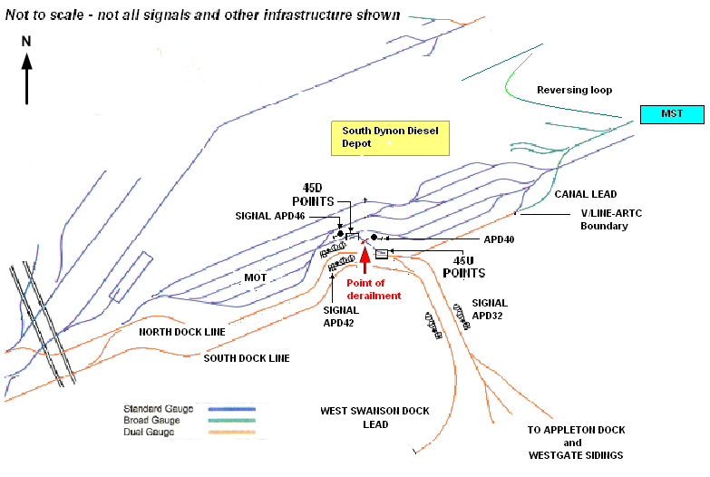
Figure 2 - Track layout of South Dynon, Pacific National MOT and Port of Melbourne

Operations
Prior to the Missing Link Stage 3 project, the only connection to the Westgate sidings and Appleton and Swanson Docks was via the South Dock Line; there was no direct connection into the MOT. A connection to the V/Line network via the Canal Lead was also available but its use was limited. Broad gauge locomotive movements from the Westgate sidings to South Dynon Locomotive Depot were usually routed via Sims Street Junction and South Kensington.

Stage 3 added a dual-gauge connection from the V/Line network and the North Dynon yard to the Melbourne Ports area via ‘W’ track and the North Dock Line (see Figure 6). ARTC Train Notices, presentations and hard copy handouts were used by SIA to disseminate the notice of changes to the track and signalling infrastructure to rail operators.

An extract from Missing Link Commissioning Train Notice (page 4) in the Specification for the Operational Safeworking of Trains during the Signalling Commissioning of Missing Link Stage 3, stipulated the operational procedures for movements between the ARTC mainlines and the Pacific National MOT:

“VI: MOVEMENTS BETWEEN ARTC MAINLINE AND PACIFIC NATIONAL MELBOURNE OPERATIONS TERMINAL

Movements between the ARTC Main Line and the Pacific National Operations Terminal are undertaken in liaison between the ARTC Melbourne Metro network controller and the Pacific National shunt driver or terminal operator by means of a nominated phone.

Prior to signalling a movement into the Pacific National Melbourne Operations Terminal the ARTC Melbourne Metro network controller must first contact the Pacific National shunt driver or terminal operator and seek approval for the movement to enter.

When a movement requires to depart, the train crew of the departing movement must contact the ARTC Melbourne Metro network controller and provide train details.

The ARTC Melbourne Metro network controller may then operate the relevant points and signals for the movement as required.

Dwarf signals DYN40,[APD40] and DYN46 [APD46] are located along no 4 track within the Melbourne Operations Terminal and protect the points 45D that provide access from the Melbourne Operations Terminal toward Appleton Dock, or the Canal Lead.

Provided points 45 are set in the Normal position, the ARTC Network controller can place these two signals to Proceed simultaneously allowing movements within the Pacific National yard to traverse No 4 track without having to contact the ARTC network controller.

When a movement requires to operate in either direction between the Melbourne Operations Terminal and the Canal Lead or Appleton Dock Line, the ARTC Network controller must first confer with the requesting party that there are no movements occurring that may be affected by the restoring of these signals to Stop.”

Signalling system
Network control equipment

The signalling between Moonee Ponds Creek Junction and Tottenham Junction is controlled by the ARTC Melbourne Metro network controller located in the ARTC Network Control Centre at Mile End, South Australia.

The computer-based control system operating in the Mile End Network Control Centre is a non-vital Centralised Traffic Control (CTC) system that controls points and signals. Real-time monitoring of system status, including track circuits, is provided graphically to the controller on colour Visual Display Units (VDU’s).

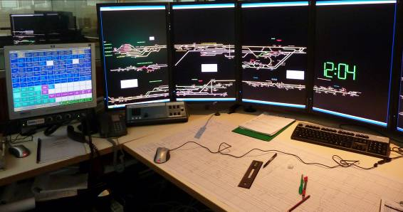
Figure 3 - Melbourne Metro Network Controller’s workstation and graphics display
In October 2009, separate track gauge colours – white for standard-gauge and yellow for dual-gauge – were introduced into the ARTC network Phoenix control displays. Prior to this modification all tracks were represented in white.

Field equipment

The in-field equipment consisted of trackside signals, points and track circuits. Signal systems such as that operating in the ARTC Melbourne Metro area provide indications to drivers of trains by a group of coloured lights and combinations thereof.

Signal APD32 was a three-position Home signal that can display both Medium and Low speed Proceed indications. It is also fitted with Gauge (‘V’ for broad-gauge and ‘S’ for standard-gauge) and Route Indicators which are displayed in conjunction with a Proceed indication.

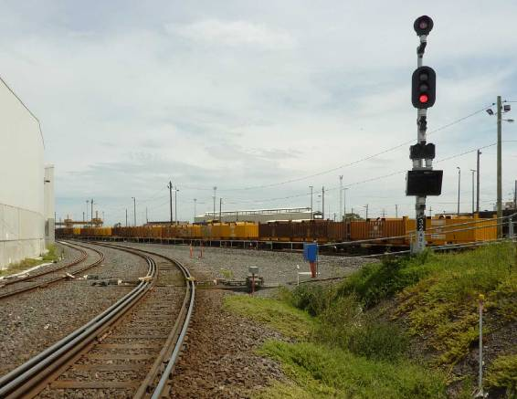
Route Indicator
Gauge Indicators
Figure 4 - Signal APL32 at Stop. Note the gauge and route indicators are not illuminated
Interlocking equipment

Interlocking equipment manages the safety functions between points and signals utilising microprocessor-based logic controls specifically designed for railway fail-safe applications.

Signalling circuits associated with dual-gauge trackage incorporate gauge detectors that identify the gauge of vehicles occupying the track sections. The gauge status is stored within the signal interlocking system and is tracked as a train progresses through a route. Should the network controller request a route that may be in conflict with the gauge of the vehicles detected on the approach track section, the signalling system is designed to prevent a Proceed indication being displayed on the applicable signal. This was the situation encountered by the broad-gauge locomotive movement at signal APD32 with the route set into the MOT.

Recorded data
Based on the voice recordings and VDU playback facilities, the following sequence of events was constructed:
- Pacific National crew requested a path for the locomotive consist to move from Westgate sidings signal APD8 to South Dynon Locomotive Depot.
- After departing signal APD8 the crew requested to be routed via the dual-gauge and the Steel Terminal direct to the South Dynon Locomotive Depot.
- The network controller and locomotive crew conferred and the locomotives were routed along the South Dock Line behind signal APD42 (see Figure 6, move number 1).
- The crew indicated that they did not need to go into the Steel Terminal but towards the Reversing Loop, which is accessible from the broad-gauge connection to the Canal Lead. [The Reversing Loop was not depicted on ARTC controller’s VDUs because it is not part of the territory they control.] At this point another network controller was heard in the background questioning whether the MOT contains broad-gauge track.
- The network controller and crew discussed the action to be taken and agreed for the move to be routed via the Steel Terminal as it would save going via South Kensington, a longer and more time-consuming route.
- A route from signal APD42 towards signal APD32 was selected and taken by the locomotives. This was to position the locomotives for the route into the MOT (see Figure 6, move number 2).
- The Pacific National MOT shunt crew were contacted by the network controller seeking permission to place dwarf signals APD40 and APD46 to Stop in order to accommodate the locomotive movement. The need for these locomotives to be routed via the MOT was questioned by the Pacific National shunt crew who indicated to the network controller that the locomotives might be able to travel via the dual-gauge and Stop boards controlled by the V/Line West Tower signaller. The Pacific National shunt crew agreed to the two dwarf signals being placed to Stop and for the locomotives to enter the MOT on the condition that the locomotive crew knew where they were going. [Note: This was the first time a movement such as this had been conducted since the latest commissioning works.]
- Signals APD40 and APD46 were placed to Stop by the network controller and the track panel indication colour on the controller’s screen for points 45 (U and D) changed from green to yellow (the dual-gauge indication).
- With the locomotives waiting at signal APD32, the network controller was unable to place this signal to Proceed and requested the locomotives to move behind signal APD24 in an attempt to clear the system (see Figure 6, move number 3). [There was some hesitation by the locomotive crew to continue with the amended move but it was agreed by all concerned to conduct the move as a familiarisation exercise.]
- Signal APD24 was placed to Proceed and the locomotives moved towards signal APD32 (see Figure 6, move number 4).
- The route was selected from signal APD32 towards the MOT via points 45 and was flashing on the network controller’s screen. When points 45 were detected in the Reverse position aligned into the MOT, the track route indication went to a steady green with all the point indications showing them to be locked.
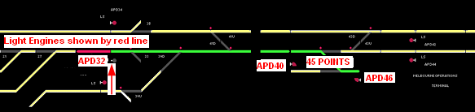
Figure 5 – VDU indications with route set (in green) into the MOT
- Signal APD32 did not respond to the network controller’s call for a Low speed Proceed indication and remained at Stop.
- The network controller contacted the crew and informed them that the route was detected ‘locked’ and that it would be sleeved against movement to enable a Caution Order to be issued. The network controller then issued a verbal Caution Order for the locomotives to proceed from signal APD32 towards the MOT (see Figure 6, move number 5).
- Under the provisions of the verbal Caution Order, the locomotives departed signal APD32.
- The locomotives derailed at the ARTC/Pacific National interface boundary on points 45U.

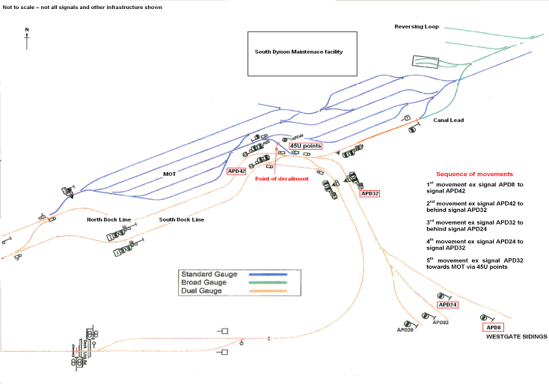
Figure 6 - Sequence of events

Personnel

Locomotive Crew
Locomotive X44 was crewed by two drivers who held current medical certification and appropriate qualifications for the respective tasks being performed. Post-incident alcohol tests were conducted on both drivers, with no alcohol being detected.
To advise and familiarise train crew with the Missing Link project upgrades and system alterations, Pacific National informed the investigation that they provided their train crews with the following:
- A copy of the Missing Link Commissioning booklet
- A notice was placed on the staff notice board indicating that extra training or clarification on any aspect of the project was available to anyone who required it
- A copy of the Missing Link commissioning booklet was placed next to the crew rosters in the foyer of the South Dynon Locomotive Depot for employees to peruse and review at any time.
The investigation was also informed that no train crew had sought or had been provided with extra training or clarification over the distributed material.

Network controller
The network controller had 13 years experience as a controller, operating various ARTC control territories including all Victorian districts on a rotational basis for 10 years. He had been qualified in and had operated the Melbourne Metro area over the last nine years. A post-incident alcohol test was conducted with no alcohol being detected.

Network controllers were offered training, in the form of voluntary familiarisation sessions, for the Missing Link project upgrades and system alterations. The network controller on duty at the time of the incident attended a familiarisation session and was provided with a copy of the relevant Train Notices. He believed that the training was relevant and that it addressed the infrastructure changes that had been implemented in the Melbourne Metro area.

Commissioning of points 45U
These points were commissioned under a ‘Conditional Certification of Signalling’ that stipulated that points 45U were only available for standard-gauge movements when set in the Reverse position. The physical operation of these points remained as designed, with all blades operational.

The signalling system had also been configured such that with points 45U in the Reverse position, Proceed indications would not be possible for broad-gauge movements.
End of broad-gauge rail – ARTC/Pacific National interface boundary
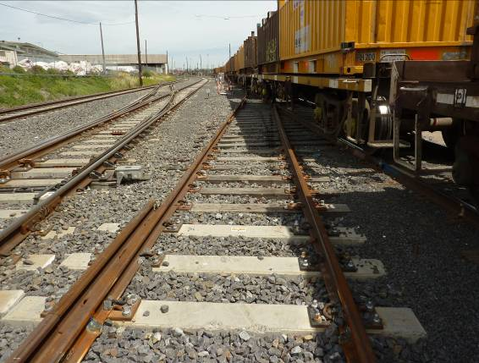

Figure 7 – The 45U turnout showing the end of the broad-gauge rail

Phoenix screen display Factory Acceptance Test
The Victorian Phoenix Factory Acceptance Test procedures for the Victorian application of the Phoenix train control system contained a test for the graphics to ensure that the track gauge on the screen display was presented correctly. In this case the graphic presentation of the track section between APD40 and APD46 dwarf signals (the destination of the locomotive movement, transiting points 45D and 45U) was displayed as dual-gauge track (yellow) when the broad-gauge rail ended within the crossover. The factory acceptance testing did not identify this discrepancy.

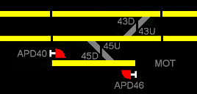 | 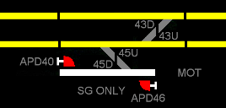

Figure 8 – VDU graphics: Left screen showing pre-incident availability of dual gauge (yellow); right screen shows post-incident modifications

Analysis

The incident
On departure from the Westgate sidings with a consist of locomotives, the crew proposed an alternate route to that usually taken on account of the new infrastructure installed as part of the Missing Link Stage 3 project. To accommodate this request, the network controller arranged to route the locomotive consist via the Pacific National MOT and their Steel Terminal. The network controller’s VDU graphics indicated that dual-gauge was available through the crossover consisting of points 45 (Up and Down ends); however, this was incorrect. In fact, while points 45U were indeed dual-gauge, the broad-gauge rail ended at a point minimally into the crossover, and points 45D at the other end of the crossover were standard-gauge only. Thus, any broad-gauge train movement that entered the crossover via points 45U and continued would become derailed. By depicting dual-gauge into the MOT, the network controller’s graphic display did not correctly show the track gauge that was available within the crossover, nor did it identify the track gauge beyond the crossover.

When asked for permission to restore APD40 and APD46 to Stop for a broad-gauge movement, the MOT shunt driver questioned the need for it to enter the MOT and offered an opinion on a route that could be taken to facilitate the locomotive movement to the maintenance facility. This suggestion was not adopted by the network controller as he believed that the move could be accommodated via the MOT. However, before agreeing to signals APD40 and APD46 being placed to Stop and giving permission for a movement to enter the MOT, the shunt driver did not clearly confirm the nature and route of the intended movement with the network controller. Had this occurred the derailment may have been avoided. In this incident the use of the term ‘Steel Terminal’ appears to have had one meaning for the network controller who used this term to identify both the Pacific National MOT and the actual Steel Terminal site, and another for the locomotive drivers.

With the locomotives standing on the approach track circuit for signal APD32, it remained at Stop despite several attempts by the network controller to place it to Proceed. The system indications at the network controller’s workstation indicated that the route was set and detected locked. It was assumed by the network controller that this signal was defective and a Caution Order was issued to permit the movement to proceed.

Signal APD32 was in fact operating correctly as the selected route was not available for broad-gauge movements in the signalling logic. The system protection for this potential danger point, interlocked signalling, was able to be circumvented by the issuing of a Caution Order. In the circumstances surrounding the events of this incident, the system was not error tolerant and proved vulnerable to the application of a procedure that was not applicable.

Commissioning of points 45U and the signalling system
The conditional commissioning of points 45U resulted in the situation where the point blades for both gauges operated when the points were activated, exposing the potential of a broad-gauge movement being wrongly routed with the points reversed. The defence to prevent this occurring was incorporated into the signalling logic, which prevented signal APD32 displaying a Proceed indication whenever a broad-gauge movement was detected on the approach track and points 45U set to the Reverse position.

The commissioning of points 45U could have included the securing of the broad-gauge point blade from movement. This action would have added another defence against the wrong routing of broad-gauge movements and would have prevented the derailment. Alternatively, had a turnout that did not expose broad-gauge movements to a physical route towards the MOT been installed, the risk of a running-out-of-gauge incident would have been eliminated. The use of type-39, dual-gauge turnout assemblies at locations where the potential for running out of gauge exists is questionable, particularly when the defences such as those in place for the reverse route on points 45U to prevent such an occurrence are not error tolerant.

Route knowledge

Training
SIA disseminated the Missing Link project track and signalling infrastructure change to rail operators via presentations, Train Notices and hard-copy handouts. Pacific National Rural and Bulk offered their locomotive drivers the option for individual in-field training by that company’s trainers; none took up this option. Network controllers were afforded the opportunity to attend SIA presentations (voluntarily), although field familiarisation was not offered by ARTC.

As train crews are responsible in this area for directly liaising with network controllers on the route to be taken by such movements as for these locomotives, a good knowledge of and familiarisation with available routes was imperative. This movement not only required a good knowledge of the ARTC Docks area and the recently commissioned North Dock Line and connections, but also the adjoining yards and interfaces with V/Line and Pacific National. Although the yard areas off the ARTC network are not part of the ARTC network controller’s area of responsibility, a good knowledge and understanding of their location and relationship to the ARTC network is important to the overall safe operation of the area.

The review of the voice recordings indicated that neither party was confident with the move but they persevered with it virtually as a training and familiarisation exercise. Had both the locomotive crew and the network controller had a more extensive understanding of the track infrastructure as recently commissioned, they would probably have realised that the broad-gauge movement could not be accommodated in the Melbourne Operations Terminal.

The fact that route knowledge training was voluntary for Pacific National personnel and not provided for the network controllers is not only unprofessional but negligent in respect to the application and compliance to the principles of robust Safety Management Systems.

Conclusions

Findings
- The signalling system and points 45U operated as designed and commissioned.
- The network controller’s Visual Display Unit indication incorrectly represented points 45U and 45D as dual-gauge.

Contributing factors
- The installation of crossover consisting of both dual-gauge and standard-gauge turnouts in which the broad-gauge rail is truncated.
- The commissioning of points 45U with the broad-gauge point blade operable.
- The failure of the Factory Acceptance Testing processes to identify the incorrect track section presentation for points 45U and 45D on the Australian Rail Track Corporation network control Visual Display Units.
- The lack of route knowledge training provided for both the Pacific National locomotive crew and the Australian Rail Track Corporation network controller.

Safety Actions

Safety Actions taken since the event
The Australian Rail Track Corporation has updated the Melbourne Metro network controller’s Visual Display Unit track schematic display to correctly reflect that broad-gauge is not available for operations on the crossover comprising points 45U and 45D.

Recommended Safety Actions
Issue 1
Had the broad-gauge point blade of points 45U been disabled at commissioning, or had a turnout that did not expose broad-gauge movements to a running-out-of-gauge route been installed, the possibility of a broad-gauge movement being routed towards the Melbourne Operations Terminal via points 45U and subsequent derailment would have been eliminated.
RSA 2012004
That Australian Rail Track Corporation reviews their Safety Management System risk profile associated with the use of dual-gauge points at the interface with single-gauge trackage.
Issue 2
Had both the locomotive crew and the network controller had a more extensive understanding of the recently commissioned track infrastructure they should have realised that the broad-gauge movement could not have been accommodated in the Melbourne Operations Terminal.
RSA 2012005
That Australian Rail Track Corporation reviews the route knowledge training requirements for network controllers when new track and signalling infrastructure is introduced into the network.
RSA 2012006
That Pacific National reviews the route knowledge training requirements for locomotive crews whenever new track and signalling infrastructure is introduced into a network.
Issue 3
The pre-commissioning Factory Acceptance Testing did not identify the discrepancy with the colour coding of the track section associated with points 45U and 45D.
RSA 2012007
That Australian Rail Track Corporation reviews their Quality Assurance processes for accepting signalling control systems.

When a rail movement on dual-gauge trackage reaches a point at which the track gauge on which it is running comes to an end (is truncated, temporarily or otherwise) while trackage of the other gauge continues.
V/Line is the Victorian Intrastate network manager.
An ARTC right-hand dual-gauge turnout mounted on concrete bearers.
Signalling equipment that should it fail to function would not cause an unsafe outcome of the signalling system.
An historical term used to indicate that the command will be prevented.
The document issued by the Tester-In-Charge verifying that the new or revised signalling arrangements may be ‘booked into service’.

