

Rail Safety Investigation
Report No 2011/04

End-of-Track Overrun
Metro Trains Melbourne
Macleod
24 March 2011

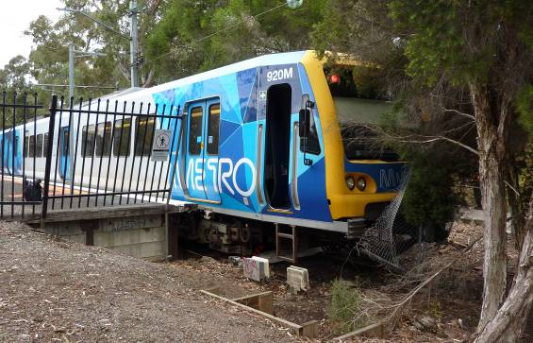

The Chief Investigator 5
Executive Summary 7
1. Circumstances 9
2. Factual Information 11
2.1 Personnel 11
2.2 The Vehicle 11
2.3 Infrastructure 12
2.4 Recorded information 14
2.5 Environment 15
3. Analysis 17
3. Analysis 17
3.1 The Incident 17
3.2 Infrastructure maintenance 17
3.3 Train brake performance 17
3.4 Train driver’s actions 18
4. Conclusions 19
4.1 Findings 19
4.2 Contributing factors 19
5. Safety Actions 21
5.1 Recommended Safety Actions 21

The Chief Investigator
The Chief Investigator, Transport Safety is a statutory position under Part 7 of the Transport Integration Act 2010. The objective of the position is to seek to improve transport safety by providing for the independent no-blame investigation of transport safety matters consistent with the vision statement and the transport system objectives.

The primary focus of an investigation is to determine what factors caused the incident, rather than apportion blame for the incident, and to identify issues that may require review, monitoring or further consideration. In conducting investigations, the Chief Investigator will apply the principles of ‘just culture’ and use a methodology based on systemic investigation models.

The Chief Investigator is required to report the results of an investigation to the Minister for Public Transport or the Minister for Ports. However, before submitting the results of an investigation to the Minister, the Chief Investigator must consult in accordance with section 85A of the Transport (Compliance and Miscellaneous) Act 1983.

The Chief Investigator is not subject to the direction or control of the Minister in performing or exercising his or her functions or powers, but the Minister may direct the Chief Investigator to investigate a transport safety matter.

Executive Summary
At about 1600 on 24 March 2011, an X’Trapolis train collided with the end-of-track baulks at Macleod Railway Station platform 3 and subsequently the station wire boundary fence. The train was fully loaded but there was no injury to any occupant or other person. The leading car of the train sustained minor damage with the baulks being destroyed and the fencing damaged.

The investigation determined that at the time of the incident low-adhesion conditions were present at the wheel-rail interface. These conditions were contributed to by vegetation matter from surrounding foliage and moss from the platform that had been washed onto the track during the platform cleaning process. The end-of-track baulks were poorly maintained and not fit for purpose.

Recommendations are made to the rail operator concerning the maintenance of infrastructure as it relates to vegetation and end-of-track baulks, and to conduct a review of the adequacy of end-of-track protection.

Circumstances
At about 1600 on Thursday 24 March 2011, the 1447 Flinders Street to Hurstbridge suburban train collided with the end-of-track protection on track 3 at Macleod Railway Station. The decision to terminate the service at Macleod was made by the operator because of the late running of the service resulting from signalling system faults between Alphington and Heidelberg.

The collision resulted in the baulks – consisting of two timber sleepers – being pushed along the rail head for 2.9 metres and the front of the lead car impacting a cyclone wire fence erected in line with the end of platform 3. There was no injury to any occupant or other persons. Minor damage was sustained by the lead car, 920M. The baulks were destroyed and the wire boundary fence was damaged.

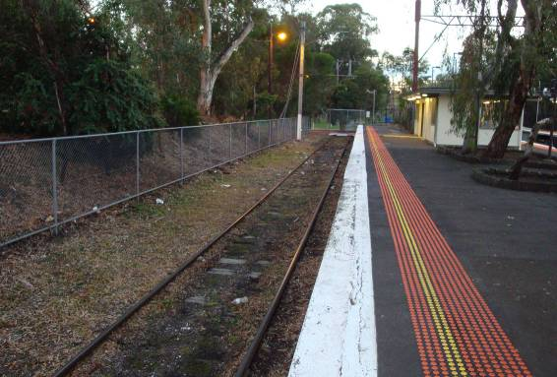
Figure 1: Macleod Railway Station platform 3 and the terminating track (following restoration)

Factual Information

Personnel

Suburban Train Driver
The driver reported that the service departed Flinders Street on schedule. However, progress to Clifton Hill was impeded by a preceding train. At Alphington the driver was advised that there were problems with the signalling system. On arrival at Heidelberg the train was further delayed for 10 to 15 minutes.

After the train departed Heidelberg, METROL advised the driver that the service was to terminate at platform 3 at Macleod Railway Station. On the approach to Macleod, the driver recalled observing a reduce-to-medium aspect on the approach signal MCD102 and a medium speed warning aspect on signal MCD104. At this time the driver recalled the speed of the train was about 30km/h and that it reduced to 20-25km/h by the approach end of the platform. The driver commented that when the train was about halfway along the platform he felt the train experience wheel-slide under braking. He attempted to recover from this situation by releasing and re-applying the brake but the train continued to slide. The brake handle was then placed to full service braking and then to the Emergency position. The driver reported that this action had little or no effect and the train slid beyond the stopping mark striking the baulks and the cyclone wire fence before coming to rest.

The driver qualified to drive suburban trains on the Melbourne network in 2009; he held current unrestricted medical status and was last audited in January 2011. There were no non-conformances or follow-up actions from this audit. The day of the incident was his first rostered day of duty after two consecutive rostered days off.

The Vehicle
The train involved in the incident was a X’Trapolis type Electric Multiple Unit (EMU) that consisted of six cars. The train received minor damage to both guard irons of the leading car. A post-incident inspection of the train did not reveal any defects that could have contributed to the overrun.

Infrastructure

Macleod Railway Station

Macleod Railway Station is an intermediate terminating and stabling location 17.71 rail kilometres from Flinders Street Station, on the Hurstbridge line. Three tracks service the station; the through Up and Down, and the terminating number 3 tracks. All platform tracks are on a relatively level gradient. Each track has an adjacent platform.

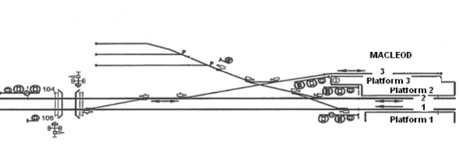
Figure 2: Macleod track layout
Platform 3, which is adjacent to the terminating track, is about 157 metres long with a stop mark located 3.6 metre from the Down end. It is used daily. The maximum allowable speed for trains to enter the platform is 25 km/h. A Position of Train System (POTS) transponder is located about 30 metres in from the Up end of this platform. This device recorded the speed of the train at 18 km/h.

End-of-track protection requirements
The Victorian Rail Industry Operators Group (VRIOG) is a collaboration of members involved in operations on the Victorian rail network. The group’s purpose is to establish standards (VRIOGS) to facilitate the interoperability of infrastructure. At the time of this incident, the group had not published a standard related to end-of-track protection at rail lines terminating at stations, such as Macleod.

However, the rail operator responsible for the infrastructure at Macleod, Metro Trains Melbourne (MTM), had a responsibility under the Rail Safety Act 2010 to establish a safety management system. This system was required to identify and document incidents that could occur on the rail infrastructure and adopt measures that eliminate, or if not practical to eliminate, to reduce, as far as is reasonably practical, the likelihood of an incident occurring and if one occurs, to reduce the magnitude and severity of the consequences of the incident.

MTM advised that the end-of-track provisions at Macleod platform 3 are as they were when handed over to the previous franchisee holder at the time of the privatisation of the metropolitan network in 1999. They also said that at the time of the 1999 handover there was no specific requirement for the use of standard plans for baulks or buffer stops at terminating stations, such as Macleod platform 3. However, for new infrastructure projects, MTM undertakes a risk assessment to assess the specific site implications of a train proceeding through the end of the track or siding.

Following two incidents in March 2011, where a train overran the end of the siding (at Sandringham and Pakenham), MTM conducted risk assessments for all their stabling sidings. The risk assessments did not include the platforms at terminal locations but MTM advised that it is their intention to conduct such assessments.

End-of-track devices
End-of-track devices are designed to provide overrun protection for rolling stock at the end of the track. Traditionally, in Victoria, two devices have been used: a buffer stop, a structure that is erected across and at the end the track to stop rolling stock; or a baulk, a device usually consisting of sleepers placed across and anchored to the track to stop slow moving rolling stock.

At Macleod, baulks were used and were situated on the track 11.8 metres from the stopping line marked on the platform; this was 1.8 metres from the end of the platform. An inspection of the baulks following the incident, found that they were generally in poor condition with the timber sleepers rotten and inadequately secured to the track. The baulks had been pushed 2.9 metres along the track by the train’s wheels.

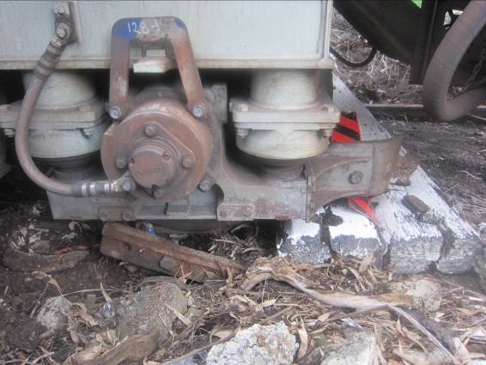
Figure 3: View showing baulks pushed along track by train wheels

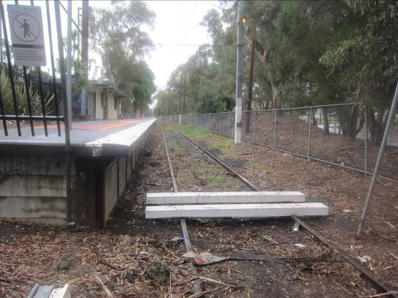
Figure 4: View showing baulks after refurbishment

Rail head residue
A swab of the residue present on the rail head was analysed for chemical composition. The analysis found mainly rust particles, plus minor components of clay, calcium carbonate/magnesium silicate mix, sugar and phosphorus.

The rust and clay components are consistent with rail head samples previously obtained from elsewhere on the network. The origin of the other components could not be determined.

Recorded information
The recorded data from the data logger fitted to lead car 920M was downloaded. A review of the data found that the train driver had made a number of short service brake applications prior to the train entering the platform at a speed of 21 km/h. The train’s speed gradually reduced to 18 km/h when it was about 30 metres from the platform stop line (about 45 metres and 15 seconds before its final stopping point), at which point the driver made a service brake application. When the train speed was 13 km/h, the driver made an emergency brake application (using both the master controller and the foot pedal). At this stage the train was abeam the platform stop line and about 15 metres from the point it came to a stand.

Under the service and then emergency brake applications, the average rate of deceleration was about 0.3 m/s². Deceleration during the emergency braking phase was slightly higher, but also incorporated the effects of impact with the track baulks.

Assuming a fully operational braking system and good railhead adhesion conditions, it is possible to stop an X’Trapolis six-car set from an initial speed of 18 km/h in less than 20 metres utilising the service brake.

Environment

Weather
The nearest weather observation station to the incident site is at Viewbank, about three kilometres to the east. The 1500 (an hour prior to the incident) observations at Viewbank indicated a temperature of 17 degrees Celsius, broken cloud cover, a relative humidity of 89% and a westerly wind at 20 km/h. Rainfall recorded for the day was 0.4 mm. Witnesses at Macleod at the time of the incident said that there was no precipitation.

Railway platform environs
MTM had engaged a contractor to conduct platform surface cleaning at several locations on the Hurstbridge line. The contractor was not given any specific instructions about the processes to be used or what was to be done with any residue resulting from the cleaning process.

On Thursday 24 March 2011 between 1200 and 1400, moss removal was conducted on about 40 metres of the Macleod platform 3 at the Down end, using the pressure-hose cleaning method. CCTV footage identified that the contractor washed the moss and any other surface material off platform 3 into the platform pit. Some of this material was observed, after the incident, to have been washed onto the rail head. The remainder of the platform surface was covered with moss.

An inspection of the terminating track found that there was a significant amount of weed growth throughout its length together with a build up of leaves, tree bark and rubbish between the platform structure and the near running rail. This material was also prevalent on and between both running rails.

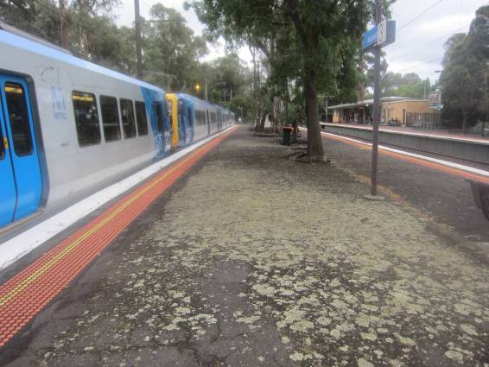
Figure 5: Shows moss on the uncleaned southern end of platform 3

Analysis

The Incident
The train was scheduled to operate a Flinders Street to Hurstbridge service but, due to signalling faults early in the journey, it was instructed to terminate at Macleod. The train was routed to Macleod platform 3 as this is a dead-end track and allowed through trains to utilise platforms 1 and 2. The approach of the train to the platform was normal with it entering the platform about 4 km/h below the maximum designated speed. It gradually slowed until the driver applied the service brake then the emergency brake before the train pushed the baulks along the track and impacted a wire fence.

The section of the track immediately before the end-of-track baulks was covered in vegetation matter from surrounding plants and the platform cleaning process that was undertaken earlier in the day. This vegetation matter on the rail head resulted in low-adhesion conditions at the wheel-rail interface and the resultant braking underperformance of the train.

Infrastructure maintenance
It is well know that vegetation on the rail head has a detrimental effect on both the traction and braking performance of rolling stock. Therefore, it is reasonable to expect that an infrastructure manager have in place an adequate inspection regime for those locations that may be affected by vegetation matter. Also, that any contractor involved in activities around the track that have the potential to contaminate the rail head be instructed on how those activities should be conducted.

The end-of-track baulks are designed to stop slow moving rolling stock. At Macleod platform 3, the sleepers were in poor condition and as a result they were poorly secured to the rails allowing a slow moving train to push them along the track. Had the baulks been in better condition they may have stopped the train or at least impeded its progress more than they did on this occasion.

It is also worthy of note that a short distance beyond the fence was a pedestrian pathway providing access to the station and it is reasonable to conclude that even had the baulks been in good condition they may still not have provided adequate protection for the public had the train been travelling faster.

Train brake performance
The recorded data analysed did not provide information on the actual service brake application, or brake cylinder pressures reached during the service application.

The deceleration rate achieved during the final 45 metres of travel under service and then emergency braking is significantly lower than that achievable with full service and normal emergency braking. The lower rate during service braking may have been due in part to a less than full application by the driver. However, the continued sub-optimal deceleration after emergency brake application suggests either a defective braking system or unusual interaction at the wheel-rail interface.

Given that post-incident inspections did not find any defect in the train, and this type of train has not been prone to overrun on the Melbourne network, the reduced performance is most likely to have been the result of low-adhesion conditions at the wheel-rail interface caused by the vegetation contamination of the track.

Train driver’s actions
The train driver complied with the rail operating rules and approached the terminal platform at below the maximum allowable speed. Also, the investigation considered that his operation of the train at an end-of-track were consistent with good operating practices.

Conclusions

Findings
- The train driver was appropriately qualified to operate the train over the route.
- The train was operated in accordance with the rules on the approach to the platform.
- Post-incident inspection did not find any relevant faults with the train.
- The track and the rail head at Macleod platform 3 had a significant coverage of vegetation matter.
- The end-of-track baulks on the track at Macleod platform 3 were in poor condition.

Contributing factors
- The platform cleaning contractor was not adequately instructed as to how to perform cleaning duties.
- The process for monitoring and removal of vegetation matter from the track area was inadequate.
- Low-adhesion conditions were present on the platform 3 track at the time of the incident.
- The end-of-track baulks were not adequately maintained for their purpose.

Safety Actions

Recommended Safety Actions
Issue 1
Macleod platform 3 track was covered in plant matter from surrounding vegetation and the platform cleaning process.

RSA 2011035
That Metro Train Melbourne reviews their infrastructure maintenance system as it applies to management of vegetation surrounding running lines and sidings, and reviews contractor management in respect to platform cleaning processes.

Issue 2
The baulks on the end-of-track at Macleod platform 3 were poorly maintained and were pushed along the track by a slow moving train. This lack of maintenance negated the purpose for which the baulks were positioned on the rails.

RSA 2011036
That Metro Trains Melbourne reviews the maintenance of end-of-track baulks.

Issue 3
In this incident the baulks at the end-of-track did not provide overrun protection because they were poorly maintained. There is a potential for a train travelling at a higher speed to overrun even well maintained baulks and infringe on a public pedestrian area. Therefore, baulks may not be an adequate end-of-track protection at Macleod and possible other locations across the network.

RSA 2011037
That Metro Trains Melbourne conducts a risk assessment of end-of-track protection at terminating platforms with the view to ensuring that the protection provided is adequate.

Metropolitan train control centre.
For rail operations in Victoria the ‘Up’ direction refers to the track leading towards Melbourne, while ‘Down’ refers to travelling away from Melbourne.
The braking effort of the service brake application is not recorded.

