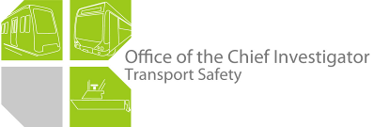

Rail Safety Investigation
Report No 2011/09

Southern Cross Station
End-of-track collision
15 September 2011

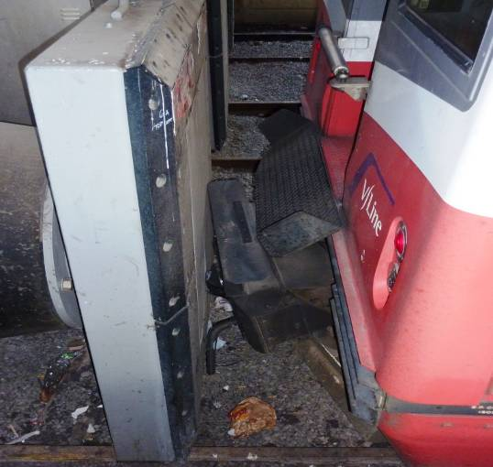

TABLE OF CONTENTS
The Chief Investigator 5
Executive Summary 7
1. Circumstances 9
2. Factual Information 11
2.1 The train 11
2.2 Infrastructure 14
2.3 Interview information 15
2.4 Recorded information 16
2.5 Operating procedures 17
2.6 Buffer stops 18
3. Analysis 19
3.1 The incident 19
3.2 Driver and maintenance crew actions 19
3.3 Coupling 20
3.4 Operating procedures 20
3.5 End-of-track protection 20
4. Conclusions 21
4.1 Findings 21
4.2 Contributing factors 21
5. Safety Actions 23
5.1 Safety Actions taken since the event 23
5.2 Recommended Safety Actions 23

The Chief Investigator
The Chief Investigator, Transport Safety is a statutory position under Part 7 of the Transport Integration Act 2010. The objective of the position is to seek to improve transport safety by providing for the independent no-blame investigation of transport safety matters consistent with the vision statement and the transport system objectives.

The primary focus of an investigation is to determine what factors caused the incident, rather than apportion blame for the incident, and to identify issues that may require review, monitoring or further consideration. In conducting investigations, the Chief Investigator will apply the principles of ‘just culture’ and use a methodology based on systemic investigation models.

The Chief Investigator is required to report the results of an investigation to the Minister for Public Transport or the Minister for Ports. However, before submitting the results of an investigation to the Minister, the Chief Investigator must consult in accordance with section 85A of the Transport (Compliance and Miscellaneous) Act 1983.

The Chief Investigator is not subject to the direction or control of the Minister in performing or exercising his or her functions or powers, but the Minister may direct the Chief Investigator to investigate a transport safety matter.

Executive Summary
On the morning of 15 September 2011, V/Line passenger train № 8103 departed Southern Cross Station bound for Bacchus Marsh. The train had moved only a few hundred metres when the brakes applied due to a loss of brake pipe pressure, bringing it to a stop.

Fault rectification procedures by the driver and the attending maintenance crew could not satisfactorily rectify the fault and it was decided that the train should be driven back to the station platform. After moving to the other end of the train and activating the new driving cab, the driver found that the brakes would still not release. The maintenance crew were subsequently able to release the brakes by re-activating the original driving cab, now at the rear of the train, and in so doing reset the vigilance control system. However, this activation of a second driving cab also had the effect of isolating the electro-pneumatic braking control system, leaving the less responsive automatic air brake system to stop the train. The maintenance crew were not aware their action had this effect and did not advise the driver of their action.

On arrival at the platform, the driver attempted to slow the train and stop it as he normally would, but it did not respond as quickly as he had anticipated, resulting in a low-speed collision with the end-of-track buffer at about 0749.

As a result of the collision, the front panel of the leading car and its coupler were damaged. There was also some damage to the couplers of the other cars. There were no reported injuries to personnel.

Post-incident inspection found faults in the couplers of two adjoining cars. The faults had caused air to directly exhaust from a brake pipe coupling and an apparent electrical discontinuity in the vigilance control system. Following the incident, V/Line has taken action to improve the routine maintenance of Sprinter coupler assemblies.

The investigation found that the manufacturer’s operations manual did not address the operation of Sprinter trains with two driver’s cabs activated simultaneously and recommends that drivers and maintenance crew be provided with clear instruction regarding the activation of a second cab.

- The investigation also identified that there was no in-cab warning to drivers that indicated that the electro-pneumatic brake control was not functioning and recommends that V/Line considers installing such a device.

Other recommendations are made to V/Line concerning risk management of operations at Southern Cross Station and the training of drivers in the operation of Sprinter consists with unserviceable electro-pneumatic brakes.

Circumstances
At about 0712 on 15 September 2011, the V/Line passenger train 8103 departed № 6 platform at Southern Cross Station, bound for Bacchus Marsh. On board were 15 passengers, a conductor and the driver. The train consisted of five Sprinter cars and was being driven from car 7021.

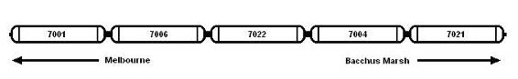
Figure 1 - Consist of Train 8103

During its passage from № 6 platform towards the Through Country Line the train lost brake pipe air and was brought to a stand on three occasions, before it became permanently disabled adjacent to the Southern Cross Station Operations Centre. Part of the train blocked the vehicular access road to the building (see Figure 2).

On inspecting the train, the driver found that air was exhausting at the coupling of cars 7004 to 7022. He uncoupled then recoupled the two cars, which appeared to him to rectify the problem. However, when the driver attempted to move the train, the brake once again applied as a result of low brake pipe pressure.

The driver then informed his company of the situation and two maintenance personnel were sent to the train. At about this time an ambulance arrived to attend to an ill person in the Operations Centre, but the road was blocked by the stationary train.

The fault could not be rectified and after consultation with the Operations Centre, the driver was instructed to return the train to Southern Cross Station. To achieve this, the driver isolated the cab of car 7021 and proceeded to the other end of the train where he activated the cab of car 7001. The maintenance crew remained in car 7021 and observed that the brake pipe pressure was low. They inserted their controller key into the master controller which energised the vigilance control, allowing the brake pipe pressure to restore and the brakes to release.

The train proceeded back towards platform № 6 and was slowed by the driver through a number of brake applications on the approach to the platform stop. The brakes were re-applied on the immediate approach to the buffer but the train did not respond as quickly as the driver expected. The driver then applied the brake in Emergency but the train collided with the end-of-track buffer stop.

As a consequence, the front coupler and body of car 7001 were damaged. There was also some damage to the couplers of the other cars. There were no reported injuries to personnel.

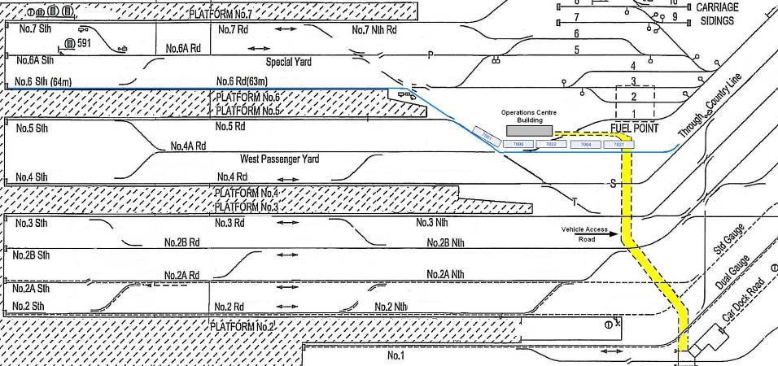
Figure 2 - Diagram of track and infrastructure at Southern Cross Station (not to scale) showing the route and stopped position of the train

Factual Information

The train

Sprinter cars
Overview

- The Sprinter cars were manufactured for V/Line by Goninan & Co, Melbourne, between 1991 and 1995. A Sprinter car may be operated individually or coupled (up to a maximum of eight cars) to form a diesel multiple-unit (DMU) consist. Each Sprinter car is 25.9 metres long, has a tare mass of about 51 tonnes and is powered by two air-cooled diesel engines.

The braking system

The braking system of the Sprinter is an air-operated railway disc brake system. The automatic air brake system incorporates an electro-pneumatic (EP) control facility. Both control functions are train-lined through the multifunction coupler. With EP control, the braking request in the driver’s cab is transmitted by electrical signal through the train consist to a local brake controller on each car. This local controller manages brake cylinder pressures to achieve the desired braking effort, compensating for vehicle weight, to achieve consistent braking along the consist. This is the normal mode of brake control on the Sprinter and because of the electrical transmission of the braking request, it provides responsive application of the brakes even with multiple car consists.

If the EP control fails or is isolated, the brake system will revert to automatic air brake mode. In this pneumatic control mode, the brake pipe acts as the means of transmitting the brake request along the train consist. When braking, brake pipe pressure will be reduced proportional to the movement of the driver’s brake controller handle. This pressure reduction results in an increase in brake cylinder pressures at each vehicle and in the braking of the train. This mode of braking control is less responsive than EP, particularly for multiple car consists, because of the time lag as the brake pipe pressure reduction occurs along the consist.

The coupler arrangement

A Scharfenberg Multifunction Coupler is fitted to each end of a Sprinter car and is designed to enable automatic coupling. Each coupler is fitted with connectors for brake pipe air and main reservoir air and two electrical boxes, each housing an electrical plate. One of the electrical plates has retractable contacts and the other fixed (non-retractable) contacts (see Figure 3). Retractable contacts mate with non-retractable contacts on the adjoining DMU. The faces of the electrical boxes must be flush with the opposing electrical box to a tolerance of one millimetre to ensure correct electrical connectivity. An indicator light in the driver’s cab indicates when the cars are correctly coupled.
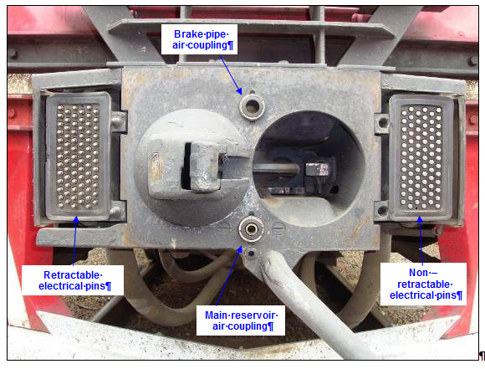

Figure 3 – Scharfenberg coupling

Train 8103
Train 8103 was made up of three arrivals into Southern Cross, as follows:
- Car 7001 was the first car to arrive at the platform, from Marshall.
- Cars 7006 and 7022 arrived from Kyneton and were coupled to car 7001.
- Cars 7004 and 7021 arrived from Seymour and were coupled to the other cars such that car 7004 № 2 end was coupled to car 7022 № 1 end.

Post-incident inspection
Post incident, the train was inspected at the platform and then at the Southern Cross stabling yards. It was found that:
- The bolts that attached car 7004 № 2 end coupler to the car frame were loose, allowing the coupler to droop slightly.
- The electrical box alignment to the coupler face on car 7022 № 1 end was set back about six millimetres from the correct position. In addition, several retractable electrical pins were noted to be depressed in the housing.

Figure 4 shows the alignment of the couplers of cars 7004 and 7022 when inspected post incident. The coupling faces are not flush and the electrical pins are visible.

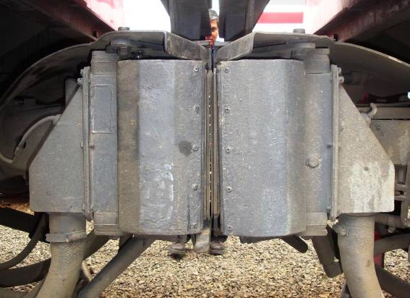
7022
7004
Figure 4 – Coupling of cars 7004 and 7022 at post incident inspection

During the post-incident testing, the investigation found that with two driving cabs activated, as they were in this incident, the EP brake mode was disabled. There was no indicator light or alarm in the driving cab to indicate that the EP braking system was not functional.

Maintenance
In accordance with the manufacturer’s recommendation, Sprinter cars are required to undergo a series of maintenance and servicing schedules. V/Line advised that coupler units undergo scheduled inspections every 35 days. The inspection includes the following:
- the tightness of the mounting bolts are checked with a torque spanner (to 850 Nm).
- electrical pins are inspected and cleaned, and defective pins replaced.
- coupler heads are cleaned, inspected and re-greased.
- coupler height from the rail is checked and adjusted, and
- the position of the electrical boxes in relation to the coupler face is also checked and adjusted if required.

The couplers of cars 7004 and 7022 were inspected and serviced on 16 and 17 August 2011 respectively and no defects were found.

Infrastructure

Track
Post-incident inspection indicated that the curvature and geometry of the track between the platform and the Operations Centre was within normal limits with respect to curvature and horizontal levels.

Operations Centre
The building is located adjacent to the fuel point near the sidings (see Figure 2). The vehicle access road is the only vehicular access to the building. However, there is a pedestrian pathway adjacent to the vehicular access road leading to the building. There are also pedestrian pathways leading from the operations centre building to each platform and to the stabling yard.

The platform
Platform № 6 at Southern Cross Station is about 127 metres long, running in an approximately north-northwesterly to south-southeasterly direction.

At the platform end-of-track, a Fentek Super Cone marine fender (see Figure 5) is provided as a buffer. This type of buffer was originally designed for use on wharves. It was installed at the time of the Spencer Street Station redevelopment. Similar buffers were also installed on the large mass concrete structure at the end of platforms № 1 to 5, 7 and 8.

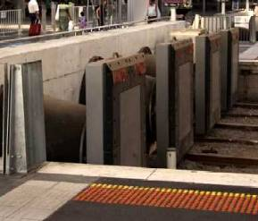 | 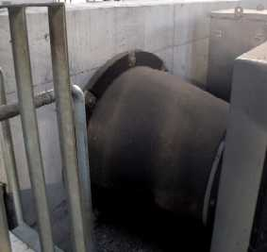
Figure 5 – Fentek Super Cone fenders at Southern Cross Station

Interview information

The driver
The driver had about 20 years experience as a train driver. He joined V/Line in January 2006 and obtained his Sprinter car accreditation in October 2006. His last driver assessment (safety audit) was conducted in May 2011 and he was found to be competent. His last medical assessment was in October 2009 at which time he was found to be fit for duty.

The driver reported for duty at 0648 on the day of the incident and was assigned to drive the 0712 scheduled service to Bacchus Marsh. He stated that on arrival at the platform he walked the length of the train and noted that all was normal. He then entered the driver’s cab of car 7021 and activated the cab. He stated that the cab activated normally and at that time there was no indication of any malfunction.

At 0712 the train received the signal to proceed. The driver stated that the train commenced travelling but as they passed the operations centre building, there was a loss of air and the brakes applied. The driver got out of the cab and walked the length of the train and noticed that there was air exhausting between cars 7004 and 7022, so he uncoupled then re-coupled the cars. He said that this seemed to fix the problem so he decided to resume the journey.

The driver stated that when he reactivated the driving cab of car 7021, the brake pipe air pressure initially increased releasing the brakes, but almost immediately there was a loss of air and the brakes applied. At this point the driver requested the Operations Centre have a maintenance crew from the rail workshop attend. The problem could not be rectified and after consultation with the Operations Centre, he was advised to return the train back to platform № 6.

The driver said that he isolated the cab of 7021 and walked to the other end of the train and activated cab 7001. The maintenance crew remained in car 7021 and when they waved to him from the back of the train, he took that as the signal to proceed. The driver was unaware that the maintenance crew had re-activated the cab of 7021. He was also unaware that the EP brakes were not operable.

The driver commented that as the train entered the platform he applied the brakes to slow the train, and then released them. He stated that at this point he did not notice any change in the responsiveness of the brakes. When the train was near the end of the track, the driver once again applied the brakes to bring the train to a stop. This time he noticed that the train was not slowing as quickly as he had anticipated, so he applied the emergency brake. However, that action could not prevent the train from colliding with the buffer.

After the incident the driver underwent a preliminary breath test and impairment assessment. He was assessed as being not impaired and there was no alcohol detected.

Maintenance crew
The two maintenance crew who attended train 8103 both held an ‘A’ Class Electrician certificate. One had been employed by Bombardier Transportation since January 1988 and the other since April 2003. They obtained their Sprinter Air Brake accreditation in December 2008 and May 2009 respectively.

In their evidence, the maintenance crew stated that after the driver proceeded towards car 7001 to drive the train back to the platform, they remained in the cab of 7021. They found that when the driver activated the cab of 7001, the vigilance control system would not reset. In order to reset it they activated the cab of 7021. They advised that once the vigilance control was reset, brake pipe air pressure increased and the brakes released.

When interviewed at the incident site, the maintenance crew stated that they were unaware that this action caused the train’s EP braking system to be isolated. When asked whether they maintained contact with the driver they stated that they did not, because they did not have mobile radios to remain in contact with the driver and the train public address system was not functional.

Recorded information
All sprinter cars were fitted with data loggers. The data record for car 7021 indicated that on the outbound trip, the train experienced a temporary reduction in brake pipe pressure and a corresponding increase in brake cylinder pressure on several occasions; in each case, resulting in a reduction in train speed. The train came to a brief stop on three occasions before coming to a final stop after travelling about 400 metres from the station.

Data logger records show the deactivation of the driving cab of car 7021, the activation of the driving cab of car 7001 and then the re-activation of the cab of car 7021 about 15 seconds before the commencement of the return journey. The cab of car 7021 remained activated for the complete transit back to Southern Cross Station.

The data record for car 7001 indicated that on the return trip to the platform, the train reached a maximum speed of 21 km/h. The brakes were applied by the driver about 263 metres from the end-of-track, bringing the train’s speed down to about 12 km/h. The train then coasted and slightly increased speed to 16 km/h before another light brake application commenced when the train was 63 metres from the end-of-track. The brake was fully released 10 metres from the end-of-track, with the train travelling at four km/h. After travelling a further five metres, a final brake application was commenced. At this point the brake cylinder pressure was starting to rise and the train was five metres from the buffer. An emergency application was made two metres before impact with the buffer with the train travelling at five km/h. The train made impact with the buffer at a speed of about four km/h at about 0749.

The data records for the cars trailing car 7001 on the return journey indicated that in the moments prior to impact, and at impact, the brake pipe pressure was progressively higher towards the rear of the train and the brake cylinder pressure progressively lower, indicating a lag in brake application towards the rear of the train.

Operating procedures

Sprinter operator manual
V/Line’s standard operating procedures for the operation of Sprinter cars follow the manufacturer’s (Goninan) Operator Manual for Sprinter Passenger Railcar. In summary, the manual describes the operation of Sprinter cars individually or in a multiple-car consist, with only the driving cab activated. The manual does not make any mention of the consequences of activating two cabs in the same consist and does not specifically prohibit the activation of a second cab in the same consist.

Section 9.3.3 of the manual stipulates that a brake test in the intermediate (coupled) cars is to be conducted during daily preparation of a multiple unit Sprinter consist, as follows:
- With the control key switch ON, the brake controller isolating cock OPEN and the brake controller in RELEASE, the brake cylinder pressure gauge should read full service pressure.
- Leaving the controller in RELEASE, depress the Brake Test pushbutton and check that brake cylinder pressure falls to zero.
- Release the pushbutton and check that brake cylinder pressure rises to full service. This confirms that the EP brake is working.

The manual also advises that a Sprinter may continue in service with the EP brake not functional but only at the discretion of the Officer-in-Charge, Sprinter maintenance. However, the investigation found that drivers are not trained to operate a train with automatic air brake only and the procedures do not require drivers to conduct a ‘running brake test’ of the automatic air brake only.

Approach speed
V/Line’s Network Operating Requirements states that when entering a platform at any station at which the train has to stop, the maximum train speed is 25 km/h.

There is a signal at the cross-over half way along platform № 6, beyond which the maximum permissible speed is 15 km/h.

Stopping distance
There are no markers on the platform or on the tracks to assist the driver’s judgement of where to stop prior to the buffer. Observation of V/Line train movements at Southern Cross Station found that trains stop very close to the end-of-track buffers, in many cases less than one metre from the buffer. V/Line did not provide drivers with documented policy regarding the required stopping distance from buffers.

Buffer stops

Design requirements
A buffer stop is a structure provided at the end of tracks at main-line terminals and other dead-end sidings, designed to protect other infrastructure and arrest the movement of rail vehicles. There is no standard for main line end-of-track buffer stops within the Rail Industry Safety and Standards Board (RISSB) suite of rail standards and none are planned for development.

Buffer stops are currently specified in VRIOGS (Victorian Rail Industry Operators Group Standards) for reasons of asset protection and safety at the termination of single-ended siding tracks used to stow passenger rolling stock. VRIOGS however does not address the installation of buffer stops at the end of tracks that occur at platforms.

Design requirements adopted by New South Wales RailCorp for buffer stops apply to all terminal roads and sidings where passenger trains operate. The applicable Civil Engineering Standard specifies, among other things:
- the types of material that may be used in the construction;
- that energy-absorbing buffer stops are preferred where passenger trains operate;
- that ‘lower-order protection devices’ (stop-blocks and earth or ballast run-off areas) may be used where passenger trains do not operate. Stop blocks may be timber bearers or concrete sleepers;
- that buffer stops are to have a cut-out at the bottom for the Scharfenberg guiding horn;
- that a risk assessment shall be made at each location to determine the design performance criteria and whether additional overrun protection is required;
- that train mass and train speed (probable worst case speed) to be taken into account;
- that fixed buffer stops shall only be used when space constraints exist and it is not economically feasible to erect an energy absorbing buffer stop.

Analysis

The incident
Prior to departure, the train driver walked the consist and observed that all appeared normal. On returning to the lead car he entered the cab and activated it; again all appeared normal. Then, after receiving the signal to proceed, the driver commenced the journey to Bacchus Marsh. However, the train was brought to a momentary stand on three occasions before, on the fourth occasion, it stopped due to a loss of brake pipe pressure and could not proceed. The train had stopped at a position adjacent to the Southern Cross Operations Centre, about 400 metres distance from its start point.

The driver was unable to release the brakes and requested assistance from maintenance personnel. They were also unable to rectify the fault with the train and after discussion between the driver and the Operations Centre it was decided to return the train to the departure platform. To achieve this, the driver changed ends on the train and activated what was now the lead driver’s cab. However, he was unable to release the brakes. The maintenance crew, realising this, inserted their key in the master controller of the now trailing driver’s cab to release the brakes. The maintenance crew did not advise the driver of the action they had taken, and there is no indication in the driver’s cab that the EP brake was out of operation, thus the driver was not aware of the braking available to his train.

Subsequently, as the train entered and proceeded along the platform the driver applied the brakes to slow the train, and then released them to allow the train to proceed to a position that was close to the end of track, as was normal custom for stopping trains at Southern Cross Station. The driver then applied the brakes again to halt the train but, because the EP brake was not operational and the automatic air brake system had a greater delay in its operation, the train did not stop before impacting the end-of-track buffer.

Driver and maintenance crew actions
In this incident the maintenance crew took action to release the brakes so that the train could be driven back to the station. In doing so, they effectively reduced the braking performance of the train. It is apparent that they were not fully aware of the results of their action; otherwise it would have been prudent for them to advise the driver. Had the driver been aware that the EP brake was non-operational, it is considered likely that he would have adjusted his braking technique when approaching the end of the track at the platform.

Coupling
At the platform, the track geometry was straight and level, so cars 7004 and 7022 appeared to be properly coupled. However, when the train started moving, the movement of each carriage and the curvature of the track caused the coupling to momentarily lose connectivity several times before permanently losing connectivity and bringing the train to a stop.

The faulty couplers of cars 7004 (№ 2 end) and 7022 (№ 1 end) resulted in the separation of the brake pipe air connection that caused air to exhaust directly at the coupling, which was immediately identified by the driver; and also an apparent loss of electrical continuity of the vigilance control circuit through the consist, which was noted only when the train was split and the couplings inspected.

The air exhausting from the brake pipe at the coupling was rectified when cars 7004 and 7022 were uncoupled and re-coupled; however, the primary cause for preventing the brake system to recharge was the electrical discontinuity of the vigilance control system. When the vigilance control of car 7021 could not be reset, it immediately triggered the emergency brakes by exhausting brake pipe air. When the cab was re-activated, this allowed the vigilance control system to reset, and brake pipe pressure to be restored.

Operating procedures
The Operator Manual for Sprinter Passenger Railcar does not warn against the activation of more than one driving cab. Had there been such reference in the manual, it is possible that the maintenance crew would have been aware that their action to activate the driving cab in the now trailing car may have affected the train performance and consequently, would have warned the train driver.

End-of-track protection
End-of-track buffers are installed to arrest trains that overrun the end-of-track and are typically designed to accommodate impact speeds of up to 15 km/h. On passenger lines in particular, one of the performance criteria for their design should be the deceleration of the train at a rate that will limit passenger injury and vehicle damage.

The buffers currently installed at Southern Cross Station do not provide this protection. Although the impact speed was just four km/h the train was significantly damaged. Had the train been travelling at 15 km/h (the regulated speed limit on this section of the track), impact with the buffers may have resulted in passenger injury and further train damage.

Conclusions

Findings
1. Car 7004 № 2 end and car 7022 № 1 end had defective couplers which affected the pneumatic and electrical continuity between the cars.
2. The manufacturer’s Operator Manual does not address the consequences of operating a Sprinter train with two cabs activated.
3. The maintenance crew were unaware of the effect on the electro-pneumatic braking system when two cabs in a Sprinter train are activated.
4. The end-of-track buffer did not provide adequate protection to the train and its couplers.

Contributing factors
1. Cars 7004 and 7022 were not coupled correctly due to faults in each coupler, resulting in a loss in continuity of the train’s air and electrical systems.
2. The electro-pneumatic braking system was disabled when the second cab was activated.
3. There was no alarm/warning device in the driver’s cab to alert the driver that the train’s electro-pneumatic brake system was not functioning.
4. The driver was unaware that the electro-pneumatic braking was non-functional when driving the train back to the platform.

Safety Actions

Safety Actions taken since the event
V/Line engineering department in conjunction with Bombardier Transportation have changed the Sprinter Rail Car ‘D’ examination checklist and the Sprinter A, B and C servicing maintenance information. This will result in more frequent and robust inspection of the components that make up the Scharfenburg couplers.

Recommended Safety Actions
Issue 1
Neither the manufacturer nor the Sprinter operator issued an instruction or caution to drivers or maintenance crews against the activation of a second cab.
RSA 2012021
That V/Line provides clear instruction to all drivers and maintenance crews regarding the activation of a second cab when operating a Sprinter train.

Issue 2
There may be instances when an ‘in service’ train loses electro-pneumatic braking functionality and is required to continue to operate on the automatic air brake. Currently drivers are not being provided with the appropriate training to appreciate the train’s performance under automatic air braking.
RSA 2012022
That V/Line considers training drivers to operate a Sprinter train with automatic air brakes only and considers introducing a ‘running brake test’ of the automatic air brake at a frequency appropriate to the level of operation and risks involved.

Issue 3
A Sprinter’s response to a driver’s brake application differs between electro-pneumatic mode and automatic air brake mode. However, there is no indication to inform drivers that the electro-pneumatic mode is not operational.
RSA 2012023
That V/Line considers installing a warning in Sprinter driving cabs to alert drivers when the electro-pneumatic brake control function is not operational.

Issue 4
The front of the train, its Scharfenberg coupler and some of the couplers of the other cars were damaged by an impact with the end of platform buffer at only four km/h. Had the impact occurred at a slightly higher speed, it is likely that damage would have been more extensive and that train occupants could have been injured.
RSA 2012024
That V/Line reviews the risks and risk controls associated with its operations at Southern Cross Station platforms with dead-end tracks.

The previous name of Southern Cross Station.
Wholly owned by the Australasian Railway Association and responsible for the development and management of rail industry standards, rules, codes of practice and guidelines, all of which have national application.
ESC 361, v2.3 Feb 2011 adopted by NSW RailCorp.
The minimum determined design speed shall be 10 km/h.

