Transport Safety Investigation

Report No 2008/07

Collision
Latrobe Valley Bus Lines bus and semitrailer
Princes Highway Traralgon
24 July 2008

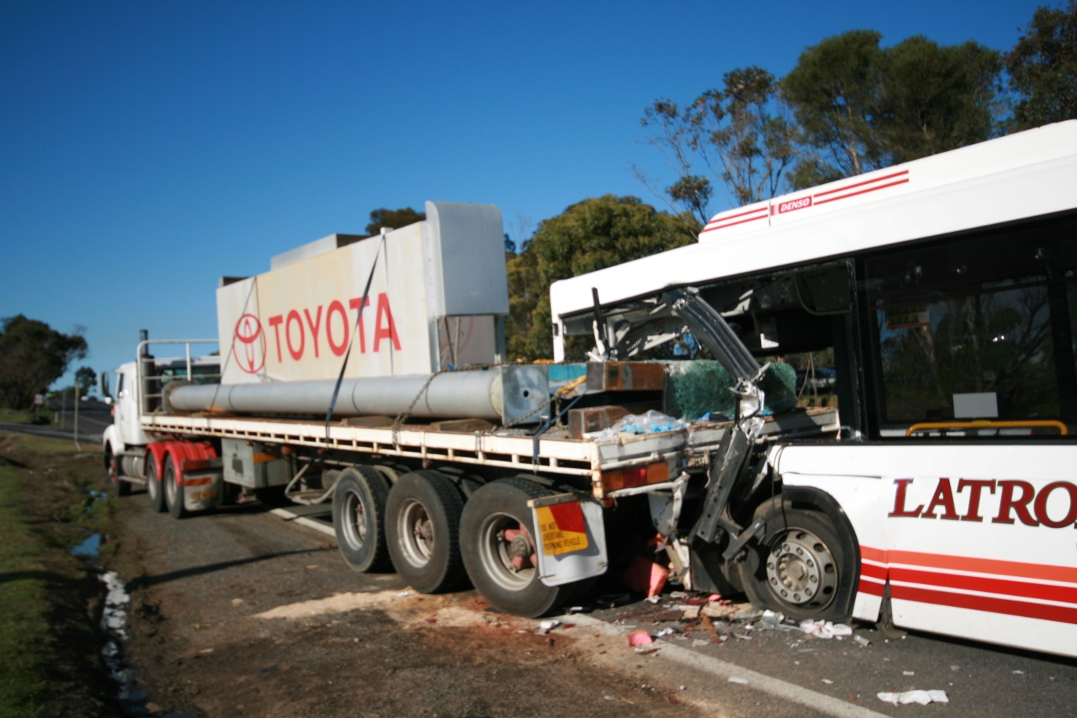

TABLE OF CONTENTS

THE CHIEF INVESTIGATOR 5
1. EXECUTIVE SUMMARY 7
2. CIRCUMSTANCES 9
3. FACTUAL INFORMATION 11
3.1 Bus 11
3.1.1 Route Bus 24 11
3.1.2 Route 11
3.1.3 Damage to bus 11
3.2 Semitrailer 13
3.3 Personnel information 13
3.3.1 Passengers 13
3.3.2 Bus driver 13
3.3.3 Management - La Trobe Valley Bus Lines 14
3.3.4 Semitrailer driver 15
3.3.5 Witness reports 15
3.4 Site inspection 17
3.5 Collision Mechanism 19
3.6 Road Infrastructure 19
3.6.1 Road design standards 19
3.6.2 Sighting distances 20
3.6.3 Road geometry 21
3.6.4 Traffic volumes and accident history 21
3.7 Regulatory System 21
3.7.1 VicRoads 21
3.7.2 Public Transport Safety Victoria 22
3.7.3 Director of Public Transport 22
3.7.4 Safety harnesses 22
3.8 Environmental Conditions 23
4. ANALYSIS 25
4.1 The incident 25
4.2 Human factors 25
4.3 Road Infrastructure 26
4.4 Medical examination 27
4.5 Safety harnesses in commuter buses 27
5. CONCLUSIONS 29
5.1 Findings 29
Personnel 29
5.2 Contributing Factors 29
6. SAFETY ACTIONS 31
6.1 Safety actions taken since the incident 31
6.2 Recommended Safety Actions 31
BIBLIOGRAPHY 33

THE CHIEF INVESTIGATOR

The Chief Investigator, Transport and Marine Safety Investigations is a statutory position established on 1 August 2006 under Part V of the Transport Act 1983.

The objective of the position is to improve public transport and marine safety by independently investigating public transport and marine safety matters.

The primary focus of an investigation is to determine what factors caused the incident, rather than apportion blame for the incident, and to identify issues that may require review, monitoring or further consideration. In conducting investigations, the Chief Investigator will apply the principles of ‘just culture’ and use a methodology based on systemic investigation models.

The Chief Investigator is required to report the results of investigations to the Minister for Public Transport and/or the Minister for Roads and Ports. However, before submitting the results of an investigation to the Minister, the Chief Investigator must consult in accordance with section 85A of the Transport Act 1983.

The Chief Investigator is not subject to the direction or control of the Minister(s) in performing or exercising his or her functions or powers, but the Minister may direct the Chief Investigator to investigate a public transport safety matter or a marine safety matter.

1. EXECUTIVE SUMMARY

At about 1045 on Thursday 24 July 2008, Route Bus 24 operated by Latrobe Valley Bus Lines collided with a semitrailer on the Princes Highway, 320 metres west of the intersection between the Princes Highway and Coonoc Road.

Immediately prior to the collision the semitrailer had joined the Princes Highway from a side road and was travelling in the left hand lane of the highway. The commuter bus was operating the 1000 scheduled service from Moe to Traralgon and was travelling at about 75 km/h on the left hand lane of the Princes Highway. The bus did not deviate from its course and ran into the back of the semitrailer.

At the time of the incident the bus was carrying 18 passengers including two children aged seven and nine years and an eight month infant in a stroller.

One passenger and the driver of the bus sustained critical injuries, two passengers were seriously injured and the remaining passengers received minor or no injuries. The critically injured passenger, who was seated in the left front seat, was trapped in the wreckage for almost three hours before being extricated by the emergency services.

The left front panel and left front interior of the bus was extensively damaged by the intrusion of the load, a sign-board mounting column on the semitrailer. There was minimal damage to the semitrailer.

Both the commuter bus driver and the semitrailer driver was appropriately licensed and certified by the relevant authorities.

The investigation determined that prior to the incident the commuter bus and semitrailer were in a serviceable condition. The road infrastructure was in good condition and the weather conditions were not contributory factors. Although the bus driver suffered from hypertension and diabetes, there was no evidence that the driver’s medical condition contributed to the incident.

The investigation concluded that inattentional blindness and inappropriate attention to an object in the westbound carriageway by the bus driver led to a loss of situational awareness resulting in the collision.

The investigation recommends that:

- VicRoads erects signage warning drivers of the changed road conditions after the crest of the road.

- PTD (Public Transport Division) and the Bus Association of Victoria consider fitting commuter buses with restraining devices for infant strollers, and signage is displayed on secure storage of infant strollers.

- An independent panel of registered medical practitioners, approved by the Director of Public Transport, is established for the certification of drivers of commuter buses.

2. CIRCUMSTANCES

Latrobe Valley Bus Lines Route Bus 24 was operating the 1000 scheduled service from Moe to Traralgon via Morwell. After departing the Morwell bus terminal at about 1025, the bus proceeded to the Mid Valley bus stop and then to the Latrobe Hospital stop. The bus was then on its scheduled route to the Traralgon plaza stop and was 320 metres west of the intersection between the Princes Highway and Coonoc Road when it collided with a semitrailer that was travelling at a slower speed on the Princes Highway.

The semitrailer involved in the incident arrived at the second vehicle dealership at about 0900 to transport an advertising sign board that was being replaced. The loading of the sign board was completed by 1030. The semitrailer then proceeded to the top of the left hand turn lane and waited approximately five minutes for the traffic to clear. The driver then proceeded into the right hand lane of the highway to keep the trailer clear of the left hand side kerb before moving back into the left lane.

The vehicle had travelled about 42 metres on the highway and accelerated to about 25 km/h when the bus collided with the semitrailer from behind. The left front section of the bus struck the right rear section of the trailer. Both vehicles then travelled together for about 74 metres before veering off to the left shoulder of the road and stopping on the shoulder.

The right rear section of the semitrailer and the load intruded approximately 2.5 metres into the bus, trapping the passenger in the left front seat. Emergency services took approximately three hours to extricate the trapped passenger.

Figure 1 - Incident Location on Princes Highway (Source Google Maps)

3. FACTUAL INFORMATION

  - Bus

    - Route Bus 24

The low-entry route bus has a 12.5-metre chassis built by Iveco Trucks Australia Limited and is of standard design. The Metrotec 17.250 model body structure was built by Volgren Australia Pty Ltd, and is designed for public transport operations in urban and suburban street environments. It provides 35 fixed seats with an additional two, three seater bench seats located in the left and right side spaces allocated for mobility aids and pram/stroller accommodation, providing a total of 41 seats.

Maintenance and testing

On 18 June 2008, Route Bus 24 was subjected to a VicRoads inspection. During the inspection the vehicle brakes were tested and found to be functioning satisfactorily. On completion of the inspection VicRoads re-certified the vehicle to be in a safe condition to be used on a highway.

On 30 June 2008, a routine 10,000 km service of Route Bus 24 was carried out. The vehicle had completed 145,080 km in total. The service included the inspection and satisfactory testing of the controls and steering, tyres and the braking system.

Post incident inspection of the vehicle by the Major Collisions Investigations Unit of Victoria Police did not reveal any defects that may have contributed to the incident. The inspection also revealed that the bus was travelling at approximately 72 km/h when it collided with the semitrailer.

    - Route

Typically a driver of Route Bus 24 is expected to carry out an inspection of the bus and commence duties at approximately 0530. The driver is then required to drive the bus to Traralgon Plaza and take on passengers to commence the scheduled 0600 run from Traralgon terminating at Moe bus stand at 0640. The driver then commences the 0700 run from Moe bus stand terminating at Traralgon Plaza at 0740. At 0800 the driver commences the Traralgon to Moe run arriving at the Moe bus stand at approximately 0840. The driver then takes a half-hour break before taking on passengers for the scheduled 1000 Moe to Traralgon run which is expected to terminate in Traralgon Plaza at approximately 1040.

    - Damage to bus

In carrying out the damage inspections, it was recognised that the bus condition was altered from the immediate post incident condition by the activities of the emergency services.

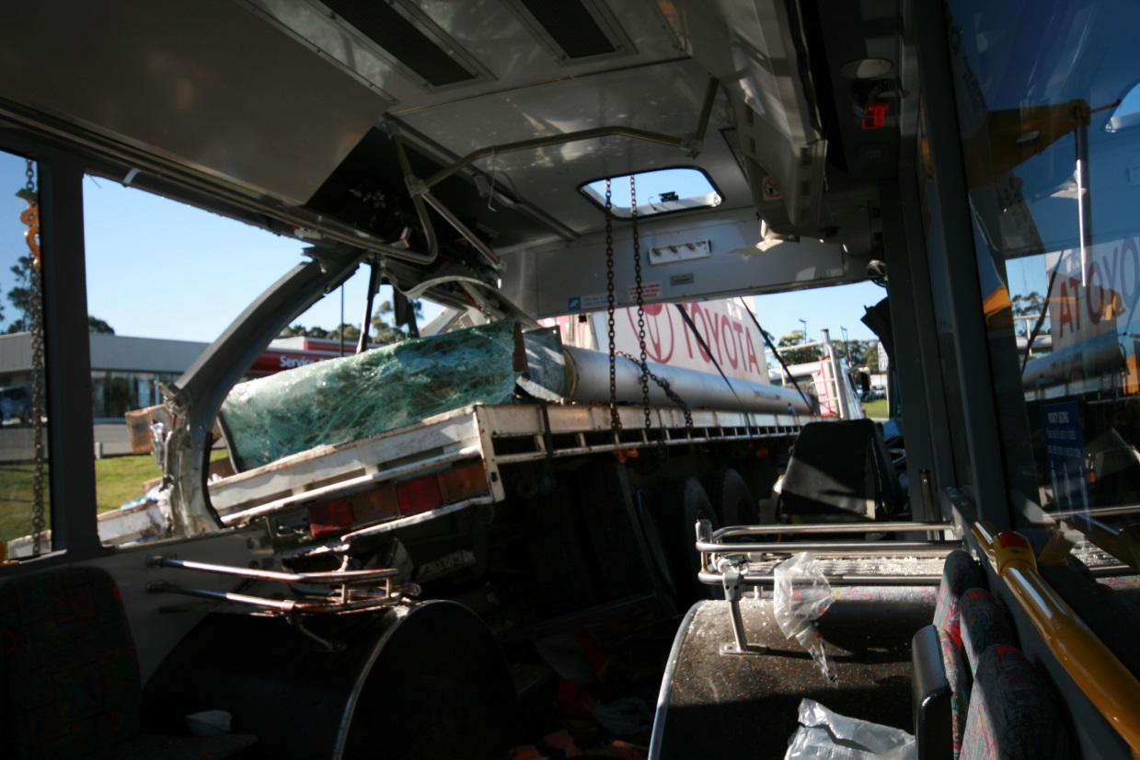
Figure 2 - Penetration of truck into bus

The chassis front frame, near-side wall frame, roof cantrail and the chassis floor structure were forced in by the penetration of semitrailer and load into the bus. The front dash assembly was dislodged from its mounting and internal seats and handrails were damaged.

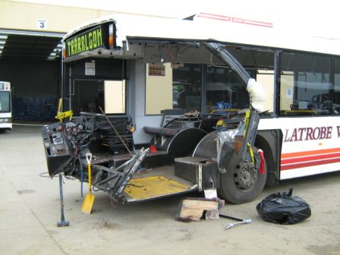
Figure 3 - Damage to bus
  - Semitrailer

The semitrailer consisted of model S-3600, International S Line prime mover manufactured in 1998 by Navistar International Corporation, USA and a flat-deck, tri-axle model HT3 trailer of 12.2 metres length, manufactured by Fruehauf Trailers, New Zealand. The prime mover was powered by a 450 hp, Cummins N14 model diesel engine.

The semitrailer loading was assessed by VicRoads. All loadings were within the maximum allowable loadings for this make and model of prime mover and trailer.

Post incident inspection of the semitrailer indicated that the load had remained secure during the incident and had not moved significantly.

  - Personnel information

    - Passengers

At the time of the incident the bus was carrying 18 passengers including two children aged seven and nine years and an eight month infant in a stroller.

One passenger and the driver of the bus sustained critical injuries, two passengers were seriously injured and the remaining passengers received minor or no injuries. The critically injured passenger, who was seated in the left front seat, was trapped in the wreckage for almost three hours before being extricated by the emergency services.

    - Bus driver

The driver of the bus was a 57 year old male, holding a valid and current Victorian heavy vehicle driving licence. The driver also held a ‘driver accreditation certificate’ issued by the Director of Public Transport.

The bus driver informed the investigation that he had been driving route buses for 37 years and had been operating on the Moe-Traralgon route for about six years. He stated that he normally worked a 52 hour week, Monday to Friday.

On the day of the incident he said that he woke up around 0415 and arrived at work at about 0500. He stated that he had breakfast before starting his shift at about 0555. He drove the bus to Traralgon Plaza, where he commenced his first run at 0600, which terminated at the Moe stand at about 0840. He then took his scheduled 30-minute break before commencing the Moe to Traralgon run at about 1000. The driver told the investigation that during his morning break he usually has a sandwich or a pie at Moe. However, on the day of the incident he could not recall what he had eaten during the morning break.

The driver stated that during his Moe to Traralgon run he had left the Latrobe Valley Hospital bus stop and rejoined the Princes Highway when the incident occurred. He stated that he was in the left lane on the east bound carriageway of the Princes Highway and was travelling at about 80 km/h. When the bus went over the crest of the highway, he said that he saw the truck ahead of him and it was moving into the left lane from the right lane. He stated that he then looked in the rear view mirror and saw two cars adjacent to him in the right lane and that he “had nowhere to go, and then it was too late”. He said that he expected the truck to continue onto the extreme left of the lane and onto the service lane and when it did not do so, it was too late to stop and the bus collided with the truck.

On the day before the incident the bus driver stated that he completed his scheduled route bus runs without incident. He worked from about 0600 to about 1730 and got home at about 1800. He told the investigation that he had his tea, watched some TV and got to bed between 2030 and 2100.

When asked if he was diabetic, the bus driver replied in the affirmative. He reiterated that he had his breakfast that morning and had taken his “blood pressure” and “diabetes” medication at the scheduled times. He stated that he used prescription lenses and had no problems with his vision.

    - Management - La Trobe Valley Bus Lines

The Traralgon depot supervisor of La Trobe Valley Bus Lines stated that he had 26 years experience driving route buses before he took over supervisory duties. He said that he had been a depot supervisor for the last 13 years and on occasion still drove route buses when required.

He stated that at about 1045 on the day of the incident, the proprietor of the business called him and told him that one of the buses had been involved in an accident in front of the car dealerships in Traralgon. He drove to the site and when he arrived there at about 1100 he observed the collision and immediately went to assist the driver. The driver was conscious and when he inquired if he was alright the driver replied “I was daydreaming and something on the other side of the road caught my eye. When I looked back on to the road the truck was in front of me and it was too late”.

The supervisor stated that he came to work at about 0530 as was his usual practice. He said that it was usual for the bus driver to be at the depot, having his breakfast when he arrived. However on the day of the incident he did not observe the driver having his breakfast and neither did he observe any breakfast utensils in the sink, as was usually the case.

The supervisor stated that the driver informed him that he would not be available for the afternoon shift as he had a doctor’s appointment at 1300 for a blood test for diabetes. He said that he asked the driver if he was fasting for the test and the driver replied that he was not. He also stated that on previous occasions when the driver had a blood test for diabetes in the morning and was fasting for the test, he was not allowed to drive buses after 0900.

The supervisor further stated that in 2008, there were several complaints from passengers regarding the driver of the bus. The complaints ranged from, not stopping at bus stops to pick up or drop off passengers to not stopping at traffic lights. Suspecting that the diabetes was affecting the driver’s eyesight and hearing, the depot supervisor advised the management of the bus company of the complaints.
On 21 November 2007, La Trobe Valley Bus Lines requested the bus driver to undergo a complete medical test by an independent medical practitioner, before resuming the driving of commuter buses. The driver was on paid medical leave from 21 November 2007 to 8 February 2008.

The General Manager of Latrobe Valley Bus Lines advised the investigation that on 8 February 2008, the bus driver provided the company with a certificate from a diabetes specialist declaring that he was fit to maintain his bus licence and he was returned to driving duties from that date.

    - Semitrailer driver

The driver of the semitrailer was a 47 year old male, holding a valid and current Victorian heavy vehicle driving licence. He had about 27 years experience driving various types of heavy vehicles. He stated that he had never had an accident or been convicted of a traffic offence in a commercial vehicle.

The semitrailer driver stated that he had commenced work at 0700 on the day of the incident. His first task for the day was to transport an advertising sign from the Toyota dealership to a storage facility in Traralgon.

On the day of the incident he arrived at the Toyota dealership at about 0900. Once the loading of the sign board and pole was completed at about 1030, he said that he drove the truck to the top of the dealership exit lane and waited stationary for about five minutes for the traffic to clear. When he did not see any vehicles coming over the crest of the highway he entered the highway, turning left into the right hand lane to accommodate the turning circle of the trailer, before moving back into the left lane. He stated that he had accelerated to about 25 km/h when he felt the “impact and knew that something had struck him from behind”. He then swerved to the left and was pushed by the bus to the extreme left of the road, with both vehicles locked together ending on the entry service lane to the third car dealership.

The semitrailer driver then stated that he ran to the bus and asked the driver “what happened?” to which the driver replied “I didn’t see you at all”.

The semitrailer driver stated that he did not see the bus approaching as he had not looked in his rear-view mirrors.

    - Witness reports

The investigation wrote to 15 passengers of whom 10 passengers responded by providing information such as seating position, injuries and other useful information.

Bus passenger 1

A passenger in the bus stated that he boarded the bus at the Midvalley Shopping Centre. The bus then stopped at the Latrobe Valley Hospital before entering the Princes Highway. He stated that he was half asleep when he heard people shouting “watch out! Truck, watch out!” He looked up and saw the truck directly ahead and observed the bus colliding with the truck. He stated that he ended up with his legs trapped in the wreckage and subsequently the emergency services attended to him.

Bus passenger 2

A passenger who was seated in the aisle seat six rows behind the driver stated that she was talking to the lady who was seated to her left, when she heard someone shout “watch out”. She was then thrown onto the aisle and sustained a shoulder injury. She said that her seven year old son who was seated behind her was thrown forward and sustained facial injuries. She also stated that she observed an infant stroller almost lift off the bus floor and if the person seated next to it had not held it down the eight month infant may have been seriously injured.

The passenger commented that her son may not have been injured if he had been restrained by a seat belt.

Commercial vehicle driver

Just prior to the collision a commercial vehicle was following the commuter bus involved in the incident. The driver of the vehicle stated that he was travelling at about 80 km/h while following the bus. He said that he observed a car in the right lane adjacent and in the process of overtaking the bus. He reduced speed and moved into the entry lane of the second car dealership. He was in the entry lane when he observed the bus collide with the semitrailer. He said that he did not observe the bus brake to reduce speed prior to the collision. He stated that he saw the brake lights on the bus light up at the moment of impact. He then went to the bus and assisted the injured passengers.

Passenger car driver 1

A passenger car driver stated that she was driving a car from Moe to Traralgon along the Princes Highway at the time of the incident. She stated that she is very familiar with this section of road. She advised that she overtook the incident bus, which was travelling in the left lane of the highway, well before the incident and before the car yards on the left of the highway. At the time of overtaking the bus she stated that her vehicle was travelling at about 75 km/h and that she was going faster than the bus. She commented that this section of road had had the speed limit reduced on it recently.

The driver advised that after overtaking the bus she moved back into the left lane in front of the bus and behind the truck, which she said was on the highway and in the left lane and a “reasonable” distance in front of her car. She commented that initially she did not realise how slowly the truck was travelling and had to move to the right lane again and overtake the truck. She commented that when she first saw the truck it was well established on the highway.

After overtaking the truck she moved her car into the left lane again and a short time later heard a loud bang. She looked in the rear view mirror and saw that there were vehicles coming in the right lane through debris. She did not think there were any vehicles next to the bus prior to the impact, but could not be certain. She said that after the collision she went back to the scene to offer assistance.

Passenger car driver 2

Another passenger car driver, who also witnessed the incident, recalled that the commuter bus was travelling in the left lane of the highway at about 80 km/h. She stated that her vehicle was in the right lane and approximately a bus-length to the rear of the commuter bus. She said that she observed the semitrailer ahead of the bus in the left lane as her vehicle went over the crest of the highway. As the semitrailer appeared to be moving at a relatively slow speed, the car driver stated that she slowed down expecting the bus to change lanes to the right lane of the highway. She then saw the bus collide with the rear of the semitrailer. She stated that the bus did not reduce speed or attempt to change lanes before the collision.

  - Site inspection

The dual carriageways of the highway are separated by a grass and foliage median strip between the opposing traffic directions. Each carriageway is also divided into left and right lanes. The eastbound lanes at the site of the incident have no horizontal curves and are a straight alignment on a bearing of about 075 degrees.

Figure 4 - Car dealership exits to highway
Adjacent to the carriageway heading in the easterly direction are three car dealerships. The first dealership has a dedicated service road while the other two dealerships exit though left hand turn lanes directly onto the Princes Highway. The access road to the car dealerships is classified as a private property access point and not a declared road under the local or state road network.

Inspection of the incident site revealed gouge marks in the left lane of the carriageway indicating that the forward underside of the bus had dug into the tarmac just after the impact. Tyre scuff marks of approximately 10 metres in length could also be observed on the road. Vehicle debris was scattered in a large area indicated in Figure 5. The front of the semitrailer was on the left shoulder of the road about 74 metres from the point of impact. The trailer was wedged approximately 2.5 metres into left side of the commuter bus.

Figure 5 - Site drawing of Princes Highway (Eastbound lanes)

Figure 6 - Truck exit from car dealership

  - Collision Mechanism

The distance from the crest of the highway to the exit lane from the second dealership is approximately 360 metres. The semitrailer had exited the lane from the dealership and travelled about 42 metres before the collision, indicating that the collision occurred approximately 402 metres after the crest of the highway. The evidence suggests that the commuter bus was travelling at approximately 80 km/h at the crest of the highway. The bus speedometer dial was broken and had jammed the indicator at 72 km/h indicating the approximate speed at impact. The semitrailer had accelerated to about 25 km/h before the collision, indicating that the vehicle had accelerated at approximately 0.57 m/s². This figure is consistent with the Austroads average acceleration figures for heavy vehicles.

  - Road Infrastructure

The section of Princes Highway that the incident occurred forms a part of the National Road Network and is classified an M1 route by VicRoads. An ‘M’ classification is a duplicated freeway or expressway connecting the capital cities and major provincial centres. The functional classification of the Princes Highway is a VicRoads declared ‘Arterial Highway’ and VicRoads is responsible for its maintenance and operation.

    - Road design standards

The standards applicable to road design in Victoria are documented in VicRoads Design Guidelines. Austroads, the Association of Australian and New Zealand Road Transport and Traffic Authorities have also produced National Road Design Guidelines that are considered an additional resource to the VicRoads Design Guidelines.

    - Sighting distances

The VicRoads Design Guidelines defines three sight distances that are major factors in road safety. The guidelines provide minimum sight distance requirements for road design.

Approach Sight Distance (ASD) or Stopping Sight Distance (SSD)
Safe Intersection Sight Distance (SISD)
Entering Sight Distance (ESD).

ASD enables a driver to perceive markings on the road surface and stop. SISD allows the driver sufficient time to perceive a problem, react and stop if a vehicle entering the road obstructs traffic. ESD allows a driver to enter a major road without impeding traffic on major roads.

Vertically, the incident site lies in a low point between two crests on the carriageway. The crest on the approach to the site influences sighting distances.

Figure 7 - Gradelines and Sightlines

As can be observed in Figure 7, the sight line for ASD (1) is well above the eastbound carriageway and the sight distance requirement is exceeded. The SISD (2) which is about 275 metres is also above the required design value. The maximum available sight distance (3) for the two drivers to be able to see each others vehicles is approximately 360 metres. ESD has not been considered in this case as it is calculated for cars with a lower driver eye height.

There were no road side features such as vegetation affecting sight distances and driver visibility at this site.

    - Road geometry

The VicRoads design guidelines specifies minimum lane and shoulder widths. Lane and shoulder conditions primarily affect head-on and run-off-road accidents and do not directly affect rear end collisions, as was the case in this incident. Measurement of lane and shoulder dimensions of the site of the incident indicates that they are consistent with the design guidelines.

VicRoads Traffic Engineering Manual details the requirements for both signs and pavement markings in Victoria. The auxiliary lane was separated by a continuous line from the left lane of the eastbound carriageway. According to the guidelines the auxiliary lane from the exit of the car dealership may require a break in the continuous line to allow vehicles to cross into the left lane of the eastbound carriageway of the highway.

    - Traffic volumes and accident history

The Austroads Guide to Traffic Engineering discusses the capacity of a single lane of traffic ranging from 1800 vph (vehicles per hour) for significant lengths of road with long groups of vehicles, to 2200 vph for urban freeways in peak periods with no lane changes.

Traffic volumes for 2007 for the closest count site to the incident were provided by VicRoads. The AM peak hour volume of traffic in this section of Princes Highway is approximately 1000 vehicles; hence the volume of traffic for this section of road is well within the design capacity of the road.

The accident records provided by VicRoads indicate that there is no significant accident or incident trend for the eastbound carriageway of this section of Princes Highway.

  - Regulatory System

    - VicRoads

VicRoads is the responsible statutory authority for the section of highway that the incident occurred.

VicRoads is the registered business name of the Roads Corporation, a statutory Corporation within the Victorian Government infrastructure portfolio. The functions and objects of the Corporation are outlined in the Transport Act 1983, Road Safety Act 1986 and the Road Management Act 2004. These Acts provide VicRoads with the powers to manage Victoria’s arterial road network, implement road safety strategies and programs and provide vehicle registration and driver licensing services.

VicRoads reduced the maximum speed for this section of the Princes Highway from 100 km/h to 80 km/h in April 2008 due to increasing development and traffic activity in the area of the incident and associated community input.

    - Public Transport Safety Victoria

Under the Public Transport Competition Act 1995 operators of scheduled (route) bus services are required to be accredited by the Safety Director. Public Transport Safety Victoria (PTSV) ensures that the conditions of accreditation are complied with before certification is issued. La Trobe Valley Bus Lines was appropriately accredited by PTSV.

    - Director of Public Transport

Accredited bus operators are required to employ drivers who hold a valid and current Victorian heavy vehicle driving licence issued by VicRoads and a ‘driver accreditation certificate’ issued by the Director of Public Transport as required by the Transport Act 1983. VTD (Victorian Taxi Directorate) assesses applications and issues the ‘driver accreditation certificate’. The legislation gives the Director of Public Transport the authority to request an applicant to provide medical evidence of their suitability to drive a commercial passenger vehicle.

The ‘Driver Accreditation Certificate’ renewal form Part 1, requires a registered medical practitioner to complete this section certifying that the applicant has been examined in accordance with the relevant National Medical Standards for Commercial Vehicle Drivers, as set out in the document Assessing Fitness to Drive, 2003. Part 2 of the renewal form requires a registered optometrist to certify that the applicant meets the minimum acceptable vision acuity standards and Part 3 of the form requires the applicant to complete and sign this section.

The Driver Accreditation Certificate for the driver involved in this incident was renewed from 15 March 2008 to 15 March 2009, despite non completion of Parts 1, 2 and 3 of the renewal form. However, VTD has advised this investigation that the driver accreditation certificate was renewed on receipt of a medical report declaring that the bus driver was fit to maintain his bus licence.

    - Safety harnesses

In Australia a number of reviews have been conducted on the use of seatbelts in school buses. A study conducted by AustRoads, Investigation of Internal Bus Safety Measures, published in 2002 found that:

- The risk of being struck by passing traffic after alighting from a bus presents a considerably greater risk to children than travelling as a bus passenger during school commuting hours.

- There is varying evidence regarding the safety effectiveness of fitting seatbelts, allowing the student to stand, allowing three for two seating or installing higher seat backs (compartmentalisation).

- There is conflicting evidence regarding the effectiveness of fitting seatbelts. Lap-sash seat belts may improve protection in side impact and rollover crashes, compared with compartmentalisation alone.

- There is a lack of evidence to indicate that seated travel is significantly safer than standing. The research is mixed and evidence is largely inconclusive due to the low number of crashes associated with school buses.

  - Environmental Conditions

Latrobe Valley Airport is the closest Bureau of Meteorology weather monitoring station and is located two km from the accident location. At the time of the incident visibility was greater than 10 km and there was no rain. Wind was an Easterly five knots gusting to seven knots. The sky was clear and the sun was at an altitude of 28 degrees and an azimuth of 24 degrees. The temperature was 9.8 degrees Celsius and relative humidity was 71 per cent.

4. ANALYSIS

  - The incident

There was no evidence to indicate that the design, manufacture or condition of the bus or semitrailer contributed to the collision.

The bus driver was experienced and had driven this route for approximately six years. Given the collision scenario, the incident would require a significant error of judgement by the bus driver.

The bus driver advised this investigation that he had approximately seven hours sleep the night before the incident. He had been awake for approximately six hours before the incident. There is no evidence to suggest that the driver was suffering from any fatigue related symptoms that may have contributed to the incident.

Considering the altitude (28 degrees) and azimuth of the sun (24 degrees) and the heading of the bus (075 degrees) at the time of the incident, the position of the sun is not considered a factor in this incident.

  - Human factors

Muttart (2005) suggests that there are appropriate and inappropriate contributors to inattention to a road hazard. Inappropriate attention could take the form of talking on a mobile phone or adjusting radio settings. Appropriate attention could take the form of checking the speedometer reading or attending to the movement of road traffic on the road ahead. Any of these activities, whether appropriate or inappropriate could lessen the likelihood of detecting a hazard.

In this incident, evidence suggests that the bus driver’s attention was directed towards an object in the westbound carriageway, lessening the likelihood of him observing the semitrailer ahead of his vehicle.

Inattentional blindness (‘blank stare’) phenomenon is the failure to see an object because attention is not focused on it (Green, 2004). Research conducted in this area indicates that in performing tasks such as operating a vehicle, the operator may fail to see what should have been plainly visible and afterwards, cannot explain why. If an object, of its own accord, captures our attention it is ‘conspicuous’, however if we focus attention on too many things at once we may miss something that is critical. Another cause of ‘blank stare’ is low arousal caused by too moderate a mental load. When people become bored they cease to pay close attention and their attention wanders. Green states: “People may…go on ‘auto-pilot’ when performing highly practised tasks, such as driving.” ‘Day dreaming’ by the driver of the commuter bus could be attributed to the above phenomena.

A reaction time of 2.5 seconds is generally used in the road design context (Austroads, 2003). This value however does not include the time for the driver’s actions to affect the vehicle’s stopping performance. In addition, research has found wide variance in driver reaction times ranging from fractions of a second up to approximately seven seconds (Triggs & Harris, 1982).

A vehicle travelling a distance of 402 metres at a constant speed of 80 km/h takes approximately 18 seconds to travel this distance. Therefore, the bus driver had about 18 seconds to assess the situation and take appropriate action, if he observed the semitrailer. The fact that he did not take any evasive action indicates that he was unaware of the threat created by the presence of the semitrailer and it can therefore be concluded that the bus driver was not concentrating appropriately on the driving task. It is most probable that inattentional blindness and/or inappropriate attention to an object in the westbound carriageway contributed to the driver not detecting the road hazard.

  - Road Infrastructure

Guidelines

The existing guidelines are considered appropriate benchmarks for the design of roads in Victoria. The guidelines clearly outline the requirements for urban and rural roads. However it is left to the road designer’s judgement on whether to classify transition areas such as this section of the Princes Highway as a rural or urban road. In this instance a mix of urban and rural road guidelines have been used in the design of this section of the Princes Highway. The application of guidelines for rural road design to a transition area may become inappropriate when road side developments increase, resulting in changed traffic conditions.

Traffic flow and sighting distance

In this instance the truck driver waited until no vehicles could be observed on the crest of the road, which is approximately 360 metres from the dealership exit, giving a vehicle coming over the crest ample time to take evasive action. Further, there was adequate SISD (275 metres) and ASD (360 metres) for both drivers to observe the other well in time.

Signage

Whilst the speed limit reduction from 100 km/h to 80 km/h in the area of the incident may indicate to the vehicle drivers that there may be a hazard ahead, there is no indication that there are a number of access and intersection points. Signage warning drivers of the changed road conditions ahead may heighten driver awareness leading to increased safety.

Road geometry and design

Although not consequential to this incident, the current line marking at the exit of the second vehicle dealership is a solid continuous line (Figure 4). This may lead to driver confusion as to appropriate lane usage when joining the highway and a break in the continuous line may be more appropriate.

The current geometry of the road does not lend itself to an effective extension of the existing acceleration lane. A second entrance to another dealership lies east of the incident site. By lengthening the acceleration lane vehicles wishing to turn left into the second dealership would be in conflict with vehicles merging right from the acceleration lane. The safest treatment option would be to extend the existing service lane from the west to provide access to all developments on the eastbound carriageway.

  - Medical examination

Due to passenger complaints Latrobe Valley Bus Lines requested the driver of the bus to undergo a medical examination by a medical practitioner nominated by the company.

A medical examination carried out on 5 December 2007 by a medical practitioner in Traralgon stated that the driver did not pass the medical standards to hold a licence to drive a bus and required him to be examined by a specialist in diabetes. On 5 February 2008, the driver was examined by a diabetes specialist who stated that he is being treated with the required medication and was declared fit to maintain his bus licence.

There was no evidence to suggest that the bus driver’s medical condition contributed to this accident.

With respect to medical examination and certification for operators in the Marine and Aviation industries, the statutory authorities require operators to be examined by medical practitioners who are approved by the authorities. Train drivers are required to be examined by medical practitioners approved by their employer (rail operator).

For the road public transport sector, consideration should be given to the establishment of an independent panel of registered medical practitioners approved by the Director of Public Transport. All applicants for driver accreditation certificates should be required to be certified by a practitioner on this panel.

  - Safety harnesses in commuter buses

The current legislation does not require safety harnesses in commuter buses. In this incident safety harnesses would not have prevented the critical injuries sustained by one passenger and the driver of the bus. The two seriously injured passengers may have avoided their injuries if they had been wearing safety harnesses. However there is conflicting evidence regarding the effectiveness and safety implications of fitting seat belts. Hence, safety harnesses for all passenger seats in frequently stopping commuter buses are not considered a practical option.

The potential for serious injury to the infant in the stroller was averted by the quick reaction of a passenger, who secured the stroller at the moment of impact. Securing devices in the spaces allocated for mobility aids and pram/stroller accommodation may enhance safety of infants in strollers.

5. CONCLUSIONS

5.1 Findings

Personnel
- The bus driver was licensed by VicRoads to drive the commuter bus.

- The bus driver was accredited by the Director of Public Transport to drive a commuter bus.

- The bus driver was familiar with the Moe to Traralgon bus route and had been operating on this route for about six years.

- The bus driver had been recently assessed by a medical specialist and declared fit to drive a commuter bus.

- The semitrailer driver was licensed to drive a heavy vehicle.

Commuter bus

- Post incident inspection of the bus did not reveal any defects that could have contributed to the incident.

Semitrailer

- The semitrailer was loaded within the maximum allowable loadings for this make and model of prime mover and trailer.

Bus operator

- The bus operator was accredited by PTSV.

Road infrastructure

- The existing design guidelines do not clearly outline the requirements for roads in transition areas that are neither urban nor rural.

- This section of highway met the relevant minimum sight distance requirements for road design as stated in VicRoads Design Guidelines.

- Road Design Guidelines require breaks in the solid continuous line at the exit of the car dealership.

- There was no signage warning drivers of the changed road conditions after the crest of the road (number of access and intersection points).

5.2 Contributing Factors

It is probable that inattentional blindness and inappropriate attention to an object in the westbound carriageway by the bus driver led to a loss of situational awareness.

6. SAFETY ACTIONS

6.1 Safety actions taken since the incident

VicRoads has undertaken a road safety and traffic operations review of this section of Princes Highway.

  - Recommended Safety Actions

Safety Issue

There is no forewarning for vehicle drivers of changed traffic conditions or potential traffic hazards, after the crest of this road section in the eastbound carriageway of the highway.

RSA2008048

VicRoads erects signage warning drivers of the changed road conditions after the crest of the road.

Safety Issue

There is a potential of serious injury to infants in strollers due to unsecured strollers in commuter buses.

RSA2008049

Public Transport Division and the Bus Association of Victoria consider fitting commuter buses with restraining devices for infant strollers and, the display of signage on secure storage of infant strollers.

RSA2008050

An independent panel of registered medical practitioners, approved by the Director of Public Transport, is established for the certification of drivers of commuter buses.

BIBLIOGRAPHY

AustRoads (2002). AP-R213. Investigation of Internal Bus Safety Measures.

Austroads. (2003). Guide to traffic engineering practice: Part 7 – traffic signals.

Green, M. (2004) Visual Expert Human Factors: Inattentional Blindness & Conspicuity.

Muttart, J.W. (2005). Estimating driver response times. Handbook of Human Factors in Litigation (pp. 14-1 – 14-25).

Triggs, T., and Harris, W. (1982). Reaction time of drivers to road stimuli. Human factors report N. HFR-12. Monash University.

One knot is one nautical mile per hour or 1.852 km/h.
The azimuth of the sun is the angle of the sun measured from the north.

