Marine Safety Investigation
Report No 2006 / 01

Collision between
Liquefied petroleum gas carrier “KINNA” and
Charter vessel “CHALLENGER”
Port of Hastings
9 October 2006

TABLE OF CONTENTS

THE CHIEF INVESTIGATOR 5
1. EXECUTIVE SUMMARY 7
2. CIRCUMSTANCES 9
2.1 Kinna 9
2.2 Challenger 10
2.3 The incident 10
2.4 Consequences 11
3. FACTUAL INFORMATION 13
3.1 Kinna 13
3.2 Challenger 14
3.3 Port of Hastings 15
3.4 Other factual information 17
3.5 Environmental conditions 18
3.6 Emergency response 19
3.7 Governing legislation, rules and guidelines 19
4. ANALYSIS 21
4.1 Evidence 21
4.2 The incident 21
4.3 Safety Management Systems 24
5. CONCLUSIONS 27
5.1 Findings 27
5.2 Contributing factors 28
6. SAFETY ACTIONS 29
6.1 Safety actions taken since the incident 29
6.2 Recommended Safety Actions 29
7. APPENDICES 31
Appendix A Port of Hastings and Shipping Channels 31
Appendix B The North Arm 33
Appendix C Overview of charted position of Kinna and Challenger 35

THE CHIEF INVESTIGATOR

The Chief Investigator, Transport and Marine Safety Investigations is a statutory position established on 1 August 2006 under part V of the Transport Act 1983.

The objective of the position is to improve public transport and marine safety by independently investigating public transport and marine safety matters.

The primary focus of an investigation is to determine what factors caused the incident, rather than apportion blame for the incident, and to identify issues that may require review, monitoring or further consideration. In conducting investigations, the Chief Investigator will apply the principles of ‘just culture’ and use a methodology based on systemic investigation models.

The Chief Investigator is required to report the results of investigations to the Minister for Public Transport and / or the Minister for Roads and Ports. However, before submitting the results of an investigation to the Minister, the Chief Investigator must consult in accordance with section 85A of the Transport Act 1983.

The Chief Investigator is not subject to the direction or control of the Minister(s) in performing or exercising his or her functions or powers, but the Minister may direct the Chief Investigator to investigate a public transport safety matter or a marine safety matter.

1. EXECUTIVE SUMMARY

On 9 October 2006, the Hong Kong registered liquefied petroleum gas tanker Kinna was proceeding upstream towards its berth at Long Island Point in the Port of Hastings.

The vessel was navigating in the alternative shipping channel adjoining the east side of the main shipping channel in the North Arm to keep the main shipping channel clear for a vessel departing from the same berth.

At about 1233, when in the vicinity of channel marker 31, Kinna encountered a Victorian charter fishing vessel Challenger, which was anchored in that channel.

The investigation concluded that Challenger and Kinna drew together, which resulted in Challenger’s bow rails coming into contact with the starboard ship side of Kinna. Both vessels attempted to take evasive action to avoid the collision.

The contact between the vessels resulted in minor disfiguration of Challenger’s bow rails and superficial paint scrape on Kinna’s ship side. There were no reported injuries.

Since the incident the Port of Hastings has undertaken steps to clear shipping channels of small vessels when there is a large vessel navigating in those channels.

The report noted the safety actions taken to date and recommends that the Port of Hastings upgrade its safety management system and harbour master’s directions. Also, that the master of Challenger appraise himself of the Western Port waterways regulations and that Marine Safety Victoria (MSV) review whether the system of disseminating safety information to vessel operators can be improved.

2. CIRCUMSTANCES

2.1 Kinna

The liquefied petroleum gas carrier Kinna arrived at Western Port on 7 October 2006 and anchored approximately 0.57 nautical miles east of Stony Point jetty in Western Port, awaiting a berth at the Esso terminal at Long Island Point in the Port of Hastings.

At about 1155 on 9 October 2006 the vessel was boarded by a pilot and commenced weighing anchor. The bridge team of Kinna consisted of the master, the third officer, the helmsman and the pilot. After arriving on the bridge the pilot, master and third officer discussed and agreed on the plan for the inward passage and berthing arrangements.

At that time there was another vessel occupying the berth intended for Kinna. The vessel was due to depart at about 1230.

The master and pilot agreed that Kinna would proceed at slow speed using the alternative shipping channel adjoining the eastern side of the main shipping channel to permit the departing vessel a clear passage. They agreed that Kinna would navigate upstream past channel marker 31, keeping it on the port side, then turn to port and approach the berth from upstream.

The vessel was underway by 1200 and commenced its passage upstream to its designated berth, entering the main shipping channel in the vicinity of channel marker 22.

After passing channel marker 27 to starboard, Kinna exited the main shipping channel and set course to pass approximately 250 metres east of channel marker 31.

At about this time, the bridge team noticed a small vessel in the alternative shipping channel in the vicinity of channel marker 31. This vessel was later identified to be Challenger. The vessel was observed to be stationary and holding its position some distance east of channel marker 31.

At about 1229, when in the vicinity of channel marker 29, the pilot requested an adjustment of course to port to pass between channel marker 31 on the port side and Challenger on the starboard side. The pilot estimated that Kinna had about 100 metres clearance on each side.

At about 1230, the master entered the chartroom to make a telephone call to the vessel’s agent and the third officer also entered the chartroom to plot the ship’s position. The pilot remained the sole look-out in the wheelhouse.
2.2 Challenger

Challenger is a small charter vessel usually berthed in Hastings Marina. On the day of the incident the master decided to take Challenger around the bay to engage in recreational fishing.

On board was the master and one other person.

Challenger departed Hastings Marina at about 1130 and entered the North Arm a short time later. It then proceeded north and anchored in approximate GPS position 38⁰18.42’South 145⁰14.23’East which is about 310 metres south-east by south of channel marker 31 and lies in the alternative shipping channel.

Once anchored, the persons onboard Challenger commenced laying out fishing lines from the aft deck. The tide was from a south, south-westerly direction and the wind was from a general south-westerly direction. Challenger therefore lay at anchor with its bow facing downstream in the general south-westerly direction.

The persons on the aft deck were facing upstream and therefore were not in a position to observe traffic approaching from downstream.

2.3 The incident

As Kinna was approaching Challenger, the passenger on Challenger turned around to check the echo sounder reading and observed Kinna approaching at close range. He immediately advised the master.

The master of Challenger reported that on sighting Kinna, he immediately put the engines to ‘full astern’ to back away from Kinna.

The pilot of Kinna observed Challenger to be about 60 metres forward of his vessel’s bow when he noticed Challenger was drawing closer. He immediately ordered an increase of speed and helm hard over to starboard, to swing the stern of Kinna away from Challenger.

At this point the third officer returned to the wheelhouse to relay the engine orders and the master also returned to the wheelhouse to investigate the reasons for the sudden manoeuvre.

At about 1233, the bow rails of Challenger came in contact with the starboard ship side of Kinna. Kinna recorded its GPS position immediately after the incident to be 38⁰18.32’South 145⁰14.27’East which is about 215 metres southeast of channel marker 31.

2.4 Consequences

Contact between the vessels resulted in minor disfiguration of Challenger’s bow rails and superficial paint scrape on Kinna’s ship side.

There were no reported injuries.

3. FACTUAL INFORMATION

  - Kinna

3.1.1 The vessel

Kinna is a liquefied petroleum gas carrier registered in Hong Kong. At the time of the incident the vessel was chartered to Geogas Trading SA and was classed with Bureau Veritas.

The vessel was built in 1989. It has an overall length of 105.9 m, a breadth of 16.2 m and deadweight of 3,230.8 tonnes at a draught of 5.028 m. At the time of the incident the vessel was in ballast with a draught of 3.30 m forward and 4.80 m aft.

Propulsion power is supplied by a six cylinder slow speed diesel engine developing 3,190 shaft horsepower at 183 RPM driving a fixed-pitch, right hand single screw propeller, giving the vessel a service speed of 13.0 knots.

The vessel’s navigational equipment complied with the requirements of Chapter V of SOLAS 74 (International Convention for the Safety of Life at Sea 1974).

The vessel also had a Bridge Resource Management (BRM) plan in place, incorporating the guidelines of the Bridge Procedures Guide (see section 4.3.1).

3.1.2 The crew

The master and crew of the vessel were of Philippine nationality.

The master holds a certificate of competency as Master issued by the Government of Philippines in accordance with the provisions of the IMO Standards of Training and Certification of Watchkeepers 1978 as amended in 1995 (STCW 95). The certificate is recognised by the Government of Hong Kong as appropriate to command Kinna.

The master has held a certificate of competency as Master continuously since 1989 and has been in command of vessels of similar size to Kinna since 1991. He took over Kinna in June 2006 and this was his second visit on Kinna to the Port of Hastings.

The third officer holds a certificate of competency as Watchkeeper issued by the Government of Philippines in accordance with the provisions of STCW 95. The certificate is recognised by the Government of Hong Kong as appropriate to act as watchkeeper on board Kinna.

The third officer joined Kinna in February 2006, and has been visiting the port of Hastings on board Kinna approximately twice a month since that time.

In the days leading up to the incident the master and crew of Kinna complied with the STCW requirements for rest.

3.1.3 The pilot

At the time of the incident Kinna was under the advice of a pilot licenced by MSV to pilot vessels such as Kinna in the Port of Hastings.

The pilot has about 40 years seagoing experience. He obtained a Certificate of Competency as Master (Unrestricted) in 1974 and obtained his first command in 1975. The pilot currently holds a Certificate of Competency as Master issued by the Australian Maritime Safety Authority in accordance with STCW 95.

The pilot joined Port Phillip Sea Pilots in December 1987 and obtained an ‘unrestricted’ pilotage licence in September 1990. He has regularly piloted vessels of unlimited size in Port Phillip since that date and in the Port of Hastings since July 2001.

The pilot was on rostered leave on 7 and 8 October 2006. He resumed his rostered duty on 9 October 2006. His first job was piloting an outbound vessel in Port Phillip from about 0100 to about 0600.

After a short rest the pilot departed his home at 1030 to drive to Western Port to attend Kinna.

Immediately after the incident the pilot requested the attending police to breathalyse him. No trace of alcohol was found as a result of the test.

  - Challenger

3.2.1 The vessel

Challenger is a passenger / fishing charter vessel listed in Victoria with MSV. The investigation has not been able to determine whether the vessel’s certificate of survey was current at the time of the incident. However, the master indicated that all equipment on board was functioning normally prior to and at the time of the incident.

The vessel was built in 1998. It has an overall length of 9.75 m, a breadth of 3.00 m and depth of 0.77 m.

Propulsion power is supplied by a six cylinder 157 kilowatt Volvo Penta diesel engine driving a fixed-pitch, right hand single screw propeller, giving the vessel a service speed of about 15 knots.

3.2.2 The master

At the time of the incident the master held a certificate of competency as Coxswain issued in June 1992 by the then Marine Board of Victoria (now known as Marine Safety Victoria). The certificate is appropriate for the operation of vessels such as Challenger in Western Port.

The master of Challenger has been operating vessels similar to Challenger in Western Port for the last 20 years. He stated that he had about 38 years boating experience in Western Port.

The master advised that he was properly rested in the days prior to taking Challenger into the bay.

3.3 Port of Hastings

The Port of Hastings lies in Western Port (see Appendix A). Entrance to the bay is from Bass Strait. The navigational channels consist of the Western Arm which extends from the entrance beacon for about 9 nautical miles to Sandy Point, then the North Arm for about 6.5 nautical miles to Long Island Point. The North Arm channel runs approximately north-south.

Pilotage for the Port of Hastings is compulsory for ships 35 metres and over in length except for those vessels specially exempted. The pilot boarding ground is about 3.75 nautical miles south-west of the entrance beacon.

The North Arm has two shipping channels. The main shipping channel has a maintained depth of 14.3 metres and a width of approximately 275 metres, widening at the jetties, marked with port and starboard hand lateral markers in accordance with the International Association of Lighthouse Authorities Region ‘A’ (IALA ‘A’) system of buoyage. The channel is marked on navigational charts AUS 150, AUS 151 and AUS 152.

Adjoining the eastern edge of the main shipping channel is the alternative shipping channel, of varying charted depths between 9.8 metres and 12.5 metres. The alternative channel is about 722 metres wide in the vicinity of channel marker 27 and about 815 metres wide in the vicinity of channel marker 31.

The alternative shipping channel was established in November 1992 and published in a Notice to Mariners No 27/92(T) on 25 November 1992. The eastern edge of this channel is marked with three special markers in accordance with the IALA ‘A’ system. The channel is marked on navigational charts AUS 151 and AUS 152. A description of this alternative channel is also described in the Admiralty Sailing Directions Australia Pilot Volume II commonly known as the “Pilot Book”.

There are two designated anchorages. One anchorage is located in an area of the East Arm of Western Port, north of Phillip Island and marked on navigational chart AUS 151 and AUS 152. The second anchorage is in an area north of channel marker 31 marked on navigational charts AUS 150, AUS 151 and AUS 152.

A third anchorage area is situated just off Stony Point jetty for small vessels on short term anchorage. This area has been designated as an approved anchorage by a determination made by the harbour master but is not denoted in navigational publications pertaining to these waters.

Toll Western Port has a Port Management Agreement (PMA) with the Port of Hastings Corporation to manage the marine terminals at the Port of Hastings. The PMA includes an agreement with the Victorian Regional Channels Authority to also manage the port waters.

The Port of Hastings services tankers and liquefied gas carriers at the jetties located at Crib Point and Long Island Point. The number of shipping movements per day is rarely more than two, but there are a large number of recreational and small commercial vessels regularly transiting and fishing at anchor in the waterway.

The port has a dedicated telephone number which plays a recorded message of shipping movements for the day and up to one week in advance. This message is updated 0900 and 1600 daily. It is also updated immediately if there is an amendment to movement times for that day.

3.3.1 Port Safety Management Plan

The Port Services Act (PSA) 1995 requires all ports to prepare and implement a certified Safety and Environmental Management Plan for the port. In accordance with s91G(1) of this Act, the Minister may issue guidelines to assist port managers in developing detailed plans for their particular ports.

The Victorian Minister for Transport issued, in May 2005, in accordance with the provisions of the PSA, a set of guidelines for port managers to prepare a management plan which, among other requisites, should:

- identify the nature and extent of the hazards and risks associated with the operation of the port;

- assess the likely impact of those hazards and risks on the port and the surrounding area; and

- specify the measures and strategies to be implemented to prevent or reduce those hazards or risks.

At the time of the incident the Port of Hastings had in place an ‘Interim Copy November 2002’ of the Port Information Booklet and a ‘draft copy dated 01/10/01’ of the Quality & Risk Management Manual.

These documents detailed the administrative and port operating procedures for arriving and departing vessels. The investigation did not find any evidence that the port had identified the risk of small vessel(s) obstructing the navigation channels and had assessed the impact that hazard could have.

  - Other factual information

3.4.1 Kinna’s anchoring position

When Kinna arrived at Hastings on 7 October 2006, it anchored off Stony Point by permission of the harbour master and in accordance with the Harbour Master’s Determination. The vessel could not anchor at the designated northern anchorage adjacent to Long Island Point as it would impede the departure of another vessel from the Steel Wharf further upstream.

3.4.2 Clearing of channels

The port occasionally requests any vessel of opportunity, the pilot vessel or the assisting tugs to help warn small vessels of the approach of large vessels, but these vessels do not have the authority to order vessels to clear the channel. In this incident the port was unaware that Challenger was anchored in the alternative channel and therefore could not warn Challenger of Kinna’s approach.

3.4.3 Pilot’s evidence

The pilot of Kinna stated that Kinna was moving slowly along its intended path, at a speed of about 2 to 4 knots. He noted that Challenger lay stationary in the water, by his estimate approximately 200 metres due east of channel marker 31 and that Kinna would clear Challenger by about 100 metres.

The pilot did not attempt to attract Challenger’s attention by sounding its whistle as the pilot was confident that there was sufficient clear water of at least 100 metres between the two vessels and that Challenger continued to lie stationary. He stated that he did not attempt using the VHF radio, as most recreational vessels do not carry a radio and the pilot could not determine whether Challenger was a recreational or a commercial vessel.

When Challenger was observed to be about 60 metres forward of the bow of Kinna, the pilot observed Challenger to start drawing towards Kinna.

At this point the pilot realised that collision was imminent and immediately ordered an increase of speed to ‘half ahead’ and helm hard over to starboard, to swing the stern of Kinna away from Challenger.

The pilot clarified his decision not to sound the ship’s whistle when he noticed Challenger drawing near as Kinna was too close to Challenger and the pilot was afraid that sounding the whistle at such close quarters would only have served to create additional panic on Challenger.

As soon as the helm and engine orders were given the pilot went out to the starboard bridge wing to verify that Kinna had swung clear of Challenger. By the time he looked over the gunwale, he noted that Challenger was past the stern of Kinna and lying safely afloat.

Immediately after the incident, the pilot requested the third officer to note the GPS position on Kinna, which he recorded to be 38⁰18.32’South 145⁰14.27’East. This position is approximately 215 metres off channel marker 31.

3.4.4 Master, Kinna evidence

The master of Kinna corroborated the pilot’s evidence in that, whilst he remained in the wheelhouse, he noted that Challenger was stationary but he stated that by his estimation Kinna would pass clear of Challenger by about 30 to 50 metres.

3.4.5 Master, Challenger evidence

Challenger let out approximately 160 feet (just under 50 metres) of anchor chain and rope to hold its position at anchor. The master confirmed with the investigator that following the incident he steamed to the position where he dropped his anchor, to report the coordinates to the water police. At the master’s request, his vessel’s GPS position, 38⁰18.42’South 145⁰14.23’East, was also verified as correct by another vessel in the vicinity.

The master also stated that the vessel’s position was about 800 metres to the east of channel marker 31.

When questioned whether Challenger was in proximity with any other buoy or beacon, the master insisted that he could only see channel marker 31. The master also stated that he was unaware that he had anchored in a shipping channel.

Challenger lay stationary at anchor, when the passenger alerted him to Kinna approaching at very close quarters. The master stated that he immediately moved to the controls and put the engines to full astern.

At this point the master said that Challenger appeared to swing around in a clockwise direction. Since Challenger was still riding to its anchor, it could not pull away sufficiently from Kinna.

  - Environmental conditions

At the time of the incident the weather was reported to be fair with clear visibility. The wind direction was south westerly at about nine to fifteen knots with slight to choppy sea of about half-metre wave height.

The state of tide was in the second half of the flood tide, the flow of water being approximately in the north, north-east direction at about one knot.

There were no reported wind gusts or tidal surges that occurred during that period.

  - Emergency response

Soon after the incident, Challenger phoned Harbour Control to report the incident. Harbour Control in turn phoned the Victoria Water Police (VWP). VWP then contacted Challenger to verify and obtain an initial report of the incident.

  - Governing legislation, rules and guidelines

A Notice to Mariners No 27/92 (T) issued on 25 November 1992 by the Marine Operation Manager, specifies the establishment of the alternative shipping channel adjoining the eastern side of the North Arm main shipping channel.

Another Notice to Mariners No 66/04 was issued on 29 June 2004 by the Harbour Master of the Port, specifying the Department of Transport and Regional Services (DOTARS) requirement for exclusion zones around port facilities and around vessels in transit in port waters. The exclusion zone is in place within 400 metres ahead and 100 metres around a ship in transit in port waters.

Rule 23B of the Vessel Operating and Zoning Rules for Victorian Waters and Rule 9 of the International Collision Regulations specify that vessels must not anchor in a channel except in an emergency.

Enforcement of the exclusion zones and no-anchoring zones within Western Port is demarcated to VWP. VWP exercises random patrols of the waterways on most weekends and, at other times, attends when there is a specific complaint made.

Rule 34 of the International Collision Regulations advises mariners to sound five short and rapid blasts on the whistle if in doubt whether sufficient action is taken by the other vessel to avoid collision or if the mariner fails to understand the intentions of the other vessel.

Rule 36 of the International Collision Regulations permits mariners to make such sound signals as is necessary to attract the attention of another vessel provided that it cannot be mistaken for any other warning or manoeuvring signal specified in the Regulations. An accepted international practice to attract attention has been the continuous sounding of the whistle for about eight to ten seconds.

3.7.1 Notices to Mariners

Notices to Mariners are issued by local waterways managers and port authorities advising mariners of changes to local regulations / legislation or amendments to detail in navigational charts and publications. The amendments may pertain to dangers to navigation or changes to the position of charted objects, depths or heights.

The authority issuing a notice must ensure that it is distributed as comprehensively as possible. The Port of Hastings uses the emailing list compiled by Port of Melbourne Corporation and in addition, posts the notice in the local newspapers, boating clubs and marinas.

3.7.2 Marine Safety Victoria

MSV plays a pivotal role as the State’s marine safety agency by coordinating waterway management, developing and implementing vessel standards and operator competencies, protecting the marine environment and by funding the improvement and development of associated infrastructure to provide for the efficient and safe operation of vessels on State waters.

One of the functions of the Director of Marine Safety is “to issue certificates and to develop appropriate standards for the training of crews and to take steps to ensure that those standards are maintained.”

The Director of Marine Safety also has a function “to promote education and training in marine safety.” To this extent MSV issues safety notices and alerts on its website and in its newsletter. The MSV website also has links to the various waterways managers’ websites where local safety notices can be accessed.

4. ANALYSIS

4.1 Evidence

The investigator interviewed the master, third officer and pilot of Kinna; the master of Challenger; and the harbour master and assistant harbour master of the Port of Hastings.

Copies were made of relevant parts of Kinna’s engine movement book, passage plan, berthing plan and pilot card.

The investigator also received a copy of the incident report prepared by the assistant harbour master and the sworn statements made to the police by the master and passenger of Challenger.

Copies of the relevant sections of navigational chart AUS 152 were obtained from Kinna, which shows the vessel’s plotted position every two to three minutes during the passage from the anchorage to the berth.

There is some difference between the evidence of the master of Kinna, the pilot of Kinna and the master of Challenger with regard to the position of Challenger and the estimated clearing distance leading up to the incident.

Since the master and third officer of Kinna exited the wheelhouse shortly before the incident, the investigation has had to rely on the evidence of the pilot of Kinna and the master of Challenger to determine the interaction between the vessels immediately prior to and at the time of the incident.

In the absence of course recorders or voyage data recorders on either vessel, the investigation has reconstructed the positions and tracks of the vessels on navigational chart AUS 152, with the information available.

4.2 The incident

4.2.1 The clearing distance

Challenger dropped its anchor in approximately 13.5 metres depth of water and laid out about 50 metres of chain and rope. Due to the effect of wind and tide the vessel would have drifted about 40 to 45 metres in the general north-easterly direction of its anchor position.

A plot of Challenger’s reported anchor position when superimposed on Kinna’s plotted positions during its passage indicates that Kinna’s path was about 15 to 20 metres off Challenger’s anchor position.

The beam of Kinna is 16.2 metres therefore the distance from its centre line to its starboard shipside is 8.1 metres.

Therefore, it is reasonable to assume that the clearing distance between Kinna’s starboard shipside and Challenger was closer than the pilot estimated and, depending on the influence of the tide and wind would have been in the region of 22 to 45 metres clearance.

4.2.2 The closing of Challenger and Kinna

The master and the pilot of Kinna observed Challenger to be stationary when the master entered the chartroom. The pilot reported that Challenger was about 60 metres forward of Kinna’s bow when he observed that it started drawing towards Kinna

This would have been at about the same time that the passenger on Challenger observed Kinna at close quarters and informed the master.

The normal reaction for a vessel at anchor attempting to move clear of an approaching vessel would be to attempt to first pick up its anchor. This would require the vessel to move toward the anchor to allow some slack in the line so that the anchor could be recovered. The vessel would then be free to move away from the on coming vessel.

The master of Challenger stated that his only action on sighting Kinna was to put its engines to ‘full astern’. This is not considered a normal reaction for an experienced master. The only way this could achieve an increase in the distance between the two vessels was if the Challenger had been able to drag its anchor.

With a right handed single screw fixed propeller operating astern propulsion the stern of the Challenger would swing clockwise (to port), slightly away from the path of Kinna.

Immediately prior to and at the time of the incident there were no reported gusts of wind or tidal surges that could have caused Kinna to ‘surge’ towards Challenger. However, the effect of the wind and the tide acting in the same direction from Kinna’s port quarter may have caused Kinna to drift north-east by a few metres towards Challenger. To an observer on either vessel, it would be perceived that the vessels were drawing towards each other.

The closing of the vessels may also have been influenced by the interaction between the vessels. As Kinna sailed past it created a suction effect on Challenger. This effect would be further exaggerated by Kinna’s mid section and stern swinging to port as it tried to avoid Challenger, increasing the volume and rate of flow of water on its starboard side.

Therefore, in the absence of other corroborating witnesses, the pilot’s perception that the Challenger drew closer as his vessel sailed by could have resulted from a combination of the master of the Challenger attempting to raise his anchor, the drift with the tide and wind of the Kinna as it passed Challenger, the Challenger moving into the lee of the Kinna and the suction effect from the Kinna.

4.2.3 The position of the incident

Given the reported GPS positions from both vessels following the incident, it has been established that both vessels were within 310 metres of channel marker 31. The comment by the master of the Challenger that his vessel was some 800 metres east of marker 31 is not credible.

It is therefore concluded that Challenger was anchored in the alternative shipping channel and that the incident took place in the vicinity of Challenger’s reported anchor position.

4.2.4 Knowledge of the alternative shipping channel

The master of Challenger stated that he was unaware that he had anchored in a shipping channel. The master also stated that he has had about 38 years experience of operating in Western Port.

The master reportedly obtained a certificate of competency as Coxswain in June 1992. The syllabus for Coxswain required students to have knowledge of the existence and issue of Notices to Mariners and the need to reference relevant charts and publications for the area he intended to operate in.

The alternative shipping channel was established in November 1992, soon after the master obtained his certificate of competency. The master would have been expected to notice the positioning of the new beacons marking the eastern edge of the alternative channel.

It is therefore reasonable to assume that the master should have known that he had anchored Challenger in a designated shipping channel.

4.2.5 Knowledge of the exclusion zone

The Port of Hastings harbour master’s notice has been widely promulgated and is also posted on the notice boards of Hastings Marina. It is reasonable to assume that the master of Challenger would have known of this notice and therefore should have been extra vigilant to keep a look out for ‘a ship in transit in port waters’.

4.2.6 Alerting Challenger

As soon as it became obvious to Kinna that Challenger had breached the rule regarding no-anchoring in a shipping channel, it would have been prudent to alert Challenger to the situation by a sound signal. This action should have been taken when Kinna first sighted Challenger about 2.5 to 3 nautical miles from that vessel.

Similarly, as soon as Kinna noted that Challenger was believed to be in breach of the requirement to keep at least 100 metres clear of the side of a vessel in transit, it would have been prudent of Kinna to alert Challenger by sounding its whistle.

4.3 Safety Management Systems

4.3.1 Bridge Resource Management (BRM)

BRM is a form of management taught to ships’ officers as a mandatory short course pursuant to STCW 95 certification. BRM provides a method of organising the best use of human and other resources on the bridge to reduce the level of operational risk. A key aspect of BRM is that it puts in place defences against ‘single person errors’.

Kinna had in place, as part of its safe operating practices, a BRM plan incorporating the guidelines of the Bridge Procedures Guide published by the International Chamber of Shipping. The aim of the guide is to encourage good bridge watchkeeping practices.

“The master and the bridge team should remember that they are always responsible for and in charge of the safe navigation of the ship, even when navigating with a pilot” (Australian Maritime Safety Authority, Marine Notice 34/2002).

When Kinna came into a close quarters situation with Challenger, the master and the third officer should have questioned the pilot’s intentions, to prevent ‘single person errors’.

Another integral part of bridge watchkeeping is adherence to the International Collision Regulations. In this incident, the master and the third officer had a responsibility to maintain a proper look-out at all times to determine if a risk of collision exists.

When approaching Challenger at such close quarters, the master and third officer of Kinna had a responsibility to monitor the other vessel, take avoiding action as was appropriate to the circumstances and in any case Challenger should have been carefully monitored until Kinna was finally past and clear.

4.3.2 Port Safety Management Plan

The extent of a management plan should be appropriate to the nature of shipping and the layout of the port. A major port with many vessel movements may introduce a sophisticated Vessel Traffic Systems (VTS) to monitor and direct the flow of traffic within that port.

On the other hand, in a port with just a few berths and irregular vessel movements, it may suffice to direct transiting vessels to sound warning signals as they transit the channels.

The port should also have a system in place to be able to clear a channel should an obstruction exist or a contingency plan for the transiting vessel if the navigational obstruction cannot be cleared.

4.4 Certificate of competency

An implied condition on every certificate of competency holder, is for the holder of such certificate to maintain his or her competency to operate the type of vessels as specified in the certificate, in the waterways or sea areas also specified in the certificate of competency.

In addition to maintaining the various technical skills to maintain competency, the holder should also update his or her information regarding the local regulations of the waterway as well as information regarding the current notices affecting the waterway in which the intend to operate.

In this incident, the master of Challenger was not aware of the notices issued for the Port of Hastings or Western Port, or the details of how to access such information.

5. CONCLUSIONS

The following conclusions are made with respect to the collision of Kinna and Challenger on 9 October 2006 and should not be read as apportioning blame or liability to any particular organisation or individual.

5.1 Findings

- The master of Kinna did not query the pilot’s decision to pass Challenger at close quarters, even after his estimation of the clearing distance to be 30 to 50 metres.

- Kinna did not sound its whistle when it would have been prudent to do so.

- There was a lapse of bridge team management on Kinna in that the master and third officer exited the wheelhouse when a close-quarters situation was developing.

- Challenger anchored in a designated shipping channel.

- Whilst at anchor Challenger did not maintain a proper look out.

- The master of Challenger was unaware of the means to obtain information regarding shipping movements for the port or to obtain information regarding notices to mariners for local waterways.

- The Port of Hastings safety management plan does not include procedures to verify that the navigation channels are cleared of small vessels prior to large vessel transits.

- The Port of Hastings has an informal system to warn vessels of impending danger but in this incident it could not be implemented because the Port was unaware of the presence of the Challenger.

9. Both vessels took emergency action in an attempt to avoid the collision.

5.2 Contributing factors

- Challenger anchored in a designated shipping channel.

- Challenger did not maintain a lookout when at anchor.

- The Port of Hastings did not implement its system to clear the channel prior to Kinna’s transit.

- Kinna did not warn Challenger of its approach.

- Kinna attempted to pass Challenger at close quarters.

6. SAFETY ACTIONS

6.1 Safety actions taken since the incident

6.1.1 The Port of Hastings

The Port of Hastings has advised that they have initiated the following safety actions:

- commenced discussions with the Victorian Water Police (VWP) to monitor traffic during shipping movements. To this effect, the Port of Hastings will inform the VWP of shipping movements up to two weeks in advance so that the VWP can roster patrols to coincide with shipping movements. VWP has also been made aware of the shipping movement information line;

- resumed a review of the Port Information Handbook on a priority basis with the intent to republish it as the ‘Harbour Master’s Directions’;

- prepared a final draft of the Quality and Risk Management Manual. Whilst the manual is a comprehensive document on operating procedures and VTS, it does not address the risk of vessel(s) obstructing the navigation channel and the actions to be implemented to mitigate this risk;

- resumed an internal review of Notice to Mariners No 27/92(T) with the intention to republish this notice as a permanent notice and to advise the Hydrographic Office to note this ‘alternative shipping channel’ in all affected charts and publications;

And intend to initiate the following actions:

- inform Parks Victoria to include this alternative channel in their boating guides for Western Port;

- provide advice to pilots on the use of the ship’s whistle as an early warning device to ensure that the shipping channels are clear of small vessels.

6.2 Recommended Safety Actions

6.2.1 RSA 20060001

The Port of Hastings should consider the risk of small vessels obstructing the navigational channel and implement procedures to mitigate such risk.

6.2.2 RSA 20060002

The operators of the Kinna should remind masters and bridge officers of their obligation to comply with approved bridge resource management procedures.
.

6.2.3 RSA 20060003

The master of Challenger should appraise himself of the local waterways regulations and of the relevant contact details of the local waterways managers with respect to accessing local waterways regulations and notices to mariners.

6.2.4 RSA 20060004

MSV should review whether the system of disseminating safety information to vessel operators can be improved.

7. APPENDICES

Appendix A Port of Hastings and Shipping Channels
(extract from navigational chart AUS 150)

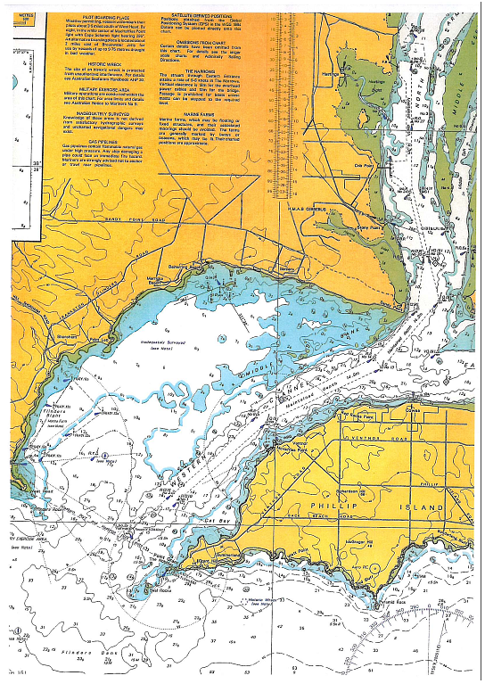

Appendix B The North Arm
(extract from navigational chart AUS 151)

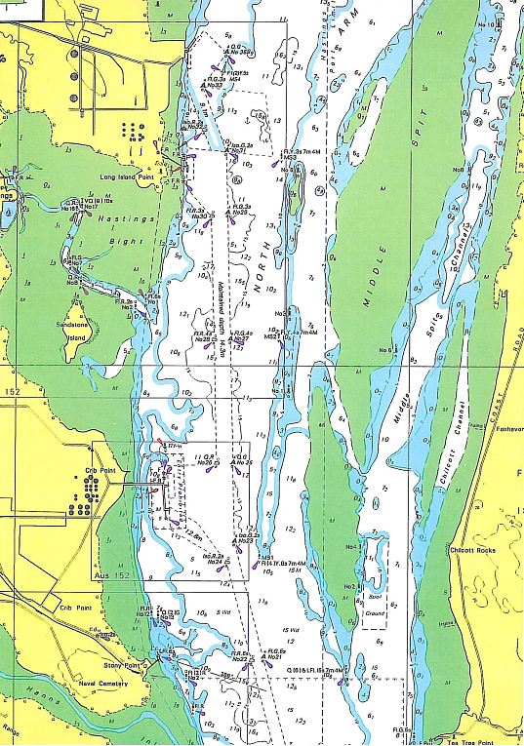

Appendix C Overview of charted position of Kinna and Challenger
(superimposed on navigational chart AUS 152)

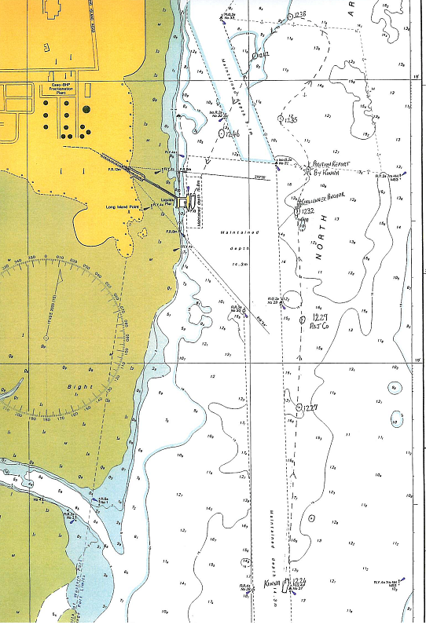

See Appendix B for an overview of the North Arm.
All times are denoted in Australian Eastern Standard Time adjusted for Daylight Saving (UTC + 11 hours).
One nautical mile is 1,852 metres.
There is a discrepancy in the evidence of the master and pilot of Kinna and the master of Challenger with regard to Challenger’s distance off channel marker 31 and the clearing distance between Kinna and Challenger, which is discussed in later sections of this report.
This is the position Challenger reported to the police immediately after the incident. The master states that this position was verified by another vessel in the vicinity, when requested by Challenger to come alongside it and read out the GPS position.
The effect of using helm to starboard causes the stern to swing to port, thereby achieving the intention of swinging the bow to starboard.
1 knot is one nautical mile per hour which is 1.852km per hour.
The master of Challenger would not make the information available. MSV advised the Chief Investigator that this was considered to be personal information and that the provisions of the Marine Act 1988 prevented the Director from making personal information available to the investigation. The investigation has not pursued this matter as this issue will not affect the outcome of the investigation.
Only Victoria Water Police has the authority to ‘order’ vessels to clear the channel.
The plotted positions of Kinna were by distance and true bearing off fixed objects whilst the reported positions of Challenger’s anchor position and Kinna’s record of the incident position were by GPS. The datum of the GPS and of the navigational chart is WGS 84, therefore no correction needs to be applied when plotting. See Appendix B.

