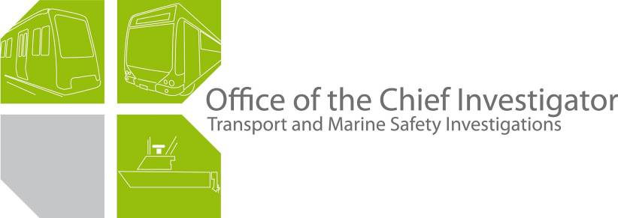

Bus Safety Investigation
Report No 2009/10

Dyson Group School Bus
Collision with Tree
Doreen
2 September 2009

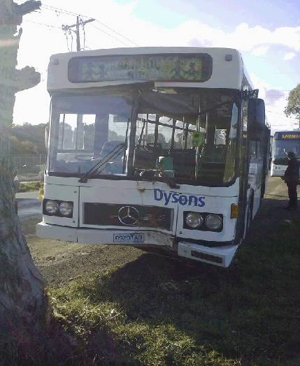

TABLE OF CONTENTS
The Chief Investigator 5
Executive Summary 7
1. Circumstances 9
2. Factual Information 11
2.1 The bus 11
2.2 The driver 13
2.3 Interview information 13
2.4 Infrastructure 14
2.5 Environment 16
2.6 Bus and driver licensing and accreditation 16
2.7 Dyson Group 16
3. Analysis 19
3.1 The incident 19
3.2 Park brake solenoid valve 19
3.3 Defect reporting 20
3.4 Maintenance management 20
4. Conclusions 21
4.1 Findings 21
4.2 Contributing factors 21
5. Safety Actions 23
5.1 Safety Actions taken since the incident 23
5.2 Recommended Safety Actions 23
6. Appendix 25
Appendix A School bus route 25

The Chief Investigator
The Chief Investigator, Transport and Marine Safety Investigations is a statutory position established on 1 August 2006 under Part V of the Transport Act 1983.

The objective of the position is to improve public transport and marine safety by independently investigating public transport and marine safety matters.

The primary focus of an investigation is to determine what factors caused the incident, rather than apportion blame for the incident, and to identify issues that may require review, monitoring or further consideration. In conducting investigations, the Chief Investigator will apply the principles of ‘just culture’ and use a methodology based on systemic investigation models.

The Chief Investigator is required to report the results of investigations to the Minister for Public Transport and/or the Minister for Roads and Ports. However, before submitting the results of an investigation to the Minister, the Chief Investigator must consult in accordance with section 85A of the Transport Act 1983.

The Chief Investigator is not subject to the direction or control of the Minister(s) in performing or exercising his or her functions or powers, but the Minister may direct the Chief Investigator to investigate a public transport safety matter or a marine safety matter.

Executive Summary
On the afternoon of 2 September 2009, Dyson Group bus 273 was on a school bus run from Whittlesea Secondary College, Whittlesea. During the trip the driver noticed the Common Fault Light illuminate and at the same time the bus movement became sluggish, as if the brakes had been partially applied. The student passengers alerted the driver that they could see smoke emanating from the rear wheels. The driver reported the defect to his company and requested a replacement bus meet him at the stop immediately after Bridge Inn Road.
As the bus approached the stop just before the Yan Yean and Bridge Inn Roads intersection, the driver applied the brake and moved the bus off the sealed road surface. The front wheels of the bus skidded on the gravel and it collided with a tree. The driver was not injured, but five of 16 student passengers reported suffering bruising. The bus received damage to its bumper bar, front panels and windscreen.
The investigation found that the bus had an electrical defect that caused the park brake, which acted on the rear wheels, to be partially applied while running which reduced the effectiveness of the rear wheel brakes.
Since the incident, Dyson Group has made an alteration to the electrical system of the bus which has had the effect of eliminating the problem. They have also taken action to improve defect reporting by bus drivers and update some park brake system components on this and similar buses in their fleet.
The investigation makes recommendations for Dyson Group to review its maintenance management system with regard to vehicle maintenance procedures.

Circumstances
On 2 September 2009, the Dyson Group school bus 273 was operating a scheduled school bus run from Whittlesea Secondary College, Whittlesea. The bus departed its depot at Bundoora at about 1500 and arrived at the school without incident. At the school 25 students boarded the bus and at about 1525 the bus commenced its service along the scheduled route (see Appendix A).
The bus entered the Laurimar Housing Estate via Flaxen Hills Road at about 1540. The students claimed that smoke came from the rear wheel area of the bus on two occasions while the bus was in the Laurimar Estate and on each occasion they advised the driver. During the trip through the Laurimar Estate, the driver noted that on three occasions the Common Fault, Park Brake and Rear Door Open warning lights on the dashboard would illuminate and at the same time the bus movement became sluggish, as if the brakes had been partially applied.
The driver reported the matter to the depot supervisor and they agreed that the driver would drive the bus to the south side of the intersection of Yan Yean and Bridge Inn Roads where a replacement bus would meet it (bus stop № 7, see Appendix A).
After driving through the Laurimar Estate, the bus rejoined Yan Yean Road via Timbertop Drive and travelled south on Yan Yean Road for about 500 metres when the students again alerted the driver that they could see smoke emanating from the rear wheels.
The driver decided to take the bus to the next designated stop (bus stop № 6), which was just prior to the intersection of Bridge Inn and Yan Yean Roads to inspect it. As the bus approached the stop, the driver applied the brake but found the bus did not respond as he expected. He stated that the front wheels ‘locked’ when the bus was on the gravel verge. The bus then skidded into a tree at the side of the road.
The collision distorted the front bumper bar and the left-hand windscreen frame which resulted in the left windscreen pane breaking. The driver was not injured. At the time of collision there were 16 students on the bus. Five of them reported suffering bruising.

Factual Information

The bus

Features
Bus 273 was built in January 1993 and delivered to Bell Street Transport which was subsequently purchased by Dyson Group in August 2003. The bus was used as a school bus and for regular route bus services. At the time of the incident, it complied with the VicRoads Licensed Passenger Vehicle Standards.
Bus 273 is a Mercedes Benz OH0405 chassis. The body was built by Volgren Australia Pty Ltd, to carry 42 seated passengers and 40 standing passengers.
The bus was not fitted with seat belts and was not required to be.

The braking system
The bus is equipped with an air-operated braking system. The system operates on the rear (drive) wheels and the front wheels of the bus. In addition, a mechanically applied air release park brake system is fitted. The park brake acts only on the rear wheels.
The park brake is controlled by the driver by means of a manual lever located under the dashboard. The park brake is released and held off by air pressure acting on a spring in a cylinder. When the driver applies the park brake, air is exhausted to atmosphere from the cylinder and the spring mechanically applies the brake.
The park brake is also activated when the rear doors open. In this case, magnetic proximity switches fitted on each door actuating cylinder energises the park brake control solenoid valve. When energised, the solenoid valve exhausts air from the park brake system to atmosphere and the brake is applied. When the doors are closed the proximity switch de-energises the solenoid valve which now supplies air to the brake cylinder to release the park brake.
The rear doors are also fitted with a door interlock switch which is connected to the speedometer and to the park brake solenoid valve. If a speed of five km/h or more is detected, the interlock prevents the rear doors from being opened and also sends a signal to the solenoid valve to prevent the park brake being applied.
The air compressor providing air to both brake systems is engine-driven. It starts operating immediately the engine is switched on and its operating speed is directly proportional to the engine speed. Therefore, an increase in engine speed increases the charging rate.
The investigation noted that neither the park brake solenoid valve nor the air line from the brake cylinder to the valve had a filter fitted.

Dashboard alarms
The warning devices provided to the driver on the instrument panel consist of the following:
- A Common Fault warning light which illuminates when there is a general fault detected within any of the bus systems.
- A Service Brake Low Pressure warning light illuminates at approximately 6.5 bar (650 kilopascals) indicating an impending loss of braking efficiency.
- A Park Brake ON light illuminates when the park brake is fully engaged.
- Two pressure gauges, one for each circuit, indicating the pressure in each brake reservoir.
- A warning light indicating that the rear door (which carries the park brake actuating sensors) is open.

Prior history
In accordance with the bus periodic inspection regime, the condition of the vehicle’s brake drums and linings and the operation of the braking system were inspected on 21 January 2009 (3-monthly inspection), 29 April 2009 (10,000 kilometre servicing) and again on 19 June 2009 (annual inspection) and were found to be satisfactory. In accordance with the schedule, the next 3-monthly inspection was due on 19 September 2009.
Dyson maintenance records indicate that since January 2009, the bus was reported on three occasions to have a rear brake malfunction due to low air pressure in the braking system, on 27 January 2009, 17 July 2009 and 24 August 2009; the latter about one week prior to the incident. On each occasion it was found that the park brake solenoid valve that regulated the air supply to the system was leaking, causing the park brake to partially apply.
Depot records indicate that on each occasion the bus was attended by a different mechanic. On each occasion the leaking solenoid valve was replaced and the bus was tested and returned to service.

Post incident testing
The vehicle’s brakes were inspected post-incident and both front wheel brake assemblies were found to be operating correctly and the brake adjustment was satisfactory. However, it was found that the rear wheel brake drums were heat-affected with the linings severely heat-affected.
A test was carried out with the engine operating and it was found that the park brake solenoid valve had an air leak when it was de-energised (park brake released). This would cause the park brake to be partially applied. The park brake circuit was tested and inspected and no other leaks were detected.
The solenoid valve was removed and tested in a laboratory. An internal inspection of the valve showed some signs of contamination and minor surface irregularities. When the system was pressurised to a pressure equivalent to that of the nominal operating pressure of the bus brake system, no leak was detected.
The solenoid was then tested to determine at what voltage it would open and allow application of the park brake. This was found to be 9 to 10 volts. Further testing found that the valve would not close until the voltage had reduced to 2.5 volts.
Subsequently, an auto electrician conducted tests on the bus and found that six volts was being applied to the park brake solenoid valve from the rear door interlock switch, which caused the valve to remain partly open. When a diode was fitted to the system, the problem was eliminated.

Feedback from solenoid valve manufacturer
The valve manufacturer informed Dyson that the type of solenoid valve fitted on bus 273 had previously failed in another operator’s vehicles resulting in air leaks, dashboard warnings, damage to O-rings and under performance of the compressor. It was the opinion of the manufacturer that substituting valve VT-317 (which incorporated an air filter in the valve) for VT-307 would remove the problem.

2.2 The driver
The bus driver has about 44 years experience driving buses and has been a driver of this particular vehicle from the time that it was delivered to Bell Street Transport in 1993. At the time of the incident the driver was appropriately licensed and accredited to drive a school bus. He had been in continuous employment with Dyson Group since August 2003.
The driver completed his annual driver assessment and evaluation in November 2008 and received a satisfactory rating. He completed the company fatigue management training in August 2008 and is currently enrolled to undertake a Certificate III course in Transport & Distribution Training (Road Transport).
Wednesday 2 September was the driver’s first day at work after three days of rostered off-duty. He commenced driving at 0712 and had three breaks during the day, 0911 to 0931, 1040 to 1216 and 1355 to 1500.

2.3 Interview information

2.3.1 The driver
The driver stated that he had driven this bus on Friday 28 August 2009 and during that trip he noticed that the Common Fault light, on a few occasions, illuminated for a few seconds, accompanied by sluggishness when driving as if the brakes had been applied. He did not report the matter at the end of his shift as he was unsure whether there was a genuine fault with the bus. (Note: the bus had been driven on a couple of other occasions by other drivers between Friday and the incident day but there were no reports of any problems with its operation.)
He stated that this was the first time that he experienced these symptoms in all the years that he drove this bus and that he was unaware of any brake malfunction history with it.
The driver next drove the bus on the day of the incident. He stated that he made the customary safety inspection, found no faults and then drove it to Whittlesea Secondary College to pick up the students. He reported that the bus drove normally on the trip to the school.
At 1525 the bus departed the school with about 25 students aboard, dropping them off along the way. The driver stated that at each stop the doors and the brakes operated normally.
While driving through the Laurimar Estate the driver noticed that the Park Brake and the Rear Door Open warning lights illuminated on his dashboard and at the same time he could feel that the brakes were partially applied. He stated that the first time this happened he got out of the bus and checked the rear wheels but could not find any problem. This occurred on three occasions but the warning lights would extinguish and the brakes became free when he pressed the accelerator.
The driver reported this malfunction to the depot supervisor and they agreed that a replacement bus would meet bus 273 just south of the roundabout at the intersection of Yan Yean and Bridge Inn Roads. The driver stated that he continued en-route, re-entering Yan Yean Road and proceeded south.
He stated that soon thereafter, he saw the Common Fault warning light illuminate and he could feel the bus ‘dragging’. At about the same time, the students told him that there was smoke emanating from the rear wheels. He said that from the driver’s seat he could not see the smoke nor could he smell anything burning so he decided to drive the bus up to the stop just prior to the roundabout and inspect it there.
The driver stated that as he steered the bus on to the gravel verge, he applied the brakes. At that instant he stated that he felt the front wheels lock and the bus then skidded into the tree.
When asked about his general duties and obligations, the driver reported that he felt there was insufficient time at the end of his shift to log a defect notice. He stated that after a long shift of concentrated driving, he had to refuel the bus and clean it, then park it and tally and deposit the cash.

2.3.2 The students
The students on the bus were interviewed by the assistant principal of the school who then provided the following information to the investigation.
The students advised that they had informed the driver about the smoke coming from the rear wheels when the bus was travelling on Flaxen Hills Road (just prior to Safeway) in the Laurimar Estate. They said that the driver looked out of the doorway but did not exit the bus and continued on the route. They again told the driver about more smoke when the bus was at the corner of Flaxen Hills Road and Hazel Glen Drive but the driver continued with the service.
The route has a normal stop on Yan Yean Road prior to Bridge Inn Road and the students advised “the bus did not stop; it just kept going and hit the tree head-on”.
The students reported that the driver then reversed the bus away from the tree and they commented that there was a lot of smoke entering the cabin. They recalled that the driver then opened the rear door for them to alight, advised them to stay off the road and then used his mobile phone. The students said that they were informed that another bus would collect them. While some waited for the replacement bus others were picked up by their relatives.

2.3.3 Depot supervisor
The depot supervisor confirmed that he received a phone call from the driver about the brakes and that they agreed to swap buses just south of the Yan Yean/Bridge Inn Road roundabout as that was the most convenient spot, but provided that the driver felt it was safe to continue to that point. He said that he organised a spare bus to proceed to the meeting point.
Soon after, the supervisor received another call from the driver informing him that the bus had collided with a tree. He asked the driver if he and the children were okay to which the driver replied that everyone was okay and that the children had left the bus and were taking photographs with their mobile phones.
The supervisor then sent the break-down crew to attend the site and a relief car to bring the driver back to the depot.

2.4 Infrastructure
Yan Yean Road is a single-carriageway, two-lane, arterial road which runs in a general north-south direction. Between Timbertop Drive and Bridge Inn Road the road is mainly flat but with a small rise about 500 metres from the roundabout (see Figure 2).
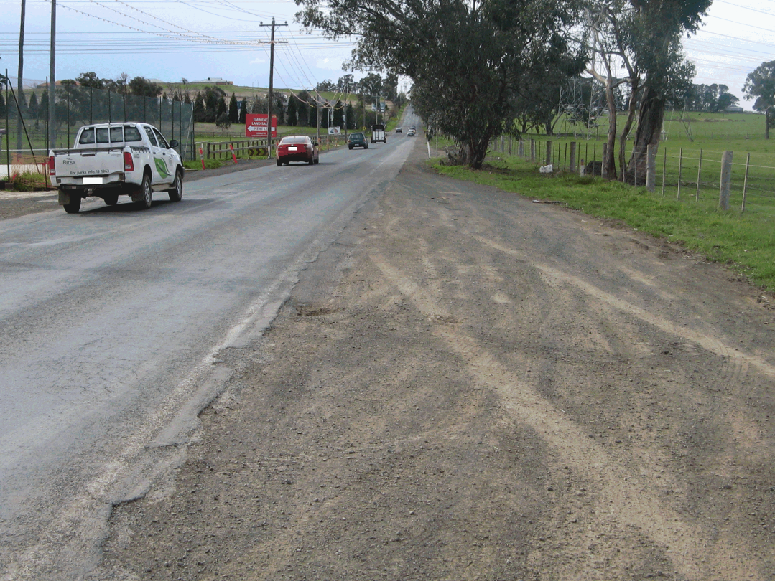
Figure 2 – YanYean Road looking north from the bus stop. Note the slight rise in the distance and the skid marks on the verge (bottom right).
On either side of the road there is a verge about five metres wide. The east side of the road is tree-lined except for the clearing where the bus stops just prior to the roundabout intersection with Bridge Inn Road (see Figure 3).
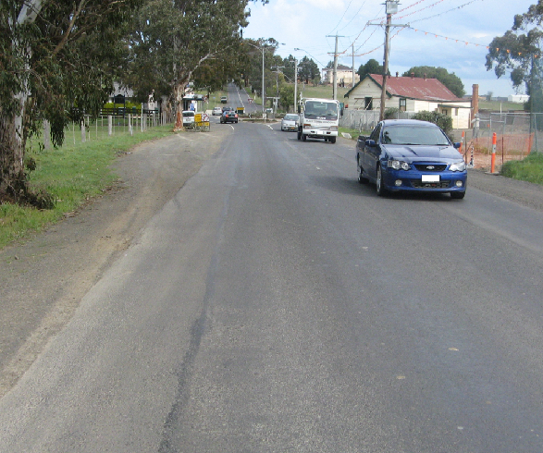
Figure 3 – Yan Yean Road looking south. The skid marks leading to the tree against which the bus collided can be seen on the left hand side.

2.5 Environment
At the time of the incident the sky was partly cloudy with a northerly wind at about 35 km/h. The sun was at about 23 degrees above the horizon and about 120 degrees to the right of the driver when he was driving down Yan Yean Road. The visibility was clear and there was no precipitation recorded for that day.

2.6 Bus and driver licensing and accreditation
In order to operate an approved route bus service, the operator enters into a contractual arrangement with the Public Transport Division of the Department of Transport. To obtain and then retain accreditation to operate services, the company’s operating systems (maintenance and information management) are subject to a system of audit by the bus industry regulator, Public Transport Safety Victoria.
The drivers must be accredited by the Victorian Taxi Directorate after obtaining a bus driver licence through VicRoads. A condition of accreditation is that drivers must be medically “fit for duty”. The driver accreditation must be renewed every three years.
Buses are required to undergo annual roadworthiness inspection by a VicRoads-accredited independent inspector and a three-monthly or 10,000 kilometre inspection as part of the regulator’s accreditation requirements. The Dyson Group has a maintenance management system that sets out the practices and procedures to maintain its buses to both these and additional company requirements.
At the time of the incident Dyson Group was approved to operate a number of school bus and route bus services.

2.7 Dyson Group

2.7.1 Driver recruitment and training
Drivers are employed by Dyson Group after obtaining their bus driver licence and accreditation. The company management system requires drivers to be audited once a year by a VicRoads-accredited assessor on their general competency while driving a route bus service.
Dyson Group arranges individual driver training if it identifies that a driver needs to upgrade his or her driving skills. Also, each driver is required to complete a 4-hour fatigue management course aimed at making drivers aware of the causes and signs of fatigue and the steps to take should they recognise such signs.

2.7.2 Rosters
Dyson has a 4-day and a 5-day weekly roster with drivers able to elect the roster of their preference on a monthly basis. Shifts vary in duration with breaks interspersed during the shift to give a worked time for each shift of about 10 to 12 hours.
The driver of bus 273 had elected to operate the 4-day weekly roster. On the day of the incident his sign-on time was 0712 and his rostered sign-off time was 2021, with rostered breaks of 1053 to 1203 and 1410 to 1455. The total hours worked for the shift were scheduled to be 11 hours and 59 minutes.
In their submission regarding driver rostering and end of shift duties, Dyson stated that as a part of the rostering system, a time of 13 minutes is factored in to ensure that all post driving activities are completed. Dyson has highlighted to drivers that Dyson take safety very seriously and that the company does, and is willing to, pay overtime to ensure those tasks are completed.

2.7.3 Defect reporting
The Dyson Group maintenance management system sets out the procedures for bus daily inspections and defect reporting and handling. A Daily Inspection and Defect Report logbook is to be available at the depot or in the vehicles. The logbook contains the safety inspection sheet. The daily safety inspection must be carried out on each vehicle at the depot prior to it being driven. The investigation noted that Dyson Group Bundoora preferred to retain the logbook at the depot and not on each bus.
Should a defect be discovered during this check, the driver or person carrying out the safety inspection is required to document it in the daily safety inspection sheet and follow it up by raising a defect notice on the prescribed form and submitting it to the depot supervisor.
When a defect notice is lodged, the depot supervisor in consultation with the depot mechanic will determine whether the defect needs to be rectified immediately, in which case the bus will be removed from service, or whether it can be deferred until a later date.
When a defect is discovered on the road, the driver is required to report it to the depot supervisor, normally by means of a two-way radio or mobile phone. The supervisor will then contact workshop staff who will consult with the driver before an assessment is made as to what action is to be taken. The investigation found that the instructions did not specify who has responsibility for completing and lodging a defect notice when a defect is discovered ‘on the road’ but was informed by depot management that the driver is expected to complete and lodge the defect notice.

2.7.4 Servicing and maintenance
To maintain records and documentation for each bus, Dyson Group has installed TIMS (Transport Integrated Management System), an IT based product. TIMS records all services, inspections, repairs, replacements and modifications carried out to each vehicle with the date and the person or organisation undertaking the work.
The Dyson Group bus depot at Bundoora has about 240 buses of which 14 are similar to bus 273. Their workshop has three supervisors and 23 mechanics and at any time there are between seven and ten buses undergoing servicing or maintenance. Mechanics are not assigned to a particular bus or fleet of buses, therefore a bus coming in for service or maintenance may not necessarily be checked by the same supervisor or mechanic who conducted the previous work on the vehicle.
Under the current maintenance management system, unless there is a major defect with the bus (for example a braking or steering failure), the assigned mechanic does not consult with the TIMS database to access the bus service history. Where the repair is assumed to be minor, the faulty part is repaired or replaced and the bus is sent for testing. The investigation did not find evidence of any written guidance to mechanics as to when and under what circumstances TIMS should be consulted prior to effecting repair.
Once the repair has been completed, Dyson procedures require the mechanic to check all vehicle systems before the vehicle is test driven and all systems checked under ‘on-road’ conditions. If the bus is found satisfactory it is signed off by the Fleet Services Manager to re-enter passenger service.

Analysis

The incident
The first indication of a problem with the bus brakes on this service was as it transited the Laurimar Estate. The student passengers advised that they twice told the driver about smoke from the bus’ rear wheels while the bus was in the Estate. However, the driver reports that the advice from the students did not come until the bus had exited the Estate. Regardless of which version is correct, the driver advised that he had an issue with the operation of the bus on three occasions in the Estate and was concerned enough to contact the bus operator and organise a replacement to complete the service. The driver’s decision to continue the service beyond the Estate proved to be flawed.

Ultimately, the driver attempted to stop the bus on the verge of Yan Yean Road to set down a passenger. At this stage the performance of the rear brakes was diminished due to overheating and they probably provided little assistance in braking the vehicle. It was thus necessary for the driver to apply more braking effort to slow the bus and when it was steered onto the gravel verge the front wheels locked and the bus skidded, at a relatively low speed, into the tree.

The reduction in the effectiveness of the rear brakes was due to their having been affected by heat because of the cumulative effect of the park brake being partially applied over a period of time.

On the day of the incident it is probable the problem did not fully manifest itself until the bus was in the Laurimar Estate. It was not until this stage of the service that the rear door was opened a sufficient number of times (to allow students to alight) to cause the air reservoir to be depleted. The reservoir remained depleted in the Estate because of the short intervals between rear door openings which did not allow sufficient time for the engine-driven air compressor to fully recharge the air reservoir and be able to provide sufficient pressure to the control valve springs for the park brake to be fully off.

Park brake solenoid valve

Maintenance
The solenoid valve was replaced three times in 2009 because it was leaking air. The time gap between the first and second replacements was about six months. It is reasonable to expect that the mechanics working on the bus would not have associated the two replacements even if had they been aware of them. However, the time between the second and third valve replacements was about four weeks and it is likely that had the same mechanic worked on the vehicle they may have suspected a more systemic issue with the bus than just a faulty solenoid valve.

Reason for malfunction
The partial park brake application was the result of a voltage being applied to the park brake solenoid from the rear door operating system; the exact cause of this fault was not determined. This prevented the park brake control valve from closing and in turn caused an air leak in the park brake circuit thus applying the park brake to varying degrees.
It is not uncommon for dust, filings or flakes to be found in an air system. Some minor contamination was noticed in the solenoid valve seat when it was first dismantled, which dislodged when the valve parts were closely inspected prior to testing in the laboratory. The tester believed this contamination should not have contributed to the leak due to the flexible nature of the rubber seal maintaining the system sealing. However, it is possible that this minor contamination may have accentuated the air leak caused by the stray voltage.

Defect reporting
The driver said that when he last drove the bus on the Friday prior to the incident he observed that on a few occasions the Common Fault light illuminated and the bus performed sluggishly. However, he did not lodge a defect notice during or at the end of his shift.

Other drivers drove the bus between Friday and the incident day and did not report problems. However, had the incident driver reported the problems on the Friday it is possible that mechanics may have identified the underlying fault and potentially avoided the incident on 2 September.

Maintenance management
The maintenance system recorded all work done on each bus, who did the work and when, what modifications were done and what parts were replaced. The system appears to be flexible and a good tool to manage the maintenance of the bus fleet. However, it was not the practice for mechanics to review the service history of a bus prior to conducting maintenance. Had this been company policy and practice it is possible that the mechanic who changed the solenoid valve eight days before the incident would have recognised that the defect had a wider cause than the valve itself.

Conclusions

Findings
- The bus was correctly accredited to operate a school bus service.
- The driver was correctly accredited to drive a school bus.
- Dyson Group had a maintenance management system that recorded all servicing and maintenance done on the bus fleet.
- The maintenance management system does not provide guidelines to mechanics for consulting a vehicle’s service history.
- The Maintenance Management System manual does not specify the person responsible for completing a defect notice when the defect is detected ‘on the road’.
- An electrical fault in the rear door operating system caused the park brake solenoid valve to remain partially open.

Contributing factors
- The bus electrical system had an underlying electrical fault which went undetected during maintenance.
- The electrical fault caused the park brake solenoid valve to partially open resulting in the park brake being applied during operation of the bus.
- The effectiveness of the rear wheel brakes was reduced by being overheated.
- The driver did not report and lodge a defect notice on the Friday preceding the incident.
- The driver did not stop the bus when he first became aware of the problem with the bus.
- The company maintenance system did not require mechanics to refer to the service history of the vehicle prior to conducting maintenance.

Safety Actions

Safety Actions taken since the incident
1. Since the incident Dyson Group has instructed all drivers of their requirement to report, record and lodge defect notices for every malfunction noted, without exception.
2. The depot inspected the other 14 similar buses and confirmed that only bus 273 experienced the electrical defect associated with the rear door interlock switch. A diode was connected in the circuit to the rear door inter-lock switch and the problem was eliminated.
3. Dyson Group will replace the park brake solenoid valve (VT-307) currently fitted on 15 buses with a larger and upgraded valve (VT-317) and place an air filter into the air system.

Recommended Safety Actions
Issue 1
Dyson Group Bundoora Depot does not have a documented process or systems to access bus service history each time a vehicle is entered for repairs, despite the bus records being readily available in the IT-based Transport Integrated Management System. This incident has shown that failure to consult the bus service history may lead to an underlying systemic malfunction on a bus not being detected.
RSA 2009012
That Dyson Group review its maintenance management system and operating procedures with a view to providing guidance to mechanics on when to consult the service history of the bus.

Appendix
Appendix A School bus route
Page 1 of the route map depicting stops 1 to 10. The incident occurred near stop 6.

Public passenger commuter service.

