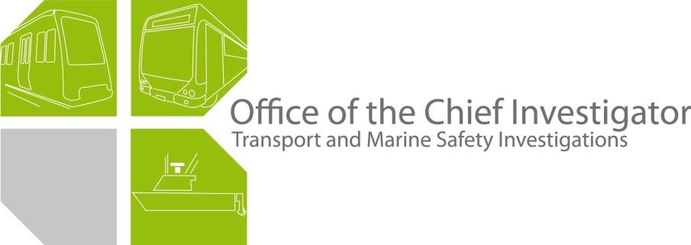

Rail Safety Investigation
No 2008/08

Brief Report

Tram to tram collision
Arts Centre platform tram stop
St Kilda Road
Melbourne
10 September 2008
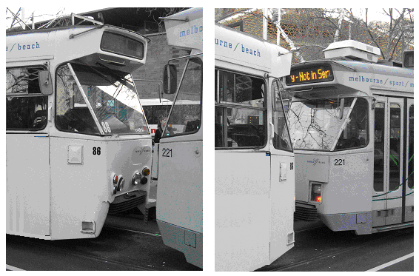

Scope and reporting

The Chief Investigator
The Chief Investigator, Transport and Marine Safety Investigations is a statutory position established on 1 August 2006 under Part V of the Transport Act 1983.
The objective of the position is to improve public transport and marine safety by independently investigating public transport and marine safety matters.
The primary focus of an investigation is to determine what factors caused the incident, rather than apportion blame for the incident, and to identify issues that may require review, monitoring or further consideration. In conducting investigations, the Chief Investigator will apply the principles of ‘just culture’ and use a methodology based on systemic investigation models.
The Chief Investigator is required to report the results of investigations to the Minister for Public Transport and/or the Minister for Roads and Ports. However, before submitting the results of an investigation to the Minister, the Chief Investigator must consult in accordance with section 85A of the Transport Act 1983.
The Chief Investigator is not subject to the direction or control of the Minister(s) in performing or exercising his or her functions or powers, but the Minister may direct the Chief Investigator to investigate a public transport safety matter or a marine safety matter.

Issuing of a Brief Report
In those cases where an investigation is curtailed or a full investigation report is not considered warranted, the Chief Investigator may issue a Brief Report.
A Brief Report will typically include the particulars of the event, a description of the incident, a summary of pertinent investigation information and key findings and, as applicable, a description of identified safety issues and recommended safety actions.

Occurrence details
Date: 10 September 2008
Time: 1700

Location: At the Arts Centre tram platform stop on St Kilda Road.

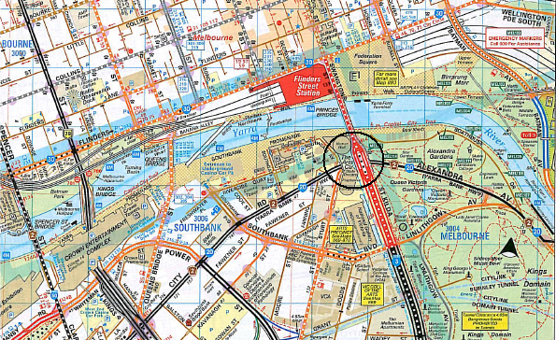
Figure 1. General location of Platform Tram Stop (Copyright Melway Publishing 2007. Reproduced from Melway Edition 35 with permission).

Tram Stop No 14 on St Kilda Road is opposite the Melbourne Arts Centre, about 156 metres north of Southbank Boulevard intersection. The inbound tram track is on a bearing of approximately 340 degrees. The approach to Stop No 14 from Alexandra Avenue is in a straight line for about 1.5 kilometres. The track goes across the Southbank Boulevard and approximately 65 metres after the intersection, deviates right to align with the tram platform stop. (Figure 2)

The length of the ‘safety zone’ on the inbound track is about 83 metres. The safety zone is separated from the road by a protective metal fence on a concrete barrier. The length of the platform on this track is about 63 metres.
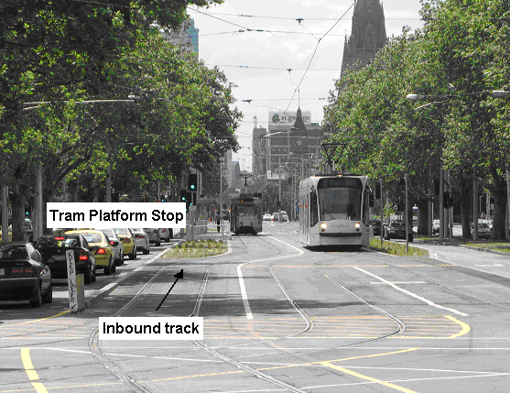
Figure 2. Approach to Arts Centre tram platform stop.

At the time of the incident there was heavy road traffic along St Kilda Road near the Arts centre. The track in this section slopes upwards by about 150 mm from the Southbank Boulevard intersection and is level across the ‘safety zone’ and tram platform stop.

Trip/route details
Tram 86 was operating Route 6 service from Glen Iris to Melbourne University.

Tram 221 was operating Route 67 service from Carnegie to Melbourne University.

Both trams were travelling inbound, heading north on St Kilda Rd.

Incident outcomes
Of the 20 passengers in Tram 86, six passengers sustained minor injuries and were treated at the site. Two passengers were transported by ambulance to Royal Melbourne Hospital, where they were discharged after medical attention.

Tram 86 sustained extensive damage to its bumper bar and the underslung metal support structure and body. Tram 221 sustained damage to the bumper bar deformation struts.

Vehicle details

Tram 86
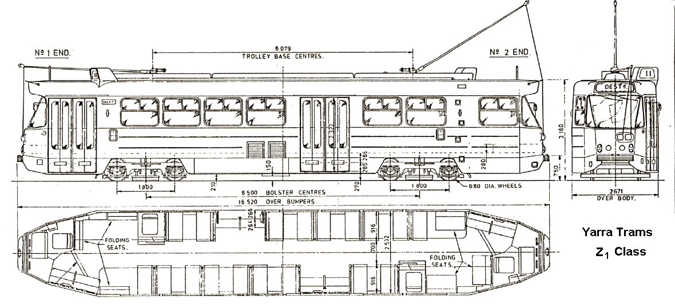
Figure 3. – ‘Z1’ Class Tram.

Tram 86 is a pantograph equipped, double bogie tram of the ‘Z1’ class and is driven by four 57 kW ASEA motors. The vehicle has driver consoles at both ends and has a 48 passenger seating capacity and a 114 total passenger capacity.

The tram is 16.52 metres in length and has a tare weight of 19.23 tonnes and a maximum service speed of 60 km/h.

Tram 221

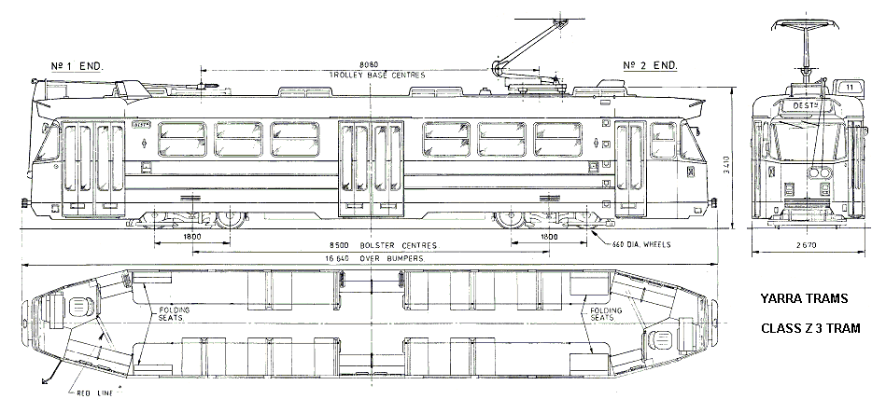
Figure 4. ‘Z3’ Class Tram.

Tram 221 is a pantograph equipped, double bogie tram of the ‘Z3’ class and is driven by two 195 kW AEG Siemens motors. The vehicle has driver consoles at both ends and has a 42 passenger seating capacity and a 125 total passenger capacity. The vehicle has three doors on either side.

The tram is 16.64 metres in length and has a tare weight of 21.8 tonnes and a maximum service speed of 60 km/h.

Vehicle operator
Metrolink Victoria Pty Limited trading as Yarra Trams.

Infrastructure manager
Metrolink Victoria Pty Limited trading as Yarra Trams.

Environmental details
There were no weather induced impediments affecting the driver’s visibility or adverse track conditions that would have affected vehicle traction or braking. The track was dry and clear of debris.

Circumstances

Sequence of events
On Wednesday 10 September 2008, Tram 221 was operating Route 67 service from Carnegie to Melbourne University and travelling inbound, heading north on St Kilda Rd. At about 1655, Tram 221 arrived at the Arts Centre tram stop and stopped at the centre of the three stopping positions.

Tram 86 was operating Route 6 service from Glen Iris to Melbourne University and travelling inbound, heading north on St Kilda Rd.

At around 1700 Tram 86 collided with the stationary Tram 221 at the Arts Centre tram platform stop.

Each tram was carrying approximately 20 passengers.

The driver of Tram 86 reported that the brakes had not operated correctly when he attempted to stop the tram.

Both tram drivers were breath tested and returned zero readings.

Following the incident Tram 221 was driven under its own power to the Preston depot and Tram 86 was driven under its own power to the Malvern depot.

Summary investigation information and findings

Personnel
Driver – Tram 86

The driver of Tram 86 has approximately 16 years experience driving trams. He joined the PTC (Public Transport Corporation) in February 1992 and has been in continuous employment with M>Tram and Yarra Trams. He has been trained to drive ‘Z’ and ‘Combino’ class trams and has undergone regular Yarra Trams mandated refresher courses and driver assessments.

The driver of Tram 86 advised the investigation that he finished work on the day prior to the incident at about 2200 and arrived home at about 2230. On the day of the incident he woke up at about 0800 and arrived at work at about 0900. His first shift, Route 16 commenced at 0934 from the Malvern depot and he returned to the depot for his lunch break at 1300. His next run commenced at 1424 on Tram 86 operating Route 72 from Glenferrie Road to Melbourne University and then operating Route 6 from the University to Glen Iris.

At about 1623 he departed Glen Iris to head back to Melbourne University. After crossing the Southbank Boulevard – St Kilda Road intersection, he headed into the Arts Centre Tram Platform Stop. The driver advised that at this point of the journey the tram was about a minute behind the scheduled arrival time. On approaching the Arts Centre tram stop he observed that Tram 221 was stopped approximately half way along the platform.

The driver of Tram 86 stated that he was about a tram-length from the stationary Tram when he started braking. At that time he estimated that he was travelling at approximately 20 km/h. He stated that the brakes responded at the beginning and the tram appeared to be slowing down. When the tram entered the platform area he felt the tram gain speed and he immediately ‘gonged’, ‘dropped sand’ and pressed hard on the brake pedal but the tram did not slow down and collided with the stationary tram.

After the collision, he stated that he checked with the passengers and the other driver for injuries. The driver was subjected to a preliminary breath test by Victoria Police and returned a zero reading.

Vehicle(s)
‘Z’ Class Trams are not fitted with data loggers. Due to the lack of this evidential data the investigation was unable to reconstruct the events including the driver’s actions leading the collision.

Z1 Class braking system
Application of the foot brake reduces the speed of the tram at a rate proportional to the pedal travel.

The vehicle has three independent braking systems:

- Dynamic braking
- Disc braking
- Track braking.

During the dynamic braking process the traction motor acts as a generator and is the main form of braking down to a service speed of seven km/h. The braking effect is proportional to the pressure applied by the driver on the brake pedal. Above approximately 80 per cent of brake pedal application the dynamic braking is assisted by the disc brakes.

Once the vehicle speed drops below seven km/h the dynamic braking cuts out and the disc brakes are applied automatically by the control system. The disc brakes act as the holding brake when the vehicle is stopped and is released when the accelerator is depressed or the brake release button is pushed.

Track brakes are suspended from each side of the bogie frames between the wheels just above the rails. When activated the track brake shoe is magnetically clamped to the rail retarding the vehicle.

When the brake pedal is fully depressed the emergency braking is applied.

During emergency braking, the dynamic brakes operate at maximum rate, disc brakes and track brakes are activated and sand is discharged onto the rails.

Operational tests
Post incident inspections found no condition with either vehicle that would have contributed to the incident.
Tram 86 was driven within the depot using a series of drive and brake commands to test the functionality of the braking system.

Analysis of data recordings taken during the testing indicate that the braking system functioned normally.

At this point in time repairs to Tram 86 have not been completed and the tram is not yet back in service.

Infrastructure
Post incident inspection of the track infrastructure, found no condition that would have contributed to the incident.

Operations
Yarra Trams has developed and implemented ‘General Operational Rules and Procedures’ for the operation of its trams. The manual provides guidelines on operational procedures, tram operations, safe interaction with traffic, interaction with the public and general road rules. Any new amendments to the rules are considered by the Yarra Trams Rules Committee in consultation with the Rail, Tram and Bus Union and other stakeholders. Once the rule change is approved by the committee, PTSV (Public Transport Safety Victoria) is notified of the amendment. New notices and information regarding the operating rules are disseminated to drivers through their depot mail boxes as a part of the driver update program.

Drivers are only assigned the types of trams that they have been trained to drive. The driver is also subject to six-monthly follow-up assessments, where his/her driving is assessed by the senior depot trainer. Drivers are required to undertake a refresher training course every 18 months on tram operations and procedures and general skills on interaction with other traffic and public behaviour. Since July 2007, Yarra Trams has included fatigue awareness and management as part of the refresher course. Yarra Trams advised the investigation that a new Operations Standards Manager was appointed in May 2008 to strengthen driver awareness training.

Yarra Trams conducts monthly senior managers’ meetings and fortnightly operations managers’ meetings. Safety is a mandated agenda item at these meetings.

Safety zones & speed limits
Up to 4 August 2008, Yarra Trams ‘General Operational Rules and Procedures’, Rule 78(g) mandated a maximum speed of 10 km/h through designated safety zones which includes tram terminals and stops.

Due to the change in nature of some tram stops, Rule 78(g) was amended by Yarra Trams on 4 August 2008. The amendment to Rule 78(g) requires ‘Trams entering or leaving a safety zone or platform stop must proceed with caution, consistent with the conditions at the time and maintaining appropriate control of the vehicle, unless otherwise specified’.

Tram 86 entered the Arts Centre Tram Terminal at a speed of approximately 20 km/hr. Trams have been observed approaching this Platform Stop at 30 – 35 km/h.

Yarra Trams advised this investigation that they have appointed an officer to monitor all incidents and complaints in order to ensure the Rule is effective.

Public Transport Safety Victoria
PTSV (Public Transport Safety Victoria) monitors Yarra Trams compliance with the Rail Safety Act 2006 and the Rail Safety Regulations 2006. Part 9 of Schedule 2 of the regulations requires rail safety operators to have in their Safety Management System ‘processes to ensure, so far as reasonably practicable, that corrective action is taken in response to any safety risks identified following inspections, testing, internal audits, investigations and reporting of hazards or incidents undertaken by the rail operator’. PTSV monitors Yarra Trams compliance with Part 9.

Tram to tram collisions
Figure 5. Tram to Tram Collision Data (Does not include mirror contacts and depot collisions).

Yarra Trams and Public Transport Safety Victoria (PTSV) provided the investigation with Tram incident data from 2004 to September 2008.

The numbers of collisions depicted in Figure 5, are only incidents of bodily collisions between trams in service and does not include mirror contacts or collisions in depots.

The average kilometres per financial year from 2004 to 2008 range from 22.4 million km to 23.1 million km, an approximate increase of three per cent over four years. No clear trend could be identified for bodily collisions of trams in service.

Maintenance

Maintenance history – Tram 86

Yarra Trams requires tram drivers to report any defects on the trams that they have been operating. Records for Tram 86 indicate that 93 defects have been reported from January 2008 to September 2008. Of the reported 93 defects, 19 of them relate to braking issues. Eleven reported braking incidents occurred in January 2008, two in February 2008 and two in March 2008.

On 12 March 2008, the braking system of Tram 86 was subjected to a major inspection and service and several components including a failed micro-switch actuated by the brake pedal were replaced. Since the service, one incident of ‘weak brakes’ was reported in May 2008 and two incidents of ‘rough brakes/soft brakes’ and ‘grabbing brakes’ were reported in August 2008. Adjustments were carried out to the braking system in all three instances and the tram was satisfactorily road tested.

Discussion
The proposed change to Rule 78, giving the tram driver the discretion to determine the safe speed, appears to be a practical and operationally feasible option. However, there is a higher risk of a collision in case of an error of judgement by a driver.

The driver of Tram 86 advised this investigation that the tram brakes had failed. However, Tram 86 was comprehensively tested by Yarra Trams after the incident and the tests indicated that the braking system functioned satisfactorily.

The application of the emergency brake releases sand onto the track. Mounds of released sand were found approximately 1.5 metres from the front of Tram 86. These mounds had not been traversed by the tram wheels, indicating that the release of the sand was at the point of impact or just after impact.

It is most probable that the driver of Tram 86 made an error of judgement that led to the collision between the two trams.

Recommended Safety Actions (RSA)

RSA 2008043

Yarra Trams carries out a comprehensive review and analysis of Tram to Tram collision data and adopts a strategy to isolate contributory factors in order to minimise the number of incidents.

RSA 2008044

Yarra Trams sets up a program to monitor tram speeds on approach to tram safety zones including all tram stops.

Decision to curtail investigation
Five previous incidents of Tram to Tram collisions have been investigated by the Chief Investigator and recommendations made to Yarra Trams. Further investigation into the St Kilda Road incident by the Chief Investigator is therefore not considered warranted.
The Chief Investigator recognises that ongoing monitoring of Yarra Trams’ management of the risks to safety of Tram to Tram collisions rests with Public Transport Safety Victoria.

