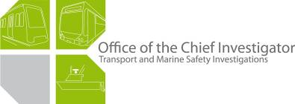

Rail Safety Investigation
No 2009/04

Brief Report

Tram to tram collision
St Kilda Road near Commercial Road
Melbourne
31 January 2009
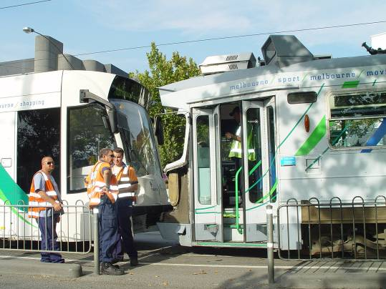

Scope and Reporting

The Chief Investigator
The Chief Investigator, Transport and Marine Safety Investigations is a statutory position established on 1 August 2006 under Part V of the Transport Act 1983.
The objective of the position is to improve public transport and marine safety by independently investigating public transport and marine safety matters.
The primary focus of an investigation is to determine what factors caused the incident, rather than apportion blame for the incident, and to identify issues that may require review, monitoring or further consideration. In conducting investigations, the Chief Investigator will apply the principles of ‘just culture’ and use a methodology based on systemic investigation models.
The Chief Investigator is required to report the results of investigations to the Minister for Public Transport and/or the Minister for Roads and Ports. However, before submitting the results of an investigation to the Minister, the Chief Investigator must consult in accordance with section 85A of the Transport Act 1983.
The Chief Investigator is not subject to the direction or control of the Minister(s) in performing or exercising his or her functions or powers, but the Minister may direct the Chief Investigator to investigate a public transport safety matter or a marine safety matter.

Issuing of a Brief Report
In those cases where an investigation is curtailed or a full investigation report is not considered warranted, the Chief Investigator may issue a Brief Report.
A Brief Report will typically include the particulars of the event, a description of the incident, a summary of pertinent investigation information and key findings and, as applicable, a description of identified safety issues and recommended safety actions.

Occurrence details
Date: 31 January 2009
Time: 1657

Location: St Kilda Road near Commercial Road.

Figure 1: General location of incident (Copyright Melway Publishing 2008)
Figure 2: Approach to tram stop (Source Google Maps).

Circumstances

Sequence of events
On Saturday 31 January 2009, Tram 3533 was operating Route 16 from St Kilda Beach to Melbourne University. Tram 3533 joined St Kilda Road from Fitzroy Street and stopped at the St Kilda Junction tram stop at about 1647. The tram departed the stop and arrived at the High Street tram stop at approximately 1649. Tram 3533 then arrived at the Commercial Road Stop at about 1652. Just prior to stopping at the Commercial Road tram stop the tram was travelling at approximately 48 km/h at 1651.

The tram had completed the boarding of passengers and the doors were closed when Tram 180 collided with it from behind. At the moment of impact Tram 3533 was stationary at the tram stop.

Tram 180 was operating Route 67 from Carnegie to Melbourne University. At about 1633 a new driver took over the driving of the tram, opposite the Glen Huntly depot and continued on Glen Huntly Road and Brighton Road heading towards Melbourne CBD. The tram stopped at the St Kilda Junction tram stop at about 1648. The tram departed the stop and arrived at the High Street tram stop at approximately 1650.

Tram 180 then headed towards the Commercial Road Stop and was travelling at about 40 km/h at about 1652. Tram 180 then collided with the stationary Tram 3533 at the Commercial Road tram stop, pushing tram 3533 about four metres forward into the pedestrian crossing.

Incident outcomes
Tram 180 was carrying approximately 45 passengers and Tram 3533 was carrying approximately 60 passengers at the time of the incident. Ten passengers were treated at the site for minor injuries and one passenger was transported by ambulance to hospital.

Both trams sustained extensive damage to end body panels, windscreen and the underslung metal support structure.

Vehicle details

Tram 3533

Tram 3533 is a pantograph equipped, double bogie tram of the ‘D1’ class (Combino) and is driven by four 100 kW AEG Siemens motors. The tram is a three-section, low floor, articulated power car for bi-directional operation. The vehicle has a 36 passenger seating capacity and a 63 total passenger capacity. The vehicle has three doors on either side.

Tram 180 – Z3 Class

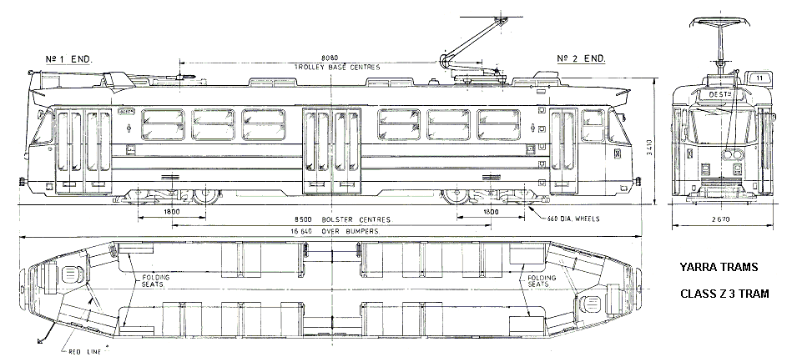

Tram 180 is a pantograph equipped, double bogie tram of the ‘Z3’ class and is driven by two 195 kW AEG Siemens motors. The vehicle has driver consoles at both ends and has a 42 passenger seating capacity and a 125 total passenger capacity. The vehicle has three doors on either side.

The tram is 16.64 metres in length and has a tare weight of 21.8 tonnes and a maximum service speed of 60 km/h.

Z3 Class braking system

Application of the foot brake reduces the speed of the tram at a rate proportional to the pedal travel.

The vehicle has three independent braking systems:

- dynamic braking
- disc braking
- track braking.

During the dynamic braking process the traction motor acts as a generator and is the main form of braking to reduce the tram speed to about seven km/h. The braking effect is proportional to the pressure applied by the driver on the brake pedal.

Once the vehicle speed drops below seven km/h the dynamic braking becomes less effective and the disc brakes are blended in automatically by the control system to provide a smooth and sustained braking effort. The disc brakes act as the holding brake when the vehicle is stopped and is released when the accelerator is depressed or the brake release button is pushed.

Track brakes are suspended from each side of the bogie frames between the wheels just above the rails. When activated the track brake shoe is magnetically clamped to the rail retarding the vehicle.

When the brake pedal is fully depressed the emergency braking is applied.

During emergency braking, the dynamic brakes operate at maximum rate, track brakes are activated and sand is discharged onto the rails. When the tram speed drops below seven km/h the disc brakes are applied by the control system.

Operational Tests
Tram 180 was not drivable from #1 end due to damage sustained in the incident. Brake function testing and accelerometer charts were obtained by driving the tram from #2 drive end.
Checks carried out by Yarra Trams on Tram 180 indicated that the disc brakes operated satisfactorily when actuated by the brake pedal and the disc brake button. The disc brakes also operated satisfactorily when the safety pedal was released. The track brakes also operated correctly when the brake pedal was depressed to the full emergency position.

Yarra Trams reported that analysis of data recordings taken during the testing indicate that the braking system functioned normally. All deceleration levels met the specified limits with the exception of the blending dip which was 0.05 m/s² below the specified minimum of 1.0 m/s². This deviation is not considered a contributory factor in the above incident as it would have a minimal effect on the braking performance of the tram.

The damage to the tram is such that repair will require the replacement and/or servicing of components of the braking system and any subsequent tests may not accurately reflect the operation of the tram from #1 end at the time of the incident.

Data Loggers

‘Z’ Class Trams are not fitted with data loggers. Due to the lack of this evidential data the investigation was unable to reconstruct the events including the driver’s actions leading to the collision and brake operations.

Maintenance History – Tram 180

Yarra Trams requires tram drivers to report any defects on the trams that they have been operating. Records for Tram 180 indicate that six brake defects have been reported from September 2008 to 22 January 2009.

In September 2008, the reported brake defects were ‘losing dynamic braking’, ‘losing dynamic braking and slipping’, ‘grabbing brakes’ and ‘weak brakes #2 end’. There was one reported brake defect in October 2008 of ‘slip control reactive’ and one reported defect in January 2009 of ‘grabbing brakes’.

Replacement of components and adjustments were carried out to the braking system in all of the above instances and the tram was satisfactorily road tested.

Vehicle operator
Metrolink Victoria Pty Limited trading as Yarra Trams.

Infrastructure manager
Metrolink Victoria Pty Limited trading as Yarra Trams.

Environmental details
There were no weather induced impediments affecting the driver’s visibility or adverse track conditions that would have affected vehicle traction or braking. The track was dry and clear of debris. The temperature at the time of the incident was approximately 38 degrees Celsius.

Summary investigation information and findings

Personnel
Driver – Tram 180

The driver of Tram 180 joined the PTC (Public Transport Corporation) in 1992 as a conductor and started driving trams in 1996. Since 1996 he has been in continuous employment as a tram driver with M>Tram and Yarra Trams. He has been trained to drive ‘Z’ and ‘B’ class trams and has undergone regular Yarra Trams mandated refresher courses and driver assessments.

The driver advised the investigation that he finished work on the day prior to the incident at about 2200 and arrived home at about 2300.

On the day of the incident he commenced his shift at 1623. At about 1633 he took over Tram 180 opposite the Glen Huntly depot. As the tram was already in service he did not carry out any pre-departure tests of the tram. He was also advised by the previous driver that the tram was operating satisfactorily.

The driver advised that he observed Tram 3533 turn into St Kilda Road from Fitzroy Street. He followed Tram 3533 across High Street and observed Tram 3533 stop at the Commercial Road tram stop. He stated that he reduced speed to about 10 – 15 km/h as he approached the ‘safety zone’. He then stated that the tram ‘raced to’ about 40 km/h. He said that he pushed all the way down on the brakes and dropped sand by pressing the sand button. The tram did not slow down at all and collided with the stationary Tram 3533.

After the collision, he stated that he checked his passengers and communicated with the other driver.

The driver stated that he had experienced previous braking difficulties with Tram 180 since taking over the tram and prior to the collision. On his approach to the Alma Road tram stop he applied the brakes but overshot the safety zone due to sub-optimal braking of the tram. He stated that the tram ‘vibrated and shuddered and continued to skid forward’ after the application of the brake. He said that he experienced a similar problem when he was approaching the Barkly Street tram stop.

The driver stated that the air-conditioner of the tram was not functioning satisfactorily and it was extremely warm inside the driver’s cabin and the passenger compartment as the outside temperature was about 38 degrees Celsius.

The driver was subjected to a preliminary breath test by Victoria Police and returned a zero reading.

Tram Monitoring
The locations of all trams are pinpointed on a map of the network through the AVM (Automatic Vehicle Monitoring) system. The AVM updates the position of the trams every 10 seconds. Six fleet controllers monitor the trams on the system. The controllers have two-way communication access to trams at all times. The AVM system provides data and voice communication. Timing points along each tram route provide data to the AVM computer to determine schedule adherence.
The AVM records instantaneous tram speeds at indicated times. The speed records for Tram 180 show that at 1650:51 the tram departed High Street stop. At 1651:52 the tram was travelling at approximately 24 km/h and at 1652:03 at about 36 km/h. At 1652:15 the tram speed record shows the tram travelling at 40 km/h. No communication was received from the tram after 1652:19.

Infrastructure
Post incident inspection of the track infrastructure, found no condition that would have contributed to the incident.

Operations
Yarra Trams has developed and implemented ‘General Operational Rules and Procedures’ for the operation of its trams. The manual provides guidelines on operational procedures, tram operations, safe interaction with traffic, interaction with the public and general road rules. Any new amendments to the rules are considered by the Yarra Trams Rules Committee in consultation with the Rail, Tram and Bus Union and other stakeholders. Once the rule change is approved by the committee, the rail safety regulator, PTSV (Public Transport Safety Victoria) is notified of the amendment. New notices and information regarding the operating rules are disseminated to drivers through their depot mail boxes as a part of the driver update program.

Drivers are only assigned the types of trams that they have been trained to drive. The driver is also subject to six-monthly follow-up assessments, where their driving is assessed by the senior depot trainer. Drivers are required to undertake a refresher training course every 18 months on tram operations and procedures and general skills on interaction with other traffic and public behaviour. Since July 2007, Yarra Trams has included fatigue awareness and management as part of the refresher course. Yarra Trams advised the investigation that a new Operations Standards Manager was appointed in May 2008 to strengthen driver awareness training.

Yarra Trams conducts monthly senior managers’ meetings and fortnightly operations managers’ meetings. Safety is a mandated agenda item at these meetings.

Safety Zones & Speed Limits
Up to 4 August 2008, Yarra Trams ‘General Operational Rules and Procedures’, Rule 78(g) mandated a maximum speed of 10 km/h through designated safety zones which includes tram terminals and stops.

Due to the change in nature of some tram stops, Rule 78(g) was amended by Yarra Trams on 4 August 2008. The amendment to Rule 78(g) requires ‘Trams entering or leaving a safety zone or platform stop must proceed with caution, consistent with the conditions at the time and maintaining appropriate control of the vehicle, unless otherwise specified’.

Yarra Trams advised this investigation that an officer was appointed to monitor all incidents and complaints in order to ensure the Rule is effective. Yarra Trams reports that there were no complaints received or incidents reported by the appointed officer.

Discussion

Tram brakes

The driver of Tram 180 advised this investigation that the tram brakes had failed. He also stated that he approached the safety zone at about 10-15 km/h. The AVM data does not support this statement and shows speeds between 24 to 40 km/h approaching the safety zone.

After the collision, Tram 180 was not drivable from #1 drive position, hence was only tested from #2 drive position by Yarra Trams. The tests indicated that the braking system functioned satisfactorily.

Due to the fact that testing has not been carried out from #1 drive position, the investigation has not been able to establish if the brakes functioned satisfactorily from #1 position. It would be unreasonable to conclude that the braking system functioned satisfactorily from both ends based on the above tests as there are components that are exclusive to each drive position and it is possible that any of these components may have failed.

Yarra Trams has advised the investigation that it would take approximately four months to repair the tram to make it drivable from #1 end. It would not be possible to establish that the braking system functioned satisfactorily after the repair of #1 drive position, as component may have sustained damage during the collision and some components may have to be replaced to make # 1 position drivable.

The investigation has therefore been unable to establish if the collision occurred due to brake failure or due to an error of judgement by the driver.

Tram speeds approaching safety zones

The proposed change to Rule 78, gives the tram driver the discretion to determine the safe speed on approaching a safety zone. However, there is a higher risk of a collision in case of an error of judgement by a driver or the failure of the braking system of the tram.

AVM instantaneous speed records show Tram 180 travelling at 24 km/h at 1651:52, increasing to 36 km/h at 1652:03 and travelling at 40 km/h at 1652:15 approaching the Commercial Road safety zone. The speed records show Tram 3533 approaching the safety zone at approximately 48 km/h.

Tram 180 approached the safety zone which was occupied by Tram 3533 at approximately 40 km/h. It is debatable if this approach speed is consistent with Rule 78(g) that requires that ‘trams entering a safety zone proceed with caution, consistent with the conditions at the time and maintain appropriate control of the vehicle’ as the conditions specified are highly subjective.

Safety actions taken
Seven previous incidents of Tram to Tram collisions have been investigated by the Chief Investigator and recommendations made to Yarra Trams. A previous investigation recommended that Yarra Trams carries out a comprehensive review and analysis of Tram to Tram collision data and adopts a strategy to isolate contributory factors in order to minimise the number of incidents. The investigation also recommended that Yarra Trams sets up a program to monitor tram speeds on approach to safety zones and tram stops.

Yarra Trams advised this investigation that they have increased the number of on-road traffic officer supervision at certain tram stops and safety zones and that senior depot trainers ride on trams mainly on St Kilda Road to advise drivers of safe driving techniques.

Long term actions taken by Yarra Trams include reviewing the tram driver training program, introducing driver fatigue management training and rostering arrangements. Yarra Trams has developed a Tram Driver Profile Report that will assist in focusing on driver behaviour issues and are developing a personalised action plan for drivers needing attention.

Yarra Trams also advised the investigation that they have been focussing on vehicle reliability issues and are investigating ‘collision warning and avoidance systems’ suitable for application on trams.

