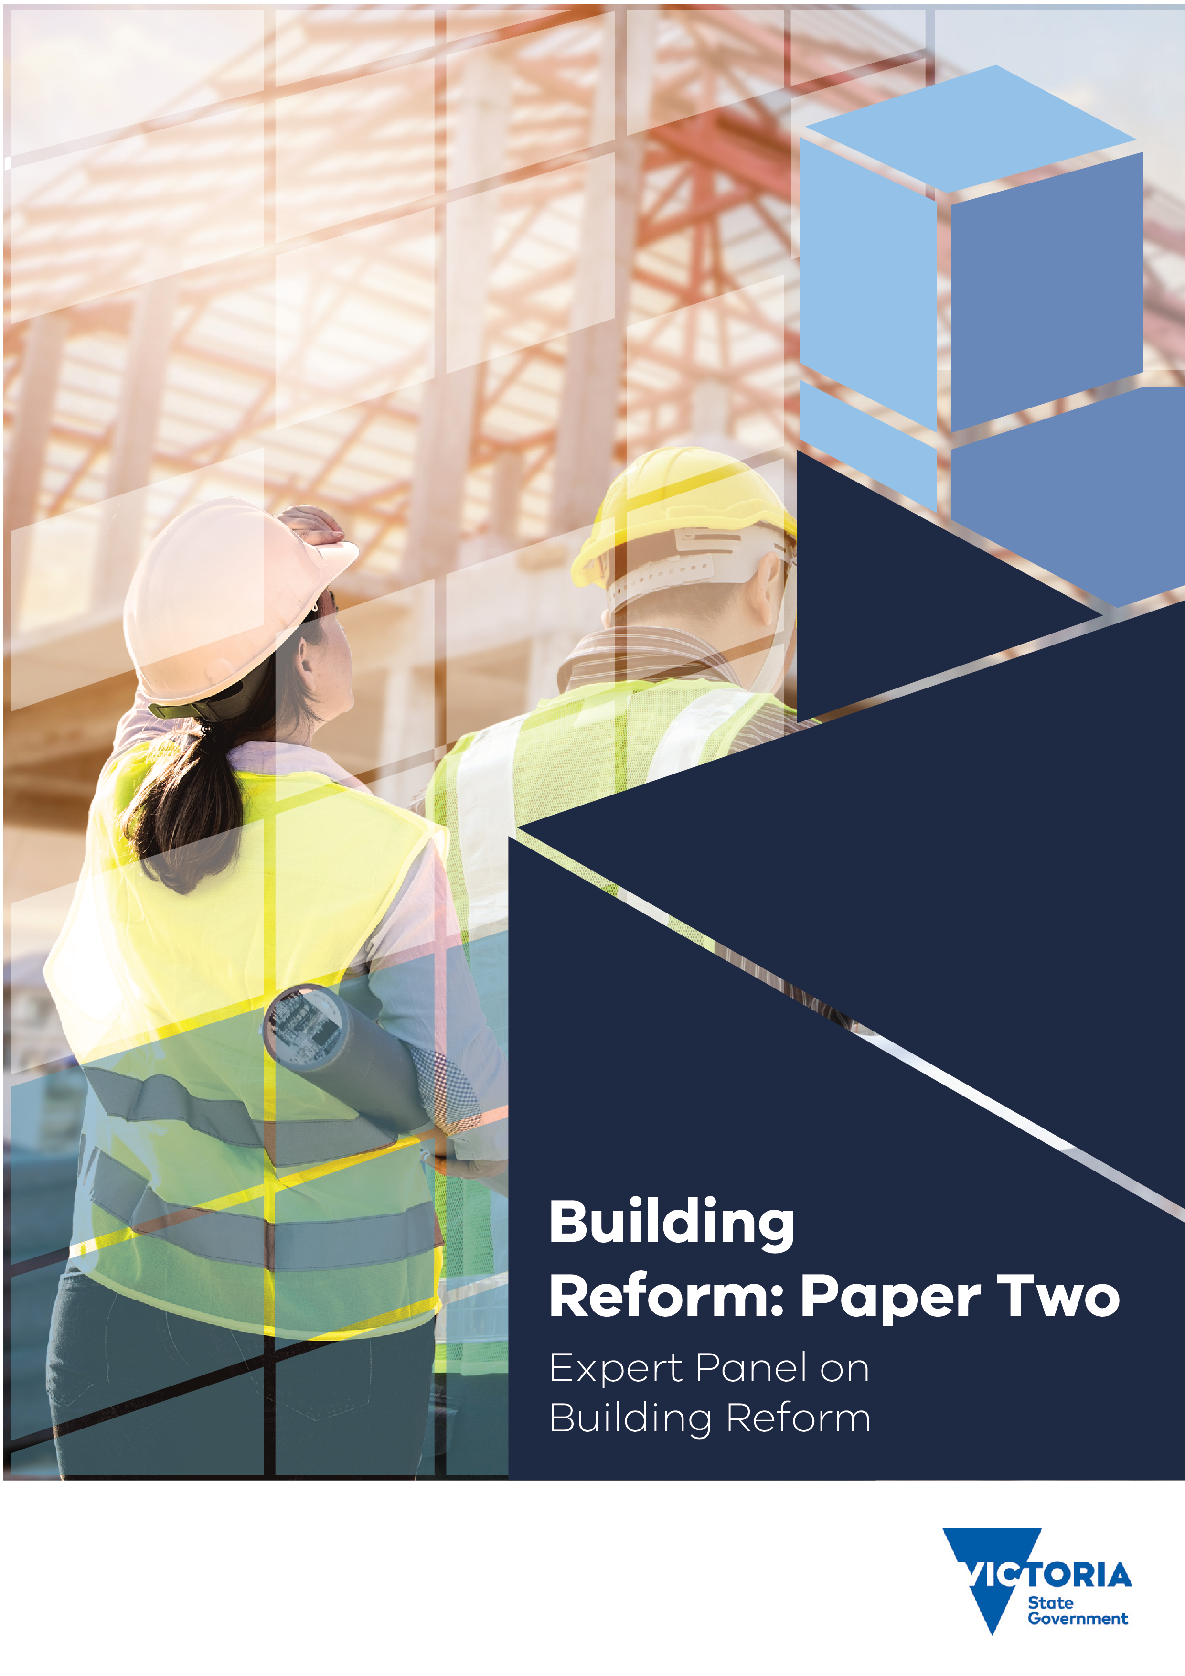
jiBuilding Reform: Paper Two
f
Contents
1 Background and context for the Review 5
2 About the Review 8
3 About Stage 2 10
4 Extending accountability 12
5 Compliance, enforcement and discipline 19
6 Insurance 27
7 Dispute prevention and resolution 34
8 Building maintenance, products and technologies 42
9 Next steps 57
Appendix A Early Initiatives 59
Appendix B The Panel’s Stage 1 recommendations 62
Appendix C Dispute resolution journey map 66
Appendix D Bibliography 67

Foreword
The Victorian Government has established the independent Building Reform Expert Panel (‘the Panel’ or ‘the Expert Panel’) to lead a review of the building legislative and regulatory system (the Review). The Review is designing a modern building regulatory system for Victoria that:
- delivers safe, compliant, durable, affordable, and sustainable housing and buildings efficiently and effectively;
- protects consumers and boosts consumer confidence in the industry and in regulators;
- supports skilled and experienced practitioners to carry out compliant and safe practices; and
- supports regulators to enforce compliance effectively and efficiently.
The Panel’s Review is being undertaken in the context of high-profile regulatory and industry failures, such as the Lacrosse and Neo200 building fires exacerbated by the presence of combustible cladding.
The Review follows other state and national reviews – the Building Confidence Report and Victorian Cladding Taskforce – which pointed to regulatory weaknesses and the need to manage risks much more effectively across Australia. The Expert Panel’s Review was a key recommendation of the Cladding Taskforce in 2019.
Given the size and complexity of the reform task, the Panel is delivering reforms over three stages: Stages 1 and 2 are focused on how to improve accountability, oversight, and put consumers first through a range of recommendations. Stage 3 will develop a framework for a new Building Act.
In Stage 1, the Panel addressed areas of significant reform across the regulatory system. The proposed reforms include improvements to regulatory oversight and practice; practitioner registration and regulation; building approvals processes; and consumer representation and advocacy. In Stage 1, the Panel made 16 recommendations to the Victorian Government which address issues of system oversight, practitioner accountability, consumer empowerment and the roles of key decision-makers in the system. These go to the core of how the building system operates.
Many of the reforms recommended by the Panel in Stage 1 are reflected in the Building Legislation Amendment Bill 2023, which is currently before Parliament.
In Stage 2 of the Review, the Panel is looking at reforms across other core components of the regulatory system:
  - extending accountability, including to developers;
  - compliance, enforcement and discipline;
  - insurance;
  - dispute prevention and resolution; and
  - building maintenance, products, and technologies.
These areas build on the Panel’s recommendations in Stage 1 – as well as the early initiatives recommended in 2020. Together, they lead to substantial improvements in the regulatory system and strengthen accountability across the building lifecycle.
The Panel’s proposed recommendations for Stage 2 are outlined in this Paper.
Stage 3 of the Panel’s work will finalise our recommended reform package, including advice on the development of a framework for a new Building Act, and changes to regulations to align with the outcomes of Stages 1 and 2.

Glossary
ABCB Australian Building Codes Board
ACL Australian Consumer Law
AIBS Australian Institute of Building Surveyors
ARBV Architects Registration Board of Victoria
BACV Building Advice and Conciliation Victoria
BCA Building Code of Australia
BCC Building Codes Committee
BCR Building Confidence Report
BIL Building Information Line
BIM Building Information Modelling
BLA Business Licensing Authority
BRAC Building Regulations Advisory Committee
BRV Better Regulation Victoria
CAV Consumer Affairs Victoria
CFA Country Fire Authority
CSV Cladding Safety Victoria
DBCA Domestic Building Contracts Act 1995 (Vic)
DBDRV Domestic Building Dispute Resolution Victoria
DBI Domestic Building Insurance
DBS Developer Bond Scheme
DJCS Department of Justice and Community Safety
DRO Dispute Resolution Order
DTF Direction to Fix
DTP Department of Transport and Planning
ESM Essential Safety Measures
ESV Energy Safe Victoria
FFR Framework for Reform
FRV Fire Rescue Victoria
GSP Gross State Product
HGF Housing Guarantee Fund
HIA Housing Industry Association
IDI Inherent Defects Insurance
MAV Municipal Association of Victoria
MBAV Master Builders Association of Victoria
MBS Municipal Building Surveyor
NCC National Construction Code
OC Owners corporation
PBS Private Building Surveyor
PCA Plumbing Code of Australia
PII Professional Indemnity Insurance
RBS Relevant Building Surveyor
RICS Royal Institute of Chartered Surveyors
SBS State Building Surveyor
SPV Special Purpose Vehicle
VBA Victorian Building Authority
VCAT Victorian Civil and Administrative Tribunal
VCT Victorian Cladding Taskforce
VMIA Victorian Managed Insurance Authority
WMCAB WaterMark Conformity Assessment Bodies
WSV WorkSafe Victoria

Background and context for the Review
The Victorian Government established the independent Building Reform Expert Panel (the Panel or the Expert Panel) to lead a Review of Victoria’s building legislative and regulatory system (the Review). The reasons the Government commissioned this comprehensive Review include the need to:
- address risks of regulatory and industry failure, as highlighted by the inappropriate use of combustible cladding material and poor-quality installation of critical building safety elements;
- modernise the legislative and regulatory framework to address contemporary building design and construction approaches; and
- to underpin a thriving construction sector committed to safety and quality.
This Review was a recommendation of the Victorian Cladding Taskforce (‘VCT’ or ‘Cladding Taskforce’) in its 2019 Final Report to the Government.
The Expert Panel released a Framework for Reform (FFR) paper in April 2021, and sought feedback on options for improving practitioner registration, consumer representation, regulatory oversight, and building approvals. After reviewing stakeholder input the Panel provided recommendations relating to Stage 1 of the Review. Many of the Panel’s Stage 1 recommendations are now being considered by Parliament in the Building Legislation Amendment Bill 2023.
The themes of Stage 2 are:
  - extending accountability, including to developers;
  - compliance and enforcement;
  - insurance;
  - dispute prevention and resolution; and
  - building maintenance, products and technologies.
This chapter briefly describes the background and context to the Review, including:
  - the importance of the building and construction industry to Victoria; and
- the aims and objectives of the Review.

The building and construction industry is important to Victoria’s economy and society
Victoria’s construction sector is a major contributor to the state’s economy and plays a central role in shaping the future of the state’s built environment, economic growth and prosperity. The construction industry contributed $38.1 billion to Victoria’s Gross State Product (GSP) in 2021/22, equivalent to 7.6 per cent of Victoria’s economy.
Building and construction is a significant employer for the state, making up nearly 10 per cent of Victoria’s jobs. Over 325,000 Victorians are directly employed in the construction industry, including architects, draftspersons, building designers, builders, building surveyors, building inspectors, engineers, fire safety professionals, planners, project managers, property managers, and trades.
The Victorian Government is investing significantly in the industry. The 2022/23 State Budget included the investment of $28 million over the next two years to support and improve the building and construction industry. This builds on initiatives announced in the 2021/22 State Budget, such as the investment of $5.3 billion in the Big Housing Build to construct more than 12,000 new homes throughout Victoria. This investment will boost Victoria’s economic recovery, generating an estimated $6.7 billion in economic activity and supporting more than 18,000 jobs. Construction has already begun on hundreds of dwellings in six ‘fast-start’ sites around Melbourne, due to be completed in 2023.
In addition to its economic importance, the building sector plays an important social role. The built environment provides basic needs for shelter and is the foundation for family stability and community wellbeing. It also contributes to improved health and educational outcomes. In these ways it supports civil society to function effectively and supports the prosperity of people who live in Victoria. The COVID-19 pandemic has underscored the importance of the built environment, which has reshaped the home as a place of work.
A modern, proportionate building regulatory system is fundamental to supporting business and jobs growth, strengthening Victoria’s economy, and restoring consumer and industry confidence. A regulatory system with appropriate safeguards will give government, consumers and industry confidence that buildings are safe, of high quality and compliant. The intent is to support those who are committed to doing the right thing, and to hold those who seek to take shortcuts to account.

The review aims to modernise the building regulatory system
Victoria’s current building legislative and regulatory system was developed in the early-1990s. It has evolved over the past 30 years through amendments to the Building Act 1993 (Vic) and various changes in regulations and practice requirements. Many amendments have resulted from reviews that identified the need for changes to certain aspects of the regulatory system. However, most reforms have been piecemeal. Holistic reform is required to ensure – into the future – the building regulatory system meets its objectives to promote compliant practices and protects the health and safety of those who use buildings. The Panel is eager to see the building regulatory system in Victoria modernised and strengthened to ensure regulatory settings cover new technologies and practices, and quality and safety risks are effectively addressed.
Key trends which highlight the need for reform are outlined below.

The regulatory system has not kept pace
Over the past three decades, building and construction practices have evolved considerably. This has been driven by industry and technological innovation, economic growth, demographic trends, and changes in Victorians’ living preferences and patterns. Trends include:
- growth in multi-storey residential apartment living;
- an increasingly globalised supply chain for building products, including greater reliance on imported and prefabricated products; and
- increases in the use of new contractual arrangements and practices, such as design and construct contracts.
These factors present specific opportunities and risks that require modern, responsive regulatory framework developments that are tailored to the underlying complexity of different types of buildings and construction practices.

High profile building failures have contributed to a lack of confidence in the regulatory system
Several significant building failures in Australia and around the world have reduced public confidence in the building regulatory system. These include the inappropriate use of combustible cladding which led to the 2017 Grenfell fire tragedy in London, the 2014 fire at the Lacrosse apartment building in Melbourne’s Docklands and the 2019 fire at Neo200 building in Melbourne’s CBD. Recent supply chain and inflationary pressures have contributed to insolvency risk and consumer exposure.
The Panel notes a broad consensus – from industry, government and consumer stakeholders – that modern, efficient, proportionate and effective regulation is required to restore confidence in the building regulatory system and ensure those with key responsibilities are held to account.
The 2018 Building Confidence Report (BCR) by Peter Shergold and Bronwyn Weir, and the 2017 and 2019 Interim and Final reports from the Cladding Taskforce highlighted regulatory system failures and made recommendations for improvements to the regulatory system. The Cladding Taskforce recommended the establishment of this Review.
Since the BCR, the Australian Building Codes Board (ABCB) has issued a number of consultation documents and proposed specific changes to the National Construction Code (NCC). To support a regulatory approach that is consistent with other jurisdictions and proposed changes to the NCC, the Panel is cognisant of the need to align its recommendations with the ABCB-led national approaches.

About the Review
The objectives of the Review, as set out in the Panel’s Terms of Reference, are to provide a building regulatory system that delivers safe, compliant, durable, affordable and sustainable housing and buildings efficiently and effectively, while holding those with key responsibilities to account. This requires a building regulatory system that:
  - supports skilled and experienced practitioners to carry out compliant and safe practices;
  - supports regulators to effectively and efficiently enforce compliance; and
  - protects consumers and improves confidence in the industry and regulators.
The Review is important to protect and empower Victorian consumers who make significant and complex decisions when building or renovating a home, including buying off the plan apartments.
Figure 1 outlines the outcomes the Panel is aiming to deliver and links each outcome to the objectives described above.
Figure 1 | Objectives and outcomes of the Review
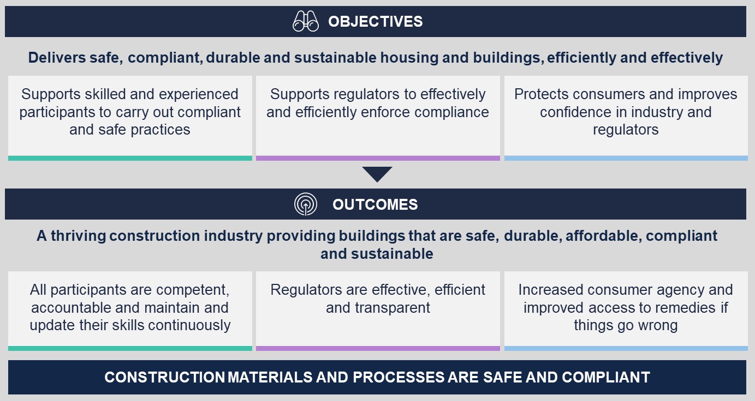

The Panel is taking a staged approach to the Review
The Panel has recommended that comprehensive reform of the building regulatory system be delivered over three stages. Stages 1 and 2 involve recommending changes to the regulatory framework in light of recent and emerging priorities. Stage 3 will culminate from advice on a new Building Act and regulations aligned with the national framework.
The staged approach (set out in Figure 2) prioritises the reform steps and provides a pathway for implementation. Each stage will build on the next to deliver a comprehensive suite of reforms which meet the objectives and outcomes of this Review. This report outlines the Panel’s Stage 2 proposed recommendations. Details on the Panel’s Stage 1 recommendations, which the Government has endorsed, are provided in Appendix A.
Stage 3 will finalise the total reform package, including provision of a framework for the drafting of a new Building Act. This will involve restructuring the legislative framework and subordinate instruments to align with the outcomes of Stages 1 and 2. Stage 3 will provide the scope to further refine the reforms to ensure they continue to give effect to the intended objectives and outcomes of the Review. The Panel will also consider potential further improvements required to other legislation that affect the building regulatory system, such as the Domestic Building Contracts Act 1995 (Vic) (DBCA) and the Owners Corporations Act 2006 (Vic).
Figure 2 | Staged approach to Panel's review

About Stage 2
This Paper provides an overview of current mechanisms, key issues and proposed recommendations for each of the Stage 2 theme areas of extending accountability, compliance and enforcement, insurance, dispute prevention and resolution, building maintenance and products and technologies.
There are many interdependencies between the theme areas. For example, a more robust compliance and enforcement framework will reduce defects, thereby reducing pressures on the dispute resolution system. Together, these theme areas will strengthen the regulatory system, prevent harms from occurring and provide for efficient and effective mechanisms to address issues that arise. Figure 3 gives a summary of the proposed recommendations explored in this Paper.
Figure 3 | Stage 2 proposed recommendations
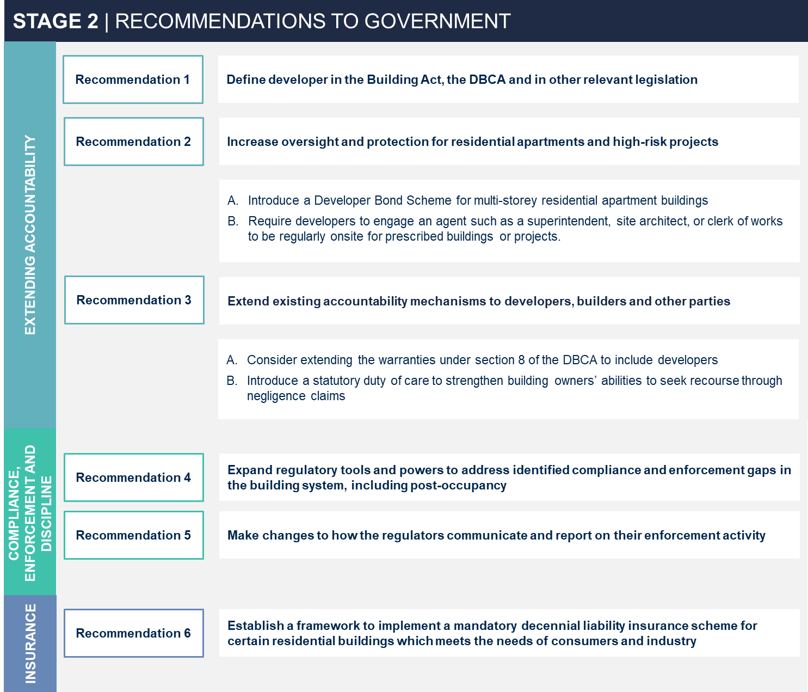


Extending accountability

Many practitioners influence the performance of buildings across the building lifecycle. The work of all participants in the system – including developers, architects, designers, builders, building surveyors, plumbers, and other practitioners – are intrinsically linked. Fragmented accountability can compromise building safety and quality and make it difficult for consumers to access recourse for defective or non-compliant work. Conversely, clearly defined accountabilities can improve building performance, practitioner conduct and support better outcomes for consumers by:
  - making it easier to determine the appropriate person to commence proceedings against for defective or non-compliant work;
  - enhancing regulatory options to prevent defects arising and – where they do occur – ensuring timely rectification; and
  - enhancing opportunities for private litigation to require rectification and/or to compensate consumers for economic loss.
The Panel is conscious of the need for clear accountabilities for all those involved in the building regulatory system, including developers and other parties responsible for compliance and safety of buildings. Extending accountabilities was a focus of the Panel’s Stage 1 reforms and continues to be a focus of our Stage 2 proposed recommendations.
This chapter describes, in brief, the current accountability mechanisms and the current accountability gaps which contribute to poor outcomes for consumers, practitioners and the system. It then proposes recommendations to address the issues described.
Proposed recommendations described in this chapter include defining developers in the legislative framework, increasing oversight for high-risk projects and ensuring that all parties – including developers – are appropriately captured in the regulatory system.

Overview of current accountability mechanisms
This section provides a brief overview of the current regulatory safeguards and controls in place to protect consumers and practitioners and hold responsible parties to account (set out in Figure 4).
Figure 4 | Key legislative mechanisms to promote accountability in Victoria's building regulatory system

The legislative obligations and duties outlined above are intended to provide a foundation for determining fair and equitable allocation of risks and responsibilities for building projects.
  - Section 8 warranties under the DBCA apply to all work carried out under a domestic building contract and provide protections against non-compliant building work and poor practitioner conduct. Any owner (or subsequent owner) can bring a dispute/action under the section 8 warranties for up to 10 years after the initial occupation of the building. Disputes relating to section 8 warranties are heard in Domestic Building Dispute Resolution Victoria (DBDRV) or Victorian Civil and Administrative Tribunal (VCAT).
  - The Australian Consumer Law (ACL) gives general protections for consumers that products are of acceptable quality, free from defects, and that services are provided with due care and skill within a reasonable time and are fit for purpose for up to six years from when the defects are found. Disputes relating to the ACL are heard under VCAT.
  - The Building Act and Regulations include a range of general enforceable obligations on practitioners that seek to ensure that building work complies with the Act, Regulations,
  - NCC and the building permit. These are enforced by the regulators. Further detail on compliance, enforcement and discipline is provided in chapter 5.
The regulatory system also includes a range of other mechanisms to increase accountability of system participants. Regulators have a range of tools and powers to take proactive action and oversee the safety and compliance of building work. This includes investigative powers under Part 13 of the Act and power under Part 8 of the Act to issue building rectification orders. The registration and licensing schemes under Part 11 of the Act ensure work is undertaken by people with the necessary skills. Disciplinary action is available to regulators (both the Victorian Building Authority (VBA) and Architects Registration Board of Victoria (ARBV)) where conduct raises significant concerns about competency, professionalism and/or compliance with legislative requirements.
Lastly, insurance arrangements help to manage and mitigate risks faced by practitioners and consumers and enable rectification of defective building work. There is a range of mandatory and optional building insurance products available in the Victorian market. These are described further at chapter 6.1.

Key issues
The accountabilities of different parties involved in a building project are determined both by private contracts and legislative requirements. Differences in power between building regulatory system participants can lead to unfair allocations of risk and responsibility. In this context, it is important that legislation provides a framework for fair and reasonable allocation of accountabilities.
The Panel has identified two key issues in relation to accountability which the proposed recommendations aim to address:
- Current regulatory controls do not apply to all participants in the building system – especially ‘upstream’ participants – leading to gaps in accountability and responsibility.
- Current pathways for consumers to obtain recourse in relation to defective building work are limited.

Current regulatory controls do not apply to all participants in the building system – especially ‘upstream’ participants – leading to gaps in accountability and responsibility
Many participants in the building system influence the safety and quality of buildings. These include practitioners who work on building sites during construction, building surveyors who issue permits and conduct inspections, and participants responsible for maintenance and upkeep of buildings. There are also participants that are ‘upstream’ in the supply chain, such as product manufacturers and suppliers, financiers, designers, and property developers.
Upstream participants are not specifically regulated under the Building Act and Regulations, aside from general provisions that apply to any person or registered corporation undertaking building work and building orders as an owner.
While these participants are not typically directly involved on building sites, their decisions can influence building outcomes, including safety and quality. For example, property developers provide the capital to finance building projects and can have control over decisions relating to design, costs and contractual arrangements that influence the overall outcomes of the building project.
Additionally, developers and builders may establish Special Purpose Vehicles (SPVs) for a particular building project to attract investors and to separate project finances from the parent company. SPVs are then liquidated when the project is completed. This can leave consumers with no access to recourse if the building is non-compliant after it is built and the SPV no longer exists.
To deliver an effective regulatory system, it is necessary that all participants, including upstream participants, are directly accountable for their activities and decisions.

Current pathways for consumers to obtain recourse in relation to defective building work are limited
The existing protections under the common law duty of care, the consumer guarantees and implied warranties provide limited avenues for consumers to hold the relevant participants to account for non-compliant building work.
Both builders and building surveyors have a duty to prevent pure economic loss. However, building owners can only establish a duty of care to prevent economic loss from building work if an owner is able to show that a standard of vulnerability, responsibility and reliance existed in the relationship between the owner and builder. It will generally be difficult and costly for building owners, particularly Owners Corporations (OCs), to satisfy the Court that they were vulnerable and owed a duty of care.
Further, the common law duty of care under negligence provides limited recourse for consumers when economic loss is caused by the negligence of a person who does not have a direct duty of care to them (i.e., developers, engineers and other building participants).
Other accountabilities, such as implied warranties and consumer guarantees, while providing important pathways for consumers to obtain recourse, are narrow in their application and can be complex to enforce. For instance, implied warranties in the DBCA only apply to the building practitioner with whom the owner has a domestic building contract but not to other participants involved in building work. While the ACL guarantees apply more broadly – such as for disputes relating to a single trade contractor – consumers rarely use this pathway to enforce consumer guarantees due to cost issues.

Proposed recommendations to extend accountabilities to developers and other responsible parties
The Panel proposes three recommendations to ensure that responsibilities for design, construction and maintenance work are clear and fair for all practitioners.

Recommendation 1 | Define developer in the Building Act, the DBCA and in other relevant legislation

Description
The Panel recommends that a definition of a developer is added into the Building Act and DBCA along with any other relevant laws. The definition intends to capture all developers and should include:
  - an individual or partnership on whose behalf the work was done; and
  - the owner of the land (if this is different to the individual or partnership on whose behalf the work was done).
Any definition of a developer should be consistent with and compatible with equivalent definitions in other jurisdictions.
The introduction of a statutory definition constitutes the first step in considering a system of registration for developers that the Government could also explore.

Rationale
A definition of developer in the building framework is the foundation for the effective implementation of Recommendations 2 and 3 in this report. The developer definition ensures that appropriate distinctions and accountabilities are drawn between developers, building owners, builders and others in the system..

Outcome
Developers will have clear and specific accountability within the statutory framework.

Recommendation 2 | Increase oversight for residential apartments and high-risk projects

Description
In Stage 1, the Panel recommended three additional inspections for residential high-risk buildings: pre-plastering, pre-waterproofing, and a pre-occupancy permit inspection. In Stage 2, the Panel recommends further measures to increase oversight and protection for residential apartments and prescribed projects by:
- Introduce a Developer Bond Scheme (DBS) for multi-storey residential apartment buildings. The bond scheme would require developers responsible for new residential developments over 3 storeys and prescribed high risk projects to pay a bond (which could be in the form of a bank guarantee as in NSW)to a government authority. The bond would be held for a fixed period to cover the costs of rectifying specified defects. The bond would be set as a percentage of the contract price and be returned to the developer should no defects be found before the fixed period expires.
For example, a DBS scheme could be introduced at five per cent of the contract price to be held for a period of ten years (consistent with the DBCA) after the completion of the building project.
- Require developers to engage an agent such as a superintendent, site architect, or clerk of works to be regularly onsite for prescribed buildings or projects. Under this reform, the developer would engage an agent such as a superintendent, site architect or clerk of works to regularly monitor compliance and quality on site for the developer. The agent would conduct inspections and report to the developer so the developer is aware of, and maintains, shared responsibility for the whole construction process. The agent would not have statutory powers or certification functions.

Rationale
The proposed recommendations would improve the quality and standards of building work for residential apartments and prescribed projects that are at highest risk of non-compliance. Further, they would address gaps in consumer protections that currently exist for lot owners, specifically:
  - A DBS would address the current gap in consumer protections for lot owners of apartments over three storeys. While the bond is held, the scheme may also encourage developers to remain an active and registered company and reduce instances of SPVs that are discontinued post-completion of building work.
  - Requirement to engage an agent could address the fragmentation between different contractors and professionals involved in the design, development and construction process which currently results in lack of clear responsibility and reduces quality building outcomes. Monitoring of compliance throughout the project by the agent would support early identification and rectification of potential compliance problems before they escalate into safety and other costly issues for the subsequent purchasers to address.

Outcome
Compliance of residential apartment buildings and high-risk prescribed projects will be improved with increased oversight and protections for consumers where non-compliance occurs.

Recommendation 3 | Extend existing accountability mechanisms to developers, builders and other parties

Description
The Panel recommends considering two additional actions to increase accountability for developers, builders and other parties under existing mechanisms:
- Consider extending the warranties under section 8 of the DBCA to include developers. Extending the application of implied warranties under section 8 of the DBCA will hold the developer (in addition to the builder) liable to the initial and subsequent purchasers of a building for defective work. Actions alleging breach of such warranties could then be brought against the developer.
- Introduce a statutory duty of care to strengthen building owners’ abilities to seek recourse through negligence claims. Building owners already have a cause of action for negligence at common law, but success in claims for economic loss requires an owner to prove ‘vulnerability’, which can be difficult to prove in relation to upstream participants. The statutory duty of care could be captured in all relevant legislation. The Government could consider a statutory duty of care with the following features:

    - The duty would be owed to each owner of the land in relation to which construction work is carried out and to each subsequent owner of the land.
    - The duty would be non-delegable and parties would not be able to contract out of it.
    - The duty would relate to a broad range of work, including building work; preparation of designs; manufacture and supply of building products; and supervising, coordinating and project managing design and construction.
    - The duty of care could apply to building work, or other kinds of work, for a 10-year period (consistent with statutory warranties in the DBCA).

Rationale
Increasing statutory accountability for developers through implied warranties and a duty of care will clarify and strengthen the developer’s responsibility for delivering safe and compliant buildings, thereby increasing both the incentive to comply and the consequences for non-compliance. Developers would also benefit from a duty of care. These extensions would better reflect shared responsibility in the building construction chain, ensure procedural fairness and improve avenues for appeal.

Outcome
Defective work should be reduced. With a duty of care in place building owners will have improved access to recourse for defective work, with clear apportionment of responsibility between developers, builders and other persons involved in building construction.


Compliance, enforcement and discipline

Compliance monitoring, enforcement and discipline are critical tools to identify and respond to non-compliant building work and poor practitioner conduct, and to encourage industry to proactively comply with legislative requirements. Victoria’s building regulatory system includes a range of entities with co-regulatory responsibilities for monitoring and enforcing compliance. The Act further provides specific tools and powers in building approvals and disciplinary processes to respond to non-compliance and rectify defective building work.
These tools can also have a substantial impact in preventing the occurrence and escalation of building disputes. As domestic building disputes commonly involve legislative non-compliance, dealing with non-compliant building work through the regulatory system should reduce the need for consumers to take time-consuming and expensive private action to address defective building work.
In Stage 1, the Panel made recommendations to strengthen regulatory oversight of building practitioners and proposed that the VBA is supported to become a contemporary best practice regulator. In Stage 2, the Panel is focused on the tools and powers that are needed to enforce compliance.
This chapter provides an overview of compliance, enforcement and discipline in the building regulatory system, specifically the roles, responsibilities, tools and powers. It sets out the key issues of the current system and proposes two recommendations related to compliance, enforcement and discipline.
Proposed recommendations described in this chapter include reforms to the Building Act to amend existing tools and powers to address accountability gaps, and practice reforms to improve the transparency and timeliness of disciplinary outcomes.

Overview of current compliance, enforcement and disciplinary processes
This section provides an overview of the current roles, responsibilities and powers for compliance and enforcement. It outlines:
  - the entities with compliance and enforcement roles and responsibilities; and
  - the tools and powers available to co-regulators across building approvals, enforcement and disciplinary processes to ensure compliant practitioner conduct and building work.

The building system has a range of entities with co-regulatory responsibilities
Victoria’s building regulatory system is overseen by a broad range of entities with different co-regulatory responsibilities for monitoring and enforcing compliance. The roles of key entities are depicted in Figure 5.

Figure 5 | Co-regulatory entities in Victoria's building regulatory system
The VBA is the principal regulator of building and plumbing practitioners in Victoria. The VBA’s functions are established under section 197 of the Building Act and include monitoring and enforcing compliance and supervising and monitoring the conduct of registered practitioners, including through disciplinary action.
Local Councils (through the Municipal Building Surveyor (MBS)) are responsible for administration and the enforcement of Parts 3, 4, 5, 7 and 8 of the Act and Regulations within their municipality. Their role is outlined in section 212 of the Building Act.
The Relevant Building Surveyor (RBS) . In addition to issuing permits, certifying compliance of building work and designs, and conducting inspections, the RBS has powers under the Act to require building work to be brought into compliance during building approval processes.
Other entities also play a role in the building regulatory system. These include the ARBV, which regulates the conduct of architects; Energy Safe Victoria (ESV), which regulates electricity and gas in Victoria; relevant fire authorities, which oversee fire safety elements of building work; and WorkSafe Victoria (WSV), which is the workplace health and safety regulator .

The Building Act contains a broad scope of tools and powers to monitor and enforce compliance of building work, buildings, and practitioner conduct Tools and powers under the Building Act and Regulations enable regulators to carry out their statutory responsibilities and monitor and enforce compliance of practitioners and the built environment.
Tools and powers can be used by regulators as part of the building approvals, compliance and enforcement, and discipline processes. Some tools and powers relate to the relevant wrongdoer and seek to deter non-compliance across the industry. For example, powers to suspend and cancel practitioner registration while other tools focus on fixing defective building work. Some tools and powers can be used for both purposes.

An overview of the co-regulatory roles in the system, and tools and powers that enable those statutory roles is provided in Figure 6.
Figure 6 | Roles, responsibilities, tools and powers across the building regulatory system

Building approvals
As part of the building approvals process, powers are used to bring building works into compliance prior to issuing an occupancy permit or certificate of final inspection. Powers to bring about compliance of building work are generally the responsibility of the RBS. The RBS may use specific powers to bring building work into compliance, including a Direction to Fix (DTF), building notices and orders and minor work orders. If the orders are not followed, the RBS must refer the matter to the VBA for enforcement. Following an inspection of building work, the VBA can issue a DTF and the MBS can issue a building notice or order.

Enforcement
Compliance and enforcement processes regulate practitioner conduct, rectify non-compliant building work, and ensure that buildings do not pose a threat to the health and safety of people who live in and use them. Enforcement tools and powers are primarily used in relation to buildings to make them safe during building approvals processes or after the building is built. The VBA and Local Councils (MBS) have a range of powers outlined in sections 8, 12A and 13 of the Act which include information gathering, powers of entry, ability to issue emergency orders or infringement notices, ability to apply for injunctions and to commence criminal proceedings against individuals who contravene offence provisions.

Disciplinary action
Disciplinary action applies to registered practitioners where conduct raises significant concerns about competency, professionalism and/or compliance with legislative requirements.
Disciplinary action primarily sanctions practitioners for non-compliance but can also be used to require rectification of building non-compliance. Disciplinary action against builders and plumbers is the sole responsibility of the VBA, while the ARBV is responsible for taking disciplinary action against registered architects. Grounds for disciplinary action are defined under section 178 of the Act. This includes powers to require rectification of defective work, variations, suspension or cancellations to a practitioner’s registration and financial penalties.

Key issues
Through its Review, the Panel has found that entities with regulatory oversight responsibilities do not always achieve compliance objectives. This is driven by four distinct issues:
- System-wide roles and responsibilities are not clearly articulated in legislation or understood in practice.
- Regulators’ powers to achieve regulatory objectives are not well utilised.
- Regulators do not have the full suite of appropriate compliance tools and powers to achieve their intended objectives.
- Disciplinary and enforcement processes are perceived to be slow and opaque to consumers, practitioners and the general public.

System-wide roles and responsibilities are not clearly articulated in legislation or understood in practice
Statutory roles and responsibilities of the VBA and local councils are unclear. While section 212 gives local councils responsibility for administering and enforcing Parts 3, 4, 5, 6, and 8 of the Building Act within their municipal district, it is not clear how this role interacts with the VBA’s broader role to monitor and enforce compliance as the state’s building regulator. Responsibility for taking enforcement action can be fragmented. This lack of clarity has contributed to ‘numerous and ongoing disagreements between the VBA and local councils’ about who is responsible (and when) for acting in response to non-compliance.
Further, enforcement action during the building approvals process is poorly coordinated, with the Private Building Surveyor as Relevant Building Surveyor ( RBS), the MBS and the VBA all playing a role at different stages. For instance, where a person does not comply with an order issued by an RBS, they must refer the matter to the VBA who is then responsible for taking enforcement action. Despite continuing to play an oversight role for the building project, the RBS may not have a line of sight over the VBA enforcement response and the implications for the construction process.
The Panel agrees with the Cladding Taskforce’s observation that it is ‘timely to recalibrate and clarify the role of the VBA/Local Government/MBS and the RBS’. Greater clarity is required on the roles and responsibilities of the RBS, MBS and VBA under a future regulatory model. The Panel will look at the role of local councils in the building regulatory system as part of Stage 3 of the Review. This will enable the Panel to reflect on the impact of reforms on the building system framework as a whole.

Regulators’ powers to achieve regulatory objectives are not well utilised
The Panel has heard that the current suite of powers available to regulators are not being used effectively. Ineffective use of current powers is driven by a culmination of unclear roles and responsibilities (outlined above), and resourcing, capacity and capability constraints in the current system. The following issues have been identified:
  - The VBA has the power to issue a DTF and only uses this power ‘in exceptional circumstances’, preferring to refer non-compliance to the RBS or MBS for enforcement. This reflects the VBA’s role as a state-wide regulator, focused primarily on systemic issues, rather than local matters. Where this is not clearly communicated it can cause confusion and result in passing responsibility for compliance action from one party to the other.
  - Injunctions are not widely used by the VBA or MBS. Some MBSs use the power in specific circumstances, such as to require building work to be performed or to stop building work. However, the Panel believes that injunctions are not utilised by the VBA to their full capacity in other circumstances, such as to require the payment of costs for rectification, enable the Court to ‘pierce the corporate veil’, or to respond to multiple wrongdoers.
  - While enforcement functions such as building notices and building orders are intended to be used as a last resort, they are often issued by an RBS immediately following non-compliance with a DTF. Building notices and orders are issued to building owners (regardless of their level of involvement in building work) and can place undue accountability on an owner to resolve a matter.

Regulators do not have the full suite of appropriate compliance tools and powers to achieve their intended outcomes
Despite recent amendments to the Building Act to strengthen enforcement tools and powers, there are still gaps in the tools and powers available to regulators. For example:
  - A builder cannot be issued administrative directions by a building surveyor or the VBA to rectify non-compliant work after an occupancy permit or certificate of final inspection has been issued. Post-occupancy, the RBS and MBS must rely on building notices and orders which are issued to the building owner, thereby shifting responsibility for compliance from the builder to the owner. Further, the VBA can only issue a building notice or order when performing the functions of the MBS. Otherwise, the VBA’s only power to bring about compliance post-occupancy is the injunction power, which is rarely used (as noted above). As a result , there are limited avenues for regulators to rectify defective building work after the building is built. This issue was previously raised by the Cladding Taskforce, who found that a lack of enforcement powers post-occupancy presented a ‘significant barrier’ to the VBA’s compliance function.
  - The Building Act does not provide any administrative enforcement tools that can be imposed on developers after they sell the building. Developers play a direct role in influencing building project outcomes and compliance. Despite their influence, once the developer sells the building and is no longer deemed the building owner. There is no administrative order that can require developers to rectify non-compliant work.

Disciplinary and enforcement processes are perceived to be slow and opaque to consumers, practitioners and the general public
Current disciplinary processes overseen by the VBA may not effectively deter practitioners from non-compliant conduct or provide adequate mechanisms to sanction offending practitioners for serious misconduct. The Cladding Taskforce previously raised this issue, noting ongoing concerns ‘with the adequacy of disciplinary processes’ which ‘continue to be slow and largely opaque to consumers and the general public’.
Specific issues include the timeliness of disciplinary action, the use of available sanctions in the disciplinary process (namely, a perceived overreliance on fines and reprimands rather than on rectification) and a lack of transparency in reporting on disciplinary processes and outcomes.

Proposed recommendations to make compliance and enforcement effective
The Panel proposes two reforms to address the current issues in compliance, enforcement and discipline, including the increased use of prosecution powers. These recommendations build on the Panel’s Stage 1 reforms in strengthening building compliance and accountability across the system. They seek to provide each regulator with the appropriate tools to undertake their functions. Proposed reforms to the disciplinary and enforcement processes aim to improve their effectiveness in deterring poor conduct and promoting a compliant culture.

Recommendation 4 | Expand regulatory tools and powers to address identified compliance and enforcement gaps in the building system, including post-occupancy

Description
The Panel recommends amendments to the Building Act to enable the regulator or regulators to require rectification of non-compliant building work following the issuing of an occupancy permit or certificate of final inspection. The regulations could specify whether the power should exist for all non-compliance or particular serious non-compliance.
In addition to this rectification power, the Panel recommends enabling the regulator to direct the builder, developer or other responsible party to pay for the costs incurred with rectification. This could operate similarly to the rectification and cost orders in NSW.
Any new administrative order or direction would need to include procedural fairness to the recipient, including appropriate appeal rights.

Rationale
Currently, other than building orders on the current owner there are no administrative enforcement tools for rectification available to the regulators once a building has been completed. Regulators can seek an injunction to bring about compliant work, but these are relatively costly and time-consuming. Because of the lack of regulator power to require rectification of defective building work post-occupancy, building owners must seek dispute resolution outcomes and/or take legal action. This often results in substantial costs for current and subsequent owners.

Outcome
These new enforcement tools and powers will reduce regulatory barriers, supportefficient rectification of defective building work, enable the appropriate apportionment of liability across the building construction chain and reduce or eliminate the need for building owners to pursue legal action.

Recommendation 5 | Make changes to how the regulators deliver, communicate and report on their enforcement activity

Description
The Panel recommends that the regulator develop guidance and information on its enforcement tools. This would include what is expected of practitioners during the disciplinary processes, required documentation and expected timelines. The regulator should also publish guidelines on disciplinary sanctions that may apply in different circumstances, the process for undertaking disciplinary proceedings and report on
outcomes and timelines achieved. The necessary improvements to information sharing (including with local councils) recommended earlier by the Panel will support regulators’ awareness of practitioner non-compliance and facilitate effective enforcement.

Rationale
The Cladding Taskforce, in its final report, noted ongoing concerns with the ‘adequacy of disciplinary processes’ which ‘continue to be slow and largely opaque to consumers and the general public’ in its final report. Transparent disciplinary processes are important to promote industry improvement among practitioners who understand what is expected of them, to better understand the nature of issues that are identified and to inform appropriate practitioner guidelines and training.. Further, timely processes are critical to a robust egulatory system so that those who pose unsafe, non-compliant practices are swiftly removed and prohibited from entering into new building contracts.

Outcome
This recommendation will increase the standard of information available to building practitioners and policy makers about disciplinary processes, outcomes and the nature of non-compliance. Guidelines will increase the consistency of decision making, increase practitioner understanding of sanctions that are likely to apply in various scenarios, and enable the building regulator to better ensure disciplinary sanctions reflect the policy intent of achieving a robust disciplinary system to support delivery of safe, compliant and quality building work.


Insurance

Insurance is an important safeguard to help ensure that consumers and practitioners are protected from financial loss. It plays a significant role in the building regulatory system in managing and mitigating risks faced by practitioners and consumers and enabling rectification of defective building work. In Victoria, there are a range of mandatory and optional building insurance products which can protect homeowners and industry participants from financial loss across the building lifecycle.
The Panel’s early initiatives recommended the establishment of a pathway to project-based insurance. Project-based insurance policies provide a single insurance instrument that unites the interests of all parties involved in a single building project and strengthens protection for consumers and practitioners against defects.
Recent regulatory failures and subsequent loss of confidence by the insurance sector has led to high Professional Indemnity Insurance (PII) costs and the widespread use of exclusions. A robust regulatory system, competent practitioners, quality building products, effective dispute resolution and accessible information are all critical to the successful development of a market-led insurance product. That is why the Panel has recommended reforms to increase accountabilities in the system and strengthen compliance and enforcement. These are foundational to the successful implementation of a new decennial liability insurance system.
This chapter builds on the Panel’s early initiative. It outlines the role of insurance in the building regulatory system and existing insurance arrangements; key issues related to the building insurance framework; and recommends a path forward for an insurance framework focused on strengthening consumer protection mechanisms for rectification of defects.

Overview of current insurance framework
This section provides background and context on insurance arrangements in Victoria’s building regulatory system. It outlines:
  - the role that insurance plays in the building regulatory system;
  - insurance products available in the Victorian market; and
  - the evolution of Victoria’s insurance framework.

Insurance can manage certain risks and plays varying roles in the building regulatory system
Insurance is a means of managing and transferring risk. Insurance in domestic building projects has two distinct goals: to fund rectification work, and to compensate consumers for economic loss associated with defective building work.
The role of insurance in building regulatory systems differs across jurisdictions in Australia and around the world. Some jurisdictions have first resort schemes while others (including Victoria) have last resort schemes.
A last resort system is one where insurance coverage exists only after all other avenues of recovery or rectification have been sought. In Victoria, Domestic Building

Insurance (DBI) is a last resort scheme. Dispute resolution mechanisms to assist consumers and builders to resolve disputes have a greater role in last resort systems.
A first resort system is one where consumers can progress to an insurance claim earlier than under a last resort scheme. In a first resort scheme, the insurer may be the first port of call for the claimant, and they may have greater responsibility (earlier in the process) to resolve the dispute. Insurers can pursue costs from practitioners in a first resort scheme. In a first resort system, consumers tend to be compensated in a timelier manner. Normally, the original builder will be given an opportunity to rectify work before insurance is triggered, which provides funding for rectification by an alternative builder.

There is a range of insurance products available in Victoria, some of which are required by legislation
Victoria’s building regulatory system includes several mandatory insurance products which seek to establish a minimum level of protection for consumers and practitioners when engaging in building work. Insurance products relevant to the Review are illustrated in Figure 7 and explained below.
Figure 7 | Mandatory insurance products in Victoria's building regulatory system
PII is a mandatory insurance requirement for building surveyors, building inspectors, quantity surveyors, engineers and draftspersons. Requirements for PII are set out in the Building Act (and related Ministerial Orders). PII indemnifies practitioners against civil liability associated with negligence and breaches of professional duties. Common examples of claims include negligent design, the provision of inaccurate or incomplete advice and failure to perform duties to a reasonable standard of care. Under the Architects Act (section 17A) architects must also purchase PII as a condition of registration.
DBI is a last resort insurance that is mandatory for all domestic building projects of three storeys or less and above $16,000 in value. The builder takes out the policy on behalf of the consumer. DBI coverage is triggered only if all the following conditions are met:
  - The domestic building work is defective or incomplete.
  - The builder has died, disappeared, or become insolvent, or they have not complied with a court of tribunal order (only if the DBI policy has been issued by the Victorian Managed Insurance Authority (VMIA)).
  - The loss occurs within six years of completion of the home (or two years for non-structural defects).
Claims for incomplete building work are limited to 20 per cent of the total contract value, with any insurance payout (for incomplete work, defective work and losses) capped at $300,000. The VMIA provides the vast majority of DBI cover in Victoria (estimated at 90-95 per cent of the total market).
Plumbing insurance is mandatory for all licensed plumbers as a condition of undertaking plumbing work. Plumbers are indemnified under the policy for defects, public liability, completed work liability, consequential financial loss and non-completion of work. Where an owner encounters defective plumbing work and the plumber cannot resolve the issue in the first instance, the owner may make an insurance claim.
Owners Corporations Insurance is legislated under the Owners Corporations Act and is a requirement for all OCs with common property. Reinstatement and replacement insurance for buildings on common properties insures the cost of replacing, repairing or rebuilding common property. Public liability insurance protects owners in case of unexpected damage to (or loss of) property, and any injuries, death or illnesses that occur in connection to common property.

Victoria’s insurance framework for building has evolved in response to market pressures
In response to market pressures, Victoria’s insurance framework for the building sector has shifted substantially over the last 50 years. Compulsory building insurance for new homes in Victoria was introduced in the 1970s as a first resort scheme and covered the owner for any loss arising from incomplete or defective building work.
In the 1990s, the government-administered Housing Guarantee Fund (HGF) was replaced with a market-run scheme that was privately underwritten. Subsequently, market pressures led to shifts in the insurance arrangements for domestic building work. Most notably in 2002 following the collapse of a major provider (HIH insurance) and withdrawal of others from the market, the scheme was narrowed to a last resort scheme for buildings three storeys or below (as the product exists today). Further changes in 2010 saw another major market leader exiting due to complexity of the product and poor profitability. This led to the current last-resort scheme being primarily administered by the VMIA. The evolution of Victoria’s insurance landscape is shown in Figure 8.

Figure 8 | Evolution of Victoria's insurance landscape over last 50 years
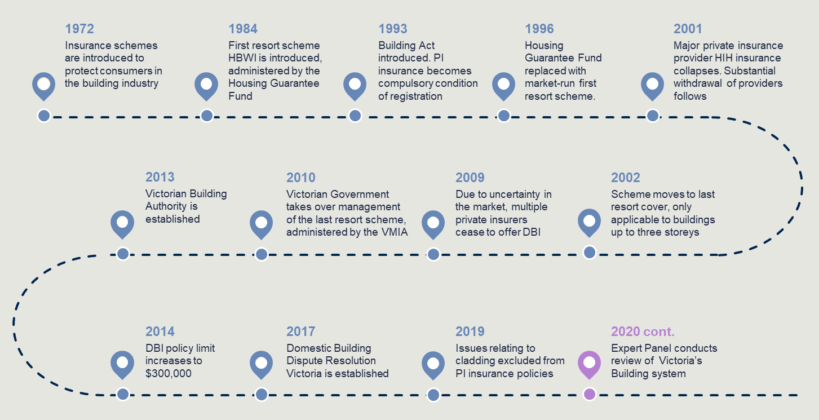

Key issues
Insurance is one component of the broader building system. Insurance can be used to manage risks, provide financial protection for consumers and practitioners, and provide for rectification of defective building work. The insurance market is influenced by how well the regulatory framework manages risks related to non-compliant and/or defective building work.
The Panel has identified two key issues:
- DBI provides some protections to consumers to rectify defects.
- A lack of confidence in the regulatory system has led to declining coverage and increasing cost of insurance over time.

DBI, for buildings of three storeys or less, provides some protections for consumers
DBI is the only mandatory insurance product in Victoria that provides direct protections for building owners. DBI is a last resort scheme that applies only to buildings that are three storeys or less and where the builder has died, disappeared, or become insolvent or, if insured by the VMIA, has not complied with a tribunal or court order.
The increase in residential apartment living means more Victorian homeowners do not have the safety net of this last resort insurance product. The three-storey limitation means that many consumers do not have access to recourse even where the triggers of DBI are met, which leads to costly, time-consuming legal processes to seek recourse against building practitioners. Further, non-mandatory policies that cover damage or loss resulting from structural defects are rarely available in the Victorian market.
In addition to gaps in coverage, the Panel has also heard that there is limited understanding about the protection provided by DBI, including:
  - Consumers may not fully understand the limitations of cover provided by DBI and the nature of building work that is covered.
  - Anecdotally, some practitioners assume that DBI will respond in instances where their work is defective and may not be aware that the policy cannot be accessed unless a prescribed trigger is met (e.g., the builder is insolvent).
  - DBI is not triggered by failure of a builder to comply with a Dispute Resolution Order (DRO) through the dispute resolution system (see chapter 7).

A lack of confidence in the regulatory environment has led to declining coverage and increasing cost of PII
In recent years, there has been increasing pressure on PII driven in part by a lack of confidence in the regulatory system to prevent harms and manage risks. This has resulted in a significant increase in PII premiums and some insurers leaving the market. As a result, practitioners are being exposed to a greater risk when undertaking building work.
This issue highlights limited protections under existing insurance arrangements as well as the broad challenges in developing new insurance products that are commercially viable for insurers to underwrite. It is important to note recent improvements in the PII market for building surveyors. The Australian Institute of Building Surveyors (AIBS) has received a liability cap of $2 million for some of their members. The Royal Institute of Chartered Surveyors (RICS) has obtained an exclusion free PII policy for some of their members.

Proposed recommendations to introduce insurance mechanisms that meet the needs of consumers
Victoria’s building regulatory system could be strengthened through developing a decennial liability, first resort insurance scheme. The Panel recommends a pathway towards a decennial liability insurance model.

Recommendation 6 | Establish a framework to implement a mandatory decennial liability insurance scheme for certain residential buildings which meets the needs of consumers and industry

Description
The Panel recommends the establishment of an Advisory Committee to develop a staged introduction plan for mandatory, decennial liability insurance for certain residential buildings. It is critical that the establishment of decennial liability insurance is economically viable, that stakeholders are engaged on the details of the scheme and that it aligns with the legislative reform agenda. The Committee should develop a plan including the specifications set out in Figure 9.
Figure 9 | Parameters for a decennial liability insurance model
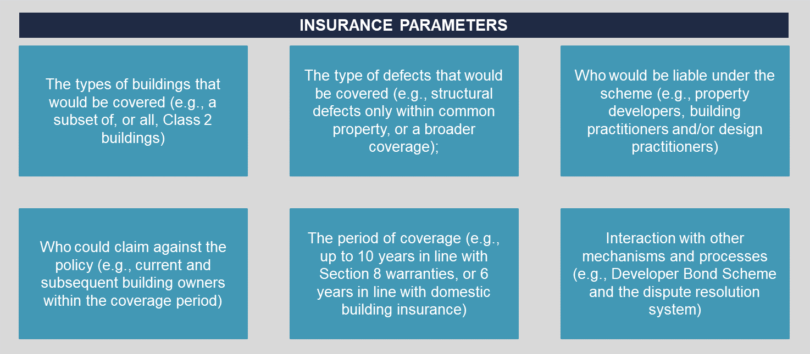
The Committee should comprise experts from the building and construction industry, the insurance sector, consumer groups and the government.

As part of this plan, the Government could support a developer rating system to rank and identify the risk of a developer’s business based on their track record, capital, risk management and ownership structure.
Developer rating systems are voluntary schemes which rank and identify risk of a developer’s business and practice based on their track records, capital, risk management and ownership structure.
Implementation of a developer rating system enables practitioners to understand the relative trustworthiness of the developer they are working for, the financiers to accurately price risk when selecting projects to fund and gives insurers independent verification of the risk of an operator based on past performance. In NSW the iCIRT developer rating system has been taken up by a number of developers. Further analysis of a Developer Rating System could be included as part of the Advisory Committees terms of reference.
A developer bond (see 4.3.2 Recommendation 2) could be considered as part of the transition to mandatory decennial liability insurance.

Rationale
Mandatory first resort decennial insurance for residential apartments four storeys and above will provide consumers with quicker and improved access to rectification when serious defects occur. Insurers would provide consumers with more immediate rectification of defects, and then work with liable parties to recover costs. This will give insurers a strong incentive to drive quality and compliance improvements. It will also help to reduce pressure on other insurance products, including PII.
Supporting the establishment of a developer rating system enables practitioners to understand the relative trustworthiness of the developer they are working for, allows financiers to accurately price risk when selecting projects to fund, and gives insurers independent verification of the risk of an operator based on past performance. A rating tool would improve data and transparency on developers operating in the market.

Outcome
The staged introduction plan – with the involvement of an Advisory Committee – will ensure that all key stakeholders have input into the design and operation of the new insurance system. This ensures consumer protection, affordability and the promotion of best practices. Once the insurance scheme is made mandatory, regular reviews should be undertaken to ensure that it is meeting the Government’s requirements and objectives.
The viability of a decennial liability insurance model will be strengthened when industry and insurance markets recognise the regulatory framework is robust and the regulator will act swiftly and pro-actively against poor performance by all practitioners.


Dispute prevention and resolution

Domestic building disputes can arise across the building lifecycle and may involve non-compliance with legislative and regulatory requirements, breach of contract under the DBCA, a breach of consumer laws, or a claim in negligence. Disputes between building owners and practitioners can be expensive, time consuming and stressful. It is important to have robust systems in place both to prevent disputes from happening and ensure their timely, fair and cost-effective resolution.
In the Stage 1 Report, the Panel made clear that consumer protection should be a central focus of Victoria’s building regulatory system. the Panel made recommendations to strengthen systemic understanding of consumer issues through the Building Monitor and increase the scope for consumers to access individual advocacy services. Reforms to the dispute prevention and resolution system is the next step to strengthen consumer protections.
Recommendations in this chapter focus on the regulatory settings and practices that enable building owners and practitioners to resolve building issues before they escalate and the systems and processes for resolving disputes when they escalate.
As other elements of the regulatory framework (i.e., compliance, enforcement, and insurance) improve, reliance on dispute resolution will be alleviated for new buildings. Nevertheless, there will always be disputes in the system, which require timely and effective services to resolve issues in a manner ‘that is fair and balanced for both consumers and building practitioners.’
This chapter provides an overview of how dispute prevention and resolution in Victoria’s building regulatory system works, the key issues in it and the proposed recommendations to address them.
Proposed recommendations described in this chapter include several actions to improve the prevention of disputes and strengthen the current dispute resolution model. The Panel also presents a potential recommendation for larger structural reform to dispute resolution institutional arrangements.
The recommendations in this chapter build on the Stage 1 recommendations to increase availability of consumer representation, support and advocacy services.

Overview of dispute prevention and resolution
This section provides an overview of how Victoria’s building regulatory system aims to prevent domestic building disputes from occurring. It then describes the dispute resolution system, including the legislative framework, the roles of entities in the system and the process for resolving disputes.

Overview of current dispute prevention mechanisms
There are a range of mechanisms and tools within the building regulatory system that seek – directly or indirectly – to prevent disputes from occurring. This includes several online tools and information resources available to assist building owners and practitioners to resolve disputes themselves:
  - Consumer Affairs Victoria (CAV) provides information to support consumers and builders understand the requirements and terms of a domestic building contracts.
  - The VBA, CAV and DBDRV websites provide information strategies to self-resolve disputes, eligibility for different dispute services and details on the process.
Recent legislative reforms have sought to improve consumer education and awareness around the building contract and building practitioners by:
  - Requiring builders to provide consumers with information on domestic building work before entering a major domestic building contract.
  - Establishing the Register of Building Practitioners which publishes information on the registration status of building practitioners and any disciplinary actions taken against them. The Register was introduced to ‘assist consumers to make more informed decisions about their choice in building practitioner.’
In response to the Panel’s early initiatives, the Department of Transport and Planning (DTP) have streamlined building information relevant to consumers and practitioners into a single front door website. The website is the first stage in the Building Consumer Information and Support Program. This program aims to improve the consumer and practitioner experience navigating the Victorian building regulatory system, improve upfront information, early access to self-resolution pathways and early dispute resolution by navigating consumers to the right agency at the right time.

Overview of the current dispute resolution system
Where disputes escalate beyond local-resolution, consumers or practitioners can access support through a number of agencies. DBDRV, CAV, the Courts, the VBA and VCAT are all involved in the resolution of domestic building disputes. This section briefly outlines the legislative framework, key agencies and processes that make up the dispute resolution system.
The DBCA sets out the consumer protection framework for Victoria’s building regulatory system for domestic building work
The consumer protection framework for Victoria’s building regulatory system – including the mechanisms and processes for consumer recourse – are established under various Acts, including the DBCA and the Building Act. The DBCA sets the remit for both DBDRV and VCAT through the following sections:
  - Parts 2 and 3 regulate domestic building contracts and the statutory warranties that apply to all domestic building contracts.
  - Part 4 defines a ‘domestic building work dispute’ and sets out the powers and functions of DBDRV and the mechanisms for dispute resolution.
  - Part 5 outlines VCAT’s jurisdiction in hearing and settling domestic building disputes.
Fairness to all parties in a dispute – both practitioners and building owners – is a key objective of the DBCA. The Building Act also requires builders carrying out domestic building work to be covered by insurance.
In addition, section 16 of the Building Act protects consumers through registration processes, practitioner obligations and building compliance requirements. This is detailed in chapter 5.
There are opportunities to modernise and improve the DBCA to address gaps in the system and address modern construction practices.

DBDRV is the primary dispute resolution agency in the system
DBDRV is a free conciliation service and the primary resolution body for disputes involving domestic building contracts under the DBCA. DBDRV was established in 2017 under the Building Legislation Amendment (Consumer Protection) Act 2016 (Vic) to address barriers
for consumers accessing low-cost mechanisms to resolve issues in the sector. It came about in response to increasing criticism of the ineffective and voluntary scheme under Building Advice and Conciliation Victoria (BACV).
As noted in the second reading speech Building Legislation Amendment (Consumer Protection) Act 2016 (Vic), DBDRV was intended to ‘respond as early, quickly and inexpensively as possible’ to resolve disputes in a manner ‘that is fair and balanced for both consumers and building practitioners.’
DBDRV can assist to resolve disputes between a building owner and building practitioner, subcontractor, engineer or architect where the dispute is a contractual issue, or where it relates to an allegation of defective building work (i.e., a breach of the Section 8 warranties).
Under the DBCA, a client must lodge a dispute with DBDRV before they can apply to VCAT. Before a building owner or practitioner can access DBDRV’s services, they are expected to attempt to resolve the dispute directly with the other party. The Chief Dispute Resolution Officer has discretion to assess a matter as unsuitable for conciliation if the applicant has, without reasonable excuse, failed to attempt to resolve the dispute before seeking DBDRV’s assistance.
Where conciliation is not possible, or the parties are unable to resolve the dispute via conciliation, DBDRV will issue a certificate of conciliation to enable the parties to apply to VCAT. If a matter is not resolved through conciliation, in some circumstances, DBDRV will issue a DRO. A DRO can order a practitioner to complete, rectify or to pay for the rectification of building work. It can also require a consumer to pay for the completion of work or refrain from any actions that would inhibit a builder’s compliance.,
DBDRV received 5,605
disputes in 2021-22
(equivalent to five per cent of all building permits).
Department of Justice and Community Safety (DJCS)
Safety (DJCS) Annual Report 2021-22 p. 134.
An application to DBDRV must be made within ten years of the date of the occupancy permit, or – where there is no occupancy permit – ten years from the date of issue of the certificate of final inspection. A detailed journey map is provided at Appendix C for how a consumer interacts with DBDRV and the key stages.
Since its inception, DBDRV has been working to fulfil its mandate. It has recently invested in the triaging and early assessment of disputes by developing an online application process that helps clients identify the suitability of their dispute for DBDRV. This has reduced the number of applications made that are out of jurisdiction. DBDRV is currently expanding its use of DROs and technical assessments, which should lead to more effective dispute resolution.

VCAT is an administrative tribunal that can hear matters relating to domestic building disputes, in circumstances where the matter cannot be conciliated
VCAT may hear domestic building disputes involving the building owner only after the matter has progressed through DBDRV or where it has been expedited. Disputes between practitioners, or disputes between an owner and a DBI insurer, on the other hand, can be heard directly by VCAT. They may also hear building disputes relating to a breach of the ACL or where the dispute relates to matters outside of DBDRV’s jurisdiction (including single trades). In 2021-22, VCAT heard 1,128 building dispute-related matters brought under the DBCA. They will attempt to resolve a dispute through mediation or compulsory conference. VCAT also has the power to direct a dispute to a hearing and to issue a monetary or non-monetary order on either party.

CAV can receive complaints and offer limited dispute resolution and triage services
CAV is Victoria’s consumer affairs regulator under the Australian Consumer Law and Fair Trading Act 2012 (Vic). CAV can receive and investigate building issues and complaints relating to breaches of the ACL consumer guarantees and matters relating to single trades that are outside of DBDRV’s jurisdiction.
CAV also oversees the administration of the DBCA. As part of this role, CAV provides information to consumers regarding disputes and offers initial triage and limited dispute resolution advice through the Building Information Line (BIL). The BIL can provide advice to property owners and tradespeople on small building matters. Where it cannot resolve the issue, it will advise consumers to apply to DBDRV or VCAT.

Key issues
This section describes the key issues with current elements of dispute prevention (i.e., preventing disputes from arising) and dispute resolution (i.e., resolving disputes when they arise). These elements influence one another as robust dispute prevention mechanisms empower consumers to resolve issues early and reduce the reliance on dispute resolution mechanisms.

Key issues relating to dispute prevention
Despite available consumer information, the complexity of the building regulatory system contributes to a lack of understanding of roles and responsibilities which can exacerbate disputes. Where disputes arise between a building owner and practitioner, the system does not effectively enable early resolution to prevent issues from escalating. The Panel has identified three issues relating to dispute prevention in the building regulatory system, described below.

Disputes can be caused or exacerbated by limited engagement with the terms of a domestic building contract
Consumers may feel that they are not empowered to vary terms in the domestic building contract, either due to a lack of familiarity with the issues, or to maintain a good relationship with the builder. Resultantly, few building owners meaningfully engage with the contract documents, or fully understand their rights and responsibilities under the contract. Instead, building owners often rely on their practitioners, family and friends for information.
Recent amendments to the DBCA require a builder entering into a domestic building contract to provide a building owner with a Domestic Building Consumer Guide and Domestic Building Contract Checklist. The guide sets out owners’ rights and responsibilities, the roles of the builder and building surveyor, the requirements of a building contract, and the avenues available to consumers if things go wrong. The guiding documents seek to support consumers to engage with the terms of the building contract and understand their rights and responsibilities under it. There are opportunities to improve this guidance to be more user-centric and to better communicate roles and responsibilities. There are also opportunities to modernise the DBCA and address known issues.

There are few mechanisms to assist building owners and practitioners to resolve disputes early and avoid engaging with the dispute resolution system
Where a dispute arises, building owners and practitioners have few mechanisms to assist in resolving a dispute themselves (locally), before engaging with dispute resolution services. While building owners can access information online and receive advice through the BIL, they often don’t know where to go to understand how to resolve their dispute, or the different role played by each agency in the system. Frustration with the system can
worsen where an owner contacts an agency and is referred to another service. While building owners and practitioners are encouraged to attempt to resolve their dispute before they can access DBDRV, support provided in the system to support initial (local) resolution could be improved. This includes access to the Domestic Building Legal Service before entering DBDRV, as recommended in Stage 1, and better guidance for consumers and industry on resolving disputes.

Key issues relating to dispute resolution
Where building owners and practitioners seek resolution services, several issues can cause delays, uncertainty and add to the stress of the resolution process. The Panel has identified two primary issues.

Current dispute resolution pathways may not result in timely or effective outcomes for consumers and building practitioners
Since its establishment, DBDRV has effectively provided building owners and practitioners with a free avenue to resolve disputes across the building lifecycle. However, as the nature of buildings and disputes change, the current model may no longer be fit for purpose. Specific issues include:
  - Triaging processes are not well coordinated or clear to users. There is no single front-door triaging service for consumers and industry within the building system. This leads to situations where consumers reach out to multiple agencies for support, often repeating the same information. This can then contribute to the escalation of disputes by the time they reach DBDRV and may limit the effectiveness of conciliation. DTP’s single front-door website is the first step in a new coordinated triaging service to address this issue.
  - A number of the cases DBDRV receives are not suitable for conciliation. Currently, DBDRV issues a Record of Agreement for 29 per cent of the total applications it receives. This indicates that many of the matters that go to DBDRV are not suitable for conciliation or resolution. Some stakeholders note that the percentage of ‘not suitable’ matters can be linked to the growth in the construction of multi-storey apartment dwellings and complexity in disputes brought to DBDRV. Conciliation is often not appropriate to resolve disputes involving multiple apartment owners or for issues with a high level of technical complexity (such as cladding or water ingress). Instead, these matters often require a VCAT hearing and determination. However, due to the mandatory requirement that parties attend DBDRV prior to commencing litigation at VCAT, these applications must first be assessed and triaged through DBDRV.
  - Technical assessments are not used to their full potential. There is substantial value in the use of technical building assessments to help ‘settle the facts’, clarify the underlying cause of a dispute, and determine whether the building work is non-compliant. However, on average only 14 per cent of cases that progress to conciliation receive a technical assessment, while 50 per cent of applications to DBDRV include an allegation of defective building work. Industry stakeholders consider that too few disputes appropriately engage building assessors, and that greater use of technical assessments early in the process would reduce the time taken to resolve disputes. DBDRV note labour market challenges in obtaining a sufficient number of qualified building assessors to increase the number of technical assessments. The Panel understands that DBDRV is currently recruiting more building assessors and is considering establishing an independent panel of assessors.
  - DROs have been used infrequently. In 2020, DBDRV issued 35 DROs. Less than one per cent of DBDRV’s cases between April 2017 to December 2020 were resolved through a DRO. The Panel is of the view that increased use of DROs would improve the effectiveness of the dispute resolution process. DBDRV is currently reviewing its DRO making function, including analysing its case data to determine whether there are legislative barriers preventing it from issuing DROs in more matters. In recent months, DBDRV has significantly increased their use of DROs with over twice as many issued so far in 2023 compared to the same time in 2022.
  - There are limited powers to resolve disputes between building owners and non-registered practitioners. DBDRV has the remit to conciliate disputes between consumers and unregistered practitioners. However, resolution processes in these instances are restricted in their effectiveness. This is in part due to limited incentive for unregistered practitioners to participate in resolution processes. In addition, stakeholders note difficulties in contacting unregistered builders during the conciliation process which limits the possibility of resolution.

There is scope to improve the DBCA to provide more effective consumer protection and a better dispute resolution framework
The intention of the DBCA was to make the processes for engaging in domestic building work and resolving domestic building disputes ‘as speedy and cost efficient as possible’ to keep pace with industry changes. The Panel is conscious that the DBCA may no longer provide appropriate protection and recourse for disputes that arise in modern residential construction.
For example, the definition of ‘domestic building work’ is not clear or fit for purpose. Stakeholders note that there are often uncertainties as to whether building disputes fit within the definition of domestic building work and are therefore within DBDRV’s jurisdiction. This causes administrative delays in appropriately triaging disputes. For example, disputes between building owners and single trades (i.e., tilers or carpenters) do not fall within the definition of domestic building work and are unable to be brought to DBDRV. The circumstances where work by a single trade can be classified as domestic building work is unclear to consumers and causes confusion. This limits the avenues for recourse where single trades are accountable for building defects. In such cases, the building owner needs to take legal action in the more costly VCAT process. Other areas that could be clarified or improved include requirements related to design work and emerging technologies, including for prefabricated buildings. There are also opportunities to clarify and improve the Order making process and requirements, including for owner builders.

Proposed recommendations for a timely, equitable and cost-effective dispute resolution system
The Expert Panel's review aims to improve building quality and reduce domestic building disputes. However, the Panel acknowledges that disputes will arise regardless of significant reform and improvements. Therefore, improvements to the dispute resolution system are critical for a well-functioning, high-quality building regulatory system that protects consumers and improves consumer agency.
The Panel proposes four recommendations to better prevent disputes from arising and – where they do occur – to resolve them in a timely, equitable and cost-effective manner. These are described below.

Recommendation 7 | Streamline information and reporting processes, develop a practitioner information portal and encourage more local resolution of disputes by co-designing training and guidance materials

Description
All of the Panel’s recommendations are tailored to a more robust regulatory system and these changes will prevent defects from rising. Moreover, the Panel recommends two more actions to streamline available information:
- DBDRV to set and publish regular reports on achievement of performance targets, timeliness and outcomes. This would complement the systemic reporting on common defects and emerging trends by the Building Monitor and contribute to a better dispute prevention system.
- The relevant agencies (the VBA, CAV, DBDRV and VMIA) and DTP to establish a single, integrated portal and to develop a consumer communications strategy for building issues:
  - Establish a single, integrated portal including relevant practitioner details, registration classes, insurance coverage and claims, discipline history and outcomes and other relevant information.
  - Develop a consumer communications strategy detailing the importance of using registered practitioners, checking the portal and using Domestic Building Contracts.
  - Co-design with industry and consumer groups, materials and training on building contracts and dispute resolution for industry.
  - Co-design with industry and consumer groups, dispute resolution and contract guidance and materials.

Rationale
Disputes in the building regulatory system are exacerbated by poor consumer understanding of building issues and the roles and responsibilities of different agencies. Regular reporting by DBDRV will increase information on issues, including emerging trends and defects and support the prevention of these issues arising into the future. Further, in a complex co-regulatory environment with multiple agencies responsible for resolving building issues, coordinated and co-design responses are required.
An integrated consumer portal and improved consumer materials will improve the experience of consumers and their understanding of the system, along with better access to information about a practitioner’s history and insurance coverage. There are also opportunities for training, including mandating Continuous Professional Development for
building practitioners, to include a focus on dispute resolution best practice, including prevention and early resolution.
Together, these reforms will empower consumers and practitioners to self-resolve issues, thereby reducing pressure on dispute resolution agencies.

Outcome
Building consumers and practitioners are provided the right information and tools to proactively resolve issues and understand their rights and responsibilities. Pressure on existing services is reduced as consumers and practitioners are empowered to self-resolve issues.

Recommendation 8 | Identify and address immediate process improvements in dispute resolution by reviewing application and assessment processes and developing a triaging model for all building disputes

Description
The Panel recommends two actions to improve existing processes for the early and efficient resolution of disputes. These are:
- Better Regulation Victoria (BRV) to work with DBDRV to identify improvements to dispute resolution processes which can be implemented to make a difference in the immediate term. This includes a review of the application and assessment processes.
- Develop an effective triaging model for all building disputes. Early upfront triaging, categorisation and lodgement processes would enable the efficient resolution of disputes. The service would categorise cases based on the nature of the issue and would allocate a technical assessment if required to resolve the dispute. It would also complete a jurisdictional check and decide on what initial resolution pathway is most appropriate (Orders, mediation or other) and place the dispute into the appropriate resolution pathway (see 7.3.4 Recommendation 10). Triaging of disputes would be done through a simple, user-friendly online system and phone service, accessible by both building owners and practitioners.

Rationale
The proposed recommendations are intended to address current process issues and delays experienced by consumers and practitioners at DBDRV Improvements to the triaging system will assist resolution of disputes more efficiently in a way that builds on existing services.

Outcome
Improvements to DBDRV’s processes and triaging model will enable issues to be addressed quickly, technical assessments assigned as required and cases more effectively allocated to the right resolution pathway (e.g., Orders). These improvements will result in faster resolution and a better experience for consumers and practitioners.

Recommendation 9 | Improve the effectiveness of dispute resolution services by increasing the use of technical assessments and rectification orders, allowing single trade disputes to be heard at DBDRV and removing any process duplication with VCAT

Description
The Panel further recommends several reforms to improve building dispute resolution services to better meet community expectations. These include:
- Embed the use of technical assessments as a core function where disputes relate to defective building work. Technical assessments can be effective across the whole dispute resolution process where there are technical issues, such as to inform the application of an Order. Where appropriate, technical assessments should be used proactively to resolve disputes where the primary issue is non-compliance. Increased resourcing would be required to support additional building assessments. To facilitate this, consideration could be given to pooling assessors from across the relevant agencies (the VBA, DBDRV, VMIA and other agencies with building assessors) or increasing the availability of technical assessors and assessments by DBDRV. Technical assessments would be allocated with an improved triage service (see 7.3.2 Recommendation 8B)
- Increase use of Orders to rectify non-compliance where conciliation is not appropriate. Currently, dispute resolution processes are heavily reliant on conciliation mechanisms. There is an opportunity to increase the use of Orders to resolve disputes, particularly where there are clear instances of non-compliance. This may involve amending the criteria which DBDRV can consider when making an Order (e.g., the process for owner-builders). Note the use of Orders in the dispute resolution system may become less critical if post-occupancy enforcement functions are introduced so that non-compliance with the building regulatory system is dealt with by the regulators (see 5.3.1 Recommendation 4). The improved triage service could determine, initially, whether an Order may be more appropriate (see 7.3.2 Recommendation 8B).
- Allow single trade disputes to be considered by the building dispute resolution agency. Single trade work refers to situations where a tradesperson has carried out only a single type of work. Currently this is outside the scope of DBDRV. In the event of disputes, the building owner is therefore required to take legal action through the more costly VCAT process. This should be amended to ensure the future dispute resolution system adequately captures all issues in the system and provide better protection for consumers, many of whom engage single trades only.
- Reduce any duplication between VCAT and DBDRV and make their processes more effective and efficient. Ensure that when cases proceed to VCAT, that DBDRV and VCAT implement processes to remove any duplication and to facilitate efficient resolution of disputes. This would include ensuring that DBDRV technical reports continue to meet VCAT’s standards.

Rationale
The proposed recommendations above intend to address a number of issues with the current dispute resolution system. Increasing the use of technical assessments will give a better understanding of the potential defect, dispute and expedite a resolution. Coupled with the use of Orders, building disputes relating to defective work will be resolved quickly and effectively. Amending the jurisdiction of DBDRV to cover single trade disputes will more closely align its scope and powers with the types of disputes occurring in the system. Removing any duplication between VCAT and DBDRV will improve the experience for practitioners and consumers.

Outcome
Consumers and practitioners can resolve disputes in a timely, equitable and cost-effective manner. This recommendation will help support more effective, low-cost dispute resolution, and support earlier, more conclusive resolution of disputes.

Recommendation 10 | Consider structural reforms to the dispute resolution institutional arrangements

Description
While the issues outlined in this chapter can be addressed through changes to the current dispute resolution approach, the Panel also recommends that, in the longer term, the Government consider major reforms to the institutional arrangements for building dispute resolution. For example, the establishment of a new single organisation to receive, triage and resolve disputes. A single body would make the system simpler for consumers and industry and could allocate cases more efficiently to different pathways. It could involve combining DBDRV and relevant domestic building disputes from the VCAT Building & Property List.
In addition, new resolution pathways could also be considered, including:
  - Enable the new resolution agency to inquire into the circumstances of the dispute (i.e., request information and seek documents) and the power to decide a dispute following an investigation.
  - Create additional powers (e.g., arbitration processes) to provide for more effective resolution, for certain disputes.
  - Dispute avoidance mechanisms, including contract facilitation support could also be considered.
These additional pathways and structure could be considered as part of the domestic building consumer framework.

Rationale
An effective pathway to resolve building disputes is critical to a well-functioning building regulatory system. As described above, the current model was established with the intent to ‘significantly reduce the costs [and] stresses that come with formal legal proceedings.’ Since its establishment, the nature of building disputes has changed with a greater number of complex defect issues multiple stakeholders – apartment dwellers, building practitioners and other accountable parties. The current model can be improved but may no longer be fit-for-purpose to address the broad range of disputes and issues in the building system. Therefore, there is a desire among stakeholders to ensure arrangements are in place to resolve building disputes in a way which embeds confidence in the outcomes for consumers and practitioners alike.

Outcome
The Panel believes that a single dispute resolution body (e.g., a separate tribunal) would reduce complexity in the system by creating a centralised entry point that can allocate and resolve issues more efficiently. Additional pathways, including inquiry, arbitration and dispute avoidance, would facilitate the efficient resolution of issues and may produce more satisfactory outcomes for both consumers and practitioners.


Building maintenance, products and technologies

The building legislative framework aims to protect the health and safety of people who live in and use buildings across the building lifecycle. This includes during the design and construction of buildings but also extends to the maintenance of completed buildings. The primary regulatory safeguards to oversee building maintenance are Essential Safety Measures (ESMs). ESMs include active fire systems (i.e., sprinklers, fire hydrants) and passive fire safety systems (i.e., smoke alarms, emergency exits and lifts). The ongoing maintenance and compliance of these ESMs helps to ensure our buildings, and those that live in them, remain safe.
Part of maintenance is ensuring that building and plumbing products, whether they are imported or manufactured in Victoria, are safe and compliant. Innovations in product manufacturing and construction processes present opportunities for a more efficient, higher-performing, and cost-effective building sector. Further, recycled materials in building products can reduce waste and the environmental footprint of construction and building work. The adoption of new innovative technologies and practices should be supported without compromising safe and compliant construction processes and our built environment.
This chapter provides an overview of current regulatory framework for building maintenance and a brief description of new and emerging plumbing and building practices. It then describes key issues in the oversight of maintenance and regulation of new practices and proposes several recommendations to ensure our regulatory system for plumbing and building remains fit for purpose now, and into the future. A building regulatory system that supports the safe adoption of new technologies will continue to be a focus of the Panel in Stage 3, when the Panel will turn its mind to a new, technology neutral Building Act.

Overview of building product compliance and emerging technologies and practices
This section describes the regulatory controls and safeguards for building technologies and processes and the Victorian Government’s current investments in new technologies and practices. It outlines:
  - the role of the performance-based NCC;
  - the role of the Plumbing Code of Australia (PCA) in plumbing accreditation;
  - the process for building and plumbing product accreditation; and
  - recent investments in innovative approaches to improve efficiencies and support improved regulatory practice.

The NCC sets the technical standards and performance requirements for building and plumbing work in Australia
The NCC aims to ensure that all building and plumbing work meets nationally approved standards for the design, construction, performance and livability of all buildings. The NCC is a performance-based building code. This means it sets mandatory minimum performance requirements for buildings with which practitioners must be able to demonstrate
compliance. Its aim to is efficiently enable the achievement of minimum necessary standards for health, safety (including structural safety and safety from fire), amenity and sustainability objectives.
The NCC is split into three volumes. Volumes 1 and 2 – which collectively set the performance standards for all ten building classes – and Volume 3 which covers plumbing and drainage standards. There are four levels in the NCC that demonstrate how objectives are translated into standards for the construction of buildings. Broadly, levels 1 and 2 are ‘guidance levels’, and levels 3 and 4 are ‘compliance levels’. Figure 10 depicts the hierarchy of the NCC.
Figure 10 | Hierarchy of the NCC
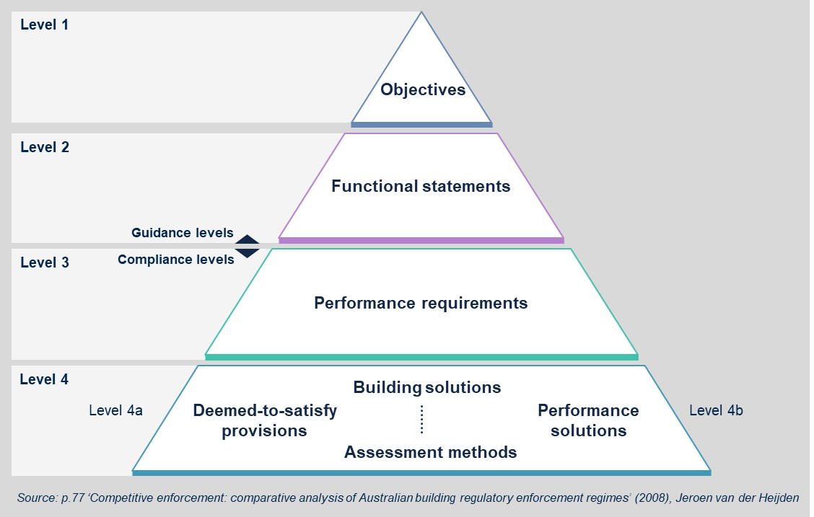
The NCC performance framework enables building and plumbing practitioners to incorporate new practices as they arise while still meeting compliance requirements.
The NCC is amended in three-year cycles through a public consultation process to ensure it is updated in response to new technologies and practices. Specific amendments can also be proposed by the public at any time.

The PCA prescribes the technical requirements for the design, construction, installation, repair and maintenance of plumbing systems
The PCA sets out the technical standards for plumbing work and the scheme for authorisation and certification of plumbing products. Under Part 5A of the PCA, plumbing practitioners must not install any plumbing or drainage products listed in the technical standards unless there is evidence the product is fit for its intended purpose to achieve the relevant requirements of the NCC. The WaterMark Certification Scheme certifies products that meet PCA requirements. Further detail on WaterMark Certification scheme is provided
below.

There are national and state-based product accreditation processes for building and plumbing products
Product accreditation is the process of verifying that new products can be used by building and plumbing practitioners and meet the performance requirements of the NCC. A building surveyor must accept an accredited product if the use complies with the certificate of accreditation.
There are three entities in Victoria’s building regulatory system that have a role in accrediting new building products and practices:
  - Building Regulations Advisory Committee (BRAC) can accredit building products under the Building Act, including construction methods, design components or systems connected with building products on application. Any product that is accredited by BRAC automatically fulfills the compliance requirements under the NCC. Accreditation is voluntary and must be renewed every three years. A register of accredited products is available on the VBA website, which also outlines revoked accreditations. BRAC also has a role in advising the Minister for Planning on building product regulation.
  - CodeMark is a national non-mandatory building product certification scheme that provides a method for verifying that a building product meets the nominated requirements of the NCC. It is managed by the ABCB. A building product can be accredited with either BRAC or CodeMark.
  - WaterMark is a mandatory certification scheme for plumbing and drainage products used in plumbing work in Victoria. Any new plumbing or drainage product introduced into the market will be assessed by WaterMark Conformity Assessment Bodies (WMCAB). If the product is part of an existing category of regulated products it will be assessed against existing technical specifications. If it is a new product not currently listed on the WaterMark Schedule of Products or Schedule of Excluded Products, ABCB will undertake a risk assessment to determine if the product should be regulated by WaterMark and, if so, a technical specification will need to be developed. The process for WaterMark accreditation is illustrated in Figure 11.

Figure 11 | Flow chart for product certification in Victoria

Government has invested in building innovation to support regulatory compliance and meet industry and community expectations
The Government is investing in building innovation to reduce waste and support industry wide digitisation of construction processes and compliance.

Investment in the Building Information Modelling (BIM) and the Digital Twin will create efficiencies across the planning and building approvals process
BIM is a digital representation of the physical and functional characteristics of a building. BIM is one tool that can inform the creation of a Digital Twin. Digital Twin refers to the digital replication of physical assets, construction and systems. It is an online database that can store live information across the building lifecycle, including permit approvals, construction processes and materials, and post-occupancy usage details (such as energy use) in a user-friendly format.
BIM and, more broadly, a Digital Twin, has clear consumer benefits. As noted in the Panels’ Stage 1 recommendations report, the availability and quality of documentation across the building lifecycle during design, construction and maintenance is a critical enabler of an effective building approvals process. Without clear documentation, consumers have little oversight on what is occurring (or has occurred) in their building project. The Panel has heard that where defects or complaints arise, consumers may be
unable to trace the documentation to determine the relevant responsible practitioner. The Digital Twin can help to improve record keeping for building projects and maintenance requirements and better empower consumers to oversee ongoing compliance during and after the construction process.
A Digital Twin also support more streamlined and accurate compliance activity. For example, DTP in partnership with Development Victoria, the VBA, the Office of Projects Victoria and Brimbank City Council have successfully completed the Proof of Concept testing of a planning and building assessment tool as a trial of the Digital Twin technology (illustrated in Figure 12).
Figure 12 | DTP's eComply trial
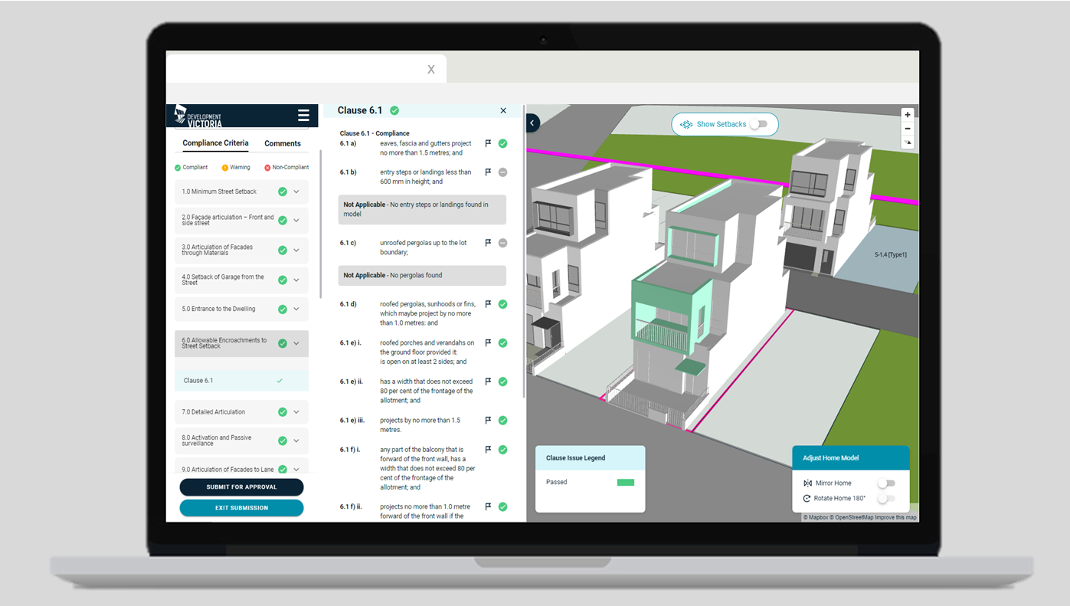
eComply uses BIM to assess the compliance of digital building designs with the Small Lot Housing Code. BIM models can be uploaded to the system by builders, developers or architects which are then examined against compliance criteria and can be approved in real-time. This technology is now currently entering its second development phase for public release in 2023.

New processes and practices in the building sector can reduce waste and contribute to Victoria’s broader sustainability targets
Construction is a leading contributor of landfill waste, producing 20 million tonnes of waste each year. Just over 40 per cent of this waste is recycled, with the rest going to landfill, illegally dumped, reprocessed, or stockpiled. Reduction of construction waste and the support for recycled building materials has been a focus of recent reform in Victoria. The Victoria’s Built Environment Adaption Action Plan aims to embed climate change adaptation into the building environment. Over the next 5 years, the plan aims to strengthen and extend existing climate change responses; build adaptation capacity across government, the private sector, and the community; and establish regulatory and other frameworks needed for long-term transformative action. This includes embedding the use of adaptive building products and infrastructure.
Further, the Victorian Supply Chain Review found that increased research and development in the use of recycled materials is necessary to address these constraints and support Victoria’s transition to a circular economy. The increased use of recycled materials, particularly recycled bricks and timber, can improve the supply of materials and strengthen the supply chain in case of future market shocks.
The Victorian Government is supporting research and private sector development of new construction initiatives and practices. This includes Building 4.0 CRC, an industry-led research initiative which aims to identify and encourage the use of new sustainable building products. This work is supported by the VBA. Similarly, the Victorian Government’s Recycling Victoria Innovation Fund has supported the use of recycled materials in prefabricated methods through grants programs.

Overview of building maintenance
Legislative requirements for building maintenance are primarily set out in the Building Regulations and the Owners Corporations Act. These two legislative frameworks are summarised in Figure 13 and explained below.
Figure 13 | Regulatory parameters of ESMs and maintenance

The Building Regulations and the NCC set out the building regulatory framework for ESMs
ESMs are the safety systems that must be installed in buildings to ensure the health and safety of those who occupy the building. ESMs are designed to operate as a networked system to safeguard the occupants and provide a coordinated response to specific emergencies. The maintenance of ESMs helps to ensure that a building’s safety systems are working at the required operational level throughout the life of a building.
ESM maintenance requirements apply to all buildings apart from a house or outbuilding. That is, they apply to Class 1b and Class 2-9 buildings. The NCC sets out which ESMs must be installed for each type of building. Installation requirements for ESMs vary across building class, based on the size, potential risks and intended use of buildings. This recognises that different types of buildings are susceptible to different threats.
Part 13 of the Building Regulations require the RBS to specify, in the occupancy permit, all required ESMs; how they must perform; the frequency and type of inspection; and the testing and maintenance that is necessary. Part 15 outlines the ongoing maintenance requirements which must be listed in a maintenance schedule that captures all ESM requirements specified in the occupancy permit.
Building owners and occupiers have maintenance obligations under the Building Regulations. Owners are required maintain all ESMs and ensure they operate satisfactorily. Owners must also prepare an annual ESM report and keep records of maintenance checks, safety measures, and repair work. Occupiers also have obligations to maintain ESMs in their lot and keep all exits and paths of travel clear of obstructions. In apartment buildings, OCs are responsible for ESMs in common property, this is described in further detail below.
MBSs and fire authorities have co-regulatory responsibilities for overseeing ESM compliance and maintenance. The RBS is responsible for ensuring compliance with the NCC during the building approvals process. The MBS and fire authorities are responsible for enforcing maintenance provisions and may inspect properties and ESM maintenance either jointly or separately. Non-compliance with ESM maintenance requirements may result in infringement notices, building orders, emergency orders, fines or prosecution on the responsible parties (building owners).

The Owners Corporations Act places additional maintenance responsibilities on OCs
The Owners Corporations Act sets out management, powers and functions of OCs, including relating to building maintenance. Under the Act, OCs are responsible for maintaining all common property and services that benefit more than one lot, including any ESMs that are ‘services’. Individual lot owners in an OC remain responsible for maintaining any ESMs that exist in their individual lot.
The Owners Corporations Act also regulates building maintenance beyond ESMs. For instance, OCs with more than 50 lots are required to prepare and approve maintenance plans to fulfil their obligations. Maintenance plans have a much broader scope than ESM maintenance schedules. Along with the maintenance plans, these OCs must establish a maintenance fund – into which all lot owners contribute – to cover anticipated maintenance and repair works outlined in the plan.
Often large OCs will hire an OC manager to deliver the maintenance plan. The OC manager is responsible for overseeing maintenance and repairs (including of ESMs in shared spaces); managing the maintenance fund; and maintaining insurance. OC managers must be registered with the Business Licensing Authority (BLA).

The Owners Corporations Act has recently been subject to substantial reform which has sought to increase the rights of owners and increase accountability of developers and OC managers.

Key issues
The Building Regulations currently rely on ESM maintenance as the key regulatory safeguard after building work is complete. Safety risks arise where ESMs are not appropriately maintained due to poor understanding of maintenance obligations and minimal compliance monitoring. As buildings age, normal deterioration can cause health and safety risks to those who occupy and use them. ESM requirements specified in an occupancy permit may not remain applicable over time, either through natural deterioration, significant events such as natural disasters or changes in the use of buildings.
The Panel has identified fives issues below which contribute to poor oversight and maintenance of buildings post occupancy. These are described below.

There are overlapping obligations in relation to ESMs and maintenance, particularly for OCs
ESM maintenance schedules can be complex and include a range of different safety requirements. Failure to comply with ESM maintenance requirements can cause significant health and safety risks. The Neo200 apartment tower fire is an example where inadequate maintenance of ESMs by contractors led to substantial fire damage. Anecdotally, building owners often do not understand their obligations and how to discharge them. Regulatory entities in the system also note ongoing concerns with compliance of ESMs.
This is further complicated in apartment buildings where OCs engage managers to maintain the property. In such cases, lot owners often assume the responsibility for maintenance shifts to the OC manager where, in fact, the owners of a building remain responsible for non-compliance with the ESM maintenance schedule under the Building Regulations. Further, there are no competency requirements for OC managers in relation to ESM maintenance or requirements to support owners to understand their obligations.

In practice, there is limited compliance monitoring of ESMs and maintenance requirements
MBSs and fire authorities are primarily responsible for monitoring and enforcing compliance of ESMs and maintenance requirements. The following reasons contribute to poor oversight of ESMs by the regulatory authorities:
  - Local councils and fire authorities do not have sufficient resources to carry out quality inspections of the 800,000 buildings in Victoria with ESM maintenance requirements. For example, there are currently ten Fire Safety Inspectors (FSIs) operating across Victoria. Due to these resource constraints, Fire Rescue Victoria (FRV) can only inspect approximately 260 buildings per year.
  - MBSs and fire authorities rely on maintenance records to be completed accurately for their inspections. Certain ESMs, such as sprinkler systems, are difficult to properly test and require up-to-date reporting to effectively test. Records of ESM maintenance can differ substantially in quality and accuracy and often fail to reflect upgrades to the property and ESMs. The lack of up-to-date information on building performance can affect the response of emergency services in case of an emergency.
  - There are different maintenance obligations for buildings constructed before the introduction of ESM requirements with amendments to the Regulations in July 1994.
  - As such, installed ESMs may not be appropriate and maintenance obligations of existing ESMs may be unclear.
  - There is little oversight by the regulatory authorities on ESM maintenance and whether obligations are being met. For example, while MBSs and fire authorities can request annual ESM reports, there is no requirement in the Regulations for owners to periodically provide these. Stakeholders note systemic non-compliance by owners and OCs in completing annual ESM reports and compliance checks.

ESMs and maintenance requirements for buildings are largely determined at the point of occupancy and may not be flexible to changing circumstances
General enforcement provisions in the Building Act allow for the MBS (or the PBS on the MBS’ behalf) to review any risk to the life, safety, or health of any occupant in a building. This includes upgrading ESMs of older buildings to current standards and practices where necessary to protect occupants, including where new hazards and risks have emerged or new technologies are available. ESM requirements will also be reviewed and amended if the class or use of the building changes. Building owners (including OCs) are required to provide annual ESM reports and confirm that ESMs are maintained appropriately.
These reports only focus on demonstrating the compliance of ESMs, not whether the maintenance schedule remains fit for purpose against changing circumstances. This is likely to be an increasingly significant issue given the environmental effects of climate change, for example greater severity and frequency of natural disasters. Improving the adaptability of the building environment in response to climate impacts is the focus of the Victorian Governments’ Built Environment Action Plan. The Panel is cognisant of such reforms and recognises the need for improvement in these areas.

The plumbing legislative framework may no longer be fit for purpose
The growth of more complex plumbing systems, prefabricated bathroom and kitchen modules and the use of new plumbing products and technology present challenges for the sector and regulators to ensure that plumbing work is safe and fit for purpose. The Panel has identified three key issues:

The regulatory framework is not equipped to address the growth of complex plumbing systems
Compared to plumbing systems used in single-storey building or homes, those used in multi-storey residential buildings and non-residential settings – such as schools, hospitals and shopping centres – are sophisticated and complex to design and install. Due to their technical nature, these systems can present serious health and safety risks to building occupants if inappropriately designed or installed.
Currently, the Building Act and Plumbing Regulations do not distinguish between complex and non-complex plumbing work and the same regulatory requirements broadly apply to all plumbing work. Stakeholders suggest that this approach is no longer appropriate and that there are inadequate regulatory controls to oversee the design and installation of complex plumbing work. Specific issues are:
  - All licensed plumbers can certify complex plumbing systems, despite no additional training or qualifications. While some licensed plumbers are suitably experienced to prepare designs, or assess compliance of complex plumbing designs, including multi-storey plumbing and drainage systems, others may not be.
  - Complex plumbing systems are often designed by hydraulic engineers who are not required to be registered or licensed. Where issues arise that are the fault of poor design, liability for non-compliance rests solely with the licensed plumber who provided the compliance certificate.

The regulation of prefabricated plumbing work is unclear and may place undue liability on plumbers
In 2016, the VBA published a fact sheet providing guidance on the regulatory requirements for the off-site construction of prefabricated plumbing systems. The fact sheet outlines that off-site construction of plumbing systems can be classified as either ‘regulated plumbing work’ (if carried out in Victoria), or as ‘work involved in the construction of a plumbing product.’ The relevant licensed plumber is responsible for determining how the work is classified and ensuring it complies with the plumbing laws.
In late 2016, the ABCB published a Notice of Direction providing similar guidance in relation to prefabricated plumbing modules. These two compliance pathways involve substantially different processes and regulatory safeguards:
- Regulated plumbing work. Prefabricated plumbing systems defined as regulated plumbing work must be carried out by a registered or licensed plumber. All products and materials used in the work must be fit for purpose, including a WaterMark certification where required. A compliance certificate must be issued at the completion of the work by a licensed plumber.
- Work involved in the construction of a plumbing product. Prefabricated plumbing systems – defined as a plumbing product – require a licensed plumber to certify compliance in respect to the onsite installation of the system.
Some stakeholders note approach to define prefabricated plumbing work as a plumbing product can lead to inappropriate concentration of liability and risk on the plumber installing the system. This is because the plumber generally only makes the connections leading to and from the prefabricated system. Any failure of a plumbing product lies with the manufacturer to resolve, but some stakeholders believe that blurring the line between prefabricated plumbing work and products may result in plumbers being blamed for defective work that is the fault of the product manufacturer.
Stakeholders argue that as the distinction between prefabricated plumbing products and plumbing work becomes less clear, it may be more difficult to objectively establish the source of non-compliance for prefabricated systems. This can limit the ability for consumers to obtain adequate and timely recourse for non-compliant work.

The plumbing certification process may not effectively regulate plumbing products
Since WaterMark began certifying prefabricated plumbing work in 2018, the scope of prefabricated systems has significantly expanded from small all-in-one shower cubicles to large bathroom modules, and modules containing a combination of laundry, bathroom and/or kitchen elements.
Some stakeholders suggest that prefabricated modules are more aligned to plumbing work than plumbing products and that there may not be appropriate regulatory controls through the WaterMark Certification Scheme to adequately ensure safety and compliance of complex prefabricated systems. Specifically:
  - The WaterMark Certification Scheme may not have the expertise required to assess compliance of larger modules. Prefabricated plumbing modules, such as bathroom pods, are constructed complete with all internal plumbing pipework and fixtures already installed before the module arrives on-site for installation. Where prefabricated plumbing modules are completed as plumbing work, these connections are completed by a registered or licensed plumber. However, when they are certified products, their compliance as a product is assessed by the WMCAB. Some plumbing stakeholders raise doubts about whether the WMCAB have the required technical
  - expertise to assess the compliance of these internal plumbing works on a prefabricated module during the product certification process. In addition, it is difficult for the installing plumber onsite to assess the compliance of the internal works within the module prior to making connections to and from the system.
  - There may be insufficient regulatory oversight of prefabricated systems during manufacturing. There are no requirements that registered or licensed plumbers are involved in the manufacture of a prefabricated plumbing product. The Panel understands that currently the role of plumbers in the manufacturing of prefabricated modules varies between manufacturers. While some manufacturers use registered and licensed plumbers to construct, or oversee the construction of, prefabricated systems, others do not. This raises further concerns among stakeholders as to the compliance of prefabricated plumbing systems about the suitability of the WaterMark Certification Scheme for certifying these products as an alternative compliance pathway.

Proposed recommendations to improve building maintenance and support a digitally enabled building regulatory system
The Panel is proposing four recommendations to strengthen regulatory safeguards for building maintenance, improve operations of OCs and to facilitate the use of new building and plumbing technologies and practices.
As new technologies, materials and building practices emerge, the regulatory framework will need to be flexible and responsive to support innovation, while maintaining compliance and safety. A key focus of the Panel’s work in Stage 3 of its Review will be to make recommendations to support a future-proof, technology-neutral Building Act. To inform its deliberations in Stage 3 of the Review and to identify early opportunities to address key issues, the Panel is interested in stakeholders’ perspectives on current barriers to the development and uptake of new building technologies, information, practices and materials.

Recommendation 11 | Strengthen compliance monitoring and enforcement of existing maintenance schedule requirements

Description
The Panel recommends increasing the oversight of building maintenance by:
- Increasing the focus on ESMs and other maintenance requirements and strengthen sanctions where ESM maintenance has not been complied with. This could be supported by improving the coordination between the MBS, FRV and Country Fire Authority (CFA) to develop a risk-based ESMs maintenance approach.
- In addition to the annual ESM inspection introduce regular (such as five year) inspection periods to assess whether ESMs remain fit for purpose. As part of this new inspection, MBSs or the private inspector would assess whether ESMs have been compromised by refurbishments, test if they remain effective and appropriate, and determine whether they must be altered in response to changing building requirements.
- Require OCs to implement recommended changes from the ESM inspections. This would involve introducing a requirement for OCs in apartment buildings to implement any changes to ESMs and maintenance requirements that arise from the proposed inspections detailed above in this recommendation. This could include altered maintenance requirements in response to environmental change, refurbishments, or the natural aging of buildings.

Rationale
The investigation of the 2019 Neo200 fire found that the fire was exacerbated by issues with the building’s ESMs. ESMs had not been adequately maintained, and residents had tampered with passive systems such as smoke alarms. Cladding Safety Victoria’s (CSV) investigation of Victoria’s building safety systems also revealed widespread issues with ESMs in common areas, including instances where fire hoses were not attached to a water supply, non-compliant fire doors had been installed, or there was an inadequate number of fire exits. Adequate oversight of ESMs after a building is occupied is critical to keeping those inside safe.
ESMs must keep pace as buildings are refurbished, retrofitted or upgraded. In light of evolving technologies, many domestic buildings are being retrofitted to include the installation of EV batteries and solar panels. These additions can change the safety profile of the building and what is required from ESMs.

Outcome
Strengthened compliance monitoring and enforcement of maintenance requirements will ensure that buildings remain safe overtime, especially in response to changing circumstances, environmental changes and natural ageing.

Recommendation 12 | Strengthen competencies and obligations of OC managers and OCs in relation to ESMs and maintenance requirements

Description
The Panel recommends increasing the required competencies of OC managers with respect to ESMs and other maintenance requirements. OCs must be informed of their obligations in relation to ESMs and maintenance requirements to ensure they remain effective and fit-for-purpose. This includes their obligations to produce an annual ESM maintenance report with a statement of compliance.
As part of obtaining registration, OC managers could be required to undertake professional development in ESM obligations and record keeping. Materials could also be developed to support OCs to employ OC managers that understand ESM requirements and their ongoing regulatory obligations in relation to building maintenance.

Rationale
MBSs and fire authorities rely on completed and up-to-date maintenance records to accurately assess compliance. In practice, these often vary in quality and fail to reflect upgrades to the property and ESMs. Where owners engage OC managers, they are responsible for ESMs in common property. However, owners remain responsible for ESM compliance in individual lots. As part of their role, OC managers should have an ongoing responsibility to inform and educate lot owners about maintenance and compliance obligations. Currently, there are no competency requirements for OC managers in relation to ESMs. This leads to a lack of understanding by OCs and individual lot owners about ESM maintenance requirements, and contributes to inconsistent reporting and poor compliance.

Outcome
Strengthening competencies and obligations of OCs and OC managers will better ensure ongoing safety throughout a building’s lifespan. Increasing competencies of OC managers
will contribute to more informed building owners and more accurate annual ESM maintenance reports.

Recommendation 13 | Strengthen regulatory requirements relating to complex plumbing work

Description
The Panel proposes four recommendations to strengthen the regulatory requirements for complex plumbing and shift away from the current one-size-fits-all approach to support a modern, future-proof regulatory framework that tailors oversight to risk. These recommendations build on the Panel’s Stage 1 Report which recommended that specialist design services (including plumbing design) be considered as a practitioner class under the Plumbing Regulations. Plumbers or designers performing hydraulic design work would be required to be registered or licensed, hold relevant PII, meet certain competence and qualification requirements, and be subject to regulatory oversight by the regulator.
- Introduce a definition of complex plumbing work. Complex plumbing work could be defined in the Act and Plumbing Regulations to provide clarity about the activities and types of services that would fall under any changed regulatory requirements.
- Require notification to regulator of complex plumbing work. Persons licensed in a new class of work for hydraulic design could be required to notify the regulator of complex plumbing work before it commences. This could improve information available to the regulator and enable the regulator to focus its compliance activities to inspect work during the construction process.
- Consider introducing requirements for inspection of complex plumbing work. The Government should consider introducing requirements for inspecting these complex works at key stages of the construction process. This could be done by licensed practitioners or the building regulator to ensure that any issues can be detected and rectified prior to commissioning of the system.
- Introduce certification of designs. Licensed hydraulic designers could be required to certify their designs to more appropriately apportion risk between the installing plumber and the design practitioner.

Rationale
The current regulatory framework for Victoria’s plumbing sector – including the compliance certification and registration and licensing processes – is broadly robust and effective. However, it is not equipped to address the growth of complex plumbing systems. The Building Act and Plumbing Regulations do not distinguish between complex and non-complex plumbing work and the same regulatory requirements broadly apply to all plumbing work. Moreover, the scope of prefabricated plumbing work certified under WaterMark has expanded significantly since 2018, increasing the need for clarity over prefabricated plumbing work that it otherwise defined as a pluming product.

Outcome
Complex and prefabricated plumbing systems will be adequately captured and regulated to address gaps in accountability and to keep pace with the production and design of new products and processes.

Recommendation 14 | Enable the adoption of new technologies, practices and products

Description
The Panel recommends the regulatory system enables:
  - the increased use of recyclable materials, where appropriate; and
  - the adoption of BIM (3D technology) and Digital Twin by the industry and regulatory entities.
Ongoing support should be provided for existing programs to incentivise the uptake of alternate building materials and additional programs which align with the targets of the National Waste Policy Action Plan. This can reduce construction waste and relieve supply chain constraints. Both safety and quality will need to be assured with the adoption of new construction practices. Regulatory settings must therefore be done in a way that is outcomes focused.
This may include amendments to the legislative framework to remove regulatory barriers that otherwise prevent the adoption of new technologies, practices and products.

Rationale
Improvements to the regulatory framework can incentivise innovation. The new regulatory system needs to enable innovative building practices and digital technologies and be responsive to increased demand for recycled products and greater sustainability of the built environment overall. In the longer-term, there is an opportunity to further embed new building software in regulatory compliance processes. For example, 3D modelling and project-management software can collate data from a building site to create real-time version of projects during construction. This gives the regulator a clearer line of sight to determine whether non-compliance arises as a result of the designs in the building permit, or failure by a builder to build to the building permit. In Stage 3 of the Review, the Panel will propose a new building legislative framework. A key feature of this will be technological neutrality to ensure that it is sufficiently flexible to support future advancements in building technologies.

Outcome
The regulatory environment will be flexible to new building technologies and practices – such as the use of recycled, alternate materials and prefabricated building work – while ensuring compliance and protecting the health and safety of those who occupy and use buildings.


Next steps
In Stage 3, the Panel will look to develop a new Building Act that is technology neutral and responsive to a modern construction sector. In establishing a new Building Act, the Panel will consider how the form and operation of the Building Act and Regulations might be reformed for the benefit of the Victorian building industry, consumers and the economy.

- - Early Initiatives
As requested in the Terms of Reference, the Panel has advised the Minister for Planning on some Early Initiatives to improve the building system.
Establish a centralised building consumer information and support service
There are five key Victorian government agencies which interact with consumers of building services:
- ARBV;
- CAV;
- DBDRV;
- VBA; and
- VMIA.
Consumers often find it difficult to identify which body they should contact to seek information, make a complaint or resolve a dispute.
The centralised service would support consumers by:
- providing a single, easily accessible first point of contact;
- assisting them to navigate the building system by directing them to the correct organisation more efficiently;
- cutting down delay, misinformation and unnecessary referrals; and
- providing easy access to basic information about the building system targeted to the consumer’s particular circumstances.
The service could also provide information for consumers on the importance of regular building maintenance.
This initiative would have a number of benefits, including increasing consumer confidence, addressing information asymmetry, and improving consumer awareness and education effectively and efficiently in accessing the sector.
Consider a pathway to project-based insurance in Victoria
PB insurance policies can provide a single, first resort, insurance instrument that unites the interests and strengthens the accountability of all parties involved in a single building project such as owners, financiers, consultants, designers, engineers, surveyors, builders and other trades. PB insurance models are common in other jurisdictions such as Europe and can include decennial liability or Inherent Defects Insurance (IDI). Currently, Victoria has last resort DBI for buildings up to and including three storeys and is over reliant on the PI insurance of building surveyors. For class 2 buildings, including residential high rise above three storeys, there is no DBI.
The Panel advised that the Government to investigate the viability of adopting first resort project-based insurance models for the Victorian building regulatory system.
Promote consumer awareness about building consultants
Building consultants are engaged by consumers to check on quality at defined stages of the build. Alternatively, they can be engaged post-occupation to investigate potential defects in a building. They are not a registered category of practitioner, although some may be registered as builders or architects, for example. These consultants, whether registered
practitioners or not, are not subject to regulatory oversight since they are not carrying out building work as defined under the Building Act.
The rise in use of building consultants as third-party quality checkers in part stems from an increasing lack of trust in building professionals. Consumers can fear unscrupulous builders will take shortcuts and leave them with a need to remedy defective work. Building consultants can exploit this lack of confidence by advising their potential clients an independent consultant is needed to protect their interests. In some cases, consultants issue reports that detail potential non-compliance issues with little or no reference to the breaches of the NCC or Standards.
The Panel advised the Minister that a consumer awareness campaign was necessary to improve consumer knowledge about building consultants, and to help consumers avoid unnecessary disputes over building work. In addition, it was suggested the Government investigate options for registration or licensing of building consultants, including the potential development of a code of conduct.
Strengthen the role of the State Building Surveyor (SBS)
The Panel identified and advised that the role of the SBS could be strengthened to provide greater clarity, advice and guidance on the roles and responsibilities of the building surveyor. The role of the SBS could be expanded to include:
- monitoring and reporting on the performance of building surveyors and compliance with their regulatory duties;
- provision of technical advice and guidance to the surveying profession including on areas that have been recommended in the BCR;
- acting as decision maker (under delegation) when the VBA is declared a MBS for certain buildings;
- acting as the decision maker (under delegation) in cases where an application has been made to the VBA for termination of the appointment of a PBS; and
- obtaining agreement on a protocol which clarifies roles and responsibilities and facilitates effective compliance and enforcement activity between the VBA and local councils/MBSs and PBSs.
To implement this change in a meaningful and effective manner, the role of the SBS would need to be clarified, strengthened and enhanced. Initially, this could be partially achieved by refining the specifications of the role and having this approved by the VBA Board. In addition, the Government’s view on the role and responsibilities of the SBS could be set out in the Minister’s Statement of Expectations provided to the VBA. It may be of benefit to also consider if a degree of autonomy within the VBA’s operational structure would result in the more effective discharging of the SBS’ strengthened functions, and how this could be achieved.
Support higher education and training system reform
The Panel considered the need to increase current pipeline of qualified building surveyors to be one of the most acute skills issues confronting the sector. The Panel therefore proposed a suite of short-term changes to the training system in Victoria that would increase the supply of building surveyors to meet current and future needs and help support occupational mobility. This early initiative advised the Government to consider working with the Victorian Skills Commissioner and universities to:
- develop bridging courses and a pilot Recognition of Prior Learning (RPL) project for appropriately qualified building professionals (e.g., architects and engineers) who are interested in completing building surveyor qualifications and removing the Building
- Regulations which do not recognise building surveyors’ and inspectors’ qualifications unless they have completed courses at either Holmesglen or Victoria University;
- develop a pathway for experienced builders who would like to qualify as registered building surveyors;
- remove the barriers to accessing Free TAFE assistance if a potential student already has a degree or has commenced and not completed a degree course;
- recognise a broader suite of appropriate qualifications that are acceptable to register as a building surveyor or inspector in Victoria; and
- work with universities to promote building surveyor post graduate courses to attract architects, engineers and other professionals to a career in building surveying.
The Panel also advised that a supervised practical training scheme could be established for both TAFE and post graduate building surveying graduates.
The Panel has also made recommendations to support industry compliance
In response to persistent concerns of non-compliance across the industry, the Panel suggested that improvements to industry compliance could be supported through:
- The VBA publishing guidelines and inspection checklists to be used and certified by RBSs and inspectors for mandatory inspections.
- The VBA publishing existing checklists and ongoing findings from their Proactive Inspection Program (PIP).
- The ABCB and the VBA prioritising NCC usability enhancement projects and improving access to and understanding of Australian Standards.

- The Panel’s Stage 1 recommendations
As part of Stage 1 of the Review, the Panel released a FFR paper in April 2021. The FFR paper set out the key issues in the building regulatory system and possible improvements to address these issues across four primary focus areas:
  - practitioner registration and regulation;
  - consumer protection and advocacy;
  - regulatory oversight; and
  - building approvals.
The Panel invited written submissions on the FFR paper and conducted an eight-week consultation period on the issues and improvements canvassed in the paper. The Panel received 142 written submissions from stakeholders including consumers, practitioners, unions, industry groups and local government. The Panel also engaged with over 40 key stakeholders in one-on-one discussions and facilitated eight workshops with different stakeholder groups.
Following extensive consultation, the Panel developed its final Stage 1 Report to government with reform recommendations for each of the key focus areas. The Panel also made foundational recommendations to improve data collection, information sharing and the quality of documentation across the building lifecycle. These foundational recommendations will enable whole-of-system improvements and underpin the successful implementation of the Panel’s reform package and the implementation of Stage 2 reforms.
The Stage 1 recommendations lay the foundations for a fundamental reshaping of the regulatory landscape in Victoria, by strengthening regulatory oversight, modernising the building approvals process, increasing accountability in practitioner licensing and registration schemes, and enhancing consumer representation and advocacy. Figure 14 summarises the Stage 1 recommendations.

Figure 14 | Stage 1 recommendations
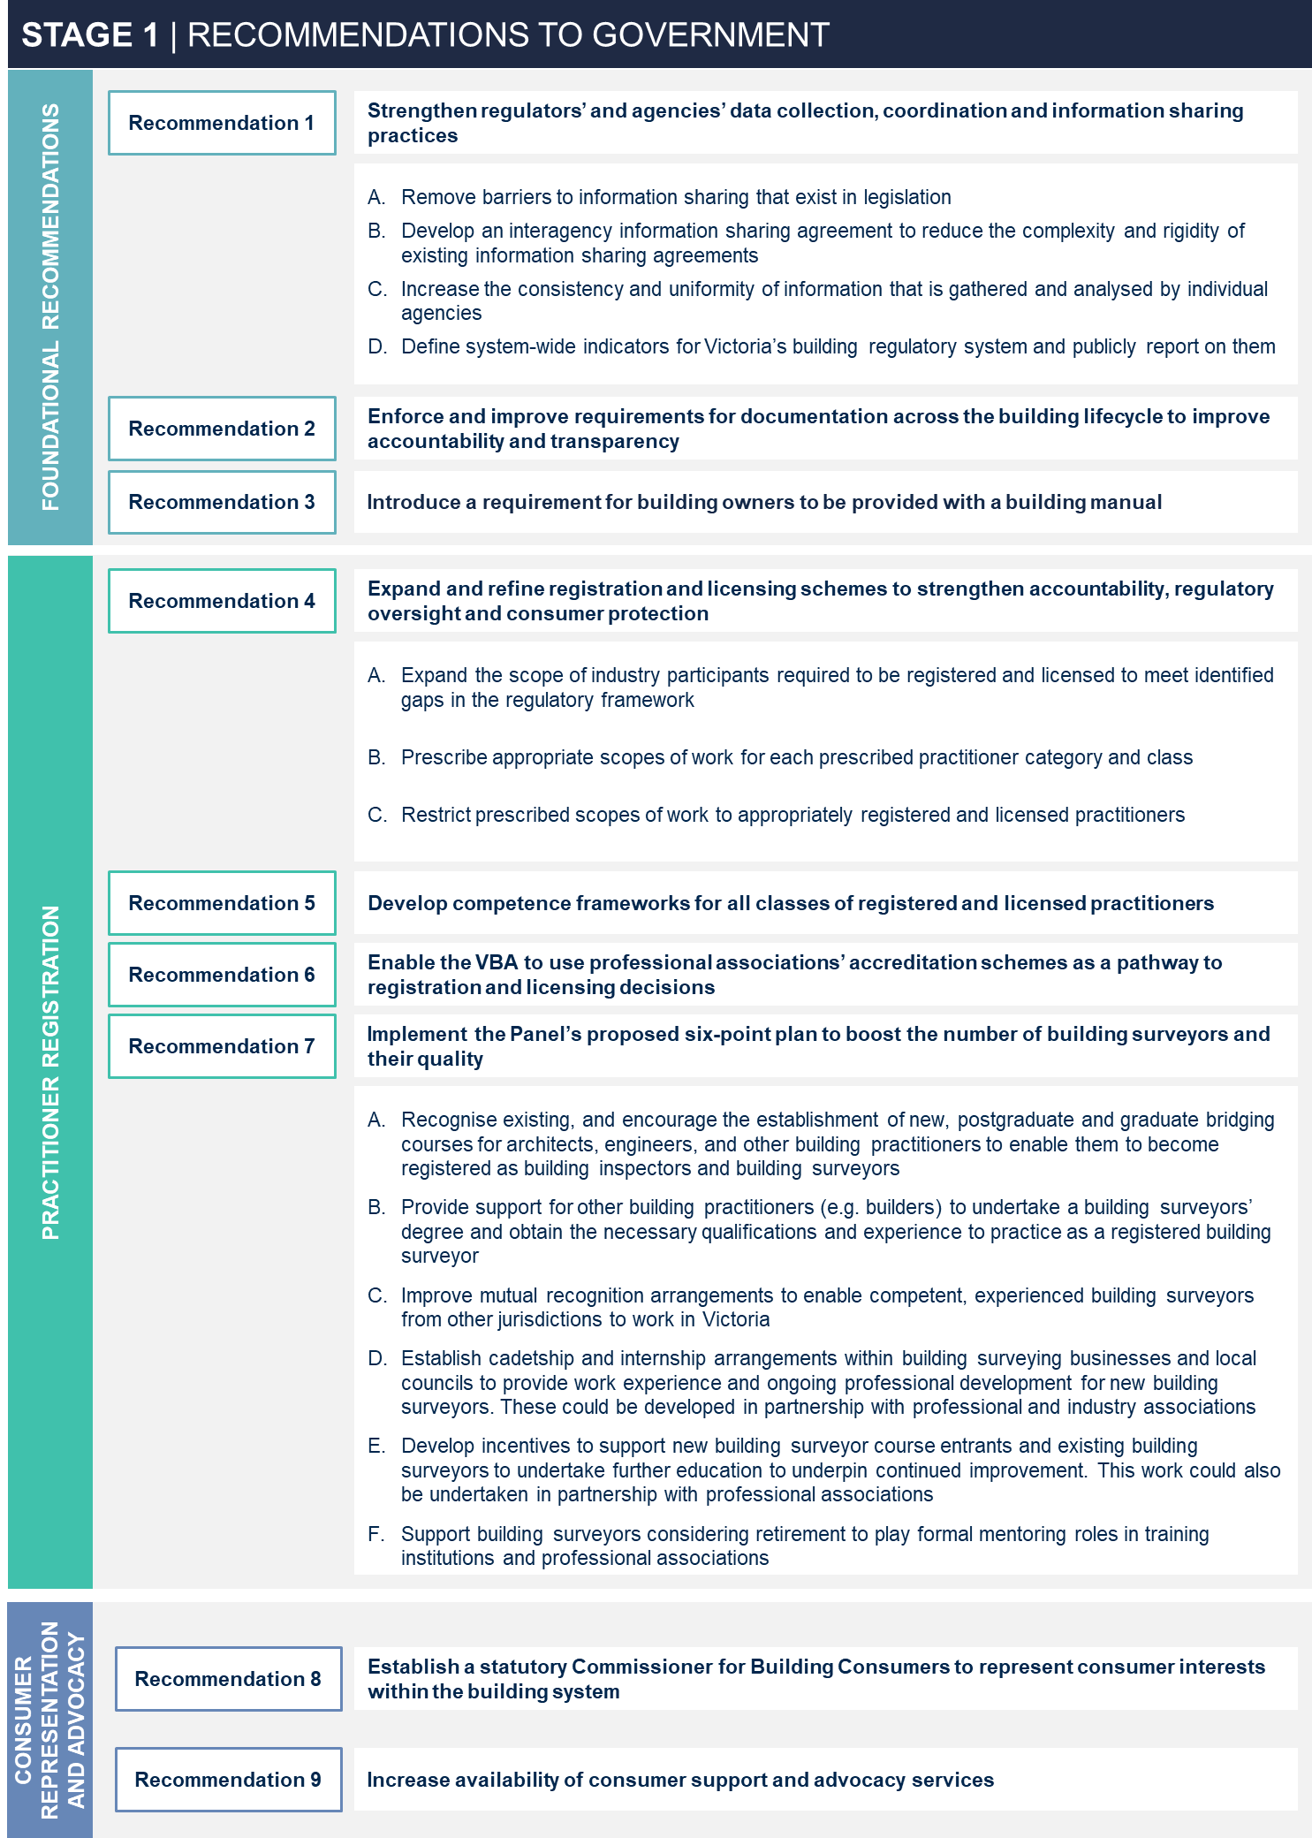

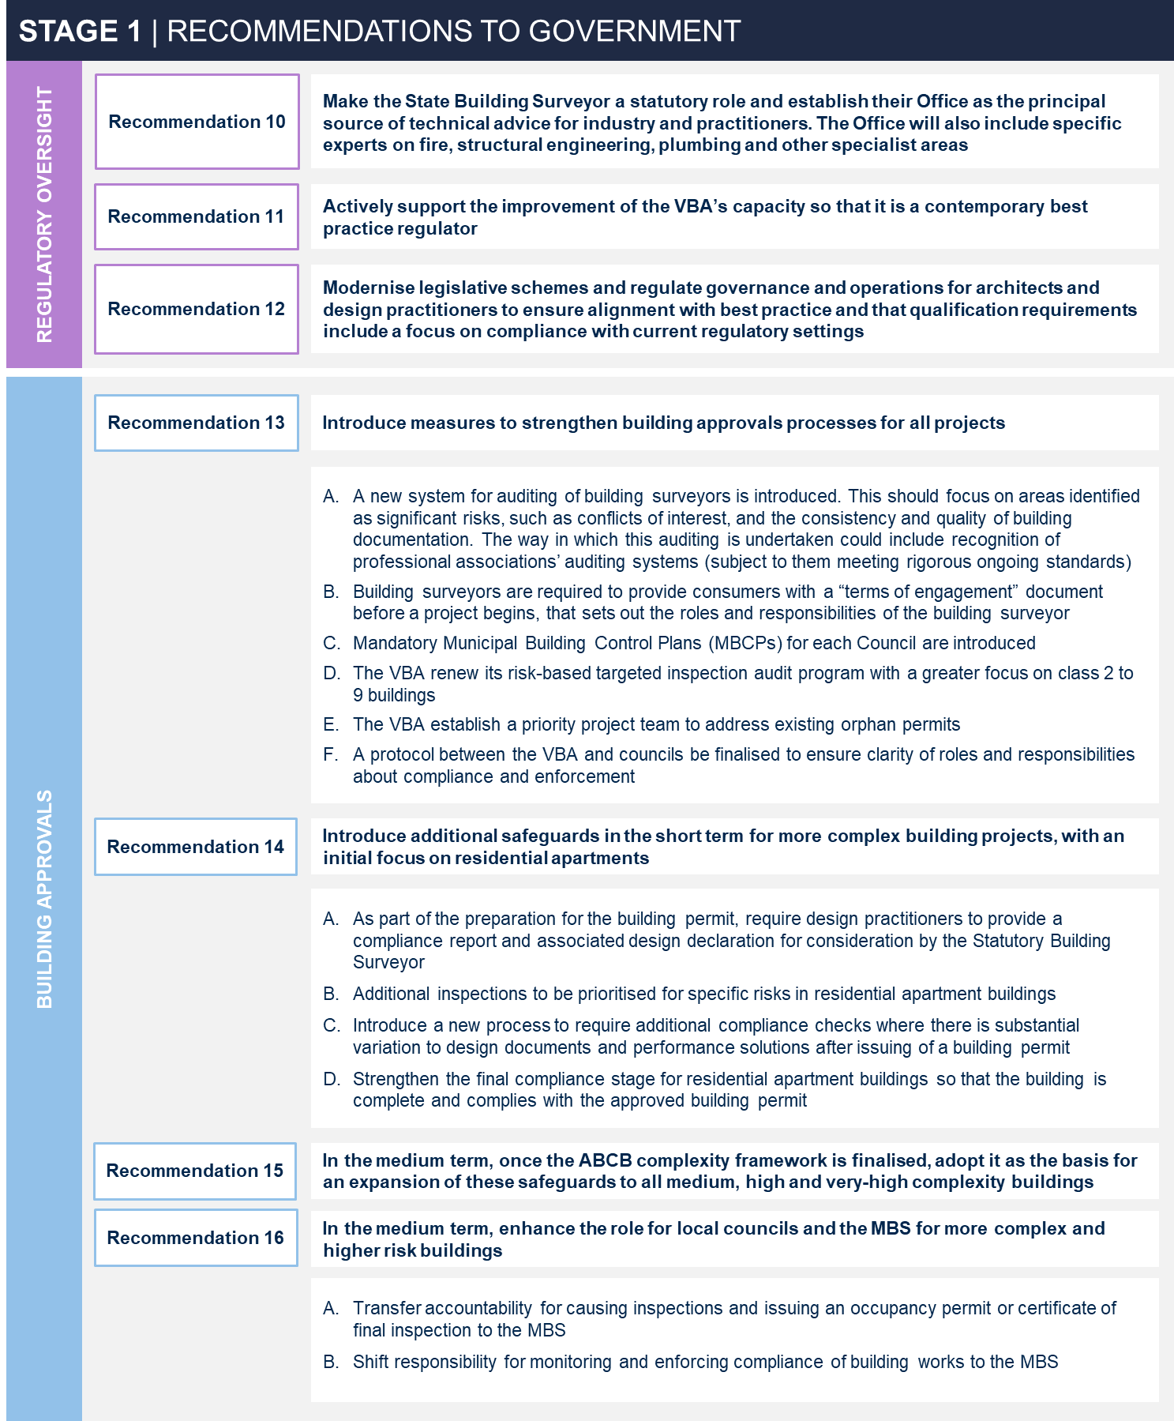
The Stage 1 recommendations were accepted and have been incorporated into the Building Legislation Amendment Bill 2023 as part of a broader suite of changes in the building industry. These reforms will “reshape the regulatory landscape in Victoria, with a key focus on consumer protection” as part of the Government’s larger commitment to delivering a building system that provides safe, compliant and durable housing and buildings
The amendments will create the following reforms:
  - formalising and strengthening the role of the SBS;
  - establishing a Building Monitor;
  - expanding the categories of building practitioner that will be required to be registered;
  - enhancing the building approvals process by introducing further safeguards to better inform consumers;
  - strengthening information sharing between statutory entities with a role in the building regulatory framework;
  - amending the distribution of the cladding rectification levy; and
  - strengthening and improving the governance arrangements of the ARBV under the Architects Act.

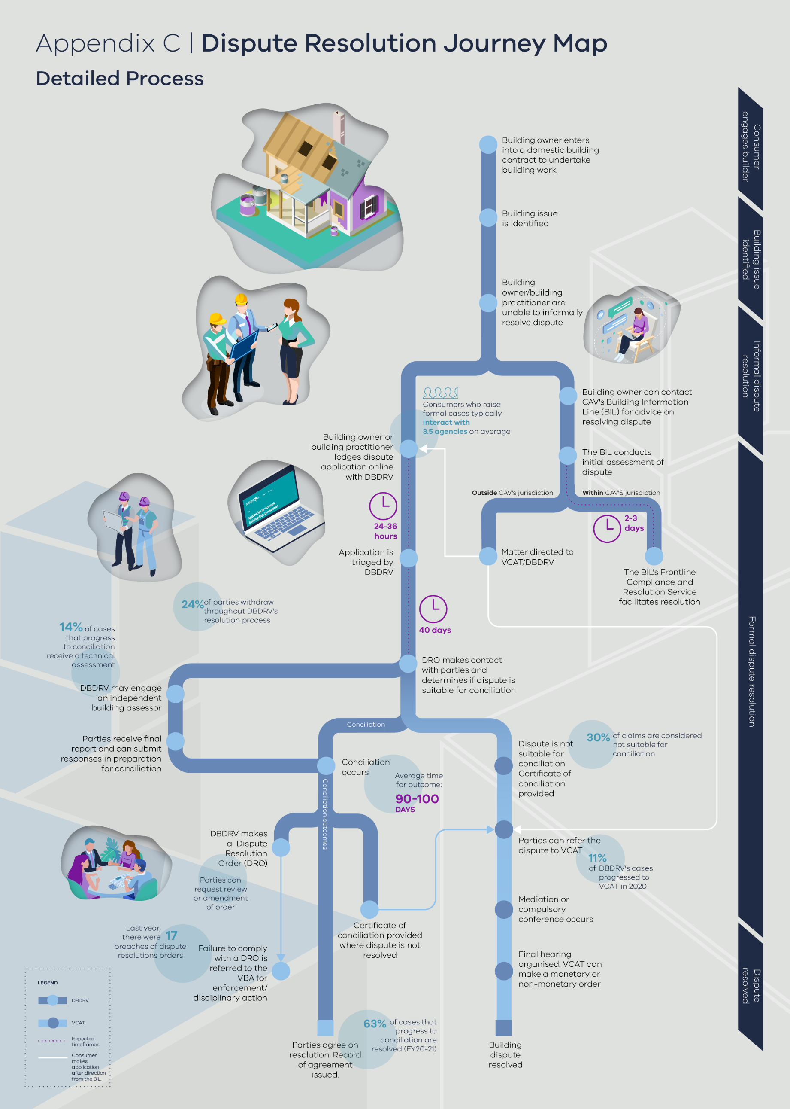
- Dispute resolution journey map

- Bibliography

Victorian Cladding Taskforce, Report from the Co-Chairs, (Melbourne: Department of Transport and Planning, 2019), p. 7-8. https://www.planning.vic.gov.au/__data/assets/pdf_file/0019/426034/DTP0124_Victorian_Cladding_Taskforce_Final_Report_July_2019_v9.pdf.
Ibid p. 7-8.
Australian Bureau of Statistics, Australian National Accounts: State Accounts, published November 18, 2022. https://www.abs.gov.au/statistics/economy/national-accounts/australian-national-accounts-state-accounts/latest-release
“Regional Labour Market Data Dashboard – November 2021: Victoria,” Australian Government Labour Market Information Portal, data current as of 27 October 2022. https://lmip.gov.au/default.aspx?LMIP/Downloads/EmploymentRegion.https://lmip.gov.au/default.aspx?LMIP/Downloads/EmploymentRegion.
“Strengthening industry – Victorian Budget 2022/23,” Victorian State Government, published May 3, 2022. https://www.budget.vic.gov.au/strengthening-industry
“Victoria’s Big Housing Build,” Premier of Victoria, published November 15, 2020. https://www.premier.vic.gov.au/victorias-big-housing-buildhttps://www.premier.vic.gov.au/victorias-big-housing-build
Ibid.
“Fast-start projects,” Victorian State Government, updated December 7, 2021. https://www.vic.gov.au/homes-victoria-fast-start-projectshttps://www.vic.gov.au/homes-victoria-fast-start-projects
The Productivity Commission (2004) notes that: “Access to affordable and quality housing is central to community wellbeing. Apart from meeting the basic needs for shelter, it provides the foundation for family and social stability, and contributes to improved health and educational outcomes and a productive workforce. Thus, it enhances both economic performance and ‘social capital’. See Australian Government Productivity Commission, 2004, ‘First Home Ownership’, https://www.pc.gov.au/inquiries/completed/first-home-ownership/report/housing.pdf, p.3.
Nicolas Cecil, “Grenfell Tower cladding helped fire spread faster than 'match in petrol,' inquiry hears,” Evening Standard, June 5, 2018, https://www.standard.co.uk/news/london/grenfell-tower-cladding-helped-fire-spread-faster-than-match-in-barrel-of-petrol-inquiry-hears-a3855671.html; Nick Toscano and Rania Spooner, “Docklands apartment tower fire fuelled by material in building's walls, says MFB,” The Age, April 28, 2015, https://www.abc.net.au/news/2019-02-28/lacrosse-apartment-owners-win-5.7-million-cladding-fire-damages/10857060; “Melbourne apartment tower fire fuelled by combustible cladding on Spencer St high-rise,” ABC News, February 4, 2019, https://www.abc.net.au/news/2019-02-04/spencer-street-apartment-fire-melbourne/10776018
Peter Shergold and Bronwyn Weir, Building confidence: Improving the effectiveness of compliance and enforcement systems for the building and construction industry (2018). https://www.industry.gov.au/sites/default/files/July%202018/document/pdf/building_ministers_forum_expert_assessment_-_building_confidence.pdf
The Building Code of Australia (BCA) Volume 1 and 2 are part of the NCC series published by the Australian Building Codes Board. The Building Codes Committee (BCC) is one of the technical advisory committees that is supporting the ABCB.
Product manufacturers and suppliers are partially liable for their work under the ACL, including s106 of Schedule 2 of the ACL which prohibits the support of ‘consumer goods’ and s106(3) which prohibits a person from manufacturing or having control of such goods.
Amendments to the Building Act in 2017 introduced the registration of corporations as building surveyors and builders. Under the corporate registration framework, any company that wishes to enter into a domestic building contract with a building owner or be engaged as the RBS by the owner, must be a registered corporation; Building Act 1993 (Vic), s 171A and 171C. In addition, the injunction power (discussed further in section 5.2 of this Paper) is wide-ranging and can be sought in relation to anyone who has – or proposes to – breach the building laws, or any person who aids and abets another person doing so. This is broad enough to capture upstream participants (such as developers).
A SPV is a separate legal entity create to undertake a specific business purpose or activity.
For instance, in Brookfield Multiplex Ltd v Owners Corporation Strata Plan 61288 & Anor [2014] HCA 36 the High Court held that no duty of care existed between a builder and an owner’s corporation. Considering the sophisticated contractual arrangements in place, the owner’s corporation was not regarded as ‘vulnerable’. At common law, the duty of care can only apply to a subsequent owner if it is found to exist in relation to the original owner. As the decision in Brookfield demonstrates this can be disadvantageous for subsequent purchasers of high-rise residential apartments. The problem is that the original developer or owners’ corporation is unlikely to be regarded as having sufficient “vulnerability” to attract the duty, as they are assumed to be capable of managing risks through relevant contracts or other commercial arrangements. Yet a subsequent owner of a residential apartment is unable to do this.
For example, cases of breach in ACL are often difficult to prove and must be brought in VCAT, often involving lengthy legal engagement.
Victorian Cladding Taskforce, Interim report, (Melbourne: Department of Transport and Planning, 2017), p.29. https://www.planning.vic.gov.au/__data/assets/pdf_file/0012/110316/Victorian-Cladding-Taskforce-Interim-Report-November-2017.pdf
The statutory duty of care in NSW includes a broad range of building and related work, and includes having “substantive control” over the carrying out of any of these kinds of work.
Of note, there is no intention that the duty would apply retrospectively
Corporations registered under the Building Act are also subject to disciplinary proceedings.
The Act also contains grounds for immediate suspension whereby suspension can take effect before the completion of the normal show cause process that applies for the disciplining of practitioners.
Municipal Association of Victoria, Building a better system: discussion paper on reforms to Victoria’s building regulatory system (Municipal Association of Victoria, 2020).
Victorian Cladding Taskforce, Interim report, (Melbourne: Department of Transport and Planning, 2017), p.24. https://www.planning.vic.gov.au/__data/assets/pdf_file/0012/110316/Victorian-Cladding-Taskforce-Interim-Report-November-2017.pdf
This is particularly where a Court would make orders based on proportionate or joint liability principles.
Building Act 1993 (Vic) s118A.
Victorian Cladding Taskforce, Report from the Co-Chairs (Melbourne: Department of Transport and Planning, 2019), p.29.
Victorian Cladding Taskforce, Report from the Co-Chairs (Melbourne: Department of Transport and Planning, 2019), p. 31.
Victorian Cladding Taskforce, Report from the Co-Chairs (Melbourne: Department of Transport and Planning, 2019), p. 31.
Note, in addition to applying where a builder is DDI, DBI is available in Victoria if coverage is with the VMIA where a builder fails to comply with a Tribunal or Court Order.
This is the Building Practitioners’ and Endorsed Building Engineers’ Insurance Ministerial Order. See: Richard Wynne (Minister for Planning), ‘Building Practitioners’ And Endorsed Building Engineers’ Insurance Ministerial Order,’ in Victoria, Victoria Government Gazette, No G 26, July 1, 2021, 1389-1393.
The VMIA policy is to pay DBI claims where a builder has not complied with a court Order.
Department of Transport and Planning, ‘Insurance in Victoria’s Building System: Review and Analysis’ (internal document) (2020), p. 83.
The Building Act authorises a minister to specify requirement for insurance coverage. This requirement is specified in a Ministerial Order. Building Act 1993 (Vic) s 221ZQ, s221ZT.
This does not include two-lot subdivisions.
House Contracts Guarantee Act 1987 (Vic).
Senate Standing Committee on Economics, Australia’s mandatory Last Resort Home Warranty Insurance Scheme (Canberra: Senate Printing Unit, Parliament House, 2008), p.7-15. https://www.aph.gov.au/Parliamentary_Business/Committees/Senate/Economics/Completed_inquiries/2008-10/home_warranty_08/report/index
This does not include DROs received by DBDRV.
See section 7.2 for a discussion on key issues across dispute resolution processes.
Importantly, the Victorian construction industry is not alone in experiencing a tight PII market. Across the world, and for different professionals and industries, there has been a significant tightening of the PII market in recent years.
Building surveyors and engineers are identified as occupations where the number of insurers willing to write PI policies has decreased significantly in the past 12-18 months, though these pressures also extend to architects and design professionals.
Higher premiums also affect the viability of small and medium construction businesses, as practitioners are unable to absorb or pass additional costs onto consumers.
A 2020 report prepared by Lockton on behalf of DTP noted that establishing project-based insurance “will require the Victorian government to invest significant time and energy working with (re)insurers, building practitioners and other stakeholders … Any potential solution would need to be considered holistically alongside broader issues in the building system, other proposed legislative reforms and the government’s objectives for the building system review.”
Victoria, Parliamentary Debates, Assembly, December 10, 2015, 5541, (Richard Wynne, Minister for Planning) (‘Building Legislation Amendment (Consumer Protection) Bill 2015 Second Reading Speech’)
“Building contracts,” CAV, updated April 22, 2021. https://www.consumer.vic.gov.au/housing/building-and-renovating/plan-and-manage-your-building-project/contracts
“Tips to help you resolve your dispute,” DBDRV, accessed December 8, 2021. https://dbdrv.vic.gov.au/tips-to-resolve-dispute; “Is our service right for you?” DBDRV, accessed December 8, 2021. https://dbdrv.vic.gov.au/is-our-service-right-for-you; “Our dispute resolution process” DBDRV, accessed December 8, 2021. https://dbdrv.vic.gov.au/dispute-resolution-process
Major domestic building contracts are defined as contracts for domestic building work valued over $10,000. The DBCA requires registered practitioners and building owners to enter into a major domestic building contract in this instance. This is outlined in Domestic Buildings Contracts Act 1995 (Vic) s3 and s5.
Building Amendment (Enforcement and Other Measures) Bill 2016 (Vic)
In certain circumstances building disputes are heard by the Magistrate’s Court of Victoria instead of VCAT, including where a dispute involves an interstate party. This is outlined under the Victorian Civil and Administrative Tribunal Act 1998 (Vic), p3A.
Further detail on the role and use of domestic building contracts is set out in the box below.
Note, insurance requirements as a prerequisite for practitioner registration and licensing is set out in the Building Act and Regulations.
Victoria, Parliamentary Debates, Assembly, December 10, 2015, 5541, (Richard Wynne, Minister for Planning) (‘Building Legislation Amendment (Consumer Protection) Bill 2015 Second Reading Speech’)
Contractual issues include: failure to complete work, failure to complete work in a specified time, failure to pay money under the contract, and failure to maintain the standard or quality of the building work specified in the contract.
81% of applicants to DBDRV are building owners. Department of Transport and Planning, Victorian Building System Review - Evidence Improvement Project (internal document) (2021),.
A building owner may apply directly to VCAT if they are seeking injunctive relief.
The Chief Dispute Resolution Officer can also issue stop work orders.
Orders can also be issued against a Builder to make payment to an Owner for a claim or entitlement under the contract
In FY2020, 0.8% of settled cases were settled with a DRO. Department of Transport and Planning, Victorian Building System Review - Evidence Improvement Project (internal document) (2021); “Our dispute resolution process” DBDRV, accessed December 8, 2021. https://dbdrv.vic.gov.au/dispute-resolution-process
Domestic Building Contracts Act 1995 (Vic).
This includes excluding disputes where both parties are yet to attempt resolution.
Only 5.6% of DBDRV’s cases in FY21 were out of jurisdiction, compared to 19.1% in FY17. Department of Transport and Planning, Victorian Building System Review - Evidence Improvement Project (internal document) (2021).
This could occur where an injunction is needed to immediately stop another party from doing building work. VCAT is considered “chiefly responsible” for resolving ‘domestic building disputes’, noting this is a term defined under the DBCA to encompass disputes between both owners, builders, architects and subcontractors; Domestic Building Contracts Act 1995 (Vic), s57.
The Dispute Settlement Centre of Victoria assists VCAT with mediation of these disputes through their Fast Track Mediation and Hearing Program. VCAT’s building and property list received 195 applications enabled by the ACL in 2020-21. VCAT, Annual Report 2020-21, (Melbourne: VCAT, 2021), p. 69. https://www.vcat.vic.gov.au/about-vcat/annual-reports-and-strategic-plan.
VCAT’s building and property list received 2406 cases in 2020-21. This figure includes disputes enabled by the DBCA, ACL, Property Law Act 1958, Water Act 1989, and the Retail Leases Act 2003. VCAT, Annual Report 2020-21, (Melbourne: VCAT, 2021), p. 69. https://www.vcat.vic.gov.au/about-vcat/annual-reports-and-strategic-plan.
Consumers also have statutory rights in the DBCA in addition to contractual rights
In a consumer survey, the most common source that respondents used to understand and resolve a dispute were informal networks (friends, family, and colleagues). This accounted for 12% of responses.
Building Legislation Amendment (Consumer Protection) Act 2016 (No. 15 of 2016) (Vic).
Domestic Building Contracts Act 1995 (Vic), s29A.
This is intended to be resolved by the implementation of DTP’S building information ‘front-door’ website, detailed on page 130.
‘Warm referral’ refers to the process by which a service discusses the services of another organisation with a client, and gains client consent to contact the other organisation and pass on relevant information.
Department of Transport and Planning, Victorian Building System Review - Evidence Improvement Project (internal document) (2021).
This figure represents the number of cases resolved or partially resolved by DBDRV from July 2021 to November 2022. In addition, 396 cases were withdrawn in CY2020 as a DBDRV assisted settlement had been reached prior to conciliation. Withdrawal figures for 2021-2022 are not currently available.
21 per cent of disputes at DBDRV in FY20-21 related to multi-storey apartments. Department of Transport and Planning, Victorian Building System Review - Evidence Improvement Project (internal document) (2021).
This figure represents the percentage of conciliated cases that received a technical assessment in 2021. It should be noted that the COVID-19 environment limited the ability of DBDRV to undertake building assessments.
Average time to resolve building disputes at DBDRV is currently between 90 – 100 days.
Department of Transport and Planning, Victorian Building System Review - Evidence Improvement Project (internal document) (2021).
Victoria, Parliamentary Debates, Assembly, October 24, 1995, 697 (Jan Wade, Attorney-General), (‘Domestic Building Contracts and Tribunal Bill Second Reading Speech’).
Victoria, Parliamentary Debates, Assembly, December 10, 2015, 5541, (Richard Wynne, Minister for Planning) (‘Building Legislation Amendment (Consumer Protection) Bill 2015 Second Reading Speech’)
Victoria State Government, Construction Technologies: Sector Strategy (Melbourne: State of Victoria, 2016) https://business.vic.gov.au/__data/assets/pdf_file/0006/1275495/Construction-Technologies-Strategy-web-version-20160310.pdf
Building Act 1993 (Vic), s15; “Building product accreditation,” Victorian Building Authority, accessed December 10, 2021. https://www.vba.vic.gov.au/building/building-regulations-advisory-committee/building-product-accreditation
Of note, some products are accredited when they are used / installed in a particular way. Where accredited products are installed incorrectly they no longer meet the compliance requirements under the NCC.
Over the last twelve months, 6 products have been submitted for accreditation; 4 have been approved; and 2 have been refused.
“Building Regulations Advisory Committee,” Victorian Building Authority, accessed December 8, 2021. https://www.vba.vic.gov.au/about/building-regulations-advisory-committee; Building Act 1993 (Vic) s211.
“What is CodeMark?” CodeMark Australia, accessed December 8, 2021. https://codemark.abcb.gov.au/building-practitioners/what-codemark
ABCB, Manual for the Watermark Scheme (Canberra: ABCB, 2017), p. 20. https://watermark.abcb.gov.au/sites/default/files/resources/2020//Manual_for_the_WaterMark_Certification_Scheme.pdf
“Digital Twin Victoria,” Department of Transport and Planning, updated July 23, 2021. https://www.land.vic.gov.au/maps-and-spatial/projects-and-programs/digital-twin-victoria
Salman Shooshtarian et al, “We create 20m tons of construction industry waste each year. Here’s how to stop it going to landfill” The Conversation, July 12, 2019. https://theconversation.com/we-create-20m-tons-of-construction-industry-waste-each-year-heres-how-to-stop-it-going-to-landfill-114602; Arthur Kyriakopoulos, Solid Waste Collection Services in Australia, (IbisWorld, 2021), p. 10.
Salman Shooshtarian et al, “We create 20m tons of construction industry waste each year. Here’s how to stop it going to landfill” The Conversation, July 12, 2019. https://theconversation.com/we-create-20m-tons-of-construction-industry-waste-each-year-heres-how-to-stop-it-going-to-landfill-114602
Commissioner for Better Regulation Victoria, Addressing Supply Chain Challenges (Melbourne: Better Regulation Victoria, 2021), p. 31.
Victoria State Government, Victorian Government Response to the Commissioner for Better Regulation’s Final Report on Addressing Supply Chain Challenges (Melbourne: State of Victoria, 2022) p. 6. https://www.vic.gov.au/supply-chain-review https://www.vic.gov.au/supply-chain-review
Premier of Victoria, “Innovative Business Cutting Waste and Costs,” The National Tribune, May 14, 2022. https://www.nationaltribune.com.au/innovative-businesses-cutting-waste-and-costs/
“Essential safety measures,” Victorian Building Authority, accessed December 15, 2021. https://www.vba.vic.gov.au/consumers/guides/essential-safety-measures
While detached houses, units, and townhouses may have ESMs installed, there is no legislative requirement for these to be maintained.
Building Regulations 2018 (Vic), r194.
Ibid, r223-4.
Ibid, r228. Building occupiers in this instance refer to both building owners and renting occupants in apartment buildings,
The CFA are responsible for enforcing provisions of the Regulations where a building is located outside FRVs operational area. Building Act 1993 (Vic) s227E.
Common property includes chattels, fixtures, and services that benefit more than one lot owner, Owners Corporations Act 2006 (Vic) s46-47.
While only tier 1 and 2 OCs are required to develop a maintenance plan, other OCs may choose to. Owners Corporations Act 2006 (Vic) s36.
For example, maintenance plans must set out the major capital items anticipated to be repaired within the next 10 years, such as lifts, pools, and water tanks, Owners Corporations Act 2006 (Vic) s37; Owners Corporations Regulations 2018 (Vic) r7.
Owners Corporations Act 2006 (Vic) s40.
Tier 1 OCs (which consist of more than 100 occupiable lots) are required by legislation to appoint a manager. Other tiers are not required to buy may choose to. See: Owners Corporations Act 2006 (Vic) s119.
Owners Corporations Act 2006 (Vic) s119(2), s180, to be eligible, managers must hold PII with a minimum coverage of $2 million, Owners Corporations Act 2006 (Vic) s119(5).
Michael Blelby, “Melbourne’s Neo200 tower ‘in a serious state of dysfunction,” Australian Financial Review, September 4, 2019. https://www.afr.com/property/residential/melbourne-s-neo200-tower-in-a-serious-state-of-dysfunction-20190903-p52nmo
Approximately 2 million buildings have some form of ESMs installed in Victoria, 1.2 million of which are Class 1a buildings which are not required to maintain ESMs.
If the building was built before 1 July 1994, the owner is responsible for ensuring that any safety equipment, safety fittings or safety measures are maintained and fulfilling their purpose. All commercial, public industrial and some residential buildings built before 1994 require an annual ESM report to be produced. The report includes a compliance statement confirming that ESMs within the building have been maintained for the past 12 months.
Building Act 1993 (Vic), pt8.
“Maintenance of Essential Safety Measures,” Victorian Building Authority, published February 2018. https://www.vba.vic.gov.au/__data/assets/pdf_file/0008/99368/PN-23-Maintenance-of-Essential-Safety-Measures.pdf
These issues have been primarily raised – and brought to the Panel’s attention – through the work of the Plumbing Advisory Council’s Complex Plumbing Subcommittee and the Prefabricated Plumbing Working Group. Both initiatives are supported by DTP.
AS/NZS 3500.
This will include ensuring that materials can be safely recycled.
Rob Bryant, “Accelerating the construction sector’s digital transformation will help Australia meet net zero by 2050,” The Mandarin, November 25, 2021. https://www.themandarin.com.au/176101-accelerating-the-construction-sectors-digital-transformation-will-help-australia-meet-net-zero-by-2050/
This include access to building related standards. Professor Ian Bailey AM SC, Note concerning the position in Victoria, as to the form, extent, content and possible reform of the law relating to the building industry (November 24 2021).

