
Final Report
Summary and recommendations

Summary and recommendations
ISBN 978-1-925789-63-8 (Print)
Published February 2021
Authorised and published by the Royal Commission into Victoria’s Mental Health System, Melbourne Victoria.
© State of Victoria, Royal Commission into Victoria’s Mental Health System, February 2021.
Except where otherwise indicated, the images in this publication show models and illustrative settings only, and do not necessarily depict actual services, facilities or recipients of services. This publication may contain images of deceased Aboriginal and Torres Strait Islander peoples.
In this document, ‘Aboriginal’ refers to both Aboriginal and Torres Strait Islander people. ‘Indigenous’ or ‘Koori/Koorie’ is retained when part of the title of a report, program or quotation.
ISBN 978-1-925789-64-5 (pdf/online/MS word)
Available at the Royal Commission into Victoria’s Mental Health System website <https://rcvmhs.vic.gov.au>. If you have any questions about the Commission’s work please contact the Department of Health <MentalHealth@dhhs.vic.gov.au>.
ISBN:
- Volume 1: A new approach to mental health and wellbeing in Victoria
ISBN 978-1-925789-65-2 (Print) 978-1-925789-66-9 (pdf/online/MS word)
- Volume 2: Collaboration to support good mental health and wellbeing
ISBN 978-1-925789-67-6 (Print) 978-1-925789-68-3 (pdf/online/MS word)
- Volume 3: Promoting inclusion and addressing inequities
ISBN 978-1-925789-69-0 (Print) 978-1-925789-70-6 (pdf/online/MS word)
- Volume 4: The fundamentals for enduring reform
ISBN 978-1-925789-71-3 (Print) 978-1-925789-72-0 (pdf/online/MS word)
- Volume 5: Transforming the system—innovation and implementation
ISBN 978-1-925789-73-7 (Print) 978-1-925789-74-4 (pdf/online/MS word)
Suggested citation: State of Victoria, Royal Commission into Victoria’s Mental Health System, Final Report, Summary and recommendations, Parl Paper No. 202, Session 2018–21 (document 1 of 6).

Royal Commission into
Victoria’s Mental Health System
Summary and recommendations

Penny Armytage AM
Chair
Professor Allan Fels AO
Commissioner

Dr Alex Cockram
Commissioner
Professor Bernadette McSherry
Commissioner

ORDERED TO BE PUBLISHED
Victorian Government Printer
February 2021
PP No 202, Session 2018–2021 (document 1 of 6)

A note on content
The Royal Commission recognises the strength of people living with mental illness or psychological distress, families, carers and supporters, and members of the workforce who have contributed their personal stories and perspectives to this inquiry.
Some of these stories and the Commission’s analysis may contain information that could be distressing. You may want to consider how and when you read this report.
Aboriginal readers are advised that this report may contain photos, quotations and/or names of people who are deceased.
If you are upset by any content in this report, or if you or a loved one need support, the following services are available to support you:
- If you are not in immediate danger but you need help, call NURSE-ON-CALL on 1300 60 60 24.
- For crisis support, contact Lifeline on 13 11 14.
- For phone-based support contact Beyond Blue on 1300 224 636.
- If you are looking for a mental health service, visit the Victorian Government Better Health Channel <https://www.betterhealth.vic.gov.au>.
- For situations that are harmful or life-threatening, contact emergency services immediately on Triple Zero (000).
A note on terminology can be found in the front matter of the Commission’s final report.

Contents
Summary 9
Summary 10
1. Context for reform 11
1.1 Designing a new system 12
2. Major themes 13
3. Transformational reform 26
3.1 A responsive and integrated system with community at its heart 27
3.2 A system attuned to promoting inclusion and addressing inequities 30
3.3 Re-established confidence through prioritisation and collaboration 33
3.4 Contemporary and adaptable services 34
4. Realising the Commission’s ambitions 35
Recommendations 37
Recommendation 1: Supporting good mental health and wellbeing 38
Recommendation 2: Governance arrangements for promoting good mental health and preventing mental illness 39
Recommendation 3: Establishing a responsive and integrated mental health and wellbeing system 40
Recommendation 4: Towards integrated regional governance 41
Recommendation 5: Core functions of community mental health and wellbeing services 42
Recommendation 6: Helping people find and access treatment, care and support 43
Recommendation 7: Identifying needs and providing initial support in mental health and wellbeing services 44
Recommendation 8: Responding to mental health crises 45
Recommendation 9: Developing ‘safe spaces’ and crisis respite facilities 46
Recommendation 10: Supporting responses from emergency services to mental health crises 47
Recommendation 11: New models of care for bed‑based services 48
Recommendation 12: Developing new bed-based rehabilitation services 49
Recommendation 13: Addressing gender-based violence in mental health facilities 50
Recommendation 14: Supporting mental health consultation liaison services 51
Recommendation 15: Supporting good mental health and wellbeing in local communities 52
Recommendation 16: Establishing mentally healthy workplaces 53
Recommendation 17: Supporting social and emotional wellbeing in schools 54
Recommendation 18: Supporting the mental health and wellbeing of prospective and new parents 55
Recommendation 19: Supporting infant, child and family mental health and wellbeing 56
Recommendation 20: Supporting the mental health and wellbeing of young people 57
Recommendation 21: Redesigning bed-based services for young people 58
Recommendation 22: Supporting the mental health and wellbeing of older Victorians 59
Recommendation 23: Establishing a new Statewide Trauma Service 60
Recommendation 24: A new approach to addressing trauma 61
Recommendation 25: Supported housing for adults and young people living with mental illness 62
Recommendation 26: Governance arrangements for suicide prevention and response efforts 63
Recommendation 27: Facilitating suicide prevention and response initiatives 64
Recommendation 28: Developing system-wide roles for the full and effective participation of people with lived experience of mental illness or psychological distress 65
Recommendation 29: A new agency led by people with lived experience of mental illness or psychological distress 66
Recommendation 30: Developing system‑wide involvement of family members and carers 67
Recommendation 31: Supporting families, carers and supporters 68
Recommendation 32: Supporting young carers 69
Recommendation 33: Supporting Aboriginal social and emotional wellbeing 70
Recommendation 34: Working in partnership with and improving accessibility for diverse communities 71
Recommendation 35: Improving outcomes for people living with mental illness and substance use or addiction 72
Recommendation 36: A new statewide service for people living with mental illness and substance use or addiction 73
Recommendation 37: Supporting the mental health and wellbeing of people in contact with, or at risk of coming into contact with, the criminal and youth justice systems 74
Recommendation 38: Providing safe and appropriate mental health treatment, care and support at Thomas Embling Hospital 75
Recommendation 39: Supporting the mental health and wellbeing of people in rural and regional Victoria 76
Recommendation 40: Providing incentives for the mental health and wellbeing workforce in rural and regional areas 77
Recommendation 41: Addressing stigma and discrimination 78
Recommendation 42: A new Mental Health and Wellbeing Act 79
Recommendation 43: Future review of mental health laws 80
Recommendation 44: A new Mental Health and Wellbeing Commission 81
Recommendation 45: Effective leadership of and accountability for the mental health and wellbeing system 82
Recommendation 46: Facilitating government‑wide efforts 83
Recommendation 47: Planning the new mental health and wellbeing system 84
Recommendation 48: Selecting providers and resourcing services 85
Recommendation 49: Monitoring and improving mental health and wellbeing service provision 86
Recommendation 50: Encouraging national partnerships 87
Recommendation 51: Commissioning for integration 88
Recommendation 52: Improving the quality and safety of mental health and wellbeing services 89
Recommendation 53: Strong oversight of the quality and safety of mental health and wellbeing services 90
Recommendation 54: Towards the elimination of seclusion and restraint 91
Recommendation 55: Ensuring compulsory treatment is only used as a last resort 92
Recommendation 56: Supporting consumers to exercise their rights 93
Recommendation 57: Workforce strategy, planning and structural reform 94
Recommendation 58: Workforce capabilities and professional development 95
Recommendation 59: Workforce safety and wellbeing 96
Recommendation 60: Building a contemporary system through digital technology 97
Recommendation 61: Sharing mental health and wellbeing information 98
Recommendation 62: Contemporary information architecture 99
Recommendation 63: Facilitating translational research and its dissemination 100
Recommendation 64: Driving innovation in mental health treatment, care and support 101
Recommendation 65: Evaluating mental health and wellbeing programs, initiatives and innovations 102
Interim Report Recommendations 103
Victorian Collaborative Centre for Mental Health and Wellbeing 103
Targeted acute mental health service expansion 104
Suicide prevention 105
Aboriginal social and emotional wellbeing 106
A service designed and delivered by people with lived experience 107
Lived experience workforces 108
Workforce readiness 109
New approach for mental health investment 110
The Mental Health Implementation Office 111
Endnotes for Summary and recommendations 112
Appendix: Larger version of Figure 7 114

Summary

Summary
In February 2019, on advice from the Victorian Government, the Governor of the State of Victoria formally established the Royal Commission into Victoria’s Mental Health System. This signalled that the state’s mental health system was failing to support those who needed it. The Premier, the Hon. Daniel Andrews MP—along with countless people living with mental illness or psychological distress, families, carers and supporters, as well as those working in the system—described it as ‘broken’. Ms Honor Eastly, a witness before the Commission, shared:
It wasn’t until I started working in advocacy in the mid 2010s that I started to understand that a big part of what I was dealing and struggling with was a broken and traumatic system. I had, up until that point, thought that what was happening was because I was a broken and ill person.
People have shared some positive experiences with the Commission, such as being supported by compassionate and empathetic workers. As one person said, ‘I was lucky to find the treating doctor that I have. She’s saved my life dozens of times through compassionate, evidence-based care.’
Despite the goodwill and hard work of many people, Victoria’s mental health system has deteriorated for a multitude of reasons and over the course of many years. In November 2019, the Commission’s interim report concluded that the system had catastrophically failed to live up to expectations and was underprepared for current and future challenges. Good mental health and wellbeing have been a low priority of governments at all levels and the community.
Most of us will experience poor mental health or mental illness at some point in our lives—directly or indirectly. Each year, around one in five Victorians will experience mental illness. Almost half of Victorians will experience mental illness during their life. It is estimated that three per cent of people living in Victoria meet the criteria for ‘severe’ mental illness, such as schizophrenia or bipolar disorder. That amounts to more than 200,000 people.
Every individual, including friends, loved ones, families, neighbours and colleagues, must be able to rely on a well-resourced, compassionate and responsive mental health and wellbeing system. Yet people often described being turned away from services because they did not meet the threshold for admission. One person described the impact of this:
Reaching out for help and admitting you believe you could have an issue is hard enough in itself. But going through that difficult process to then be turned away from treatment makes the anxiety about reaching out even worse for fear of being told you aren’t worthy of treatment. Turning people away because they ‘aren’t sick enough’ … sends a message that there is a level that needs to be achieved before you’re allowed to get better.
Good mental health and wellbeing is not just the absence of mental illness; it is the ability to fully and effectively participate in society. This means attention must be paid to a range of factors related to poor mental health—psychological, biological and social—all of which can change over a person’s life. Health is not the only priority in promoting good mental health and wellbeing. Other social services, such as housing, education and justice, and the places people live, work and connect, shape people’s mental health and wellbeing. Victoria needs to be a place where people look out for one another, build social connections, and treat others with empathy.
The Commission has set out an ambitious reform agenda to redesign Victoria’s mental health and wellbeing system. Achieving its vision will require a collaborative, collective effort and shared responsibility across governments, service providers, community groups, advocates, people with lived experience of mental illness or psychological distress, families, carers and supporters.

1. Context for reform
The present system is not designed or equipped to support the diverse needs of people living with mental illness or psychological distress, families, carers and supporters, let alone to cope with unforeseen pressures that may arise. The 2019–20 severe bushfire season and the COVID-19 pandemic shone further light on the pressures on the mental health system.
Due to system constraints, services are often inaccessible at the times when they would make the most difference, and the system largely operates in crisis mode—that is, it tends to react to mental health crises rather than preventing them. The system is complex and fragmented and, for those who do manage to get into it, difficult to navigate. People experience enormous frustration and distress when trying to identify the right mental health services for themselves or someone else. A mother shared her challenges with the Commission:
As a single mother who had to work full time to keep a roof over my girls’ heads, navigating the service system has been so difficult. This has taken a huge emotional and financial toll on me as I have not been able to progress my career due to my caring requirements, which will severely impact the amount of super I have to retire on. Disconnected, poorly promoted services with overly tight eligibility criteria meant that only some aspects of my girls’ multiple and complex needs could be addressed.
The system’s failures can be linked to its origins. In the 19th and 20th centuries, people living with mental illness were separated from the rest of the community and housed in institutions. These institutions began to be dismantled from the 1980s, with a desire to move towards a community-based model of care. But while there has been social change since then, such as a strengthened focus on protecting and promoting human rights and the consumer movement, Victoria’s mental health system has not kept pace. It has drifted away from its earlier aspirations of a community-based system and now relies too heavily on hospital‑based services and emergency departments.
’Power imbalances’ that disadvantage and marginalise people living with mental illness or experiencing psychological distress are still apparent. For example, supported decision-making principles and practices, where a person is enabled to make decisions, communicate and have their preferences respected, are not routinely used. Consumers still have their human rights breached through compulsory treatment and the use of seclusion and restraint.
Ms Lucy Barker, a witness before the Commission, shared her experiences of compulsory treatment, seclusion and restraint:
The thing with compulsory treatment is that the measures that are taken are extreme. You wouldn’t treat anybody else that way, but because you are perceived to have a mental illness, you can be restrained to a bed for hours or thrown in a seclusion room or chucked in the back of a divvy van or jabbed in the butt, and then knocked unconscious for a day. It’s that kind of stuff that makes compulsory treatment terrible. Yes, your life was saved, but to what extent? I now have significant trauma from compulsory treatment.
This history of marginalising people living with mental illness or experiencing psychological distress is reflected in structural challenges in the mental health system, such as inadequate investment, the inability to meet increasing demand, and a lack of system planning. These challenges partly exist because of the stigma and discrimination associated with mental illness—community attitudes deter governments from investing in good mental health and wellbeing.
Despite recent reviews by the Victorian Auditor-General, along with efforts by government to improve Victoria’s mental health system, the case for comprehensive reform remains urgent and compelling.

1.1 Designing a new system
The Commission’s interim report sets out nine recommendations to commence a new approach to mental health and wellbeing treatment, care and support. The Victorian Government has started implementing these recommendations.
This report builds on these priority reforms and outlines system-wide changes to create a mental health and wellbeing system that is contemporary and adaptable. The report comprises five volumes:
- Volume 1: A new approach to mental health and wellbeing in Victoria
- Volume 2: Collaboration to support good mental health and wellbeing
- Volume 3: Promoting inclusion and addressing inequities
- Volume 4: The fundamentals for enduring reform
- Volume 5: Transforming the system—innovation and implementation
Across these volumes, the Commission sets out 65 recommendations to transform Victoria’s mental health system. Some of the recommendations are foundational and focus on creating new structures to support a sustainable mental health and wellbeing system. Some concentrate on ensuring that treatment, care and support are available and accessible. Others focus on redesigning services to move from a crisis-driven model to a community‑based one that delivers beneficial outcomes for people. Some recommendations are a first for Victoria, such as setting up initiatives led by people with lived experience of mental illness or psychological distress, and establishing lived experience leaders throughout the system. Some challenge the system’s traditional focus on medical treatment alone by highlighting the importance of community and places in shaping mental health and wellbeing.
New Local Mental Health and Wellbeing Services will respond to a large amount of the current demand that is placed on area mental health services. Looking ahead, new Area Mental Health and Wellbeing Services will have resources freed up. Coupled with greater investment in service delivery, this will mean that Area Mental Health and Wellbeing Services will be able to offer more responsive and intensive services to people with higher levels of need, with greater flexibility to support people as their needs and strengths change.
Collectively, these reforms go beyond making isolated improvements to the existing system—they represent a complete transformation in the way mental health and wellbeing treatment, care and support will be provided in Victoria.

2. Major themes
Throughout its inquiry, the Commission has extensively engaged with people living with mental illness or psychological distress, families, carers and supporters, mental health workers, researchers, service providers and others to understand the existing strengths and challenges of the system, as well as future needs and expectations. Figure 1 provides an overview of the consultation the Commission has undertaken.
The Commission’s consultation approach included targeted engagement to explore the needs of Victoria’s diverse communities, including those from Aboriginal communities, LGBTIQ+ people, and people from culturally diverse communities. This included dedicated public hearing days, roundtables and focus groups with members of these communities, as well as consideration of detailed submissions. For example, the Victorian Aboriginal Community Controlled Health Organisation (VACCHO) supported the Commission’s deliberations, with the development of the Balit Durn Durn report. VACCHO engaged with more than 100 people to further understand the impact of the mental health system on Aboriginal people. The report explored the power of Aboriginal culture and outlined ‘ways to build strength, resilience, connectedness and identity in Aboriginal people and communities to create essential pathways for fostering positive mental health and wellbeing’.
Some of the most powerful contributions the Commission heard were from people with lived experience. People came forward to share personal experiences about how the system has failed and sometimes even harmed them. The Commission is deeply grateful to everyone who shared their experiences.
The Commission is conscious that it carries the hopes of many people. It acknowledges this responsibility and has been buoyed by the collective desire to create a better future. This sense of shared purpose is reflected in the Commission’s reforms.
Figure 1: Facts and figures
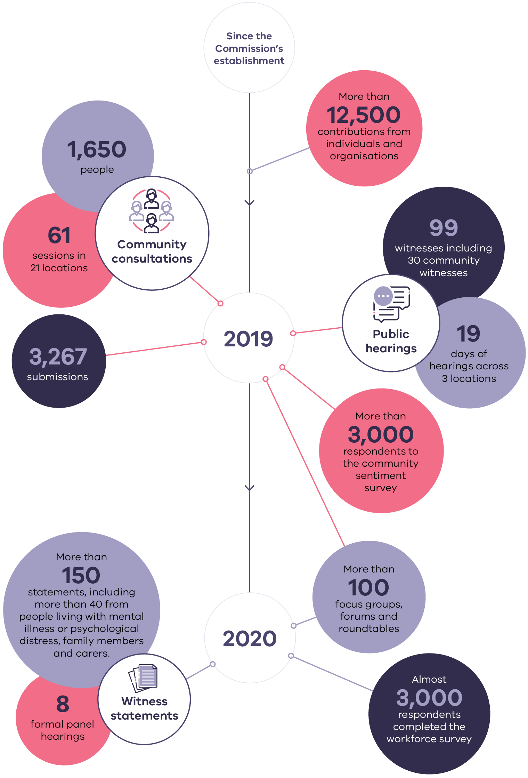
Throughout the Commission’s engagement and research, major themes emerged that shaped the Commission’s recommendations. Some of these themes are about the system itself; some are about people’s experiences; and some are about how people can be supported outside the system, and about the importance of community and places:
- Demand has overtaken capacity. The system is overwhelmed and cannot keep up with the number of people who seek treatment, care and support. This is evident at all levels, from individual mental health professionals to acute and emergency services. One person with lived experience of mental illness explained how the system is greatly overburdened:
the most affected … are left to navigate an overburdened and essentially dysfunctional system. … I feel like the public system is battling to not fall apart itself, that its crisis reflects on us.
- Community-based services are undersupplied. Many people cannot access treatment, care and support close to their homes and in their communities. There is a large gap between the number of hours of community-based services provided by public specialist mental health services and the estimated demand (Figure 2).
Figure 2: The difference between the actual number of people receiving specialist mental health services/actual consumer-related community service hours delivered and estimated demand, all ages, Victoria, 2010–11 to 2019–20
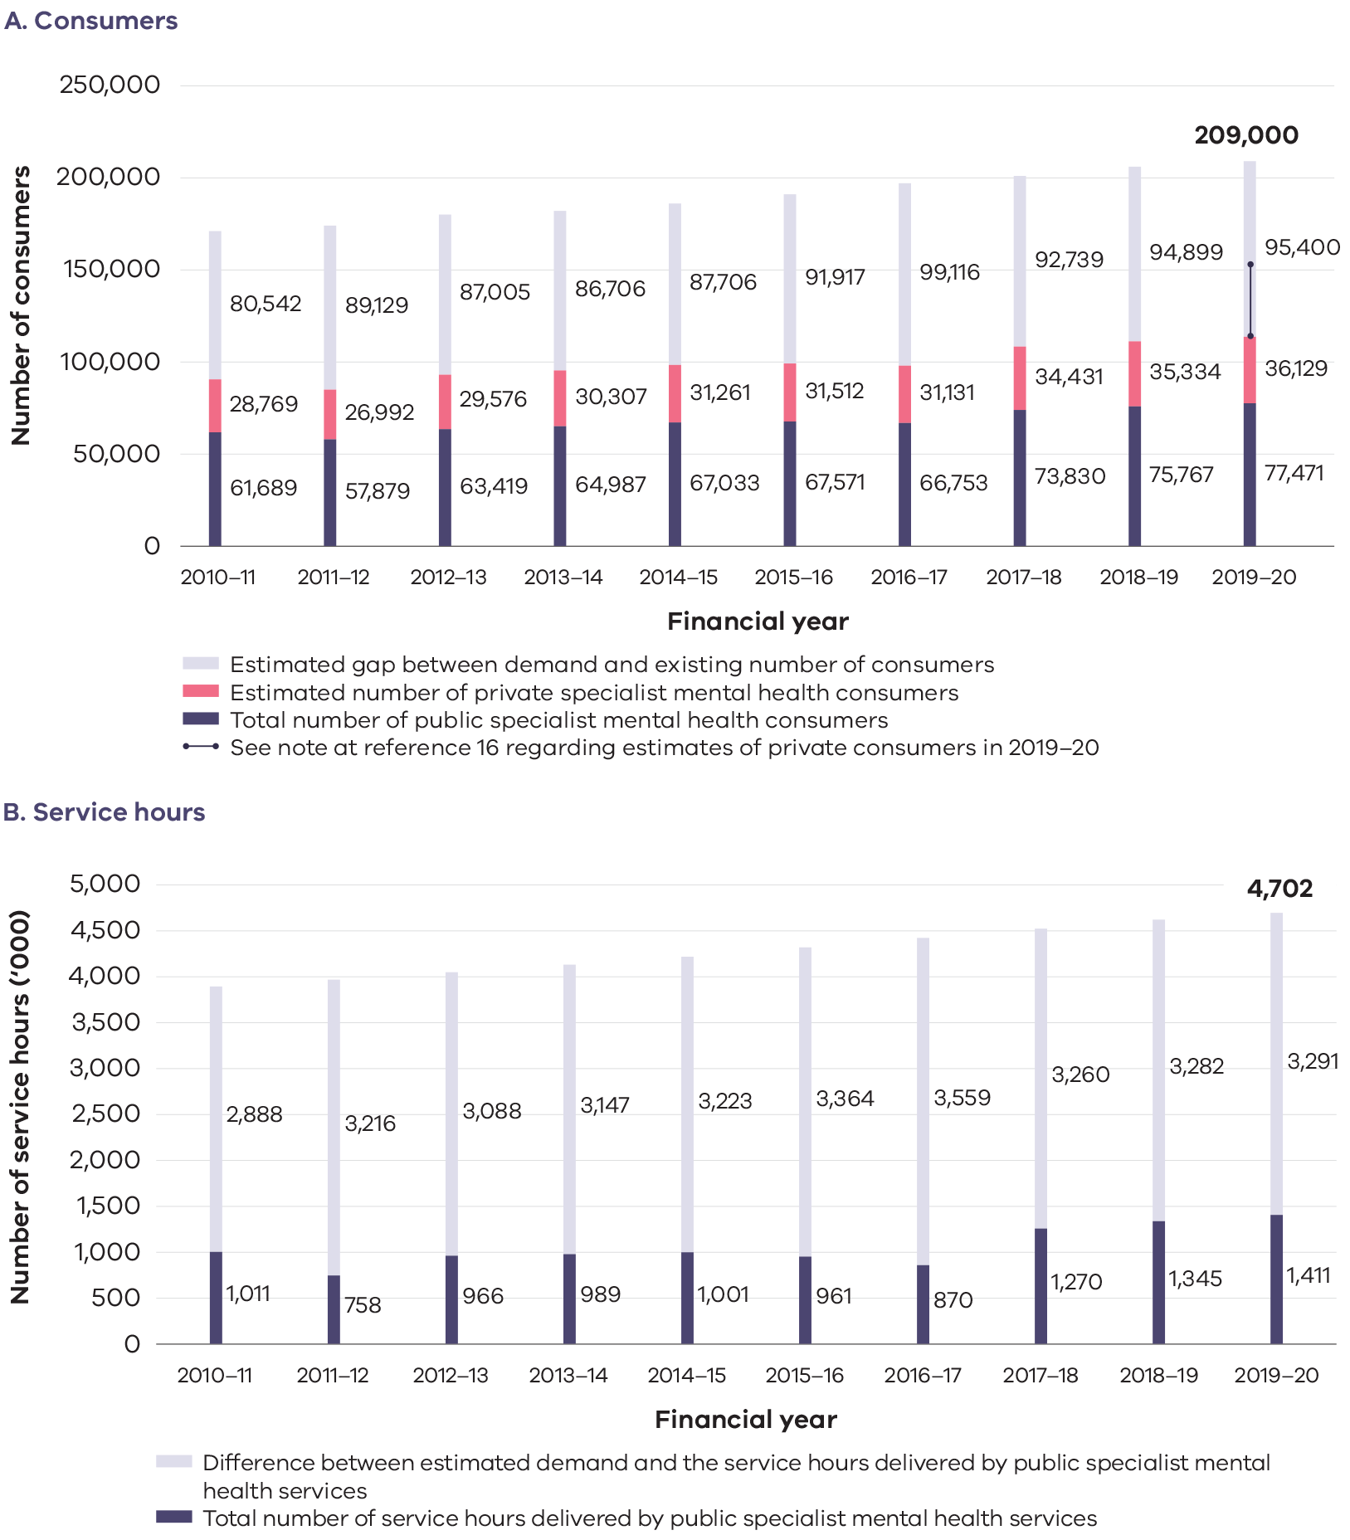
- The system has become imbalanced, with an over-reliance on medication. Services have come to rely on medication as the main, or sometimes only, treatment people can receive due to major system-wide challenges, such as under-resourcing. This has led to an imbalance, with a lack of focus on therapeutic interventions and recovery-centred treatment, care and support.
- There is a ‘missing middle’. A large and growing group of people have needs that are too ‘complex’, too ‘severe’ and/or too ‘enduring’ to be supported through primary care alone, but not ‘severe’ enough to meet the strict criteria for entry into specialist mental health services. As a result, people receive inadequate treatment, care and support, or none at all. Ms Amelia Morris, a witness before the Commission, shared:
One of the main problems I encountered with the mental health system was that when I asked for help, it felt like there was nothing there. The narrative around mental health seems to repeat the same message—’don’t be afraid to ask for help’. The problem comes when you ask, there doesn’t appear to be any answer. It’s so heartbreaking when you finally work up the courage to voice the horrible things that you’re experiencing, but there’s nothing there to help you.
- Getting help is difficult. People cannot access suitable services, and those who do access the system find it hard to navigate. People living with mental illness or psychological distress wait long periods and become ‘sicker’ before they can gain access to services: increasingly, a person must exhibit signs of major distress or crisis before treatment, care and support are provided. One person told the Commission:
I personally have asked for help from all the promoted channels and been turned away as I was not suicidal enough … Surely if someone has the courage to ask for help, Australia has the resources to help.
- Access to services is not equitable. Poverty and disadvantage make it particularly difficult for people to access services. A disproportionate number of people living with mental illness have low incomes and no private health insurance. For many, this makes access to primary care (for example, through a GP) difficult to afford. Catchments that determine access to services create a ‘postcode lottery’, meaning that people must access specialist services within their catchment, unless a person is seeking a specialist service that is unavailable in their catchment area. Further, where people live dictates how difficult it is to gain access to services, and this situation can be worse for people in rural and regional areas.
- The system is driven by crisis. Limited service availability means that many people living with mental illness or experiencing psychological distress receive treatment, care and support only at times of crisis. This means that people do not receive therapeutic supports, such as psychological therapies, and wellbeing supports, such as assistance connecting with the community, at the time when it would make the most difference.
- Emergency departments are used as entry points. System complexity, navigation difficulties and a lack of accessible, appropriate services mean that people are unable to obtain the right treatment, care and support when and where it would benefit them the most. Lack of appropriate community-based mental health services may have led to far greater growth in mental health-related presentations to emergency departments than in non–mental health related presentations (Figure 3).
Figure 3: Change in the number of emergency department presentations, by mental health status, Victoria, 2008–09 to 2019–20
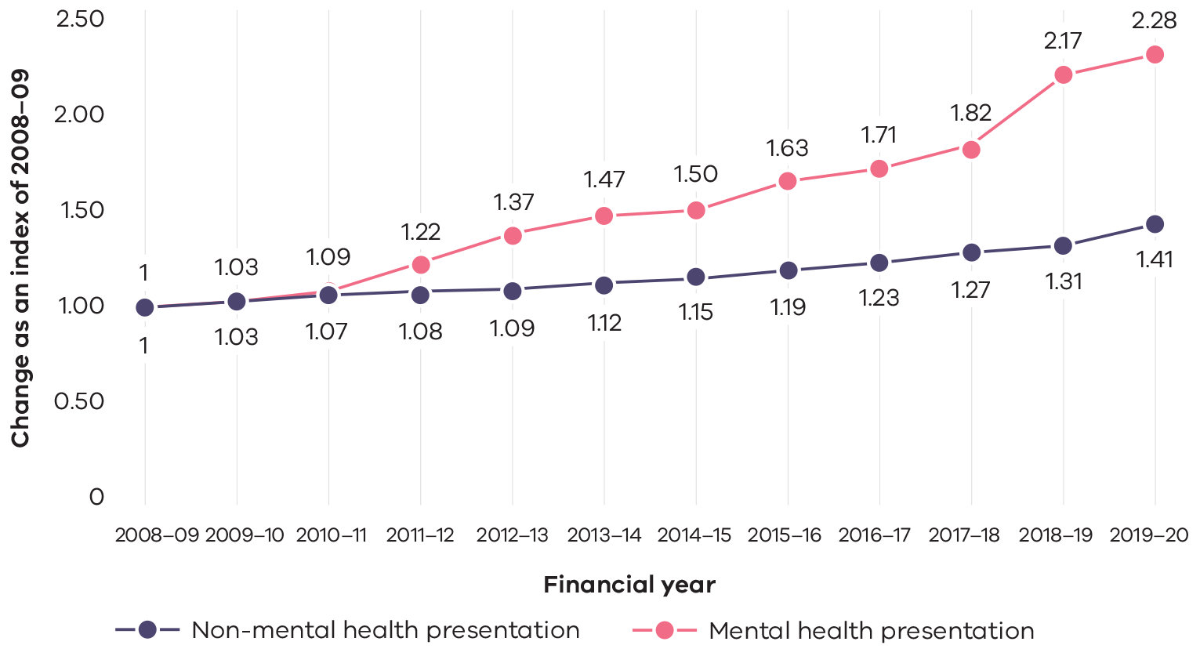
- There is a patchwork of services that do not reflect local needs. Service offerings are highly variable, reflecting old funding arrangements rather than current local needs. There are too many different service models, which are tested but not rolled out broadly, and this causes confusion and inefficiency across the system.
- Services are poorly integrated. People living with mental illness and other conditions such as poor physical health, disability or substance use or addiction can find it particularly difficult to gain access to services. This is because these services are often not sufficiently integrated to respond to people’s needs and preferences. Mr Michael Silva, a witness before the Commission, shared the experience of his brother:
Alan has a dual diagnosis of bipolar disorder (with psychotic episodes) and addiction to alcohol and drugs. … We have never had an experience in the public mental health system of Alan being treated in an integrated way with respect to his dual diagnosis … The psychiatrists will only see you for your mental health issues … [they] may say that you should not take the drugs or smoke marijuana, but that is about the extent of the integration.
- The perspectives and experiences of people with lived experience of mental illness or psychological distress are overlooked. Power imbalances throughout the system mean that the experiences, perspectives and expertise of people with lived experience of mental illness or psychological distress are not valued, understood or recognised. There are limited opportunities for people with lived experience of mental illness or psychological distress to truly lead, participate in and promote change, and the mental health system falls behind other social sectors in this regard. Ms Cath Roper, Consumer Academic of the Centre for Psychiatric Nursing at the University of Melbourne, told the Commission about the importance of shifting these power imbalances:
We need approaches in which we deliberately and proactively try to understand issues around power. We need to think consciously about whose voice might be the thinnest or the hardest to hear (and that approach will usually help the consumer).
- Families, carers and supporters are left out. There are about 60,000 Victorians who care for someone living with mental illness. Families, carers and supporters can feel excluded by the system, and are often left out of engagement that would help them in their caring role. Many families, carers and supporters require but are unable to access dedicated supports in their own right. There is a widespread lack of access to information about treatment, care and support to assist families, carers and supporters.
- There is not enough focus on the promotion of good mental health and wellbeing. The ‘burden of disease’ associated with mental illness is considerable, as are the personal, community and economic costs of poor mental health. Victoria has a higher estimated ‘burden of disease’ from mental illnesses than most other Australian states and territories: in 2015, the ‘burden of disease’ from mental illnesses was estimated to be 26.5 disability-adjusted age-standardised life years lost per 1,000 people in the Victorian population. In its interim report, the Commission estimated that the economic cost of poor mental health to Victoria is $14.2 billion a year. Given this, there is not enough focus on promoting good mental health and wellbeing nor preventing mental illness, and opportunities to ensure all parts of government and the community are focussed on these efforts are missed.
- Communities and places do not adequately support good mental health and wellbeing. There is a predominant focus on the ‘mental health system’, meaning that the social factors influencing mental health and wellbeing are not recognised. This focus also downplays the importance of communities, workplaces and education settings in shaping good mental health and wellbeing. System leaders need to better support these places and settings to support good mental health and wellbeing.
- There is limited focus on the early years. The system can be slow to respond to the mental health and wellbeing needs of infants and children under the age of 12 and prospective or new parents. The system predominantly focuses on young people and adults; parents find it difficult to access services and navigate the system; and families experience long wait times and stigmatising responses in seeking help for themselves or their children. By failing to focus on these early years, the system misses an opportunity to improve the mental health and wellbeing of future generations.
- Younger people are adversely affected. Younger people can experience mental illness just as they are seeking to participate in higher education and employment, form relationships and set out on adult life. One frequently cited United States study estimates that 75 per cent of all lifetime cases of anxiety, mood, impulse control and substance use disorders emerge by the age of 24 years. There is a strong case for investment in and attention to the mental health and wellbeing of young people.
- There is a substantial service gap for older Victorians. Victoria’s population is ageing: during the next three decades, the number of Victorians aged 65 years and over is estimated to double, rising from 1.05 million (as of 30 June 2020) to 2.13 million by 30 June 2051. This means that Victoria will also likely see an increase in the number of older Victorians living with mental illness. Yet, currently, increasing demand and inadequate investment in services for older adults means that those who do seek support are often turned away.
- Trauma is unseen. The close relationship between trauma and mental illness and the need for trauma-informed mental health treatment, care and support are starting to be recognised, but there is much work still to be done. The system needs to provide more holistic approaches for consumers and must be responsive to trauma and the potential for consumers to be retraumatised. A failing system can itself cause trauma.
- The focus on personal recovery needs to be strengthened. The current system focuses primarily on the goal of ‘clinical recovery’, where symptoms abate. However, the central focus needs to be on ‘personal recovery’. This concept has been developed by those with lived experience through the consumer movement. Personal recovery means being able to create a meaningful and contributing life, with or without mental health challenges. As Ms Erandathie Jayakody, a witness before the Commission, explained:
[Mental illness] does not have to be a lifelong sentence that limits your life. With the right supports and learnings the condition can be managed and a person can lead a full and meaningful life.
At the heart of a recovery-oriented approach is a recognition of the most basic human desire to have control of one’s own life and future, and the belief that people with mental health challenges have the ability and autonomy to achieve that.
The importance of recovery and community is illustrated in Rick Corney’s personal story.
Personal story:
Rick Corney

Rick first experienced mental health challenges when he was 28 years old. Following several involuntary hospitalisations, he was diagnosed with schizophrenia.
It was devastating. I didn’t understand the illness … I lost all hope of being well.
After his diagnosis, Rick became clinically depressed and suicidal. He credits his mum with the fact that he is still here today, saying she played an important role in supporting him throughout his treatment.
She went beyond and above what I thought possible.
I look back now … there was no carer’s network when she was supporting me.
Support also came directly from Rick’s community after a friend of his mum’s told members of the local cricket club about his situation. Rick believes the community at the cricket club was critical to his recovery.
They ended up coming and picking me up every Saturday to take me to the cricket. The first season I was so unwell and couldn’t play, so they sat me behind the bar and the only thing I said was ‘$2.50 thanks’, every time I sold a beer … We still laugh about that today, and about how far I’ve come.
While in the early days Rick experienced some stigma at the club, he believes this came from a lack of understanding about mental illness. Over time, instead of being the face of mental illness, he moved to being the face of what recovery can look like.
the cricket club has taken their learning out of my experience which has helped raise awareness. It has been really powerful … now people are able to talk about issues they are facing without feeling as though they are going through things alone and keep things hidden like I did.
Rick is now a peer worker at a mental health service in Ballarat. He sees his story as a powerful message to share with others to inspire them, demonstrating that ‘anything is possible’.
The fact that I’m here … kicking these goals and doing what I’m doing now … is a testimony to what recovery is about, and it’s the gold standard of how life can change.
Rick is a strong advocate of the importance of peer workers to support recovery. He describes an immediate bond and shared understanding that peer workers can develop from the outset.
For me, at the point at which I had lost all hope and saw no future for myself, if a peer worker had said to me, 'actually I was in your shoes twenty years ago and I had no hope and I never thought I would have a job or a partner and I do have these things now', I think my recovery might have begun sooner.
Source: Witness Statement of Richard Corney, 3 May 2020; Richard Corney meeting with Commissioner Armytage, 5 May 2020.
- Culturally safe services are not always available to Aboriginal communities in Victoria. Aboriginal communities continue to live with the effects of trauma connected to colonisation and post-invasion government activity, such as policies that gave rise to the Stolen Generation. Everyday stresses associated with social marginalisation can have pervasive negative effects on Aboriginal Victorians’ social and emotional wellbeing. Victorian data suggest that depression and anxiety is more prevalent among Aboriginal Victorians than among non-Aboriginal Victorians (refer to Figure 4).
Figure 4: Proportion of the Aboriginal and non-Aboriginal adult population ever diagnosed with anxiety or depression or with high/very high levels of psychological distress in the past four weeks, Victoria, 2017
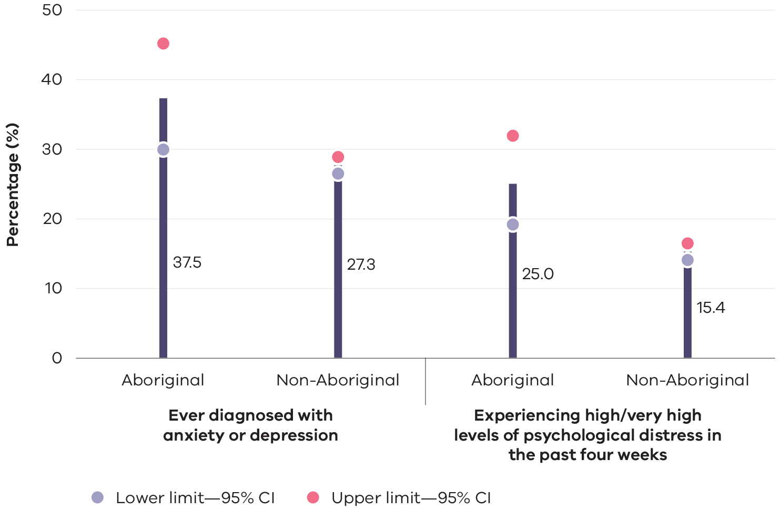
- Some groups face further barriers. Additional factors shape the experiences of some people living with mental illness or experiencing psychological distress, among them Aboriginal people, LGBTIQ+ people, refugees, asylum seekers, people from culturally diverse backgrounds, and people living with disability. People from these groups face a range of barriers when seeking treatment, care and support. For example, the mental health system does not currently deliver safe, responsive or inclusive care for many people from diverse communities and social groups.
- Mental illness can be compounded by housing instability. The changeable nature of mental illness can increase the likelihood of people experiencing housing instability. For example, people may be forced to move accommodation, or may be uncertain about where they will live. Many people living with mental illness also live in substandard accommodation. The Commission’s recommendations set out strong foundations for longer-term housing reform and build on recent investments, but resolution of Victoria’s housing crisis will require a continuing government-wide response that extends beyond the remit of this inquiry.
- People in the criminal justice system do not get the support they need. People living with mental illness are over-represented in the criminal justice system, and the interface between the criminal justice system and the mental health system is poorly coordinated. It is also impeded by capacity constraints in the mental health system, which mean people cannot access services when and where they would offer the greatest benefit. As a result, the justice system, rather than the mental health system, too often becomes the provider of mental health services, or the ‘provider of last resort’.
- The experience of poor mental health and wellbeing is different in rural and regional areas. People living in rural and regional areas can face a number of challenges when accessing treatment, care and support, among them stigma and a lack of local services. Although the prevalence of mental illness is generally the same as in metropolitan Melbourne, suicide rates are higher in rural and regional Victoria than in the city. In addition, while the whole system experiences workforce shortages, these are often pronounced in rural and regional areas.
- Stigma and discrimination are ever present. Stigma is much like racism and other forms of prejudice. It can prevent people living with mental illness or psychological distress from seeking support, can make social isolation and loneliness worse, and can be a barrier to gaining and retaining employment. Ultimately, it can be an obstacle to recovery that keeps people from fully and effectively participating in society. Discrimination is widespread and presents in many ways, such as difficulties accessing health care or being unsupported in the workplace, leaving people socially and economically excluded from society.
- Good mental health and wellbeing are not given priority. Over previous decades, external factors such as community attitudes, stigma and discrimination, competing political priorities and a lack of coherent, consistent advocacy have contributed to mental health and wellbeing not being given priority in government decision making. System leadership is weak, and accountability for how the system is managed is unclear. To some degree, mental health also appears to have been deprioritised within the health system itself.
- Suicide is far-reaching. Sadly, in 2019 there were 718 deaths by suicide in Victoria. Suicide has a ripple effect across the community, touching loved ones, friends, families and colleagues in profound and enduring ways. Some groups in the community are affected by suicide more than others, for example, men, people living in rural and regional areas, Aboriginal people, and LGBTIQ+ people. Ms Katerina Kouselas, bereaved by the suicide of her husband, told the Commission:
We had been married for 32 years when Bill passed away. I will never come to terms with that. We were together since we were 18, we have a beautiful daughter, Natalie, and it took my life away and my heart and it will never be okay.
There are many complex factors that are associated with suicide and these can often overlap. Current efforts need to move away from a single health response to a community- and government-wide approach.
- The system’s foundations need reform. Structural challenges, such as inadequate approaches to outcomes measurement, poor system planning and weaknesses in monitoring service providers, as well as inadequate partnering with the Commonwealth Government, have all contributed to an uncoordinated system, with large service gaps.
- Investment in the system is inadequate. Historically, Victoria’s monetary investment in mental health has been low compared with many other parts of Australia (refer to Figure 5). Investment in mental health per capita is also poor compared with physical health. The Honourable Professor Kevin Bell AM QC, Director of The Castan Centre for Human Rights Law, Monash University, giving evidence in a personal capacity, emphasised how unacceptable this is:
In human rights terms, this is a matter of obligation, not policy. Victoria is not like a developing nation where lack of resources is an explanation for under-investment in health.
Money is one measure, but of great concern is the profound human toll that accompanies a broken system.
Figure 5: Recurrent expenditure per capita ($) on state and territory community mental health services, constant prices, states and territories, 2008–09 and 2018–19
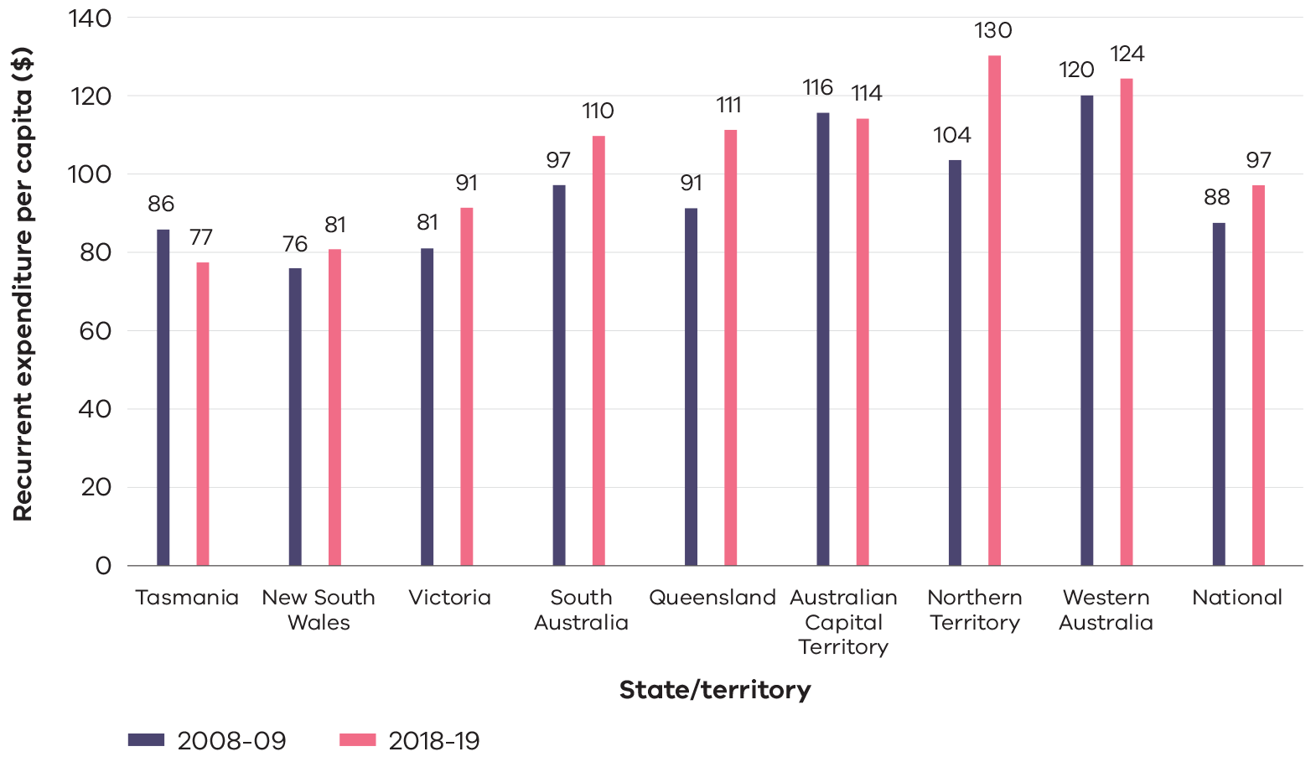
- Regulation and oversight is complex and unclear. Many consumers have experienced a lack of dignity, empathy and choice in the mental health system, and many have said they feel unsafe. There have been many efforts to encourage improvement to quality and safety, but these have not lasted.
- Dignity is often disregarded and human rights are breached. Many people who do obtain access to mental health services are not treated with dignity or respect and are not involved in making decisions about their own treatment, care and support. There is an excessive use of restrictive practices and compulsory treatment. One person shared their experience with the Commission, stating that ‘[s]eclusion is barbaric. Worse than prison. You are penalised for being unwell.’
- The workforce is under-resourced. The mental health workforce is diverse but there are serious shortages, which are more pronounced in some specialities and in rural and regional areas. Despite the commitment and competence displayed by workers, many have struggled to perform their best in a crisis-driven system. Teams feel overworked and under-resourced:
In my workplace … the team is very burnt out and mentally exhausted, and we will talk about how when we have our days off, no one has energy to do anything … and people keep turning up to work, because of not letting the team down.
- The value of lived experience work is starting to be recognised, but faces challenges. There is great potential to expand and support lived experience workforces. These workforces, however, experience unique challenges, including stigma and discrimination as well as a lack of infrastructure, professional supports and legitimacy as a profession. Expanding and unlocking the true value of these workforces will require services to be ready to promote, support and empower lived experience workforces.
- The system is antiquated. The mental health system has failed to keep up with people’s changing needs and expectations for contemporary approaches to treatment, care and support. The system has not fostered innovation, does not reflect contemporary evidence about effective forms of treatment, care and support, and has failed to keep up to date with the latest advances in digital technology, which could improve peoples’ experiences and outcomes.

3. Transformational reform
In considering how these challenges might be confronted, the Commission has used a system-design approach, which is based on engagement with people with lived experience. From this, it has developed a pathway for reform, founded on seven guiding principles—refer to Figure 6.
Figure 6: Guiding principles for Victoria’s mental health and wellbeing system
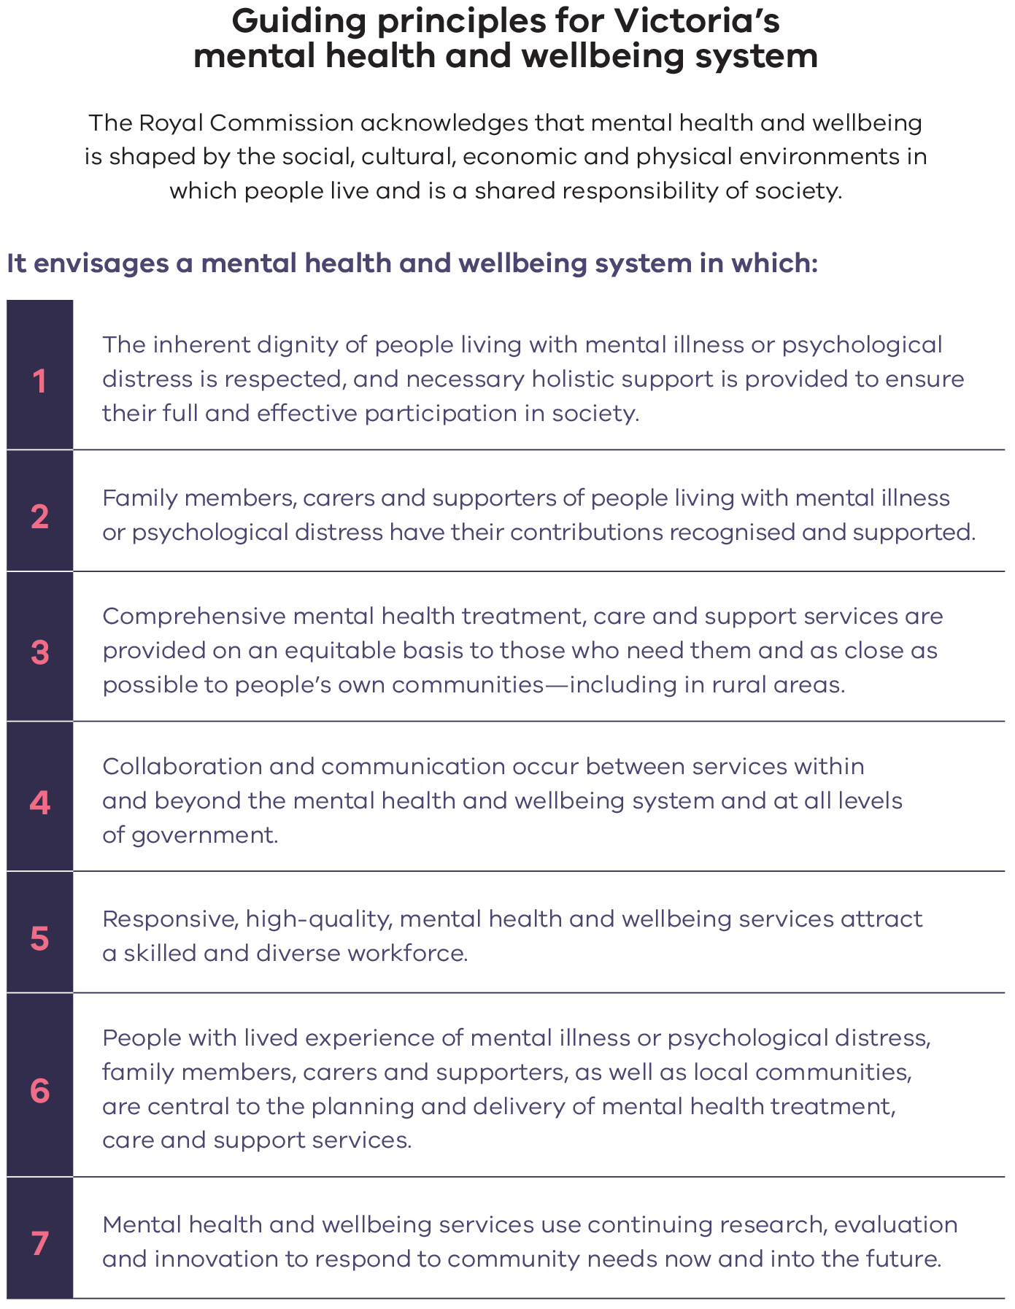
Note: These principles are in large part based on the many contributions made to the Commission, as well as relevant international documents such as the United Nations’ Convention on the Rights of Persons with Disabilities, the World Health Organization’s publications on mental health (including its 2014 report with the Calouste Gulbenkian Foundation on the social determinants of mental health) and legislation such as the Commonwealth Government’s Carers Recognition Act 2010.
The Commission’s recommendations are centred on transformational reform, with a vision for a balanced system where mental health and wellbeing treatment, care and support are provided in the community, hospital and other residential settings. These reforms aim to rebalance the system so that more services will be delivered in community settings, and extend beyond a health response to a more holistic approach to good mental health and wellbeing across the community.
The Commission’s 65 recommendations in this final report (and the nine in the interim report) support this ambition. An overview of major reform areas, grouped around four key features of the future mental health and wellbeing system, are summarised in the following sections.

3.1 A responsive and integrated system with community at its heart
The future mental health and wellbeing system will be fundamentally restructured around a community-based model of care, where people access treatment, care and support close to their homes and in their communities. There will be two parallel systems. One will be a system for infants, children and young people. The other for adults and older adults.
Recognising that there is diversity in the way people experience mental health and wellbeing, the reformed system will offer comprehensive and varied services, delivered by a multidisciplinary workforce.
People will access services based on their strengths and needs. The Commission has chosen to focus on these characteristics, rather than labels, which can be stigmatising and discriminatory. Figure 7 shows five ‘consumer streams’ across a spectrum of intensity of mental health and wellbeing treatment, care and support. This recognises that consumers’ needs will often change over time, meaning that people move between streams.
The service system will consist of six levels, where the top level is aimed at the largest number of people and the lowest level, statewide services, the fewest—refer to Figure 7. At each level, teams will operate with progressively increasing specialisation. Each level will engage with the next level, with service providers working together in an integrated way. Three levels will be fundamentally reformed: Local Mental Health and Wellbeing Services (50 to 60 new Adult and Older Adult Local Mental Health and Wellbeing Services with dedicated local services for infants, children and families, and young people), 22 Adult and Older Adult Area Mental Health and Wellbeing Services and 13 Infant, Child and Youth Area Mental Health and Wellbeing Services and statewide services.
Primary and secondary mental health and related services will be supported through the expanded provision of primary consultation with consumers, secondary consultation with providers of those services, and models of comprehensive shared care.
Wherever possible, consumers, regardless of their level of need, will be supported to receive services through Local Mental Health and Wellbeing Services, close to their support networks. People will access these services either directly or via referral. Through formal pathways between different types of services, individuals will have planned and dependable access to services.
New Adult and Older Adult Local Mental Health and Wellbeing Services will create a ‘broad front door’ so more people can access services than is currently the case. They will be required to deliver three core functions to make sure their services respond to individuals’ needs. As shown in Figure 7, these functions will include a range of treatments and therapies and expanded wellbeing supports (currently known as psychosocial supports). These functions will be delivered based on a philosophy of ‘how can we help?’ to enable people to be supported from their first to their last contact with mental health and wellbeing services.
Figure 7: Community mental health and wellbeing system: consumer streams, age-based streams, services within each level and core functions
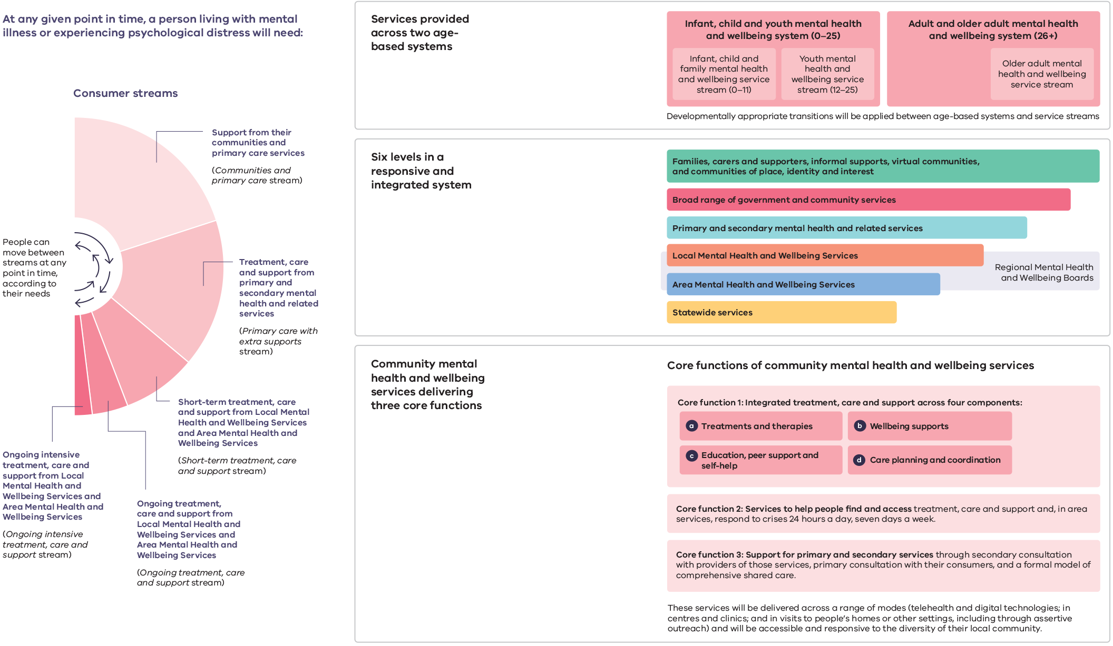
Larger version of Figure 7 in the Appendix
When a person has higher levels of need, a medical practitioner or Local Mental Health and Wellbeing Service will be able to refer them to an Area Mental Health and Wellbeing Service (22 Adult and Older Adult Area Mental Health and Wellbeing Services and 13 Infant, Child and Youth Area Mental Health and Wellbeing Services) that will provide tertiary-level, high-intensity and complex support responses using multidisciplinary teams. Area Mental Health and Wellbeing Services will be responsible for delivering all of the core functions of community mental health and wellbeing services for those requiring a higher intensity of treatment, care and support than can be provided through local services alone.
Area Mental Health and Wellbeing Services will be delivered in a partnership between a public health service (or public hospital) and a non-government organisation that provides wellbeing supports. These services will operate with extended hours and respond to crisis calls from anyone in the community 24 hours a day, seven days a week.
Community-based treatment, care and support, delivered by Area Mental Health and Wellbeing Services and based on assertive community treatment, including an outreach program, will be provided for people living with mental illness who need ongoing intensive treatment, care and support, where necessary.
The expertise of statewide services will be readily available to people and other service providers, in a way that minimises the distance people need to travel to access these services. New links between statewide services and the Collaborative Centre for Mental Health and Wellbeing, recommended in the Commission’s interim report, will be established to take advantage of the centre’s research and knowledge-sharing capabilities. Access to statewide services will require a referral from an Area Mental Health and Wellbeing Service, with the Department of Health, in conjunction with statewide services, establishing access policies that provide clarity about how referrals will be managed.
Age and developmentally appropriate treatment, care and support will be provided, and strict age-based eligibility will be removed. One responsive and integrated infant, child and youth mental health and wellbeing system will be established to provide developmentally appropriate treatment, care and support for newborns to 25-year-olds. The Infant, Child and Youth Area Mental Health and Wellbeing Services include two aligned and dedicated service streams: Infant, Child and Family Area Mental Health and Wellbeing Services (from birth to 11 years old) and Youth Area Mental Health and Wellbeing Services (12–25 years old). Further, Aboriginal community-controlled health organisations will be commissioned to deliver culturally appropriate, family-oriented, social and emotional wellbeing services for children and young people.
Community mental health and wellbeing services will encompass a broad range of support and service providers, including public health services, public hospitals, non-government organisations, community health services, private providers, new consumer-led providers, and a range of primary and secondary services. People will access services by attending site‑based services, through digital platforms, and by being visited in their home or community.
Rigid catchments, where people can only receive specialist services based on their place of residence, will be dismantled. Service providers will never turn people away on the basis of where they live.
The system will be designed around eight regions. New regional governance structures, which will be known as Regional Mental Health and Wellbeing Boards, will be phased in over time. This will support mental health and wellbeing services to be planned and organised in a way that responds to community needs and improves outcomes. These structures also provide a platform for greater integration across services beyond the mental health and wellbeing system, including both Victorian Government—and Commonwealth Government—funded services. Within each region, a multiagency panel will also be established to coordinate the delivery of multiple services for people living with mental illness who may require ongoing intensive treatment, care and support.
Within these regions, new ways of commissioning and contracting will also be used to encourage more integrated service delivery for people living with mental illness who need ongoing intensive treatment, care and support and for people who need short-term treatment, care and support and are in the ‘missing middle’. Regional Boards will contract ‘demonstration projects’ in each region to trial new commissioning and contracting approaches—promoting innovation and disseminating best practice.
While most people will receive treatment, care and support through community-based services, hospitals and residential services will play an important role, supporting people who need highly specialised or acute care. A responsive and integrated mental health and wellbeing system, however, will resolve the current over-reliance on hospital and crisis-based services. For people who do require bed-based services, new models of care and greater diversity of choice will be available. This includes a new rehabilitation pathway for people who need ongoing intensive treatment, care and support, and new models of multidisciplinary care for bed-based services that are delivered in a range of settings, including a person’s home and fit-for-purpose community and hospital environments. Gender-based separation in mental health inpatient facilities will help to address gender-based violence in those facilities.
A comprehensive mental health crisis system will be established, based on compassion and respect. For those in crisis, police and ambulance callouts and visits to emergency departments will no longer be the only options. A range of new consumer-led, safe spaces will be available for people experiencing different levels of distress or crisis. These will be provided in compassionate settings where people can stay safe and access support.
A new agency will be established, led by people with lived experience of mental illness or psychological distress, to support the development of organisations and services that are led by and for people with lived experience of mental illness or psychological distress.
The role of families, carers and supporters will be recognised as central to the mental health and wellbeing system. These individuals make a substantial contribution to the wellbeing of the people they care for or support. The value of families, carers and supporters will be promoted across the system, and family- and carer-led centres will be established to support them and respond to their needs. Ms Anna Wilson’s personal story, set out in this summary, illustrates the important role families, carers and supporters can play, and the challenges they confront with the current system.
The new system will support the mental health and wellbeing of the next generations through one infant, child and youth mental health and wellbeing system for newborns to 25-year-olds.
Community perinatal mental health teams will support prospective and new parents. A responsive and integrated service stream of treatment, care and support will support children from birth to 11 years and their families, focusing on the start of life and the formative years.
Victoria’s young people, aged 12–25 years, will be supported to grow into adulthood with good mental health and wellbeing. A new youth mental health and wellbeing service stream will be established, with youth services being reformed and expanded.
The reformed mental health and wellbeing system will offer different types of treatment, care and support, recognising the different preferences of consumers, families, carers and supporters. A statewide trauma centre will help in delivering the best possible mental health outcomes for people who have experienced trauma. A statewide service for people living with mental illness and substance use or addiction will also be established, alongside other reforms, that will provide integrated treatment, care and support.
Supporting good mental health and wellbeing extends beyond the mental health and wellbeing system, requiring a focus on other service systems and how they can work together. For example, stable housing can be transformative, bringing a sense of purpose, hope and opportunity. As part of the Victorian Government’s 10-year social and affordable housing strategy, people living with mental illness will be recognised as a priority population, and supported housing places will be provided for young people living with mental illness and experiencing unstable housing or homelessness.

3.2 A system attuned to promoting inclusion and addressing inequities
The future mental health and wellbeing system will be responsive to people and populations in Victoria with the greatest need, providing services that are safe, tailored and localised. The system will adapt to new and changing inequities, supporting those who may be experiencing disadvantage. This reform requires looking beyond the system to examine the varied factors that shape mental health and wellbeing. Mrs Lucinda Brogden AM, Chair of the National Mental Health Commission, told the Commission:
Some of the most powerful root causes of health inequalities are the social conditions in which people are born, grow, work, live and age, as well as the systems that shape the conditions of daily life. These conditions are collectively referred to as the social determinants of health.
The Commission envisages a system that focuses on improved mental health and wellbeing outcomes for consumers, families, carers and supporters. A Mental Health and Wellbeing Outcomes Framework will create accountability for mental health and wellbeing outcomes across services and government. It will guide the transformation of the system and challenge it to address inequity.
The Commission’s hope for Victorians to enjoy optimal mental health and wellbeing is based on a commitment to promote and uphold human rights and to focus on the promotion of good mental health and wellbeing. There will be appropriate and continuing investment in the leadership, coordination and delivery of a statewide approach to prevention and promotion activities, and these activities will concentrate on human rights and on reducing imbalances in mental health and wellbeing outcomes.
Working in partnership with Victoria’s diverse communities and setting new expectations of services, will mean the needs of Victoria’s diverse communities will be recognised and responded to. For example, support for LGBTIQ+ people to navigate and access the system will be strengthened. Victorians will be able to obtain appropriate mental health information regardless of first or preferred language, hearing, literacy or neurocognitive ability. Building on the reforms outlined in the Commission’s interim report, supports to improve the social and emotional wellbeing of Aboriginal children and young people will be increased, with healing centres delivered by Aboriginal community-controlled health organisations.
Good mental health and wellbeing is a shared priority across the community: wellbeing is influenced by interactions and connections with people. Therefore, inequality must also be tackled where people live, work, learn and connect. ‘Community collectives’ will be established that bring together community leaders and members to promote social connection and inclusion in Victorian communities.
Regional Boards will commission Local Mental Health and Wellbeing Services and Area Mental Health and Wellbeing Services, ensuring that these services respond to the needs of local communities and recognise the unique strengths and challenges of each region. Disparities in service access and mental health and wellbeing outcomes across rural and regional communities will also be resolved, through expanded services and strategies to attract and retain more mental health workers.
In the reformed system, stigma and discrimination will be confronted. This will create the basic conditions needed to support good mental health and wellbeing. Anti-stigma programs will be developed, implemented and evaluated, and people will have improved access to legal protection from mental health discrimination.
Personal story:
Anna Wilson
Anna* is the carer for her 27-year-old son Harold.* Anna said that they have always been close, and that Harold sends her phone messages saying ‘love you Mum’.
He was a beautiful little boy, who would often pick flowers for me on his way home from school. He had beautiful school reports, about how kind, gentle, polite and well-mannered he was.
Harold has been diagnosed with schizophrenia, post-traumatic stress disorder and alcohol dependency. Anna said that over the nine years she has tried to get treatment for Harold, his condition has worsened.
My son experienced his first psychotic episode in 2014 … Since Harold has been suffering from mental illness, it has been nine long torturous years struggling to get help. I have been forced to watch my beautiful boy’s life deteriorate in front of my eyes.
Anna reflected that being a carer trying to get help from the public mental health system in crisis situations has been a battle.
I have felt so disempowered and exhausted from constantly battling to get my son the support and care he needs.
I have been pushed aside because staff are busy. Mental health workers have said to me ‘I can’t talk now’ or ‘I’ll let you go now’. I’ve felt like saying ‘I don’t want to be let go’.
Anna said she has tried to call emergency and crisis services about Harold, but that help is only provided in the most severe situations.
There have been thousands of phone calls, between 20 to 50 calls on some days, yet I have been unable to get my son the help he needs. Sometimes, the situation has to be really drastic before you are taken seriously, and help is provided. I’ve had to talk to the Mental Health Complaints Commissioner, the Office of the Chief Psychiatrist and, at times, I have had to threaten legal action because otherwise you just don’t get listened to. It shouldn’t have to be like this.
However, Anna spoke positively of how police have responded to Harold, particularly on one occasion where they attended after a neighbour reported a disturbance.
Although the policeman was assertive, he was also compassionate, empathetic and listened to Harold. Harold really opened up his heart to him. He showed the policeman all the scars on his arms and the cuts he’d made a couple of days earlier, talked about … how his cat was missing. One of the policeman said to Harold ‘I know, I’ve lost a cat too, it’s really hard’ …
The police and some public service officers have been fantastic … and in my experience far more supportive and responsive than the [crisis assessment and treatment] team.
Anna would like to see improved crisis services so that police are not the main contact for people who need specialised treatment. She would also like to see more hospital beds available and better support for people being discharged from a service. Anna also wants the waiting lists reduced for services that provide long-term rehabilitation.
I want my son to learn to be independent and to be able to live in his own home. I’m scared that after I pass away, he will end up on the street. It breaks my heart …
Anna described how caring affects her own health and wellbeing and leaves her feeling drained. She would like carers to receive more support and opportunities to have a break.
She also said that the mental health system needs more compassion.
the system, the services and the workforce need to be more compassionate and understanding of the immense pain and stress that families and people like my son are experiencing. Workers need patience and understanding to properly engage with people with mental illness.
Source: Witness Statement of ‘Anna Wilson’ (pseudonym), 2 July 2020.
Note: *Names have been changed in accordance with an order made by the Commission.

3.3 Re-established confidence through prioritisation and collaboration
Strong foundations create the conditions for the reformed mental health and wellbeing system to be sustained. These relate to effective leadership, governance and oversight, accountability and collaboration across governments and communities, and ensuring that people with lived experience of mental illness or psychological distress are leading and partnering with others in reform efforts. Ms Mary O’Hagan MNZM, former New Zealand Mental Health Commissioner and current Manager of Mental Wellbeing at Te Hiringa Hauora, New Zealand, gave evidence in a personal capacity and emphasised:
the reforms we need are not about ‘giving greater voice’ to people with lived experience. Rather, we need to transform the system from within, so that those voices are central to the discourses and are deeply heard.
A new independent and statutory Mental Health and Wellbeing Commission will be established to hold the Victorian Government to account for the performance of the mental health and wellbeing system and the implementation of the Commission’s recommendations. The new Commission will be able to initiate its own inquiries into matters that support its objectives. As part of efforts to strengthen oversight, the new Commission will also take on responsibility for responding to complaints.
To elevate mental health and wellbeing as a government priority, system-level governance will be strengthened. A Chief Officer for Mental Health and Wellbeing, whose role will be defined in legislation, will lead the Mental Health and Wellbeing Division in the Department of Health.
The leadership of people with lived experience will be foundational to the future system. The new Mental Health and Wellbeing Commission will include Commissioners with lived experience of mental illness or psychological distress and lived experience as a family member or carer. The new Commission will also support people with lived experience of mental illness or psychological distress to fully and effectively take part in decision making about the issues that affect their lives. It will also promote the role, value and inclusion of families, carers and supporters across the mental health and wellbeing system.
A key part of improving people’s experiences and outcomes is ensuring that the quality and safety of mental health and wellbeing services are of the highest standard. A Mental Health Improvement Unit will be established within Safer Care Victoria to support a new approach to improving quality and safety that embeds contemporary and multidisciplinary approaches in services. The unit will focus on reducing the use of seclusion, restraint and compulsory treatment and on tackling the unacceptable rate of gender-based violence, particularly in inpatient settings.
Services will be commissioned in new ways to respond to the diverse preferences and expectations of people living with mental illness or psychological distress, families, carers and supporters. Investment in mental health and wellbeing will be made a priority through the implementation of the levy recommended in the interim report. There will also be substantial changes to the way services are planned, funded and monitored, ensuring that providers meet people’s expectations and that services are achieving the outcomes that are most important to consumers, families, carers and supporters.
Collaboration across governments and sectors will be vital in responding to the varied factors that shape people’s mental health and wellbeing, such as education and justice settings, workplaces and social networks. This is particularly important for suicide prevention and response, because multiple factors are associated with suicide. Working towards zero suicides will require a government- and community-wide approach and will be facilitated through a new Suicide Prevention and Response Office.
The Commission’s reimagined mental health and wellbeing system will be enshrined in legislation—a new Mental Health and Wellbeing Act. The new Act will reflect the vision for the future system and will promote good mental health and wellbeing.

3.4 Contemporary and adaptable services
Contemporary and adaptable service delivery is crucial to improving the experiences and outcomes of people living with mental illness or psychological distress, families, carers and supporters for generations to come. Providing such services will require a fundamentally different approach: the new system will need to adapt to changing expectations, trends and emerging challenges.
These reforms cannot be delivered without a sustainable workforce. Workforce reforms will be implemented to build a workforce that is diverse, large enough and with the skills and experience to deliver effective treatment, care and support in the future mental health and wellbeing system. There will be increased support for workforce wellbeing and practice, learning and professional development activities.
In a contemporary mental health and wellbeing system, consumers’ human rights are respected every step of the way. Consumers are supported to make decisions that affect their own lives. Real changes will be put in place to shift practices and cultures, ensuring consumers’ human rights are upheld. This includes efforts to greatly reduce the use of seclusion and restraint, eventually eliminating these practices, and to substantially reduce the use of compulsory treatment so it is only used as a last resort.
The future system will be enabled through digital technology. To improve system access, continuity of care and navigation, service providers will be required to provide minimum digital functionality, and they will be helped to achieve this. A new approach to information management will be established in partnership with consumers, to help collect, use and share information across the system effectively, safely and efficiently.
The system will continue to evolve and respond to the expectations of people living with mental illness or psychological distress, families, carers and supporters. Innovation in treatment, care and support will be promoted through a dedicated mental health and wellbeing innovation fund, and services will be helped to implement and test new approaches. There will be a strong focus on translational research (testing and applying new treatments and models of care in service delivery environments) that is led and co-produced with people with lived experience of mental illness or psychological distress. Evaluation will be widespread, and providers of all new mental health and wellbeing programs will need to agree to evaluation as part of funding arrangements.

4. Realising the Commission’s ambitions
Although the Commission’s inquiry has drawn to a close, some of the most important work will now begin. The transformed mental health and wellbeing system described in this report will only be realised if implementation is done properly and government is committed to delivering this vision and stays true to the course.
This will not be easy. The system is complex; so too are the causes of poor mental health. The Commission has, however, consulted widely to redesign the new system, and has recommended pragmatic reforms that reflect the needs and expectations of people living with mental illness or psychological distress, families, carers and supporters.
In regard to the Commission’s reform agenda, it is imperative that implementers do not repeat the consultative work of the Commission or revisit the decisions behind it. To do so would be a disservice to those who have generously shared their experiences, analysis and ideas for reform with the Commission.
The Commission’s inquiry into the mental health system is not the first of its kind. But, unlike previous inquiries, there is a real commitment to following through: the present Victorian Government has committed to implementing all of the Commission’s recommendations. The 2020–21 State Budget assigned substantial funding for the reforms recommended in the Commission’s interim report.
The Commission has had a unique opportunity to review the system in its entirety and to engage widely with people, enabling it to understand the system’s failures and to identify opportunities for lasting reform.
The inquiry has coincided with an increased interest in good mental health and wellbeing from the Commonwealth Government. This has been apparent through the Productivity Commission’s Mental Health Inquiry Report and the work of the Prime Minister’s National Suicide Prevention Adviser to develop a government-wide approach to suicide prevention and response.
Alongside this interest from government, there is also an encouraging level of public discourse and open communication about good mental health and wellbeing. This has been particularly evident during the COVID-19 pandemic, which has had broad social and economic impacts for Victorians. While the world is still coming to understand how the pandemic has affected people’s mental health and wellbeing, some research indicates there may be increased rates of depression and/or anxiety as a result, as well as increased substance use and suicidal thoughts. These impacts highlight the need for a continued focus on reforming the system.
The public has placed great trust in this Commission to reform the mental health system. We have been humbled by the number of people who have engaged with the Commission to share their perspectives about, and hope for, a new system. This collective hope has guided the Commission’s vision for a future mental health and wellbeing system and must be central to realising this vision.
Strong and committed leadership is required across governments and services and, importantly, from people with lived experience of mental illness or psychological distress, families, carers and supporters. All levels of government, service providers, the workforce, related systems and the community must work together.
The Commission has inquired into the system for nearly two years, and it has set out the reforms required to deliver a reimagined mental health and wellbeing system. There is much cause for hope that this time, effective and lasting reform will be implemented.
The Victorian public’s optimism and desire for change gives implementers a unique opportunity to create enduring reform. All partners in delivering profound change must rise to the challenge. The Commission’s inquiry is over; the time for decisive and deliberate action is now.

Recommendations

Recommendation 1:
Supporting good mental health and wellbeing
The Royal Commission recommends that the Victorian Government:
- build on the interim report’s nine recommendations and develop a Mental Health and Wellbeing Outcomes Framework to drive collective responsibility and accountability for mental health and wellbeing outcomes across government portfolios.
- through a newly established Mental Health and Wellbeing Cabinet Subcommittee, chaired by the Premier (refer to recommendation 46(2)(a)), use the Mental Health and Wellbeing Outcomes Framework to monitor outcomes to inform planning and policy decisions.
- use the Mental Health and Wellbeing Outcomes Framework as a mechanism to inform government investment processes and assess the benefits, including the economic benefits, of early intervention.
- update the Mental Health and Wellbeing Outcomes Framework and publicly report on progress against outcomes at a service, system and population level, every year.

Recommendation 2:
Governance arrangements for promoting good mental health and preventing mental illness
The Royal Commission recommends that the Victorian Government:
- establish within the Mental Health and Wellbeing Division, a Mental Health and Wellbeing Promotion Office, led by a Mental Health and Wellbeing Promotion Adviser, who reports to the Chief Officer for Mental Health and Wellbeing (refer to recommendation 45(1)).
- enable the Mental Health and Wellbeing Promotion Office to develop and coordinate a statewide approach to the promotion of good mental health and wellbeing and the prevention of mental illness which:
  - delivers the economic and social benefits of good mental health and wellbeing across the population;
  - is informed by public health principles;
  - promotes and is informed by human rights; and
  - focuses on reducing inequities in mental health and wellbeing outcomes.

Recommendation 3:
Establishing a responsive and integrated mental health and wellbeing system
The Royal Commission recommends that the Victorian Government:
- establish a responsive and integrated mental health and wellbeing system, in which people receive most services locally and in the community throughout Victoria, close to their families, carers, supporters and networks.
- establish service delivery across Victoria at local, area-based and statewide levels comprising:
  - between 50 to 60 new Adult and Older Adult Local Mental Health and Wellbeing Services that operate with extended hours and are delivered in a variety of settings;
  - 22 Adult and Older Adult Area Mental Health and Wellbeing Services delivered through partnerships between public health services or public hospitals and non-government organisations that deliver wellbeing supports;
  - 13 Infant, Child and Youth Area Mental Health and Wellbeing Services delivered through partnerships between public health services or public hospitals and non-government organisations that deliver wellbeing supports; and
  - statewide services that are delivered in a way that minimises the need for people to travel far to access services.
- for planning and governance purposes, realign existing boundaries and organise mental health and wellbeing services across eight regions (refer to recommendation 4).
- remove rigid boundaries (or catchments) for service delivery based on where people live.
- establish the requirements for each service and the links between them through a ‘service capability framework’.

Recommendation 4:
Towards integrated regional governance
The Royal Commission recommends that the Victorian Government:
- by mid 2021, establish eight interim regional bodies to provide advice to the Mental Health and Wellbeing Division in the Department of Health as it plans, develops, coordinates, funds and monitors a range of mental health and wellbeing services in each region.
- by no later than the end of 2023, replace interim regional bodies with legislated Regional Mental Health and Wellbeing Boards to:
  - undertake workforce, service and capital planning for mental health and wellbeing services; and
  - lead engagement with their respective communities.
- from the end of 2023 and by no later than the end of 2026, enable each Regional Mental Health and Wellbeing Board also to:
  - commission mental health and wellbeing services; and
  - hold individual providers to account to improve the outcomes and experiences of people who use their services.
- in parallel with the establishment process, ensure that Regional Mental Health and Wellbeing Boards:
  - acquire and maintain the required skills and capabilities to perform the above functions;
  - are accountable for the delivery of agreed outcomes through new accountability arrangements; and
  - are skills-based and include at least one person with lived experience of mental illness or psychological distress and one person with lived experience as a family member or carer.
- with the assistance of the interim regional bodies, establish a multiagency panel in each region to coordinate as required the delivery of multiple mental health and wellbeing services for people living with mental illness or psychological distress, including children and young people, who may require ongoing intensive treatment, care and support.

Recommendation 5:
Core functions of community mental health and wellbeing services
The Royal Commission recommends that the Victorian Government:
- commission and ensure that Adult and Older Adult Local Mental Health and Wellbeing Services and Adult and Older Adult Area Mental Health and Wellbeing Services referred to in recommendation 3(2)(a) and (b) work in collaboration to deliver in each of the 22 service areas short-term, ongoing and intensive services as required and include the following core functions:
  - Core function 1: integrated treatment, care and support that comprises:
    - a broad range of treatments and therapies;
    - a broad range of wellbeing supports (formerly called psychosocial supports) for those who require them, including those who are unable to access the National Disability Insurance Scheme;
    - education, peer support and self-help; and
    - care planning and coordination.
  - Core function 2: services to help people find and access treatment, care and support and, in Area Mental Health and Wellbeing Services, respond to crises 24 hours a day, seven days a week.
  - Core function 3: support for primary and secondary care and related services, through primary consultation with consumers, secondary consultation with providers of those services and a formal model of comprehensive shared care.
- commission and ensure that Adult and Older Adult Local Mental Health and Wellbeing Services and Adult and Older Adult Area Mental Health and Wellbeing Services referred to in recommendation 3(2)(a) and (b) work in collaboration to deliver multidisciplinary, holistic and integrated treatment, care and support through a range of delivery modes including:
  - site-based care (such as centres or clinics);
  - telehealth;
  - digital technologies; and
  - visits to people’s homes and other places (including targeted assertive outreach).
- ensure Adult and Older Adult Local Mental Health and Wellbeing Services and Adult and Older Adult Area Mental Health and Wellbeing Services are accessible and responsive to the diversity of local communities.

Recommendation 6:
Helping people find and access treatment, care and support
The Royal Commission recommends that the Victorian Government:
- ensure people can access Local Mental Health and Wellbeing Services through a referral from a general practitioner or any other service provider, or through a discussion with the relevant service’s access and navigation support worker.
- ensure people can access Area Mental Health and Wellbeing Services through a referral from a Local Mental Health and Wellbeing Service or through direct referral from a medical practitioner.
- ensure people can access Statewide Mental Health and Wellbeing Services through a referral from an Area Mental Health and Wellbeing Service.
- promote, and co-produce with people with lived experience, a website that provides clear, up-to-date information about Victoria’s mental health and wellbeing system that helps users to:
  - understand their mental health needs;
  - identify services and supports across all relevant provider types; and
  - access online self-help resources.
- collaborate with its funded non-government helpline services to improve helplines’ connections with mental health and wellbeing services and to assist people to find and access treatment, care and support.

Recommendation 7:
Identifying needs and providing initial support in mental health and wellbeing services
The Royal Commission recommends that the Victorian Government:
- ensure mental health and wellbeing services provide three ‘needs identification and initial support’ functions:
  - access and navigation support;
  - initial support discussions; and
  - comprehensive needs assessment and planning discussions.
- ensure these functions are delivered based on a philosophy of ‘how can we help?’ to enable people to be supported from their first to their last contact with mental health and wellbeing services.

Recommendation 8:
Responding to mental health crises
The Royal Commission recommends that the Victorian Government:
- ensure each Adult and Older Adult Area Mental Health and Wellbeing Service delivers a centrally coordinated 24-hours-a-day telephone/telehealth crisis response service accessible to both service providers and to members of the community of all ages that provides:
  - crisis assessment and immediate support;
  - mobilisation of a crisis outreach team or emergency service response where necessary; and
  - referral for follow-up by mental health and wellbeing services and/or other appropriate services.
- expand crisis outreach services in each Adult and Older Adult Area Mental Health and Wellbeing Service to provide treatment, care and support from a clinician and non-clinical worker such as a peer worker.
- improve emergency departments’ ability to respond to mental health crises by:
  - establishing a classification framework for all emergency departments and urgent care centres, based on their capability to respond to people experiencing mental health crises;
  - using the classification framework to ensure that health services are appropriately resourced to perform their role in a regional network of emergency departments and urgent care centres; and
  - ensuring there is at least one highest-level emergency department suitable for mental health and alcohol and other drug treatment in each region.

Recommendation 9:
Developing ‘safe spaces’ and crisis respite facilities
The Royal Commission recommends that the Victorian Government:
- invest in diverse and innovative ‘safe spaces’ and crisis respite facilities for the resolution of mental health and suicidal crises which are consumer led and, where appropriate, delivered in partnership with non-government organisations.
- in collaboration with the new agency led by people with lived experience of mental illness or psychological distress (refer to recommendation 29) and non-government organisations that deliver wellbeing supports, establish:
  - one drop-in or crisis respite facility for adults and older Victorians per region (refer to recommendation 3(3)); and
  - four safe space facilities across the state, comprising a mix of drop-in spaces and crisis response services, co-designed with and for young people.
- establish a crisis stabilisation facility, in consultation with people with lived experience, led by a public health service or public hospital in partnership with a non-government organisation that delivers wellbeing supports.

Recommendation 10:
Supporting responses from emergency services to mental health crises
The Royal Commission recommends that the Victorian Government:
- ensure that, wherever possible, emergency services’ responses to people experiencing time-critical mental health crises are led by health professionals rather than police.
- support Ambulance Victoria, Victoria Police and the Emergency Services Telecommunications Authority to work together to revise current protocols and practices such that, wherever possible and safe:
  - Triple Zero (000) calls concerning mental health crises are diverted to Ambulance Victoria rather than Victoria Police; and
  - responses to mental health crises requiring the attendance of both ambulance and police are led by paramedics (with support from mental health clinicians where required).
- ensure that mental health clinical assistance is available to ambulance and police via:
  - 24-hours-a-day telehealth consultation systems for officers responding to mental health crises;
  - in-person co-responders in high-volume areas and time periods; and
  - diversion secondary triage and referral services for Triple Zero (000) callers who do not require a police or ambulance dispatch.

Recommendation 11:
New models of care for bed‑based services
The Royal Commission recommends that the Victorian Government:
- review, reform and implement new models of multidisciplinary care for bed-based services that are delivered in a range of settings, including in a person’s home and in fit-for-purpose community and hospital environments.
- deliver a broad range of bed-based services, including as a matter of immediate priority:
  - expanding Hospital in the Home services as an alternative to acute hospital-based treatment, care and support where appropriate;
  - investing in a wide range of time-limited and flexible residential respite services informed by local priorities, including establishing a peer-led residential respite service at a demonstration site; and
  - developing new bed-based rehabilitation services (refer to recommendation 12).
- build on the interim report’s recommendation 2 about the need for the expansion of acute mental health services and deliver at least 100 additional beds in settings that reflect optimal allocation and distribution across Victoria.
- periodically review the allocation of new beds as part of the statewide and regional planning processes recommended by the Royal Commission (refer to recommendation 47) and audit the outcomes.

Recommendation 12:
Developing new bed-based rehabilitation services
The Royal Commission recommends that the Victorian Government:
- implement the new whole-of-system rehabilitation pathway described by the Royal Commission in its final report, which includes two new bed-based rehabilitation models of care, for people living with mental illness who require ongoing intensive treatment, care and support.
- consistent with the ‘design and quality features’ described by the Royal Commission in its final report, co-design with consumers, clinicians and relevant non-government organisations and services:
  - the new community rehabilitation model of care and deliver it at a community care unit demonstration site; and
  - the new intensive rehabilitation model of care and deliver it at a secure extended care unit demonstration site.
- subject to the evaluation and required adaptation of the new rehabilitation models of care, apply these models to existing community care and secure extended care units and enhance and expand infrastructure accordingly.

Recommendation 13:
Addressing gender-based violence in mental health facilities
The Royal Commission recommends that the Victorian Government:
- ensure that all new mental health inpatient facilities:
  - are built and designed with the necessary scale and flexible infrastructure to enable gender-based separation in all bedrooms and bathrooms; and
  - provide separate communal spaces as required.
- by mid-2022, ensure that existing high dependency units in inpatient facilities allow for gender-based separation.
- review and retrofit existing inpatient facilities on a case-by-case basis to:
  - achieve gender-based separation where possible; and
  - as a matter of priority, ensure that each facility meets the minimum standards for gender safety set out in the Chief Psychiatrist’s guideline: Promoting sexual safety, responding to sexual activity and managing allegations of sexual assault in adult acute inpatient units.
- ensure that the Mental Health and Wellbeing Division supports mental health and wellbeing services to eliminate sexual and gender-based violence in bed-based service settings.

Recommendation 14:
Supporting mental health consultation liaison services
The Royal Commission recommends that the Victorian Government:
- work with the Independent Hospital Pricing Authority and the Commonwealth Government to:
  - ensure mental health consultation liaison services for consumers admitted for physical health reasons are formally recognised and adequately funded as part of routine care; and
  - ensure mental health consultation liaison services are incorporated, costed and priced in the relevant classifications and standards.
- ensure public health services and public hospitals:
  - receive adequate temporary funding to embed and deliver in-hospital mental health consultation liaison services as part of routine care until joint funding arrangements between the Commonwealth and Victorian Governments are established;
  - are accountable for delivering in-hospital mental health consultation liaison services and, whenever required, provide such services to consumers admitted for physical health reasons; and
  - are accountable for providing the sustained delivery of high-quality integrated mental health treatment, care and support across the hospital system.

Recommendation 15:
Supporting good mental health and wellbeing in local communities
The Royal Commission recommends that the Victorian Government:
- establish and recurrently resource ‘community collectives’ for mental health and wellbeing in each local government area.
- support each community collective to bring together a diversity of local leaders and community members to guide and lead efforts to promote social connection and inclusion in Victorian communities.
- test and develop a range of initiatives that support community participation, inclusion and connection.
- by the end of 2022, establish one social prescribing trial per region (refer to recommendation 3(3)) in Local Mental Health and Wellbeing Services to support healthcare professionals to refer people, particularly older Victorians, living with mental illness, into community initiatives.

Recommendation 16:
Establishing mentally healthy workplaces
The Royal Commission recommends that the Victorian Government:
- as an initiative of the Mental Health and Wellbeing Cabinet Subcommittee (refer to recommendation 46(2)(a)):
  - foster the commitment of employers to create mentally healthy workplaces;
  - advise on, develop and provide resources to assist employers and employees across Victorian businesses to:
    - promote good mental health in workplaces;
    - address workplace barriers to good mental health;
    - promote inclusive workplaces that are free from stigma and discrimination; and
    - support people experiencing mental illness at work.
- sponsor industry-based trials to demonstrate how to adapt and implement comprehensive mentally healthy workplace approaches in an industry context.

Recommendation 17:
Supporting social and emotional wellbeing in schools
The Royal Commission recommends that the Victorian Government:
- fund evidence-informed initiatives, including anti-stigma and anti-bullying programs, to assist schools in supporting students’ mental health and wellbeing.
- develop a digital platform that contains a validated list of these initiatives.
- develop a fund, modelled on School Readiness Funding for kindergartens, to support schools, with priority given to those in rural and regional areas, to select the most appropriate suite of initiatives for them.

Recommendation 18:
Supporting the mental health and wellbeing of prospective and new parents
The Royal Commission recommends that the Victorian Government:
- expand and reform the community perinatal mental health teams in each Adult and Older Adult Area Mental Health and Wellbeing Service across Victoria to adapt and deliver the core functions as set out in recommendation 5, including by providing consultation to primary and secondary care and related services for prospective and new parents, including maternal and child health nurses.
- review approaches to perinatal mental health screening.

Recommendation 19:
Supporting infant, child and family mental health and wellbeing
The Royal Commission recommends that the Victorian Government:
- establish one responsive and integrated infant, child and youth mental health and wellbeing system to provide developmentally appropriate mental health and wellbeing treatment, care and support for newborns to 25-year-olds.
- by the end of 2022, establish a dedicated service stream for infants, children and their families, consisting of Infant, Child and Family Area Mental Health and Wellbeing Services, within the 13 Infant, Child and Youth Area Mental Health and Wellbeing Services (refer to recommendation 3(2)(c)) to:
  - provide developmentally appropriate mental health and wellbeing treatment, care and support services for newborns to 11-year-olds and their families; and
  - adapt and deliver the core functions of community mental health and wellbeing services (refer to recommendation 5), including through a range of delivery modes, ensuring services are accessible and responsive to the diversity of local communities.
- by the end of 2022, and in partnership with the Commonwealth, establish three infant, child and family health and wellbeing multidisciplinary community-based hubs.
- deliver evidence-informed online parenting programs and group-based parenting sessions.
- establish two statewide subacute residential family admission centres located in the community.

Recommendation 20:
Supporting the mental health and wellbeing of young people
The Royal Commission recommends that the Victorian Government:
- by the end of 2022, establish a dedicated service stream for young people, consisting of Youth Area Mental Health and Wellbeing Services, within the 13 Infant, Child and Youth Area Mental Health and Wellbeing Services (refer to recommendation 3(2)(c)) to:
  - appropriately adapt and deliver the core functions of community mental health and wellbeing services set out in recommendation 5, including through a range of delivery modes and ensuring services are accessible and responsive to the diversity of local communities; and
  - provide both short-term and ongoing treatment, care and support to young people, including those who require ongoing intensive treatment, care and support.
- ensure Youth Area Mental Health and Wellbeing Services are available for young people aged 12 to 25 (until a person’s 26th birthday), with age boundaries and transitions to be applied flexibly by services in partnership with young people and their families, carers and supporters.
- support the development of formal partnerships, step-up and step-down referral pathways, shared staff and infrastructure and co-location between headspace centres and Infant, Child and Youth Area Mental Health and Wellbeing Services.
- work with the Commonwealth Government, headspace National and Primary Health Networks to ensure that Infant, Child and Youth Area Mental Health and Wellbeing Services become the preferred providers of headspace centres where they exist or are established in Victoria.

Recommendation 21:
Redesigning bed-based services for young people
The Royal Commission recommends that the Victorian Government:
- review, reform and implement new models of multidisciplinary care for bed-based services for young people that are delivered in a range of settings, including in young people’s homes and in fit-for-purpose community and hospital environments.
- deliver a broad range of bed-based services, including as a matter of immediate priority:
  - ensuring every region has a Youth Prevention and Recovery Centre for young people aged 16 to 25, supported through a common and consistent model of care;
  - creating a new stream of inpatient beds across Victoria for young people aged 18 to 25 by reconfiguring existing inpatient beds for adults and using an allocation of the 100 new beds referred to in recommendation 11(3); and
  - ensuring Hospital in the Home services are available for young people as an alternative to acute hospital-based treatment, care and support where appropriate.
- formally review the Youth Residential Rehabilitation Program, in consultation with young people, as well as families, carers and supporters.

Recommendation 22:
Supporting the mental health and wellbeing of older Victorians
The Royal Commission recommends that the Victorian Government:
- establish a responsive and integrated mental health and wellbeing service stream for older Victorians, that focuses on improving their mental health and wellbeing outcomes.
- ensure older Victorians have access to the same mental health treatment, care and support as the rest of the adult population.
- establish older adult mental health and wellbeing specialist multidisciplinary teams in Adult and Older Adult Area Mental Health and Wellbeing Services (refer to recommendation 3(2)(b)), to:
  - provide specialist mental health treatment, care and support for people with complex and compounding mental health needs generally related to ageing; and
  - assist primary and secondary care and related services that support older Victorians, including aged care, through primary consultation, secondary consultation and shared care.

Recommendation 23:
Establishing a new Statewide Trauma Service
The Royal Commission recommends that the Victorian Government:
- by the end of 2022, establish a Statewide Trauma Service hosted within the Collaborative Centre for Mental Health and Wellbeing, to deliver the best possible mental health and wellbeing outcomes for people of all ages with lived experience of trauma.
- fund the Statewide Trauma Service to bring together mental health practitioners, trauma experts, peer workers and consumers with lived experience of trauma to:
  - conduct multidisciplinary and translational trauma research;
  - develop and deliver education and training that supports Victoria’s mental health and wellbeing workforce to deliver trauma-informed care;
  - develop and oversee digital peer-led support platforms offering consumers access to peer support networks; and
  - coordinate and facilitate access to specialist trauma expertise, including secondary consultation for mental health practitioners and peer workers across Victoria’s mental health and wellbeing system.

Recommendation 24:
A new approach to addressing trauma
The Royal Commission recommends that the Victorian Government:
- in collaboration with the Statewide Trauma Service (refer to recommendation 23), enable each of the 22 Adult and Older Adult Area Mental Health and Wellbeing Services and each of the 13 Infant, Child and Youth Area Mental Health and Wellbeing Services (refer to recommendation 3(2)(b) and (c)) to employ up to three specialist trauma practitioners to:
  - work with peer support workers in Local Mental Health and Wellbeing Services to provide and facilitate access to a broad range of trauma supports for consumers of all ages and backgrounds; and
  - contribute to the ongoing learning and professional development of the mental health and wellbeing workforce through supervision, consultation and shared clinical care.

Recommendation 25:
Supported housing for adults and young people living with mental illness
The Royal Commission recommends that the Victorian Government:
- recognise people who are living with mental illness as a priority population group as part of Victoria’s 10-year strategy for social and affordable housing and ensure that, during the next decade, people living with mental illness are allocated a continuing substantial proportion of social and affordable housing.
- revise the Victorian Housing Register’s Special Housing Needs ‘priority access’ categories to include people living with mental illness, including people who need ongoing intensive treatment, care and support.
- ensure that the 2,000 dwellings assigned to Victorians living with mental illness in the Big Housing Build are delivered as supported housing and are prioritised for people living with mental illness who require ongoing intensive treatment, care and support, with Area Mental Health and Wellbeing Services assisting with the selection process.
- in addition to the 2,000 dwellings, invest in a further 500 new medium-term (up to two years) supported housing places for young people aged between 18 to 25 who are living with mental illness and experiencing unstable housing or homelessness.
- ensure that the supported housing homes for adults and young people living with mental illness are:
  - delivered in a range of housing configurations including stand-alone units, self-contained units with shared amenities and various forms of clustered independent units on a single-site property;
  - appropriately located, provide for the requirements of people living with mental illness and are co-designed by Homes Victoria, representatives appointed by the Mental Health and Wellbeing Division and people with lived experience of mental illness; and
  - accompanied by an appropriate level of integrated, multidisciplinary and individually tailored mental health and wellbeing treatment, care and support.
- periodically review the allocation of supported housing homes as part of the statewide and regional planning processes recommended by the Royal Commission (refer to recommendation 47) and audit the outcomes.

Recommendation 26:
Governance arrangements for suicide prevention and response efforts
The Royal Commission recommends that the Victorian Government:
- establish in the Mental Health and Wellbeing Division, a Suicide Prevention and Response Office, led by a State Suicide Prevention and Response Adviser who reports to the Chief Officer for Mental Health and Wellbeing (refer to recommendation 45(1)).
- enable the Suicide Prevention and Response Office to:
  - establish a system-based approach to suicide prevention and response efforts;
  - work with people with lived experience of suicidal behaviour, family members and carers, and people with lived experience of bereavement by suicide to co-produce, implement and monitor a new suicide prevention and response strategy for Victoria;
  - work closely with the Commonwealth Government to ensure suicide prevention and response efforts in Victoria are coordinated with, and complement, national approaches;
  - facilitate a community-wide and government-wide approach to suicide prevention and response efforts;
  - work within governance structures that encompass all government departments and relevant agencies, with Deputy Secretary and Secretary level membership; and
  - employ people with lived experience of suicidal behaviour, family members and carers, and people with lived experience of bereavement by suicide.

Recommendation 27:
Facilitating suicide prevention and response initiatives
The Royal Commission recommends that the Victorian Government:
- build on the interim report’s recommendation 3 on suicide prevention and response and develop initiatives to support people experiencing suicidal behaviour including:
  - providing training in appropriate responses for members of workforces likely to come into contact with people experiencing suicidal behaviour;
  - providing free, online evidence-informed ‘community gatekeeper training’ for Victorians to develop suicide awareness and prevention skills;
  - enabling Aboriginal people to design culturally safe ‘community gatekeeper training’ for Aboriginal people; and
  - facilitating Victorian industries and businesses to invest in evidence-informed workplace suicide prevention and response programs, with an initial focus on forming partnerships with high-risk industries.
- develop initiatives to support people at risk of experiencing suicidal behaviour, by:
  - co-producing an aftercare service for lesbian, gay, bisexual, trans and gender diverse, intersex, queer and questioning people following a suicide attempt; and
  - in partnership with the Commonwealth Government, implementing statewide postvention bereavement support, so that every person bereaved by suicide is automatically referred to a postvention bereavement provider.
- develop an intensive 14-day support program for adults who are experiencing psychological distress, modelled on Scotland’s Distress Brief Intervention program.

Recommendation 28:
Developing system-wide roles for the full and effective participation of people with lived experience of mental illness or psychological distress
The Royal Commission recommends that the Victorian Government:
- in addition to the nominated roles specified in other recommendations, develop key roles across the mental health and wellbeing system for people with lived experience of mental illness or psychological distress.
- enable the Mental Health and Wellbeing Commission (refer to recommendation 44) to:
  - elevate the leadership and support the full and effective participation of people with lived experience of mental illness or psychological distress in decision-making about policies and programs, including those directly affecting them;
  - develop and support the leadership capabilities of people with lived experience of mental illness or psychological distress through learning and development opportunities;
  - design and deliver initiatives to prevent and address stigma towards people living with mental illness or psychological distress; and
  - design and deliver initiatives to develop awareness and understanding of the experiences and perspectives of people with lived experience of mental illness or psychological distress.

Recommendation 29:
A new agency led by people with lived experience of mental illness or psychological distress
The Royal Commission recommends that the Victorian Government:
- build on the interim report’s recommendation 5 and establish a new non-government agency, overseen by a skills-based board chaired by and consisting of a majority of people with lived experience of mental illness or psychological distress, to:
  - deliver accredited training and resources to aid the development of organisations led by people with lived experience of mental illness or psychological distress;
  - develop and deliver mental health and wellbeing services led by people with lived experience of mental illness or psychological distress; and
  - facilitate co-location, shared resourcing, learning opportunities and the creation of new partnerships and networks between people with lived experience of mental illness or psychological distress and the organisations they lead.

Recommendation 30:
Developing system‑wide involvement of family members and carers
The Royal Commission recommends that the Victorian Government:
- in addition to the nominated roles specified in other recommendations, develop key roles across the mental health and wellbeing system for people with lived experience as family members and carers.
- enable the Mental Health and Wellbeing Commission (refer to recommendation 44) to:
  - elevate the leadership and promote the valued role of family members and carers of people living with mental illness or psychological distress throughout the mental health and wellbeing system; and
  - develop and support the leadership and governance capabilities of families and carers of people living with mental illness or psychological distress through learning and development opportunities.
- ensure that:
  - in commissioning mental health and wellbeing services, expectations are set for working with families, carers and supporters;
  - families, carers and supporters are included in a range of therapeutic interventions in each Area Mental Health and Wellbeing Service; and
  - working with families, carers and supporters is part of system-wide workforce training.
- in addition to reforms to improve information sharing outlined in other recommendations, develop standards for services and practitioners to guide the sharing of appropriate information with families, carers and supporters.

Recommendation 31:
Supporting families, carers and supporters
The Royal Commission recommends that the Victorian Government:
- by the end of 2022, commission non-government organisations to use consistent branding and deliver one family and carer-led centre in each of the eight regions (refer to recommendation 3(3)) to:
  - provide tailored information and supports for families, carers and supporters in the region;
  - work with families, carers and supporters to help identify their needs and connect them to the supports that will best respond to those needs;
  - provide access to increased funds for immediate practical needs including short-term respite (brokerage); and
  - deliver support for family and carer peer support groups in the region.
- establish a statewide peer call-back service for families, carers and supporters caring for people experiencing suicidal behaviour.
- ensure there is tailored information for families, carers and supporters, such as on the new statewide mental health website (refer to recommendation 6(4)).

Recommendation 32:
Supporting young carers
The Royal Commission recommends that the Victorian Government:
- by the end of 2022, fund a non-government organisation such as the Satellite Foundation to co-design and expand the range of supports across Victoria for young carers and children and young people who have a family member living with mental illness or psychological distress.
- by the end of 2022, broaden the scope and reach of the Families where a Parent has a Mental Illness program, including by:
  - enabling each Area Mental Health and Wellbeing Service to employ new workers to support young carers in their local environment; and
  - increasing the funding available to young carers to help with practical needs (brokerage).
- strengthen identification and referral pathways for young carers through the mental health and education systems.

Recommendation 33:
Supporting Aboriginal social and emotional wellbeing
The Royal Commission recommends that the Victorian Government:
- build on the interim report’s recommendation 4 to support Aboriginal social and emotional wellbeing, and resource the Social and Emotional Wellbeing Centre to establish two co-designed healing centres.
- resource Infant, Child and Youth Area Mental Health and Wellbeing Services to support Aboriginal community-controlled health organisations by providing primary consultation, secondary consultation and shared care.
- resource Aboriginal community-controlled health organisations to commission the delivery of culturally appropriate, family-oriented, social and emotional wellbeing services for children and young people.
- resource the Victorian Aboriginal Community Controlled Health Organisation, in partnership with an Infant, Child and Youth Area Mental Health and Wellbeing Service, to design and establish a culturally appropriate, family-oriented service for infants and children who require intensive social and emotional wellbeing supports.

Recommendation 34:
Working in partnership with and improving accessibility for diverse communities
The Royal Commission recommends that the Victorian Government:
- ensure the active engagement of Victoria’s diverse communities throughout the process of planning, implementing and managing the reformed mental health and wellbeing system.
- legislatively provide that the Secretary of the Department of Health is responsible for the delivery of a mental health and wellbeing system that responds to the needs of Victoria’s diverse communities and promotes access and equity of outcomes, with this function able to be delegated to the Chief Officer for Mental Health and Wellbeing (refer to recommendation 45(1)).
- ensure that the Mental Health and Wellbeing Division:
  - collects, analyses and reports on data on the mental health and wellbeing of Victoria’s diverse communities for planning and funding purposes and to improve transparency in mental health and wellbeing outcomes for diverse communities;
  - ensures that Victorians, regardless of first or preferred language, hearing, literacy or neurocognitive ability, have access to appropriate mental health and wellbeing information and means of communication throughout the mental health and wellbeing system;
  - enables Victoria’s diverse communities and community-led organisations to:
    - design and deliver mental health and wellbeing information and awareness campaigns; and
    - assist their communities to navigate the mental health and wellbeing system.
- by the end of 2021, provide recurrent funding to Switchboard Victoria to deliver its Rainbow Door program, at scale, to support people who identify as lesbian, gay, bisexual, trans and gender diverse, intersex, queer and questioning to navigate and access the mental health and wellbeing system.
- enable the development of digital technologies to support the delivery of language services that assist access to and engagement with mental health and wellbeing services.

Recommendation 35:
Improving outcomes for people living with mental illness and substance use or addiction
The Royal Commission recommends that the Victorian Government:
- by the end of 2022, in addition to ensuring there is at least one highest-level emergency department suitable for mental health and alcohol and other drug treatment in every region (refer to recommendations 3(3) and 8(3)(c)), ensure that all mental health and wellbeing services, across all age-based systems, including crisis services, community-based services and bed-based services:
  - provide integrated treatment, care and support to people living with mental illness and substance use or addiction; and
  - do not exclude consumers living with substance use or addiction from accessing treatment, care and support.

Recommendation 36:
A new statewide service for people living with mental illness and substance use or addiction
The Royal Commission recommends that the Victorian Government:
- establish a new statewide specialist service, built on the foundations established by the Victorian Dual Diagnosis Initiative, to:
  - undertake dedicated research into mental illness and substance use or addiction;
  - support education and training initiatives for a broad range of mental health and alcohol and other drug practitioners and clinicians;
  - provide primary consultation to people living with mental illness and substance use or addiction who have complex support needs; and
  - provide secondary consultation to mental health and wellbeing and alcohol and other drug practitioners and clinicians across both sectors.
- as a matter of priority, increase the number of addiction specialists (addiction medicine physicians and addiction psychiatrists) in Victoria.
- work with the Commonwealth Government to explore opportunities for funded addiction specialist trainee positions in Victoria.

Recommendation 37:
Supporting the mental health and wellbeing of people in contact with, or at risk of coming into contact with, the criminal and youth justice systems
The Royal Commission recommends that the Victorian Government:
- expand the Assessment and Referral Court to each of the 12 headquarter Magistrates’ Courts to meet demand at both existing and new locations.
- expand the existing forensic community model to:
  - enable Adult and Older Adult Area Mental Health and Wellbeing Services and Infant, Child and Youth Area Mental and Wellbeing Services (refer to recommendation 3(2)(b) and (c)) to provide consistency in treatment, care and support to people in contact with, or at risk of coming into contact with, the criminal justice system; and
  - establish the specialist behaviour response team described by the Royal Commission in its final report.
- establish a program for people in prison living with mental illness who require ongoing intensive treatment, care and support to transition the delivery of supports from correctional settings to the mainstream mental health and wellbeing system upon their release.
- expand specialist youth forensic mental health programs to a statewide model, including across the 13 Infant, Child and Youth Area Mental Health and Wellbeing Services (refer to recommendation 3(2)(c)), to provide consistent and appropriately specialised treatment, care and support to children and young people in contact with, or at risk of coming into contact with, the youth justice system.

Recommendation 38:
Providing safe and appropriate mental health treatment, care and support at Thomas Embling Hospital
The Royal Commission recommends that the Victorian Government:
- in line with master planning for Thomas Embling Hospital and the proposal of the Victorian Health and Human Services Building Authority:
  - refurbish the existing 136 beds; and
  - by the end of 2026, provide an additional 107 beds, a small number of which should be allocated for people living with mental illness whose treatment, care and support requirements cannot be safely and appropriately met in acute inpatient settings or through the forensic community model (refer to recommendation 37(2)).
- provide up to 20 beds, in addition to the 107 beds referred to in recommendation 38(1)(b) and the additional beds in recommendation 11(3), to support people living with mental illness whose treatment, care and support requirements cannot be, or are unlikely to be, safely and effectively met in other extended rehabilitation settings.

Recommendation 39:
Supporting the mental health and wellbeing of people in rural and regional Victoria
The Royal Commission recommends that the Victorian Government:
- in addition to ensuring rural and regional communities receive the benefits of the Royal Commission’s recommended responsive and integrated mental health and wellbeing system:
  - provide additional resources to enable mental health and wellbeing services operating in regional Victoria to deliver services to small or geographically isolated rural communities; and
  - by the end of 2022, trial two new digital service delivery initiatives in rural and regional areas that meet the needs of local communities.

Recommendation 40:
Providing incentives for the mental health and wellbeing workforce in rural and regional areas
The Royal Commission recommends that the Victorian Government:
- address mental health and wellbeing workforce supply needs in rural and regional areas and establish an incentive scheme to:
  - attract mental health and wellbeing workers to rural and regional mental health and wellbeing services; and
  - retain mental health and wellbeing workers in such services.

Recommendation 41:
Addressing stigma and discrimination
The Royal Commission recommends that the Victorian Government:
- fund and support the Mental Health and Wellbeing Commission (refer to recommendation 44) to work with a network of partners, including research organisations, to lead the design and delivery of anti-stigma programs that:
  - continue on a long-term basis; and
  - aim to reduce the impact of stigma in a range of settings including, but not limited to, healthcare settings, workplaces and schools.
- design and deliver an anti-stigma grants program to:
  - support community-led organisations and community members to deliver projects that challenge stigma in Victorian settings and communities; and
  - focus, as an immediate priority, on communities and social groups at increased risk of stigma.
- conduct a comprehensive evaluation of anti-stigma efforts to:
  - develop evidence about effective ways to address mental health stigma across Victoria; and
  - inform the design and delivery of anti-stigma programs.
- support and establish mechanisms to:
  - address systemic issues of mental health discrimination;
  - enhance individual access to legal protection from mental health discrimination; and
  - enable one or two independent legal services with a demonstrated connection or ability to connect with people with lived experience of mental illness or psychological distress to initiate legal claims, including test cases relating to systemic mental health discrimination.

Recommendation 42:
A new Mental Health and Wellbeing Act
The Royal Commission recommends that the Victorian Government:
- repeal the Mental Health Act 2014 (Vic) and enact a new Mental Health and Wellbeing Act, preferably by the end of 2021 and no later than mid-2022, to:
  - promote good mental health and wellbeing;
  - reset the legislative foundations underpinning the mental health and wellbeing system; and
  - support the delivery of services that are responsive to the needs and preferences of Victorians.
- ensure the Mental Health and Wellbeing Act:
  - includes new objectives and mental health principles, with its primary objective to achieve the highest attainable standard of mental health and wellbeing for the people of Victoria by:
    - promoting conditions in which people can experience good mental health and wellbeing;
    - reducing inequities in access to, and the delivery of, mental health and wellbeing services; and
    - providing a diverse range of comprehensive, safe and high-quality mental health and wellbeing services.
  - clarifies the roles, responsibilities and governance arrangements of the new mental health and wellbeing system;
  - establishes the bodies and roles referred to in other recommendations, including the Mental Health and Wellbeing Commission (refer to recommendation 44), the Chief Officer for Mental Health and Wellbeing (refer to recommendation 45(1)) and Regional Mental Health and Wellbeing Boards (refer to recommendation 4(2));
  - strengthens accountability mechanisms and monitoring arrangements for service delivery;
  - specifies measures to reduce rates and negative impacts of compulsory assessment and treatment, seclusion and restraint;
  - simplifies and clarifies the statutory provisions relating to compulsory assessment and treatment such that they are no longer the defining feature of Victoria’s mental health laws; and
  - specifies the ways in which information about mental health and wellbeing may be collected and used.

Recommendation 43:
Future review of mental health laws
The Royal Commission recommends that the Victorian Government:
- commission an independent review of Victoria’s mental health laws five to seven years after the enactment of the Mental Health and Wellbeing Act.
- co-design terms of reference for the review that focus on ensuring mental health laws remain contemporary, effective and responsive to the needs and preferences of consumers, families, carers and supporters.
- as part of this review, consider the role and functions of the Mental Health Tribunal and Chief Psychiatrist to ensure they remain appropriate.

Recommendation 44:
A new Mental Health and Wellbeing Commission
The Royal Commission recommends that the Victorian Government:
- establish an independent statutory authority, the Mental Health and Wellbeing Commission, to:
  - hold government to account for the performance and quality and safety of the mental health and wellbeing system;
  - support people living with mental illness or psychological distress, families, carers and supporters to lead and partner in the improvement of the system;
  - monitor the Victorian Government’s progress in implementing the Royal Commission’s recommendations; and
  - address stigma related to mental health.
- ensure the Mental Health and Wellbeing Commission:
  - is led by a Chair Commissioner and who is supported by a small group of Commissioners, all of whom are appointed by the Governor-in-Council; and
  - includes at least one Commissioner with lived experience of mental illness or psychological distress and one Commissioner with lived experience as a family member or carer.
- enable the Mental Health and Wellbeing Commission to:
  - obtain data and information about mental health and wellbeing service delivery, system performance and outcomes, and other relevant information, from all government agencies;
  - work with and share data and information with the Department of Health and other relevant entities (for example, the Collaborative Centre for Mental Health and Wellbeing and Safer Care Victoria);
  - initiate its own inquiries into matters that support its objectives;
  - handle and investigate complaints about mental health and wellbeing service delivery;
  - make recommendations to the Premier, any minister and the heads of public service bodies; and
  - publish reports on the performance and quality and safety of the mental health and wellbeing system.

Recommendation 45:
Effective leadership of and accountability for the mental health and wellbeing system
The Royal Commission recommends that the Victorian Government:
- establish in legislation the role of Chief Officer for Mental Health and Wellbeing to lead the Mental Health and Wellbeing Division in the Department of Health, and set out in that legislation that this Chief Officer is:
  - delegated the functions and powers conferred on the Secretary of the Department of Health under the new Mental Health and Wellbeing Act (refer to recommendation 42);
  - appointed by and reports to the Secretary; and
  - at the level of a Deputy Secretary.
- empower the Chief Officer to take responsibility for the implementation of the Royal Commission’s recommendations, unless otherwise stated in these recommendations.
- transfer the functions of Mental Health Reform Victoria (which was established pursuant to the interim report’s recommendation 9) to the division by mid-2021.
- ensure that the division employs people with lived experience of mental illness or psychological distress and people with lived experience of caring for someone living with mental illness in multiple, substantive positions, including leadership positions.

Recommendation 46:
Facilitating government‑wide efforts
The Royal Commission recommends that the Victorian Government:
- establish governance structures to:
  - facilitate government-wide and community-wide approaches to improving mental health and wellbeing; and
  - oversee the implementation of the Royal Commission’s recommendations.
- ensure these governance structures comprise:
  - a Mental Health and Wellbeing Cabinet Subcommittee, chaired by the Premier for at least two years;
  - a Mental Health and Wellbeing Secretaries’ Board, chaired by the Department of Premier and Cabinet and comprising: the Secretaries of the Department of Health, the Department of Families, Fairness and Housing, the Department of Education and Training, the Department of Justice and Community Safety and the Department of Treasury and Finance, as well as the Chief Officer for Mental Health and Wellbeing;
  - a Suicide Prevention and Response Secretaries’ Board Subcommittee, co-chaired by the Department of Premier and Cabinet and the Department of Health, attended and supported by the State Suicide Prevention and Response Adviser (refer to recommendation 26(1)) and comprising all state government departments and relevant agencies, with Deputy Secretary and Secretary-level membership; and
  - an Interdepartmental Committee on Mental Health and Wellbeing Promotion, co-chaired by the Department of Premier and Cabinet and the Department of Health, attended and supported by the Mental Health and Wellbeing Promotion Adviser (refer to recommendation 2(1)) and comprising all state government departments and relevant agencies, with Deputy Secretary level membership.

Recommendation 47:
Planning the new mental health and wellbeing system
The Royal Commission recommends that the Victorian Government:
- establish a process for assessing the Victorian population’s need for mental health and wellbeing services by initially using a substantially adjusted version of the National Mental Health Service Planning Framework.
- develop and publish a statewide mental health and wellbeing service and capital plan and eight regional mental health and wellbeing service and capital plans, with the first plans to be endorsed by the Mental Health and Wellbeing Secretaries’ Board (refer to recommendation 46(2)(b)) by the end of 2022, with the remainder approved by the end of 2023.
- update the statewide mental health and wellbeing service and capital plan every three years.
- by no later than the end of 2026, empower Regional Mental Health and Wellbeing Boards (refer to recommendation 4(2)) to update regional mental health and wellbeing service and capital plans every three years.

Recommendation 48:
Selecting providers and resourcing services
The Royal Commission recommends that the Victorian Government:
- build on the interim report’s recommendation 8 regarding a new approach to mental health investment and use, and empower Regional Mental Health and Wellbeing Boards (refer to recommendation 4(2)) to use, new service standards developed by the Royal Commission to select providers of mental health and wellbeing services, including new providers and provider partnerships.
- support the further development of new and existing providers to meet the long-term ambition of the service standards.
- develop new ways of funding providers that encourage the provision of mental health and wellbeing services that consumers, families, carers and supporters value and result in an equitable allocation of resources through:
  - trialling then implementing an activity-based funding model for both bed-based and community-based mental health and wellbeing services;
  - working with the Collaborative Centre for Mental Health and Wellbeing to develop and implement an approach to bundling funding into one price for an evidence-informed pathway that is linked to improving outcomes; and
  - developing and trialling a capitation funding model that provides a tailored package for consumers, families, carers and supporters.

Recommendation 49:
Monitoring and improving mental health and wellbeing service provision
The Royal Commission recommends that the Victorian Government:
- establish a new performance monitoring and accountability framework to:
  - hold, and empower Regional Mental Health and Wellbeing Boards (refer to recommendation 4(2)) to hold, mental health and wellbeing service providers to account and improve performance over time;
  - improve the outcomes and experiences of consumers, families, carers and supporters; and
  - measure the effectiveness of mental health and wellbeing services from the perspectives of consumers, families, carers and supporters.

Recommendation 50:
Encouraging national partnerships
The Royal Commission recommends that the Victorian Government:
- work with the Commonwealth Government and the National Cabinet Reform Committee to:
  - delineate the responsibilities of governments in providing a structured, coordinated, long-term approach to planning, investment and reform through the new National Mental Health and Suicide Prevention Agreement;
  - raise the profile of:
    - mental health and wellbeing, and suicide prevention and response services;
    - associated supports such as housing and homelessness services; and
    - lived experience leadership.
  - ensure a strong focus on the implementation of mental health and wellbeing strategies.

Recommendation 51:
Commissioning for integration
The Royal Commission recommends that the Victorian Government:
- build on new ways of resourcing and monitoring mental health and wellbeing services (refer to recommendations 48 and 49) and empower Regional Mental Health and Wellbeing Boards (refer to recommendation 4(2)) to:
  - commission one demonstration project in each region (refer to recommendation 3(3)) in which a provider or providers deliver multiple services to people living with mental illness who require ongoing intensive treatment, care and support;
  - commission demonstration projects in each region in which a provider or providers deliver multiple services to people living with mental illness who require short-term treatment, care or support and who are in the ‘missing middle’;
  - evaluate demonstration projects to inform decisions on scaling approaches and expanding to new providers or provider partnerships that are tailored to the needs of communities and span the full age spectrum; and
  - monitor provider partnerships using a common set of indicators with an emphasis on improving mental health and wellbeing outcomes.
- in collaboration with Regional Mental Health and Wellbeing Boards (refer to recommendation 4(2)), work with the Commonwealth and Primary Health Networks to establish a co-commissioning approach for Commonwealth and state-funded mental health and wellbeing services that:
  - builds on joint Commonwealth–state planning approaches to mental health and wellbeing service delivery; and
  - leverages existing commitments including in the Addendum to the National Health Reform Agreement 2020–2025.

Recommendation 52:
Improving the quality and safety of mental health and wellbeing services
The Royal Commission recommends that the Victorian Government:
- by no later than the end of 2021, establish a Mental Health Improvement Unit within Safer Care Victoria to provide a multidisciplinary approach to improving the quality and safety of mental health and wellbeing services.
- enable the Mental Health Improvement Unit to work with mental health and wellbeing services to:
  - provide system leadership on quality and safety improvement;
  - provide professional, clinical and practice leadership for mental health and wellbeing services;
  - promote awareness and understanding of high-quality service delivery across the mental health and wellbeing system;
  - co-design quality and safety improvement programs with people with lived experience; and
  - issue practice guidelines and frameworks.

Recommendation 53:
Strong oversight of the quality and safety of mental health and wellbeing services
The Royal Commission recommends that the Victorian Government:
- enable the Mental Health and Wellbeing Commission (refer to recommendation 44) to use its full suite of complaints and oversight functions (refer to recommendation 44(3)) to monitor, inquire into and report on system-wide quality and safety.
- facilitate the Mental Health and Wellbeing Commission to monitor, as matters of priority, the:
  - use of seclusion and restraint;
  - use of compulsory treatment;
  - incidence of gender-based violence in mental health facilities; and
  - incidence of suicides in healthcare settings.
- enable the Mental Health and Wellbeing Commission to:
  - work with the Department of Health and relevant regulators to build a comprehensive understanding of quality and safety issues in mental health and wellbeing services;
  - ensure on an ongoing basis that complaints-handling and investigation approaches:
    - meet the needs of consumers, families, carers, and supporters and
    - support services to resolve concerns;
  - advise government on issues of concern and areas for improvement; and
  - record, report and publish service-level complaints and other relevant data and information.

Recommendation 54:
Towards the elimination of seclusion and restraint
The Royal Commission recommends that the Victorian Government:
- act immediately to reduce the use of seclusion and restraint in mental health and wellbeing service delivery, with the aim to eliminate these practices within 10 years.
- regulate the use of chemical restraint through legislative provisions in the new Mental Health and Wellbeing Act (refer to recommendation 42(2)(e)).
- ensure the Chief Officer for Mental Health and Wellbeing (refer to recommendation 45(1)) develops and leads a strategy to reduce the use of seclusion and restraint.
- enable the Mental Health Improvement Unit within Safer Care Victoria (refer to recommendation 52(1)) to co-design with mental health and wellbeing services and people with lived experience a range of programs and supports aligned with the strategy that focus on:
  - working with each mental health and wellbeing service to investigate local data and practices in order to identify priority areas for change;
  - making workforce training available for services; and
  - continuing to support services to embed Safewards.

Recommendation 55:
Ensuring compulsory treatment is only used as a last resort
The Royal Commission recommends that the Victorian Government:
- act immediately to ensure that the use of compulsory treatment is only used as a last resort.
- set targets to reduce the use and duration of compulsory treatment on a year-by-year basis and gather and publish service-level and system-wide data in this regard.
- when commissioning mental health and wellbeing services, set expectations they will provide non-coercive options for people living with mental illness or psychological distress, including those at risk of compulsory treatment, in both Local Mental Health and Wellbeing Services and Area Mental Health and Wellbeing Services.
- ensure the Mental Health Improvement Unit within Safer Care Victoria (refer to recommendation 52(1)) works with mental health and wellbeing services to:
  - increase consumer leadership and participation in all activities to reduce compulsory treatment;
  - support the design and implementation of local programs, informed by data, to reduce compulsory treatment; and
  - make available workforce training on non-coercive options for treatment that is underpinned by human rights and supported decision-making principles.

Recommendation 56:
Supporting consumers to exercise their rights
The Royal Commission recommends that the Victorian Government:
- promote, protect and ensure the right of people living with mental illness or psychological distress to the enjoyment of the highest attainable standard of mental health and wellbeing without discrimination.
- include a legislative provision in the new Mental Health and Wellbeing Act (refer to recommendation 42) enabling an opt-out model of access to non-legal advocacy services for consumers who are subject to or at risk of compulsory treatment.
- increase access to legal representation for consumers who appear before the Mental Health Tribunal, particularly when consecutive compulsory treatment orders in the community are being sought.
- align mental health laws over time with other decision-making laws with a view to promoting supported decision-making principles and practices.

Recommendation 57:
Workforce strategy, planning and structural reform
The Royal Commission recommends that the Victorian Government:
- ensure that the range of expanded mental health and wellbeing services is delivered by a diverse, multidisciplinary mental health and wellbeing workforce of the necessary size and composition across Victoria.
- by the end of 2023, implement and support structural workforce reforms to:
  - attract, train and transition staff to deliver the core functions of services across Local, Area and Statewide Mental Health and Wellbeing Services (refer to recommendation 5); and
  - develop new and enhanced workforce roles as described by the Royal Commission in its final report.
- develop, implement and maintain a Workforce Strategy and Implementation Plan and, by the end of 2021, enable the Department of Health to:
  - conduct ongoing workforce data collection, analysis and planning;
  - establish a dedicated workforce planning and strategy function; and
  - encourage collaborative engagement and partnerships with relevant workforce stakeholders in implementing recommendations.

Recommendation 58:
Workforce capabilities and professional development
The Royal Commission recommends that the Victorian Government:
- through the Department of Health, by the end of 2021, define the knowledge, skills and attributes required of a diverse, multidisciplinary mental health and wellbeing workforce, starting with the priorities as described by the Royal Commission.
- develop a Victorian Mental Health and Wellbeing Workforce Capability Framework as a component of this.
- detail the approach to capability development across the mental health and wellbeing workforce as part of the workforce strategy and implementation plan.
- build on the interim report’s recommendation 1 and enable the Collaborative Centre for Mental Health and Wellbeing, in collaboration with training providers, mental health and wellbeing services and people with lived experience, to coordinate learning and professional development activities across the whole mental health and wellbeing workforce.

Recommendation 59:
Workforce safety and wellbeing
The Royal Commission recommends that the Victorian Government:
- by the end of 2021, establish an ongoing Mental Health Workforce Wellbeing Committee to address occupational health and safety needs, co-chaired by the Department of Health and WorkSafe Victoria that will:
  - identify, monitor and address existing physical safety and wellbeing risks as well as those that may emerge throughout the reform process; and
  - develop tailored monitoring approaches for the psychological health and safety of staff in the mental health and wellbeing workforce.
- work with service providers, workers (including lived experience workers), unions, representative and professional bodies to set clear expectations and implement a range of measures to support the professional wellbeing of the mental health and wellbeing workforce, as described by the Royal Commission in its final report.
- beginning in 2021, work with the Mental Health Workforce Wellbeing Committee to monitor workforce wellbeing outcomes at least once a year.

Recommendation 60:
Building a contemporary system through digital technology
The Royal Commission recommends that the Victorian Government:
- develop new statewide digital service requirements for all publicly funded mental health and wellbeing service providers that outline the consistent minimum digital functionality every provider should offer to consumers, families, carers and supporters.
- support mental health and wellbeing service providers to adopt digital technologies, where safe and appropriate to do so, through:
  - developing regulatory arrangements;
  - providing funding; and
  - building the ability of mental health and wellbeing service providers to integrate digital technologies.
- enable mental health and wellbeing services to offer people living with mental illness or psychological distress access to devices, data and digital literacy support, where it is their preference to use digital services but they are otherwise unable to do so.

Recommendation 61:
Sharing mental health and wellbeing information
The Royal Commission recommends that the Victorian Government:
- develop policies, standards and protocols to enable the effective, safe and efficient collection and sharing of mental health and wellbeing information.
- set expectations that mental health and wellbeing services will provide opportunities for consumers to contribute to the information held about them and gain easy access to it.
- collaborate with consumers to introduce a consent-driven approach to information sharing with mental health and wellbeing services and individuals outside of the mental health and wellbeing system.

Recommendation 62:
Contemporary information architecture
The Royal Commission recommends that the Victorian Government:
- develop, fund and implement modern infrastructure for Information and Communications Technology (ICT) systems, including:
  - a new statewide electronic Mental Health and Wellbeing Record for mental health and wellbeing services to replace the current Client Management Interface/Operational Data Store (CMI/ODS) system;
  - a review of data items currently required for service delivery and system administration, the removal of unused items and the addition of new items that accurately reflect mental health service activity and consumer outcomes;
  - a new Mental Health Information and Data Exchange that allows interoperability between the proposed Mental Health and Wellbeing Record and other services’ major ICT systems to support information sharing in real-time within and across services and sectors;
  - a new user-friendly online consumer portal (web and mobile) connected to the Mental Health Information and Data Exchange that allows consumers to view key information about themselves and authorise sharing of information with members of their care team, including families, carers and supporters; and
  - a comprehensive data repository and associated clinical registries for mental health (within the recommended Mental Health Information and Data Exchange) that will support outcome measurement, future service planning, continuous improvement and mental health research.

Recommendation 63:
Facilitating translational research and its dissemination
The Royal Commission recommends that the Victorian Government:
- building on the interim report’s recommendation 1, by the end of 2023, enable the Collaborative Centre for Mental Health and Wellbeing, to:
  - facilitate translational research throughout the mental health and wellbeing system, including in collaboration with other research centres and institutes;
  - ensure new research aligns with initial reform priorities identified by the Royal Commission;
  - strengthen and support a formal network of academic service leaders responsible for sharing and applying research in service settings;
  - ensure that evidence informs workforce education and training, and promotes cultures of inquiry, innovation and learning;
  - provide a ‘clearing house’ to collect, combine and share information from research, innovation projects and evaluations; and
  - provide authoritative advice on evidence-informed approaches to treatment, care and support to inform policy development, planning and investment.
- identify and promote opportunities to increase collaboration in translational research on the mental health and wellbeing of infants, children and young people.

Recommendation 64:
Driving innovation in mental health treatment, care and support
The Royal Commission recommends that the Victorian Government:
- commission an existing entity to provide dedicated support and resources for innovation in mental health treatment, care and support.
- fund this entity to:
  - administer a dedicated mental health innovation fund for projects selected by an expert panel;
  - establish and promote collaborative networks to drive and facilitate innovation in mental health treatment, care and support; and
  - provide practical support to services to implement and test new approaches to mental health treatment, care and support.

Recommendation 65:
Evaluating mental health and wellbeing programs, initiatives and innovations
The Royal Commission recommends that the Victorian Government:
- set an expectation that adequate evaluation is a condition of funding for all new mental health and wellbeing programs, initiatives and innovations.
- develop and fund a strategy to ensure evaluation routinely informs the implementation of reforms and ongoing decision making about policies and investment.
- promote and improve evaluation practices throughout the mental health and wellbeing system by issuing guidance and facilitating access to evaluation expertise.

Interim Report Recommendations

Victorian Collaborative Centre for Mental Health and Wellbeing

Recommendation 1
The Royal Commission recommends that the Victorian Government establishes a new entity, the Victorian Collaborative Centre for Mental Health and Wellbeing. As a first step, the Mental Health Implementation Office should establish the governance of the Collaborative Centre and begin planning for a purpose-built facility in Melbourne.
The Collaborative Centre will bring people with lived experience together with researchers and experts in multidisciplinary clinical and non-clinical care to develop and provide adult mental health services, conduct research and disseminate knowledge with the aim of delivering the best possible outcomes for people living with mental illness. The centre will work within a network of partners including service and research organisations in rural and regional areas.
The Collaborative Centre will:
- drive exemplary practice for the full and effective participation and inclusion of people with lived experience across the mental health system
- conduct interdisciplinary, translational research into new treatments and models of care and support to inform service delivery, policy and law making
- educate the mental health workforce through practice improvement, training and professional development programs.
Models of care for the services the Collaborative Centre provides to its local community will reflect the Commission’s final redesign of Victoria’s mental health system.

Targeted acute mental health service expansion

Recommendation 2
The Royal Commission recommends that the Victorian Government, through the Victorian Health and Human Services Building Authority and the Mental Health Implementation Office, provides funding for 170 additional youth and adult acute mental health beds to help address critical demand pressures. The allocation should be as follows:
- 135 additional acute inpatient public mental health beds or equivalent beds, with the majority of these delivered by the end of 2021 and the remainder by mid-2022, proportionally provided to Barwon Health and to Melbourne Health, the latter in alliance with Western Health and Northern Health, using the following criteria: predicted population growth, forecast bed availability, socioeconomic need and the availability of primary and community-based health services
- 35 additional acute inpatient mental health beds or equivalent beds procured by the end of 2021 from a private provider to deliver clinical treatment, care and support for public patients who would otherwise be treated in a public inpatient mental health unit.
The design and establishment of the additional beds should:
- be contemporary, co-designed with people with lived experience, and provide high‑quality care in a hospital setting
- involve public, private and community health service partnerships.
Assertive outreach should be used to enable acute care in a home or community residence, where possible, as a direct substitute for an inpatient bed.

Suicide prevention

Recommendation 3
The Royal Commission recommends that the Victorian Government, through the Mental Health Implementation Office, expands follow-up care and support for people after a suicide attempt by recurrently funding all area mental health services to offer the Hospital Outreach Post-suicidal after Engagement (HOPE) program. To facilitate access to HOPE, the statewide rollout should be complemented by:
- broad referral pathways to give people living with mental illness who are receiving care from clinical community-based teams within area mental health services access to HOPE
- additional clinical outreach services in each subregional health service, networked to a regional health service HOPE program, to provide support for people living in rural and regional areas
- extended service delivery that allows access to support whenever it is needed, including outside standard business hours.
The Commission also recommends the creation, delivery and evaluation of the first phase of a new assertive outreach and follow-up care service for children and young people who have self-harmed or who are at risk of suicide.

Aboriginal social and emotional wellbeing

Recommendation 4
The Royal Commission recommends that the Victorian Government, through the Mental Health Implementation Office, expands social and emotional wellbeing teams throughout Victoria and that these teams be supported by a new Aboriginal Social and Emotional Wellbeing Centre. This should be facilitated through the following mechanisms:
- dedicated recurrent funding to establish and expand multidisciplinary social and emotional wellbeing teams in Aboriginal community-controlled health organisations, with statewide coverage within five years
- scholarships to enable Aboriginal social and emotional wellbeing team members to obtain recognised clinical mental health qualifications from approved public tertiary providers, with a minimum of 30 scholarships awarded over the next five years
- recurrent funding for the Victorian Aboriginal Community Controlled Health Organisation to develop, host and maintain the recommended Aboriginal Social and Emotional Wellbeing Centre in partnership with organisations with clinical expertise and research expertise in Aboriginal mental health. The centre will help expand social and emotional wellbeing services through:
  - clinical, organisational and cultural governance planning and development
  - workforce development—including by enabling the recommended scholarships
  - guidance, tools and practical supports for building clinical effectiveness in assessment, diagnosis and treatment
  - developing and disseminating research and evidence for social and emotional wellbeing models and convening associated communities of practice.

A service designed and delivered by people with lived experience

Recommendation 5
The Royal Commission recommends that the Victorian Government establishes Victoria’s first residential mental health service designed and delivered by people with lived experience. This should be facilitated through the Mental Health Implementation Office in co-production with people with lived experience.
This service should provide short-term treatment, care and support in a residential community setting as an alternative to acute hospital-based care, and be:
- delivered and operationally managed by a workforce comprising a majority of people with lived experience, working across a range of disciplines
- facilitated through a partnership between an area mental health service and a mental health community support service or a community health service
- independently evaluated, with findings to inform continuous improvement and guide the expansion of similar services.

Lived experience workforces

Recommendation 6
The Royal Commission recommends that the Victorian Government, through the Mental Health Implementation Office, expands the consumer and family-carer lived experience workforces and enhances workplace supports for their practice. This program of work should be co-produced with people with lived experience and representatives of lived experience workforces and be implemented across area mental health services and identified non-government organisations comprising:
- the development and implementation of continuing learning and development pathways, educational and training opportunities and optional qualifications for lived experience workers, including adding the Certificate IV in Mental Health Peer Work to the free TAFE course list
- new organisational structures, capability and programs within services to enable practice supports, including coaching and supervision for lived experience workers
- delivery of a mandatory, organisational readiness and training program for senior leaders, and induction materials for new staff, that focus on building shared understanding of the value and expertise of lived experience workers
- implementation of ongoing accountability mechanisms for measuring organisational attitudes and the experiences of lived experience workers, including establishing a benchmark in 2020 of the experience of lived experience workers.

Workforce readiness

Recommendation 7
The Royal Commission recommends that the Victorian Government, through the Mental Health Implementation Office, prepares for workforce reform and addresses workforce shortages by developing educational and training pathways and recruitment strategies by providing:
- public mental health services in areas of need, including in rural and regional locations, through an expression of interest process that each year offers a minimum of:
  - 60 new funded graduate placements for allied health and other professionals
  - 120 additional funded graduate placements for nurses
- postgraduate mental health nurse scholarships to 140 additional nurses each year that covers the full costs of study
- an agreed proportion of junior medical officers to undertake a psychiatry rotation, effective from 2021, with it being mandatory for all junior medical officers by 2023 or earlier
- overseas recruitment campaigns, including resources to assist mental health services to recruit internationally, new recruitment partnerships between organisations, and mentoring programs for new employees
- a ‘mental health leadership network’ with representation across the state and the various disciplines, including lived experience workforces, supported to participate collaboratively in new learning, training and mentorship opportunities
- the collation and publication of the profile of the mental health workforce across all geographic areas, disciplines, settings and subspecialties
- mechanisms for continuing data collection and analysis of workforce gaps and projections, and the regular mapping of the workforce to meet these gaps.

New approach for mental health investment

Recommendation 8
The Royal Commission recommends that the Victorian Government designs and implements a new approach to mental health investment comprising:
- a new revenue mechanism (a levy or tax) for the provision of operational funding for mental health services
- a dedicated capital investment fund for the mental health system.
This new approach should support a substantial increase in investment in Victoria’s mental health system, supplementing the current level and future expected growth of the state’s existing funding commitments.

The Mental Health Implementation Office

Recommendation 9
The Royal Commission recommends that the Victorian Government establishes a Mental Health Implementation Office—a new administrative office in relation to the Department of Health and Human Services under the Public Administration Act 2004 (Vic).
The Implementation Office is to implement the Commission’s recommendations as set out in the interim report. It will operate for two years while the Commission designs final governance arrangements for the mental health system and should:
- develop and publicly commit to a program of work and report annually through the Victorian Parliament on its progress against outcome measures and targets
- employ and commission people with specialist skills and diverse expertise, including people with lived experience, to respond to the Commission’s recommendations
- work closely with the Commission to ensure implementation of the Commission’s recommendations stay true to the original vision and intent.

Endnotes for Summary and recommendations

Appendix: Larger version of Figure 7
Figure 7: Community mental health and wellbeing system: consumer streams, age-based streams, services within each level and core functions
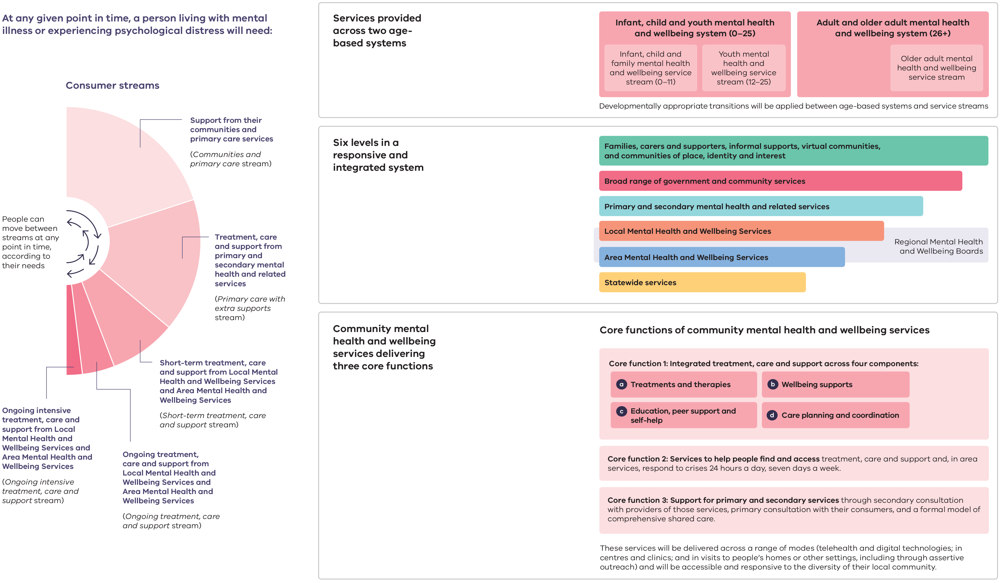
Return to text following Figure 7

The Age, Commissioners Named in Bid to Fix State’s “Broken” Mental Health System, 24 February 2019, p. 2.
Witness Statement of Honor Eastly, 14 September 2020, para. 67.
Anonymous 236, Submission to the RCVMHS: SUB.0002.0021.0007, 2019, p. 1.
Commission analysis of Department of Health (Commonwealth), National Mental Health Service Planning Framework; and Department of Environment, Land, Water and Planning, Victoria in Future 2019, June 2019.
Australian Bureau of Statistics, 4326.0 National Survey of Mental Health and Wellbeing: Summary of Results, 2007, <http://www.abs.gov.au/AUSSTATS/abs@.nsf/Lookup/4326.0Main+Features32007?OpenDocument>, [accessed 23 June 2020].
National Mental Health Service Planning Framework, Introduction to the NMHSPF, 2019, p. 10.
Anonymous, Brief Comments to the RCVMHS: SUB.0001.0031.0024, 2019, p. 4.
Leigh Garde, Brief Comments to the RCVMHS: SUB.0001.0029.0014, 2019, p. 5.
Witness Statement of ‘Lucy Barker’ (pseudonym), 29 June 2020, para. 31.
Victorian Auditor-General’s Office, Access to Mental Health Services, 2019; Victorian Auditor-General’s Office, Child and Youth Mental Health, 2019.
For example, Department of Health and Human Services, Victoria’s 10–Year Mental Health Plan, 2015; Commonwealth Department of Health, The Fifth National Mental Health and Suicide Prevention Plan, 2017.
Victorian Aboriginal Community Controlled Health Organisation, Correspondence to the RCVMHS: CSP.0001.0114.0001, Balit Durn Durn Report, 2020, p. 10.
Anonymous 221, Submission to the RCVMHS: SUB:0002.0028.0395, 2019, p. 1.
Source: A. Calculation by the Commission based on Department of Health (Commonwealth), National Mental Health Service Planning Framework; Australian Bureau of Statistics, Australian Demographic Statistics, June 2020, cat. no. 3101.0, Canberra; Department of Health and Human Services, Client Management Interface/Operational Data Store 2010–11 to 2019–20; Department of Health and Human Services, Victorian Admitted Episodes Dataset, 2010–11 to 2018–19; Australian Government Services Australia, Medicare Benefits Schedule, 2017–18. B. Calculation by the Commission based on Department of Health (Commonwealth), National Mental Health Service Planning Framework; Australian Bureau of Statistics, Australian Demographic Statistics, June 2020, cat. no. 3101.0, Canberra; Department of Health and Human Services, Client Management Interface/Operational Data Store 2010–11 to 2019–20. Notes: 2010–11, 2012–13, 2015–16 and 2016–17 data collection was affected by protected industrial action. The collection of non-clinical and administrative data (public specialist mental health services) was affected, with impacts on the recording of community mental health service activity and client outcome measures. A. Consumers: The estimated number of private clients using the private system is based on the proportion of overall people admitted to a private hospital in Victoria for a mental health reason between 2010–11 and 2018–19. There may be consumers receiving mental health services in both public and private specialist services that are double counted. There may also be people receiving specialist mental health services from other private providers that are not counted with this methodology. This analysis does not include ‘unregistered clients’. Each year there are a number of contacts delivered to consumers that are not registered in the Client Management Interface/Operational Data Store which in 2019–20 was 16 per cent of total contacts. For 2019–20, there are two alternative estimates of the number of private specialist mental health consumers. First, 36,129 consumers which would mean there is an estimated gap of 95,400. This estimate is based on the proportion of people that had a mental health admission to a private hospital. Second, 75,421 consumers which would mean there is an estimated gap of 56,108. This includes all people that received more than one service from a medicare-subsidised psychiatrist or had a mental health-related admission to a private hospital. Anyone that also received public specialist mental health services has been excluded to avoid double counting. B. Service hours: Some of the gap may be met through services delivered in the private mental health system. Consumer-related service hours are defined in the National Mental Health Service Planning Framework as time spent working with or for a client. This includes direct activity, for example assessment, monitoring, and ongoing management, care coordination and liaison, respite services, therapies, peer work, review, intervention, prescriptions, pharmacotherapy reviews, carer peer work and support services and community treatment teams. It does not include administration, training, travel, clinical supervision and other activities that do not generate reportable activity on a consumer’s record.
Witness Statement of Amelia Morris, 29 June 2019, para. 20.
Anonymous, Brief Comments to the RCVMHS: SUB.0001.0032.0028, 2019, p. 4.
Sources: Department of Health and Human Services, Integrated Data Resource, Victorian Emergency Minimum Dataset 2008–09 to 2018–19; Department of Health and Human Services, Victorian Emergency Minimum Dataset 2019–20. Notes: Mental health-related emergency department presentation defined as: (a) the presentation resulted in an admission to a mental health bed (inpatient or residential), or (b) the presentation received a mental health-related diagnosis (‘F’ codes, or selected ‘R’ and ‘Z’ codes R410, R418, R443, R455, R4581, Z046, Z590, Z609, Z630, Z658, Z765), or (c) the presentation was defined to be ‘Intentional self-harm’, or (d) the presentation involved interaction with a mental health practitioner. Data excludes the Albury campus of Albury Wodonga Health. The Commission’s definition of mental health-related emergency department presentation may differ slightly from the definition used by the Department of Health and Human Services.
Witness Statement of ‘Michael Silva’ (pseudonym), 22 June 2020, paras. 5 and 51.
Witness Statement of Cath Roper, 2 June 2020, para. 90.
Department of Health and Human Services, Victoria’s Mental Health Services Annual Report 2019–20, 2020, p. 34.
Royal Commission into Victoria’s Mental Health System, Interim Report, p. 30.
Royal Commission into Victoria’s Mental Health System, Interim Report, p. 30.
Witness Statement of Professor Patrick McGorry AO, 2 July 2019, para. 21; Ronald C Kessler and others, ‘Lifetime Prevalence and Age-of-Onset Distributions of DSM-IV Disorders in the National Comorbidity Survey Replication’, Archives of General Psychiatry, 62.6 (2005), 593–602 (p. 593).
Commission analysis of Department of Environment, Land, Water and Planning, Victoria in Future 2019.
National Ageing Research Institute, Submission to the RCVMHS: SUB.0002.0024.0049, 2019, p. 4.
Commissioner for Senior Victorians, Submission to the RCVMHS: SUB.1000.0001.1667, 2019, p. 7; Mental Health Victoria and Council on the Ageing, Correspondence to the RCVMHS: CSP.0001.0101.0001, Priorities to Support the Mental Health of Older Victorians, 2020, p. 15; RCVMHS, Aged Persons Mental Health Services Roundtable: Record of Proceedings, 2020.
Witness Statement of Erandathie Jayakody, 4 June 2020, paras. 38–39.
Department of Health and Human Services, Balit Murrup: Aboriginal Social and Emotional Wellbeing Framework 2017–2027, 2017, p. 10; Graham Gee and others, ‘Chapter 4: Aboriginal and Torres Strait Islander Social and Emotional Wellbeing’, in Working Together: Aboriginal and Torres Strait Islander Mental Health and Wellbeing Principles and Practice (Canberra: Commonwealth of Australia, 2014), pp. 55–68 (p. 62).
Source: Victorian Agency for Health Information, Mental Health and Wellbeing—Victorian Population Health Survey 2017 (preliminary draft and unpublished). Notes: Data is age-standardised to the 2011 Victorian population. Lower limit/Upper limit is the 95 per cent confidence interval lower and upper limits. Psychological distress based on the Kessler 10 scale.
Nicola Brackertz and others, Trajectories: The Interplay Between Housing and Mental Health Pathways (AHURI Limited and Mind Australia, 2020), p. 20; Dr Nicola Brackertz, Alex Wilkinson, and Jim Davison, Housing, Homelessness and Mental Health: Towards Systems Change (Australian Housing and Urban Research Institute, 2018), p. 16; Witness Statement of Professor Karen Fisher, 5 May 2020, para. 8.
Witness Statement of Peta McCammon, 13 August 2020, para. 13; Witness Statement of Distinguished Professor James Ogloff AM, 6 August 2020, p. 106.
Witness Statement of Peta McCammon, para. 13.
Coroners Court of Victoria, Monthly Suicide Data Report: November 2020 Update, 2020, p. 3.
Evidence of Katerina Kouselas, 23 July 2019, p. 1513.
Witness Statement of the Honourable Professor Kevin Bell AM QC, 26 August 2020, para. 27.
Source: Australian Institute of Health and Welfare, Mental Health Services in Australia: Expenditure on Mental Health Services 2018–19, Table EXP.4. Note: Funding includes both Commonwealth and state and territory government contributions.
Royal Commission into Victoria’s Mental Health System, Interim Report, p. 225.
Royal Commission into Victoria’s Mental Health System, Interim Report, p. 236.
RCVMHS, Box Hill Community Consultation—May 2019.
RCVMHS, Allied Health Workforce Human-Centred Design Focus Group: Record of Proceedings, 2020.
Ellie Fossey, Carol Harvey and Fiona McDermott, ‘Housing and Support Narratives of People Experiencing Mental Health Issues: Making My Place, My Home’, Frontiers in Psychiatry, 10:939 (2020), 1–14 (p. 1); National Mental Health Commission, A Contributing Life: The 2012 National Report Card on Mental Health and Suicide Prevention, 2012, p. 59.
Witness Statement of Lucinda Brogden AM, 11 May 2020, para. 8.
Witness Statement of Mary O’Hagan, 16 June 2020, para. 112.
Working towards zero suicides is supported by the Victorian and Commonwealth government: National Suicide Prevention Project Reference Group, National Suicide Prevention Strategy for Australia’s Health System: 2020–2023, 2020, p. v.
Victorian Government, Announcement: Royal Commission into Mental Health Speech, 24 October 2018, p. 4.
Mark É. Czeisler and others, ‘Mental Health, Substance Use, and Suicidal Ideation During the COVID-19 Pandemic—United States, June 24–30, 2020’, MMWR. Morbidity and Mortality Weekly Report, 69.32 (2020), 1049–57 (p. 1053).

