2023 Forest Audit Program audit of timber harvesting operations in Victoria’s State forests
Document no: IS46550-03
Version: B
Department of Energy, Environment and Climate Action
CMS106437
Forest Audit Program 2023
17 November 2023
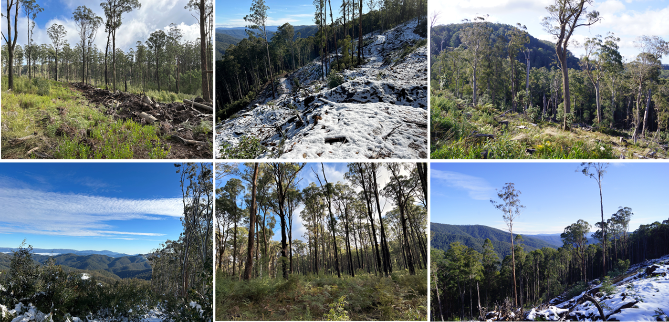

2023 Forest Audit Program audit of timber harvesting operations in Victoria’s State forests
Client name: | Department of Energy, Environment and Climate Action
Project name: | Forest Audit Program 2023
Client reference: | CMS106437 | Project no: | IS465500
Document no: | IS46550-03 | Project manager: | Craig Clifton
Version: | B | Prepared by: | Craig Clifton
Date: | 17 November 2023 | File name: | is465500-03 fap 2023_revB.1_final
Document history and status
Version | Date | Description | Author | Checked | Reviewed | Approved
A | 4/9/23 | Draft for review | CC |  | DE | DE
B | 17/11/23 | Final | CC |  | DE | DE
Distribution of copies
Version | Issue approved | Date issued | Issued to | Comments
Jacobs Group (Australia) Pty Ltd
Floor 13, 452 Flinders Street  Melbourne, VIC 3000  PO Box 312, Flinders Lane  Melbourne, VIC 8009  Australia | T +61 3 8668 3000  F +61 3 8668 3001  www.jacobs.com
Copyright Jacobs Group (Australia) Pty Ltd © 2024.
All rights reserved. The concepts and information contained in this document are the property of the Jacobs group of companies (“Jacobs Group”). Use or copying of this document in whole or in part without the written permission of Jacobs Group constitutes an infringement of copyright. Jacobs, the Jacobs logo, and all other Jacobs Group trademarks are the property of Jacobs Group.
NOTICE: This document has been prepared exclusively for the use and benefit of Jacobs Group client. Jacobs Group accepts no liability or responsibility for any use or reliance upon this document by any third party.

Executive summary

Audit scope and objectives
This report documents the methods, results, findings, and recommendations of an environmental audit of timber harvesting operations in Victoria’s State forests. Jacobs Group (Australia) Pty Ltd (Jacobs) was commissioned by the Department of Energy, Environment and Climate Action (DEECA) to deliver the audit, as part of its Forest Audit Program (FAP). The audit addresses mandatory compliance elements from the Code of Practice for Timber Production (the Code) and the Management Standards and Procedures for Timber Harvesting Operations in Victoria’s State forests (the MSPs).
The FAP has been in operation since 2002 and has been managed by DEECA since 2010. The audit is commissioned by the Timber Harvesting Compliance Unit (THCU), within DEECA’s Conservation Regulator (CR). FAP audits are designed to assess conformance with the regulatory framework for timber harvesting operations in State forests and identify and assess any risk of harm non-conformances pose to the environment. The FAP plays an important role in continuous improvement in sustainable forest management within Victoria’s State forests.
The specific regulatory compliance criteria that were considered in this years’ audit were selected by THCU staff from Code mandatory actions relating to:
- Protection of soil, water and river health values
- Conservation of biodiversity
- Operational planning and record-keeping
- Coupe infrastructure for timber harvesting operations.
Conformance with the regulatory framework was assessed for 32 coupes listed in VicForests’ Timber Release Plan (TRP) in the Central Highlands, East Gippsland, Gippsland and North East Regional Forest Agreement (RFA) regions (Figure 2-1) and with harvesting activity reported in 2021-22. Four coupes in the Central Highlands RFA region were within Melbourne Water catchment areas.

Audit approach
Prospective coupes for the audit were selected using a risk-based procedure that emphasised coupes with waterway crossings; long lengths of in-coupe road; steep slopes; more erosive soils; rainforest vegetation nearby; presence of threatened flora and/or fauna; Special Protection or Special Management Zones (SPZ and SMZ respectively) in close proximity.
As coupe selection was risk-based rather than fully randomised, the findings of this audit cannot be taken as being statistically representative of VicForests’ operations overall.
Compliance criteria considered in the audit drew on mandatory requirements of the Code and related clauses of the MSPs. Audits of individual coupes considered up to 179 compliance criteria. An audit workbook was completed for each coupe, based on observations by the audit team and their review of VicForests’ Forest Coupe Plan (FCP) and related coupe planning information. Where instances of non-conformance with the regulatory framework were detected, their potential environmental impact was assessed using the FAP’s environmental impact assessment (EIA) tool. Field assessments for the audit were undertaken in May and June 2023.
VicForests personnel accompanied the audit team on all coupe assessments. This enabled useful discussions about planning and management practices, applicable elements of the regulatory framework and any observed non-conformances.

Audit findings
The overall level of full conformance with applicable audit criteria across the 32 coupes ranged between 79% and 100%, averaging 94%. Non-conformance incidents in 28 of the 32 coupes included in the audit were assessed to have potential for environmental impact. There was an average of 1.7 such incidents per coupe, with up to four incidents recorded in several coupes. The assessed level of potential environmental impact associated with these incidents ranged between negligible and major, with minor being the most common rating. No severe rated incidents were observed.
The average level of full conformance was slightly less than in 2022 (94% compared with 96%). Non-conformance incidents with potential environmental impact were observed in more coupes in the current audit than in 2022 (28 coupes in 2023 compared with 20 in 2022). The most common level of potential environmental impact was minor in 2023, compared with moderate in the 2022 FAP audit. Three incidents with major potential environmental impact were detected in both audits.
Audit criteria were grouped into four themes and several sub-themes. A summary of audit results against each theme and sub-theme is given below:
- Protection of soil, water and river health values:
  - Protection of forest soils: the level of full conformance with applicable criteria ranged between 64% and 100%, with an average of 88%. Non-conformance incidents at 28 coupes were assessed to have up to moderate potential environmental impact.
  - Protection of water flows, water quality and river health: the level of full conformance with applicable criteria ranged between 64% and 100%, with an average of 93%. Non-conformance incidents at 16 coupes were assessed to have up to major potential environmental impact, with the latter applying to incidents related to an in-coupe road waterway crossing in one of the coupes.
- Conservation of biodiversity: the average level of full conformance with applicable biodiversity conservation criteria was 98%, with the range being 87-100%. Non-conformance incidents with potential environmental impact were observed in six coupes, with two incidents (in one coupe) assessed to have a major potential environmental impact on aquatic biodiversity values. Both incidents related to the same in-coupe road waterway crossing.
- Operational planning and record keeping: the average level of full conformance with applicable criteria was 97%, with the level for individual coupes ranging between 86% and 100%. Non-conformance incidents with potential environmental impact were observed at six coupes. Incidents with major potential environmental impact were observed at two of these coupes. One was linked to the failure to plan for a fish ladder to accompany an in-coupe road crossing with a culvert more than 750mm in diameter. The other incident was linked to coupe planning not being properly executed, in that a harvesting machine entered an SPZ.
- Coupe infrastructure for harvesting operations:
  - Road planning: the level of full conformance with applicable criteria ranged between 71% and 100%, with an average of 95%. Non-conformance incidents with potential environmental impact were observed at two coupes. An incident at one coupe was assessed to have a major potential environmental impact. This related to not planning to construct a fish ladder at a waterway crossing that used a culvert greater than 750mm in diameter.
  - Road design: the level of full conformance with applicable criteria ranged between 40% and 100%, with an average of 95%. Non-conformance incidents with potential environmental impact were observed at three coupes. An incident at one coupe was assessed to have a major potential environmental impact. This, again, related to the failure to plan or design the crossing with a fish ladder to accompany the culvert with greater than 750mm diameter.
  - Road construction: the level of full conformance with applicable criteria ranged between 77% and 100%, with an average of 98%. Non-conformance incidents with potential environmental impact were observed at four coupes. An incident at one coupe was assessed to have major potential environmental impact. This related to the downstream outlet of the culvert being elevated above the bed of the permanent stream, thereby posing a barrier to aquatic fauna movement.
  - Road maintenance and closure: the level of full conformance with applicable criteria ranged between 67% and 100%, with an average of 97%. No non-conformance incidents with potential environmental impact were observed.
  - Non-road coupe infrastructure: the level of full conformance with applicable criteria ranged between 64% and 100%, with an average of 89%. Non-conformance incidents with potential environmental impact were observed at 26 coupes, with the highest level of potential environmental impact being moderate.

Recommendation
The Victorian Government has announced that timber harvesting in State forests will end by 1 January 2024. Given this context, the wide scope of previous recommendations made by this audit team (many of which would be relevant if native forest timber harvesting were to continue in State forests) and that the 2023 FAP audit did not identify any significant new issues, only one new recommendation has been made from this audit, namely:
Recommendation D-01: That DEECA commission or undertake a review or audit to assess conformance of VicForests’ rehabilitation of in-coupe road waterway crossings with mandatory Code and MSP prescriptions and identify remedial works required to address any on-going sediment delivery into permanent or temporary streams.

Contents
Executive summary i
Audit scope and objectives i
Audit approach i
Audit findings ii
Recommendation iii
Glossary vii
1. Introduction 1
1.1 Sustainable Forest Management in Victoria 1
1.2 Forest Audit Program 2
1.3 About this report 3
2. Audit scope 4
2.1 Audit objectives 4
2.2 Audit scope 4
2.3 Audit timing 5
2.4 Audit team 5
3. Audit approach 7
3.1 Coupe selection 7
3.2 Audit criteria and workbook 10
3.3 Field assessments 11
3.4 Environmental impact assessment 14
4. Audit results 15
4.1 Overall findings 15
4.2 Environmental compliance theme 16
4.2.1 Compliance elements related to the protection of forest soils 16
4.2.2 Compliance elements related to the protection of water flows, water quality and aquatic habitat 19
4.3 Conservation of biodiversity 21
4.4 Operational planning and record-keeping 22
4.5 Coupe infrastructure for harvesting operations 24
4.5.1 Compliance elements related to in-coupe road planning 24
4.5.2 Compliance elements related to in-coupe road and waterway crossing design 25
4.5.3 Compliance elements related to in-coupe road and waterway crossing construction 27
4.5.4 Compliance elements related to in-coupe road and waterway crossing maintenance and closure 27
4.5.5 Compliance elements related to non-road infrastructure 28
5. Discussion 30
5.1 Overall audit findings 30
5.1.1 Conformance with audit criteria and potential environmental impact 30
5.1.2 Incidents resulting in non-conformances with audit criteria 31
5.2 Comparison with previous audits 35
5.3 Fire salvage harvesting 38
5.4 Management of bark and harvesting debris 39
5.5 Potential improvements in coupe planning, harvesting and rehabilitation practice 41
5.6 Potential improvements to the regulatory framework for timber harvesting 42
5.7 Audit target selection 43
6. Conclusions and recommendation 44
6.1 Conclusions 44
6.2 Recommendation 46
7. References 47
Spatial data sources: 47

Appendices
Appendix A. Audit compliance elements 48
Appendix B. Environmental impact assessment 73
B.1 Extent and location of impact 73
B.2 Extent and duration of recovery 73
B.3 Asset 74
B.4 Overall environmental risk 74
Appendix C. Incidents leading to assessments of non-conformance with audit criteria and the regulatory framework for timber harvesting 75
Appendix D. VicForests’ substantive comments 79

Tables
Table 3-1. Summary of audit targets by Regional Forest Agreement area and Forest Management Area 7
Table 3-2. Location and characteristics of coupes included in the 2023 Forest Audit Program 8
Table 3-3. Descriptors for conformance assessment for the 2023 Forest Audit Program 11
Table 3-4. Field assessment methods for 2023 Forest Audit Program 11
Table 5-1. Numbers of incidents resulting in non-conformances with audit criteria in 2021 to 2023 FAP audits 31
Table 5-2. Types of incident resulting in non-conformances with the regulatory framework that have potential or actual environmental impact, including comparison with 2020-21 and 2021-22 FAP audits (Jacobs, 2021; Jacobs,2023) 32
Table 5-3. Comparison of results for recent Forest Audit Program audits 37
Table 5-4. Summary of findings of 2021, 2022 and 2023 FAP audits in relation to conformance with fire salvage harvesting prescriptions 39
Table A-1. FAP 2023 audit criteria and related regulatory compliance elements 48
Table B-1. Extent and location of impact assessment criteria and scoring 73
Table B-2. Assessment of the duration and extent of recovery 73
Table B-3. Asset or value significance score 74
Table B-4. Ranking of EIA scores 74
Table C-1. Summary of incidents resulting in non-conformances with potential or actual environmental impact 75

Figures
Figure 2-1. Locations of coupes included in 2023 Forest Audit Program, with references to Victorian Forest Management Areas (FMA; green text and boundaries) and Regional Forest Agreement (RFA; blue text and boundaries) regions. Sources: ESRI, DEECA. 5
Figure 4-1. Overall compliance findings and assessed environmental impact for instances of non-conformance. The x-axis refers to the coupe numbers, as per Table 3-2. 15
Figure 4-2. Compliance findings and assessed environmental impact for instances of non-conformance for criteria applicable to the protection of forest soils. The x-axis refers to the coupe numbers, as per Table 3-2. 17
Figure 4-3. Incident in coupe 1 where a succession of snig track crossings of a drainage line did not adequately manage environmental risk to soils and water quality. 17
Figure 4-4. Incident involving disturbance to a seasonal or temporary wetland by a corded snig track in coupe 17. 18
Figure 4-5. Incident involving incomplete rehabilitation of snig track crossing of a temporary stream in coupe 18. 18
Figure 4-6. Compliance findings and assessed environmental impact for instances of non-conformance for criteria applicable to the protection of water flows, water quality and aquatic habitat. The x-axis refers to the coupe numbers, as per Table 3-2. 20
Figure 4-7. Incident involving poorly rehabilitated snig track crossing at coupe 23. 20
Figure 4-8. Incident involving in-coupe road waterway crossing of permanent stream at coupe 31. 21
Figure 4-9. Compliance findings and assessed environmental impact for instances of non-conformance for criteria applicable to the conservation of biodiversity. The x-axis refers to the coupe numbers, as per Table 3-2. 22
Figure 4-10. Compliance findings and assessed environmental impact for instances of non-conformance for criteria applicable to the conservation of biodiversity. The x-axis refers to the coupe numbers, as per Table 3-2. 23
Figure 4-11. GPS track log showing path of entry of harvesting machine into SPZ within/adjacent to coupe 23. The path ended at the harvest boundary that was proposed on the assumption that the SPZ would be converted to GMZ. 24
Figure 4-12. Compliance findings and assessed environmental impact for instances of non-conformance for criteria applicable to in-coupe road planning. The x-axis refers to the coupe numbers, as per Table 3-2. 25
Figure 4-13. Compliance findings and assessed environmental impact for instances of non-conformance for criteria applicable to in-coupe road and waterway crossing design. The x-axis refers to the coupe numbers, as per Table 3-2. 26
Figure 4-14. Examples of good practice for managing runoff and sediment at an in-coupe road waterway crossing, coupe 31. 26
Figure 4-15. Compliance findings and assessed environmental impact for instances of non-conformance for criteria applicable to in-coupe road and waterway crossing construction. The x-axis refers to the coupe numbers, as per Table 3-2. 27
Figure 4-16. Compliance findings for criteria applicable to maintenance and closure of in-coupe roads and waterway crossings. The x-axis refers to the coupe numbers, as per Table 3-2. 28
Figure 4-17. Compliance findings and assessed environmental impact for instances of non-conformance for criteria applicable to non-road infrastructure. The x-axis refers to the coupe numbers, as per Table 3-2. 29
Figure 4-18. Examples of coupes with large pile of bark and logging debris, whose dimensions exceed the maxima prescribed in MSP 7.2.4.2. 29
Figure 5-1. Summary of overall audit findings for conformance with the regulatory framework for timber harvesting and related activities in State forests in Victoria 30
Figure 5-2. Examples of incidents where soil disturbance has resulted from inappropriate placement, use and/or rehabilitation of snig or boundary tracks. 35
Figure 5-3. Compliance findings for criteria applicable to fire salvage harvesting operations. The x-axis refers to the coupe numbers, as per Table 3-2. 38
Figure 5-4. Examples of varying levels of logging slash cover along forwarding tracks in fire salvage operations in former thinnings coupes; coupe 32 39
Figure 5-5. Examples of settings in which it may be difficult to prevent unintended scorching of or encroachment of regeneration burns into retained habitat within or on the edge of timber harvesting coupes 40
Figure 5-6. Example of good practice in snig track waterway crossing, coupe 19 41
Figure 5-7. Examples where snig or boundary tracks have been constructed through wet areas or other areas with dispersive soils, leading to erosion, soil compaction, rutting and/or soil movement. 43

Glossary
Audit criteria | Criteria used to assess whether timber harvesting and related activities are consistent with mandatory requirements of the Code and MSP.
Boundary track | Track constructed in some harvest coupes that follows the marked boundary and is often used to support the containment of regeneration burns. Some boundary tracks may be used as snig tracks. Abbreviated as BT at places in this report.
Buffer strip | A protective margin of vegetation excluded from any harvesting activity abutting a waterway or an area of rainforest or other special area, which protects it from potentially detrimental disturbances in the surrounding forest.
Code | The Code of Practice for Timber Production 2014 (revised 2021), which lists mandatory actions for timber harvesting activities in native forests and plantations in Victoria.
Conformance | Conformance with audit criteria. Activities were assessed to:  - Fully conform (or fully comply) with audit compliance element  - Not fully conform with the audit compliance element, but pose no direct risk of environmental harm  - Not fully conform with the audit compliance element and either have potential to pose a risk of harm to the environment or cause observable environmental harm. The severity of risk or actual harm is assessed using the FAP’s environmental impact assessment (EIA) rating tool (Appendix B).
CR | Conservation Regulator, an office within DEECA that administers the regulatory framework for timber harvesting in State forests.
Cording | Log material (>15 cm diameter) placed in a corduroy fashion on landings and snig tracks to distribute loading over a greater area and reduce soil disturbance. Cording is typically accompanied by matting, which is bark or head material used to cover cording on snig tracks and landings.
Coupe | An individual management unit within forests and plantations where timber harvesting or thinning activities are planned and conducted. Under the Sustainable Forests (Timber) Act 2004, a coupe is a specific area of State forest identified for timber harvesting and regeneration in a Timber Release Plan.
DEECA | Department of Energy, Environment and Climate Action: DEECA has responsibility for environmental regulation of timber production activities in State forests. DEECA was formerly known as the Department of Environment, Land, Water and Planning (DELWP), the Department of Environment and Primary Industries (DEPI) and the Department of Sustainability and Environment (DSE).
EI | Environmental impact, as assessed using the EIA rating tool (Appendix B).
EIA, EIA rating tool | Environmental Impact Assessment. The EIA rating tool was developed for the FAP (see Appendix B) to provide a consistent basis for assessing the potential environmental implications of non-compliance with audit criteria.
FAP | Forest Audit Program, an annual program of environmental audits coordinated by DEECA to ensure that timber production operations in State forests provide for sustainable forest management.
Filter strip | A protective boundary around a drainage line, temporary stream or buffer strip. Trees may be harvested from within a filter strip, although harvesting machines may not generally enter them.
FCP | Forest Coupe Plan, a plan that is prepared for each coupe that describes the biophysical character of the coupe and the nature of planned harvesting operations. The minimum FCP content requirements are specified in the Code. The FCP is contained within a coupe file that includes other information, such as: coupe monitoring records, traffic management provisions and silvicultural operations. The coupe file may also refer to information about the coupe and its operations that is held within a VicForests or DEECA information management system.
FMA | Forest Management Area, the basic regional unit for forest planning used for public land in Victoria. These forest planning units are not administrative units.
FPSP | Forest Protection Survey Program. Program of pre-harvest flora and/or fauna surveys conducted by ecological contractors engaged by DEECA. FPSP surveys are undertaken of coupes listed on VicForests’ Timber Release Plan (TRP) and scheduled for harvesting.
In-coupe road (ICR) | A temporary or, in some cases, permanent road constructed to provide access to landings and/or allow haulage of timber from the coupe. Abbreviated ICR in some tables in this report.
Incident | An event, action or lack of action on a coupe that gives rise to an assessment of non-conformance with an audit criterion. The nature of the audit criteria and various prescriptions mean that a single incident may result in multiple non-conformances.
Landing | An area within the coupe specifically developed to sort, process and/or load trees or parts of trees for transport from the forest. Topsoil may be removed before landings are developed. Landings must be rehabilitated at coupe closure (including by ripping and re-spreading topsoil) unless they are to be used for an adjacent coupe.
MSP | Management standards and procedures for timber harvesting operations in Victoria’s State forests 2014 (revised 2021). They are designed to help interpret the Code for timber harvesting and related activities in State forests. They are a secondary source of mandatory prescriptions for forest management.
MRT | Montane Riparian Thicket, a vegetation community containing at least 40% canopy cover of Mountain Tea-tree (Leptospermum grandifolium) and with understorey composition as per the MSPs.
Rainforest stand | Patch of rainforest vegetation that meets the minimum species composition, size and projected foliage cover requirements of MSP 4.3.7 and 4.3.8.
Rainforest vegetation | A patch of vegetation comprised of recognised rainforest canopy species, as per MSP 4.3.7. Rainforest vegetation may or may not form a stand, as described in the MSPs.
RFA | Regional Forest Agreement. The 2020-21 FAP considered coupes in three RFA regions, Central Highlands, Gippsland and East Gippsland.
Rough heaping | A method of preparing coupes for regeneration. Woody residue from harvesting is pushed into heaps and burnt. Soils, understorey and coupe infrastructure are disturbed by machinery to create a receptive seed bed.
Snig track | A track through a harvested coupe along which harvested logs are towed or winched, normally towards a landing. Abbreviated ST in some tables in this report.
SMZ | Special Management Zone is a forest management zone managed to conserve specific features or values, allowing timber harvesting operations to proceed under special management.
Soil erosion hazard | Soil erosion hazard (or SEH) is a composite index of the potential for soil erosion to occur within a forest coupe. SEH is based on field assessments of soil texture, aggregate stability, structure, colour, organic content, mottling and stoniness. It also takes account of the erosivity of rainfall at the location, average slope, slope length, tree size and revegetation capacity. The calculation method is described in the MSP (DEPI, 2014b). SEH is assessed for each coupe during harvest planning.
SPZ | Special Protection Zone is a forest management zone for specific conservation values. SPZs form a network within State forests to complement the formal conservation reserve system.
State forest | Publicly owned and managed forest estate. Victoria has 3.4 million ha of State forest. State forest is managed for multiple beneficial uses, including conserving flora and fauna, protecting water catchments and water supply, providing timber for sustainable forestry, protecting the landscape, archaeological and historic values, and providing recreational and educational opportunities.
STX | Snig track crossing, a constructed crossing through a waterway for a snig track.
THCU | Timber Harvesting Compliance Unit. The group within the CR that is responsible for regulatory compliance in timber harvesting operations conducted within State forest.
TRP | Timber Release Plan. Timber resources in State forests in eastern Victoria are allocated to VicForests for harvesting and/or selling through the Allocation to VicForests Order 2004 (as amended). The Allocation Order specifies the extent and location of the forest stands to which VicForests has access under this Order. VicForests must prepare a Timber Release Plan for allocated areas.  TRPs are publicly available documents that must include: a schedule of coupes selected for timber harvesting and associated access road requirements; details of the location and approximate timing of timber harvesting in the proposed coupes; and details of the location of any associated access roads. They are prepared by VicForests in accordance with Part 5 of the Sustainable Forests (Timber) Act 2004 and may be reviewed and changed in accordance with Section 43.
UP | VicForests’ Utilisation Procedures. Operational procedures used by VicForests and its contractors in their management of harvesting and in-coupe roading operations. The UPs typically apply Code and MSP requirements.
Waterway | A permanent stream, temporary stream, drainage line, pool, spring or wetland, as defined in the Code.
WWX | Waterway crossing constructed for an in-coupe road.

Introduction

Sustainable Forest Management in Victoria
The legislative framework for the harvesting and management of timber resources in Victoria’s State forests is provided by five main pieces of legislation (based on DELWP, 2019):
- Forests Act 1958: provides for the management, maintenance, improvement, and use of State forests. It provides the legislative basis for developing and implementing Forest Management Plans and Forest Management Zones, influencing how timber harvesting activities in State forests are conducted.
- Wildlife Act 1975: establishes procedures to promote the protection and conservation of wildlife. It regulates the conduct of persons engaged in wildlife-related activities, including timber harvesting.
- Conservation, Forests and Lands (CFL) Act 1987: provides the legislative basis for the creation and enforcement of codes of practice (including the Code of Practice for Timber Production 2014 [amended 2021; DELWP, 2021a]; the Code) which specify standards and procedures for carrying out timber harvesting operations (among other activities).
- Flora and Fauna Guarantee (FFG) Act 1988: provide the legislative basis for biodiversity conservation in Victoria. Action Statements for threatened species and communities are published under the auspices of the FFG Act. These statements inform updates to the Code when undertaking timber harvesting in State forests.
- Sustainable Forests (Timber) (SFT) Act 2004: provides a framework for sustainable forest management and sustainable timber harvesting in State forests. It establishes the Allocation Order, Timber Release Plans (TRPs) and compliance obligations for timber harvesting in State forests. The SFT Act requires VicForests and persons who have entered into an agreement with VicForests for the supply and sale of timber resources to comply with the Code.
The SFT Act also provides the legislative basis for commissioning audits of compliance with relevant codes of practice (including the Code) by VicForests. It also requires VicForests to respond to any adverse findings of such an audit, including details of measures it has or intends to undertake to improve compliance with the relevant code of practice. The SFT Act also provides for the publication of audit reports and VicForests’ responses to these.
The SFT Act requires VicForests, when harvesting timber from public land, to do so in a manner which has regard to the principles of ecologically sustainable development. The Act provides for the development of a Sustainability Charter, which sets out the State’s objectives for sustainable forest management. These objectives (DSE, 2006) are to:
- Maintain and conserve biodiversity in State forests
- Maintain and improve the capacity of forest ecosystems to produce wood and non-wood products
- Promote healthy forests by actively managing disturbance
- Maintain and conserve the soil and water resources of State forests
- Maintain and better understand the role of Victoria’s State forests in global carbon cycles
- Maintain and enhance the socio-economic benefits of State forests to Victorian communities
- Ensure Victoria’s legal, institutional and economic frameworks effectively support the sustainable management of State forests.
In reviewing VicForests’ Allocation Order, the SFT Act requires that the Minister will also have regard to VicForests’ compliance with applicable codes of practice.
The primary instrument used to regulate timber harvesting activities in State forests is the Code, administered by the Department of Energy, Environment and Climate Action’s (DEECA’s) Conservation Regulator (CR). The purpose of the Code is to provide direction to timber harvesting managers, harvesting entities and operators to deliver sound environmental performance when planning for and conducting timber harvesting activities. Those activities are to be undertaken in a way that:
- Permits an economically viable, internationally competitive, sustainable timber industry
- Is compatible with conservation of the wide range of environmental, social and cultural values associated with forests
- Provides for the ecologically sustainable management of native forests proposed for cyclical timber harvesting operations
- Enhances public confidence in the management of timber production in Victoria’s forests and plantations.
The Code applies to the planning and implementation of all commercial timber production and timber harvesting operations on both public land and private land in Victoria, but not the collection or production of firewood for domestic use. Haulage, road construction, significant road improvement operations or road maintenance works, tending, regeneration or rehabilitation activities conducted in association with a timber harvesting operation, by definition, also form part of the timber harvesting operation.
The Code includes a set of operational goals and mandatory actions for various aspects of planning and implementation of timber harvesting operations and applies to native forests and plantations on private and public land. For timber harvesting operations conducted in State forests, it is supported by the Management Standards and Procedures for Timber Harvesting Operations in Victoria’s State Forests 2014 (amended 2021; the MSPs [DELWP, 2021b]). These prescribe mandatory standards and procedures for timber harvesting activities and only apply in State forests.

Forest Audit Program
Since 2002, independent environmental auditors have been engaged to undertake audits of timber harvesting operations in Victoria’s State forests, as provided for by the SFT Act. These audits have assessed compliance with the Code and MSPs. This annual program of audits has been delivered by DEECA under its Forest Audit Program (FAP) since 2010. Independent auditors are engaged by the CR to undertake FAP audits.
FAP audits do not have a direct regulatory function. They help to monitor VicForests’ compliance with the regulatory framework provided by the Code and MSPs and are intended to contribute to continuous improvement in sustainable native forest management. In keeping with the latter, field components of the audit are undertaken with VicForests personnel present. This informs the auditors of the history of operations on the coupe and any challenges faced during harvesting and/or regeneration. It also allows for on-site discussion about any potential non-conformance issues that the audit team has observed and exposes any safety issues. However, the paths of the audit team as they inspect the coupe are entirely at their discretion and are only influenced by the VicForests personnel in relation to safety issues (e.g., avoiding hazardous trees).
VicForests are provided, via the CR, with a copy of the draft audit report. This allows them to contest draft compliance findings and offer further evidence for the audit team to consider. VicForests’ comments and any additional evidence are considered by the audit team in finalising the audit report. For transparency, all substantive changes to the draft report based on VicForests comments are noted in the final audit report.

About this report
This is the draft audit report for the 2023 Forest Audit Program. The remainder of the document includes five main sections, as follows:
- Section 2 Audit scope: describes the scope of the audit, including the audit objectives, the regulatory scope it addresses, the audit timing and audit team.
- Section 3 Audit approach: describes the coupe selection process, development of audit compliance elements and the methods by which conformance with the regulatory framework is assessed during the audit.
- Section 4 Audit results: presents the main results of the audit, including the level of conformance with audit criteria and the assessed potential environmental impact associated with any observed non-conformance incidents. Audit results are organised by the compliance themes and sub-themes included in the audit scope developed by the CR.
- Section 5 Discussion: of the overall audit findings and comparison (to the extent appropriate) of the 2023 audit results with previous FAP audits. The discussion also draws on observations made during the field audit to suggest potential improvements in coupe planning and timber harvesting activities.
- Section 6 Conclusions and recommendations: summarises the audit's main findings and outlines recommendations for improvements in timber harvesting operations and the regulatory framework.
The report’s appendices incorporate the following:
- Appendix A Audit compliance elements: lists the audit compliance elements and conformance criteria and summarises the overall level of full conformance with each applicable audit criterion.
- Appendix B Environment impact assessment tool: describes the method for assessing potential environmental impacts associated with non-conformances with audit criteria.
- Appendix C Incidents leading to assessments of non-conformance with audit criteria and the regulatory framework for timber harvesting: describes the various non-conformance incidents observed that had direct potential for environmental impact.

Audit scope

Audit objectives
The FAP is delivered by an independent environmental auditor commissioned by DEECA’s Conservation Regulator. The audit is intended to provide an objective and independent assessment of:
- Compliance by VicForests and their contractors with mandatory prescriptions for timber harvesting and related activities that are outlined in the applicable regulatory framework for Victoria
- Environmental performance of the audited timber harvesting operations and any associated risks of environmental harm resulting from non-conformances with the regulatory framework for timber harvesting activities.
The FAP also contributes to continuous improvement in sustainable management of Victoria’s State forests.

Audit scope
The audit addresses a suite of mandatory Code compliance elements selected by DEECA’s Timber Harvesting Compliance Unit (THCU; a unit within the CR). It focuses on four main compliance priorities under the Code, namely:
- Environmental values in State Forests: specific measures to protect water quality, river health and soils
- Conservation of biodiversity: application of the precautionary principle during coupe planning and taking measures during coupe operations which protect listed threatened species and vegetation communities; avoids harvesting in specified rainforest stands, areas of montane riparian thicket and heathlands maintains forest hygiene
- Operational planning and record-keeping: measures required by the Code to ensure that timber harvesting operations are planned to satisfy applicable regulatory requirements, as well as the successful implementation of planned measures
- Coupe infrastructure for timber harvesting operations: measures required by the Code to ensure the planning, design, construction and rehabilitation of in-coupe roads and other coupe infrastructure (e.g., landings, extraction tracks) protect key environmental values.
Audit compliance elements from the Code are supplemented by elements drawn from related mandatory requirements of the MSPs. These additional elements were selected by the auditors and agreed with the THCU prior to commencing the audit.
Collectively, the compliance elements seek to ensure that coupe planning, harvesting and associated forest roading activities are conducted so that the environmental goods and services provided by State forests are maintained.
The audit included 32 coupes listed in VicForests’ TRP (for harvesting operations in eastern Victoria) and operational during the 2021-2022 financial year. These coupes were located within the Central Highlands, East Gippsland, Gippsland and North East Regional Forest Agreement (RFA) regions (Figure 2-1).

Audit timing
Field assessments of the coupes included in this audit were undertaken in May and June 2023. Audit reporting is carried out in three stages:
- Initial conformance summary report: a brief interim report on audit results, prior to detailed analysis of observations. The conformance summary does not draw out any overall findings or recommendations. This report was submitted to DEECA in June 2023
- Draft audit report: a draft full report on and analysis of the audit results, discussing key audit findings and recommendations. It is submitted for review and comment by THCU and VicForests. VicForests has the opportunity to challenge draft audit findings and provide supporting evidence
- Final audit report: a final version of the audit report that takes account of review comments and additional information provided by VicForests to support any challenges to draft audit findings. The final report notes VicForests’ substantive comments and how they have been addressed.
The general content and format of the conformance summary and audit report follow the CR’s project specification.
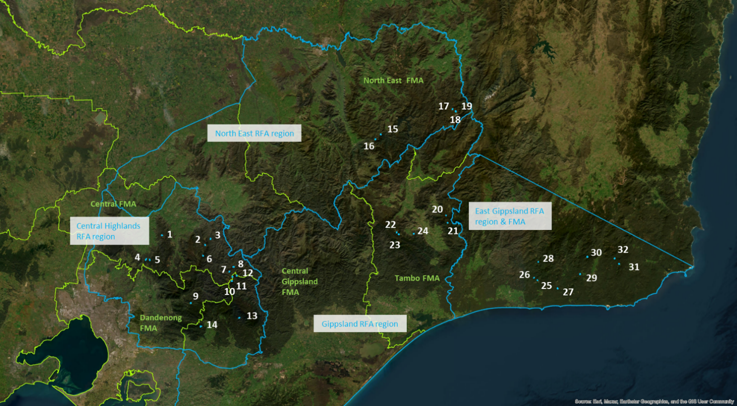
Note: Coupe numbers depicted in the have been assigned for simplicity. Their links to the TRP coupe address are given in Table 3-2.
Figure 2-1. Locations of coupes included in 2023 Forest Audit Program, with references to Victorian Forest Management Areas (FMA; green text and boundaries) and Regional Forest Agreement (RFA; blue text and boundaries) regions. Sources: ESRI, DEECA.

Audit team
The core team for this audit comprised:
- Craig Clifton (Lead auditor and Project Manager): Craig has undergraduate and post-graduate qualifications in Forest Science and is an EPA-appointed environmental auditor (natural resources). He developed the audit methodology, led the field assessments and their analysis and is lead author of this report. Craig has led teams in many previous audit projects, as well as in regulatory and compliance investigations for DEECA and native forestry management agencies in other states.
- David Endersby (Project Director): David is a principal terrestrial ecologist specialising in botany, plant ecology and geomorphology. He has extensive experience in vegetation assessment, management, conservation and mapping. David is the Project Director and technical reviewer for this report. He has played a similar role in previous FAP audits.
- Dr Drew King (Senior Ecologist): Drew is senior ecologist with extensive experience in both research and consulting environments. He is proficient in vegetation assessment and has an excellent understanding of native flora throughout south-eastern Australia. Drew has participated in several previous FAP audits, as well as regulatory investigations for the CR and supported field audits in East Gippsland.
- Austen Hawkins (Bushfire and Climate Change Consultant): Austen is an environmental scientist with wide bushfire management, modelling and policy experience. Austen supported field audits in this audit project in all but the East Gippsland RFA region. He played a similar role in the 2022 FAP field audits.

Audit approach

Coupe selection
Target coupes for the audit were selected from the set of VicForests’ TRP coupes that were subject to timber harvesting activity during the 2021-22 financial year. The coupes are located in the Central Highlands, East Gippsland, Gippsland and North East RFA regions. Thirty-two coupes were selected for inclusion in the audit, distributed as listed in Table 3-1. Reserve coupes were selected in each RFA area in case the initial target coupes were inaccessible and/or unsafe at the time of the field audit.
Table 3-1. Summary of audit targets by Regional Forest Agreement area and Forest Management Area
Regional Forest Agreement region and Forest Management Area | # coupes
Central Highlands: including Central and Dandenong FMAs and parts of Central Gippsland FMA | 14
East Gippsland: East Gippsland | 8
Gippsland: Tambo FMA | 5
North East: North East FMA | 5
Access issues during the audit’s field program meant that one of the planned reserve coupes (in East Gippsland RFA region) was substituted for one of the initial audit targets.
As in previous FAP audits, a risk-based selection process was used to identify the target and reserve coupes. The process uses data from VicForests that characterises inherent coupe conditions and details of planned harvesting activities. The factors influencing selection for target coupes included:
- Waterway crossing for the in-coupe road and/or snig track was constructed within or to access the coupe
- Modelled rainforest and/or montane riparian thicket vegetation communities were identified within or adjacent to the gross coupe boundary
- Length of in-coupe road required to access the landing(s)
- Soil erosion hazard in the A or B horizon
- Presence of special protection or special management zones (SPZ/SMZ) within or adjacent to the coupe
- Recorded presence of listed threatened flora and/or fauna within or near the coupe
- Location of a coupe within a designated water supply catchment
- Average and maximum slope within the coupe.
Coupes were preferentially selected where multiple risk factors were present. Coupes were excluded from selection if they had previously been included in FAP audits.
Four coupes located in Melbourne Water catchment areas were selected for audit, three in the catchment of the Thomson River and one in the Tarago River catchment. Selection of these coupes was informed by the risk-based selection process.
A summary of key characteristics of the selected coupes is given in Table 3-2.

Table 3-2. Location and characteristics of coupes included in the 2023 Forest Audit Program
Audit # | Address | FMA¹ | Coupe status – end 2021-22 | Net harvest area (ha) | Rainforest EVC² | Waterway crossing³ | In-coupe road length (m)⁴ | Slope  >25° | Soil erosion hazard (max) | SMZ or SPZ | Threatened flora/fauna⁵
Central Highlands RFA region
1 | 281-513-0011 | CT | Active - Harvest | 8.4 | No | Yes | 1478 | No | Low | Yes | No
2 | 288-519-0003 | CT | Regenerating | 16.6 | No | No | 512 | No | High | Yes | No
3 | 293-500-0004 | CT | Regenerating | 31.7 | No | Yes | 200 | No | Medium | Yes | Yes
4 | 297-504-0002 | CT | Regenerating | 27.0 | No | Yes | 768 | No | Medium | Yes | No
5 | 297-507-0002 | CT | Regenerating | 15.3 | No | Yes | 768 | No | Low | Yes | Yes
6 | 312-504-0003 | CT | Active - Harvest | 4.0 | Yes | Yes | 70 | No | Low | Yes | No
7 | 318-512-0037 | CT | Regenerating | 3.1 | No | No | 391 | Yes | Medium | Yes | No
8 | 318-512-0045 | CT | Active - Harvest | 14.2 | No | No | 391 | Yes | High | Yes | No
9 | 345-501-0006 | DD | Active - Harvest | 5.0 | No | No | 600 | No | Low | Yes | Yes
10⁶ | 457-501-0019 | CG | Regenerating | 4.8 | No | No | 210 | No | Low | Yes | No
11 | 457-503-0002 | CG | Regenerating | 6.2 | No | No | 800 | Yes | Low | Yes | No
12 | 457-504-0010 | CG | Regenerating | 7.7 | No | No | 520 | Yes | Low | Yes | Yes
13 | 460-510-0038 | CG | Regenerating | 12.4 | No | No | 340 | No | High | Yes | Yes
14 | 464-507-0008 | CG | Regenerating | 30.5 | No | No | 190 | Yes | Medium | No | Yes
North-East RFA region
15 | 687-504-0001 | NE | Regenerating | 19.1 | No | No | 0 | No | Medium | Yes | Yes
16 | 687-511-0006 | NE | Regenerating | 10.8 | No | No | 0 | Yes | Medium | No | Yes
17 | 699-518-0004 | NE | Regenerating | 4.8 | No | Yes | 0 | No | High | No | No
18 | 699-524-0004 | NE | Regenerating | 11.6 | No | Yes | 0 | No | Medium | No | No
19 | 699-524-0005 | NE | Regenerating | 14.2 | No | Yes | 0 | No | Medium | No | No
Gippsland RFA region
20 | 765-510-0003 | TB | Regenerating | 15.0 | No | Yes | 300 | No | Medium | Yes | Yes
21 | 766-502-0004 | TB | Regenerating | 13.0 | No | Yes | 130 | No | Medium | Yes | Yes
22 | 771-507-0026 | TB | Regenerating | 13.8 | No | No | 350 | No | Medium | Yes | Yes
23 | 773-502-0009 | TB | Regenerating | 30.3 | No | Yes | 800 | No | Medium | Yes | No
24 | 774-504-0010 | TB | Active - Harvest | 17.6 | No | No | 400 | No | High | Yes | No
East Gippsland RFA region
25 | 829-507-0013 | EG | Regenerating | 11.0 | No | No | 400 | No | Medium | Yes | Yes
26 | 829-512-0014 | EG | Regenerating | 16.1 | No | No | 400 | No | Low | Yes | Yes
27 | 834-507-0008 | EG | Regenerating | 20.2 | No | No | 158 | No | Low | Yes | Yes
28 | 842-513-0058 | EG | Regenerating | 12.6 | No | No | 0 | No | Low | Yes | Yes
29 | 864-507-0006 | EG | Regenerating | 17.2 | Yes | No | 1600 | No | Low | Yes | Yes
30 | 871-503-0015 | EG | Regenerating | 27.9 | No | No | 500 | No | Medium | Yes | Yes
31 | 874-507-0025 | EG | Regenerating | 18.3 | Yes | Yes | 850 | No | Medium | Yes | Yes
32 | 874-511-0015 | EG | Regenerating | 29.6 | No | No | 767 | No | Medium | Yes | Yes
Notes:
- FMA: CG – Central Gippsland, CT – Central, DD - Dandenong EG – East Gippsland, NE – North East, TB – Tambo.
- Rainforest EVC: pink shading – indicates rainforest vegetation present within coupe, but not referred to in the FCP and not identified in EVC modelling.
- Waterway crossing: dark blue shading – waterway crossing planned but not constructed (excluding informal snig or boundary track crossing of drainage line); unshaded cells – crossing status is as per plan.
- Planned in-coupe road length: pink shading – no in-coupe road, dark red – in-coupe road present but <50m, dark blue – in-coupe road 50-500m, dark yellow – in coupe road >500m.
- Threatened flora/fauna: dark blue shading – threatened species referenced in planning extract from VicForests but not coupe plan, pink shading - threatened species not referenced in planning extract from VicForests but reported in coupe plan.
- Grey shaded rows are coupes located in Melbourne Water catchment area.

The average net harvest area for the selected coupes is 15.3 ha, compared with an average gross coupe area of 38.7 ha. Three of the coupes had areas of a modelled rainforest vegetation (either cool or warm temperate rainforest) within their boundary. One additional coupe had cool temperate rainforest vegetation (but not a stand as defined by the MSPs), but this had not been modelled.
While 12 of the coupes were planned to have in-coupe road or snig track waterway crossings, these were present in only five of the coupes. Snig or boundary tracks in several additional coupes crossed drainage lines (as defined by the Code) or drainage depressions but did not require a formal crossing.
The length of in-coupe road required to access landings that serviced the coupes was planned to range between zero and about 1600m. Several coupes that were planned to have long in-coupe roads (coupes 4, 7, 11, 13; Table 3-2) actually had no or a very short in-coupe roads.
Slopes exceeding 25° were identified for six coupes, with some of these recording slopes exceeding 30° within the gross coupe area. Most coupes (28 of 32) included or were adjacent to land zoned as SPZ and/or SMZ. Threatened native plant and animal species had been recorded in all but five of the coupes. Threatened species were identified in several coupes after the initial planning was undertaken (8 coupes, pink shaded cells under threatened flora/fauna in Table 3-2).
The analysis in Table 3-2 shows that the data reported by VicForests on key risk characteristics from coupe planning, particularly the presence of waterway crossings and length of in-coupe roads, is not completely reliable for audit target selection. As noted above, only five of the twelve coupes reported in VicForests’ coupe planning data extract to have planned waterway crossings actually had crossings. In-coupe road length was often significantly less that was originally planned. While shorter in-coupe roads and fewer waterway crossings significantly reduces environmental risk to the coupes, it somewhat confounds the risk-based selection process.

Audit criteria and workbook
Audit criteria were based on mandatory requirements of the Code selected by the THCU. The criteria also referenced additional compliance elements from the MSPs, which provide more detailed interpretations of Code requirements in many settings. Compliance criteria were grouped into several themes and sub-themes, as follows:
- Environment: compliance criteria developed for the audit drew on Section 2.2.1 of the Code (Water quality, river health and soil protection) and related compliance elements from the MSPs. There are two sub-themes, soil and water, with the latter incorporating flows, water quality and river health.
- Conservation of biodiversity: compliance criteria developed for the audit drew on Section 2.2.2 of the Code and related MSP compliance elements.
- Operational planning and record-keeping: compliance criteria for the audit drew on Sections 2.3 and 2.5.1 of the Code and related MSP compliance elements.
- Coupe infrastructure for timber harvesting operations: compliance criteria were organised into five sub-themes, four related to roading for timber harvesting operations (based on Code Section 2.4; 2.4.1 Road planning, 2.4.2 Road design, 2.4.3 Road construction, 2.4.4 Road maintenance) and one sub-theme relating to other coupe infrastructure (i.e., landings, snig, forwarding and boundary tracks; Code Section 2.5.2). As with other compliance themes, audit criteria also drew on relevant MSP mandatory compliance elements.
The audits considered 179 individual compliance criteria (see Appendix A). These were assessed, as applicable, for each of the 32 selected audit coupes. A digital audit workbook was used to capture assessments against applicable criteria for each individual coupe. Assessments recorded in the workbook were based on observations by the audit team and their review of VicForests’ Forest Coupe Plans (FCPs). They considered the applicability of each criterion, as well as the operations’ conformance with the audit criteria or compliance element. The latter was assessed using the descriptors in Table 3-3.
Table 3-3. Descriptors for conformance assessment for the 2023 Forest Audit Program
Level of conformance | Fully conforms | Non-conforming with no environmental impact | Non-conforming with environmental impact
Abbreviation  (used in figures in Section 4) | Full | Non-no EI | Non-EI
Description | All requirements of the compliance element are fully satisfied. | All requirements of the compliance element are not fully satisfied. However, the non-conformance will pose no direct risk of harm to the environment. | All requirements of the compliance element are not fully satisfied. The non-conformance has potential to pose a risk of harm to the environment.
The workbook was also used to capture the basis for any non-conformance assessment. Photographs were taken of coupe features during the field assessments; particularly where/if non-conformances were observed.

Field assessments
Field assessments considered relevant coupe characteristics (Table 3-4) to determine whether the timber harvesting operations had conformed with the regulatory framework in the Code and MSPs. Observations were captured in the field using Avenza and a geo-referenced version of VicForests operations or final harvest map. Photographic records of the coupes and any non-conformance issues were also captured. Assessments against all applicable audit criteria were recorded in a digital workbook. GPS were used to track the field team’s movements through the coupe.
Table 3-4. Field assessment methods for 2023 Forest Audit Program
Attribute being assessed | Audit criteria | Method
- Waterway classification and correct provision of riparian filters and/or buffers. | 1, 3, 5, 16 | Assessment of waterway as drainage line, temporary stream or permanent stream, based on Code definitions. Streams and widths of filters/buffers were assessed along the length of the waterway, if present. Adequacy of filter and buffer widths were assessed with a range finder, supported by ground traverses to locate the centreline of the stream (if/as required). Buffer widths were not explicitly measured where they obviously exceeded those specified in MSP Tables 9 or 10.  For fire salvage coupes, conformance with additional filter and buffer requirements was noted
- Soil erosion hazard | 2 | Comparison of VicForests assessment of soil erosion hazard with observations of soil conditions and erosion within the coupe. Soil erosion hazard is assessed using MSP methods where evidence of soil conditions and soil erosion suggests to the auditor that the initial assessment may have been incorrect or only applicable for one of multiple soil types present within the coupe.
- Extent to which harvesting was conducted on slopes >30°/25° (EG granite-derived soils). | 4,5 | Visual observation, using a clinometer, if required. Pre-field audit GIS analysis using Lidar data was undertaken to target investigations. Slope is assessed along traverses in steep areas if it appears that harvesting in steep slope areas (>25/30°) exceeded the 10% allowed by the MSPs.
- Adequacy of protection provided to soils, waterways and river health. | 6, 7, 8, 16, 17, 21 | Visual observations and auditors’ interpretations, based on the presence of excessive disturbance and/or activities which are not compliant with elements of the regulatory framework. The assessment considered in-coupe roads (ICR) and coupe infrastructure (snig tracks [ST], boundary tracks [BT] and landings). Evidence of inadequate protection might include mass movement of fill batters and cuttings for ICR and ST/BT, excessive rutting in damp areas, sediment being mobilised into waterways.
- Presence of in-coupe roads or snig tracks in riparian habitats. | 7, 15, 21 | Visual observations and auditors’ interpretations of the reasonable practicability of alternative placements which avoided or were more remote from riparian areas.
- Waterway crossings and culverts. | 7, 18, 19, 21, 22 | Assessment of culverts, embankments and road drainage against MSP requirements. Observations and auditors’ interpretation of crossings in which the culvert had been removed (if observed). Observations of any sediment entry into the waterway. Presence of a fish ladder if culvert diameter exceeds 750mm. Observation of impediments to aquatic fauna movement posed by elevation of culvert relative to downstream bed of waterway.
- Habitat and habitat tree retention | 10, 16 | Assessment of the density and distribution of habitat trees and habitat patches, their location in relation to other habitat and trees’ possession of or potential to develop hollows.
- If listed threatened fauna or flora are recorded as being present, whether prescribed management actions been followed. | 9, 11, 17 | Comparison of observed coupe conditions with management actions specified in the MSPs and forest coupe plan (FCP).
- Harvesting and/or road construction in or near box-ironbark, heathland or montane riparian thicket (MRT) if present within or near the coupe. | 12 | Confirmation of the presence of the vegetation community and observation of its proximity to in-coupe roads and/or harvesting activity. Auditors’ assessment as to the reasonable practicability of alternative road location if the road entered the protected vegetation community. Presence of harvesting in or in proximity to box-ironbark forests (if present), heathlands or MRT.
- Old growth forest (OGF) | 12 | Provision of 100 m buffers around verified Ash OGF within Central Highlands FMAs.
- Rainforest buffers | 12 | Identification of rainforest stands, as per MSP definitions. Assessment of provision of any required buffers as per MSP prescriptions. Assessment as a rainforest stand and of stand size only undertaken where rainforest vegetation was within 40m of the marked harvest area (or greater if the rainforest is within a Rainforest Site of Significance and a wider buffer is required; as per MSP Table 16).
- Protection of exclusion areas and areas outside gross coupe boundaries | 13, 15, 21 | Identification and assessment of any effect of harvesting operations (including roading, regeneration burning, tree felling, ST/BT, rough heaping and machinery movement) on exclusion areas or areas outside the coupe boundary.
- Biosecurity. | 14, 16 | Observation of harvesting related damage to or wounding of Myrtle Beech trees, in applicable coupes. Implementation of any management plans where harvesting operations appear to have led to disease or pest introduction. Observation of the presence of weeds within the coupe and their potential introduction by harvesting machinery.
- In-coupe road planning, design, construction and maintenance | 16, 17, 18, 19, 21 | Assessment of whether road construction follows any documented plan or design. Identification of any evidence that road construction was inconsistent with need to minimise risk of erosion and water quality impact. Identification of any evidence that table drains were constructed by subsequent excavation. For in-coupe roads through retained vegetation, assess whether clearing width was consistent with MSP requirements. Assessment of the appropriateness of the intensity of earthworks for ICR. Observation and auditors’ interpretation of the adequacy of road maintenance and any road closure works.
- Fill batters | 20 | Evidence of soil movement and instability. Observation of instances where fill batters cover base of retained live trees.
- Road drainage | 21 | Compliance with MSP drain spacing requirements, based on soil erosion hazard and gradient, for the full length of in-coupe road. Assessment of effectiveness of drainage and appropriateness of drainage disposal, considering Code and MSP requirements. Compliance of culverts with MSP specifications.
- ICR and waterway crossing (WWX) closure | 7, 22 | Conformance of WWX construction, management and rehabilitation with MSP requirements. Appropriateness and avoidability of stream bed disturbance during and after crossing construction and removal. Observation of whether an ICR that is no longer required has been closed permanently.
- Coupe management | 23 | Observation of the consistency between the FCP and the timber harvesting operation.
- Coupe infrastructure – ST & BT | 7, 22, 24 | Assess if ST have been progressively rehabilitated and rehabilitated in a way that prevents soil movement into streams, consistent with MSP requirements. Assess adequacy of ST and BT drainage and its conformance to requirements under VicForests’ Utilisation Procedures (UP). Assess the appropriateness of removal of cording and matting from ST, where used. Assess rehabilitation of ST waterway crossings (STX).
- Coupe infrastructure – landings | 24 | Assess adequacy of landing rehabilitation, including removal of cording and matting, ripping of landing and final 30 m of ST, placement of bark piles and storage and redistribution of stockpiled soil.
- Slash and bark piles | 24 | Assess whether slash and bark have been placed appropriately and are in piles of appropriate size (as per MSP requirements), in preparation for regeneration burning.
- Campsites | 24 | Assess whether any campsites are/were located appropriately and whether sanitary facilities were set up in relevant water supply catchments.
- Fire salvage harvesting | 16 | Assess conformance of coupe operations with applicable salvage harvesting prescriptions as per Section 8 of the MSP.

Environmental impact assessment
The Environmental Impact Assessment (EIA) tool provided by the CR (Appendix B) was used to assess the potential environmental impacts of non-conformance with audit criteria and the regulatory framework for timber harvesting. EIA tool assessments are based on:
- Extent and location of impact: an auditor’s assessment based on one or more of several factors:
  - Proportion of the harvestable coupe area affected by the non-conformance
  - Length of in-coupe road and/or snig/boundary track without conforming drainage
  - Suitability of landing rehabilitation
  - Extent of soil mass movement
  - Number of retained trees whose base is covered by in-coupe road, landing or snig track embankment materials
  - The number and/or extent of incidences of inappropriate disturbances (i.e., disturbances to planned timber harvesting exclusions areas which are either not permitted by the Code or MSPs or were not consistent with coupe planning) to waterways, riparian buffers or filters or other areas within or adjacent to the gross coupe area.
- Duration of impact/recovery time: an assessment by the auditor of the likely time required for the coupe to recover from any impact or disturbance associated with the non-conformance incident.
- Values affected: an assessment based on the value or environmental aspect experiencing or potentially experiencing an impact stemming from the non-conformance. For example, general forest areas are valued less than riparian or rainforest buffers and SPZ.
The overall five-point EIA rating is based on the sum of scores for individual components. Ratings potentially range between negligible and severe. The assessed potential environmental impact does not necessarily reflect the actual environmental impact of a non-conformance incident. Incidents in sensitive locations (e.g., SPZ, buffers of permanent streams) may sometimes be assessed to have relatively high potential environmental impact even if the actual impact observable at the time of audit is minimal.
Non-conformances for which there is no direct pathway to cause harm to the environment (and not just that they did not directly cause material environmental damage) were assessed as non-conforming with no environmental impact, as per Table 3-3.

Audit results
This section summarises the results of the assessments of conformance with compliance criteria based on mandatory elements of the regulatory framework for timber harvesting in State forests, as listed in Appendix A. Overall results are presented first, with those for each compliance theme and sub-theme following. As the coupe selection method was risk-based, rather than random, these results are not necessarily statistically representative of VicForests’ operations overall.
In both the figures presented below and the accompanying narrative, coupes are represented by the number assigned in Table 3-2 rather than the formal TRP coupe address.

Overall findings
A total of 179 criteria were identified from the various audit compliance elements (Appendix A). Of these, 27 criteria were found not to apply to any of the audit coupes. The overall level of full conformance with applicable audit criteria ranged between 79% (coupe 23) and 100% (coupes 12 and 21), with the average across the 32 coupes being 94% (Figure 4-1). Non-conformances identified in 28 of the 32 coupes had (at least) potential for environmental impact.
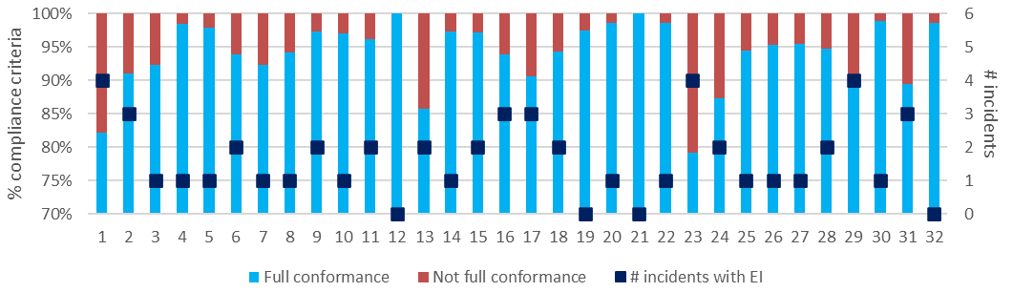
a) Level of conformance with audit criteria and number of non-conformance incidents with assessable environmental impact. Conformance as per Table 3-3, with not full compliance including all criteria with which the coupe did not fully comply, regardless of the potential for environmental impact.

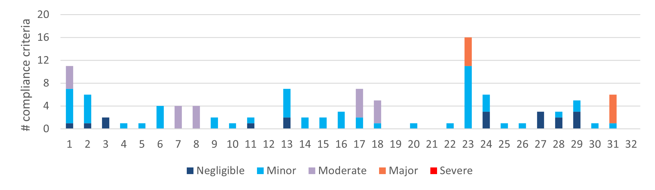

b) Number of compliance criteria with assessable environmental impact and the assessed level of impact for each non-conformance.
Figure 4-1. Overall compliance findings and assessed environmental impact for instances of non-conformance. The x-axis refers to the coupe numbers, as per Table 3-2.
Figure 4-1a also shows the number of incidents resulting in non-conformance with actual or potential environmental impact. These ranged between zero (3 coupes) and four (coupes 1, 23, 29), with an average of 1.7 incidents per coupe. Descriptions of the incidents associated with non-conformance with audit criteria and the regulatory framework for timber harvesting are given in Appendix C.
The EIA tool (Appendix B) was used to assess the potential environmental impact associated with each non-conformance incident. This ranged between negligible and major (Figure 4-1b). Non-conformances assessed to have major potential environmental impact were detected in two of the 32 coupes (23 and 31). Incidents with moderate potential environmental impact were detected in a further five coupes (1, 7, 8, 17, 18). These incidents are discussed in greater detail in the following sections.

Environmental compliance theme
The environmental compliance theme includes two main groups of compliance element and audit criteria: soils and water flows, quality and river health.

Compliance elements related to the protection of forest soils
Compliance elements related to the protection of forest soils (Appendix A) focus on the avoidance of erosion or mass soil movement, as well as on mitigating the risk of entry of sediments into waterways, should they be mobilised. The entry of mobilised sediments into waterways is primarily dealt with under the water and river health sub-theme (Section 4.2.2). The Code and MSPs seek to avoid erosion, soil mass movement and unrectified compaction of soils by:
- Assessing and understanding soil erosion hazard within the coupe and adjusting planning and operations accordingly
- Not harvesting in excessively steep areas
- Application of seasonal closures to coupes in water supply catchments to reduce the risk of harvesting or snigging machinery disturbing wet soils, leading to sediment mobilisation, rutting, soil mixing and/or soil compaction
- Appropriate location, construction, maintenance, closure, rehabilitation and/or removal of landings, in-coupe roads, road drainage and road or snig track waterway crossings.
Forty-three audit criteria were relevant to the protection of forest soils, all but three of which applied to at least one of the target coupes. The average level of full conformance with applicable criteria was found to be 88%, with the level of conformance ranging between 64% (coupe 1) and 100% (coupes 12, 21, 32; Figure 4-2). The assessed environmental impact associated with non-conformances ranged between negligible and moderate.
Non-conformance incidents resulting in actual or potential environmental impacts on forest soils were identified in 28 coupes. Incidents with moderate potential environmental impact were observed at five coupes and related to:
- Long lengths of snig and boundary track in coupe 1 without drainage structures or with poorly constructed structures that failed, leaving the drain spacing significantly exceeding prescriptions in VicForests’ UPs
- Spacing of cross drains on many snig and boundary tracks in coupes 7 and 8 were based on moderate soil erosion hazard, rather than high as recorded in the coupe plan. As a result, long lengths of track in both coupes had drainage spacings that exceeded prescriptions in VicForests UPs
- Unrehabilitated log fill or corded crossing of an ephemeral wetland in coupe 17 (Figure 4-4)
- Soil disturbance associated with the partial rehabilitation of a snig track that crossed a temporary stream with an existing log fill crossing in coupe 18 (Figure 4-5).
These incidents also potentially affect water-related coupe values and are considered in Section 4.2.2.
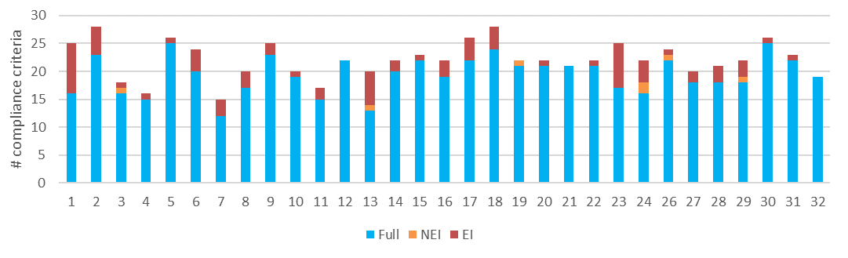
a) Level of conformance with audit criteria. Conformance definitions (Fully conforms [full], Non-conforming with no environmental impact [NEI], Non-conforming with environmental impact [EI]) as per Table 3-3.
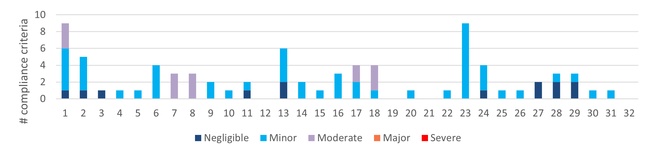
b) Number of compliance criteria with assessable environmental impact and the assessed level of impact for each instance of non-conformance.
Figure 4-2. Compliance findings and assessed environmental impact for instances of non-conformance for criteria applicable to the protection of forest soils. The x-axis refers to the coupe numbers, as per Table 3-2.
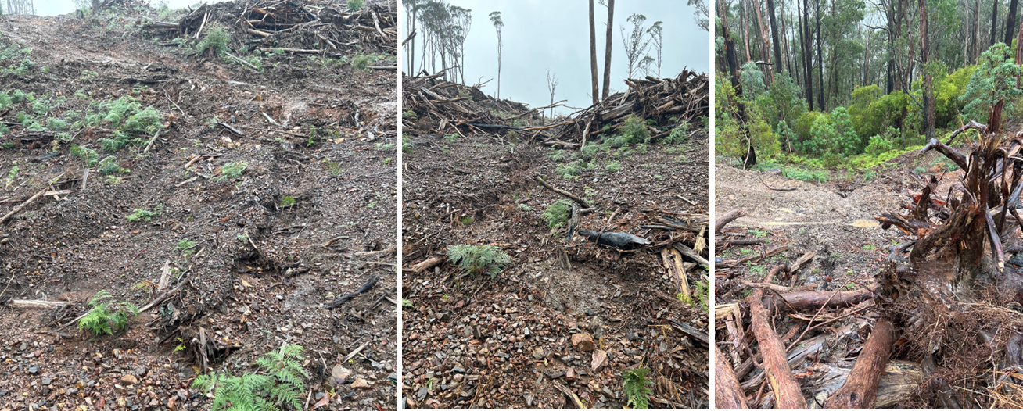
Evidence of soil movement along drainage depression that the audit team consider should have been marked as a drainage line. Sediment has moved towards a temporary stream (right hand image). Potential environmental impact rating: minor.
Figure 4-3. Incident in coupe 1 where a succession of snig track crossings of a drainage line did not adequately manage environmental risk to soils and water quality.
Construction of several snig tracks and a boundary track across a drainage line in coupe 1 contributed to sediment mobilisation and movement towards a temporary stream during heavy rainfall event(s). While the crossings were consistent with regulatory requirements, the audit team considered that they collectively did not adequately address the risk to water quality from overland flow during heavy rainfall events. (Figure 4-3). Since the sediment movement was towards undisturbed vegetation along a temporary stream, the incident was assessed to have only minor potential environmental impact.
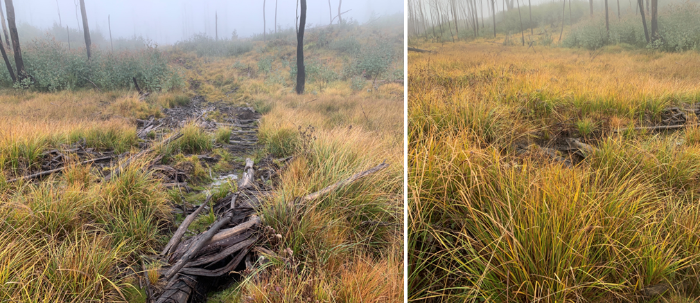
A corded snig track was constructed across a seasonal/temporary wetland in coupe 17, with some soil disturbance. The crossing was not removed, and the cording remains in place after use of the track ceased. There were also reasonably practicable alternatives for snigging other than crossing the seasonal wetland. Potential environmental impact: moderate.
Figure 4-4. Incident involving disturbance to a seasonal or temporary wetland by a corded snig track in coupe 17.
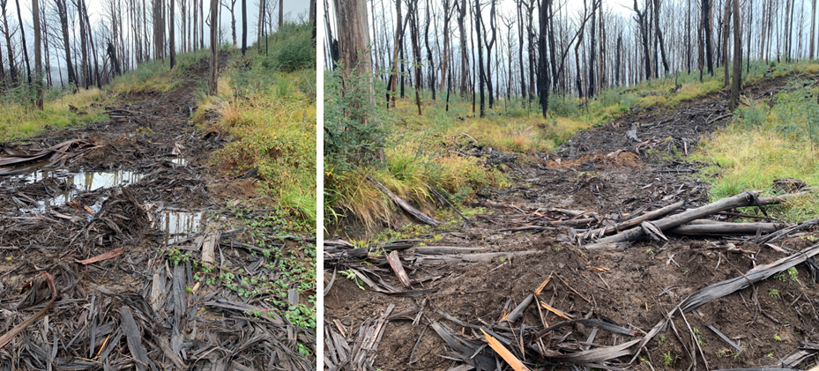
Cording was laid over an existing logfill crossing of a temporary stream to enable use as the main snig/log extraction track in a fire salvage harvest operation. The cording was mostly lifted and cross drains constructed to intercept flows into the crossing. However, there remained significant residual soil disturbance. Potential environmental impact: moderate.
Figure 4-5. Incident involving incomplete rehabilitation of snig track crossing of a temporary stream in coupe 18.

Compliance elements related to the protection of water flows, water quality and aquatic habitat
Compliance elements relevant to this theme (Appendix A) seek to protect water flows, water quality and river health by:
- Classifying waterways present in the coupe, applying at least the minimum width of filters and/or buffers required and excluding harvesting activities and/or machinery from those areas
- Applying seasonal closures to reduce the risk of sediment mobilisation and soil compaction during wet weather in water supply catchments
- Appropriate design, construction and maintenance of in-coupe roads, road drainage and waterway crossings
- Locating, configuring and rehabilitating other coupe infrastructure (snig and boundary tracks, landings) so that they do not become a source of sediment movement in waterways
- Applying appropriate methods to remove and rehabilitate waterway crossings following the completion of timber harvesting and regeneration activities.
Many of the compliance requirements (and audit criteria) also apply to the protection of forest soils, conservation of aquatic biodiversity and management of impacts from the construction and rehabilitation of in-coupe roads and snig or boundary tracks. A total of 62 audit criteria were relevant to this theme, nine of which did not apply to any audit coupes.
The average level of full conformance with applicable criteria was found to be 93%, with the level of conformance ranging between 64% (coupe 23) and 100% (13 coupes; Figure 4-6). The low level of conformance for coupe 23 related to disturbance of a snig track crossing of what, post-harvest, became a temporary stream and inadequate drainage of a snig track leading into the crossing (see Figure 4-7).
The assessed potential environmental impact associated with non-conformances ranged between negligible and major (Figure 4-6). Non-conformances assessed to have major and moderate potential environmental impact were identified in coupes 31 and 1, 7, 8, 17 and 18, respectively. Incidents with moderate potential environmental impact also applied to forest soils and were described in Section 4.2.1.
The incidents with major potential environmental impact were both observed at coupe 31 and related to the design and construction of a waterway crossing for a permanent stream (Figure 4-8), namely:
- Use of a culvert greater than 750 mm diameter in a waterway crossing of a permanent stream without a fish ladder
- Constructing the culvert so that its outlet was elevated above the permanent stream's bed and hindered and possibly prevented upstream movement of aquatic fauna.

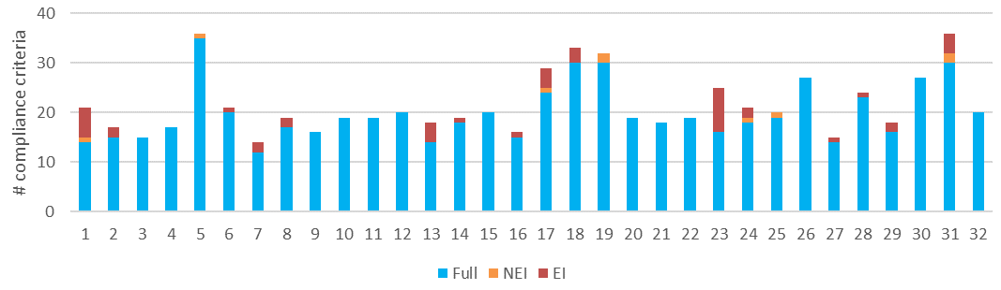
a) Level of conformance with audit criteria. Conformance definitions (Fully conforms [full], Non-conforming with no environmental impact [NEI], Non-conforming with environmental impact [EI]) as per Table 3-3.
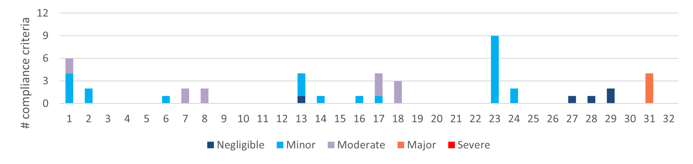
b) Number of compliance criteria with assessable environmental impact and the assessed level of impact for each instance of non-conformance.
Figure 4-6. Compliance findings and assessed environmental impact for instances of non-conformance for criteria applicable to the protection of water flows, water quality and aquatic habitat. The x-axis refers to the coupe numbers, as per Table 3-2.
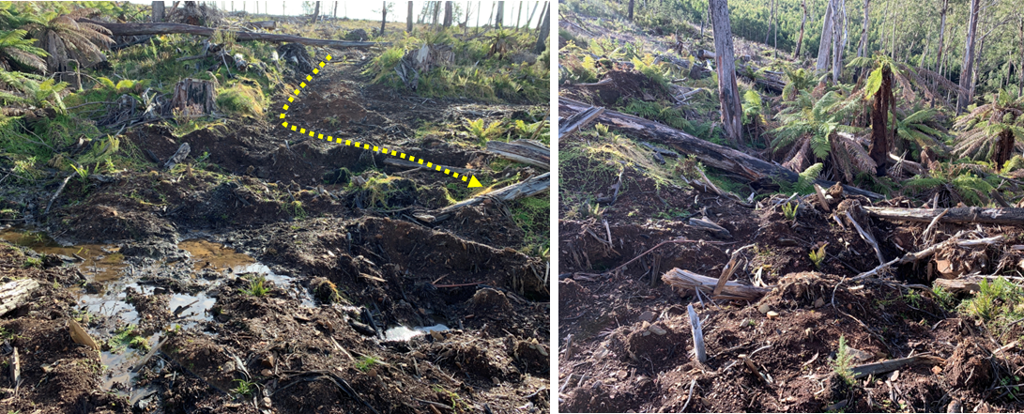
The snig track crossing was most likely over a drainage line when the coupe was marked but is currently functioning as a temporary stream. A temporary log crossing was constructed, but there was significant disturbance during rehabilitation, as the photographs show. The snig track leading into the crossing (left) runs 50m at 13° into the waterway (yellow arrow). The drainage structure diverts flows directly into the waterway. Potential environmental impact of the two incidents: minor.
Figure 4-7. Incident involving poorly rehabilitated snig track crossing at coupe 23.
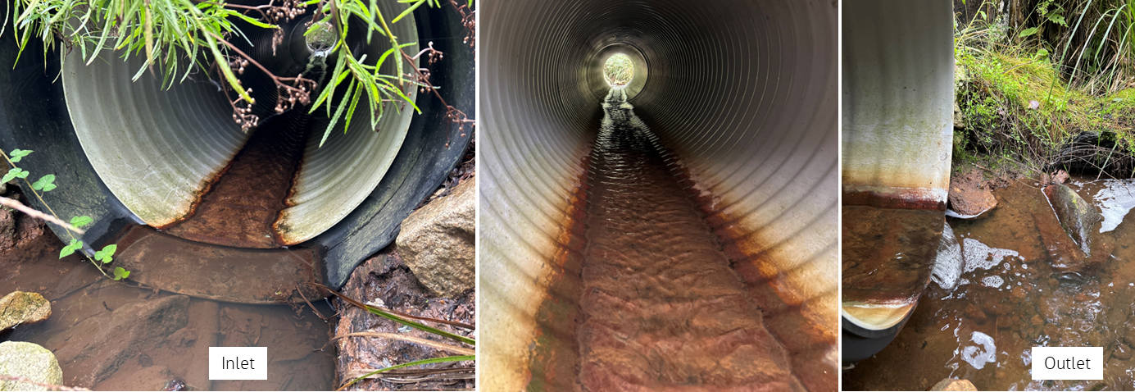
Culvert on permanent stream in-coupe road crossing. The culvert is 900mm diameter and to conform with MSP 6.2.5.9 requires a fish ladder. The culvert outlet discharges a few centimetres above the downstream bed of the waterway, which poses a barrier to the upstream movement of small fish and some other aquatic fauna. Potential environmental impact of both non-conformances: major.
Figure 4-8. Incident involving in-coupe road waterway crossing of permanent stream at coupe 31.

Conservation of biodiversity
Code and MSP compliance elements relevant to this theme (Appendix A) seek to protect biodiversity values by:
- Retaining trees and understorey elements within the gross coupe and/or harvested area, including old growth elements and trees with or with potential to form hollows
- Preventing harvesting activities, roading and regeneration burning from taking place within and/or adjacent to sensitive vegetation communities (e.g., heathlands, montane riparian thickets, rainforest stands) and other retained vegetation within the coupe
- Identifying listed, threatened species of native flora and fauna that have been recorded within or adjacent to the coupe and applying relevant protective measures, including those prescribed by the MSPs
- Not harvesting in (or otherwise disturbing) Special Protection Zones (SPZ) established to protect important native fauna habitats (e.g., for Leadbeater’s Possum, Long-footed Potoroo, large Owls)
- Maintaining passage for fish or other aquatic fauna along permanent streams
- Protecting water quality from sediment movement to waterways from in-coupe roads, snig tracks and other coupe infrastructure
- Managing the risk of entry and/or spread of weeds and soil-borne or other plant diseases.
A total of 63 audit criteria are relevant to protecting biodiversity values, of which 12 were not applicable to any of the selected coupes. The average level of full conformance with applicable criteria was found to be 98%, with the level of full conformance ranging between 87% (coupe 31) and 100% (26 coupes; Figure 4-9).
Biodiversity-related non-conformances with potential environmental impact were observed at six of the 32 coupes. The assessed environmental impact ranged between minor and major (Figure 4-9). Non-conformance incidents with major potential environmental impact were observed at coupe 31 and, as discussed in Section 4.2.2, were associated with installation of the waterway crossing culvert (Figure 4-8). Those with moderate potential environmental impact (coupes 17, 18) were associated with snig track crossings of a season wetland and temporary stream, respectively (Figure 4-4, Figure 4-5).
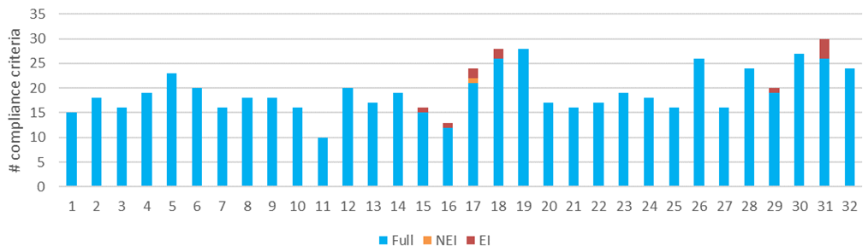
a) Level of conformance with audit criteria. Conformance definitions (Fully conforms [full], Non-conforming with no environmental impact [NEI], Non-conforming with environmental impact [EI]) as per Table 3-3.
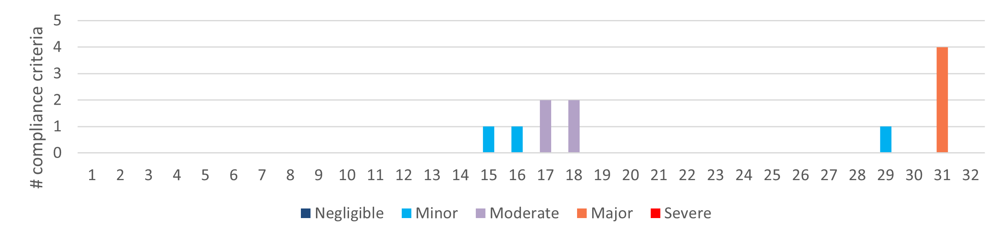
b) Number of compliance criteria with assessable environmental impact and the assessed level of impact for each instance of non-conformance.
Figure 4-9. Compliance findings and assessed environmental impact for instances of non-conformance for criteria applicable to the conservation of biodiversity. The x-axis refers to the coupe numbers, as per Table 3-2.

Operational planning and record-keeping
Compliance elements considered under this theme are concerned with the development of the forest coupe plan (FCP) in conformance with the Code and MSPs and the consistency of coupe operations with that plan. The compliance elements seek to protect soil, water and biodiversity values from risks associated with poorly planned or executed harvesting, roading and regeneration operations. Ninety-four audit criteria were identified (Appendix A), with 19 found not to apply to any of the audited coupes.
The average level of full conformance with applicable criteria was 97%, with full conformance ranging between 86% (coupe 23) and 100% (13 coupes; Figure 4-10). Non-conformance incidents ranged in severity of potential environmental impact between negligible and major. Incidents with major potential environmental impact were observed on coupes 23 and 31. Those with moderate potential environmental impact were observed at coupes 7, 8 and 17.
Excepting the incident at coupe 23, these non-conformance incidents have been discussed previously (Sections 4.2.1 and 4.2.2). They relate to:
- Not planning to incorporate a fish ladder when installing a 900mm culvert at a permanent stream waterway crossing (coupe 31)
- Planning drainage spacings for snig and boundary tracks based on medium soil erosion hazard when the coupe plan noted the soil erosion hazard was high (coupes 7, 8)
- Routing a snig track through an ephemeral wetland when there were alternatives and not adequately rehabilitating the track (coupe 17).
The incident with major potential impact at coupe 23 related to entry by harvesting machinery into an SPZ in the south west of the coupe (Figure 4-11). VicForests staff reported that the coupe was marked with the expectation that the SPZ (#698) would be converted to General Management Zone (GMZ) and become available for harvest. This had occurred on adjacent coupes due to the values to be protected not being present. An application to rezone the SPZ was made, but not approved. While the coupe plan specified that harvesting activities were to be excluded from the SPZ, a harvesting machine entered the SPZ (for a distance of about 20m) and disturbed elements of the understorey vegetation. No trees were harvested. In this case, the EIA rating reflects the sensitivity of the area where the disturbance occurred and not the actual environmental harm.
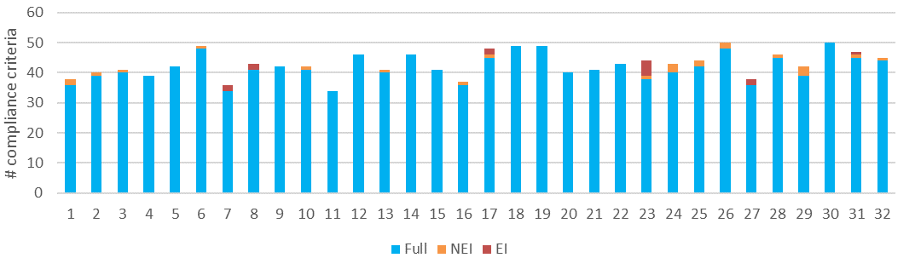
a) Level of conformance with audit criteria. Conformance definitions (Fully conforms [full], Non-conforming with no environmental impact [NEI], Non-conforming with environmental impact [EI]) as per Table 3-3.
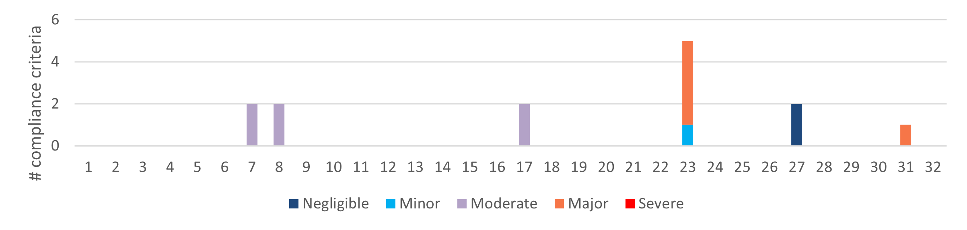
b) Number of compliance criteria with assessable environmental impact and the assessed level of impact for each instance of non-conformance.
Figure 4-10. Compliance findings and assessed environmental impact for instances of non-conformance for criteria applicable to the conservation of biodiversity. The x-axis refers to the coupe numbers, as per Table 3-2.
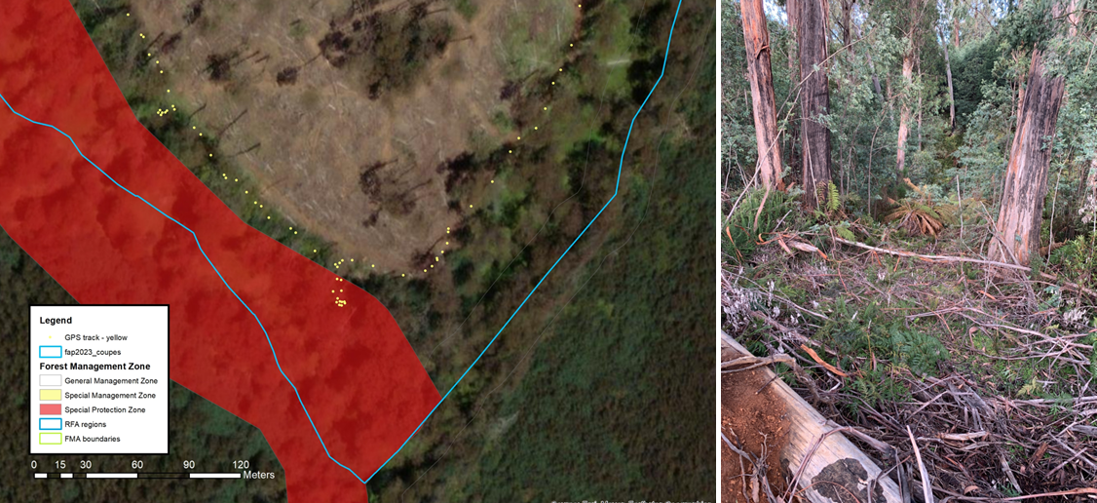
Left image shows GPS track log that follows the path of a harvesting machine, which enters ~20m into the SPZ at coupe 23. Right image shows the location of entry. The incident likely involved only a single machine pass in and out. No trees were harvested.
Figure 4-11. GPS track log showing path of entry of harvesting machine into SPZ within/adjacent to coupe 23. The path ended at the harvest boundary that was proposed on the assumption that the SPZ would be converted to GMZ.

Coupe infrastructure for harvesting operations
The coupe infrastructure theme includes five main groups of compliance elements and audit criteria. The first four relate to in-coupe roading (planning, design, construction, maintenance and closure) and the fifth relates to other forms of coupe infrastructure, namely landings and snig and boundary tracks.
Seven of the audit coupes (coupes 4, 7, 11, 13, 18, 19, 28) had either no in-coupe road or such short lengths of in-coupe road (significantly less than 50m) that they were not assessed against the in-coupe roading sub-themes.

Compliance elements related to in-coupe road planning
Compliance elements relevant to this theme (Appendix A) seek to ensure that in-coupe roads are planned to reduce or avoid interaction with sensitive vegetation communities (e.g., montane riparian thicket, heathland, rainforest) or habitat types (e.g., aquatic or riparian habitat), SPZ and other forms of harvesting exclusion area, very steep slopes and/or areas with highly erodible soils. Opportunities for planning in-coupe roads to minimise potential impacts on site values include constructing the landing adjacent to an existing road and requiring no or only a very short length of in-coupe road and snigging to an existing landing on an adjacent coupe.
In-coupe road planning has not been considered in recent FAP audits. Ten road planning compliance elements were considered in this audit, of which nine applied to at least one coupe.
The average level of full conformance with applicable criteria was 95%, with full conformance ranging between 71% (coupes 23 and 31) and 100% (19 coupes; Figure 4-12). Non-conformance incidents with potential environmental impact were observed at coupes 24 and 31, with the potential environmental impact being negligible and major, respectively. Major potential environmental impact at coupe 31 was associated with failure to construct a fish ladder when a 900mm culvert was planned for the in-coupe road waterway crossing (see discussion in Section 4.2.2).
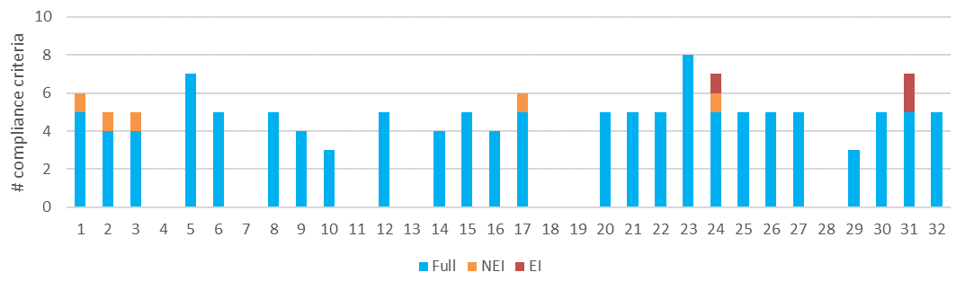
a) Level of conformance with audit criteria. Conformance definitions (Fully conforms [full], Non-conforming with no environmental impact [NEI], Non-conforming with environmental impact [EI]) as per Table 3-3.
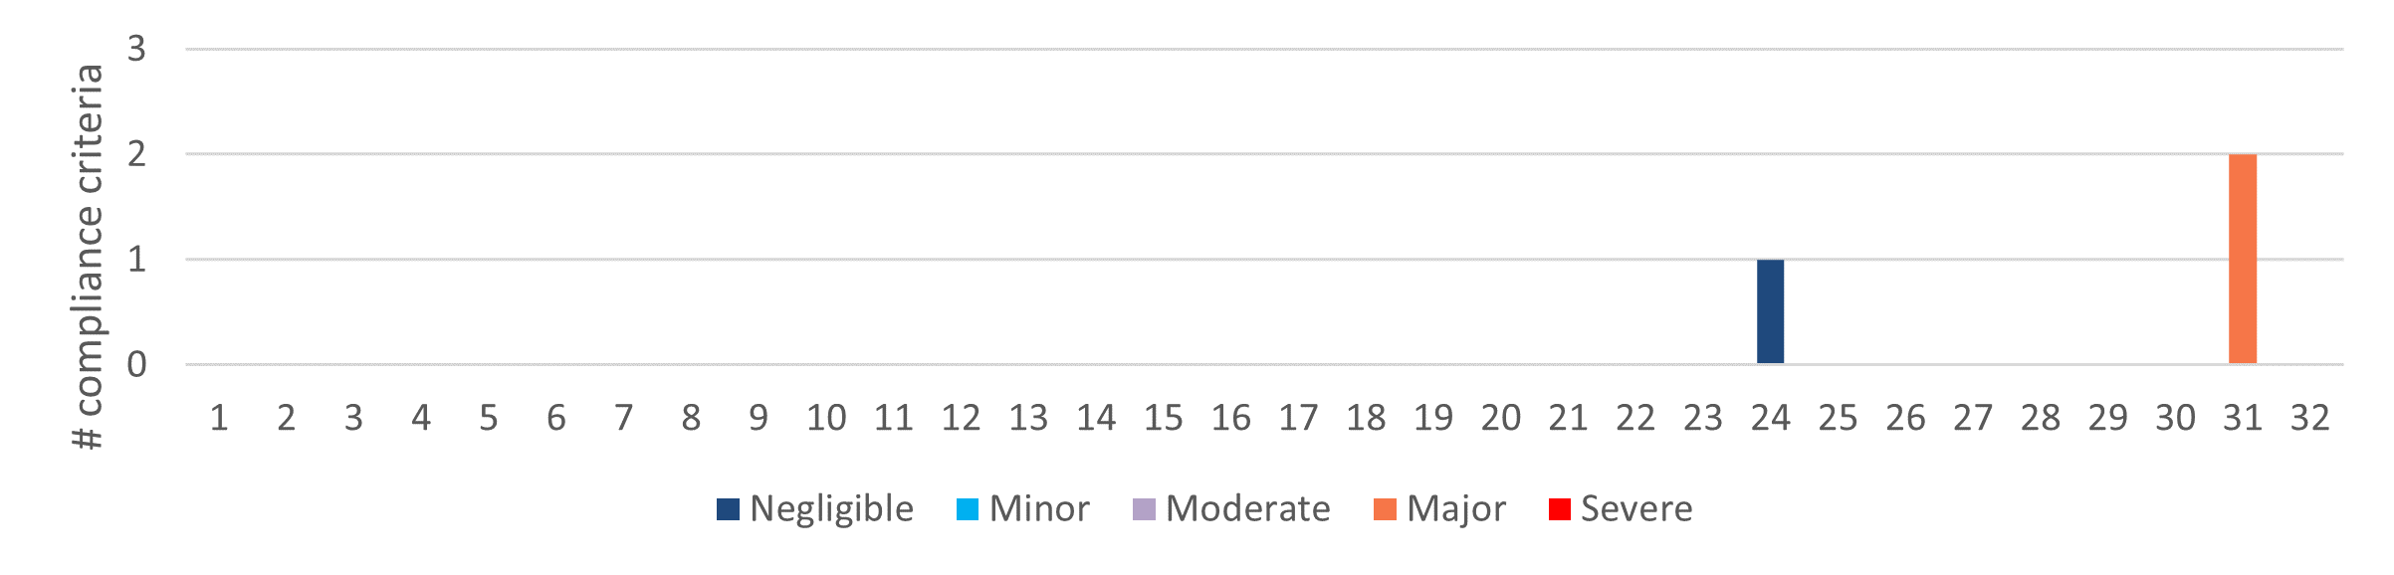
b) Number of compliance criteria with assessable environmental impact and the assessed level of impact for each instance of non-conformance.
Figure 4-12. Compliance findings and assessed environmental impact for instances of non-conformance for criteria applicable to in-coupe road planning. The x-axis refers to the coupe numbers, as per Table 3-2.

Compliance elements related to in-coupe road and waterway crossing design
The 17 compliance elements relevant to this theme (Appendix A) seek to ensure that appropriate design protects soil and water values from risks associated with the construction of fill batters for roads, waterway crossings and road drainage structures. Design is intended to ensure the stability of roads and road embankments, safe passage of high flow events through crossings and culverts and prevent erosion of roads and crossings and associated sediment generation. One of the criteria was not applicable to any of the audited coupes. This sub-theme was not applicable to coupes that had no in-coupe road.
The average level of full conformance with applicable criteria was found to be 95%, with the level of full conformance ranging between 40% (coupe 24) and 100% (21 coupes; Figure 4-13). Non-conformance incidents with potential environmental impact were observed at three coupes (coupes 1, 24 and 31), with incidents at coupe 31 having major potential environmental impact. As discussed in Section 4.2.2 and depicted in Figure 4-8, these incidents were associated with:
- Failure to design the crossing without a fish ladder when the culvert was 900mm diameter (in contravention of MSP 6.2.5.9)
- Laying of the culvert with the outlet elevated above the waterway bed, providing a barrier to upstream movement of aquatic fauna (in contravention of MSP 6.2.5.11).
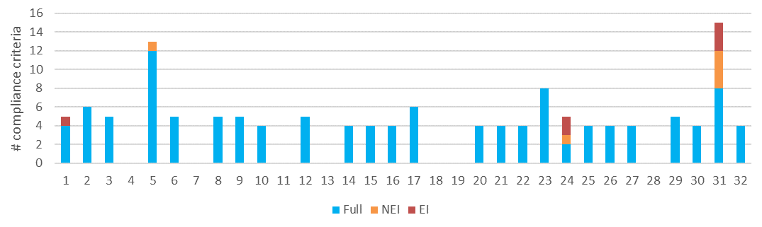
a) Level of conformance with audit criteria. Conformance definitions (Fully conforms [full], Non-conforming with no environmental impact [NEI], Non-conforming with environmental impact [EI]) as per Table 3-3.
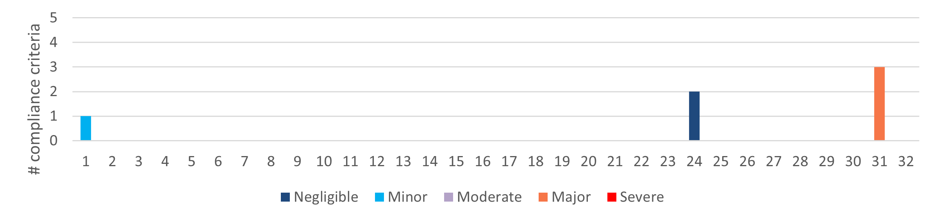
b) Number of compliance criteria with assessable environmental impact and the assessed level of impact for each instance of non-conformance.
Figure 4-13. Compliance findings and assessed environmental impact for instances of non-conformance for criteria applicable to in-coupe road and waterway crossing design. The x-axis refers to the coupe numbers, as per Table 3-2.
While the in-coupe road waterway crossing at coupe 31 had design and construction flaws, as indicated by the non-conformances discussed above, it presented a good example of how sediment carried by road runoff could be managed (see Figure 4-14 and accompanying text).
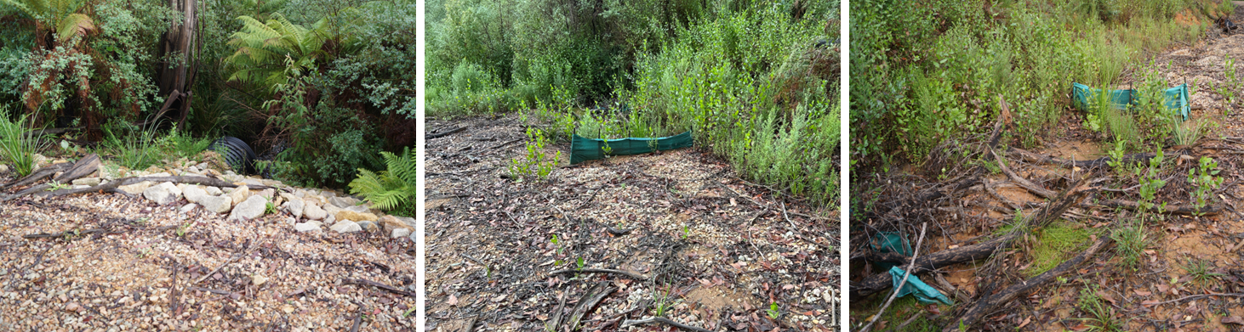
The left image shows good management of runoff across the fill batter on the crossing. Rock rip rap is used to slow flow and capture any sediment entrained. Centre and right images show the use of silt fences to capture sediment in runoff shed by the road. The coupe was burnt by wildfire in 2019-20 and there was little scope for vegetation to filter/infiltrate runoff diverted from the road. Accumulation of sediment upslope of the silt fence (centre) demonstrates its effectiveness. The right image highlights the need for maintenance if silt fences are to retain their effectiveness. As is evident from the bottom left corner of the image, a fallen branch has damaged the backup silt fence and rendered it ineffective.
Figure 4-14. Examples of good practice for managing runoff and sediment at an in-coupe road waterway crossing, coupe 31.

Compliance elements related to in-coupe road and waterway crossing construction
The 47 compliance elements relevant to this theme (Appendix A) largely seek to protect soil and water values from impacts associated with road drainage and the construction of road embankments and waterway crossings. Five of these compliance elements were found not to be applicable to any of the audit coupes. This sub-theme did not apply to the coupes that had no in-coupe road.
The average level of full conformance with applicable criteria was found to be 98%, with the level of conformance ranging between 77% (coupe 24) and 100% (20 coupes; Figure 4-15). Non-conformances with potential environmental impact were identified in four coupes, with incidents having either negligible potential environmental impact (coupes 1, 3, 24) or major potential environmental impact (coupe 31).
The non-conformance with major potential impact at coupe 31 was described previously (Section 4.2.2). It relates installation of the waterway crossing culvert with its outlet above the downstream bed of the permanent stream (see Figure 4-8).
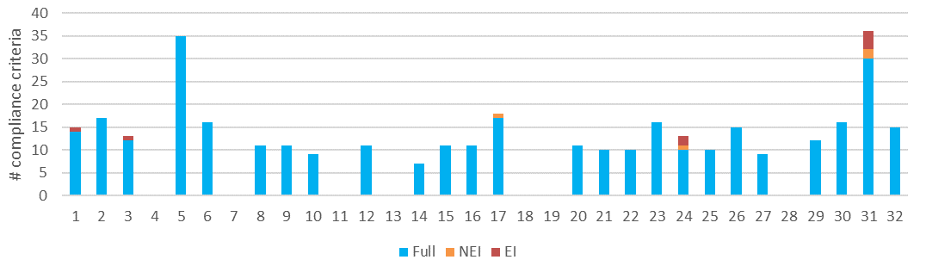
a) Level of conformance with audit criteria. Conformance definitions (Fully conforms [full], Non-conforming with no environmental impact [NEI], Non-conforming with environmental impact [EI]) as per Table 3-3.
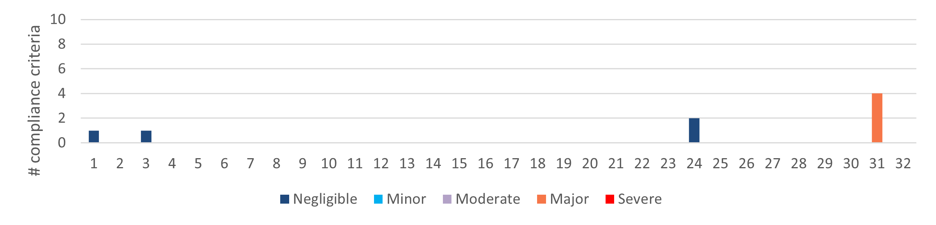
b) Number of compliance criteria with assessable environmental impact and the assessed level of impact for each instance of non-conformance.
Figure 4-15. Compliance findings and assessed environmental impact for instances of non-conformance for criteria applicable to in-coupe road and waterway crossing construction. The x-axis refers to the coupe numbers, as per Table 3-2.

Compliance elements related to in-coupe road and waterway crossing maintenance and closure
Thirteen compliance criteria relevant to road maintenance or closure were considered in this audit (Appendix A), of which all but two were applicable to at least one coupe. Like compliance elements for road design and construction, they are largely concerned with protecting soil and water values from risks associated with the use of in-coupe roads, their closure following the completion of harvesting operations and the removal of any waterway crossings.
The average level of full conformance with applicable criteria was found to be 97%, with the level of conformance ranging between 67% (coupe 24) and 100% (21 coupes; Figure 4-16). There were no non-conformance incidents with potential environmental impact for this sub-theme.
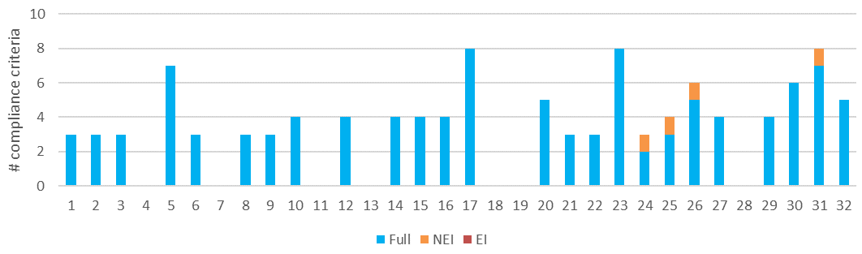
Level of conformance with audit criteria. Conformance definitions (Fully conforms [full], Non-conforming with no environmental impact [NEI], Non-conforming with environmental impact [EI]) as per Table 3-3.
Note: there were no non-conformances with potential environmental impact for this audit sub-theme
Figure 4-16. Compliance findings for criteria applicable to maintenance and closure of in-coupe roads and waterway crossings. The x-axis refers to the coupe numbers, as per Table 3-2.

Compliance elements related to non-road infrastructure
Compliance elements considered under the non-road infrastructure sub-theme have a similar function to those for in-coupe roading, in that they seek to protect soil and water values from risks associated with the construction, use and rehabilitation of snig tracks, boundary tracks and landings. Fifty audit criteria were identified, with all but two applying to at least one of the audited coupes.
The average level of full conformance with applicable criteria was found to be 89%, with full conformance ranging between 64% (coupe 23) and 100% (4 coupes; Figure 4-17). Non-conformance incidents with potential environmental impact were observed at 26 of 32 coupes, with the assessed level of potential environmental impact ranging between negligible and moderate.
Incidents assessed to have moderate potential environmental impact were observed at coupes 1, 7, 8, 17 and 18. These related to:
- Long sections of snig/boundary track in coupe 1 one without constructed drainage or with drainage that did not work effectively. The spacings between effective drainage structures consequently exceeded prescriptions in VicForests UPs.
- Spacings between drainage structures on coupes 7 and 8 were based on moderate soil erosion hazard rather than high and consequently exceeded UP prescriptions.
- Inadequate rehabilitation of snig track crossings of a seasonal/temporary wetland in coupe 17 and temporary stream in coupe 18 (see Figure 4-4 and Figure 4-5).
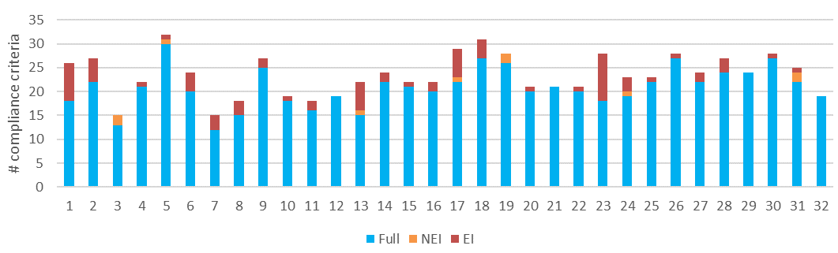
a) Level of conformance with audit criteria. Conformance definitions (Fully conforms [full], Non-conforming with no environmental impact [NEI], Non-conforming with environmental impact [EI]) as per Table 3-3.
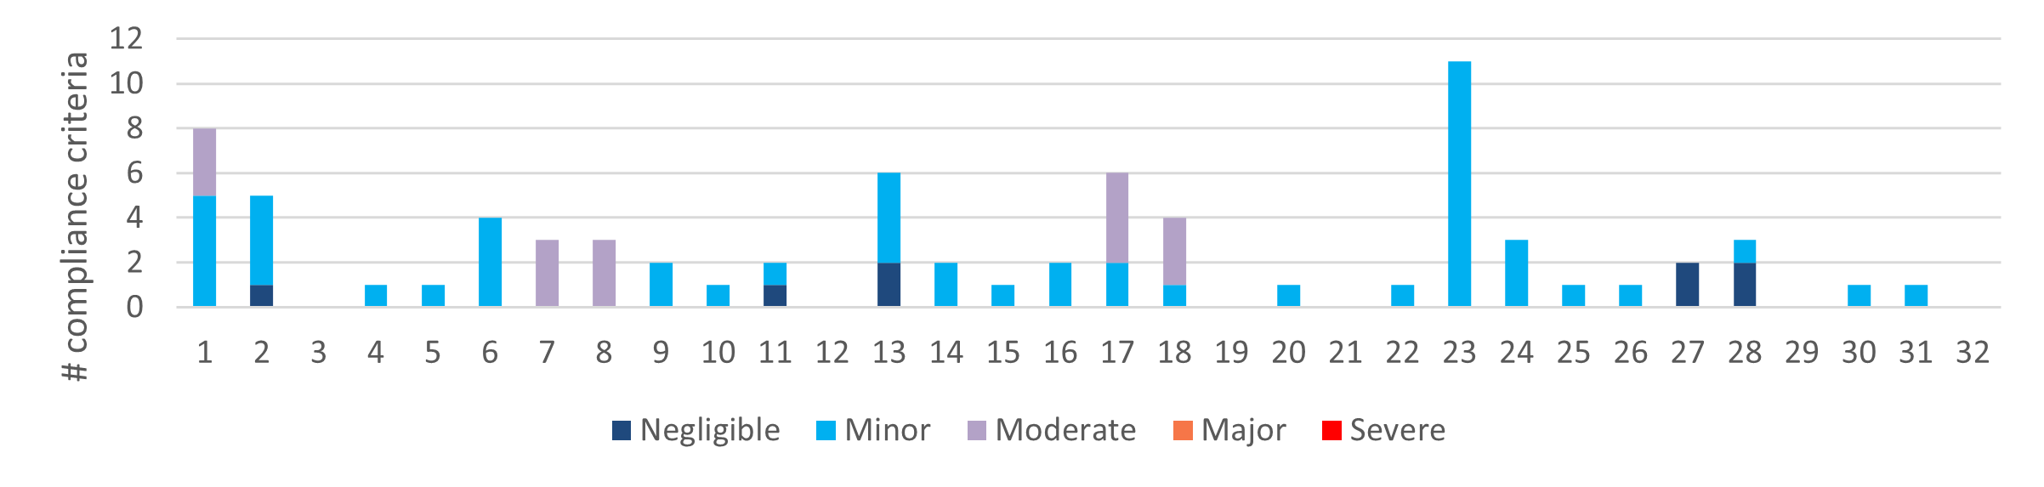
b) Number of compliance criteria with assessable environmental impact and the assessed level of impact for each instance of non-conformance.
Figure 4-17. Compliance findings and assessed environmental impact for instances of non-conformance for criteria applicable to non-road infrastructure. The x-axis refers to the coupe numbers, as per Table 3-2.
Nineteen of the audited coupes were assessed to not conform with the MSP requirement (7.2.4.2) to limit slash and bark piles to a maximum of 4m² (ground area) and 10m³ (volume). Each observed non-conformance (e.g., Figure 4-18) was in a coupe that had not been subject to regeneration burning to manage slash and/or had been rough heaped to disturb soils and consolidate slash piles. The appropriateness of this prescription, particularly in the context of reduced use of regeneration burning and increased use of rough heaping for regeneration is discussed in Section 5.4.
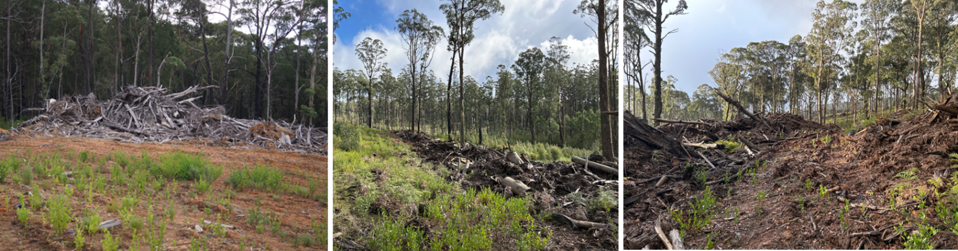
Figure 4-18. Examples of coupes with large pile of bark and logging debris, whose dimensions exceed the maxima prescribed in MSP 7.2.4.2.

Discussion

Overall audit findings

Conformance with audit criteria and potential environmental impact
FAP audits are conducted to assess VicForests’ conformance with selected elements of the regulatory framework for timber harvesting activities in State forests, and identify any environmental risks posed by non-conformances. This section provides a summary of the audit’s overall findings in relation to these objectives.
The audit considered 32 coupes distributed through State forest areas in eastern Victoria. Since coupe selection was weighted towards those with higher risk features (e.g., rainforest vegetation, waterway crossings, in-coupe roads, steeper slopes, and more erodible soils), the findings of the audit are not necessarily statistically representative of VicForests’ operations overall.
The audit found that the average level of full conformance (per coupe) was 94% of applicable audit criteria (Figure 5-1). The average level of full conformance varied between compliance themes, ranging between 88% (soils) and 99% (biodiversity). Non-conformances with direct or potential environmental impact were associated with 56 unique incidents at 28 of the 32 audited coupes.
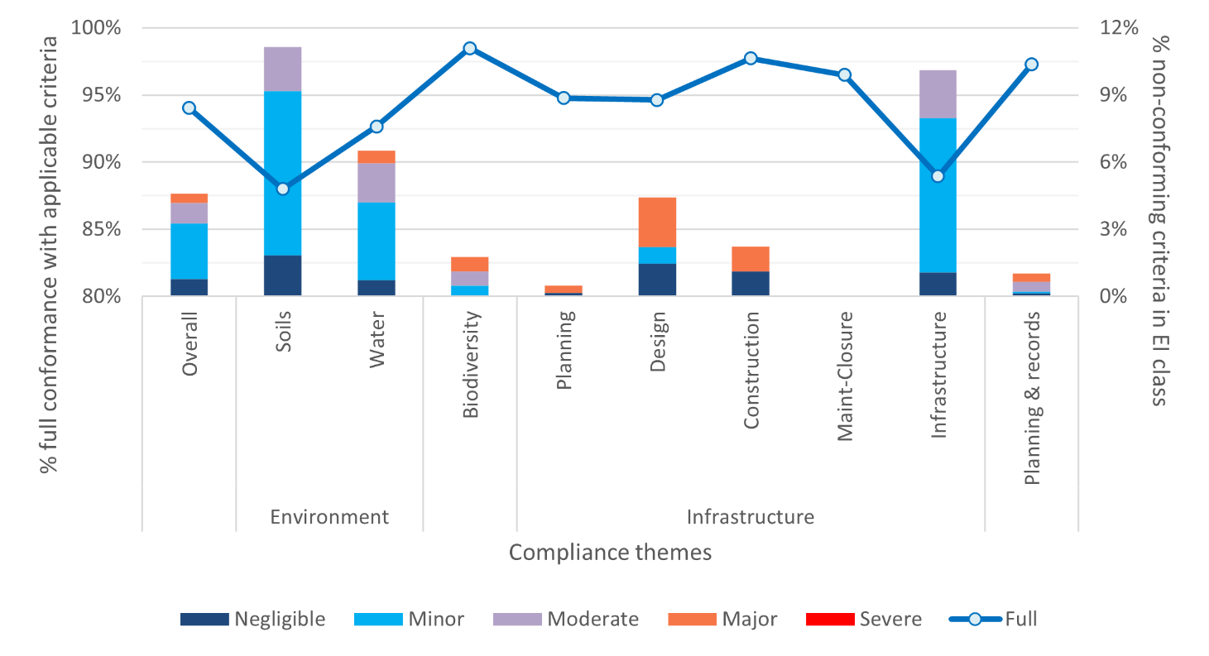
Average % full conformance with applicable audit criteria overall and in each audit theme and sub-theme (left Y axis). % non-conformances in each potential environmental impact (EI) class overall and for audit themes and sub-themes (right Y axis)
Figure 5-1. Summary of overall audit findings for conformance with the regulatory framework for timber harvesting and related activities in State forests in Victoria
Instances of non-conformance with audit criteria were identified across all audit themes and sub-themes (Figure 5-1) apart from in-coupe road maintenance and closure. Non-conformances with potential environmental impact were most common (proportionally) for the soils and non-road infrastructure sub-themes. Overall, non-conformances with potential environmental impact were recorded for almost 5% of applicable criteria.
Assessed environmental impact for non-conformances ranged between negligible and major. Three individual non-conformance incidents with major potential environmental impact were observed in the audit. These were observed at coupes 23 and 31 (two incidents). Incidents with major potential environmental impact were reported against each compliance theme and sub-theme except soils, in-coupe road maintenance and closure and non-road infrastructure (Figure 5-1).

Incidents resulting in non-conformances with audit criteria
As noted above, audit criteria non-conformances with potential environmental impact were attributed to 56 individual incidents, of which three were assessed to have major potential environmental impact (Table 5-1). Each incident aligned with one or more audit themes or sub-themes (apart from road maintenance and closure). Almost all incidents had potential impacts on soil and water values, most related to non-road coupe infrastructure. Incidents with potential environmental impact were observed in 28 of the 32 coupes included in the audit.
Of the three incidents assessed to have major potential environmental impact, two (in coupe 31) had potential to affect aquatic biodiversity values. In common with incidents with major potential environmental impact observed in previous FAP audits, they involved the design and construction of an in-coupe road waterway crossing. The third incident with major potential environmental impact related to the entry of a harvesting machine into an SPZ and hence represented a mismatch between coupe planning and its implementation.
Table 5-1. Numbers of incidents resulting in non-conformances with audit criteria in 2021 to 2023 FAP audits
Audit theme and sub-theme | # incidents¹ |  |  | # incidents with major potential environmental impact²
 | 2021 | 2022 | 2023 | 2021 | 2022 | 2023
Overall | 39 | 44 | 53 | 1 | 3 | 3
Environment
- Soils | 20 | 31 | 47 | 0 | 2 | 0
- Water | 18 | 22 | 22 | 0 | 2 | 2
Biodiversity | 11 | 15 | 4 | 1 | 3 | 2
Planning & record keeping | 9 | 18 | 7 | 1 | 3 | 2
Coupe infrastructure
- Road planning³ | n/a | n/a | 1 | n/a | n/a | 1
- Road design | 3 | 7 | 3 | 0 | 1 | 1
- Road construction | 11 | 18 | 5 | 0 | 1 | 2
- Road maintenance & closure | 7 | 1 | 0 | 0 | 0 | 0
- Non-road infrastructure | 17 | 22 | 44 | 0 | 1 | 0
# coupes with no EI incidents⁴ | 11/30 | 12/32 | 4/32 | 29/30 | 29/32 | 30/32
Note:
- Note that as incidents may be reported against multiple themes/sub-themes, the overall number of incidents is not the sum of incident numbers for all themes and sub-themes.
- There were three incidents overall with major potential environmental impact. Each of these incidents had impacts across multiple audit themes/sub-themes.
- Road planning was not included in the audit scope in 2021 and 2022 audits.
- Numbers of coupes with either no incidents with potential environmental impact (EI) or no major potential environmental impact. Total number of coupes included in the audit program is also given, as it differed in 2021 to 2022 and 2023.
Eleven different incident types resulted in non-conformances with potential environmental impact in this year’s audit (Table 5-2). As noted previously, two types of incident were found to have up to major potential environmental impact and one additional incident type had up to moderate potential environmental impact. Potential environmental impact ratings for these incidents reflect the sensitivity of the locations at which the incidents occurred, and, in some cases, the extent, severity and likely duration of actual impact. Incidents with major potential environmental impact were associated with either permanent streams or SPZ.
Table 5-2 also compares the types of incidents detected in this audit with the types and frequency of incidents detected in the two previous FAP audits (Jacobs, 2021; 2023). Seven of the 11 incident types with potential environmental impact observed in this audit have been observed in at least one of the two previous audits. Those incident types include:
- Formation of excessively large piles of bark or slash at landings or other locations in coupes
- Effective drainage structure spacing on in-coupe roads or snig or boundary tracks exceed MSP or UP prescriptions (respectively) for slope and soil erosion hazard
- Inappropriately designed, constructed and/or rehabilitated waterway crossings
- Mass movement and other forms of erosion of in-coupe road, landing or snig/boundary track fill or cut batters
- Machinery entry and/or harvesting in SPZ, riparian buffers or other planned exclusion areas
- Construction of snig or boundary tracks through drainage depressions, flow paths or other wet areas, leading to soil disturbance and potential for sediment movement.
Incursions of regeneration burns into areas of retained vegetation, buffers or harvesting exclusion areas, which were observed frequently in previous audits, were not observed during this year’s audit. This reflects the small number of coupes in which regeneration burning had been conducted. Reduced use of regeneration burning is directly related to increased non-conformance with size requirements for bark and debris piles (as per MSP7.2.4.2).
Table 5-2. Types of incident resulting in non-conformances with the regulatory framework that have potential or actual environmental impact, including comparison with 2020-21 and 2021-22 FAP audits (Jacobs, 2021; Jacobs,2023)
Type of incident and potential consequences¹ | # incidents in FAP audit program |  |  | Maximum environmental impact rating  (2022-23) | Code (C) or MSP (M) reference
Type of incident and potential consequences¹ | 2020-21 | 2021-22 | 2022-23 | Maximum environmental impact rating  (2022-23) | Code (C) or MSP (M) reference
- Piles of slash, bark or other debris formed at landing, by rough heaping or elsewhere in the coupe in preparation for regeneration burning exceed prescriptions. | 5 | 5 | 20 | Minor | C2.4.2.5, M6.2.4.1
Potential consequences: damage to soil structure and chemistry due to heat of fire, poor regeneration and seedling recruitment, loss of site productivity if piles remain unburnt.
- Spacing of effective drains along snig or boundary tracks exceed permitted value (from UP) based on recorded soil erosion hazard and slope.1 | 9 | 8 | 13 | Moderate | C2.5.2.5
Potential consequences: soil erosion, sediment deposition into waterways, impairment of aquatic habitat, reduced water quality.
- Placement, use and rehabilitation of snig or boundary tracks lead to soil disturbance. | 0 | 0 | 6 | Minor | C2.2.1.2
Potential consequences: soil rutting, compaction mixing and/or erosion, water quality impairment, impairment of regeneration.
- In-coupe road or snig track waterway crossing design, construction and/or rehabilitation does not conform with the regulatory framework, including culvert installation, management of road drainage in the vicinity of the crossing, rehabilitation of crossing, absence of fish ladder with 750+mm culvert. | 4 | 12 | 3 | Major | C2.2.1.2/6/7/ 8/12, 2.4.2.9, 2.4.6.2, M6.2.5.5/9, 6.2.4.1/2/4/5.6, 8.1.5.6
Potential consequences: soil erosion, sediment deposition into waterways, impairment of aquatic habitat, reduced water quality.
- In-coupe road drainage structure spacing exceeds permitted value based on recorded soil erosion hazard and slope. Slope of in-coupe road exceeds permitted range for soil erosion hazard. | 4 | 4 | 3 | Negligible | C2.2.1.2/3/ 8/15
Potential consequences: soil erosion, sediment deposition into waterways, impairment of aquatic habitat, reduced water quality.
- Machinery entry into SPZ or other exclusion areas within or adjacent to the coupe, including for unauthorised harvesting or construction of boundary or regeneration burning tracks. | 2 | 2 | 2 | Major | C2.2.1.2/5, 2.5.1.2, M3.5.1.1, 4.2.1.1, 7.1.2.1, P4.3.1.1
Potential consequences: soil compaction/ disturbance, reduction in habitat values.
- Snig track constructed through flow path of temporary stream or other wet area that required protection from machinery disturbance. | 0 | 2 | 1 | Minor | C2.2.1.2, 2.2.2.4/5, 2.5.1.2, M4.1.4.5, 7.1.2.3
Potential consequences: soil compaction, sediment mobilisation, reduced water quality, impairment of aquatic habitat.
- In-coupe road, snig track and/or landing cut or fill batter subject to mass movement and/or other form of erosion. | 4 | 2 | 1 | Minor | C2.2.1.2/14/ 15, 2.4.3.3, M6.2.2.3
Potential consequences: soil mass movement and erosion, water quality and aquatic biodiversity impairment, damage to regenerating forest.
- Tree felled into SPZ or other harvest exclusion area. | 0 | 0 | 1 | Minor | C2.2.2.5, 2.1.5.2, M7.1.2.1
Potential consequences: minor damage to retained understorey vegetation.
- Cording on landing has been lifted but not removed. | 0 | 0 | 1 | Minor | M7.2.2.2/5
Potential consequences: impaired regeneration, loss of productive capacity of regenerating forest.
- Mature tree retained through harvest has part of base covered by fill batter from coupe infrastructure. | 0 | 0 | 1 | Minor | C2.4.3.3
Potential consequences: health and productivity of tree impaired
- Regeneration burn has entered and/or affected exclusion areas within or adjacent to coupe and/or vegetation in exclusion areas/habitat patches damaged by regeneration or rough heap burn that remains within the planned burn boundary. | 6 | 1 | 0 |  | C2.2.1.2, 2.2.2.4/5, 2.5.1.2, M4.1.4.5, 7.1.2.3
- Bark placed on uncorded snig track. | 0 | 2 | 0 |  | M7.2.1.2
- Controls for management of runoff and sediment from coupe to forest road drainage system and external waterways insufficient to prevent sediment movement. | 1 | 1 | 0 |  | C2.2.1.2/3/14, 2.2.4.1, 2.5.1.1
- Barrier to entry to coupe removed and not reinstated following regeneration activities. | 0 | 1 | 0 |  | M6.4.1.3
- Damage to snig track by traffic following initial rehabilitation. | 0 | 1 | 0 |  | M7.2.2.1
- Compacted area near landing not ripped during landing rehabilitation. | 0 | 1 | 0 |  | M7.2.2.6
Note:
- Potential consequences only described for incidents observed in the current audit.
Almost all incidents identified in Table 5-2 pose risk to soil, water and aquatic biodiversity values. Several threaten terrestrial biodiversity values and some (e.g., excessively large slash or bark piles, in-coupe road or landing embankments experiencing mass soil movement) could affect the productive capacity of parts of the regenerating forest.
Several new types of incident were observed in this audit. The most significant of these related to soil disturbance (e.g., rutting, soil mixing, compaction, slumping of cut batters) resulting from inappropriate placement, use and/or rehabilitation of snig or boundary tracks. While common (they were observed at eight coupes), such incidents had no greater than minor potential environmental impact. Figure 5-2 provides two examples of this type of incident.

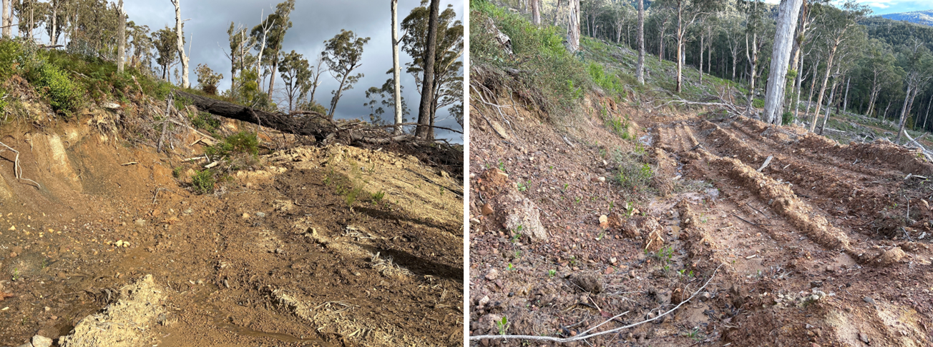
Coupe 13: This snig track has been cut deeply into highly dispersive soils, leading to slumping of the cut batter and water and sediment movement along the track. Distance from waterways means there is little direct risk to water quality or aquatic habitat.
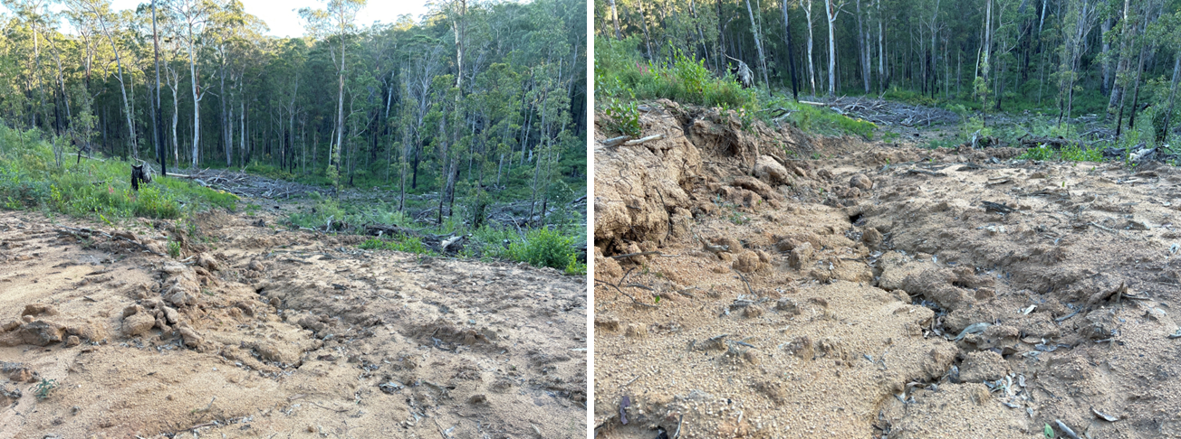
Coupe 29: This section of snig track was cut into a slope with highly dispersive soil, which is confined to this area within the coupe. The track has eroded significantly and will mobilise sediment until it is stabilised by vegetation. Soil movement may ultimately lead to drainage structures on the snig track being filled.
Figure 5-2. Examples of incidents where soil disturbance has resulted from inappropriate placement, use and/or rehabilitation of snig or boundary tracks.

Comparison with previous audits
As was previously discussed, coupe selection for the FAP is risk-based, rather than randomised. This means that audit results are not necessarily statistically representative of VicForests’ operations overall and may not be directly comparable between years. Comparisons between past audits are further confounded by incremental modification of criteria sets, changes in how criteria are mapped to audit themes, and how potential environmental impacts associated with non-conformances are assessed.
However, since there has been a broadly consistent approach to coupe selection and compliance criteria for all audit sub-themes (except in-coupe road planning, which is new to this audit) there is a reasonable basis for comparison of audit results over time. Table 5-1 and Table 5-3 compare results of the current audit with the two most recent FAP audits, both of which only considered timber harvesting operations in eastern Victoria.
Table 5-1 provides data on the number of incidents with potential environmental impact and the number of coupes in which those incidents were observed. It shows that the number of incidents was greater, overall, in this year’s audit than in the previous two (53, compared with 44 and 39, respectively) and that the number of incidents with major potential environmental impact was the same as in 2022 (three) and greater than in 2021 (one). Key differences to previous audits were the greater number of incidents applicable to the soils and non-coupe infrastructure sub-themes and the lower number of incidents applicable to biodiversity and road construction.
While the number of coupes recording incidents with major potential environmental impact has been stable (one, three and two in 2021 to 2023), the number of coupes with no incidents has fallen significantly in this audit. This largely reflects the increased detection of piles of bark and logging debris that exceed MSP prescriptions and follows the greatly reduced incidence of regeneration burning.
Table 5-3 provides information on the level of conformance with audit criteria over time. The overall level of full conformance in the current audit was 94%, compared with 96% and 94%, respectively, in the two previous audits. The level of full conformance was more than 2% less than in previous audits for only the soils and non-road infrastructure sub-themes, which is consistent with the observation of greater frequency of incidents with potential environmental impact (Table 5-1). The level of full conformance was more than 2% greater than in previous audits for the biodiversity and road construction sub-themes.
The overall count of non-conformances with potential environmental impact was slightly greater in the current audit than in 2022 and significantly greater than in 2021. The number of non-conformances with major potential environmental impact was similar in the current audit to 2021 and much less than in 2022. There were many non-conformances with potential environmental impact for soils and non-coupe infrastructure and relatively low numbers for biodiversity and each of the road infrastructure sub-themes.
In common with many previous FAP audits, some non-conformance incidents with major potential environmental impact related to in-coupe road waterway crossings. However, these incidents were only observed in a single crossing.

Table 5-3. Comparison of results for recent Forest Audit Program audits
FAP compliance theme and sub-theme | % full conformance with applicable audit criteria |  |  | # non-conformances with potential environmental impact | # non-conformances with major potential environmental impact¹
FAP compliance theme and sub-theme | 2021² | 2022³ | 2023 | 2021² | 2022³ | 2023
Overall | 94% | 96% | 94% | 81 | 6 | 106 | 21 | 108 | 10
Environment
- Soils | 92% | 95% | 88% | 40 | 0 | 32 | 4 | 79 | 0
- Water | 91% | 94% | 93% | 51 | 0 | 57 | 11 | 45 | 4
Biodiversity | 95% | 96% | 99% | 28 | 5 | 34 | 11 | 11 | 4
Planning and record-keeping | 94% | 96% | 97% | 13 | 2 | 33 | 10 | 14 | 5
Coupe infrastructure
- Road design | 89% | 96% | 95% | 4 | 0 | 8 | 2 | 6 | 3
- Road construction | 86% | 92% | 98% | 25 | 0 | 38 | 6 | 8 | 4
- Road maintenance & closure | 88% | 99% | 97% | 11 | 0 | 1 | 0 | 0 | 0
- Non-road infrastructure | 95% | 96% | 89% | 25 | 0 | 34 | 4 | 76 | 0
Note:
- Individual non-conformance incidents may give rise to non-conformances against more than one criterion and against multiple themes
- Source: Jacobs (2021)
- Source: Jacobs (2023)

Fire salvage harvesting
The current audit included eight coupes burnt in the 2019-20 bushfires and harvested under fire salvage prescriptions. Three coupes were located in the North East FMA and the remaining five in East Gippsland FMA. The average level of full conformance with fire salvage prescriptions in these eight coupes was 99%, with no non-conformances identified with potential environmental impact (Figure 5-3).
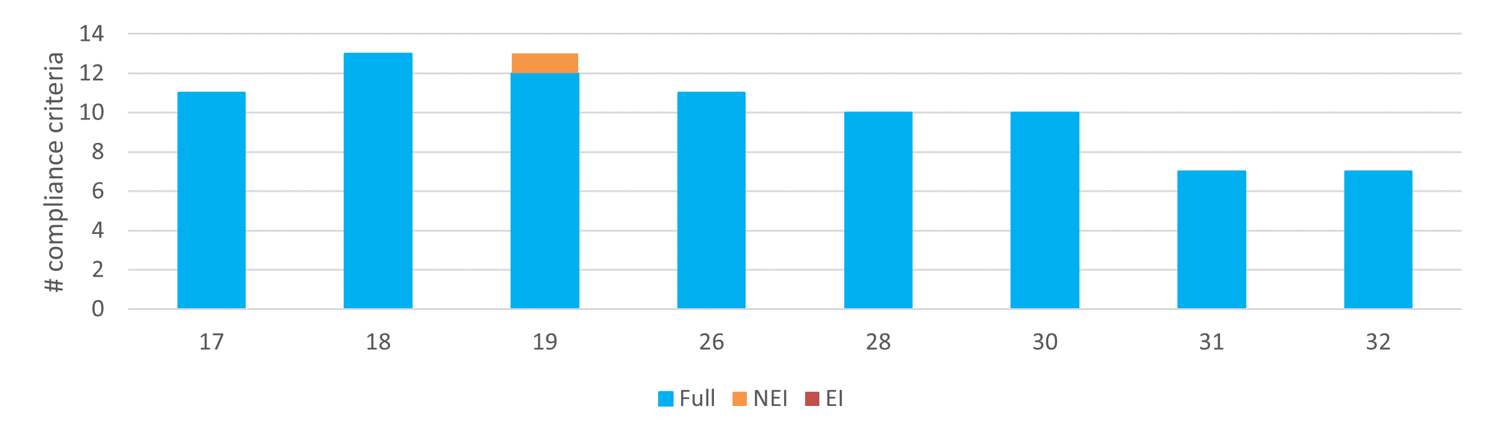
Level of conformance with audit criteria. Conformance definitions (Fully conforms [full], Non-conforming with no environmental impact [NEI], Non-conforming with environmental impact [EI]) as per Table 3-3. There were no non-conformances with potential environmental impact for fire salvage harvesting prescriptions.
Figure 5-3. Compliance findings for criteria applicable to fire salvage harvesting operations. The x-axis refers to the coupe numbers, as per Table 3-2.
This audit and the previous two have included 27 coupes harvested under fire salvage prescriptions. These have been distributed between the East Gippsland, North East and Tambo FMAs. Fire salvage coupes have included a variety of operations from re-harvesting of recent thinning coupes (in Silvertop Ash/Eucalyptus sieberi forests) to harvesting of only fire-killed ash species (in coupes with ash and mixed species vegetation communities) to (near) clearfall.
Table 5-4 summarises conformance findings for fire salvage prescriptions across the three audits. The level of full conformance with fire salvage prescriptions has varied over a narrow range, from 96% of applicable criteria in 2021 to 99% in the current audit.
The number of incidents detected with potential environmental impact was low in two of the three years in which fire salvage prescriptions were considered. However, there were seven such incidents in 2022, distributed across five of the 15 fire salvage coupes included in the audit that year. Four of the non-conformances related to excessive spacing between effective drainage structures on snig tracks (three incidents) or the in-coupe road (one incident). Two incidents related to waterway crossings and one incident involved harvesting in the planned riparian buffer.
While no conformances of these types were identified in the current audit, the audit team noted several instances where re-harvesting operations in earlier thinnings coupes could have used formal cross drainage structures on forwarding tracks to prevent movement of water and soil. In some sections of the forwarding tracks there were insufficient small stems and bark to provide full ground cover, which potentially enabled water to run along the tracks for distances of 20-30m before encountering and being intercepted by debris (Figure 5-4). The level of soil movement and the distance of water runs was insufficient for any non-conformance incident to be recorded.
Table 5-4. Summary of findings of 2021, 2022 and 2023 FAP audits in relation to conformance with fire salvage harvesting prescriptions
Audit year | # coupes | % full conformance | # EI incidents¹ | # non-conformances with potential environmental impact
 |  |  |  | Negligible | Minor | Moderate | Major | Severe
2021 | 4 | 98% | 1 | 1 | 0 | 0 | 0 | 0
2022 | 15 | 96% | 7 | 0 | 4 | 3 | 0 | 0
2023 | 8 | 99% | 0 | 0 | 0 | 0 | 0 | 0
Note:
- #EI incidents: number of incidents with actual or potential environmental impact
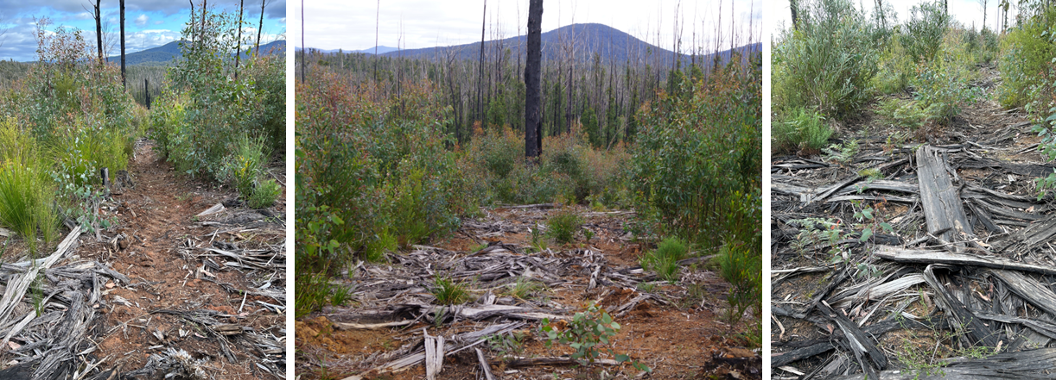
Low groundcover with potential for water to flow 20-30m along track | Moderate groundcover, with potential for water to flow 5-10m along forwarding track | Good groundcover with little potential for water flow along track
Figure 5-4. Examples of varying levels of logging slash cover along forwarding tracks in fire salvage operations in former thinnings coupes; coupe 32

Management of bark and harvesting debris
Regeneration burning has traditionally been used to manage bark and other forms of debris generated by harvesting activities in eastern Victoria. Exceptions to this have included post-fire salvage harvesting, thinning operations and some harvesting operations in Gippsland coastal and foothill forests. Regeneration burning is generally inappropriate in fire salvage coupes due to the damage it would inflict on the regenerating stand. Thinnings operations typically generate much less debris than end of rotation harvesting operations and much of this is used to construct corded forwarding tracks. The potential to damage to retained trees also typically precludes regeneration burning. Coastal and foothill forests in Gippsland often regenerate successfully without fire.
Increased use of habitat islands, particularly in tall, wet, eucalypt forests, as well as irregularly shaped harvest areas (e.g., in response to Leadbeaters Possum detections; e.g., Figure 5-5), can complicate regeneration burning. Based on several recent FAP audits, these and other factors appear to have contributed to incidents where regeneration burns scorch tree canopies in planned harvest exclusion areas or directly encroach on areas that were intended to remain free from harvesting disturbance.
While not using regeneration burning avoids non-conformances associated with its impacts on areas that were to remain undisturbed by harvesting activities, it has significantly diminished VicForests’ (and its contractors’) capacity to manage bark and other harvesting debris. Bark piles remain in coupes (either at the landing or along snig tracks) and harvesting debris (or slash) is typically pushed into rough heaps so that regeneration can occur in remaining areas where the soil has been disturbed. In this context, many coupes (e.g., Figure 4-18) are unable, practicably, to conform with MSP requirements (MSP 7.2.4.2) to limit slash and bark piles to no more than 4m² ground area and 10m³ total volume.
The origins of this prescription are unknown, and its appropriateness has been questioned in previous audits (e.g., Jacobs 2021; 2023), particularly for slash piles distributed through the coupe. DEECA’s Native Forest Silviculture Guideline 11 Management of landings, bark and extraction tracks (Poynter, 2004) includes prescriptions (from NRE, 2001) for the management of bark and logging debris, specifically:
- Bark must not be disposed of by piling along the edge of snig tracks. If bark is not required for matting, it is to be redistributed through the coupe by excavator, though it can initially be removed from the landing by skidder.
- Large slash accumulations, including bark, are to be avoided where possible to provide for an even burn. In-coupe bark piles must not exceed 4m³, and all piles of bark must be placed at least 10m from the coupe boundary.
These prescriptions were intended to contribute to the productivity of the regenerating stand by redistributing the nutrients contained in bark back across the coupe and reducing the area occupied by slowly decomposing debris. Poynter (2004) also advised that the formation and burning of large bark piles at landings should be avoided due to the potential damage caused to the underlying soil.
We have previously recommended that DEECA review and reconsider ground area and volumetric limits on bark and slash piles (currently 4m² and 10m³, respectively (Jacobs, 2023). Following Poynter’s (2004) guidance, redistribution of bark through the coupe is preferred to heaping, although release of nutrients and avoidance of site occupation with both approaches is at least partly dependent on subsequent burning. Similarly, avoiding the formation of large slash piles (significantly greater than the 10m³ prescribed by MSP 7.2.4.2) is preferred, but is almost unavoidable in the absence of regeneration burning. The status of the recommendation is unknown.
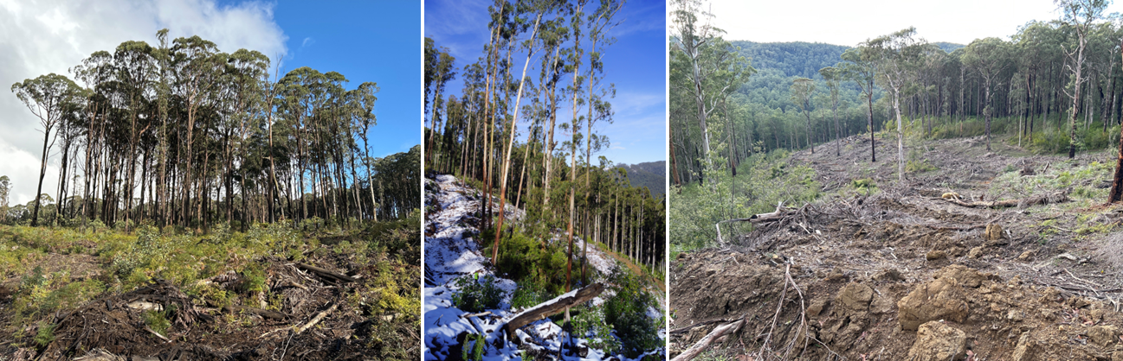
Retained habitat island, coupe 4 | Retained habitat island with narrow gap to coupe boundary, coupe 7 | Narrow harvesting corridor, coupe 14
Figure 5-5. Examples of settings in which it may be difficult to prevent unintended scorching of or encroachment of regeneration burns into retained habitat within or on the edge of timber harvesting coupes
The pervasiveness of this type of incident has, to an extent, affected overall audit results. Non-conforming bark and slash piles (to MSP 7.2.4.2) were observed in 19 of the 32 coupes included in the audit and hence accounted for that number of reported non-conformance incidents (about one third of the total). If this conformance element was removed from consideration, the average level of conformance for soils and non-road infrastructure (the two sub-themes for which this criterion was relevant) would increase from 88% to 90% and 89% to 91%, respectively. Overall average conformance would increase from 94% to 95%. The number of coupes with no incident with potential environmental impact would increase from four to seven coupes.
We reiterate our previous recommendation (D-02, Jacobs, 2023) to DEECA to reconsider the appropriateness of this prescription, particularly in light of reduced use of regeneration burning.

Potential improvements in coupe planning, harvesting and rehabilitation practice
The audit team’s thoughts on potential improvements in coupe planning, harvesting and rehabilitation have been documented thoroughly in previous FAP audit reports (e.g., Jacobs, 2018; 2019; 2020a; 2020b; 2021; 2023). With the planned cessation of timber harvesting in Victoria (under VicForests TRP) from 2024 and the current near absence of harvesting and related roading activity, there seems to be limited value in providing thoughts on potential improvements in the planning, conduct and rehabilitation of timber harvesting activities. In any case, no new issues were identified in the current audit.
However, there is merit in considering the practice improvement issues raised in our most recent FAP audit report (Jacobs, 2023) in the context of the current audit. Three that were highlighted in that report were also identified in the current audit as areas of non-conformance, namely:
- Waterway crossings: past FAP audits have consistently identified deficiencies in the design, construction, maintenance and/or rehabilitation of waterway crossings, both for in-coupe roads and snig tracks. While the number of coupes with crossings has fluctuated in recent audits (five of 32 coupes in this audit, 12 of 32 coupes in the 2022 audit and four of 30 coupes in the 2021 audit), there have consistently been a small number of non-conformance incidents with waterway crossings that were assessed as having moderate or major potential environmental impact. Two incidents (at coupe 31; Figure 4-8) with major potential environmental impact were detected in this audit.
Despite the persistent evidence of non-conformance in waterway crossing design and/or construction, the audit team have also observed some examples of good practice for both in-coupe road waterway crossings (e.g., Figure 4-14) and snig track crossings (e.g., Figure 5-6).
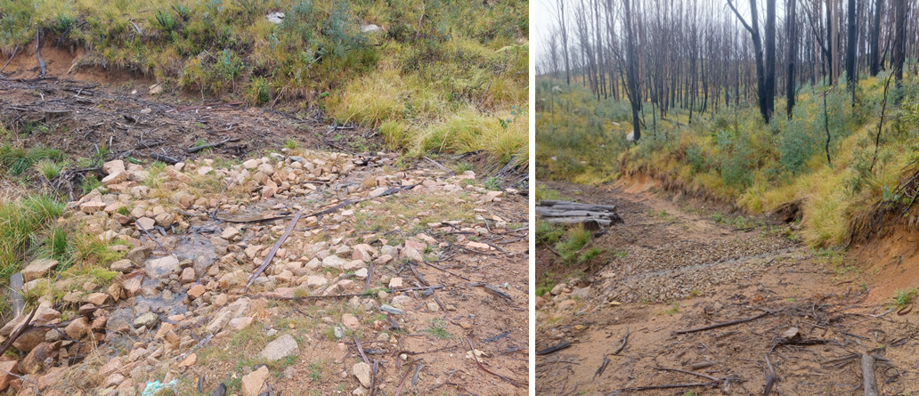
Examples of well rehabilitated snig track crossings, coupe 19. In both cases, rock rip rap has been used to stabilise the bed of the temporary stream crossing following (and possibly during) use and intercept any sediment movement.
Figure 5-6. Example of good practice in snig track waterway crossing, coupe 19
One aspect of waterway crossings that has not received attention in recent audits has been the rehabilitation of in-coupe road crossings. While snig track crossings have generally been rehabilitated at the time of audit, in-coupe road waterway crossings have typically still been in place and hence conformance with rehabilitation prescriptions has not been assessed. While VicForests staff continue to work with their contractors to finalise coupe regeneration and rehabilitation, there is an opportunity to review or audit in-coupe road waterway crossing rehabilitation effectiveness and target remedial activity if and where needed.
Recommendation D-01
That DEECA commission or undertake a review or audit to assess conformance of VicForests’ rehabilitation of in-coupe road waterway crossings with mandatory Code and MSP prescriptions and identify remedial works required to address any on-going sediment delivery into permanent or temporary streams.
- In-coupe road and snig track drainage: failure to fully conform with MSP or UP prescriptions for drainage spacings on in-coupe roads and snig or boundary tracks, respectively, has been a persistent finding of previous FAP audits. Non-conforming in-coupe road drainage was identified for three coupes in the current audit (down from four coupes in 2022; Table 5-2). Potential environmental impact in each case was negligible, which reflected that the cumulative excess in spacing between effective drainage structures (over MSP requirements) was relatively small in each case.
Non-conforming snig/boundary track drainage was identified in 13 coupes in this audit, compared with eight coupes in 2022. The maximum potential environmental impact associated with these was moderate (in three coupes), which reflected a large cumulative difference in snig/boundary track drainage spacing from prescriptions in VicForests’ UPs.
- Snig tracks and traffic through wet areas: the 2022 FAP audit observed several instances where snig tracks were constructed through naturally wet areas in coupes. While these areas were reportedly dry at the time of construction (Jacobs, 2023) they subsequently became wet, and some soil disturbance and sediment movement ensued. Somewhat similar kinds of issues were observed in the current audit, where snig tracks were routed through drainage depressions (that were not drainage lines according to Code definitions), other areas in the coupe that were wet and/or prone to soil disturbance (e.g., Figure 4-7, Figure 5-2). Subsequent traffic resulted in rutting, soil compaction and/or sediment movement along the track (also see Figure 5-7). While none of the issues had more than minor potential environmental impact, they suggest insufficient awareness of soil properties and their sensitivity to disturbance when wet and/or insufficient attention to the protection of soil conditions within the coupe.

Potential improvements to the regulatory framework for timber harvesting
Previous reports from this audit team have made recommendations on potential improvements in the regulatory framework for timber harvesting provided by the Code and MSPs (especially Jacobs, 2021). There were no issues encountered in the current audit that give rise to additional recommendations to those made in that audit report or the recommendation in our 2022 FAP report (Jacobs, 2023) that specific and more tailored prescriptions for snig track waterway crossing be developed. As noted in the 2022 FAP report and observed in this audit, in-coupe road waterway crossings do not provide a particularly useful model for the design of snig track crossing drainage and should not form the basis of assessing the appropriateness of snig track crossing design and construction.

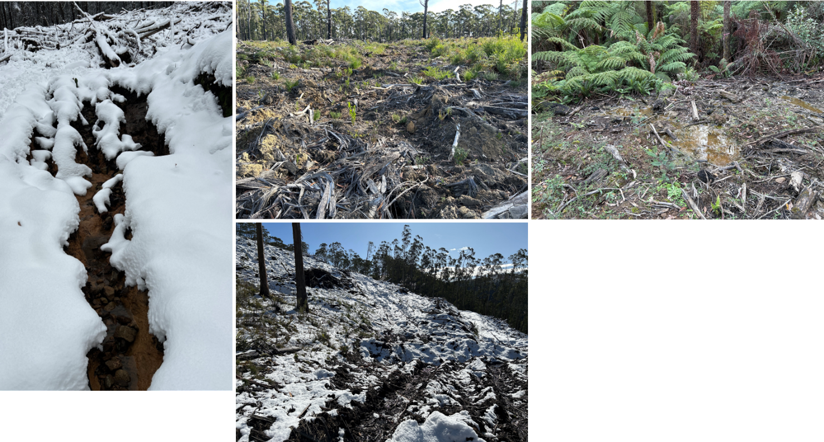
Left: coupe 6, drainage from snig track to landing has exposed dispersive soils, leading to soil erosion. Centre top: coupe 27, snig track constructed through drainage depression, with traffic causing rutting. Centre bottom: coupe 11, track from rough-heaping operation through drainage depression, leading to soil disturbance and rutting. Right: coupe 13, boundary track through drainage line, with soil disturbance and some sediment movement.
Figure 5-7. Examples where snig or boundary tracks have been constructed through wet areas or other areas with dispersive soils, leading to erosion, soil compaction, rutting and/or soil movement.

Audit target selection
Discrepancies between the information provided by VicForests to support selection of target coupes for the audit and actual coupe conditions have been a common point of discussion in previous FAP audit reports. The main issues have been in relation to the presence of waterway crossings and length of in-coupe road present. Typically, coupes that were initially planned (in VicForests tactical planning) to have waterway crossings were configured so that no crossings were required and many of the coupes that were proposed to have long lengths of in-coupe road ultimately did not. As this implies coupes that were planned to have higher risk features were developed in ways that presented lower environmental risk. While this is likely a good outcome from a sustainable forest management perspective, it dilutes the focus in audit target selection on higher risk coupes.
Coupes with waterway crossings and very long lengths of in-coupe roads are uncommon and it is typically the case that all known and available coupes with these characteristics are selected for audit. Provided there are no unreported coupes with waterway crossings or very long lengths of in-coupe road (i.e., tactical planning did not suggest these were required, but the operation was set up in a way that required one, the other or both), this does not detract from the audit.

Conclusions and recommendation

Conclusions
The objectives of the FAP are to assess the conformance of VicForests’ timber harvesting operations with the regulatory framework for timber harvesting activities in State forests provided by the Code and MSPs. The FAP also assesses environmental risks associated with any identified non-conformances. The 2023 FAP was based on field inspections of 32 timber harvesting coupes distributed across the Central Highlands, East Gippsland, Gippsland and North East RFA regions. It addressed Code and MSP mandatory compliance elements relating to four themes:
- Protection of soil, water and river health values
- Conservation of biodiversity
- Operational planning and record-keeping
- Coupe infrastructure for timber harvesting operations.
As in previous FAP audits, selection of coupes was risk-based, meaning that audit findings are not necessarily statistically representative of VicForests’ operations overall.

Overall conformance findings
A total of 179 compliance criteria were identified from Code and related MSP prescriptions included within the audit scope. The applicability of and conformance with these criteria was assessed for each of the 32 selected coupes during site inspections undertaken in May and June 2023.
The overall level of full conformance with applicable audit criteria across the 32 coupes ranged between 79% and 100%, with the average being 94%. Non-conformance incidents in 28 of the 32 coupes included in the audit were assessed to have potential for environmental impact. There was an average of 1.7 such incidents per coupe, with as many as four incidents recorded in several coupes. The assessed level of potential environmental impact associated with these incidents ranged between negligible and major, with minor being the most common rating. There were no severe rated incidents.
Although the risk-based rather than random sampling approach taken for the audit means that results are not directly comparable across years, the consistency of audit teams and methodology means that cross-year comparisons are not inappropriate. Comparisons of the overall audit results show that the average level of full conformance is slightly less than in 2022 (94% compared with 96%) and that non-conformance incidents with potential environmental impact were observed in more coupes than in the previous audit (28 coupes compared with 20 in 2022). However, the most common level of potential environmental impact was minor, compared with moderate in the 2022 FAP audit. Three incidents with major potential environmental impact were detected in both audits.

Findings against conformance themes

Protection of soil, water and river health values
Environment-themed audit criteria were grouped into two sub-themes focusing on soil and water values. The main findings for each sub-theme were:
- Protection of forest soils: the level of full conformance with applicable criteria ranged between 64% and 100%, with an average of 88%. Non-conformance incidents at 28 coupes were assessed to have up to moderate potential environmental impact. The main types of incident contributing to higher potential environmental impact non-conformances related to snig and boundary track drainage and soil disturbance associated with snig track crossings. The most common type of incident with potential implications for soil values was the presence of large bark and debris piles (exceeding MSP limits for ground area and/or volume), an issue that was observed at 19 coupes.
- Protection of water flows, water quality and river health: the level of full conformance with applicable criteria ranged between 64% and 100%, with an average of 93%. Non-conformance incidents at 16 coupes were assessed to have up to major potential environmental impact. The two water-related incidents with major potential environmental impact related to two aspects of defective waterway crossing design and construction on a single crossing.

Conservation of biodiversity
The average level of full conformance with applicable biodiversity conservation criteria was 98%, with the range being 87-100%. Non-conformance incidents with potential environmental impact were observed in six coupes, with two incidents (in one coupe) assessed to have a major potential environmental impact on aquatic biodiversity values. Both of these incidents related to the same in-coupe road waterway crossing.

Operational planning and record keeping
The average level of full conformance with applicable criteria was 97%, with the level for individual coupes ranging between 86% and 100%. Non-conformance incidents with potential environmental impact were observed at six coupes. Incidents with major potential environmental impact were observed at two of these coupes. One was linked to the failure to plan for a fish ladder to accompany an in-coupe road crossing with a culvert more than 750mm in diameter. The other incident was linked to coupe planning not being properly executed, in that a harvesting machine entered (within minimal disturbance) an SPZ.

Coupe infrastructure for harvesting operations
Infrastructure-themed audit criteria were grouped into five sub-themes focusing on planning for, design, construction, maintenance of in-coupe roads, as well as placement and construction of non-road coupe infrastructure such as landings and snig or boundary tracks. The main findings for each sub-theme were:
- Road planning: the level of full conformance with applicable criteria ranged between 71% and 100%, with the average being 95%. Non-conformance incidents with potential environmental impact were observed at two coupes. An incident at one coupe was assessed to have a major potential environmental impact. This related to not planning to construct a fish ladder at a waterway crossing that used a culvert that was greater than 750mm in diameter.
- Road design: the level of full conformance with applicable criteria ranged between 40% and 100%, with the average being 95%. Non-conformance incidents with potential environmental impact were observed at three coupes. An incident at one coupe was assessed to have a major potential environmental impact. This related to the failure to plan or design the crossing with a fish ladder to accompany the greater than 750mm diameter culvert.
- Road construction: the average level of full conformance with applicable criteria was 98%, with the level of conformance ranging between 77% and 100%. Non-conformance incidents with potential environmental impact were observed at four coupes. An incident at one coupe was assessed to have major potential environmental impact. This related to the downstream outlet of the culvert being elevated above the bed of the permanent stream and so posing a barrier to aquatic fauna movement.
- Road maintenance and closure: the average level of full conformance with applicable criteria was 97%, with the level of full compliance ranging between 67% and 100%. None of the non-conformance issues for this sub-theme had a direct potential environmental impact.
- Non-road coupe infrastructure: the average level of full conformance with applicable criteria was 89%, with the level of full conformance ranging between 64% and 100%. Non-conformance incidents with potential environmental impact were observed at 26 coupes, with the highest level of potential environmental impact being moderate. The most common incident type relating to the presence of large piles of bark and other logging debris withing the coupe.

Fire salvage harvesting
Eight coupes that were burnt in the 2019-20 bushfires and harvested under fire salvage prescriptions were included in this year’s audit. The average level of full conformance with fire salvage prescriptions in these eight coupes was 99%, with no non-conformances identified with potential environmental impact. This is a noticeable improvement on the 2022 audit, in which the average level of full conformance with fire salvage prescriptions was 96% and there were seven incidents (across five coupes) with potential environmental impact.

Management of bark and harvesting debris
Regeneration burning has traditionally been used to manage bark and other forms of debris generated by harvesting activities in native forests in eastern Victoria. However, few of the coupes included in this year’s audit have been subject to regeneration burning. While in this year’s audit this resulted in no observed incidents of regeneration burn incursion into areas that were planned to be excluded from timber harvesting activities, it has contributed to a large increase in the number of incidents where bark and debris piles exceeded the limits for basal area (4m²) and volume (10m³) set in the MSPs (five in 2022, 19 in 2023).
The pervasiveness of the incident type has influenced overall conformance levels reported for the two relevant audit sub-themes (soils, non-road infrastructure), The 19 recorded incidents of this type accounted for about one third of total incidents observed in the current audit. However, it is not clear what the basis is for the specific limits on bark and debris pile size or whether they can be practicably achieved (at least for debris piles and wet forest types) in the absence of regeneration burning.

Recommendation
The Victorian Government has announced that timber harvesting in State forests will end by 1 January 2024. Given this context, the wide scope of previous recommendations made by this audit team (many of which would be relevant if native forest timber harvesting were to continue in State forests) and that the 2023 FAP audit did not identify any significant new issues, we have made only one new recommendation. That recommendation is to DEECA and is as follows:
Recommendation D-01
That DEECA commission or undertake a review or audit to assess conformance of VicForests’ rehabilitation of in-coupe road waterway crossings with mandatory Code and MSP prescriptions and identify remedial works required to address any on-going sediment delivery into permanent or temporary streams. | Rationale:  Recent FAP audits have been targeted towards coupes that were active in the previous financial year. Due to the often-long timeframe between cessation of harvesting and confirmation that a coupe is regenerated, few in-coupe road waterway crossings have been rehabilitated at the time of audit. While this and recent audits have considered the planning, design and construction of waterway crossings, they have not considered rehabilitation.  Since VicForests will continue with regeneration and coupe rehabilitation activities following the cessation of timber harvesting, the opportunity exists to review/audit waterway crossing rehabilitation and, if necessary, undertake remedial works on any inadequately rehabilitated crossings.

References
DELWP 2021a. Code of practice for timber production 2014 (as amended November 2021). DELWP.
DELWP 2021b. Management standards and procedures for timber harvesting operations in Victoria’s State forests 2021. DELWP.
Department of Sustainability and Environment [DSE] 2006. Sustainability charter for Victoria’s State forests. DSE.
Jacobs 2018. Audit of timber harvesting and forest regeneration in State forests in eastern Victoria. Report on the 2016-17 Forest Audit Program. IS206000-P2-001. Report to DELWP. April 2018.
Jacobs 2019. Audit of timber harvesting operations in Victoria’s State forests. Report on the 2017-18 Forest Audit Program. IS247800-RP-002. Report to DELWP. July 2019.
Jacobs 2020a. Audit of timber harvesting operations in Victoria’s State forests. Report of the 2018-19 Forest Audit Program. IS284400-RP-002. Report to DELWP. February 2020.
Jacobs 2020b. Audit of timber harvesting operations in Victoria’s State forests. Report of the 2019-20 Forest Audit Program 2019-20. IS326300-03. Report to DELWP. October 2020.
Jacobs 2021. Audit of timber harvesting operations in Victoria’s State forests. Report of the 2020-21 Forest Audit Program. IS37900-03. Report to DELWP. December 2021.
Jacobs 2023. Audit of timber harvesting operations in Victoria’s State forests: Report of the 2022 Forest Audit Program. IS427600-03. Report to DEECA. March 2023.
NRE 2001. Utilisation Procedures for all commercial harvesting in State forests in Victoria. Department of Natural Resources and Environment, Victoria.
Poynter M 2004. Management of landings, bark and extraction tracks. Native forest silviculture guideline No. 11. Department of Sustainability and Environment, Victoria.
VicForests 2018. Utilisation procedures for all commercial harvesting and haulage managed by VicForests. VicForests.

Spatial data sources:
- Victorian government: www.data.vic.gov.au
- ESRI

Audit compliance elements
Regulatory compliance elements considered in this audit are included in Table A-1. They were drawn from the Code and MSPs. Code compliance elements were selected by DEECA’s Timber Harvesting Compliance Unit. Supporting compliance elements from the MSPs were selected by the audit team.
Compliance criteria (stated as a question) were developed by the audit team to enable assessments of conformance with each element of the regulatory framework. Criteria mostly refer to individual MSP compliance elements, although they do, in some cases refer to relevant overarching Code requirements.
Table A-1. FAP 2023 audit criteria and related regulatory compliance elements
Source¹ | Criteria # | Code compliance elements and audit compliance questions | Theme² | % full³
C |  | 2.2 Environmental Values in State forests
C |  | 2.2.1 Water Quality, River Health and Soil Protection
C |  | 2.2.1.1 Planning and management of timber harvesting operations must comply with relevant water quality, river health and soil protection measures specified within the Management Standards and Procedures.
M |  | 3.1.1.1 Use the following categories when determining buffer (B) and filter (F) widths for waterways within and immediately adjacent to each coupe. Aids to the identification of each class of waterway are provided in the Code Glossary. (a) Permanent streams, pools and wetlands. (b) Temporary streams. c) Drainage lines.
 | 1.01 | Have the categories prescribed in the MSPs been used in classifying waterways present on the coupe? | W, P | 100%
 | 1.02 | Are the classification assessed to have been applied correctly? | W, P | 97%
M |  | 3.2.1.1 Conduct field assessments to determine the soil erosion hazard and soil permeability classifications for an area proposed for any soil disturbing timber harvesting operations as follows (3.2.1.2-3.2.1.11, Table 8).
 | 2.01 | Has soil erosion hazard and soil permeability been assessed using the method prescribed in the MSPs? | S, P | 100%
 | 2.02 | Has the methodology been followed correctly? | S, P | 100%
M |  | 3.2.1.2 Collect soil profile samples that reflect the variety of soils represented within the coupe.
 | 2.03 | If there are significant changes in soil and/or vegetation types within the coupe, ITAO have an adequate number of soil profile samples been taken to assess soil erosion hazard for the coupe? | S, P | 91%
M |  | 3.3.1.1 Apply appropriate protection to class of waterway as outlined in MSP Table 9.
 | 3.01 | If applicable, have the buffer and filter strip widths prescribed in MSP Table 9 been applied to the coupe? | W, P | 96%
 | 3.02 | In applicable Spotted Tree Frog, Barred or Mountain Galaxia catchments, have the protections from MSP Table 10 been applied? | W, B, P | 100%
M |  | 3.4.1.1 Exclude timber harvesting operations from slopes over 30 degrees.
M |  | 3.4.1.2 Exclude timber harvesting operations from slopes over 25° in the East Gippsland FMA in areas with granite-based soils.
M |  | 3.4.1.3 Up to 10% of the planned net coupe area can contain areas greater than the slope limits referred to in 3.4.1.1, 3.4.1.2, 3.5.1.1 and Table 11 Water supply protection areas, where the risk of mass soil movement has been managed accordingly.
 | 4.01 | Has timber harvesting been excluded from areas with slopes >30°/25° (unless the area exceeding the slope limit is ≤10% net harvest area and ITAO the risk of mass soil movement has been managed accordingly)? | S, W, P | 100%
M |  | 3.5.1.1 Apply the slope limits, seasonal closures, buffer and filter strip widths and other relevant management actions specified in MSP Table 11 (Water supply protection areas) for timber harvesting operations and associated roading and regeneration in water supply protection areas.
M |  | 3.5.1.2 Refer to Table 11 Water supply protection areas for actions that apply to water supply protection area SMZs in the Benalla-Mansfield FMA, the East Gippsland FMA and Midlands FMA.
M |  | 3.5.1.3 Where any proposed timber harvesting operations are not in accordance with clauses 3.5.1.1 or 3.5.1.2, obtain exemption approval from the Minister or delegate in accordance with Section 1.4.
M |  | 3.5.1.4 Special water supply catchment areas and water supply protection areas not listed in Table 11 Water supply protection areas do not require protection in addition to existing Code requirements.
M |  | 3.5.1.5 In addition to Appendix 3 Table 11 (Water supply protection areas), in the Bunyip, Thomson and Tarago special water supply catchments and the Yarra Tributaries State forests the area harvested must not exceed the following limits measured as a rolling average: (a) Thomson ‐ Ash forests 150 ha/year, Mixed species forests 15ha/year; (b) Tarago ‐ Ash forests 55 ha/year, Mixed species forests 23ha/year; (c) Yarra Tributaries – Ash forest 52 ha/year, Mixed species forests 15 ha/year; and (d) Bunyip – Ash forest 15 ha/year, Mixed species forests 15 ha/year.
M |  | 3.5.1.7 In addition to Table 11 Water supply protection areas, in the Rocky and Betka River catchments in the East Gippsland FMA, no new road crossings may be built on major streams.
 | 5.01 | Does the FCP correctly note that the coupe is or is not located in a water supply catchment? | W, P | 100%
 | 5.02 | For relevant couples located in WSPA/DWSC, have the applicable slope limits, seasonal closures, buffer and filter strip widths and other relevant management actions specified in Table 11 been correctly applied on the coupe? | S, W, P | 100%
 | 5.03 | For relevant couples located in WSPA/DWSC, are the applicable stream buffers correctly applied on the coupe? | W, P | 100%
 | 5.04 | For relevant couples located in WSPA/DWSC, are the applicable maximum annual areas harvested noted in the FCP and correctly applied on the coupe? | W, P | 83%
 | 5.05 | For relevant couples located in WSPA/DWSC, if timber harvesting operations are not conducted in accordance with the relevant MSP prescriptions, has Ministerial approval been obtained in accordance with MSP section 1.5 and Appendix 1 prior to harvesting commencing? | P | n/a⁴
C |  | 2.2.1.2 Management actions to protect waterways, river health and soil must be appropriate to the waterway class, soil category, and potential water quality risk posed by timber harvesting operations at each site.
C |  | 2.2.1.3 Additional measures to protect water quality and aquatic habitat (including widening buffers or filter strips) must be adopted within coupes where there is a high local risk due to: i. local topography; ii. the intensity and magnitude of the timber harvesting operation; iii. events such as wildfire that reduce the effectiveness of protection measures; or iv. the location of the timber harvesting operation in a declared Special Water Supply Catchment or any other water supply protection area.
 | 6.01 | ITAO is there evidence from the coupe which suggests that management actions to protect waterways, river health and soil have not been appropriate to protect waterways, river health and soil? | S, W, B, C, M, I, P | 69%
 | 6.02 | If ITAO additional measures were required to protect water quality and aquatic habitat due to local risk factors, were any undertaken? | S, W, B, C, M, I | 100%
 | 6.03 | Where ITAO additional measures were required and undertaken, were they effective in protect water quality and aquatic habitat | S, W, B, C, M, I | 78%
C |  | 2.2.1.5 Where practical exclude roads and snig tracks from aquatic and riparian habitats.
C |  | 2.2.1.6 Where crossings are required, minimise the extent of habitat damage, constriction to stream flow and barriers to fish and other aquatic fauna.
C |  | 2.2.1.7 Remove temporary crossings immediately after harvesting or any subsequent regeneration work is complete using a technique that minimises soil and habitat disturbance.
C |  | 2.2.1.8 Use drainage, artificial structures, buffers and filters of effective width to slow and disperse surface flows and deposit sediment before reaching waterways.
C |  | 2.2.1.12 Design, construct and maintain roads, crossings, coupe infrastructure and drainage structures to withstand foreseeable rainfall events and traffic conditions and protect water quality.
 | 7.01 | If roads and snig tracks have not been excluded from aquatic and riparian habitats, ITAO was it reasonably practicable to have done so? | W, B, RP, C, I, P | 89%
 | 7.02 | For coupes with road and/or snig track waterway crossings, ITAO did the crossing minimise the extent of habitat damage and, where relevant, constriction to stream flow and/or barriers to fish and other aquatic fauna? | W, B, RP, D, C, I, P | 71%
 | 7.03 | ITAO has the crossing been removed as soon as reasonably practicable following harvesting or regeneration work? | M, I | 60%
 | 7.04 | ITAO has removal of the crossing been undertaken in a manner that has minimised soil and habitat disturbance? | S, W, B, M, I | 50%
 | 7.05 | ITAO have drainage, artificial structures, buffers and filters of effective width been appropriately used to try to slow and disperse surface flows and deposit sediment before reaching waterways? | S, W, RP, D, C, M, I | 80%
 | 7.06 | Have the measures put in place to slow and disperse surface flows and deposit sediment before reaching waterways been effective? | W, RP, D, C, M, I | 83%
C |  | 2.2.1.14 Minimise potential for soil erosion or mass movement by planning and using operational methods and restrictions appropriate to the assessed soil erosion risk and slope.
C |  | 2.2.1.15 Locate coupe infrastructure and roads to minimise soil erosion and degradation.
C |  | 2.2.1.16 Use appropriate equipment, harvesting techniques and operational management to minimise soil rutting, mixing or compaction
C |  | 2.2.1.18 Employ topsoil conservation techniques in timber harvesting areas affected by coupe infrastructure and roads.
 | 8.01 | ITAO have planning (including locating coupe infrastructure and roads), and operations methods applied on the coupe been appropriate for the assessed soil erosion risk and slope? | S, W, RP, D, C, M, I, P | 78%
 | 8.02 | Is there evidence within the coupe of soil erosion or mass movement resulting from harvesting operations, including from roading, snig tracks and/or landings? | S, C, M, I | 84%
 | 8.03 | Is there evidence within the coupe of soil rutting, mixing or compaction resulting from harvesting operations? | S, I | 90%
 | 8.04 | ITAO has topsoil conservation been used as appropriate in areas affected by coupe infrastructure and/or roads? | S, I | 100%
C |  | 2.2.2 Conservation of Biodiversity
C |  | 2.2.2.1 Planning and management of timber harvesting operations must comply with relevant biodiversity conservation measures specified within the Management Standards and Procedures.
C |  | 2.2.2.2 The precautionary principle must be applied to the conservation of biodiversity values. The application of the precautionary principle will be consistent with relevant monitoring and research that has improved the understanding of the effects of forest management on forest ecology and conservation values.
C |  | 2.2.2.4 During planning identify biodiversity values listed in the Management Standards and Procedures prior to roading, harvesting, tending and regeneration. Address risks to these values through management actions consistent with the Management Standards and Procedures such as appropriate location of coupe infrastructure, buffers, exclusion areas, modified harvest timing, modified silvicultural techniques or retention of specific structural attributes.
 | 9.01 | Is there evidence from the FCP and coupe planning process of attempts to identify biodiversity values listed in the MSPs within or near the coupe by survey and/or habitat modelling? | B, P | 100%
 | 9.02 | Where listed biodiversity values are present or identified by habitat modelling, is there evidence that risks to these values from timber harvesting operations have been assessed? | B, P | 100%
 | 9.03 | Where listed biodiversity values are present or identified by habitat modelling, have management actions applied on the coupe to protect those values been consistent with MSP prescriptions. | B, P | 100%
 | 9.04 | Where listed biodiversity values are present or identified by habitat modelling, have management actions been consistent ITAO with the risk of serious or irreversible environmental damage? | B, P | 100%
 |  | MSP4.1 Habitat retention
C |  | 2.2.2.10 Retain and protect habitat trees or habitat patches and long-lived understorey species to provide for the continuity and replacement of old hollow-bearing trees and existing vegetation types within each coupe.
M |  | 4.1.1.1 Retain habitat trees in accordance with the FMA summary provided in Table 12 (Habitat tree prescriptions).
M |  | 4.1.1.2 Trees in buffers or other exclusion areas that have been extended beyond minimum required widths can contribute to habitat tree retention requirements.
M |  | 4.1.1.3 Retain all living large trees and protect them from the direct effects of timber harvesting operations and regeneration burning. This includes not deliberately felling, falling into or damaging large trees during harvesting and extraction, and ensuring slash is not accumulated within 3m of the base of large trees immediately prior to regeneration burns.
M |  | 4.1.1.4 Where possible, incorporate large trees in retained patches of habitat trees or expanded buffers or exclusion areas.
 | 10.01 | Have the required number of habitat trees been retained on the coupe (as per MSP Table 12) - including in areas where buffers and other exclusion areas extended beyond the minimum required widths? | B | 100%
 | 10.02 | Have habitat patches of long-lived understorey species been retained to represent existing vegetation types within the coupe? | B | 100%
 | 10.03 | Have all large (≥2.5m) living trees been retained and protected from direct effects of timber harvesting operations and regeneration burning? This includes not having accumulating slash within 3m of the base of large trees prior to regeneration burns | B | 100%
 | 10.04 | Where reasonably practicable (ITAO) have large trees been incorporated into retain habitat patches, buffers or exclusion areas> | B, P | 100%
 |  | MSP 4.1.2 Benalla/Mansfield and North East FMA
M |  | 4.1.2.1 When selecting habitat trees, prioritise live hollow-bearing trees where they are present and trees of younger age classes that are likely to develop hollows in the longer term.
M |  | 4.1.2.2 Where possible retain dead trees for habitat trees.
M |  | 4.1.2.3 Retain habitat trees adjacent to areas of high value habitat and areas most easily protected from damage during harvesting and regeneration operations.
M |  | 4.1.2.4 Habitat trees may be retained in groups/patches dispersed across the coupe.
M |  | 4.1.2.5 Seed trees may be counted as habitat trees.
 | 10.05 | In North-East FMA, is there evidence of that live hollow-bearing trees and dead trees have been prioritised for retention as per MSP 4.1.2.1/2? | B, P | 100%
 | 10.06 | In North-East FMA, are retained habitat trees generally located adjacent to areas of high value habitat that are most easily protected from damage during harvesting and regeneration? | B, P | 100%
 |  | MSP4.1.4 Central Highlands FMAs
M |  | 4.1.4.1 In Central Highlands FMAs, when selecting habitat trees, prioritise hollow‐bearing trees where they are present and trees most likely to develop hollows in the short term.
M |  | 4.1.4.2 Scatter habitat trees across the timber harvesting coupe in mixed‐species forest.
M |  | 4.1.4.3 Where possible, retain potential hollow‐bearing ash eucalypts in clumps to increase their protection from exposure, windthrow and fire.
M |  | 4.1.4.4 No gap between retained vegetation is to be greater than 150 m.
M |  | 4.1.4.5 Retain habitat trees where they can be most easily protected from damage during harvesting and site preparation treatment.
 | 10.07 | Based on evidence from the coupe and ITAO, have hollow-bearing or potential hollow-bearing trees, where present, been prioritised for habitat retention | B, P | 100%
 | 10.08 | In mixed species forests, if there are retained habitat trees, have they been scattered evenly across the coupe? | B, P | 100%
 | 10.09 | If present, have hollow bearing ash eucalypts been retained in clumps. | B, P | 100%
 | 10.10 | Are gaps between retained vegetation ≤ 150 m? | B, P | 100%
 | 10.11 | ITAO, are any retained habitat trees located where they can most easily be protected from damage during harvesting and site preparation treatment? | B, P | 100%
 | 10.12 | Is there evidence of damage to retained vegetation from harvesting or regeneration? | B | 100%
 |  | MSP4.1.5 East Gippsland and Gippsland FMAs
M |  | 4.1.5.1 When selecting habitat trees, prioritise old living trees with a range of hollow sizes. Where these are absent or not present in sufficient numbers, prioritise trees that are old enough to develop hollows during the next 50 years.
M |  | 4.1.5.2 Stags and younger, smaller trees may be counted as habitat trees if trees of the type described in 3.1.5.1 are absent or not present in sufficient numbers.
M |  | 4.1.5.3 Where possible, retain habitat trees in small clusters which include younger regrowth and understorey.
M |  | 4.1.5.4 Distribute habitat tree clusters across the coupe with consideration of the proximity of other retained vegetation.
 | 10.13 | Is there evidence that selection of habitat trees has prioritised living trees with a range of hollow sizes, where present, or trees that are old enough to develop hollows during the next 50 years. | B, P | 100%
 | 10.14 | Have habitat trees been retained in small clusters that include younger regrowth and understorey (where ITAO this is reasonably practicable)? | B, P | 100%
 | 10.15 | Have habitat tree clusters been distributed across the coupe, with (ITAO) apparent consideration of the proximity of other retained habitat? | B, P | 100%
 |  | MSP 4.2 Fauna and flora: 4.2.1 Detection-based management
M |  | 4.2.1.1 Detection based management obligations apply in any area that may be affected by current or planned timber harvesting operations, and in any area in which an obligation may affect the conduct of such timber harvesting operations (for example, if a protection area would include an area within which timber harvesting operations are proposed).
M |  | 4.2.1.2 If evidence of the presence of a value listed in Table 13 Rare or threatened fauna and invertebrate prescriptions or Table 14 Rare or threatened flora prescriptions is identified, the managing authority must: a) notify the Secretary, providing details (including spatial information) of evidence and the value location; and b) unless the Secretary otherwise approves, take appropriate steps to verify evidence of the presence of the value.  Note: The Secretary may otherwise approve if the Secretary intends to take steps to verify the existence of the value.
M |  | 4.2.1.3 If evidence of the presence of a value listed in Table 13 Rare or threatened fauna and invertebrate prescriptions or Table 14 Rare or threatened flora prescriptions is verified, apply and undertake any associated management action specified in the Table
M |  | 4.2.1.4 If a management action or other mandatory action includes a requirement to apply a protection area or a management area, the managing authority must (in addition to any other action): a) Provide information to the Secretary about the extent and boundary of the area proposed to be delineated as a protection area or management area; b) Follow any input or direction of the Secretary about the extent and boundary of the area (which must not be inconsistent with the Code or these Management Standards and Procedures); c) Delineate the boundary of the protection area or the management area in any applicable Forest Coupe Plan (consistently with the applicable requirement and any input or direction from the Secretary), including by updating the Forest Coupe Plan as the case requires; and d)
M |  | 4.2.1.5 In any management area that is required to be applied by these Management Standards and Procedures, the managing authority must (in addition to any other action): a) consult with the Secretary about proposed measures to ensure the persistence of a value across the management area; and b) ensure sufficient practical measures are undertaken to ensure the persistence of a value across the management area.
M |  | 4.2.1.6 The managing authority must comply with the requirements of clause 4.2.1.2, 4.2.1.3, 4.2.1.4 and 4.2.1.5, either: a) prior to the commencement of timber harvesting operations; or b) if a requirement only arises after timber harvesting operations have commenced, as soon as possible after the requirement arises.
 | 11.01 | If a listed flora or fauna value is identified and verified within or adjacent to the coupe, have the prescribed protection measures (from MSP Tables 13 and 14) been put in place? | B, P | 100%
 | 11.02 | If the management action for the threatened flora or fauna value requires application of a protection area or management area, has the boundary of the management area been delineated in the FCP? | B, RP, C, P | 100%
 | 11.03 | Is there evidence of consultation with the Secretary regarding the proposed measures to be applied to ensure the persistence of the value across the management area? | B, P | 100%
 | 11.04 | Have the agreed management measures been carried out? | P | 100%
 |  | MSP 4.3 Vegetation communities
 |  | MSP 4.4.1 Box-Ironbark
M |  | 4.4.1.1 In the Gippsland FMAs exclude selective harvesting from Box Ironbark forests typically containing Forest Red Gum (Eucalyptus tereticornis), Yellow Box (Eucalyptus melliodora), Coast Grey Box (Eucalyptus bosistoana) and Red Ironbark (Eucalyptus tricarpa). Silvicultural practices that promote regeneration of these species is permitted.
M |  | 4.4.1.2 In the East Gippsland FMA exclude selective harvesting from Box Ironbark forests typically containing Red Ironbark (Eucalyptus tricarpa), Gippsland Grey Box (Eucalyptus bosistoana), Red Box (Eucalyptus polyanthemos), Blue Box (Eucalyptus baueriana) and Yellow Stringybark (Eucalyptus muelleriana). The use of seed‐tree regeneration systems is permitted to restore the original species mix when combined with: a) cutting stumps of desired species to a maximum height of 30 cm, to encourage coppice growth; b) supplementary planting and sowing where necessary; c) removing unproductive trees of the less-preferred species to remove overwood competition; and d) thinning of advanced regrowth
 | 12.01 | In Gippsland FMAs, has selective harvesting been excluded from Box-Ironbark forests, as per MSP 4.4.1.1/2? | B, P | n/a
 |  | MSP 4.3.2 Heathland
M |  | 4.3.2.1 Avoid road construction across areas of heathland or within 40 m of heathlands unless no reasonable alternative exists.
M |  | 4.3.2.2 In the Gippsland FMAs, exclude Wet Heathland, Clay Heathland and Riparian Scrub Mosaic EVCs from harvesting. Protect these heathland EVCs with a 40 m buffer.
M |  | 4.3.2.3 In the East Gippsland FMA and Otway FMA where evidence of heathland is found in the field and it isn’t already classified as SPZ, apply a protection area prior to commencement of the timber harvesting operation consistent with management actions listed in Table 15 Detection based rules for Heathland, Snow Gum, Swamp Gum and Heath vegetation communities.
M |  | 4.3.2.4 In the Central Highlands and North East FMAs, where evidence of heathland is found in the field and it isn’t already classified as SPZ, apply a protection area over the identified heathlands, however there is no buffer required.
 | 12.02 | If a road was constructed through or within 40 m of a heathland, ITAO, was it reasonably practicable to construct the road in another location? | B, RP, C, P | 100%
 | 12.03 | In the Gippsland FMAs, has harvesting been excluded from Wet Heathland, Clay Heathland and Riparian Scrub Mosaic EVCs and have these heathland EVCs been protected with a 40 m buffer, where present? | B, P | n/a
 | 12.04 | In the East Gippsland FMA, if evidence of heathland was found in the coupe and it was not already classified as SPZ, has application been made to the Secretary to create an SPZ in accordance with Table 7 in Appendix 5 the Planning Standards? | P | n/a
 | 12.05 | In the Central Highlands or North East FMAs, where evidence of heathland is found in the field and it isn’t already classified as SPZ, has a protection area been applied over the identified heathlands, however there is no buffer required. | B, P | n/a
 | 12.06 | Have the SPZ/protection area conditions been followed in the management of harvesting? | P | 100%
 |  | MSP 4.3.3 Montane Riparian Thicket
M |  | 4.3.3.1 In the Tambo FMA protect small stands of MRT between 0.01ha and 0.5ha and less than 10m wide with a 10m filter strip and stands of MRT wider than 10m with a 20m wide filter strip. Protect stands of MRT greater than 0.5ha with a 20m buffer from the edge of the Mountain Tea-tree canopy.
M |  | 4.3.3.2 In all other FMAs (than Tambo) apply the heathland prescriptions listed above in 4.3.2 (sic – actually 4.4.2) – i.e., protect with a 40 m buffer and do not construct a road through or within 40 m of MRT, except where not practicable alternative exists.
M |  | 4.3.3.3 MRT stands must contain at least 40 % canopy cover of Mountain Tea‐tree (Leptospermum grandifolium) and up to two key understorey species from the MRT definition in the Glossary. Gaps in the Mountain Tea‐tree canopy may occur at intervals up to 10 m in length. Discrete areas of Mountain Tea‐tree having canopy gaps greater than 10 m are to be treated as individual stands.
 | 12.07 | In Tambo FMA, have any MRT stands that are present been protected as per MSP 4.3.3.1? | B, P | 100%
 | 12.08 | In FMAs other than Tambo, if stands of MRT are present and a road has been constructed through or within 40 m, was it reasonably practical to have constructed the road in an alternative location? | B, RP, C, P | n/a
 | 12.09 | In FMAs other than Tambo, if stands of MRT are present, have protection areas been identified (as per 4.3.2.3/4)? | B, P | n/a
 |  | MSP 4.3.4 Old growth
M |  | 4.3.4.1 Within the Central Highland’s FMAs, apply a 100m buffer around all stands of modelled Ash old growth forest that are depicted in the Department’s corporate spatial datasetMOG2009.shp, and confirmed during field assessment by the managing authority or the Department to be Ash type forest
 | 12.10 | Have 100 m buffers been provided around all stands noted in MSP 4.3.4.1? | B, P | 100%
 |  | MSP 4.3.9 Rainforest protection measures
C |  | 2.2.2.7 Rainforest communities must not be harvested.
M |  | 4.3.9.1 Protect all rainforest from timber harvesting operations as follows: (a) Exclude non-linear stands that are 0.1 ha or more in size but less than 0.4 ha from timber harvesting operations. These stands do not require a buffer. (b) Exclude linear stands that are at least 0.1 ha but are less than 0.2 ha from timber harvesting operations. These stands do not require a buffer. (c) Exclude linear stands that are at least 0.2 ha but are less than 0.4 ha from timber harvesting operations. Protect these stands with a 20 m buffer. (d) Exclude all rainforest stands (including linear stands) equal to or exceeding 0.4 ha from timber harvesting operations. Protect these stands with a 40 m buffer except for rainforest stands in the Central Highlands FMAs and the Gippsland FMAs where 4.3.9.2 below must be complied with. (e) Distribute slash away from retained rainforest stands or buffers.
M |  | 4.3.9.2 In areas categorised as being of National, State or Regional significance in the Sites of Significance for Rainforest spatial layer where evidence of rainforest greater in size than 0.4ha is found in the field and it isn’t already classified as SPZ, apply a protection area prior to commencement of the timber harvesting operation consistent with management actions listed in Table 16 Buffer widths for Rainforest Sites of Significance by category and priority.
 | 12.11 | Has the existence of mapped/modelled rainforest EVC and any status as a RFSOS been noted within the FCP? | B, P | 90%
 | 12.12 | Have any rainforest stands present within/adjacent to the coupe been provided with appropriate buffers as per MSP 4.3.9.1 and 4.3.9.2 | B, P | 100%
C |  | 2.2.2.5 Protect areas excluded from harvesting from the impacts of timber harvesting operations.
 | 13.01 | Have areas that were excluded from harvesting been affected by impacts from timber harvesting operations, including roading and regeneration burning?
 |  | MSP4.4 Pests, weeds and diseases
C |  | 2.2.2.13 Implement appropriate vehicle and equipment hygiene precautions when moving from forest disease control areas.
C |  | 2.2.2.14 Implement appropriate control actions where timber harvesting operations have introduced or exacerbated a pathogen or weed.
M |  | 4.4.1.1 Minimise the risk of introduction or movement of Cinnamon Fungus (Phytophthora cinnamomi) and Root Rot (Armillaria) from a forest disease control area into other areas, by: (a) washing machinery before moving into uninfected areas; (b) restricting activities where the movement of soil or gravel is likely to cross from infected sites into healthy vegetation; (c) minimising the relocation or movement of infected gravel or soil during road and track construction or maintenance works, or logging operations; (d) restricting or controlling drainage water run‐off from roads and tracks away from healthy vegetation; (e) testing gravel from infected areas and using only uncontaminated gravel in uninfected areas; and (f) cleaning and disinfecting vehicles, machinery, tools and equipment used in infected areas.
 | 14.01 | Has machinery moving to the coupe been washed down prior to entry if it has come from a forest disease control area? | B, C | 100%
 | 14.02 | If a new ICR has been constructed, is there evidence in the FCP that any gravel or other road-making materials imported to the site are from a quarry or another coupe that is known to be free of PC or Armillaria? | B, C, P | 100%
 | 14.03 | If the coupe is located in a forest disease control area (with PC or Armillaria), is road drainage from infected areas diverted away from healthy vegetation? | B, C | n/a
 | 14.04 | If the coupe is located in a forest disease control area (with PC or Armillaria), does the FCP have evidence that vehicles, machinery, tools and equipment was cleaned and disinfected prior to being removed from the coupe? | B, P | n/a
 | 14.05 | If timber harvesting operations have introduced a pathogen to a timber harvesting coupe, has an appropriate control program been developed and implemented? | B, P | 100%
M |  | 4.5.2.1 Conduct a pre‐harvest assessment to determine the type and extent of weeds on the coupe and on associated access roads.
M |  | 4.5.2.2 Conduct a post-harvest assessment to determine the type and extent of weeds on the coupe and associated access roads in the first spring after completion of site preparation and establishment and during the stocking survey.
M |  | 4.5.2.3 Where the assessments identify the timber harvesting operation has introduced weeds, prepare a weed management plan and implement a weed control program.
M |  | 4.5.2.4 Record any areas to be treated on a map in the FCP and mark in the field as necessary prior to treatment.
 | 14.06 | Does the FCP provide evidence that a pre-harvest assessment for weeds of the coupe and roads was undertaken? | P | 93%
 | 14.07 | If appropriate to the life cycle of the coupe (following spring after completion of site preparation and establishment) does the FCP provide evidence that a post-harvest assessment for weeds of the coupe and roads was undertaken? | P | n/a
 | 14.08 | If weed surveys or auditors’ observations suggest that timber harvesting has introduced weeds to the coupe, has a weed control plan been developed and implemented? | B, P | n/a
 | 14.09 | Is there evidence in the FCP of any weed control plan being implemented, including mapping of areas proposed for treatment in the FCP? | B, P | n/a
C |  | 2.3 Operational planning and record keeping
C |  | 2.3.1.1 All timber harvesting operations must be planned to meet the requirements of this Code and the Management Standards and Procedures.
 | 15.01 | ITAO, have timber harvesting operations been planned to meet the requirements of the Code and MSPs? | P | 97%
C |  | 2.3.1.2 A Forest Coupe Plan must: i. be prepared by the managing authority prior to the commencement of a timber harvesting operation including road construction or upgrades; ii. communicate the intended boundaries, activities and requirements in adequate detail to enable operators to complete work to the required standard, comply with the Code and comply with the Management Standards and Procedures for the life of the coupe, and to support the Secretary in reviewing compliance; iii. be sanctioned; iv. be approved and provide evidence of the approval for timber harvesting operations occurring within SPZ or outside the area identified in an Allocation Order or licensed to the harvesting entity; v. record details of the type of timber harvesting operation; and vi. document all variations to operational requirements and sanctions (such as the removal of trees from buffers for safety purposes) until the timber harvesting coupe is approved as successfully regenerated and rehabilitated.
M |  | 2.4.1.1 Forest Coupe Plans prepared for timber harvesting operations must: (a) state the net area that is planned to be harvested or tended; (b) state the start date and season during which operations are scheduled to occur; (c) identify the silvicultural systems or tending methods to be employed; (d) identify requirements for the location*, design, construction, maintenance and use of roads, and closure of temporary roads; (e) identify requirements for the design, siting*, construction, use, and rehabilitation of log landings and dumps and, where necessary, siting and rehabilitation measures for major snig tracks; (f) describe regeneration procedures to be applied; (g) identify and describe management actions for all relevant coupe values specified within the Code, these Management Standards and Procedures and the forest management zoning scheme; (h) describe measures employed to protect biodiversity such as: i habitat tree retention; ii provision for the continuity and replacement of old hollow‐bearing trees within the harvestable area; and iii retention of long‐lived understorey species in appropriate numbers and configurations to allow for the regeneration of the vegetation types that existed within the coupe before the timber harvesting operation commenced. (i) describe soil erosion hazard classes present within the coupe and measures employed to protect and rehabilitate soils and to maintain water quality and river health.
M |  | 2.4.1.2 Forest Coupe Plans must include a map which clearly and accurately identifies: (a) the net area that is planned to be harvested; (b) areas within and adjacent to a coupe that are to be excluded from harvesting and associated activities, or to which special prescriptions apply (including biodiversity protection or habitat enhancement, water quality and aquatic habitat protection, landscape protection, or cultural heritage sites and places); and (c) waterway, historic tramway and water race crossing locations.
 | 15.02 | ITAO, does the FCP adequately communicate the intended boundaries, activities and requirements in adequate detail to enable operators to complete work to the required standard, comply with the Code and MSPs for the life of the coupe, and to support the Secretary in reviewing compliance | P | 100%
 | 15.03 | Has the FCP been sanctioned prior to the commencement of harvesting? | P | 100%
 | 15.04 | If timber harvesting activities have been carried out in an SPZ or outside the area designated in the AO, is there evidence that this has been approved prior to the activity occurring? | P | 50%
 | 15.05 | Does the FCP document all variations to operational requirements and sanctions (such as the removal of trees from buffers for safety purposes) until the timber harvesting coupe is approved as successfully regenerated and rehabilitated? | P | n/a
 | 15.06 | Does the FCP state the net area that is planned to be harvested or tended? | P | 100%
 | 15.07 | Does the FCP state the start date and season during which operations are scheduled to occur | P | 100%
 | 15.08 | Does the FCP identify the silvicultural systems or tending methods to be employed? | P | 100%
 | 15.09 | Does the FCP identify requirements for the location*, design, construction, maintenance and use of roads, and closure of temporary roads? | P | 100%
 | 15.1 | Does the FCP identify requirements for the design, siting*, construction, use, and rehabilitation of log landings and dumps and, where necessary, siting and rehabilitation measures for major snig tracks? | P | 88%
 | 15.11 | Does the FCP describe regeneration procedures to be applied? | P | 100%
 | 15.12 | Does the FCP identify and describe management actions for all relevant coupe values specified within the Code and MSPs and the forest management zoning scheme | P | 100%
 | 15.13 | Does the FCP describe measures employed to protect biodiversity such as: i habitat tree retention; ii provision for the continuity and replacement of old hollow‐bearing trees within the harvestable area; and iii retention of long‐lived understorey species in appropriate numbers and configurations to allow for the regeneration of the vegetation types that existed within the coupe before the timber harvesting operation commenced | P | 100%
 | 15.14 | Does the FCP describe soil erosion hazard classes present within the coupe and measures employed to protect and rehabilitate soils and to maintain water quality and river health? | P | 94%
 | 15.15 | Does the FCP include a map(s) that clearly and accurately identifies (a) the net area that is planned to be harvested; (b) areas within and adjacent to a coupe that are to be excluded from harvesting and associated activities, or to which special prescriptions apply (including biodiversity protection or habitat enhancement, water quality and aquatic habitat protection, landscape protection, or cultural heritage sites and places); and (c) waterway, historic tramway and water race crossing locations? | P | 100%
C |  | 2.3.1.3 Coupes associated with roading, must be approved with adequate time to construct the required standard of access without compromising safety, water quality and other values.
 | 15.16 | If the coupe is a roading coupe, has coupe planning been approved (ITAO) with adequate time to construct the required standard of access without compromising safety, water quality and other values? | P | n/a
 |  | Fire salvage harvesting: Note that as per MSP 8.1.1.1, fire salvage prescriptions apply till the beginning of the third winter following the wildfire, except where otherwise indicated.
C |  | 2.3.1.4 In addition to the requirements outlined in this code, Forest Coupe Plans for salvage harvesting operations must complement any additional recovery strategies and rehabilitation plans.
M |  | 8.1.3.1 120 ha is the maximum coupe size for fire salvage operations in Alpine or Mountain Ash dominated forest. No size restrictions apply to aggregates of Alpine or Mountain Ash fire salvage coupes.
 | 16.01 | If the coupe is a salvage coupe in Mountain Ash or Alpine Ash dominated forest does the coupe size exceed 120 ha? | P | 100%
M |  | 8.1.4.1 Plan the coupe so there is no more than 200 m between areas of retained habitat. Retained habitat includes habitat tree exclusion areas, filters and buffers, green patch exclusion areas and any forest adjacent to the coupe.
M |  | 8.1.4.2 Exclude machinery from a minimum of 15 % of the gross coupe area to facilitate the recovery of understorey species. All exclusion areas and stream filters that are additional to standard stream protection prescriptions within the coupe may count towards the 15 % of gross coupe area from which machinery is excluded. 20 m is the minimum width for machinery exclusion areas set aside exclusively for understorey recovery. Where present, locate in areas with evidence of tree ferns. Tree felling is permitted in these areas. Cording and matting may remain on landings after salvage harvesting operations (replaces clause 7.2.2.5).
 | 16.02 | If the coupe is a salvage coupe, is there more than 200 m between areas of retained habitat as defined in 8.1.4.1? | B, P | 100%
 | 16.03 | If the coupe is a salvage coupe, has machinery been excluded from at least 15% of the gross coupe area? | B | 100%
 | 16.04 | Are machinery exclusion areas for understorey recovery in salvage coupes at least 20 m wide? | B, P | 100%
 | 16.05 | If tree ferns are/were present in the salvage coupe, are the machinery exclusion areas located in areas where there is evidence of tree ferns? | B, P | 100%
M |  | 8.1.5.1 Except in restricted access and special water supply catchments locate landings, where possible: (a) at least 40 m for slopes of 15º or less, or 60 m for slopes of greater than 15º, from any permanent stream, or wetland; and (b) at least 20 m for slopes of 15º or less, or 30 m for slopes of greater than 15º, from any temporary stream and any drainage line.
M |  | 8.1.5.2 In restricted access and special water supply catchments locate landings, where possible:(a) at least 60 m for slopes of 15º or less, or 80 m for slopes of greater than 15º, from any permanent stream, or wetland; or (b) at least 40 m from any temporary stream drainage line.
 | 16.06 | If the coupe is a salvage coupe and not located in restricted access or special water supply catchment, is the landing located as per 8.1.5.1? | W, I, P | 100%
 | 16.07 | If the coupe is a salvage coupe and is located in restricted access or special water supply catchment, is the landing located as per 8.1.5.2? | W, I, P | 100%
M |  | 8.1.5.3 Locate boundary tracks at least 40 m from any permanent stream or wetland.
M |  | 8.1.5.4 Apply the buffer and filter prescriptions for sites with high or very high water quality risk as specified in section 3.3 Table 9 (Minimum widths in metres for buffers and filter strips applicable to various waterway categories, in relation to water quality risk and slope).
M |  | 8.1.5.5 Install drainage structures for all coupe and haulage infrastructure at an appropriate frequency to mitigate increased risks to water quality due to potential sediment loads associated with water flow in the fire affected terrain.
M |  | 8.1.5.6 In restricted access and special water supply catchments establish a drainage structure between 20 m to 40 m upslope of where a road or vehicle route crosses any waterway.
 | 16.08 | If the coupe is a salvage coupe are the boundary tracks located at least 40 m from any permanent stream or wetland? | W, I | 100%
 | 16.09 | If the coupe is a salvage coupe have buffer and filter prescriptions followed those applicable to high or very high water quality risk at per Table 9 of the MSP? | W, P | 100%
 | 16.1 | If the coupe is a salvage coupe, have drainage structures for all infrastructure been installed at appropriate frequency to mitigate risks to water quality from sediment movement? | W, C, I | 88%
 | 16.11 | If the coupe is a salvage coupe and the coupe is restricted access or in a special water supply catchment, have drainage structures been constructed 20-40 m upslope of where a road or vehicle rout crosses any waterway? | W, C | 100%
M |  | 8.1.6.1 Clean soil from all harvesting machinery (excluding trucks and passenger vehicles) before floating to or from a salvage coupe. Replaces clause 4.5.1.1 where pre‐harvest disease and weed infestations cannot be assessed due to fire effects.
 | 16.12 | If the coupe is a salvage coupe is there evidence that all soil from harvesting machinery has been removed prior to floating to or from the coupe? | B, C | 100%
M |  | 8.1.9.1 Retain an average of at least 5 habitat trees per hectare of net coupe area in (Ash forest) exclusion areas of greater than 0.1 ha. Replaces Table 12 Habitat tree prescriptions. Prescriptions protecting trees of pre-1900 origin continue to apply for Central Highlands FMAs
M |  | 8.1.9.2 Situate habitat tree exclusion areas to maximise retention of high priority habitat trees. Habitat trees have the following order of priority: a) large live hollow bearing trees; b) large live trees without hollows; c) large dead trees; d) ; d) small live trees; then e) small dead trees.  Note: In the context of salvage harvesting operations, trees greater than 50 cm DBHOB are considered to be large. Replaces habitat tree selection criteria in Section 4.1, except where the Bendigo FMA standard applies or where all trees of a particular type (e.g., hollow bearing / dead) are protected.
M |  | 8.1.9.3 Situate habitat tree exclusion areas to maximise retained forest connectivity within the coupe.
M |  | 8.1.9.4 Arrange the shape and location of habitat tree exclusion areas to reduce ongoing operational and weather-related damage to habitat trees.
 | 16.13 | In salvage harvesting operations in Ash-type forests, have ≥5 habitat trees been retained per ha in exclusion areas >0.1ha? | B, C | 100%
 | 16.14 | In salvage harvesting operations in Ash-type forests, ITAO has habitat retention prioritised larger, hollow-bearing trees (>50 cm DBHOB)? | B | 100%
 | 16.15 | Have exclusion areas been located ITAO to maximise connectivity and reduce operational and weather-related damage to habitat trees? | B, P | 100%
M |  | 8.1.10.1 Apply the minimum stream buffer and filter strip widths below in Table 23 (Salvage harvesting Barred Galaxia minimum buffer and filter strip widths) upstream of Barred Galaxias populations (all soils). Replaces section 3.3 Table 10 (Minimum widths in metres for buffer strips and filter strips applicable to various waterway categories, in relation to water quality risk and slope for coupes in catchments up to 1 km upstream of known Spotted Tree Frog sites and or coupes in Barred Galaxias and Mountain Galaxias SMZs where specified in section 4.2)
M |  | 8.1.10.2 Retain harvesting slash in filter strips, and aligned parallel to the stream, to slow the flow of water and reduce the potential for sediment to enter the stream or wetland
 | 16.16 | If the coupe is a salvage coupe and located up to 1 km upstream of Barred/Mountain Galaxid or Spotted Tree Frog sites have the filter and buffer strip widths been applied as per Table 23? | W, B, P | 100%
 | 16.17 | If the coupe is a salvage coupe and located up to 1 km upstream of Barred/Mountain Galaxid has harvesting slash been retained in any filter strips and aligned parallel to the stream? | W, B | n/a
C |  | 2.4 Roading for Timber Harvesting Operations
C |  | 2.4.1 Road planning
C |  | 2.4.1.5 Forest Coupe Plans for roads must be based on field surveys to ensure that all environmentally sensitive locations are identified, and appropriate design and construction techniques are adopted
M |  | 6.1.1.1 Plan new roads and significant road improvement operations to minimise construction through management areas, SMZ, protection areas, SPZ, wet, unstable areas, and slopes greater than 30 degrees.
 | 17.01 | Has planning for any in-coupe road been informed by field surveys to ensure that all environmentally sensitive locations are identified, and appropriate design and construction techniques are adopted? | RP, P | 86%
 | 17.02 | Has any new in-coupe road or road improvements been planned so that construction through management areas, SMZ, protection areas, SPZ, wet, unstable areas, and slopes greater than 30 degrees are minimised? | S, W, B, RP, P | 100%
C |  | 2.4.2 Road Design
C |  | 2.4.2.1 Planning and management of timber harvesting operations must comply with this Code and relevant road design measures specified within the Management Standards and Procedures unless the road is covered by a formal roading agreement with DEPI that would supersede this requirement.
M |  | 6.1.1.3 Seek engineering advice for road alignments traversing cross slopes of ≥30° or ≥25° in areas of high soil erodibility
 | 18.01 | For coupes with ICRs traversing these slopes, is there evidence in the FCP of engineering advice contributing to the design of the road? | D | n/a
M |  | 6.1.1.4 Identify the intended class of a new road or road upgrade in accordance with the appropriate service function description in Appendix 4 Table 20 (Road classification system).
 | 18.02 | Does the FCP specify the intended class of a new in coupe road or road upgrade in accordance with MSP Appendix 4 Table 18? | D, P | 100%$
M |  | 6.1.2.4 Limit clearing widths to those specified in MSP Table 22 (Minimum clearing widths (m) required for typical road construction) plus any additional width required to construct batters.
 | 18.03 | Does the minimum clearing width for an in-coupe road not located within the harvest area conform to the specifications in MSP Appendix 4 Table 20? | D, C | 100%
C |  | 2.4.2.4 Stream crossings must be designed according to traffic requirements and the nature, size and period of flow (both pre and anticipated post-harvest) and characteristics of the bed and banks of the stream.
 | 18.04 | 24.1 Does the FCP include evidence of design for the stream crossing, considering the elements specified in Code 2.4.2.4? | W, D, I | 33%
C |  | 2.4.3 Road Construction
C |  | 2.4.3.1 Planning and management of timber harvesting operations must comply with this Code and relevant road construction measures specified within the Management Standards and Procedures unless the road is covered by a formal roading agreement with DEPI that would supersede this requirement
C |  | 2.4.3.2 Road construction must be conducted in a manner consistent with plans and designs.
 | 19.01 | Does the FCP provide evidence of planning and design prior to construction of the ICR? | RP, D | 100%
 | 19.02 | ITAO, has construction of the ICR appropriately followed any documented plan and/or design? | RP, D, C | 92%
M |  | MSP 6.2.1.1 Undertake road construction when rainfall and soil conditions minimise the risk of erosion and impact on water quality, and when soil moisture is adequate to achieve compaction and stabilisation of the sub‐grade.
 | 19.03 | ITAO, is there evidence that the timing of road construction was inconsistent with the requirement to minimise the risk of erosion and impact on water quality? | S, W, C | 100%
M |  | 6.2.1.5 Create table drains by extending the road when it is formed, and not by subsequent excavation.
 | 19.04 | Is there evidence that table drains have been formed by subsequent excavation? | C | 100%
M |  | 6.2.1.6 Limit earthworks to the least possible to achieve the road design specification.
 | 19.05 | ITAO are the earthworks for an ICR a reasonable minimum to achieve the road design specification? | W, C | 100%
 |  | MSP 6.2.2 Fill batter construction
C |  | 2.4.3.3 All fill disposal areas and embankments must be appropriately stabilised. Where revegetation is used to stabilise fills or embankments, the species must be suitable for the site and where possible indigenous to the area.
 | 20.01 | Is there evidence of instability and sediment movement from any fill disposal areas or embankments? | S, W, C, I | 83%
M |  | 6.2.2.1 Minimise fill batters from covering the base of live trees.
M |  | 6.2.2.3 Stabilise fill batters using mechanical consolidation where practical, to manage any soil movement away from the fill area
 | 20.02 | ITAO has any coverage of the base of live, retained trees by fill batters been minimised? | B, C, I | 80%
 | 20.03 | Have larger fill batters been effectively consolidated to, where reasonably practicable, manage soil movement away from the fill area | S, C, I | 100%
 |  | MSP 6.2.4 Road drainage
C |  | 2.4.2.5 Appropriate drainage must be provided. Spacing of drainage outlets along a road must take into account the soil erodibility, rainfall frequency and intensity, and the proximity of the road to streams.
C |  | 2.4.2.6 Energy dissipating structures or silt traps must be used where necessary to reduce water velocity and trap sediments
C |  | 2.4.2.8 Drainage must be prevented from discharging directly onto any road.
M |  | 6.2.4.1 The maximum distance between drainage structures for road grade and soil erosion hazard is specified in Table 23.
M |  | 6.2.4.2 Construct cross‐drains at an angle sufficient to discharge any water from the surface of the road.
M |  | 6.2.4.3 On soils of high erosion hazard, use temporary sediment traps to prevent erosion during road construction
 | 21.01 | Does the spacing between road drainage structures conform with the specifications of MSP Table 23? | S, C | 86%
 | 21.02 | Have cross drains been constructed at sufficient angle to discharge any water from the surface of the road? | C | 100%
 | 21.03 | On coupes with soils of high erosion hazard, have temporary sediment traps been used to prevent erosion using road construction? | S, W, C | n/a
 | 21.04 | ITAO have energy dissipating structures or silt traps been used where necessary to reduce water velocity and trap sediments? | W, C | 100%
 | 21.05 | In coupe with high soil erosion hazard, have temporary sediment traps to prevent erosion been used during road construction? | S, W, C | 86%
C |  | 2.4.2.9 Before entering a waterway road drainage must discharge onto vegetation or through a structure that effectively dissipates the velocity of drainage flows.
C |  | 2.4.2.10 Materials or techniques with low sediment generating potential must be applied to the road area on bridge approaches and on unsurfaced bridges or culverts, when crossing permanent or temporary streams
M |  | 6.2.4.4 Appropriate discharge areas for drainage include: (a) a strip of undisturbed vegetation at least 20 m wide; (b) a rock spill; or (c) some other structure that dissipates the velocity of drainage flows.
M |  | 6.2.4.5 Place drainage structures approximately 20 m from permanent or temporary streams, to allow discharge onto undisturbed vegetation and to maximise the flow distance between the drainage outlet and the waterway.
M |  | 6.2.4.6 Within 20 m of a permanent or temporary stream: (a) use crown or cross fall techniques to drain roads into undisturbed vegetation; or (b) pass drainage through an appropriate sediment control structure such as a sediment pond or silt trap before entering a permanent or temporary stream.
 | 21.06 | Do drainage discharge areas comply with MSP 6.2.4.4 specifications? | W, C | 100%
 | 21.07 | Do drainage structures allow interception and discharge of road drainage prior to a stream crossing, as per MSP 6.2.4.5? | W, D, C | 100%
 | 21.08 | Does road construction appropriately manage road drainage in the final 20 m prior to a stream crossing, as per MSP 6.2.4.6? | W, C | 100%
 | 21.09 | Have materials or techniques been used to minimise sediment generation potential on permanent or temporary stream waterway crossings? | W, D, C | 100%
M |  | 6.2.4.7 Construct table drains to: (a) allow water to flow, without ponding; (b) include run‐offs of sufficient length to allow the table drain and run‐offs to be cleaned; (c) be supported by rock or otherwise stabilised in soils of a high erosion hazard; and (d) have silt traps constructed at the end if discharging directly into a stream or wetland buffer.
 | 21.10 | Does construction of any table drain comply with the requirement of MSP 6.2.4.7? | C | 100%
 |  | MSP6.2.5 Culverts
M |  | 6.2.5.1 Culverts used in permanent roads are a minimum of 375 mm in diameter.
M |  | 6.2.5.2 Culverts used in temporary roads are a minimum of 300 mm in diameter.
 | 21.11 | Is the size of the culvert consistent with the type of road, as per MSP 6.2.5.1 and 2? | D, C | 100%
M |  | 6.2.5.3 All culverts are designed to withstand a 1 in 10 year rainfall event.
M |  | 6.2.5.4 Construct culverts in catchment areas exceeding 100 ha in accordance with engineering advice.
 | 21.12 | Is there evidence in the FCP that the size of the culvert is consistent with flow requirements in a 10% AEP rainfall event? | W, D, C | 50%
 | 21.13 | Where the catchment area for a road culvert exceeds 100 ha, Is there evidence in the FCP that engineering advice has been provided on culvert construction? | D | 0%
 | 21.14 | Where the catchment area for a road culvert exceeds 100 ha, has the culvert/WWX been constructed consistently with the engineering advice provided? | D, C | 0%
M |  | 6.2.5.5 On drainage lines, stream and river crossings or soils of High Erosion Hazard place sandbags, timber, concrete or rock at the head of the culvert and at the point of discharge to hold the culvert in place and protect it from erosion.
 | 21.15 | Have the head and outlet of culvert(s) been constructed as specified in MSP 6.2.5.5 to hold them in place and protect from erosion? | C | 100%
 | 21.16 | Is there evidence of erosion at the head and/or outlet of the culvert? | S, W, C | 100%
M |  | 6.2.5.7 If constructed of concrete, have a minimum cover of 600 mm as measured from the road surface to the top of the pipe and a maximum cover as specified in the Installation of Steel‐Reinforced Concrete Drainage Pipelines, Concrete Pipe Association of Australasia.
M |  | 6.2.5.8 If constructed of a material other than concrete, have a minimum cover over the pipe as recommended in the manufacturer’s specifications.
 | 21.17 | Does the cover provided satisfy MSP 6.2.5.7/8 requirements, given the culvert material? | C | 100%
M |  | 6.2.5.9 On permanent streams, include a fish ladder if the diameter of the culvert is greater than 750 mm.
 | 21.18 | If the culvert is >750 mm (on a permanent stream) does it include a fish ladder? | W, ,B, D | 0%
M |  | 6.2.5.11 Ensure culverts do not project above the bed of a waterway in a way which may prevent the passage of aquatic fauna.
M |  | 6.2.5.12 Where culvert construction diverts water from its natural course, return water to its natural course over a flume, rock spill, or other hard surface.
 | 21.19 | Does the culvert project above the bed of the downstream waterway and prevent the passage of aquatic fauna, where this is a relevant consideration? | W, B. C | 50%
 | 21.20 | If the culvert diverts water from its natural course, does it return water to its natural course via a flume, rock spill, or other hard surface? | W, B, C | n/a
C |  | 2.4.3.6: Road construction must ensure that: i disturbance to stream beds and banks is kept to a minimum; ii soil and rock fill is not pushed into waterways, nor placed into a position where there is a risk that it can erode into a waterway; and iii cement, raw concrete, soil fill and other road making materials are not spilt or disposed of into waterways during road construction.
 | 21.21 | ITAO has the road been constructed in a way that the stream bed and/or banks are unnecessarily disturbed or there is an unnecessary risk of erosion into a waterway? | S, W, C | 100%
 | 21.22 | Have road construction materials been spilt or disposed of into a waterway? | W, C | 100%
C |  | 2.4.6 Road Closure
C |  | 2.4.6.2 Roads no longer required for timber harvesting operations or other forest management purposes, must be permanently closed to vehicle traffic and effectively drained following completion of the timber harvesting operation
M |  | 6.4.1.1 Close temporary roads (including removal of all bridges, crossings and culverts on streams or drainage lines) as soon as possible after harvesting and/or regeneration is complete in all coupes that use the road.
M |  | 6.4.1.2 Drain the approach to any bridge, culvert of log fill crossing that has been removed to restrict soil movement into the stream or waterway.
 | 22.01 | If use of the ICR has ceased, have all crossings and culverts been removed? | W, M | 100%
 | 22.02 | ITAO have the approaches to any crossing been drained appropriately to restrict soil movement into the stream or waterway? | W, M, I | n/a
 | 22.03 | Is there evidence that removal of a crossing or culvert has led to soil movement into the waterway? | S, W, M, I | n/a
M |  | 6.4.1.3 Use an effective barrier to close to all vehicles temporary roads that will not be used to access a coupe for a period of 12 months or more.
 | 22.04 | If the road is no longer required for harvesting or other forest management purposes, has it been permanently closed to traffic? | M | 85%
C |  | 2.5 - Timber Harvesting
C |  | 2.5.1 Coupe Management
C |  | 2.5.1.1 Planning and management of timber harvesting operations must comply with relevant coupe management measures specified in the Management Standards and Procedures
C |  | 2.5.1.2 Timber harvesting operations must be conducted in accordance with the Forest Coupe Plan and all applicable Special Management Zone plans – see audit criteria 20.01-20.16
 | 23.01 | ITAO has the timber harvesting operation been conducted in accordance with the MSPs, FCP and all applicable SMZ plans. | P | 59%
C |  | 2.5.1.4 Timber harvesting operations must only be undertaken within established coupe boundaries as indicated on the Forest Coupe Plan and where required marked in the field, unless the timber harvesting operation is specifically sanctioned or exempted in accordance with this Code and the MSPs.
 | 23.02 | Have timber harvesting operations only been undertaken within established coupe boundaries, except where harvesting outside the boundary is explicitly sanctioned in accordance with the Code/MSPs? | P | 100%
 | 23.03 | Have timber harvesting operations only been undertaken within marked harvest boundaries, except where harvesting outside the boundary is explicitly sanctioned in accordance with the Code/MSPs | P | 100%
C |  | 2.5.1.5 Timber harvesting operations (excluding haulage on existing or approved roads) are not permitted in special protection zones, buffers, or other exclusion areas identified on the Forest Coupe Plan, except where: i. the removal of a limited number of trees is necessary for the construction and use of stream crossings or for river health; or ii. the operator has been sanctioned to remove a limited number of trees to protect public or worker safety or for forest health.
C |  | 2.5.1.6 Areas outside the coupe boundary or within special protection zones, buffers and other exclusion areas must be protected from damage caused by trees felled in adjacent areas. Trees accidentally felled into these areas may be removed only where sanctioned. Sanction will only be given if significant damage and disturbance of soil and vegetation outside the harvestable area can be avoided.
M |  | 7.1.2.1 Timber harvesting operations must be excluded from: (a) SPZs; (b) areas of SMZs where timber harvesting operations are excluded; (c) buffers and other exclusion areas created in accordance with these Management Standards and Procedures; and (d) within 10 m of vertical or near vertical sided gullies with a depth of half a metre or more that are actively eroding (or within 20 m where slope exceeds 20 degrees) in the Bendigo FMA.
M |  | 7.1.2.3 Exclusion areas must be protected from damage during rough heaping or windrowing operations.
M |  | 7.1.3.1 Trees can only be harvested within buffer areas if sanctioned for safety purposes.
M |  | 7.1.3.2 Machinery is to be excluded from buffers except where involved in the construction of a sanctioned stream crossing or when using an established stream crossing.
M |  | 7.1.3.3 Keep fill, harvesting debris and drainage structures out of buffers except where constructing a sanctioned stream crossing.
 | 23.04 | Is there evidence from the FCP or observations on the coupe of timber harvesting activities having been conducted and/or machinery access provided in exclusion areas identified on the FCP, except where permitted? | W, B, I, P | 97%
 | 23.05 | Have rough heaping or windrowing activities during regeneration resulted in damage to exclusion areas? | S, W, B | 100%
 | 23.06 | Has fill, harvesting debris or drainage structures been kept out of buffers, except for construction of a sanctioned stream crossing? | W, C, I | 97%
 | 23.07 | If trees have been removed from exclusion areas for reasons other than construction or a stream crossing or for river health, has the operator been sanctioned to do so for safety or forest health purposes? | P | 67%
C |  | 2.5.1.10 On slopes with a high soil erosion hazard or where there is an assessed risk of mass soil movement, additional measures must be taken to avoid movement of soil into streams, such as modification to harvesting methods or increasing of the widths of buffers and filter strips.
 | 23.08 | ITAO, where harvesting has been undertaken on slopes with high soil erosion hazard or there is a high risk of mass soil movement, have appropriate measures been taken to avoid movement of soil into streams? | S, W | 100%
C |  | 2.5.2 Coupe Infrastructure
C |  | 2.5.2.1 Planning and management of timber harvesting operations must comply with relevant coupe infrastructure measures specified within the Management Standards and Procedures.
C |  | 2.5.2.3 Coupe infrastructure must be rehabilitated on completion of timber harvesting operations, where not required for future timber harvesting operations or an approved purpose for which native vegetation is not compatible. Rehabilitation techniques must ensure that suitable soil conditions are provided for the regeneration and growth of vegetation existing on the site prior to harvesting (refer to section 2.6.1). Progressive rehabilitation of coupe infrastructure during timber harvesting operations must be undertaken where operationally possible.
M |  | 7.2.1.1 Crossing standards and procedures for roads also apply to snig track crossings.
 | 24.01 | Have any snig track crossings been constructed to the same standards for drainage as ICR waterway crossings (as per MSP 6.2.4 and 6.2.5? | W, I | 100%
M |  | 7.2.1.2 Avoid placing bark on uncorded snig tracks (this does not apply to thinning outrows).
 | 24.02 | Is there evidence of back being placed on uncorded snig tracks? | I | 100%
M |  | 7.2.1.3 Where cording is to be used, it should not be placed on snig tracks if machinery caused soil damage already exists.
 | 24.03 | Is there evidence that cording has been placed on snig tracks following machinery caused soil damage? | S, I | 89%
M |  | 7.2.1.4 Stockpile any existing topsoil during landing construction for later use in rehabilitation, this is not required if the operation uses suitable soil protection techniques (such as cording and matting).
 | 24.04 | Is there evidence that top soil has been stockpiled for later use in rehabilitation (unless landings have been corded and matted or landing soil has otherwise been protected)? | S, I | 100%
 |  | MSP 7.2.2 Snig track and landing rehabilitation
M |  | 7.2.2.1 Following closure of the timber harvesting operation rehabilitate all snig tracks to prevent: (a) unacceptable movement of soil down or from the track surface; and (b) soil movement into streams.
 | 24.05 | Have snig tracks been progressively rehabilitated during timber harvesting operations? | I | 97%
 | 24.06 | Have all snig tracks been rehabilitated in a way that ITAO has prevented unacceptable soil movement along tracks? | S, W, I | 93%
 | 24.07 | Have all snig tracks been rehabilitated in a way that prevents soil movement into streams? | S, W, I | 90%
M |  | 7.2.2.2 Rehabilitate landings following completion of timber harvesting operations, and before the coupe is vacated, unless they are required for: (a) future Shelterwood 2 operations; (b) harvesting of adjacent coupes within 3 years; or (c) any other DEPI approved purpose for which native vegetation is not compatible.
M |  | 7.2.2.3 Identify any landings that do not require rehabilitation in the Forest Coupe Plan.
 | 24.08 | Have landings that are no longer required been rehabilitated successfully? | S, I | 95%
 | 24.09 | If a landing is to be retained, is this indicated on the FCP? | P | n/a
M |  | 7.2.2.4 Lift and aerate corded and matted snig tracks to allow burning.
 | 24.10 | If snig tracks were corded and matted have they been lifted and aerated prior to regeneration burning? | S, I | 90%
M |  | 7.2.2.5 Remove cording and as much matting, bark and slash as possible from landings before rehabilitation works occur.
 | 24.11 | ITAO have cording, matting, bark and slash been removed from landings as much as reasonably practicable before coupe regeneration works? | S, I | 88%
M |  | 7.2.2.6 Rip/cultivate any snig track, landing or other area where machinery has compacted the soil. Ripping of snig tracks should be extended for at least 30 m from the landing.
 | 24.12 | Has coupe infrastructure and other areas that have been compacted by machinery been ripped or cultivated to assist rehabilitation? | S, I | 100%
 | 24.13 | Have snig tracks been ripped for at least 30 m distance from the landing? | S, I | 100%
M |  | 7.2.2.7 Where removed and stockpiled, replace topsoil to a consistent depth across the landing
 | 24.14 | For landings whose topsoil has been removed and stockpiled, has topsoil been replaced to a consistent depth across the landing? | S, I | 100%
 |  | MSP 7.2.3 Boundary Trails
M |  | 7.2.3.1 Locate boundary trails within the gross coupe boundary and outside buffers, filters and exclusion areas except for sanctioned crossings identified in the Forest Coupe Plan.
 | 24.15 | Are boundary trails located consistently with the requirements of MSP 7.2.3.1? | W, I | 100%
 | 24.16 | If the boundary trail includes a waterway crossing, is there evidence in the Forest Coupe Plan of the crossing having been sanctioned? | I, P | 100%
M |  | 7.2.3.2 Minimise debris deposited outside the coupe boundary when constructing boundary trails.
 | 24.17 | ITAO has the boundary trail been constructed in a way that has minimised debris deposit outside the gross coupe boundary? | I | 100%
M |  | 7.2.3.3 Maintain adequate drainage of boundary trails at all times until rehabilitation is complete.
 | 24.18 | Has the boundary track been appropriately drained between its construction and rehabilitation? | S, I | 73%
M |  | 7.2.3.4 Rehabilitate boundary trails as soon as practical after any regeneration burns and before commencement of any relevant closure periods.
 | 24.19 | Have any boundary trails been rehabilitated as soon as reasonably practicable following regeneration burning? | S, I | 100%
 |  | MSP 7.2.4 Slash and bark management
M |  | 7.2.4.1 Where regeneration burning is planned: (a) place bark piles at least 10 m inside the coupe boundary; (b) place windrows at least 3 m from excluded areas; and (c) ensure slash is not permitted to accumulate within 3 m of the base of any retained habitat tree or Shelterwood 1 tree.
 | 24.20 | Is there evidence that bark piles have been located in conformance with MSP 7.2.4.1, where regeneration burning is planned? | B, I | 100%
M |  | 7.2.4.2 Limit slash and bark piles to a maximum of 4 m2 (ground area) and 10 m3 (total volume).
 | 24.21 | Is there evidence that slash and bark piles have been restricted to no more than the area and volume specified in MSP 7.2.4.2? | S, I | 34%
 |  | MSP 7.2.5 Campsites and facilities
M |  | 7.2.5.1 Obtain approval from the Minister or delegate in accordance with section 1.4 for any camp site or shower units associated with timber harvesting operations that are not located on a sanctioned coupe.
 | 24.22 | If a campsite or shower unit associated with the timber harvesting operation is located outside a sanctioned coupe, has the appropriate approval been provided? | W, P | n/a
M |  | 7.2.5.2 Situate camp sites and shower units in a location which requires no additional tree clearance.
 | 24.23 | If a camp site and/or shower unit has been set up, is there evidence that it was located in an area that did not necessitate additional tree clearance? | W, P | n/a
M |  | 7.2.5.3 In the Thomson, Tarago and Yarra Tributaries, special water supply catchments serviced sanitary facilities must accompany any operation that is conducted on the land for any extended period.
 | 24.24 | If the coupe is located in the Thomson, Tarago and Yarra Tributaries special water supply catchments and harvesting is conducted for an extended period, have services sanitary facilities been provided? | W, P | n/a
C |  | 2.5.2.4 Snigging and forwarding tracks must be placed at the greatest practicable distance from waterways without compromising operator safety.
 | 24.25 | ITAO have snig or forwarding tracks been placed at the greatest practicable distance from waterways without compromising operator safety? | W, I, P | 100%
C |  | 2.5.2.5 Tracks must have effective drainage to prevent soil erosion. Cross-drains, where used, must be spaced and angled as appropriate to the soil erosion hazard, to disperse surface run-off and prevent discharge of turbid water into streams or drainage lines.
 | 24.26 | Is snig track and boundary track drainage spacing consistent with soil erosion hazard and slope as per guidance in VicForests’ Utilisation Procedures? | S, W, I | 58%
 | 24.27 | ITAO has the snig track drainage been constructed to disperse surface run-off and prevent discharge of turbid water into streams? | W, I | 95%
Notes:
- Source: C – Code, M – MSP
- Theme: audit theme and sub-theme: S – soil, W – water, B – biodiversity, RP – road planning, D – road design, C – road construction, M – road maintenance & closure, I – non-road infrastructure, P – planning
- % full: % full conformance with applicable audit criteria
- n/a: audit criterion not applicable to any coupe

Environmental impact assessment
The assessment of risk of harm to the environment resulting from any instance of non-conformance with the regulatory framework for timber harvesting is assessed using an environmental impact assessment (EIA) tool provided by DELWP. This was applied to situations where non-conformance with the audit criterion was considered to have direct potential for environmental impact (as per Table 3-2).
  - Extent and location of impact
The first criterion (Table B-1) considers the extent and location of the potential impact resulting from a non-compliance incident.
Table B-1. Extent and location of impact assessment criteria and scoring
Extent and location of impact | Score
Impact affects 0-10% marked harvesting area. ≤100/80 m ICR not correctly drained (low-med/high soil erosion hazard) | 1
Impact affects 11-25% marked harvesting area. 101-150/81-100 m ICR not correctly drained (low-med/high soil erosion hazard) | 2
Impact affects 26-50% marked harvesting area. 151-200/101-130 m ICR not correctly drained (low-med/high soil erosion hazard). Single or localised incidence of unplanned or unauthorised disturbance within drainage line filter area (e.g., entry of harvesting machine) affecting <10% of filter area. | 3
Impact affects >50% marked harvesting area. >200/130 m ICR not correctly drained (low-med/high soil erosion hazard). Multiple and/or widespread (>10% of filter area) unauthorised disturbance within drainage line filter area. Localised (<10% of filter or buffer area) unauthorised disturbance to temporary stream filter or buffer (e.g., single entry of harvesting machine, escape of regeneration burn). Non-compliant waterway crossing disturbs temporary stream within 10 m of the crossing. | 4
Impact involves disturbance (including regeneration burn escape) or harvesting of small area (within gross coupe area) extending ≤10m into an area that should have been excluded from harvesting (e.g., threatened species habitat, rainforest, riparian buffer). Non-compliant waterway crossing disturbs permanent stream within 10 m of the crossing or a temporary stream >10 m from the crossing. | 5
Impact involves disturbance (including regeneration burn escape) or harvesting 10-100 m into area (within gross coupe area) that should have been excluded from harvesting (e.g., threatened species habitat, rainforest, riparian buffer). Non-compliant waterway crossing disturbs permanent stream >10 m of the crossing. | 6
Impact involves disturbance or harvesting (within gross coupe area) extending >100m into an area that should have been excluded from harvesting (e.g., threatened species habitat, rainforest, riparian buffer) or extends beyond the coupe into an area which should not have been harvested. | 7
  - Extent and duration of recovery
The second criterion considers the expected duration of impact and its likelihood of recovery, as per Table B-2.
Table B-2. Assessment of the duration and extent of recovery
Duration and recovery from impacts | Score
Near full recovery from impact or disturbance within 1 year | 1
Near full recovery from impact or disturbance within 1-3 years | 2
Near full recovery from impact or disturbance within 3-10 years | 3
Near full recovery unlikely within harvest cycle. | 4
  - Asset
The third criterion (Table B-3) assesses the consequence or significance of the environmental risk resulting from non-compliance with the regulatory framework.
Table B-3. Asset or value significance score
Asset or value | Score
General forest | 1
Filters | 2
Landscape buffers, representative Special Protection Zones (based on modelled values) | 3
Riparian Buffers, Rainforest and Rainforest Buffers, Special Protection Zones; other protected forest values such as threatened species habitat; National Parks or other formally acknowledged reserves. | 4
  - Overall environmental risk
Overall environmental risk associated the non-compliance issue is taken as the sum scores for the criteria in Tables B-1 to B-3. This is ranked in five classes as per Table B-4.
Table B-4. Ranking of EIA scores
EIA class | Overall score
Negligible | 3-4
Minor | 5-7
Moderate | 8-10
Major | 11-13
Severe | 14-15

Incidents leading to assessments of non-conformance with audit criteria and the regulatory framework for timber harvesting
This appendix (Table C-1) describes the incidents resulting in non-conformances with audit criteria and their link to the regulatory framework for timber harvesting. The analysis only considers non-conformances with potential environmental impact.
Table C-1. Summary of incidents resulting in non-conformances with potential or actual environmental impact
# | Incident(s) resulting in actual or potential environmental impact | Audit criteria¹ | Compliance element² | Rating³
1 | Long sections of rehabilitated snig track with no constructed drainage or failed cross drains | 8.03, 24.06, 24.26 | C2.2.1.16/ 2.5.1.1/ 2.5.2.5; M7.2.2.1 | Moderate
 | Boundary and snig tracks marked through drainage depression that ITAO⁴ should have been marked as a drainage line, leading to soil movement | 3.01, 6.01, 9.01, 8.02, 24.07 | C2.2.1.2/14/15, M3.3.1.1/ 7.2.2.1 | Minor
 | Slash piles from rough heaping exceed 10m³ | 24.21 | M7.2.4.2 | Minor
 | Section of in-coupe road with spacing between culverts that exceeds requirements based on slope and soil erosion hazard | 21.01, 23.01 | C2.4.2.5/ 2.5.1.1; M6.2.4.1 | Negligible
2 | Snig and boundary track with drainage spacing not conforming with VicForests UP requirements for slope and soil erosion hazard | 8.01, 23.01, 24.18, 24.26 | C2.2.1.14/ 2.5.1.1/ 2.5.2.5; M7.2.3.3 | Minor
 | Slash piles from rough heaping exceed 10m³ | 24.21 | M7.2.4.2 | Minor
 | Failure of cross drain on rehabilitated snig track leading to development of small erosion gully | 8.02 | C2.2.1.14 | Negligible
3 | Failure of roll-through (cross drainage structure) leading to length of in-coupe road without effective drainage exceeding MSP prescriptions for slope and soil erosion hazard. | 21.01, 23.01 | C2.5.1.1; M6.2.4.1 | Negligible
4 | Large debris piles from lifting of cording, exceeding 10m³ | 24.21 | M7.2.4.2 | Minor
5 | Large debris piles from lifting of cording, exceeding 10m³ | 24.21 | M7.2.4.2 | Minor
6 | Cording on landing has been lifted but not removed | 24.08, 24.011 | M7.2.2.2/5 | Minor
 | Snig track drains onto landing and has caused small erosion gully to form | 6.01, 8.02 | C2.2.1.2/14 | Minor
7 | Long sections of rehabilitated snig and boundary track with constructed drainage at spacings based on moderate soil erosion hazard and not high as reported in coupe plan. | 8.01, 23.01, 24.18, 24.26 | C2.2.1.14/ 2.5.1.1/ 2.5.2.5; M7.2.3.3 | Moderate
8 | Long sections of rehabilitated snig and boundary track with constructed drainage at spacings based on moderate soil erosion hazard and not high as reported in coupe plan. | 8.01, 23.01, 24.18, 24.26 | C2.2.1.14/ 2.5.1.1/ 2.5.2.5; M7.2.3.3 | Moderate
9 | Large debris piles, exceeding 10m³. | 24.21 | M7.2.4.2 | Minor
 | Snig/boundary track constructed through unharvested forest with minimal constructed drainage, when in some sections drainage was required due to level of soil disturbance | 24.26 | C2.5.2.5 | Minor
10 | Large debris piles, exceeding 10m³. | 24.21 | M7.2.4.2 | Minor
11 | Large debris piles, exceeding 10m³. | 24.21 | M7.2.4.2 | Minor
 | Small area of rutting and soil disturbance associated with rough heaping operation. | 8.03 | C2.2.1.16 | Negligible
12 | No incidents.
13 | Long sections of rehabilitated snig and boundary track with constructed drainage at spacings based on moderate soil erosion hazard and not high as reported in coupe plan. | 6.01, 8.01, 23.01, 24.18, 24.26 | C2.2.1.2/14/ 2.5.1.1/ 2.5.2.5; M7.2.3.3 | Minor
 | Mass movement in an embankment of a major snig track. Erosion from snig track cut batter. | 8.02, 20.01 | C2.2.1.14? 2.4.3.3 | Negligible
14 | Section of boundary track with drainage spacing exceeding UP prescriptions for soil erosion hazard and slope. | 24.18, 24.26 | C 2.5.2.5; M7.3.3 | Minor
15 | Large debris piles, exceeding 10m³. | 24.21 | M7.2.4.2 | Minor
 | Harvest machinery entered areas of retained habitat that was planned to remain free of harvest disturbance. Three trees were removed. | 13.01 | C2.2.2.5 | Minor
16 | Tree accidentally felled (and left) in retained habitat patch. | 13.01 | C2.2.2.5 | Minor
 | Large debris piles, exceeding 10m³. | 24.21 | M7.2.4.2 | Minor
 | Section of snig track with drainage spacing exceeding UP prescriptions for soil erosion hazard and slope due to failure of drainage structure. | 24.26 | C2.5.2.5 | Negligible
17 | Snig track runs across temporary/seasonal wetland, with some disturbance, but no track rehabilitation. | 6.01, 6.03, 7.03, 23.01, 23.06 | C2.2.1.2/3/7 2.5.1.1; M7.1.3.2 | Moderate
 | Large bark and debris piles, exceeding 4m² and 10m³. | 24.21 | M7.2.4.2 | Minor
 | Section of snig track with drainage spacing exceeding UP prescriptions for soil erosion hazard and slope. | 24.26 | C2.5.2.5 | Minor
18 | Not fully rehabilitated disturbance to existing log fill crossing of drainage line that was used as major snig track. | 6.01, 6.03, 23.01, 24.07 | C2.2.1.2/3/ 2.5.1.1; M7.2.2.1 | Moderate
 | Large debris piles, exceeding 10m³. | 24.21 | M7.2.4.2 | Minor
19 | No incidents
20 | Large debris piles, exceeding 10m³. | 24.21 | M7.2.4.2 | Minor
21 | No incidents
22 | Large debris piles, exceeding 10m³. | 24.21 | M7.2.4.2 | Minor
23 | Harvesting machinery has entered an SPZ on the (unrealised) expectation that it would be removed and harvesting allowed. No harvesting took place, but understorey was disturbed. | 13.01 15.01, 15.04, 23.01, 23.04 | C2.2.2.5/ 2.3.1.1/2/ 2.5.1.1/6/ 2.5.2.5; M2.4.1.1/ 7.1.2.1 | Major
 | Soil disturbance associated with presence and removal of log fill from rehabilitated snig track crossing. Increased flow following harvest has resulted in sediment movement along what has become a temporary stream | 6.01, 7.02, 7.04, 7.05, 7.06, 24.27 | C2.2.1.2/6/7/8/12 | Minor
 | Snig track without adequate or effective control of discharge of drainage into drainage line | 8.02, 24.06, 24.07 | C2.2.1.14/ 2.5.2.5, M7.2.2.1 | Minor
 | Large debris piles, exceeding 10m³. | 24.21 | M7.2.4.2 | Minor
24 | Snig track drainage based on medium soil erosion hazard rather than high as identified in coupe plan. Cross drain spacings on snig tracks therefore exceed UP prescriptions for slope and soil erosion hazard | 6.01, 24.18, 24.26 | C2.2.1.2/ 2.5.2.5; M7.2.3.3 | Minor
 | Drain spacing for in-coupe road based on medium rather than high soil erosion hazard and hence exceed MSP prescriptions for slope and soil erosion hazard. | 19.02, 21.01, 23.01 | C2.4.3.1/2/ 2.4.2.5/ 2.5.1.1; M6.2.4.1 | Negligible
25 | Large debris piles, exceeding 10m³. | 24.21 | M7.2.4.2 | Minor
26 | Large debris piles, exceeding 10m³. | 24.21 | M7.2.4.2 | Minor
27 | Disturbance to soil in drainage depression with corded snig track. Area was wet at time of harvest and hence corded and soil subsequently disturbed during rehabilitation. | 6.01, 8.03, 23.01 | C2.2.1.2/14/15? 2.5.1.1 | Negligible
28 | Large debris piles, exceeding 10m³. | 24.21 | M7.2.4.2 | Minor
 | Poorly constructed drainage structures on boundary track have failed, leading to distance between effective structures exceeding UP prescriptions for slope and soil erosion hazard. | 24.18, 24.26| C2.5.2.5; M7.2.3.3 | Negligible
29 | Mature tree retained post-harvest has part of its base covered by snig/boundary track fill batter. | 20.02 | C2.4.3.3 | Minor
 | Large debris piles, exceeding 10m³. | 24.21 | M7.2.4.2 | Minor
 | Construction of snig track with deep cut into dispersive soils, leading to potential for erosion and sediment movement. | 6.01, 8.01, 23.01 | C2.2.1.2/14/ 2.5.1.1 | Negligible
 | Construction of a snig track along a drainage depression, without appropriate regard to potential for erosion and sediment movement. | 6.01, | C2.2.1.2 | Negligible
30 | Large debris piles, exceeding 10m³. | 24.21 | M7.2.4.2 | Minor
31 | Downstream outlet of waterway crossing culvert on permanent stream elevated above stream bed, therefore impeding aquatic fauna movement | 6.01, 7.02, 19.02, 21.185, 21.19 | C2.2.1.2/6/ 2.4.3.1/2; M6.2.5.9/11 | Major
 | Waterway crossing with >750mm culvert has no fish ladder | 7.02, 19.02, 21.18 | C2.2.1.6/ 2.4.3.1; M6.2.5.9 | Major
 | Large debris piles, exceeding 10m³. | 24.21 | M7.2.4.2 | Minor
32 | No incidents
Notes:
- Audit criteria – number of audit criterion used in conformance assessment (Appendix A)
- Compliance element – reference to the Code (C) or MSP (M) compliance element from which the audit criteria were drawn (Appendix A)
- Rating – potential environmental impact rating, as per Appendix B
- ITAO – in the auditor’s opinion

VicForests’ substantive comments

Section Reference | VicForests’ comment | Audit team’s response
Executive summary  Table 3-3 | Is actual environmental impact considered along with potential environmental impact?  Actual environmental impact should be assessed. | We assess potential environmental impact using the method in Appendix B, which was provide by THCU (having been developed by the Jacobs FAP team). This has been a feature of the FAP methodology since its inception, noting that it has been modified periodically. The method accounts for actual environmental impact, the sensitivity of affected environmental feature and the anticipated duration of impact. The time domain of potential impact and the sensitivity of the receiving environment are both important characteristics of impact.  The text of the audit report typically notes incidents for which the actual level of environmental impact significantly exceeds the rating provided by the potential environmental impact assessment methodology.
Executive summary, Conclusion | No severe environmental impact rating incidents were found. | Correct. This is noted in revised text.
Table 3-2 | The soil category for coupe 13 was moderate/moderate and therefore drainage spacings were based on medium soil erosion hazard. | The FCP for coupe 13 reports that the overall soil category was medium-medium. However, soil erosion hazard (which is reported in Table 3-2) is reported as high-high-high. Drain spacings in the MSP and UP for in-coupe roads and snig tracks, respectively, are based on soil erosion hazard.  Overall soil category is used to determine buffer and filter widths and accounts for the permeability of the soil and its erosion potential. Given the compaction experiences by roads and tracks, high permeability will not mitigate erosion potential, as it will in general forest areas.
Section 4.2.1 | The FCP states soil erosion hazard of low and medium for A and B horizons, respectively of coupes 7 and 8. | The FCP states the soil erosion hazard for coupes 7 and 8 is high-high-high and medium-high-high for the A, B and C horizons, respectively. Overall soil category is low, moderate and moderate, respective for the A, B and C horizons.  See response to previous comment.
Sections 4.2.1, 4.4.2 Figure 4-3 | VicForests do not believe that the depression should be considered a drainage line as it did not meet the requirements when assessed during marking. Definition of a drainage line in the Code is - ‘drainage lines’ means depressions that have visible evidence of periodically flowing water (including obvious sedimentation or other clear evidence of overland flow)’.  This was not the case during coupe marking | We are unable to comment on conditions in the drainage feature pre-harvest.  However, at the time of audit, the feature was operating as a drainage line under the Code definition, as is apparent from Fig 4-3. The depression is quite deeply incised and is crossed by two snig tracks and a boundary track in the space of ~100m. It was reasonably foreseeable that in this landscape harvesting would lead to increased flows along the drainage feature. The potential for soil erosion and sediment movement was, in the auditor’s opinion, not sufficiently addressed in the location and management of the snig and boundary tracks, as highlighted by the erosion observed.
Section 4.2.2 Figure 4-8 | The potential environmental impact rating for the in-coupe road waterway crossing non-conformances at coupe 31 seems a bit extreme for what was otherwise a well-constructed crossing. The size of the culvert used was larger in diameter than required and was used to reduce the amount of soil disturbance required for construction. | The audit report notes that aspects of the construction of the waterway crossing at coupe 31 demonstrated good practice – as per Figure 4-14.  Two non-conformances were observed:  - Construction with a 900mm culvert without a fish ladder  - The culvert outlet was elevated above the stream bed and hence posed a barrier to fish passage.  As both non-conformances related to a permanent stream waterway crossing and were anticipated to persist for up to a further 3 years, they rated 6-2-4 in the EIA tool.  If the 900mm crossing had been constructed with a fish ladder as required by MSP 6.2.5.9, there would have been upstream passage available to small native fish. The two issues collectively meant that these fish and potentially other native aquatic fauna could not move upstream while the culvert is in place.  The EIA rating of major is, in the auditor’s opinion, consistent with the level of environmental impact.
Section 4.4 | The assessment of major potential impact for the incident at coupe 23 is misleading. As demonstrated, the values assigned to the SPZ do not exist at the location and the only actual impact was a machine tracking in and then out with almost no soil disturbance and no vegetation removed. The machine stopped at the blue tape that reflected a hydrology buffer. The only reason the SPZ still exists on paper is because DEECA were unable to do a field visit. From VicForests perspective the actual environmental impact is zero, but acknowledge it is an incursion into SPZ (on paper) which reflects poor planning (or implementation) on our part. We believe the impact rating should be downgraded to reflect this. | We agree that the actual level of environmental harm caused by the machine incursion into the SPZ is minimal and do not assert that the SPZ possessed the values for which it was reserved.  The incident was not assessed as a non-conformance because of its environmental impact. As noted, the SPZ was known to exist and marked on the operations map. The operations map recorded that a zoning amendment had been submitted but that there was to be “no harvesting of the unallocated area until approval (to do so) is given”. Entry of the machine into the marked SPZ was inconsistent with that requirement.  The EIA tool was used to assess the severity of the incident. It was scored 5-2-4 because it was a low impact disturbance in a sensitive SPZ receiving environment, with an impact that was likely to persist for at least another year. The score of major is consistent with the tool, notwithstanding the low actual environmental harm caused
Section 4.5.5 | The overall soil category (coupe 7 and 8) was moderate/moderate and therefore spacings were based on medium soil erosion hazard. | As noted previously and in this comment, the overall soil category was moderate/moderate for the A and B horizons. However, the soil erosion hazard, which is used to determine drainage structure spacing, was high/high and hence the spacings were not based on the soil characteristics reported in the coupe plan.
Section 4.5.5 Figure 4-18, Table C-1 | The coupes were managed with the expectation of regeneration burning. The halt on regeneration burning was outside VicForests’ control. | We note that some of the coupes were prepared for regeneration burning and others for rough heaping and acknowledge that VicForests had little influence over decisions to permit or not permit regeneration burning.  We note two points regarding the debris piles highlighted in Fig 4-18 and discussed in Section 5.4:  - Some of the debris piles observed (including the one from coupe 25, left image in the Fig 4-18) were very large and not consistent with Silviculture Guideline 11 recommendation to distribute fuels more evenly across the coupe. That pile could burn at very high intensity and damage soil and regenerative capacity below.  - Consistent with other issues, we note the non-conformances we observe, regardless of causation.
Section 5.1.2 | Suggest altering reference to “mass soil movement” as this sounds like a land slip, which was not what was observed. | Mass movement is defined as the “down slope movement of earth materials under the influence of gravity”. Mass soil movement is differentiated from most other forms of erosion in that water is not the direct cause of soil movement (although it is often an accelerant). Mass movement is one of the forms of erosion observed at coupes included in the 2023 and previous FAP audits.
Section 5.4 | Comparison between audits is very difficult due to the risk-based approach to selecting coupes. Consider re-phrasing the comment that “the increased prevalence of this type of incident does not fully explain the somewhat poorer conformance record identified in this audit.” | The sentence has been removed.  There was only a very small difference overall between the overall level of conformance observed in this audit and that from the FY2022 audit. The large increase in non-conformances for non-coupe infrastructure is partly explained by the increased incidence of non-conformances related to debris piles.

While this was not reported in the forest coupe plan, it had been identified by the supervising VicForests forester and a 40+m buffer provided (despite the rainforest not meeting MSP rainforest stand definitions).
Note that road planning has not been considered within the scope of recent FAP audits.
This includes six coupes with incident type 3 from Table 5-2 and one each of incident types 7 and 8, which are broadly similar in their cause and impact.
Note that previous FAP audits included comparisons with the 2019-20 audit, in which 15 VicForests’ Timber Utilisation Plan coupes from Western Victoria and 15 TRP coupes from Central Highlands RFA region were included. This confounded the comparisons between audits over time. The two previous audits were considered by the audit team to provide a sufficient length of record for comparative purposes.

