Focus species

Bearded dragon
Figure 1: An illustration of a bearded dragon
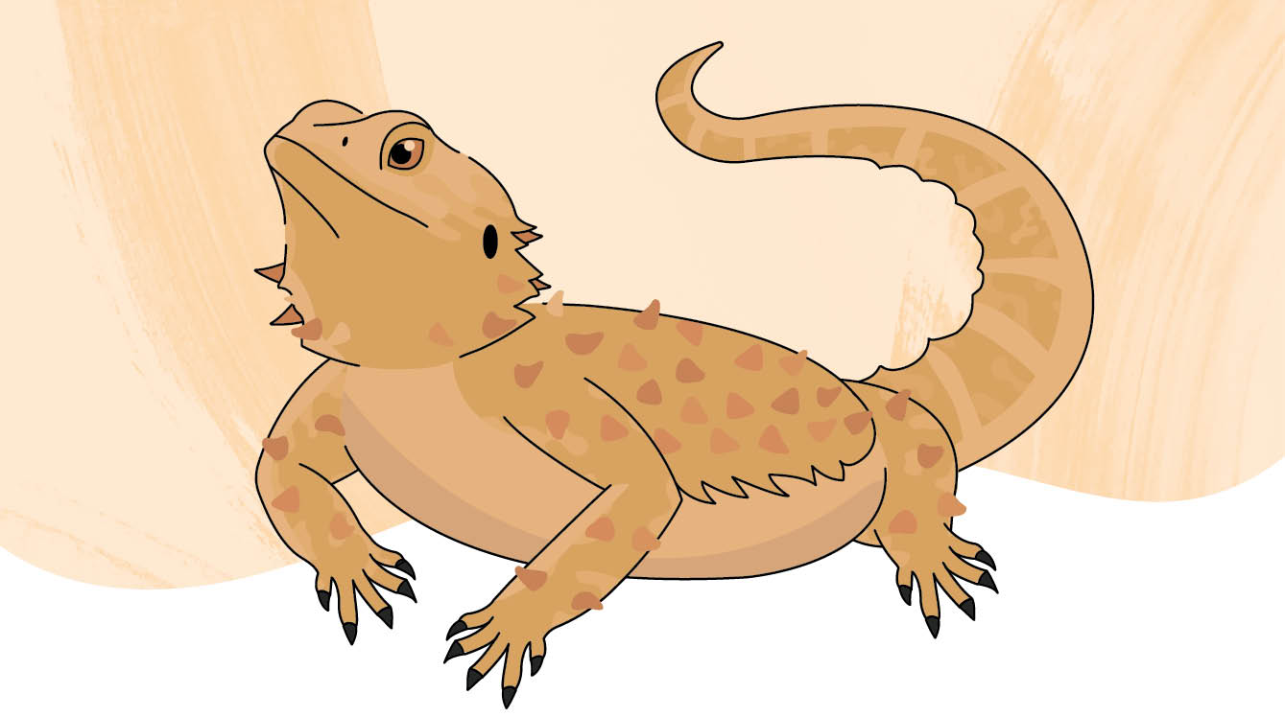
Scientific name: Pogona viticeps
Average life span: 10 to 15 years (in captivity)
Habitat: A large, solid enclosure with good light, a heat lamp, and plenty of places to sleep, hide, and climb.
Classification: Terrestrial reptile

Who am I?
I am a sun-loving lizard with my own spiky armour, and you can call me a “beardie” – it’s my nickname!
I have a wide, flat body and triangular head, and I’m covered head-to-tail in spiny scales that can change colour to suit my surroundings or my mood.
When I feel threatened or scared, I puff up my whole body to look bigger, open my mouth, raise my chin, and stick out my throat which looks like a beard – hence my name.
Don’t let my tough exterior fool you, I’m quite friendly and easy-going, which makes me one of the most common pet reptiles in Victoria. I do well in captivity if you look after me right.
I love laying on rocks and logs to bask in the sun or under a heat lamp in your home. Munching on fruits, vegetables and insects keeps me happy and healthy and I use my fast, sticky tongue to quickly pull the food inside my mouth before it wriggles away.

How can you help me?
If you’re thinking of getting your own pet beardie, you’ll need a wildlife licence, and I have to come from a licenced source, who has kept me in good conditions. It’s never okay to take me or any other wildlife from the wild.
At home, make sure you keep me in a proper enclosure with a heat source and lots of things to climb on and hide under. Don’t worry about me getting lonely either, I prefer to be on my own and love to have you all to myself. And never release your pet dragon into the wild as they could spread diseases to wild lizards.
Wildlife as pets, know the rules.

Design an enclosure
Draw the five things this bearded dragon needs in his tank.
- Rocks and logs for climbing and hiding
- Bowls filled with food and water
- A light source
- Flooring cover like paper or reptile carpet
- A heat source
Figure 2: A bearded dragon inside an enclosure
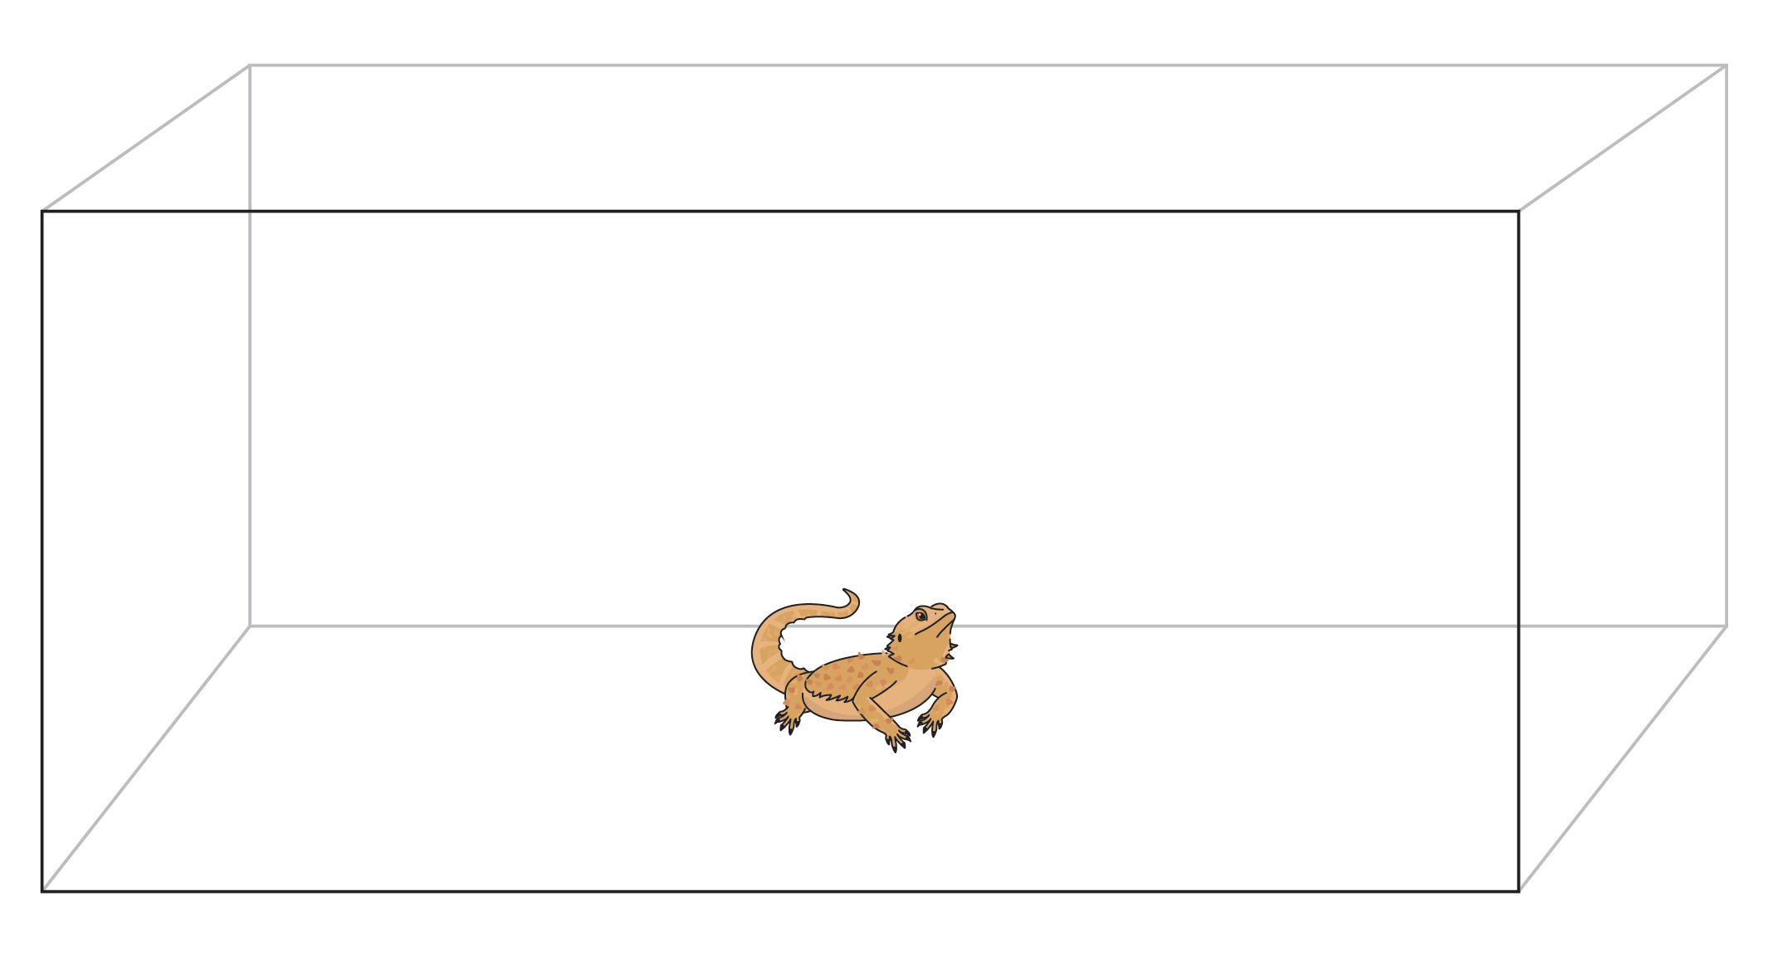

Fill in the blanks
You can never get your pet dragon from the __ __ __ __.
Hint! The answer is on the first page.
Conservation Regulator Focus Species have been selected to raise awareness about the small changes people can make to protect wildlife in the wild and in captivity.
Find out more at conservationregulator.vic.gov.au
End of document.

