Focus species

Brush-tailed phascogale
Figure 1: An illustration of a brush-tailed phascogale
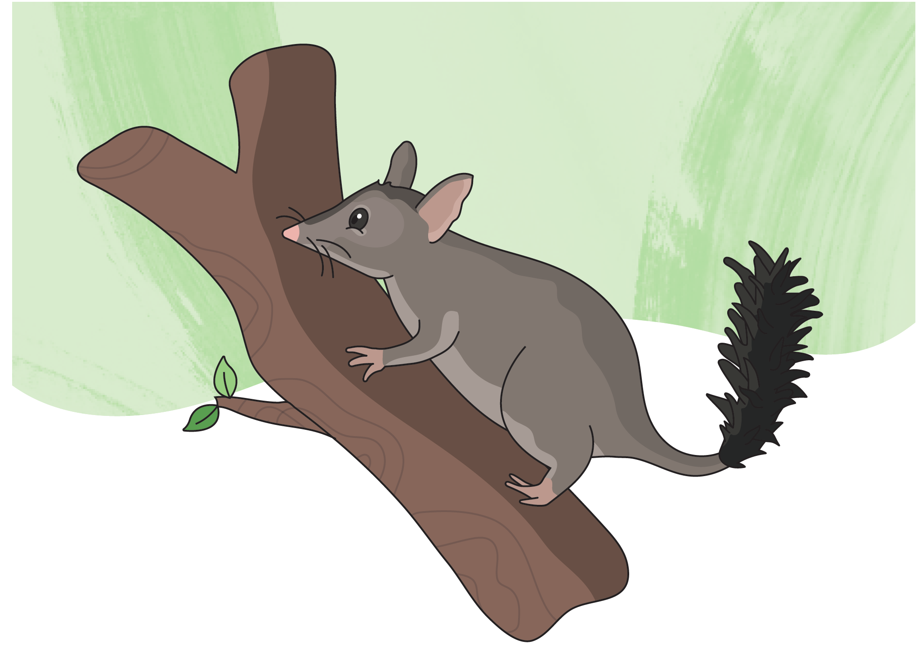
Scientific name: Phascogale tapoatafa
Conservation status: Vulnerable
Average life span:
Males: 1 year
Females: 2 to 3 years
Range/distribution: North-east of Melbourne and through central Victoria
Habitat: Tree hollows in dry, open forests
Classification: Arboreal mammal

Who am I?
I am a tiny, nocturnal marsupial who lives in and moves swiftly between the treetops of Victoria’s eucalyptus forests.
My body is small and grey, with a thick, black ‘bottle-brush’ tail - hence my name! I have a pointy snout, and large eyes and ears to help me detect predators.
I spend most of my time in trees, sleeping in hollows during the day and foraging for food at night while you’re sleeping. For safety, I tend to stick to trees, looking under tree bark for insects like spiders and centipedes to eat, and only come down to travel between trees and check in leaf litter and logs for snacks. On the ground, I’m always on alert for predators like cats or foxes and will use my bushy tail to distract them while I make a lightning-fast escape up a tree.
I build nests in the hollows of standing and dead trees and line them with shredded bark and feathers. I can live in up to 30 different trees every year while I travel around for food and to avoid predators.

How can you help me?
I rely on native trees for shelter and nesting, so it’s important to leave these trees alone. If your family uses firewood to heat your home, make sure it’s from a legal, sustainable source to help protect our habitat.
Hollow trees, leave them please.

Complete the word search
Can you find and circle all the words hidden in the letters below?

- SUSTAINABLE
- PHASCOGALE
- NOCTURNAL
- GREY
- EUCALYPTUS
- MARSUPIAL
- FORAGING
- LOGS
- SHELTER
- FIREWOOD
- SNOUT
- TREES

Figure 2: A word search letter grid
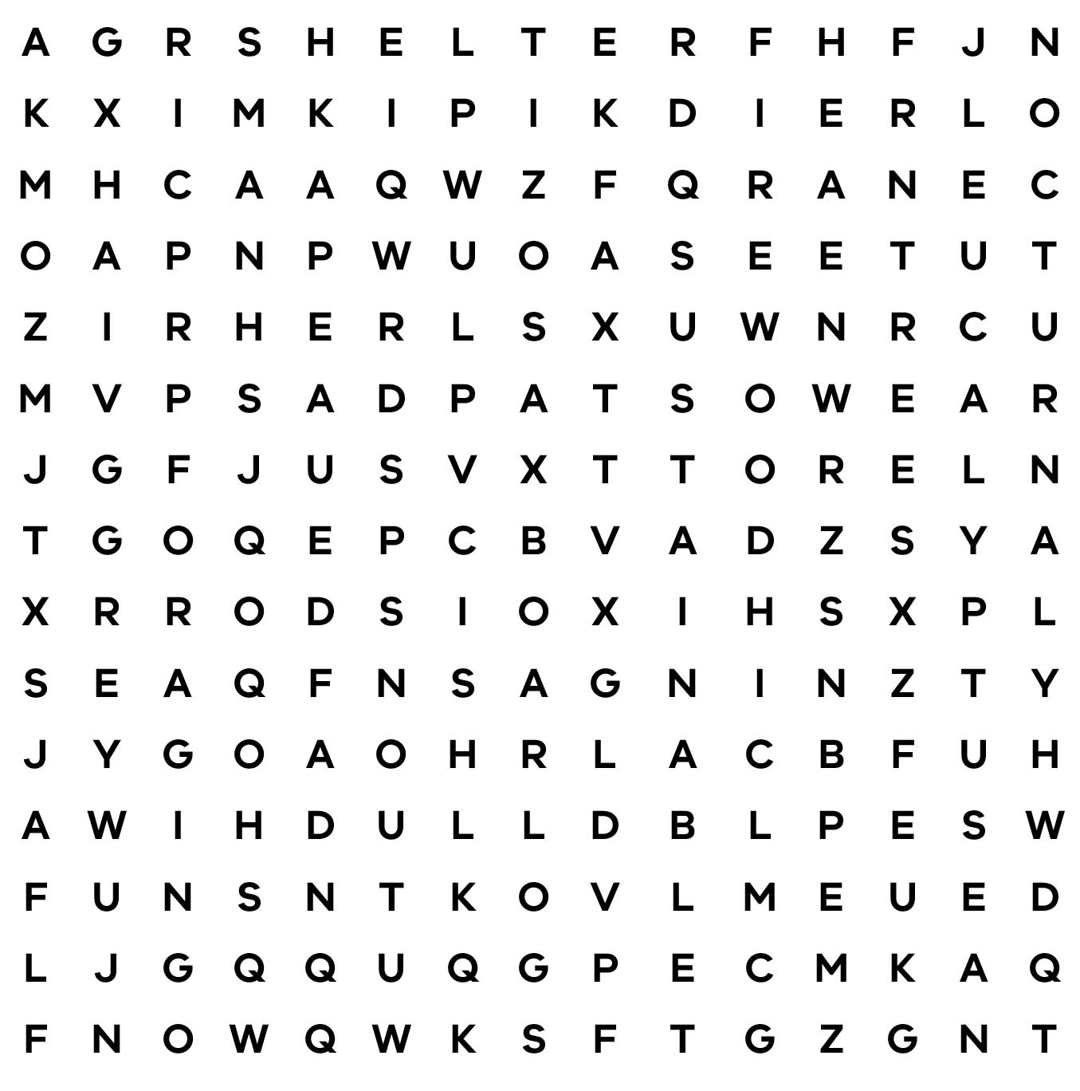

Is this true or false?
Circle your answer.
Phascogales can sometimes live in dead trees!
True or False
Hint! The answer is on the first page.
Conservation Regulator Focus Species have been selected to raise awareness about the small changes people can make to protect wildlife in the wild and in captivity.
Find out more at conservationregulator.vic.gov.au
End of document.

