Recycling Victoria Annual Report 2023-24
Table of Contents
Acknowledgements 4
Message from the Head, Recycling Victoria 5
About Recycling Victoria 5
Our key priorities and achievements 6
Engagement 8
Acknowledging our portfolio partners 9
Purpose 11
Operating context 11
Legislation 11
Regulations 12
About Recycling Victoria 13
Our vision 13
Our purpose 14
Our priorities 14
Our operating approach with portfolio partners 14
Our functions 15
Our Head and executive directors 17
Our governance 19
Recycling Victoria Advisory Committee 19
Local Government Advisory Committee 20
Recycling Victoria Stewardship Committee 20
Strategic Planning 21
Strategic Plan 21
Regulatory Strategy 24
Charter of Engagement 26
Community Engagement Strategy 26
Our engagement approach 27
Engagement and consultation 27
Aboriginal self-determination 28
Key priorities 2023-24 29
Container Deposit Scheme 29
CDS Vic launch 29
Regulation and oversight 30
Shared responsibilities model 30
Determination instruments 31
Material recovery facilities and local government refund sharing protocols 31
Material Recovery Facilities Protocol 31
Community support 32
Waste to Energy Scheme 32
Risk, consequence and contingency planning 35
Circular Economy Risk, Consequence and Contingency Plan 35
Responsible entities 36
Responsible Entity Risk, Consequence and Contingency Plans 36
Guidelines for Responsible Entity Risk, Consequence and Contingency Plans 37
Summary of the key risks, consequences and measures in CERCC Plan 2024 37
Victorian Recycling Infrastructure Plan 38
Circular Economy Market Report 39
Recycling Victoria Data Hub 40
Household Waste and Recycling Service Standard 43
Strategic Procurement Framework 44
Stakeholder engagement 44
Connecting with leaders in local government and industry 45
Witnessing the circular economy in action through site visits 46
Contributing at conference and external presentation 49
Formal consultation 50
Our people 50
Section 22 (2) Annual Report Mandatory Content 52

Acknowledgements
We acknowledge and respect Victorian Traditional Owners as the original custodians of Victoria’s land and waters, their unique ability to care for Country and deep spiritual connection to it, and pay respects to Elders, past and present. Recycling Victoria is committed to enabling Aboriginal self-determination, by genuinely partnering and meaningfully engaging with Victorian Traditional Owners and First Peoples to progress their aspirations.
© The State of Victoria Department of Energy, Environment and Climate Action, September 2024
Creative Commons
This work is licensed under a Creative Commons Attribution 4.0 International licence, visit the Creative Commons website (http://creativecommons.org/licenses/by/4.0/).
You are free to re-use the work under that licence, on the condition that you credit the State of Victoria as author. The licence does not apply to any images, photographs or branding, including the Victorian Coat of Arms, and the Victorian Government and Department logos.
ISSN 2981-9288 – Online (pdf/word)
Disclaimer
This publication may be of assistance to you but the State of Victoria and its employees do not guarantee that the publication is without flaw of any kind or is wholly appropriate for your particular purposes and therefore disclaims all liability for any error, loss or other consequence which may arise from you relying on any information in this publication.
Accessibility
To receive this document in an alternative format, phone the Customer Service Centre on 136 186, email customer.service@delwp.vic.gov.au, or contact National Relay Service on 133 677. Available at DEECA website (www.deeca.vic.gov.au).

Message from the Head, Recycling Victoria
Tony Circelli, Head, Recycling Victoria
I am pleased to present the Recycling Victoria 2023–24 Annual Report on the operation of the Circular Economy (Waste Reduction and Recycling) Act 2021 (CE Act).
Recycling Victoria was created to lead, to be a steward and provide oversight of the waste, recycling and resource recovery sector, and support the development of a circular economy.
The past 12 months has seen Recycling Victoria establish a sustainable organisation, strengthen the operating approach and engagement with portfolio partners and key stakeholders, and implement the governance framework to commence delivery of key statutory initiatives.
During our second year of operation, we continued working closely with industry, local government, and the state government on a shared duty to pursue more opportunities and sustainable practices for greater stability, investment and growth in the sector.

About Recycling Victoria
Recycling Victoria commenced operation on 1 July 2022. It is a central part of the Victorian Government’s once in a generation reform of Victoria’s waste and recycling system, to make it more effective, accountable, and consistent with community expectations. Our focus is on pursuing statewide market growth and investment, building capacity, resilience and reliability in the sector, whilst maximising the ongoing use and value of products and materials which supports the broader Victorian economy.
The establishment of Recycling Victoria is a key initiative of the Victorian Government’s circular economy plan, Recycling Victoria: A new economy, released in February 2020.
The Head, Recycling Victoria was established under section 15 of the CE Act. The Head, Recycling Victoria reports to the Deputy Secretary, Regions, Environment, Climate Action, and First Peoples (RECAFP) of the Department of Energy, Environment and Climate Action (DEECA) and is supported by 3 executive directors.
Steve Dimopoulos MP, Minister for Environment, is the responsible minister for Recycling Victoria. Ingrid Stitt MP was the responsible minister until October 2023.

Our key priorities and achievements
Our key priorities and achievements in 2023–24 include:
- Recycling Victoria Vision and Purpose: We released the inaugural Recycling Victoria Strategic Plan, Regulatory Strategy, Charter of Engagement, and the Community Engagement Strategy in July 2023. These strategic documents set out Recycling Victoria’s vision, its strategic intent, priorities and direction for 2023–2026.
- Engagement and consultative committees: Two statutory committees were established and commenced meeting during the year: the Recycling Victoria Advisory Committee and Local Government Advisory Committee.
- Container Deposit Scheme: The Minister for Environment successfully launched the Container Deposit Scheme (CDS Vic) on 1 November 2023. Recycling Victoria is responsible for oversight and regulation of the scheme, including to ensure contractual delivery outcomes for CDS Vic including scheme regulatory functions. The scheme has been designed to be the most accessible CDS in Australia, with diverse policy outcomes including reducing litter and turning beverage containers into high valued new recycled products, thereby creating new economic opportunities and critical new recycling infrastructure and generating sustainable new jobs. A key focus post launch has been the mobilisation of the scheme to ensure it meets public expectations.
- Waste to Energy Scheme: The first stage of the Waste to Energy scheme, which pertains to ‘existing operators’, commenced 1 June 2023, following the commencement of the Circular Economy (Waste Reduction and Recycling) (Waste to Energy Scheme) Regulations 2023. The Head, Recycling Victoria, issued 4 existing operator licences during 2023–24, approving proposed investments involving the processing of over 1 million tonnes of permitted waste. The second stage of the scheme, which pertains to new operators, will commence in 2024–25 once further licensing regulations are made.
- Risk, consequence and contingency planning: The inaugural Circular Economy Risk, Consequence and Contingency Plan (CERCC Plan 2024) came into force on 9 May 2024 following approval by the Minister for Environment. The CERCC Plan 2024 identified 6 serious risks that may impact waste, recycling and resource recovery service continuity or progress towards a circular economy. As of 30 June 2024, 10 entities self-assessed as Responsible Entities (REs) during the initial notification period, and are required to prepare a Responsible Entity Risk, Consequence and Contingency Plan (RERCC Plan) by 30 September 2024. The inaugural notification period for REs had not concluded at the time of this report; the initial 60-day notification period ended on 8 July 2024, where further REs were anticipated to notify.
- Victorian Recycling Infrastructure Plan (VRIP): The second revised draft inaugural VRIP was submitted to the Minister for Environment in accordance with the CE Act and is expected to be published during 2024.
- Circular Economy Market Report: We were pleased to release, in March 2024, our inaugural annual Circular Economy Market Report: an overview of Victoria’s progression to a circular economy, and highlighting issues that require further focus and investment.
- Data Hub: Two sets of core statistics for Victoria have been produced and were released on 12 June 2024. The new data shows that Victorian households are increasing their recycling, with an overall landfill diversion rate of 69%, which is higher than the 2021 national average of 63%. We also published a suite of market insight reports on a range of material types in September 2023.
- Service Standard: The draft Household Waste and Recycling Service Standard 2024 was prepared and released for public consultation in June 2024.

Engagement
Recycling Victoria continued to proactively engage with key stakeholders in local government and the waste, recycling and resource recovery sector throughout the year.
A total of 5 Local Government CEO forums and 6 Resource Recovery, Recycling and Waste Industry Group forums were held in 2023–24.
The Head, Recycling Victoria presented at 10 conferences and forums during 2023–24. Senior Recycling Victoria staff also actively presented at external conferences and forums.
During the year, the Head, Recycling Victoria, along with senior staff, visited industry sites to learn more about the progress individual businesses are making towards contributing to a circular economy and future investment aspirations.
Recycling Victoria also conducted formal, targeted consultations with stakeholders via the Victorian Government’s centralised online consultation platform, Engage Victoria, on a range of initiatives: the Container Deposit Scheme Refund Sharing Protocols; Container Deposit Scheme determinations instruments, the draft Household Waste and Recycling Service Standard 2024 and a consultation paper to inform the Victorian Recycling Infrastructure Plan.

Acknowledging our portfolio partners
Recycling Victoria recognises the importance of working closely with our lead portfolio partners and appreciates their support during our second year of operation including:
- Climate Action and Circular Economy Division (CACE), within RECAFP Group in DEECA
- Environment Protection Authority Victoria
- Sustainability Victoria.
We collaborated with these and other partners on a range of important policy reforms including:
- establishing and launching Victoria’s Container Deposit Scheme
- waste to energy regulations
- Victorian Recycling Infrastructure Plan
- service standards regulations and kerbside reform
- Risk, Consequence and Contingency framework and regulations.
I would like to sincerely thank Recycling Victoria staff for their commitment, professionalism, and dedication throughout the year, one that involved delivery of many exciting inaugural functions and programs, whilst building many systems and structures to establish Recycling Victoria. They continued to be champions for more sustainable economic outcomes for the sector and the state. I would also like to sincerely thank Ingrid Stitt MP and Steve Dimopoulos MP, along with DEECA staff and senior leadership, for their dedicated support and direction during this establishment year.
Tony Circelli
Head, Recycling Victoria
30 September 2024

Purpose
This report on Recycling Victoria’s operations under the CE Act is submitted by the Head, Recycling Victoria to the Minister under section 22 of the CE Act.
A detailed schedule of compliance with section 22 is contained at the conclusion of this report. Recycling Victoria’s annual compliance reporting is incorporated within the DEECA Annual Report.

Operating context
The Head, Recycling Victoria was established under section 15 of the CE Act. Mr Tony Circelli was appointed Head, Recycling Victoria in October 2022. Recycling Victoria is a business unit of DEECA.
Our responsible Minister is Steve Dimopoulos MP, Minister for Environment.
Ingrid Stitt MP was our responsible Minister until October 2023.

Legislation
The CE Act first came into operation on 1 July 2022 and was amended from 1 June 2023.
It established the Head, Recycling Victoria to provide leadership, stewardship and oversight of waste, recycling, or resource recovery services and to support the development of a circular economy.
Our focus is on pursuing statewide market growth and investment, building capacity, resilience and reliability in the sector, whilst maximising the ongoing use and value of products and materials.
The CE Act establishes a range of schemes, powers and functions to the Head, Recycling Victoria including, but not limited to:
- overseeing and regulating the Container Deposit Scheme
- developing and regulating the service standards
- developing the Victorian Recycling Infrastructure Plan
- leading risk, consequence and contingency planning
- administering and regulating the waste to energy scheme
- establishing and supporting advisory committees
- centralising data collection.

Regulations
On 27 September 2023 and 1 March 2023, the Circular Economy (Waste Reduction and Recycling) (Container Deposit Scheme) Regulations 2022 came into force, facilitating administration of the Container Deposit Scheme. These regulations were subsequently amended in August 2023 and in June 2024.
On 1 June 2023, the Circular Economy (Waste Reduction and Recycling) (Waste to Energy Scheme) Regulations 2023 came into force, facilitating administration of the Waste to Energy licensing scheme for existing operators.
The Circular Economy (Waste Reduction and Recycling) (Risk, Consequence and Contingency Plans and Other Matters) Regulations 2023 were made on 20 December 2023, which was followed by the release of the Circular Economy Risk, Consequence and Contingency Plan (CERCC Plan), which came into force on 9 May 2024.

About Recycling Victoria
As the recycling industry continues to transform, including by responding to changes in international markets, it is essential that Victoria’s waste and resource recovery sector can provide services for our current and future needs and maximises the benefits of resource recovery for households and the business community.
Recycling Victoria has been established to:
- provide leadership, stewardship and oversight of waste, recycling, and resource recovery services
- support the development of a circular economy.
Transitioning to a stronger circular economy will:
- encourage innovation and investment
- create more sustainability focussed jobs
- enable more consistent, valued and high-quality recycled material for remanufacturing or repurposing into new goods.
Through our work we focus on building a world class circular economy system that minimises the impact on non-renewable resources, maximises waste avoidance and makes a strong contribution towards a more sustainable, environmentally friendly and climate resilient future for all Victorians.

Our vision
A world class circular economy system that helps build a sustainable future for all Victorian.

Our purpose
Leadership, stewardship and oversight of Victoria’s waste and resource recovery services to support a strong and resilient circular economy with robust market investment and growth.

Our priorities
In our second year of operation, our priorities were linked to establishing key schemes and functions under the CE Act, including:
- establishing the engagement and consultative committees
- overseeing and regulating the Container Deposit Scheme
- administering and regulating the Waste to Energy Scheme
- developing the market risk and contingency plans
- developing the infrastructure plan
- uplifting and sharing market intelligence
- developing the Household Waste and Recycling Service Standard
- developing the strategic procurement framework
- building a strong culture and organisation underpinning our operation.
Recycling Victoria’s priorities directly supports Victoria’s economic transition and growth in the waste, recycling and resource recovery sector.

Our operating approach with portfolio partners
On 31 July 2024, Recycling Victoria joined RECAFP Group within DEECA. The Head, Recycling Victoria, retains his statutory role, while reporting to the Deputy Secretary RECAFP to maximise coordination with policy colleagues in CACE Division in RECAFP Group, who lead on broader delivery of the circular economy agenda.
Recycling Victoria recognises the importance of working closely with other lead portfolio partners, including:
- CACE Division within the RECAFP Group in DEECA
- Environment Protection Authority Victoria
- Sustainability Victoria.
Along with these partners, Recycling Victoria is a member of the Circular Economy Portfolio Coordination Group, which is a critical inter-agency forum for building shared understanding, integration, and plans in response to the risks, opportunities and issues faced by the sector. Less formal, day to day interactions between the portfolio partners are observed at all levels in the organisations. This includes regular meetings at the senior officer level and collaboration on shared priorities.
In particular, Recycling Victoria established a Memoranda of Understanding with the EPA and Sustainability Victoria in 2022–23 to clarify the roles and responsibilities of participating entities and provide solid foundations for collaboration, data and intelligence sharing, and working together on key issues or opportunities relating to sector operations and future investment.

Our functions
Under section 16 of the CE Act, the Head, Recycling Victoria must deliver functions aimed at providing leadership, stewardship and oversight of waste, recycling and resource recovery services in Victoria and support the development of a circular economy, outlined below.

Support development of a circular economy:
- Reduce waste, support recycling, and promote circularity in the use and reuse of products.
- Maximise the continued use of products and waste material over their life cycle.
- Support the transition to a net zero and resilient Victoria.

Leadership
- Identify, monitor, and manage risks and harm associated with the provision of waste, recycling and resource recovery services.
- Provide strategic infrastructure planning for waste, recycling and resource recovery services.
- Collect, use, disclose and publish information, market insights and data.

Stewardship
- Oversee and build knowledge and capacity for municipal residual waste, recycling and resource recovery service delivery.
- Support best practice procurement management by local government, Alpine Resorts Victoria and service providers for waste, recycling and resource recovery services.
- Advise on best practices for waste, recycling and resource recovery services.

Oversight
- Build and implement regulatory capability, and data and information systems to monitor the performance of the sector.
- Oversee the Container Deposit Scheme.
- Implement and administer the Waste to Energy Scheme.
- Develop and implement service standards, including standards for household waste and recycling services

Our Head and executive directors
Recycling Victoria is led by the Head, Tony Circelli. The Head is supported by 3 executive directors.
Tony Circelli
Head, Recycling Victoria
Tony has spent more than 30 years in the environment protection field, with extensive experience in environment and sustainability issues, modern regulatory practice, and organisational strategy and reform. He has led numerous policy and operational reforms at state and national levels in areas including chemicals and public health, site contamination, waste and resource recovery, container deposit systems and waste to energy. He has held senior executive positions with the South Australian Environment Protection Authority (SA EPA) and was the Chief Executive for over 8 years.
Tony was appointed as the inaugural Head, Recycling Victoria in October 2022. He holds an Honours degree in Mechanical Engineering, a Master of Business Administration, and is a Fellow of the South Australian Governor’s Leadership Foundation. Tony has been a director on numerous government boards including the SA EPA Governing Board, the national Heads of Environment Protection Agencies forum and Chair of the national Australasian Environmental Law Enforcement and Regulators network.
Deb Cailes
Executive Director Strategy, Procurement and Planning
Deb joined Recycling Victoria in September 2022 coming from executive roles in local government, managing waste, strategic infrastructure investment, engineering, and sustainability. With qualifications in science, finance and economics, Deb has spent 20 years in the manufacturing industry driving output optimisation in highly regulated plants around the world. As Executive Director Strategy, Procurement and Planning, Deb oversees statewide data and insights, strategic infrastructure planning, and sector risk and contingency management. Deb also plays a key role in supporting local government waste and recycling service procurement.
Anastasia Kontogiorgis
Executive Director Regulation, Schemes and Standards
Anastasia joined Recycling Victoria in June 2024. Anastasia has almost 30 years of regulatory, operational, and strategic leadership experience in the private and public sectors. Anastasia has spent much of this time in the gas and pipeline industry and has been instrumental in leading regulatory direction and intervention of gas appliances and installations, pipeline infrastructure construction, operation and maintenance and electrolysis mitigation.
Anastasia has held prominent positions in industry forums such as Chair of the Gas Emergency Management Consultative Forum, Chair of the National Regulators Forum and was the Statutory Chair of the Victorian Electrolysis Committee. Anastasia’s extensive experience and executive leadership roles have enabled regulatory compliance coupled with fostering safety and innovation within the sectors.
Grant Breheny
Executive Director People, Performance and Engagement
Grant joined Recycling Victoria in August 2022 from the Department Health/Health and Human Services where he was Director Organisational Design and Performance. As Executive Director People, Performance and Engagement, Grant manages Recycling Victoria’s corporate, administrative and operational functions. Grant leads Recycling Victoria’s transformation programs to maximise performance, service delivery, legislative compliance and risk management to best serve the interests of government and Victorian communities.
Jennifer Anne was Executive Director, Engagement, Regulation and Oversight to November 2023.

Our governance
Recycling Victoria is a business unit of DEECA, with a statutory head.
In accordance with section 37(2) of the CE Act, the Minister must establish at least one advisory committee that includes people with relevant skills, knowledge and experience in local government and rural and regional communities.
The Minister must consider any advice or comments received from an advisory committee in relation to making, amending, or revoking a service standard as stated under section 66(a)(ii) of the CE Act.

Recycling Victoria Advisory Committee
The Recycling Victoria Advisory Committee (RVAC) has been established to provide advice and insights to the Minister and the Head, Recycling Victoria on matters relating to Recycling Victoria’s implementation of its legislative functions, as outlined in the Recycling Victoria Advisory Committee Terms of Reference.
The Minister for Environment approved the committee’s terms of reference and appointed 8 members, including the Chair, Christine Wardle, on 12 August 2023 for a 2 year term.
The RVAC brings diverse issues, perspectives, and experiences to the fore as Recycling Victoria establishes and delivers on its key priorities and functions, as outlined in the Recycling Victoria Strategic Plan.
The RVAC draws on its members’ experience in local government, the waste and resource recovery sector, market regulation, and circular economy practices.
The RVAC held its inaugural meeting in September 2023 and met 7 times in 2023–24. The Minister for Environment attended meetings in March and May 2024.

Local Government Advisory Committee
The function of the Local Government Advisory Committee (LGAC) is to provide advice to the Head, Recycling Victoria, and the Minister for Environment in accordance with the CE Act on:
- Recycling Victoria’s functions and early priorities, and how these arrangements support local government
- ensuring effective strategic relationships across the state.
The Chairperson, Councillor Tina Samardzija and 14 other members were appointed by the Minister for Environment. Members include 12 councillors from across Victoria. The remaining members represent local government peak bodies, including Municipal Association Victoria, Victorian Local Governance Association and the Australian Services Union.
As a short-term committee, the LGAC commenced operation in April 2024 and will conclude in September 2024 ahead of local council elections. The LGAC met in April and June 2024.

Recycling Victoria Stewardship Committee
The Recycling Victoria Stewardship Committee is a subcommittee of the DEECA Executive Board and has been operational since June 2023.
During 2023–24, the Committee provided oversight and coordination of key decisions required as part of the establishment of Recycling Victoria. The committee also provided feedback and guidance on Recycling Victoria’s key priorities, as articulated in Recycling Victoria’s Strategic Plan.
The committee is chaired by the Secretary, DEECA and met monthly during the first 9 months of operation, before transitioning to a quarterly cadence.

Strategic Planning
Section 21 of the CE Act requires Recycling Victoria to prepare and submit to the Minister for approval a strategic plan for waste, recycling and resource recovery services.
The Recycling Victoria Strategic Plan, Regulatory Strategy, Charter of Engagement, and Community Engagement Strategy set out Recycling Victoria’s vision, and its strategic intent and direction for 2023–26. The Strategic Plan details Recycling Victoria’s vision, strategic objectives, key focus, purpose and priorities – see Recycling Victoria Strategy Map.
These governing documents provide the foundation for Recycling Victoria to focus effort and to ensure effective engagement and collaboration with its stakeholders on developing and implementing initiatives to strengthen the sector.
The Minister approved these strategic documents in July 2023. With the release of these documents, Recycling Victoria continued consultation with portfolio partners and key industry, local government, and state government stakeholders, with the focus shifting towards implementation of our priorities.

Strategic Plan
We are proud to have launched the inaugural Recycling Victoria’s Strategic Plan 2023–26 (Strategic Plan) at the 2023 Waste Summit Conference in Melbourne in October 2023.
The Strategic Plan defines our purpose, objectives and vision for a world class circular economy system that helps build a more sustainable future for all Victorians. The Strategic Plan, together with our Charter of Engagement, Community Engagement Strategy, and Regulatory Strategy, sets out the pathway to continue reform and strengthening Victoria’s waste, recycling and resource recovery services.
Recycling Victoria provides leadership, stewardship and oversight of waste and resource recovery services to support the circular economy through monitoring, regulating, and planning to further strengthen and build market outcomes.
Figure 1: Recycling Victoria Strategy Map

Regulatory Strategy
Our Regulatory Strategy 2023–2026 outlines how we utilise our regulatory functions as a key tool in achieving the strategic objectives set forth in the Strategic Plan. In implementing the strategy, we are committed in adopting modern outcome and risk focused regulatory principles, to focus on material harms to the sector, and respond to emerging issues whilst being mindful of costs to our regulated community and government.
The Regulatory Strategy sets the early regulatory priorities for Recycling Victoria and outlines the principles and approach we can apply. Recycling Victoria takes a proportionate and risk-based approach to exercising its regulatory functions. Our Regulatory Strategy further outlines our commitment to engaging with regulated entities and stakeholders ensuring the provision of timely and high-quality compliance advice and support.
As a new regulator, we will continue to build our regulatory capability and systems as we deliver on our priorities.
Figure 2: Regulatory priorities, harms, and objectives
Harms → |  | Regulatory priorities |  | ← Objectives
- Need for increased resilience  - Improved waste management practices  - Consistent and good quality services  - Trusted, consistent  and comprehensive data and intelligence | Priority 1  Ensuring regulated waste and resource recovery services and scheme operate with integrity  - Establish Container Deposit Scheme  - Commence Waste to Energy Scheme  - Service Standard for household waste and recycling services | Priority 2  Reducing significant  risks of service disruption  - Establish approach  to understand and monitor risks of service disruption | Priority 3  Preparedness to respond to emerging issues  - Compliance  and enforcement capability building  - Collaboration  with our partners | - Increase resilience  of the Victorian waste and resource recovery system  - Enable sector investment and  growth  - Build system capacity and capability  - Contribute to a strong and robust circular economy

Charter of Engagement
Our Charter of Engagement describes our commitment to engage meaningfully and transparently with stakeholders. It states how we will engage with stakeholders on issues and decisions that matter to them.
Our Charter of Engagement applies a whole of Victorian Government approach to engagement, encompassing the Victorian Government Public Engagement Framework, the DEECA Community Charter and the Traditional Owner and Aboriginal Community Engagement Framework.
The Public Engagement Framework aims to strengthen meaningful engagement practice in Victoria.
Figure 3: Engagement principles in the Victorian Government
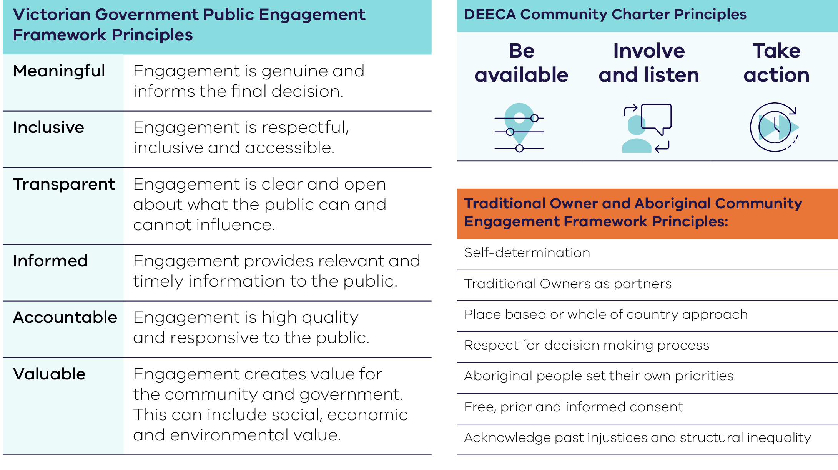

Community Engagement Strategy
Our Community Engagement Strategy 2023–2026 sets out our commitment to work with regional and metropolitan stakeholders and communities, businesses, industry, Traditional Owners, local government and Alpine Resorts Victoria in decisions that affect them and on issues that matter to them.
This involves connecting with our broader community to:
- build strong relationships
- share information and data
- strengthen our waste, recycling and resource recovery system.

Our engagement approach
Waste, recycling and resource recovery system reforms affect every household in Victoria, as well as each local government, Alpine Resorts Victoria and the waste, recycling and resource recovery services sector. More broadly we will need to see continued and stronger leadership and commitment by all business and industry for more circular use of resources. The input and collaboration of these sectors will be critical to the successful implementation of the CE Act.
Our engagement approach is tailored to individual stakeholders, locations and circumstances.

Engagement and consultation
Our engagement strategy includes:
- Regional and local, and frequently in person across Victoria. Based on feedback we receive, engagement is tailored to stakeholder’s interests, preferences, implementation of CE Act components and focussed consultation episodes.
- Statewide, strategic and structured, including the Ministerially appointed advisory committees, represented by industry, local government and peak bodies, as well as senior level local government and industry based forums led by the Head, Recycling Victoria.
- Emerging issues and opportunities, ongoing and as needed, including the implementation of new schemes and functions, capability development and sector emerging issues.

Aboriginal self-determination
Traditional Owners are the original custodians of the land across Victoria, and hold legal rights and responsibilities to care for Country. These rights and responsibilities are recognised in various policies and laws, which set out obligations for Government, industry and Traditional Owners to enable self-determination, support Traditional Owners rights and aspirations and protect and enhance cultural heritage.
The Victorian Government is working with Traditional Owners and Aboriginal Victorians to advance a treaty or treaties that will provide a foundation for a new, positive relationship, and enable true self-determination for Victoria’s First Peoples.
Recycling Victoria will work with Victoria’s Traditional Owners and ensure our work is founded on the principles of self-determination. We will make sure that Traditional Owner cultural knowledge is part of how we deliver our functions.

Key priorities 2023-24
In 2023–24 we focused on delivering the following key priorities for Victorian communities. These priorities contribute to Victoria’s economic growth and development in the waste, recycling and resource recovery sector.

Container Deposit Scheme
Victoria’s Container Deposit Scheme (CDS Vic) is an important part of the work that is transforming Victoria’s waste and recycling system.

CDS Vic launch
The Minister for Environment launched CDS Vic on 1 November 2023, allowing Victorians to return their eligible beverage containers for a 10-cent refund at refund collection points across Victoria. The scheme has been designed to reduce the state’s litter by up to half, create new economic opportunities, generate new jobs, and turn drink containers into new and high value recycled products.
As at 30 June 2024, CDS Vic had more than 628 million containers returned since its launch. The Scheme is expected to generate and fund an estimated 600 new jobs and has enhanced Victoria’s recycling infrastructure with more than 560 refund collection points operational supported by collection logistics and container sorting facilities.
The initiative returned more than $62.8 million back to Victorians including through donations to charities, communities and sporting groups, and was processing an average of around 18 million eligible cans, cartons and bottles across the state each week. A further 372.2 million containers were returned as at 30 June 2024 through Materials Recovery Facilities which process kerbside materials.

Regulation and oversight
Recycling Victoria is responsible for the regulation, oversight and administrative direction of CDS Vic under Part 6 of the CE Act.
Recycling Victoria’s responsibilities include:
- managing, monitoring and ensuring compliance with Scheme Coordinator and Zone Operator agreements
- ensuring compliance with associated CE Act provisions
- making decisions in relation to ‘first suppliers’ and ‘eligible containers’ intending to be sold in the state
- publishing guidelines and issuing directions to scheme participants
- establishing branding and marketing guidelines for CDS Vic
- collecting information and providing advice to the Victorian Government
- establishing Material Recovery Facilities and Local Government Refund Sharing protocols
- acting where compliance and other issues are identified.

Shared responsibilities model
CDS Vic operates on a shared responsibilities model, which separates administration and contract management for the scheme operators (see below), and regulation for operations and for the beverage industry.
There are 4 key contracted operators for the scheme. The Scheme Coordinator, VicReturn, is responsible for managing scheme administration, education, and finances. Return-It, TOMRA Cleanaway and Visy are the Zone Operators responsible for establishing and maintaining a network of refund points in the East, West and North Zones respectively.

Determination instruments
As required under the CE Act, people who supply, or intend to supply, an eligible container in Victoria must notify the Head, Recycling Victoria who will determine whether the person is, or will be, a first supplier of the eligible container for CDS Vic.
Recycling Victoria has developed formal instruments to determine first suppliers and the eligibility of drink containers for inclusion in CDS Vic:
- First Supplier Determination Instrument for the Victorian Container Deposit Scheme
- Suitable Eligible Container Determination Instrument for the Victorian Container Deposit Scheme.

Material recovery facilities and local government refund sharing protocols
CE Act provides for the Head, Recycling Victoria to issue protocols that enable material recovery facilities (MRFs) and local governments and Alpine Resorts Victoria to access a refund from CDS Vic in relation to the suitable eligible containers they collect and manage.

Material Recovery Facilities Protocol
The Material Recovery Facilities Protocol establishes the terms for determining the refund amount from CDS Vic between the Scheme Coordinator and MRF operators with a Recovery Agreement.
It provides a structured approach calculating the refund amount payable between parties and managing the financial implications, including approved incurred costs, which arise due to the implementation of CDS Vic.

Local Government Refund Sharing Protocol
The purpose of the Local Government Refund Sharing Protocol is to ensure equitable and transparent sharing of refunds among contracted parties involved in providing municipal recycling services that collect, sort and separate suitable eligible containers. It provides a framework that promotes accountability and cooperation among the involved parties to determine and distribute refund amounts attributed to collected suitable eligible containers.

Scheme Payments and Contributions Methodology
The Scheme Payments and Contribution Methodology (SPCM) outlines the calculation, nature and timing of scheme payments made to and by the CDS Vic Scheme Coordinator.
The SPCM sets out the arrangements for first suppliers’ scheme contributions, export payments, network fees payable to Zone Operators, the service fee payable to Recycling Victoria, refund payments to MRF operators and how financial penalties are charged and collected.

Community support
CDS Vic provides charities, community groups, environmental organisations, sports groups and educational organisations with new and easy ways to raise funds. They can:
- receive donations from the community – Victorians can choose to pocket their refund or donate to a participating charity
- conduct a collection drive and receive containers from the community
- host a refund collection point.

Waste to Energy Scheme
Waste to energy is an important part of the Victorian Government’s 10-year circular economy policy, implementing the Victorian Waste to Energy Framework.
Waste to energy involves turning waste material, otherwise destined for landfill, into useful energy resources such as heat, electricity, gas and liquid fuels. After waste avoidance, reuse and recycling, waste to energy is the final opportunity to get value from material that would otherwise be sent to landfill.
As Victoria shifts towards a circular economy, waste to energy facilities can play a role in:
- diverting waste from landfill, thereby limiting the need for new landfills
- allowing businesses to generate more value from the materials they manage
- creating valuable energy that can be used by industry or exported to the electricity grid for the community
- supporting Victoria to meet its target of net zero emissions by 2045.
Recycling Victoria is the scheme regulator, with a circular economy market focus, to control the amounts and types of waste processed in thermal waste to energy facilities. The scheme design ensures investment in waste to energy facilities does not compromise existing and future infrastructure investment and jobs aimed at higher value material recovery.
Under Part 5A of the CE Act, Recycling Victoria is responsible for:
- licensing operators by providing existing and new operators with a licence to process permitted waste using a thermal waste to energy process
- administering the scheme by providing information and education, guidelines and administering licences (including licence transfers and amendments)
- monitoring and enforcing compliance with licence terms and conditions and working with co-regulators such as the EPA.
The Victorian Government is delivering regulations that prescribe the processes and requirements to apply for licences in 2 stages.
Stage one of the scheme, which pertains to existing operators, commenced 1 June 2023, following the commencement of the Circular Economy (Waste Reduction and Recycling) (Waste to Energy Scheme) Regulations 2023. According to the CE Act, an existing operator is a person who operates an existing facility.
During 2023–24, the Head, Recycling Victoria, issued 4 existing operator licences to:
- Paper Australia Pty Ltd
- Visy Industries Australia Pty Ltd
- Great Southern Waste Technologies Pty Ltd
- Recovered Energy Laverton.
This concluded the existing operator stage of licensing.
Stage 2 of the scheme, which pertains to new operators, will commence in 2024–25 once cap licensing regulations are made. A cap licence allows thermal waste to energy facility operators to process permitted waste up to a specified maximum amount.
DEECA conducted public consultation on the proposed cap licence regulations and the associated Regulatory Impact Statement from December 2023 to February 2024. Once the cap licence regulations commence, the Head, Recycling Victoria will invite expressions of interest for cap licences and subsequently invite full applications for a cap licences.

Risk, consequence and contingency planning
Recycling Victoria is leading risk, consequence and contingency planning in the waste, recycling and resource recovery sector. Our priority is to make the system more reliable and support Victoria’s transition to a sustainable and thriving circular economy.
Enactment of the Circular Economy (Waste Reduction and Recycling) (Risk, Consequence and Contingency Plans and Other Matters) Regulations 2023, part of a new risk, consequence and contingency planning framework, supports greater understanding, visibility, and oversight of sector-wide risk planning.
It allows shared understanding and management of risks by industry and government to reduce disruptions and make the system more resilient and reliable as we transition to a stronger circular economy.

Circular Economy Risk, Consequence and Contingency Plan
The Circular Economy Risk, Consequence and Contingency Plan (CERCC Plan) is an annual, state-wide plan for the waste, recycling and resource recovery sector.
The Head, Recycling Victoria is required to develop and submit the CERCC Plan to the Minister for Environment on or before 31 December each year, in accordance with the CE Act (section 74B).
The first Circular Economy Risk, Consequence and Contingency Plan (CERCC Plan 2024) came into force on 9 May 2024 following approval by the Minister for Environment.
It is the first of its kind in Australia and brings together government and industry in a shared commitment to provide Victorians with greater confidence in the reliability in the provision of waste, recycling, and resource recovery services.
The CERCC Plan identifies and reports on risks of disruption to essential waste, recycling, and resource recovery services in Victoria, and ensures that contingency plans are developed and implemented by sections of industry, referred as responsible entities, to minimise the impact of any serious disruptions to service delivery.

Responsible entities
Recycling Victoria acknowledges a level of shared responsibility between industry and all tiers of government for the management of risks to waste, recycling, and resource recovery services.
Responsible entities manage services that, if disrupted, present a serious risk to service continuity or progressing to a more circular economy.
In 2023–24, 10 entities self-assessed as responsible entities during the initial notification period up to 30 June 2024, and are required to prepare a Responsible Entity Risk, Consequence and Contingency (RERCC Plan) under section 74F. The inaugural notification period for entities had not concluded at the time of this report; the initial 60-day notification period ended on 8 July 2024.

Responsible Entity Risk, Consequence and Contingency Plans
In accordance with section 74F(2) of the CE Act and as a portion of the risk, consequence, and contingency (RCC) planning framework, responsible entities must respond to the serious risks outlined in the CERCC Plan in the preparation of their Responsible Entity Risk, Consequence and Contingency (RERCC) Plan. RERCC Plans are required to be submit to Recycling Victoria by 30 September each year.

Guidelines for Responsible Entity Risk, Consequence and Contingency Plans
To assist responsible entities to complete their RERCC Plans and associated statements of assurance, Recycling Victoria issued guidelines under section 74K of the CE Act on 9 May 2024, in conjunction with the release of CERCC Plan 2024. These support entities to self-assess their responsible entity status, and if they are a responsible entity, assist them to develop their RERCC Plan.

Summary of the key risks, consequences and measures in CERCC Plan 2024
Section 22(2)(f) of the CE Act requires the Head, Recycling Victoria, to include in the Annual Report, a description or summary of the key risks, consequences and measures identified in the CERCC Plan.
There are 6 serious risks identified that may impact waste, recycling and resource recovery service continuity or progress towards a circular economy within the inaugural CERCC Plan 2024:
- contamination such as physical and chemical contamination of waste streams that compromise resource recovery outcomes and/or present serious risks to infrastructure or work health and safety
- external threats such as a major emergency or security issue impacting a facility or entity
- planning such as operational business planning and strategic land use planning pressures that may impact a facility or entity
- social acceptance such as fostering trust in the sector as part of a shared responsibility to delivering quality and better practice
- internal threats such as mishandling of hazardous materials, equipment failure, insufficient capability and capacity, or poor risk culture/control regimes
- economic stressors such as a loss of markets (loss of major supply contracts), or adjustments required to respond to increased regulation.
Specific measures that responsible entities are required to take (as per section 74B(2)(d) of the CE Act), have not been included in the inaugural CERCC Plan 2024. However, responsible entities must assess their preparedness and existing measures in place in relation to managing the serious risks stated in the CERCC Plan when developing their annual RERCC Plan.

Victorian Recycling Infrastructure Plan
Infrastructure development in the waste, recycling and resource recovery sector will support Victoria’s economic growth and development.
Recycling Victoria is responsible for statewide waste, recycling and resource recovery infrastructure planning, a key component of the Victorian Government’s ongoing reforms to the waste and recycling sector.
The VRIP will provide long-term strategic infrastructure planning to guide and inform decision-making about waste, recycling and resource recovery infrastructure over the next 30 years.
The VRIP replaces Victoria’s 7 regional waste and resource recovery implementation plans, and the Statewide Waste and Resource Recovery Infrastructure Plan.
Recycling Victoria has developed the VRIP in accordance with the requirements set out in the CE Act. Recycling Victoria went beyond these requirements by conducting targeted external consultation with the sector.
The second revised draft inaugural VRIP has been submitted to the Minister for Environment in accordance with the CE Act, and it is intended that the VRIP will be published in 2024–25.

Circular Economy Market Report
The Head, Recycling Victoria is required to submit the Circular Economy Market Report to the Minister for Environment on or before 31 December each year in accordance with the CE Act.
In March 2024 we were pleased to release our inaugural Circular Economy Market Report: an overview of Victoria’s progression to a circular economy. The report provides annual information about material circularity relating to the generation, collection, sorting, re-processing, or re-manufacturing of products within the circular economy market.
The Circular Economy Market Report provides information on 8 key material streams:
- aggregates, masonry, and soil
- glass
- metals
- organics
- paper and cardboard
- plastics
- tyres
- textiles.
This information will be used to help businesses and the government to make better policy and investment decisions.​
The report confirms that Victoria is one of the highest performing Australian states for landfill diversion. Victorians generated close to 16 million tonnes of waste in 2020–21, and our waste, recycling and resource recovery sector recovered 11 million tonnes.
The report is based on resource recovery rates as a measure of the circular economy market, understanding the current limitations to fully reporting the circularity of each material stream.​
The Australian Government is also proposing circular economy metrics through the Circular Economy Ministerial Advisory Group, which are also being considered as part of Recycling Victoria’s review of circular economy metrics.
The Circular Economy Market Report will continue to evolve in future years, as further important work is done to expand and improve measurement of Victoria’s material streams and market information.

Recycling Victoria Data Hub
Our decisions and actions are informed by market data and intelligence.
The online Recycling Victoria data hub is a leading and high-quality waste data management system for our investment in market research, risk management and strategic planning.
Two sets of core statistics for Victoria have been produced and released during the year:
- 2021–22 and 2022–23 statewide industry waste and recycling performance figures
- 2022–23 Victorian local government waste and performance figures.
Figure 4: Recycling Victoria data hub
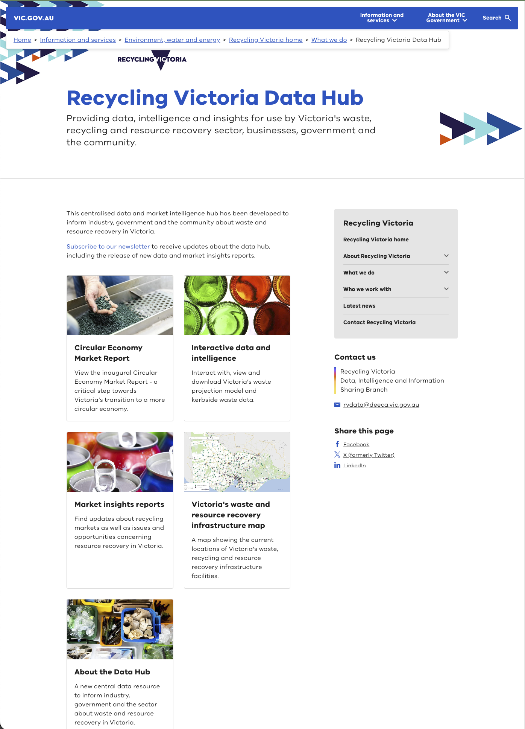
This data underpins:
- policy and infrastructure investment decisions
- the Circular Economy Market Report
- the Victorian Recycling Infrastructure Plan
- the Circular Economy Risk, Consequence and Contingency Plan
- performance against the government’s Recycling Victoria policy targets
- supply chain analyses
- capacity forecasting, risk and contingency planning.
New data sourced from local government and the waste and recycling sector was made available on the data hub on 12 June 2024.
The new data shows that Victorian households are increasing their recycling with a landfill diversion rate of 69%, which is higher than the 2021 national average of 63%. Increased household diversion rates have been supported by increased access to food organics and garden organics (FOGO) collections, with more than half of all Victorian councils now having access to a FOGO service.
Action towards landfill redirection remains a priority, with a range of programs underway including household recycling reforms, the Container Deposit Scheme, Waste to Energy scheme, and investments in increased recycling and resource recovery infrastructure.
Collected annually, this critical data has been used to update the Victorian waste projection model, which forecasts waste generation in Victoria until 2053. This data also provides insights into the recycling sector and allows for a better understanding of how material streams are managed in Victoria.
Insights gained from this data will inform government and industry investment decision making, by identifying opportunities and trends in the Victorian market to achieve a more circular economy.

Market Insights Report
Recycling Victoria’s market insight reports provide a snapshot of the waste and resource recovery sector’s circularity and market resilience and include:
- market profiles for each waste stream – paper and paperboard, plastics, glass, and metals
- trends and opportunities
- special topics.
The market insights reports published in September 2023 include:
- Market Insights Report Summary
- Recovered glass packaging
- Recovered metal packaging
- Recovered paper and paperboard packaging
- Recovered plastic packaging.
These reports include export data to the end of March 2023 and pricing updates to the end of April 2023.

Household Waste and Recycling Service Standard
The draft Household Waste and Recycling Service Standard 2024 was developed and released for public consultation in June 2024. This service standard is the first of its kind in Australia and once made, will create a consistent household waste and recycling system across Victoria by setting the requirements for how councils and Alpine Resorts Victoria provide general rubbish, mixed recycling, glass recycling and FOGO services to households. The service standard will enable Recycling Victoria to drive statewide consistency while balancing the flexibility needed in how waste and recycling services are delivered at a local level.
The objectives of the draft service standard are to:
- provide a simpler, consistent household waste and recycling service
- reduce emissions
- capture greater value of recyclables and result in less extraction of virgin materials
- reduce the volume of household recyclables and organic material being sent to landfill.
Public consultation on the draft Circular Economy (Waste Reduction and Recycling) (Mandatory Service Provision and Other Matters) Regulations 2024 and draft Household Waste and Recycling Service Standard 2024, opened on 18 June 2024 via Engage Victoria, with submissions closing on 14 August 2024. All feedback received will be analysed and considered for use to inform changes to the regulations and service standard, ahead of their making during the next financial year.
Finalising the requirements of the service standard and supporting councils and Alpine Resorts Victoria to prepare to comply with the service standard will be a key focus of Recycling Victoria in 2024–25.

Strategic Procurement Framework
Recycling Victoria is progressing work on the Strategic Procurement Framework, including targeted consultation with councils and Alpine Resorts Victoria. This framework will inform the development and implementation of annual plans to support local councils and Alpine Resorts Victoria in procuring waste and resource recovery services. Recycling Victoria expects to publish the Framework in 2024–25.

Stakeholder engagement
Recycling Victoria engaged regularly with key stakeholders in local government and the waste, recycling and resource recovery sector.
During the year, the Head, Recycling Victoria participated in a wide array of engagements including:
- leading consultations
- presenting at conferences
- attending governance committee meetings
- site visits
- facilitating multiple stakeholder meetings.

Connecting with leaders in local government and industry
The Local Government Chief Executive Officer Forum (LG CEO Forum) provides an avenue for local government stakeholders across Victoria to:​
- hear from Recycling Victoria and other parts of DEECA on progress towards the implementation of the CE Act​
- provide feedback on the planning and implementation of work to deliver the government’s reforms towards the transition to a circular economy​
- raise issues, risks, and opportunities for local government in the planning and delivery of government reforms towards the transition to a circular economy​
- participate in genuine information sharing and dialogue on the implementation of the CE Act.​
The Recycling Victoria LG CEO Forum is an important avenue to enable the state and local government to work together towards more resilient and sustainable outcomes for the waste, recycling and resource recovery sector.
A total of 5 LG CEO forums were held in 2023–24.
The Head, Recycling Victoria also chairs the Resource Recovery, Recycling and Waste Industry Group (RRRWIG). During 2023–24, a total of 6 RRRWIG forums were held.
The RRRWIG’s role is to provide industry views, input, and advice on the delivery of government reforms. This includes development, consultation on, and implementation of new regulatory ​requirements through regulations and standards as provided for in the CE Act. It also includes emerging industry issues and risks in the lead up to and during the roll out of legislative and regulatory reforms, and any further statutory reforms, as required.
The RRRWIG operates as an avenue for advice and consultation. Whilst that consultation may identify and analyse issues, any final resolution rests with Recycling Victoria and government.
During May to June 2024, Recycling Victoria held 5 online information sessions for industry participants and a further 2 sessions with local governments on the CERCC Plan and requirements of responsible entities preparing their RERCC Plans.
The Head, Recycling Victoria also met with La Trobe City Council, Greater Shepparton City Council and Ballarat City Council during August and September 2023.

Witnessing the circular economy in action through site visits
Site visits are a great way for Recycling Victoria to learn more about the progress individual businesses are making towards contributing to a circular economy.
Throughout the year, the Head, Recycling Victoria, and key staff were involved in several site visits associated with the development and delivery of the Victoria’s Container Deposit Scheme. Along with the Scheme Coordinator, VicReturn, and the 3 Zone Operators – Return-It, TOMRA Cleanaway, and Visy – the Head, Recycling Victoria joined Steve Dimopoulos MP, Minister for Environment, for the scheme’s launch at Return-It’s depot in Oakleigh on 1 November 2023.
Figure 5: 500 million containers milestone at the CDS Vic depot Melton operated by KARI. From left: James Dorney, CEO TOMRA Cleanaway; Steve McGhie MP, Member for Melton; The Hon. Steve Dimopoulos, Minister for Environment; Jim Round, CEO VicReturn; Casey Ralph, CEO KARI; Andrew Macarther, Managing Director Clean Vibes; Lyle Sansbury, Employment Specialist KARI; Freya Marsden, Board Chair VicReturn
Recycling Victoria staff were hosted by Cleanaway at the Melbourne Regional Landfill (Ravenhall) on 5 March 2024. The focus of the site visit was to gain insight into how the waste and resource recovery industry is meeting a range of technical and environmental challenges. Held during the week of International Women’s Day, those participating highlighted the strong and growing role of women in the waste, recycling, and resource recovery sector.
Women in leadership from both organisations were in the majority on the day, including Cleanaway’s Preet Brar (Executive General Manager Energy from Waste) and Meldina Klehic (Regional Manager Victoria Post Collections), and from Recycling Victoria, Deb Cailes (Executive Director Strategy, Procurement and Planning), Sonia Parisi (Director Container Deposit Scheme), Lucy Barrow (Director Regulation and Oversight), and Siobhan Jennings (Manager Service Standards).
Figure 6: Cleanaway and Recycling Victoria leadership teams at the Ravenhall landfill
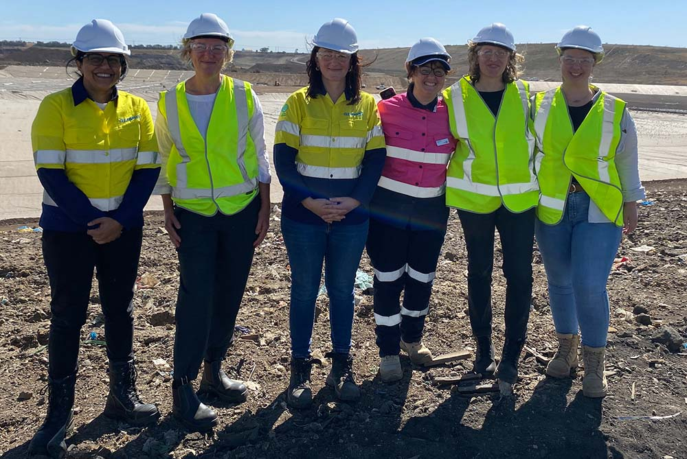
Recycling Victoria visited west zone operator Tomra Cleanaway’s reverse vending machine warehouse in Clayton on 17 September 2023. Former Victorian Minister for Environment, the Hon Ingrid Stitt, local government representatives, the Head, Recycling Victoria and Executive Officer, Gippsland, Matthew Peake toured the facility, which employs world-leading technology in the production of infrastructure to support the container deposit scheme.
The tour was also an acknowledgement of the scheme’s estimated 600 jobs across Victoria with 200 new jobs across the west zone alone. Roles created include sales staff, technicians, collections drivers, refund point operator staff, and recycling sorting facility operators.
Other site visits included Asahi Beverages, Carlton & United Breweries and the Circular Plastics Australia Recycling Facility in December 2023, Cleanaway in February 2024, and Visy Coolaroo Drum Pulper, W2E and Recycled Paper Mills in June 2024.

Contributing at conference and external presentation
The Head, Recycling Victoria presented at 10 conferences and forums during 2023–24.
The Head, Recycling Victoria joined The Hon. Ingrid Stitt, former Minister for Environment, EPA CEO Lee Miezis and Sustainability Victoria’s Interim CEO Matt Genever as the keynote speakers at the Waste Expo in Melbourne in October 2023. The Head, Recycling Victoria also participated in the Waste Expo panel on “What does a Modern Contemporary Regulator look like?”.
Senior staff from Recycling Victoria presented at the Victorian Waste Management Association State Conference 2024 in April 2024. The Head, Recycling Victoria was a keynote speaker and participated in the panel discussion on resilience, growth, and change. Recycling Victoria’s Director Container Deposit Scheme, Sonia Parisi provided policy update on the Container Deposit Scheme, Project Director Sector Risk and Issues Management, Nicholas Nagle presented on ‘Risk, Consequence and Contingency Planning – Towards Implementation’, and Director Sector Strengthening Peter Laslett gave a special presentation on the VRIP to the conference attendees.
Recycling Victoria’s Executive Director Strategy, Procurement and Planning, Deb Cailes, facilitated a panel discussion on “Fixing Gap 2. Procurement programs that drive innovation, sales, circularity and recycled content” at the A-NZ Plastics and Circular Economy Conference in October 2023. At the VWMA Breakfast Briefing as part of the Waste Expo in Melbourne on 25 October 2023, Deb participated in a panel discussion regarding changes to the industry and how entities are working together.

Formal consultation
Recycling Victoria formally consulted with stakeholders via the Victorian Government’s centralised online consultation platform, Engage Victoria, on 4 matters.
Table 1: Consultations with stakeholders
Consultation via Engage Victoria |  | Timeline
Container Deposit Scheme Refund Sharing Protocols | - Draft Material Recovery Facilities Protocol  - Draft Local Government Refund Sharing Protocol | 30 June – 11 August 2023
Container Deposit Scheme determinations instruments | - Draft First Supplier Determination Instrument  - Draft Suitable Eligible Container Determination Instrument | 11 July – 11 August 2023
Victorian Recycling Infrastructure Plan | - Draft summary Victorian Recycling Infrastructure Plan consultation document | 28 March – 28 April 2024
Household Waste and Recycling  Service Standard | - Draft Household Waste and Recycling Service Standard 2024 | 18 June – 14 August 2024

Our people
Our people deliver a multitude of services and value to the Victorian community and stakeholders each year.
In 2024, Recycling Victoria held 2 all-staff in-person events, in March and May. These events provided the opportunity to come together as a newly organised group, to progress connection, collaboration and commitment to Recycling Victoria and each other. Staff collaborated to consider their individual and collective actions and contributions, and provided valuable input to continue that progress.
Recycling Victoria workforce data is included in the DEECA Annual Report 2023–24.

Section 22 (2) Annual Report Mandatory Content
Section 22 of the CE Act requires the Head, Recycling Victoria, to submit to the Minister an Annual Report, on or before 30 September each year. The prescribed minimum contents of the report are shown in the following table, along with a reconciliation of how they are addressed by this current edition.
Table 2: Prescribed minimum contents of the annual report
Leg. Ref | Legislative requirement | Outcome | Comment
S22(2) | An annual report under subsection (1) must include the following— |  | Recycling Victoria Annual Report 2023–24 has been prepared
S22(2)(a) | the total number of written directions given by the Minister under this Act; | No written  directions | No written directions were given under the CE Act during 2023–24
S22(2)(b) | the total number of written directions given by the Head, Recycling Victoria under this Act; | No written  directions
S22(2)(c) | a description or summary of each written direction; | Not applicable
S22(2)(d) | a copy of each written direction as published in accordance with this Act; | Not applicable
S22(2)(e) | details of the community engagement activities undertaken by the Head, Recycling Victoria in accordance with any existing community engagement strategy | Stakeholder engagement  Page 44 in this report | The Community Engagement Strategy was approved by the Minister in July 2023  Details of community engagement activities undertaken during 2023–24 have been included in this report.
S22(2)(f) | a description or summary of the key risks, consequences and measures identified in the Circular Economy Risk, Consequence and Contingency Plan (CERCC Plan) | CERCC Plan  Page 35 in this report | Waste, recycling and resource recovery sector risk sector risks, consequences and measures are contained in the approved CERCC plan 2024. A summary is provided in this annual report.
S22(2)(g) | the total number of responsible entities that are required to prepare a Responsible Entity Risk, Consequence and Contingency Plan (RERCC Plan) under section 74F | 10 | 10 entities self-assessed as responsible entities in 2023–24 and are required to prepare a RERCC Plan under section 74F by 30 September 2024. The inaugural notification period for entities had not concluded at the time of this report; the initial 60-day notification period ended on 8 July 2024.
S22(2)(h) | the total number of statements of assurance submitted to the Head, Recycling Victoria under section 74G | 0 | The statements of assurance are due after 30 June 2024 and will be reported in the next annual report.
S22(2)(i) | the total number of written reports (in relation to RERCC Plans) prepared by the Head, Recycling Victoria (as directed by the Minister) under section 74I; | Not applicable | The Minister for Environment did not direct preparation of any written reports relating to RERCC Plans during 2023–24.
S22(2)(j) | a description or summary of each written report prepared under section 74I; | Not applicable
S22(2)(k) | details of any actions that the Head, Recycling Victoria has carried out or proposes to carry out in response to a written report prepared under section 74I. | Not applicable
recycling.vic.gov.au
End of document.

