Update of the Victorian Freight Plan
Conversation summary October 2024

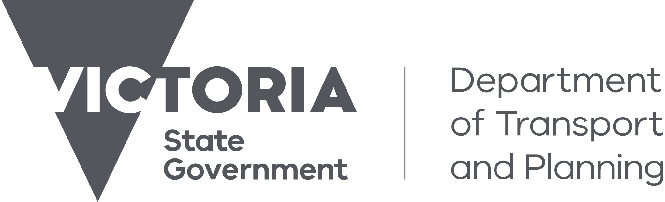

Contents
Acknowledgements 2
Introduction 4
Our stakeholder engagement strategy 5
Stakeholder Reference Group 5
Industry summit 6
Discussion Paper 6
Direct engagement 6
Engagement highlights 6
What we asked 7
A summary of what we heard 7
Infrastructure 8
Land use planning 8
Harmonisation 9
Freight task 9
Supply chain performance 9
Workforce planning 9
Cost of operations 10
Decarbonisation 10
Safety 10
Priority areas 10
Next steps 11
Contributors 11

Acknowledgements
Authorised and published by the Department of Transport and Planning, Melbourne October 2024
© The State of Victoria, Department of Transport and Planning 2024
This work is licensed under a Creative Commons Attribution 4.0 International licence. You are free to re-use the work under that licence, on the condition that images, photographs or branding, including the Victorian Coat of Arms, the Victorian Government logo and the Department of Transport and Planning (DTP) logo. To view a copy of this licence, visit http://creativecommons.org/licenses/by/4.0/
We proudly acknowledge First Peoples throughout Victoria. We acknowledge their ongoing strength in practising the world’s oldest living culture. We acknowledge the Traditional Owners’ lands, waters and skies on which we live and work, and we pay our respects to Elders past and present.
We recognise the use of Song Lines as an integral part of First Peoples Culture which allowed First Peoples to easily connect their journeys across Victoria. We recognise the cultural significance of Song Lines as trade routes and ceremonial paths, and that some of the freight networks and assets we use today are on those traditional Song Line routes.
Description of artwork
Aaron (Gunaikurnai) ‘Movements Between the Five Clans’ 2019, acrylic on canvas.
‘The tracks are going between the five clans of the Gunaikurnai and the hands are the symbols of my spirit travelling around the campsites.’
This artwork was created through programs provided by the Torch. The Torch provides art, cultural and arts industry support to Indigenous offenders and ex-offenders in Victoria. The Torch aims to reduce the rate of re-offending by encouraging the exploration of identity and culture through art programs to define new pathways upon release
Disclaimer
This publication may be of assistance to you, but the State of Victoria and its employees do not guarantee that the publication is without flaw of any kind or is wholly appropriate for your particular purposes and therefore disclaims all liability for any error, loss or other consequence which may arise from you relying on any information in this publication.
Accessibility
If you would like to receive this publication in an accessible format, please email freightvictoria@transport.vic.gov.au.
This document is also available in PDF format at vic.gov.au/ freight-victoria
Description of artwork
Aaron (Gunaikurnai) ‘Movements Between the Five Clans’ 2019, acrylic on canvas.
‘The tracks are going between the five clans of the Gunaikurnai and the hands are the symbols of my spirit travelling around the campsites.’
This artwork was created through programs provided by the Torch. The Torch provides art, cultural and arts industry support to Indigenous offenders and ex-offenders in Victoria. The Torch aims to reduce the rate of re-offending by encouraging the exploration of identity and culture through art programs to define new pathways upon release.

Introduction
Victoria is the freight and logistics capital of Australia. Our state is the nation’s largest exporter of agricultural commodities and generates more freight sector activity per person than any other state. Resilient, productive and sustainable freight connections are essential to the success of Victoria’s businesses and communities.
The Victorian Freight Plan was published in 2018. Since then, a lot has changed both within Australia and across the world. Impacts from the pandemic, global conflict and local supply disruptions have highlighted the critical role of the freight sector.
The past few years have also seen growing momentum for decarbonisation of our economy, including through the introduction of stronger climate action targets, and growing community demand for action to improve air quality, particularly in industrialised areas of Melbourne. As the world has been going through significant change, technological innovation and improved access to data are also driving new opportunities to boost supply chain efficiency, safety and connectedness.
To respond to this changing environment, the Victorian Government is updating the Victorian Freight Plan. Input from stakeholders is vital to this update and the Department of Transport and Planning (DTP) is committed to authentic engagement that:
- builds productive partnerships between the department and industry and across government
- informs the initiation, design and development of our work
- creates better understanding of freight system issues and the impact of our work.
This document summarises the key themes from the broad engagement to inform the update. The engagement has included:
- the establishment of a senior level Industry Stakeholder Reference Group to inform and guide the update process
- the release of a discussion paper setting the context for the update and seeking feedback on the key issues that need to be considered in an updated plan
- an industry summit held in June 2024 with 86 leaders from across the freight sector and government
- opportunities for one-on-one engagement wherever requested
- an online survey and submission process open to all Victorians on Engage Victoria.
This wide-ranging engagement has attracted a strong response with over 200 potential actions for consideration. Common themes across those actions have been developed for the purpose of this summary and all detailed feedback will be considered in the updating of the plan.
We thank everyone who has given their time to contribute to the Victorian Freight Plan update, the roadmap for our freight system, giving long-term confidence to the sector and supporting the liveability and prosperity of all Victorians.

Our stakeholder engagement strategy
Through 2024, DTP undertook a comprehensive engagement program to inform the update of the plan that ensured meaningful collaboration with industry, across government, business and the community as described in the diagram below.

Stakeholder Reference Group
A senior level Industry Stakeholder Reference Group was established to guide the update process. The group provided advice on:
- assessing the current plan’s goals to ensure relevance and ability to further improve Victoria’s competitive advantage
- considering appropriate goals, objectives and initiatives for the updated plan, focussing on significant statewide actions
- Informing development of appropriate data-driven and high impact key performance indicators to measure the success of the plan.
The Industry Stakeholder Reference Group includes senior representatives from:
- Australasian Railway Association
- Australian Logistics Council
- Cement Concrete and Aggregates Australia
- Freight Trade Alliance
- Linfox
- Port of Melbourne
- Victorian Chamber of Commerce and Industry
- Victorian Farmers Federation
- Victorian Transport Association.

Industry summit
To gain broad sector input into the updating of the plan, on 5 June 2024, the Department of Transport and Planning hosted a Victorian Freight Plan Industry Summit with approximately 86 representatives from the freight industry and government. The summit provided an opportunity for stakeholders to discuss challenges and actions that could be included in the updated Victorian Freight Plan.

Discussion Paper
Ahead of the summit, a discussion paper on the update of the Victorian Freight Plan was released publicly on the Engage Victoria website, with responses invited until the end of June. We received 86 responses, which included 55 written submissions and 31 online survey responses.

Direct engagement
Freight Victoria met with 82 individual industry, government and community organisations to discuss their unique challenges and ideas for actions in the updated plan.

Engagement highlights
- Over 150 stakeholders engaged, including:
  - 140 separate freight industry organisations – 58 at the industry summit and a further 82 at separate meetings
  - 27 local government councils
    - 11 metropolitan
    - 16 regional and rural
  - 86 responses to the discussion paper process including 55 industry submissions and 31 public online survey responses
Over 200 ideas for potential action
Stakeholders represented:
- Commercial ports
- Rail freight
- Heavy vehicles
- Logistics
- Airports
- Supply Chain
- Businesses
- Tech innovators
- Government and regulatory agencies
- Community groups
- General public
- Universities
- Councils

What we asked
The purpose of engagement was to provide stakeholders with an opportunity to identify their freight system challenges and how the Victorian Government could help address these challenges through an updated Victorian Freight Plan. Our engagement sought feedback on topics important to protect the competitive advantage of freight and logistics in Victoria, including:
- Infrastructure
- Land use planning
- Harmonisation
- Freight task
- Supply chain performance
- Workforce planning
- Cost of operations
- Decarbonisation
- Safety.
We wanted to understand what the most important short, medium and long-term priorities are to support our freight and logistics system through this period of unprecedented growth and rapid change in the broader environment, while allowing us to embrace new opportunities in the future.
We asked stakeholders how we could improve the movement of goods to local, interstate and overseas markets. These discussions provided valuable insights to prepare a blueprint to position the freight sector to meet Victoria’s future challenges and further strengthen the state’s freight advantage.

A summary of what we heard
Moving goods to, from and around Victoria is vital to our economy and enhances our standard of living.
An increase in Victoria’s gross product by $30 billion over the next 2-3 decades will see freight volumes more than double. This growth brings economic prosperity and productivity. High-quality, reliable freight transport and logistics services are essential to our connectedness and liveability, for the success of Victorian businesses and primary producers and job creation across all parts of our economy.
Industry said to achieve this, more needs to be done to safeguard freight networks for the future, especially with Victoria growing faster than any other state. A word analysis of engagement feedback (see following word map) highlighted the need for a simplified and streamlined freight system that works across levels of governments and jurisdictions. Longer term investment and support for a more competitive rail freight and intermodal network were commonly mentioned. Strongly reflected was the need to support rapid decarbonisation uptake. Road and bridge infrastructure investment and prioritisation for industrial land planning for freight were also highlighted.
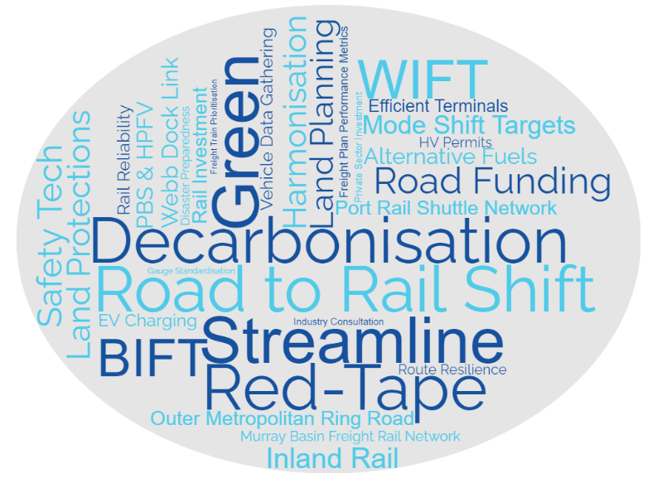
Word cloud showing the priorities identified by stakeholders.
WIFT – Western Interstate Freight Terminal
BIFT – Beveridge Interstate Freight Terminal
In total, we received over 200 ideas for potential actions to consider as part of the update to the Victorian Freight Plan. In this report, we have highlighted the key themes and shown some initial priority areas for the updated plan.

Infrastructure
Stakeholders consistently identified the need for upgrades to bridges and roads to ensure consistent, productive access for heavy vehicles across the network. Also highlighted was the need for investment in rail to improve the competitiveness of rail freight services with road. This includes investment in intermodal terminals and existing rail lines.
Key themes
- Clearly prioritise maintenance, upgrades and new freight corridors that consider future use of low emission freight vehicles and climate change impacts
- Provide greater prominence to the Principal Freight Network for road and rail and provider clearer information about network capabilities – for example rail axle loads and line speeds, road access limitations, design standards, rest areas
- A commitment to rail, road and port optimised intermodals to create an efficient and productive freight system and give private investment confidence.

Land use planning
Stakeholders identified that the availability of industrial land for freight and logistics and associated freight corridors was a significant issue, particularly across Greater Melbourne. Slow planning processes and delays in developing supporting infrastructure, for example roads and utilities are constraining land use. Also raised was protection of land and access requirements for extractive and agricultural use.
Key themes
- Secure, protect, expand and unlock strategically located industrial land and associated freight corridors that are unencumbered by residential encroachment and curfews, that allow for future growth and are accessible to the workforce
- Educate urban planners and land planning decision makers on freight system requirements and ensure integration of future freight requirements in Plan for Victoria
- Designate strategic agricultural and extractive resource areas with buffers to ensure they are not built over and have adequate access.

Harmonisation
Stakeholders noted frustration and financial burden with the lack of consistency in administrative and regulatory requirements for freight movements across jurisdictions and levels of government and even between infrastructure managers.
Key themes
- Update the Victorian Freight Plan in alignment with other jurisdictional and Victorian Government plans
- Simplify and streamline regulations and policies, for example landside tariffs, planning approvals, access, permits
- Centralise and prioritise oversight of the Victorian rail freight system
- Protect rail freight capacity on shared rail networks
- Align rail signalling, systems, operating rules and standards across Australia.

Freight task
Stakeholders highlighted the need to focus on the expected increase in freight volumes and complexities.
Key themes
- Focus on a longer-term investment plan for regional rail freight
- Allow for future co-location of additional freight infrastructure around key intermodals and ports for warehousing, rail line amplification, new terminals and stabling
- Provide for greater use and access (including first and last mile) of high performance freight vehicles (HPFV) including further dimension increases.

Supply chain performance
Stakeholders noted the impact of disruption on the supply chain and lack of centralised information on supply chain performance.
Key themes
- Better manage, coordinate, consult and communicate with the freight industry on civil works and other supply chain disruptions. Potential for Freight Impact Statements for major works
- Support more consistent, authoritative and centralised freight data, for example supply chain mapping, freight movements, journey times, network reliability and capability, accidents, rest areas and facilities, intermodal use, average loads, and noise and emissions
- Improve traffic/rail management systems, for example synchronised traffic lights, harmonised train signalling, freight rail booking systems, telematics, smart onboard mass implementation, and route optimisation.

Workforce planning
Stakeholders highlighted industry skills shortages and their causes, including attractiveness of the industry, an ageing workforce, immigration policy and employment restrictions. Industrial relations challenges were also noted.
Key themes
- Undertake assessment of supply chain workforce – current and future needs
- Work with reputable education and training providers to deliver accredited and affordable courses
- Provide guidance on improving workplace environments to attract and retain a diverse workforce
- Expand skilled migrant visas to supply chain roles.

Cost of operations
Stakeholders indicated the cost of moving freight was increasing and suggested the government could provide additional support.
Key themes
- Explore incentives, such as rebates, for mode shift to rail and for transitioning to more efficient and less polluting vehicles
- Reduce or remove land and payroll taxes, stamp duties, tolls and bridge assessment fees
- Ensure port fees are competitive with other states
- Assure timeframes for projects, infrastructure and policies to give private investment confidence.

Decarbonisation
Stakeholders wanted a clear and aligned roadmap to create confidence on investment in low emission vehicles and technology.
Key themes
- Provide a clear supply chain decarbonisation roadmap that harmonises nationally
- Provide industry guidance on decarbonisation adoption
- Explore potential incentives for transition – grants, tax breaks, curfew exemptions, access.

Safety
Stakeholders wanted safety to be a key consideration of the Freight Plan, especially for the workforce with the risks inherent in the work.
Key themes
- Upgrade road and rail freight network, bridges, pavements, safety monitoring to improve driver safety
- Work with the Commonwealth to improve safety across the network – such as trialling new safety technology and encouraging more heavy vehicle rest stop areas
- Use smart infrastructure, telematics, automation, routing and encourage adoption of newer vehicles that provide data and video to help identify hazards.

Priority areas
The engagement process has informed the development of 12 priority areas under four objectives with actions to be developed as part of an updated Victorian Freight Plan:
Ensure availability of fit for purpose freight network and gateway capacity to meet current and future need
  - Support Victoria’s gateways to meet the growing freight task
  - Safeguard key freight routes and gateways through planning
  - Optimise the capacity of the freight networks.
Enable more efficient and productive freight and supply chains
  - More efficient network access
  - Government supporting industry collaboration
  - Supporting improved supply chain performance.
Manage the impacts of freight operations on communities and drive decarbonisation
  - Create certainty for industry to invest in decarbonisation
  - Support transition to low carbon freight operations
  - Mitigating impact to surrounding communities.
Enhance the safety and resilience of Victoria’s freight industry
  - Improving resilience of the freight networks
  - Improve safety outcomes across freight networks
  - Support for industry to source appropriately skilled workers.
The plan will also include a set of key performance indicators to measure progress towards the priority areas.

Next steps
Thank you to everyone who invested their time to give us feedback to inform the update of the Victorian Freight Plan. We value your insights and perspectives and will consider the challenges and priorities you shared to guide our updated freight plan.
We are considering the feedback we have received to ensure high-quality, reliable freight transport and logistics services. These services will continue to support connectedness and liveability in Victoria, and contribute to the success of Victorian businesses, primary producers and job creation across all parts of our economy.
Information on the development of the updated Victorian Freight Plan is available at www.vic.gov.au/freight-victoria.
We aim to finalise an updated Victorian Freight Plan by the end of the year. We may call on industry and other stakeholders for further input before then. In the meantime, please contact us at freightvictoria@transport.vic.gov.au if you would like to make further contributions.

Contributors
Thank you to everyone who has contributed to the conversation. As well as many individual community members, we heard from:
ACFS Port Logistics
Advantia Transport Consulting
Arrow Logistics
Allied Seafreight
Aurizon
Austrak
Australian Bluegum Plantations
Australasian Railway Association
Australia Post
Australian Logistics Council
Australian Peak Shippers Association / Freight Trade Alliance
Australian Rail Track Corporation
Austroads
Avalon Airport
Bass Coast Shire Council
Baw Baw Shire Council
Border Town Haulage, Karger Commodities
Butler Freight Services
Cartage Australia
Cement Concrete & Aggregates Australia
Central Goldfields Shire Council
CHS Broadbent
City of Mount Gambier
City of Stonnington
City of Whittlesea
Climateworks Centre
CMA CGM Group
CMV Truck & Bus
Committee for Greater Shepparton
Committee for Melbourne
Construction Material Processors Association
Container Transport Alliance Australia
Corangamite Shire Council
CoreLogic Australia
Crane Industry Council of Australia
Cross Border Commissioner
C.T. Freight
Daimler Truck Australia Pacific
Dairy Australia
Darebin City Council
Diamond Freight
DP World
Dronamics
East Gippsland Shire Council
ESR Australia
FBT Transwest
Fennell Forestry
Frankston City Council
Freightnet Vic
Gannawarra Shire Council
Gippsland Dairy
Glenelg Shire Council
Golden Plains Shire Council
GrainCorp
GrainGrowers
Greater Shepparton City Council
Greater South East Melbourne
Green Triangle Freight Action Group
Green Triangle Forest Industries Hub
Heavy Vehicle Industry Australia
Hyzon Motors
IFC Global Logistics and Warehousing
IKEA
Intermodal Terminal Company
International Forwarders and Customs Brokers Association of Australia
K&S Corporation
Linfox
Livestock and Rural Transporters Association of Victoria
Loddon Shire Council
Logos Property Group
Maribyrnong City Council
Maribyrnong Truck Action Group
McColls Transport
Meat and Livestock Association
Melbourne Airport
Melbourne Market Authority
Melbourne Seafood Centre
Melton City Council
Merrett Logging
Metro Trains Melbourne
Mildura Airport
Mitchell Shire Council
Mondiale VGL
Mornington Peninsula Shire
Mov3ment
Moyne Shire Council
Municipal Association of Victoria
National Heavy Vehicle Regulator
National Intermodal
National Transport Commission
National Transport Research Organisation
NatRoad
Nolan’s Interstate Transport
Northern Grampians Shire Council
Pacific National
Parks Victoria
Patrick Terminals
Port of Melbourne
Port of Portland
Ports Victoria
Property Council of Australia
Pure Foods
Qube Logistics
Rail Freight Alliance
Rail Futures Institute
Rail Operators Group
Redi Milk
Roads Australia
Salta Properties
Sargeant Transport
SCT Logistics
Seaway Intermodal
Secon Freight Logistics
Sidelink Transport
Silk Logistics
South East Melbourne Manufacturers Alliance
South Gippsland Shire Council
South West Fibre
Southern Grampians Shire Council
Southern Shorthaul Railroad
Swan Hill Rural City Council
Swinburne University of Technology
Tasman Logistics Services
Timber Towns Victoria
Toll Group
Transurban
V-DAQ
V/Line
Valley Pack Cold Storage
Vantrans Container Transport
Victoria International Container Terminal Limited
Victorian Chamber of Commerce and Industry
Victorian Farmers Federation
Victorian Forest Products Association
Victorian Planning Authority
Victorian Transport Association
Volvo
WCBM World Freight
West Wimmera Shire Council
Westlink Container Park
Wyndham City Council

