Membership Types
Multiple users can now be associated with an organisation’s Portal profile, to manage the organisation’s account and licence processes.
Access Type | Manage User Access Requests | Change User Access Permissions | Apply for a Licence | Submit Notifications | Request a Licence Variation
Group Administrator | 
Group Editor
Group Viewer | VIEW ONLY |  | VIEW ONLY | VIEW ONLY | VIEW ONLY

Adding New Users or Changing Membership Type (For Group Administrators)
If you are a Group Administrator, you can add New Members to your organisation profile and update user Membership Types by:
Step 1) From the ‘HOME’ tab in ‘My Submissions’ dashboard, click on your Registered Organisation – this should start with ‘OPROF’.
Note: If you do not have a Registered Organisation, please see User Guide: Creating an Organisation Profile.
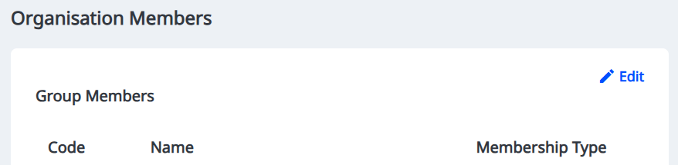
Step 2) Click on ‘Edit’ to update the Membership Type for existing Group Members or add new Group Members for your organisation

Step 4) By clicking the three dots ‘…’ next to the relevant user, you can either:
Modify member: Choose a different membership type for this member
Remove member: Remove the member from your organisation profile
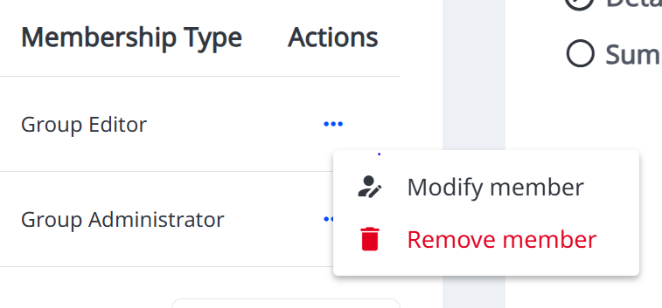


Step 5) Select ‘+ New Member’ to add a new Group Member
Make sure the person you are adding already has a Portal log in account

Step 6) Search for the Group Member using their Portal log-in email address and select the membership type you would like to grant to them.
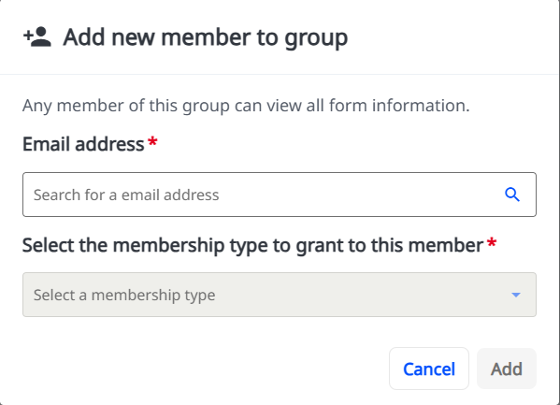

Requesting Access to an Organisation
Step 1) Create an account and log in to the Portal account
Step 2) Select ‘Organisation Access Request’ from the Portal homepage
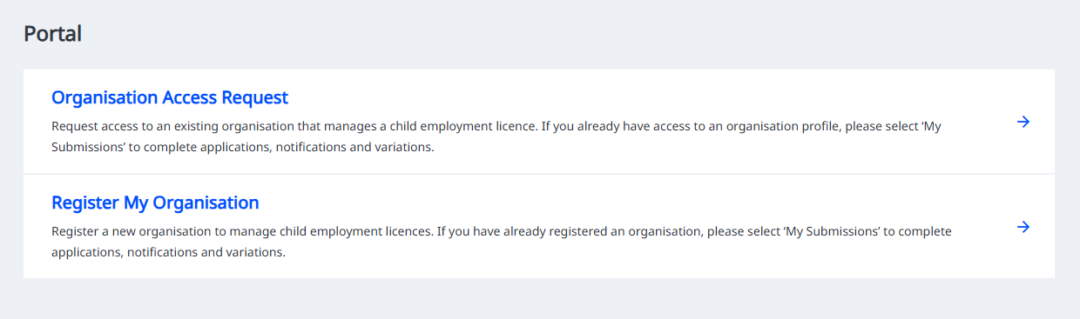

Step 3) Fill in your details and the details of the organisation you would like to access.
The organisation must be registered before you can request access. See User Guide: Creating an Organisation Profile for more information.
Step 4) Click ‘Send Access Request’ once you have reviewed the details of your access request.
Step 5) The Group Administrator will be notified to of your request to join the organisation’s Portal profile.
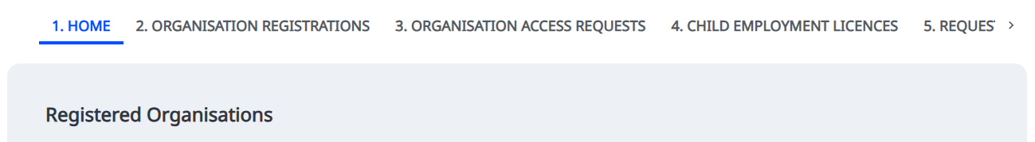
Step 6) When your access

Approving Access Requests (For Group Administrators)
If you are a Group Administrator, you will be notified of requests from New Members wanting to access your organisation profile. You can review these requests by:
Step 1) From the ‘HOME’ tab in ‘My Submissions’ dashboard, click on your Registered Organisation – this should start with ‘OPROF’.
If you do not have a Registered Organisation, please see User Guide: Creating an Organisation Profile.
Step 2) Under ‘Membership Update Requests’, click on the relevant request you want to review. This should start with ‘MU’
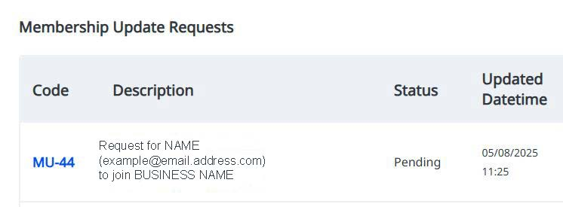

Step 3) You can review the details of the request and select either approve or deny
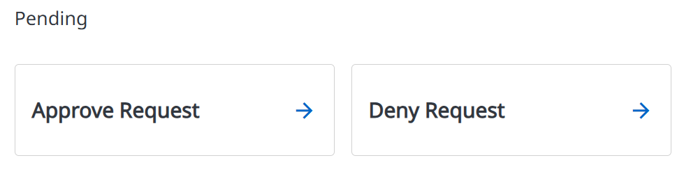

Step 4) The user will automatically be provided with the Group Editor Membership Type.

