Apply for a Licence
Step 1) Log in to your Portal account and select ‘My Submissions’ to view your dashboard
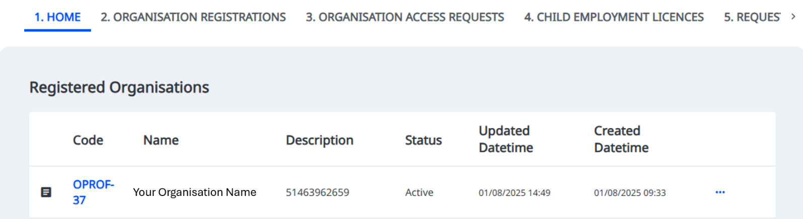
Step 2) Click on the relevant organisation, starting with ‘OPROF’ or the three dots ‘…’

Step 3) Select ‘New licence application’
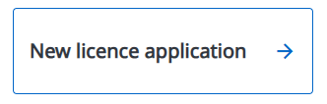

Step 4) Select the type of licence you want to apply for: General or Entertainment.

This will depend on the activities or duties the child is performing. See Introduction: Mandatory Code of Practice for the Employment of Children in Entertainment (2014) for information on the definition of entertainment.

Step 5) Once you have provided information about the employer, the employment details, and the Fit and Proper Person Declaration, your application is ready to submit.
Make sure you select ‘Submit’, otherwise your application will remain in draft and cannot be reviewed by our assessment team.

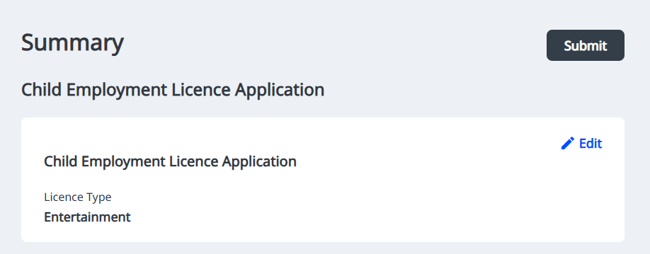
Step 6) Licence applications will be visible in the ‘Child Employment Licences’ tab in the Portal, or by clicking on the relevant organisation on your Portal homepage.
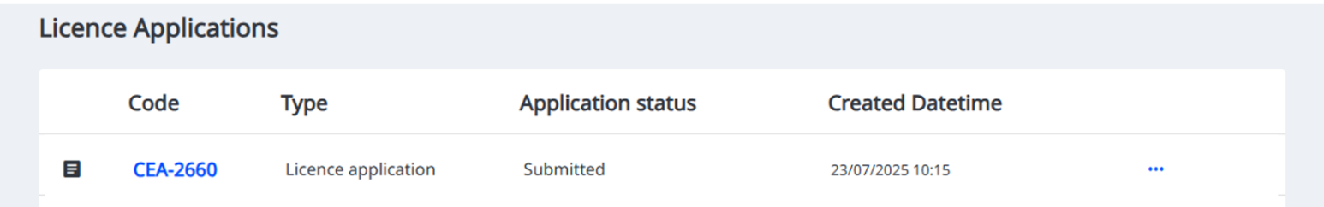

Application time frames
You cannot employ a child until you have a licence.
Submit your licence application at least 10 business days before any children are scheduled to start work, and ensure you provide all mandatory information to avoid delays in the assessment process.
When assessing an application, we consider whether the applicant:
- will act with integrity and honesty
- understands child employment regulations and restrictions
- can comply with the relevant laws, including the Child Safe Standards.
Employers may be subject to a National Police Check. If a police check is required, you will be notified after submitting your licence application.
There is no cost to the licence applicant.
Your information is kept secure and will only be used for the purpose of assessing the licence application.

