Submit a notification
Employers must use our online portal to notify us of each child they employ. It is preferable that we are notified before the child has started work.
Step 1) Log in to your Portal account and select ‘My Submissions’ to view your dashboard
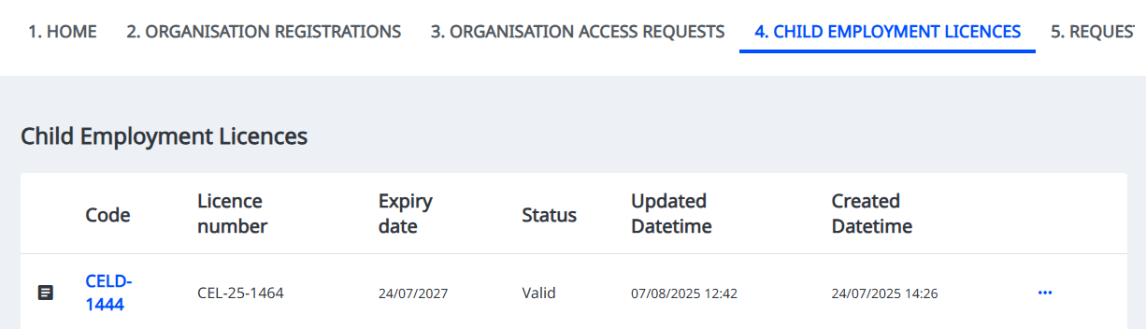
Step 2) Click on the ‘Child Employment Licences’ tab to view your active licences
Step 3) Click on the licence or the three dots ‘…’ and select ‘Notify us of an employee under 15’
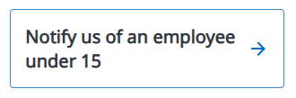

Step 4) Notifications will be visible in the ‘Notifications’ tab in the Portal, or by clicking on the relevant organisation on your Portal homepage.

If the duties or hazards differ to those identified in the original licence application, you will need to provide an updated description of the tasks or activities the children will undertake in the workplace.
