Request a licence variation
All child employment licence holders can request a variation to the:
- licence period
- licence conditions
- employer details
- nominated officer or employer representative details.


Please note: Applications to vary the Mandatory Code of Practice for Employment of Children in Entertainment cannot be made through the Portal. Further information on application requirements can be found here.

Step 1) Log in to your Portal account and select ‘My Submissions’ to view your dashboard
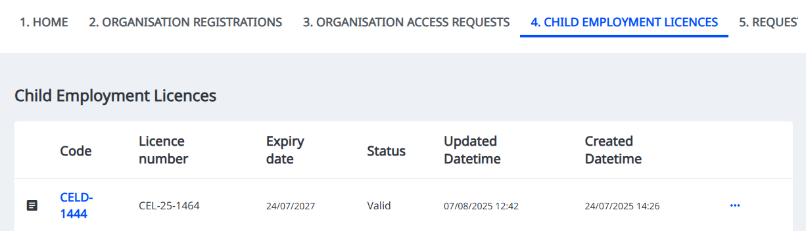
Step 2) Click on the ‘Child Employment Licences’ tab to view your active licences
Step 3) Click on the licence or the three dots ‘…’ and select ‘Vary licence’
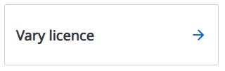

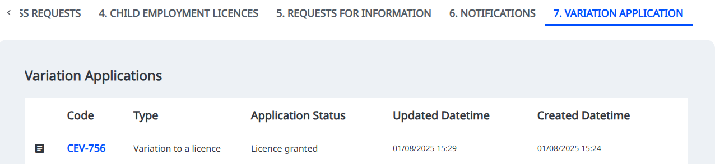
Step 4) Variation applications will be visible in the ‘Variation Application’ tab in the Portal, or by clicking on the relevant organisation on your Portal homepage.

