Department of Transport and Planning
VICTORIA DELIVERS
VICTORIAN FREIGHT PLAN 2025-30
Accessible version
Authorised by the Victorian Government, Melbourne
1 Spring Street Melbourne Victoria 3000
Telephone (03) 9655 6666
Designed and published by the Department of Transport and Planning
Contact us if you need this information in another accessible format such as large print or audio, please telephone (03) 9655 6666 or email community@transport.vic.gov.au
© Copyright State of Victoria Department of Transport and Planning
Except for any logos, emblems, trademarks, artwork and photography this document is made available under the terms of the Creative Commons Attribution 3.0 Australia licence.

CONTENTS
ACKNOWLEDGEMENT OF COUNTRY 4
MINISTERIAL FOREWORD 5
ABOUT THIS DOCUMENT 7
Developing the Plan 7
INTRODUCTION 8
The importance of freight to Victoria’s liveability and economic prosperity 8
The Victorian freight network 9
WHAT’S CHANGED SINCE 2018? 12
Pandemic 12
Global and local volatility 13
Climate change and extreme weather event impacts 13
Towards net-zero – Decarbonising supply chains 13
Increasing cost pressures 14
The freight task will increase with population growth 14
HOW THE VICTORIAN FREIGHT INDUSTRY WILL LOOK IN 2030 18
THE PLAN 19
STRATEGIC OBJECTIVES AND ACTIONS 20
OBJECTIVE 1: Ensure availability of fit for purpose freight network and gateway capacity to meet current and future need 20
OBJECTIVE 2: Enable more efficient and productive freight supply chains 28
OBJECTIVE 3: Supporting climate and sustainability goals and liveable communities and places 35
OBJECTIVE 4: Enhance the safety and resilience of Victoria’s freight industry 41
KEY PERFORMANCE INDICATORS – WHAT SUCCESS LOOKS LIKE 46
DIRECTIONS TABLE 47
GLOSSARY 50

ACKNOWLEDGEMENT OF COUNTRY
We proudly acknowledge the First Peoples of Victoria and their ongoing strength in practising the world’s oldest living culture. We acknowledge the Traditional Owners’ lands, waters and skies on which we live and work and pay our respects to their Elders past and present.
The Department of Transport and Planning recognise that many of today’s modern freight modalities and routes - from rail lines, to roads, to water crossings - follow traditional Song Lines used by First Peoples for travel, trade and ceremony.
This Freight Plan is an opportunity to strengthen our partnerships with Traditional Owners and First Peoples in Victoria to ensure their aspirations are realised.
Victoria’s principal freight network and the twelve Registered Aboriginal Parties of Victoria
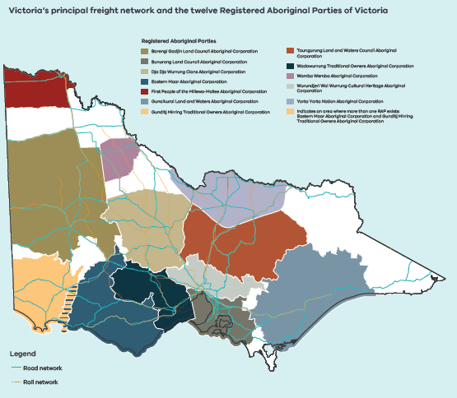

MINISTERIAL FOREWORD
Victoria is the freight and logistics capital of Australia. Our State is the nation’s largest exporter of agricultural commodities and generates the greatest sectoral economic activity and jobs. Resilient, productive and sustainable freight connections are integral to the success of business and primary producers.
The last Victorian Freight Plan: Delivering the Goods was published in 2018, the same year I became Minister for Ports and Freight. The plan responded to the needs of industry, and much was achieved out of that plan.
Since then, the context for freight has changed. Impacts from the pandemic, global conflict and local disruptions have highlighted our dependency on effective supply chains.
In parallel, we have seen increased momentum for decarbonisation, including significant zero emission targets, and community demand for action on climate change and improvements to air quality. Technological innovation and improved access to data also provides opportunities to boost supply chain efficiency, safety and connectedness.
This changed environment required an update to the Victorian Freight Plan with an even greater focus on effective, connected, safe and prosperous supply chains.
Industry engagement has been integral to the development of this Plan. We’re listening and we’ll work to ensure Victoria maintains and grows its competitive advantage. We heard from industry what it will take to attract more private investment to our State: giving greater long-term certainty, making operations more cost-effective, and incentivising cleaner and safer movement of freight within and beyond our borders.
We have set challenging but achievable targets in this Plan. Some we will achieve through new policy settings, reduction in red tape, negotiation and harmonisation with other government jurisdictions, and through key projects. Others will be achieved in partnership with industry. We know that collaboration is key to a successful Victorian freight system, and we will strive to give industry the confidence it needs to join us in achieving these goals.
I am excited that we have an updated roadmap for the Victorian freight supply chain, and I am looking forward to progressing these vital actions. This Plan will ultimately improve the prosperity and liveability of all Victorians.

Melissa Horne MP
Minister for Ports and Freight

This Plan was developed in consultation with key stakeholders from the freight and logistics supply chain. The engagement attracted a strong response with over 200 potential actions for consideration.

ABOUT THIS DOCUMENT
The Victorian Freight Plan is the Government's plan to meet the challenge of higher freight volumes as Victoria’s population continues to grow and our demand for freight continues to increase. It outlines the high-level objectives and vision of the Government and the actions that we will take to deliver on these objectives over the next five years to support thriving freight and supply chains in Victoria.

Developing the Plan
This Plan was developed by the Department of Transport and Planning (DTP) in consultation with key stakeholders from the freight and logistics supply chain. Engagement included:
- the establishment of a senior level Industry Stakeholder Reference Group (ISRG) to inform and guide the update process
- the release of a discussion paper setting the context for the update and seeking feedback on the key issues that need to be considered in an updated plan
- an industry summit held in June 2024 with 86 leaders from across the freight sector and government
- opportunities for one-on-one engagement
- an online survey and submission process open to all Victorians on Engage Victoria.
The wide-ranging engagement attracted a strong response with over 200 potential actions for consideration. All feedback was considered in the updating of the Plan. A Conversation Summary outlining what DTP heard during the engagement process can be found on DTP's website.
DTP gratefully acknowledge everyone who gave their time to contribute to the Victorian Freight Plan update, the roadmap for our freight system. This Plan will provide long-term confidence to the sector and support the liveability and prosperity of all Victorians.
Industry Stakeholder Reference Group Membership
Australian Logistics Council
Australasian Railway Association
Freight & Trade Alliance (FTA) / Australian Peak Shippers Association (APSA)
Linfox
Port of Melbourne
Cement Concrete and Aggregates Australia
Victorian Chamber of Commerce and Industry
Victorian Farmers Federation
Victorian Transport Association

INTRODUCTION

The importance of freight to Victoria’s liveability and economic prosperity
Victorians are connected to the world through a network of international and domestic ports and reliable, efficient freight and logistics services, keeping shelves stocked for families and generating opportunities for thousands of businesses, factories and farms all over the State. Every item in our homes, workplaces and play spaces and the materials used to construct our buildings and infrastructure have been carried by the freight sector to improve the liveability of Victoria. Freight is the conduit for the products that Victorian industries and communities rely on. Victoria generates more growth and jobs from freight than any other State, and freight is the economic engine for much of regional Victoria. This Plan sets the blueprint to guide investment and development of the state's freight networks and systems to protect and strengthen Victoria's traditional competitive advantages across the freight and logistics supply chain.
Freight and logistics are estimated to contribute at least $36 billion (or a little over 6 per cent) to Victoria's Gross State Product (GSP) and employs around 240,000 full time equivalent positions across the State. Analysis indicates that the sector has consistently made up around 6-8 per cent of GSP over the past 20 years. The Victorian freight task continues to grow every year and is estimated to increase from around 440 million tonnes in 2020-21 to 908 million tonnes by 2050-51 - more than doubling over 30 years between 2020 and 2050. As the freight task continues to grow, so too will the contribution of freight and logistics to the economy.
Maintaining Victoria’s competitive advantage in freight and logistics is important for every Victorian - the freight sector provides employment, delivers our goods and services and is a key component of businesses in every sector of the economy. Better freight connections are essential to the success of Victorian businesses and primary producers and ensuring affordable construction, and – ultimately - to job creation across all parts of the economy.
Victoria has consistently handled more imports (both in volume terms and value terms), with Victoria re-exporting more freight to other parts of Australia. This is due to a range of factors including its geographic location between states, including acting as the international gateway for trade to Tasmania, its historically larger manufacturing base, the availability of well-priced large flat parcels of land for warehousing and the strength of the agricultural sector.
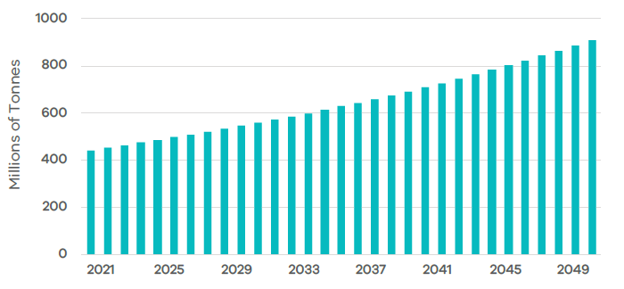Figure 1: Freight Mass Forecast (2020-21 to 2050-51)
These factors have incentivised many companies to establish freight operations in Victoria that service both the Victorian market as well as interstate markets. The result of these advantages has been highlighted through the economic modelling, finding that Victoria handles around 15 per cent more freight per person by mass and value compared to other regions across Australia.
Actions in this Plan are designed to ensure that these advantages are protected to support the freight sector to continue to play a core and growing role in the Victorian economy.
The initiatives will protect and build on Victoria's competitive advantage.
Cross-border collaboration safeguarding sustainable forest industries
The Green Triangle is one of Australia’s major timber production regions spanning the border area between the states of South Australia and Victoria. It has extensive plantation softwood and hardwood resources, and a world competitive processing industry, including pulp and paper manufacturing, sawn timber, wood panels and woodchop export.
The Green Triangle Freight Action Plan Committee was created to capture growth and export opportunities in the timber industry. The Committee has strong representation across the South Australian and Victorian Governments, Cross Border Commissioners, local government and industry including the Port of Portland, freight operators and plantation owners. It focuses on the future needs of the supply chain, including roads, to support approximately 355,000 hectares of soft and hardwood plantations in the region.
The Green Triangle Freight Action Plan has generated over $200 million of public and private sector investment, including more than $100 million in Commonwealth funding for road upgrades, HPFV access on key corridors connecting timer plantations to the Port of Portland and further afield. Strong advocacy from the Committee to the Commonwealth also helped secure a $150 million upgrade to the Maroona-Portland rail line to assist the grain and mineral sands industries.
The use of technical experts and collaboration across key players in the supply chain garners significant support and reduced risk for decision makers. Recognising that the Green Triangle region spans both South Australia and Victoria, strong regional cooperation beyond state borders and a focus on cross border regulatory harmonisation will ensure sustainability of the sector, as well as a renewed forecast of timber production for the next 10 years.

The Victorian freight network
Victoria's population continues to grow and our demand for freight continues to increase. To ensure the freight and logistics sector can meet this demand and minimise transport and flow-on costs, an end-to-end supply chain approach is required so that each mode is optimised to meet the freight task.
Road
Victoria's road network plays a crucial role in the freight task, connecting an intricate supply chain and variety of freight types throughout the State. Though the distances are relatively short, the state's exports are broadly scattered. Government foresees a future where the High Productivity Freight Vehicle (HPFV) network comprises of end-to-end access through integrated interstate, state and local road connections.
The growth of larger vehicles that can carry more freight is essential in ensuring that the capacity of Victoria's road network expands without exponentially increasing the number of heavy vehicles on our roads. Ongoing productivity improvements and the adoption of pre-approved network routes and reference vehicle designs have paved the way for the next generation of newer, cleaner, safer, and more productive vehicles to be introduced to key freight corridors.
HPFV network access
HPFVs help address the ever-growing freight task, while at the same time minimising road use, road impact, and mitigating the impact of the heavy vehicle driver shortage. HPFVs provide reduced emissions for transportation of goods as they use newer, cleaner prime movers in what is expected to be the last road vehicle segments that will move to low and zero emission vehicles.
Since the introduction of the first HPFVs, Victoria has expanded the HPFV network to cover more than 40 per cent of the arterial road network, maximising the extent of the network that HPFVs can operate on safely and without needing a permit.
Rail
Victoria's rail network is critical in providing a means for primary producers and other exporters to get their products to market efficiently, reliably and cost effectively; supporting the movement of containerised and bulk goods including, for example, timber, mineral sands and grain.
The Victorian interstate, regional and metropolitan rail networks are owned by VicTrack and leased to DTP. DTP sub-leases sections of the network to access providers who are responsible for operations, maintenance, customer service and local asset management.
The development of the Statement of Freight Network Capability, Rail Access Guidelines and investment in works to move more freight from road to rail supports Victoria’s freight and logistics system in meeting the needs of a growing freight task, population and economy. Data from V/Line shows that Victoria moves around $1.8 billion of containerised commodities and approximately $500 million of grain, annually.
Improving the efficiency of grain movement
In early 2020, the grain rail industry in Victoria was facing challenges due to a severe three-year drought and uncertainty regarding standardisation plans. At this time grain rail volumes plummeted and most of the grain transportation to ports in Geelong, Portland, and Melbourne relied on road transport.
To address these challenges, the Victorian Government invested in a $40 million freight rail maintenance program starting in the fiscal year 2022. This initiative aimed to breathe new life into regional freight rail networks. Building on this commitment, the Government allocated an additional $181 million over two years to accelerate freight rail maintenance efforts. The goal was to facilitate the introduction of longer, faster, and heavier freight trains, thus bolstering the efficiency and resilience of the industry.

Sea
Victoria’s ports system is a complex mix of shipping and land-side infrastructure that is well established and subject to varying management arrangements and interdependencies. Victoria has four commercial trading ports, declared under the Port Management Act 1995 - the ports of Portland, Geelong, Melbourne, and Hastings.
Victoria’s commercial ports support around 65,000 jobs and generate $9 billion in economic value annually. Ninety-eight per cent of trade comes through commercial ports. As Australia’s largest shipping and bulk trade port by volume, the Port of Melbourne handles approximately three million containers per year.
Activation of the Voluntary Performance Monitoring Framework for the Port of Melbourne
Monitoring the performance of the supply chain is a significant enabler of disruption identification. DTP will continue to work with industry to expand and refine the Voluntary Performance Monitoring Framework to provide greater levels of transparency in the future. Industry is encouraged to continue raising operational and strategic issues in the supply chain through the Port of Melbourne Landside Logistics Working Group.
Air
There has been a strong increase in air freight volumes through all major Australian airports over the last decade. International air freight exports are increasing steadily thanks to growth in Asian markets.
Melbourne Airport (Tullamarine) currently handles around 28 per cent of Australia’s international air freight. The bulk of freight is carried in the belly holds of the 2,300 weekly scheduled domestic and international passenger services that operate from the airport, with a number of dedicated freight carriers also providing uplift capacity. Avalon Airport continues to grow its freight offering with the airport seeing a steady increase in the number of dedicated freight services utilising the airport. As Victoria’s second curfew free international airport, Avalon has the potential to act as a significant freight and logistics hub in the future.
Flying into the future
The Victorian Government is supporting Advanced Air Mobility (AAM), drones and a zero emissions aviation sector that promises transformational industrial opportunities in supply chain logistics, service delivery, regional connectivity and resilience.
The Victorian Government has a range of grant programs and incentives that may be available for AAM companies wishing to enter the Melbourne market.
Deployment of sustainable aviation fuels (SAF) could also play a complementary role in decarbonising air freight alongside AAM. The Victorian Government is considering development of a SAF related policy.
Strategic investments in this transformational sector will create new opportunities in freight delivery, provide better cost-benefit freight delivery outcomes for regional communities, support the decarbonisation of Victoria’s freight delivery supply chain and reduce the need for future investments in significant ground infrastructure to enable commercial operations. Drones for delivery of goods are already operating commercially in Australia and is anticipated to deliver $205 to $340 million in cost savings in 2040.

WHAT’S CHANGED SINCE 2018?
Significant changes have occurred in the operating environment for freight and logistics businesses since 2018.
More than a quarter billion-dollar investment has boosted the volume, mass and speed of freight carried on Victoria’s rail network. New rail, deeper ballast, upgraded culverts and bridges to enable higher loads, and longer passing loops have increased train lengths from 650 to 800 metres and axle loads from 19 to 20 tonnes – a boost in payload from 2,000 to 3,000 tonnes per train that equates to 25 B-double trucks.
The competitiveness of Victoria’s commercial ports has been boosted by upgrades to the roads and rail lines that carry the import and export goods that every Victorian relies on.
Work has accelerated in recent years on introducing more efficient road freight combinations that reduce the number of trucks needed for the freight task. In 2018, there were 317 HPFVs operating on Victorian roads. By the start of 2024, this number had increased to 3,147. Each new vehicle performs the freight task in a more energy efficient, environmentally friendly and safe manner, as well as boosting Victoria’s economy by lowering transport costs.
To support the changes and challenges of the freight operating environment, this Plan builds on the successes of the previous plan to ensure that Government continues to effectively respond to, and plan for, the needs of the freight supply chain and its customers into the future.
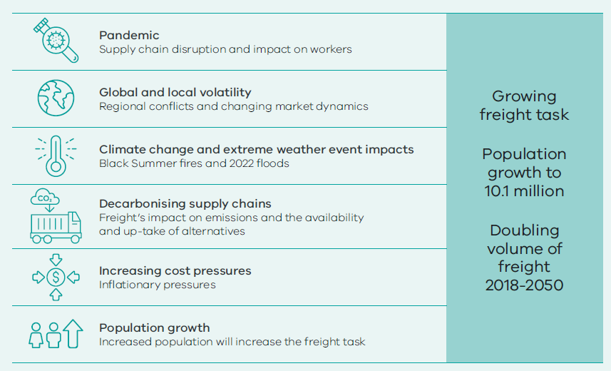

Pandemic
The pandemic saw unprecedented changes to the way we live and work and created volatility for supply chains. Temporary closures of manufacturing and distribution facilities together with bottlenecks at borders impacted the movement of goods in Victoria and other states. It also demonstrated the significant impacts that global disruptions can have on Australia, particularly given the importance of imports and exports to our economy.
The pandemic elevated the role of freight and changed perspectives on supply chain planning and resilience through things like product sourcing and inventory management.

Global and local volatility
Trade tensions, geopolitical conflicts, and changing market dynamics such as rapidly fluctuating sea freight costs are all examples of heightened risks for supply chain disruption. With the value of Victorian import and export goods totalling, in 2023-24, $120 billion and $37 billion respectively, the economy has a strong reliance on overseas supply chains for the purchase and sale of goods, and subsequently, a heightened exposure to a variety of potential disruptions.
Local disruptions also pose a risk to our supply chains, with industrial relations issues and protest activity impacting on supply chain productivity, especially within the Port of Melbourne.
The ACCC released the annual Stevedoring Monitoring Report 2023-24 in December 2024, which reflected a view that there are likely market failures in the container freight supply chain which may require a policy or regulatory response.

Climate change and extreme weather event impacts
Increasing extreme weather events and natural disasters in recent years have placed a heightened focus on the need to respond to climate change, both to improve the resilience of supply chains against its impacts, and to meet climate action government policy goals more generally.
The devastating impacts of the 2019-20 Black Summer bushfires and 2022 floods in eastern Australia, for example, resulted in the isolation of communities, major road closures and extended network outages for rail freight services, all of which contributed to limiting the supply of essential goods and increasing supply chain costs.
Aside from one-off operational impacts, the increased likelihood of natural disasters has contributed to higher insurance premiums, further adding to cost pressures across the supply chain.
The ongoing threat of fires, floods and other natural disasters and the increasing incidence of these events continue to pose risks to supply chains across Victoria. Ensuring resilience for these supply chains will require an emphasis on rapid response to disruption, alternative supply routes and modes, effective maintenance, and where feasible, improvement of freight networks.

Towards net-zero – Decarbonising supply chains
Consistent with increasing recognition of the devastating impacts of climate change, the Victorian Government has set some of the most ambitious emissions reduction targets in the world, with an objective of net-zero carbon emissions by 2045. Currently, 25 per cent of emissions stem from the transport sector and freight transport emissions alone account for roughly a third of these transport emissions – equating to around 8 per cent of Victoria’s overall emissions.
Without action, freight transport emissions could grow to 34 per cent of total emissions in the Victorian economy by 2035 (due to both an increase in the freight task and potential higher abatement of emissions by other sectors).
While Low and Zero Emissions Heavy Vehicles (LZEHVs) offer a potential solution to reducing freight sector emissions, they face barriers to their widespread adoption. Their current limited availability, high upfront cost, access limitations due to their increased mass and scarcity of charging infrastructure have resulted in delays to more definitive action in reducing emissions associated with freight transport operations.
Consistent and supporting regulations can encourage investments in cleaner technologies.
Work is underway to address barriers to access, such as the development of pre-approved network maps for a range of LZEHVs.
Facilitating the increased uptake and long-term viability of these vehicles will be a continued focus of government.
A greater shift of the relative freight task from road to rail would also provide significant climate-related benefits, particularly in the short-term, due to the lower emissions profile on a tonne-kilometre basis. While there is strong interest from freight customers in increasing the use of rail in supply chains, further action is needed to enable rail freight to remain competitive with road.

Increasing cost pressures
Industry faces ongoing financial burdens of increasing compliance requirements, fuel levies and the cost impact of technological advances. Coupled with an ageing workforce and global labour shortages, industry is faced with increasing costs for everyday operations.
The costs of decarbonising freight transport operations and achieving net-zero by 2045 will contribute further to these challenges.
The effects of increasing costs are not confined to industry, with governments at all levels facing increasing budget constraints, and capacity of public spending on freight infrastructure reduced. Ongoing road maintenance obligations coupled with the continued need to invest in new infrastructure have placed pressure on road authorities.

The freight task will increase with population growth
Despite recent volatility in local and overseas supply chains, freight volumes have begun to stabilise and return to, or exceed, pre-COVID levels. Outside of short-term growth in specific sectors, forecasts indicate that consistent long-term growth in Victoria's freight task is expected, with future population growth contributing to increased freight volumes across supply chains. From 2022 to 2023, the population of Victoria increased by 193,000. Between 2023 and 2050, the population is expected to grow from 6.9 million to 10.1 million.
Meanwhile, Greater Melbourne is forecast to become the most populous city in Australia, surpassing Sydney in 2031-32. By 2050, Melbourne’s population is expected to reach eight million, driving strong demand for construction materials and other goods. Alongside population increases, forecast long-term growth in freight, coupled with high-volume periods, highlights the need for sufficient ongoing capacity and efficiency of Victoria's freight networks and operations.
To meet the growing freight task, government will need to ensure our Principal Freight Network (PFN) is fit for purpose and that our assets can support the future task and the higher productivity vehicles and rolling stock that will be introduced over time.
Investment into maintenance and upgrades along the PFN will allow for the mass increase of HPFVs and LZEHVs that will ultimately maintain and uplift the state’s road freight productivity and allow for the movement towards decarbonisation of the road freight fleet.
Safety for the inner west
The inner west’s proximity to the Port of Melbourne and Dynon, and the high number of warehousing and logistics businesses in the area generates a large volume of heavy truck traffic.
When the West Gate Tunnel opens there will be no-truck zones for the length of Buckley and Moore Streets and Blackshaws Road as well as sections of Francis Street and Somerville and Hudsons Roads. With effective enforcement of the no-truck zones, the West Gate Tunnel will take thousands of truck movements off residential streets in the inner west, helping to improve safety, local air quality and noise levels for inner west communities.
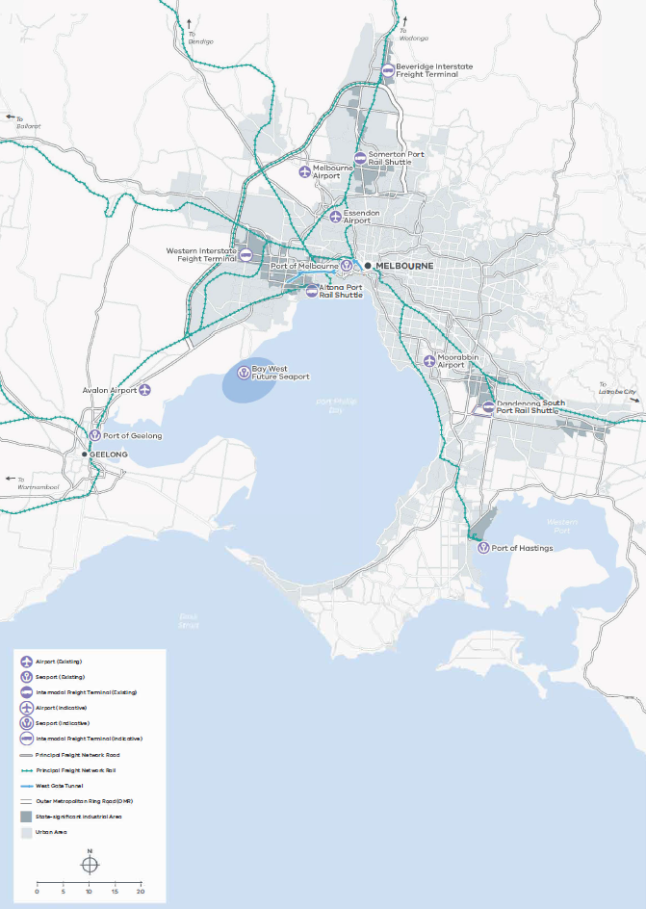

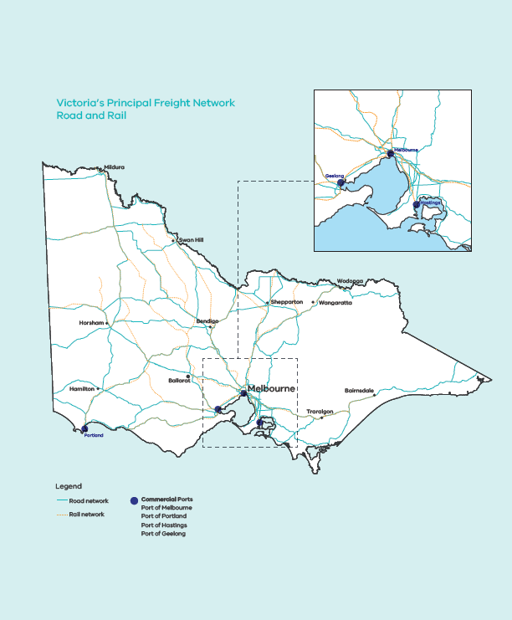

HOW THE VICTORIAN FREIGHT INDUSTRY WILL LOOK IN 2030
In 2030 Victoria's freight industry will continue to be a national hub for trade, warehousing, freight transport and logistics services.
Supported by actions in this Plan, the freight sector has had confidence to continue investing in the facilities and equipment needed to grow capacity and productivity across the industry.
Planning and targeting investment has grown the capacity of our freight networks to support a highly efficient, resilient, and sustainable freight system.
Strategic investment has allowed for more reliable and resilient networks
Key freight routes and gateways have been more clearly protected through stronger strategic planning tools, creating greater investment certainty for industry in terminals and warehouse capacity in Victoria.
The Port of Melbourne operator has delivered clear plans for the next phase of port development, supported by Government through managed landside transport capacity, to enable efficient movement of increasing trade volumes, also ensuring rail access to the port from both metropolitan and regional rail terminals.
Rail freight is a key movement mode across the Victorian network, providing for new terminal capacity and a higher number of services available to freight operators.
Heavy vehicle access arrangements have delivered significant improvements to cost, speed and certainty of access, supporting even more efficient movement of freight on our roads.
Decarbonisation of the freight industry has progressed, providing availability to low-carbon liquid fuels and open recharging facilities for zero-emissions freight vehicles.
Significant progress has been made toward transitioning technology and energy use to contribute to Victoria's climate action targets, while efficiently meeting the needs of a growing population and a rapidly evolving economy.
By 2030, Victoria will continue to be the national freight hub that is home to a world-class freight and logistics industry that is efficient, productive, sustainable, and responsive to the needs of industry and the community.
Our freight and logistics industry will continue to become safer and more resilient with the introduction of modern technologies and ongoing learnings.
By 2030 the use of new smart camera technologies has enabled active monitoring and management of freight access across urban environments, supporting efficient and sustainable delivery services, and providing real-time data on issues that may need to be addressed.
The Victorian workforce will be even better equipped to meet the demands of the freight sector, with a more diversified talent pool available to address industry needs.
Heavy vehicle licensing reforms will be completed and have delivered improvements to the licensing process, further uplifting safety standards and professionalism of heavy vehicle driving career options.
Nationally harmonised rules and standards for freight sector training will provide greater consistency and alignment across the national freight network.

THE PLAN
Our vision for the Victorian freight system
Protect and strengthen Victoria's competitive advantage, to enhance Victoria's liveability and economic prosperity.
Objectives
1. Ensure availability of fit for purpose freight network and gateway capacity to meet current and future need
2. Enable more efficient and productive freight and supply chains
3. Supporting climate and sustainability goals and liveable communities and places
4. Enhance the safety and resilience of Victoria’s freight industry
How the Plan will be delivered over 5 years
Developing policy
Strengthening protection, planning and delivery practices
Embedding safety
Supporting innovative technology and decarbonisation pathways
Creating certainty for investment
Ensuring fit for purpose infrastructure
Improving data availability and research
Fostering a skilled and diverse workforce

STRATEGIC OBJECTIVES AND ACTIONS

OBJECTIVE 1: Ensure availability of fit for purpose freight network and gateway capacity to meet current and future need
Victoria is the freight and logistics capital of Australia, being the nation's second largest agricultural producer by value, and generating more economic activity and jobs from freight and logistics activity than any other State.
Victoria's freight network comprises various modes of transport, including rail, road, sea, and air, along with intermodal terminals, freight precincts, and consolidation centres. This comprehensive network caters to a wide array of industries, including agriculture, manufacturing, construction, retail, extractives and mining, thereby playing a pivotal role in the state's liveability and prosperity.
Industry continues to diversify with new opportunities emerging particularly in regional areas. New minerals development projects will rely on modern transport networks that enhance regional connectivity, facilitate the transportation of minerals and attract further minerals investments. The forecast growth in Melbourne's demand for extractive resources will require additional quarries developed close to Melbourne, generating hundreds of extra truck movements each day on local networks.
Forecast long-term growth in freight, coupled with high-volume periods, highlights the need for sufficient ongoing capacity and efficiency of Victoria's freight networks and operations. Our road and rail networks and access to key rail, port and airport gateways must be fit for purpose and developed to accommodate the growth of the industry both in terms of freight volumes, but also the equipment and industry standards that need to be met to deliver productive and efficient services.
The freight industry is facing challenges over the next 20 years to decarbonise current operations. The transition will have a significant cost. There will also be costs for the State in supporting this transition given it is known that LZEHVs are likely to be heavier than the current diesel fleet, impacting structures and pavements. In addition to growing transport networks as our cities grow to accommodate the freight task, existing networks will need to accommodate heavier movements as the sector decarbonises.
Government will support industry to prepare for upcoming challenges and be ready to take advantage of key opportunities, by providing confidence and certainty for private sector investment.

Measuring our success - KPIs
Priority | Area | Measure
Maintaining levels of service on the Principal Freight Network | Road network performance | Journey time reliability for the PFN
 | Road network capacity | Proportion of mass constrained PFN and number of structures on the PFN which are 75 per cent of SM 1600 or above
 | Rail capacity and utilisation | Proportion of freight services supplied where access was provided on time
 |  | Number of temporary speed restrictions on the rail freight network
Maintaining capacity of industrial land | Industrial land capacity | Total vacant capacity of zoned industrial land in State Significant Industrial Precincts
STRATEGIC PRIORITY AREAS
Support Victoria’s gateways to meet the growing freight task
Victoria generates more growth and jobs from freight than any other State. Our population and the freight task are ever increasing. To meet the task, Government is working with the operators of Victoria's commercial trading ports to ensure that appropriate plans are in place to handle growing volumes. Ports Victoria, the State-owned manager of safe operation in all commercial port waters, is well placed to act as the overarching long-term planner of the port system, ensuring the provision of adequate capacity statewide and ensuring additional capacity is planned for future needs.
At the Port of Melbourne, substantial growth is expected at Webb Dock at the mouth of the Yarra. Whilst waterside access to Webb Dock supports the largest container vessels visiting Australia, on the landside Webb Dock is reliant on road access to the M1 freeway. Volumes will grow in coming years as the Port of Melbourne develops additional container handling facilities. As this progresses, additional landside transport capacity will be needed. The Port of Melbourne will continue to work with the Victorian Government while planning for the development of Webb Dock's landside transport network as part of its upcoming Port Development Strategy (PDS).
Critical to the success of the inter-capital rail supply chains are the intermodal terminals that provide the key gateway between the rail line-haul and road-based pick-up and delivery to end customers. Intermodal freight terminals need to be able to handle high productivity of multiple modes, integrate with warehouses and other logistics facilities, whilst also interfacing with existing surrounding residential areas. This requires greater connection across planning schemes that allows for consideration of the freight system in decision making.
The Victorian Government is working with the Commonwealth to support the delivery of a new interstate rail precinct at Beveridge (BIFT) in the north of Melbourne as part of the Inland Rail Project. In addition, the private sector is also investing in further terminal capacity including at Somerton, Altona and South Dandenong. To support this, the Victorian Government will apply protections around the land required for a future terminal in Truganina in Melbourne's west (WIFT).
Priority actions 2025-30
Directions | Actions
Facilitate provision of efficient container handling capacity at the Port of Melbourne | 1.1 DTP will engage with the Port of Melbourne operator as it develops its Port Development Strategy detailing its long-term plans for the provision of efficient port capacity, including plans for new container handling capacity in the Webb Dock precinct when it is required  1.2 DTP, in conjunction with Ports Victoria, will support the Minister for Ports and Freight in providing feedback on the Port of Melbourne's Port Development Strategy, before it is finalised by the Port of Melbourne  1.3 DTP will prepare a Port of Melbourne Landside Access Plan in response to the Port of Melbourne's Port Development Strategy after it is finalised which will set out the Government's plans for State managed landside transport networks to support the growth of the port
Ports Victoria to assess the long-term outlook of Victoria's commercial port system, to efficiently meet Victoria's forecast trade needs | 2.1 Ports Victoria will develop a Victorian Port System Long-term Outlook to guide Victoria's commercial ports system plans to efficiently handle the long-term forecast import and export trade task
Work with the Port of Melbourne operator to confirm the Port's plan for providing additional landside transport capacity to Webb Dock when it's needed as container handling capacity grows in future years | 3.1 DTP will support the Port of Melbourne operator to progress development of a detailed proposal for future landside transport connections to Webb Dock to support the future growth of this facility, with consideration to:  - Support for efficient handling capacity at Webb Dock North when it is developed  - Managing the impact of growing truck movements to and from  - the Port, including through the Fishermans Bend precinct  - Optimising the use of rail to and from the Port of Melbourne  - Integrating the Port's landside freight requirements into broader network transport planning  3.2 DTP will advise the Minister for Ports and Freight on our recommendations for response to the Port of Melbourne's proposal
Work with the Commonwealth Government and industry to develop and deliver efficient, long-term capacity supporting the growth of interstate rail through intermodal precincts, including those at the Beveridge Interstate Freight Terminal (BIFT), the Western Interstate Freight Terminal (WIFT), Altona, and Somerton | 4.1 DTP will finalise re-zoning processes to enable the Commonwealth Government's development of the BIFT  4.2 Government has allocated $12m, split between the Victorian and Commonwealth Governments, for DTP to complete planning work to protect for the longer-term development of the WIFT within the Chartwell East Precinct Structure Plan  4.3 DTP will continue working with the Intermodal Terminal Company to support delivery of its terminal in Somerton  4.4 DTP will continue to work with industry participants to promote the development of metropolitan intermodal terminals as part of the Port Rail Shuttle Network to encourage mode shift to rail
Deliver stronger planning protection for the Principal Freight Network
While private organisations manage supply chains and the movement of freight, government planning provides certainty for freight operations. Government funds and manages public infrastructure, regulates where appropriate and develops policy and planning that influences freight sector investment, productivity and safety.
Growing the supply of industrial land is critical for retaining freight and logistics businesses located in Victoria, particularly for large companies that have options to relocate national distribution centres and other major facilities in other Australian states. This is also important for attracting new businesses and to allow freight operators to expand operations to support the growing population.
Victoria's ports also require a strong strategic outlook for the State's port sector to inform where future trade should be focused and signal investment. Navigating our port futures, The Victorian Commercial Ports Strategy identified a potential location to the west of the Werribee River - Bay West - as a preferred site for a second container port. Land use and transport planning protections must be progressed to preserve Bay West as a viable future location for Victoria's second container port. To enable this, Bay West (the State's proposed second container port), requires adequate protection in the planning scheme and better transparency of developments that may constrain the future development of the port, so that government can ensure the long-term security of key freight routes and gateways.
Consideration of how freight operations interact with other land uses into the future is essential to ensuring the ongoing effectiveness and capacity of freight operations. This includes the identification and protection of new and existing freight precincts and corridors, as well as protecting existing and planned freight infrastructure such as ports, airports, freight terminals and their surrounds.
Priority actions 2025-30
Directions | Actions
Deliver planning scheme arrangements to protect for the development of a future Bay West container port located near Werribee | 5.1 DTP will implement a planning referral arrangement to ensure it is aware of any changes proposed in the area around where a future Bay West port would be developed, to ensure it is protected from encroachment that could risk its future delivery
Deliver a 10-year plan for industrial land that provides industry with the confidence it needs to invest in the continued growth and development of Victoria's freight and logistics industry, considering and respecting Traditional Owners and Cultural Heritage of the land | 6.1 Deliver a 10-year plan for industrial land, announced in the Economic Growth Statement and Plan for Victoria, that maps the forward pipeline of future industrial land supply to be unlocked through a range of initiatives including greenfields precinct planning, re-zoning Special Use Zones in Altona North and Hastings, identifying constraints and opportunities
Implement enhanced planning arrangements protecting the Principal Freight Network including new ‘gateway’ protections for key freight terminals and ports | 7.1 DTP will update the Victoria Planning Provisions to protect key gateways, (intermodal terminals and commercial ports) from encroachment
Deliver fit for purpose capacity of the freight networks
Since Delivering the Goods was released in 2018, the Government has added more than 8,000 kilometres of approved arterial roads to the State's HPFV Network. HPFVs are the most modern and productive vehicles on our roads and have been used by a wide range of industries, including bulk commodities like mineral sands and grain, dairy products and even waste material. Expansion of the HPFV network continues to drive investment by industry into newer and safer trucks (e.g. recently, the State Government released three new HPFV networks for the transport of livestock). Although we've opened the network to more productive vehicles on key routes - especially those on the PFN - further upgrades are required to ensure vehicles are operating at their optimal mass across all parts of Victoria.
Planning for the next tranche of investment is needed to allow for further mass increases for HPFVs on key strategic routes. Government is aware of the significant network challenge to enable broad operation by LZEHVs that are known to have higher mass across axles and to accommodate the greater mass of battery or fuel cell technologies - the planning for how government is going to support the growth of these vehicles on our road network needs to start now.
The development of the road network to accommodate the growth of the freight task, both in volume of the task and size of the vehicles that will be operating, will have a cost. Government will continue to engage with industry and all road managers across Victoria to progress conversations on how these costs can be most fairly and efficiently managed.
Along with the mass increase for road vehicle combinations, Government has also been investing in Victoria's rail freight network. Newer rolling stock (locomotives and wagons) are also progressively getting heavier, and our current rail network will need further vital maintenance work to provide access to newer freight rolling stock and allow rail freight to increase its share of the State’s freight task in line with industry and economic growth.
During the 1980s, there was a significant program of works to ensure a consistent 19 tonne axle load (TAL) was available across the rail network. V/Line has been progressively investing as it maintains the network to lift axle loading to 21 TAL - over the medium to longer term, the government will consider how to further build network capacity towards 23 TAL.
The Victorian Government continues to support the Commonwealth Government in its ongoing delivery of the Victorian section of the Inland Rail Project. This includes working with Inland Rail Pty Ltd, a subsidiary of the Australian Rail Track Corporation (ARTC) which is delivering the Inland Rail Project on behalf of the Commonwealth Government, to integrate these works into Victoria's transport network and to provide positive outcomes for towns on the inland rail route.
Priority actions 2025-30
Directions | Actions
Improve High Productivity Freight Vehicle (HPFV) access around the Port of Melbourne at the junction where CityLink meets the M1 corridor | 8.1 DTP will work with Transurban to determine requirements to strengthen the Bolte Bridge and the roads that link into the bridge to support the most efficient and productive HPFVs operating at the Port of Melbourne
Confirm the plan for prioritising the next phase of investment in Victoria’s Principal Road Freight Network including considering funding options to support the future development of the network | 9.1 DTP will work with the Commonwealth Government to investigate upgrading key roads and structures across the HPFV network to support productivity as well as decarbonisation  9.2 DTP will be a member of the working group implementing actions through the National Freight and Supply Chain Strategy to confirm the requirements for an ideal future national freight network  9.3 DTP will support work to achieve nationally agreed and consistent vehicle mass limits that support productivity and decarbonisation goals, noting that DTP is aware of industry's preference for 8 tonne weights over steer axles and 18.5 tonnes over drive axles and changing technology and equipment to support decarbonisation may have flow on effects for future network requirements  9.4 Government will explore, through future budget processes, how to further network development and strengthening
Continue to invest and plan for the development of Victoria's rail freight network, providing confidence and support for industry to invest in growing rail freight volumes | 10.1 Government has committed $103.1m of maintenance funding over 12 months (FY 2025/26) for the regional rail network (including major periodic, and routine maintenance requirements)  10.2 DTP will prepare a Victorian Rail Freight Plan for Government's consideration, to build on the Rail Freight Capability Statement and set out a long-term vision and a clear approach for the development of the rail freight network, with consideration to:  - Maintaining efficient broad-gauge freight rail access to the Port of Melbourne  - Promoting opportunities to further develop and encourage mode shift to rail  - Integrating rail freight service requirements and future demand into shared network management and planning  - Assessing opportunities for further gauge standardisation  - Targeted network improvements that will enhance the capacity and resilience of rail freight operation such as through new sidings and passing loops  - A clear plan for development and operation of Victorian intermodal terminals, including the Tottenham/Dynon rail freight precinct as volumes grow  - Building on recent investment in the regional rail network, confirm our approach for achieving a consistent minimum of 21 TAL operations on Victoria's rail freight network

CASE STUDY
Cementing the future
Expected growth in demand for new house building and delivery of Big Build infrastructure projects will continue to place significant pressure on the demand for concrete
Interstate and international cement imports at the Port of Melbourne accounts for 75-80 per cent of Victoria’s demand. The cement import facilities at South Wharf, a key hub for supplying the construction industry, are facing increasing challenges due to urban encroachment and amenity concerns. Efficient operation of cement import facilities is being impacted by the installation of urban and road infrastructure that is part of the urban growth in the Fishermans Bend precinct.
Fishermans Bend is Australia’s largest urban renewal project covering approximately 480 hectares in the heart of Melbourne. Fishermans Bend consists of five precincts and connects Melbourne's CBD to the bay. By 2050, it will be home to, and provide employment for, approximately 80,000 people. As the precinct grows, government will continue to work to balance critical urban renewal with the PFN to support the ongoing operations of the Port of Melbourne and the construction industry.
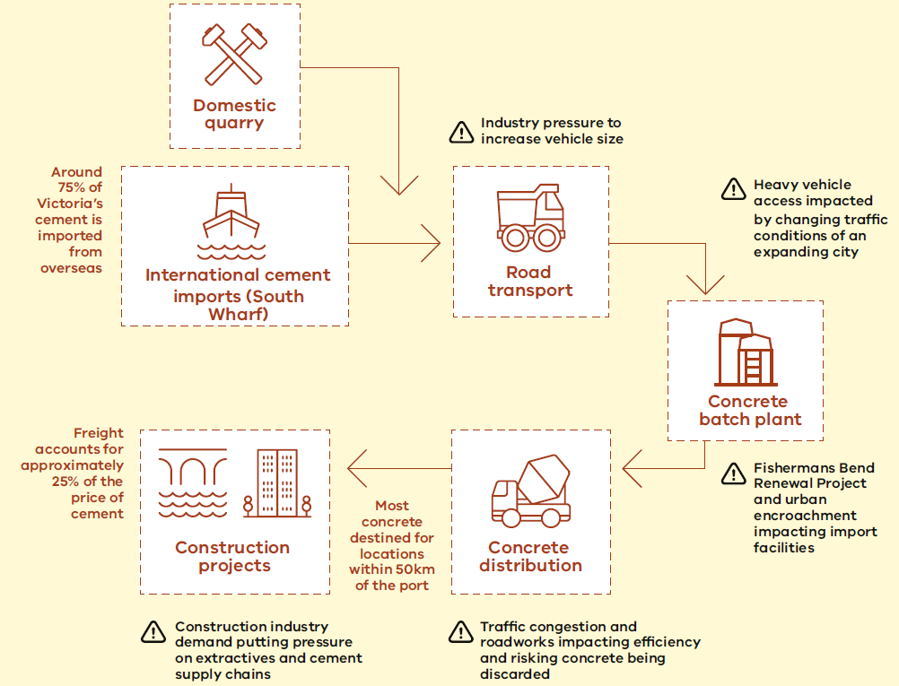

OBJECTIVE 2: Enable more efficient and productive freight supply chains
Victoria's freight network handles a significant proportion of the Australian freight task, contributing an estimated $36 billion to Victoria's GSP. In 2020-21 the Victorian freight task was 440 million tonnes. By 2051, the Victorian transport network is expected to handle approximately 900 million tonnes of freight annually, or nearly triple the 360 million tonnes transported in 2014.
Similarly, the Port of Melbourne forecasts that its containerised freight will grow by 169 per cent of current levels, from 2.4 million 20-foot containers in 2017 to 6.5 million containers in 2052. The increase in freight volumes puts pressure on the transport networks they utilise, which could be a combination of rail, road and sea.
In 2024 the Victorian Government announced the 29-hectare former Melbourne Market site will be leased to the Port of Melbourne until 2066. This site has the potential to further increase the Port's capacity by an additional one million twenty-foot containers annually, boosting trade and making Victoria's supply chains more efficient and resilient.
To further respond to this growth, the freight and logistics sector will need to be positioned to operate as efficiently and productively as possible, through use of technology, data and innovative business practices. The Victorian Government will also continue to work with the Commonwealth to support regulatory requirements through all modes of imported and exported freight (e.g. bio-security practices).
Measuring our success - KPIs
Priority | Area | Measure
Increasing freight efficiency and productivity | Productivity / empty running | Vehicle kilometres travelled of the HPFV fleet
 |  | Unladen trips as a % of total
 |  | Multi-factor productivity
 |  | % of freight rail network rated 21 TAL
Improving port efficiency and productivity | Port congestion | Vessel planned vs. actual arrivals
 | Transport costs | Multi-modal cost indices
STRATEGIC PRIORITY AREAS
More efficient network access
The road freight network in Victoria is a critical component of the State's economy and infrastructure. It facilitates the movement of goods across the State, connecting businesses with markets, and consumers with products. The road freight network is complex and multifaceted, encompassing various types of roads, freight, and vehicles, including light commercial vehicles, rigid trucks and articulated trucks.
Alongside the continued growth in the freight task, unprecedented State Government investment in major infrastructure projects has caused a significant increase in heavy vehicles requiring permits to access and move through the road network in Victoria.
Providing fast, clear, simple and low-cost access to the road network for heavy vehicle operators is essential for Victoria's economy, to help drive recovery from the pandemic and provide greater productivity and economic outcomes for the State.
Rail operators seeking access to the rail network to operate freight trains require an access agreement with an access provider. Freight operators may need to negotiate access paths and have access agreements with multiple track managers.
In 2024, as part of the Victorian Rail Access Regime (VRAR) DTP introduced new maximum rail freight access prices and rail access guidelines. We will continue working with industry to finalise the complete introduction of the VRAR to allow for a more streamlined and transparent process to accessing the rail network.
Improving the process around access will ensure Victoria's rail freight network can support the fast and efficient movement of goods to and from port.
Priority actions 2025-30
Directions | Actions
Deliver a more efficient system for industry to seek and gain road network access for heavy vehicles | 11.1 DTP will remove fees for structural assessment of Class 2 vehicles from 1 January 2026  11.2 DTP will deliver the Heavy Vehicle Structural Assessment Permit System (HVSAPS) for Class 1 and 2 HPFVs to significantly reduce cost and turnaround times for the heavy vehicle industry
Further strengthen the certainty of access and reliability of performance for rail freight services across the Victorian rail network | 12.1 DTP will support the introduction of new Rail Access Arrangements by Access Providers (Metro Trains and V/Line), to ensure they are aligned to the Rail Access Guidelines issued by the Minister for Ports and Freight and the Minister for Public Transport  12.2 DTP will include specific requirements within the next metropolitan rail franchise to, for the first time, require the franchisee to meet and report on specific rail freight related performance criteria  12.3 DTP will include specific arrangements for the oversight and governance of rail freight operations and rail access applications or alterations
Improving our understanding and ability to respond to key constraints impacting first and last kilometre access | 13.1 DTP will continue monitoring the network to gain a better understanding of first and last kilometre access issues to identify, assess and prioritise network constraints that are impacting productivity and efficiency

Government supports greater collaboration within industry
The pandemic highlighted the need for government to take a more proactive stewardship approach in working with industry to respond to incidents, develop policies, plan for infrastructure and facilitate technology development. The freight industry does an amazing job responding to change and being innovative when challenges strike. However, the pandemic years served to highlight that the State can play an important role bringing industry participants together - particularly when complex and collaborative solutions are needed.
Government has a role in connecting industry during times of emergencies or crisis. The pandemic highlighted that the community expects the government, if it is needed, to step in and coordinate across the supply chain to respond to disruptions. This experience has taught all industry participants that outside of emergency situations, the government can act as an effective facilitator to support industry connections and sharing of information and learnings. There are many opportunities for us to continue to strengthen our role in this area.
Government can create an environment that enables and supports innovation, trials and pilots. It also has an important role to ensure that appropriate policy and regulatory frameworks are in place to accommodate adoption and commercialisation of new technologies.
We acknowledge the role of First Peoples being critical partners in managing the planning and delivery of the Victorian Government's $80 billion transport investment pipeline. To enrich outcomes, we will facilitate industry collaboration with First Peoples stakeholders to ensure representation on working groups to strengthen their relationship with the community and consider impacts to Country.
Currently the manifest of data across the supply chain is inconsistent in provision. Government will work to improve the consistency and harmonisation of data collection to better inform policy decisions and support industry.
The introduction of the Voluntary Port Performance Model (VPPM) in 2020, comprising the Voluntary Pricing Protocol for container stevedore operators and the Voluntary Performance Monitoring Framework, has been a nation leading innovation in what can be achieved through partnership between the Victorian Government and industry. In early 2024, the Voluntary Code of Practice was successfully used to mitigate the impact of extended delays being experienced at a port stevedore.
We will build on this voluntary and collaborative model through further innovations to align, gather and report on pricing and performance information for the port supply chain. We will also apply this partnership approach to other issues identified by industry through a time limited group that will be established dedicated to reporting back within 12 months to the Minister for Ports and Freight with proposals for action that have been developed in collaboration between industry and the DTP.
Priority actions 2025-30
Directions | Actions
Work with industry to deliver shared recommendations to the Minister for Ports and Freight on actions to address long term and complex issues that are constraining the productivity of Victoria's freight sector | 14.1 DTP will establish an industry working group to report back to the Minister for Ports and Freight within 12 months of establishment, on actions to respond to key, complex issues that are constraining productivity and efficiency of the Victorian freight and logistics sector
Continue to deliver specific actions that supports the performance and transparency of Victoria’s ports system | 15.1 DTP will continue to enhance Victoria's Voluntary Port Performance Model, including:  - Overseeing new requirements in the Voluntary Pricing Protocol for stevedores to update landside access charges once annually on the same date and to provide further information on the reasons for price changes  - Reviewing the empty container supply chain and developing a new Voluntary Pricing Protocol for empty container parks to respond to industry's ongoing concerns regarding the scale, frequency and notice of price changes for these facilities  - Further development of KPIs to provide the best information possible on the performance of the port supply chain  15.2 DTP will design and implement a requirement for all container road transport operators that access the Port of Melbourne to be recorded under a new Registered Operator Scheme to facilitate oversight of port precinct truck activity and inform further policy development supporting both efficient and productive landside operation and decarbonisation objectives  15.3 DTP will establish a new requirement for the mandatory provision to Ports Victoria of consistent electronic container shipping information, and to enable that information to be made available to industry, to support more efficient movement of containers through the supply chain and further targeted policy development where it’s needed  15.4 DTP will work with the Port of Melbourne operator to develop a new repeatable, low-cost methodology to replicate the key elements of Port of Melbourne Container Logistics Study
Improve supply chain performance with data and research
The freight and logistics supply chain are constantly evolving through technological advancements and responding to an increasing freight task in line with Victoria's population growth and global economic conditions. To leverage the productivity benefit of performance data and reporting, information must be available and readily accessible. This Plan will deliver a step change in how the outcomes of the plan are assessed and reported.
Just as improving industry collaboration and coordination is a focus of this Plan, so is action to begin collaborating more actively and formally with the university and technology sectors that are working on freight and logistics content. Government will establish a new Freight Innovation and Technology Partnership bringing together representatives from universities and technology companies to facilitate sharing of information and research. Industry will be connected to the work of the group, providing opportunities for innovators to meet directly with industry participants experiencing challenges that might suit a technology-based solution.
Technology, particularly the automation of electronic information throughout each step in the freight task, has the potential to expand the visibility of performance across the whole supply chain. Inconsistent provision of electronic information increases the administrative burden for operators, such as empty container parks and transport operators, to efficiently run their businesses, increasing costs and adding risk of incorrect information leading to futile trips.
Priority actions 2025-30
Directions | Actions
Regularly monitor and publicly report on key indicators of progress and performance delivering the Victorian Freight Plan | 16.1 DTP will develop an on-line dashboard to regularly publish reports against a range of key performance indicator data aligned to the four objective outcomes of the Victorian Freight Plan  16.2 DTP will be a member of two working groups tasked with implementing actions from the National Freight and Supply Chain Strategy Action Plan, supporting the development of the National Freight Data Hub, and developing key performance measures for inclusion in the National Freight and Supply Chain Strategy
Facilitate improved and more structured knowledge sharing between industry, government and academia responding directly to freight sector issues and challenges | 17.1 DTP will establish a new Freight Innovation and Technology Partnership that will regularly bring together researchers, technology companies and, as needed, the freight industry to focus discussion and research effort on the key strategic operational and policy questions being faced by the sector
Support work towards development of a nationally consistent Freight Community System solution | 18.1 DTP will work with industry and other jurisdictions to consider the role of a Freight Community System to support the potential for such a system to be leveraged and used to provide benefit across all Australian jurisdictions

Victoria's Innovation Mission for Freight
In early 2025 Freight Victoria partnered with LaunchVic to host an Innovation Mission for Freight, showcasing how new technology can solve problems across the supply chain.
The Minister for Ports and Freight opened the event for approximately 60 attendees who represented the Victorian container logistics supply chain sector, Victorian startup sector and the Victorian Government.
The Innovation Mission provided a platform for participants to better understand industry challenges and potential solutions. Through a series of presentations, discussions and collaborative activities, the Innovation Mission explored opportunities to find efficiencies and cost savings for the freight sector through the better use of data and artificial intelligence, optimising journeys and improving safety and sustainability.
The Innovation Mission is an exciting demonstration of how the Victorian Government is working across different agencies and industry sectors to foster innovation and collaboration to deliver positive outcomes for Victoria's freight sector.

CASE STUDY
Efficient Extractives
Victoria's extractive resources industry is a vital part of the state's economy, representing around $1.3 billion annually.
Extractive resources such as sand, gravel, hard rock and clay are the key ingredients for a range of products such as concrete, asphalt, and road base which are essential to the construction industry.
Proximity of these natural resources to the point of demand is the key factor in transportation costs. As quarries reach the end of life, new sites need to be identified and protected for the future, and findings from government and industry analysis identifies that existing supplies of extractive resources will not adequately meet Victoria's long-term demand. This may lead to increased transport distances and prices for extractives.
Transport costs are approximately a quarter of the total extraction cost for quarries close to project sites and may increase with longer distances from quarries. Identifying and protecting future quarries and their associated freight network routes and connections will be critical to manage freight costs.
The Victorian Government is committed to helping secure access to critical materials to build our future homes and ensure infrastructure affordability. The identification of a Strategic Extractive Resource Area (SERA) ensures a quarry can supply raw materials well into the future while avoiding land use conflicts.
SERAs have been identified and incorporated into relevant planning schemes for Wyndham and South Gippsland. A further three SERAs are being considered near Lang Lang, Trafalgar and Oaklands Junction.
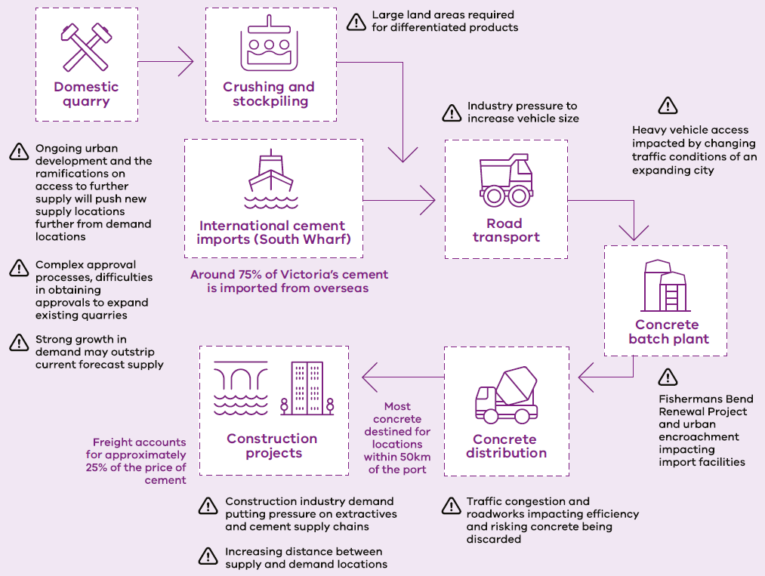

OBJECTIVE 3: Supporting climate and sustainability goals and liveable communities and places
The Victorian Government has set some of the most ambitious climate action targets that rank among the highest in the world.
This includes achieving net-zero emissions by 2045, with interim reduction targets relative to 2005 levels. Victoria's climate action targets are:
- 28-33% by 2025
- 45-50% by 2030
- 75-80% by 2035
- Net-zero by 2045
The freight industry is a significant contributor to greenhouse gas emissions, which result in impacts including hotter temperatures, more severe storms, increased drought, sea level rises, and species loss, among others. Decarbonising the freight sector is vital for improving health outcomes, ensuring sustainability of the supply chain and to meet local and international climate action targets.
For many years, governments across Australia have supported the growth of freight on rail due to the benefits it provides in terms of reduced carbon emissions, lower road trauma, lower road maintenance costs and reducing road congestion. More direct action by governments is now needed to grow rail freight. This is a core action we can take in the short to medium term to lower freight sector emissions, while the conditions are created in parallel to support heavy vehicle emissions reduction. While rail is currently a lower emitter of carbon emissions than road vehicles, the rail sector will also need to look at alternative fuel options to decarbonise for long term outcomes.
Changing the current trajectory of freight transport emissions will require transformational investment by the private sector to reduce its emissions profile in coming years. There are a range of ways this could be achieved, for example by using low carbon liquid fuels, retrofitting technology to reduce emissions, or through investing in new zero emission trucks (ZETs). This will require a transformation in how freight vehicles are re-fuelled and operated, and require investment in the equipment and facilities that support them.
Decarbonising road freight, through measures such as the electrification of trucks, hydrogen fuel cell technology, or use of low carbon liquid fuels, and in the case of air freight, further developments in the production of Sustainable Aviation Fuel (SAF), can have a substantial impact on reducing freight sector emissions. Continued government investment will be crucial to facilitating the increased uptake and long-term viability of these vehicles and low carbon liquid fuels. Additionally, future development of consistent and supportive regulations will encourage investments in cleaner technologies.
Measuring our success - KPIs
Priority | Area | Measure
Reducing freight sector externalities, including emissions | Fleet emissions profile | Emissions per tonne km per mode (including overall total, bulk and non-bulk)
 | Heavy Freight Vehicle Activity Index | Index based on three heavy vehicle inputs; incidents, vehicle kilometres travelled in passenger car equivalent units, and emissions.
Increasing rail’s share of freight | Rail mode share | Share of freight transported by rail at the Port of Melbourne
STRATEGIC PRIORITY AREAS
Create certainty for industry to invest in decarbonisation
Decarbonising freight transport will be important to deliver on Victoria's emissions targets, but it will require significant action and incur costs for both government and the freight industry. Early action allows for a more gradual and planned transition, reducing disruption and allowing for better management of costs and risks.
Industry is now investing in transitioning to low and zero emissions trucks including charging facilities. Whilst this investment is enabling new zero-emissions delivery, there is an opportunity to enable a more robust network for freight operators to recharge vehicles at open facilities whilst they are out on the road. There is an opportunity to share facilities already being funded by government. DTP will work with the bus industry on how commercial freight vehicle recharging could be enabled during the day when buses are out on the network and charging facilities at bus depots are otherwise under-utilised.
Low carbon liquid fuels can be produced sustainably from waste biomass such as agricultural feedstock, or renewable hydrogen. The Commonwealth Government is supporting development of Australia’s growing domestic Low Carbon Liquid Fuels (LCLF) industry through its Future Made in Australia program. The development of low carbon fuels will drive economic growth and jobs in regional areas, including supporting diversification in agriculture, making good use of excess feedstock from crops, sugarcane and waste products such as tallow. There is an opportunity to leverage Victoria's existing bio-diesel production capacity to achieve immediate emissions reductions, and utilise liquid fuel infrastructure to produce 'drop-in' fuels like renewable diesel.
Additionally, Government support towards emerging technologies, such as zero-emission AAM and drones will contribute to Victoria's clean energy future. The uptake of these technologies will accelerate breakthrough developments in electric and hydrogen propulsion technologies to enable more sustainable transport solutions, not just for AAM but for the entire freight transport system.
To achieve decarbonisation of freight and supply chains, we will facilitate information sharing to support the industry to make informed decisions that contribute to decarbonisation. The Victorian Government acknowledges the leadership the Commonwealth is showing in this space through its development of the net-zero pathway and seeks to harmonise with the Commonwealth by designing supportive actions that align with this work.
We will continue progressing work, in consultation with industry, to develop policies, infrastructure and technology so the freight sector can contribute to the Victorian Government's net-zero target.

Priority actions 2025-30
Directions | Actions
Bring industry and government together to set a clear pathway for the freight industry contributing to Victoria’s climate action targets | 19.1 DTP will lead the working group tasked with implementing an action of the National Freight and Supply Chain Strategy to develop government and industry frameworks to collaborate on the transition to net-zero  19.2 The Victorian Government will develop a Freight Charging Framework that considers options for recharging facilities and the emergence of new, low carbon liquid fuels to support industry to invest in decarbonising road and rail freight, including opportunities to trial low-emissions vehicles  19.3 DTP will progress work to introduce new low emissions/low impact delivery zones in partnership with industry and local authorities, including through desktop trialling of potential options  19.4 To support industry to begin the transition to low-emissions freight vehicles the Victorian Government has committed $8m over 2 years to a co-investment model with small and medium transport operators  19.5 DTP will deliver a new on-line information sharing platform where industry can share, test and learn from decarbonisation experiences to support the investment and implementation of low and zero emissions equipment  19.6 DTP will (through commercial work) roll out zero-emissions bus operation across Victoria, and investigate how to leverage investment in charging facilities at bus depots to support them being made available commercially for heavy vehicle charging  19.7 The Victorian Government will seek to become a sub-national Government endorser of the Drive to Zero Memorandum of Understanding, working collaboratively to enable, accelerate, or incentivise the transition to zero emission freight vehicles
Continue to support the growth of rail freight, including through delivery of the Port Rail Shuttle Network program | 20.1 DTP will establish a new Port Rail Access Coordinator to bring together rail terminals and network managers to facilitate efficient and productive rail freight operations to and from the Port of Melbourne  20.2 DTP will continue to work closely with the Port of Melbourne and all rail terminal operators to work towards closing the cost gap between road and rail movements to and from the Port  20.3 DTP will support V/Line to continue its program of re-purposing used V/Line locomotives no longer needed for passenger operations to offer them as a low-cost option for the freight sector's expanding operations
Support international efforts towards lower emissions from commercial shipping and improving information exchange, including to support the introduction of alternate low and no carbon fuels | 21.1 Ports Victoria will be a partner in the Green and Digital Shipping Corridor (GDSC) initiative, under the umbrella Singapore- Australia Green Economy Agreement
Mitigate impacts to surrounding communities
The transport sector is the third largest source of Australia's greenhouse gas emissions and without action, will become the largest emitter by 2030. There is a vast amount of work going into decarbonising transport and it will be important to ensure freight is considered in this work. It is a hard-to-abate sector, with many options for propulsion method and energy source depending on the transport mode and freight route.
Freight is vital to our way of life, but some communities may feel overwhelmed by current and projected freight movements. Government will work with industry to improve planning and educate our communities to help create an appropriate balance that recognises our need for flexible freight movements without overly impacting our communities.
Decarbonising the road freight sector will play a large role in mitigating impacts to communities by creating significant improvements in air quality. This is because traditional freight vehicles, which rely on diesel engines, emit a variety of pollutants that can negatively impact air quality. These emissions include particulate matter, nitrogen oxides, and other harmful substances. By transitioning to zero emission vehicles, emissions from the road freight sector can be drastically reduced, leading to cleaner air around freight corridors. By reducing the emissions from road freight, the health risks associated with poor air quality and excess noise can be mitigated.
Priority actions 2025-30
Directions | Actions
Make use of smart technologies to support more effective monitoring and management of the impacts of heavy vehicle operation on local communities, starting in Melbourne’s Inner West | 22.1 DTP will introduce camera-based compliance using new machine learning technology to support the introduction of new 'no-truck zones' in Melbourne’s inner west as part of opening the West Gate Tunnel Project in late 2025  22.2 DTP will assess the outcomes of the new 'no-truck zones' compliance system and assess options and opportunities to apply the new machine learning capability to other local freight policy challenges
Improve how government understands and measures the impact of heavy vehicle operation through local communities | 23.1 DTP will finalise delivery of a new heavy freight vehicle activity index to better understand the impacts of heavy vehicle operation at a regional level considering available data on truck involved crashes, emissions and impact on congestion

CASE STUDY
Reducing the impact of road freight by supporting movement of grain on rail
The grain supply chain is a vital component of Victoria's economy, playing a crucial role in local food production and contributing significantly to the state's export revenues. Grain was Victoria's largest export in 2022-23, increasing by 26 per cent to reach $5.6 billion in value.
Rail transport is favoured for moving large volumes of grain due to its cost-effectiveness and lower environmental impact. However, disruptions in rail services can lead to significant challenges, affecting not only the efficiency of the grain supply chain but also the wellbeing of communities and the State's decarbonisation goals.
When rail services are cancelled or delayed, there is a forced shift to road transport leading to increased truck movements. This can result in several negative community impacts including higher noise levels, traffic congestion, and increased emissions which degrade quality of life for residents along that freight network. Moreover, increased reliance on road transport (using traditional fuel vehicles) undermines efforts to reduce the carbon footprint.
We will be implementing several initiatives to balance community wellbeing with decarbonisation efforts. One key focus is securing ongoing funding to ensure the maintenance and reliability of the V/Line rail network which is essential for reducing reliance on road transport. We are also delivering actions aimed at lowering emissions, including promoting sustainable transport options and improving overall logistics efficiency. These efforts will protect local communities from the adverse effects of increased truck traffic while advancing the government’s commitment to reducing environmental impact and supporting resilience of Victoria's grain supply chain.
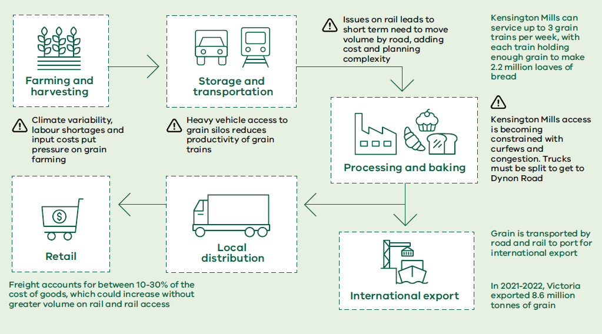

OBJECTIVE 4: Enhance the safety and resilience of Victoria’s freight industry
The movement of freight across our networks is inherently high-risk, across all freight modes, due to the complexity of the task, the need for heavy machinery and vehicles, and the constant interactions that must occur between machinery, vehicles, and people.
Additionally, our networks are extremely diverse and are subject to a multitude of possible impacts from crashes and time delays due to severe catastrophic weather and pandemics that can affect the efficiency of our networks and the way freight moves through them.
Ensuring our networks can withstand disruptions and shocks is vital to maintaining Victoria's liveability and to support our exporters to get their products to market. This requires a clear infrastructure prioritisation investment strategy, as well as enabling the progress of technology and consistently working to improve safety outcomes across all modes within the freight supply chain.
Measuring our success - KPIs
Priority | Area | Measure
Decreasing fatalities and serious injuries on the road network | Road fatalities and serious injuries | Number of fatalities and serious injuries by mode
Improving the resilience of the freight network | Workforce | Workforce Resilience Index
 | Freight network resilience | Number of unplanned closures and number of days of unplanned closures of key routes
STRATEGIC PRIORITY AREAS
Improve resilience of our freight networks
The pandemic saw unprecedented changes to the way we live and work and created volatility for supply chains. The pandemic elevated the role of freight and changed perspectives on supply chain planning and resilience through things like product sourcing and inventory management. Temporary closures of manufacturing and distribution facilities together with bottlenecks at borders impacted the movement of goods in Victoria and other states. We have learnt about the significant impacts that global disruptions, including trade tensions and geopolitical conflicts can have on Australia, and heightened risks for supply chain disruption.
With the value of Victorian import and export goods totalling $120 billion and $37 billion respectively, the economy has a strong reliance on overseas supply chains for the purchase and sale of goods, and subsequently, a heightened exposure to a variety of potential disruptions. Local disruptions also pose a risk to our supply chains, with industrial relations issues and protest activity impacting on supply chain productivity, especially within the Port of Melbourne.
Increasing extreme weather events and natural disasters in recent years have placed a heightened focus on the need to respond to climate change, both to improve the resilience of supply chains against its impacts, and to meet government’s climate action policy goals more generally. The ongoing threat of fires, floods and other natural disasters and the increasing incidence of these events continue to pose risks to supply chains across Victoria. Ensuring resilience for these supply chains will require an emphasis on rapid response to disruption, alternative supply routes and modes, effective maintenance, and where feasible, improvement of freight networks.
Priority actions 2025-30
Directions | Actions
Support the Commonwealth to prepare a National Freight Resilience Plan under its updated National Freight and Supply Chain Strategy | 24.1 DTP will be a member of the working group tasked with implementing an action of the National Freight and Supply Chain Strategy to prepare a National Freight Resilience Plan
Improve safety outcomes across our freight networks
Safety is a key focus area for government but is a shared responsibility with industry and the broader community. This can be challenging due to the broad range of stakeholder groups and diverse understanding of safety issues along each section of the supply chain.
Freight supply chain safety is impacted by the technology available (e.g. HPFVs and use of telematics), the condition of the operating environment and the behaviours of people operating within and around those environments (e.g. appropriately trained heavy vehicle drivers, including around vulnerable road users, and educating the public on how to behave around heavy vehicles).
There are many different operating systems and safe working rules currently in place across Australia's rail networks. We are supporting the National Rail Action Plan, and working to reduce differences and create a more interoperable rail system that makes the most of modern technologies.
While many trains have similar components, there are currently few shared standards. Standardising some components will create scale for local manufacturers and make rail more efficient. Common standards will also help to harmonise how people work and are trained, and ensure their skills are recognised across networks.
At the core of improving safety outcomes is training and education whilst ensuring a collaborative commitment to drive continual improvements is essential to Australia's work health and safety.
Priority actions 2025-30
Directions | Actions
Consult with industry on the performance of the existing key heavy vehicle rest areas to determine if there is sufficient capacity on key parts of the Principal Freight Network | 25.1 DTP will conduct a statewide audit, in consultation with the freight industry and the National Heavy Vehicle Regulator, of formal and informal heavy vehicle rest areas against the Austroads Guidelines for provision of rest area facilities to support opportunities for investment
Support reform of the current Victorian heavy vehicle licensing system | 26.1 DTP will implement the Heavy Vehicle Driver Safety Reform Program which aims to deliver a robust and consistent curriculum, training, and testing system based on the review and recommendations of the National Heavy Vehicle Driver Competency Framework
Support implementation of national reforms to improve the interoperability of rail systems | 27.1 DTP will progress implementation of the National Rail Action Plan to harmonise safety arrangements, including to harmonise safe signalling and safe working requirements between the V/Line and ARTC networks
Support industry to source appropriately skilled workers
As the freight task in Victoria continues to grow, it is important to increase the reach of the freight and logistics industry in securing well trained and job-ready employees to meet existing workforce shortfalls and ensure that it is well positioned for Victoria's increasing freight task of the future. This includes demonstrating the benefits of quality training, including for people not currently represented in industry.
Government is supporting more Victorians to access training directly linked to immediate job opportunities and government priorities. This builds on existing Government funded programs allowing workers to gain skills in diagnostic repair and servicing for battery electric vehicles, and inspection and serving skills for both battery and hybrid electric vehicles.
Mentoring and well-designed training opportunities will enable Victorian freight and logistic companies to meet workforce shortages and benefit from more diverse workplaces that reflect the population. Supporting the creation of and removing barriers to diversity in the sector has financial and social benefits. It not only widens the talent pool for the industry, but it has been reported that workplaces that are diverse and inclusive are twice as likely to meet or exceed financial targets and eight times more likely to achieve better business outcomes. It's proven that organisations that reflect the diversity of the market are more innovative, productive, and better serve their customers.
We will continue to work with First Peoples and community members to develop and implement strategies that attract, recruit and retain First Peoples within the Transport and Planning portfolio.
Principles of our current and past freight and logistics sector workforce training programs align with a range of internal workforce diversity and inclusion commitments, including the DTP Diversity and Inclusion Strategy, Women in Transport Strategy and the Gender Equality Action Plan.

Priority actions 2025-30
Directions | Actions
Improve understanding of future skills requirements to support the freight and logistics sector | 28.1 DTP will be a member of the working group tasked with implementing an action of the National Freight and Supply Chain Strategy Action Plan to conduct a current and future skills gap analysis for the freight and logistics sector
Support ongoing development of a highly-skilled, diverse and job-ready freight and logistics workforce | 29.1 DTP will continue to support the delivery of freight industry training programs, to deliver a more competent, diverse and job-ready workforce  29.2 The Victorian Government’s Skills Solutions Partnerships program will bring government, industry and TAFE together to develop and pilot new courses to up-skill Victoria’s auto technicians to safely work with, service and maintain hydrogen fuel cell electric vehicles and develop training for automotive workshop business owners on how to safely set up their workshops  29.3 DTP will develop an appropriate and sustainable Heavy Vehicle Driver Training Framework in consultation with Austroads and industry and explore how this could be broadened to other skill sets required across the freight and logistic industry
Establish a clear pathway for Victorians to build a career in the maritime industry | 30.1 DTP will continue to work with the maritime sector on the delivery of meaningful action to support the growth of opportunities for Victorians to work in the maritime industry

CASE STUDY
Ongoing resilience for our dairy supply chain
Milk is a staple product for many consumers with Victoria providing a significant portion of Australia's dairy products, contributing approximately $3.76 billion at the farm gate, and around $2.4 billion in exports annually.
As well as forming a significant proportion of the state's economy the Victorian dairy industry produces over 5 billion litres of milk each year and contributes 73 per cent of Australian dairy exports, making Victoria the largest dairy-producing State in Australia.
The dairy industry is volatile due to the short shelf-life of products making it susceptible to the impacts of weather events that can limit access to farms and processing facilities. Collection of fresh milk from dairy farms is required every 24-48 hours year-round, making flooding or other natural disasters a significant risk to the industry. Collection outside of this time-frame renders the product inedible and it must be subsequently dumped. Ensuring resilient dairy supply chains, alternate route availability, and suitable access are important considerations for the industry.
The Australian Competition and Consumer Commission's Dairy Inquiry found that raw milk is transported on average 150-200 km from farm to processing facility, with processors indicating that the maximum distance that is financially viable to transport raw milk is 300-600 km. The efficiency of the dairy freight supply chain is important for affordability locally, and competitiveness internationally.
We are supporting the Commonwealth Government to develop a National Freight Resilience Plan that will focus on quality of infrastructure, first and last kilometre access, and ensuring outcomes will meet industry needs.
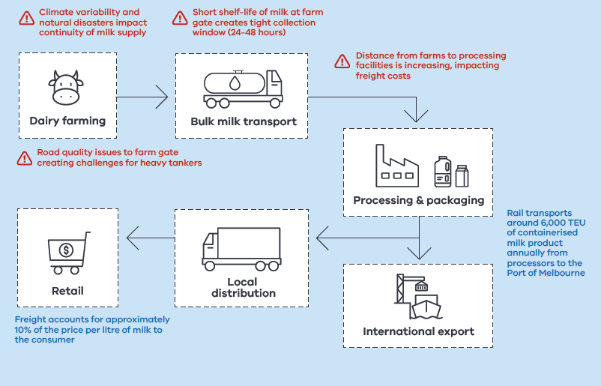

KEY PERFORMANCE INDICATORS – WHAT SUCCESS LOOKS LIKE
Transparency of freight information continues to be a priority for government and industry to improve decision making, efficiency and productivity of the industry.
Key Performance Indicators (KPIs) have been developed so that we can monitor the implementation of our actions and how their performance towards meeting our objectives. Some of these measures will be further developed over the 5-year life of the Plan. DTP will develop an on-line dashboard to regularly publish reports on the success of the Plan.
OBJECTIVE 1:
Ensure availability of fit for purpose freight network and gateway capacity to meet current and future need
Journey time reliability for the Principal Freight Network (road)
Proportion/number of mass constrained structures on the PFN rated 75% SM1600
Proportion of freight services supplied where access was provided on time (rail)
Number of temporary speed restrictions on the rail freight network
Total vacant capacity of zoned industrial land in State Significant Industrial Precincts
OBJECTIVE 2:
Enable more efficient and productive freight supply chains
Percentage of freight rail network rated 21 TAL
Vehicle kilometres travelled of the HPFV fleet
Unladen trips as a percentage of total
Multifactor productivity
Vessel planned vs. actual arrivals
Multi-modal cost indices
OBJECTIVE 3:
Supporting climate and sustainability goals and liveable communities and places
Emissions per tonne km per mode (including overall total, bulk and non-bulk)
Index based on three heavy vehicle inputs; incidents, VKT, and emissions.
Share of freight transported by rail at the Port of Melbourne
OBJECTIVE 4:
Enhance the safety and resilience of Victoria’s freight industry
Number of fatalities and serious injuries by mode
Workforce Resilience Index
Number of unplanned closures and number of days of unplanned closures on key routes

DIRECTIONS TABLE
OBJECTIVE 1: Ensure availability of fit for purpose freight network and gateway capacity to meet current and future need
STRATEGIC PRIORITY AREAS | DIRECTIONS
Support Victoria’s gateways to meet the growing freight task | Facilitate provision of efficient container handling capacity at the Port of Melbourne
 | Ports Victoria to assess the long-term outlook of Victoria’s commercial port system, to efficiently meet Victoria’s forecast trade needs
 | Work with the Port of Melbourne operator to confirm the Port’s plan for providing additional landside transport capacity to Webb Dock when it’s needed as container handling capacity grows in future years
 | Work with the Commonwealth Government and the Industry to develop and deliver efficient, long-term capacity supporting the growth of interstate rail through intermodal precincts, including those at BIFT, WIFT, Altona and at Somerton
Deliver stronger planning protection for the Principal Freight Network | Deliver planning scheme arrangements to protect for the development of a future Bay West port located near Werribee
 | Deliver a 10-year plan for industrial land that provides industry with the confidence it needs to invest in the continued growth and development of Victoria’s freight and logistics industry, considering and respecting Traditional Owners and Cultural Heritage of the land
 | Implement enhanced planning arrangements protecting the Principal Freight Network including new ‘gateway’ protections for key freight terminals and ports
Deliver fit for purpose capacity of the freight networks | Improve High Productivity Freight Vehicle access around the Port of Melbourne at the junction where CityLink meets the M1 corridor
 | Confirm the plan for prioritising the next phase of investment in Victoria’s Principal Road Freight Network including considering funding options to support the future development of the network
 | Continue to invest and plan for the development of Victoria’s rail freight network, providing confidence and support for industry to invest in growing rail freight volumes

OBJECTIVE 2: Enable more efficient and productive freight and supply chains
STRATEGIC PRIORITY AREAS | DIRECTIONS
More efficient network access | Deliver a more efficient system for industry to seek and gain road network access for heavy vehicles
 | Further strengthen certainty of access and reliability of performance for rail freight services across the Victorian rail network
 | Improving our understanding and ability to respond to key constraints impacting first and last kilometre access
Government supports greater collaboration within industry | Work with industry to deliver shared recommendations to the Minister for Ports and Freight on action to address long-term and complex issues that are constraining the productivity of Victoria's freight sector
 | Continue to deliver real action that supports the performance and transparency of Victoria's ports system
Improve supply chain performance with data and research | Regularly monitor and publicly report on key indicators of progress and performance delivering the Victorian Freight Plan
 | Facilitate improved and more structured knowledge sharing between industry, government and academia responding directly to freight sector issues and challenges
 | Support work towards development of a nationally consistent Freight Community System solution

OBJECTIVE 3: Supporting climate and sustainability goals and liveable communities and places
STRATEGIC PRIORITY AREAS | DIRECTIONS
Create certainty for industry to invest in decarbonisation | Bring industry and government together to set a clear pathway for the freight industry contributing to Victoria's climate action targets
 | Continue to support the growth of rail freight, including through delivery of the Port Rail Shuttle Network program
 | Support international efforts towards lower emissions from commercial shipping and improving information exchange, including to support the introduction of alternative low and no carbon fuels
Mitigate impact to surrounding communities | Make use of smart technologies to support more effective monitoring and management of the impacts of heavy vehicle operation on local communities, starting in Melbourne's Inner West
 | Improve how government understands and measures the impact of heavy vehicle operation through local communities

OBJECTIVE 4:
Enhance the safety and resilience of Victoria’s freight industry
STRATEGIC PRIORITY AREAS | DIRECTIONS
Improve resilience of our freight networks | Support the Commonwealth to prepare a National Freight Resilience Plan under its updated National Freight and Supply Chain Strategy
Improve safety outcomes across our freight networks | Consult with industry on the performance of existing heavy vehicle rest areas to determine if there is sufficient capacity on key parts of the Principal Freight Network
 | Support reform of the current Victorian heavy vehicle licensing system
 | Support implementation of national reforms to improve the interoperability of rail systems
Support industry to source appropriately skilled workers | Improve understanding of future skills requirements to support the freight and logistics sector
 | Support ongoing development of a highly-skilled, diverse and job-ready freight and logistics workforce
 | Establish a clear pathway for Victorians to build a career in the maritime industry

GLOSSARY
AAM - Advanced Air Mobility
ARTC - Australian Rail Track Corporation
BIFT - Beveridge Interstate Freight Terminal
DTP - Department of Transport and Planning
FIT - Freight Industry Training (program)
GDP - Gross Domestic Product
GSP - Gross State Product
HPFV - High Productivity Freight Vehicle
HVSAPS - Heavy Vehicle Structural Assessment Permit System
KPI - Key Performance Indicator
LEZ - Low Emissions Zone
LZEHVs - Low and Zero Emissions Heavy Vehicles
NHVCF - National Heavy Vehicle Competency Framework
Pandemic - Coronavirus disease 2019 (COVID-19) pandemic
PDS - Port Development Strategy
PFN Principal Freight Network
PoM - Port of Melbourne
PRSN - Port Rail Shuttle Network
PSP - Precinct Structure Plan
SAF Sustainable Aviation Fuel
SERA - Strategic Extractive Resource Area
TAL - Tonne Axle Load
TSRs - Temporary Speed Restrictions
TEU - Twenty-foot Equivalent Unit
VPPM - Voluntary Port Performance Monitoring
VRAR - Victorian Rail Access Regime
SSIPs - State Significant Industrial Precincts
VSA - Victorian Skills Authority
WIFT - Western Interstate Freight Terminal

Department of Foreign Affairs and Trade, 2023, Victoria Factsheet 2022/23
Analysis commissioned by Department of Transport and Planning, 2024
Information retrieved from ABS Protected Population Victoria, 2024
Information retrieved from ABS National, state and territory population, 2024 and Victoria in Future 2023
Agriculture Victoria, 2023. Victoria's agriculture and food industries.
ABS, 2022. Australian Industry. Accurate using 'Transport, Postal, and Warehousing' as a proxy.
Victorian Auditor-General’s Office. 2023. Effectiveness of Rail Freight Support Programs. Pg. 9.
Hewlett, S.A., Marshall, M. & Sherbin, L. (2013). How Diversity Can Drive Innovation. Harvard Business Review. Available at: https://hbr.org/2013/12/howdiversity-can-drive-innovation [Accessed 12 Mar. 2025].

