Recycling Victoria Annual Report 2024-25
Table of Contents
Message from the Head, Recycling Victoria 3
Our key priorities and achievements 5
Engagement 6
Acknowledging our portfolio partners 8
Calendar of highlights and events 9
Purpose 11
Operating context 11
Legislation 11
Regulations 12
About Recycling Victoria 13
Our vision 14
Our purpose 14
Our priorities 14
Our operating approach with portfolio partners 15
Our functions 16
Our Head and executive directors 17
Our governance 19
Strategic planning 21
Regulatory Strategy 21
Compliance and Enforcement Policy 22
Charter of Engagement 23
Community Engagement Strategy 24
Digital communications 27
Website 27
Social media – LinkedIn 28
Achievements against strategic priorities 2024–25 30
Container Deposit Scheme 30
Case study 32
Mobilising communities to participate in Victoria’s Container Deposit Scheme. 32
Waste to Energy Scheme 33
Market risk and contingency planning 35
Infrastructure planning 40
Market intelligence 43
Service standards 47
Procurement support 49
Engagement 50
Our people 56
Section 22 (2) Annual Report Mandatory Content 57
Appendix 1: Recycling Victoria Strategy Map 60
Publication information 61

Message from the Head, Recycling Victoria
I am pleased to present the Recycling Victoria 2024–25 Annual Report on the operation of the Circular Economy (Waste Reduction and Recycling) Act 2021 (CE Act).
Recycling Victoria provides leadership, stewardship and oversight of Victoria’s waste and resource recovery services. We support a strong and resilient system with robust market investment and growth towards a world class circular economy.
Now in our third year of operation, Recycling Victoria has continued to deliver our programs, mature our services and began the integration of our activities into a holistic stewardship approach that responds to emerging industry challenges.
In October 2024 we launched the inaugural Victorian Recycling Infrastructure Plan (VRIP), a key Recycling Victoria priority, which provides an essential resource for industry, local government and investors and a critical tool in strengthening and growing the sector. Outlining infrastructure needs and gaps, the VRIP helps guide decision-making on waste, recycling and resource recovery infrastructure over the next 30 years, driving innovation and growth. An investment prospectus was released in conjunction with the VRIP to highlight investment opportunities in Victoria’s waste, recycling and resource recovery sector.
We were delighted to release the second Circular Economy Risk, Consequence and Contingency Plan (CERCC Plan) in May 2025, allowing shared understanding and management of sector risks by industry and government. Together we are aiming to reduce disruptions and make the system more resilient and reliable.
Combined with oversight of Victoria’s Container Deposit Scheme (CDS Vic), administering the Waste to Energy Scheme and provision of market information and intelligence, these activities are helping to transform how we manage waste and recycling while maximising the ongoing use and value of products and materials.
We have taken the opportunity this year to better articulate our sector stewardship approach, building on Recycling Victoria’s Strategic Plan 2023–2026. Grounded in evidence and information sharing, we work with industry and our portfolio colleagues, leading the sector towards our Strategic Plan’s objectives. This system-based, future orientation underpins everything we do.
The Victorian Government has committed to a long-term target of net zero emissions by 2045 and an emissions reduction target of 75-80% by 2035.
Achieving these targets is a shared responsibility across all sectors of the economy – Australian, state and local governments, the goods and services industry, waste, recycling and resource recovery sector and the community. By reducing our waste, we also reduce our greenhouse gas emissions footprint that contributes to a more circular and climate resilient economy.
The annual achievements and milestones outlined in the following pages would not have been possible if not for our staff. Their expertise and professionalism have been instrumental in shaping the significant inroads we have achieved in creating a cleaner, more sustainable Victoria. I would like to take this opportunity to thank Recycling Victoria staff for their continued commitment, dedication and diligence. I am proud of the work and significant accomplishments Recycling Victoria has achieved in the past 12 months.

Our key priorities and achievements
Our key priorities and achievements in 2024–25 include:
- Victorian Recycling Infrastructure Plan: We released the inaugural VRIP, with a 30 year horizon for the Victorian waste, recycling and resource recovery sector, outlining infrastructure needs and gaps, driving innovation and potential investment where it is needed most. This investment will create jobs and strengthen the sector and the wider Victorian economy. An investment prospectus was released alongside the VRIP that facilitates Victorian business growth and highlights investment opportunities in the waste, recycling and resource recovery sector.
- Container Deposit Scheme milestones: CDS Vic celebrated its first year of operation on 1 November 2024. This coincided with an impressive 1 billion containers returned through refund collection points during the first year. CDS Vic processed over 7 million separate community transactions using the scheme’s network of over 640 refund collection points.
- Waste to Energy Scheme: We commenced the expression of interest (EOI) process for applicants wishing to apply for a thermal waste to energy cap licence from December 2024 to February 2025. Applicants who were successful at the EOI stage were invited to submit a full application for a cap licence in April 2025. Applications were being assessed at the time of writing.
- Compliance and Enforcement Policy: The release of the Compliance and Enforcement Policy was a significant milestone. This policy sets out how we exercise our regulatory powers to support and direct our regulated entities to comply with obligations under the CE Act and provides a framework for us to apply the law consistently, transparently and fairly.
- Service standards: The proposed Household Waste and Recycling Service Standard 2025 will create a consistent household waste and recycling system across Victoria. Public consultation on the draft service standard and associated regulations was undertaken from 18 June to 14 August 2024. The service standard is being finalised and requires the approval of the Minister for Environment to be made.
- Procurement support: We published a Strategic Procurement Framework in April 2025 to guide how we deliver our procurement support functions. The framework was informed by consultation with key stakeholders and allows us to support best practice procurement management by councils, Alpine Resorts Victoria (ARV) and service providers for waste, recycling or resource recovery services.
- Market intelligence: We released the 2025 Circular Economy Market Report in March. The report is a major milestone, with Victoria the first state or territory to report against 3 new, more system based circular economy measures aligned to Australia’s Circular Economy Framework released in December 2024.
- Circular Economy Risk, Consequence and Contingency Plan: We released the second annual CERCC Plan in May 2025. The CERCC Plan 2025 outlines serious risks in the waste, recycling and resource recovery industry that may disrupt services and the measures responsible entities must undertake to minimise them.

Engagement
We remain committed to meaningful and transparent engagement with our many stakeholders and were pleased to undertake an array of engagement activities throughout 2024–25, in-line with Recycling Victoria’s Community Engagement Strategy 2023–2026 and our Charter of Engagement.
I would like to thank our Ministerial Advisory Committees, the Recycling Victoria Advisory Committee and the Local Government Advisory Committee, for their advice and insights this year.
A total of 3 Local Government Forums and 3 Resource Recovery, Recycling and Waste Industry Group forums were also held throughout the year, providing key opportunities to share Recycling Victoria priorities and gather insights from key entities in the waste, recycling and resource recovery sector.
I was pleased to have the opportunity to present at a number of industry conferences including the Waste Expo Australia and the Victorian Waste and Resource Recovery Forum. Senior Recycling Victoria staff also presented at external conferences and forums across Australia.
Our regional visit program provided an opportunity for our Executive Leadership Team and senior staff to visit the Loddon Mallee, Gippsland and Barwon South West regions to meet with local government representatives in-person and discuss a range of issues and opportunities in a regional context. We also participated in industry site visits to gain insights and learning from the sector.
To support the Engage Victoria public consultation on the draft Household Waste and Recycling Service Standard, Recycling Victoria also organised 7 online regional forums with councils and ARV during the feedback period. These forums provided an overview of the draft service standard and regulations and Recycling Victoria’s regulatory approach. Across these forums there were 65 councils plus ARV in attendance with 120 attendees in total.
The consultation received a significant level of engagement with many submissions received during the consultation period. The service standards team worked closely with the Climate Action and Circular Economy (CACE) team to analyse the submissions.
Recycling Victoria also conducted formal, targeted consultation with stakeholders via Engage Victoria on the Strategic Procurement Framework and the draft CERCC Plan 2025.

Acknowledging our portfolio partners
We continued to work closely with our portfolio partners to share information and deliver integrated systems and policy reforms essential to support the transition to a net zero and resilient Victoria.
I would like to particularly acknowledge:
- the CACE Division, within the Regions, Environment, Climate Action and First Peoples (RECAFP) Group in the Department of Energy, Environment and Climate Action (DEECA)
- the Environment Protection Authority Victoria (EPA)
Sustainability Victoria (SV)
A culture of effective collaboration has supported the many important achievements the team at Recycling Victoria has delivered.
I would also like to thank Mr John Bradley, the outgoing Secretary of DEECA, for his support and encouragement in establishing Recycling Victoria over the last few years.
I would also like to sincerely thank Steve Dimopoulos MP, Minister for Environment and his office, along with DEECA staff and senior leadership for their ongoing support.
Tony Circelli
Head, Recycling Victoria
30 September 2025

Calendar of highlights and events
For further information on our achievements this year, please refer to Achievements against strategic priorities 2024–25 (page 31)
July 2024
- The CDS Vic Community Operating Standard regulations came into effect on 1 July 2024 requiring minimum operating hours for refund collection points
August 2024
- Consultation on the draft Strategic Procurement Framework opened
- The CDS Vic Community Access Standard regulations come into effect on 1 August 2024 requiring a minimum number of refund collection sites across Victoria
September 2024
- Inaugural Responsible Entity Risk, Consequence and Contingency (RERCC) Plans, accompanied by Statements of Assurance, submitted by responsible entities
October 2024
- Inaugural Victorian Recycling Infrastructure Plan (VRIP) published
- Commencement of in-person regionally based briefings on supporting infrastructure investment in the waste, recycling and resource recovery sector
- Annual data surveys for the waste and recycling sector and local government completed
- Waste Expo Australia
November 2024
- CDS Vic first anniversary and collection of 1 billion containers
- Consultation opened on the draft Circular Economy Risk, Consequence and Contingency (CERCC) Plan 2025
December 2024
- Expressions of interest for a waste to energy cap licence opened. Industry briefing webinars held for prospective applicants
January 2025
- CDS Vic Trash Talkers, education initiative and waste hubs at the Australian Open
February 2025
- Expressions of interest for a waste to energy cap licence closed
March 2025
- Circular Economy Market Report 2025 released
April 2025
- Strategic Procurement Framework released
- Impact of Victoria’s Container Deposit Scheme on beverage prices and consumption 2025 report published
- Full stage applications for waste to energy cap licences closed
- Gippsland regional visit
May 2025
- Circular Economy Risk, Consequence and Contingency (CERCC) Plan 2025 published
- Compliance and Enforcement Policy released
June 2025
- Barwon South West regional visit

Purpose
This report on Recycling Victoria’s operations under the CE Act is submitted by the Head, Recycling Victoria to the Minister for Environment under section 22 of the CE Act.
A detailed schedule of compliance with section 22 is contained at the conclusion of this report. Recycling Victoria’s annual compliance reporting is incorporated in the Department of Energy, Environment and Climate Action (DEECA) Annual Report.

Operating context
Recycling Victoria was established under section 15 of the CE Act, which came into operation on 1 July 2022 and was amended from 1 June 2023.
Mr Tony Circelli was appointed Head, Recycling Victoria in October 2022. Recycling Victoria is a division of the Regions, Environment, Climate Action and First Peoples (RECAFP) Group in DEECA.
The responsible Minister is Steve Dimopoulos MP, Minister for Environment.

Legislation
Under the CE Act, Recycling Victoria’s role is to provide leadership, stewardship and oversight of waste, recycling and resource recovery services to support the circular economy.
Our focus is on pursuing statewide market growth and investment, building capacity, resilience and reliability in the sector, whilst maximising the ongoing use and value of products and materials.
The CE Act established a range of schemes, powers and functions to the Head, Recycling Victoria including, but not limited to:
- overseeing and regulating Victoria’s Container Deposit Scheme
- developing and regulating service standards for waste, recycling and resource recovery services
- developing the Victorian Recycling Infrastructure Plan
- leading risk, consequence and contingency planning for waste, recycling and resource recovery services
- administering and regulating the Waste to Energy Scheme
- establishing and supporting advisory committees
centralising data collection and sector insights.

Regulations

Container Deposit Scheme Regulations
On 1 March and 27 September 2023, the Circular Economy (Waste Reduction and Recycling) (Container Deposit Scheme) Regulations 2022 came into force, facilitating administration of CDS Vic. These regulations were subsequently amended in August 2023 and in June 2024.
From 1 July 2024, a community operating standard was applied to CDS Vic refund collection points, which required minimum operating hours. Operating hours vary according to the location and remoteness of a refund point as classified by the Australian Bureau of Statistics geographic standard.
From 1 August 2024, a community access standard was applied to CDS Vic refund collection points, prescribing minimum sites across Victoria. In metropolitan areas, a minimum of one refund collection point per 14,500 people applies. For regional towns of 750 or more, or remote towns of 300 or more, refund collection points will be located as required within 5km of the town boundary as specified by the Australian Statistical Geography Standard Edition 3 published by the Australian Bureau of Statistics.

Waste to Energy Regulations
On 1 June 2023, the Circular Economy (Waste Reduction and Recycling) (Waste to Energy Scheme) Regulations 2023 came into force, facilitating administration of the Waste to Energy Scheme for existing operators. These regulations were subsequently amended in December 2024 to set the cap limit at 2 million tonnes per financial year and establish the waste to energy cap licencing for new operators. At the time of writing a further amendment to increase the cap limit to 2.5 million tonnes per financial year was being considered by government.

About Recycling Victoria
As the recycling industry continues to transform, including by responding to changes in international markets, it is essential that Victoria's waste and resource recovery sector can provide services for current and future needs and maximise the benefits of resource recovery for households and the business community.
Recycling Victoria was established to:
- provide leadership, stewardship and oversight of waste, recycling and resource recovery services
- support the development of a circular economy.
- Transition to a stronger circular economy will:
- encourage innovation and investment
- create more sustainability focussed jobs
enable more consistent, valued and high quality recycled material for remanufacturing or repurposing into new goods.
Through our work we focus on building a world class circular economy system that minimises the impact on non-renewable resources, maximises waste avoidance and makes a strong contribution towards a more sustainable, environmentally friendly and climate resilient future for all Victorians.

Our vision
A world class circular economy system that helps build a more sustainable future for all Victorians.

Our purpose
Leadership, stewardship and oversight of Victoria’s waste and resource recovery services to support a strong and resilient circular economy with robust market investment and growth.

Our priorities
In our third year of operation, priorities have centred around strengthening key schemes and functions under the CE Act, including:
- effective engagement with consultative and stakeholder committees
- overseeing and regulating Victoria’s Container Deposit Scheme
- developing the draft Household Waste and Recycling Service Standard 2025 and implementation plan
- administering and regulating the Waste to Energy Scheme
- implementing the Regulatory Strategy
- collating and assessing the market risk and contingency plans
- developing the Victorian Recycling Infrastructure Plan
- analysing and sharing market insights and intelligence
- delivery and maintenance of the Strategic Procurement Framework
establishing and maturing organisational systems and operating ways of working for our staff.
These priorities focus on pursuing statewide market growth and investment, building capacity, resilience and reliability in the sector, whilst maximising the ongoing use and value of products and materials.

Our operating approach with portfolio partners
Recycling Victoria works closely with other lead portfolio partners including the Climate Action and Circular Economy (CACE) Division within the RECAFP Group in DEECA, the Environment Protection Authority Victoria (EPA) and Sustainability Victoria (SV), to share information, deliver a coordinated and evidence-led approach to managing risks in the sector and deliver a circular economy for Victoria.
Along with these partners, Recycling Victoria is a member of the Circular Economy Portfolio Coordination Group which is a critical inter-agency forum for building shared understanding, integration and plans in response to the risks, opportunities and issues faced by the sector. Less formal, day to day interactions between the portfolio partners are observed at all levels in the organisations. This includes regular meetings at the senior officer level and collaboration on shared priorities.

Our functions
Under section 16 of the CE Act, the Head, Recycling Victoria must deliver functions aimed at providing leadership, stewardship and oversight of waste, recycling and resource recovery services in Victoria and support the development of a circular economy.

Support development of a circular economy
- Reduce waste, support recycling and promote circularity in the use and reuse of products.
- Maximise the continued use of products and waste material over their life cycle.
Support the transition to a net zero and resilient Victoria.

Leadership
- Identify, monitor and manage risks and harm associated with the provision of waste, recycling and resource recovery services.
- Provide strategic and infrastructure planning for waste, recycling and resource recovery services.
Collect, use, disclose and publish information, market insights and data.

Stewardship
- Oversee and build knowledge and capacity for municipal residual waste, recycling and resource recovery service delivery.
- Support best practice procurement management by local government, Alpine Resorts Victoria and service providers for waste, recycling and resource recovery services.
- Advise on best practices for waste, recycling and resource recovery services.

Oversight
- Build and implement regulatory capability and data and information systems to monitor the performance of the sector.
- Oversee the Container Deposit Scheme.
- Implement and administer the Waste to Energy Scheme.
Develop and implement service standards, including standards for household waste and recycling services.

Our Head and executive directors
Recycling Victoria is led by the Head, Tony Circelli, supported by 2 executive directors since March 2025.
We also thank Grant Breheny, who was Executive Director People, Performance and Engagement to February 2025 and was instrumental in Recycling Victoria’s initial establishment.

Tony Circelli
Head, Recycling Victoria
Tony has spent more than 30 years in the environment protection field, with extensive experience in environment and sustainability issues, modern regulatory practice and organisational strategy and reform. He has led numerous policy and operational reforms at state and national levels in areas including chemicals and public health, site contamination, waste and resource recovery, container deposit systems and waste to energy. He has held senior executive positions with the South Australian Environment Protection Authority (SA EPA) and was the Chief Executive for over 8 years.
Tony was appointed as the inaugural Head, Recycling Victoria in October 2022. He holds an Honours degree in Mechanical Engineering, a Master of Business Administration and is a Fellow of the South Australian Governor’s Leadership Foundation. Tony has been a director on numerous government boards including the SA EPA Governing Board, the national Heads of Environment Protection Agencies forum and Chair of the national Australasian Environmental Law Enforcement and Regulators network.

Deb Cailes
Executive Director Strategy, Procurement and Planning
Deb joined Recycling Victoria in September 2022 coming from executive roles in local government, managing waste, strategic infrastructure investment, engineering and sustainability. With qualifications in science, finance and economics, Deb has spent 20 years in the manufacturing industry driving output optimisation in highly regulated plants around the world. As Executive Director Strategy, Procurement and Planning, Deb oversees statewide data and insights, strategic infrastructure planning, sector risk and contingency management and supporting local government waste and recycling service procurement. Deb’s extensive and wide executive experience has resulted in the build and implementation of key strategic regulatory systems for Recycling Victoria that have positioned the sector well for increased resilience.

Anastasia Kontogiorgis,
Executive Director Regulation, Schemes and Standards
Anastasia joined Recycling Victoria in June 2024. Anastasia has almost 30 years of regulatory, operational and strategic leadership experience in the private and public sectors. Anastasia has spent much of this time in the gas and pipeline industry and has been instrumental in leading regulatory direction and intervention of gas appliances and installations, pipeline infrastructure construction, operation and maintenance, and electrolysis mitigation.
Anastasia has held prominent positions in industry forums such as Chair of the Gas Emergency Management Consultative Forum, Chair of the National Regulators Forum and was the Statutory Chair of the Victorian Electrolysis Committee. Anastasia’s extensive experience and executive leadership roles have enabled regulatory compliance coupled with fostering safety and innovation within the sectors.

Our governance
Recycling Victoria is a business unit of DEECA, with a statutory Head.
In accordance with section 37(2) of the CE Act, the Minister must establish at least one advisory committee that includes people with relevant skills, knowledge and experience in local government and rural and regional communities.
The Minister must consider any advice or comments received from an advisory committee in relation to making, amending or revoking a service standard as stated under section 66(a)(ii) of the CE Act.

Recycling Victoria Advisory Committee
The Recycling Victoria Advisory Committee (RVAC) provides advice and insights to the Minister and the Head, Recycling Victoria on matters relating to Recycling Victoria’s implementation of its legislative functions, as outlined in the Recycling Victoria Advisory Committee Terms of Reference.
The Minister for Environment approved the committee’s terms of reference and appointed 8 members, including the Chair, Christine Wardle, on 12 August 2023 for a 2 year term.
The RVAC brings diverse issues, perspectives and experiences to the fore as Recycling Victoria delivers on its key priorities and functions, as outlined in the Recycling Victoria Strategic Plan 2023–2026.
The committee draws on its members' experience in local government, the waste and resource recovery sector, market regulation and circular economy practices.
The RVAC met 7 times in 2024–25. The Minister for Environment attended the meeting in November 2024.

Local Government Advisory Committee
The function of the Local Government Advisory Committee (LGAC) was to provide advice to the Head, Recycling Victoria and the Minister for Environment in accordance with the CE Act on:
- Recycling Victoria’s functions and early priorities and how these arrangements support local government
ensuring effective strategic relationships across the state.
As a short-term committee, the LGAC commenced operation in April 2024 and concluded in September 2024 ahead of local council elections. The LGAC last met in September 2024, with attendance by the Minister for Environment.

Strategic planning
Recycling Victoria’s Strategic Plan 2023–2026 defines our purpose, objectives and vision for a world class circular economy system that helps build a more sustainable future for all Victorians.
The Strategic Plan 2023–2026, together with our Charter of Engagement, Community Engagement Strategy and Regulatory Strategy, sets out the pathway to continue to reform and strengthen Victoria’s waste, recycling and resource recovery sector.
The inaugural Strategic Plan has a 3 year duration and expires in 2026. It will be reviewed to ensure continued alignment with legislative requirements and sector priorities.
The Recycling Victoria Strategy Map (see Appendix 1) illustrates the key connections of Recycling Victoria’s functions and priorities with the strategic objectives and longer-term outcomes.

Regulatory Strategy
Recycling Victoria’s Regulatory Strategy 2023–2026 outlines our regulatory role and the key regulatory harms and priorities that we will focus on until 2026 to deliver on our strategic objectives.
To meet our strategic objectives, we apply a consistent regulatory approach that includes:
- a focus on collaborating and engaging
- regulating in a way that is objectives focused and risk based
- building capability in the waste, recycling and resource recovery sector.

Compliance and Enforcement Policy
Our Compliance and Enforcement Policy sets out how we exercise our regulatory powers to support and direct our regulated entities to comply.
The policy focuses on Recycling Victoria’s role as the state’s regulator for the provision of waste, recycling and resource recovery services, to guide and inform its regulatory functions under the CE Act.
The Compliance and Enforcement Policy outlines the principles and criteria that underpin our decision making and guide us in exercising our judgment and discretion in our compliance and enforcement activities in a way that is proportionate to the risk.
The policy describes how we:
- work with our stakeholders to improve compliance with the requirements under the CE Act
take a risk-based and proportionate approach, supporting those that need it and taking strong enforcement in response to intentional non-compliance.
We use a fit-for-purpose approach that considers the circumstances and attitudes of those required to comply, as well as the risks posed by non-compliance.
Figure 1: Recycling Victoria’s compliance attitude and behaviour in our regulatory approach
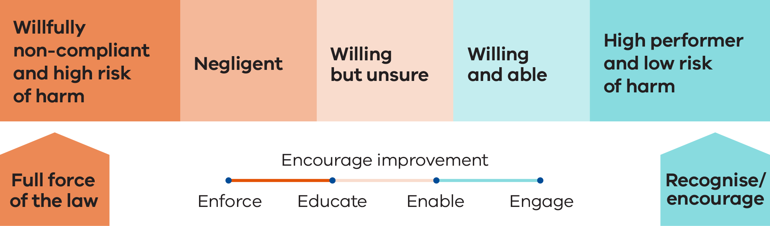

Charter of Engagement
Recycling Victoria’s Charter of Engagement describes our commitment to engage meaningfully and transparently with stakeholders. It states how we will engage with stakeholders on issues and decisions that matter to them.
Our Charter of Engagement applies a whole of Victorian Government approach to engagement, encompassing the Victorian Government Public Engagement Framework, the DEECA Community Charter and the Traditional Owner and Aboriginal Community Engagement Framework.
The Public Engagement Framework aims to strengthen meaningful engagement practice in Victoria.
Figure 2: Victorian Government engagement principles

Victorian Government Public Engagement Framework Principles
- Meaningful – Engagement is genuine and informs the final decision.
- Inclusive – Engagement is respectful, inclusive and accessible.
- Transparent – Engagement is clear and open about what the public can and cannot influence.
- Informed – Engagement provides relevant and timely information to the public.
- Accountable – Engagement is high quality and responsive to the public.
- Valuable – Engagement creates value for the community and government. This can include social, economic and environmental value.

DEECA Community Charter Principles
- Be available
- Involve and listen
- Take action

Traditional Owner and Aboriginal Community Engagement Framework Principles:
- Self-determination
- Traditional Owners as partners
- Place based or whole of country approach
- Respect for decision making process
- Aboriginal people set their own priorities
- Free, prior and informed consent
- Acknowledge past injustices and structural inequality

Community Engagement Strategy
Recycling Victoria’s Community Engagement Strategy 2023–2026 sets out our commitment to work with regional and metropolitan stakeholders and communities, businesses, industry, Traditional Owners, local government and Alpine Resorts Victoria (ARV) in decisions that affect them and on issues that matter to them.
This involves connecting with our broader community to:
- build strong relationships
- share information and data
- strengthen our waste, recycling and resource recovery system.

Our engagement approach
Waste, recycling and resource recovery system reforms affect every household in Victoria, as well as each local government, ARV and the waste, recycling and resource recovery services sector.
Recycling Victoria is committed to meaningful, transparent and frequent engagement with our stakeholders.
Our engagement approach is tailored to individual stakeholders, locations and circumstances.

Engagement and consultation
Our approach to community engagement includes 3 areas of focus:
- regional and local engagement that is tailored and frequently in person
- statewide, strategic and structured engagement through regular forums and committees
engagement on emerging issues and opportunities, including the implementation of new schemes and functions and capability development.

Aboriginal self-determination
Traditional Owners are recognised in Victoria as the First Peoples through a range of legal and policy instruments that support self-determination and their continuing responsibilities to care for Country.
The Victorian Government is working in partnership with Traditional Owners and Aboriginal Victorians to advance a treaty or treaties that will provide a foundation for a new, positive relationship and enable true self-determination for Victoria’s First Peoples.
Recycling Victoria will ensure that Traditional Owner cultural knowledge is part of how we deliver our functions.
Figure 3: Recycling Victoria’s engagement approach
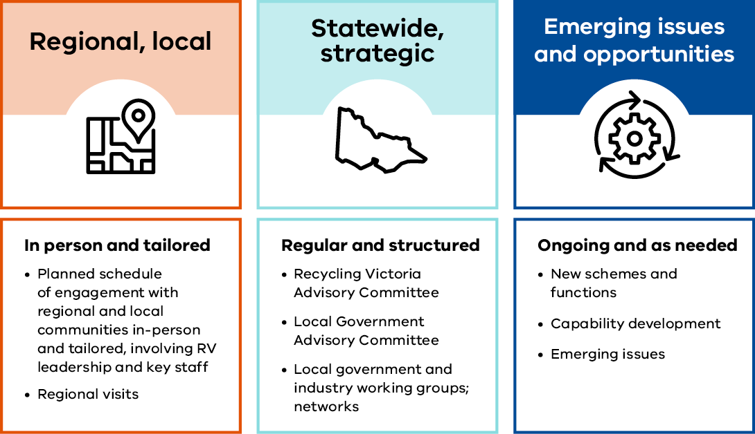

Digital communications
Digital communications channels are an essential component of the Recycling Victoria communications and engagement toolkit.
Our channels enable us to reach the public and a broad range of stakeholders almost instantly, enhancing connection, raising awareness, strengthening engagement and building trust and reputation.
We design and produce content that is factual, timely, engaging and adheres to Victorian Government and World Wide Web Consortium accessibility and user experience guidelines.

Website
- 132,063 Sessions – The Recycling Victoria site recorded 132,063 sessions/visits for 2024–25 with 81% new users (benchmark 60-80%) and 29% returning users
- 68% Engagement – A healthy engagement rate of 68% (benchmark 60-70%) for the site indicates that visitors spent time viewing pages, clicking on links and downloading resources.
Table 1: Top three most viewed pages at the Recycling Victoria website
Most viewed page | Number of views
Container Deposit Scheme | 69,422
Recycling Victoria homepage | 11,645
Recycling Victoria Data Hub | 5,869

Table 2: Top three most viewed publications at the Recycling Victoria website
Most viewed publications | Number of views
Strategic Plan 2023–2026 | 1,303
Strategic Procurement Framework 2025 | 1,106
Regulatory Strategy July 2023– June 2026 | 736
Table 3: Top three most downloaded documents at the Recycling Victoria website
Most downloaded document | Downloads
Victorian Recycling Infrastructure Plan | 1,693
CDS Vic Zone Operator Map | 1,245
Circular Economy Market Report | 754

Social media – LinkedIn
- 5,739 followers – In November we celebrated the milestone of 5,000 LinkedIn followers and are on track to reach 6,000 early in 2025–26. Growing our follower community is a direct result of delivering purposeful and useful posts that generate engagement.
- 6.9% engagement – Our LinkedIn page recorded a total of 125,775 impressions (the number of times posts have been viewed by other users on the platform) and generated a strong engagement rate of 6.9% (benchmark 5.9%).
- 5,706 clicks – A key contributor to this engagement rate was the 5,706 clicks across 79 posts (including re-posts); a high number of those link clicks channelled traffic to the Recycling Victoria website.
Table 4: Top three impressions at the Recycling Victoria LinkedIn page
Impressions | Date | Total number
Recycling Victoria visit to Bendigo | 30/08/2024 | 4,764
Regional visit (Gippsland) | 01/04/2025 | 3,851
Circular Economy Market Report launch | 25/03/2025 | 5,869
Table 5: Recycling Victoria LinkedIn page engagement rates
Engagement rate | Date | %*
Join us at the Government lounge (Waste Expo) | 23/10/2024 | 13.2%
Recycling Victoria visit to Bendigo | 30/08/2024 | 12.4%
Regional visit (Gippsland) | 01/04/2025 | 8.9%
* Benchmark = 5.9%
Table 6: Recycling Victoria LinkedIn page Click through rates
Click through rate | Date | %**
Recycling Victoria visit to Bendigo | 30/08/2024 | 10.0%
Join us at the Government lounge (Waste Expo) | 23/10/2024 | 9.8%
Waste Expo: Recycling Victoria speakers | 08/10/2024 | 8.9%
** Benchmark = 0.6%

Achievements against strategic priorities 2024–25
In 2024–25, Recycling Victoria focused on delivering the following priorities.

Container Deposit Scheme
Victoria’s Container Deposit Scheme (CDS Vic), funded by contributions from the beverage industry, contributes to Victoria's target of diverting 80% of all material away from landfill by 2030 and represents a significant step in our journey towards a stronger circular economy.
Recycling Victoria is responsible for the oversight, regulation and administrative direction of CDS Vic under Part 6 of the CE Act.
There are 4 key contracted operators for the scheme. The Scheme Coordinator, VicReturn, is responsible for managing scheme administration, education and finances. Return-It, TOMRA Cleanaway and Visy are the Zone Operators responsible for establishing and maintaining a network of refund points in the East, West and North zones respectively. The Scheme Payments and Contribution Methodology (SPCM) outlines the calculation, nature and timing of scheme payments made to and by the Scheme Coordinator.
The SPCM sets out the arrangements for first suppliers’ scheme contributions, export payments, network fees payable to Zone Operators, the service fee payable to Recycling Victoria, refund payments to material recovery facility operators and how financial penalties are charged and collected.

CDS Vic first birthday celebrations
CDS Vic celebrated its first birthday on 1 November 2024. The anniversary coincided with the return of 1 billion containers in the scheme’s first year of operation.
Victorian primary school students shared their recycling messages throughout October as part of CDS Vic’s Message in a Bottle installation which also formed part of the first birthday celebrations. The Minister for Environment Steve Dimopoulos visited Scienceworks to celebrate these milestones at the installation that was on display from November 2024 to January 2025.
CDS Vic processed an average of 19 million cans, cartons and bottles across the state every week and put $100 million back into the pockets of Victorians in the 12 months since its launch on 1 November 2023.
Victoria’s network of refund collection points has over 640 locations across the state, with a mix of depots, over the counter and reverse vending machine refund collection points.
Since commencement the scheme has created almost 600 jobs and has provided charities, schools, sports clubs and community organisations new ways to raise funds. More than $1.9 million has been generated in donations to not-for-profit groups thanks to the generosity of Victorians who have elected to donate their refund to a registered donation partner. Across the state more than 5,700 different not-for-profit organisations such as charities, schools, sports clubs or community organisations were registered donation partners in the scheme’s first year of operation.

Case study

Mobilising communities to participate in Victoria’s Container Deposit Scheme.
CDS Vic is designed to not only reduce litter and increase recycling but also foster strong community partnerships that amplify its impact.
Through a grassroots partnership between CDS Vic and AFL Victoria, the scheme is incentivising local football clubs to recycle, return eligible beverage containers and raise funds as official donation partners and support their collection efforts to fund participation in sport.
Head of AFL Victoria, Greg Madigan expressed his excitement to be partnering with CDS Vic to create a positive environmental impact whilst providing clubs with additional funding opportunities.
“Local footy clubs are the heartbeat of communities across Victoria and any program that will help clubs raise funds while having a positive impact on the environment is great for the grassroots game, which is one of the reasons why the partnership with CDS Vic has so much potential.”
Community engagement is also supported through education and outreach initiatives to help schools and community groups run campaigns, understand the refund process and promote container collection drives. Working collaboratively with Sustainability Victoria’s Resource Smart Schools Program, CDS Vic has established an annual award to highlight a primary and secondary Victorian school that is proactively utilising the scheme to embed recycling practice in their community. Kardinia International College and Wandin Yallock Primary School were winners of the 2025 CDS Vic Excellence Award.
Through these community partnerships, CDS Vic becomes more than a recycling program—it becomes a platform for grassroots environmental stewardship, local fundraising and inclusive economic development. By embedding collection and collaboration at every level, the scheme strengthens community ties while delivering lasting environmental benefits.

Waste to Energy Scheme
Waste to energy involves turning waste material, otherwise destined for landfill, into useful energy resources such as heat, electricity, gas and liquid fuels. After waste avoidance, reuse and recycling, waste to energy is the final opportunity to get value from material that would typically be disposed to landfill.
The Victorian Waste to Energy Framework recognises the role of waste to energy in diverting waste from landfill. The framework includes placing a cap on the amount of waste that can be heat treated to make energy and outlines how the cap will work.
As Victoria shifts towards a circular economy, waste to energy facilities can play a role in:
- being an alternative to landfill, through diverting waste from landfill, to limit the need for new landfills
- allowing businesses to generate more value from the materials they manage
- creating valuable energy that can be used by industry or exported to the electricity grid for the community
supporting Victoria to meet its target of net zero emissions by 2045.
Recycling Victoria regulates the market-related aspects of thermal waste to energy processes under Victoria’s Waste to Energy Scheme. It ensures that licensed facilities only accept approved amounts and specific types of residual wastes.
The scheme ensures investment in waste to energy facilities does not compromise our current and future investment in Victoria’s efforts to avoid, reuse and recycle more waste in future.
Under Part 5A of the CE Act, Recycling Victoria is responsible for:
- licensing operators by providing existing and new operators with a licence to process permitted waste using a thermal waste to energy process
- administering the scheme by providing information and education, guidelines and administering licences (including licence transfers and amendments)
monitoring and enforcing compliance with licence terms and conditions and working with co-regulators such as the Environment Protection Authority Victoria (EPA).

Issuing waste to energy licences
The Victorian Government delivered regulations that prescribe the processes and requirements to apply for licences in 2 stages. A cap licence allows thermal waste to energy facility operators to process permitted waste up to a specified maximum amount and is required by anyone that intends to:
- build and operate a new thermal waste to energy facility in Victoria to process permitted waste
existing operator licence holders who wish to increase the licensed amount of permitted waste they are allowed to process.
Stage 1 of the scheme, which pertains to existing operators, concluded in 2023–24, with the Head, Recycling Victoria issuing 4 operator licences for existing facilities. Stage 2, which relates to new operators, commenced in 2024–25 when cap licensing regulations were made.
On 10 December 2024, the Victorian Government released the Economic Growth Statement – Victoria: Open for Business, which committed to setting the waste to energy cap at 2 million tonnes per annum. This initial cap was set to enable more municipal, commercial and industrial waste to be used to generate energy rather than go to landfill.
The Economic Growth Statement also made a commitment to further increase the cap limit to 2.5 million tonnes, subject to a Regulatory Impact Statement (RIS) being completed in early 2025. DEECA conducted public consultation on the regulations to increase the cap and the associated RIS during March and April 2025.
Recycling Victoria commenced the expression of interest (EOI) process for applicants wishing to apply for a thermal waste to energy cap licence in December 2024. Successful applicants were then invited to submit a full application by the end of April 2025.
This process was open to new and existing operators seeking to increase the volume of permitted waste processed by their facility. The Head, Recycling Victoria intends to issue cap licences to thermal waste to energy facilities in 2025.

Market risk and contingency planning
Recycling Victoria is leading risk, consequence and contingency planning for Victoria’s waste, recycling and resource recovery sector.
Enactment of the Circular Economy (Waste Reduction and Recycling) (Risk, Consequence and Contingency Plans and Other Matters) Regulations 2023 supports greater understanding, visibility and oversight of sector-wide risk planning.
It allows shared understanding and management of risks by industry and government to reduce disruptions and make the system more resilient and reliable as we transition to a stronger circular economy.

Circular Economy Risk, Consequence and Contingency Plan
The Circular Economy Risk, Consequence and Contingency Plan (CERCC Plan) is an annual, statewide plan for the waste, recycling and resource recovery sector.
The Head, Recycling Victoria is required to develop and submit the CERCC Plan to the Minister for Environment on or before 31 December each year, in accordance with section 74B of the CE Act.
The second annual CERCC Plan was released on 30 May 2025.
The CERCC Plan 2025 outlines serious risks in the waste, recycling and resource recovery industry that may disrupt essential services and the measures responsible entities must undertake to minimise them. Recycling Victoria consulted on a draft of the CERCC Plan 2025 with stakeholders potentially impacted in November 2024 and revised the plan to address the feedback received.

Responsible entities
Recycling Victoria acknowledges a level of shared responsibility between industry and all tiers of government for the management of risks to waste, recycling and resource recovery services.
Responsible entities manage services that, if disrupted, present a serious risk to service continuity or progressing to a more circular economy.
Providers of essential waste, recycling and resource recovery services must self-assess whether they are a responsible entity and notify Recycling Victoria within 60 calendar days of publication of the CERCC Plan or at any time based on a change of their circumstances.
The CERCC Plan 2024 notification period closed on 7 July 2024. A total of 24 responsible entities notified of their status, 14 more than reported in the 2023–24 annual report. All 24 responsible entities prepared and submitted a Responsible Entity Risk, Consequence and Contingency Plan (RERCC Plan) under section 74F(2) of the CE Act.
As at 30 June 2025, 2 existing responsible entities notified as ceasing to be a responsible entity.

Responsible Entity Risk, Consequence and Contingency Plans
In accordance with section 74F(2) of the CE Act, responsible entities must respond to the serious risks outlined in the CERCC Plan in the preparation of their Responsible Entity Risk, Consequence and Contingency Plan (RERCC Plan). RERCC Plans are required to be submitted to Recycling Victoria by 30 September each year.
Recycling Victoria’s review of inaugural RERCC Plans determined that responsible entities were able to identify their relevance to the serious sector risks in the CERCC Plan 2024 and specify actions they propose to take to prevent or minimise the risks identified.
Responsible entities were able to demonstrate a level of preparedness for emerging challenges to service continuity and the transition to a circular economy, in partnership with other operators or the Victorian Government. Preparation of RERCC Plans is providing a better understanding of where resilience in the system is strong and where further strengthening opportunities exist.

Summary of the key risks, consequences and measures in CERCC Plan 2025
There are 7 serious risks identified in the CERCC Plan 2025 that may impact waste, recycling and resource recovery service continuity or progress towards a circular economy. These are:
- contamination such as physical and chemical contamination of waste streams that compromise resource recovery outcomes and/or present serious risks to infrastructure or work health and safety
- external threats such as a major emergency or security issue impacting a facility or entity
- planning such as operational business planning and strategic land use planning pressures that may impact a facility or entity
- social acceptance such as fostering trust in the sector as part of a shared responsibility to delivering quality and better practice
- internal threats such as mishandling of hazardous materials, equipment failure, insufficient capability and capacity or poor risk culture/control regimes
- economic shocks and stressors such as a loss of markets (loss of major supply contracts) or adjustments required to respond to increased regulation
commercial viability in the market such as challenges directly and indirectly affecting affordability in the sector and a reflection of material streams that may not currently be commercially viable.
Specific measures that responsible entities are required to take have been included in the CERCC Plan 2025. These measures were identified by considering existing controls and subsequent risk evaluations, and noting the actions that are proposed to be implemented by responsible entities, as outlined in RERCC Plans. Responsible entities need to document actions to undertake each measure in their RERCC Plan and Statement of Assurance and submit to Recycling Victoria by 30 September 2025.
Measures by responsible entities to address these risks include:
- identify relevant risk events that may arise from an inability to secure relevant approvals
- assess IT risks (including cybersecurity)
- assess implications of the revised Environment Protection Authority Victoria (EPA) Buffer and Separation guidelines
- identify relevant fluctuations in the supply and demand of material
identify relevant contamination management, including from batteries.

Incident response
One of the ways Recycling Victoria is supporting the sector is through an incident response function.
The incident response function provides value to Recycling Victoria and its stakeholders. The response:
- clarifies respective Recycling Victoria team roles and responsibilities to identify, inform and manage incidents
- strengthens internal and external awareness of Recycling Victoria’s compliance and enforcement powers
- provides clarity to industry on the respective roles and differing spheres of responsibility of the EPA, CACE and Recycling Victoria with respect to incidents
complements Recycling Victoria's role as the primary contact for industry advocacy to reduce service disruptions or issues impacting the transition to a circular economy.
A key trend identified from incidents during 2024–25 is related to fires at waste facilities, likely linked to the increased number of lithium-ion batteries entering Victoria’s waste streams. Many of the incidents caused by fire or fire threats could have triggered subsequent disruption to services for local governments or industry.

Infrastructure planning
Recycling Victoria is responsible for statewide waste, recycling and resource recovery infrastructure planning, a key component of the Victorian Government’s ongoing reforms to the waste and recycling sector.

Victorian Recycling Infrastructure Plan
Recycling Victoria released the inaugural Victorian Recycling Infrastructure Plan (VRIP) in October 2024.
The VRIP provides Victorian circular economy investors with a contemporary roadmap to guide decision-making on waste, recycling and resource recovery infrastructure over the next 30 years.
The VRIP outlines infrastructure needs and gaps, driving innovation and potential investment where it is needed most. This investment will create jobs and strengthen the sector and the wider Victorian economy. It also informs potential locations for new development and helps to protect existing infrastructure from encroachment.
The VRIP guides the delivery of new infrastructure, paving the way for Victoria’s transition to a circular economy and more sustainable future.
The VRIP is accompanied by an investment prospectus which has been developed in partnership with government agencies who facilitate Victorian business growth. The prospectus highlights investment opportunities in the waste, recycling and resource recovery sector and how Recycling Victoria can support investment.
Legislation requires the VRIP to be reviewed every 3 years. It builds on and replaces Victoria’s 7 regional waste and resource recovery implementation plans and the Statewide Waste and Resource Recovery Infrastructure Plan.
Recycling Victoria developed the VRIP in accordance with the requirements set out in the CE Act. Recycling Victoria also conducted an investment roadshow, including in-person events in each region, to target external stakeholder engagement with the sector. The roadshow was attended by 146 participants and connected technology providers, local government, water authorities, the energy sector, universities and consultants. These connections have led to several investment discussions with private sector stakeholders and strategic planning discussions with local governments and water authorities about potential recycling precincts.
Figure 4: Victoria’s Waste, Recycling and Resource Recovery System, Victorian Recycling Infrastructure Plan
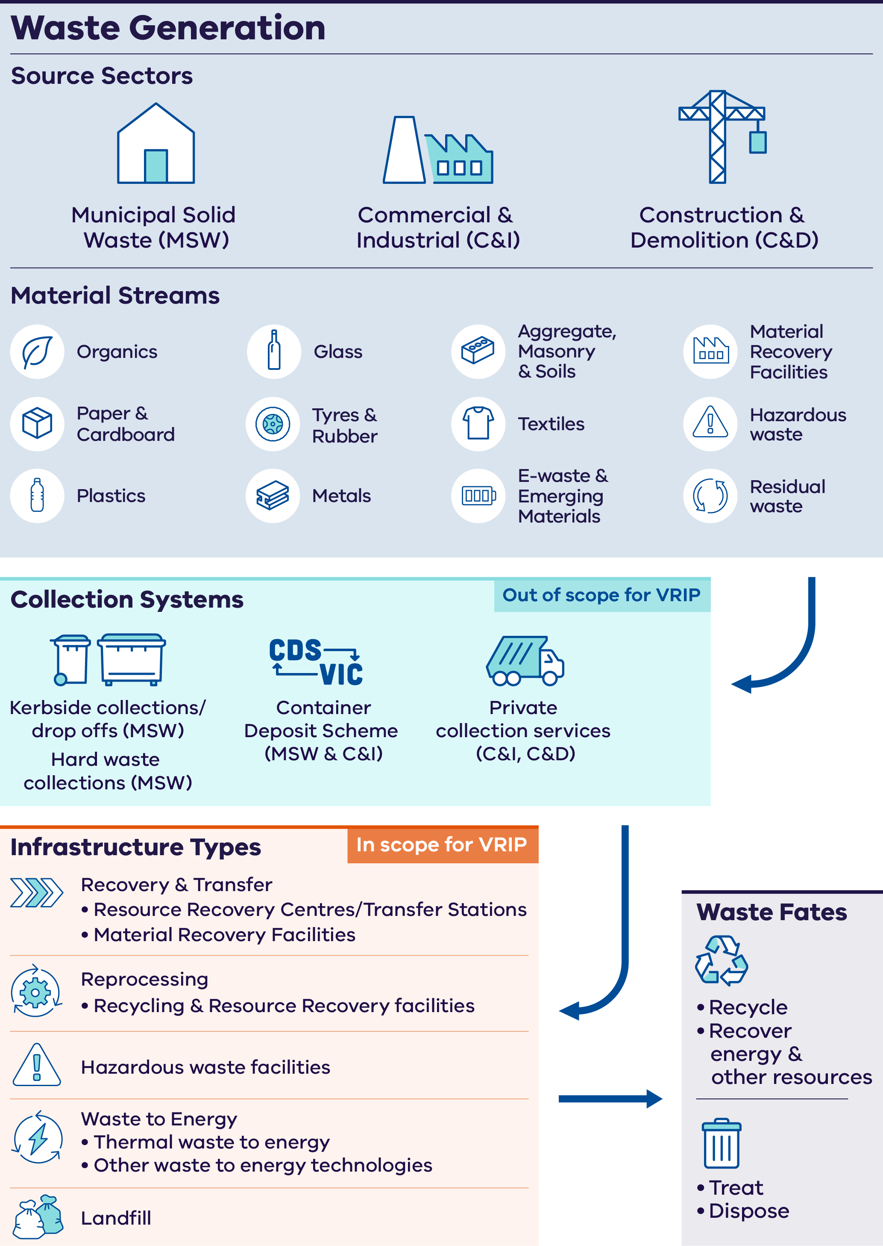

Market intelligence

Circular Economy Market Report
The Head, Recycling Victoria is required to submit the Circular Economy Market Report to the Minister for Environment on or before 31 December each year in accordance with the CE Act.
The latest Circular Economy Market Report was released in March 2025. The report provides annual information about material circularity relating to the generation, collection, sorting, re-processing or re-manufacturing of products within the circular economy market.
The Circular Economy Market Report provides information on 8 key material streams:
- aggregates, masonry and soil
- glass
- metals
- organics
- paper and cardboard
- plastics
- tyres
- textiles.
This information will be used to help businesses and the Victorian Government to make better policy and investment decisions.
The publication of this report is a major milestone for Victoria as the first state or territory to report against 3 new circular economy measures under Australia’s Circular Economy Framework released in December 2024.
The adoption of the 3 new measures (circularity rate, material footprint and material productivity) also meets a commitment made in last year’s Circular Economy Market Report and Victoria’s circular economy policy, Recycling Victoria: A new economy, to include new circular economy metrics that best monitor and measure Victoria’s material circularity.
Victoria currently recovers approximately 70% of waste. This material contributes to the circularity rate.
The new metrics will help the Victorian Government and industry better understand the amount of recycled material we put back into the economy, and how much value Victoria gets out of the material it uses.
The report confirms that Victoria is one of the highest performing Australian states for landfill diversion.
Victorians generated 14.5 million tonnes of waste material in the 2022–23 financial year and our waste, recycling and resource recovery sector recovered almost 10 million tonnes.
The Circular Economy Market Report will continue to evolve in future years, as further important work is done to expand and improve measurement of Victoria’s material streams and market information.

Recycling Victoria Data Hub
Our decisions and actions are informed by market data and intelligence.
The online hub is a nation leading and high-quality waste data management system for our investment in market research, risk management and strategic planning.
Two sets of core statistics for Victoria have been produced and released during the year:
- Victoria’s waste performance and projection model 2023–24
- Victorian local government waste and performance figures 2023–24.
This data underpins:
- policy and infrastructure investment decisions
- the Circular Economy Market Report
- the Victorian Recycling Infrastructure Plan
- the Circular Economy Risk, Consequence and Contingency Plan
- performance against the Victorian Government’s policy targets
- supply chain analyses
capacity forecasting, risk and contingency planning.
New data sourced from local government and the waste and recycling sector was made available on the data hub on 5 May 2025.
The new 2023–24 data shows that Victorian households are increasing their recycling with a landfill diversion rate of 70%, which is higher than the 2021 national average of 63%.
Increased household diversion rates have been supported by increased access to food organics and garden organics (FOGO) collections, with more than half of all Victorian councils now having access to a FOGO service.
Action towards landfill diversion remains a priority, with a range of programs underway including household recycling reforms, the Container Deposit Scheme, Waste to Energy Scheme and investments in increased recycling and resource recovery infrastructure.
Collected annually, this critical data has been used to update the Victorian waste projection model, which forecasts waste generation in Victoria until 2053.
This data also provides insights into the recycling sector and allows for a better understanding of how material streams are managed in Victoria.
Insights gained from this data will inform government and industry investment decision making by identifying opportunities and trends in the Victorian market to achieve a more circular economy.
Figure 5: Materials generated, recovered for processing, and disposed of in 2022–23 in tonnes, Circular Economy Market Report
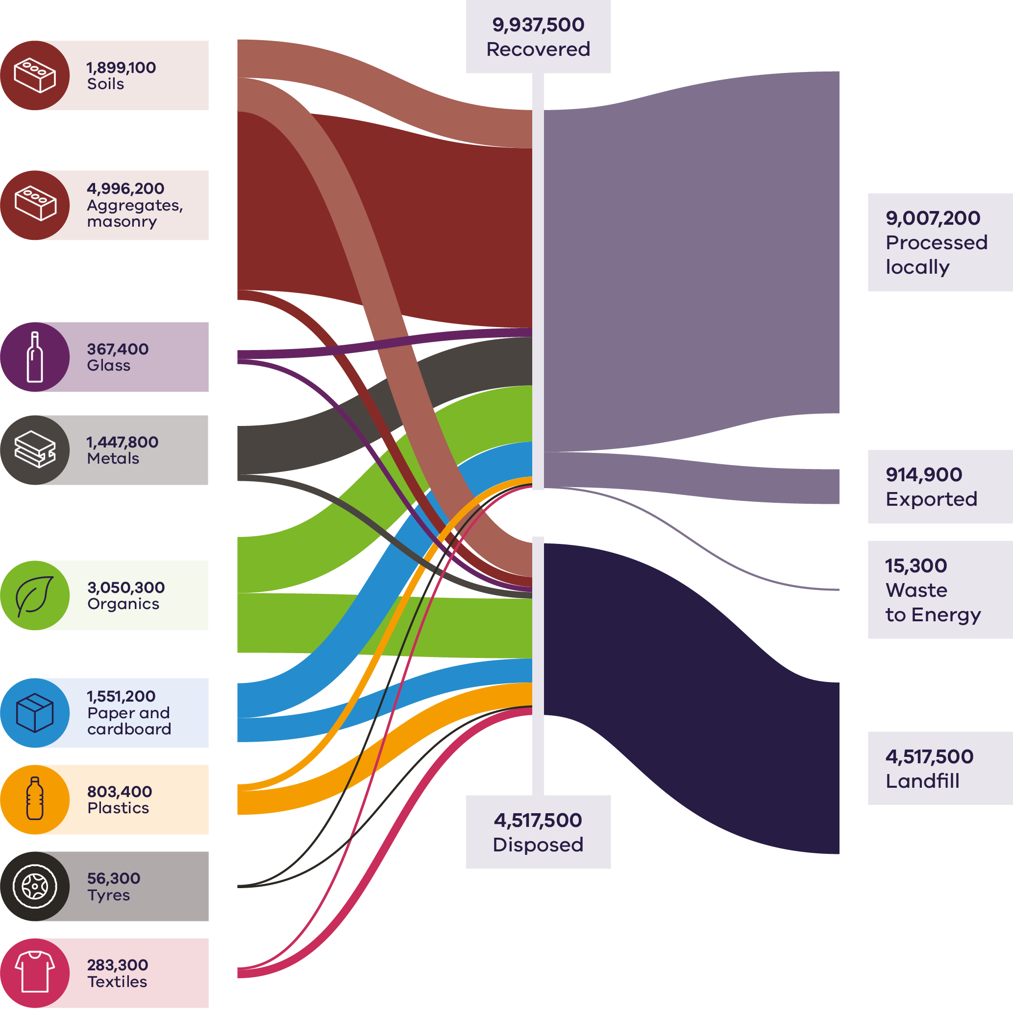

Service standards

Draft Household Waste and Recycling Service Standard 2025
The draft Household Waste and Recycling Service Standard 2025 is the first of its kind in Australia and once made, will create a consistent household waste and recycling system across Victoria by setting the requirements for how councils and ARV provide general rubbish, mixed recycling, glass recycling and FOGO services to households. The service standard will enable Recycling Victoria to drive statewide consistency while balancing the flexibility needed in how waste and recycling services are delivered at a local level.
The draft service standard was prepared over 2023 and 2024 based on prior consultation on the standard lists and policy framework.
The objectives of the service standard are to:
- provide a simpler, consistent household waste and recycling service
- reduce emissions
- capture greater value of recyclables and result in less extraction of virgin materials
reduce the volume of household recyclables and organic material being sent to landfill.
The draft Household Waste and Recycling Service Standard included:
- standard content lists of accepted and not accepted materials for each service
- standard colours for bin lids and drop-off signage
- acceptable service arrangements including:
- kerbside collection and drop-off services
- existing services
- communications to households
- reasonable access to drop-off services.

Public consultation
Public consultation on the draft service standard and associated regulations was undertaken by the CACE Division in DEECA from 18 June to 14 August 2024 via the government’s Engage Victoria website, supported by a communication campaign. Victorians were able to provide written feedback or complete an online survey.
To support the public consultation, Recycling Victoria organised 7 online regional forums with councils and ARV during the feedback period. These forums provided an overview of the draft service standard and regulations and Recycling Victoria’s regulatory approach. Across these forums there were 65 councils plus ARV in attendance with 120 attendees in total.
Key aspects of the service standard, which were consulted on included:
- a proposed commencement date of 1 July 2027
- the service arrangements for kerbside collection
- the service arrangements for the FOGO service
- the service arrangements for drop-off services
standard content lists of accepted and not accepted materials for each service.
The consultation received a significant level of engagement with many submissions received during the consultation period.
Submissions were analysed and have informed changes to the service standard and associated regulations. The Recycling Victoria Advisory Committee was also briefed on the draft service standard and provided advice to Recycling Victoria and the Minister for Environment.
Targeted consultation on the key issues raised in submissions was also undertaken to understand the complexities and interdependencies within the waste and recycling system.
The service standard is being finalised and requires the approval of the Minister for Environment to be made.

Supporting local government and Alpine Resorts Victoria
Before the service standard commences, our goal is to ensure that local government and ARV clearly understand their obligations and are supported during their transition to deliver the 4 waste and recycling services. Once the service standard has been made, Recycling Victoria will:
- develop and release guidance materials to support local governments and ARV to comply with the service standard
- conduct webinars to explain local government and ARV’s obligations and compliance readiness
engage directly through the Local Government Forum and other channels focussing on readiness and compliance with the service standards.
Once the service standard commences, the focus will be on monitoring and assessing compliance against legislative obligations. A risk-based compliance approach will be taken, with a focus on proportionate action to address non-compliance, supported by ongoing engagement.

Procurement support
Under section 57 and section 58 of the CE Act, a key function of Recycling Victoria is to support best practice procurement management by local governments, ARV and service providers for waste, recycling and resource recovery services.
Recycling Victoria published a Strategic Procurement Framework in April 2025 to guide how it will deliver its procurement support function.
The framework outlines the potential support Recycling Victoria could provide at various stages of a procurement including:
- developing resources and tools such as guidance, case studies and templates
- coordinating opportunities to share knowledge and insights
providing information and advice.
It also sets out how these activities will be prioritised.
The Strategic Procurement Framework was informed by consultation with key stakeholders and developed with legal and probity advice, to ensure the support Recycling Victoria provides is consistent with its role under the CE Act.
In developing the framework, Recycling Victoria sought to understand the procurement levers that could improve the management of all municipal kerbside waste streams, and address state significant market opportunities and industry risks.
By sharing information such as market intelligence on material flows, recovery rates and regional and statewide infrastructure opportunities, local governments and ARV can be well informed to make strategic, evidence-based procurement decisions. Information about procurement approaches, contracting and sharing lessons learned can also help deliver strategic outcomes and mitigate risks.

Engagement
Recycling Victoria engaged regularly with key stakeholders throughout the year in accordance with the Community Engagement Strategy 2023–2026.

Connecting with leaders in local government and industry

Local Government Forum
The Local Government Forum provides an avenue for local government stakeholders across Victoria to:
- hear from Recycling Victoria and other parts of DEECA on progress towards the implementation of the CE Act
- provide feedback on the planning and implementation of work to deliver the Victorian Government’s reforms towards the transition to a circular economy
- raise issues, risks and opportunities for local government in the planning and delivery of government reforms towards the transition to a circular economy
- participate in genuine information sharing and dialogue on the implementation of the CE Act.
The Local Government Forum offers an important opportunity for state and local government to work together towards more resilient and sustainable outcomes for the waste, recycling and resource recovery sector.
A total of 3 Local Government Forums were held in 2024–25.

Resource Recovery, Recycling and Waste Industry Group
The Resource Recovery, Recycling and Waste Industry Group (RRRWIG) comprises industry sector and peak body representatives and is chaired by the Head, Recycling Victoria. During 2024–25, a total of 3 RRRWIG forums were held.
The RRRWIG’s role is to provide industry views, input and advice on the delivery of government reforms. This includes development, consultation on and implementation of new regulatory requirements through regulations and standards as provided for in the CE Act. It also includes emerging industry issues and risks in the lead up to and during the roll out of legislative and regulatory reforms and any further statutory reforms, as required.
The RRRWIG operates as an avenue for advice and consultation. Whilst that consultation may identify and analyse issues, any final resolution rests with Recycling Victoria and the Victorian Government.

Program meetings, workshops and information sessions
Meetings, workshops and information sessions were used by program areas to engage with stakeholders and involve them in the issues that affect them.

Risk, consequence and contingency planning:
- 2 online sessions in August 2024 to support responsible entities with preparing their RERCC Plans. A total of 70 responsible entity representatives attended these sessions.
- 2 online information sessions during May and June 2025 for industry participants, public sector bodies and local government to hear more about the CERCC Plan 2025.
1:1 sessions with responsible entities about the CERCC Plan 2025. These sessions were also an opportunity for responsible entities to provide feedback on RERCC Plan guidance materials.

Strategic Procurement Framework:
An online information session in August 2024 for local government and ARV on the draft Strategic Procurement Framework. There were 40 attendees at this session representing 39 local councils.

Victorian Recycling Infrastructure Plan:
- 2 online infrastructure investment briefing sessions in October 2024.
6 in person regional infrastructure investment sessions between October and December 2024. These sessions focussed on investment opportunities in each region and were attended by 146 participants across Victoria.

Waste to Energy Scheme:
2 online industry briefings for prospective applicants for a waste to energy cap licence.

Service standard:
7 regional forums for councils as part of the consultation on the draft service standard.

Victoria’s Container Deposit Scheme:
- Monthly contract management meetings with all 4 scheme participants to provide support and ensure contract compliance.
- Joint Network Operator meeting to allow for open discussion on concerns and issues Network Operators may have encountered.
Scheme Coordinator and Network Operator quarterly CEO meetings with the Head, Recycling Victoria.

Witnessing the circular economy in action through site visits
Site visits enable Recycling Victoria to connect with industry and learn more about the progress individual businesses are making towards contributing to a circular economy.
Throughout the year, the Head, Recycling Victoria and key staff were involved in several site visits.

Contributing at conferences and external presentations
The Head, Recycling Victoria presented at a number of conferences and forums during 2024–25.
This included the Victorian Waste & Resource Recovery (WARR) Forum, where Steve Dimopoulos MP, Minister for Environment, released the Circular Economy Market Report – a key step towards Victoria’s transition to a more circular economy.
Director Sector Strengthening, Peter Laslett spoke about infrastructure planning at the Coffs Harbour Waste Conference in May 2025 and at the Victorian Bioenergy Network Forum in August 2024.

Waste Expo Government Lounge sponsorship
Recycling Victoria, Sustainability Victoria and the Environment Protection Authority Victoria hosted a Government Lounge at the Waste Expo Australia on 23–24 October 2024 at the Melbourne Conference and Exhibition Centre.
The Head, Recycling Victoria was a keynote speaker at the industry breakfast and in the opening address for the 2 day event. The Head, Recycling Victoria also participated in the Industry Leaders' Discussion: Progress and Future Directions in Waste Management.
Director Container Deposit Scheme, Sonia Parisi participated in the panel discussion about Victoria’s Container Deposit Scheme: Navigating the First Year – Progress, Achievements and Lessons Learned.
Director Sector Strengthening, Peter Laslett gave a special presentation launching the VRIP and Director Regulation and Oversight, Ashleigh Jones gave an update on waste to energy. Manager Sector Risk Planning, Richard Plant spoke about implementing risk, consequence and contingency planning and Director Sector Intelligence and Reporting, Jorja Pindor gave an overview of the Circular Economy Market Report.
The event was attended by more than 3,500 professionals in public and private sectors from all over Australia and the world. It allowed Recycling Victoria to reach people from all levels of government, waste service providers, consultants, engineers, technology and equipment suppliers, project developers, facility managers and landfill owners/operators. It provided great exposure at the event itself as well as through associated promotional activity.

Regional engagement
Recycling Victoria’s Executive Leadership Team visited a number of DEECA regions to meet with local government representatives in a face-to-face forum, as part of its regional visits program. The Head, Recycling Victoria, executive directors and senior staff met with local government representatives from the Gippsland region in Morwell on 1 April 2025. A second regional visit on 18 June 2025 saw senior staff and executive directors travel to Waurn Ponds to meet with council representatives from the Barwon South West region.
The regional visits program provides an opportunity for local government to meet with Recycling Victoria’s senior executive team and discuss local waste, recycling and resource recovery issues and opportunities, and circular economy initiatives.
The Executive Leadership Team travelled to Bendigo on 29 August 2024 to meet with a number of Loddon Mallee local councils. The meeting brought together 6 regional local councils and provided an opportunity to discuss issues and matters of regional significance.

Engage Victoria consultations
Recycling Victoria consulted with stakeholders on 2 occasions using the Victorian Government's centralised online consultation platform, Engage Victoria.
Table 7: Engage Victoria consultations and their timelines
Consultation via Engage Victoria | Timeline
Strategic Procurement Framework | Draft Strategic Procurement Framework  12 August – 20 September 2024
Circular Economy Risk, Consequence and Contingency Plan | Draft Circular Economy Risk, Consequence and Contingency Plan 2025  6 November – 19 November 2024

Our people
Our people deliver diverse services and value to the Victorian community and our stakeholders each year.
In 2024–25, Recycling Victoria held 2 all-staff in-person events, in December 2024 and May 2025. These events provided the opportunity to come together to progress connection, collaboration and commitment to Recycling Victoria and each other. Staff and teams collaborated to consider their individual and collective actions and contributions and provided valuable input to continue that progress.
Recycling Victoria workforce data is included in the DEECA Annual Report 2024–25.

Section 22 (2) Annual Report Mandatory Content
Section 22 of the CE Act requires the Head, Recycling Victoria, to submit to the Minister an Annual Report, on or before 30 September each year. The prescribed minimum contents of the report are shown in the following table, along with a reconciliation of how they are addressed by this current edition.
Table 8: Prescribed minimum contents of the Annual Report
Leg. Ref | Legislative requirement | Outcome | Comment
S22(2) | An annual report under subsection (1) must include the following— |  | Recycling Victoria Annual Report 2024–25 has been prepared
S22(2)(a) | the total number of written directions given by the Minister under this Act | No written directions | No written directions were given under the CE Act during 2024–25
S22(2)(b) | the total number of written directions given by the Head, Recycling Victoria under this Act | No written directions
S22(2)(c) | a description or summary of each written direction | Not applicable
S22(2)(d) | a copy of each written direction as published in accordance with this Act | Not applicable
S22(2)(e) | details of the community engagement activities undertaken by the Head, Recycling Victoria in accordance with any existing community engagement strategy | Stakeholder engagement pages 31-33 in this report | Details of community engagement activities undertaken during 2024–25 have been included in this report
S22(2)(f) | a description or summary of the key risks, consequences and measures identified in the Circular Economy Risk, Consequence and Contingency Plan (CERCC Plan) | CERCC Plan  page 24 in this report | Waste, recycling and resource recovery sector risks, consequences and measures are contained in the approved CERCC Plan 2025. A summary is provided in this annual report
S22(2)(g) | the total number of responsible entities that are required to prepare a Responsible Entity Risk, Consequence and Contingency Plan (RERCC Plan) under section 74F | 24 | 24 entities self-assessed as responsible entities in 2024–25 and were required to prepare a RERCC Plan under section 74F by 30 September 2024. Details of the notifications for 2024–25 until 30 June 2025 are detailed in this report
S22(2)(h) | the total number of Statements of Assurance submitted to the Head, Recycling Victoria under section 74G | 24 | 24 Statements of Assurance accompanying RERCC Plans were provided by 30 September 2024
S22(2)(i) | the total number of written reports (in relation to RERCC Plans) prepared by the Head, Recycling Victoria (as directed by the Minister) under section 74I | Not applicable | The Minister for Environment did not direct preparation of any written reports relating to RERCC Plans during 2024–25
S22(2)(j) | a description or summary of each written report prepared under section 74I | Not applicable
S22(2)(k) | details of any actions that the Head, Recycling Victoria has carried out or proposes to carry out in response to a written report prepared under section 74I | Not applicable

Appendix 1: Recycling Victoria Strategy Map
Figure 6: Recycling Victoria Strategy Map
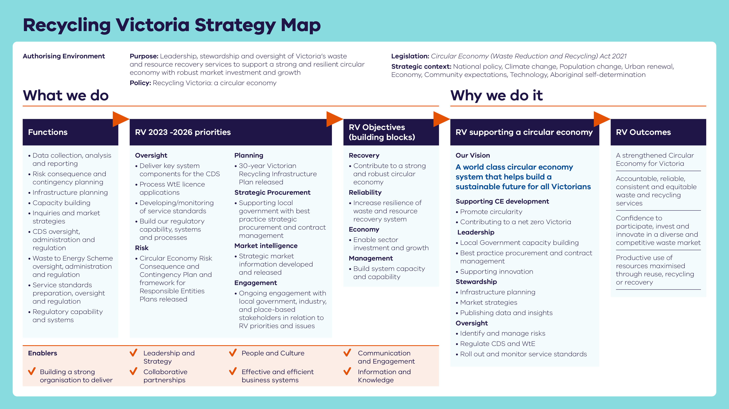

Publication information

Acknowledgements
We acknowledge and respect Victorian Traditional Owners as the original custodians of Victoria’s land and waters, their unique ability to care for Country and deep spiritual connection to it.
We honour Elders past and present whose knowledge and wisdom has ensured the continuation of culture and traditional practices.
DEECA is committed to genuinely partnering with Victorian Traditional Owners and Victoria’s Aboriginal community to progress their aspirations.

Copyright
© The State of Victoria Department of Energy, Environment and Climate Action,
September 2025.

Creative Commons
This work is licensed under a Creative Commons Attribution 4.0 International licence, visit the Creative Commons website (http://creativecommons.org/licenses/by/4.0/).
You are free to re-use the work under that licence, on the condition that you credit the State of Victoria as author. The licence does not apply to any images, photographs or branding, including the Victorian Coat of Arms, and the Victorian Government and Department logos.
ISSN 2981-9288 - Online (pdf/word)

Disclaimer
This publication may be of assistance to you but the State of Victoria and its employees do not guarantee that the publication is without flaw of any kind or is wholly appropriate for your particular purposes and therefore disclaims all liability for any error, loss or other consequence which may arise from you relying on any information in this publication.

Accessibility
To receive this document in an alternative format, phone the Customer Service Centre on 136 186, email customer.service@delwp.vic.gov.au, or contact National Relay Service on 133 677. Available at DEECA website (www.deeca.vic.gov.au).
End of document.

